

2024 Graduate Outcomes Survey ̶ Longitudinal
Methodological Report – Accessible
September 2025


Acknowledgements
We acknowledge the Wurundjeri People who are the Traditional Custodians of the lands on which our company is located, and the Traditional Custodians of country throughout Australia, where we conduct our business. We pay our respects to Elders, past and present. The Social Research Centre is committed to honouring First Nations peoples’ unique cultural and spiritual relationships to the land, waters and seas and their rich contribution to society.
The Social Research Centre would especially like to thank the institutions that contributed to the survey. Without the enthusiastic and committed assistance of the institutions, the survey would not have been such a success.
The project was led by Graham Challice and the project team consisted of Lisa Bolton, Lauren Spencer, Vicky Tong, Ben Williams, Elena Reading, Cynthia Kim, Dr Gabriel Ong, Brenwin Ang, Joe Feng, Rawan Habibeh, Serena Kim and Columbia Winterton.

Report prepared for:
Australian Government Department of Education
50 Marcus Clarke St, Canberra ACT 2601

Report prepared by:
The QILT Team
The Social Research Centre
Level 5, 350 Queen Street, Melbourne, Victoria 3000
03 9236 8500 | info@srcentre.com.au
srcentre.com.au
Version: 1 | September 2025

Contents
1. Introduction 1
1.1. About this report 1
1.2. Background 1
1.3. Objectives 1
1.4. Overview 1
1.5. Project milestones 2
2. Sample preparation 3
2.1. Target population 3
2.1.1 Additional populations 3
2.2. Institutional participation 3
2.3. Sample frame 3
2.4. Sample preparation overview 3
2.4.1 Sample processing quality assurance 4
2.4.2 Sample cleaning 4
2.4.3 Exclusions 4
2.4.4 Panel maintenance activity 5
2.4.5 Coverage 5
3. Survey design and procedures 6
3.1. Institutional engagement 6
3.1.1 Planning resources 6
3.1.2 Participation advice 6
3.1.3 Webinars and newsletters 7
3.1.4 Ongoing dialogue with institutions 7
3.2. Graduate engagement 7
3.3. Contact protocol 7
3.3.1 Email invitation and reminders 9
3.3.2 Email deliverability testing 15
3.3.3 SMS reminders 15
3.3.4 International engagement strategy 17
3.3.5 Reminder calls 18
3.3.6 Fieldwork briefing 20
3.3.7 Quality control 20
3.3.8 Social media 21
3.4. Data collection 22
3.4.1 Online survey 22
3.4.2 Survey testing 25
3.4.3 Quality assurance and applicable standards 25
3.4.4 Monitoring and progress reporting 25
3.4.5 Live online Reporting Module 25
3.5. Graduate support 25
3.6. Prize draw 26
4. Questionnaire 28
4.1. Development 28
4.2. Overview 28
4.3. Changes from 2023 28
4.4. Additional items 28
5. Data preparation 29
5.1. Definition of the analytic unit 29
5.2. Data cleaning and preparation 29
5.3. Coding and processing of free text responses 29
5.4. Data deliverables 30
5.5. Weighting 30
6. Final dispositions and response rates 31
7. Response analysis 32
7.1. Response by time 32
7.2. Non-response analysis 34
7.2.1 Characteristics associated with propensity to respond 34
7.2.2 Supplementing response rates with indicators of representativeness 35
7.2.3 Characteristics associated with non-response 36
7.2.4 Characteristics associated with outcomes 40
7.3. Sources of responses 41
8. Considerations for future surveys 43
8.1. Panel maintenance 43
8.2. Email messaging 43
8.3. Authentication 43
8.4. SMS protocol 43
8.5. GOS-L Engagement Strategy 43
8.6. Targeted response maximisation strategy 43
List of abbreviations and terms 45
References…………… 46
Appendix 1 Collection, sample and marketing guides 47
Appendix 2 Participating institutions 94
Appendix 3 Survey invitations and reminders 97
Appendix 4 Briefing slides for telephone follow-up activities 119
Appendix 5 Core questionnaire 131
Appendix 6 Survey screenshots 159
Appendix 7 Small screen optimisation 162
Appendix 8 Response by institution 168

List of figures
Figure 1 Example GOS-L invitation email on a large screen device 10
Figure 2 Example GOS-L invitation email on a small screen device 11
Figure 3 Example SMS content 16
Figure 4 Additional SMS content 16
Figure 5 Example social media advertisement – Facebook mobile news feed 21
Figure 6 Presentation of the GOS-L online survey in desktop view 23
Figure 7 Presentation of the GOS-L online survey on a small screen device 24
Figure 8 Response rates by day 33
Figure 9 Relative importance of graduate characteristics in predicting survey response in 2024 35

List of tables
Table 1 Key project statistics 2
Table 2 Key project milestones 2
Table 3 Coverage of population to sample 5
Table 4 Invitation and reminder schedule 9
Table 5 Email plan message intent 12
Table 6 Email send outcomes by round of activity 14
Table 7 SMS based follow-up activity outcomes 16
Table 8 In-field telephone reminder outcomes 18
Table 9 Post-field telephone reminder outcomes 20
Table 10 Graduate enquiries to the GOS-L helpdesk 26
Table 11 Prize draw schedule 27
Table 12 GOS-L module themes 28
Table 13 Items coded and source for coding decisions 29
Table 14 Final survey outcomes 31
Table 15 Comparison of representativeness over past three GOS-L collections 36
Table 16 Comparison between respondents and non-respondents for selected characteristics 38
Table 17 Relative importance of graduate characteristics in predicting survey outcomes in 2024 41
Table 18 Sources of response 42

Introduction

About this report
This Methodological Report describes the sample preparation, data collection, data processing and reporting aspects of the 2024 Graduate Outcomes Survey – Longitudinal (GOS-L, ‘the survey’), conducted on behalf of the Australian Government Department of Education (‘the department’) by the Social Research Centre. This report is structured into the following sections:
- Section 1 provides survey background, objectives and a general overview.
- Section 2 describes the target audience and sample design.
- Section 3 documents the survey design and procedures for conducting the study.
- Section 4 outlines the questionnaire development phase and provides an overview of changes from the previous iteration including institution specific items.
- Section 5 describes the data processing procedures.
- Section 6 documents the final dispositions and response rates.
- Section 7 presents an analysis of response.
- Section 8 summarises considerations for future iterations of the GOS-L.

Background
The GOS-L is a component of the Quality Indicators for Learning and Teaching (QILT) suite of surveys. In 2016, the GOS-L replaced the Beyond Graduation Survey (BGS), which was the longitudinal component of the Australian Graduate Survey (AGS), conducted between 2009 and 2015. The AGS was superseded by the Graduate Outcomes Survey (GOS).
Graduates who completed a course in 2020 or 2021 and responded to the 2021 GOS were invited to participate in the 2024 GOS-L.

Objectives
The broad aim of the GOS-L is to measure the medium-term labour force outcomes of higher education graduates approximately three years post completion of their undergraduate or postgraduate course. The development, collection and reporting of these measures provides reliable, valid and generalisable information on graduate outcomes to the Australian government and to higher education institutions. Specifically, the survey findings are used to:
- monitor graduates’ employment and further study outcomes
- better understand graduate attributes and preparation for the workforce
- identify specific areas that may positively impact graduates’ experiences with their higher education.
‘Higher education institutions’ refers to universities and non-university higher education institutions (NUHEIs).

Overview
The Social Research Centre administered the GOS-L from February to April 2024 with the assistance of 126 participating institutions.
Table 1 provides an overview of key project statistics. In total, 98,393 graduates were approached with 88,256 identified as in-scope to participate. A 48.0 per cent response rate was achieved, with a total of 42,399 completed surveys from graduates across all study levels. This response rate was three percentage points higher than the 45.0 per cent achieved in 2023 but was slightly down from 49.0 per cent in 2022.
Table 1 Key project statistics
- | University | NUHEI | Total
Participating institutions (n) | 42 | 84 | 126
Total sample (n) | 90,221 | 8,172 | 98,393
Final in-scope graduates (n) | 81,106 | 7,150 | 88,256
Surveys completed (n) | 39,448 | 2,951 | 42,399
Response rate¹ (%) | 48.6 | 41.3 | 48.0
¹ For the purpose of QILT projects, ‘response rate’ is defined as completed surveys as a proportion of final sample, where final sample excludes unusable sample (e.g. no contact details), out-of-scope and opted-out. This definition of response rate differs from industry standards by treating certain non-contacts and refusals as being ineligible for the response rate calculation. See American Association for Public Opinion Research (2016) for standard definitions.

The survey was fielded online in English only. Invitations and reminders were sent by email and SMS to sample members, while telephone reminders were deployed with selected non-respondents. Participating institutions could commission an additional round of SMS reminder activity towards the end of main online fieldwork, and telephone reminder calls after the conclusion of the main online fieldwork period. Surveys completed as a result of reminder calls are included as completed surveys in this report.

Project milestones
Table 2 provides a summary of the key project milestones for the 2024 GOS-L.
Table 2 Key project milestones
Milestone | 2024 GOS-L
Start-up | -
Sample preparation | 12-Oct-23 to 15-Nov-23
Questionnaire development | 16-Nov-23 to 27-Nov-23
Fieldwork | -
Soft launch main online fieldwork | 20-Feb-24
Start main online fieldwork | 22-Feb-24
In-field reminder calls | 07-Mar-24 to 24-Mar-24
Main online fieldwork closes* | 31-Mar-24
Post-field reminder calls† | 02-Apr-24 to 12-Apr-24
Fieldwork closes† | 15-Apr-24
Data deliverables | -
Draft data and documentation to the department | 3-May-24
Final data and documentation to the department | 21-May-24
Institutional Tableau report and data files delivered | 18-Jun-24
* Institutions that did not opt for post-field reminder calls.
† Institutions that opted for post-field reminder calls.

Sample preparation

Target population
To qualify as part of the in-scope population for the 2024 GOS-L, graduates must have completed the 2021 GOS via the online survey. All graduates meeting the following criteria were selected for inclusion in the survey:
- Provided consent to being recontacted for future research when completing the 2021 GOS.
- Skipped (i.e. did not answer) the question about consent to being recontacted for future research.

Additional populations
Institutions were able to request inclusion of additional populations on a fee-for-service basis, however, these responses were excluded from national reporting and analysis.
These populations could include:
- additional populations in the 2021 GOS. These additional populations must have also completed the 2021 GOS and not explicitly declined future contact
- ‘GOS non-responders', i.e. graduates who were approached to participate in the 2021 GOS, but did not respond.
Note, only medium-term outcomes are available for ‘GOS non-responder' additional populations since they did not complete the GOS immediately following completion of their studies.
Eight institutions included additional populations in the 2024 GOS-L. Additional populations are not included in the National Report and do not appear in results presented in this report.

Institutional participation
Since 2021, the scope of the GOS-L has included all higher education institutions, including non-HESA approved providers. Non-HESA providers are included in data presented in this report, as well as in the nationally reported figures. This year, in total, ten non-HESA approved providers participated in the GOS-L.
A total of 126 institutions participated in the 2024 GOS-L, comprising 42 universities and 84 NUHEIs. Refer to Appendix 2 for a list of participating institutions.

Sample frame
The population to approach for the 2024 GOS-L was sourced from the 2021 GOS data file using the criteria outlined in Section 2.1 Target population above. Records meeting the target population definition from the 2021 GOS data file were identified, with relevant contact information appended, either as collected in the GOS questionnaire, else as provided in the GOS sample. Institutions were then required to update the scope status of the sample member, review faculty name and campus name, provide updated email contact details, and were encouraged to provide telephone contact details to facilitate survey execution as detailed below.

Sample preparation overview
Detailed information regarding the GOS-L sampling process was available to institutions in the 2024 GOS-L Collection and Sample Guide (refer to Section 3.1.1). The guide was provided to institutions ahead of sample preparation and outlined:
- The timeline for sample provision
- Data elements required, including essential and optional fields
- Processes for inclusion of additional populations
- Data elements important for response maximisation
- Steps for flagging in-scope graduates.
The Social Research Centre prepared the population file based on the 2021 GOS operational data. Following this, individual sample files were distributed to institutions for verification, contact information updates and review of the in-scope status of all sample records, to ensure graduates who should not be surveyed were correctly flagged by institutions.
Institutions were asked to complete the templates as per the instructions in the Collection and Sample Guide and return the sample to the Social Research Centre for verification.

Sample processing quality assurance
Upon receipt of an institution’s returned sample file, the Social Research Centre undertook a range of validation checks to ensure the quality of returned sample files. Issues identified within a returned sample file were documented, feedback was provided, and the institution was asked to submit a revised version. This process continued for each file until all required validation checks were passed.
Quality assurance checks were undertaken in several stages, as follows:
- Manual naming of the returned file to meet version control conventions.
- Archiving an original reference copy of each returned file version.
- A basic visual inspection of the file to ensure it aligns with the required format for automated checks.
- Processing the file through an automated sample checking script (the ‘auto-checker’). The auto-checker generated a summary report of the sample file structure, adherence to variable standards (as described in Appendix 1), completeness of the returned sample, record scoping and unit record logic checks.
- An extensive sample cleaning process on files validated by the auto-checker before being operationalised for fieldwork.

Sample cleaning
In addition to quality assurance and validation checks, the Social Research Centre also undertook an extensive sample cleaning process. The main components of sample file cleaning were as follows:
- Standardisation of sample return files – including compliance to a standard format.
- Email address cleaning (e.g. correct domain formats, identification of non-personal emails, deduping)
- Email validation (using the service provided by Everest, via API integration).
- Phone cleaning (e.g. leading zeros, country codes).
- Name cleaning (e.g. correct capitalisation and salutations).
- Address cleaning (e.g. standardisation of state).
- Various institution-specific corrections.

Exclusions
As part of sample processing the following exclusions were made:
- Records without an email address.
- Out-of-scope records based on the INSCOPE variable.
- Respondents from the 2021 GOS who explicitly declined to be contacted for future follow-up.
- Duplicate records.

Panel maintenance activity
Panel maintenance activity, whereby contact is made with sample members between surveys to maintain an ongoing relationship and build engagement in the lead up to the GOS-L, was not conducted in the period prior to 2024 GOS-L fieldwork launching.

Coverage
The total target population was graduates who completed a course at an on-shore Australian higher education institution in 2020 or 2021 and participated in the 2021 GOS. The operationalised sample excluded any GOS respondent who had explicitly declined to be contacted for future follow-up. Table 3 reiterates key concepts and information from Section 1.4, illustrating the coverage of the sample to the population.
After institution removals and out-of-scope populations were excluded, 77.0 per cent of the total eligible sample was available for the 2024 GOS-L.
Table 3 Coverage of population to sample
- | University n | University % | NUHEI n | NUHEI % | Total n | Total %
Completed the 2021 GOS (n) | 117,142 | 100.0 | 10,628 | 100.0 | 127,770 | 100.0
Explicitly declined to be contacted for future follow-up (n) (A) | 25,606 | 21.9 | 2,379 | 22.4 | 27,985 | 21.9
Consent to follow-up (n) (B) | 68,542 | 58.5 | 5,675 | 53.4 | 74,217 | 58.1
Did not answer consent to follow-up (n) (C) | 22,994 | 19.6 | 2,574 | 24.2 | 25,568 | 20.0
Total eligible sample for 2024 GOS-L (n) (B+C) | 91,536 | 78.1 | 8,249 | 77.6 | 99,785 | 78.1
Institution removals and out-of-scope additional populations (n) (D) | 1,315 | 1.1 | 77 | 0.7 | 1,392 | 1.1
Sample available for 2024 GOS-L¹ (n) (Total eligible sample - D) | 90,221 | 77.0 | 8,172 | 76.9 | 98,393 | 77.0
¹ National in-scope population approached.

Survey design and procedures

Institutional engagement
To build institutional engagement, the Social Research Centre employed a strategy based on the principles of stakeholder need, transparency, knowledge sharing and responsiveness. A comprehensive range of activities was designed to actively engage institutions with the GOS-L. The Social Research Centre’s institutional engagement strategy for the 2024 GOS-L is described in this section and includes:
- Planning resources such as the QILT Key Dates Calendar and Collection and Sample Guide
- communications inviting institution participation in the GOS-L
- webinars and newsletters
- an ongoing dialogue with survey managers to build rapport, including the offer of support during fieldwork
- supporting institutions to undertake response maximisation activity (such as awareness-raising emails, social media posts and alumni newsletters) through the Collection and Sample Guide and Marketing Pack (see Section 3.1.1).

Planning resources
The Social Research Centre provided planning resources to support institutions in participating and publicising the GOS-L, allow for forward planning of institution resources and to ensure project milestones were delivered to schedule.
The QILT Key Dates Calendar was accessible via the QILT provider portal and contained an overview of the 2024 GOS-L project milestones along with timelines for the entire QILT suite of surveys. The calendar was kept up to date year-round with any project schedule adjustments.
A Collection and Sample Guide was made available to institutions via the QILT provider portal prior to the 2024 GOS-L. A notification email was sent to all institutions advising of the release. The Collection and Sample Guide provided a stand-alone source of information to introduce the GOS-L, provide timelines, outline the sample process, describe participation in the study, provide resources to assist in graduate engagement, outline response maximisation procedures and contact protocols, and document the general conduct of the GOS-L. The 2024 GOS-L Collection and Sample Guide is provided at Appendix 1.

Participation advice
Prior to the 2024 GOS-L, the Social Research Centre sent an email to key contacts at each institution notifying them that they had graduates in scope for the GOS-L. The email asked recipients to nominate additional fee-for-service activities via a Participation and Additional Services Form (‘PASF’).
The 2024 GOS-L offered the following fee-for-service activities:
- Inclusion of additional populations (refer to Section Error! Reference source not found.).
- Inclusion of additional items in the GOS-L questionnaire (refer to Section 4.4).
- Participation in an additional SMS reminder (refer to Section 3.3.3.1 Additional SMS)
- Participation in post-field reminder calls (refer to Section 3.3.4.2).

Webinars and newsletters
As part of the institutional engagement strategy, a series of webinars and newsletters was provided to institutions prior to and during the 2024 GOS-L collection. Newsletters were sent monthly, covering information related to key QILT survey milestones, and acting as a regular touch point with institution contacts who subscribed. A webinar relating directly to the GOS-L covered analysis of prior year results. To ensure continued engagement with the webinar series, institutions were consulted to inform topics of interest for future sessions.

Ongoing dialogue with institutions
An open dialogue with survey managers was maintained throughout the 2024 GOS-L collection to build rapport, offer support, discuss fieldwork performance, and better understand key issues that could impact the GOS-L. The following engagement activities were conducted to connect with institutions:
- Institutional outreach: telephone contact was attempted with all participating universities and selected NUHEIs during fieldwork for the 2024 GOS-L. To assist with response maximisation, priority was given to contacting larger institutions and institutions with particularly high or low response rates.
- Respondent Engagement Survey (RES): a brief survey sent to institution contacts after the fieldwork period. A total of 66 institutions participated in the 2024 GOS-L RES. The RES collected data to inform analysis of response maximisation and was an opportunity for institutions to provide more general feedback on their experience with using the Marketing Pack. Key findings from the RES were published on the QILT provider portal.

Graduate engagement
In addition to the Collection and Sample Guide, a Marketing Pack was published on the QILT provider portal to assist institutions with graduate engagement activities. Informed by institution feedback, a number of updates were made to the Marketing Pack for the 2024 GOS-L. Updates included new versions of digital flyers and social media tiles including QR codes directing to https://www.qilt.edu.au/GOSL.
For the purpose of contacting the Social Research Centre with any queries, all marketing materials referred graduates to either the QILT website, the Social Research Centre website, the GOS-L helpdesk email address or the GOS-L helpdesk 1800 number.
A GOS-L Marketing Pack User Guide was included with the Marketing Pack to provide information for, and examples of, the intended use of the marketing materials. The Collection and Sample Guide for the 2024 GOS-L included further marketing information and an engagement activity plan. The engagement activity plan proposed a marketing campaign schedule that was aligned to the GOS-L fieldwork period and paired engagement activities with the appropriate Marketing Pack resource.

Contact protocol
The 2024 GOS-L employed an extensive protocol of contact attempts, including an email invitation and eleven email reminders, as well as three SMS reminders and in-field telephone reminder calls. Additionally, institutions could opt-in to an extra SMS and/or post-field reminder calls on a fee-for-service basis.
In each mode of contact there was provision to opt-out or unsubscribe from future contact.

Table 4 shows the date of contact activity, as well the number of emails and SMS sent. A copy of the GOS-L email and SMS invitation and reminders is provided in Appendix 3.

Table 4 Invitation and reminder schedule
Round of activity | Date of send (2024) | Number sent
Email invitation (soft launch) | Tue 20 Feb | 98,186
Email invitation (main launch) | Thu 22 Feb
Email reminder 1 | Sat 24 Feb | 90,142
Email reminder 2 | Mon 26 Feb | 84,449
Prize draw 1 close | Mon 26 Feb | N/A
Email reminder 3 | Thu 29 Feb | 80,392
Email reminder 4 | Mon 4 Mar | 77,494
SMS 1 | Mon 4 Mar | 68,147
Prize draw 2 close | Mon 4 Mar | N/A
Email reminder 5 | Wed 6 Mar | 71,574
In-field telephone reminder calls commence | Thu 7 Mar | N/A
Email reminder Supplementary^ | Fri 8 Mar | 69,444
Email reminder 6 | Mon 11 Mar | 67,566
SMS 2 | Mon 11 Mar | 54,439
Prize draw 3 close | Mon 11 Mar | N/A
Email reminder 7 | Fri 15 Mar | 61,819
Email reminder 8 | Mon 18 Mar | 59,811
SMS 3 | Mon 18 Mar | 44,051
Prize draw 4 close | Mon 18 Mar | N/A
Email reminder 9 | Thu 21 Mar | 55,839
Email reminder 10 | Mon 25 Mar | 54,368
SMS fee-for-service | Mon 25 Mar | 7,912
Prize draw 5 close | Mon 25 Mar | N/A
End main online fieldwork* | Sun 31 Mar | N/A
Post-field telephone reminder calls | Tue 2 Apr to Fri 12 Apr | N/A
Fieldwork closed† | Mon 15 Apr | N/A
* For institutions that did not commission post-field telephone reminder calls.
† For institutions that commissioned post-field telephone reminder calls.
^ A supplementary email reminder was added to the schedule during fieldwork for the Friday prior to the Victorian Labour Day long weekend to boost response rate.

Email invitation and reminders
The Social Research Centre sent an email invitation to all sample members, inviting them to complete the GOS-L. The invitation email advised of their selection in the GOS-L, summarised the survey objectives, outlined privacy provisions and communicated the value of participation.
The invitation and reminder emails included a unique link that took the graduate directly into their survey. All emails referred to the QILT and GOS-L webpages for further information about the GOS-L, privacy provisions and prize draw terms and conditions. Further, an unsubscribe link was included in the footer of each email for sample members who no longer wanted to receive correspondence.
Figure 1 and Figure 2 illustrate the appearance of the invitation for graduates on a large (e.g. desktop computer) and small (e.g. mobile phone) screen device. A copy of the invitation and all reminders is provided at Appendix 3.
Figure 1 Example GOS-L invitation email on a large screen device


Figure 2 Example GOS-L invitation email on a small screen device
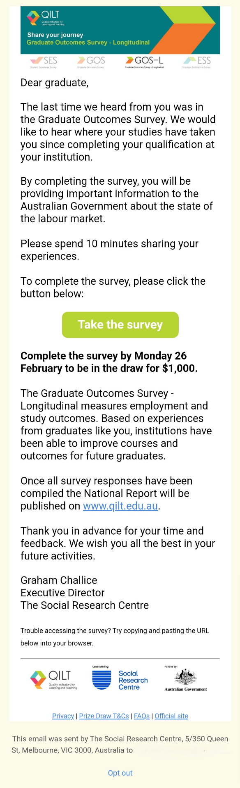

The invitation email was followed by up to ten email reminders, as well as the supplementary reminder, (refer to ^ footnote on Table 4), which was added during fieldwork due to a slowing response rate after Reminder 5. Sample members who had completed the survey or who had unsubscribed, were removed from the next scheduled email reminder.
The email send activity was designed to maintain survey completion momentum throughout the data collection period and maximise participation. The following email send and bounce outcome protocol was used for the 2024 GOS-L:
- Invitation email sent to both the Email 1 and Email 2 fields:
  - If any email addresses failed during the Invitation (i.e. hard bounce) the alternative emails were used for further communications. If either Email 1 or Email 2 failed, then Email 3 was used (if available). If both Email 1 and Email 2 failed, Email 3 and Email 4 were used (if available).
Provided at least one of the email addresses available was valid, all graduates would have been sent an email invitation.
- For graduates with a failed outcome for all available email addresses:
  - They would have received at least one form of contact if a mobile number was available for them for SMS activity (refer to Section 3.3.3) or in-field reminder calls (refer to Section 3.3.4.1 In-field telephone reminder calls).
During in-field or post-field reminder calls, the graduate had an opportunity to update their email address and receive access to the survey via a unique survey link. When contacted by SMS, the graduate could contact the GOS-L helpdesk and update their email address to receive access to the survey. A unique survey link was provided from SMS 2 onwards, which allowed for direct access to the survey via the SMS.
  - They would not have received contact about the survey if a mobile number was not available for them or if they were not selected for a reminder call.
Experimentation was conducted on Reminder 1 using alternate text appealing a sense of belonging to a ‘unique group’ or having an alternate pathway from graduation to employment. The alternate text appealing to the sense of belonging to a ‘unique group’ yielded positive results in terms of survey completion. This alternative text will be considered in future survey communications across the QILT suite.
Further, in line with the Australian Communications and Media Authority (ACMA) Spam Act 2003, each email contained an ‘unsubscribe’ facility if graduates no longer wanted to receive contact for the 2024 GOS-L. Graduates could also ‘opt-out’ by contacting the GOS-L helpdesk.
The overarching objective of the email plan was to appeal to a wide and diverse audience. As such, the theme, length and tone of each email varied. All emails featured text customised to the graduate and the content differed throughout the reminder schedule, mentioning average survey duration, confidentiality provisions and prize draw information where relevant. To minimise the risk of complaints due to contact fatigue, Reminder 6 highlighted the unsubscribe mechanism. The message intent of each successive email is summarised in Table 5.
Table 5 Email plan message intent
Round of activity | Message intent
Invitation | Awareness raising and invitation
Reminder 1 | Your feedback is valuable, first prize draw mention
Reminder 2 | Grateful if you could spare the time
Reminder 3 | Recognition of difficulty of past year, providing important information about employment outcomes and further study activities, second prize draw mention
Reminder 4 | Grateful if you could spare the time, mention of course name
Reminder 5 | Importance of completing the survey to assist institutions in understanding graduate outcomes, third prize draw mention
Supplementary  Reminder | Unique opinion is valued, help the Australian Government understand how your institution prepared you, contribute to important national research
Reminder 6 | Acknowledgment of frequency of contact, unsubscribe option emphasised, importance of hearing from as many graduates as possible to improve career resources
Reminder 7 | Sharing unique views to help future students, unsubscribe option emphasised, mention of penultimate prize draw
Reminder 8 | Link to completing Graduate Outcomes Survey, grateful if you could spare the time, providing important information about employment outcomes and further study activities
Reminder 9 | Survey closing soon, mention of course name, joining the largest study of graduate employment outcomes, mention of final prize draw
Reminder 10 | Last appeal: Absolute last chance to complete, acknowledgement of difficulties of past year, importance of feedback
In the email template design, consideration was given to the display of emails on different devices and how this could alter communication of message intent. Core message themes were communicated in subject lines and above the ‘start survey’ button. Content supplementary to the core theme was placed in the lower half of the email body. This made the ‘start survey’ button visible without the graduate having to scroll down.
A breakdown of email send outcomes by round of activity is provided at Table 6. ‘Clicked on link’ is the key indicator used to measure email performance.
Particular attention was given to inbox placement in the 2024 GOS-L, after a number of emails in the previous year’s collection had landed in promotional sub-folders rather than the primary inbox. Indications from pre-send testing suggested that almost all emails in the schedule were delivering to the ‘Primary’ folder and a very small proportion landed in ‘Other’ or ‘Promotions’ sub-folders.
As seen in Table 6 below, Reminder 1 was the most effective email across the 2024 GOS-L schedule in terms of the ‘clicked on link’ rate - 15.4 per cent. Historically, the Invitation has been the most effective, however initial deliverability issues during launch that affected email addresses with Microsoft domains had an impact on this email’s performance.
While this issue is currently under investigation, we continue to closely monitor any potential issue that may arise in upcoming QILT surveys.
Emails highlighting the weekly close of prize draws, including Reminders 4, 6, 8 and 10, all had higher ‘clicked on link’ rates than the preceding email, suggesting that the content for these types of reminders was engaging for graduates. The exception to this was Reminder 2.
The proportion of bounced emails (i.e. sent emails that return with a server response indicating non-delivery) was higher compared to previous years. This may be due to no panel maintenance activity being conducted prior to the launch of 2024 GOS-L.

Table 6 Email send outcomes by round of activity
Total | Invite | R1 | R2 | R3 | R4 | R5 | Rsupp | R6 | R7 | R8 | R9 | R10
Total sent (n) | 98,186 | 90,142 | 84,449 | 80,392 | 77,494 | 71,574 | 69,444 | 67,566 | 61,819 | 59,881 | 55,839 | 54,368
Clicked on link (%) | 12.9 | 15.4 | 6.9 | 4.5 | 6.5 | 3.3 | 2.2 | 4.3 | 3.1 | 3.4 | 2.2 | 2.9
Opt-out from link (%) | 0.6 | 0.6 | 0.8 | 0.8 | 0.7 | 0.7 | 0.8 | 0.9 | 0.8 | 0.7 | 0.7 | 0.7
Opened email (%) | 47.4 | 43.2 | 44.5 | 44.4 | 42.5 | 44.9 | 44.9 | 45.2 | 46.5 | 45.7 | 45.5 | 44.7
Unopened (%) | 34.0 | 40.3 | 47.2 | 47.6 | 47.0 | 50.4 | 51.4 | 48.9 | 48.9 | 47.4 | 48.8 | 48.9
Soft bounce (%)¹ | 3.7 | 0.4 | 0.6 | 2.7 | 3.0 | 0.7 | 0.7 | 0.7 | 0.7 | 2.8 | 2.9 | 2.8
Hard bounce (%)² | 1.3 | 0.1 | 0.1 | 0.0 | 0.0 | 0.0 | 0.0 | 0.0 | 0.0 | 0.0 | 0.0 | 0.0

1 A soft bounce occurs when an email could not be delivered because of a temporary issue, such as the recipient’s mailbox being full or inactive.
2 A hard bounce occurs when an email could not be delivered for permanent reasons, for example when the recipient’s email address does not exist or the recipient’s email server has blocked delivery.

Email deliverability testing
Following from improvements to the email deliverability testing process for QILT in 2023, the 2024 GOS-L email deliverability testing processes focused on maximising graduate email engagement by ensuring that all emails had reduced delivery to a spam or junk folder. Further, testing was conducted to optimise emails for deliverability to primary inboxes (e.g. ‘primary’ tab in Gmail, ‘focused’ inbox in Outlook).
Actions taken and products used to optimise email deliverability included:
- a dedicated Internet Protocol (IP) address range used only by the Social Research Centre for bulk email delivery. The reputation of this range was maintained year-round to keep the IP addresses ‘warm’. The dedicated range eliminated risks associated with bulk mailing from a shared IP pool.
- during sample cleaning email addresses were validated to reduce bounce rates, thereby minimising the degradation of the IP reputation
- ongoing maintenance of technical services and policies to meet sender best practice
- optimisation of all images, hyperlinks and HTML code used in emails to meet deliverability best practice
- pre-field testing of emails across a broad range of mail clients, devices and providers to confirm and optimise compatibility, display and delivery, and
- in-field tracking of email deliverability using analytics tools.
When analytics tools detected poor deliverability, often linked to themes and words such as ‘win’ and ‘prize draw’, that may have directed emails to email spam folder (including ‘Promotions’), the wording was tweaked where necessary, to ensure optimum delivery to primary inboxes, without altering the overall theme of message.

SMS reminders
SMS reminders were used during fieldwork to both compliment the email contact strategy, and remedy email deliverability and respondent receptiveness issues that have become apparent across the broader QILT project in recent times. If an institution provided mobile numbers in their sample return, it was considered as consent to contact graduates via SMS. Three SMS were sent during fieldwork as part of the standard QILT survey methodology. These messages were sent to all in-scope sample members with a valid Australian mobile number who had yet to complete the survey. Those who had already completed the survey, unsubscribed from email activity, refused participation during in-field reminder calls or opted out via a prior SMS were excluded from the SMS sends. Institutions could also opt-in for an additional fee-for-service SMS (refer to Section 3.3.4.1 Additional SMS).
SMS 1 directed recipients to check their inbox for an email to complete the survey. After removing mobile numbers that had replied with a refusal or wrong number response from the sample, a unique survey link with direct access to the online survey was included in all remaining messages sent for SMS 2, SMS 3 and the fee-for-service SMS.
Experimentation was conducted on SMS 2 and SMS 3 to determine whether including abbreviated institution names in the message would improve response. Analysis indicated no significant impact.
In compliance with the Australian Privacy Principles and the ACMA Spam Act 2003, all SMS messages identified the Social Research Centre as the sender, noted the study the SMS was referring to and had the functionality for recipients to unsubscribe. Sample members who replied ‘STOP’ to the SMS were opted-out of future communications, whilst all other responses were reviewed for further opt-outs and screen-outs. A copy of the first SMS message is provided in Figure 3 below. SMS content for all rounds is provided in Appendix 3.
Figure 3 Example SMS content
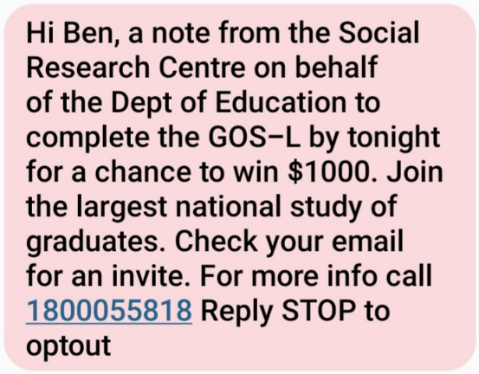

3.3.4.1 Additional SMS
Institutions were offered the opportunity to opt-in to an additional SMS (‘F4S SMS’) on a fee-for-service basis. The SMS was sent with Reminder 10 and featured an abbreviated version of the institution’s name (refer to Figure 4 for an example of the message). Institutions could choose to send the message to either all survey non-respondents with a valid mobile number, or a specific sub-group of their sample that they wished to target within a set budget. In total, twelve institutions opted to send an additional SMS.
Figure 4 Additional SMS content
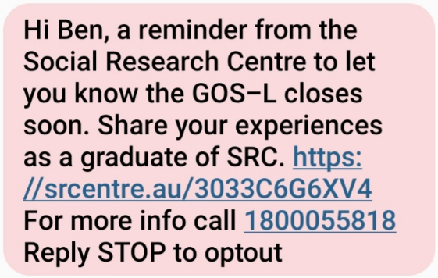

3.3.4.2 SMS reminder performance
Table 7 provides a summary of the number of SMS sent and the SMS outcomes. Open rates were highest for SMS 3, closely followed by fee-for-service SMS and SMS 2, which may be due to the fact that mobile numbers that returned a hard bounce outcome from SMS 1 were excluded from subsequent SMS, resulting in a cleaner list of valid mobile numbers and therefore a higher proportion of graduates receiving and opening the message.
In 2024 we experimented the inclusion of an abbreviation of the institution’s name in SMS 2 and SMS 3 after it proved to be providing additional credibility and engaging respondents for the fee-for-service SMS in 2023. However, analysis of SMS outcomes between control and experiment groups did not indicate any significant impact.
In comparison to SMS 3, the proportion of survey completions that could be directly attributed to the fee-for-service SMS was lower, suggesting that mentioning prize draw closing in the message had a positive impact on SMS outcomes.
Table 7 SMS based follow-up activity outcomes
Contact activity | n | %
SMS1^ | - | -
Total Sent | 69,147 | 100.0
Opened | 59,795 | 86.5
Other opened | 58,349 | 84.4
Unsubscribed | 1,446 | 2.1
Unopened | 7,906 | 11.4
SMS2 | - | -
Total Sent | 54,439 | 100.0
Opened | 50,101 | 92.0
Completed via SMS link* | 1,650 | 3.0
Other opened | 47,088 | 86.5
Unsubscribed | 1,363 | 2.5
Unopened | 2,975 | 5.5
SMS3 | - | -
Total Sent | 44,051 | 100.0
Opened | 42,520 | 96.5
Completed via SMS link* | 1,227 | 2.8
Other opened | 40,257 | 91.4
Unsubscribed | 1,036 | 2.4
Unopened | 495 | 1.1
SMS fee-for-service | - | -
Total Sent | 7,912 | 100.0
Opened | 7,629 | 96.4
Completed via SMS link* | 204 | 2.6
Other opened | 7,245 | 91.6
Unsubscribed | 180 | 2.3
Unopened | 103 | 1.3
* Graduate completed survey directly via the SMS link. Due to the large scope of SMS activity, completions that could be indirectly associated with SMS (i.e. SMS prompted graduate to complete via email link) are not shown and would instead be attributed to other sources of response (refer to Section 7.3).
^ No unique SMS link was included in SMS1

International engagement strategy
The Social Research Centre is committed to an International Engagement Strategy with the goal of increasing international student and graduate response, thereby improving their representation in the QILT data.
A customised email plan designed to appeal to international students has been implemented since the 2021 collection. Outcomes from the 2023 implementation were reviewed and learnings applied to the email plan prior to the 2024 collection. Additionally, international graduates are prioritised for in-field reminder calls (refer to Section 3.3.5).
International graduates continued to respond at a much lower rate than domestic graduates in the 2024 GOS-L, however the response rate of international graduates improved by almost 7 per cent compared to 2023. Despite this underrepresentation in the responding population, this has little impact on survey outcomes as this is not a characteristic strongly associated with predicting survey outcomes, as discussed in Section 7.2 Non-response analysis. However, to ensure institutions have sufficient data to represent their graduate cohorts, efforts to boost response from international graduates will continue to be made in future collections.

Reminder calls
Reminder calls were undertaken in-field and post-field as part of a ‘push to web’ response maximisation strategy. The purpose of in-field reminder call activity was to confirm or update the best contact email address for graduates and ask graduates to complete the survey online. A survey invitation was automatically emailed within 30 minutes of the reminder call. Up to two call attempts were made on different days and at different times, and a voicemail left where possible.

3.3.5.1 In-field telephone reminder calls
In-field telephone reminder calls were conducted between the second and final weeks of the main fieldwork period. To be selected for an in-field telephone reminder call, a graduate had to meet the following criteria:
- Have a valid phone number available in the sample.
- Have not opted-out, screened-out or completed the online survey.
In support of the International Engagement Strategy, international graduates (determined by citizenship indicator) were prioritised for selection for in-field reminder call activity for the 2024 GOS-L. In-field reminder call activity was attempted for 24.7 per cent of the total in-scope sample approached for the 2024 GOS-L (not shown).
Table 8 provides a summary of outcomes from the in-field reminder calls. Based on learnings from the previous year’s GOS-L collection, a review of phone number collection and cleaning methods was undertaken ahead of the 2024 GOS-L to reduce the number of deactivated phone numbers in the sample and maximise the use of budget allocated for the response boosting activities. Around one-fifth of the sample initiated collected graduate’s email address / agreed to complete online (18.4 per cent), higher than the previous year (13.2 per cent in 2023 GOS-L). Marginally better outcomes were reported for postgraduates (19.3 per cent agreed to complete online) than undergraduates (16.7 per cent).
A completed survey could be directly attributed to the in-field reminder call for 6.3 per cent of graduates called. There may also be an unreported indirect effect on response from in-field reminder calls that has been attributed to another source of response (refer to Section 7.3). For example, a graduate may have been prompted to complete the GOS-L via a prior email invitation or SMS link after speaking with an interviewer, listening to a voicemail, or receiving a missed call.
The proportion of total contacts from in-field telephone reminder activity increased in 2024 (up from 16.2 per cent in 2023 to 21.5 per cent in 2024). Contact rates will continue to be closely monitored and consideration given to other methods of boosting response if in-field telephone reminder contact rates fall to a level where the activity represents poor overall value for money.
Table 8 In-field telephone reminder outcomes
- | Undergraduate  n | Undergraduate  % | Postgraduate  n | Postgraduate  % | Total  n | Total  %
Total sample initiated | 8,761 | 100.0 | 15,516 | 100.0 | 24,277 | 100.0
Unusable sample | 473 | 5.4 | 786 | 5.1 | 1,259 | 5.2
No contact | 6,579 | 75.1 | 11,221 | 72.3 | 17,800 | 73.3
Total contact | 1,709 | 19.5 | 3,509 | 22.6 | 5,218 | 21.5
Collected graduate’s  email | 1,467 | 16.7 | 2,998 | 19.3 | 4,465 | 18.4
Other contact type | 242 | 2.8 | 511 | 3.3 | 753 | 3.1
Completed directly* | 471 | 5.4 | 1,069 | 6.9 | 1,540 | 6.3
Completed indirectly† | 1,488 | 17.0 | 3,061 | 19.7 | 4,549 | 18.7
* Graduate completed the survey directly via the in-field reminder email.
† Graduate completed the survey by any means other than the in-field reminder email after being contacted or left a voicemail from in-field reminder calls (excludes non-contact outcomes such as no answer, disconnected phone number).
Note: Unusable sample includes wrong numbers, disconnected numbers, not a residential number, fax lines, incoming call restrictions and respondent unreliable.

3.3.5.2 Post-field telephone reminder calls
Post-field reminder calls were a fee-for-service option to enable institutions to boost response rates for reporting purposes and their own internal analysis. Six institutions opted for post-field reminder calls.
Post-field reminder calls were conducted following the close of the main online fieldwork period, with the online survey remaining open for a two-week period (refer to Table 2) to allow for graduates of participating institutions to respond following post-field telephone reminder contact. Online survey completions resulting from post-field reminder calls were included in national reporting and analysis, as the mode of completion was consistent with online surveys completed as part of the main field period.
To qualify for a post-field reminder call, a graduate was required to meet the following criteria:
- Phone number available in the sample.
- Not completed the survey.
- Not have a ‘contact’ outcome from in-field reminder calls.
- Not opted-out of the 2024 GOS-L (i.e. either via the unsubscribe link in emails, an SMS or by submitting an opt-out request via the GOS-L helpdesk).
- Met any custom criteria chosen by the institution (e.g. the institution may only want to top up response in certain study areas).
The purpose of post-field reminder call activity was to confirm or update the best contact email address for graduates and ask graduates to complete the survey online. Table 9 provides a summary of post-field reminder call outcomes.
Email addresses were confirmed or updated for less than one-third of cases (30.4 per cent). Unlike in-field reminder calls, outcomes for postgraduates (29.3 per cent collected graduate’s email address / agreed to complete online) were marginally lower than undergraduates (31.2 per cent). Contact rates were generally higher for post-field reminder calls than in-field reminder calls. This could be due to differing demographics (in-field priority was international graduates) or placing more calls to sample members to attempt to meet institutions’ quoted targets.
Of the total sample initiated (i.e. where contact was attempted), 6.3 per cent completed the survey directly from the email sent during post-field reminder activity. A larger portion (7.9 percent) of respondents completed surveys indirectly, notably through answering machine call outcomes leading to completions. This suggests a potential reluctance to answer calls, but a legitimate message left on voicemail may have prompted recipients to engage with the subsequent email or SMS.
For fewer than one-in-ten (6.3 per cent) of the graduates called, a completed survey could be directly attributed to the post-field reminder call. Similar to in-field reminder calls, there are likely completed surveys indirectly attributed to post-field reminder calls (a further 7.9 per cent of graduates called). This lower rate of indirect completion, compared to in-field reminder calls, is likely due to no other engagement activity being conducted during the post-field period.
Table 9 Post-field telephone reminder outcomes
- | Undergraduate  n | Undergraduate  % | Postgraduate  n | Postgraduate  % | Total  n | Total  %
Total sample initiated | 3,370 | 100.0 | 2,462 | 100.0 | 5,832 | 100.0
Unusable sample | 31 | 0.9 | 38 | 1.5 | 69 | 1.2
No contact | 2,155 | 63.9 | 1,621 | 65.8 | 3,776 | 64.7
Total contact | 1,184 | 35.1 | 803 | 32.6 | 1,987 | 34.1
Collected graduate’s  email | 1,051 | 31.2 | 722 | 29.3 | 1,773 | 30.4
Other call outcome | 133 | 3.9 | 81 | 3.3 | 214 | 3.7
Completed directly* | 203 | 6.0 | 164 | 6.7 | 367 | 6.3
Completed indirectly† | 254 | 7.5 | 205 | 8.3 | 459 | 7.9
* Graduate completed the survey directly via the post-field reminder email.
† Given that standard response maximisation initiatives cease at the end of the main online fieldwork period, ‘Completed indirectly for post-field reminder calls is defined as: graduate completed the survey by means other than the post-field reminder email after being called from post-field reminder calls (excludes calls to disconnected phone numbers).
Note: Unusable sample includes wrong numbers, disconnected numbers, not a residential number, fax lines, incoming call restrictions and respondent unreliable.

Fieldwork briefing
All call centre operators selected to work on the 2024 GOS-L in-field and post-field reminder calls attended a briefing session delivered by the Social Research Centre project management team prior to the commencement of respective activities. Additional briefings were conducted throughout fieldwork as required to meet operational needs. The briefing covered:
- an overview of GOS-L and QILT
- privacy and confidentiality policy
- reminder call procedures
- fieldwork timelines.
Each briefing session was followed by a run-through of the reminder call script and a training module delivered by the operations team. The training module focused on building skills for respondent liaison and respondent engagement. It made use of interactive learning, utilising call recordings and role-play exercises to tailor response maximisation skills to the GOS-L. The briefing slides are provided at Appendix 4.

Quality control
The in-field quality monitoring techniques applied to the reminder call components of the GOS-L included:
- listening-in validations conducted in accordance with existing ISO 20252:2019 procedures
- field team de-briefing after the first shift, and thereafter, whenever there was important information to impart to the field team in relation to engagement techniques, data quality, consistency of administration, or project performance
- maintenance of a ‘field team handout’ document detailing project performance metrics, graduate liaison techniques and data quality requirements
- monitoring (listening in) by the Social Research Centre project manager and supervisory staff
- maintenance of a Wiki with answers to common graduate queries.

Social media
A limited social media campaign was conducted in 2024 to support the GOS-L response maximisation strategy while we review the impact of social media on response. This involved organic (i.e. unpaid) ads that were shared across Facebook and Instagram from the QILT social media accounts (https://www.facebook.com/QILT1, @qilt_src) to build a general level of social media presence, but no paid ads were used. Organic ad content was tailored with calls to action appropriate for each fieldwork milestone (e.g. referencing a ‘chance to win’ during the prize draw period) and built upon message intent themes from the email reminder plan.
An example of an organic ad is shown in
Figure 5.

Figure 5 Example social media advertisement – Facebook mobile news feed


Data collection

Online survey
The online survey could be accessed by clicking on the link in the email invitation or reminders or by clicking the link in the SMS. Clicking from the email invitation, email reminder or SMS would go directly to the beginning of the survey (refer to Section 3.3.33 for more information on survey links in SMS).
A new survey template was used for 2024 to comply with Australian Government accessibility guidelines, ensuring easy access for individuals to complete online. Standard online features included:
- optimisation for small screen devices (refer to Appendix 7)
- consistent presentation and placement of “Next” and “Previous” buttons
- input controls and internal logic/validation checks
- tailored error messages as appropriate
- sizing the panels for free text responses commensurate with the level of detail required in the response
- automatically ‘saving’ with progression to the next screen
- the capacity to save and return to finish off at another time, resuming at the last question viewed.
The survey’s look and feel was customised to be consistent with QILT branding guidelines, including the use of the GOS-L logo and colour scheme. This ensured consistency with the look of the email invitation and reminders, advertisements placed on social media and the QILT website. Refer to Figure 6 and
Figure 7 for examples of the online survey look and feel on desktop and small screen device. A copy of the questionnaire is included at Appendix 5 with screenshots of the online survey included in Appendix 6.
Figure 6 Presentation of the GOS-L online survey in desktop view
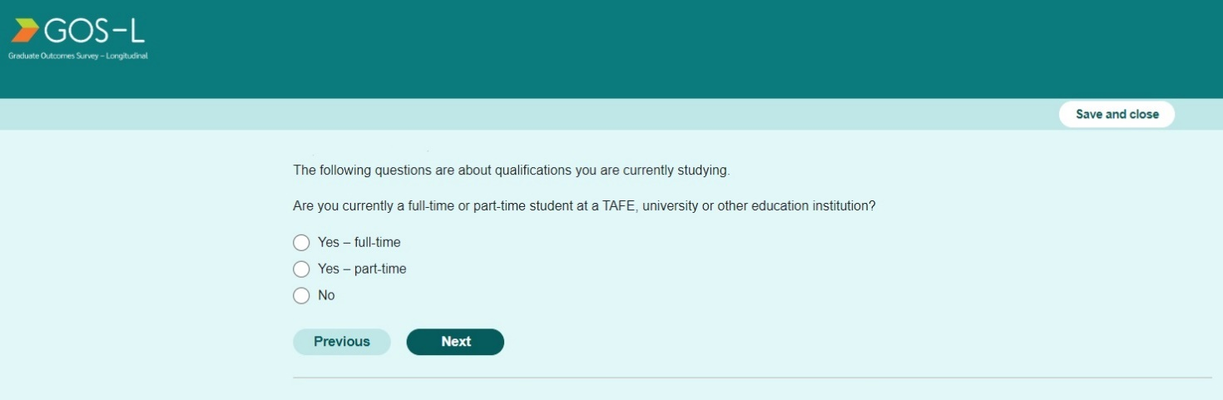

Figure 7 Presentation of the GOS-L online survey on a small screen device
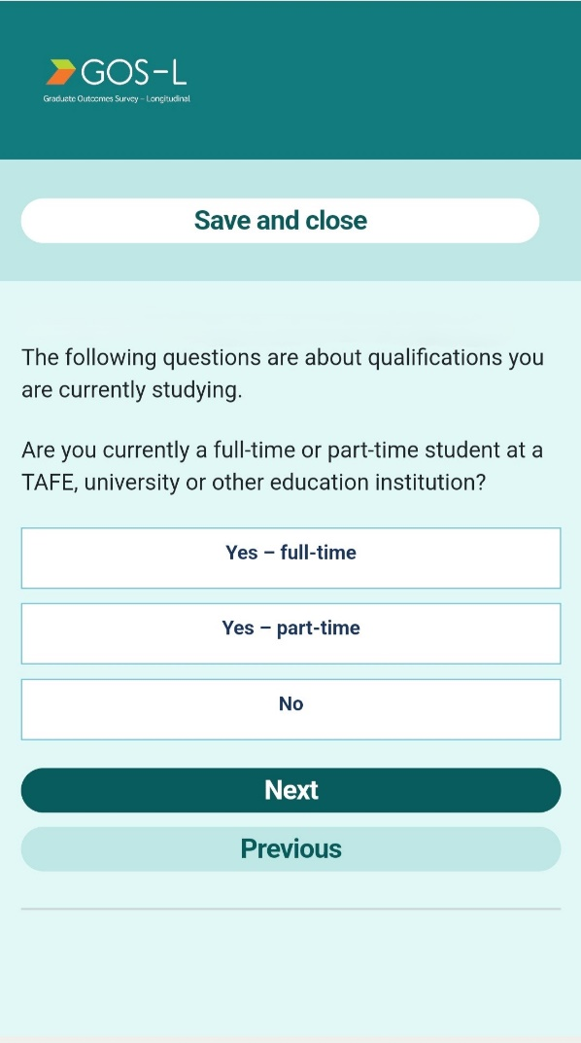

Survey testing
Standard operational checks of the online survey were conducted pre-fieldwork to ensure implementation aligned with the intended questionnaire design.
Institutions with additional items (refer to Section 4.4) were sent test links to facilitate review and sign off on these items prior to field launch.
The survey was soft launched with a small component of each institutions’ population. Data was checked following the soft launch to ensure all survey sequencing was functioning as intended. No issues were identified during the soft launch data checks and the main survey launch proceeded as scheduled. To further ensure the survey data quality, data checks were repeated on the data following the main launch.

Quality assurance and applicable standards
All aspects of the GOS-L were undertaken in accordance with the Privacy Act (1988) and the Australian Privacy Principles contained therein, the Privacy (Market and Social Research) Code 2021, the Research Society’s Code of Professional Behaviour, and ISO 20252:2019 standards. All senior QILT staff are full members of the Research Society or maintain professional membership relevant to their role and the Social Research Centre is also a member of the Australian Data and Insights Association (ADIA, formerly Association of Market and Social Research Organisations). All sensitive or personally identifiable information such as sample and data were transferred using the QILT Secure File Exchange (SFX).

Monitoring and progress reporting
Weekly fieldwork update emails were sent to institutions detailing the response rate that had been achieved and how the individual institution compared to the overall response rate, their cohort (University or NUHEI) average, and the previous year’s results.
The department was provided with weekly updates covering survey launches, in-field milestones and the response rate of institutions overall.

Live online Reporting Module
In addition to weekly updates, the department had access to a live, online reporting module which provided an overview of response rates for each institution and a national average of universities and NUHEIs. Results were provided in real time and included a summary of sample outcomes (e.g. completes, out-of-scopes and opt-outs) and response by institution.
Institutions were also able to monitor their progress through a subset of the same online reporting module. Each institution was provided with their own login which allowed them to track sample outcomes and response rates by a selection of key graduate demographic variables.
Summary tables could be downloaded in CSV format by the department and institutions. Institutions also had the option of downloading sample outcomes at the unit record level. The reporting module enabled institutions to monitor response, identify under-performing demographic groups and target engagement activity based on live sample outcomes.

Graduate support
The Social Research Centre maintained a GOS-L helpdesk for the duration of the 2024 GOS-L fieldwork to provide graduates an avenue to contact the GOS-L team. The helpdesk featured an 1800 number and a GOS-L inbox, and responded to queries within one business day. The 1800 number was also available to international graduates (with an international dialling code) and was operational for the duration of the overall fieldwork period. The helpdesk was staffed seven days a week during call centre operational hours with all calls outside these hours routed to a voicemail service. A QILT inbox is also maintained year-round, managed by the QILT team and staffed during business hours.
The GOS-L helpdesk team was briefed on the GOS-L background, procedures and questionnaire enabling them to answer a wide range of queries. To further support the helpdesk, a database was made available to the team to enable them to look up graduate information and survey links, as well as providing a method for logging all contacts. All opt-outs and out-of-scopes received via the helpdesk were removed from the in-scope sample to cease further contact with these graduates.
A summary of graduate enquires to the GOS-L helpdesk is provided at Table 10. Most queries were received via the GOS-L inbox, and survey queries continued to be the most common type, accounting for half of all enquiries (50.5 per cent). The low helpdesk contact indicates that our survey communications, including links to supporting information in the engagement emails (privacy policy, online FAQ, etc) are clear and have pre-emptively addressed many graduate concerns, with the helpdesk assisting in a support capacity and providing further legitimisation with ongoing concerns around email and SMS scans.
A review into how to gather more nuanced information from helpdesk enquiries would be beneficial to improve graduate support for future GOS-L collections.
Table 10 Graduate enquiries to the GOS-L helpdesk
Type of enquiry | 1800 number | 1800 number | GOS-L inbox n | GOS-L inbox % | Total n | Total %
Total | 134 | 100.0 | 375 | 100.0 | 509 | 100.0
Survey query | 70 | 52.0 | 187 | 49.9 | 257 | 50.5
Opt-out | 8 | 6.0 | 79 | 21.1 | 87 | 17.1
General query | 20 | 14.9 | 66 | 17.6 | 86 | 16.9
Other Query | 10 | 7.5 | 26 | 6.9 | 36 | 7.1
Change of contact details | 11 | 8.2 | 12 | 3.2 | 23 | 4.5
Out-of-scope | 5 | 3.7 | 5 | 1.3 | 10 | 2.0
Follow-up call | 10 | 7.5 | 0 | 0.0 | 10 | 2.0

Prize draw
All respondents in the 2024 GOS-L were entered into a rolling prize draw that ran over five weeks (refer to Table 11). The rolling prize draw was designed to encourage early survey completion by offering more chances to win, the earlier the survey was completed (e.g. if the survey was completed by the end of the first week, the respondent would be entered into all five prize draws). The terms and conditions of the prize draw were available on the Social Research Centre’s website and provided in all email communications sent to graduates.
In compliance with State and Territory gaming and lottery legislation, prize draw winners were notified in writing, by phone (if necessary) and published on the QILT Facebook and Instagram pages. Winners were published on the same day as the prize draw was conducted. All prize winners received a prepaid VISA e-gift card.
The total prize pool was valued at $12,500. Each prize draw consisted of the following prepaid Visa gift card incentives:
- First prize received a $1,000 gift card
- Second prize received a $500 gift card
- Third prize (four winners) received a $250 gift card
Table 11 Prize draw schedule
Prize draw activity | Date
Prize draw period opens / Fieldwork starts | 20-Feb-24
Prize draw 1 close | 26-Feb-24
Prize draw 1 conducted | 28-Feb-24
Prize draw 2 close | 04-Feb-24
Prize draw 2 conducted | 06-Mar-24
Prize draw 3 close | 11-Mar-24
Prize draw 3 conducted | 13-Mar-24
Prize draw 4 close | 18-Mar-24
Prize draw 4 conducted | 20-Mar-24
Prize draw 5 close | 25-Mar-24
Prize draw 5 conducted | 27-Mar-24

Questionnaire

Development
The 2024 GOS-L questionnaire was based on that used in 2023, with standard operational updates made to align the questionnaire with current reference periods.
In addition to the core questionnaire changes, institutions were able to add, modify or remove their additional items (refer to Section 4.4).

Overview
Table 12 outlines the thematic areas of the eight main modules in the questionnaire. The design of the GOS-L instrument was modular and longitudinal so that information collected in GOS could be followed up. Items essential to response analysis (current employment status, employment history, further study) were positioned early in the questionnaire and other core item modules positioned before additional items (Module F). Items related to future contact details and further research were positioned in the final module. A copy of the generic survey instrument (excluding any institution-specific items) is included at Appendix 5 with screen shots of the online survey at Appendix 6.
Table 12 GOS-L module themes
Module | Themes
Module A | Introduction, screening, and confirmation
Module B | Labour force
Module H | Employment history
Module C | Further study
Module D | Graduate attributes
Module E | Graduate preparation
Module F | Additional items
Module G | Contact details

Changes from 2023
The main changes to the core questionnaire were as follows:
- Altered the response option at FINDJOB from ‘Social media (e.g. LinkedIn)’ to ‘Social media’ based on a review of these items in the 2023 GOS-L.
- The addition of a new code of ‘Waiting for accreditation/registration’ to RSOVRQ, to align with RSMORE/RSNOMORE in the GOS as part of a review.

Additional items
A total of ten institutions (comprising exclusively universities) included institution-specific items in the 2024 GOS-L. Institution-specific items can be the same or a variation on questions included in prior rounds of GOS-L, or new questions entirely.
Some of the content covered by institution-specific items included questions relating to work preparedness, volunteering, values, current employment and lifestyle.
Currently, institution-specific items do not fall under any data sharing arrangements and are therefore only included in the respective institution’s data file.

Data preparation

Definition of the analytic unit
The analytic unit for the GOS-L was the graduate. The data file contained one record for each respondent to the survey.
In the 2024 GOS-L data set, a record was considered complete and valid if the graduate had:
- completed the 2021 GOS, and
- provided a response as to whether they had worked in the last week, or
- responded that they were in further study.

Data cleaning and preparation
Data preparation occurred on the raw data file exported from the data collection platform, with derivations, re-coding and cleaning routines applied, including:
- derivation of labour force status, salary and other reporting outcome variables based on the Australian Bureau of Statistics (ABS) standards (derivations are documented in the 2024 GOS-L Data Dictionary, made available to institutions on the QILT provider portal)
- re-coding value labels where required
- re-coding of ‘no answer’ to the missing values conventions
- cleaning of employer name
- coding of occupation, industry, and further study field of education.

Coding and processing of free text responses
Spell checking and light cleaning of free text responses were applied, seeking to remove identifiers and expletives.
Table 13 summarises the items where industry standard frames were applied for the coding of free text responses. For items with free text responses not associated with an industry standard frame, code frames and back-coding rules were developed in conjunction with, and approved by, the department, and were largely unchanged from previous iterations of the GOS-L.
Table 13 Items coded and source for coding decisions
Item coded | Source
Occupation | Occupation was coded using the Australian and New Zealand Standard Classification of Occupations (ANZSCO, Version 1.3, 2022, ABS catalogue number 1220.0)
Industry | Industry was coded using the Australia and New Zealand Standard Classification of Occupations (ANZSIC, 2006 Revision 2.0, ABS catalogue number 1292.0)
Country employer/business is based | For graduates working overseas, country of employment was coded using the Standard Australian Classification of Countries (SACC, 2016, Second edition, ABS catalogue number 1269.0).
Further study field of education | Field of education was coded using the Australian Standard Classification of Education (ASCED, 2001, ABS catalogue number 1272.0) at the single digit level.
Overseas country location | For graduates living overseas, country of residence was coded using the Standard Australian Classification of Countries (SACC, 2016, Second edition, ABS catalogue number 1269.0).

Data deliverables
The Social Research Centre provided the department and institutions the following data deliverables at the completion of the 2024 GOS-L collection:
- Department national data file and national final population file in CSV, SPSS and SAS format.
- Institution data files and final population files in CSV and SPSS format as a standard, and in SAS format for institutions specifically requesting this format.
- Data dictionary and data map.
- Fieldwork and data package summary in MS Word format.
- GOS-L National Report Tables.

Weighting
As was the case for previous surveys in the series, no weights were applied to the GOS-L data. Refer to Section 7.2 for analysis related to the decision not to weight the data.

Final dispositions and response rates
Table 14 shows the final survey outcomes at an overall level for the 2024 GOS-L collection.
For the purpose of the QILT suite of surveys, ‘response rate’ is defined as completed surveys (as described in Section 5.1) as a proportion of final sample, where final sample is the total sample excluding unusable sample (e.g. no contact details), out-of-scope and opted-out. This definition of response rate differs from industry standards by treating certain non-contacts and refusals as being ineligible for the response rate calculation (see American Association for Public Opinion Research 2016 for standard definitions of response rates).
The final response rate for the 2024 GOS-L collection was 48.0 per cent, with the response rate higher for universities (48.6 per cent) than NUHEIs (41.3 per cent). A 3.0 per cent increase in response rate was registered across both institution types compared to 2023, indicating the overall increase was spread evenly.
When reviewing response rate by course type, postgraduate research had the highest response rate (62.2 per cent) followed by postgraduate coursework (48.6 per cent) and undergraduate (46.3 per cent).
Final response rates by institution are provided at Appendix 8.
Table 14 Final survey outcomes
Institution | Sample approached¹ | Unusable sample | Out-of-scope | Opted-out | Final sample | Surveys completed | Response rate (%)
Total | 98,393 | 491 | 17 | 9,629 | 88,256 | 42,399 | 48.0
Universities | 90,221 | 466 | 17 | 8,632 | 81,106 | 39,448 | 48.6
NUHEIs | 8,172 | 25 | 0 | 997 | 7,150 | 2,951 | 41.3
Course type | - | - | - | - | - | - | -
Undergraduate | 52,923 | 266 | 7 | 5,380 | 47,270 | 21,890 | 46.3
Postgraduate | 45,470 | 225 | 10 | 4,249 | 40,986 | 20,509 | 50.0
Postgraduate coursework | 40,703 | 182 | 7 | 3,938 | 36,576 | 17,765 | 48.6
Postgraduate research | 4,767 | 43 | 3 | 311 | 4,410 | 2,744 | 62.2
¹ National in-scope population approached.

Response analysis

Response by time
Figure 8 shows the daily and cumulative response rate by day, overlaid with each successive component of the contact strategy (i.e. email invitation and reminders, SMS reminders and in-field reminder calls) for the 2023 and 2024 GOS-L collections.
Despite initial issues with the deliverability of the Invitation email discussed in Section 3.3.1, the daily response rate on the launch day in 2024 was 6.9 percent, compared to 6 percent in 2023. This provided an encouraging start for improving on the 2023 results. Later activities in the schedule, such as Reminder 6/SMS2 and Reminder 8, resulted in significantly higher daily response rates than the previous year, maintaining the momentum in response rates.
Each reminder activity resulted in a clear and consistent ‘lift’ in response, but the impact of reminders in the middle of the schedule (Reminder 5, Reminder 7 and Reminder 9) was low compared to emails sent at the beginning of the collection and where an SMS was sent on the same day as an email reminder. Further review of the content of these messages may be needed to find new ways of encouraging sample members to open emails and complete the survey.
All SMS reminders performed relatively well in generating additional online completions on the day they were sent, with SMS1 being a particular standout.
In addition, the timing of the fee-for-service SMS and SMS3 was changed in 2024 to align with an email reminder sent on a Monday, leveraging the "prize draw closing" messaging similar to SMS1 and SMS2. This change had a positive impact, especially for SMS3, contributing 2.8 per cent to the overall response rate compared to the 1.9 per cent achieved in 2023. SMS1, SMS2 and SMS3 were sent to all eligible sample in 2024. This SMS contact strategy should be continued in future collections, with consideration given to including unique survey links in SMS1.

Figure 8 Response rates by day
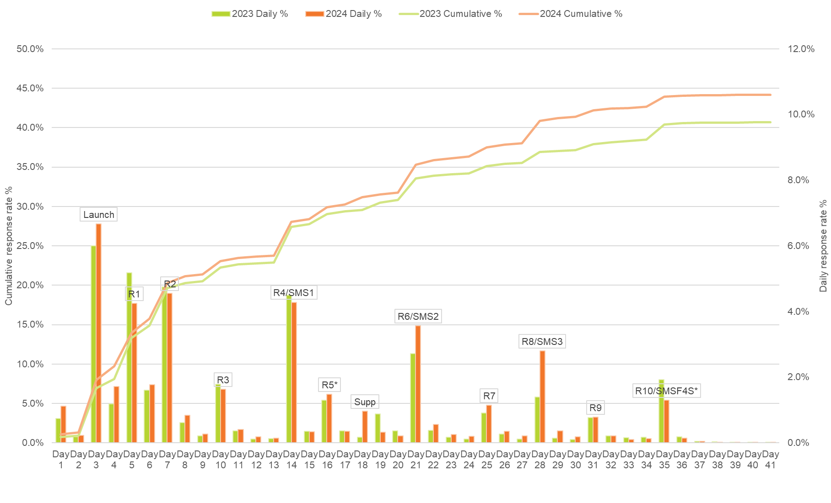
NOTE: This chart presents the daily and cumulative response rate during the main online fieldwork period. Surveys completed as a result of a post-field reminder call are not included. For the final response rate, refer to Table 1 Key project statistics.

Non-response analysis
This section assesses the extent and impact of non-response bias on estimates made from the 2024 GOS-L. Non-response bias occurs when persons who respond to the survey are systematically different from those who do not, leading to results that do not accurately reflect the population of interest. The following assessment is approached from several perspectives, by:
- supplementing response rates with measures that account for the composition of respondents compared to the population
- identifying administrative characteristics of graduates that are most different between respondents and non-respondents and that are most strongly associated with the propensity to respond to the survey
- determining if adjusting for non-response changes the key GOS-L indicators.

Characteristics associated with propensity to respond
For a number of waves, the GOS-L has made use of predicted response rates to target sub-groups of graduates for response maximisation activities. Response propensity is defined as the modelled expected likelihood of a graduate responding to the survey, conditional on their characteristics.
Response propensity is calculated by predicting survey completion conditional upon the characteristics available for both respondents and non-respondents, including:
- study area
- age grouping
- higher education provider
- higher education provider type (Group of 8, Other university or NUHEI)
- institution size
- course of study type
- type of attendance
- citizenship indicator
- language spoken at home (NESB indicator)
- birthplace
- course level
- gender
- Aboriginal or Torres Strait Islander status
- disability.
Using a random forest model (Breiman, 2001; Valliant, Dever and Kreuter, 2013) the response propensity for all sample members can be predicted. The variable importance plot shown in Figure 9 summarises the relative importance of these characteristics in predicting non-response to the surveys, where a longer bar indicates higher importance. To simplify interpretation, the original scale (the Gini index) was replaced with one where the most important predictor is set to 100 per cent and the least to 0 per cent.
The variables that were consistently the most important predictors of non-response were study area, higher education provider, age group and course of study type. This information will be considered in the refinement of the contact strategy for future iterations.
Figure 9 Relative importance of graduate characteristics in predicting survey response in 2024
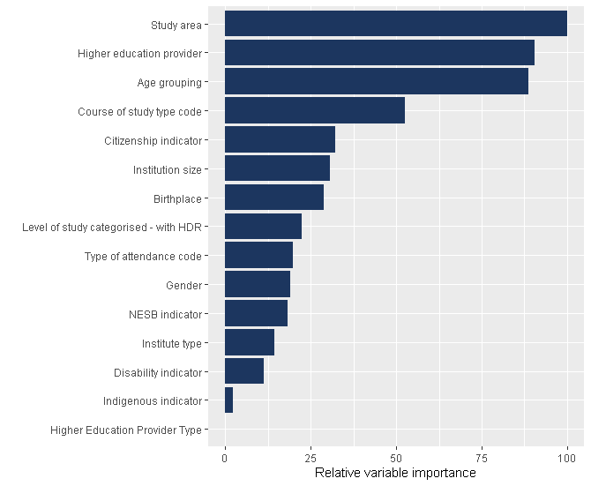

When comparing these results to the 2023 GOS-L, it was noted that age group, citizenship indicator, birthplace and non-English speaking background indicator (NESB) had the greatest decreases in their relative importance when predicting survey response. Study area became the most important characteristic in predicting non-response, replacing age group.

Supplementing response rates with indicators of representativeness
Response rate is the most commonly used measure for describing how well a survey performs, since it is simple to calculate and offers a useful indicator of overall survey quality. It has well known limitations, however (see, for example, Shlomo, Skinner and Schouten 2012), since it does not account for the composition of respondents relative to the population and the subsequent impact of non-response error.
Non-response error occurs when the responding population is considerably different from the in-scope population and there is a substantial degree of non-response, resulting in estimates that do not accurately represent the overall population (Groves et al. 2009). This is caused by the fact that, despite ideally everyone having an equal probability of responding, this is not what is observed.
To supplement the use of response rates, indicators of the representativeness of respondents (R-indicators) have been developed (Schouten, Cobben and Bethlehem 2009; Schouten, Shlomo and Skinner 2011). These indicators use modelled probabilities of response to construct an overall measure of how well the responding population represents the in-scope population. There are numerous R-indicators. The one used in the analysis in this section is expressed as follows:
$$1-2×SD_{p}$$
where $SD_{p}$ is the standard deviation of the predicted response propensities:
SDp=1N-1i​(pi-p)2
Here, N is the number of in-scope graduates, $p_{i}$ is the response propensity for graduate i and ¯p is the mean response propensity. The R-indicator can assume any value in the range 0-1, where a value of 1 indicates the most representative response and a value of 0 indicates the least. Values for R are only directly comparable if they are derived using the same model.
For the GOS-L, response propensities were predicted using a random forest model as described in Section 7.2.1. From there, the above formulae were used to calculate the R-indicator for the survey overall.
Table 15 shows the response rate and the R-indicator over the last three years of the GOS-L. As can be seen, the R-indicator has gradually increased over the last three years, while the response rate has dipped in 2023 and made a partial recovery in 2024. This uptick in the response rate in 2024 has resulted in a small spike in the R-indicator, meaning a more representative sample of the overall population.
Table 15 Comparison of representativeness over past three GOS-L collections
Year | Response rate (%) | R-indicator (%)
2022 | 49.0 | 71.71
2023 | 45.0 | 72.06
2024 | 48.0 | 74.40

Characteristics associated with non-response
Further to the response propensity analysis at Section 7.2.1, an alternative method of checking whether there is any systematic pattern of non-response is to compare the profile of respondents with that of non-respondents. The presence of extensive differences between the two groups may suggest that some adjustments (i.e. weighting) may be necessary.
Table 16 compares the distribution of respondents with the distribution of non-respondents for selected characteristics. A positive difference indicates that the relative incidence of the specified category was lower among respondents than among non-respondents and a negative difference indicates that the relative incidence of the category was lower among non-respondents.
Given the number of cases involved, the notion of ‘statistically significant differences’ is generally not helpful for the GOS-L. Standard statistical tests will typically declare significance for all but the most minute of differences between estimates. Instead, the well-known concept of ‘effect sizes’ (Cohen 1988, 1992) is used to identify sub-groups where the differences may be of practical importance, classified into ‘small’, ‘medium’ or ‘large’. Results without a stated effect size were ‘so small as to be trivial’ (Cohen 1992).
As an example, male graduates made up 36.6 per cent of respondents and 40.4 per cent of non-respondents. The difference of 3.8 percentage points indicates that this sub-group was under-represented among respondents compared to non-respondents, but the effect size (0.08) was negligible.

Table 16 Comparison between respondents and non-respondents for selected characteristics
Characteristic | Respondents (%) | Non-respondents (%) | Difference (%) | Cohen's effect size | Cohen's effect size
Age grouping | - | - | - | - | -
15-19 years old | 0.00 | 0.00 | 0.00 | 0.00 | -
20-24 years old | 10.29 | 12.14 | -1.84 | 0.06 | -
25-29 years old | 36.77 | 46.49 | -9.72 | 0.20 | -
30-34 years old | 17.46 | 17.36 | 0.10 | 0.00 | -
35-39 years old | 11.06 | 8.64 | 2.41 | 0.08 | -
40-44 years old | 7.81 | 5.72 | 2.09 | 0.08 | -
45-49 years old | 5.75 | 3.82 | 1.93 | 0.09 | -
50-54 years old | 4.72 | 2.76 | 1.96 | 0.10 | -
55+ years old | 6.15 | 3.07 | 3.08 | 0.15 | -
Unable to establish | 0.00 | 0.01 | 0.00 | 0.01 | -
Study area | - | - | - | - | -
Science and mathematics | 8.70 | 7.45 | 1.25 | 0.05 | -
Dentistry | 0.30 | 0.24 | 0.06 | 0.01 | -
Veterinary science | 0.51 | 0.39 | 0.12 | 0.02 | -
Rehabilitation | 1.27 | 1.01 | 0.26 | 0.02 | -
Teacher education | 9.09 | 7.09 | 2.00 | 0.07 | -
Business and management | 16.96 | 24.20 | -7.24 | 0.18 | -
Humanities, culture and social sciences | 9.09 | 6.61 | 2.48 | 0.09 | -
Social work | 3.06 | 2.11 | 0.95 | 0.06 | -
Psychology | 5.00 | 3.56 | 1.44 | 0.07 | -
Law and paralegal studies | 5.04 | 5.34 | -0.31 | 0.01 | -
Creative arts | 2.73 | 2.89 | -0.16 | 0.01 | -
Computing and Information Systems | 6.96 | 8.89 | -1.93 | 0.07 | -
Communications | 2.74 | 2.82 | -.007 | 0.00 | -
Tourism, Hospitality, Personal Services, Sport and recreation | 0.20 | 0.24 | -0.04 | 0.01 | -
Engineering | 6.34 | 7.00 | -0.67 | 0.03 | -
Architecture and built environment | 2.19 | 2.70 | -0.52 | 0.03 | -
Agriculture and environmental studies | 1.93 | 1.39 | 0.54 | 0.04 | -
Health services and support | 7.36 | 6.01 | 1.35 | 0.05 | -
Medicine | 1.86 | 1.32 | 0.54 | 0.04 | -
Nursing | 8.24 | 8.33 | -0.09 | 0.00 | -
Pharmacy | 0.45 | 0.41 | 0.04 | 0.01 | -
Country of Birth | - | - | - | - | -
Australia | 59.42 | 47.75 | 11.67 | 0.24 | Small
Other | 40.09 | 51.77 | -11.67 | 0.24 | Small
Level of study | - | - | - | - | -
Undergraduate | 51.64 | 55.35 | -3.71 | - | -
Postgraduate (Coursework) | 41.89 | 41.01 | 0.87 | - | -
Postgraduate (Research) | 6.48 | 3.64 | 2.84 | - | -
Gender | - | - | - | - | -
Female | 63.12 | 59.35 | 3.78 | - | -
Male | 36.63 | 40.43 | -3.79 | - | -
Type of attendance | - | - | - | - | -
Full-time | 67.23 | 70.48 | -3.24 | - | -
Part-time | 32.48 | 29.07 | 3.41 | - | -
Indigenous indicator | - | - | - | - | -
Non-Indigenous | 98.80 | 99.02 | -0.22 | - | -
Indigenous | 1.20 | 0.98 | 0.22 | - | -
NESB indicator | - | - | - | - | -
English speaking background | 83.50 | 75.37 | 8.13 | - | -
Non-English speaking background | 16.50 | 24.63 | -8.13 | - | -
Citizenship indicator | - | - | - | - | -
Domestic | 76.46 | 65.41 | 11.05 | - | -
Overseas | 23.54 | 34.59 | -11.05 | - | -
Disability indicator | - | - | - | - | -
No disability | 91.38 | 93.44 | -2.06 | - | -
Disability | 8.62 | 6.56 | 2.06 | - | -
Higher Education Provider Type | - | - | - | - | -
University (Table A-B) | 93.13 | 90.93 | 2.20 | - | -
NUHEI (Private) | 6.87 | 9.07 | -2.20 | - | -
Institution size | - | - | - | - | -
1-1000 records | 9.23 | 11.33 | -2.11 | - | -
1001-2000 records | 29.83 | 28.24 | 1.60 | - | -
2001-3000 records | 26.18 | 26.16 | 0.02 | - | -
3001-4000 records | 14.10 | 13.60 | 0.50 | - | -
4001+ records | 20.66 | .20.68 | -0.02 | - | -
Institute type | - | - | - | - | -
Group of 8 | 30.32 | 28.14 | 2.18 | - | -
NUHEI | 6.87 | 9.07 | -2.20 | - | -
Other university | 62.81 | 62.79 | 0.02 | - | -
Based on Table 16, citizenship, NESB indicator (language spoken at home) and birthplace (arguably each measuring broadly similar concepts) were the only characteristics for which there were notable differences between respondents and non-respondents at the overall level, with the effect categorised as ‘small’.

Characteristics associated with outcomes
An important consideration when assessing representation is the extent to which unit characteristics are also associated with survey outcomes (Peytchev, Presser and Zhang 2018). For example, if a particular sub-group of the population is under-represented among respondents, any non-response error may be compounded if the sub-group also gives notably different responses to survey outcomes compared to other groups. In such a situation, estimates made from the survey would potentially be biased.
Using a similar approach to that outlined at Section 7.2.1, characteristics with strong associations with outcome variables were determined. First, a random forest model was run to predict the outcome measures from respondent characteristics at the overall level.
The relative importance of variables was largely consistent across key survey outcome measures in 2024 and is shown in Table 17.

Table 17 Relative importance of graduate characteristics in predicting survey outcomes in 2024
Demographic variable label | Scale of Perceived Over-qualification (SPOQ) indicator | GAS-G(C) Collaborative skills indicator | GAS-G(A) Adaptive skills indicator | GAS-G(F) Foundation skills indicator | General employment indicator | Part-time employment indicator | Full-time employment indicator
Study area | 100.00 | 100.00 | 100.00 | 100.00 | 100.00 | 100.00 | 100.00
Higher education provider name | 69.56 | 87.86 | 84.92 | 88.26 | 82.80 | 73.99 | 67.68
Age grouping | 59.50 | 77.64 | 72.09 | 75.17 | 77.45 | 62.85 | 77.33
Course of study type code | 41.78 | 52.84 | 48.42 | 54.77 | 51.87 | 46.11 | 50.74
Institution size | 28.14 | 35.58 | 33.20 | 34.56 | 32.66 | 28.54 | 26.73
Level of study | 11.45 | 16.67 | 11.83 | 15.70 | 13.75 | 10.96 | 11.72
Birthplace | 15.05 | 21.05 | 12.42 | 16.24 | 13.56 | 14.95 | 14.66
Type of attendance | 12.71 | 22.45 | 18.51 | 14.46 | 16.88 | 14.82 | 15.14
Gender | 13.82 | 20.73 | 13.82 | 19.15 | 21.89 | 35.88 | 23.79
Disability indicator | 6.94 | 11.84 | 9.79 | 14.03 | 11.72 | 10.14 | 9.48
Institute type | 7.59 | 9.40 | 7.65 | 8.62 | 8.88 | 8.31 | 7.09
NESB indicator | 6.21 | 11.97 | 4.46 | 5.92 | 6.35 | 4.99 | 6.21
Citizenship indicator | 6.41 | 31.33 | 4.23 | 6.07 | 10.02 | 7.96 | 8.22
Indigenous indicator | 1.87 | 1.32 | 0.00 | 2.13 | 0.00 | 1.77 | 1.06
Higher education provider type | 0.00 | 0.00 | 0.54 | 0.00 | 0.95 | 0.00 | 0.00
Note: 100 = most important.
It is noted that citizenship, language spoken at home, and country of birth, which had notable differences between the responding and non-responding sample, are not strongly associated with core outcomes. However, age grouping, which also had notable differences between the responding and non-responding sample also has a relatively high association with core survey outcomes and as such, continues to be an area of focus in the 2025 GOS-L to minimise the effect of non-response bias on survey outcomes.

Sources of responses
Table 18 summarises the contribution of various online survey completion methods to the final response rate and includes sources of response by institution type, gender, age and citizenship indicator due to the variation in method of accessing the survey within these groups. Only minimal differences were observed when reviewing source of response by study mode or course level, so these groups are not displayed.
It should be noted that only completed surveys directly attributable to the in-field reminder calls, post-field reminder calls and SMS are recorded as such in Table 18. It is possible that, for example, reminder call activity may prompt a graduate to click on the direct survey link in an email they had previously received. In this context, the analysis presented at Table 18 should only be considered indicative. It should also be noted that the opportunity to complete via each method was not necessarily equal between subgroups.
Most respondents completed via the direct link in email communications, accounting for 88.6 per cent of total responses. This was followed by respondents completing after receiving the link in SMS (6.4 per cent in 2024), which increased from the 4.8 per cent of total completions in 2023. As previously noted, in-field reminder calls were targeted at international graduates in the 2024 GOS-L in support of the International Engagement Strategy. A 1.0 per cent increase in survey completions attributed to in-field reminder calls was registered in 2024. The prioritisation of international graduates for in-field reminder calls may explain the significant increase of 2.6 per cent in 2024, representing the second most common source of response for international graduates (12.4 per cent).

Table 18 Sources of response
- | Total  (%) | Institution Type: University  (%) | Institution Type: NUHEI  (%) | Age group: Aged under 30 (%) | Age group: Aged over 30  (%) | Citizenship: Domestic  (%) | Citizenship: Inter-national  (%) | Gender: Female (%) | Gender: Male  (%)
Final response rate | 48.0 | 48.6 | 41.3 | 42.9 | 55.1 | 51.9 | 38.6 | 49.6 | 45.6
Survey completion method breakdown | - | - | - | - | - | - | - | - | -
Type in | <0.1 | <0.1 | <0.0 | <0.1 | <0.1 | <0.1 | <0.1 | <0.1 | <0.1
Survey link (email) | 88.6 | 88.8 | 84.9 | 87.7 | 89.5 | 91.0 | 80.6 | 89.0 | 87.8
Survey link (SMS) | 6.4 | 6.3 | 8.4 | 6.7 | 6.1 | 6.7 | 5.6 | 6.9 | 5.5
In-field reminder calls | 3.6 | 3.5 | 5.8 | 4.1 | 3.2 | 0.9 | 12.4 | 2.8 | 5.1
Post-field reminder calls | 0.9 | 0.9 | 0.0 | 1.0 | 0.7 | 0.8 | 1.0 | 0.7 | 1.2
SMS fee-for-service | 0.2 | 0.4 | 0.9 | 0.4 | 0.5 | 0.5 | 0.4 | 0.5 | 0.3

Considerations for future surveys

Panel maintenance
A review of panel maintenance activity, including timing and communications should be undertaken. This was not conducted prior to 2024 GOS-L but is an important opportunity to communicate with graduates in the years between completion of the GOS and ahead of the GOS-L to maintain engagement, as well as to collect up to date contact information, particularly from international graduates who may be more mobile or transient.

Email messaging
Experimentation showed that using alternative email text that appealed to a sense of belonging to a "unique group" led to higher survey completion rates. This approach will be considered for future survey communications across the QILT suite.

Authentication
To address privacy concerns, a consideration would be to explore options for authenticating or validating the recipient's identity before providing them with unique survey links, for SMS 1 in particular.

SMS protocol
A sophisticated SMS contact protocol provides the opportunity to drive response at an overall level. While SMS has become an integral part of the GOS-L contact protocol (refer to Section 3.3.3), there may still be opportunities to maximise response through novel refinements to the SMS protocol. Potential opportunities include:
- a review of historical decisions not to include unique survey links in SMS1 due to concerns about the quality of mobile numbers in the sample. Consider an authentication step to ensure correct recipient, as outlined above
- ensuring SMS sends align with prize draw closing and to include this in SMS messaging
- adding a fourth SMS for all institutions as part of the standard schedule, aligned with the prize draw schedule, due to the strong performance of SMS when paired with email reminders. The associated additional cost may restrict this further contact.

GOS-L Engagement Strategy
Consideration of how to further support institutions to promote the survey. Timing of the GOS-L falling two weeks after the launch of the GOS February round can cause confusion at institutions and limits resources to promote each survey (with a tendency to prioritise GOS over GOS-L) and creates challenges promoting the two surveys at the same time on QILT social media channels. Reviewing effectiveness of social media campaigns and where best to reach and engage graduates three years on.

Targeted response maximisation strategy
In an effort to boost representation in the responding sample, targeted response strategies should be deployed in the 2025 GOS-L towards cohorts identified as being under-represented in the 2024 GOS-L responding sample: 25-30 year olds and international graduates.
Potential initiatives could include:
- increased SMS for these cohorts
- experimental messaging during panel maintenance, especially for international graduates
- prioritisation during in-field reminder activities (currently already happening for international graduates).

List of abbreviations and terms
ABS Australian Bureau of Statistics
AGS Australian Graduate Survey
AMSRS Australian Market and Social Research Society
AMSRO Association of Market and Social Research Organisations
ANZSIC Australian New Zealand Standard Industrial Classification
ANZSCO Australian New Zealand Standard Classification of Occupations
BGS Beyond Graduation Survey
GOS Graduate Outcomes Survey
GOS-L Graduate Outcomes Survey – Longitudinal
HESA Higher Education Support Act
IP Internet Protocol
ISO International Standards Organisation
NUHEI Non University Higher Education Institution
PASF Participation and Additional Services Form
QILT Quality Indicators for Learning and Teaching
RES Respondent Engagement Survey
SACC Standard Australian Classification of Countries
TCSI Tertiary Collection of Student Information

References
American Association for Public Opinion Research. 2016. ‘Standard Definitions: Final Dispositions of Case Codes and Outcome Rates for Surveys.’ 9th ed. American Association for Public Opinion Research, Oakbrook Terrace, IL, USA.

Breiman, L. (2001). Random forests. Machine Learning 45(1), 5–32.

Cohen, J. (1988). Statistical Power Analysis for the Behavioral Sciences. 2nd ed. New York: Academic Press.

––––– (1992). A power primer. Psychological Bulletin 112(1), 155–159.

Groves, R.M., F.J. Fowler, M.P. Couper, J.M. Lepkowski, E. Singer and R. Tourangeau (2009). Survey Methodology. 2nd ed. Hoboken: Wiley.

Schouten, B., F. Cobben and J. Bethlehem (2009). Indicators for the representativeness of survey response. Survey Methodology 35(1), 101–113.

Shlomo, N., C. Skinner and B. Schouten (2012). Estimation of an indicator of the representativeness of survey response. Journal of Statistical Planning and Inference 142(1), 201–211.

Valliant, R., J.A. Dever and F. Kreuter (2013). Practical Tools for Designing and Weighting Survey Samples. New York: Springer.

Appendix 1 Collection, sample and marketing guides
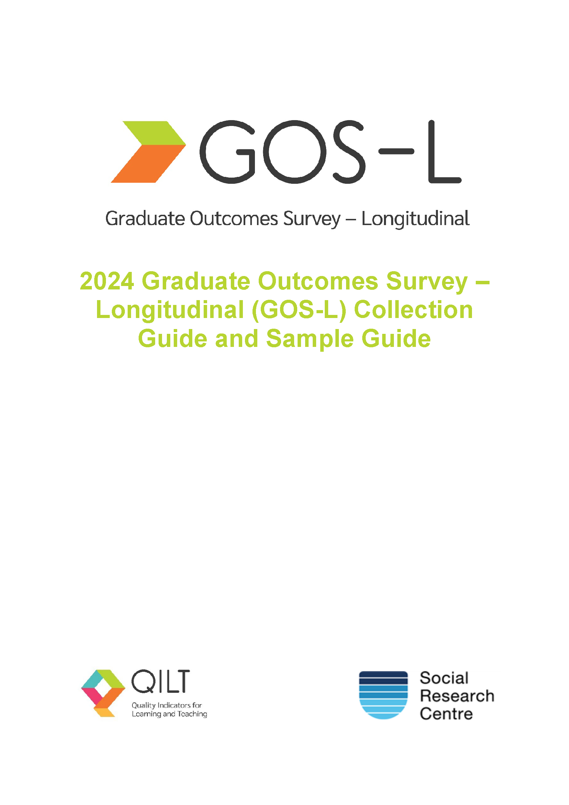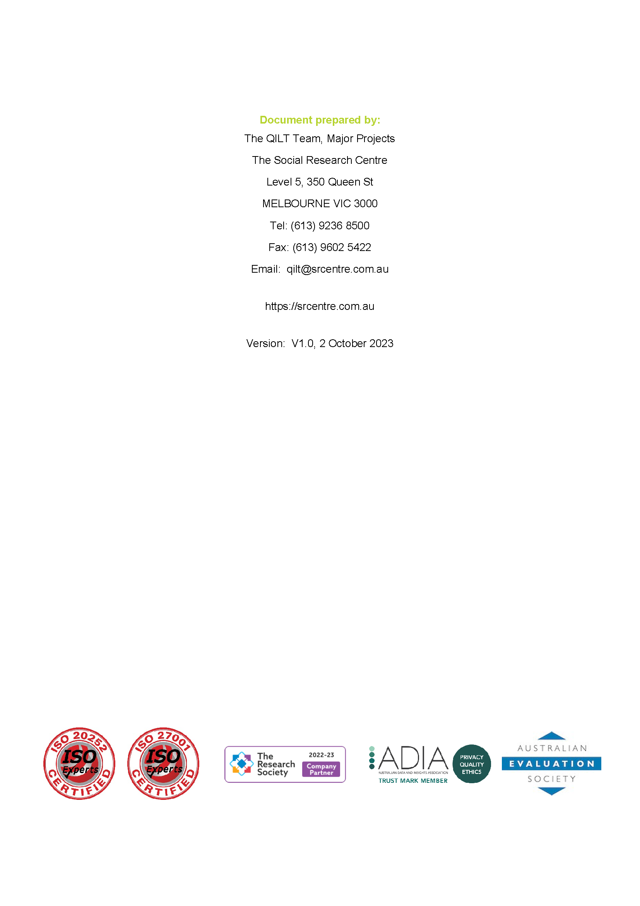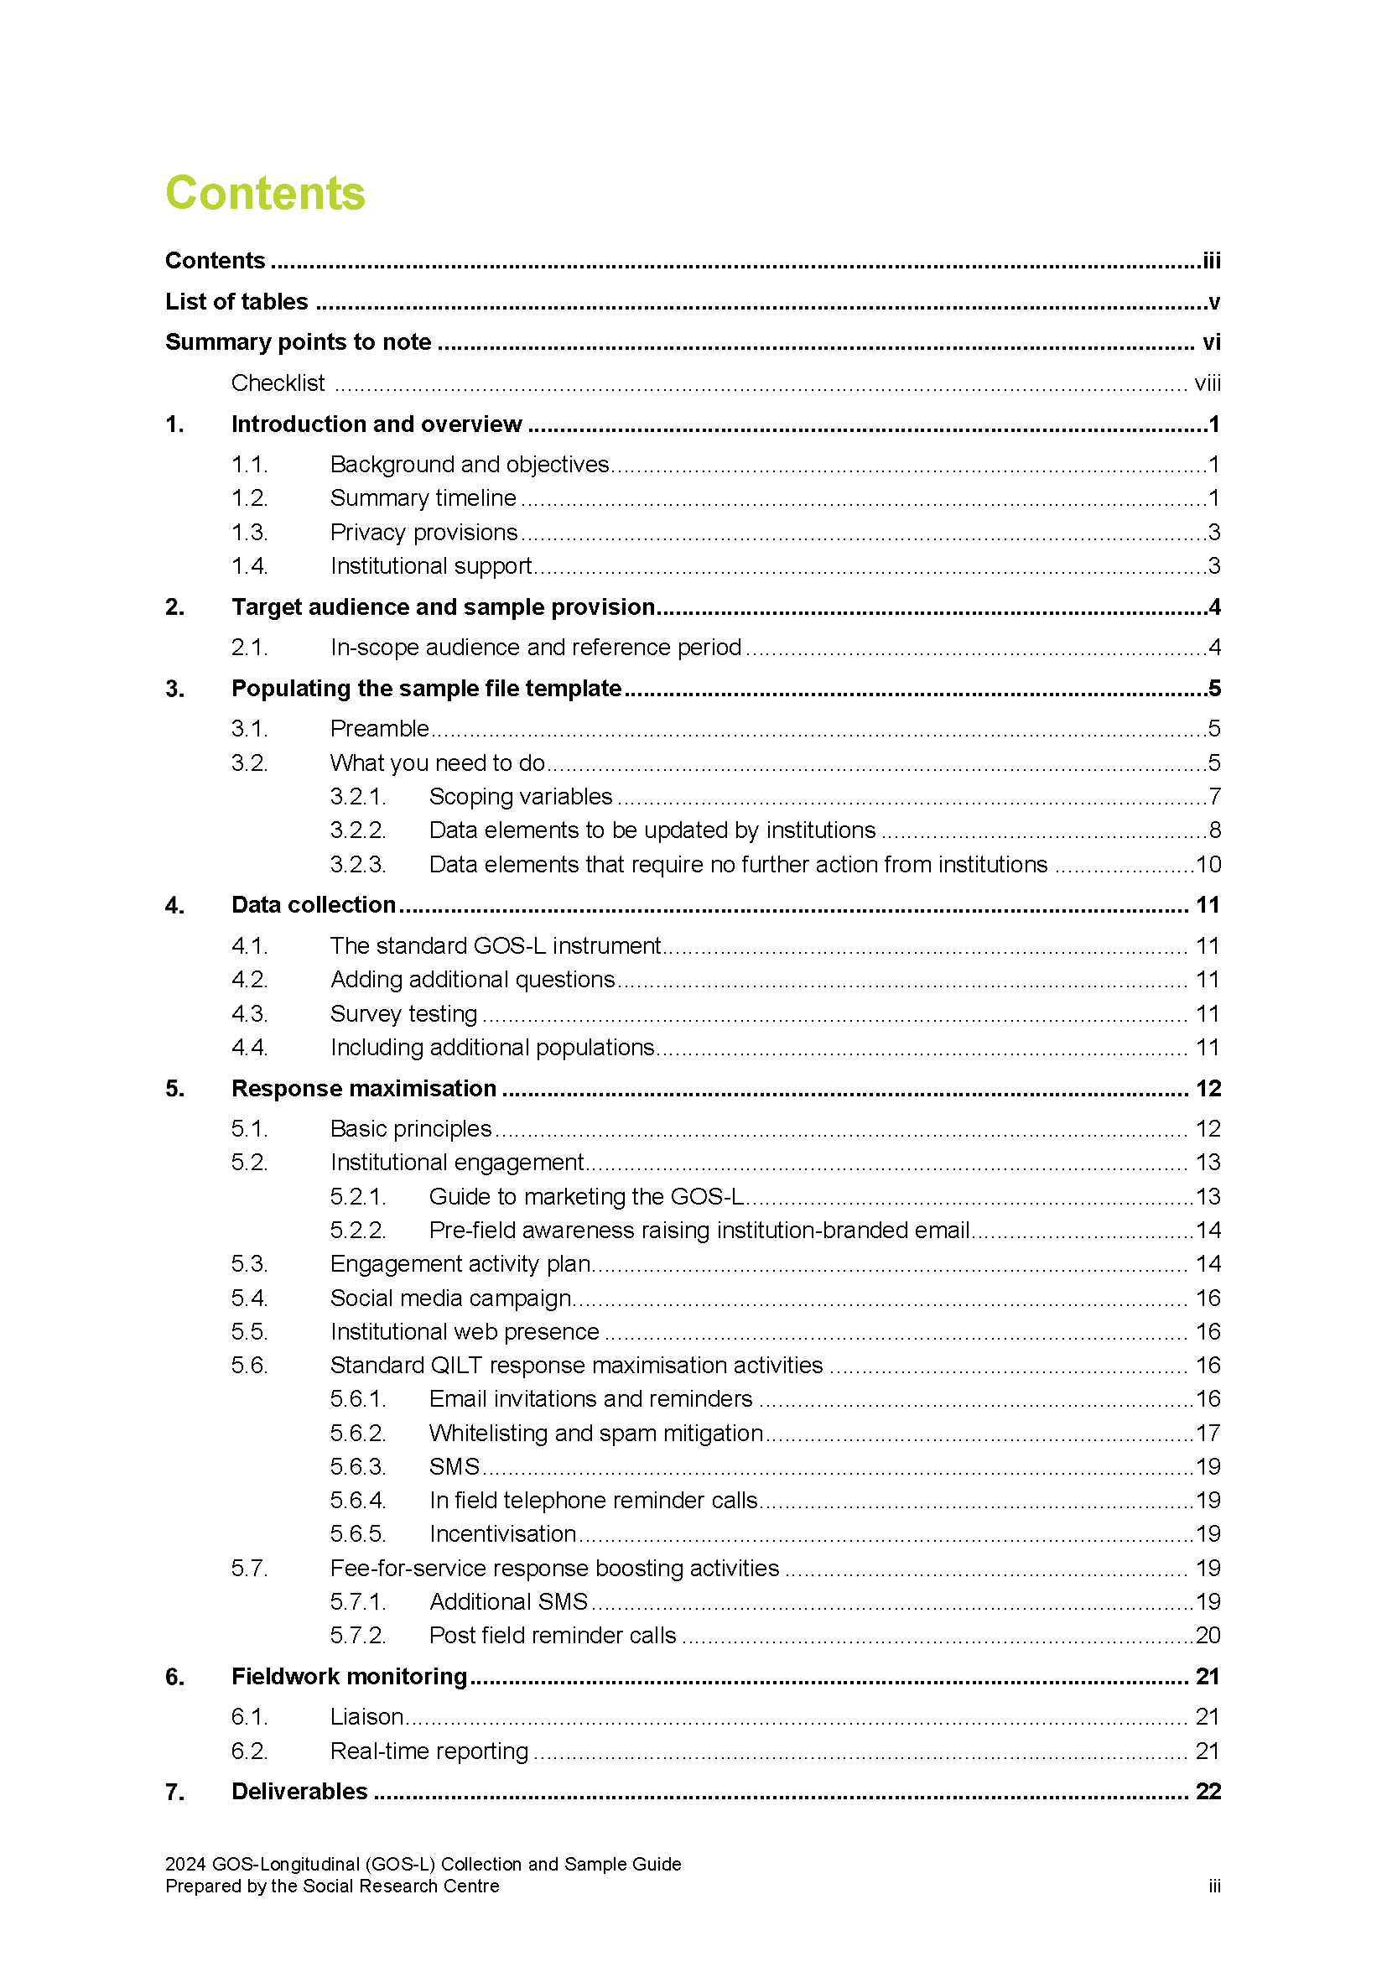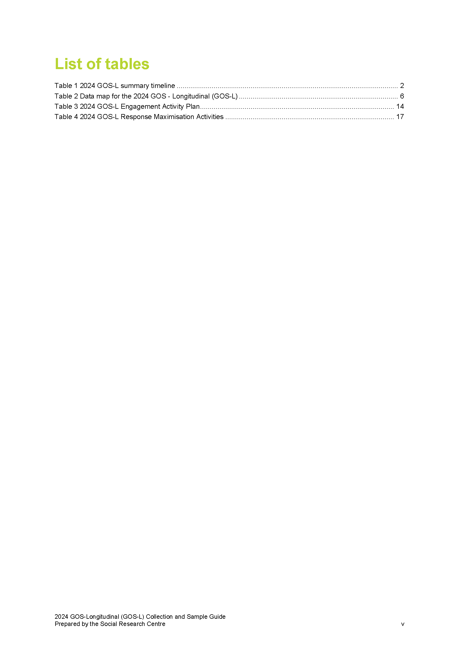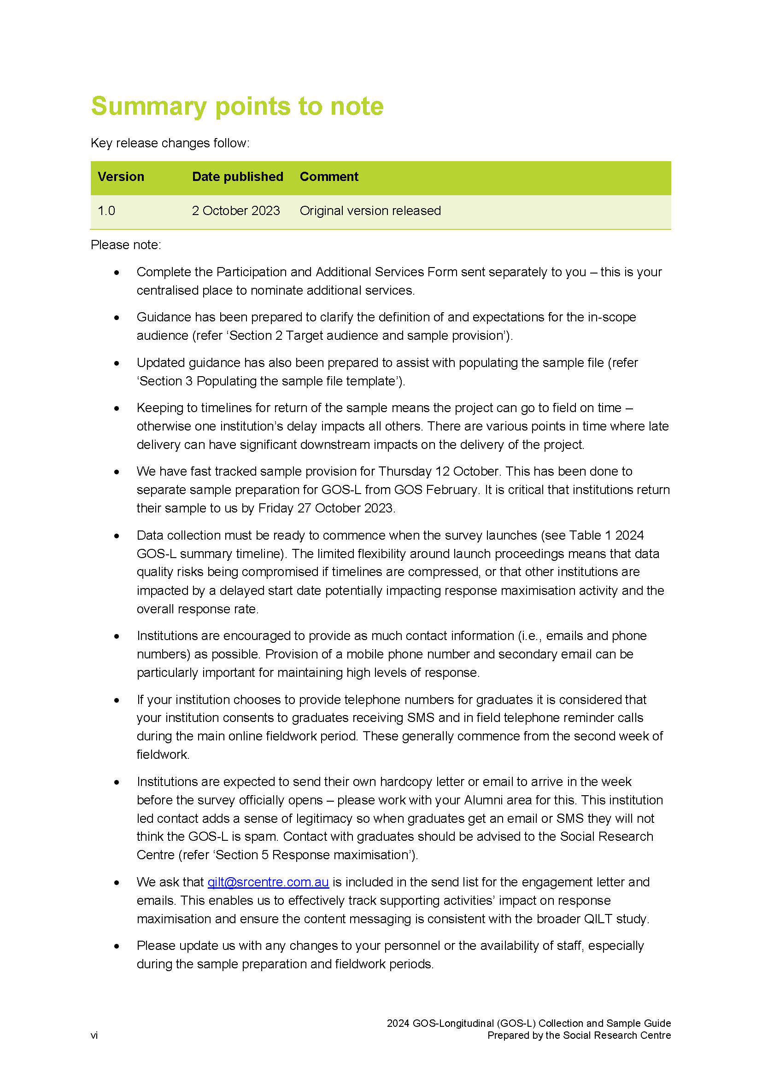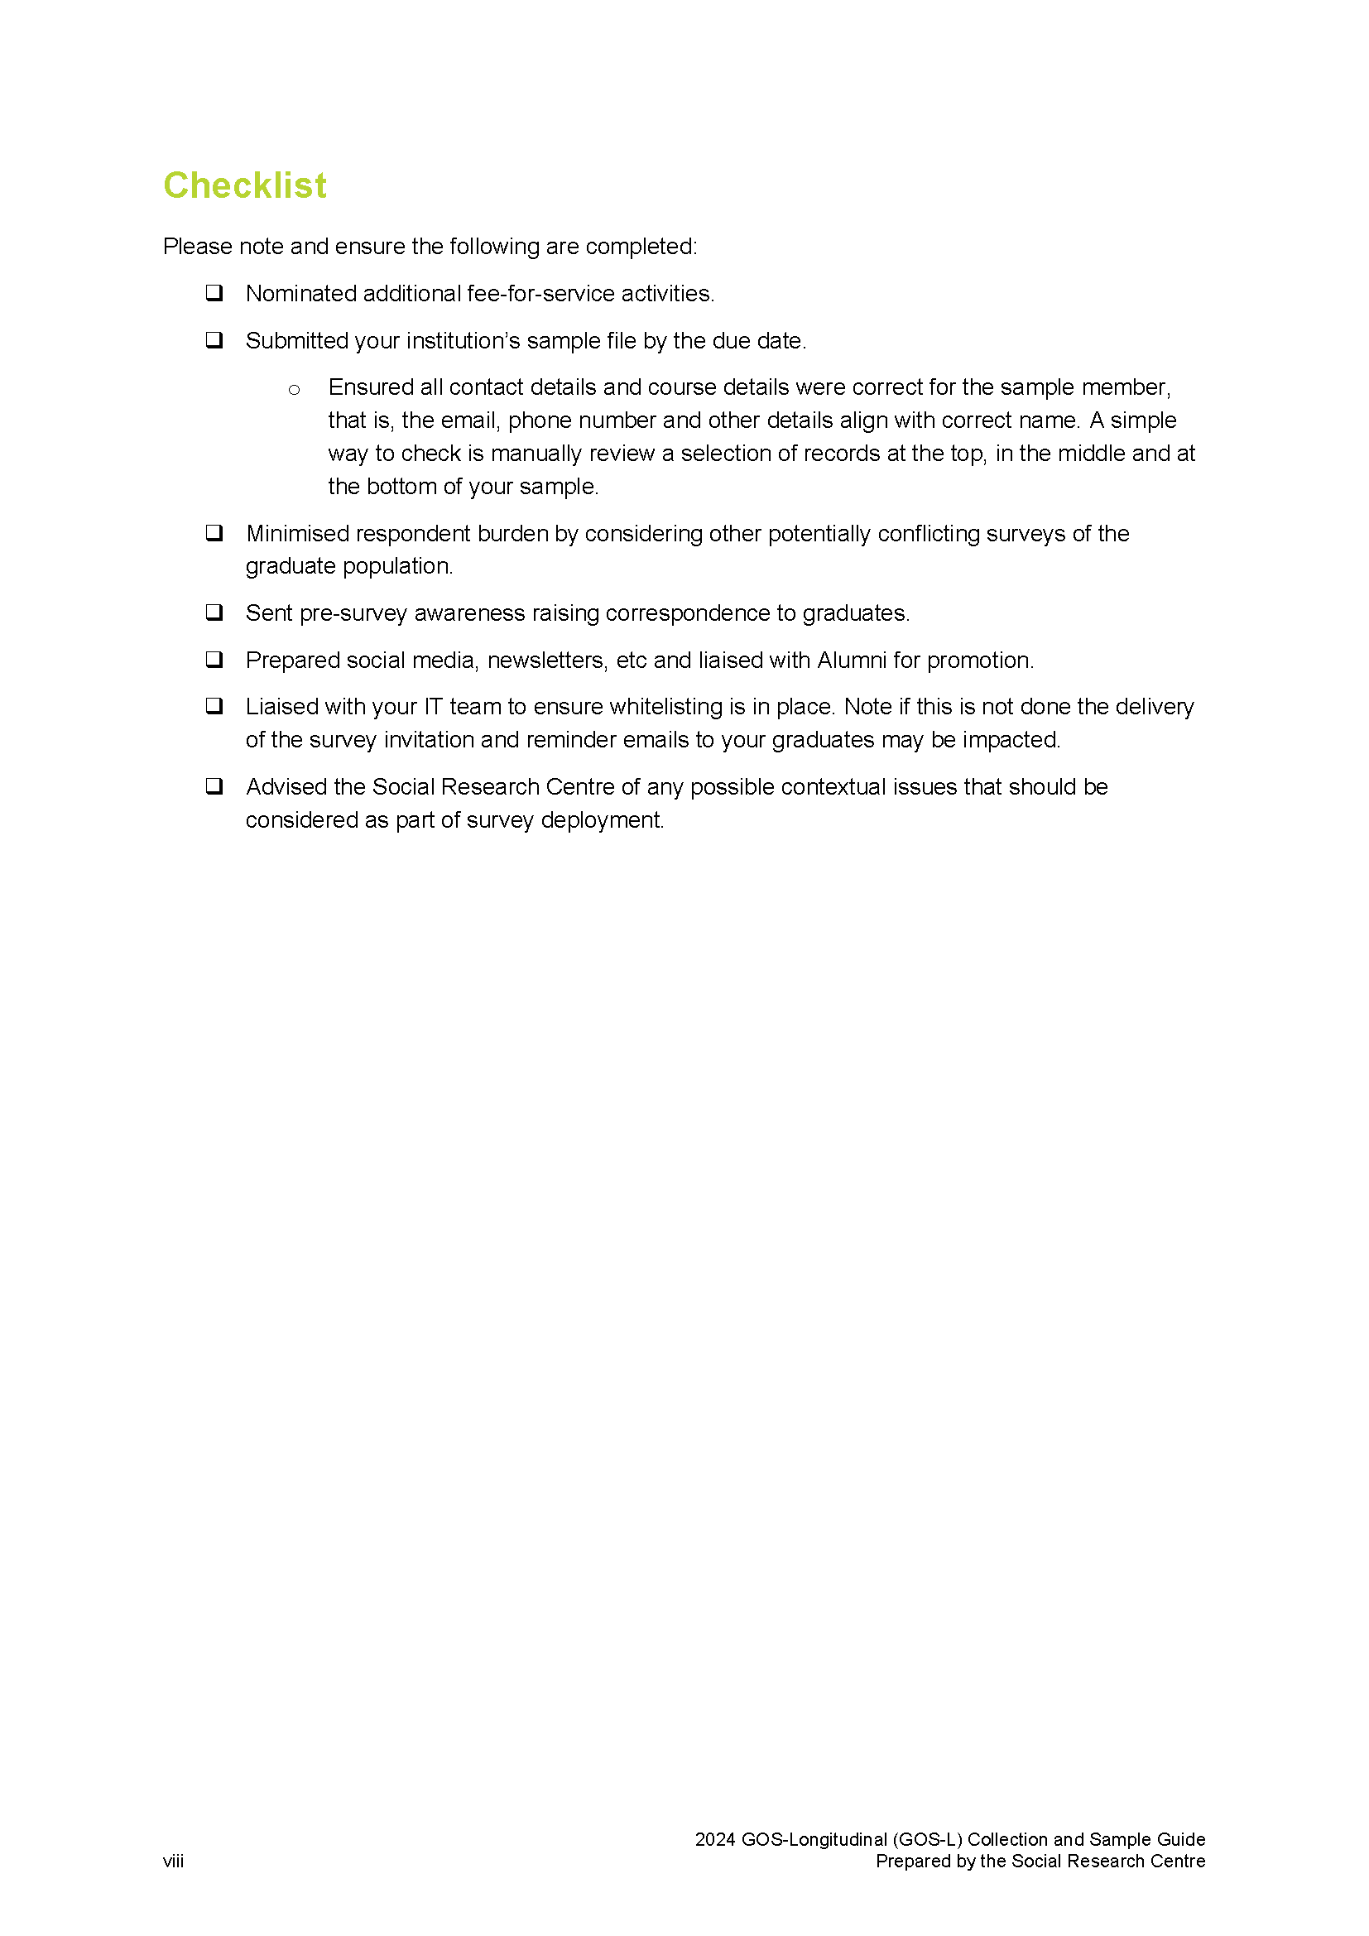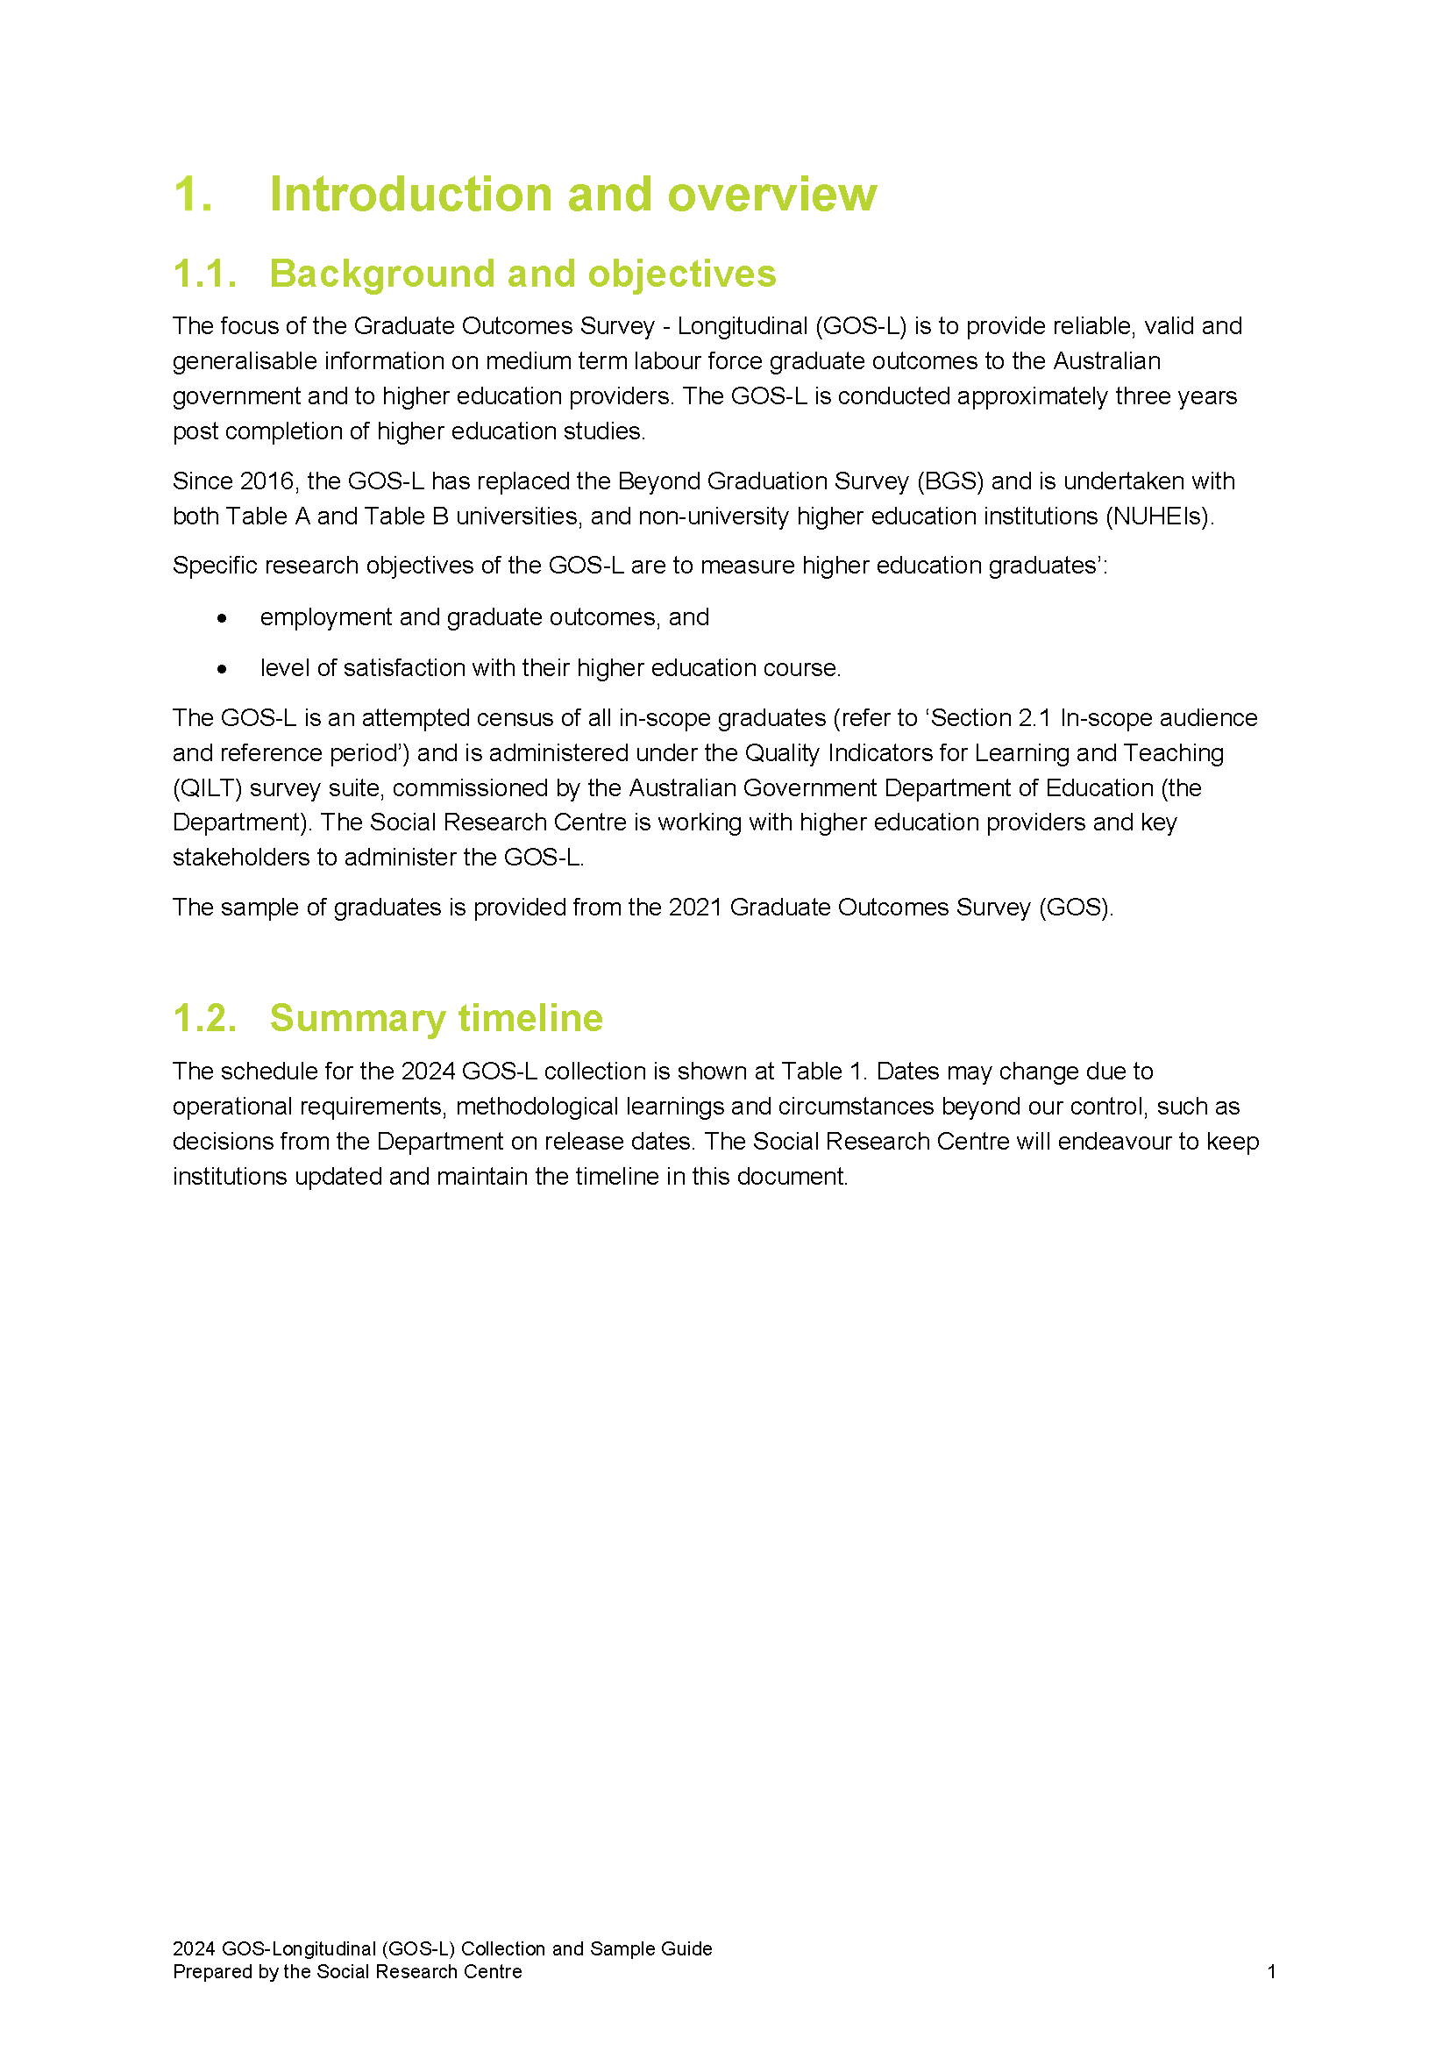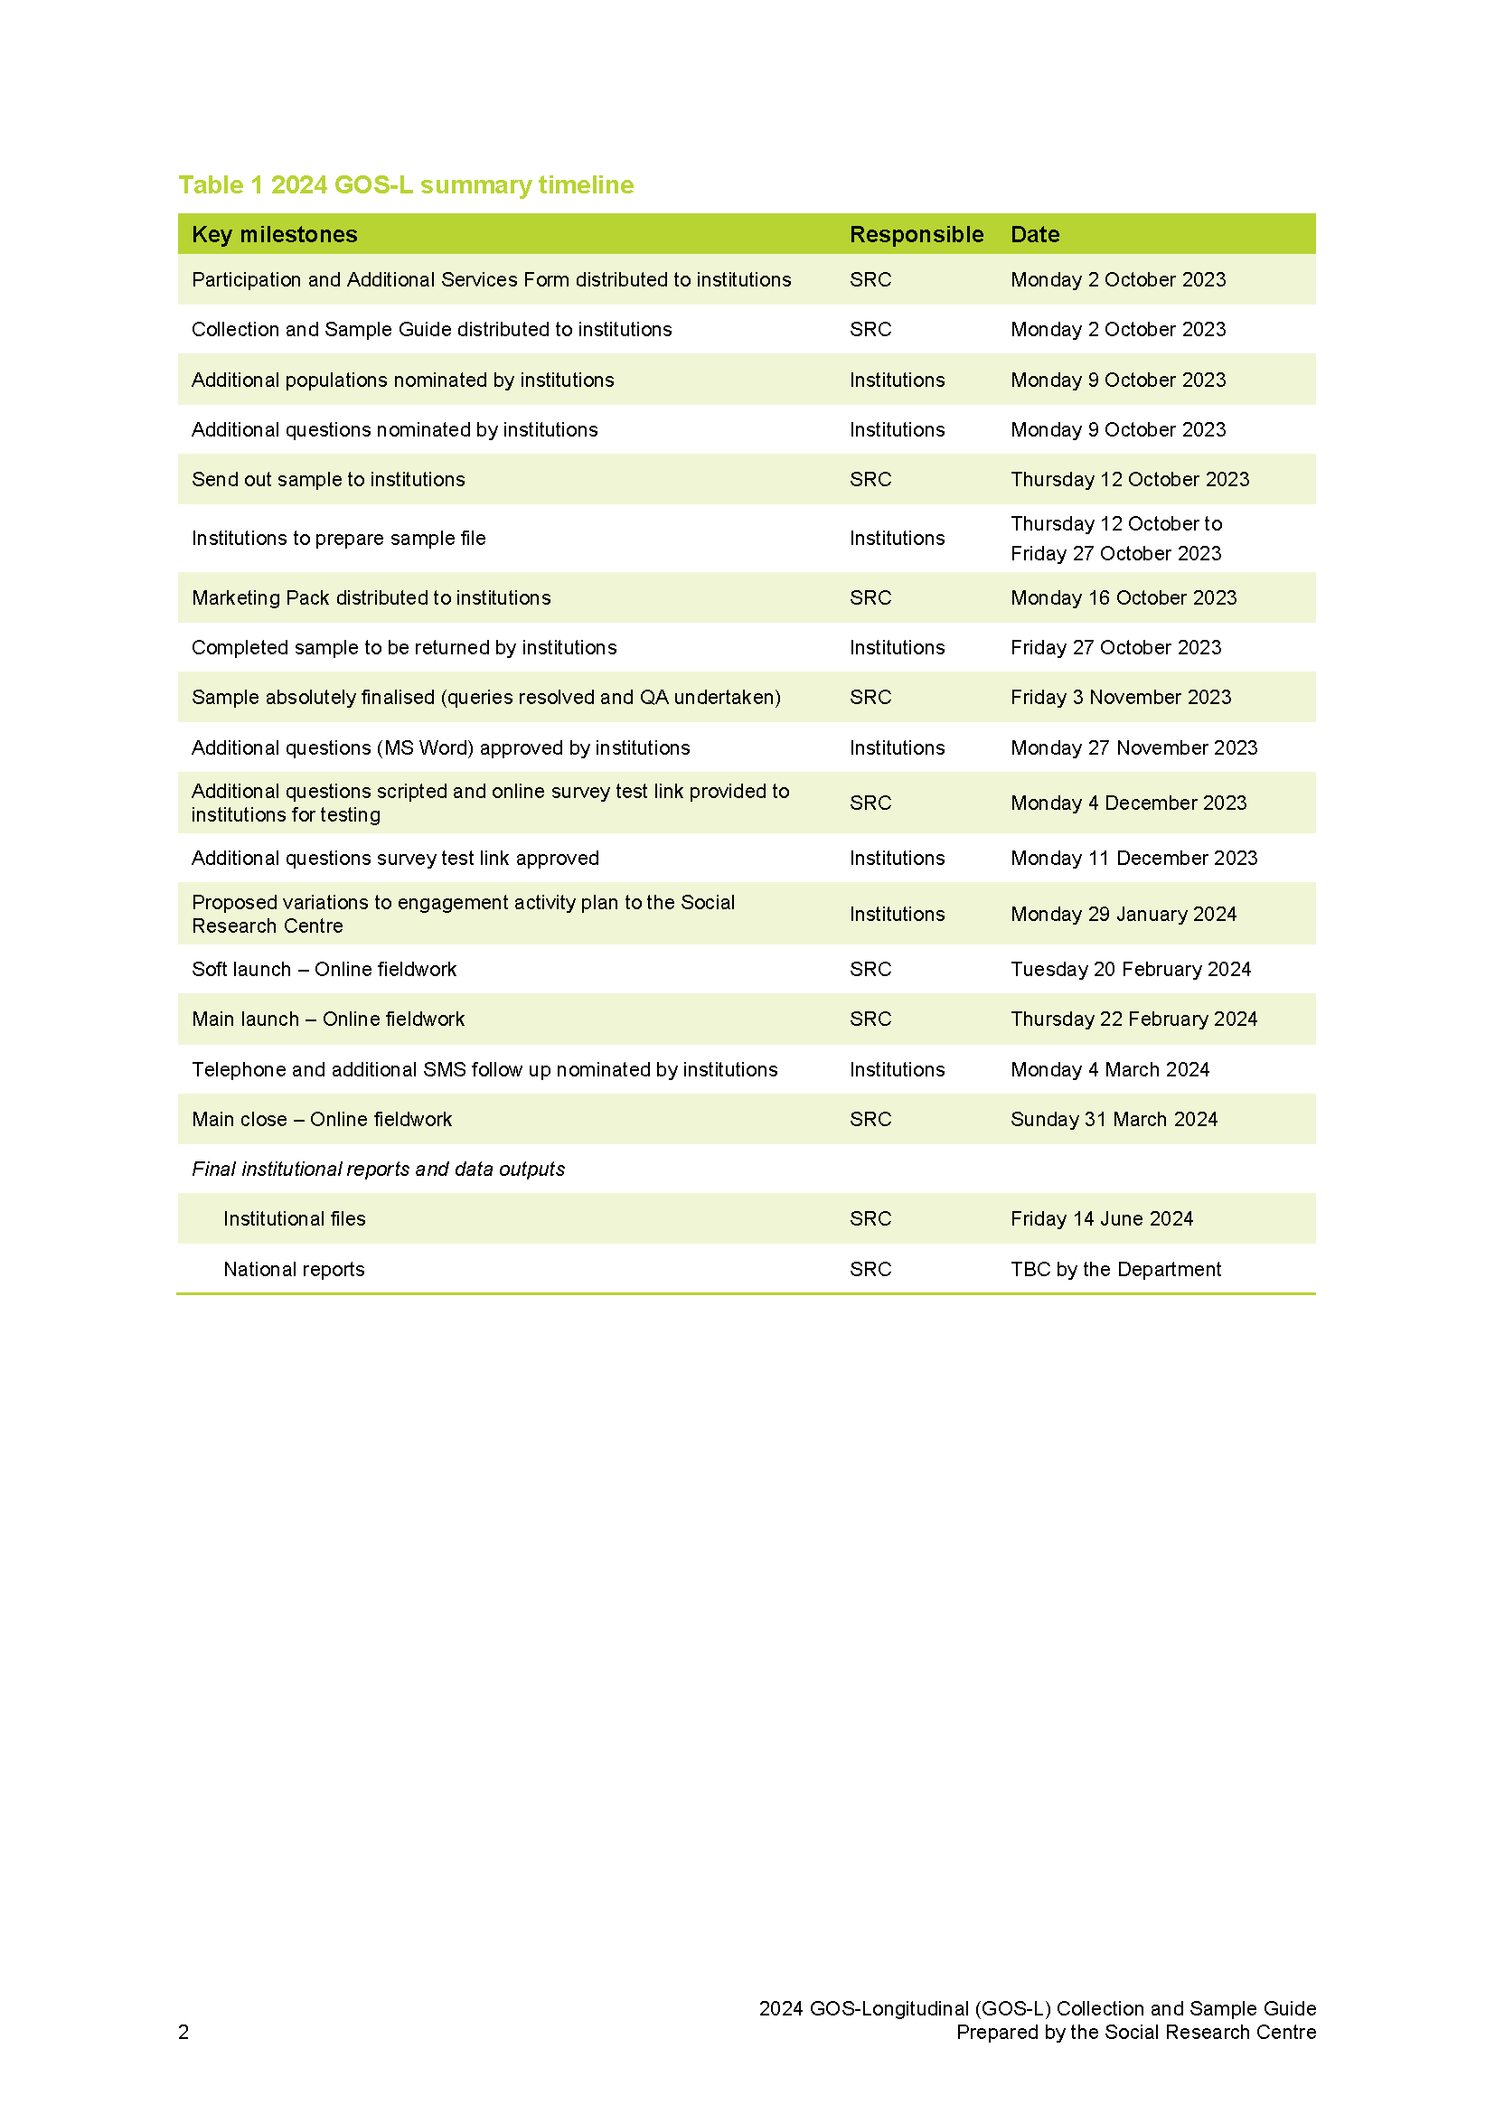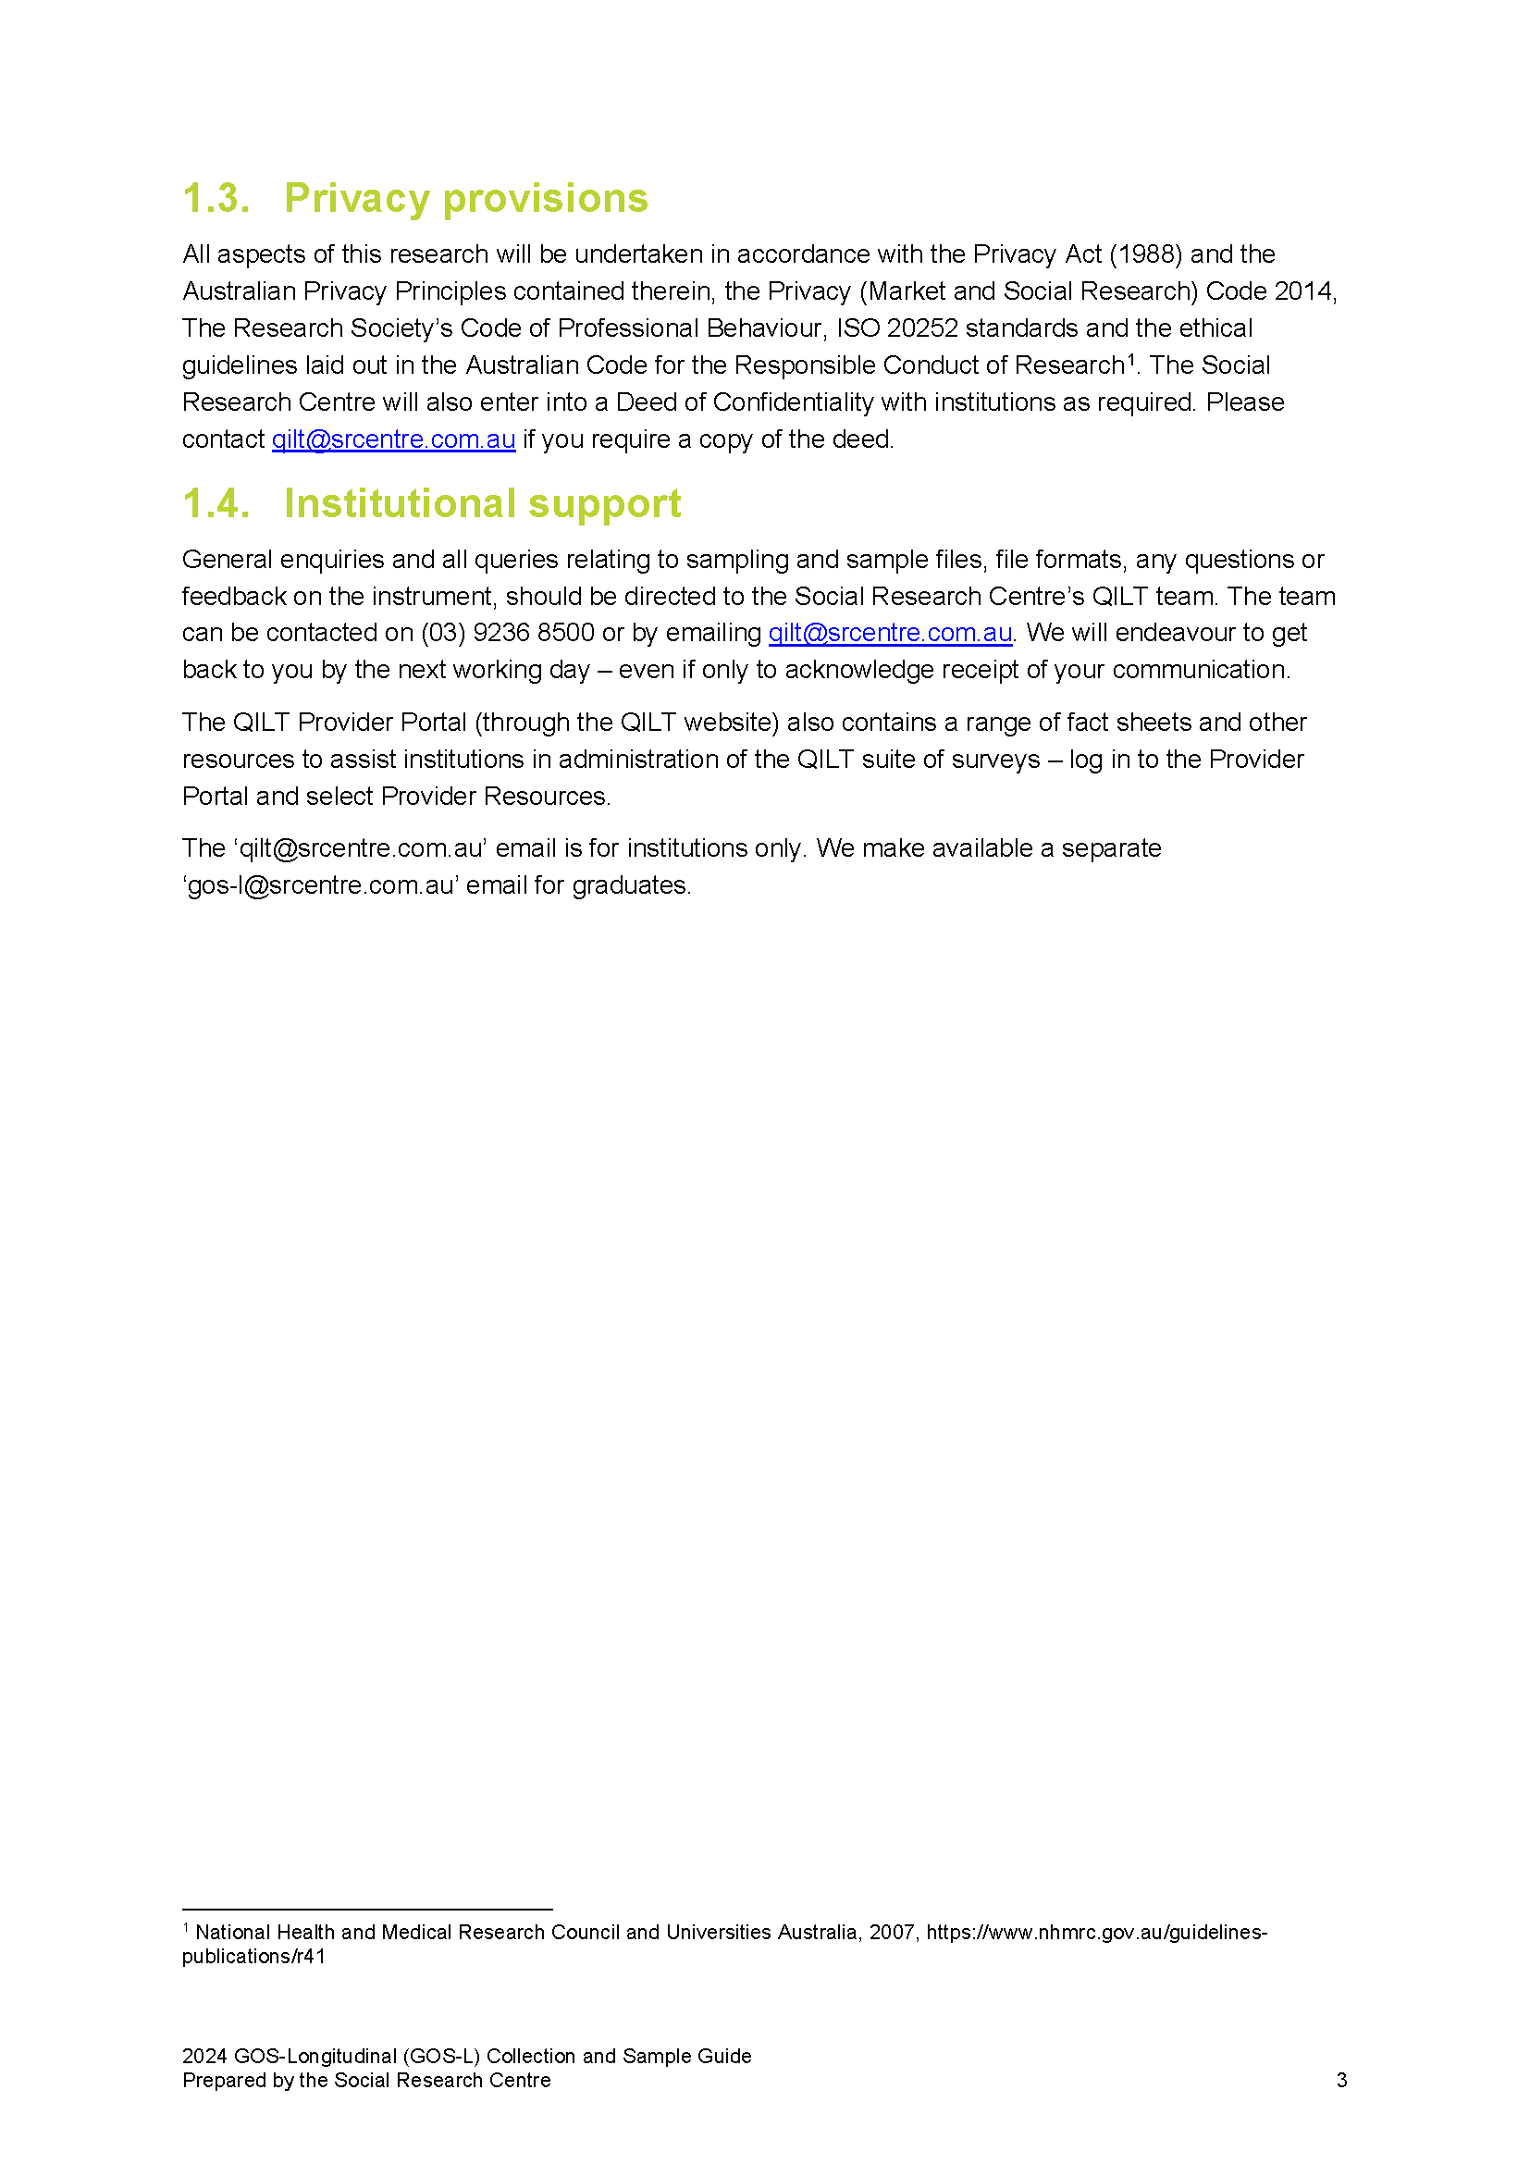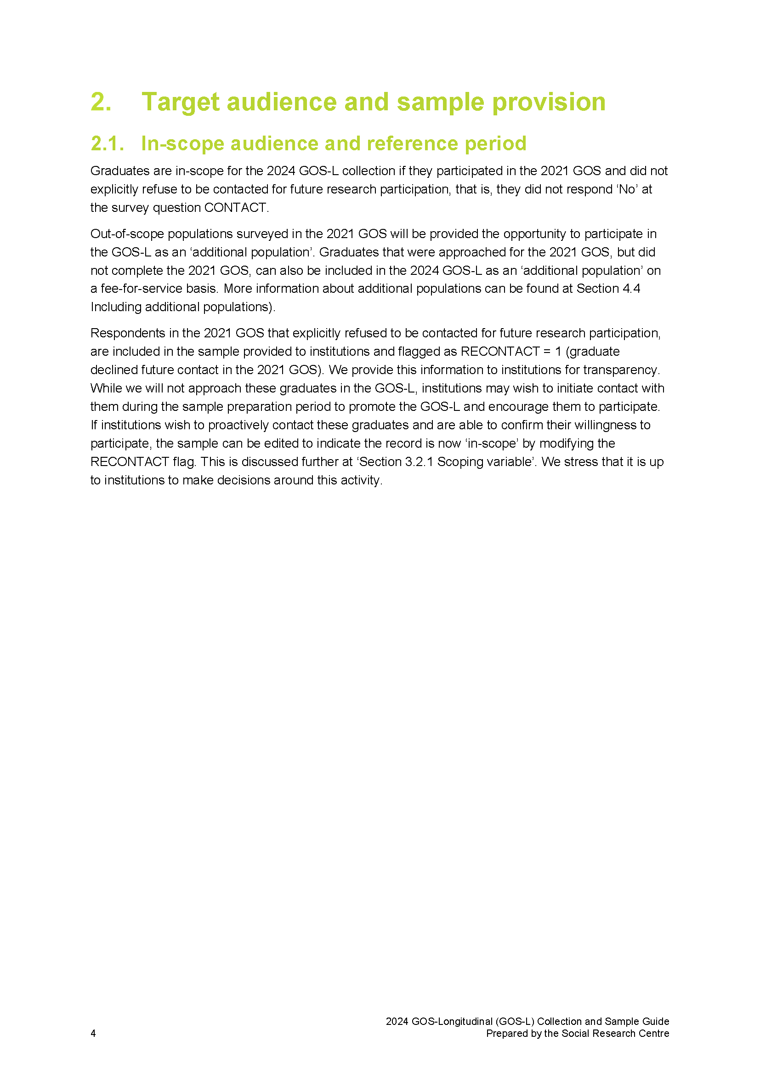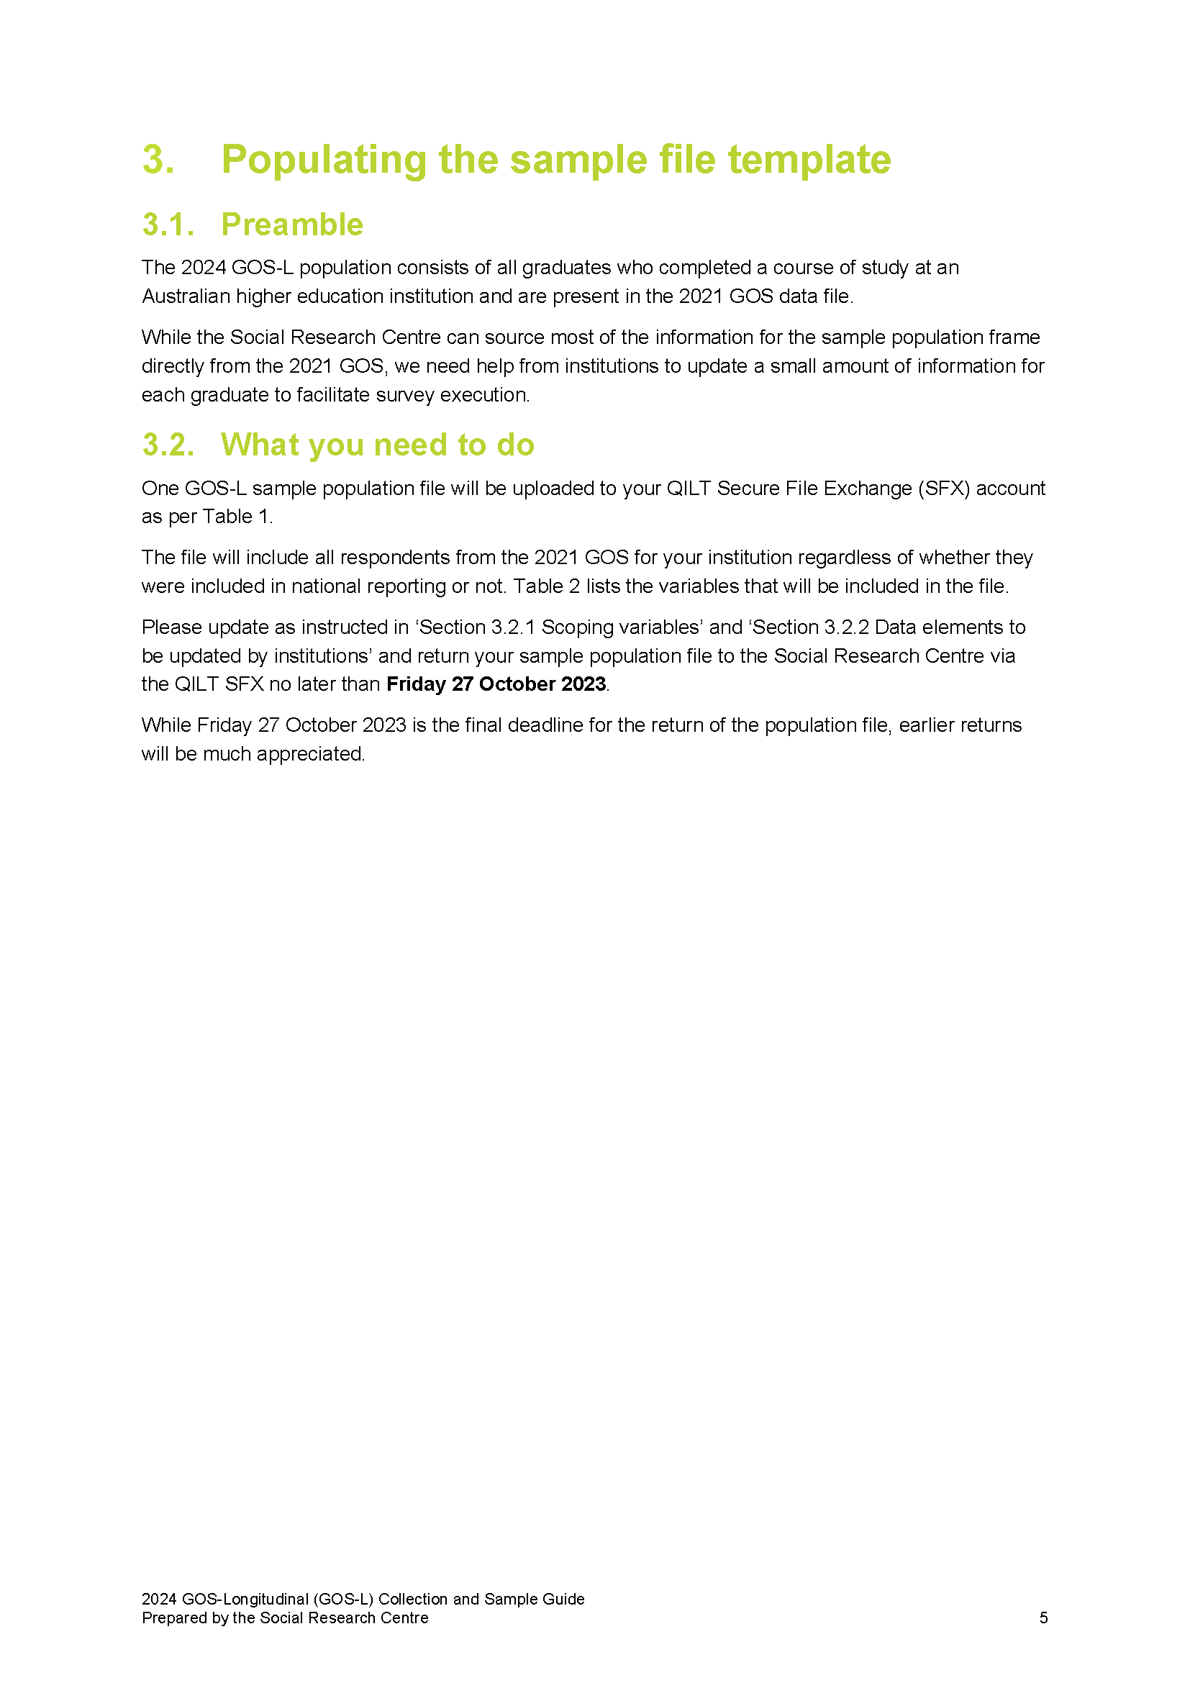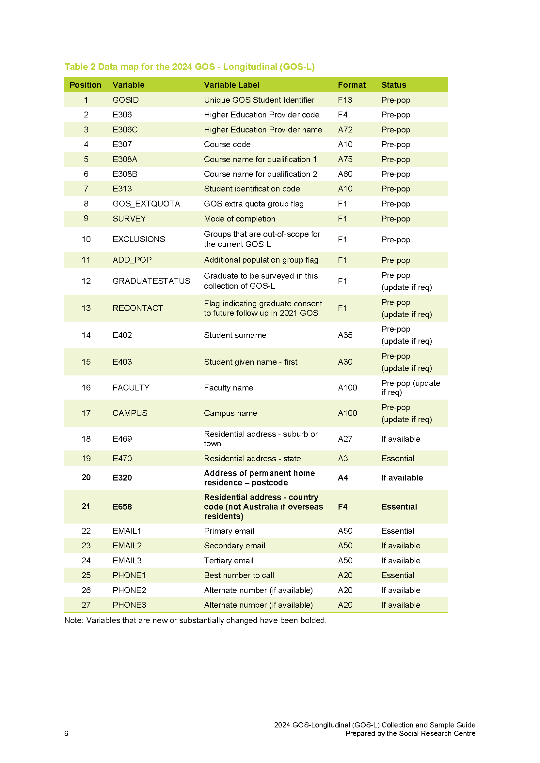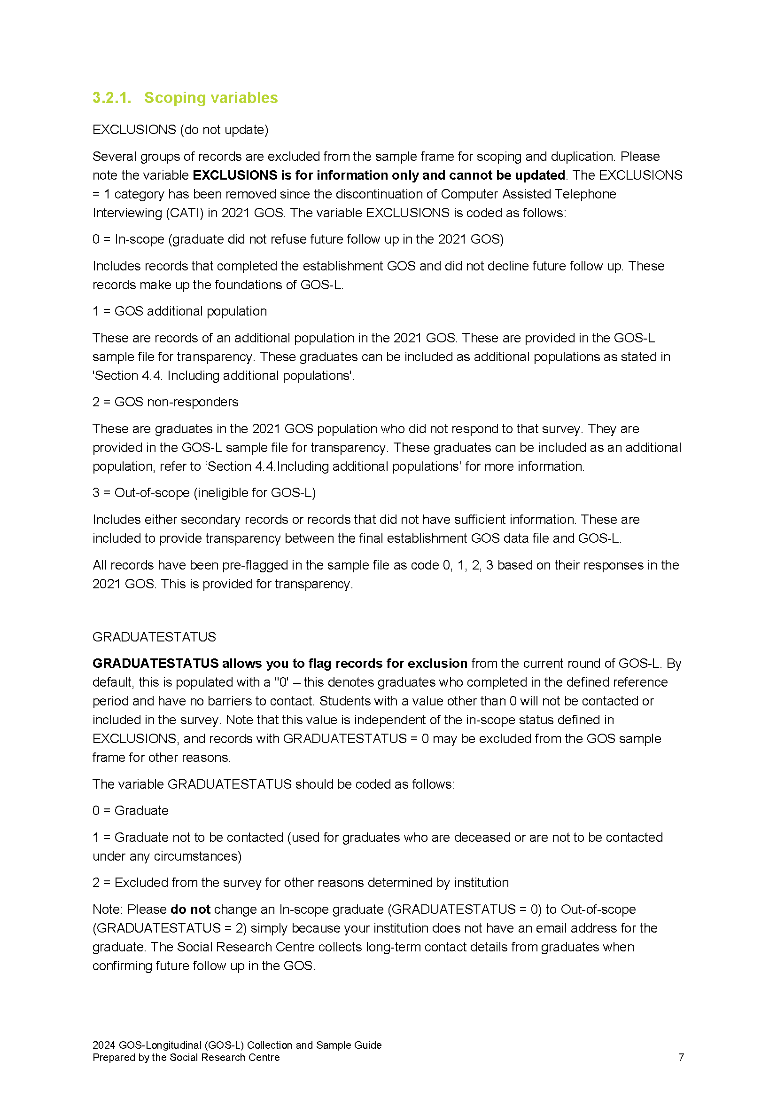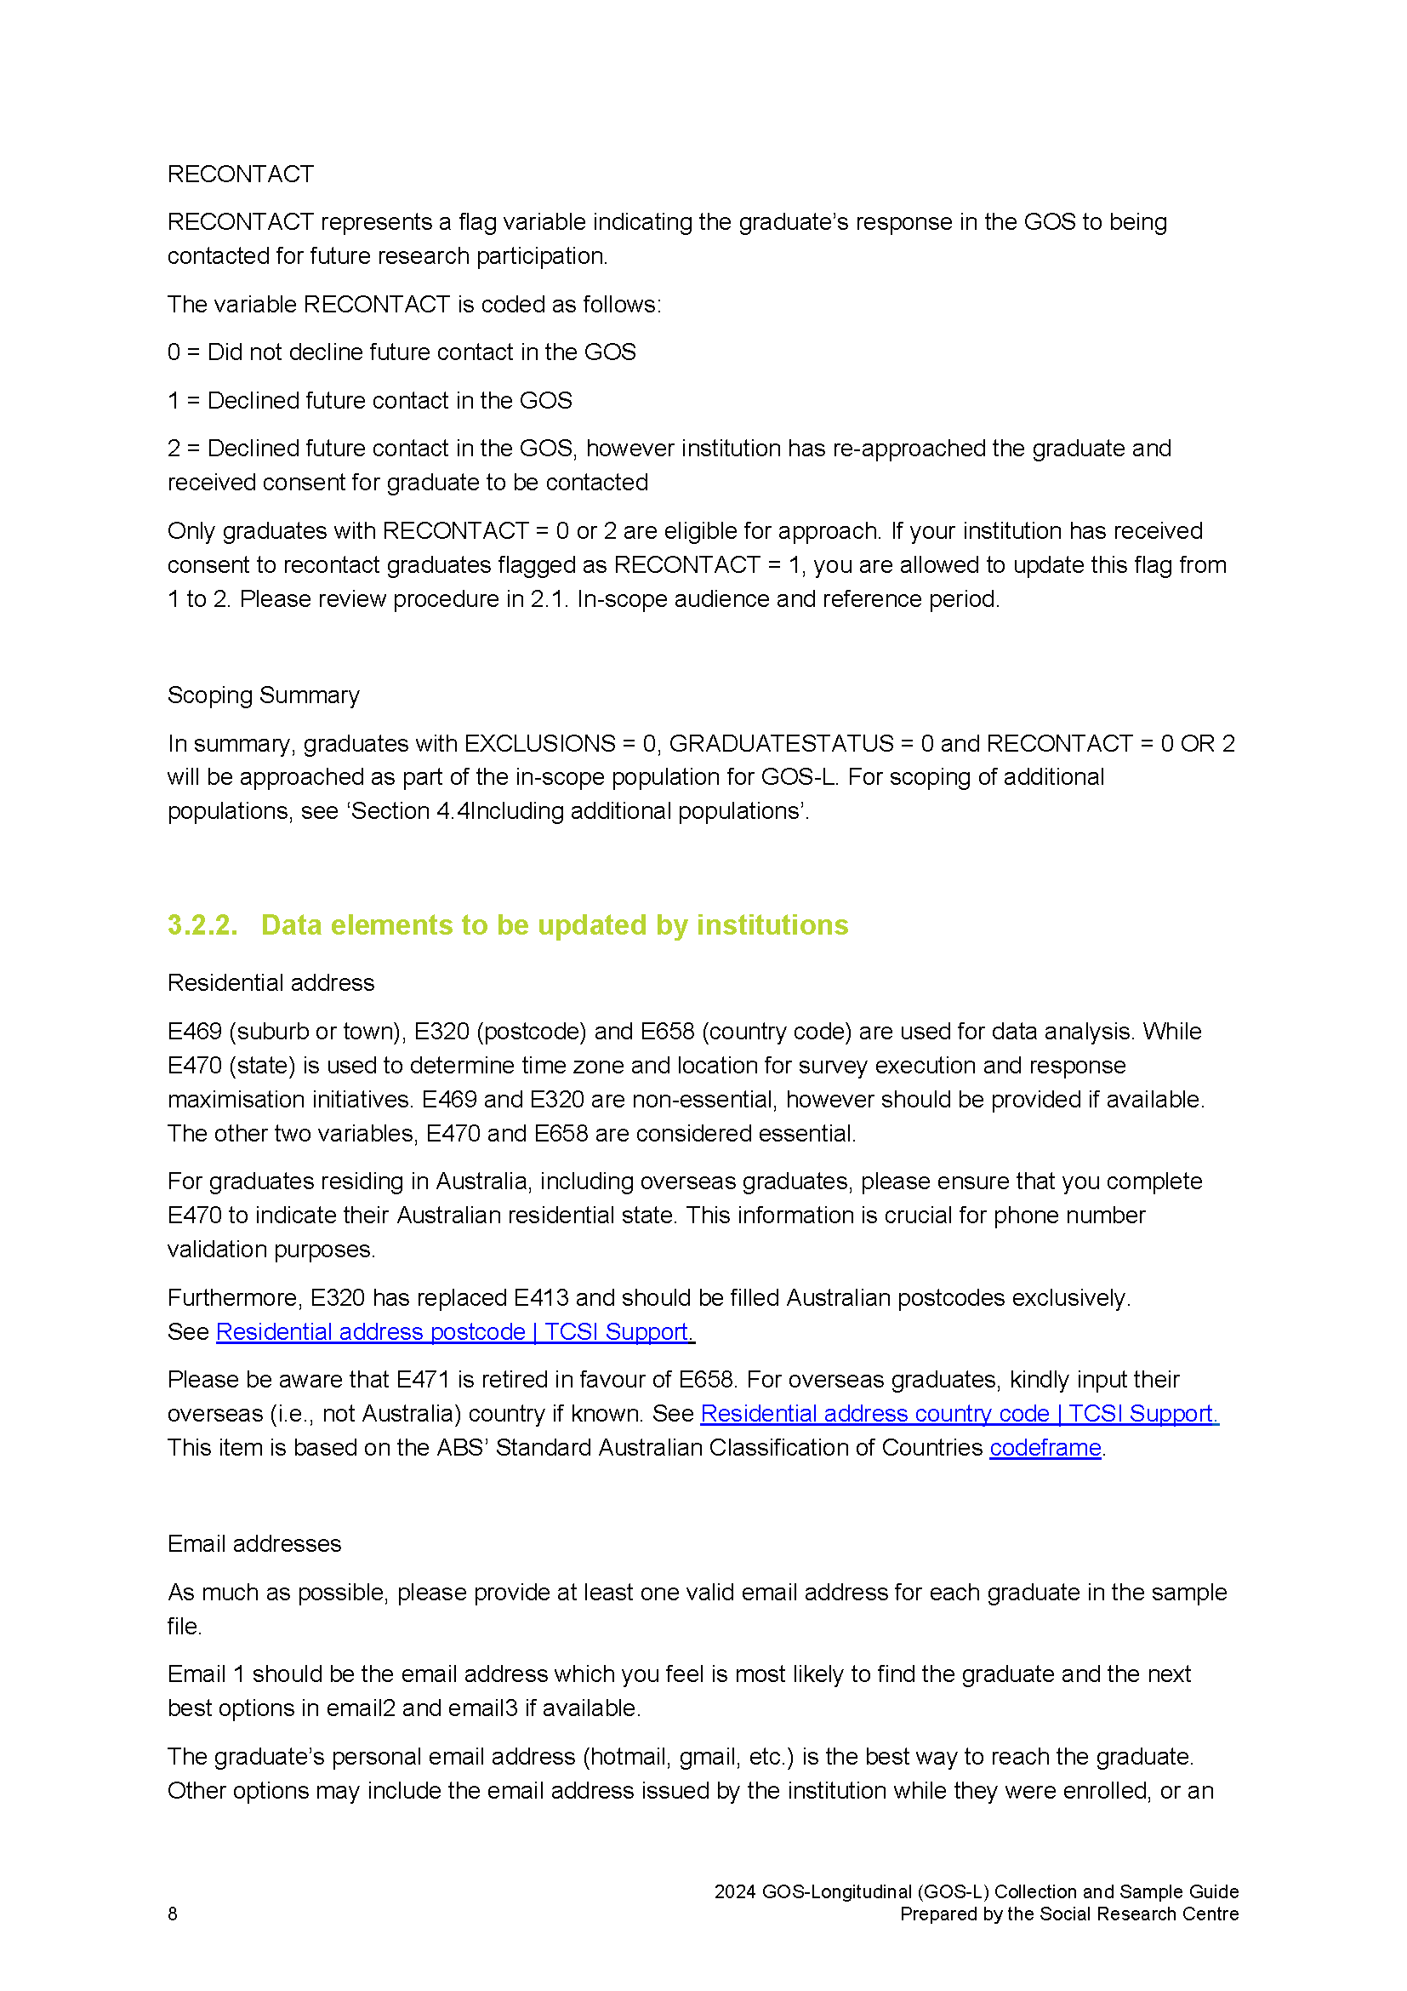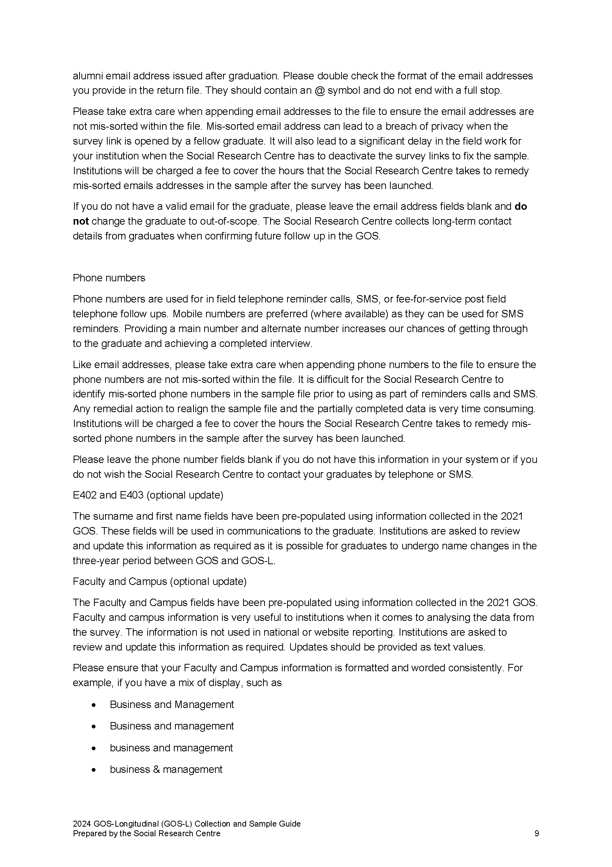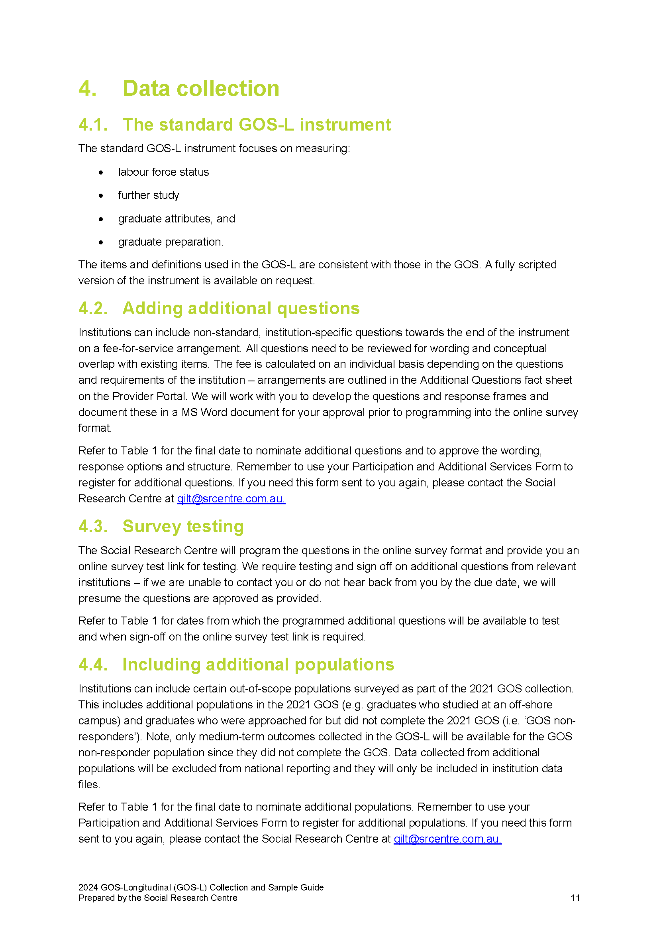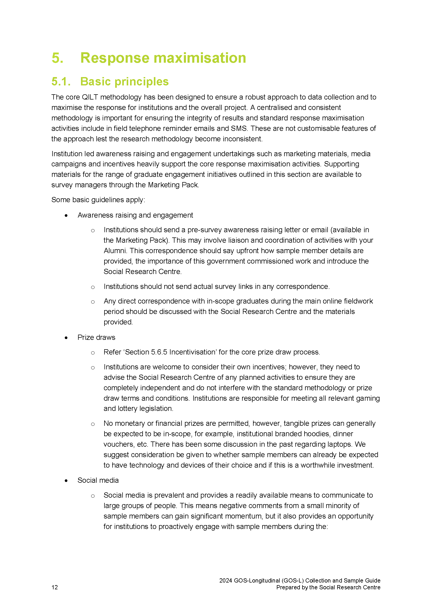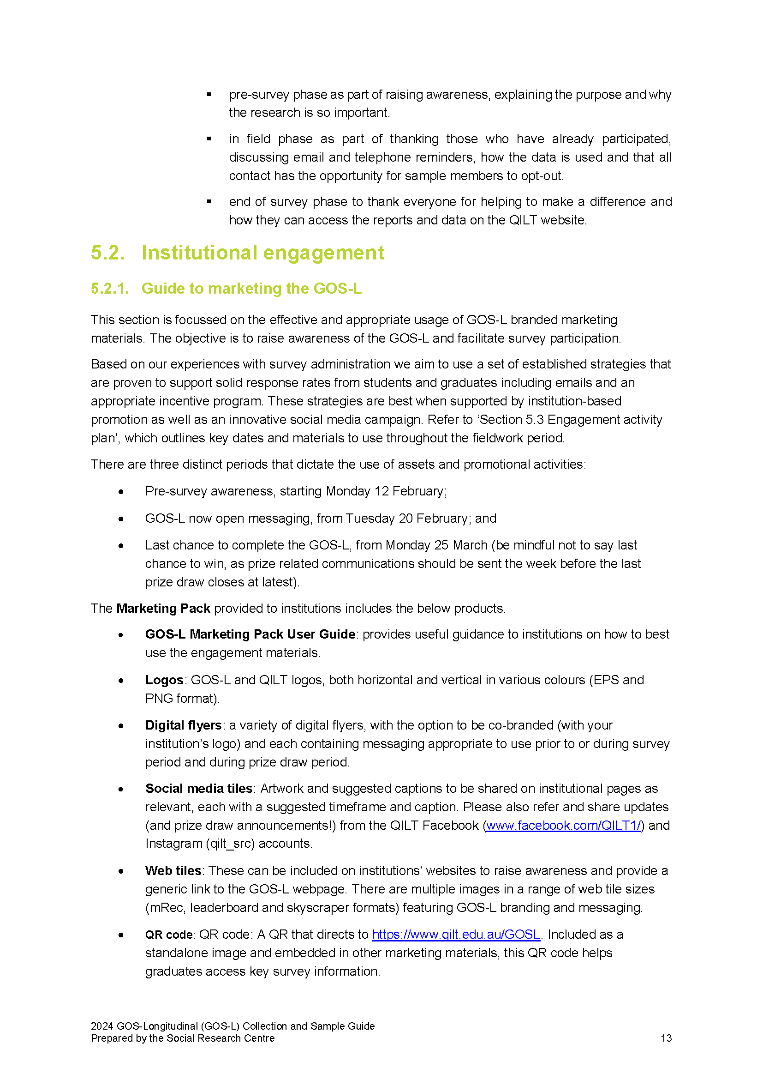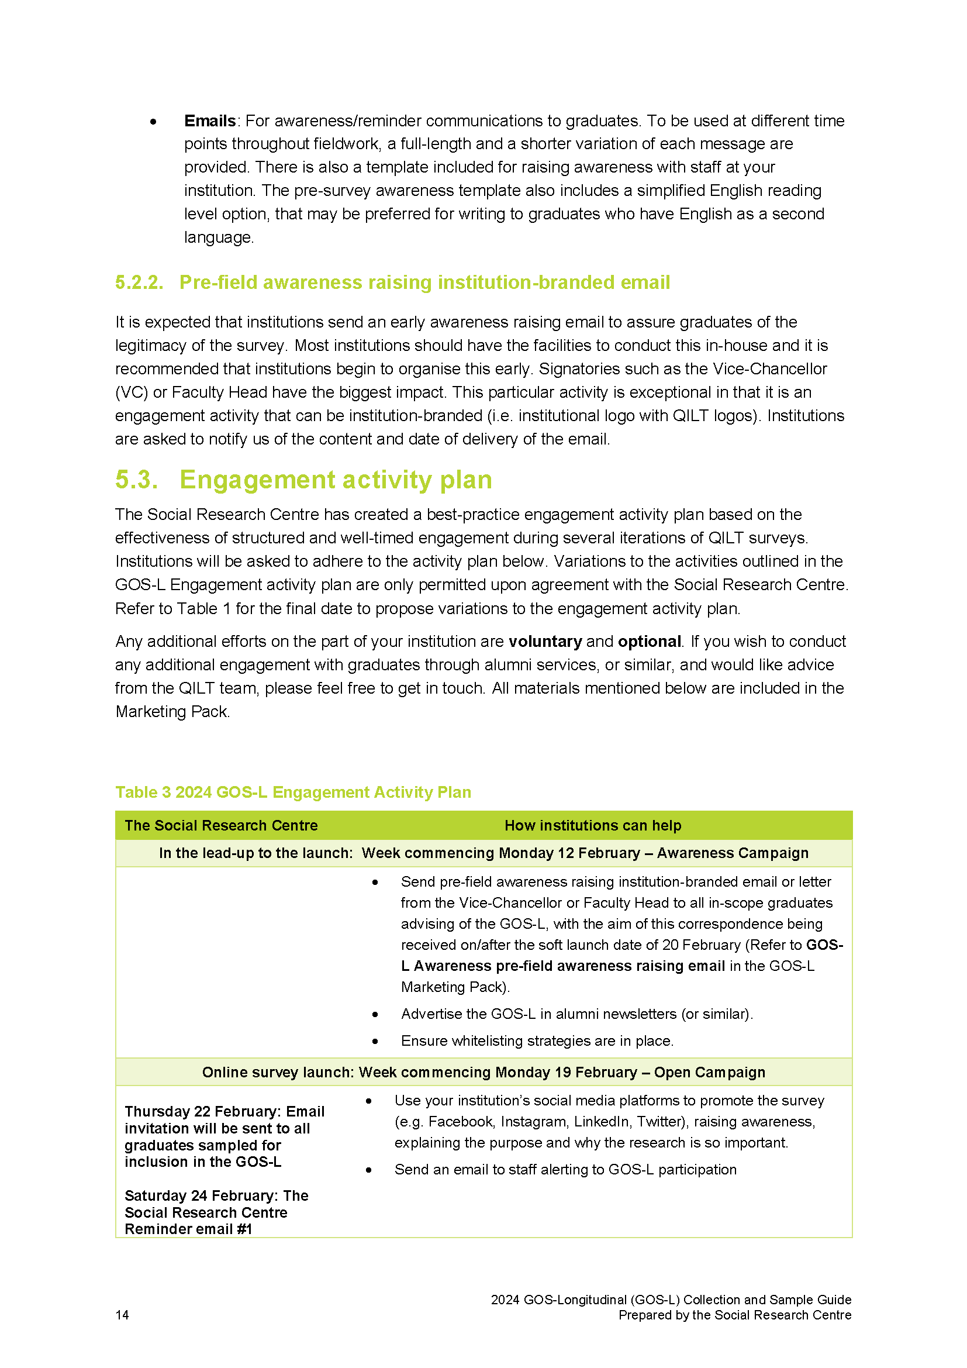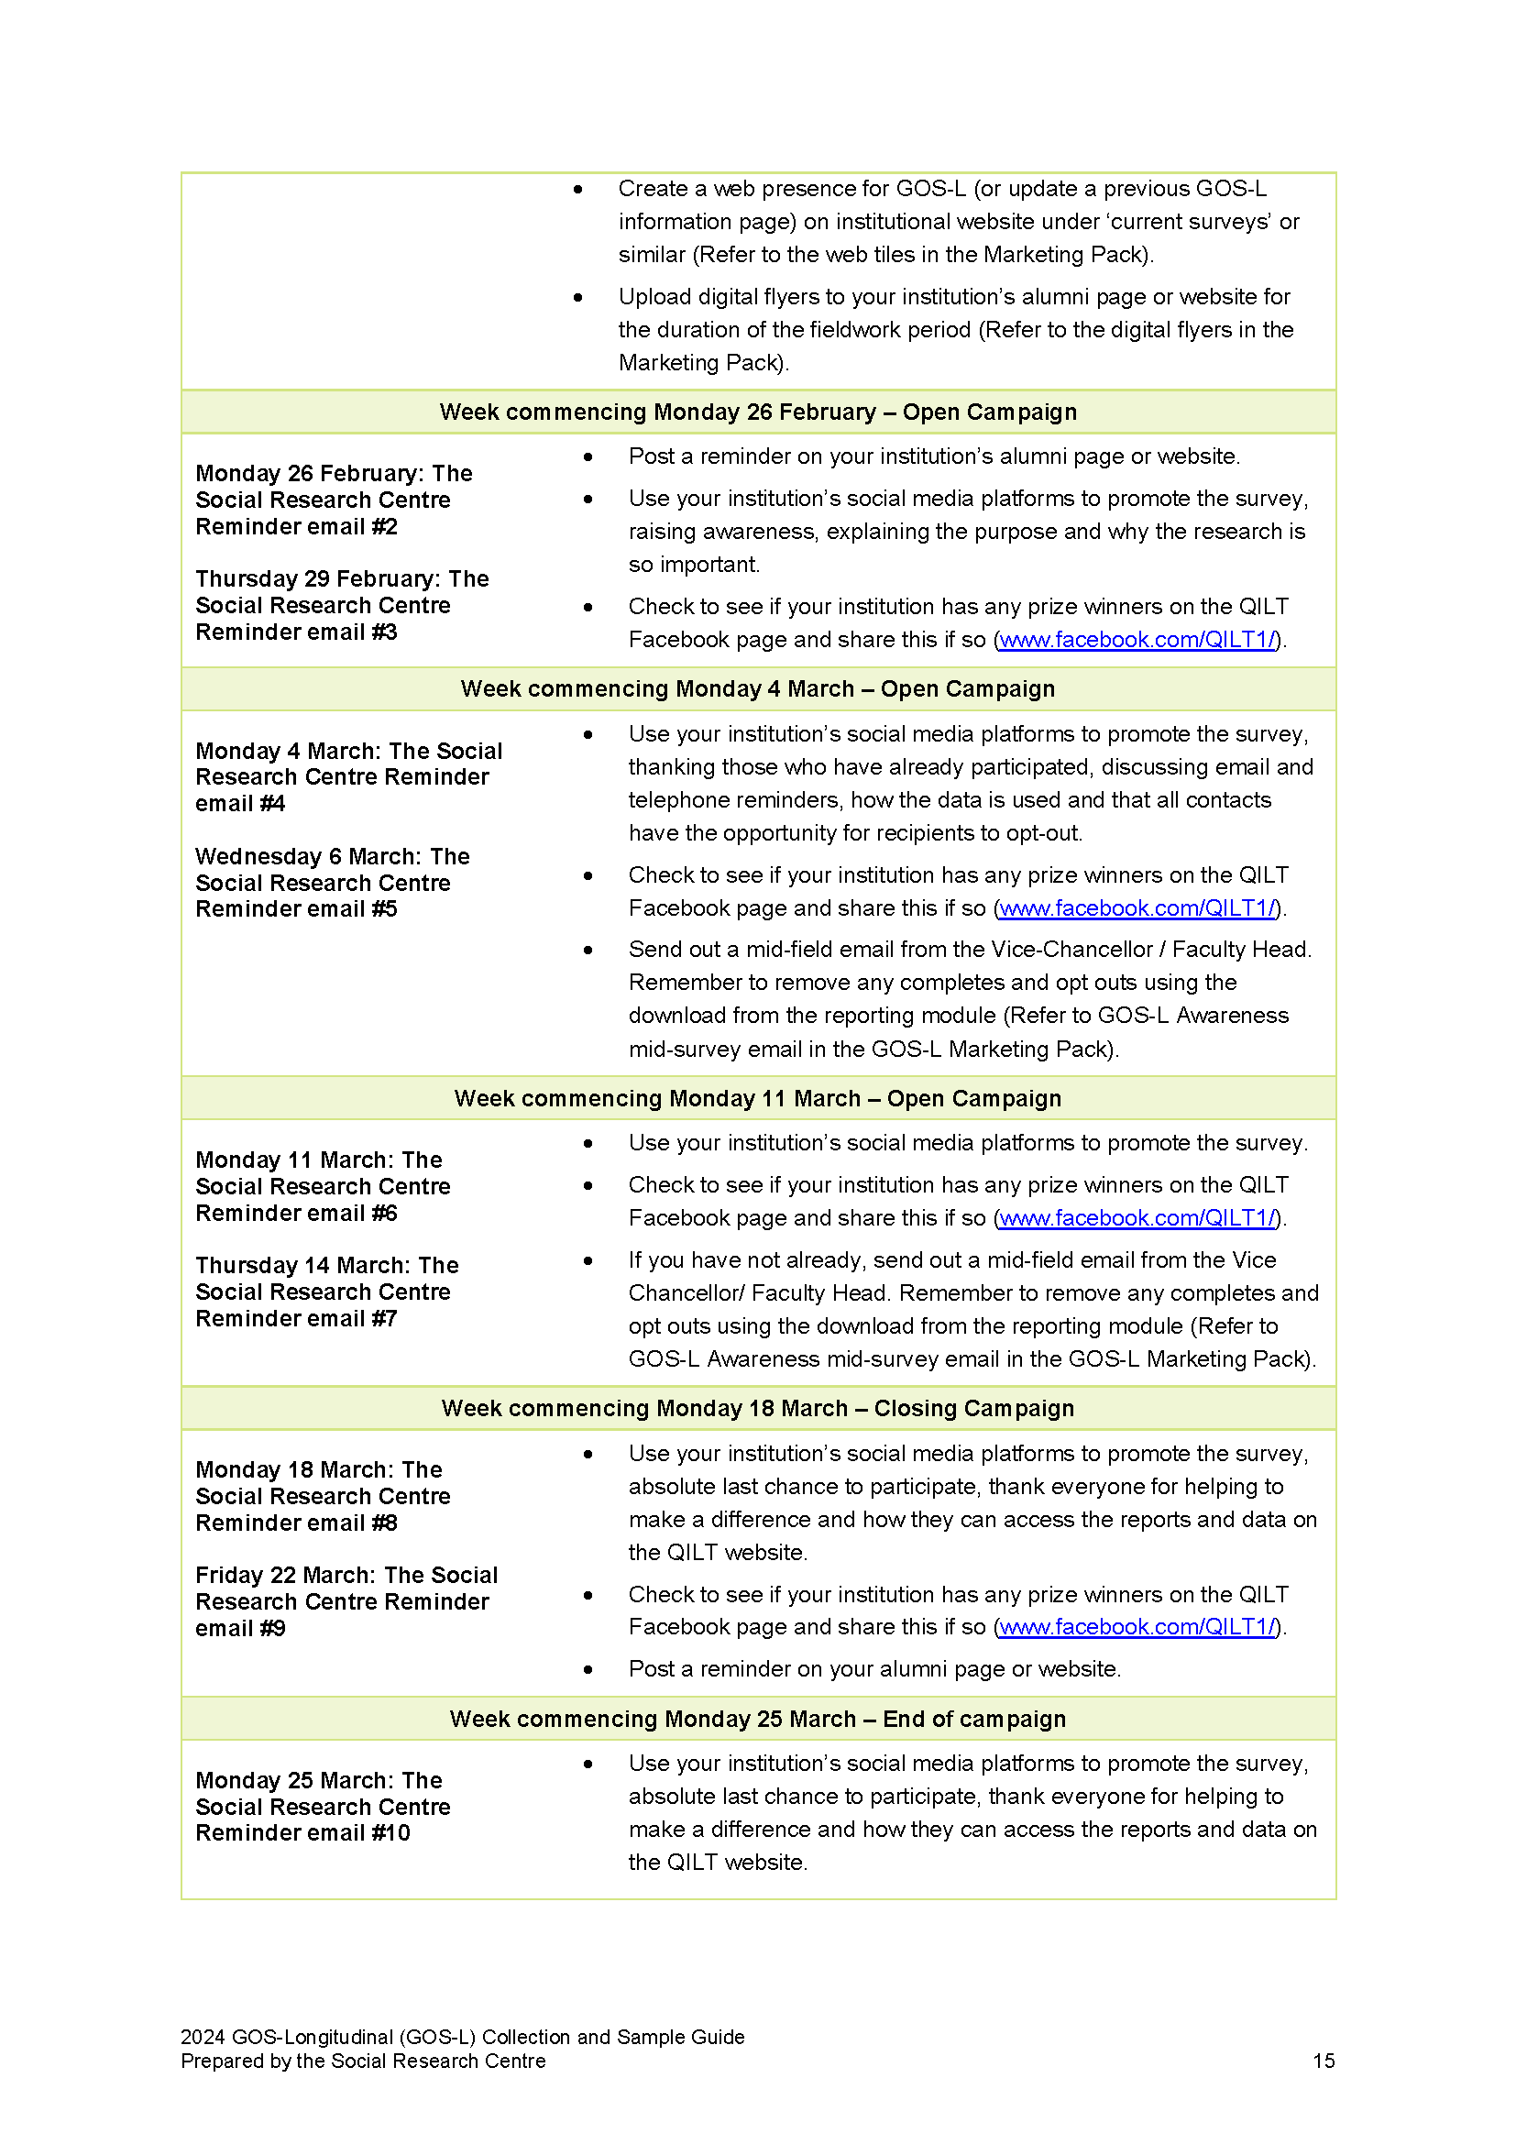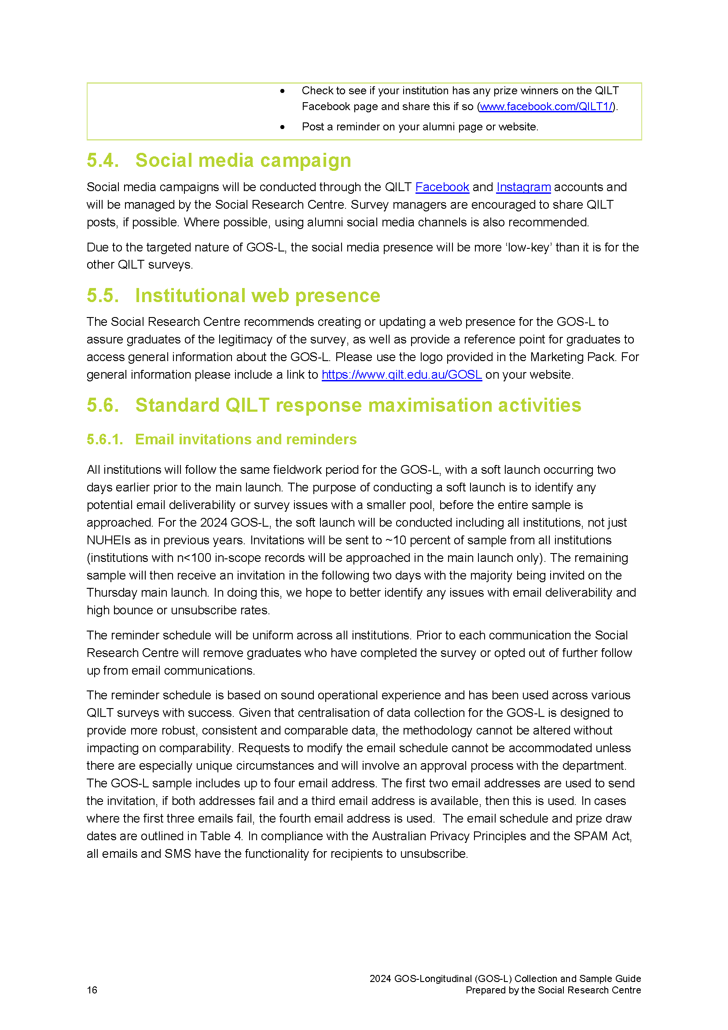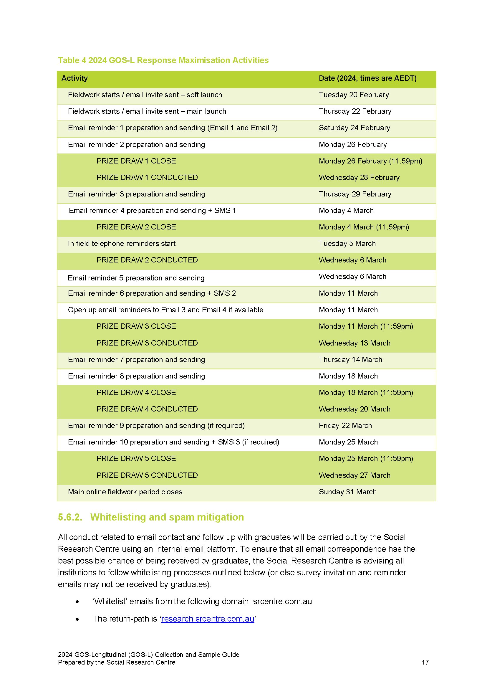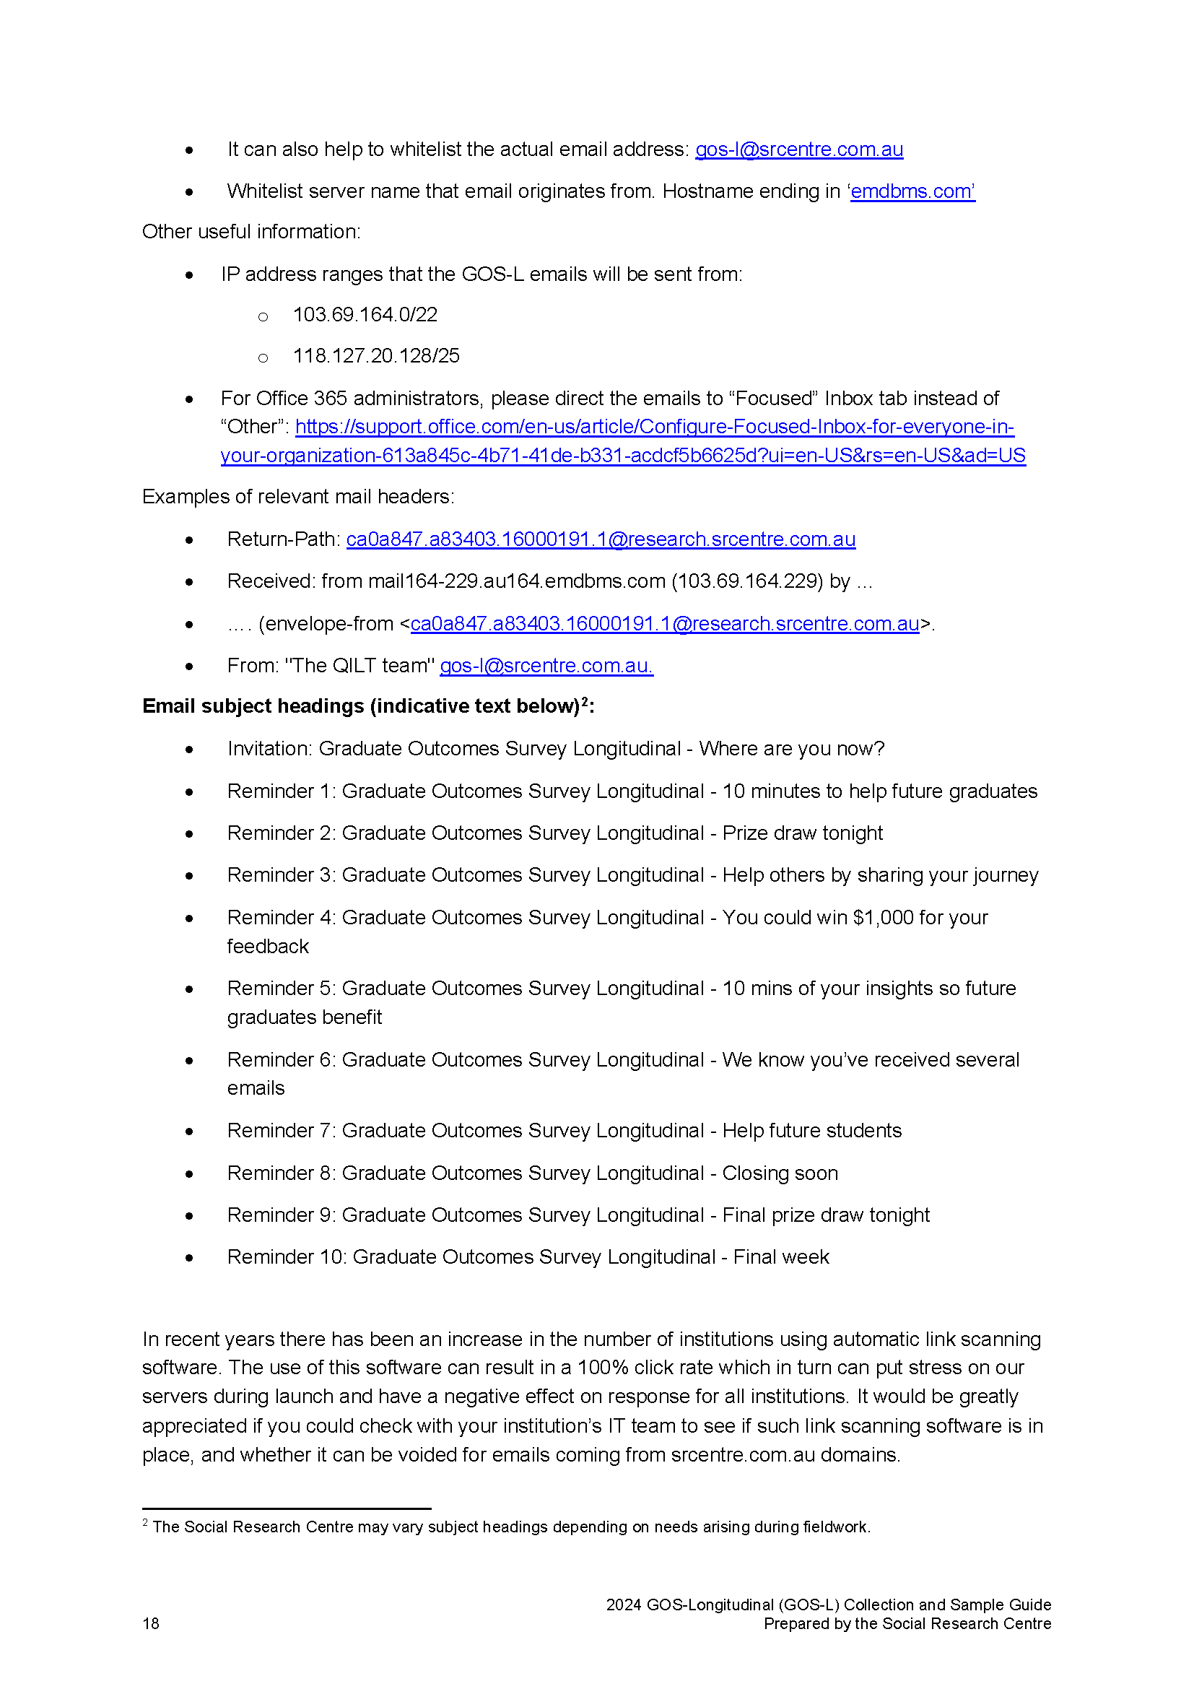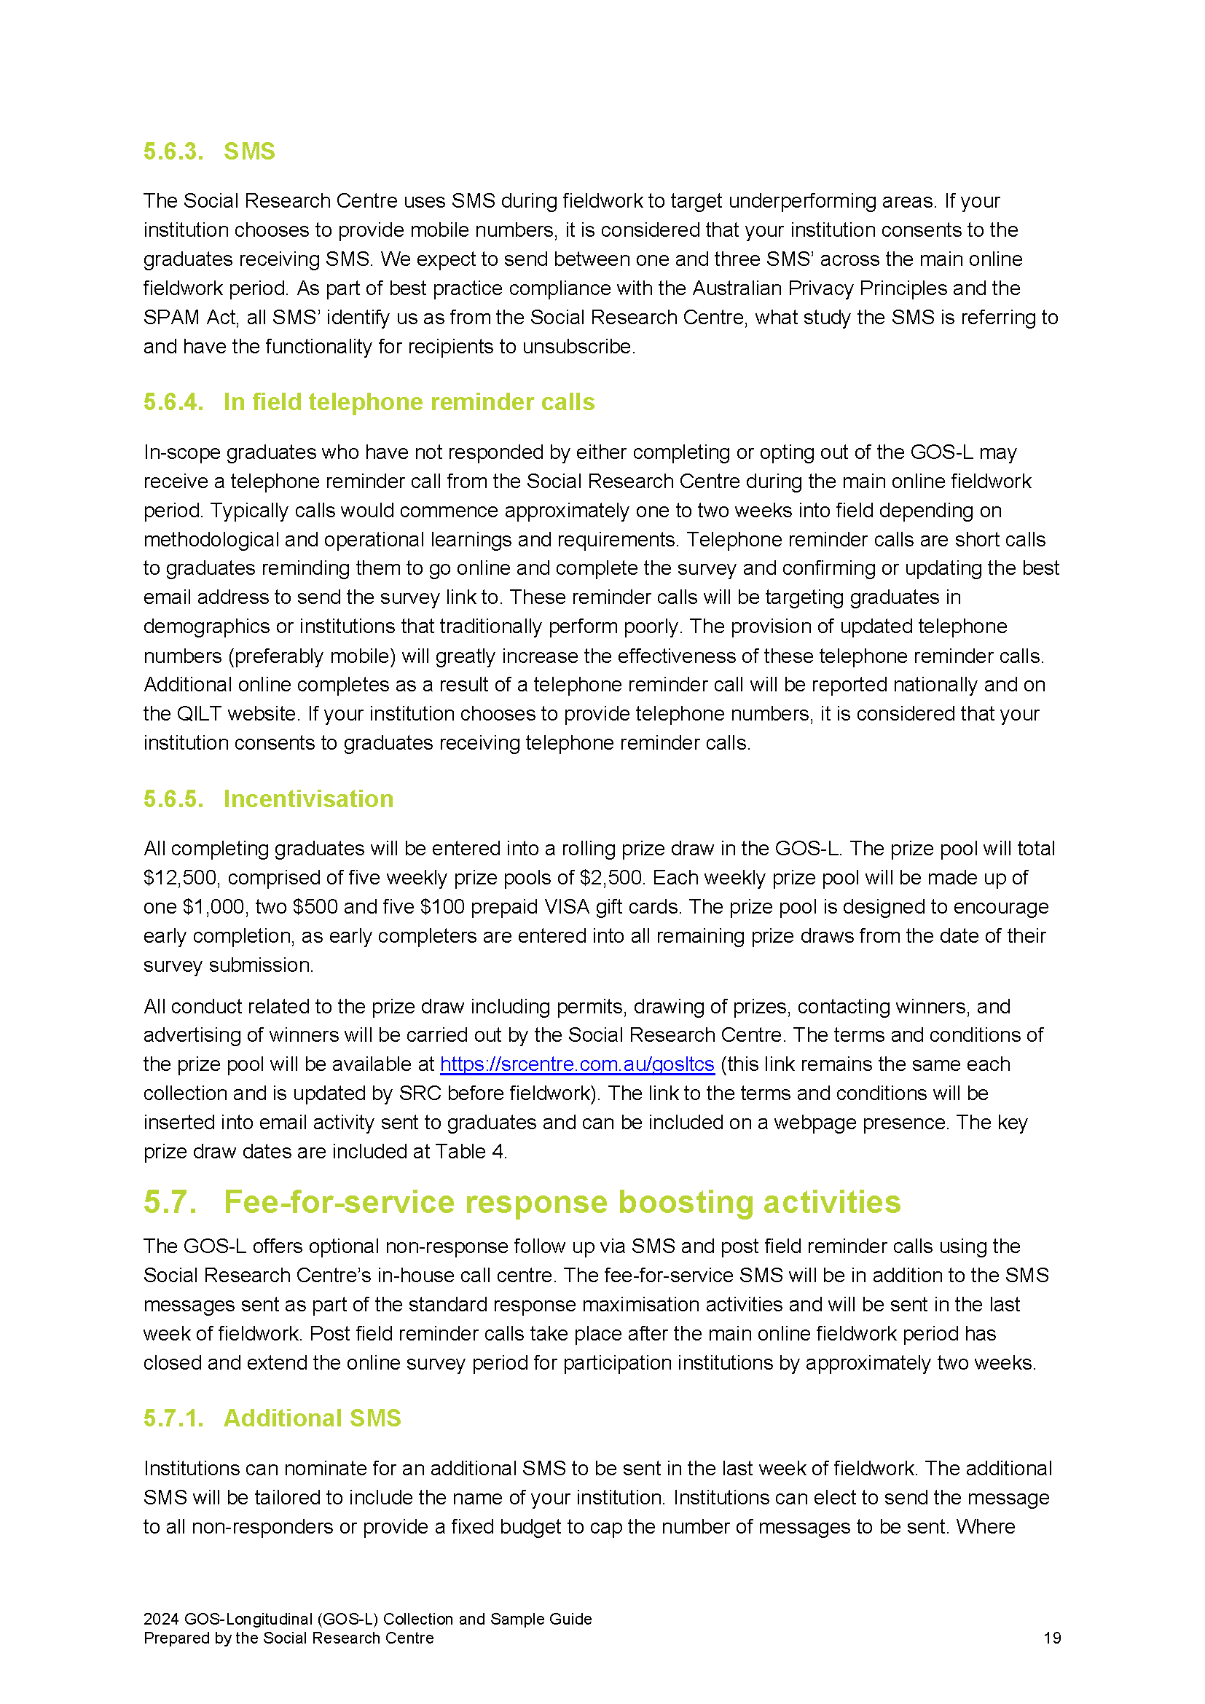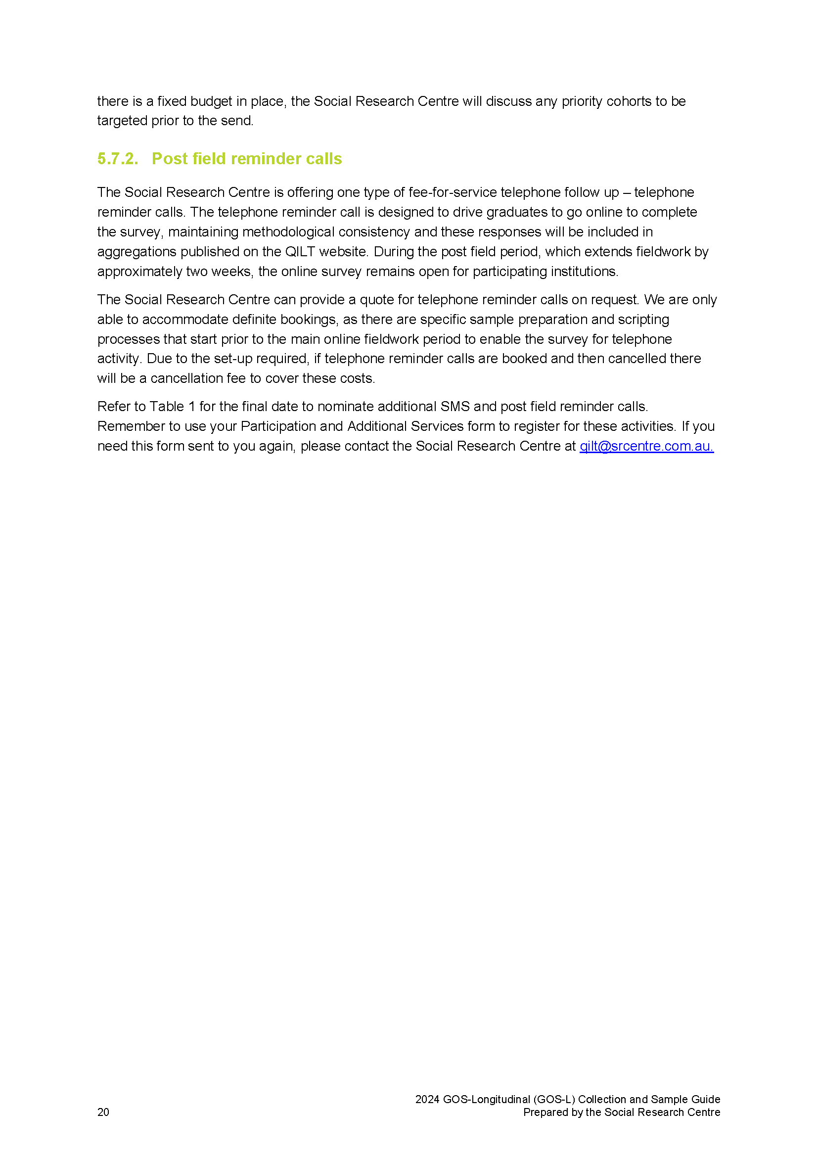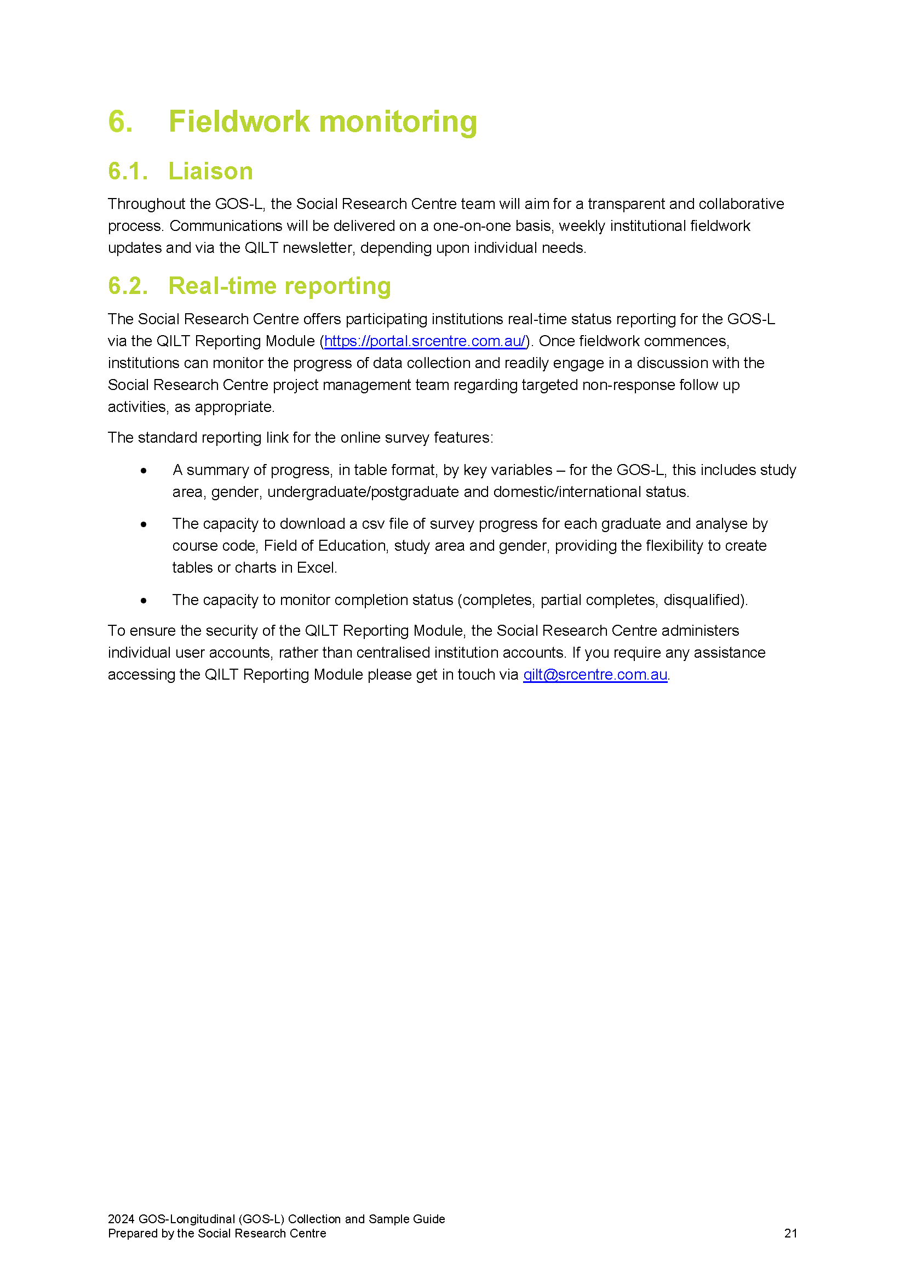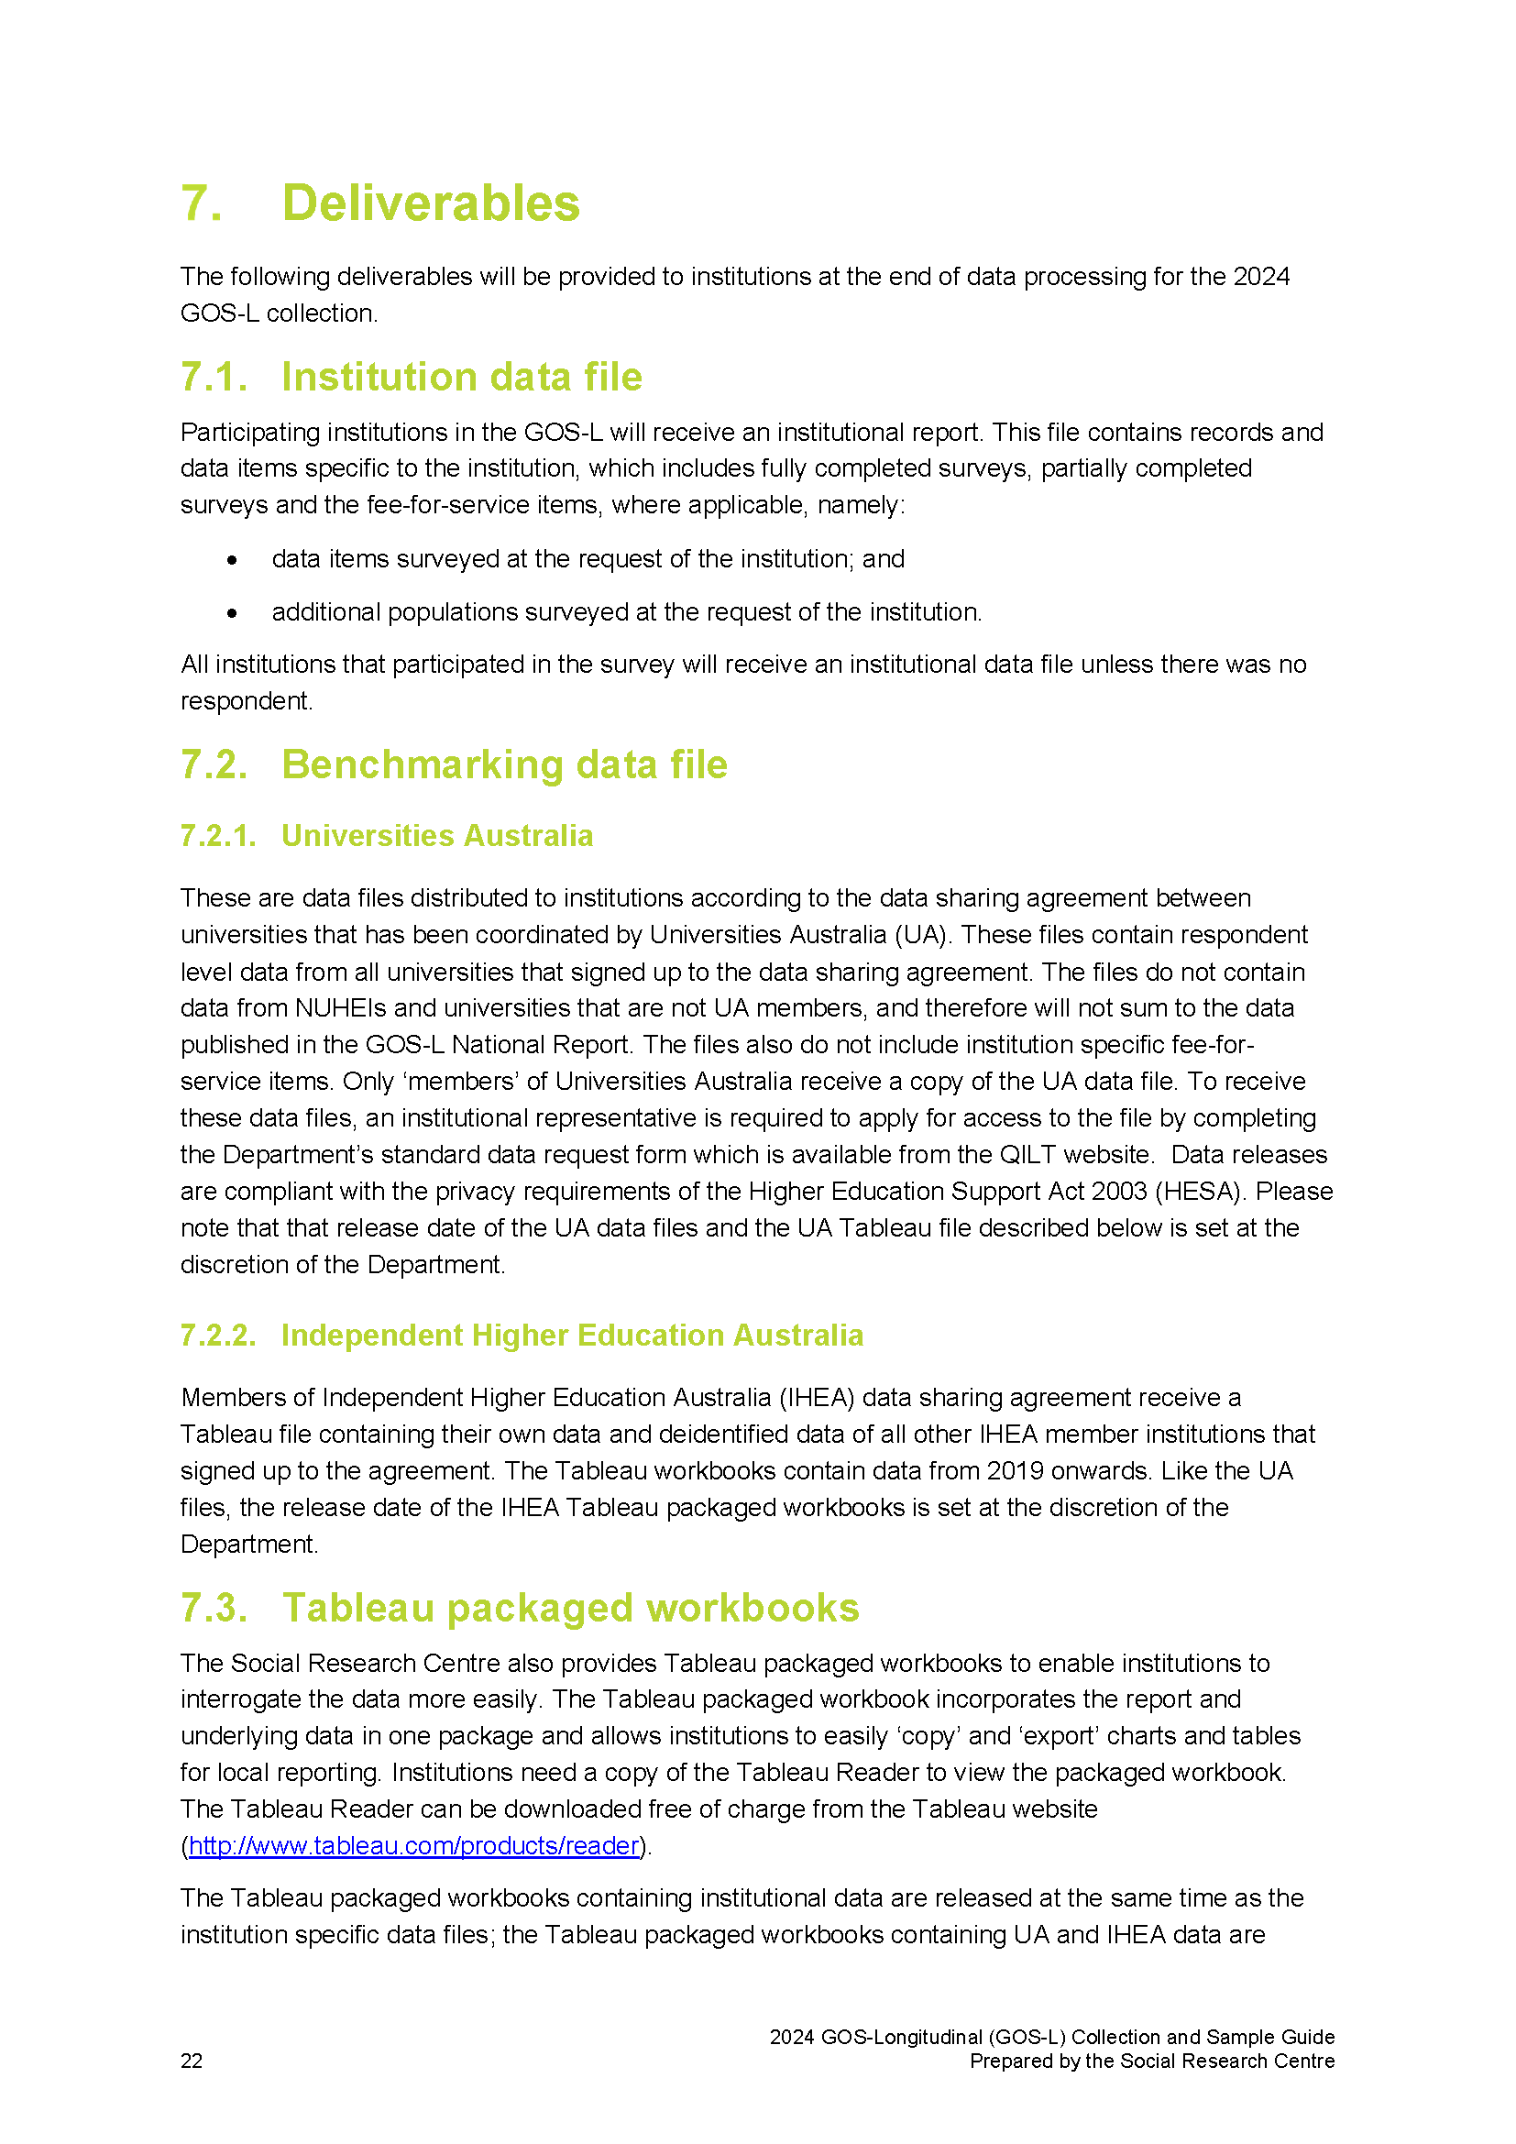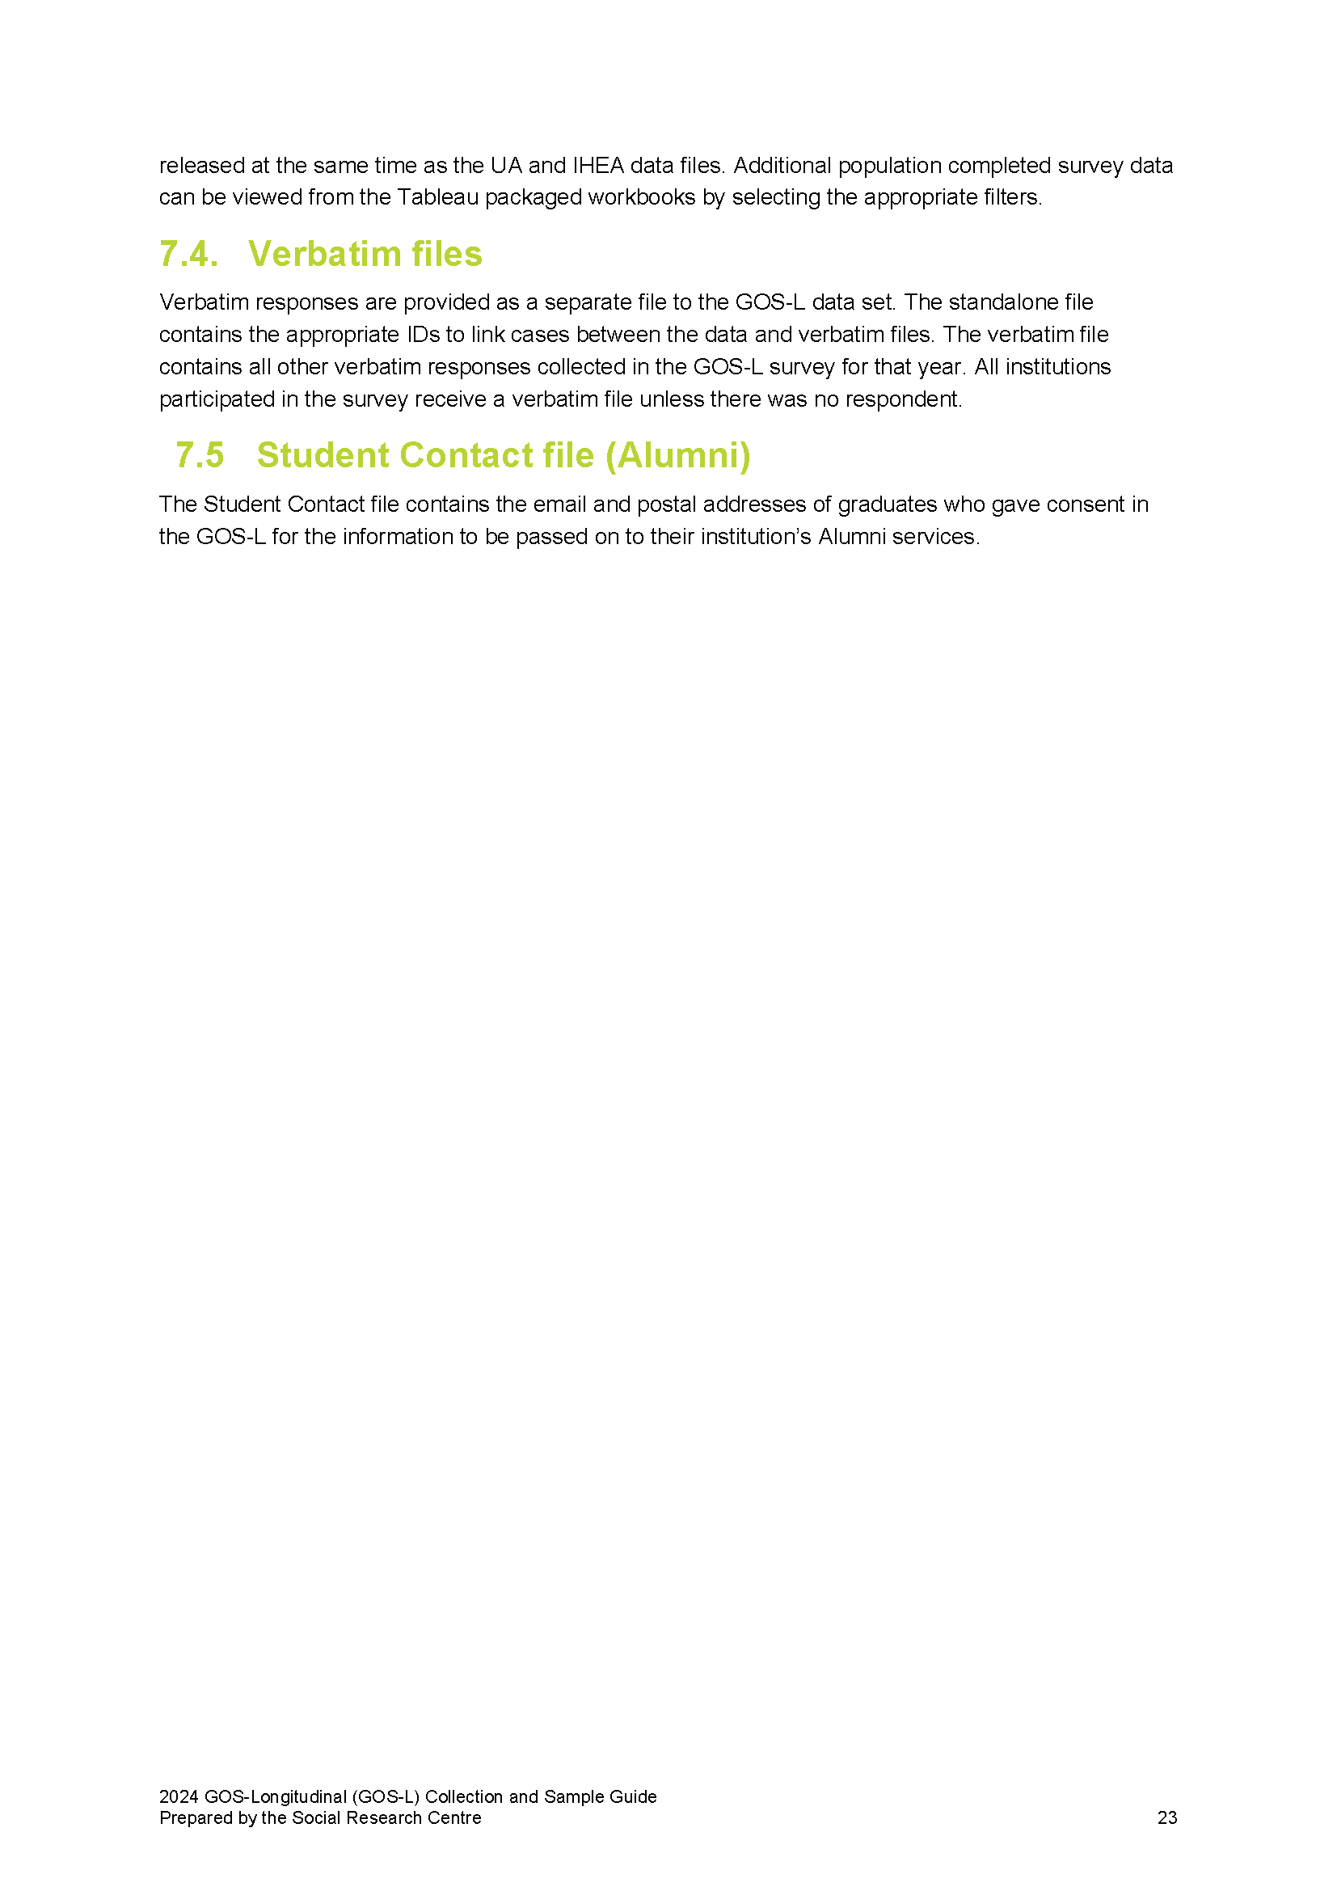

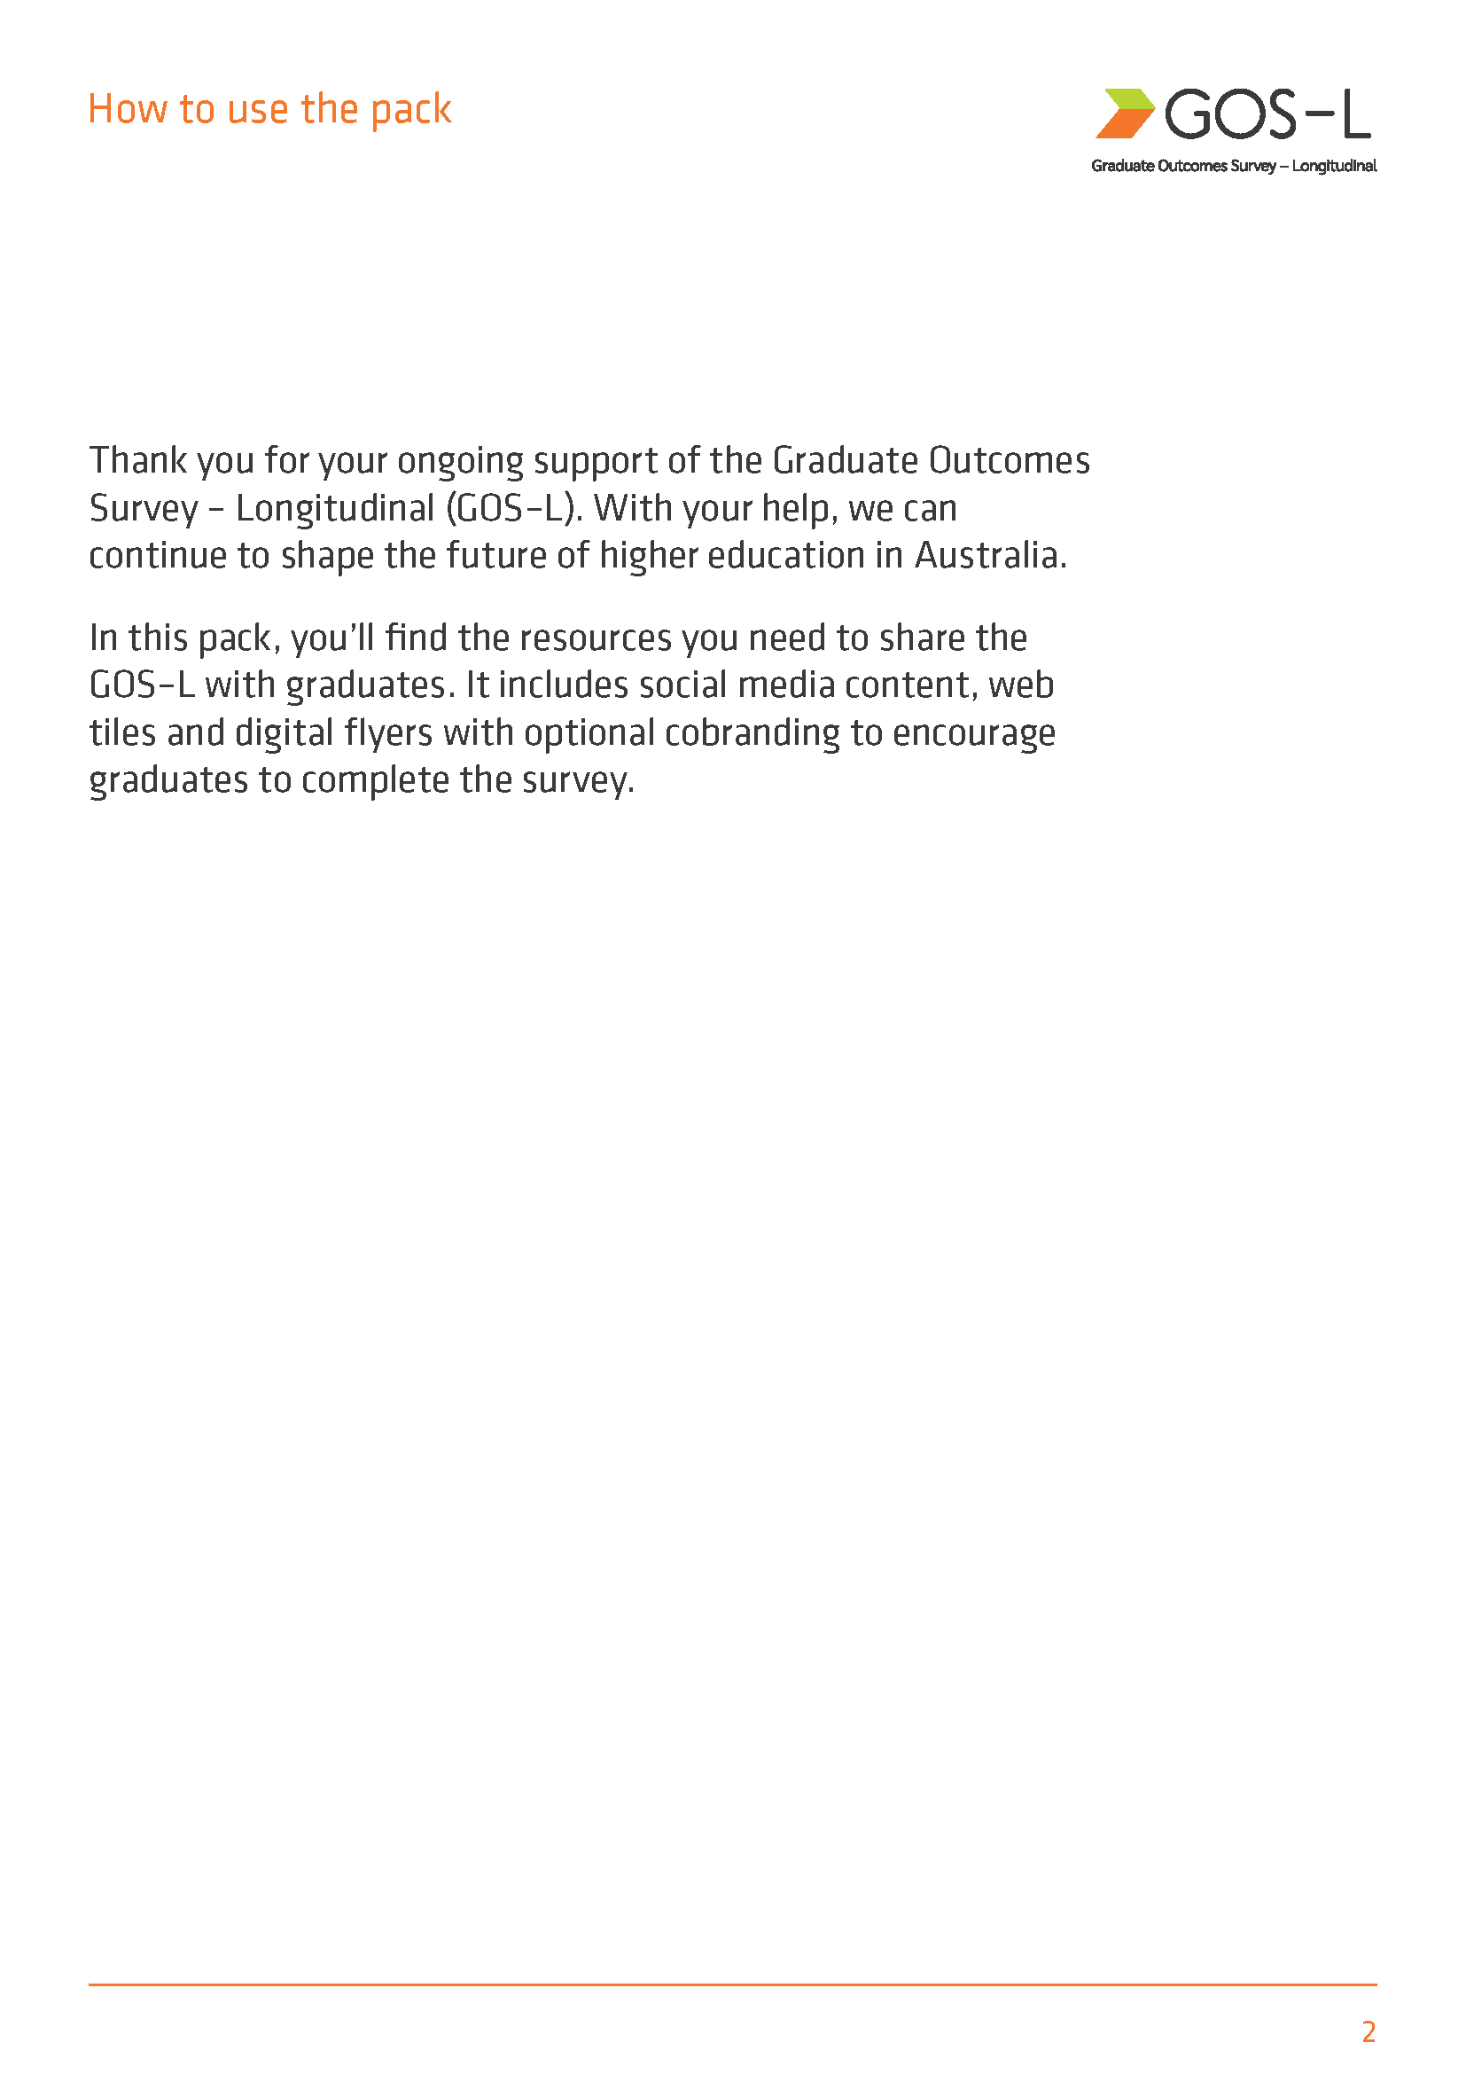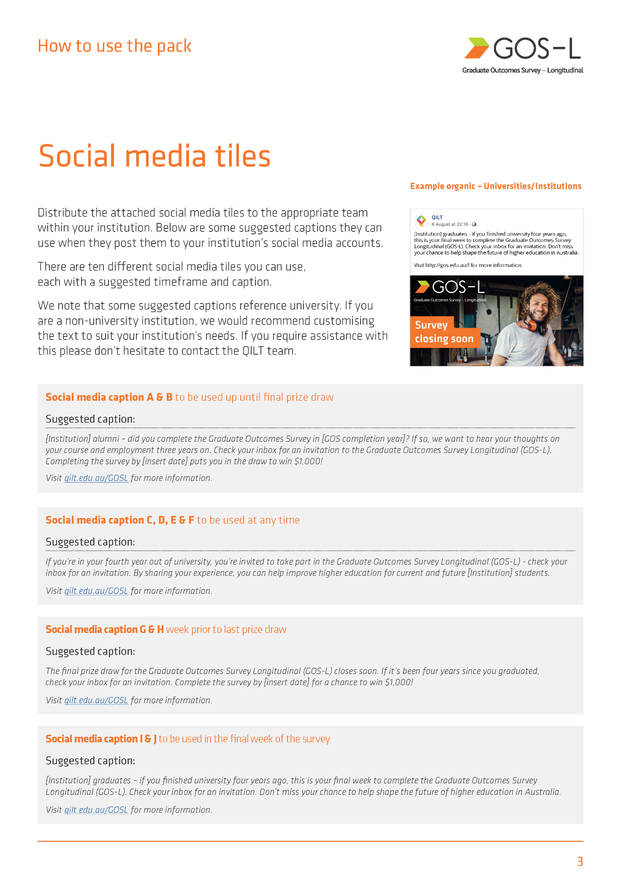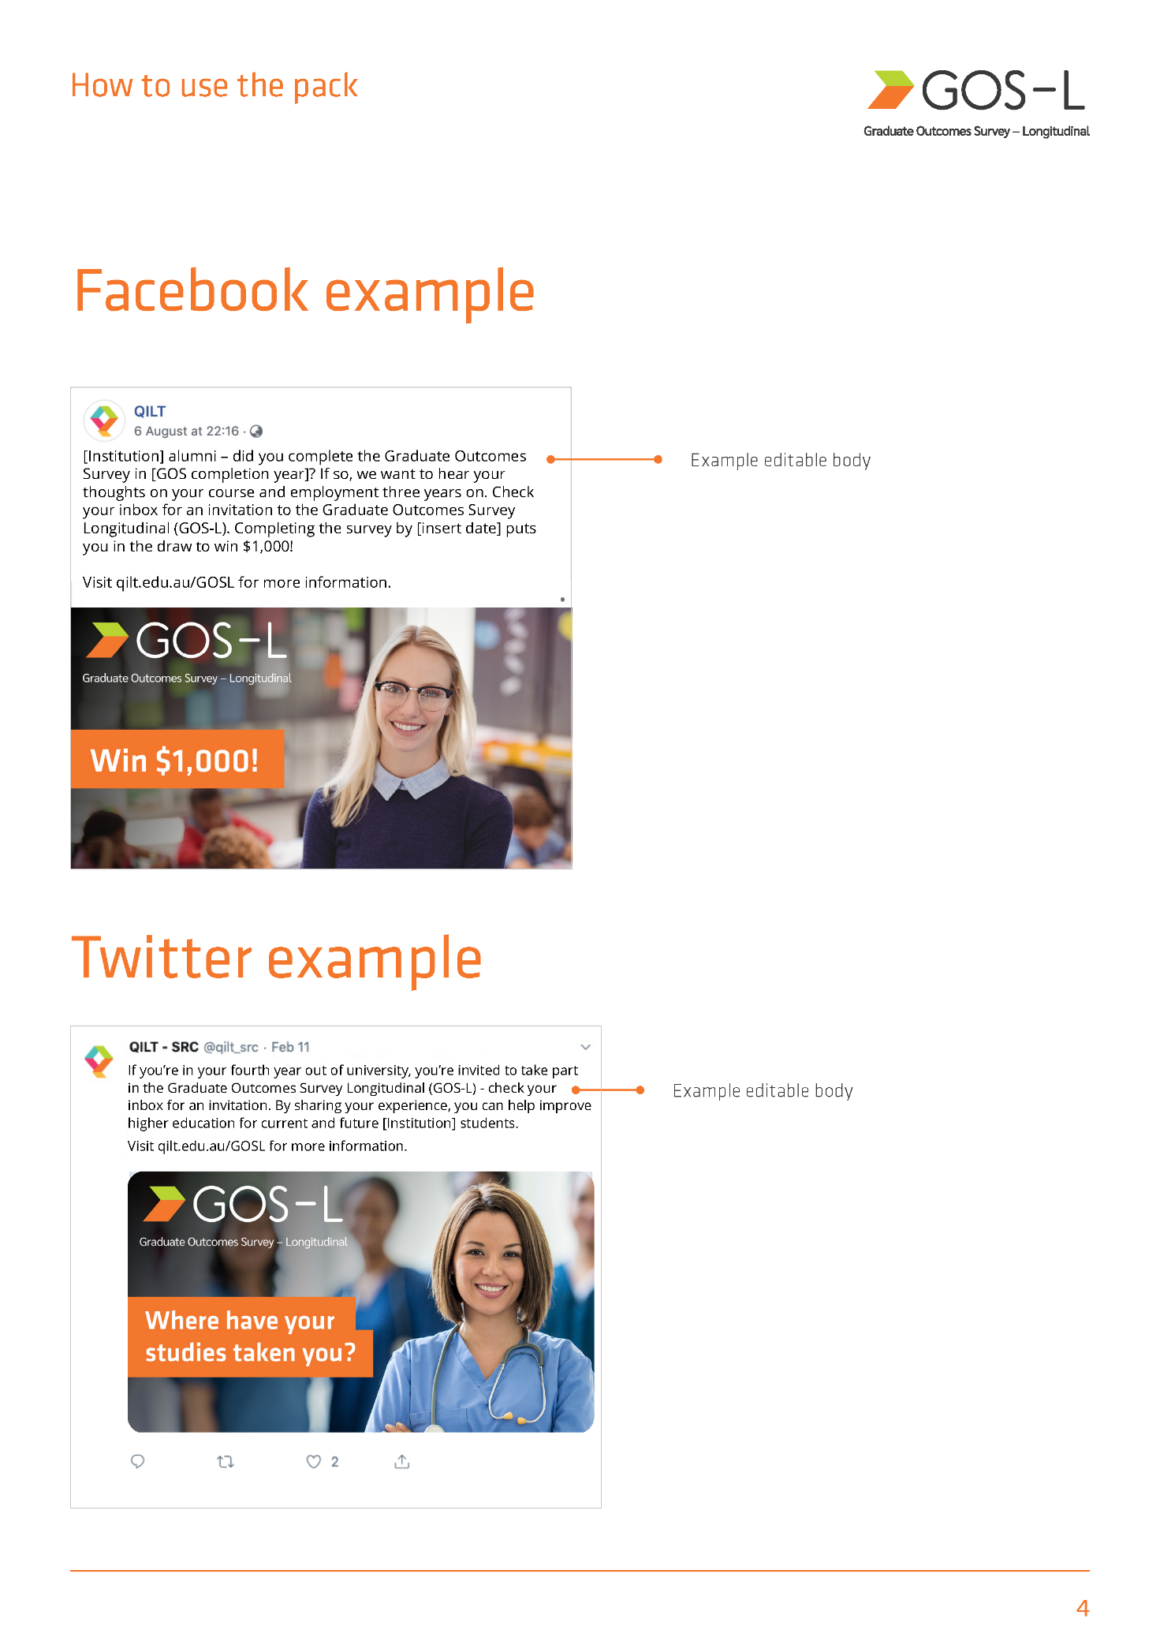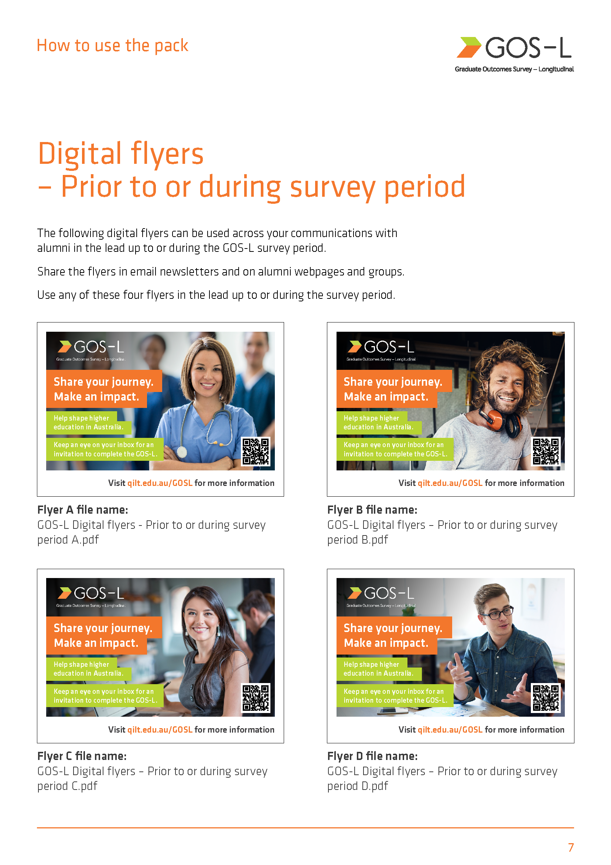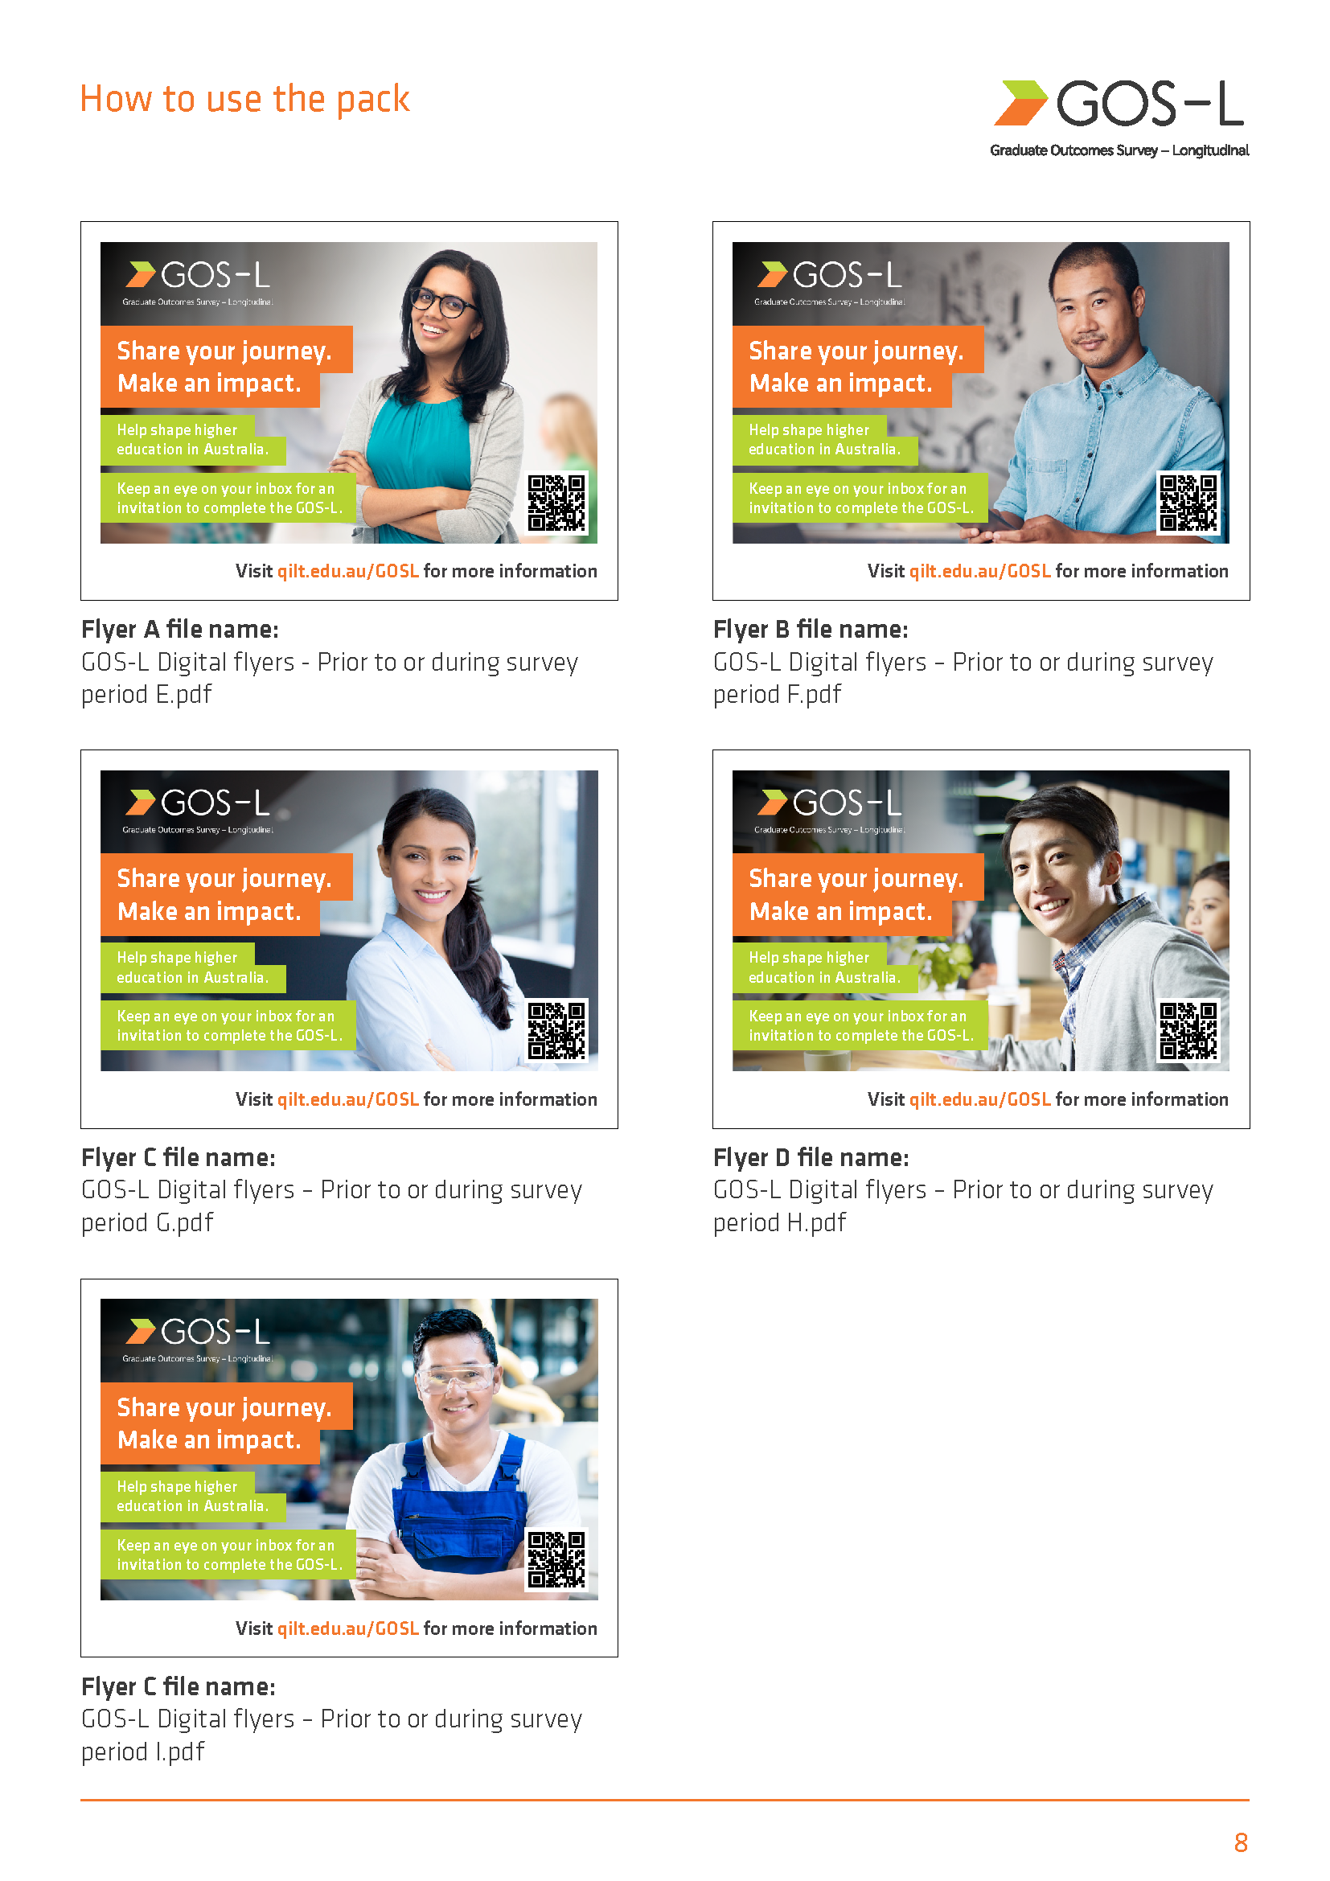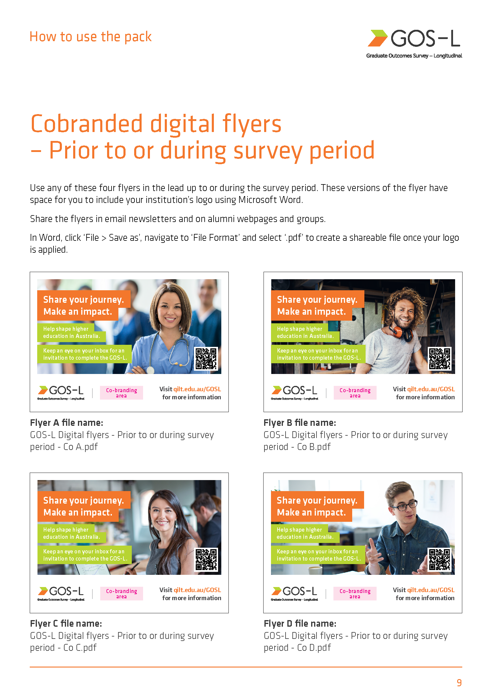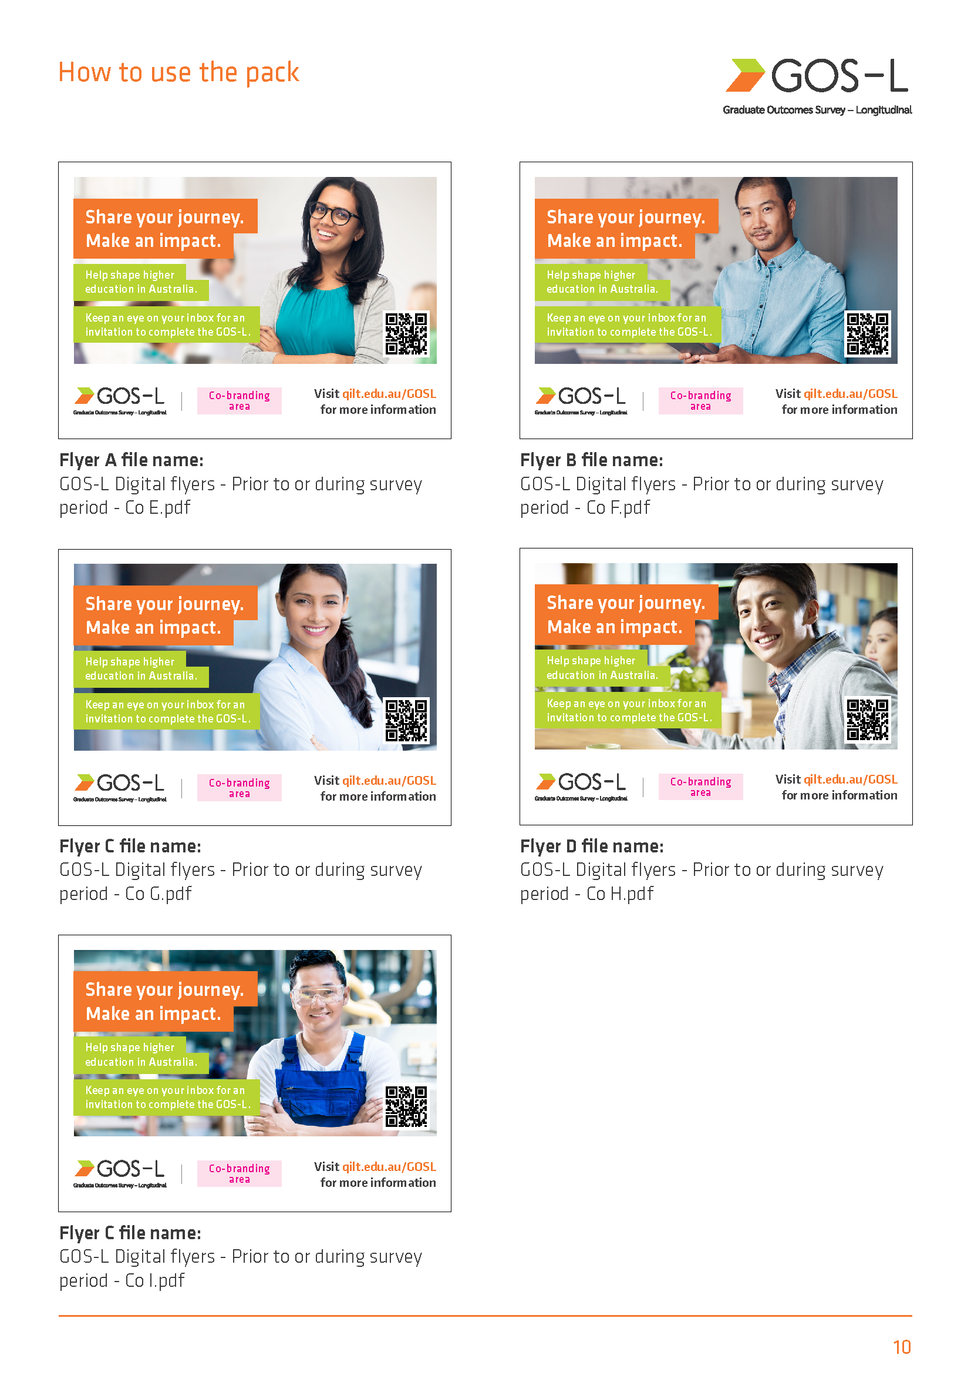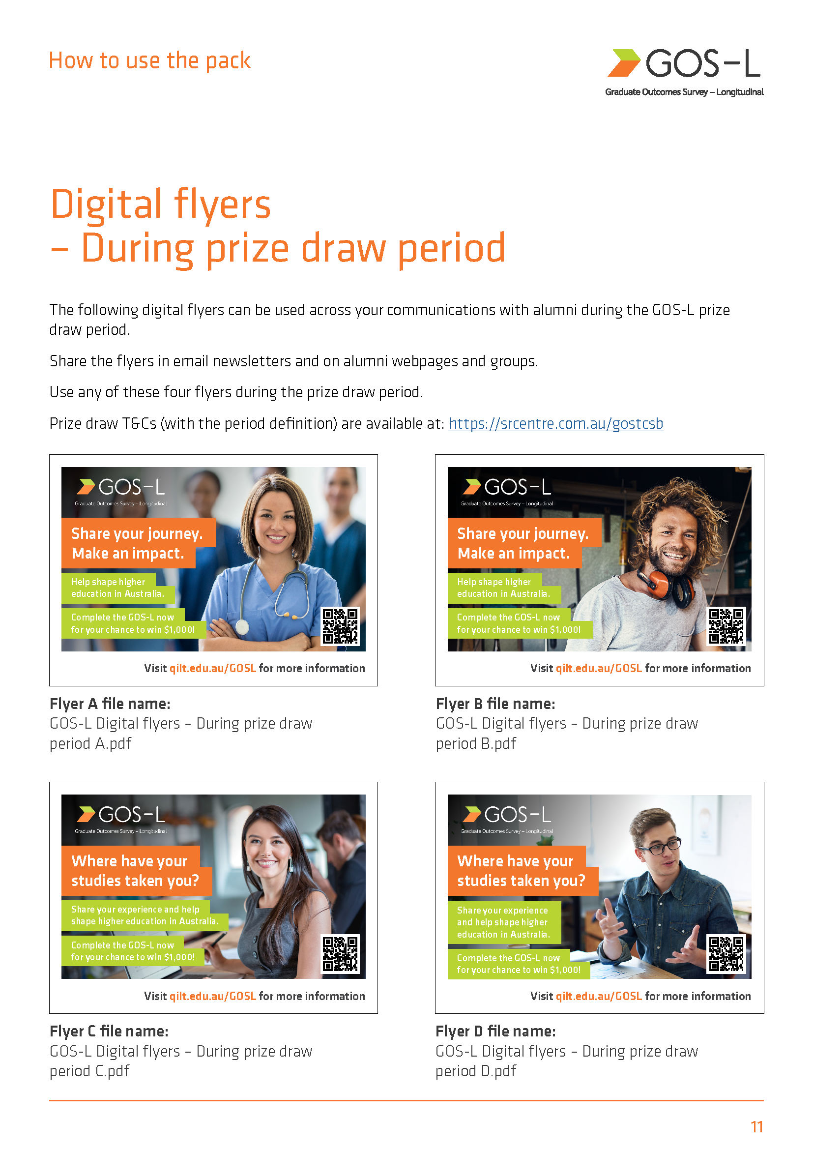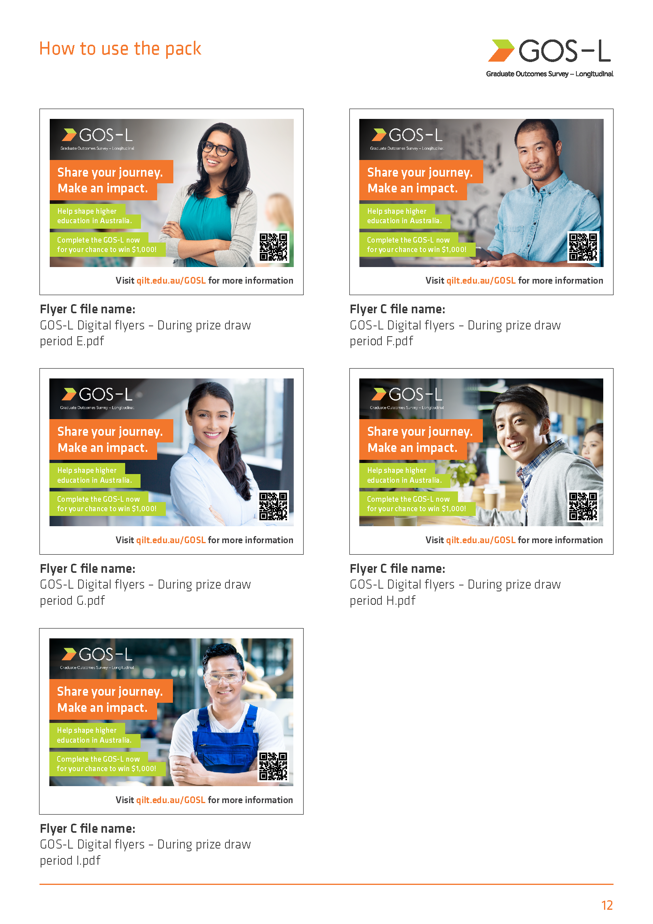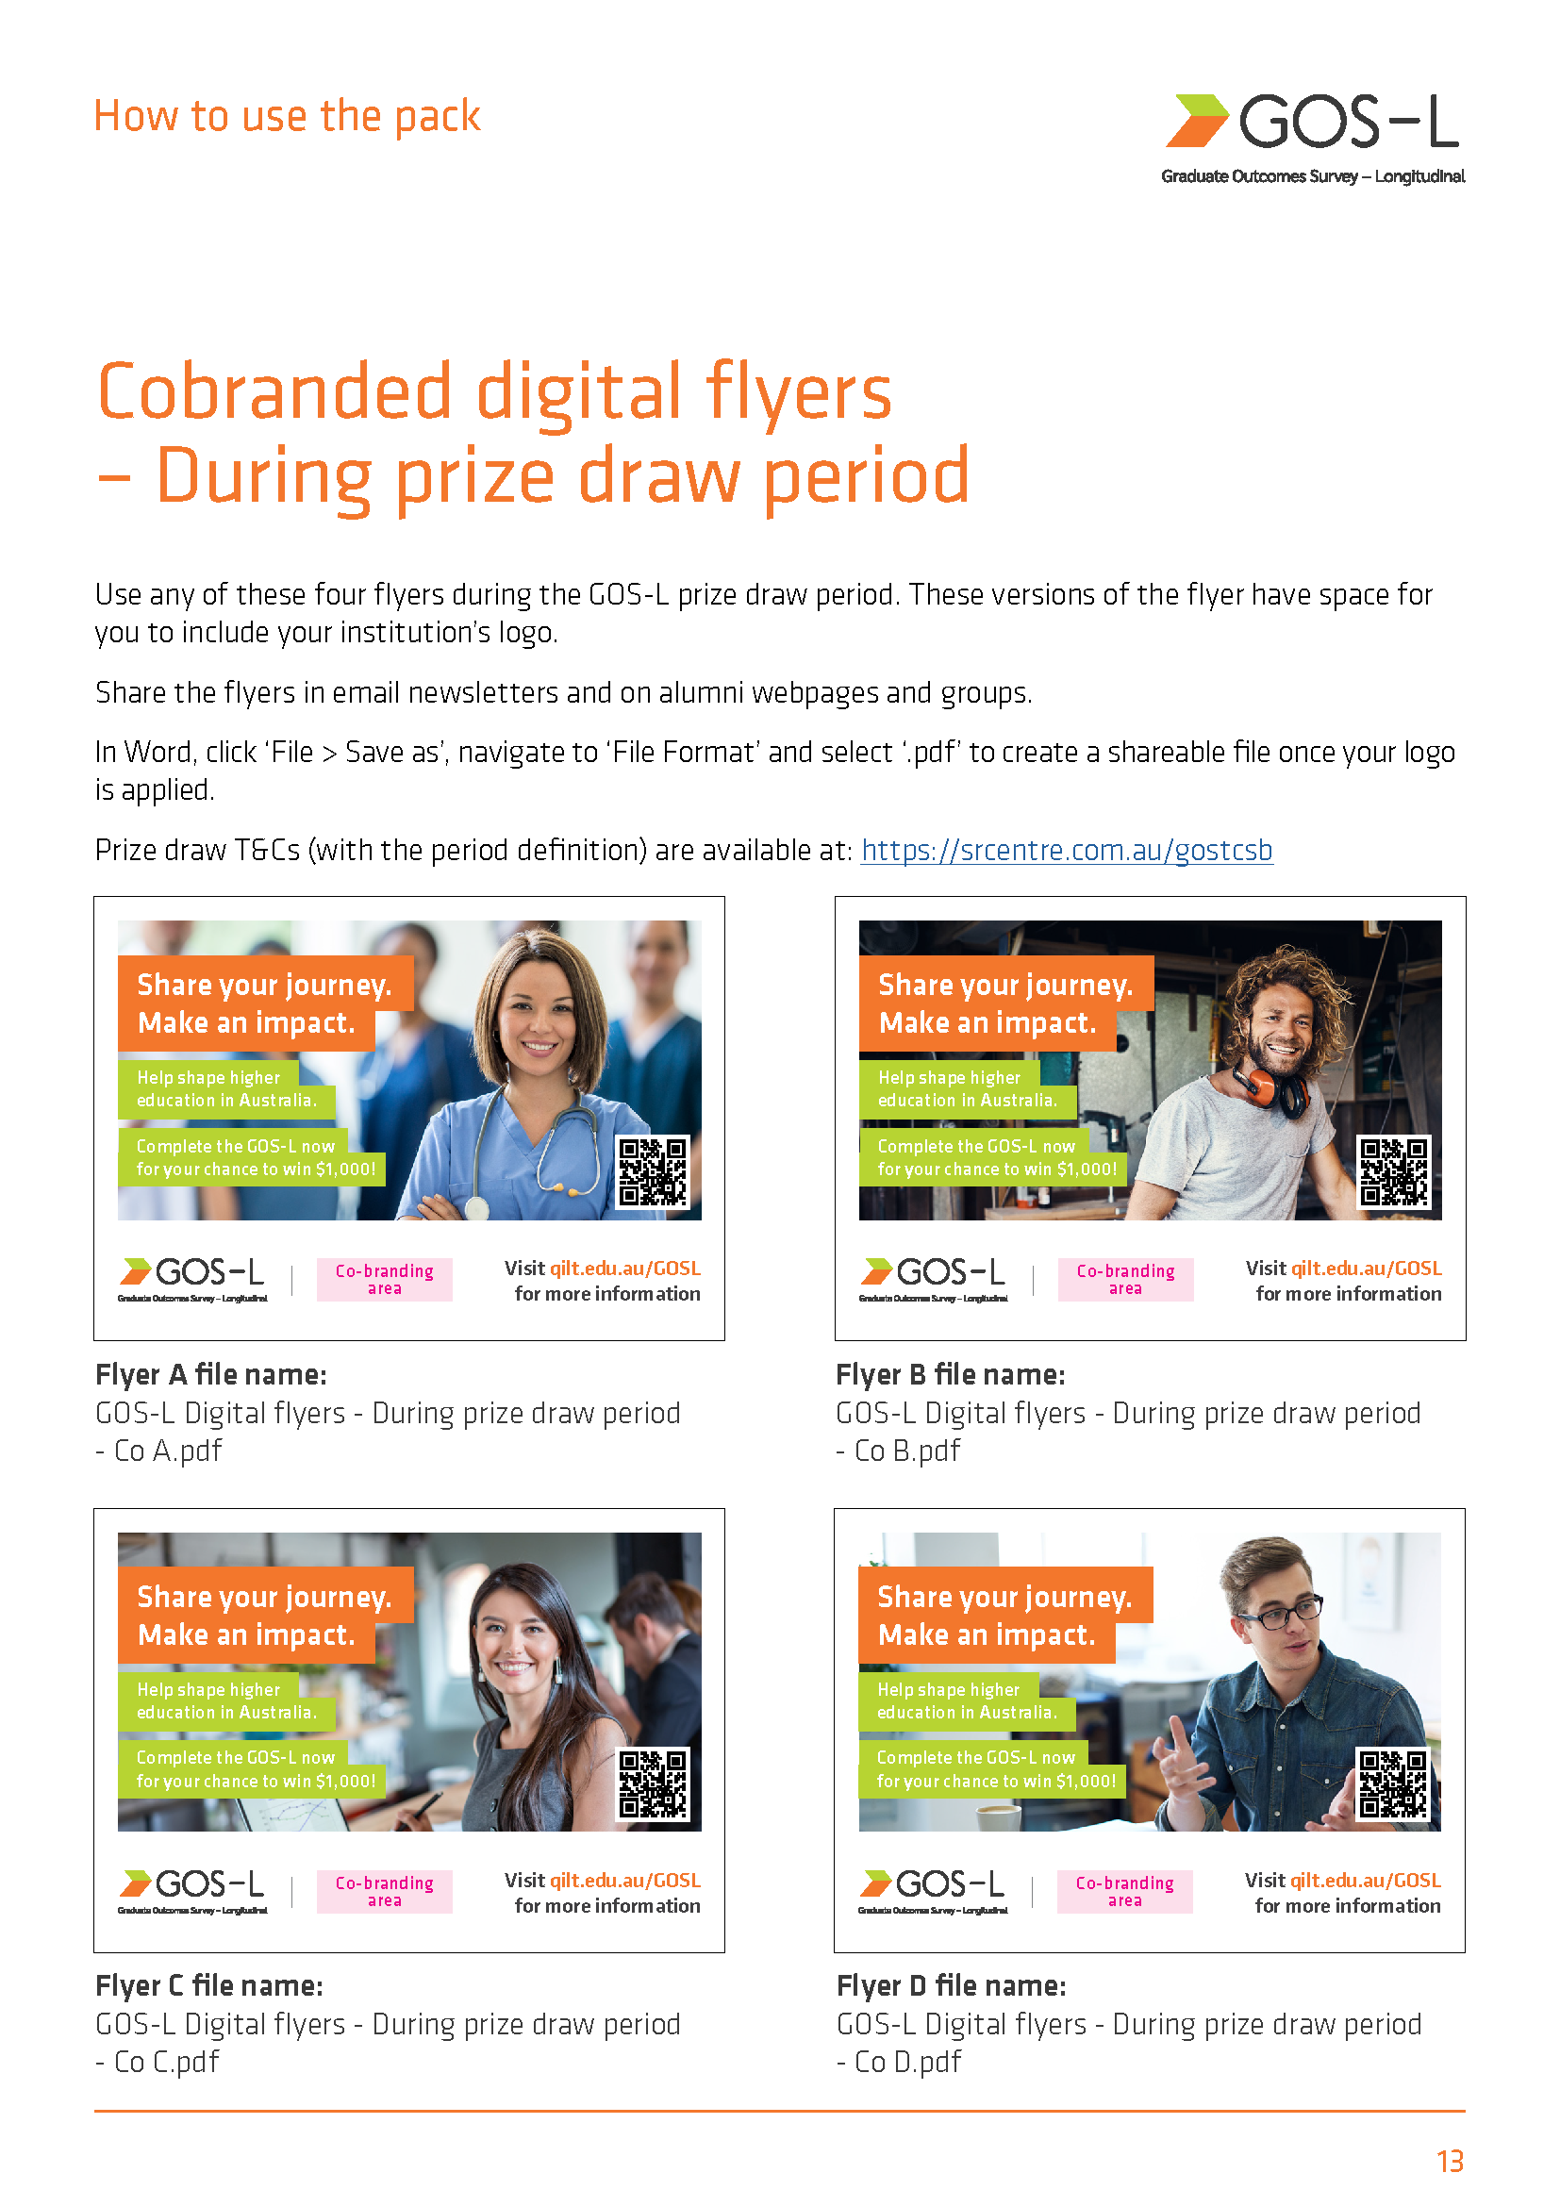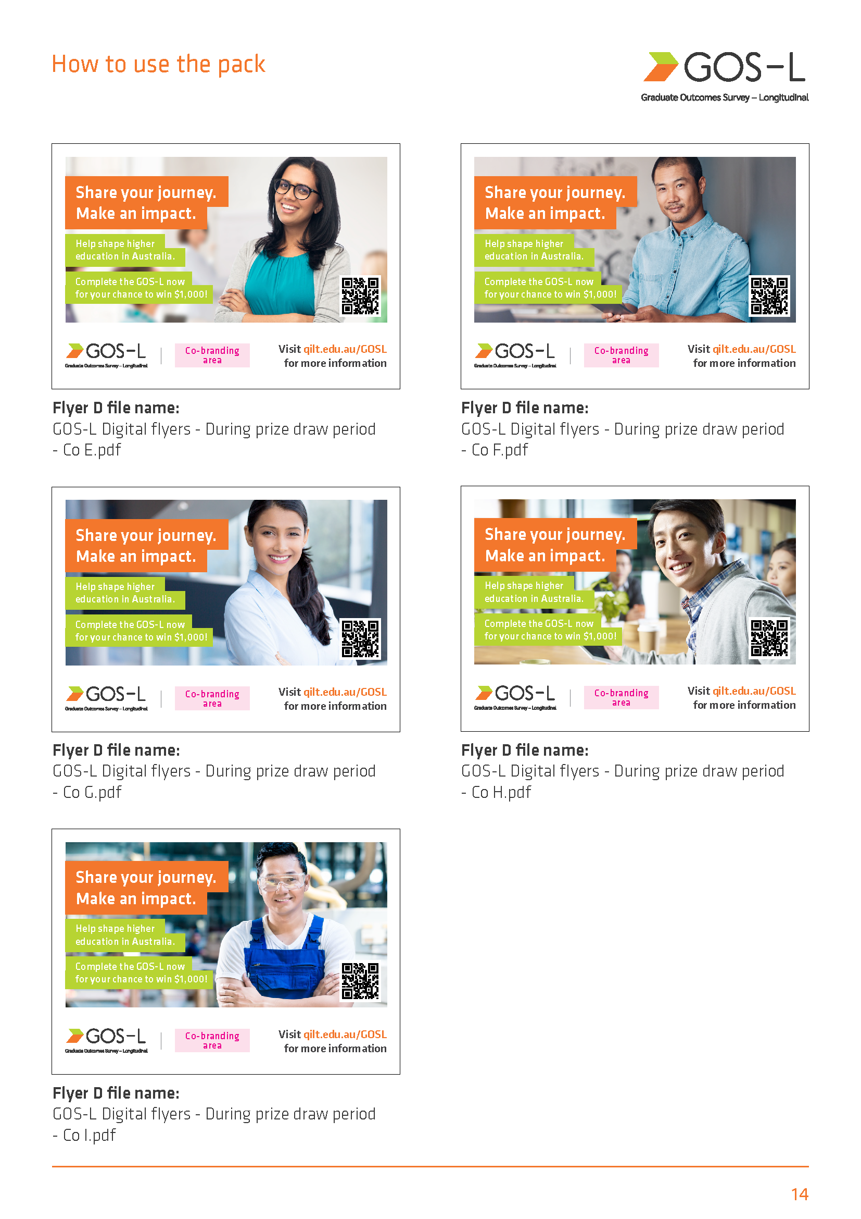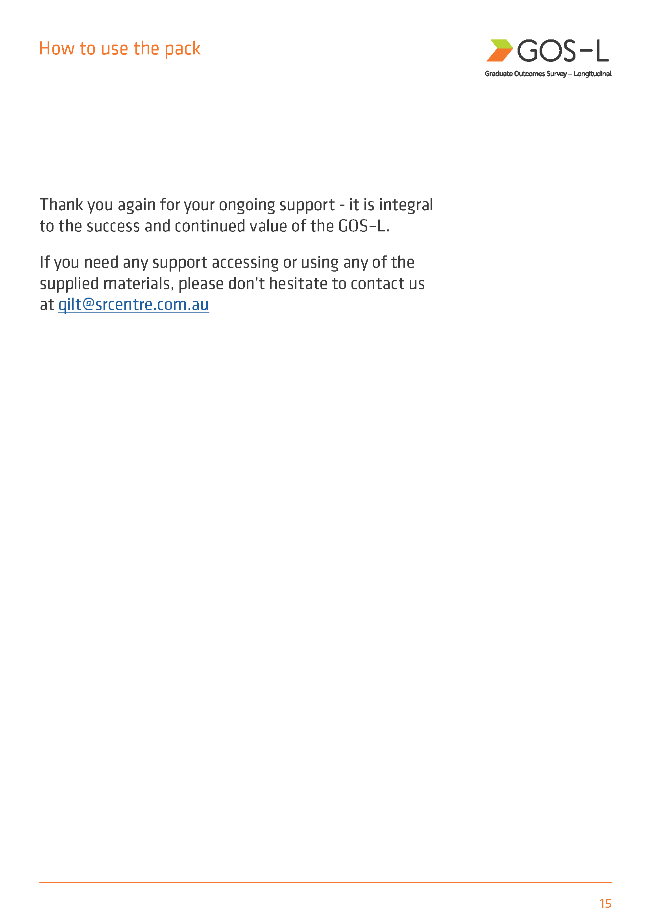

Appendix 2 Participating institutions
Provider Code | Institution Name | Total Sample (n)
3006 | Australian Catholic University | 2466
2252 | Avondale University | 89
3003 | Bond University | 413
2200 | Central Queensland University | 1445
3001 | Charles Darwin University | 860
3005 | Charles Sturt University | 2594
2236 | Curtin University | 2253
3030 | Deakin University | 4031
2235 | Edith Cowan University | 1855
2154 | Federation University Australia | 1205
3029 | Flinders University | 1811
3032 | Griffith University | 2660
1019 | James Cook University | 1269
3020 | La Trobe University | 2100
3025 | Macquarie University | 2323
3035 | Monash University | 5604
1034 | Murdoch University | 1163
3042 | Queensland University of Technology | 3713
3034 | RMIT University | 3974
3038 | Southern Cross University | 1157
2177 | Swinburne University of Technology | 2144
3033 | The Australian National University | 1787
3010 | The University of Adelaide | 2281
3036 | The University of Melbourne | 6101
3044 | The University of Notre Dame Australia | 716
3019 | The University of Queensland | 3733
3027 | The University of South Australia | 2014
3040 | The University of Sydney | 4479
1055 | The University of Western Australia | 1700
4449 | Torrens University | 1669
2241 | University of Canberra | 1029
4331 | University of Divinity | 170
3039 | University of New England | 1288
3013 | University of New South Wales | 2971
3014 | University of Newcastle | 1718
2201 | University of Southern Queensland | 1150
3045 | University of Tasmania | 2953
3016 | University of Technology Sydney | 2850
3043 | University of the Sunshine Coast | 1095
1058 | University of Wollongong | 1579
3007 | Victoria University | 1621
3004 | Western Sydney University | 2188
Non-University Higher Education Institutions
Provider Code | Institution Name | Total Sample (n)
6022 | Academies Australasia Polytechnic Pty Limited | 42
7124 | Academy of Information Technology | 139
4395 | Adelaide Central School of Art | 7
4355 | Adelaide College of Divinity | 9
4407 | Alphacrucis University College | 97
4456 | Asia Pacific International College | 163
4453 | Australasian College of Health and Wellness | <5
4388 | Australian Academy of Music and Performing Arts | 10
4336 | ACAP University College | 178
4347 | Australian College of Christian Studies | 9
4464 | Australian College of Nursing | 333
4335 | Australian College of Theology | 281
4425 | Australian Institute of Business Pty Ltd | 391
4435 | Australian Institute of Higher Education | 75
4458 | Australian Institute of Management Education & Training | 196
4405 | Australian Institute of Professional Counsellors | 13
6044 | BBI - The Australian Institute of Theological Education | 57
4366 | Box Hill Institute | 64
4368 | Campion College Australia | 8
4406 | Canberra Institute of Technology | 8
7073 | Chisholm Institute | 17
4333 | Christian Heritage College | 64
7025 | CIC Higher Education | 74
7001 | Collarts (Australian College of the Arts) | 10
4337 | Eastern College Australia | 9
4461 | Elite Education Institute | 139
4361 | Endeavour College of Natural Health | 52
4469 | Engineering Institute of Technology | 82
4346 | Excelsia University College | 21
4392 | Gestalt Therapy Brisbane | 9
6014 | Governance Institute of Australia | 13
7660 | Health Education and Training Institute | 27
6068 | HEPCO The Tax Institute Higher Education | 5
6047 | Higher Education Leadership Institute | 898
4339 | Holmes Institute | 63
4383 | Holmesglen Institute | 31
4362 | ICHM | 18
7197 | Ikon Institute of Australia | 38
4463 | Institute of Health & Management Pty Ltd | 50
4381 | International College of Management, Sydney | 128
6045 | ISN Psychology Pty Ltd | <5
7014 | Jazz Music Institute | 346
4384 | Kaplan Business School | 201
4424 | Kaplan Higher Education Pty Ltd | 85
4420 | Kent Institute Australia | 263
4451 | King's Own Institute | 12
4396 | LCI Melbourne | 18
4421 | Le Cordon Bleu Australia | 180
4402 | Leo Cussen Centre for Law | 45
2170 | Marcus Oldham College | 238
4367 | Melbourne Institute of Technology | 95
4363 | Melbourne Polytechnic | 11
4431 | Montessori World Educational Institute (Australia) | 41
4338 | Moore Theological College | 10
4412 | Morling College | 19
4428 | Nan Tien Institute | 38
4419 | National Art School | 7
6046 | National Institute of Organisation Dynamics Aust | 6
6042 | Ozford Institute of Higher Education | 8
4360 | Perth Bible College | 13
7035 | Photography Studies College (Melbourne) | 15
4467 | Polytechnic Institute Australia Pty Ltd | 250
4371 | SAE University College | 42
4455 | SP Jain School of Management | 20
4411 | Acknowledge Education | <5
7116 | Study Group Australia Pty Limited | 105
4334 | Tabor College of Higher Education | 33
7075 | TAFE NSW | 9
4450 | TAFE Queensland | 57
7338 | TAFE South Australia | 23
4352 | The Australian College of Physical Education | <5
4382 | The Australian Guild of Music Education | 26
4343 | The Australian Institute of Music | 38
6043 | The Cairnmillar Institute | 1111
4359 | The College of Law Limited | 17
4386 | The Institute of Creative Arts and Technology | <5
6049 | The Institute of International Studies (TIIS) | 15
4393 | The MIECAT Institute | 113
4375 | Think Education | 40
4377 | UOW College | 206
4380 | UTS College | 470
7221 | VIT (Victorian Institute of Technology) | 67
4434 | Wentworth Institute of Higher Education | <5
4401 | Whitehouse Institute of Design, Australia | 34
4394 | William Angliss Institute | 24

Appendix 3 Survey invitations and reminders
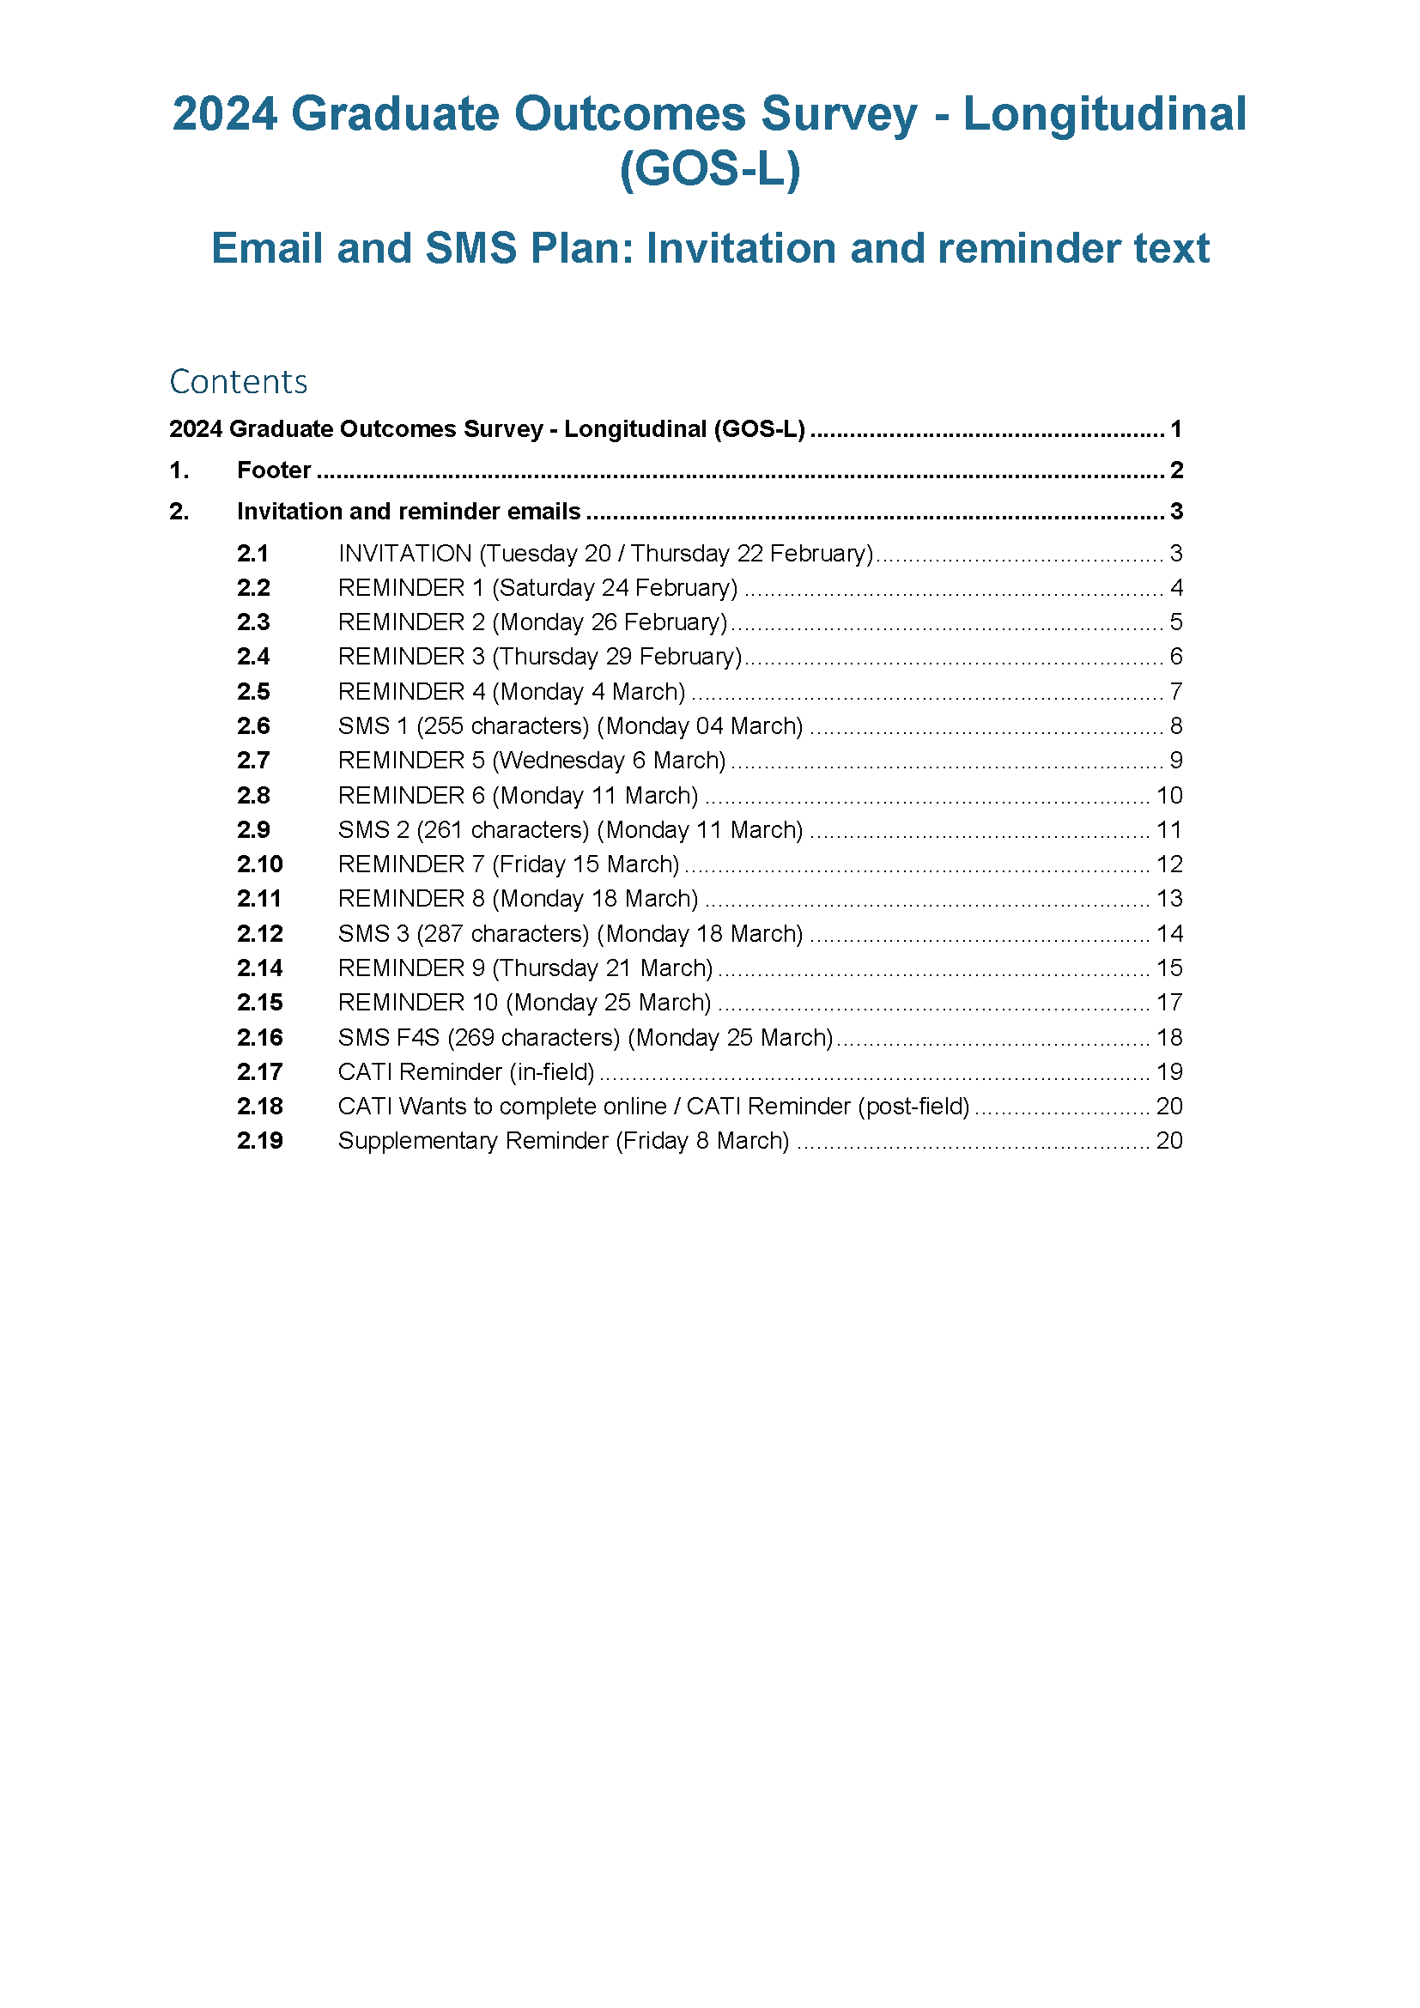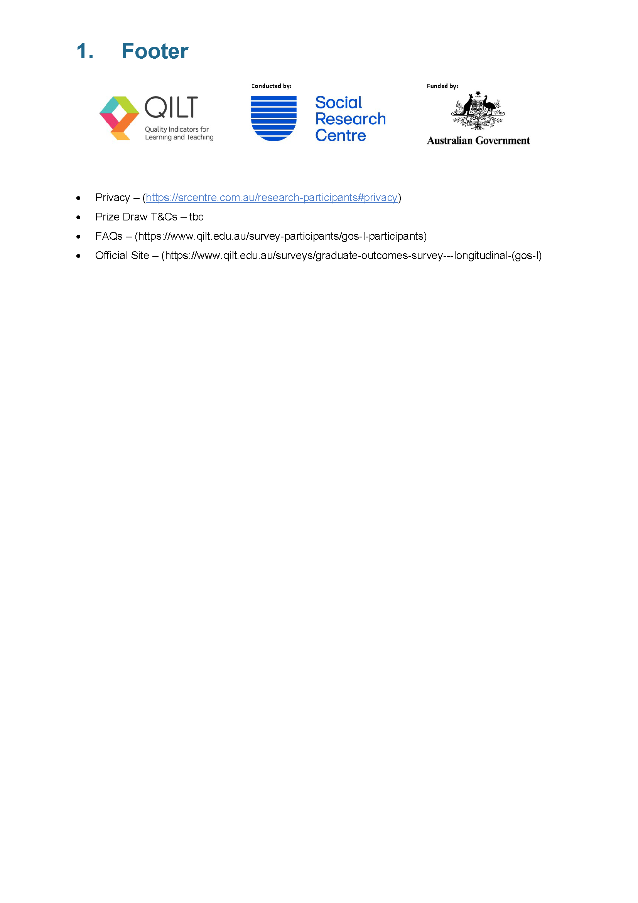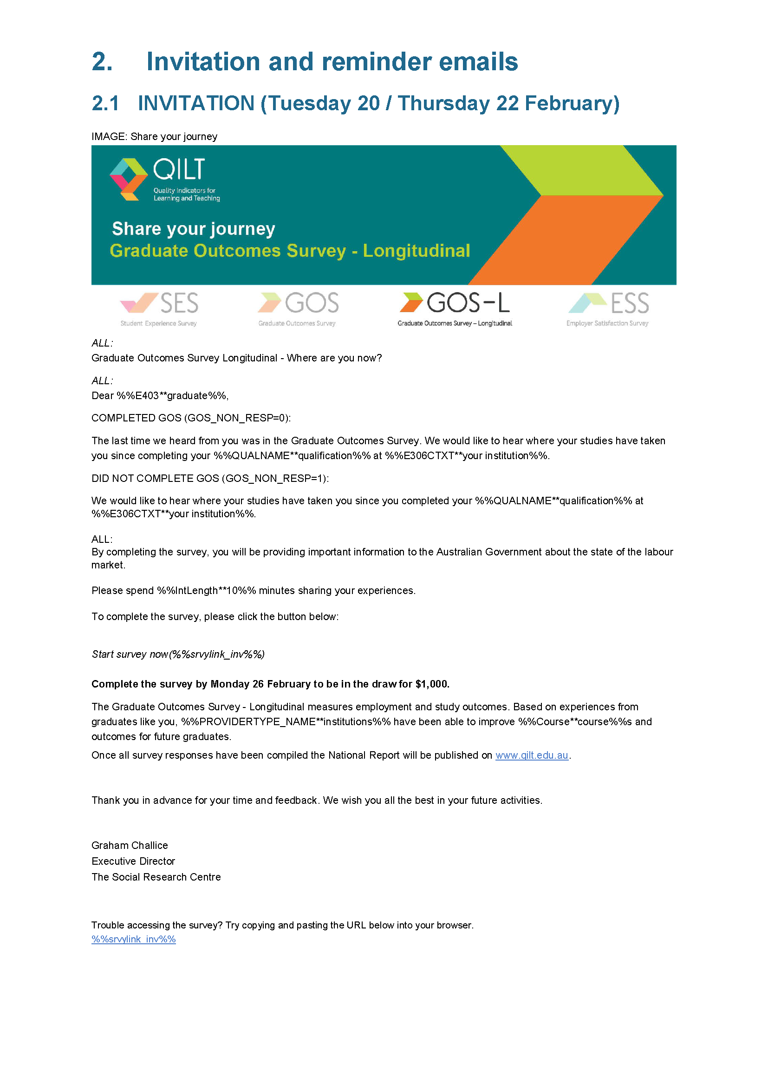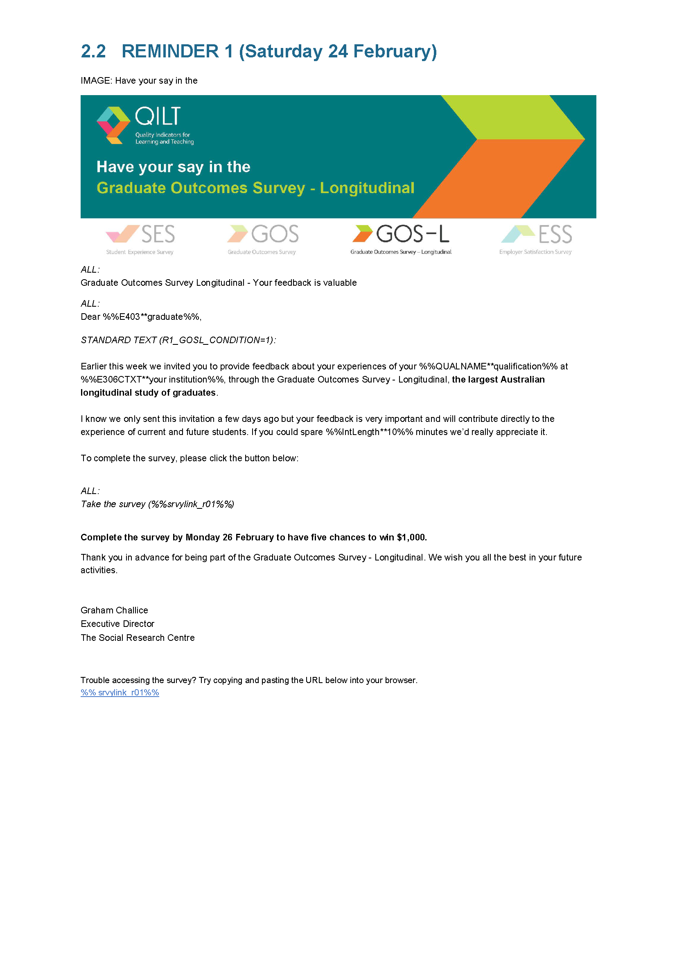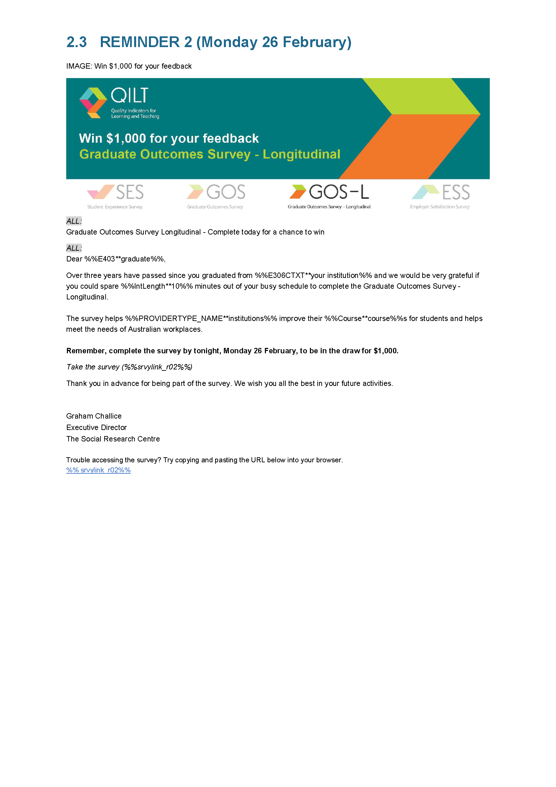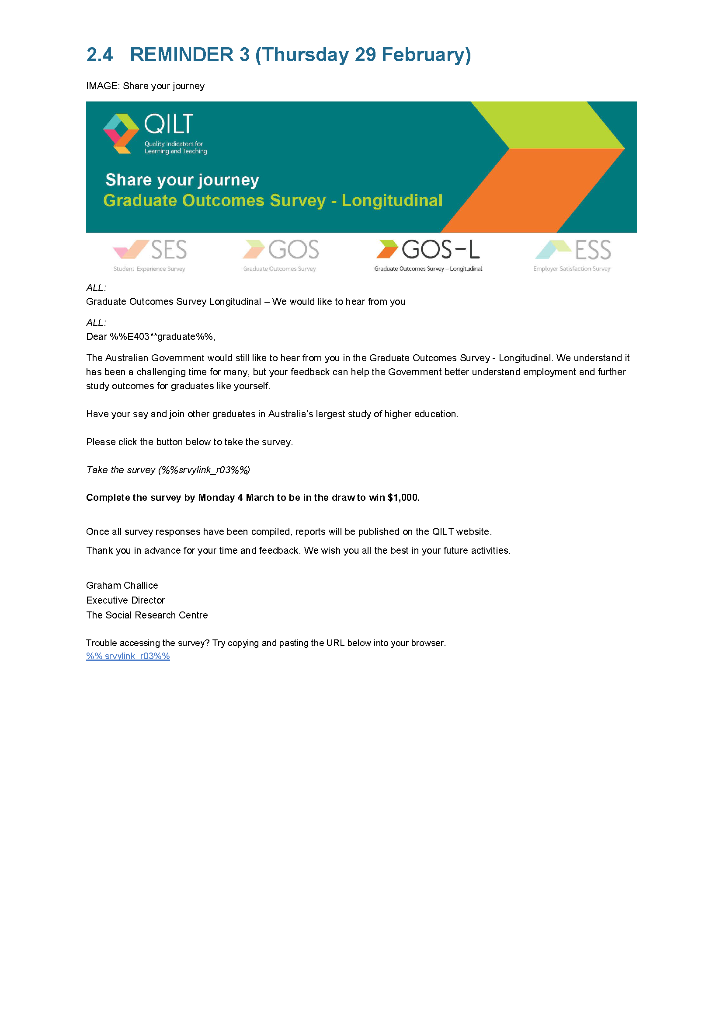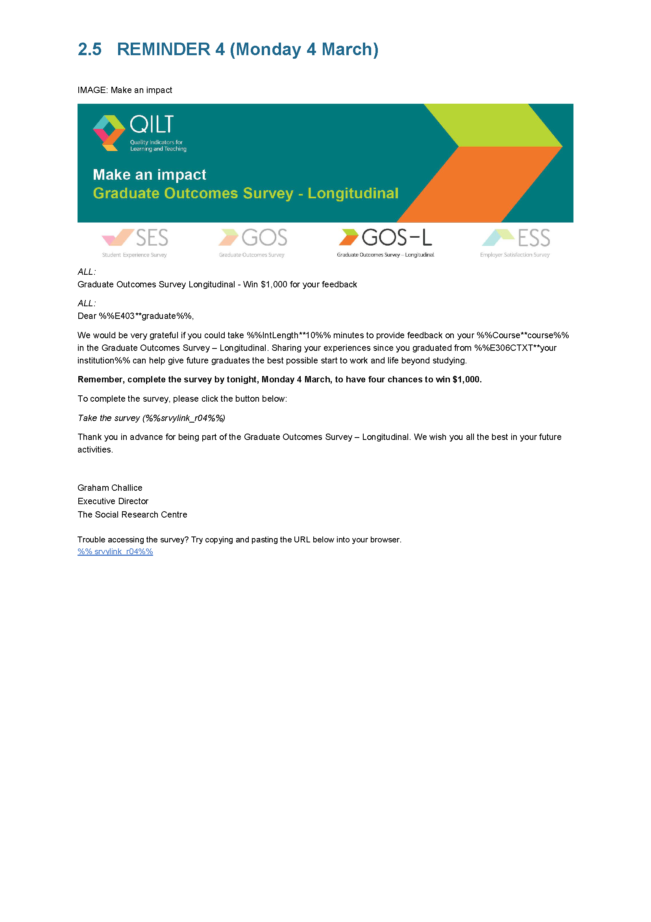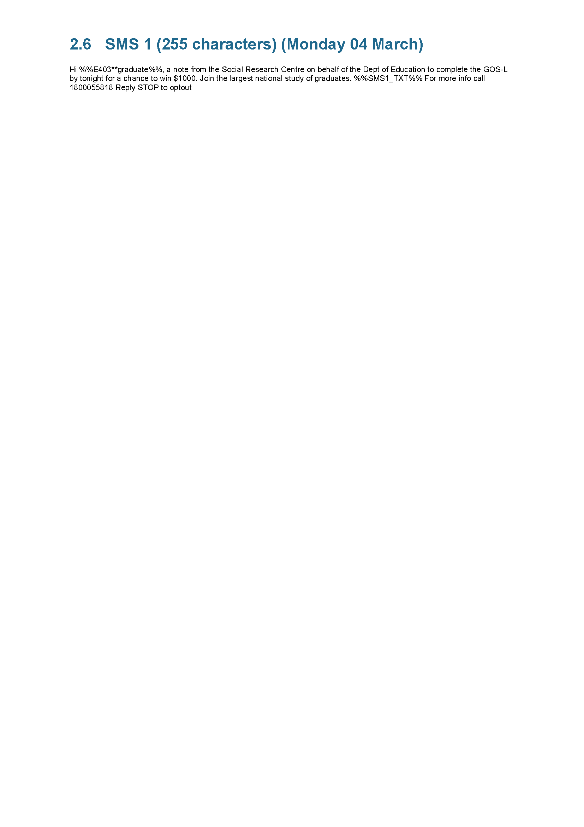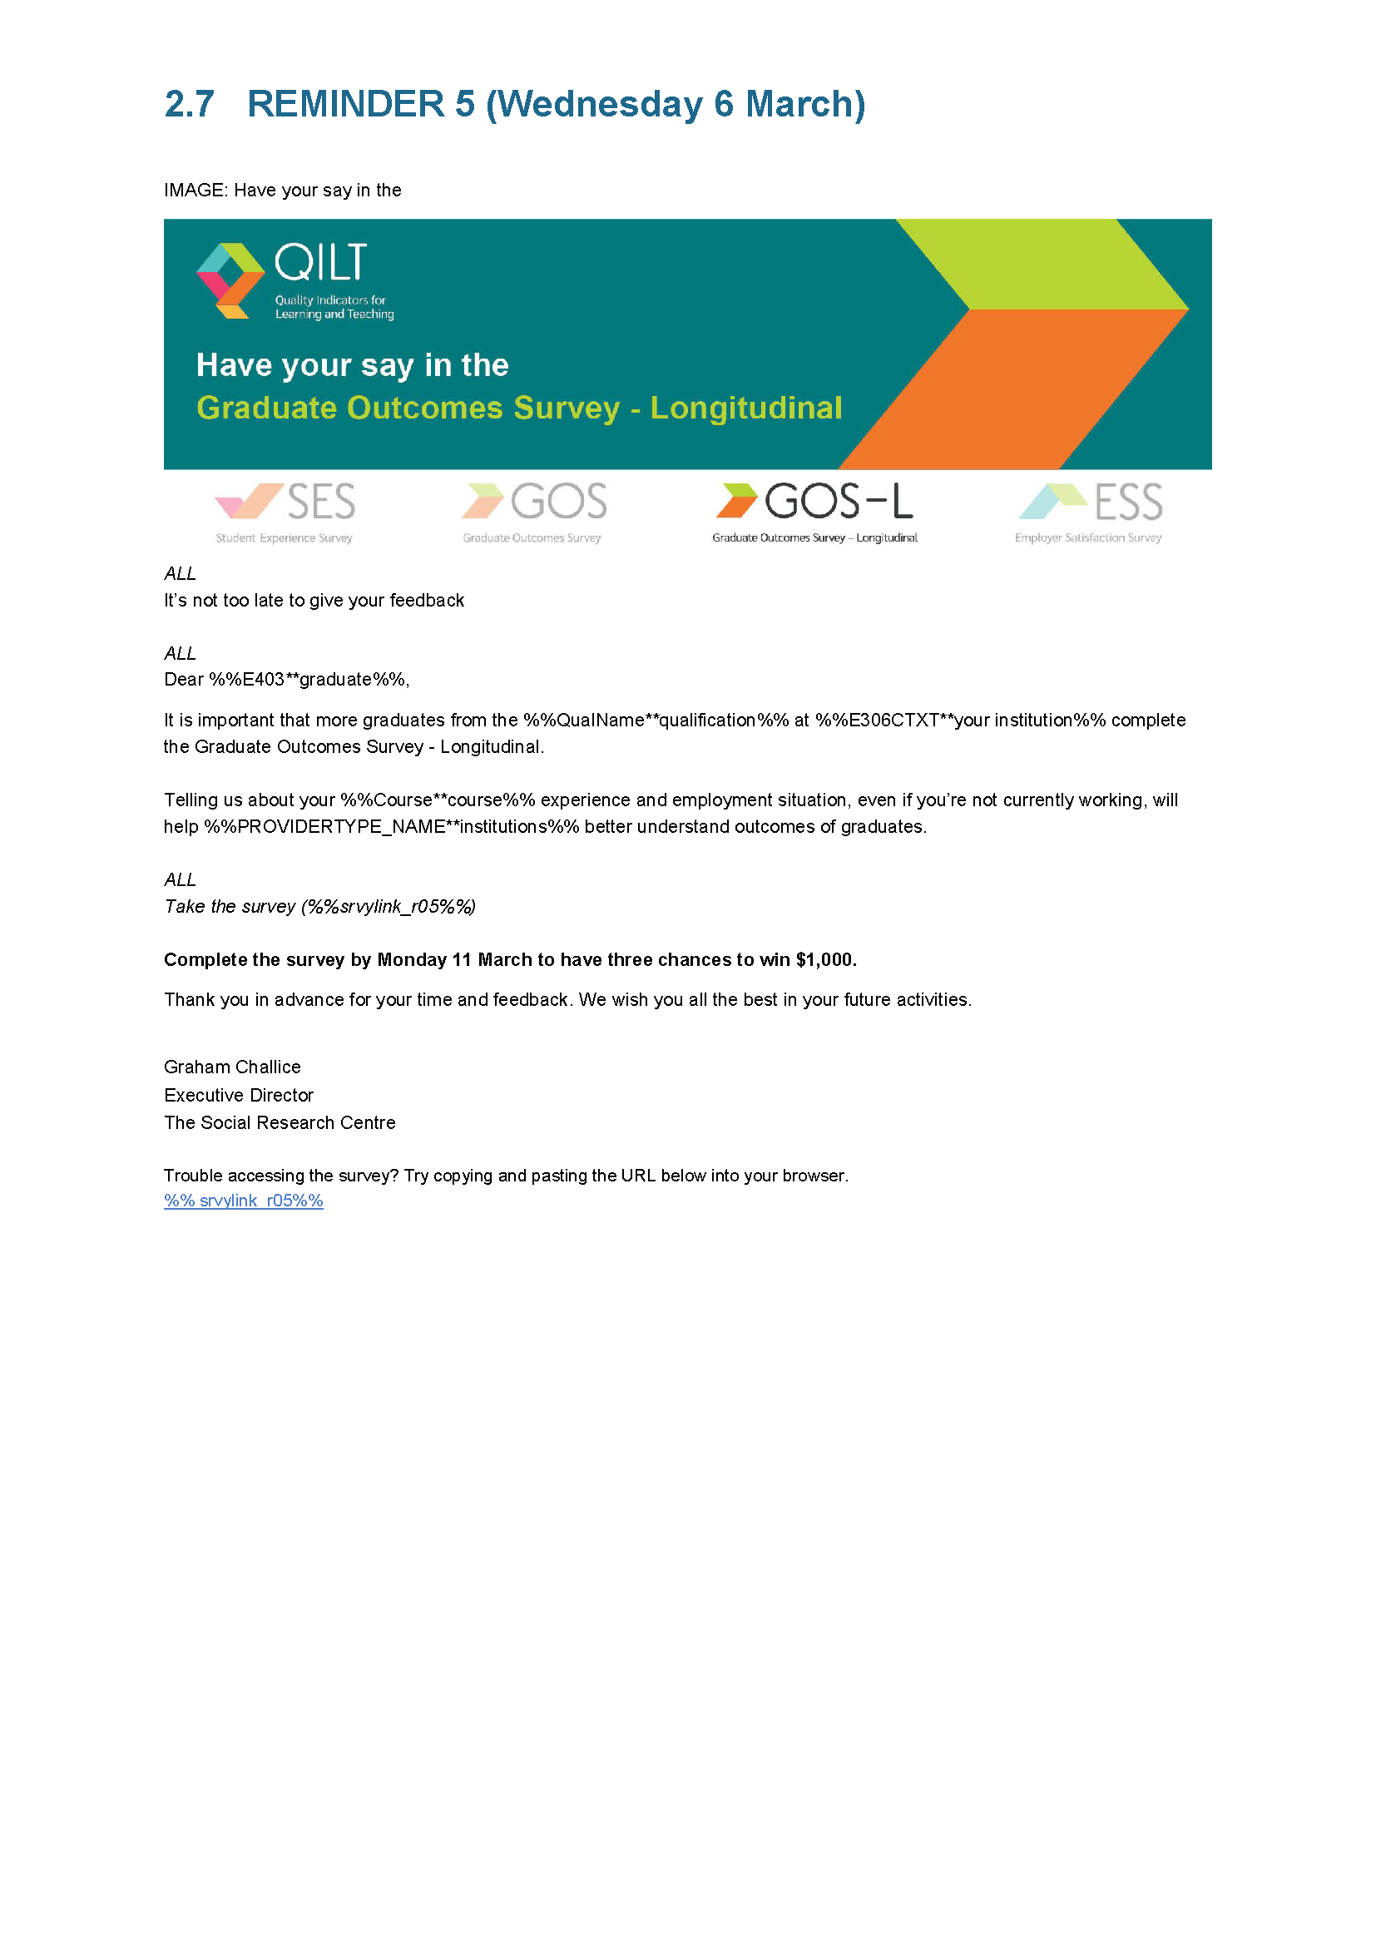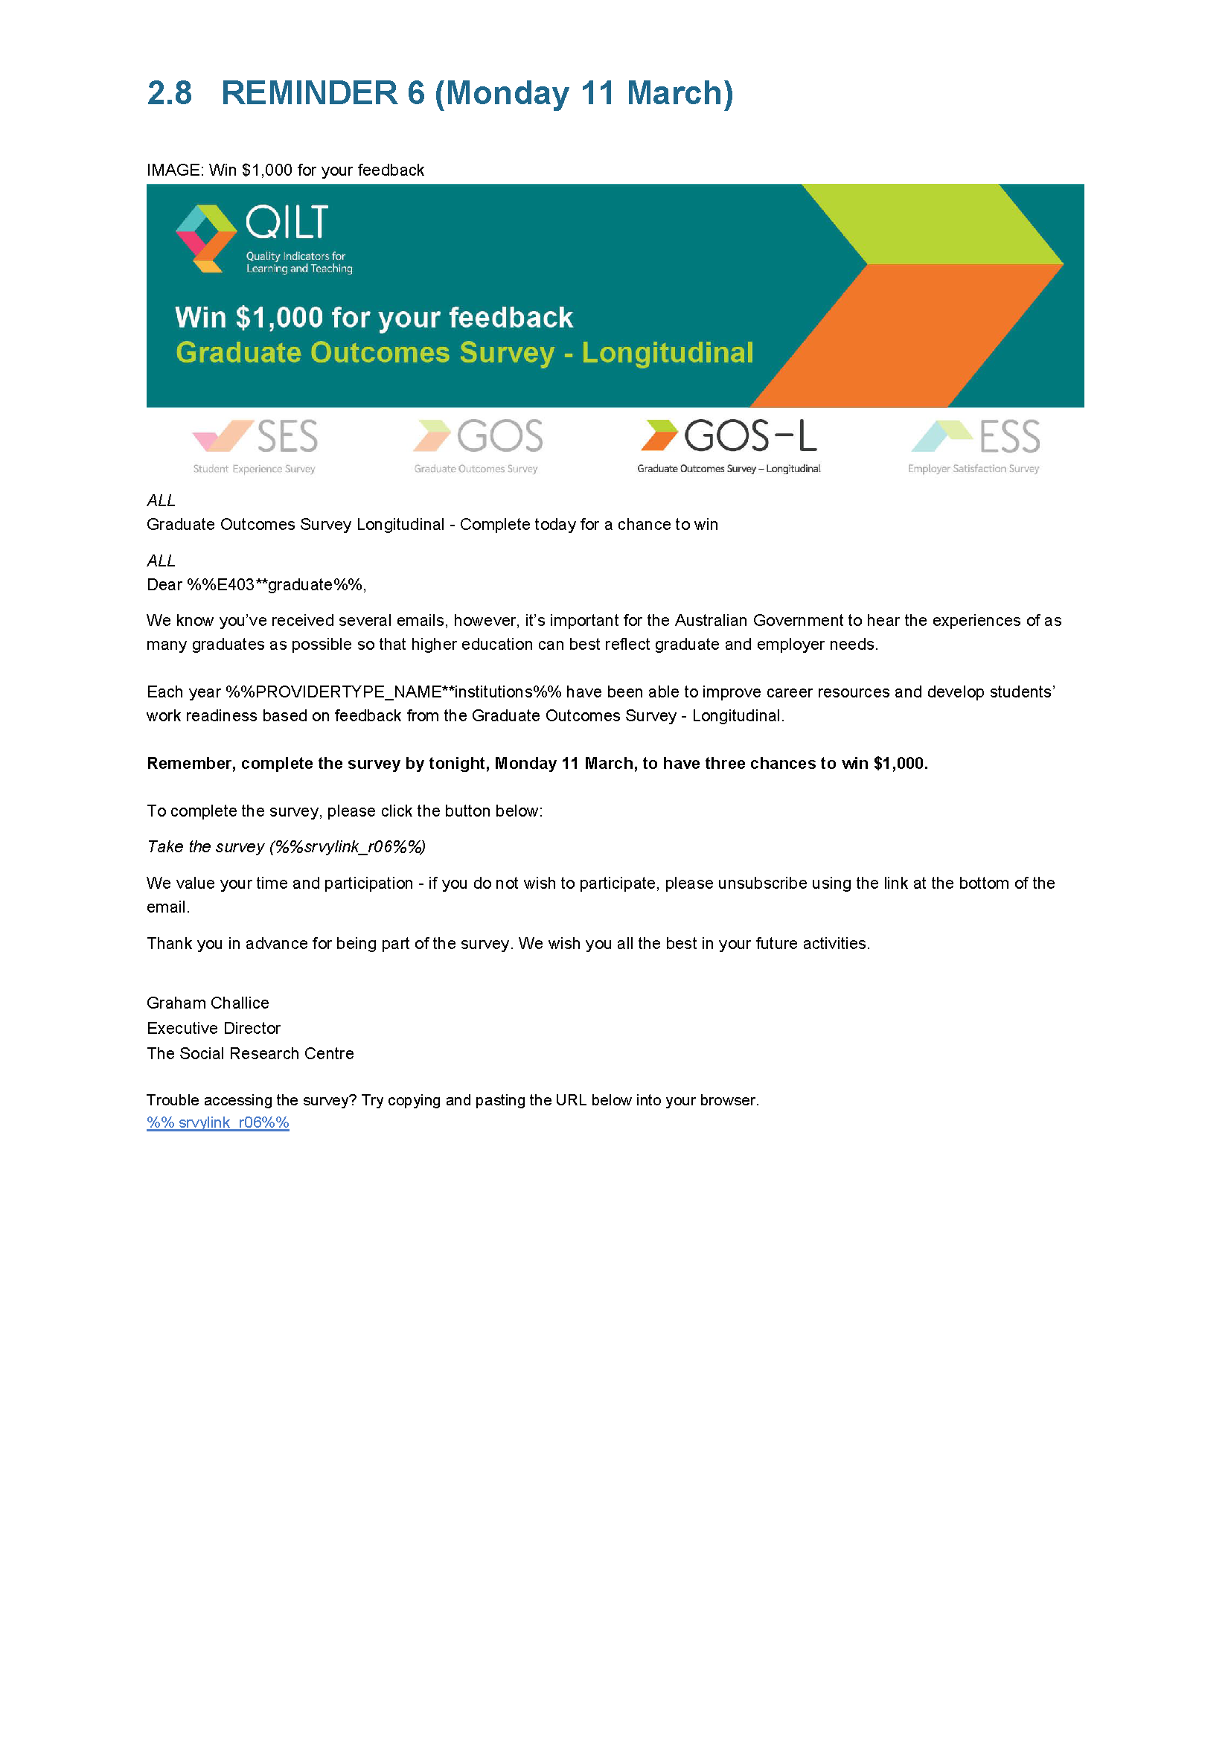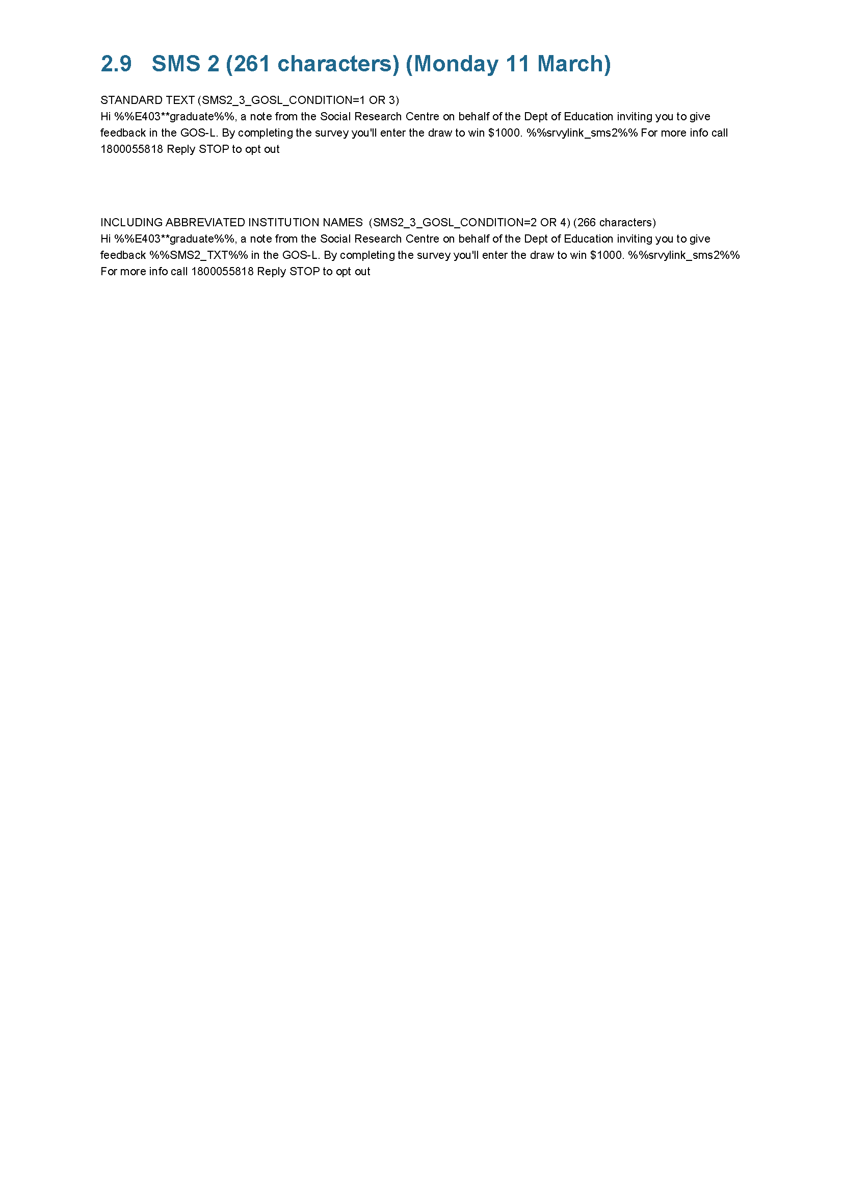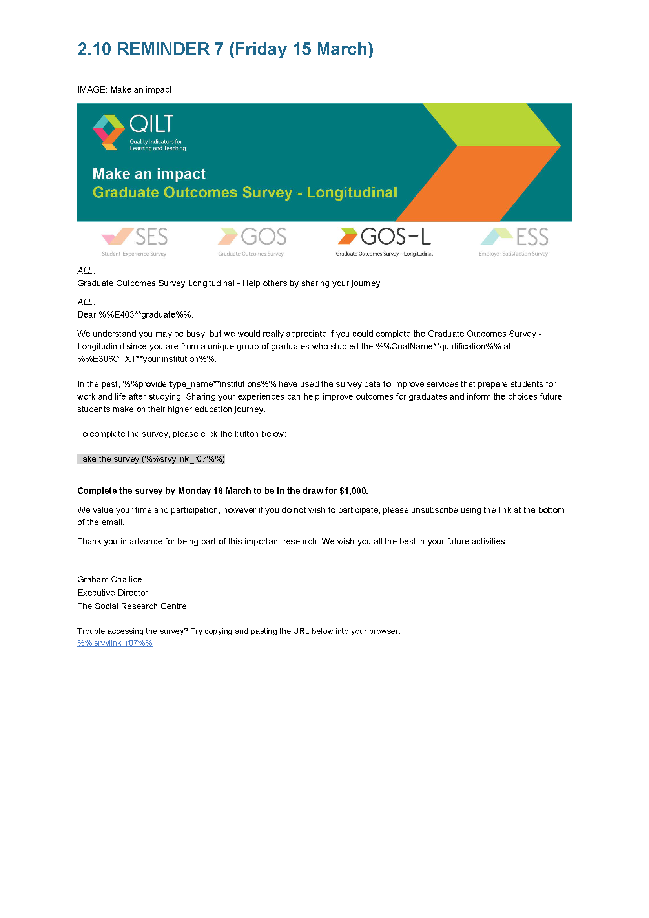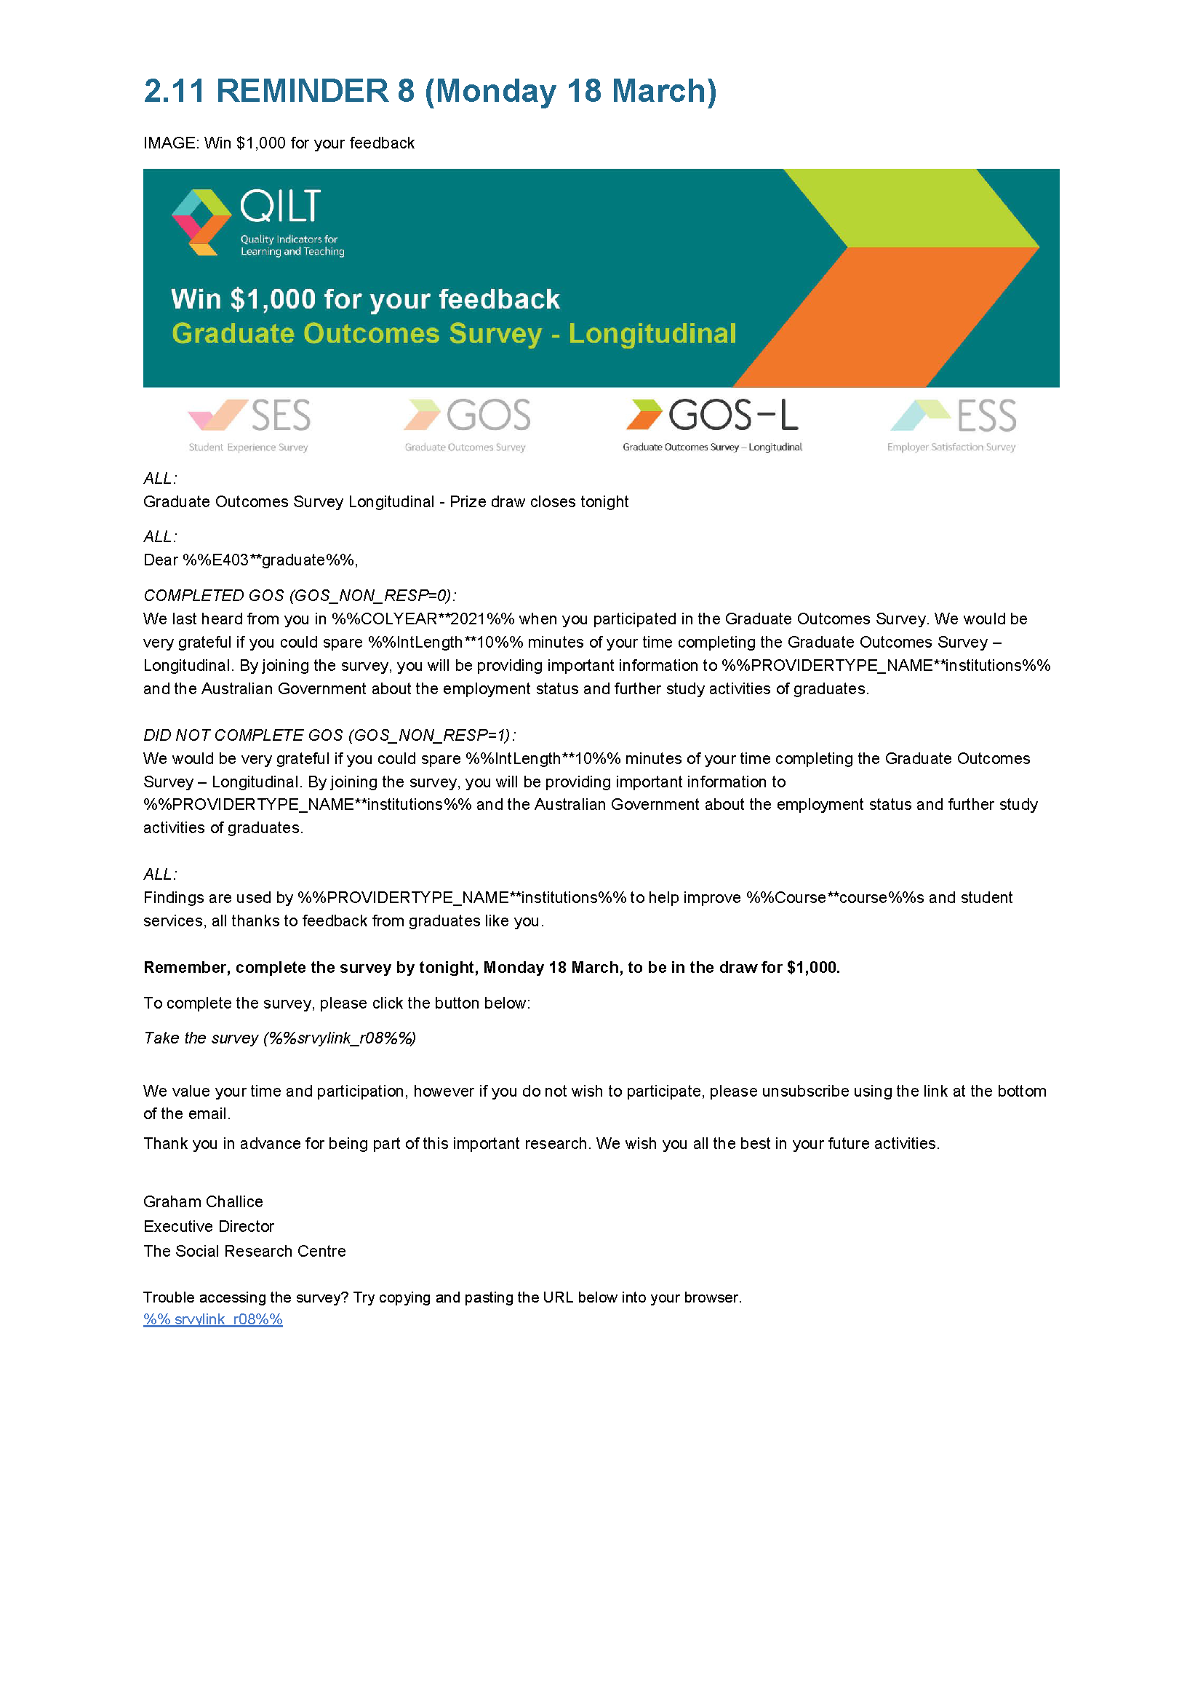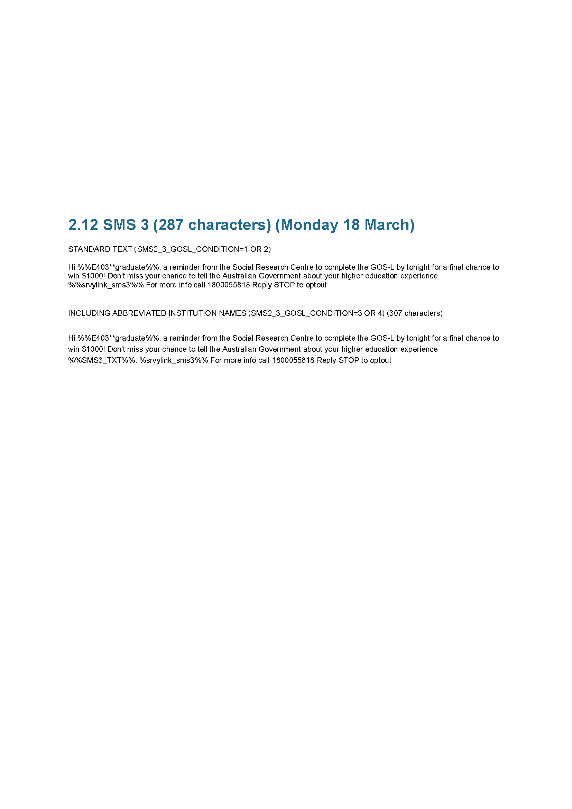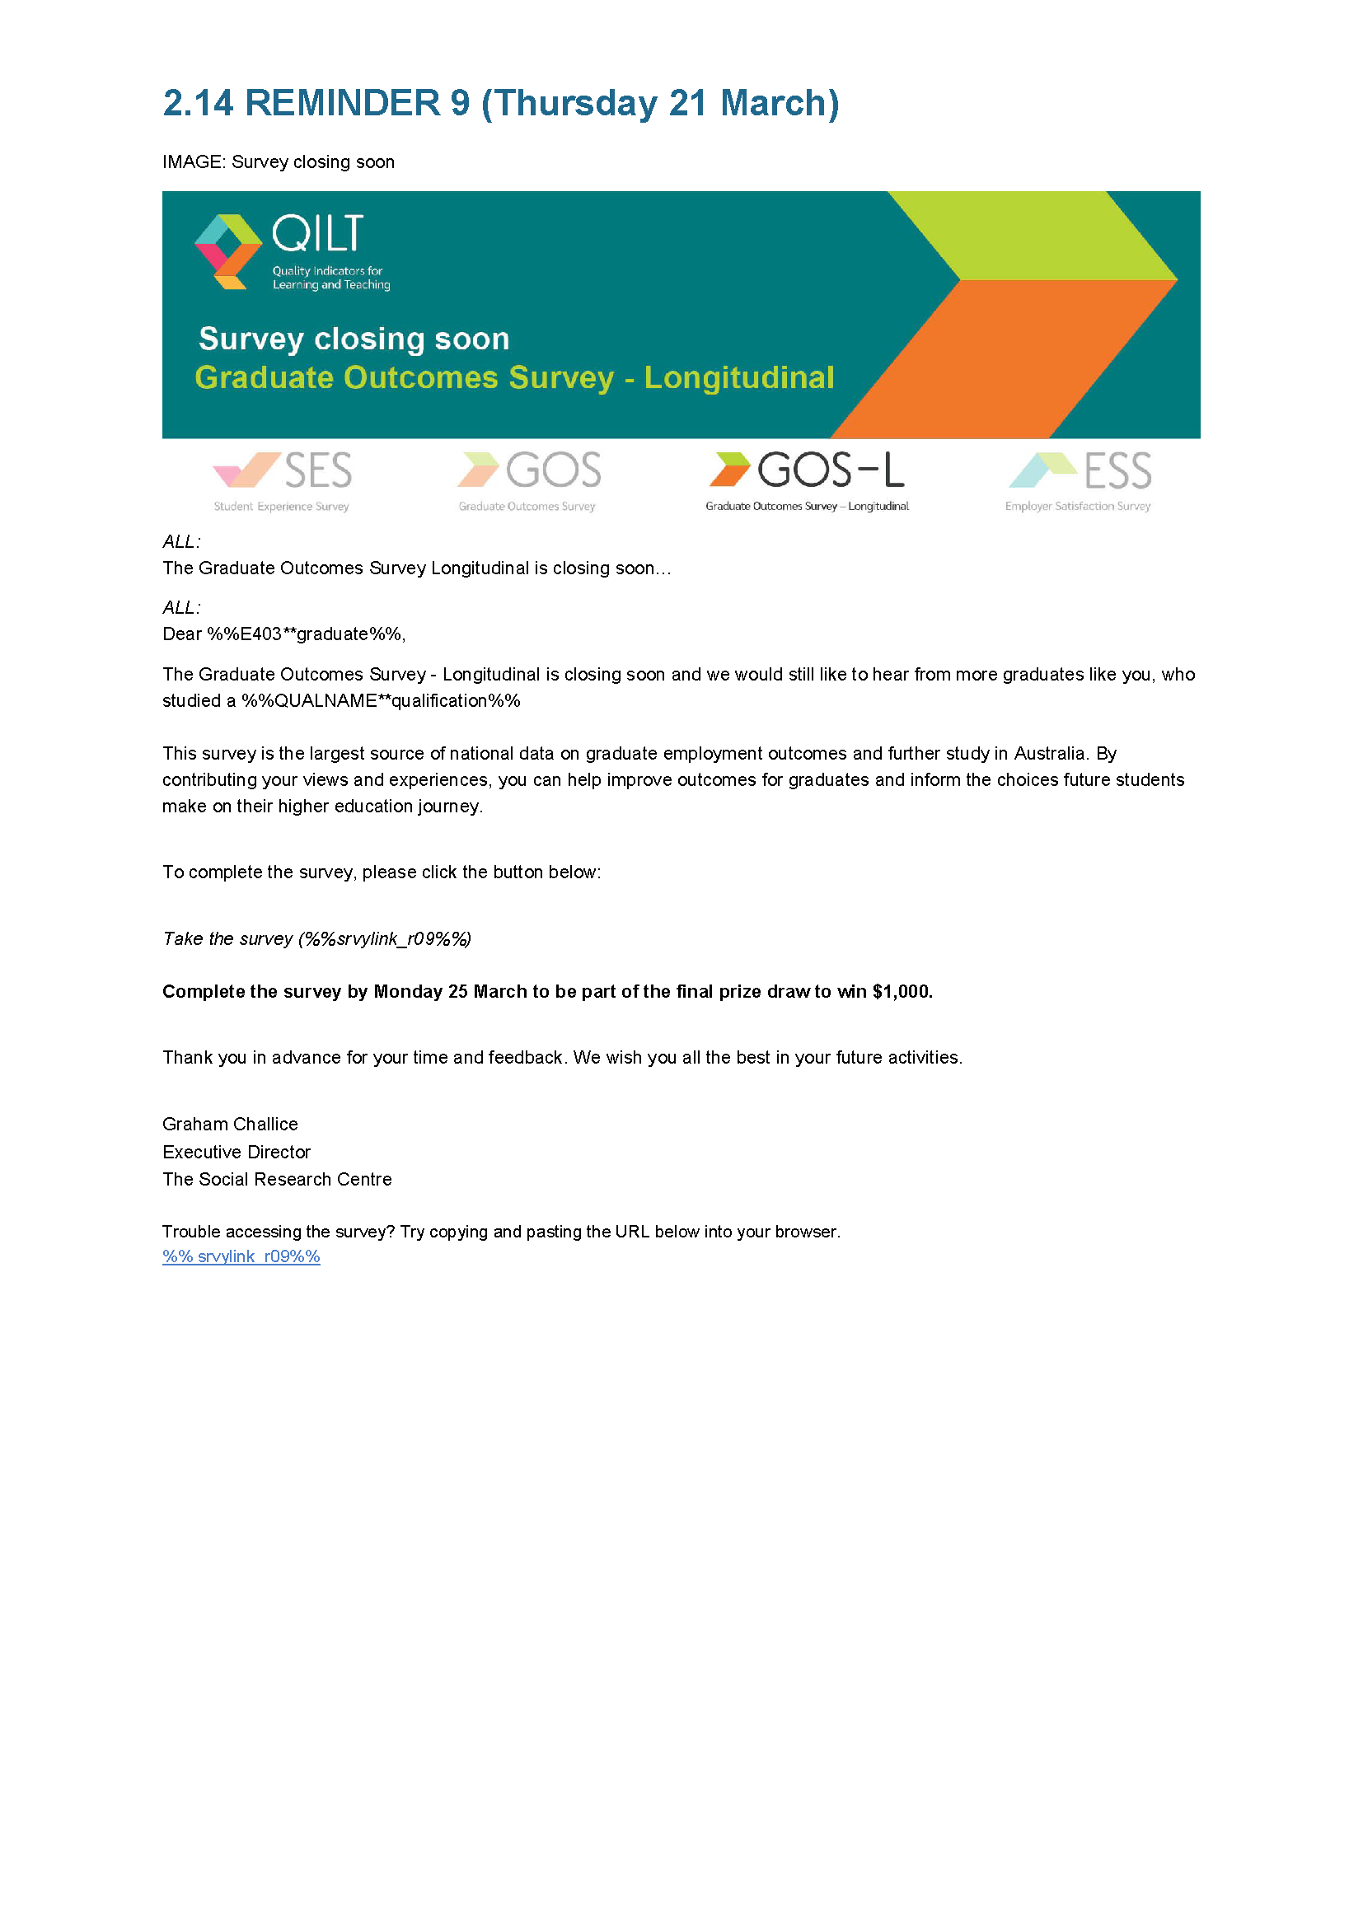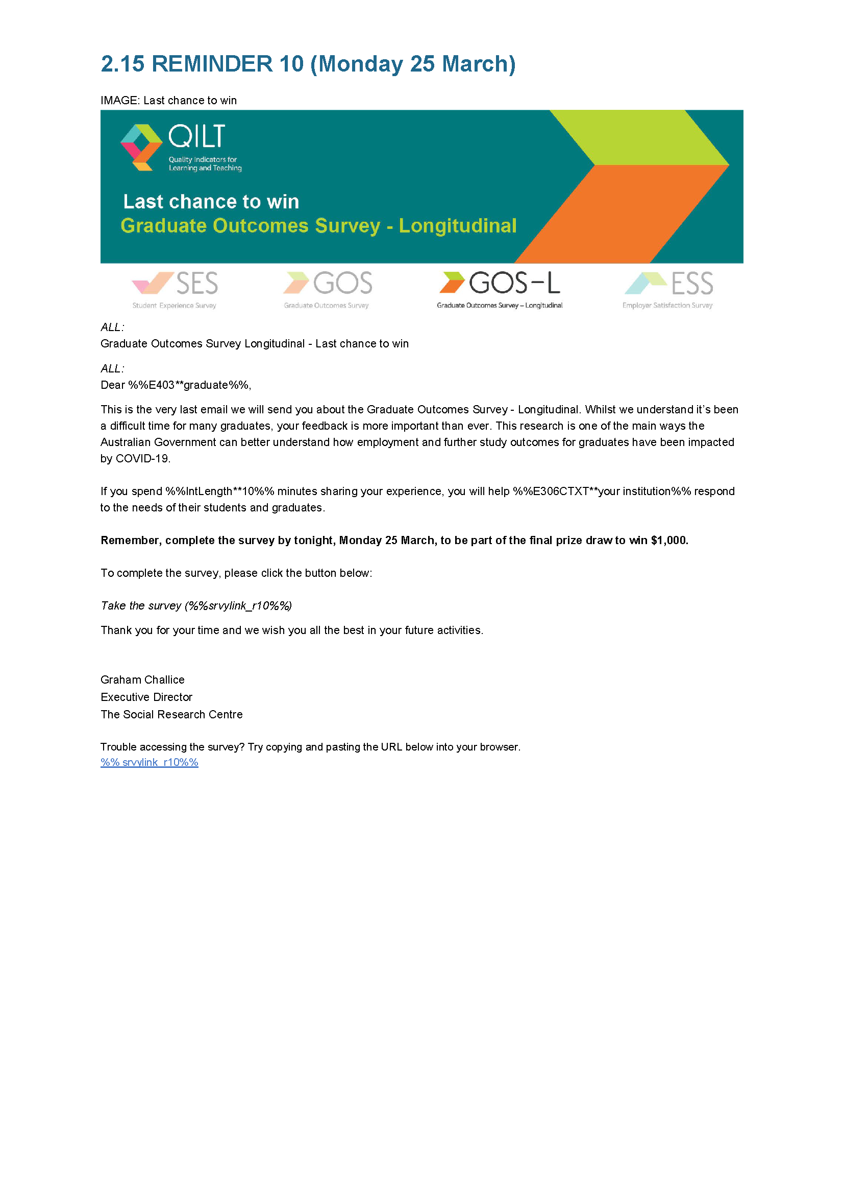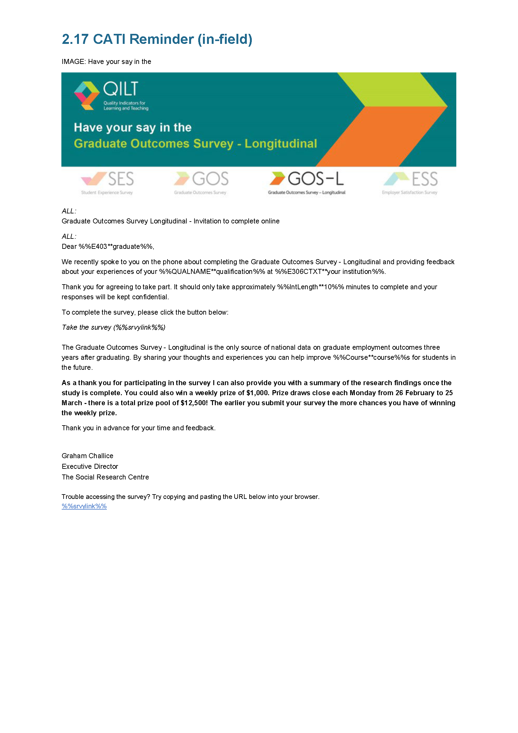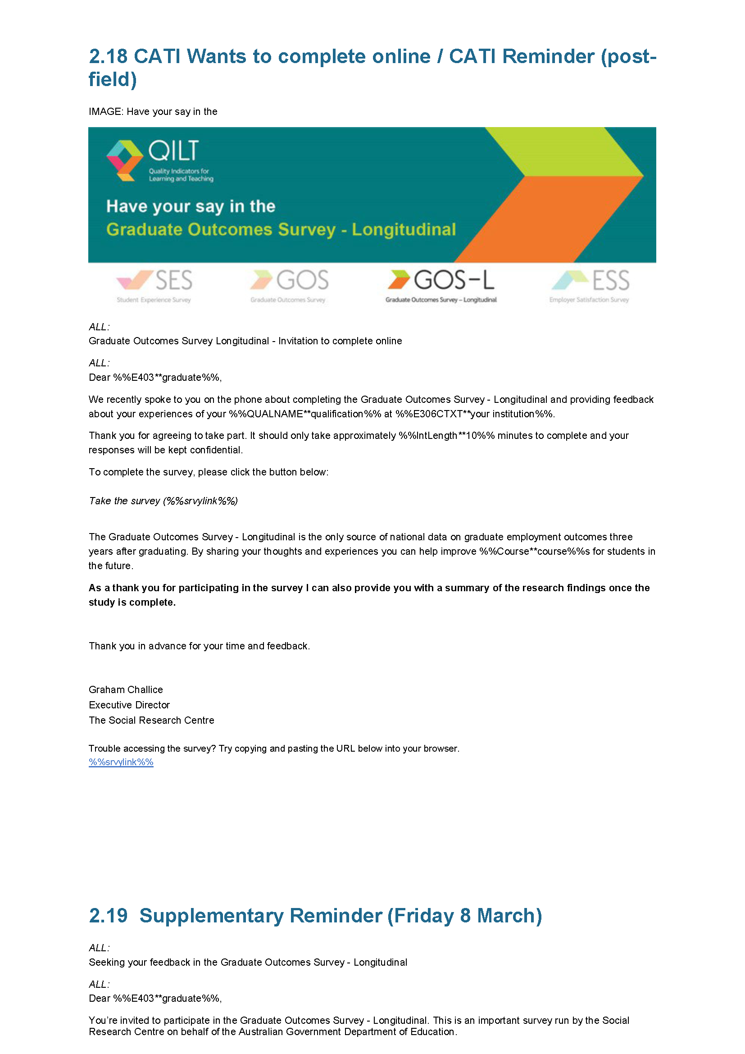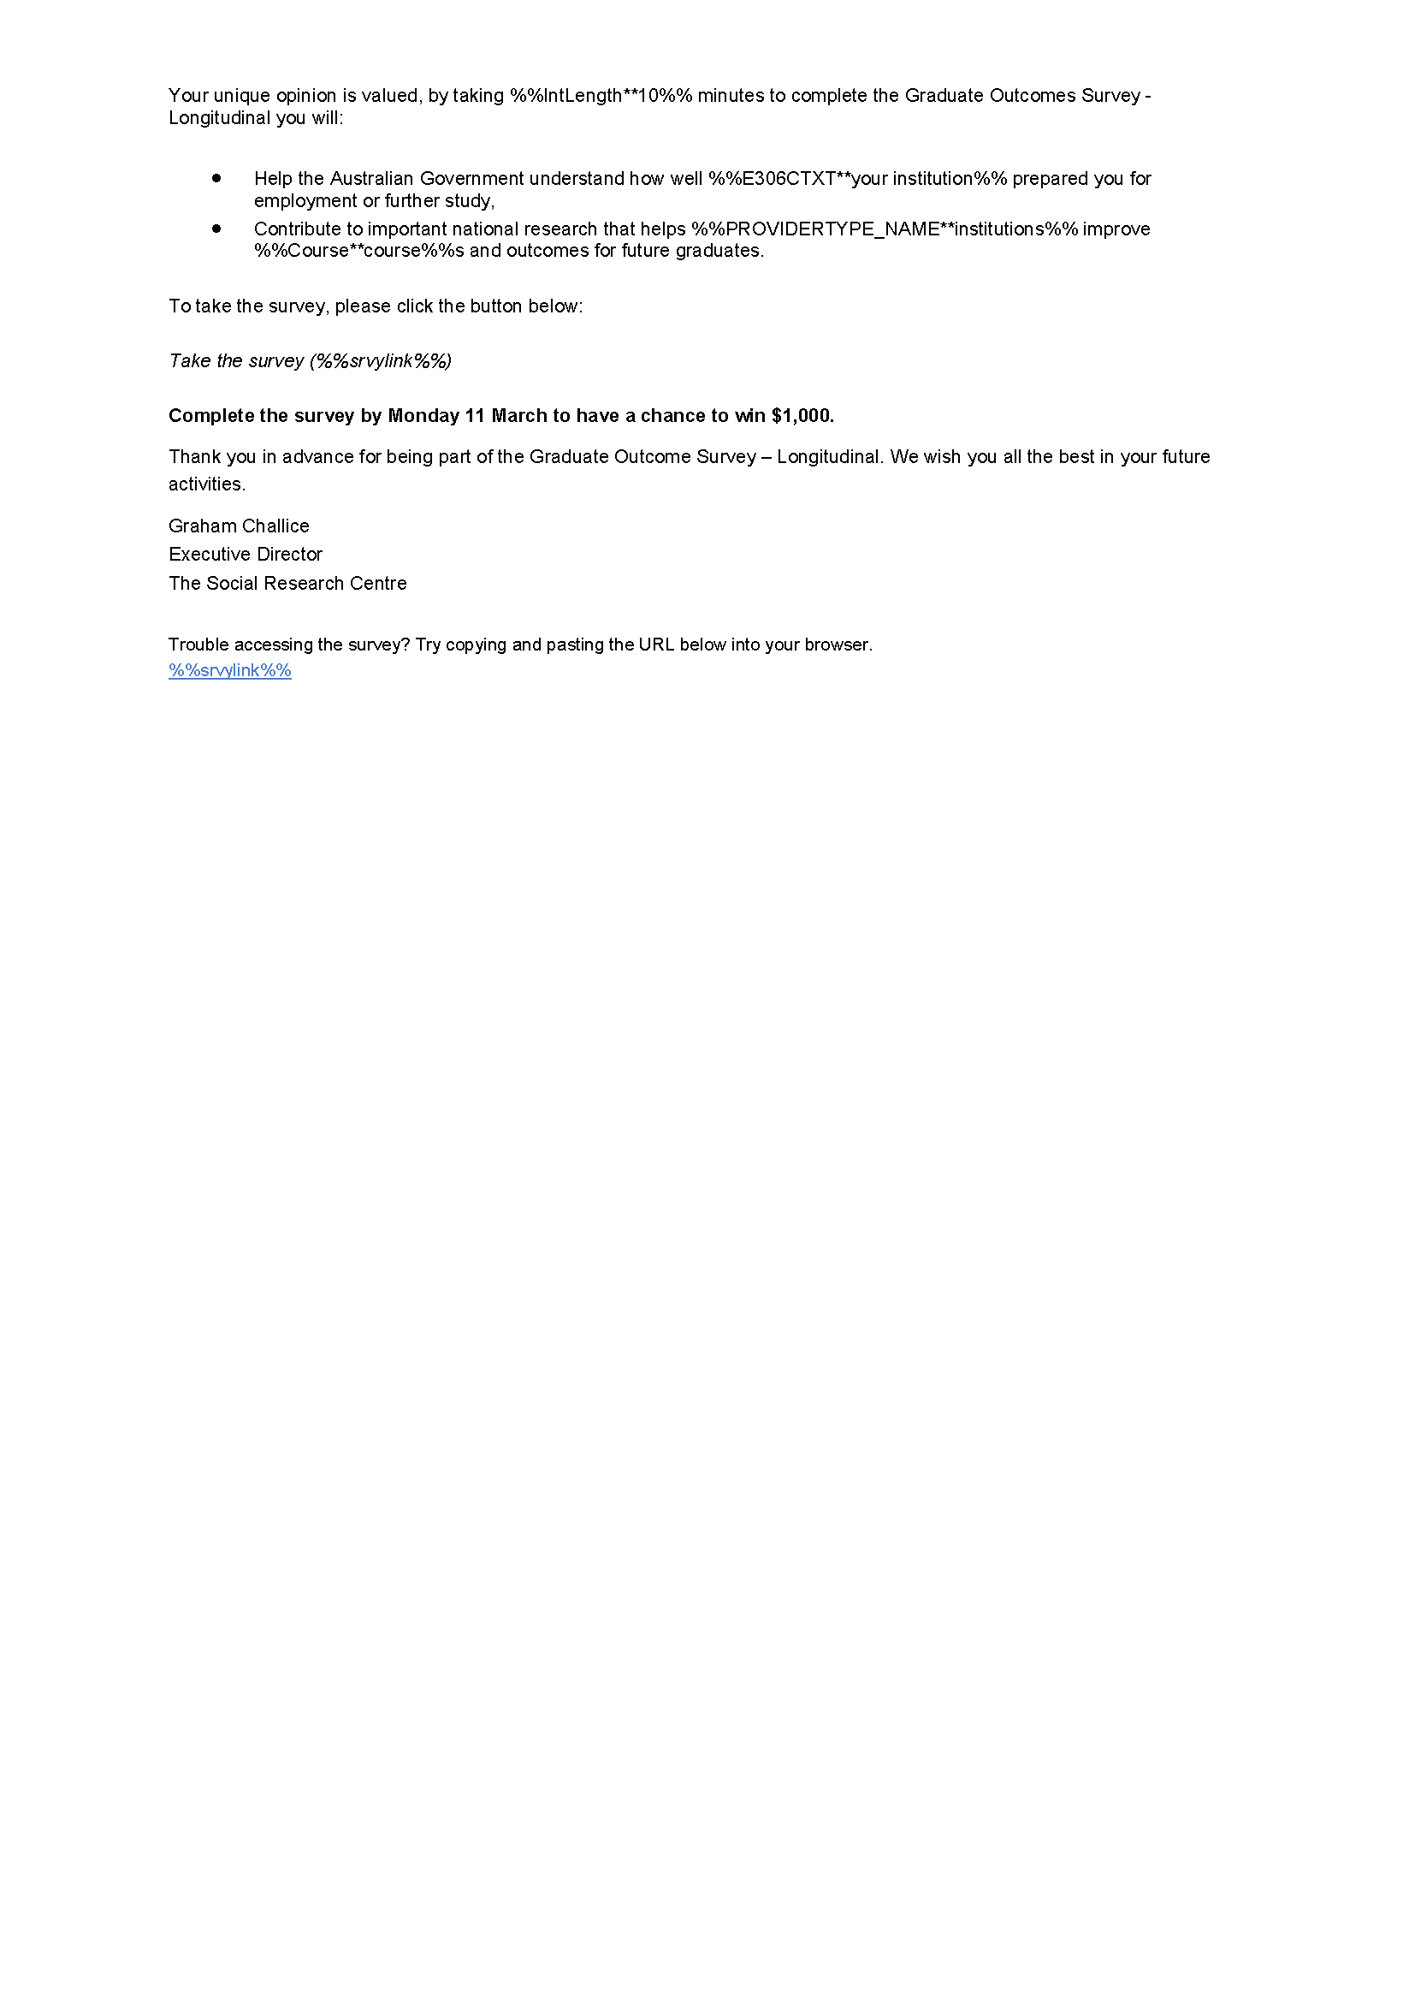

Appendix 4 Briefing slides for telephone follow-up activities
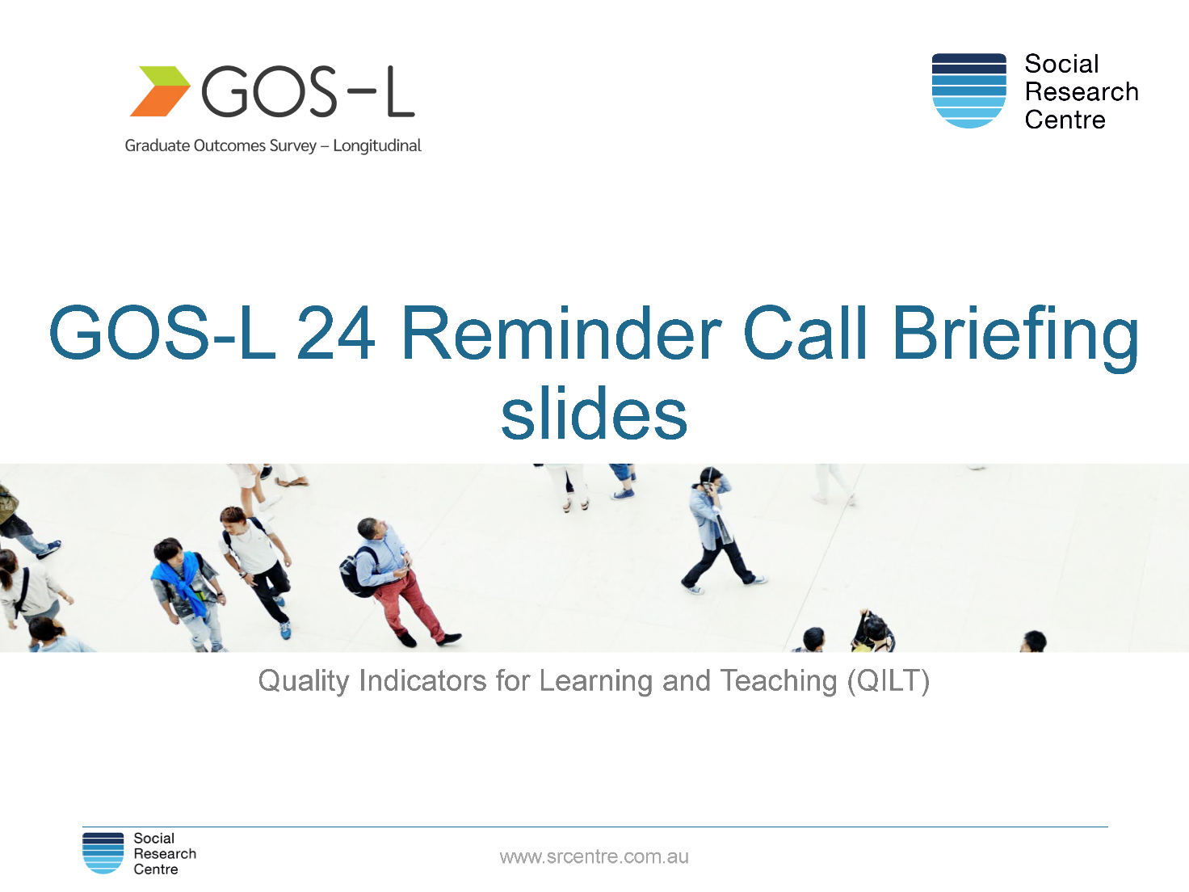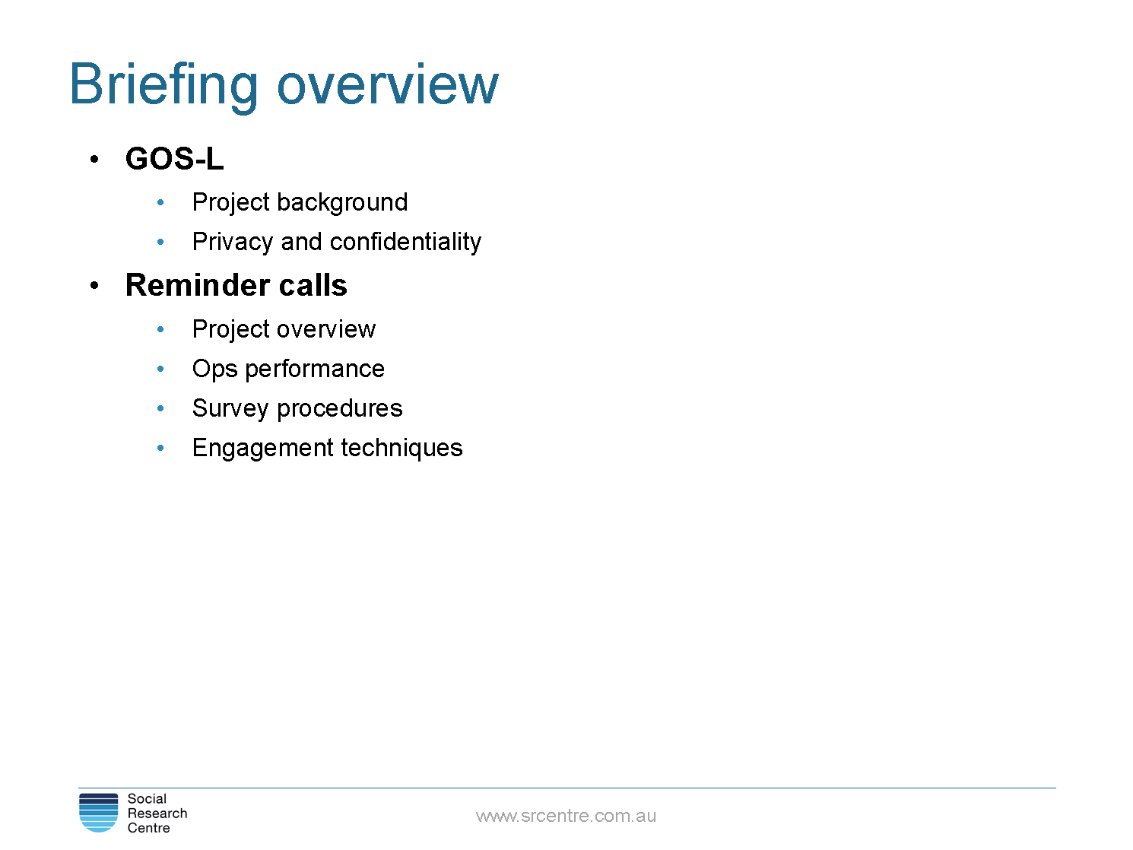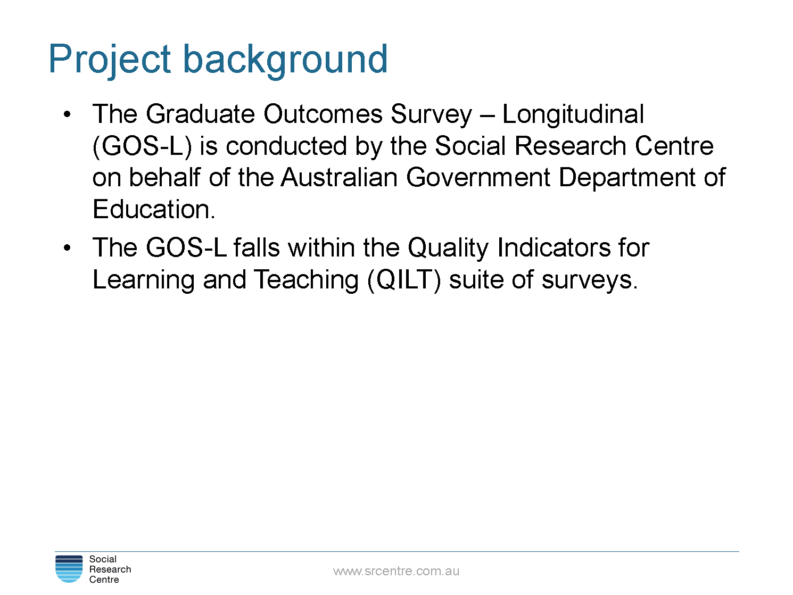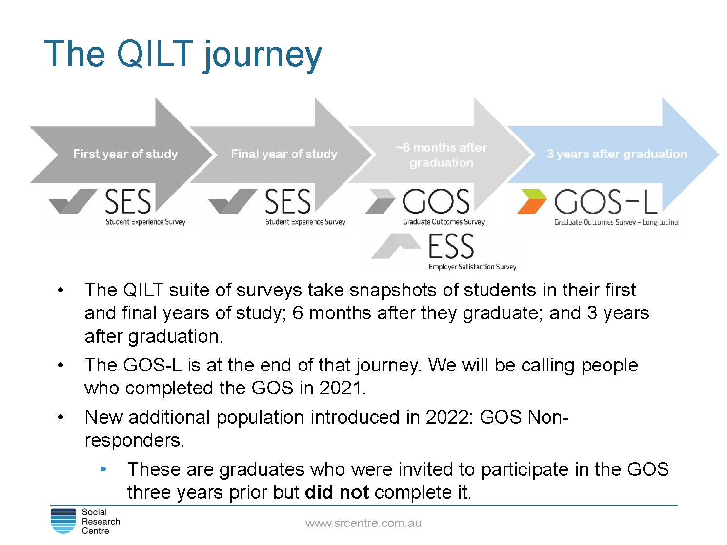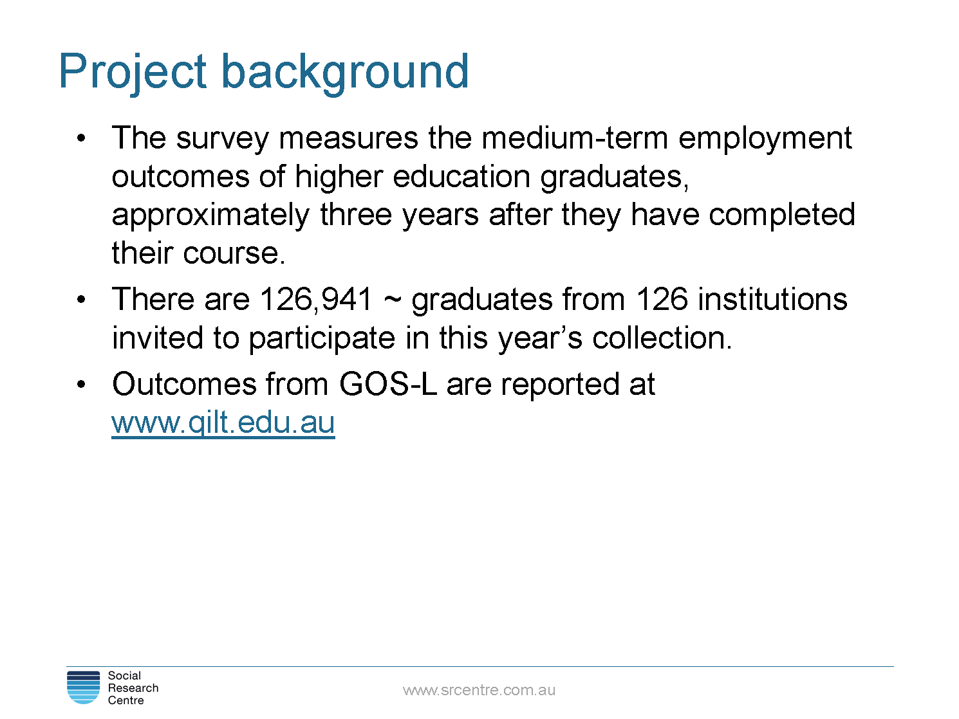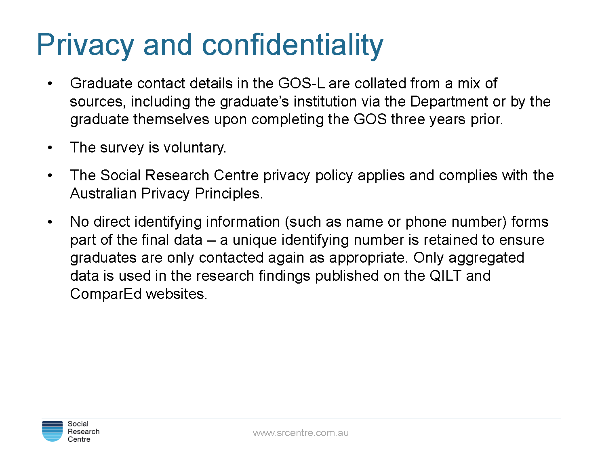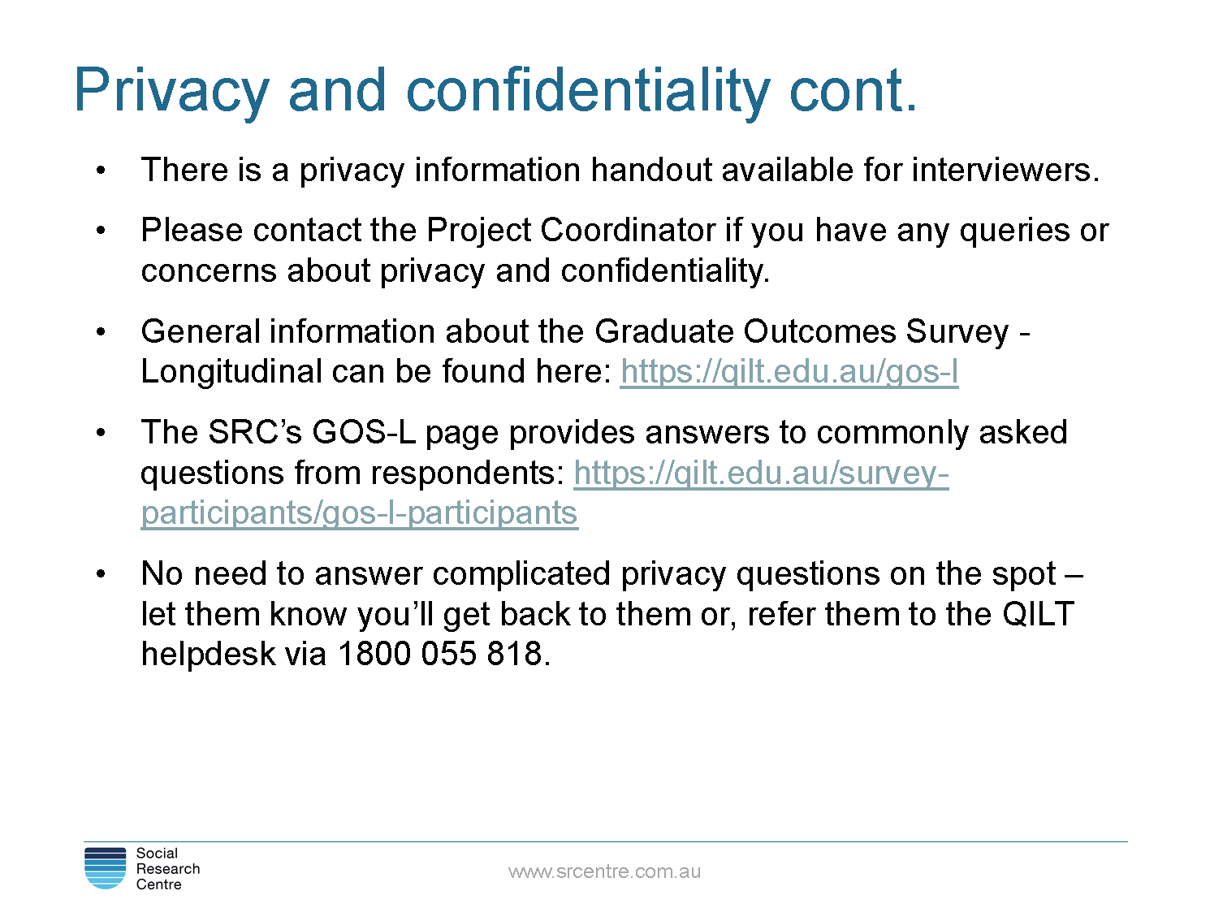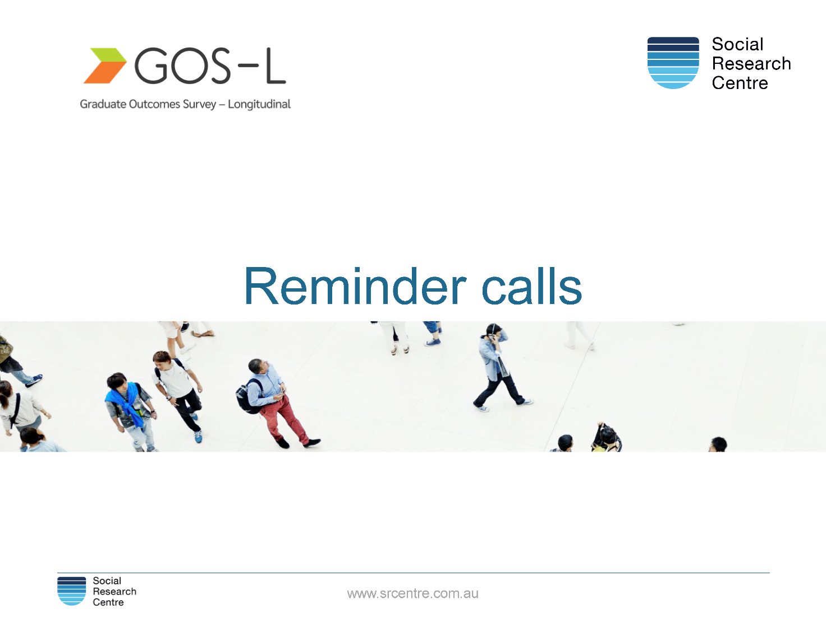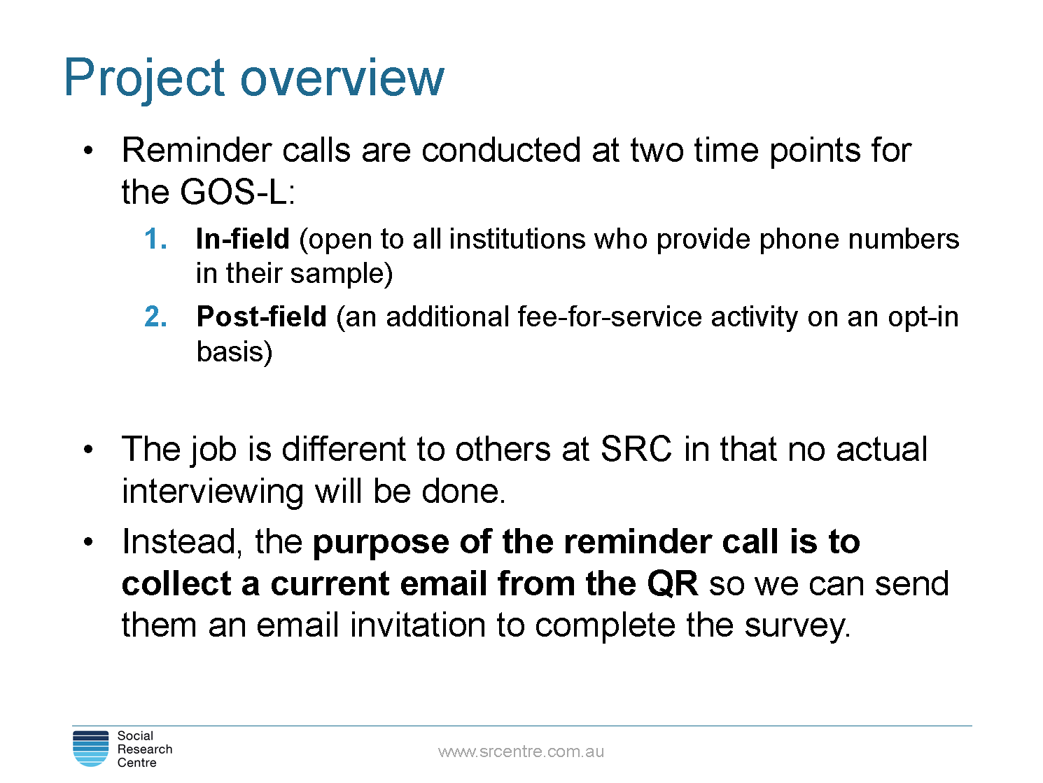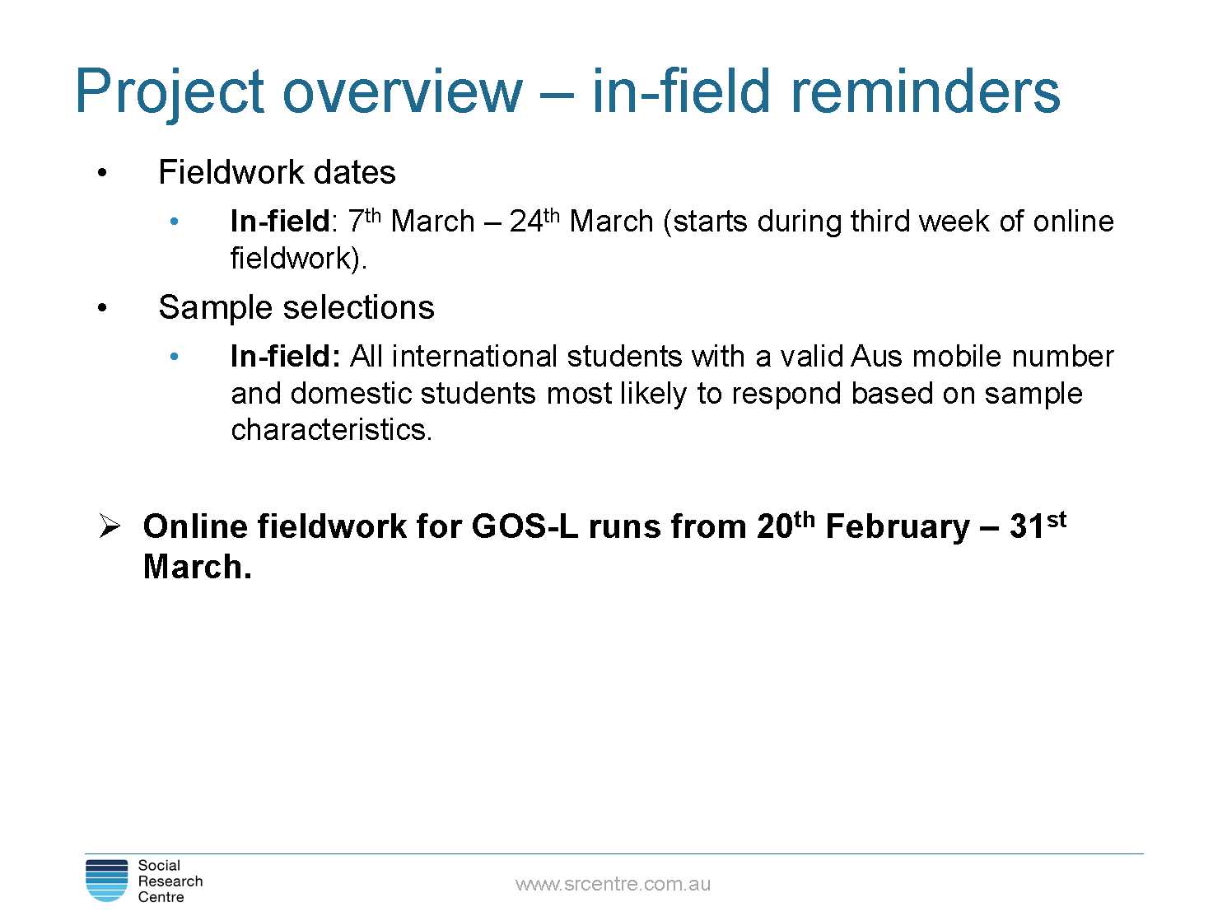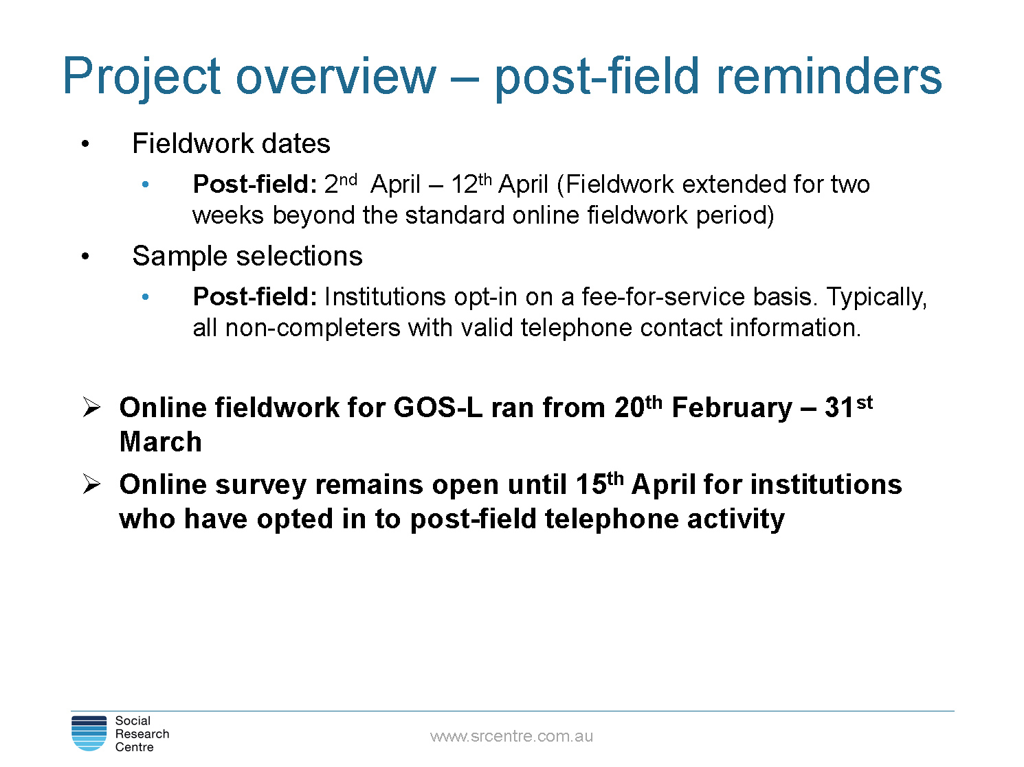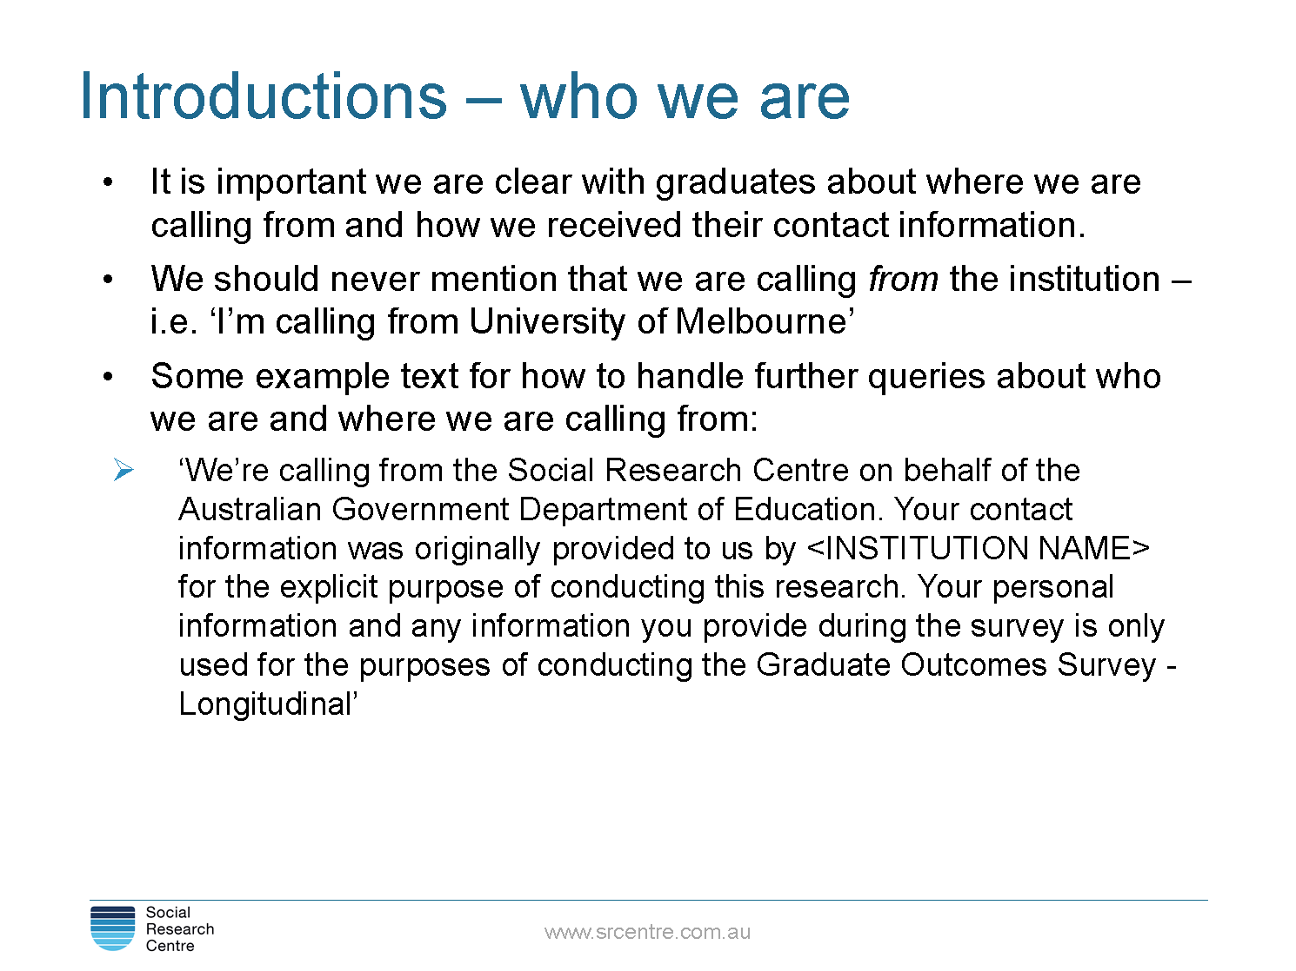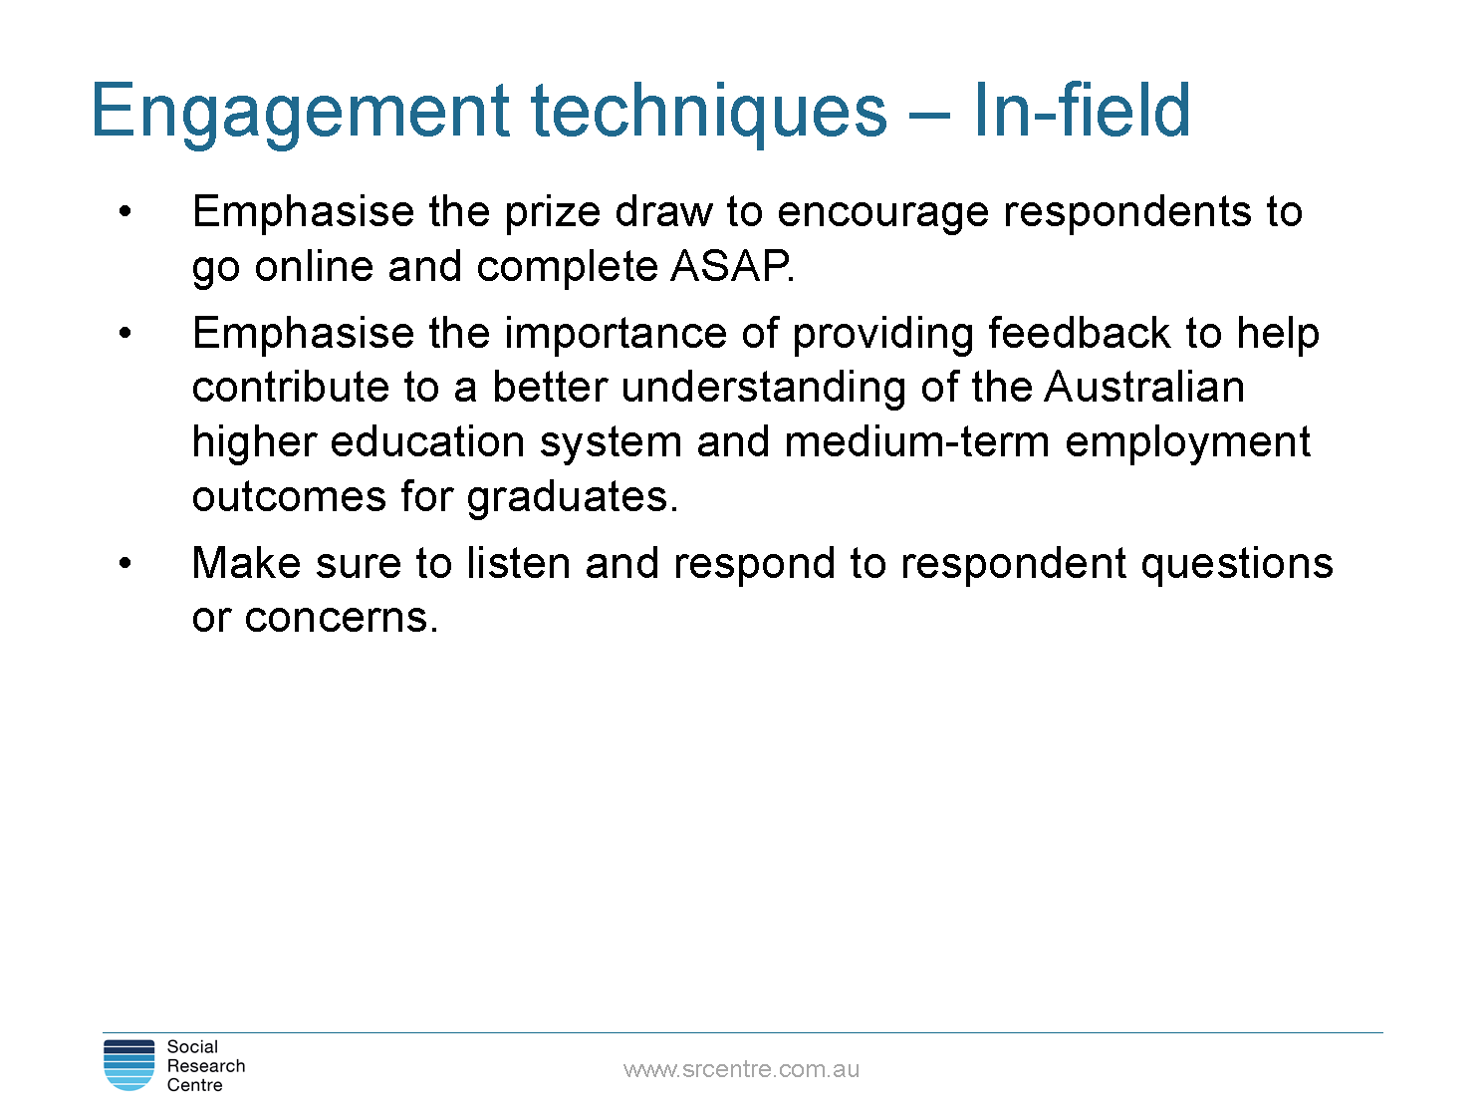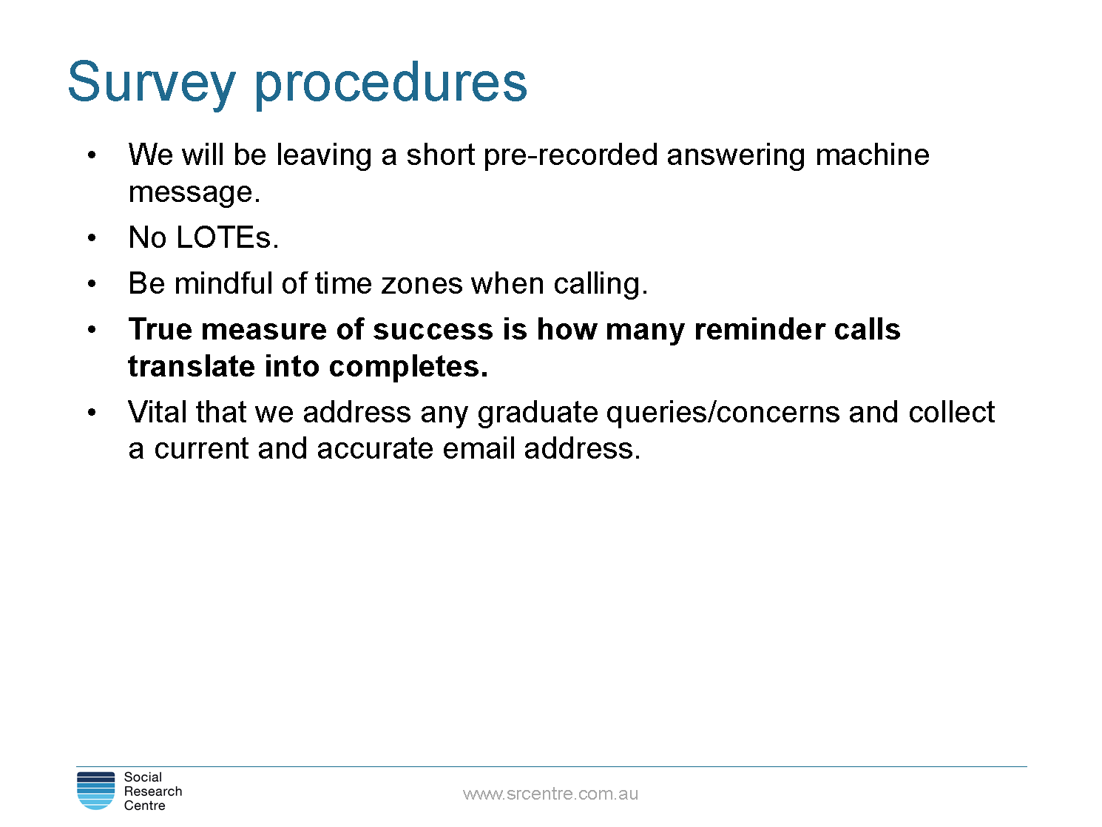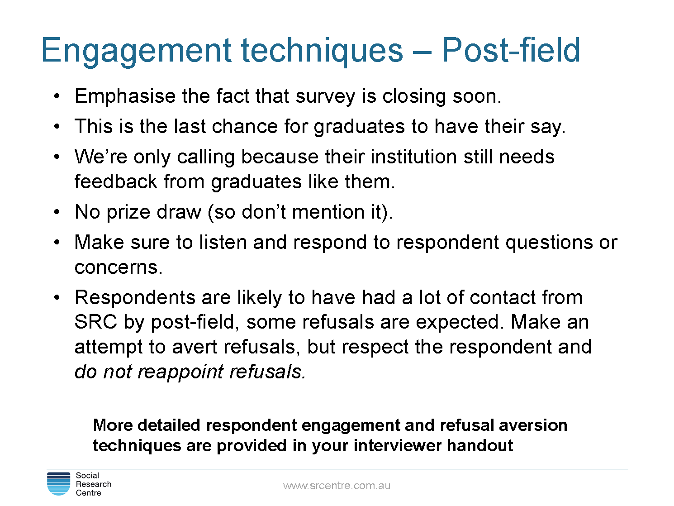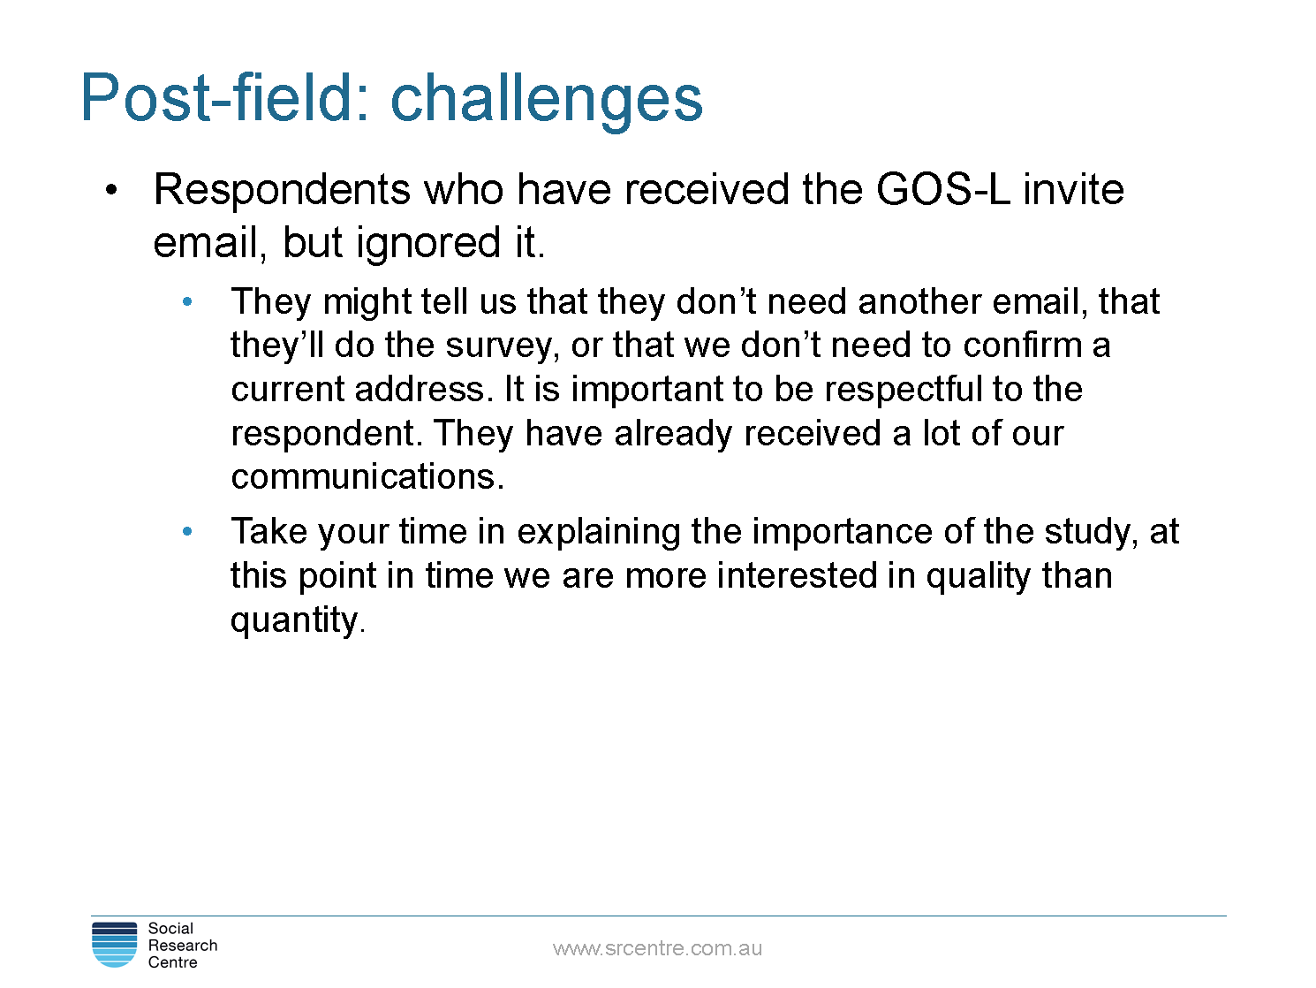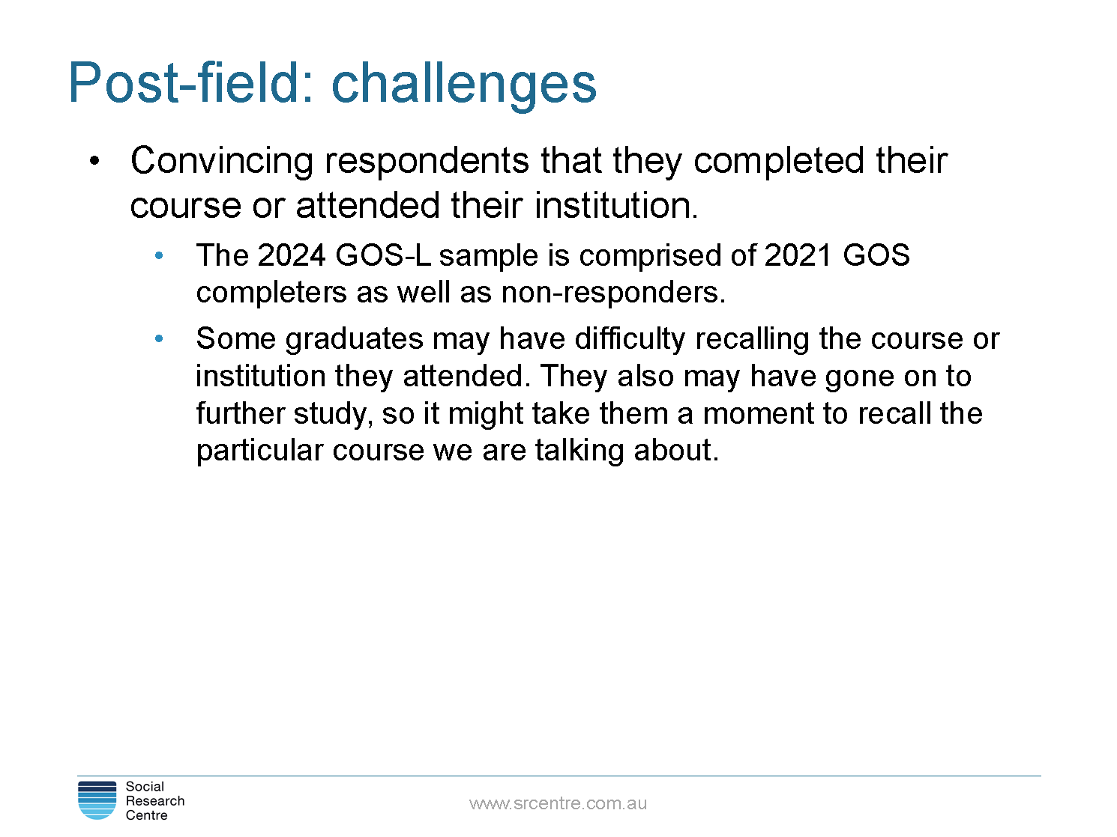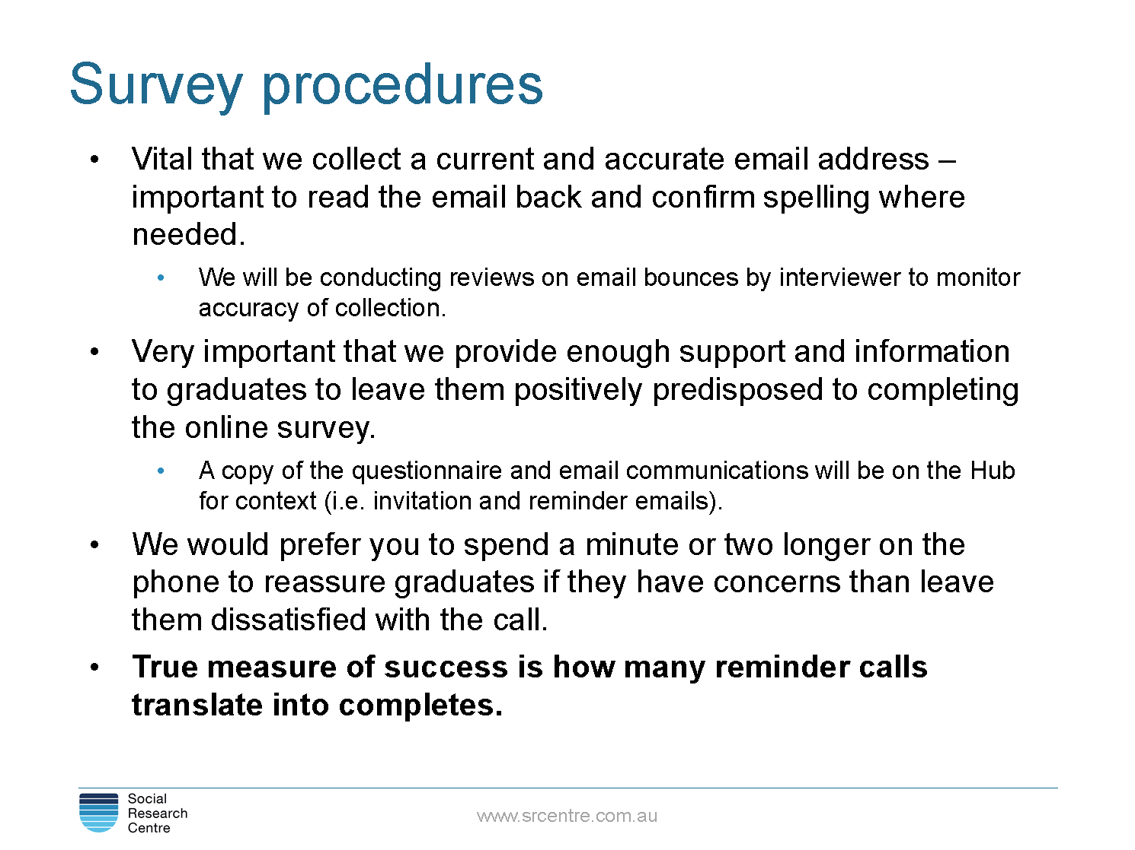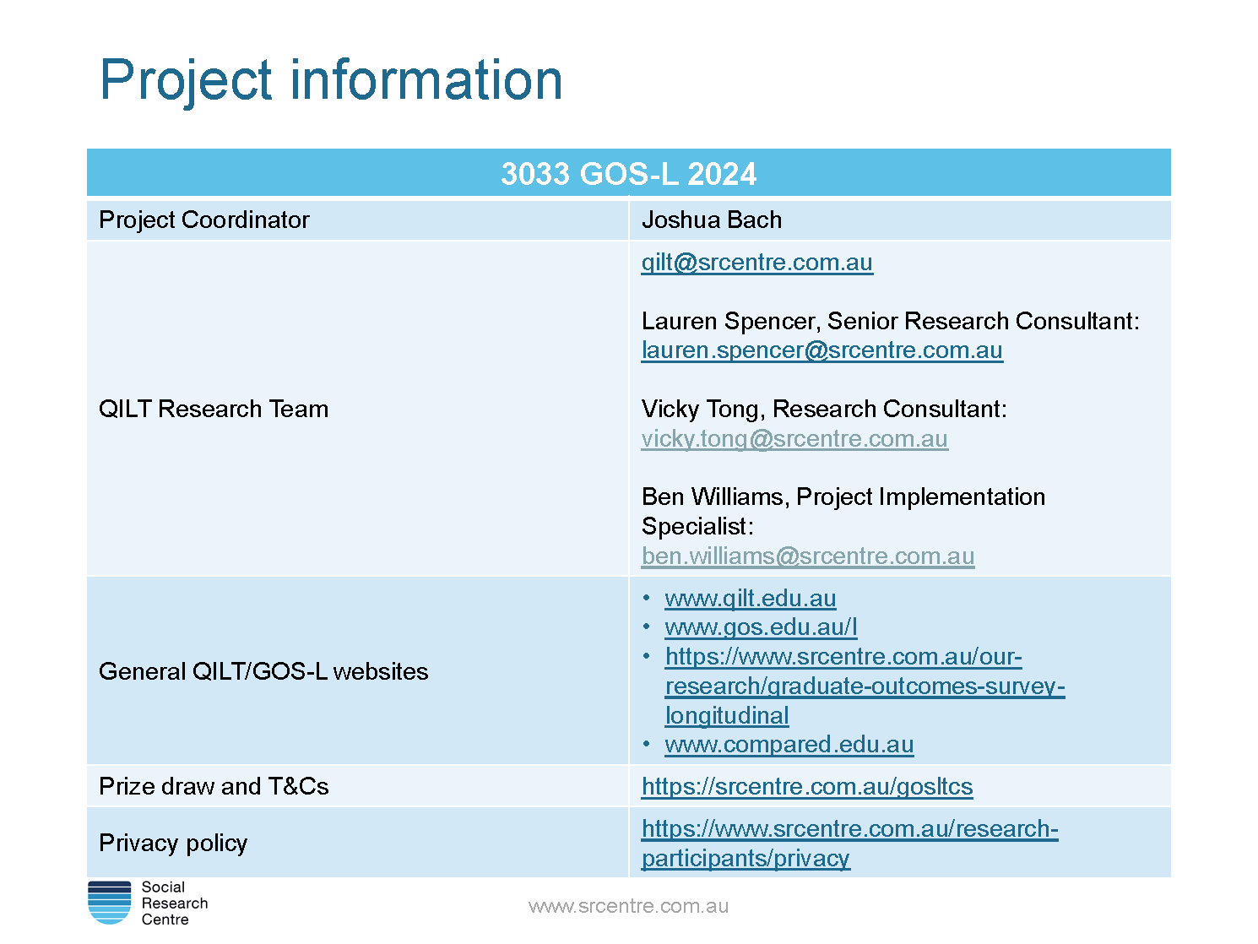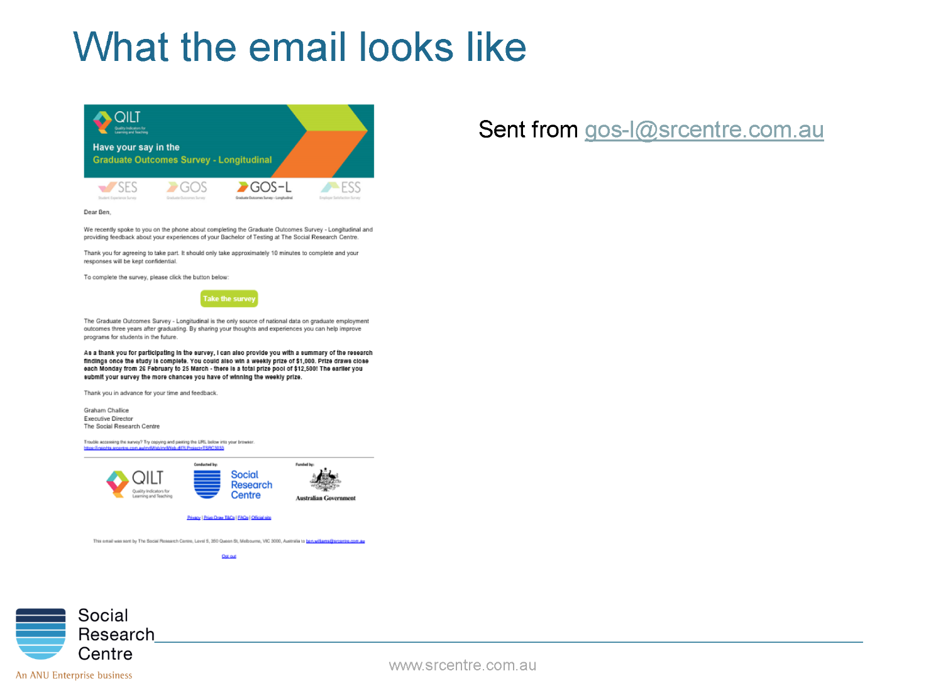

Appendix 5 Core questionnaire
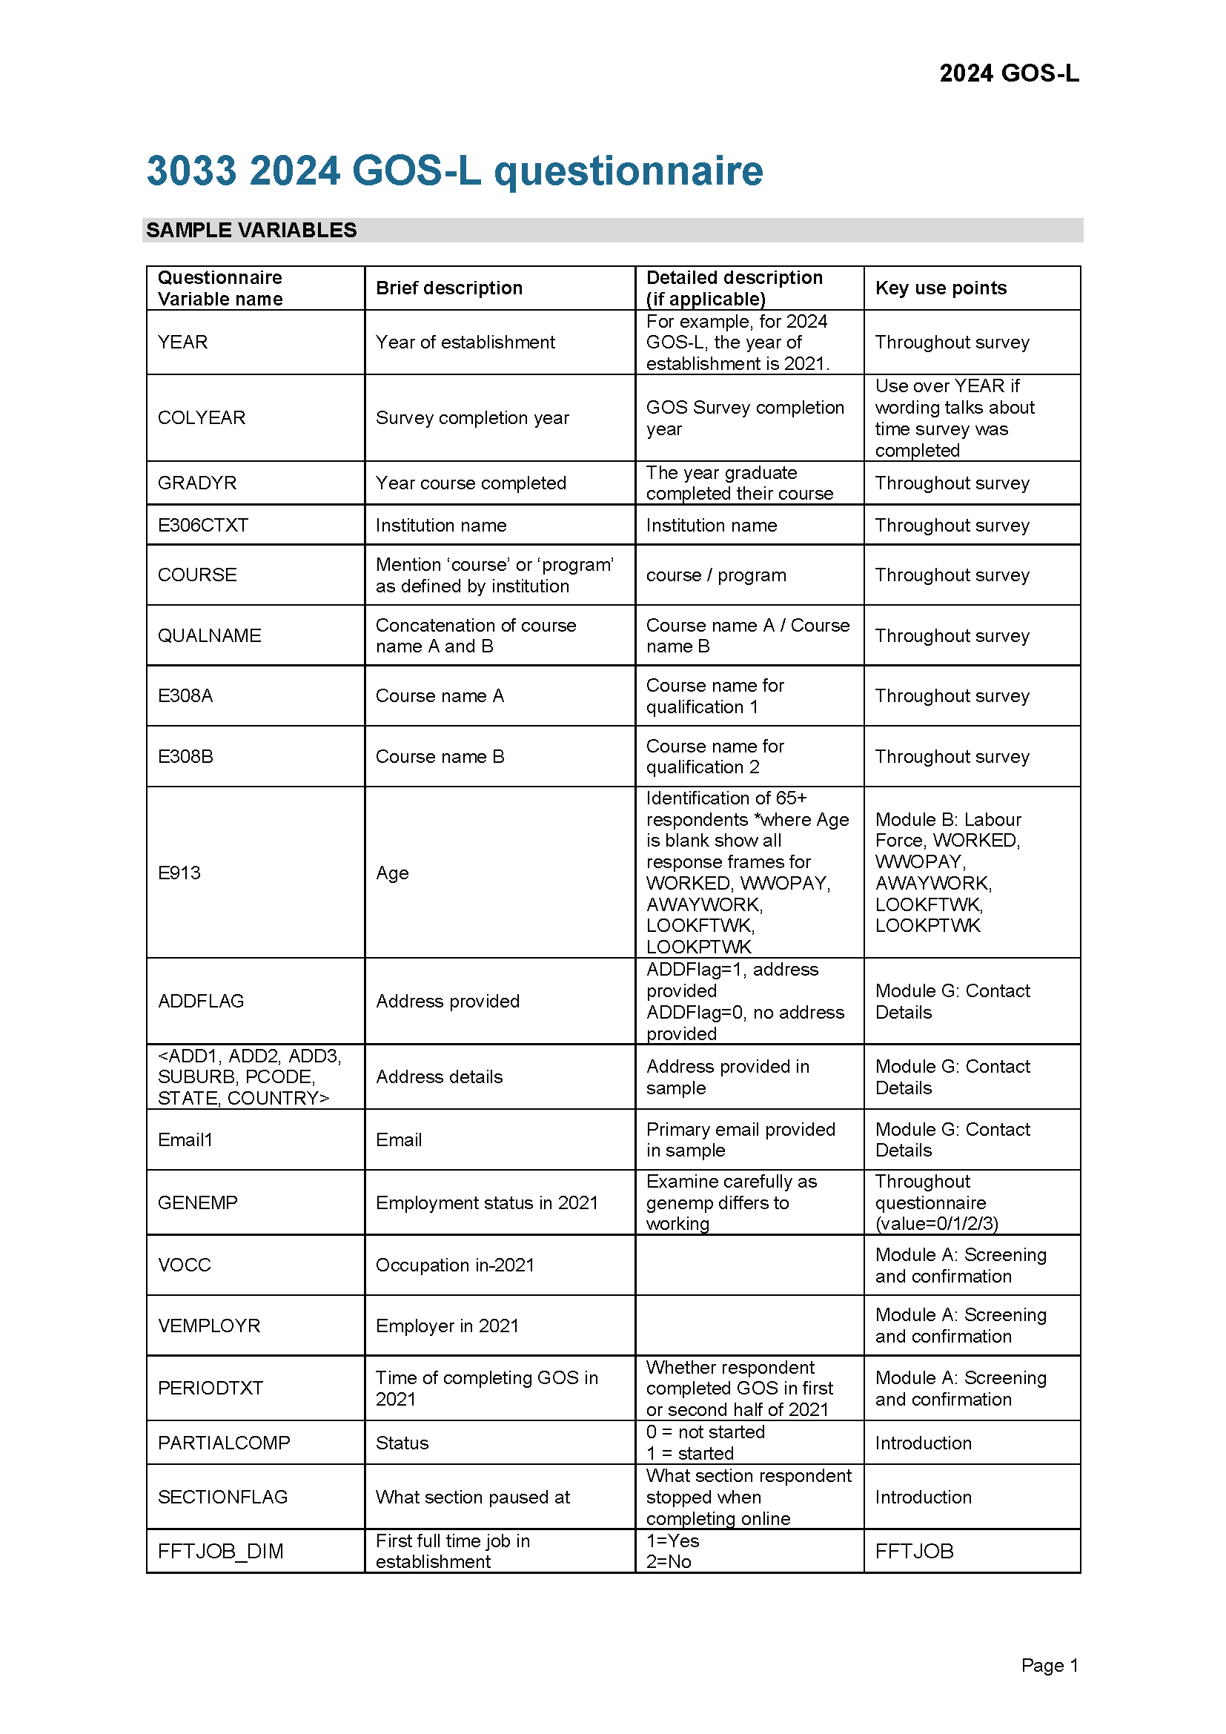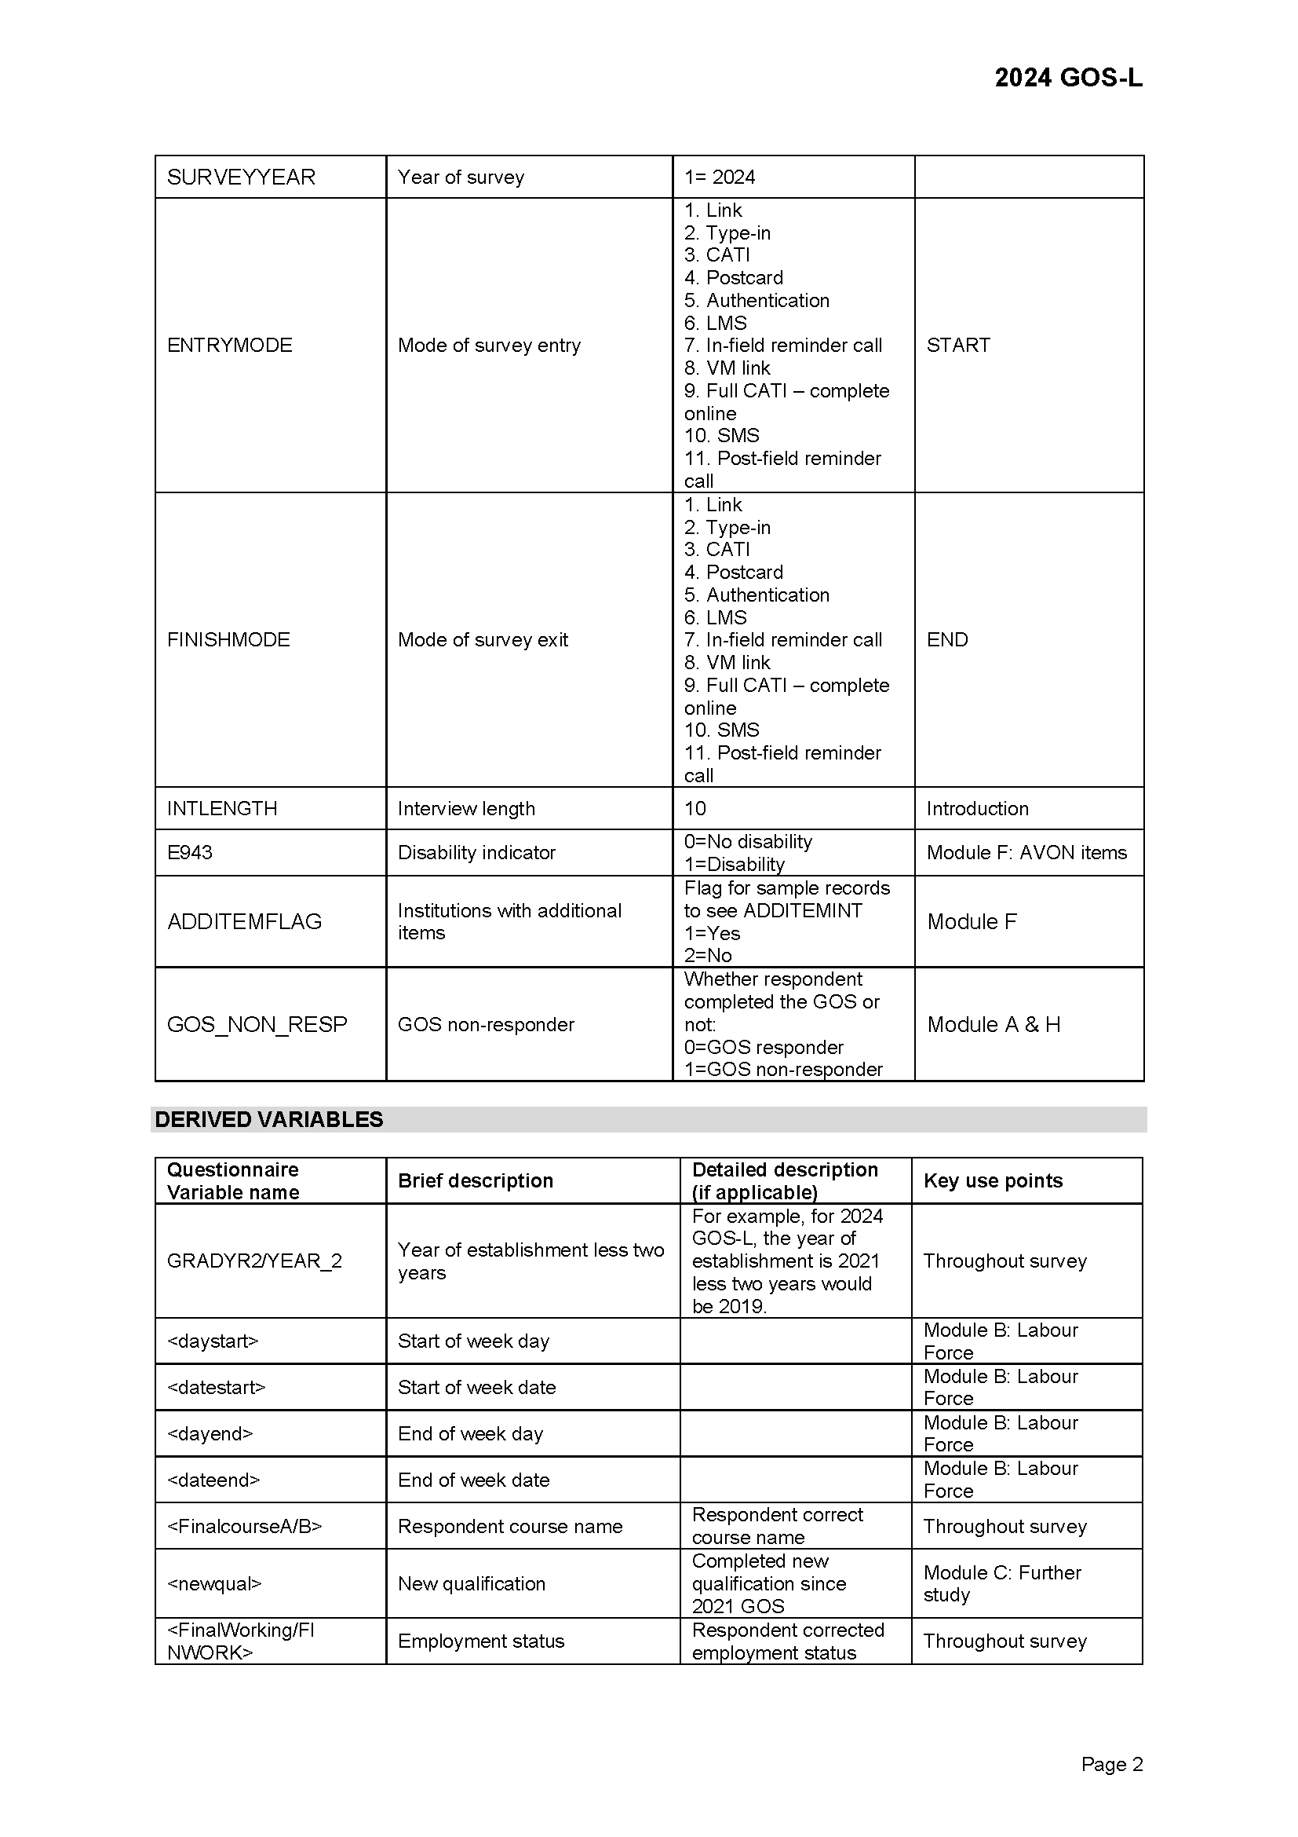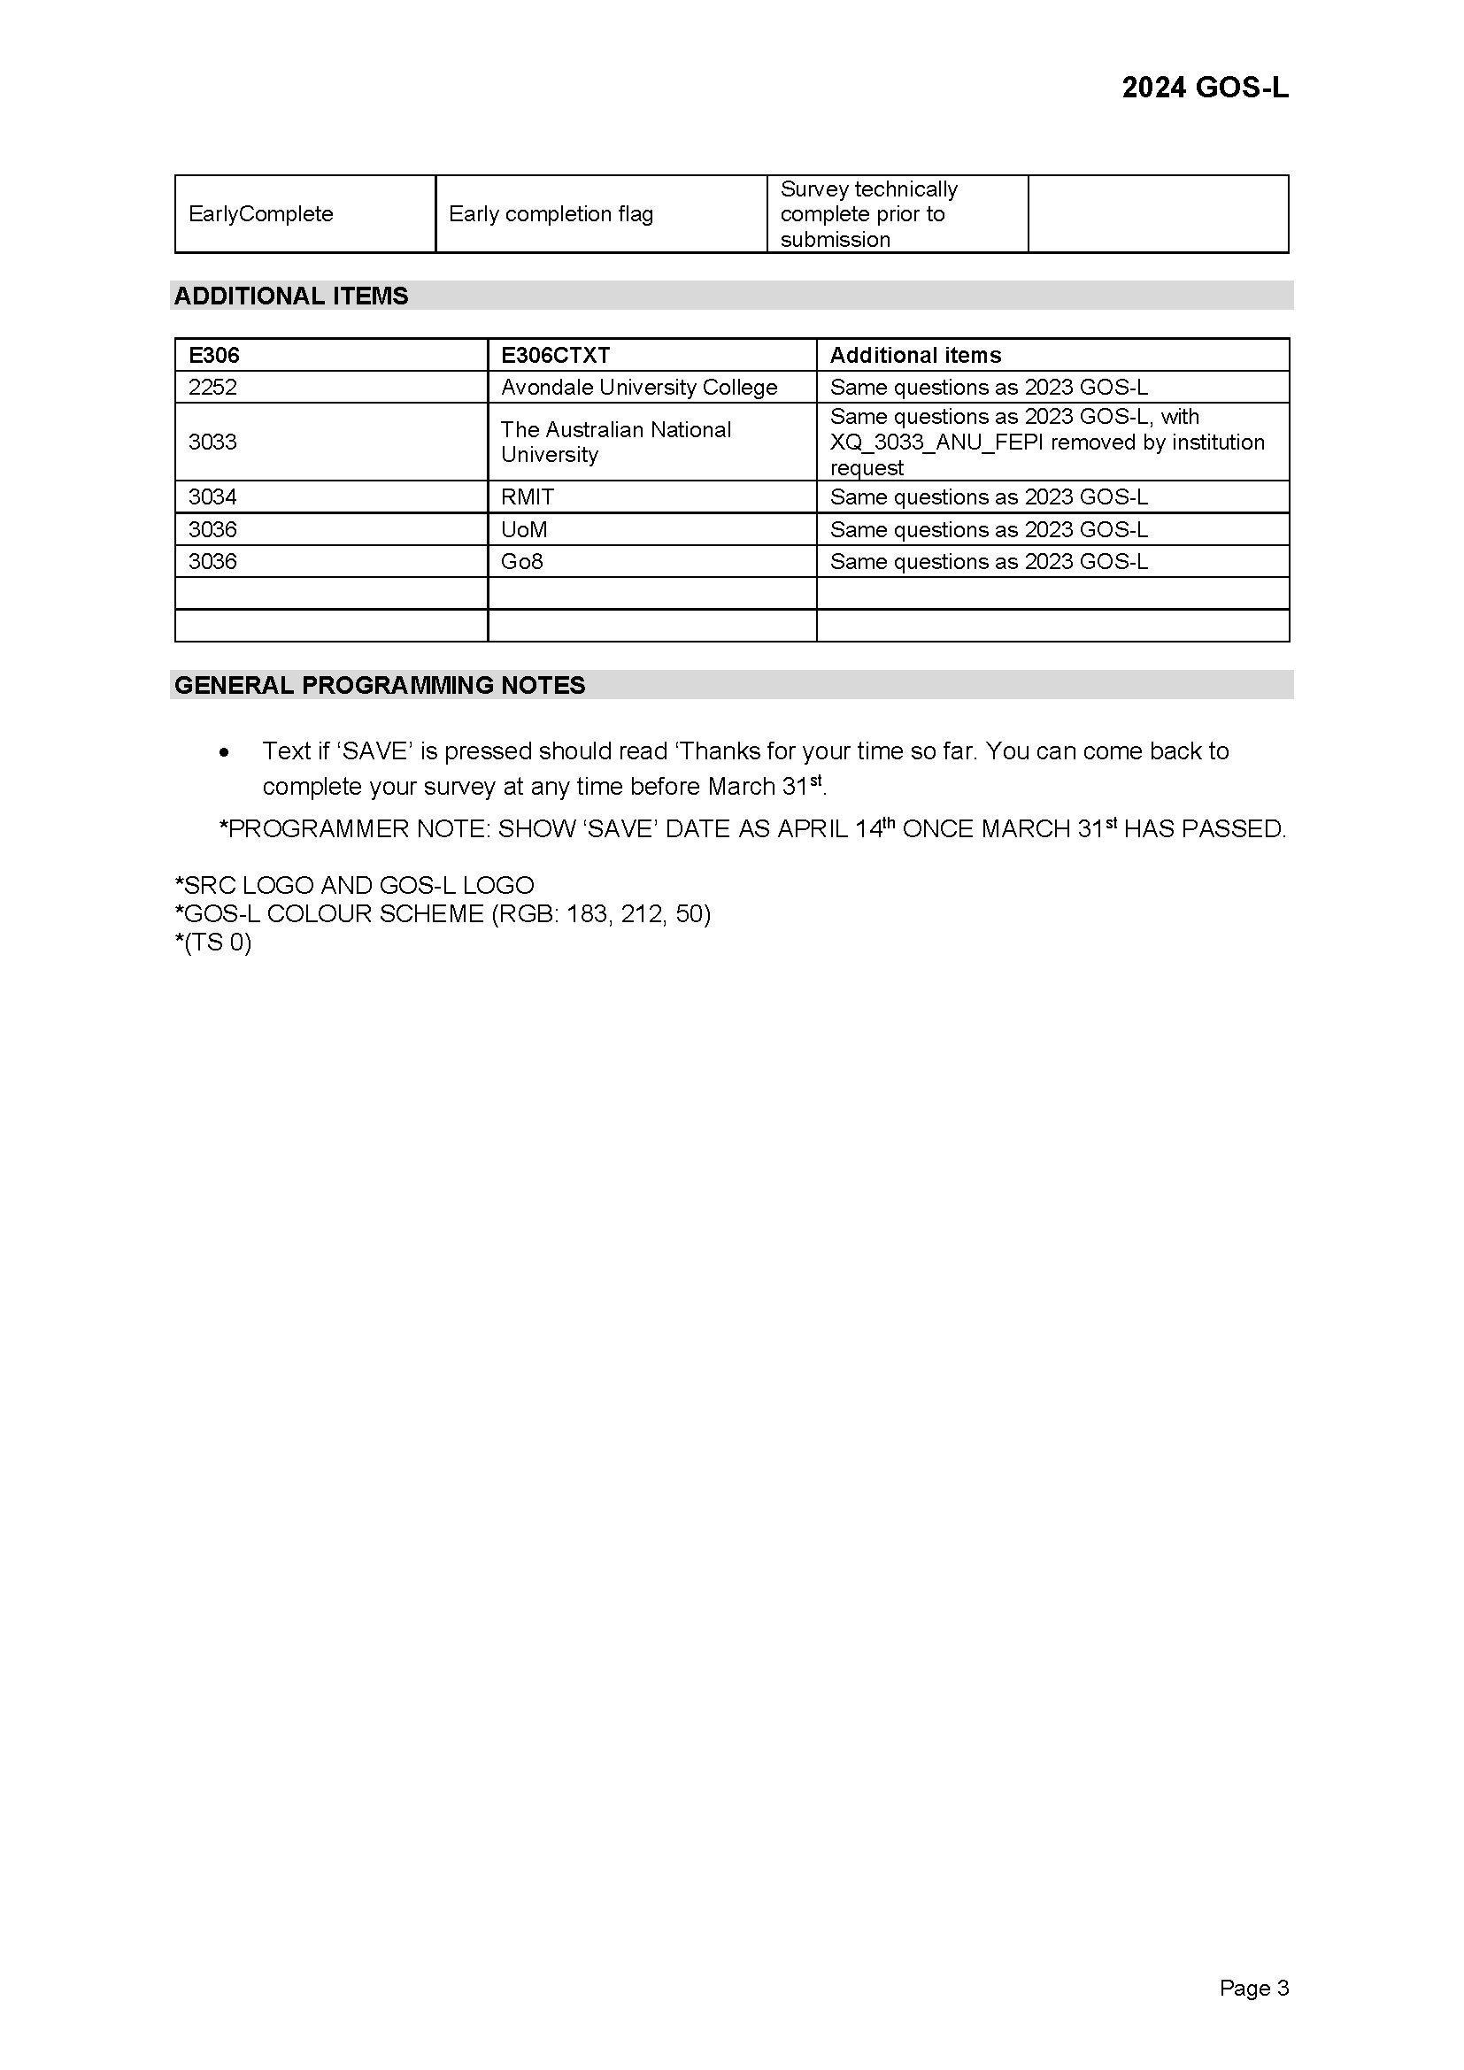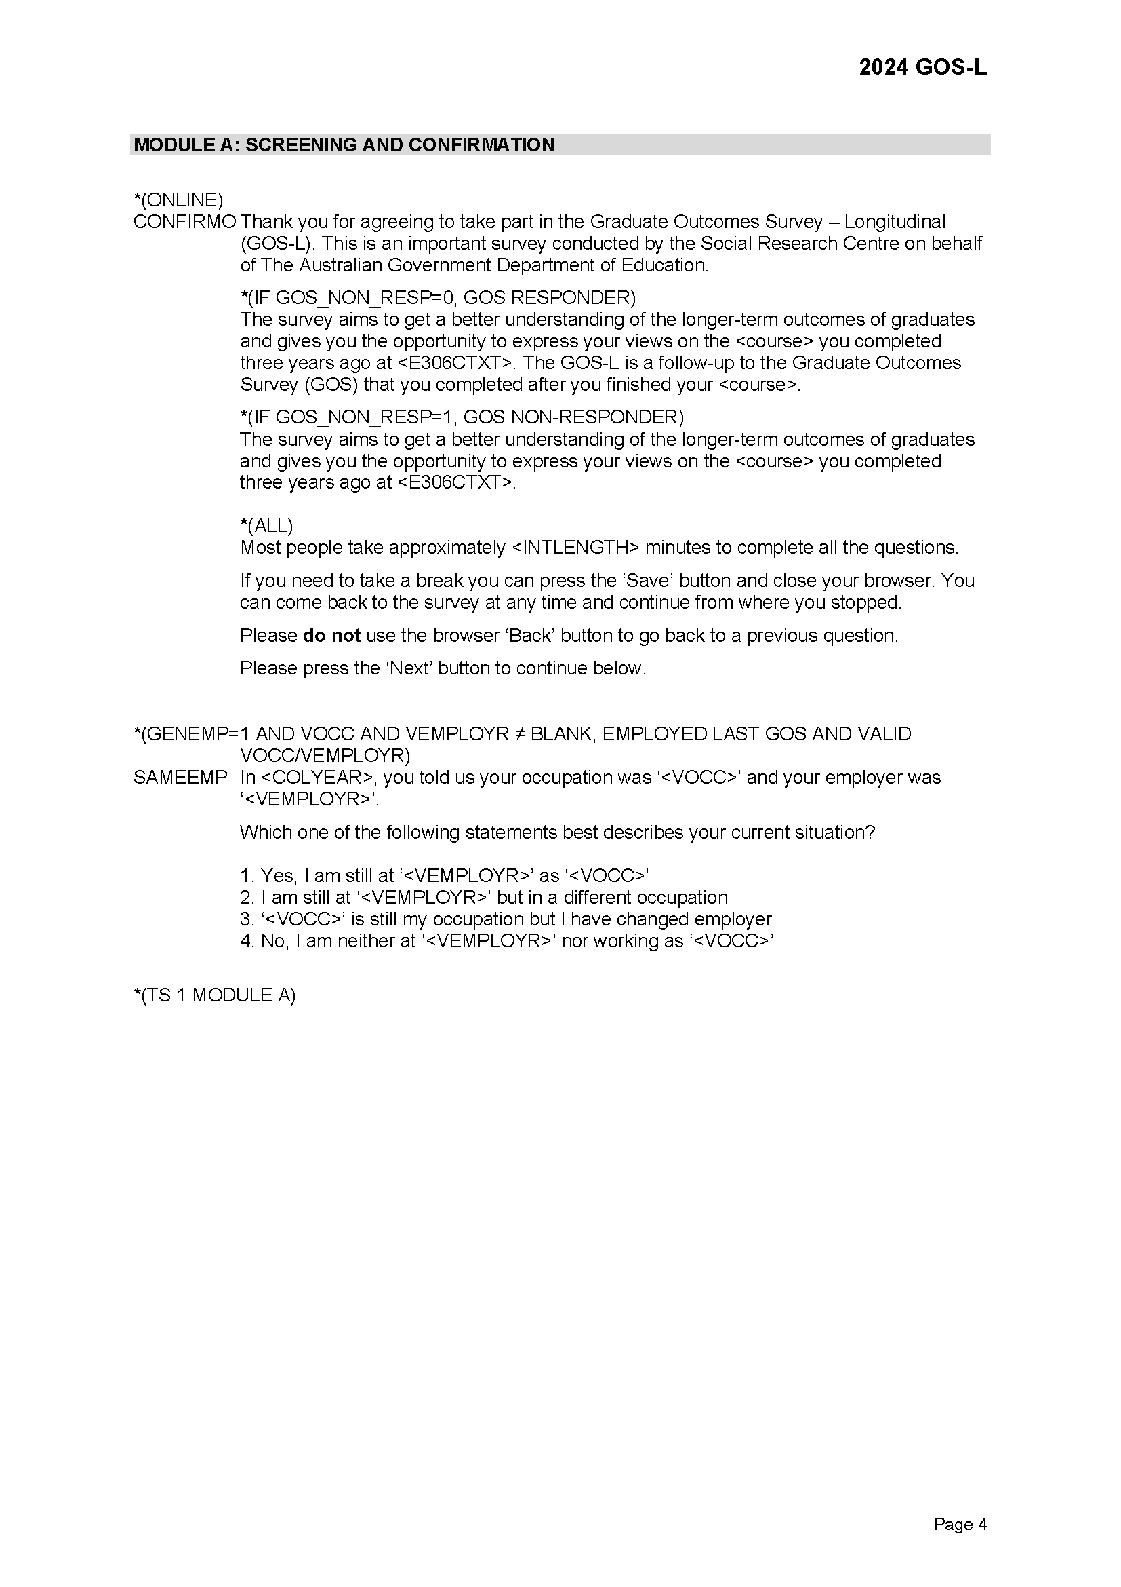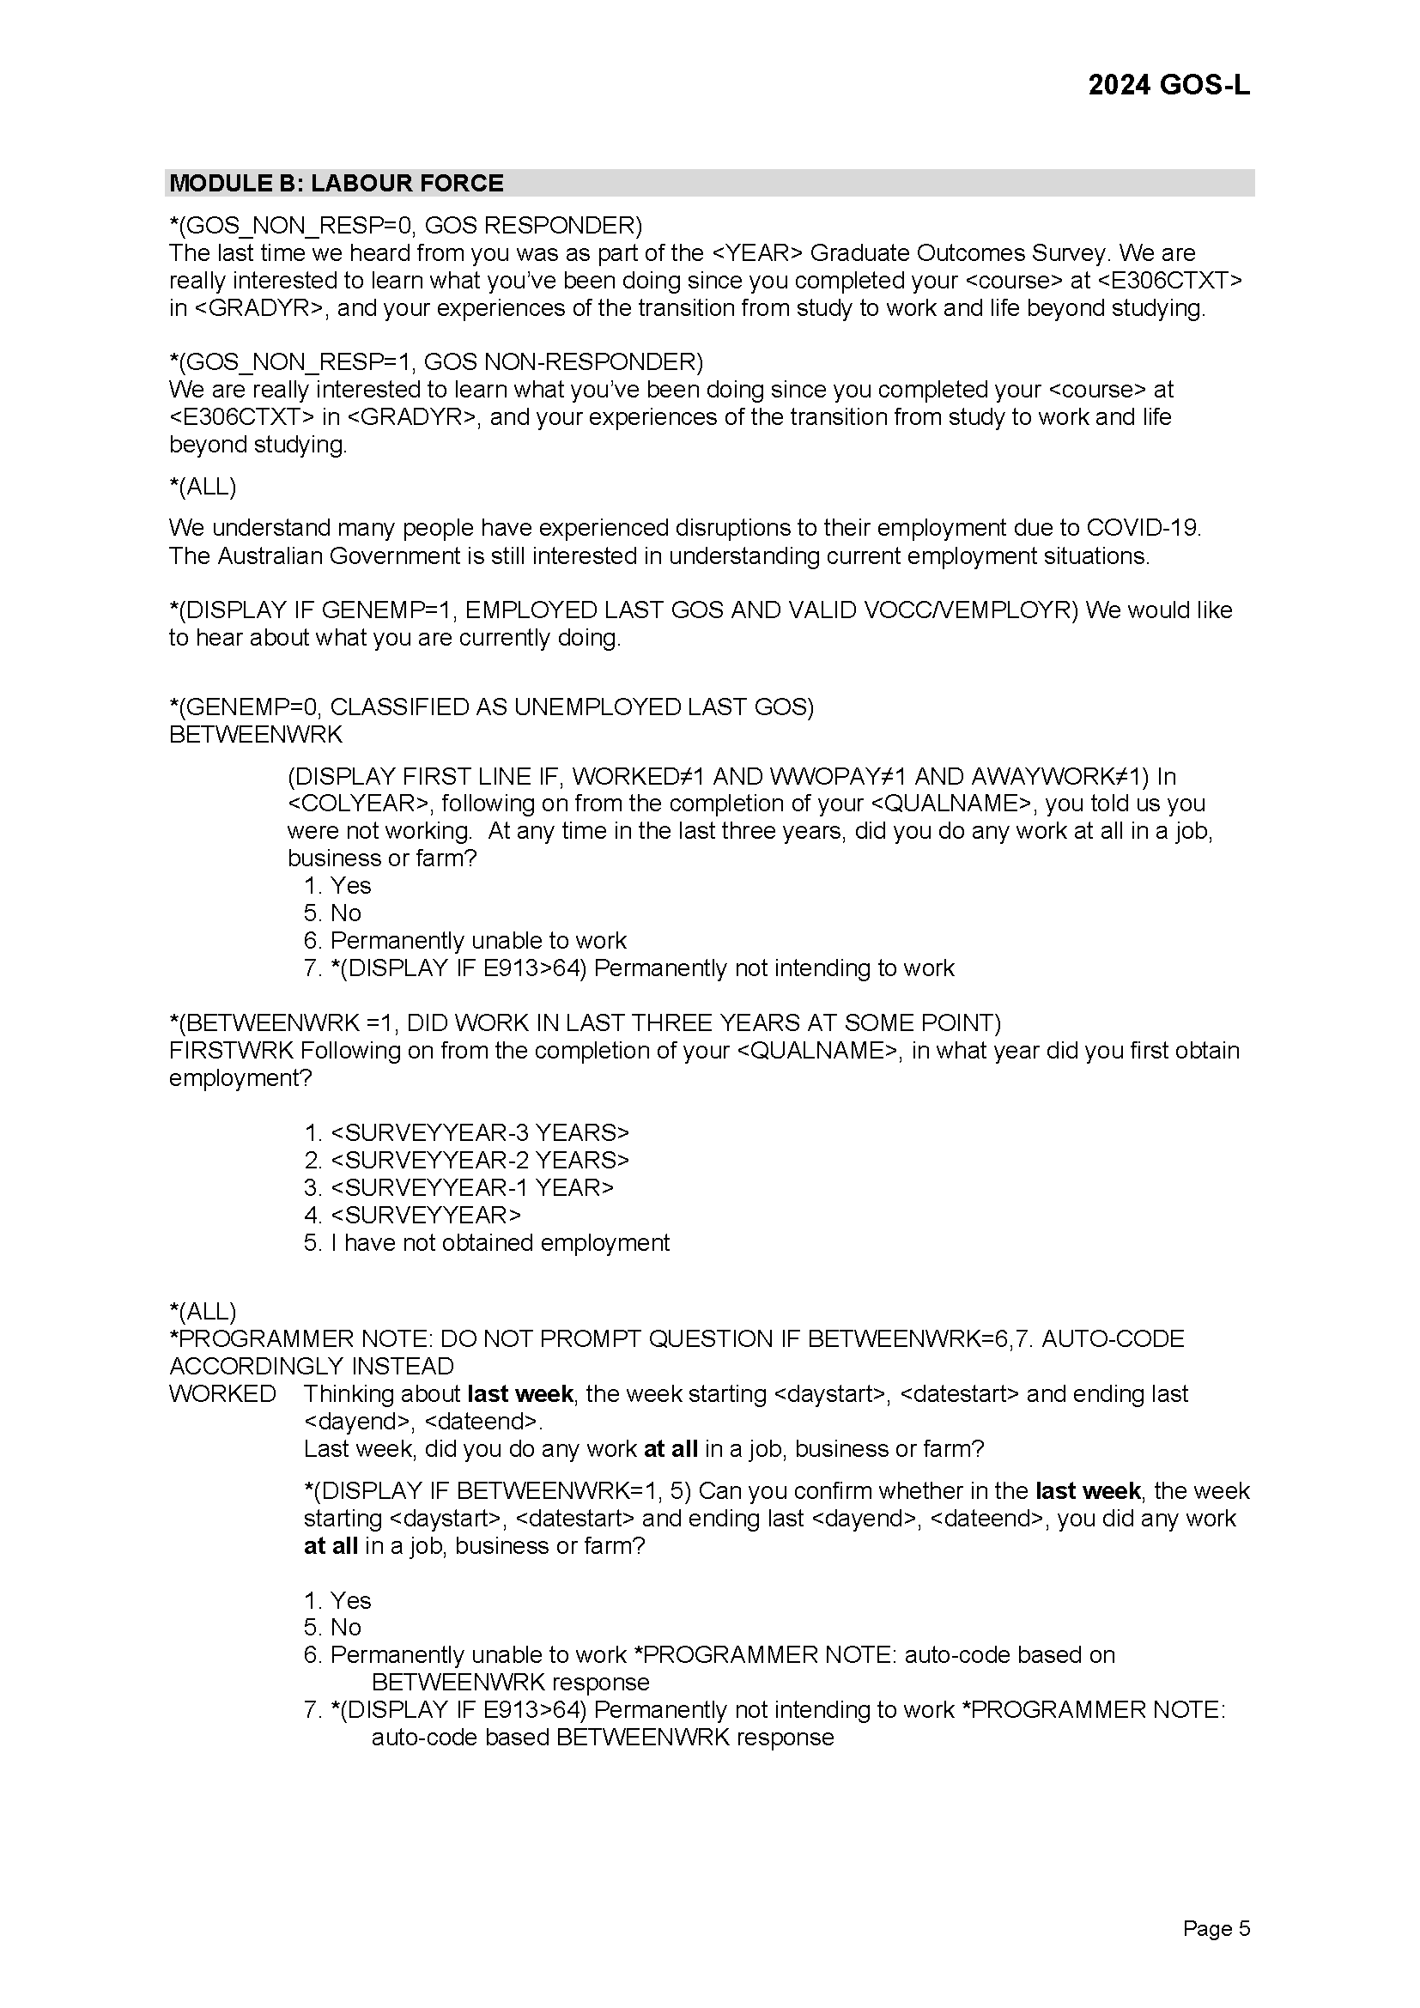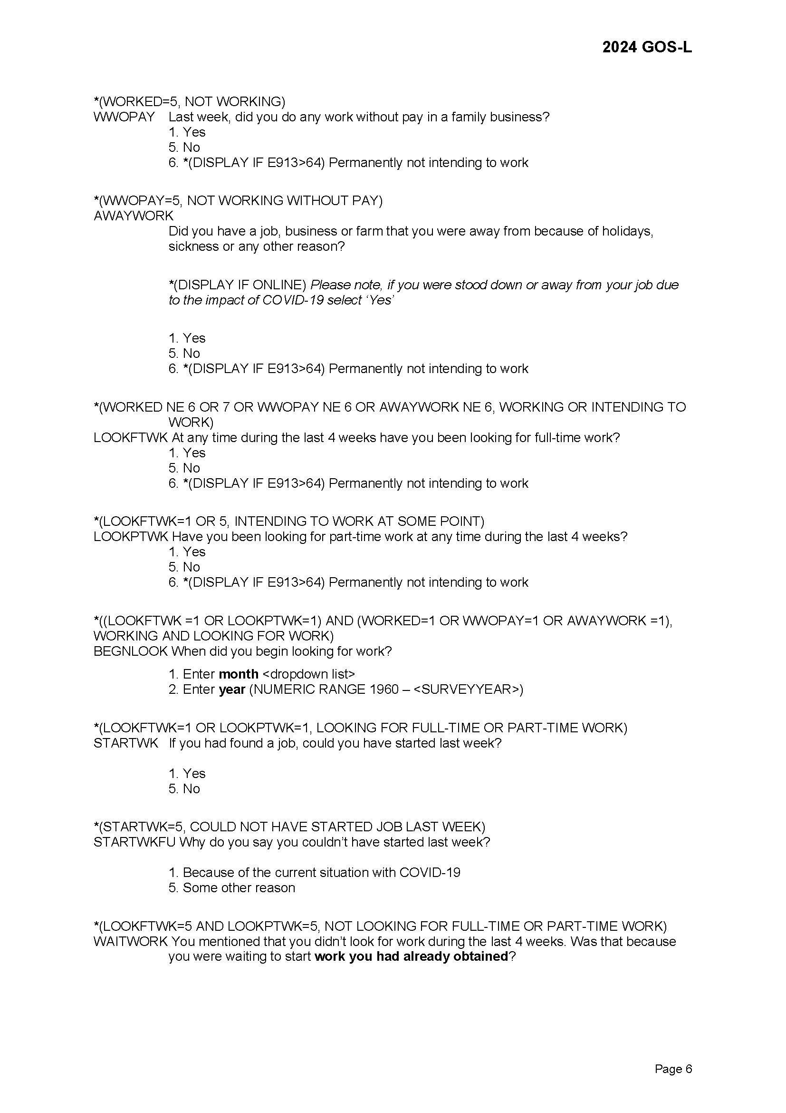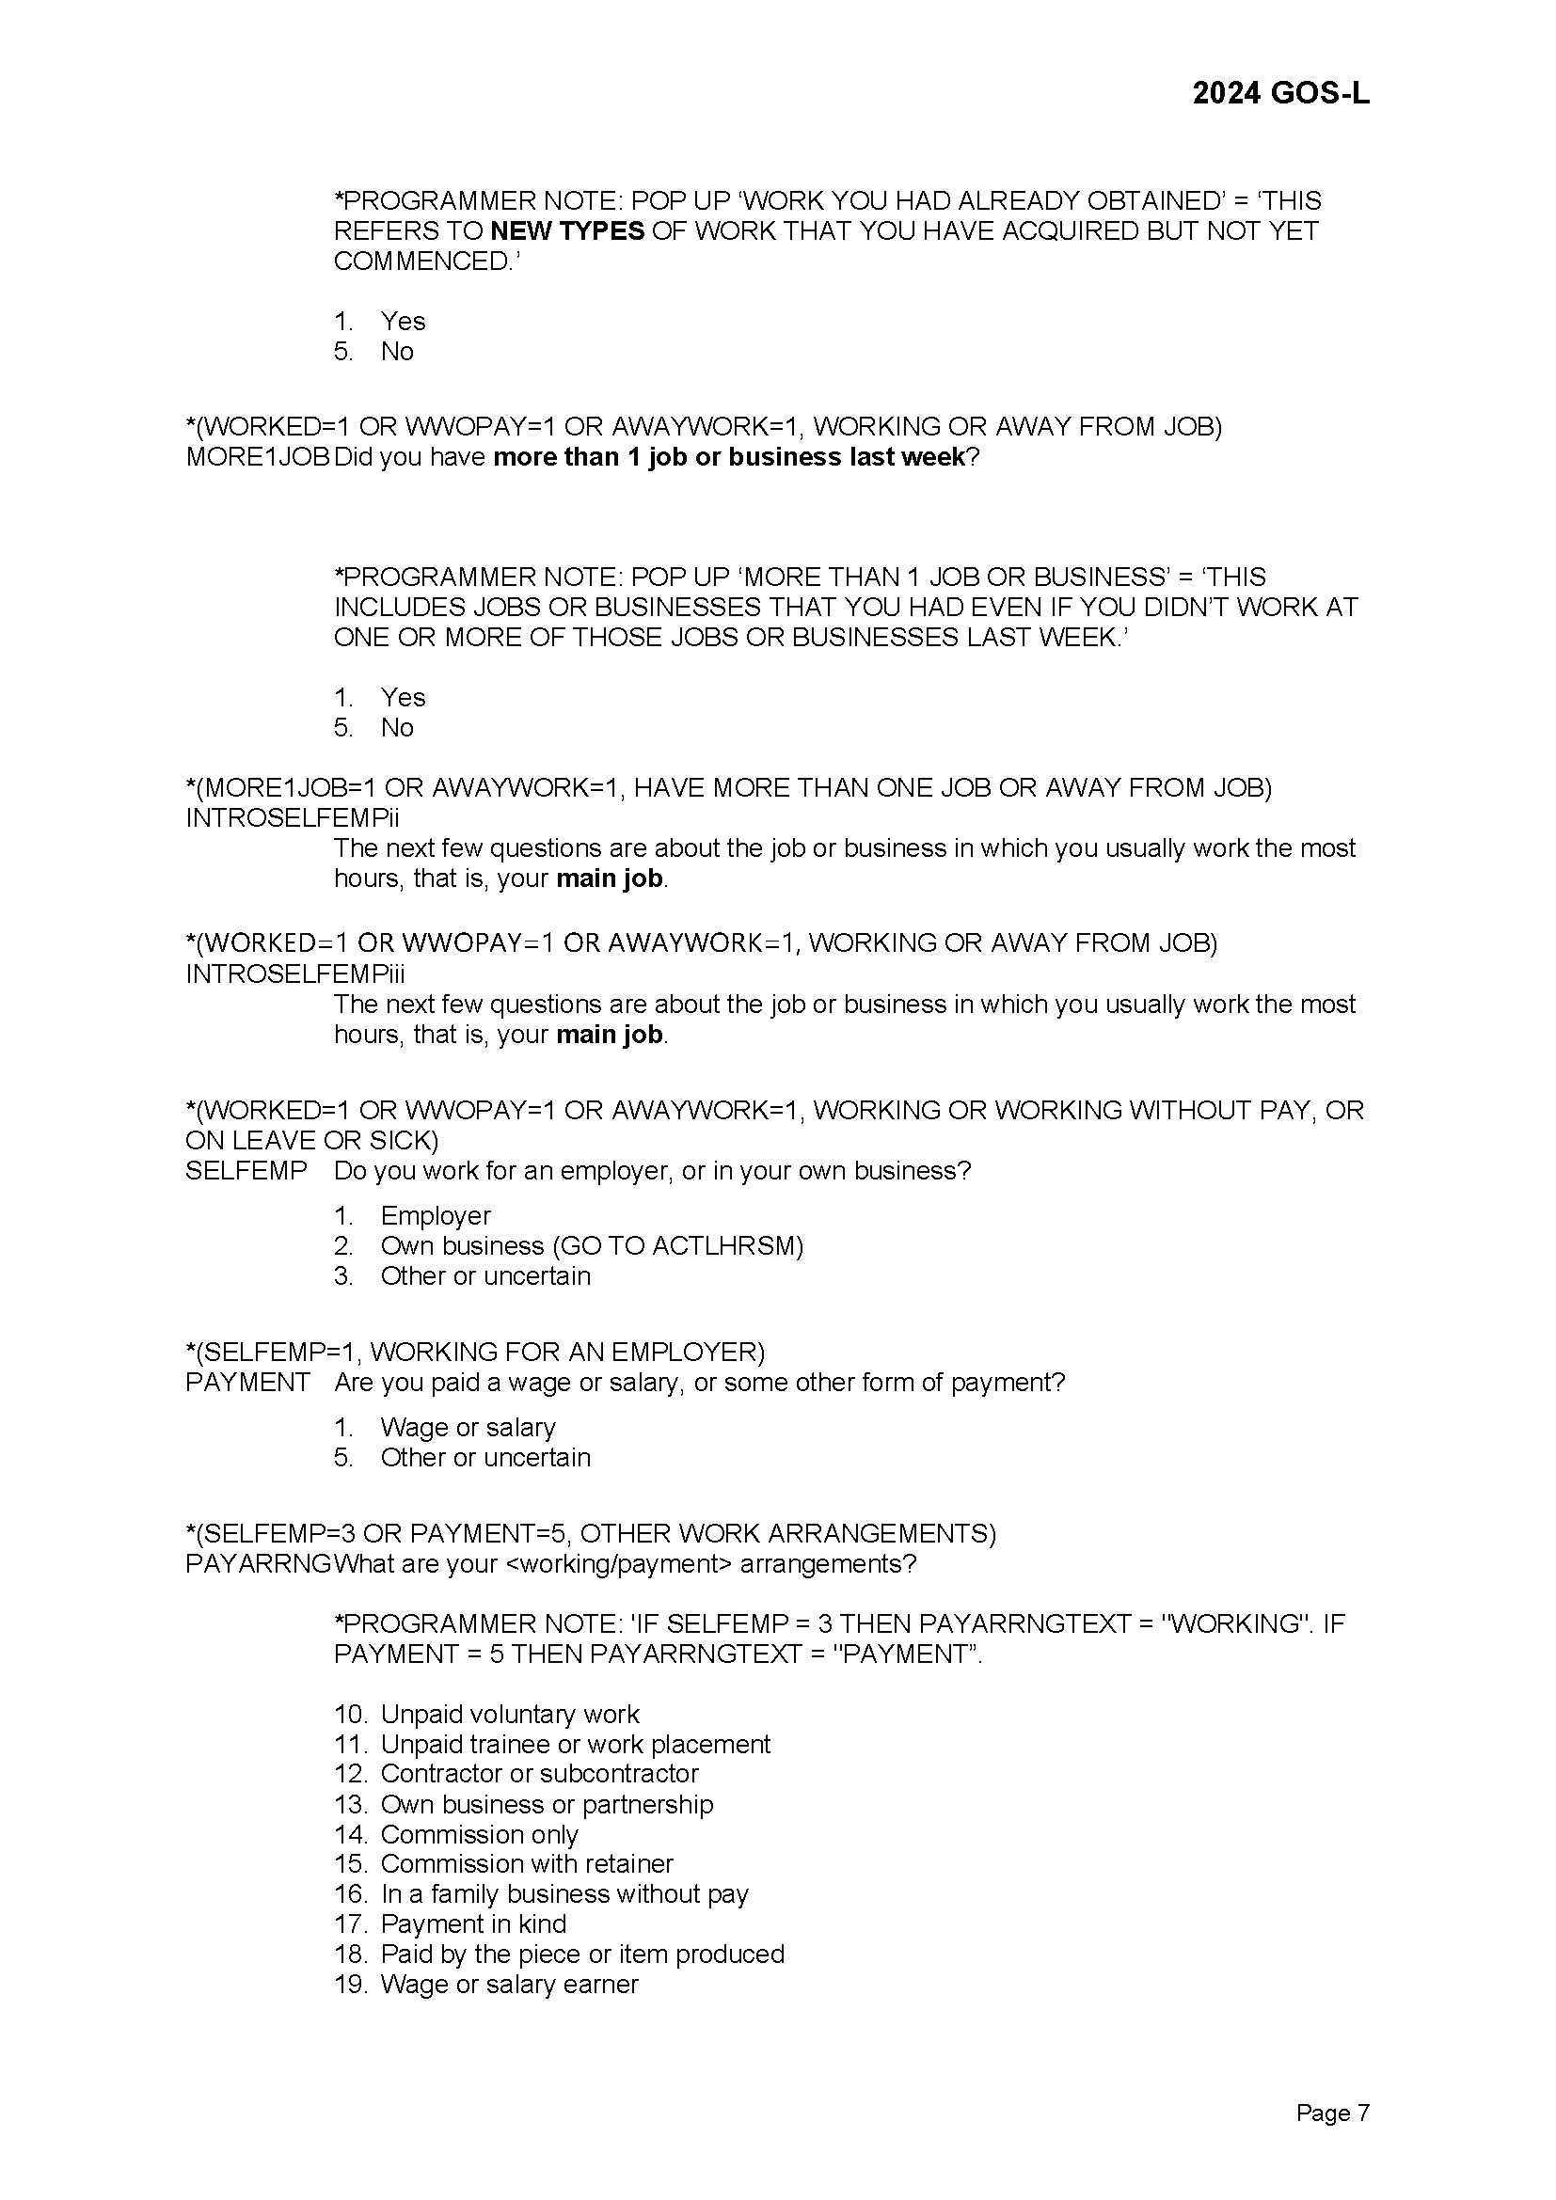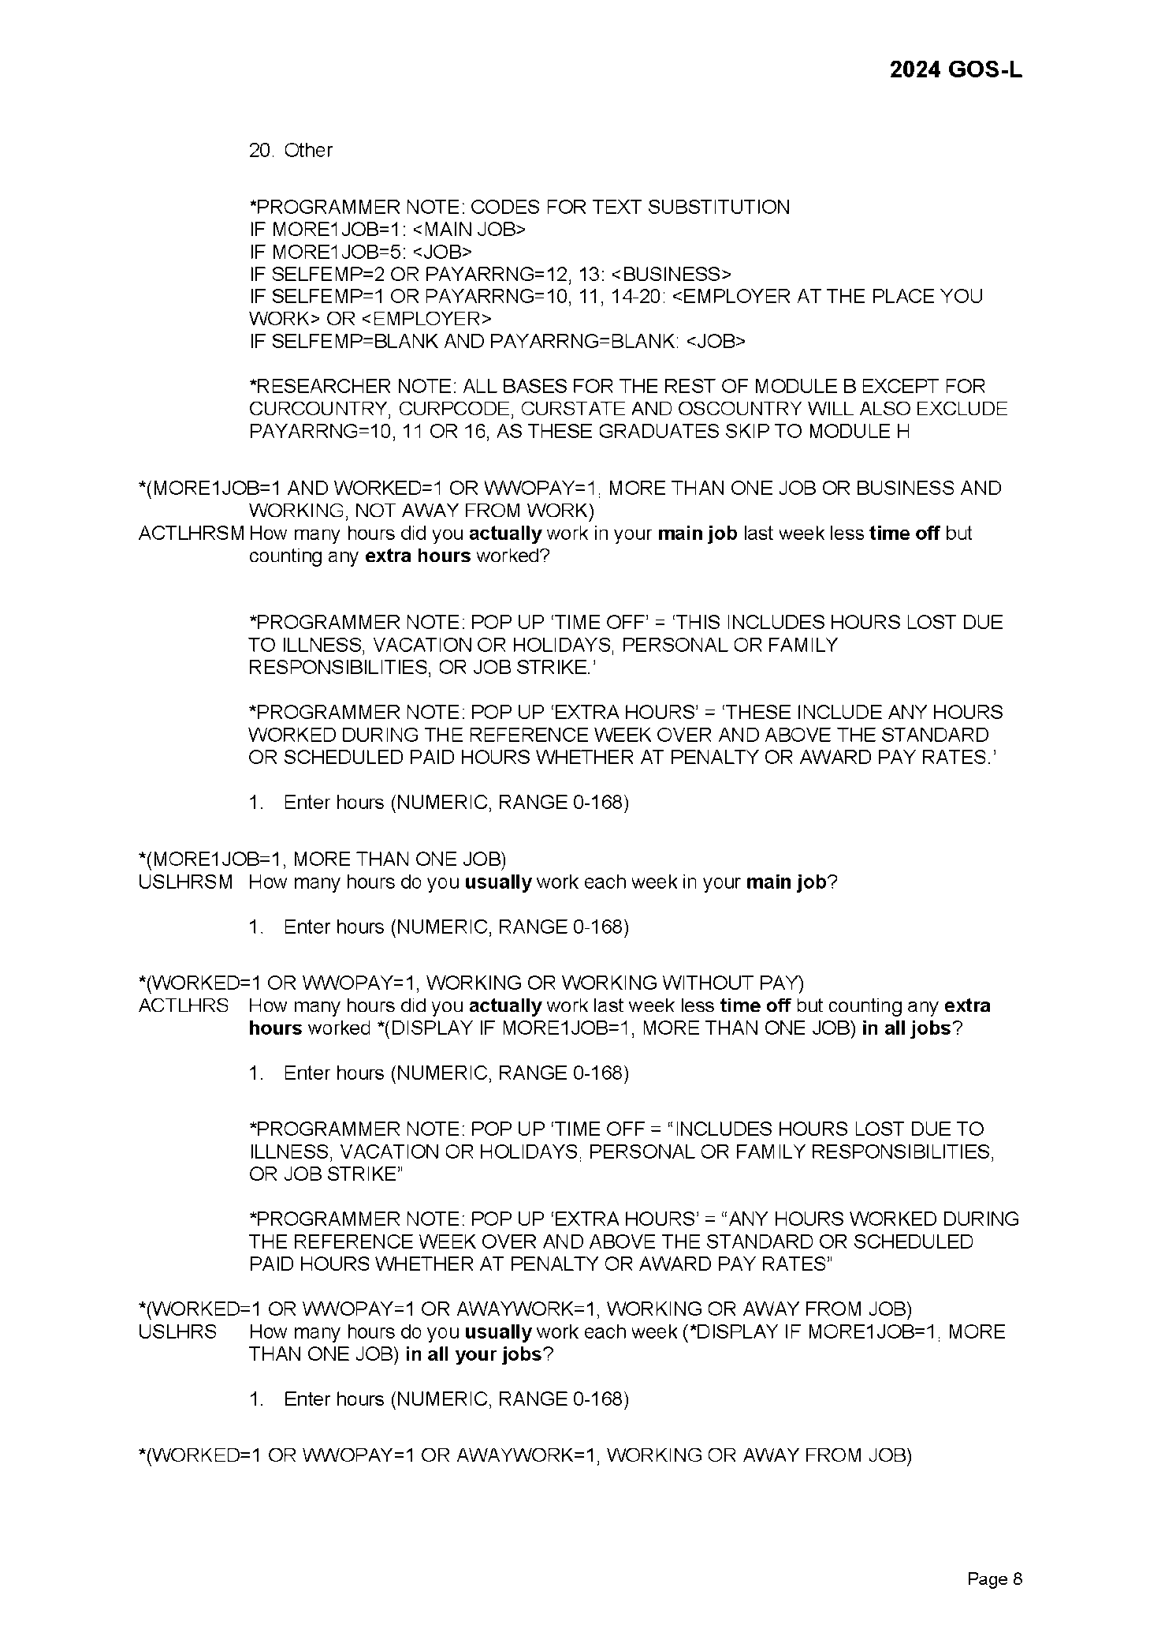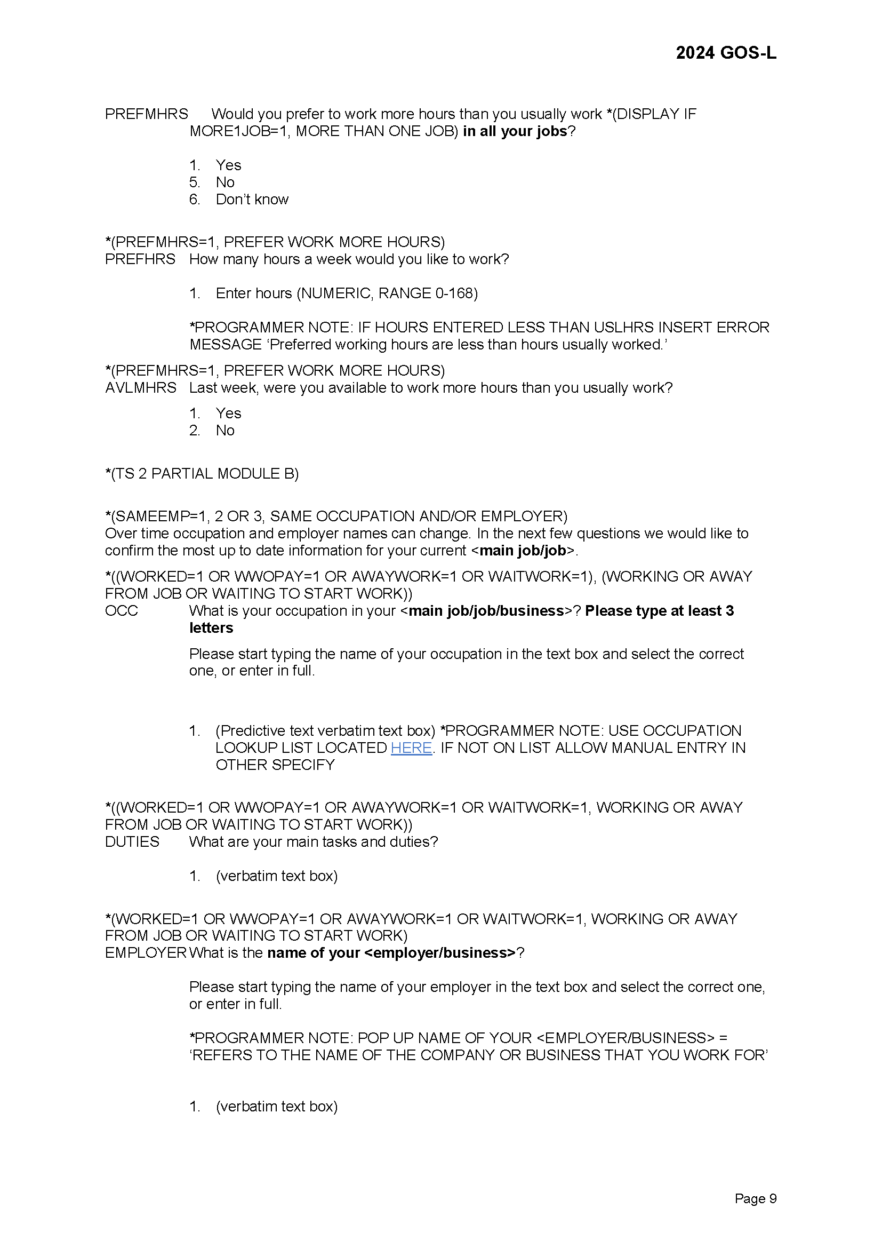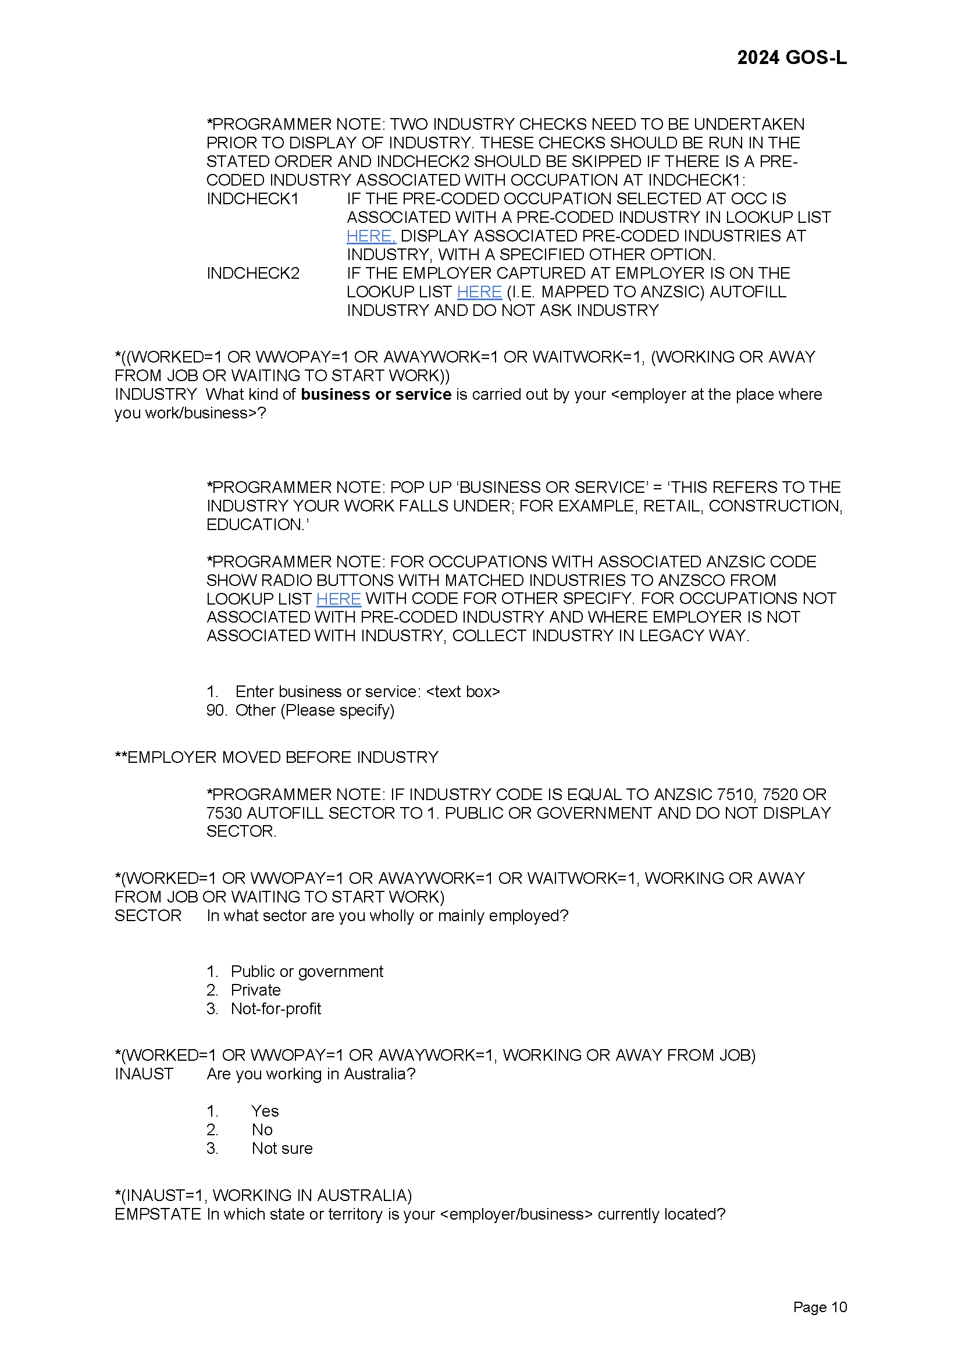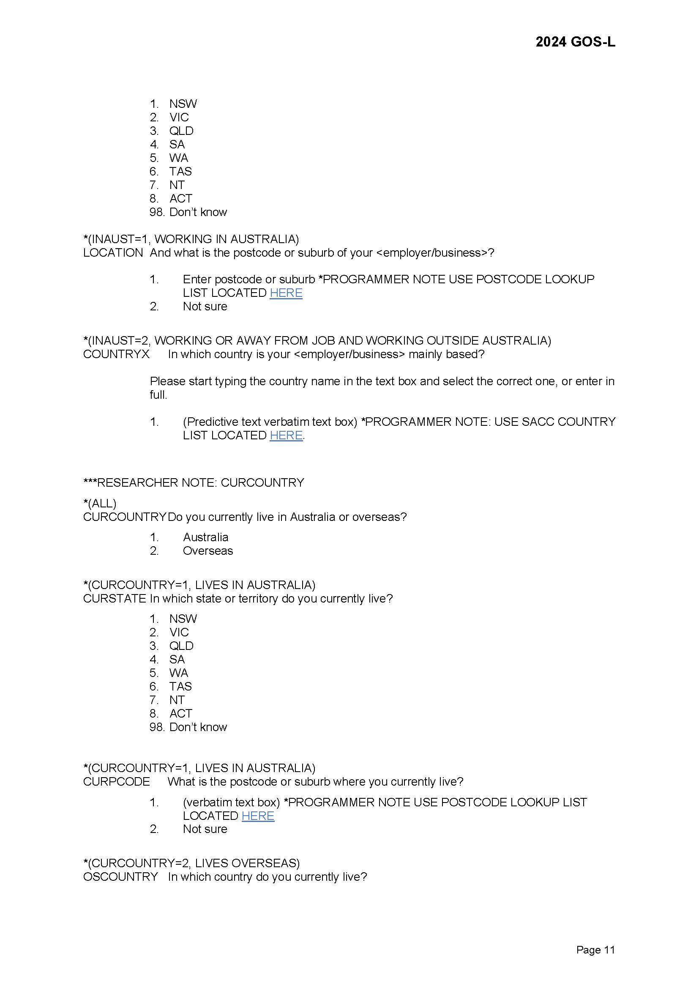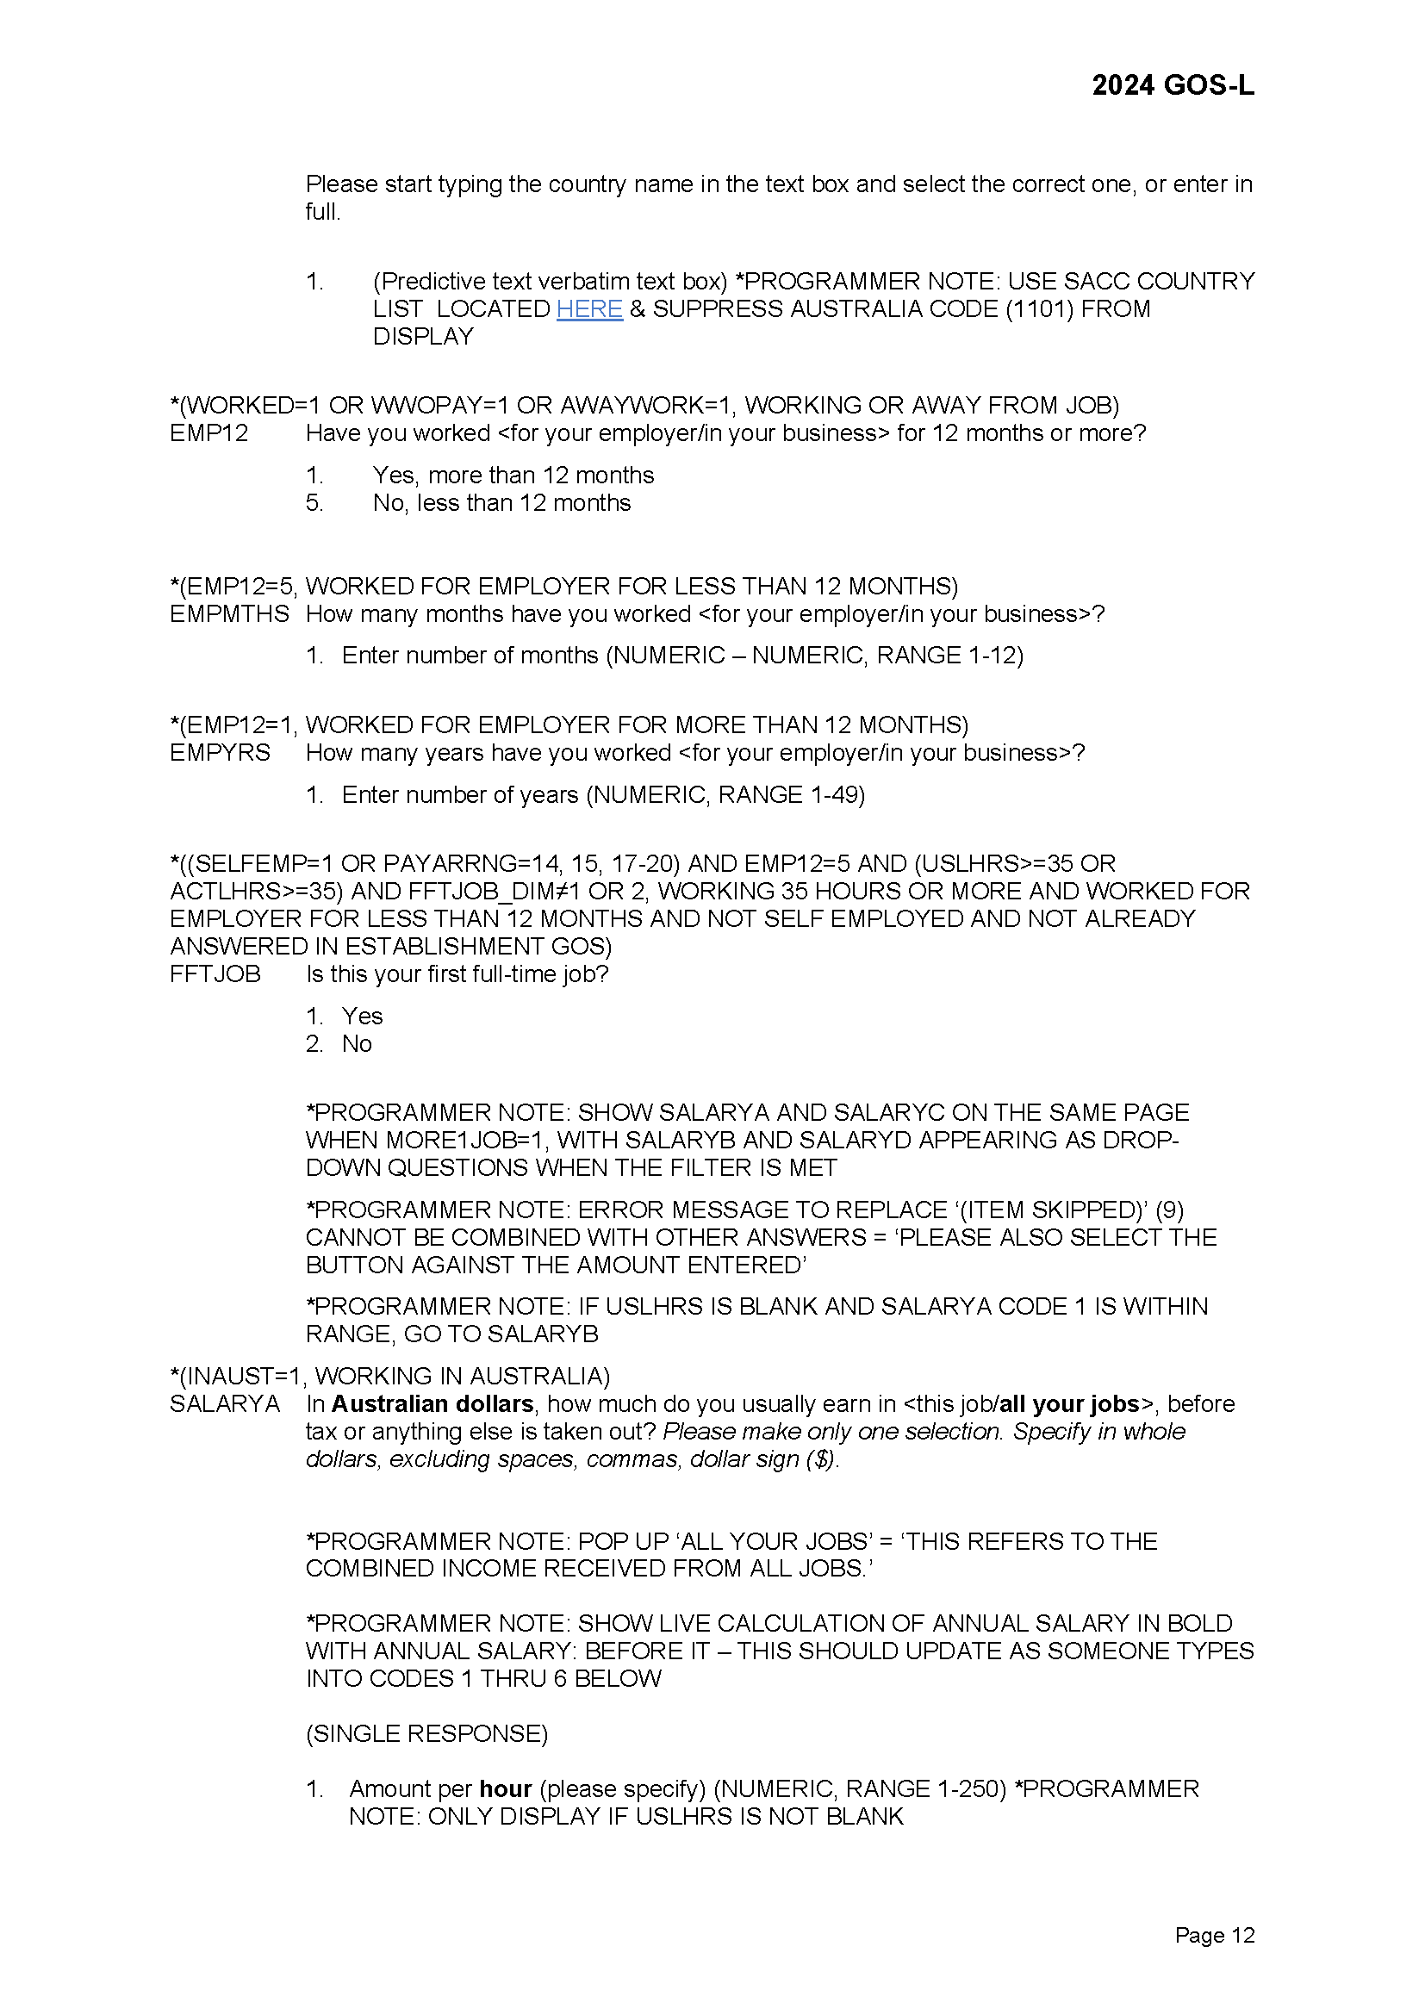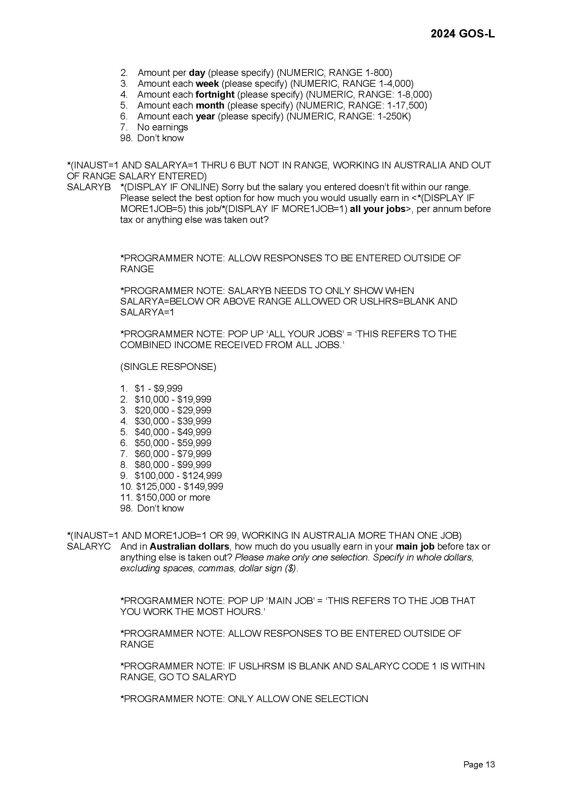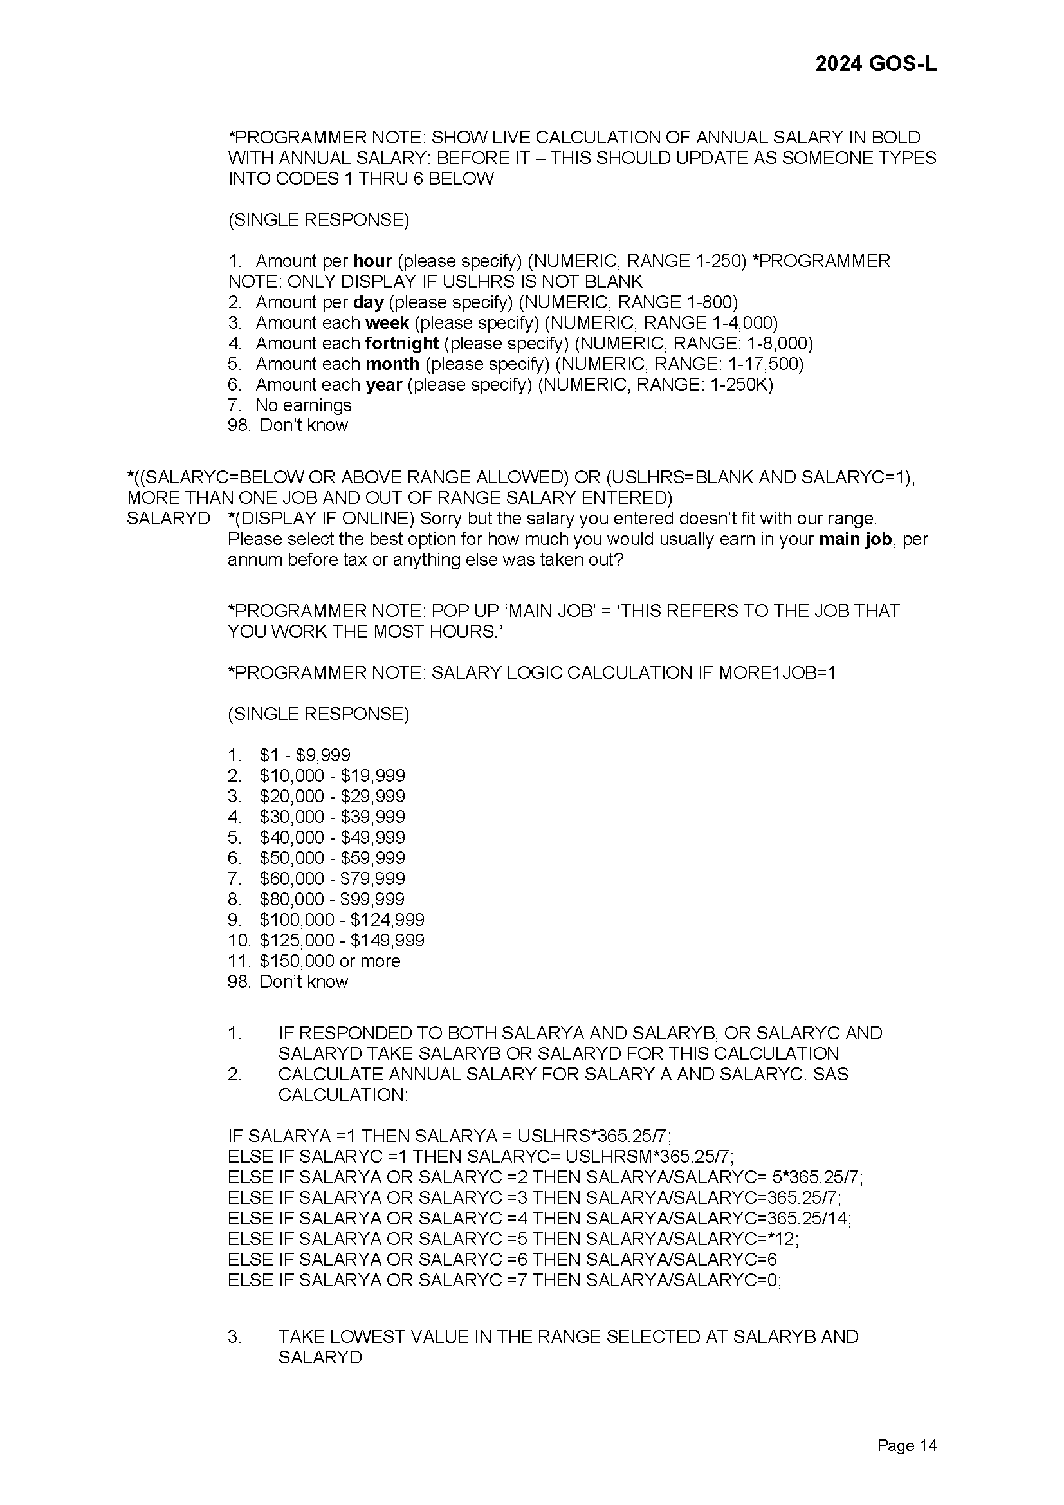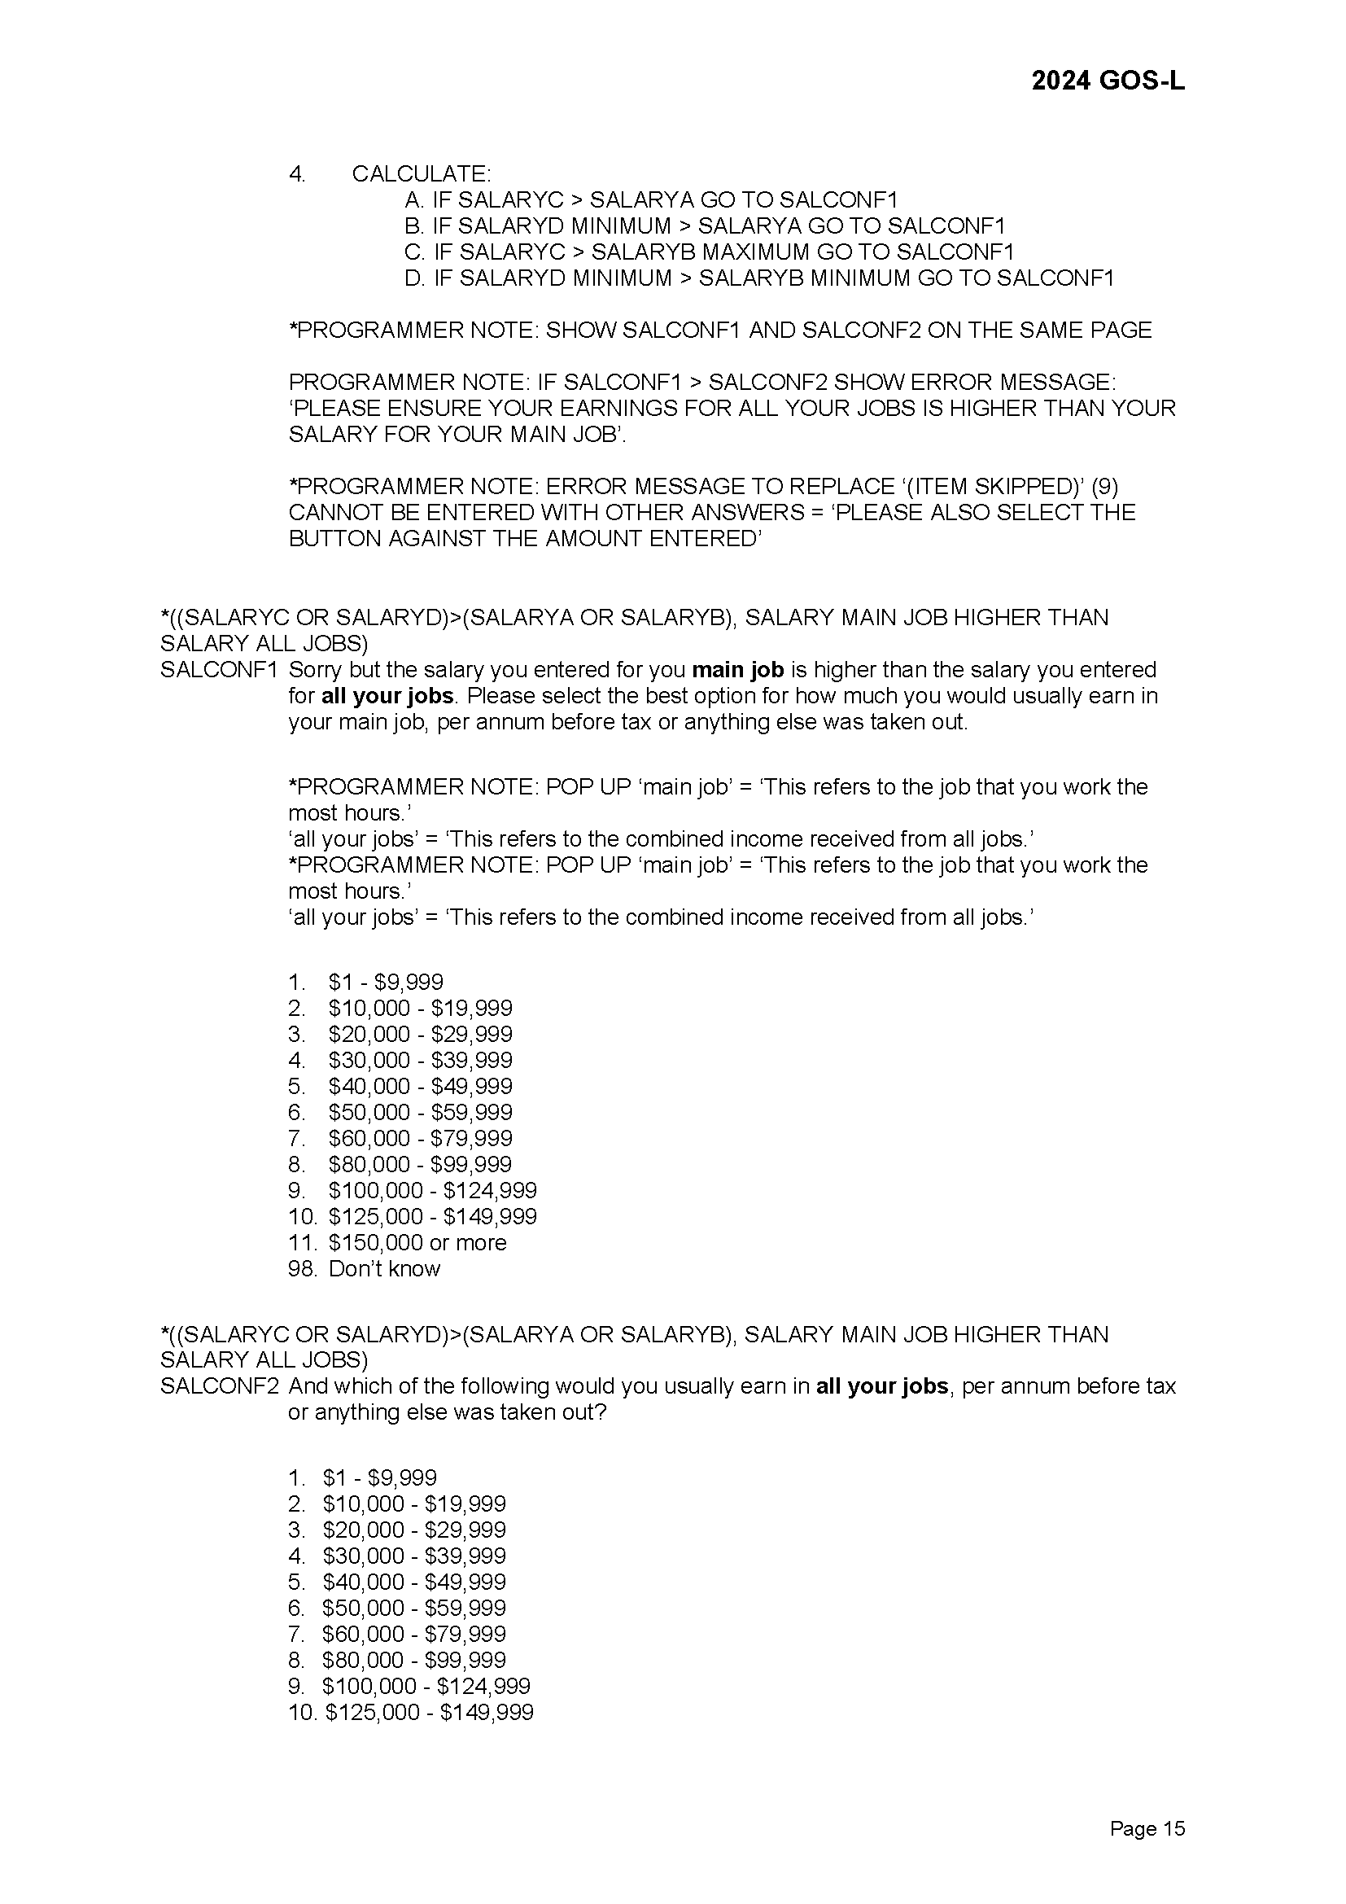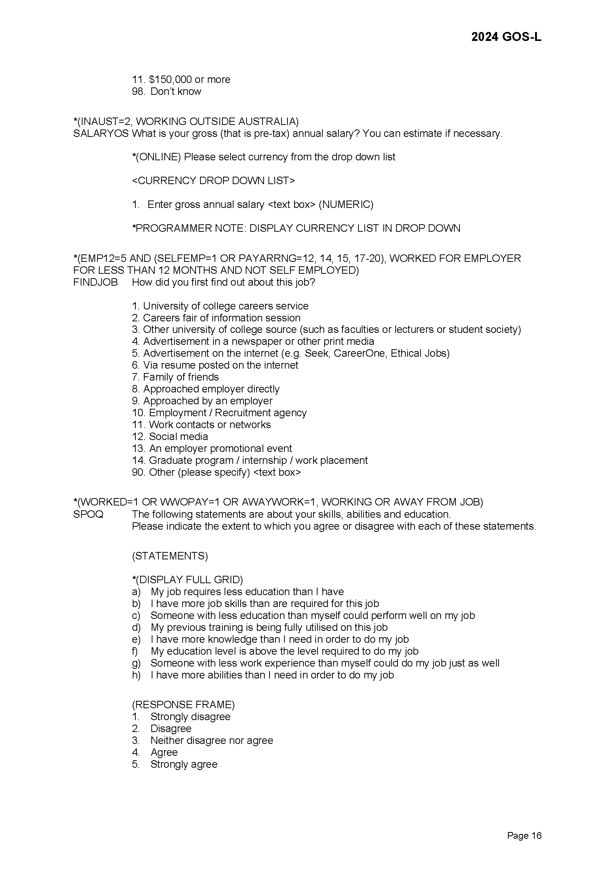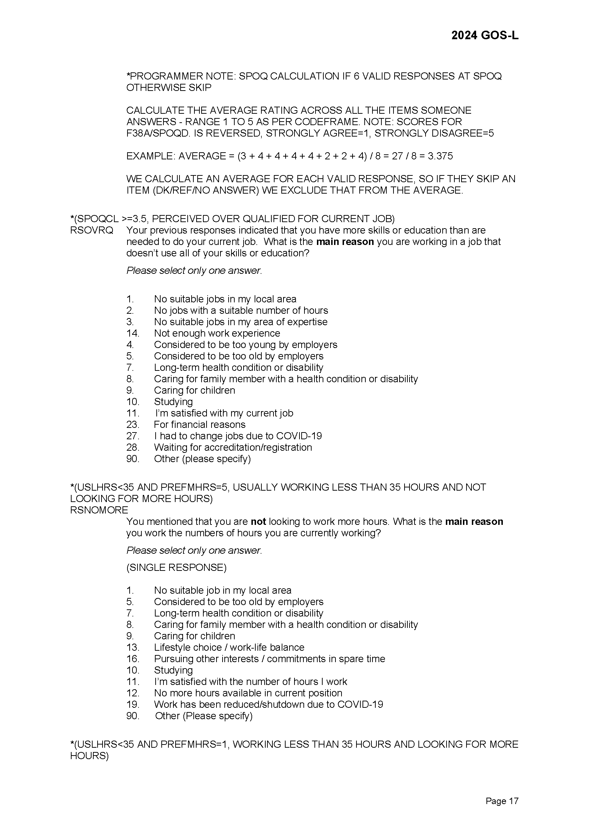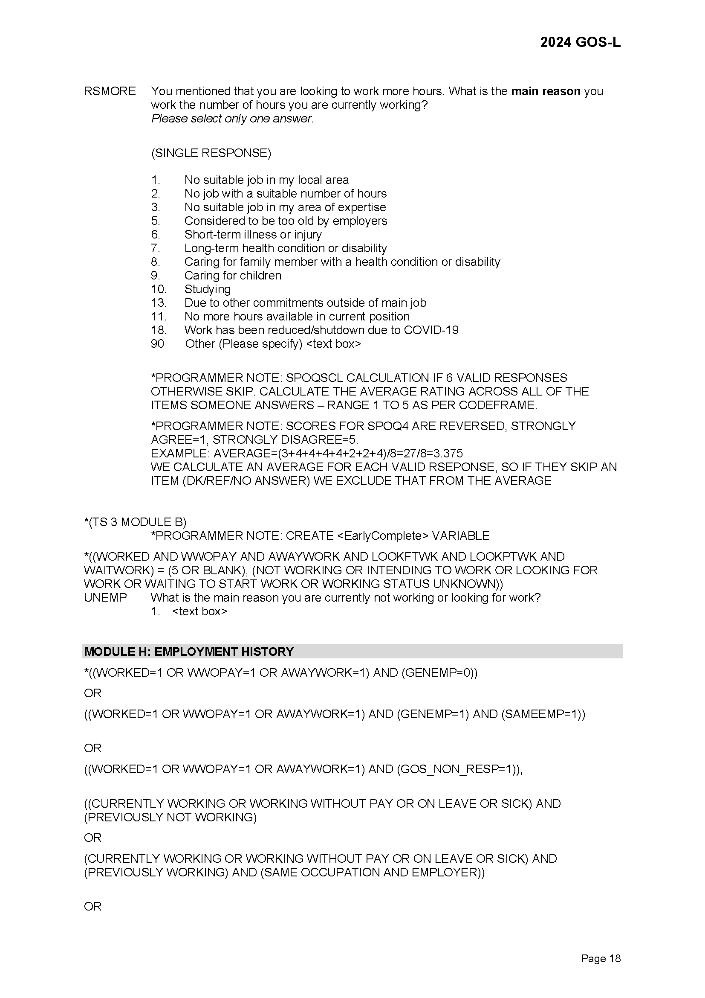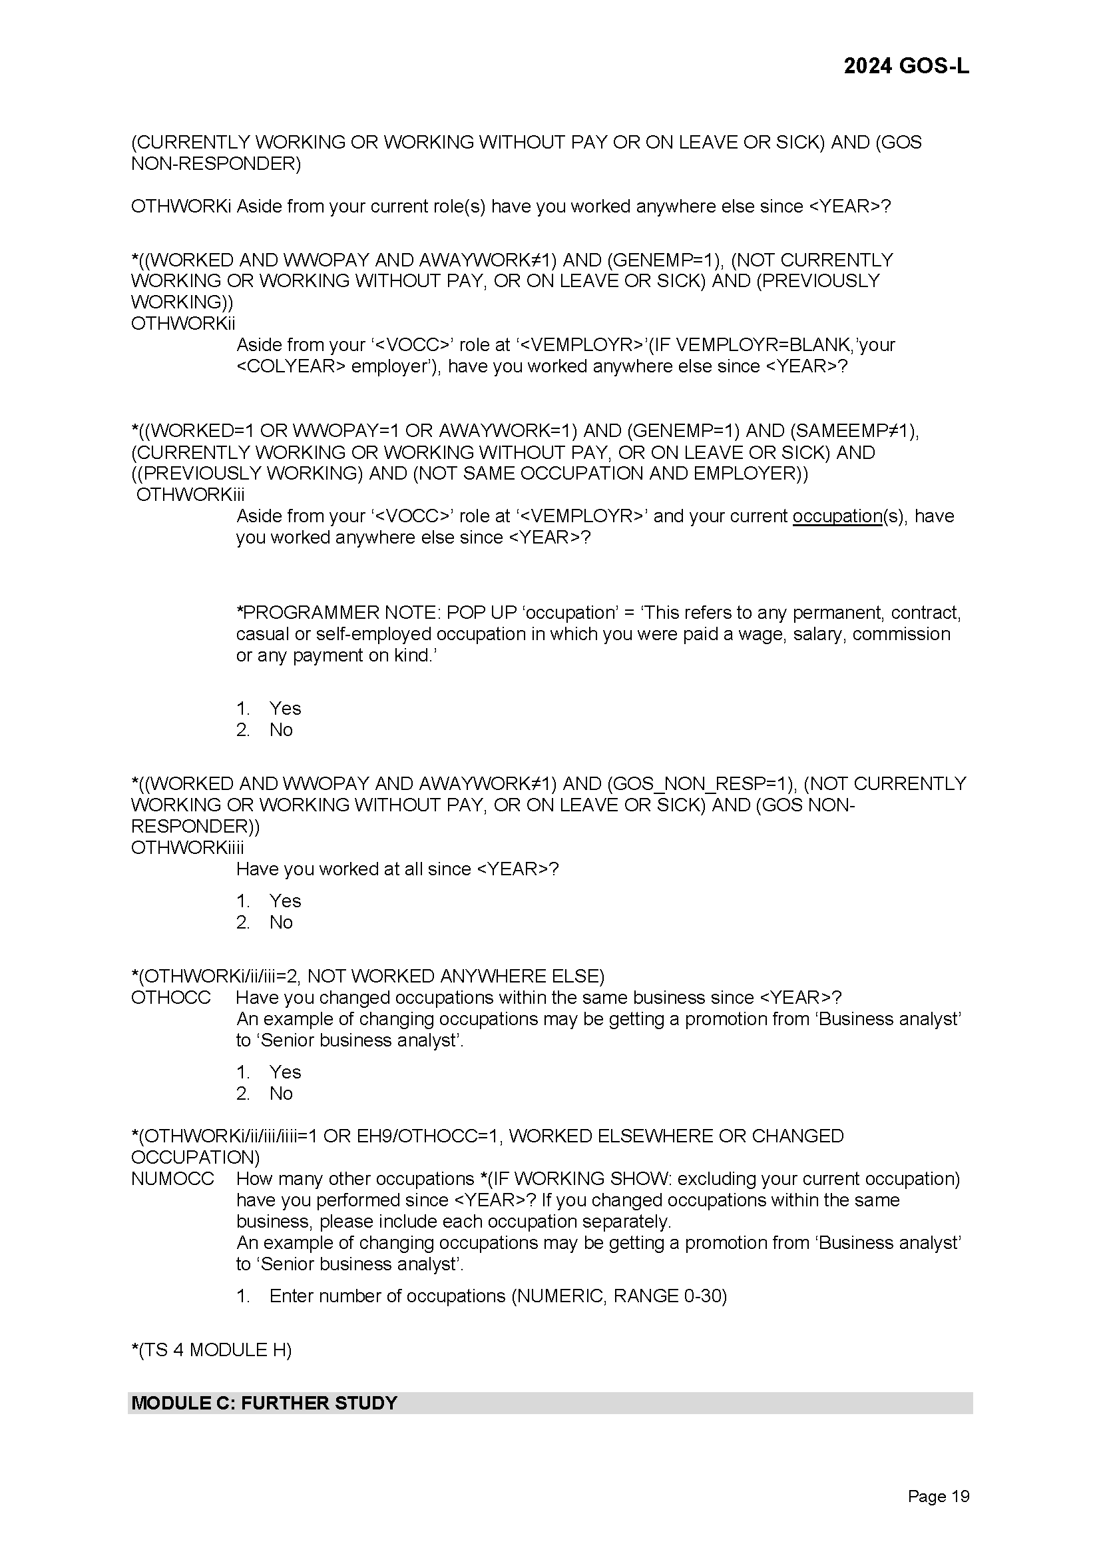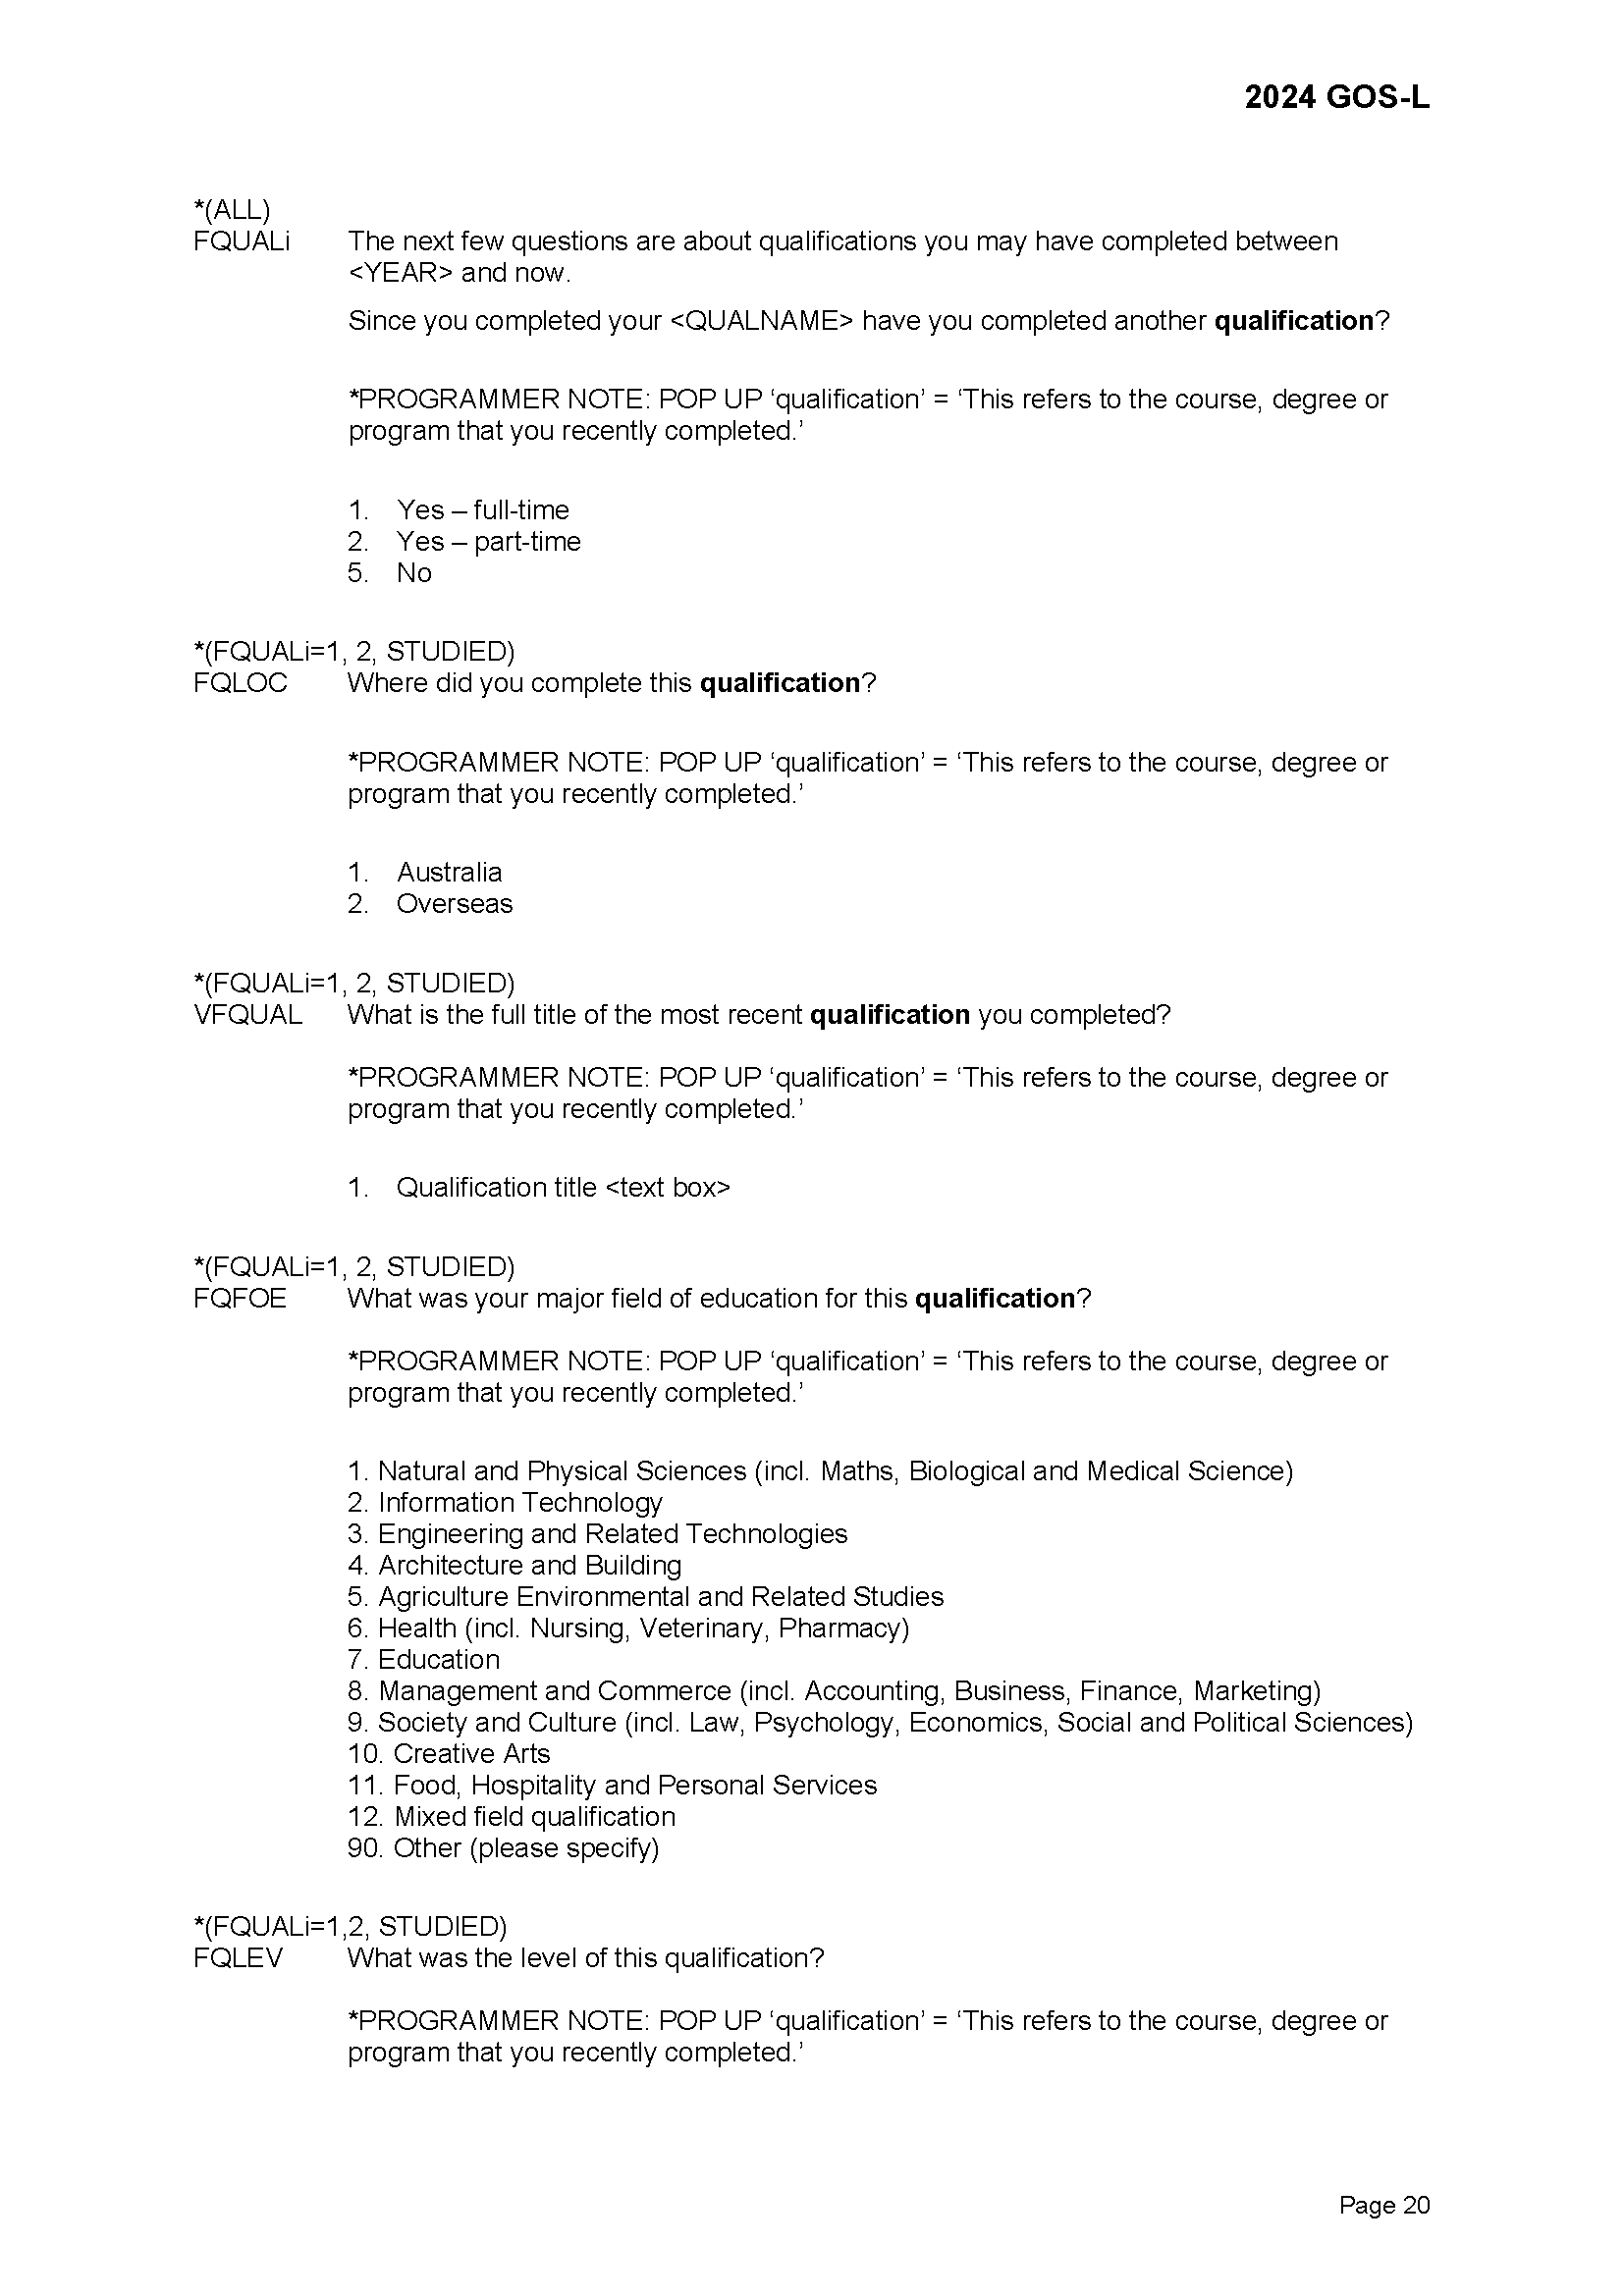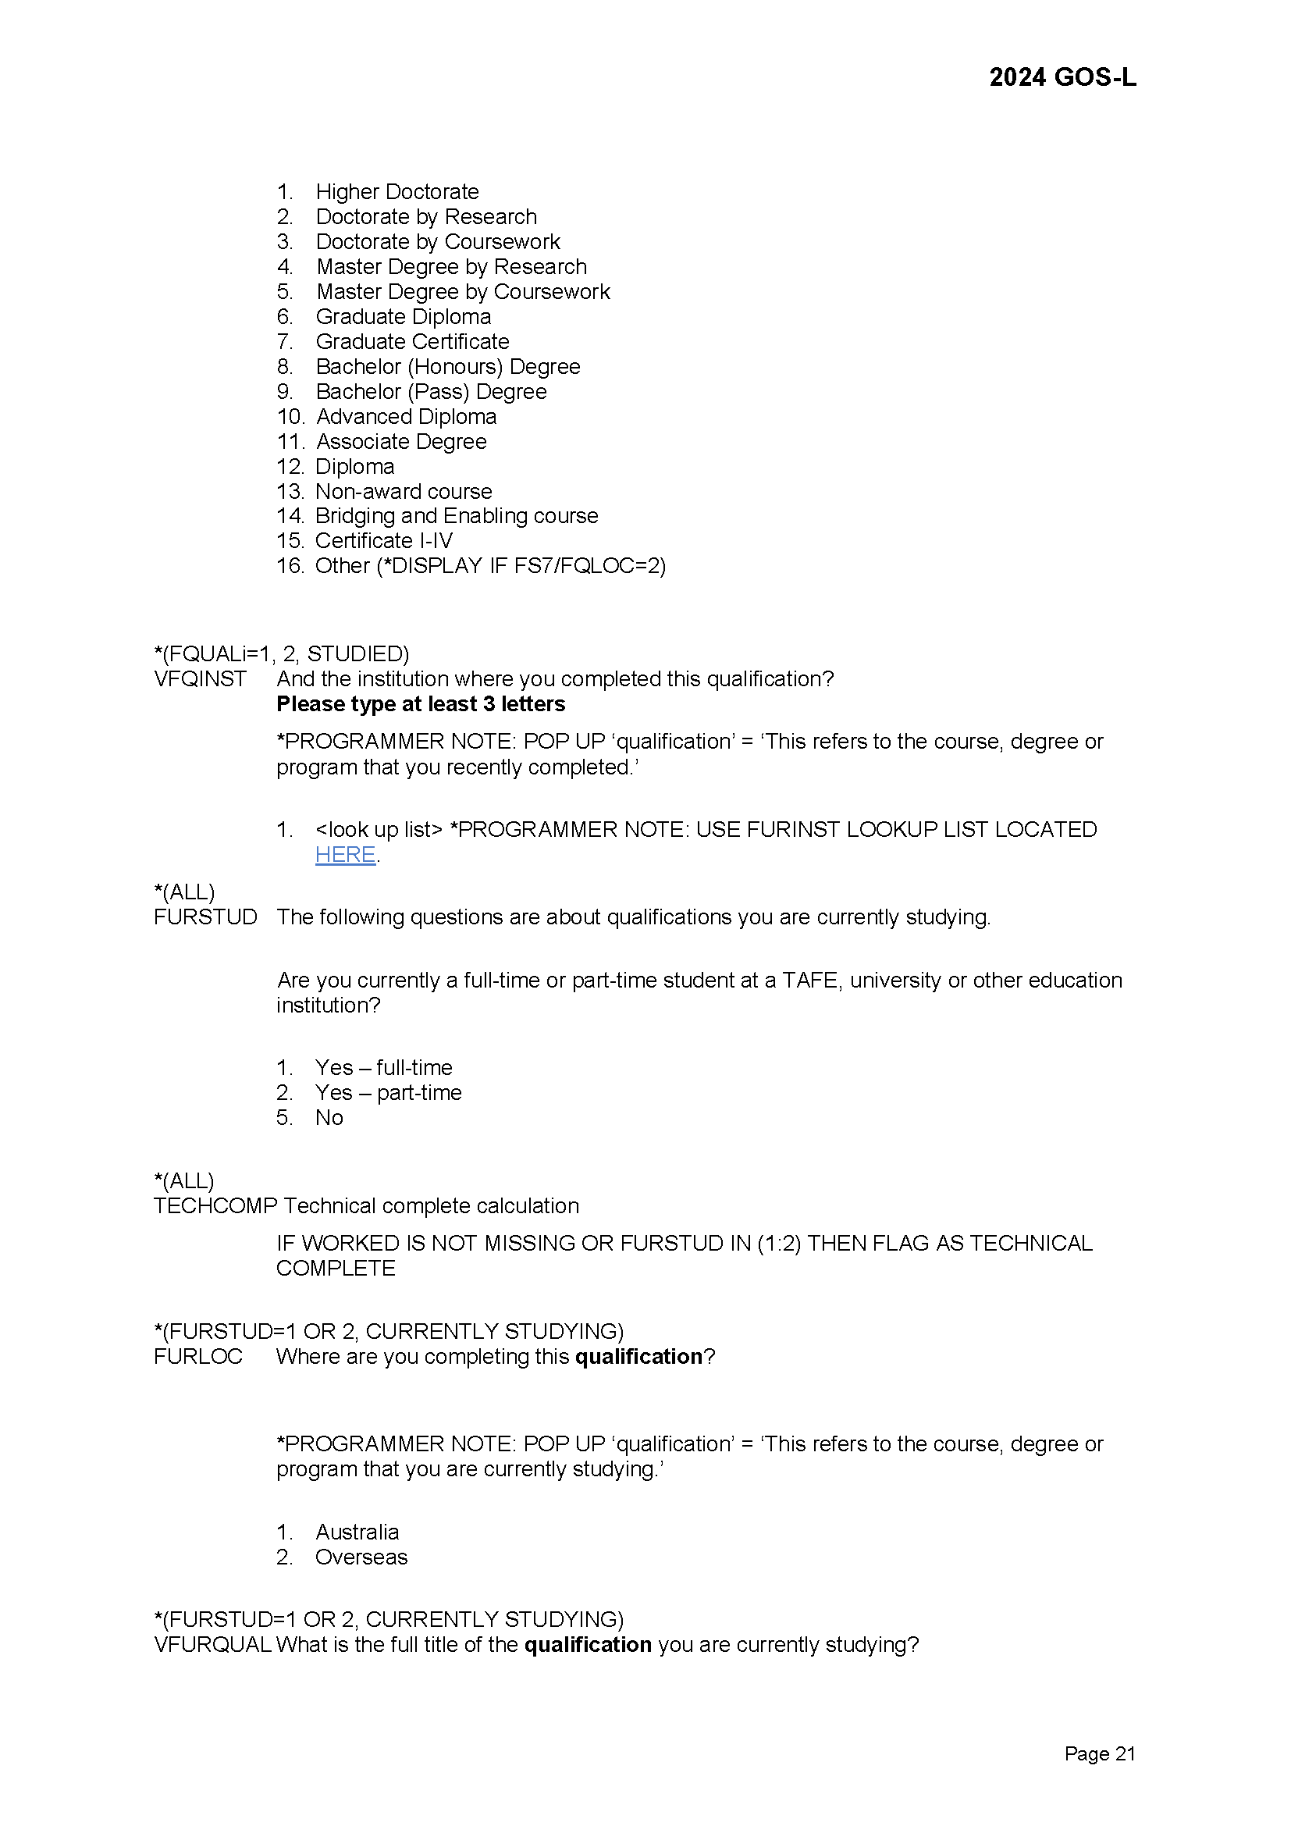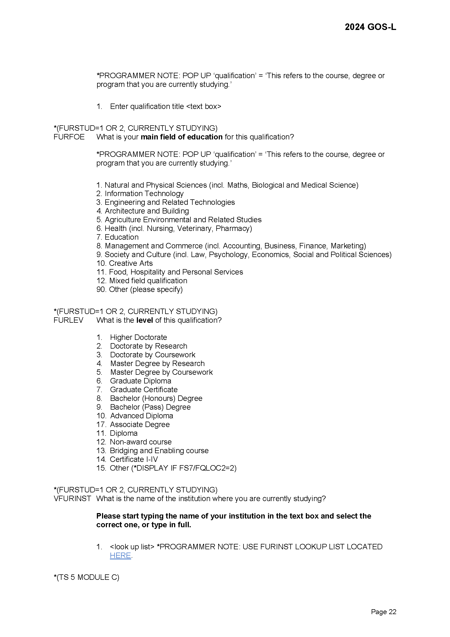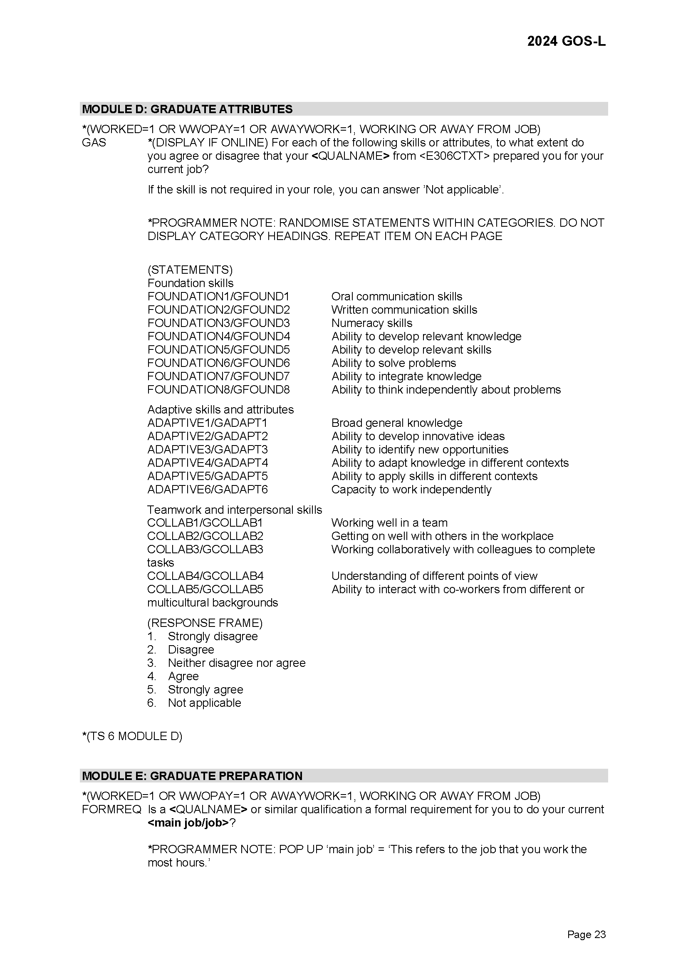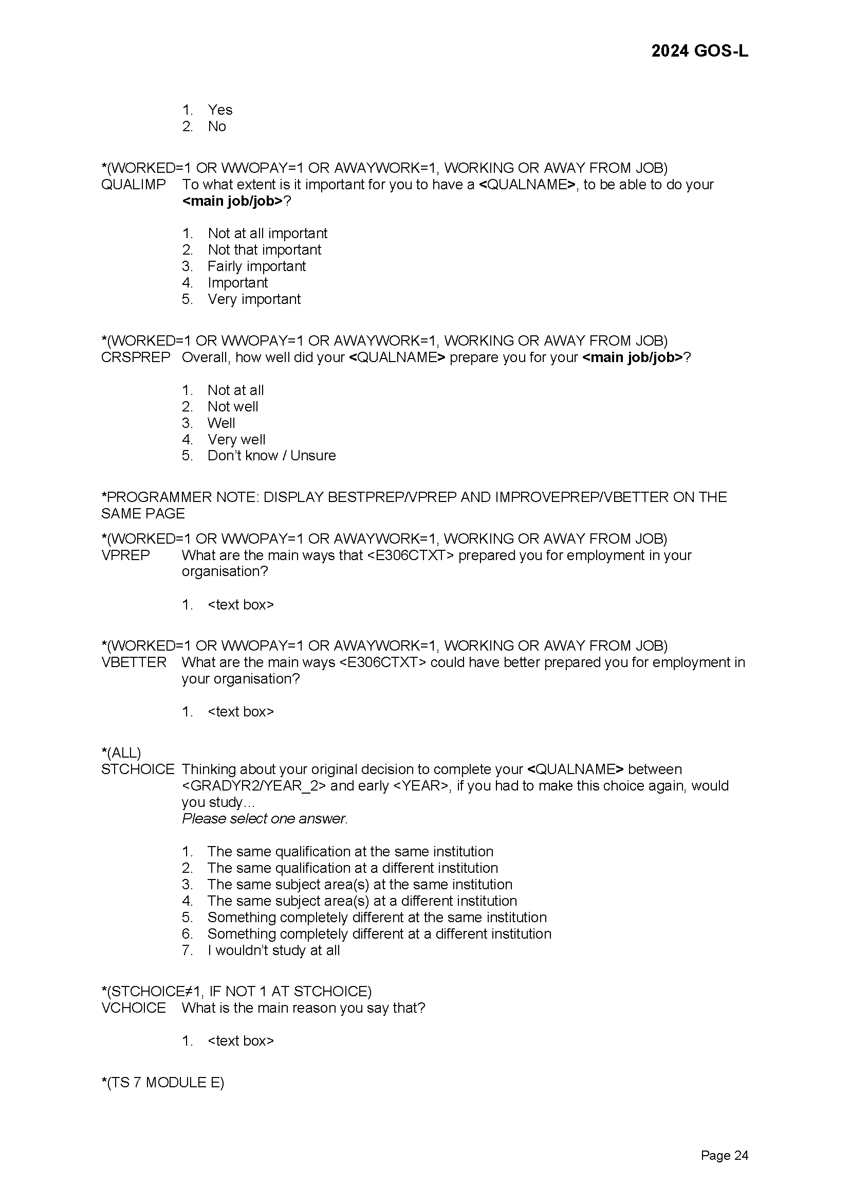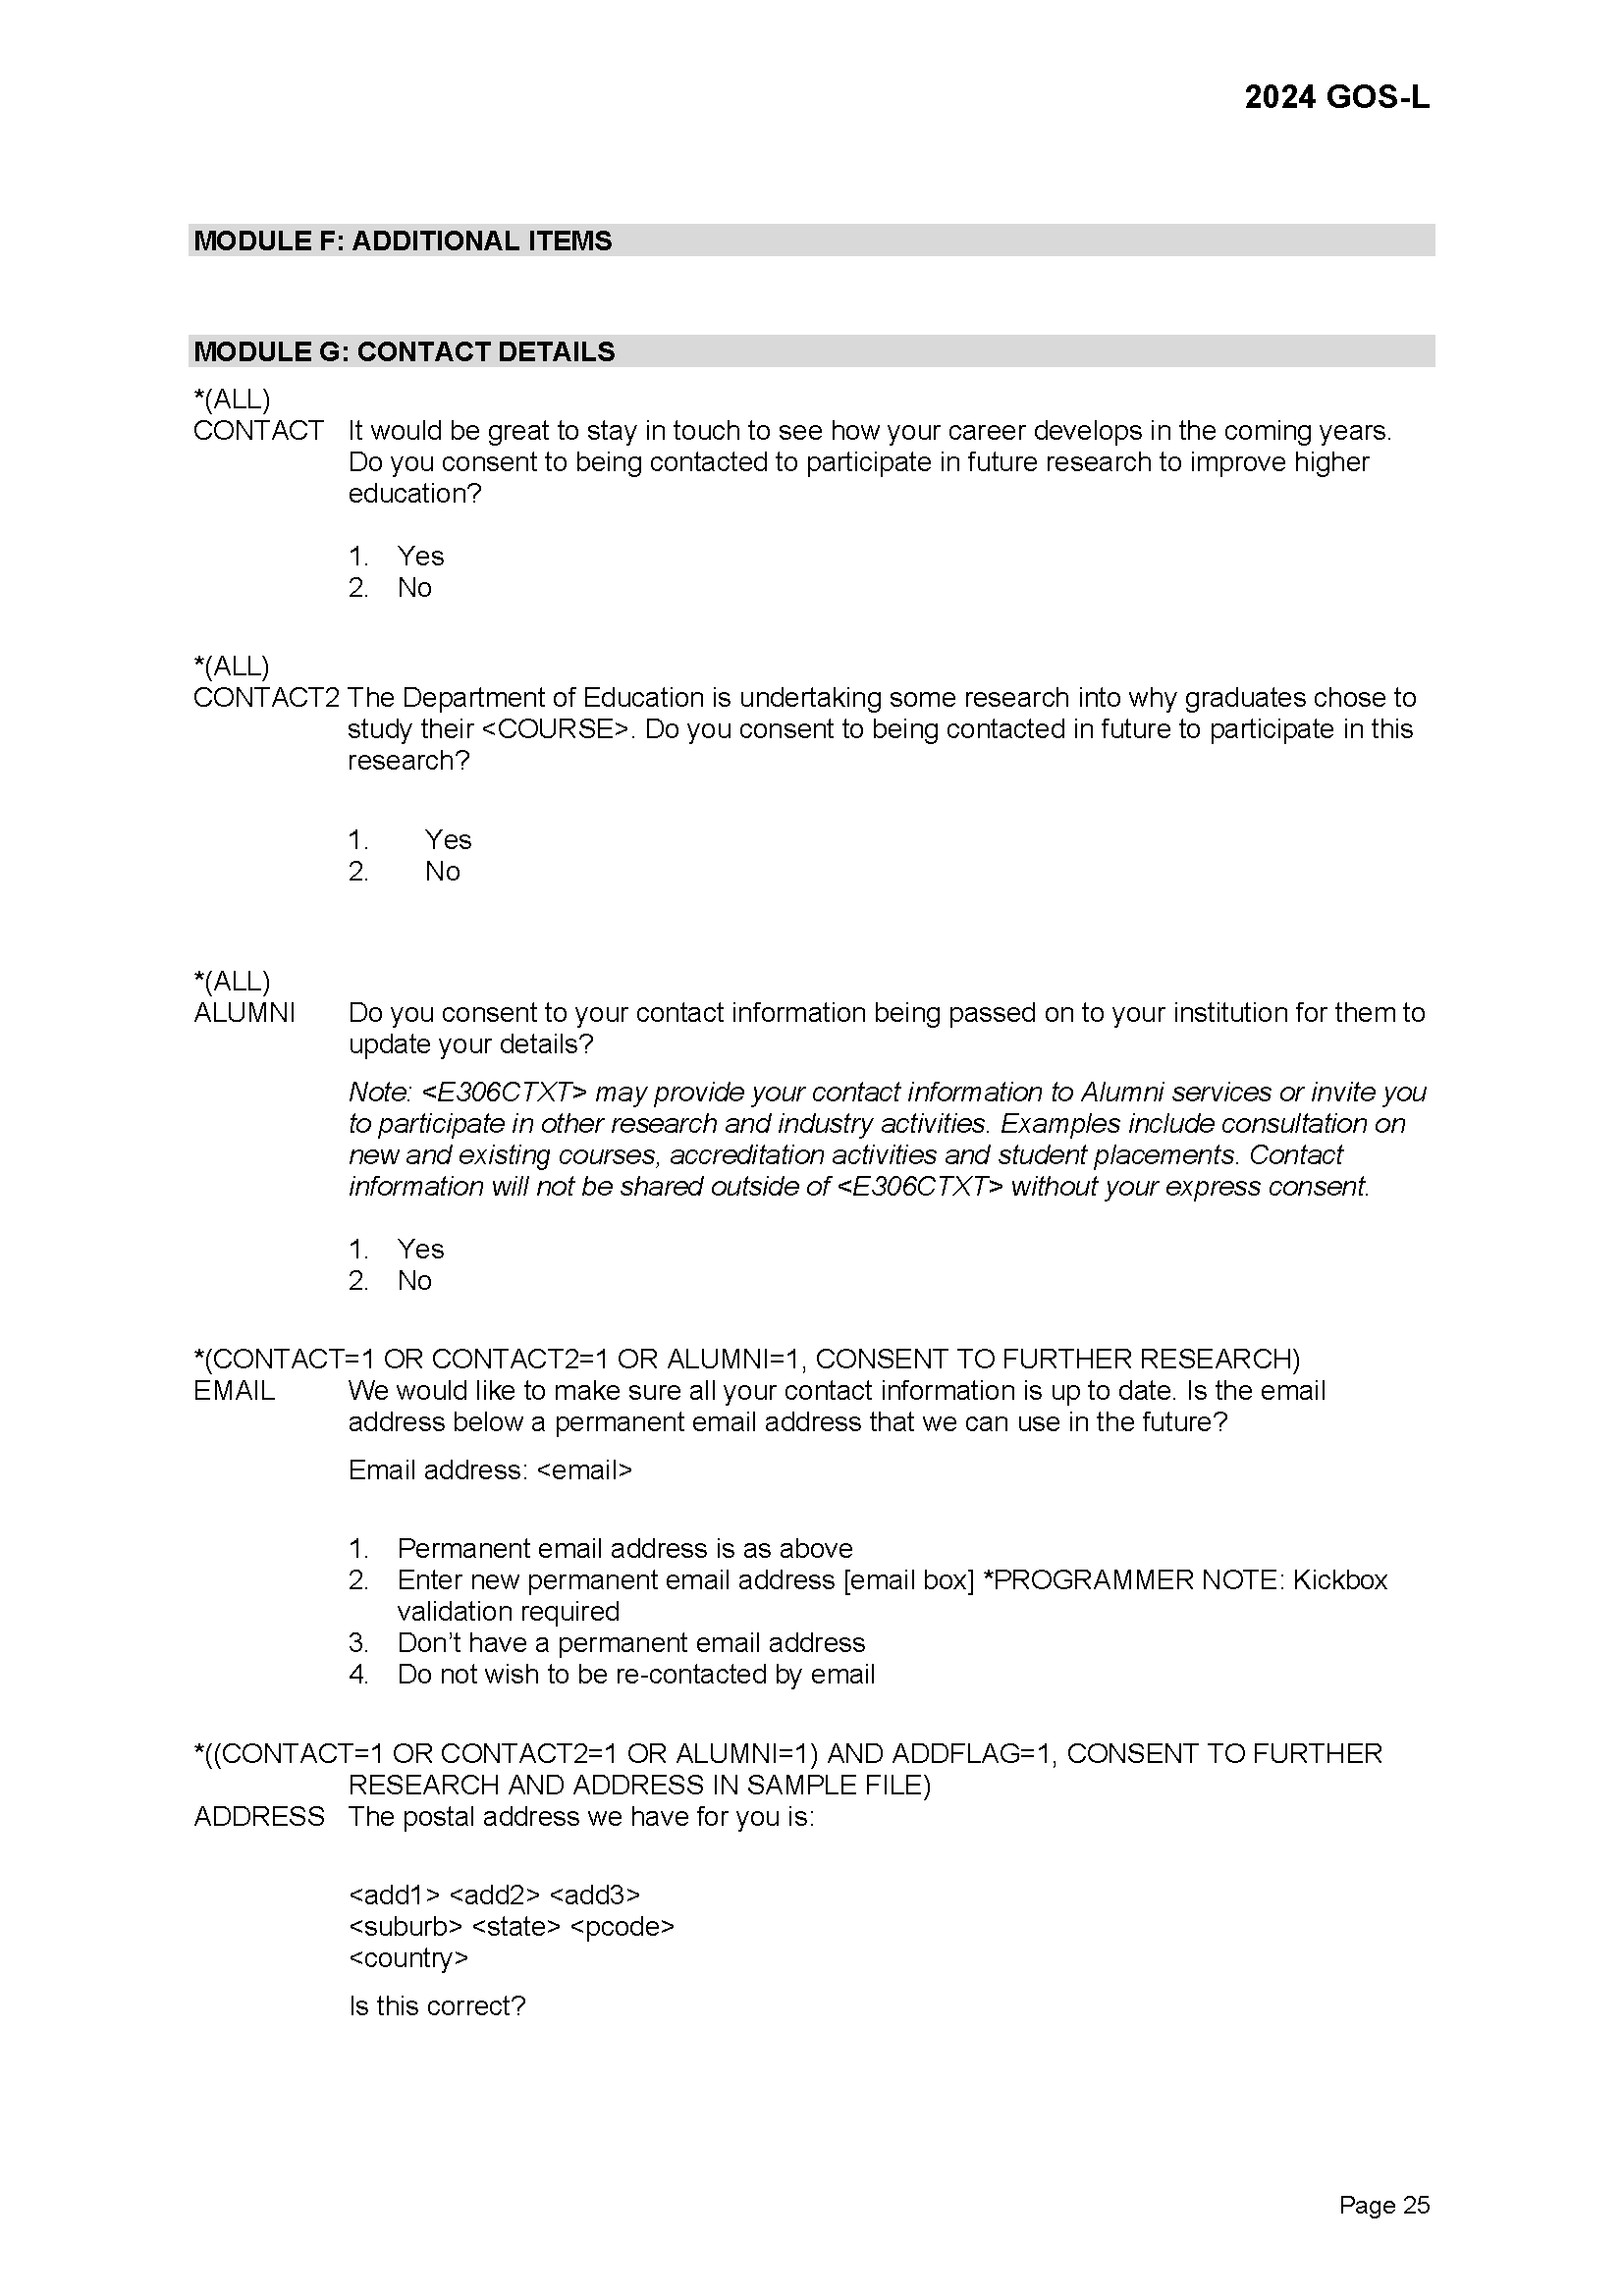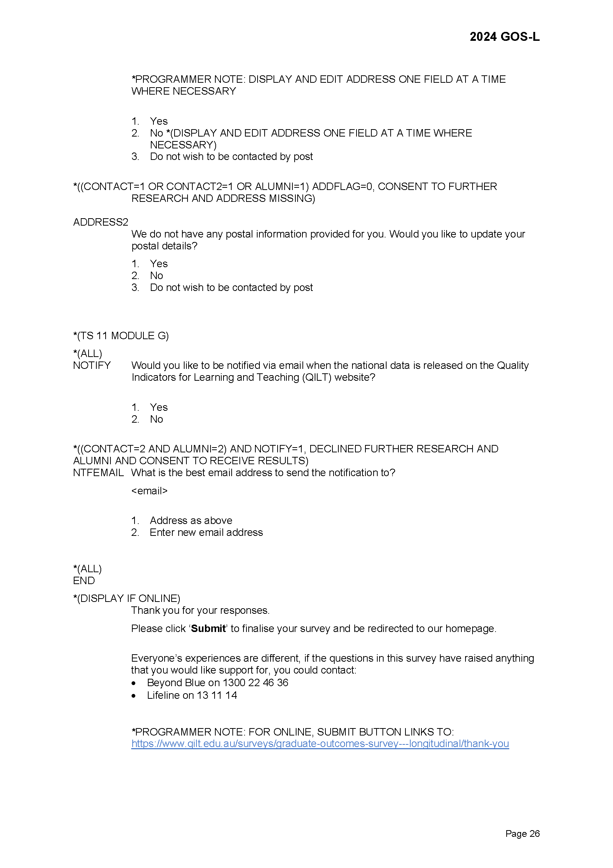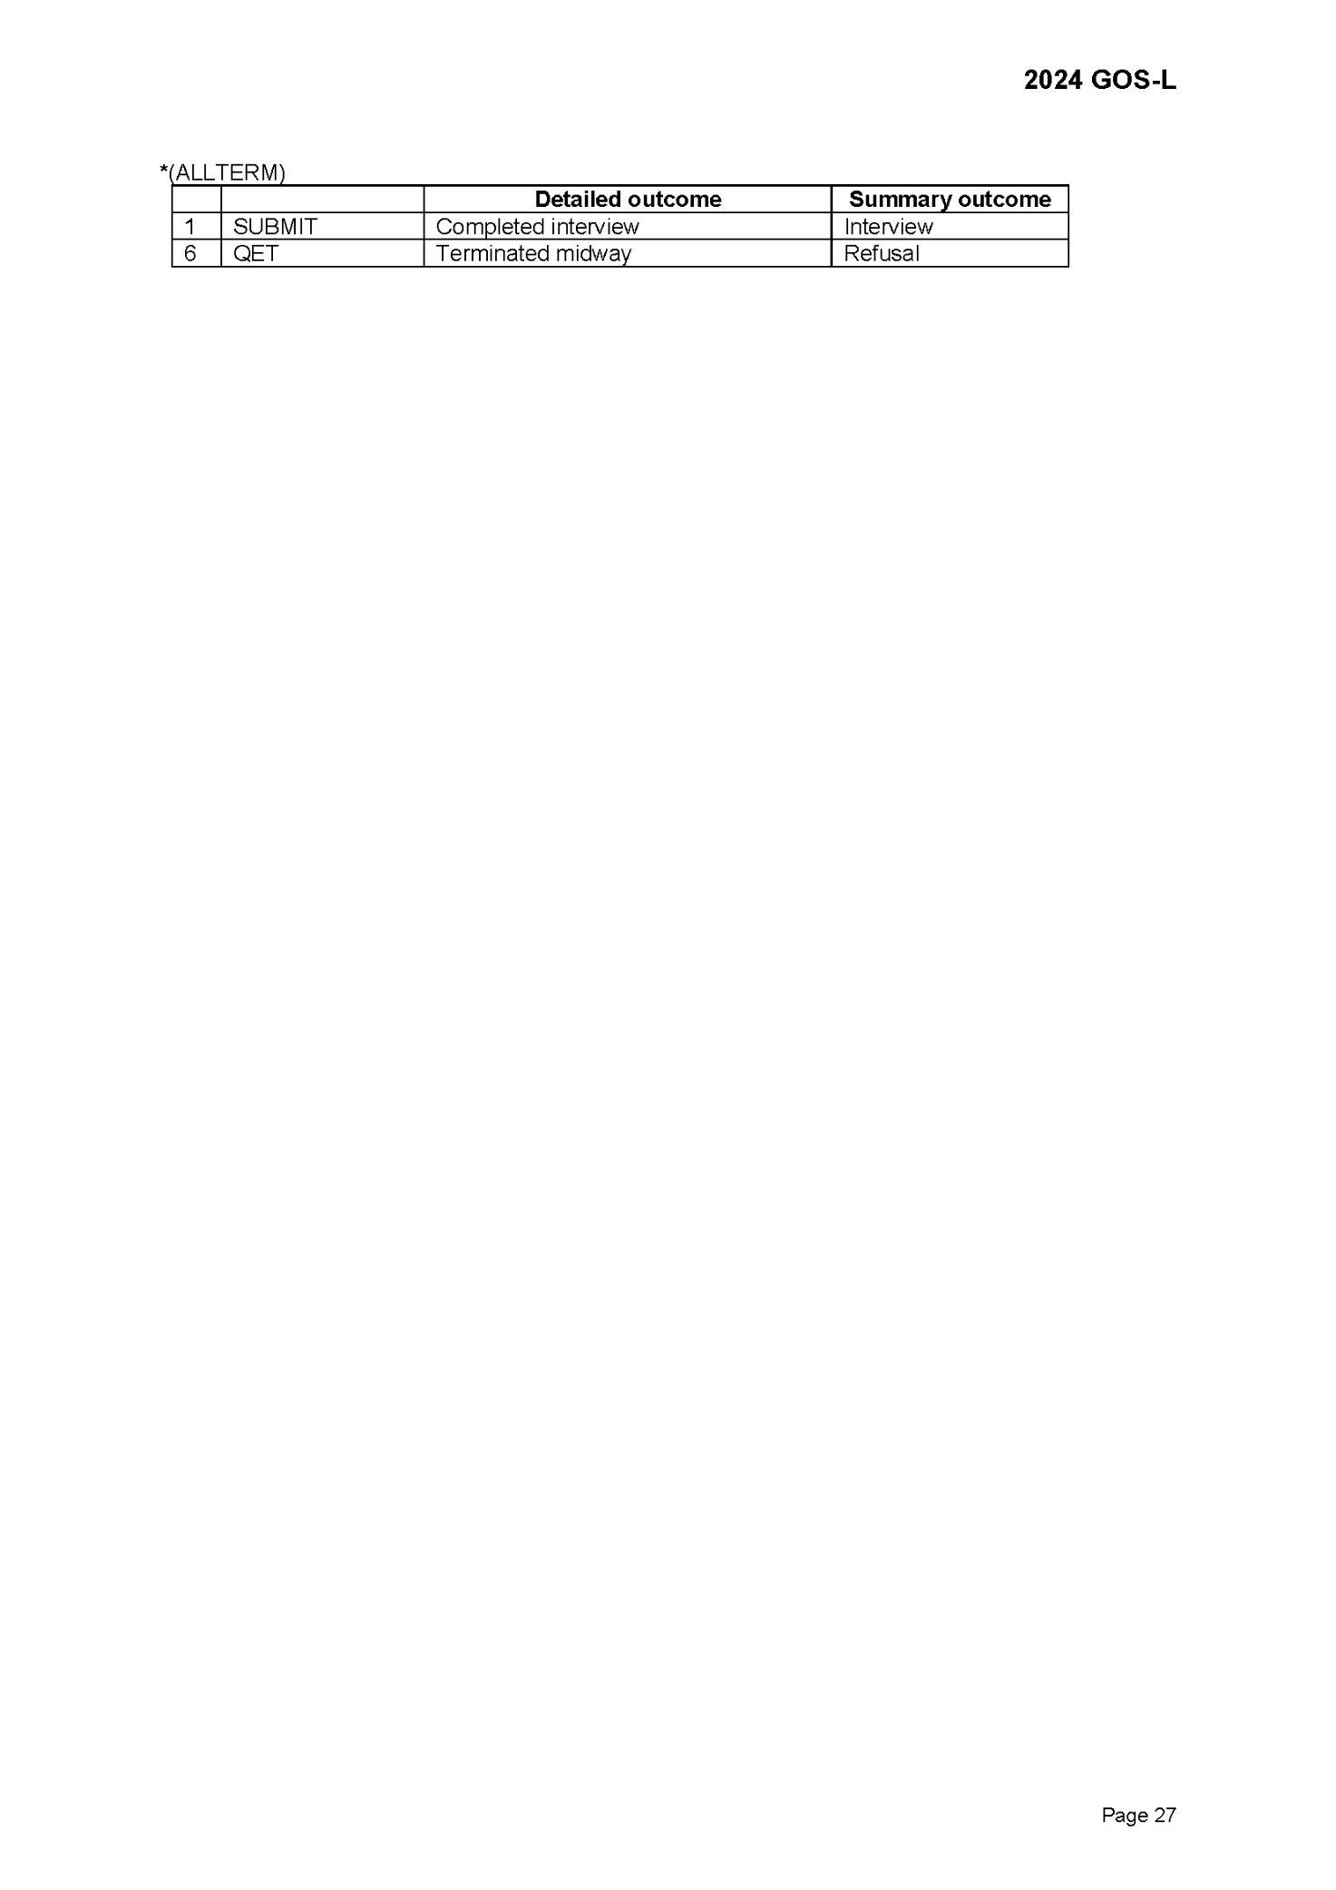

Appendix 6 Survey screenshots
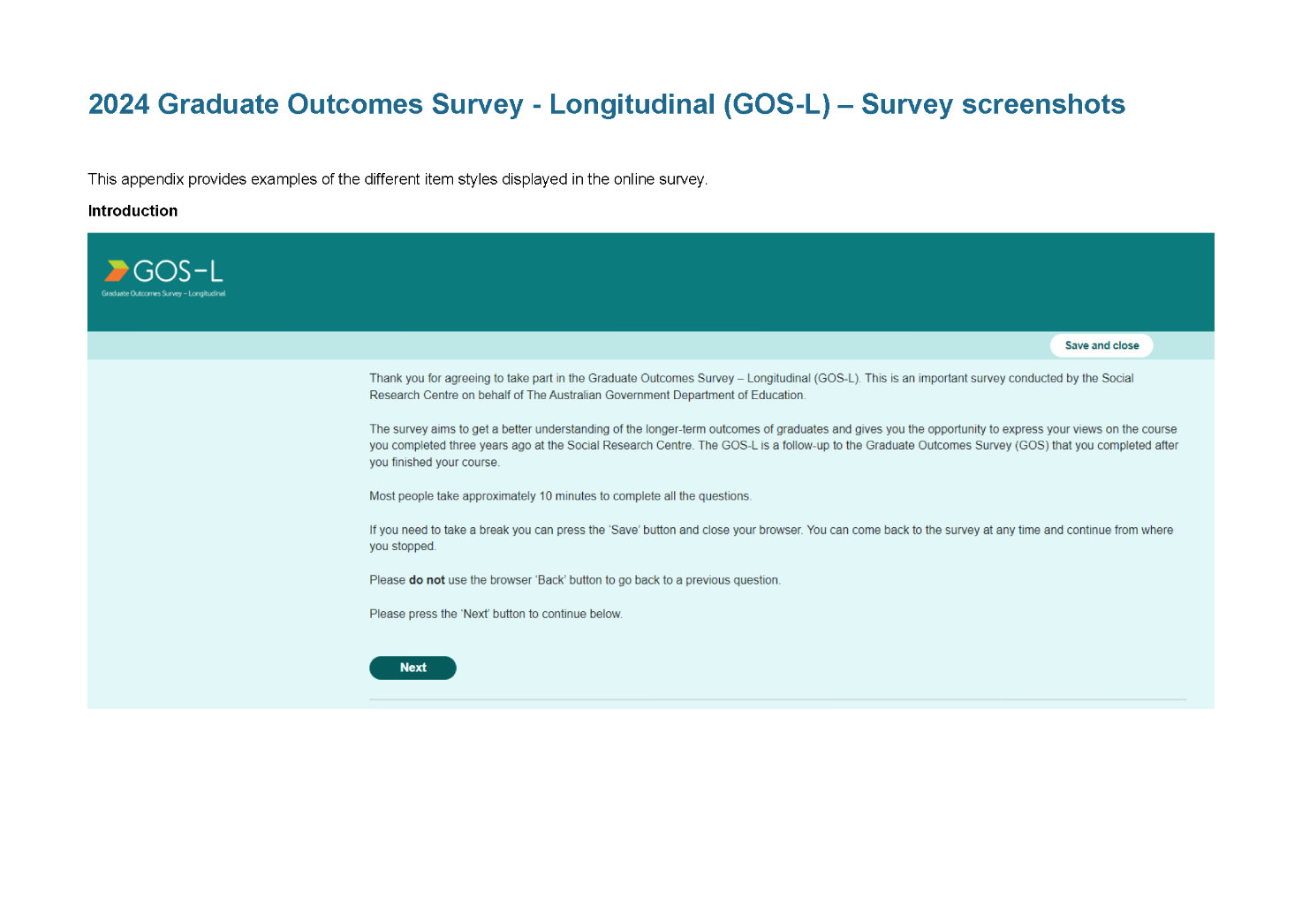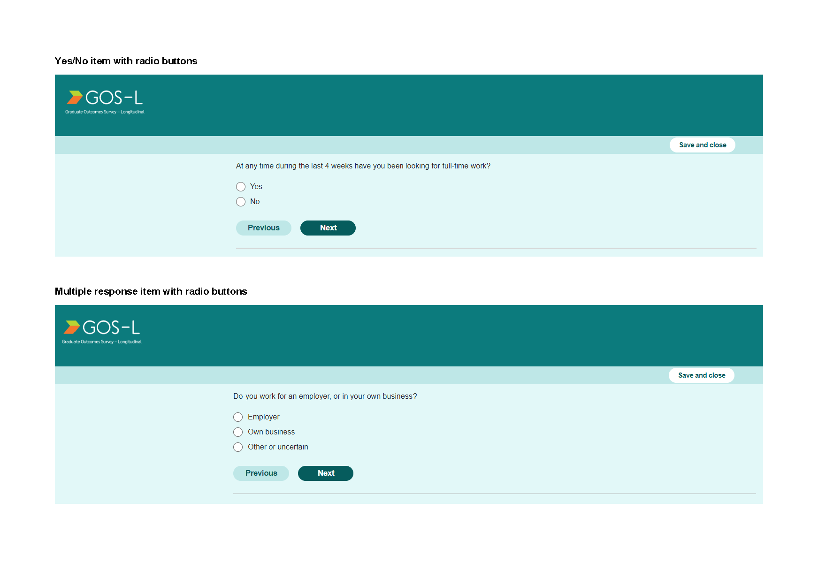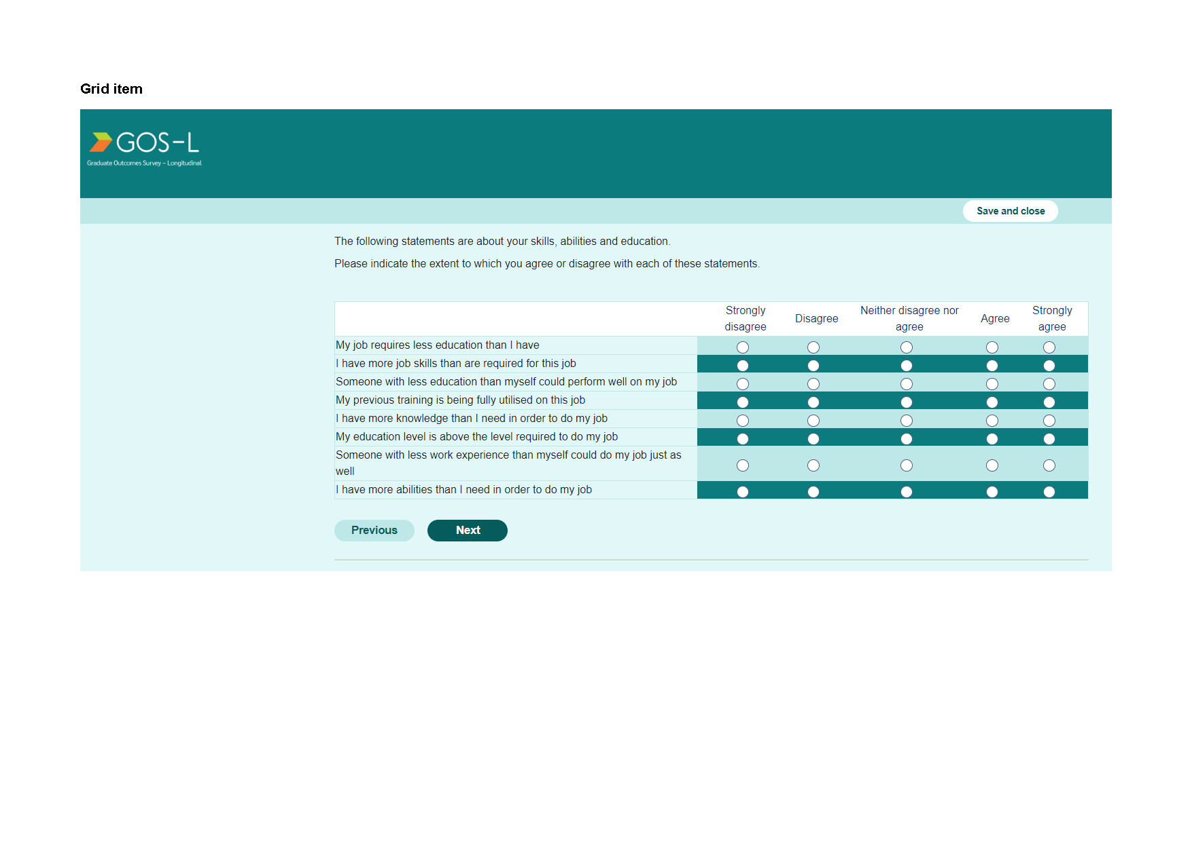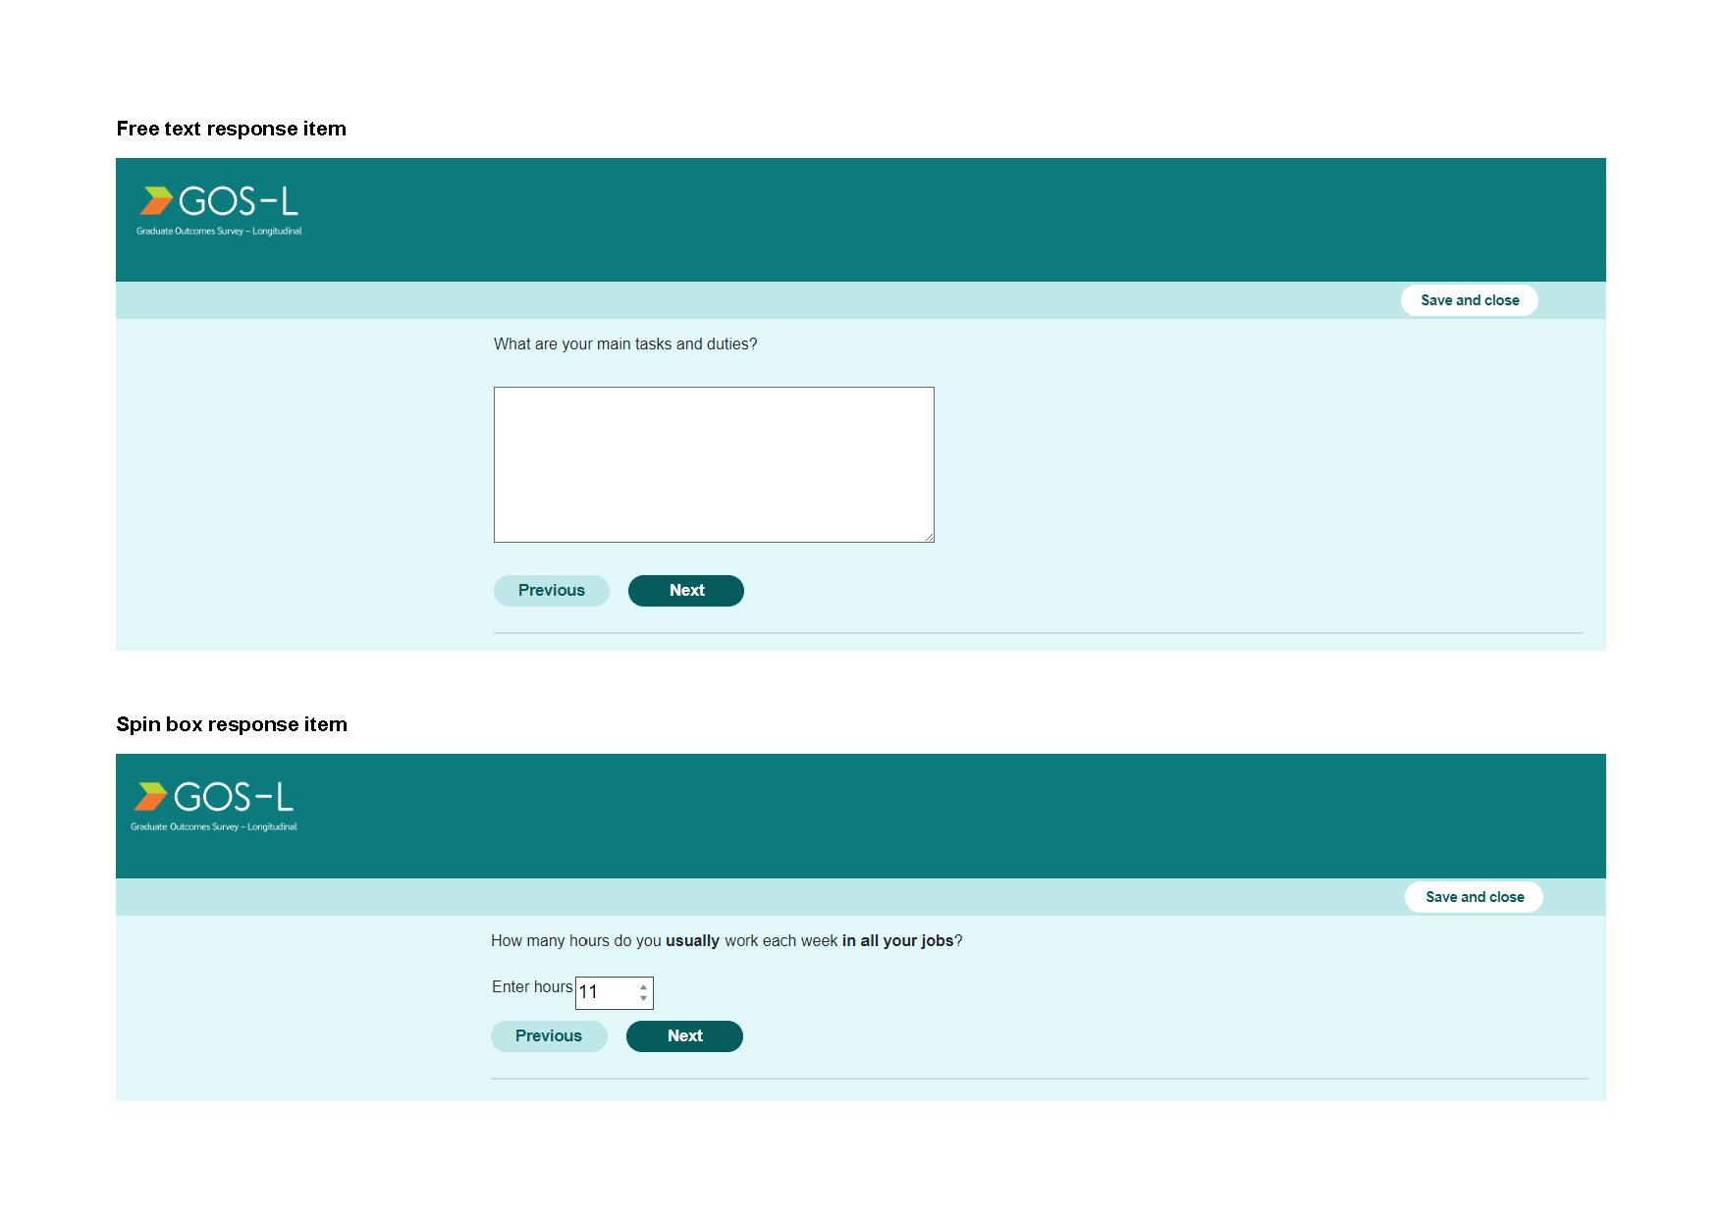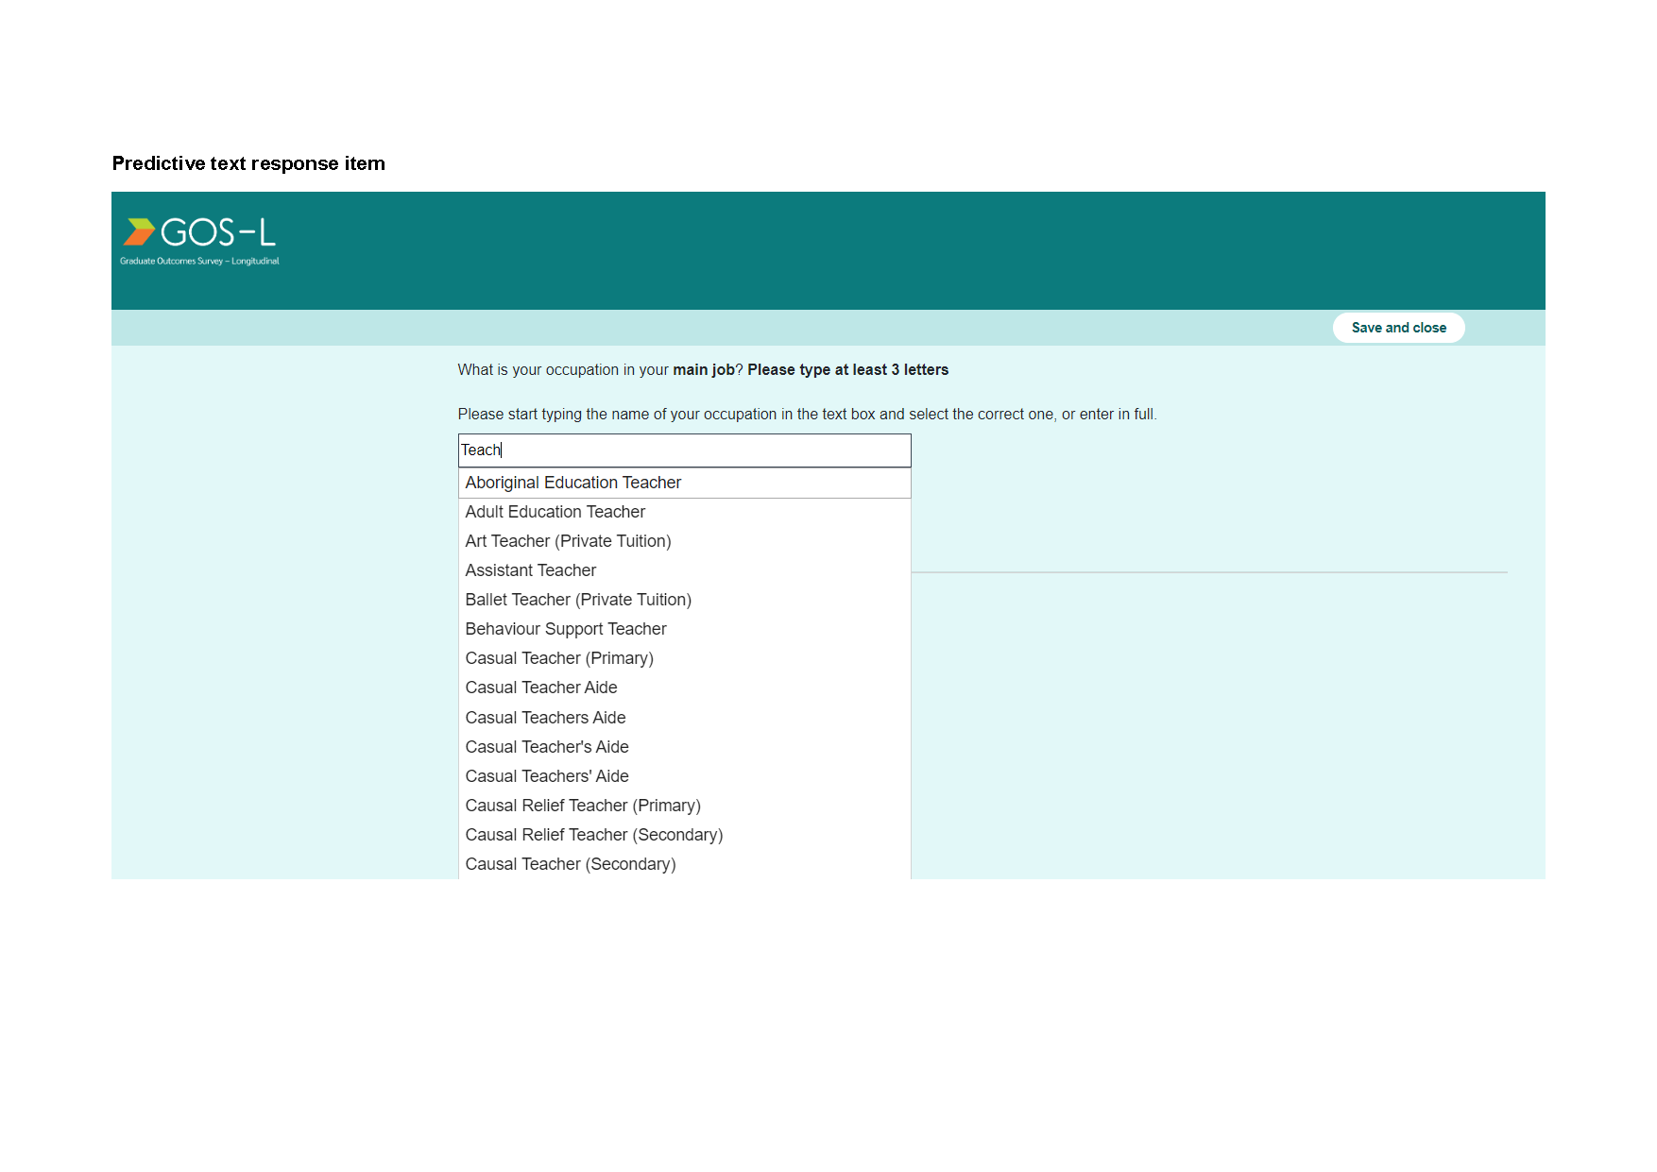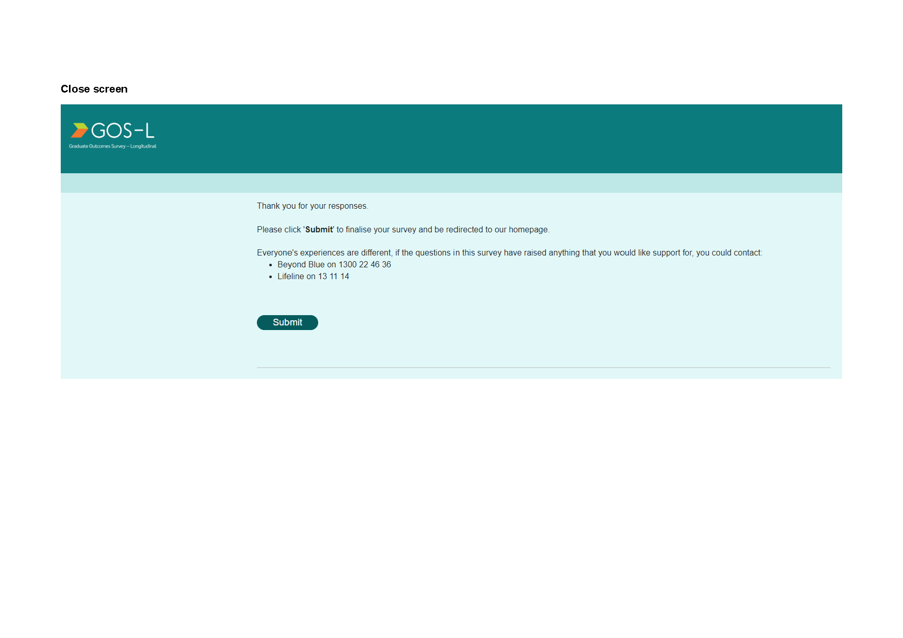

Appendix 7 Small screen optimisation
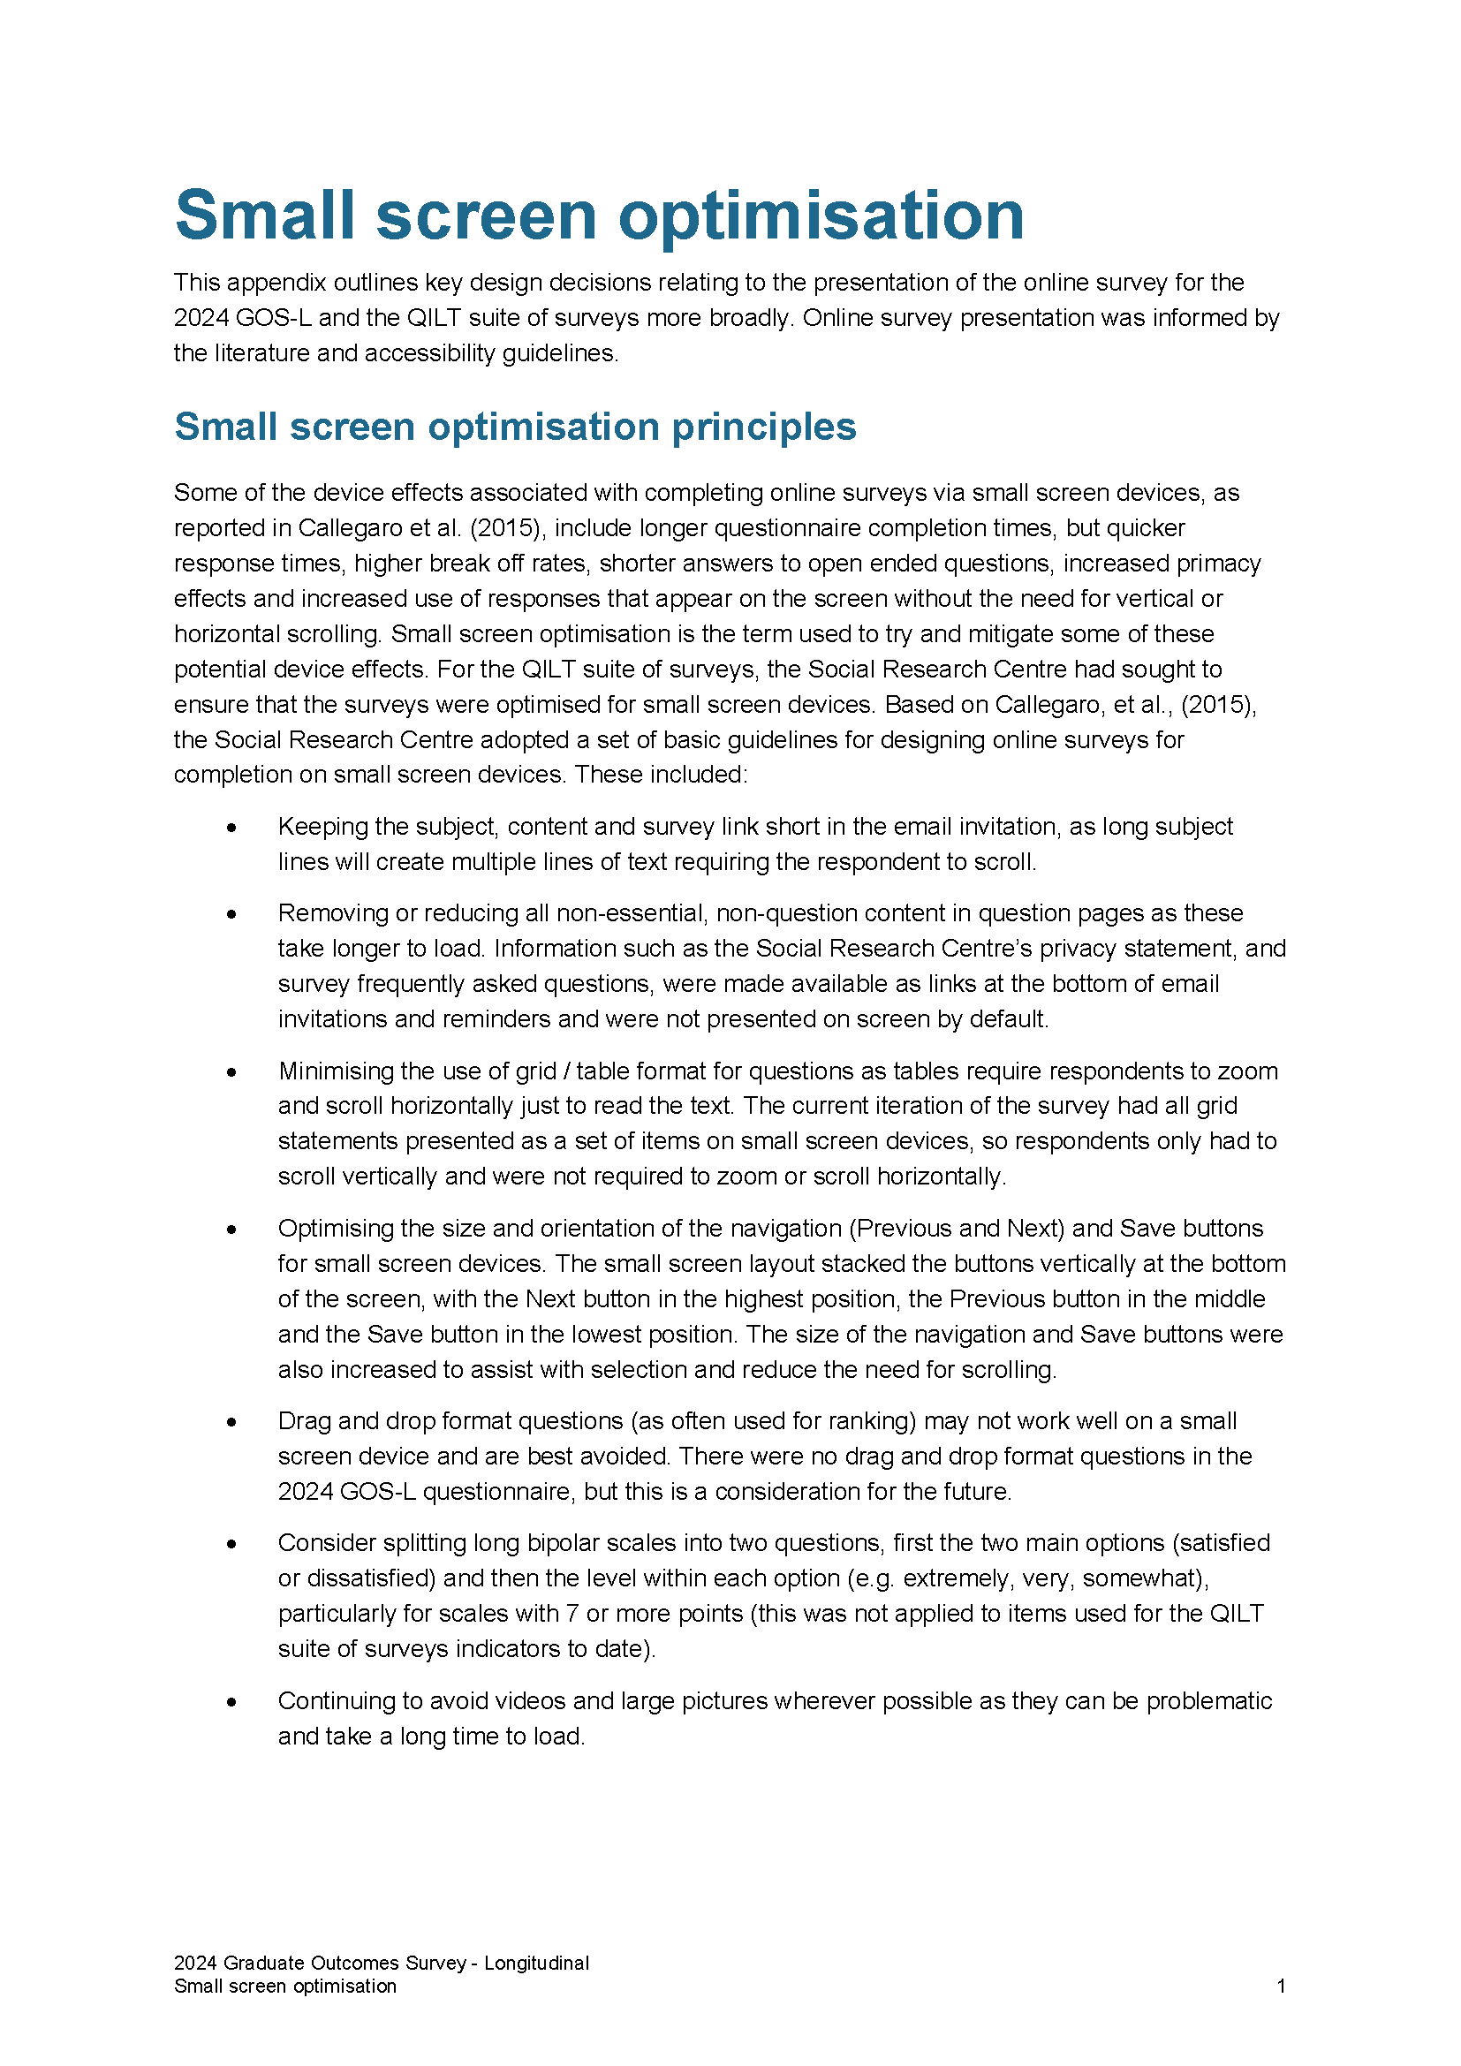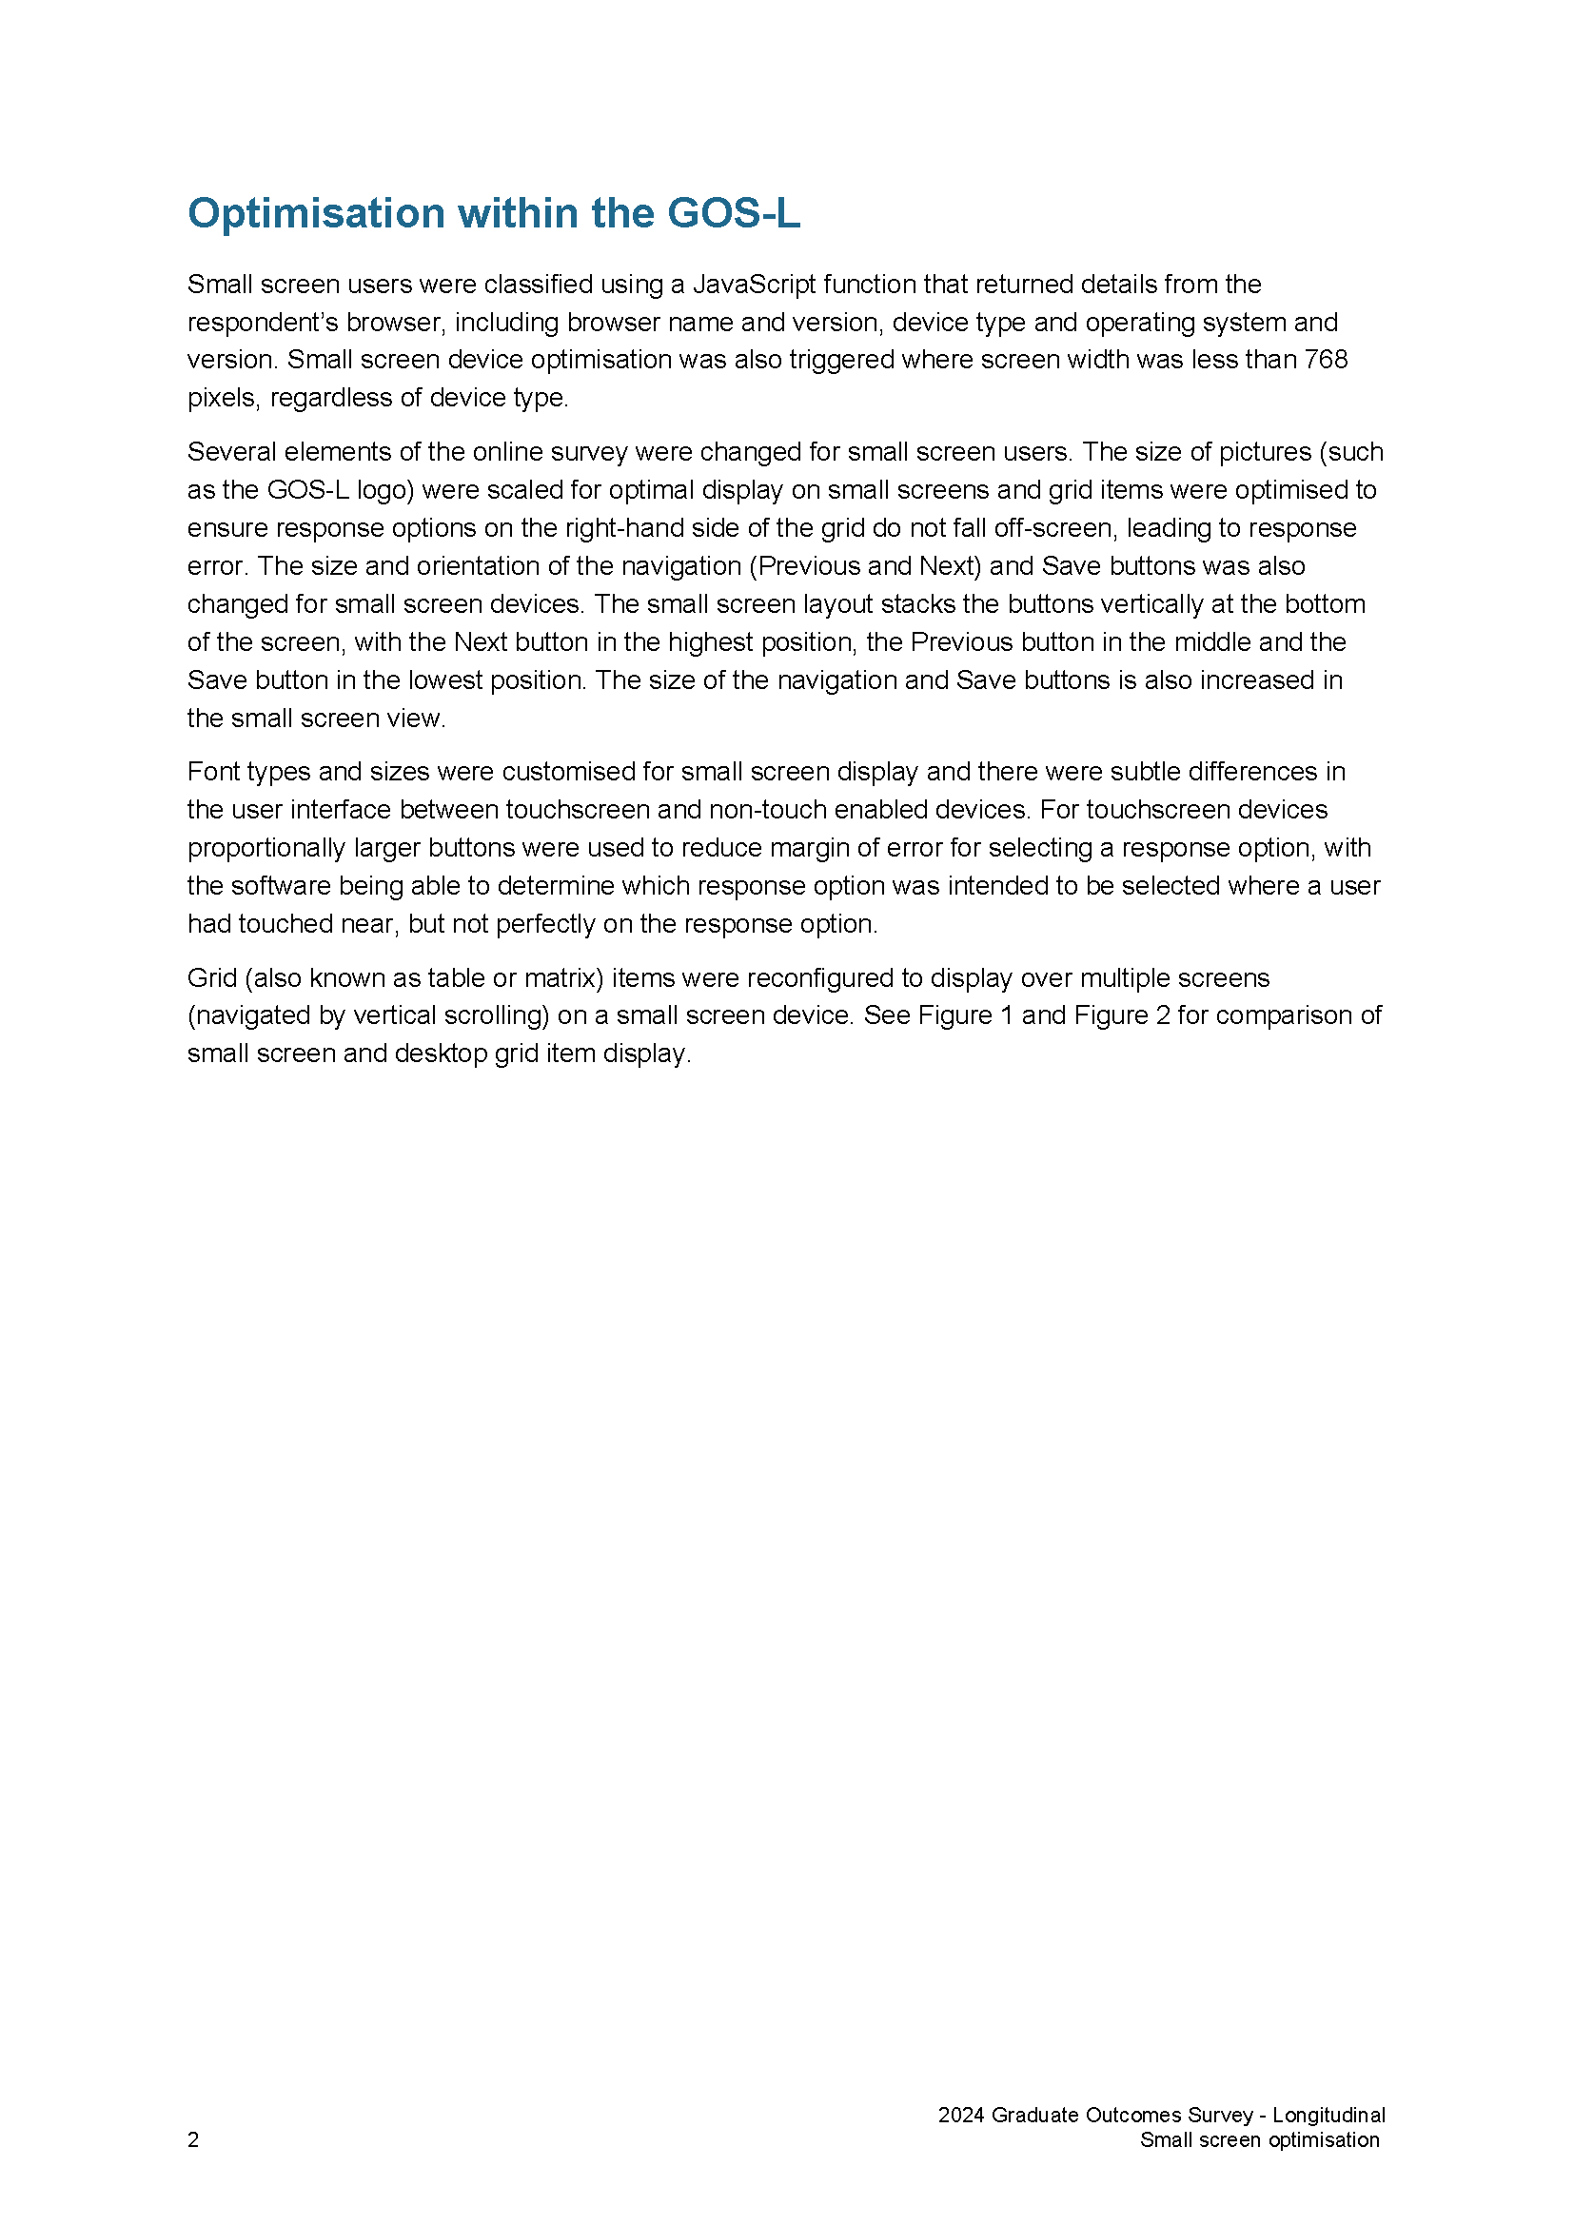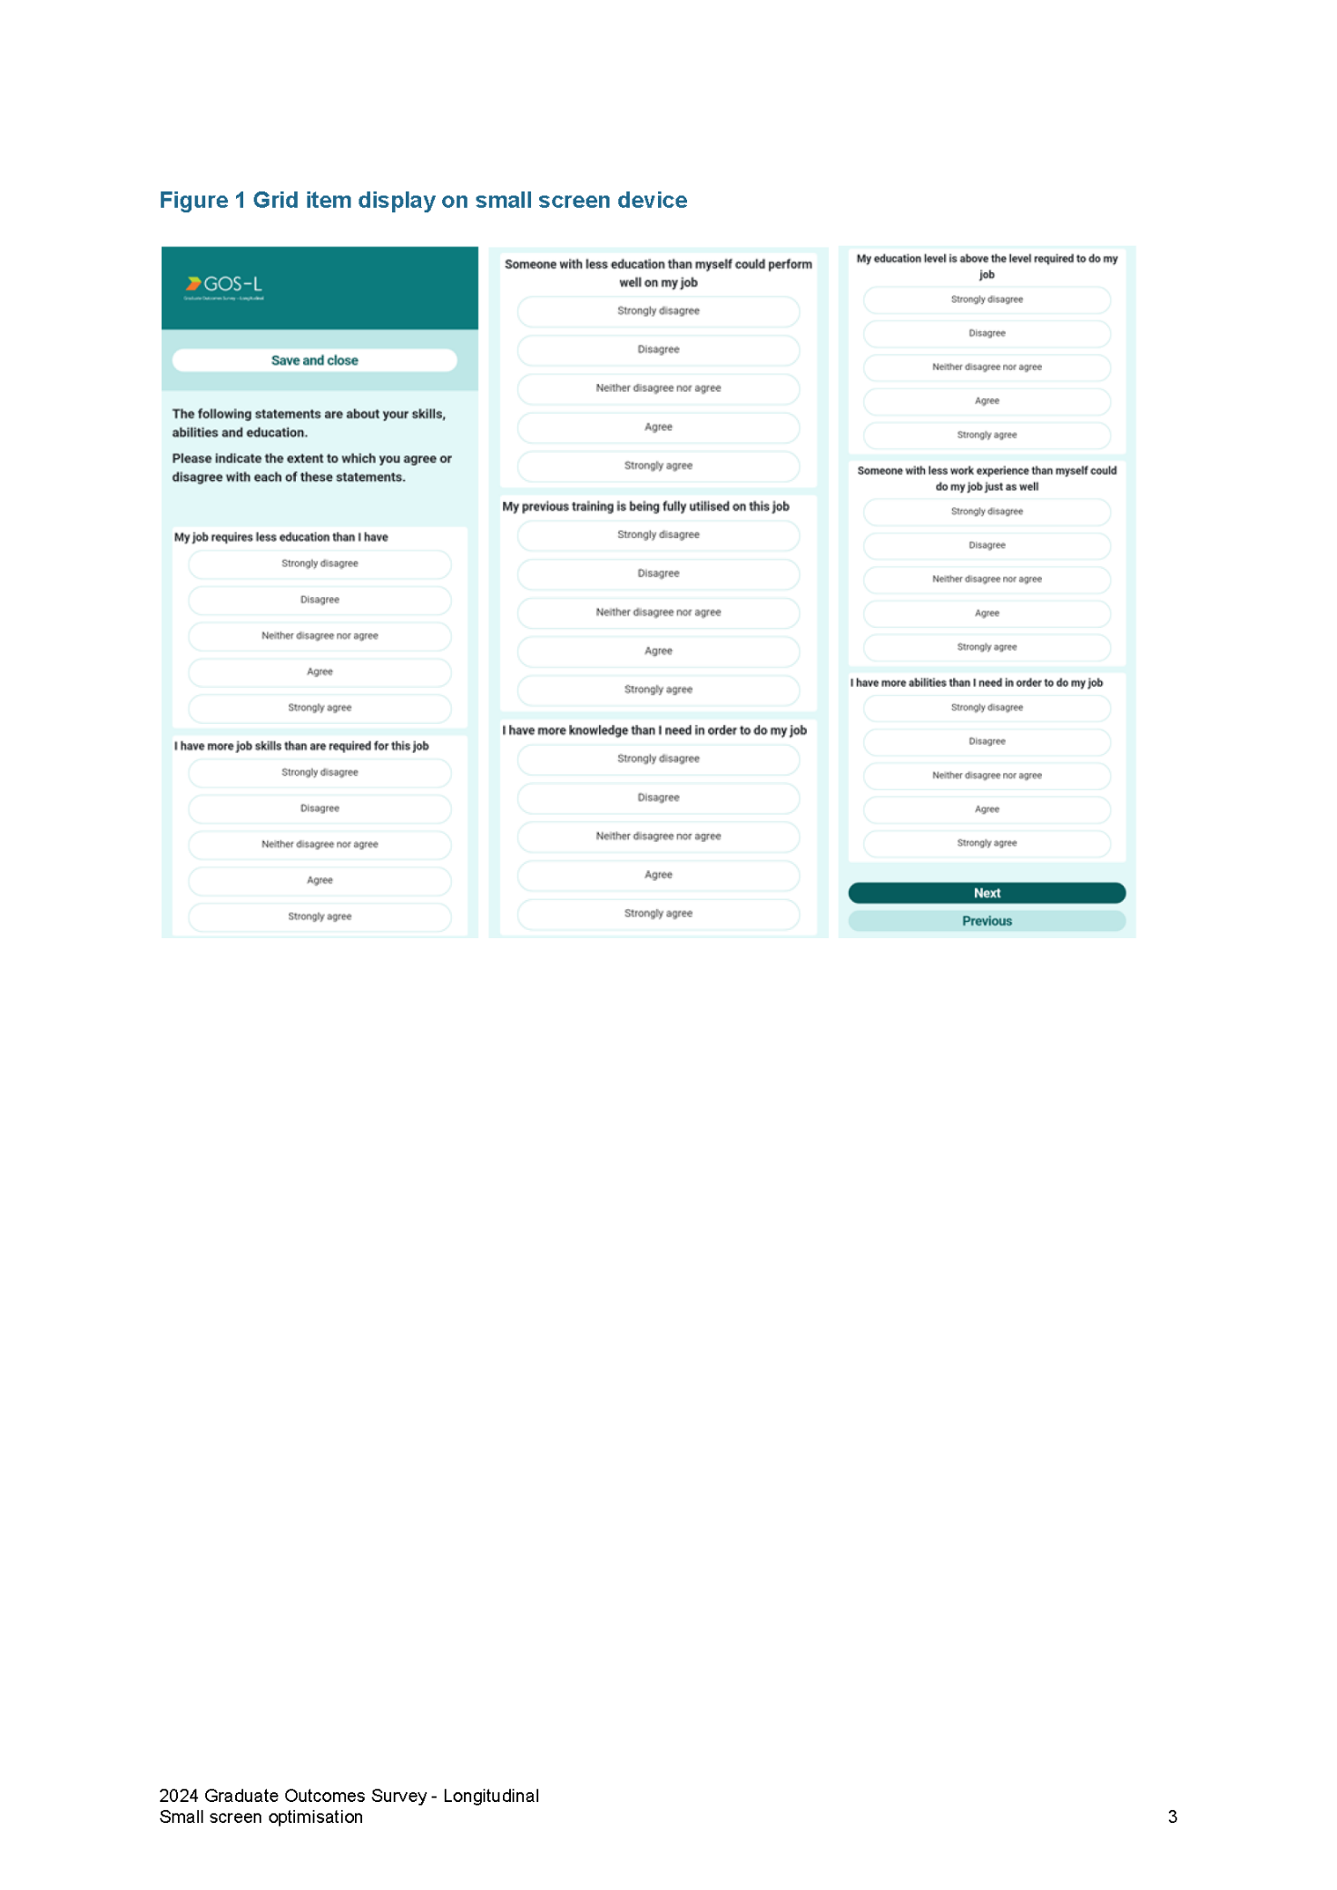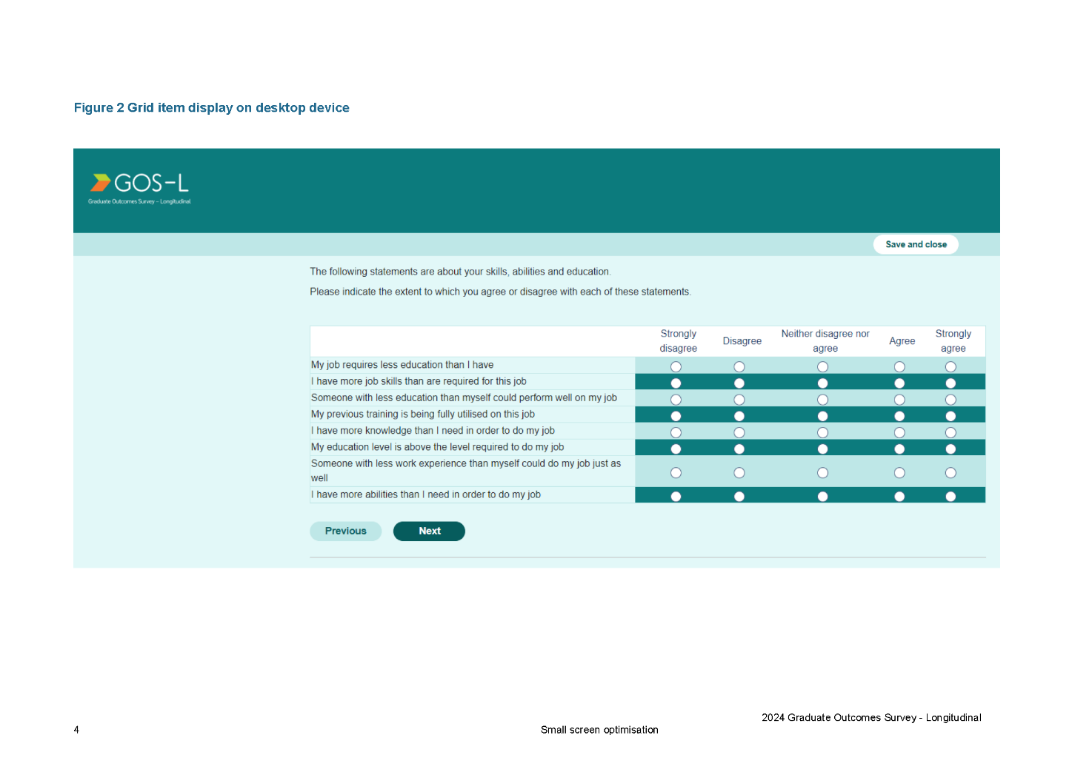

Appendix 8 Response by institution
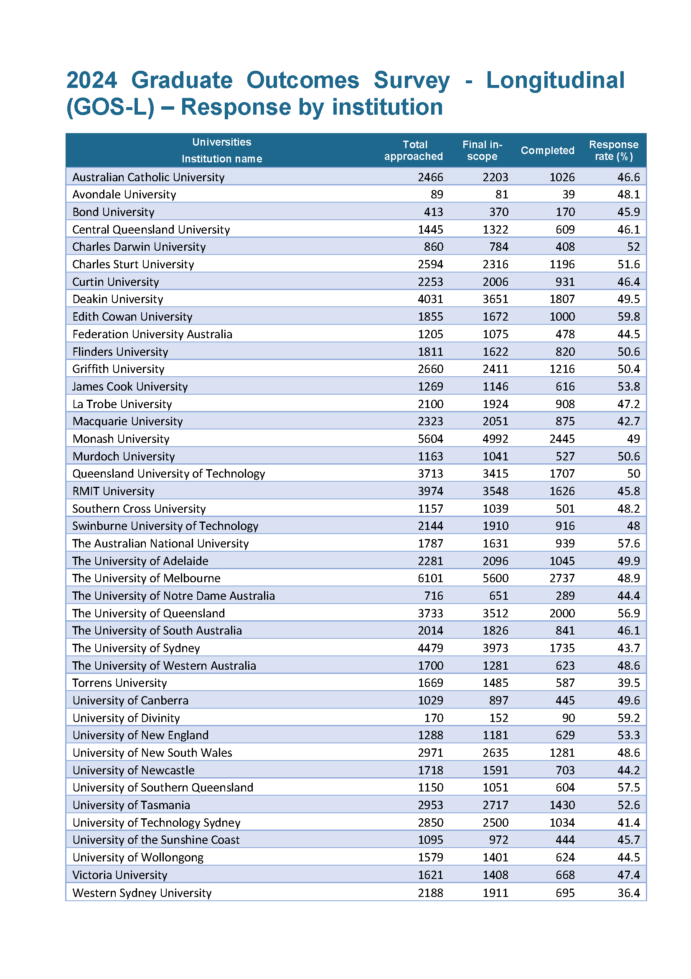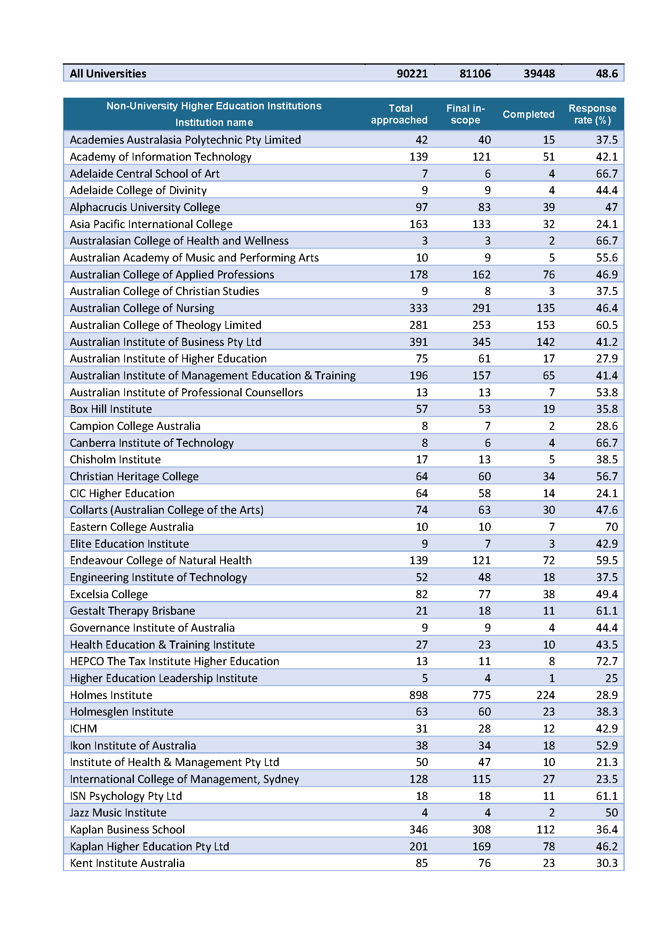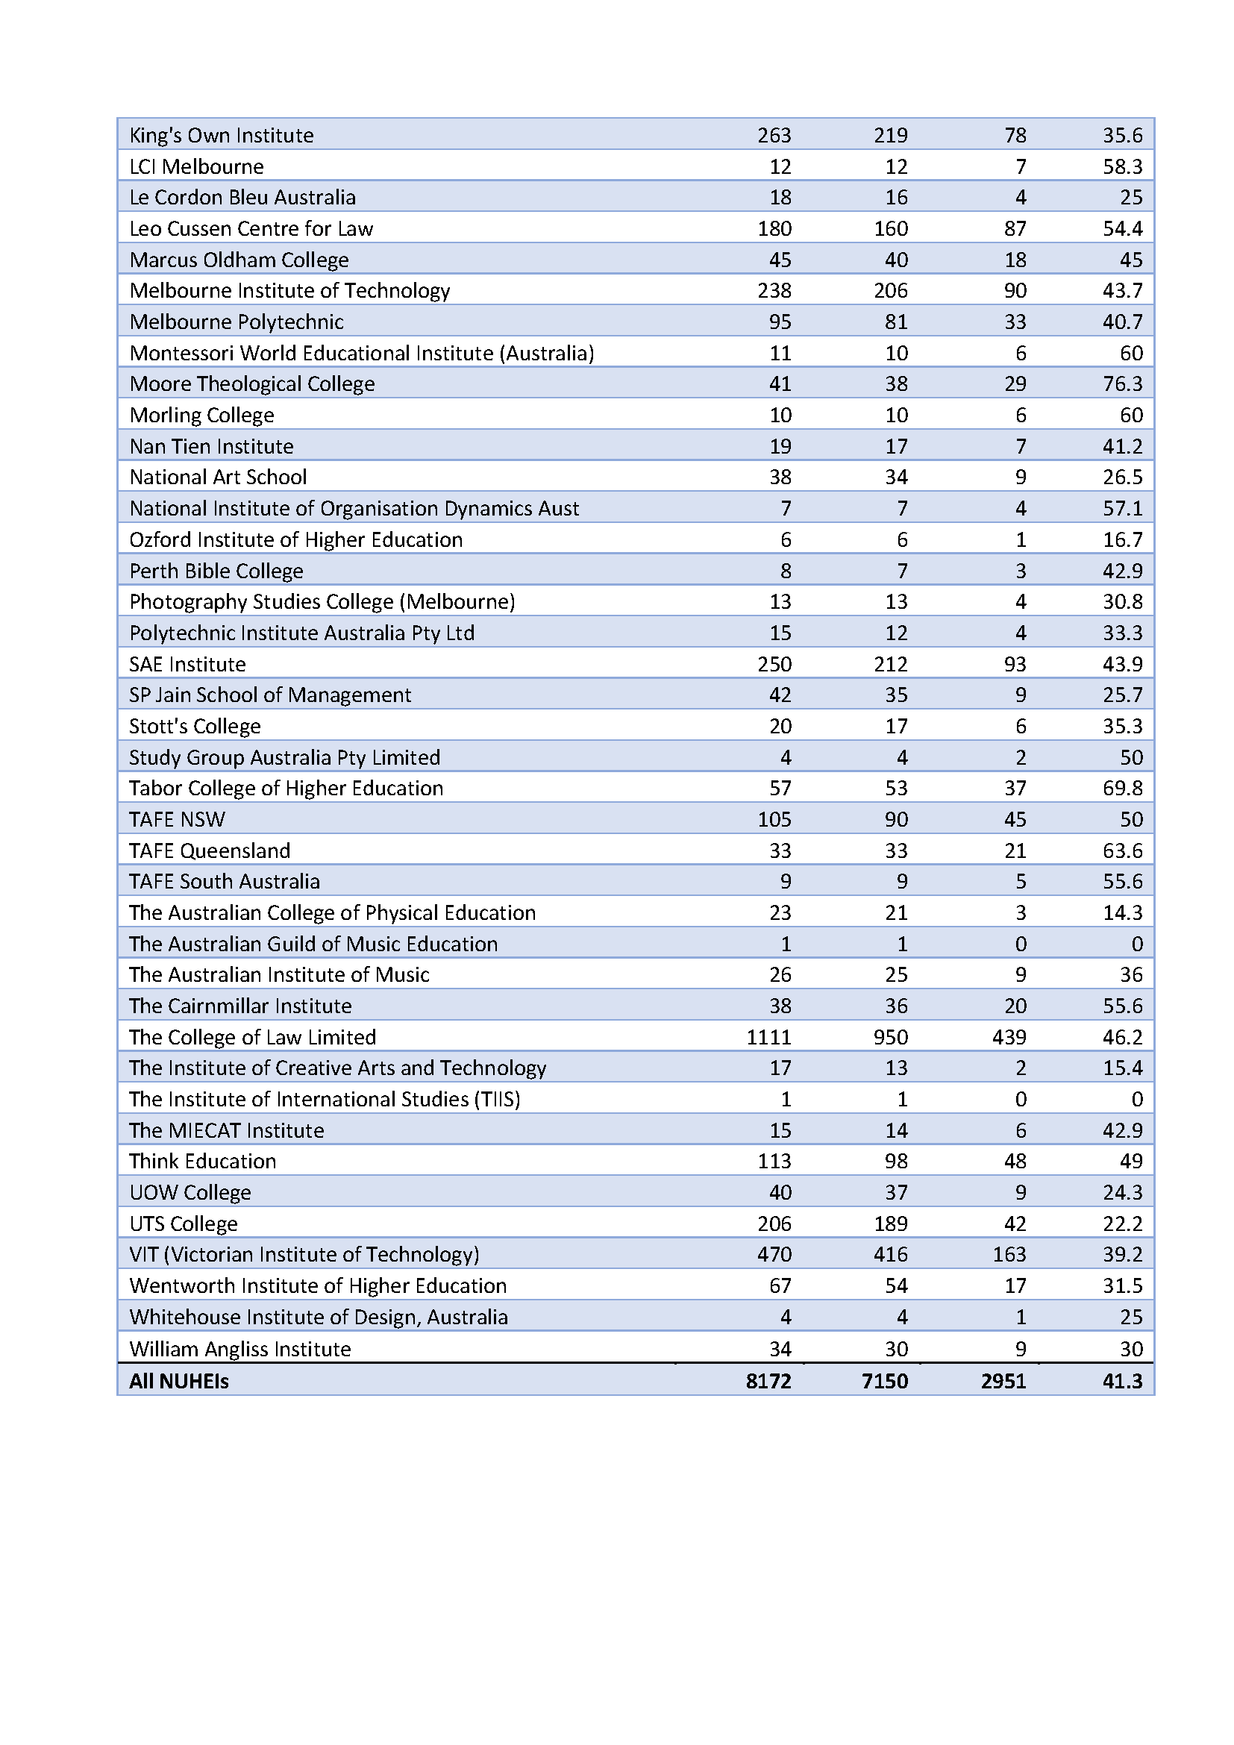

The Social Research Centre Pty Ltd
Level 5, 350 Queen Street, Melbourne Vic 3000
PO Box 13328, Law Courts Vic 8010
03 9236 8500 | info@srcentre.com.au
srcentre.com.au
The version of this publication is aimed to assist those with various
vision impairments; however, The Social Research Centre and its
employees do not guarantee that the publication meets all broad
accessibility standards and therefore disclaim all liability for any
inconvenience or other consequence that may arise from readers
relying on this publication. Please contact The Social Research
Centre if you require further assistance.

These are based on the magnitude of the difference between responding and non-responding proportions, standardized by the pooled standard deviation, with Cohen (1992) assigning qualitative labels of “small”, “medium” and “large”, with thresholds of 0.2, 0.5 and 0.8, respectively. He states that his “intent was that medium ES [effect size] represents an effect likely to be visible to the naked eye of a careful observer … I set small ES to be noticeably smaller than medium but not so small as to be trivial, and I set large ES to be the same distance above medium as small was below it.”

