|  |
| --- |
| 2024 Graduate Outcomes Survey |
| Methodological Report – Accessible  September 2025 |
| The Social Research Centre logo. |

| Acknowledgements |
| --- |
| The Quality Indicators for Learning and Teaching (QILT) survey program, including the 2024 Graduate Outcomes Survey (GOS), is funded by the Australian Government Department of Education (the department).  The Department and the Social Research Centre acknowledge the Traditional Custodians of the lands and waters on which this research was conducted. We pay our respects to Elders, past, present and emerging.  The Social Research Centre would like to thank the higher education institutions that contributed to the GOS in 2024. Without the enthusiastic and committed assistance of the survey managers and institutional planners, the 2024 GOS would not have been such a success.  We are also very grateful to the graduates who took the time to provide valuable feedback about their employment and further study outcomes, and their experience with their completed course. Institutions use GOS data for continuous improvement including exploring ways to monitor and improve the short-term labour force outcomes of graduates.  For more information on the conduct and results of the 2024 GOS see the [QILT website](http://www.qilt.edu.au). |
| Report prepared for:  Australian Government Department of Education  50 Marcus Clarke St, Canberra ACT 2601  Report prepared by:  The QILT Team  The Social Research Centre  Level 5, 350 Queen Street  Melbourne, Victoria 3000  Telephone: (613) 9236 8500  qilt@srcentre.com.au  srcentre.com.au  Version: 1 ǀ September 2025  ISO 27001 Certified logo, ISO 20252 Certified logo, The Research Society logo, The Australian Data Insights Association logo, The Australian Evaluation Society logo member 2025-26, The Inclusive Employer logo |

Contents

List of abbreviations and terms iv

1. Introduction 1

1.1. About this report 1

1.2. Background 1

1.3. Objectives 1

1.4. Overview 2

1.5. Project milestones 3

2. Sample preparation 5

2.1. Target population 5

2.2. Institutional participation 5

2.3. Course majors 5

2.4. Sample frame 6

2.4.1 Additional populations 6

2.5. Sample preparation overview 6

2.5.1 Sample processing quality assurance 7

2.5.2 Exclusions 8

3. Survey design and procedures 9

3.1. Institutional engagement 9

3.2. Contact protocol 9

3.2.1 Email invitation and reminders 11

3.2.2 SMS reminders 14

3.2.3 Reminder calls 17

3.2.4 Fieldwork briefing and quality control 19

3.2.5 Social media 19

3.3. Data collection 20

3.3.1 Online survey 20

3.3.2 Survey testing 21

3.3.3 Quality assurance and applicable standards 21

3.3.4 Monitoring and progress reporting 21

3.3.5 Live online reporting module 21

3.4. Graduate support 21

3.5. Prize draw 22

4. Questionnaire 25

4.1. Development 25

4.2. Overview 25

4.3. Changes from 2023 25

4.3.1 Institution items 26

4.3.2 Stakeholder items 26

4.3.3 Retired items 26

5. Data preparation 27

5.1. Definition of the analytic unit 27

5.2. Data cleaning and preparation 27

5.3. Coding and processing of open text responses 27

5.4. Data deliverables 28

5.5. Weighting 28

6. Final dispositions, response rates and reportable strata 29

6.1. Final dispositions and response rates 29

6.2. Population for confidence intervals calculations 30

6.3. Strata meeting the desired level of precision 31

7. Response analysis 32

7.1. Response by time 32

7.2. Non-response analysis 34

7.2.1 Supplementing response rates with indicators of representativeness 34

7.2.2 Characteristics associated with propensity to respond 35

7.2.3 Characteristics associated with non-response 36

7.2.4 Characteristics associated with outcomes 38

7.3. Sources of response 40

7.4. Sample retention for GOS-L 42

8. Considerations for future surveys 44

8.1. Revised authentication module 44

8.2. Social media engagement with graduates 44

8.3. Targeted outreach to low responding institutions 44

8.4. Revised International Engagement Strategy 44

8.5. GOS-L panel maintenance 44

Appendix 1: Participating institutions 45

Appendix 2: Contact protocol 49

Appendix 3: Core questionnaire 53

Appendix 4: Response rate by institution 54

List of figures

Figure 1 Response rates by date – November 2023 32

Figure 2 Response rates by date – February 2024 33

Figure 3 Response rates by date – May 2024 33

Figure 4 Relative importance of graduate characteristics in predicting survey response 35

List of tables

Table 1 Key project statistics 2

Table 2 Key project milestones 3

Table 3 Outcomes of contact list cleaning process 7

Table 4 Invitation and reminder schedule 9

Table 5 Email plan message intent 11

Table 6 Email send outcomes by round of activity – November 2023 13

Table 7 Email send outcomes by round of activity – February 2024 13

Table 8 Email send outcomes by round of activity – May 2024 13

Table 9 SMS based follow up activity outcomes 15

Table 10 In-field reminder call outcomes 18

Table 11 Post-field reminder call outcomes 19

Table 12 Graduate enquiries to the GOS helpdesk 22

Table 13 Prize draw schedule 24

Table 14 GOS module themes 25

Table 15 Items coded and source for coding decisions 28

Table 16 Final survey outcomes 29

Table 17 Strata meeting desired level of precision for undergraduates in full-time study 31

Table 18 Comparison of representativeness over past four GOS collection cycles 35

Table 19 Comparison between respondents and non-respondents for selected characteristics 36

Table 20 Relative importance of graduate characteristics in predicting survey outcomes 40

Table 21 Sources of response 42

Table 22 Graduate responses to further contact for GOS-L 42

List of abbreviations and terms

**AAGE** Australian Association of Graduate Employers

**ABS** Australian Bureau of Statistics

**ACEN** Australian Collaborative Education Network Limited

**ACMA** Australian Communications and Media Authority

**ADIA** Australian Data and Insights Association

**AGS** Australian Graduate Survey

**ANZSIC** Australian New Zealand Standard Industrial Classification

**ANZSCO** Australian New Zealand Standard Classification of Occupations

**ASCED** Australian Standard Classification of Education

**CEQ** Course Experience Questionnaire

**ESS** Employer Satisfaction Survey

**GAS** Graduate Attributes Scale

**GOS** Graduate Outcomes Survey

**GOS-L** Graduate Outcomes Survey – Longitudinal

**HDR** Higher Degree by Research

**HEIMS** Higher Education Information Management System

**HESA** Higher Education Support Act

**IP** Internet Protocol

**ISO** International Standards Organisation

**NUHEI** Non-University Higher Education Institution

**PASF** Participation and Additional Services Form

**QILT** Quality Indicators for Learning and Teaching

**RES** Respondent Engagement Survey

**SACC** Standard Australian Classification of Countries

**SFX** Secure File Exchange

**TCSI** Tertiary Collection of Student Information

# Introduction

## About this report

This methodological report describes the sample preparation, data collection and data preparation aspects of the 2024 Graduate Outcomes Survey (GOS, ‘the survey’), conducted on behalf of the Australian Government Department of Education (‘the department’) by the Social Research Centre. This report is organised into the following sections:

* Section 1 provides background information and a general overview.
* Section 2 describes the target audience and sample design.
* Section 3 documents the survey design and procedures for conducting the study.
* Section 4 outlines the questionnaire development phase and provides an overview of changes from the previous iteration including institution specific items.
* Section 5 describes the data preparation procedures.
* Section 6 documents the final dispositions and response rates.
* Section 7 presents an analysis of response and non-response.
* Section 8 outlines key learnings and considerations for future iterations of the GOS.

## Background

The GOS is a component of the Quality Indicators for Learning and Teaching (QILT) suite of surveys, commissioned by the department. The GOS replaced the Australian Graduate Survey (AGS) which was conducted between 2009 and 2014.

For a more detailed history of the GOS and its predecessor instruments, refer to the 2017 GOS Methodological Report.

## Objectives

The broad aim of the GOS is to measure the short-term labour force outcomes achieved by graduates of Australian higher education institutions approximately four to six months post completion of their undergraduate or postgraduate award.

The development, collection and reporting of these measures provides reliable, valid and generalisable information on graduate outcomes to the Australian government and to higher education providers.

Specific research objectives of the GOS are to measure recent higher education graduates’:

* Employment and further study outcomes.
* Level of satisfaction with their higher education course.

The GOS survey instrument is also the mechanism for building the sample for another component of the QILT suite of surveys, the Employer Satisfaction Survey (ESS), through the collection of work supervisor contact details from employed GOS respondents. The ESS is a national survey that directly links the experiences of graduates to the views of their direct supervisors. Refer to the ESS Methodological Report series for more information about the ESS.

## Overview

Graduates who completed a course from March 2023 through to February 2024 were invited to participate in the 2024 GOS. The 2024 GOS collection cycle was conducted over three distinct collection rounds (November 2023, February 2024, and May 2024).

The sample for the survey was mainly sourced from the Tertiary Collection of Student Information (TCSI) system, whilst the participating higher education institutions provided information such as contact details.

The survey instrument deployed at each collection round in the 2024 GOS was largely consistent with previous years.

The survey was fielded online in English only. Invitations were sent by email, with reminders sent by email and SMS. Reminder calls were also deployed with selected non-responding graduates.

Participating institutions could commission an additional round of targeted SMS reminders during the main online fieldwork period, and additional reminder calls after the conclusion of the main online fieldwork period. Surveys completed as a result of reminder calls are included as completed surveys in this report.

A total of 130 institutions, including all 42 universities and 88 NUHEIs, participated in the 2024 GOS. From a final in-scope sample of 305,906 graduates, a total of 117,794 surveys were completed (as defined in Section 5.1). This was made up of 108,817 graduates of 42 Australian universities and 8,977 graduates of 88 non-university higher education institutions (NUHEIs). Refer to Table 1 for further details of participation by collection round.

Response rate varied across each collection round, with a marginally stronger response in the February and May rounds, relative to the November round. The final overall response rate for the 2024 GOS was 38.5 per cent, continuing a gradual downward trend from the 2023 GOS (38.7 per cent), 2022 GOS (39.4 per cent) and 2021 GOS (40.4 per cent). The final response rate for the 2024 GOS was higher for universities (38.7 per cent) compared to NUHEIs (36.5 per cent).

Table 1 Key project statistics

| Collection round | Participating institutions (n) | Total sample (n) | Final in-scope graduates (n) | Surveys completed (n) | Response rate (%) |
| --- | --- | --- | --- | --- | --- |
| 2023 November University | 42 | 96,786 | 88,120 | 32,824 | 37.2 |
| 2023 November NUHEI | 70 | 11,008 | 9,668 | 3,419 | 35.4 |
| 2023 November Total | 112 | 107,794 | 97,788 | 36,243 | 37.1 |
| 2024 February University | 34 | 21,643 | 19,607 | 7,742 | 39.5 |
| 2024 February NUHEI | 46 | 5,050 | 4,407 | 1,537 | 34.9 |
| 2024 February Total | 80 | 26,693 | 24,014 | 9,279 | 38.6 |
| 2024 May University | 42 | 189,012 | 173,613 | 68,251 | 39.3 |
| 2024 May NUHEI | 75 | 11,654 | 10,491 | 4,021 | 38.3 |
| 2024 May Total | 117 | 200,666 | 184,104 | 72,272 | 39.3 |
| 2024 Total collection University | 42 | 307,441 | 281,340 | 108,817 | 38.7 |
| 2024 Total collection NUHEI | 88 | 27,712 | 24,566 | 8,977 | 36.5 |
| 2024 Total collection  Total | 130 | 335,153 | 305,906 | 117,794 | 38.5 |

Note: For QILT projects, ‘response rate’ is defined as surveys completed as a proportion of in-scope sample approached, where in-scope sample approached excludes unusable sample (e.g., no contact details), out-of-scope and opted-out. This definition of response rate differs from industry standards by excluding certain non-contact and refusal outcomes from the denominator for the response rate calculation. For details of industry standards, refer to the American Association for Public Opinion Research *Standard Definitions Report* (2023).

## Project milestones

Table 2 provides a summary of the key project milestones for each collection round in the 2024 GOS. There was no divergence between planned and actual milestone dates.

Table 2 Key project milestones

| Task | Collection round 2023 November | Collection round 2024 February | Collection round 2024 May |
| --- | --- | --- | --- |
| Establishment - Core questionnaire development* | 14-Aug-23 | - | - |
| Establishment - Core questionnaire finalised* | 11-Sep-23 | - | - |
| Establishment - Start sample preparation | 21-Aug-23 | 23-Oct-24 | 19-Feb-24 |
| Establishment - Sample preparation finalised | 5-Oct-23 | 15-Dec-24 | 12-Apr-24 |
| Fieldwork - Soft launch main online fieldwork period | 31-Oct-23 | 6-Feb-24 | 30-Apr-24 |
| Fieldwork - Start main online fieldwork | 2-Nov-23 | 8-Feb-24 | 2-May-24 |
| Fieldwork - Start in-field reminder calls | 9-Nov-23 | 15-Feb-24 | 9-May-24 |
| Fieldwork - In-field reminder calls close | 30-Nov-23 | 7-Mar-24 | 23-May-24 |
| Fieldwork - Main online fieldwork close** | 3-Dec-23 | 10-Mar-24 | 2-Jun-24 |
| Fieldwork - Start post-field reminder calls† | 4-Dec-23 | 11-Mar-24 | 3-Jun-24 |
| Fieldwork - Fieldwork close† | 19-Dec-23 | 26-Mar-24 | 17-Jun-24 |
| Data preparation - Draft data and documentation to the department | - | - | 19-Jul-24 |
| Data preparation - Final data and documentation to the department | - | - | 2-Aug-24 |
| Data preparation - Institutional Tableau report and data files delivered | - | - | 30-Aug-24 |

*February and May dates not shown as only minor changes made to the questionnaire for these collection rounds.

** Institutions that did not opt for post-field reminder calls.

† Institutions that opted for post-field reminder calls.

# Sample preparation

## Target population

The in-scope population consisted of all graduates who completed the requirements of an undergraduate or postgraduate award at a participating Australian higher education institution between March 2023 and February 2024. This included domestic and international graduates living outside Australia who studied at an Australian campus. Offshore graduates who studied at a campus outside Australia were excluded from the core survey.

All graduates meeting these criteria were selected for inclusion in the survey. In this way, the 2024 GOS was an attempted census of all in-scope higher education graduates, thereby ensuring as full coverage as possible.

## Institutional participation

As for previous collection cycles, institutional participation in the 2024 GOS was optional. Of the 160 institutions (42 universities and 118 NUHEIs) invited to participate, all universities participated, whilst 30 NUHEIs[1] chose not to participate. The main reasons cited by NUHEIs for non-participation included not having any student completions in the reference period, or in some cases, not having the administrative resources required.

For a list of participating institutions and sample size by collection round, refer to Appendix 1. Please note that the November and May collection rounds historically have higher levels of institutional participation as the in-scope reference period for graduates aligns with the more common course completion dates in the middle or end of the year.

## Course majors

The default methodology for the GOS is to survey at the course/qualification level. However, institutions also have the option to survey their graduates at the majors level. Prior to providing the sample for the 2024 GOS, institutions were asked to confirm whether they wanted their graduates surveyed at the majors level. For consistency of data, institutions were required to take a uniform approach to surveying at the course level or majors level across the entire 2024 GOS collection cycle.

As majors data is not included in the TCSI system, the option of surveying using majors was only recommended for institutions with generic course offerings (i.e., Bachelor of Arts, Bachelor of Science, Doctor of Philosophy) that also had accurate administrative majors data available for populating the sample. Institutions that elected to survey using majors were asked to complete or update a concordance of majors to courses for their institution and provide data for each graduate’s major(s) in the returned sample files.

In the 2024 GOS, there were 11 institutions (all universities) that opted to survey using majors. All other institutions chose to survey their graduates at the course level.

## Sample frame

The GOS used a centralised approach to sampling based on data extracted from the TCSI system[2] to create sample files for individual institutions. This ensured the sampling methodology was robust, consistent and transparent across all institutions.

Institutions are able to submit course completion data to TCSI on a continuous basis. For the purpose of extracting the GOS sample, an agreed cut-off date for all completion data to be submitted to TCSI (approximately one week prior to the delivery of institution sample files in each collection round) was communicated to institutions.

Institutions that had not yet migrated to TCSI or had missing course completion data in TCSI were offered a Full template to provide all or part of their sample. The Full template enabled institutions to submit TCSI-consistent data elements for survey execution and reporting.

### Additional populations

Institutions could include out-of-scope graduates as additional populations in the GOS on a fee-for-service basis. The sample return process allowed institutions to provide additional populations in their returned sample files.

GOS additional populations can include groups such as offshore graduates who completed the requirements for an Australian award during the relevant GOS data collection reference period, or out of cycle graduates (graduates in-scope for a previous collection round but not approached).

Six institutions (three universities, three NUHEIs) opted to survey additional populations in the 2024 GOS. Additional populations are not included in the National Report and do not appear in results presented in this report.

## Sample preparation overview

Detailed information regarding the GOS sampling process was available to institutions in the Collection and Sample Guide (refer to Section 3.1). The guide was provided to institutions prior to each GOS collection round and outlined the:

* timeline for sample provision
* options for submission of sample information
* data elements that were pre-populated, essential, or optional
* processes for inclusion of additional populations and majors data
* data elements important for response maximisation
* steps for flagging the in-scope population.

The department provided an extract of all TCSI submissions from institutions to the Social Research Centre. The Social Research Centre then reviewed this extract to identify records eligible to participate in the GOS. Sample counts by institution were checked against historical submissions to ensure all expected TCSI submissions were included in the extract. Following this, individual sample file templates were distributed to institutions for verification of the included graduate data and to append contact information.

The sample file template allowed institutions to provide up to three email addresses and three phone numbers for each graduate. Institutions were expected to provide at least one email address for each graduate, preferably a personal email, with the inclusion of a secondary email address recommended. Provision of at least one phone number was taken as consent to include the graduate in reminder calls (see Section 3.2.3) and inclusion of a mobile phone number was considered as consent to include the graduate in SMS reminders (see Section 3.2.2).

Institutions were also asked to review the in-scope status of all sample records, with an option to flag graduates who should not be surveyed as out-of-scope.

### Sample processing quality assurance

Upon receipt of an institution’s returned sample file, the Social Research Centre undertook a range of validation checks to ensure the quality of returned sample files.

Issues identified through the sample return quality assurance process were communicated to institution contacts, with assistance provided to resolve issues, as necessary, so that all required validation checks were passed.

Sample preparation guidelines were reviewed ahead of each collection round to incorporate learnings related to sample file quality issues. The main sample file quality issues observed were as follows:

* Information essential for survey operationalisation or analysis not being provided, or not provided in the specified format.
* Non-allowable values being provided for variables that changed during the transition to TCSI from HEIMS.
* Insufficient, limited, or unclean contact information (i.e., phone number, email).
* Formatting issues such as altering of templates, use of special characters or duplication of unique records/identifiers.
* Incorrect course codes being provided or course codes not being up to date in the master course list.
* Inconsistent course information (i.e., courses with the same course code submitted with different field of education codes within a collection round or between collection rounds).
* Incorrect assignment of majors or missing majors data.

Table 13 summarises the outcomes from the contact list cleaning process on contact information for all in-scope sample records provided by participating institutions. Given that many graduates could be contacted via multiple email addresses or phone numbers, the number of emails or phone numbers do not match the total sample for the 2024 GOS.

Table 3 Outcomes of contact list cleaning process

|  | Email: Base before pre-field cleaning (n) | Email: Base after pre-field cleaning (n) | Email: % valid cleaned | Phone: Base before pre-field cleaning (n) | Phone: Base after pre-field cleaning (n) | Phone: % valid cleaned |
| --- | --- | --- | --- | --- | --- | --- |
| Total | **633,396** | **614,379** | **97.0** | **410,575** | **363,604** | **88.6** |
| University | 591,487 | 574,540 | 97.1 | 374,432 | 336,067 | 89.8 |
| NUHEI | 41,909 | 39,839 | 95.1 | 36,143 | 27,537 | 76.2 |

Note: Before pre-field cleaning reflects the number of contact information for all in-scope graduates. After pre-field cleaning reflects the number of validated contact information after cleaning duplicate or invalid email addresses and phone numbers.

### Exclusions

Exclusion rules included:

* duplicate sample records
* out-of-scope sample records based on the GraduateStatus variable (reasons include not being a graduate, graduate should not be contacted, graduate has been surveyed in a prior collection round or other reasons as determined by the institution)
* sample records with course information insufficient for the administration of the GOS instrument.

After application of the exclusion rules, 222,855 records were removed from the sample. This is notably higher than the 2023 exclusions count (170,931). The TCSI extracts received by the Social Research Centre contained all sample records in the TCSI database for every collection round, thus duplicate records (218,986) were included in TCSI templates provided to institutions to provide transparency of the TCSI extract data. The increase in exclusions in 2024 may be due to a greater proportion of total sample being submitted via TCSI templates than in 2023.

# Survey design and procedures

## Institutional engagement

The institutional engagement strategy for the 2024 GOS included:

* the timely provision of institutional planning resources, such as the QILT Key Dates Calendar and Collection and Sample Guide, accessible via the QILT provider portal.
* for each round of the GOS, confirmation of participation and nomination for fee for service activities via the Participation and Additional Services Form (PASF).
* GOS specific content in the QILT webinar and newsletter series, encompassing analysis of prior year survey results, sample preparation, questionnaire changes, response maximisation, survey methodology and fieldwork progress.
* the provision of a Marketing Pack to support institutional marketing activity, including a Marketing Pack User Guide and an Engagement activity plan.
* an ongoing dialogue with survey managers at participating institutions to discuss overall progress and work through response maximisation strategies, with a focus on assisting under-performing institutions.

Feedback on institutional engagement processes and on the resources provided was sought at the end of the collection period via the Respondent Engagement Survey.

## Contact protocol

The 2024 GOS employed an extensive protocol of contact attempts, including an email invitation and up to nine email reminders, up to three SMS reminders, and telephone reminder call activity.

An additional SMS and post-field reminder calls could be commissioned by institutions on a fee-for-service basis.

Each contact mode included provision to opt-out or unsubscribe from future contact, in alignment with obligations under the Australian Communications and Media Authority (ACMA) Spam Act. Graduates could also opt-out by contacting the GOS helpdesk.

Table 4 shows the date of contact activity, as well the number of emails and SMS sent.

Table 4 Invitation and reminder schedule

| Contact activity | Collection round: 2023 November Day of send | Collection round: 2023 November Number sent | Collection round: 2024 February Day of send | Collection round: 2024 February Number sent | Collection round: 2024 May Day of send | Collection round: 2024 May Number sent |
| --- | --- | --- | --- | --- | --- | --- |
| Email invitation  (Soft launch commenced) | 31-Oct-23 | 107,574 | 06-Feb-24 | 26,519 | 30-Apr-24 | 199,285 |
| Email invitation  (Main launch commenced) | 02-Nov-23 | 107,574 | 08-Feb-24 | 26,519 | 02-May-24 | 199,285 |
| Email reminder 1 | 04-Nov-23 | 101,293 | 10-Feb-24 | 24,841 | 04-May-24 | 186,794 |
| Email reminder 2 | 06-Nov-23 | 95,714 | 12-Feb-24 | 23,455 | 06-May-24 | 177,731 |
| SMS1^ | 06-Nov-23 | 82,395 | 12-Feb-24 | 20,620 | 13-May-24 | 145,992 |
| Prize draw 1 closed | 06-Nov-23 | n/a | 12-Feb-24 | n/a | 06-May-24 | n/a |
| Email reminder 3 and In-field reminder calls commenced | 09-Nov-23 | 88,918 | 15-Feb-24 | 21,729 | 09-May-24 | 167,633 |
| Email reminder 4 | 13-Nov-23 | 85,642 | 19-Feb-24 | 20,974 | 13-May-24 | 161,945 |
| SMS2 | 13-Nov-23 | 65,643 | 19-Feb-24 | 16,288 | 20-May-24 | 113,272 |
| Prize draw 2 closed | 13-Nov-23 | n/a | 19-Feb-24 | n/a | 13-May-24 | n/a |
| Email reminder 5 | 15-Nov-23 | 80,761 | 21-Feb-24 | 19,981 | 15-May-24 | 153,018 |
| Email reminder 6 | 20-Nov-23 | 77,935 | 26-Feb-24 | 19,309 | 20-May-24 | 146,808 |
| SMS3# | 20-Nov-23 | 52,767 | 26/02/2024 | 13,117 | 27-May-24 | 99,998 |
| Prize draw 3 closed | 20-Nov-23 | n/a | 26-Feb-24 | n/a | 20-May-24 | n/a |
| Email reminder 7 | 24-Nov-23 | 73,645 | 01-Mar-24 | 18,510 | 24-May-24 | 137,646 |
| Email reminder 8 | 27-Nov-23 | 72,123 | 04-Mar-24 | 18,015 | 27-May-24 | 134,378 |
| SMS fee-for-service | 27-Nov-23 | 13,979 | 07-Mar-24 | 4,878 | 30-May-24 | 28,136 |
| Prize draw 4 closed | 27-Nov-23 | n/a | 04-Mar-24 | n/a | 27-Apr-24 | n/a |
| Email reminder 9 | 30-Nov-23 | 70,170 | 07-Mar-24 | 17,293 | 30-May-24 | 129,052 |
| Supplementary email± | - | n/a | 09-Mar-24 | 16,981 | - | n/a |
| Online fieldwork closes* | 03-Dec-23 | n/a | 10-Mar-24 | n/a | 02-Jun-24 | n/a |
| Post-field reminder calls commenced† | 04-Dec-23 | n/a | 11-Mar-24 | n/a | 03-Jun-24 | n/a |
| Fieldwork closes† | 19-Dec-24 | n/a | 26-Mar-24 | n/a | 17-Jun-24 | n/a |

* Institutions that did not opt for post-field reminder calls.  
† Institutions that opted for post-field reminder calls.  
^ The May collection round featured experimentation with the timing of SMS1, with 20% of the total sample sent SMS1 paired with email reminder 2 sent on 6 May 2024 to determine whether earlier send improved overall response.   
# The February collection round featured experimentation with the timing of SMS3, with 50% of the total sample sent SMS3 paired with email reminder 8 sent on 4 March 2024 to determine whether later send improved overall response.  
± A supplementary email was sent in the final week of main online fieldwork of the February collection round due to low response.

### Email invitation and reminders

The message intent for the GOS emails is summarised in Table 5.

An example of the invitation email used in the May collection round is provided in Appendix 2.

Table 5 Email plan message intent

| Activity | Message intent |
| --- | --- |
| Invitation | Awareness raising and invitation |
| Reminder 1 | Your feedback is important and will contribute to the experience current and future students, acknowledge graduate may be busy, soft mention of first prize draw |
| Reminder 2 | Encourage early completion with prize incentive, and grateful if you could spare the time |
| Reminder 3 | Help government understand graduate employment and further study outcomes |
| Reminder 4 | Grateful if you could spare the time to give feedback to benefit future students, improve course experiences at institutions, soft mention of second prize draw |
| Reminder 5 | More feedback needed from graduates, important to give feedback even if not working |
| Reminder 6 | Empathetic tone, acknowledge frequency of contact, improve career resources at institution, attention drawn to unsubscribe option, mention of penultimate prize draw |
| Reminder 7 | Recognise uniqueness of graduate, acknowledge graduate may be busy, help improve outcomes for graduates and inform choices for future students |
| Reminder 8 | Mention of final prize draw, still need to hear from more graduates from your course, grateful if you could spare the time |
| Reminder 9 | Survey closing soon, important to give feedback |
| Supplementary email± | Last appeal: final email and chance to complete, help government understand graduate employment and further study outcomes |

± A supplementary email was sent in the final week of main online fieldwork of the February collection round due to low response.

The Social Research Centre is committed to an International Engagement Strategy with the goal of increasing international student and graduate response, thereby improving the representation of this group in the QILT data. The customised email plan was implemented in GOS to appeal to the ‘international graduate’ identity (Reminder 1, Reminder 4, Reminder 6, Reminder 7, Reminder 8). An example of the reminder email used in the May collection round for the international graduate cohort is provided in Appendix 2. Additionally, international graduates were prioritised for in-field reminder calls (refer to Section 3.2.3).

A breakdown of email send outcomes by round of activity is provided at Table 6, Table 7, and Table 8. ‘Clicked on link’ is the key indicator used to measure email performance. Note these tables indicate the number of unique email addresses that invitations were sent to. Given that many graduates could be contacted via multiple email addresses, the number sent for the invitation email does not match the total number of graduates approached for the 2024 GOS.

The invitation remained the most effective email in the schedule with the highest ‘clicked on link’ rates across the schedule – 9.5 per cent in February, 9.2 per cent in May and 8.6 per cent in November. As could be expected, ‘clicked on link’ rates generally trended down with each subsequent reminder. Exceptions to this usually coincided with email reminders timed to align with prize draw close dates (Reminder 2, Reminder 4, Reminder 6, Reminder 8).

The proportion of bounced emails (sent emails that return with a server response indicating non-delivery) across the 2024 GOS collection cycle was lowest in May, followed by November. This indicates that at the national level, the quality of contact details in the approached sample was good and email cleaning processes were effective. However, poor email deliverability was observed throughout February with emails sent to Microsoft domains that may have caused higher proportion of soft bounce rates or significant delays in send time. While this issue is currently under investigation, we continue to closely monitor any potential issue that arise in future surveys.

Opt-outs were less than one per cent at each email, suggesting the nature of the survey and the timing of sends were not a concern for graduates.

Table 6 Email send outcomes by round of activity – November 2023

| Total | Invite | R1 | R2 | R3 | R4 | R5 | R6 | R7 | R8 | R9 |
| --- | --- | --- | --- | --- | --- | --- | --- | --- | --- | --- |
| Total sent (n) | 107,574 | 101,293 | 95,714 | 88,918 | 85,642 | 80,761 | 77,935 | 73,645 | 72,123 | 70,170 |
| Clicked on link (%) | 8.6 | 7.2 | 6.6 | 4.5 | 4.6 | 3.8 | 4.4 | 2.8 | 2.9 | 2.9 |
| Opt-out from link (%) | 0.5 | 0.6 | 0.7 | 0.7 | 0.7 | 0.7 | 0.7 | 0.7 | 0.6 | 0.5 |
| Opened email (%) | 55.9 | 53.3 | 51.2 | 52.6 | 49.2 | 49.2 | 49.0 | 49.1 | 46.3 | 47.7 |
| Unopened (%) | 32.8 | 37.2 | 39.6 | 40.3 | 43.3 | 44.2 | 42.9 | 45.1 | 46.5 | 45.5 |
| Soft bounce[3] (%) | 1.5 | 1.7 | 1.7 | 1.9 | 2.2 | 2.1 | 2.1 | 2.2 | 3.4 | 3.5 |
| Hard bounce[4] (%) | 0.7 | <0.1 | <0.1 | <0.1 | <0.1 | <0.1 | 0.9 | <0.1 | 0.2 | <0.1 |

Table 7 Email send outcomes by round of activity – February 2024

| Total | Invite | R1 | R2 | R3 | R4 | R5 | R6 | R7 | R8 | R9 |
| --- | --- | --- | --- | --- | --- | --- | --- | --- | --- | --- |
| Total sent (n) | 26,519 | 24,841 | 23,455 | 21,729 | 20,974 | 19,981 | 19,309 | 18,510 | 18,015 | 17,293 |
| Clicked on link (%) | 9.5 | 7.8 | 7.3 | 4.6 | 4.5 | 4.2 | 4.5 | 3.3 | 3.7 | 2.0 |
| Opt-out from link (%) | 0.6 | 0.7 | 0.7 | 0.6 | 0.7 | 0.9 | 0.9 | 0.9 | 0.8 | 0.7 |
| Opened email (%) | 54.2 | 51.5 | 46.5 | 47.4 | 45.7 | 47.9 | 48.0 | 46.1 | 45.1 | 45.5 |
| Unopened (%) | 30.2 | 39.7 | 45.2 | 47.1 | 48.7 | 46.8 | 45.9 | 48.1 | 48.9 | 51.1 |
| Soft bounce (%) | 4.6 | 0.2 | 0.3 | 0.3 | 0.4 | 0.3 | 0.3 | 1.5 | 1.6 | 0.5 |
| Hard bounce (%) | 0.9 | <0.1 | <0.1 | <0.1 | <0.1 | <0.1 | 0.3 | <0.1 | <0.1 | 0.2 |

Table 8 Email send outcomes by round of activity – May 2024

| Total | Invite | R1 | R2 | R3 | R4 | R5 | R6 | R7 | R8 | R9 |
| --- | --- | --- | --- | --- | --- | --- | --- | --- | --- | --- |
| Total sent (n) | 199,285 | 186,794 | 177,731 | 167,633 | 161,945 | 153,018 | 146,808 | 137,646 | 134,378 | 129,052 |
| Clicked on link (%) | 9.2 | 7.4 | 6.1 | 4.4 | 5.3 | 4.0 | 4.8 | 3.0 | 3.1 | 2.4 |
| Opt-out from link (%) | 0.5 | 0.5 | 0.8 | 0.7 | 0.7 | 0.8 | 0.7 | 0.8 | 0.6 | 0.6 |
| Opened email (%) | 56.4 | 55.5 | 54.6 | 55.7 | 52.4 | 51.3 | 50.8 | 51.6 | 50.3 | 50.4 |
| Unopened (%) | 33.1 | 36.4 | 38.3 | 38.9 | 41.3 | 43.6 | 43.2 | 44.3 | 45.6 | 46.2 |
| Soft bounce (%) | 0.4 | 0.2 | 0.3 | 0.3 | 0.4 | 0.3 | 0.3 | 0.4 | 0.4 | 0.4 |
| Hard bounce (%) | 0.4 | <0.1 | <0.1 | <0.1 | <0.1 | <0.1 | <0.1 | <0.1 | <0.1 | <0.1 |

Extensive pre-field testing was undertaken to maximise the proportion of emails delivered to primary inboxes (such as the ‘primary’ tab in Gmail and ‘focused’ inbox in Outlook).

Actions taken and products used to optimise email deliverability included:

* a dedicated Internet Protocol (IP) address range used only by the Social Research Centre for bulk email delivery. The reputation of this range was maintained year-round to keep the IP addresses ‘warm’. The dedicated range eliminated risks associated with bulk mailing from a shared IP pool
* during sample cleaning, email addresses were validated to reduce bounce rates, thereby minimising the degradation of IP reputation
* ongoing maintenance of technical services and policies to meet sender best practice
* optimisation of all images, hyperlinks and HTML code used in emails to meet deliverability best practices
* pre-field testing of emails across a broad range of mail clients, devices, and providers to confirm and optimise compatibility, display and delivery
* in-field tracking of email deliverability using analytics tools.

Poor email deliverability is often linked to themes and words such as ‘win’ and ‘prize draw’, resulting in emails being directed to email spam folders (including ‘Promotions’). When analytics tools detected deliverability issues, the wording was tweaked where necessary, to ensure delivery to the primary inbox, without altering the overall theme of message.

Despite the substantial advancements made in email deliverability testing, consistency and reliability of bulk email delivery remains an ongoing challenge for the GOS and the QILT suite of surveys more broadly.

### SMS reminders

SMS reminders were used during fieldwork to compliment the email contact strategy and provide an alternative contact channel as insurance against email deliverability issues.

Up to three SMS reminders were sent during fieldwork as part of the standard QILT contact protocol. To reinforce the legitimacy of the SMS and email contact, each SMS was paired with an email reminder, sent on the same day as the email reminder, with the SMS content referencing the email as appropriate and timed to align with prize draw close dates (Reminder 2, Reminder 4, Reminder 6, Reminder 8).

An SMS reminder was sent to all in-scope sample members with a valid Australian mobile number who had yet to complete the survey. Those who had already completed the survey, unsubscribed from email activity, refused participation during in-field reminder calls or opted out via a prior SMS were excluded from the SMS sends.

Institutions could also opt-in for an additional fee-for-service SMS (refer to Additional SMS).

An example of the first SMS used in the May collection round is provided in Appendix 2.

#### Additional SMS

Institutions were also able to nominate for participation in an additional SMS (‘F4S SMS’) on a fee-for-service basis.

The additional SMS was sent with email reminder 9 and featured an abbreviated version of the institution’s name.

Institutions could choose to send the message to either all, or a subset, of in-scope graduates with a mobile number during each collection round.

In total, 28 institutions across the 2024 GOS collection cycle opted to send an additional SMS.

#### SMS reminder performance

Table 9 summarises the number of SMS sent and the outcomes.

The rate of survey completions directly attributable to SMS1 and SMS2 was over one per cent across the three collection rounds, with SMS3 featuring the lowest directly attributable completion rate at under one per cent.

The additional SMS (featuring the abbreviated institution name) sent in all three collection rounds experienced substantially higher completion rates via the survey link included in the SMS, with the highest seen in the May round (4.6 per cent). These results illustrate the relative receptiveness of sample members to SMS in comparison to more traditional contact modes (like email) and provide justification for implementing the high performing strategy used in the fee-for-service SMS as a standard part of the contact protocol (refer to SMS reminder experimentation).

#### SMS reminder experimentation

In 2024, experiments were conducted with SMS messaging to evaluate the timing and theme of messages. One test involved pairing SMS with an earlier email for SMS1. However, analysis of SMS outcomes between control and experiment groups did not indicate any significant impact, as the SMS was sent to graduates who were already likely to respond via email invitations, resulting in only a minimal increase in the overall response rate.

As for theme messaging, two strategies were tested: one using the abbreviated institution name, which is familiar to graduates, and another featuring the standard prize draw message. The experiment was conducted twice, with the prize draw messaging consistently generating higher engagement. Efforts are being made to incorporate both the prize draw and institution abbreviation in future messaging, though balancing this within SMS character limit remains a challenge.

Table 9 SMS based follow up activity outcomes

| Contact activity | Collection round: 2023 November n | Collection round: 2023 November % | Collection round: 2024 February n | Collection round: 2024 February % | Collection round: 2024 May n | Collection round: 2024 May % |
| --- | --- | --- | --- | --- | --- | --- |
| **SMS1 -** Sent | 82,395 | 100.0 | 20,620 | 100.0 | 145,992 | 100.0 |
| **SMS1 -** Opened | 71,541 | 86.8 | 17,887 | 86.7 | 132,428 | 90.7 |
| **SMS1 -** Unopened | 9,350 | 11.3 | 2,423 | 11.8 | 11,744 | 8.0 |
| **SMS1 -** Unsubscribed | 1,500 | 1.8 | 305 | 1.5 | 1,820 | 1.2 |
| **SMS1 -** Completed via SMS link* | 1,108 | 1.3 | 332 | 1.6 | 2,416 | 1.7 |
| **SMS2 -** Sent | 65,643 | 100.0 | 16,288 | 100.0 | 113,272 | 100.0 |
| **SMS2 -** Opened | 59,953 | 91.3 | 15,079 | 92.6 | 110,062 | 97.2 |
| **SMS2 -** Unopened | 4,188 | 6.4 | 893 | 5.5 | 1,278 | 1.1 |
| **SMS2 -** Unsubscribed | 1,501 | 2.3 | 316 | 1.9 | 1,932 | 1.7 |
| **SMS2 -** Completed via SMS link* | 830 | 1.3 | 201 | 1.2 | 1,451 | 1.3 |
| **SMS3 -** Sent | 52,767 | 100.0 | 13,117 | 100.0 | 99,998 | 100.0 |
| **SMS3 -** Opened | 50,390 | 95.5 | 12,675 | 96.6 | 97,337 | 97.3 |
| **SMS3 -** Unopened | 1,024 | 1.9 | 113 | 0.9 | 844 | 0.8 |
| **SMS3 -** Unsubscribed | 1,353 | 2.6 | 329 | 2.5 | 1,817 | 1.8 |
| **SMS3 -** Completed via SMS link* | 216 | 0.4 | 56 | 0.4 | 306 | 0.3 |
| **F4S SMS** - Sent | 13,979 | 100.0 | 4,878 | 100.0 | 28,136 | 100.0 |
| **F4S SMS** - Opened | 13,330 | 95.4 | 4,711 | 96.6 | 27,166 | 96.6 |
| **F4S SMS** - Unopened | 351 | 2.5 | 69 | 1.4 | 375 | 1.3 |
| **F4S SMS** - Unsubscribed | 298 | 2.1 | 97 | 2.0 | 595 | 2.1 |
| **F4S SMS** - Completed via SMS link* | 455 | 3.3 | 93 | 1.9 | 1,293 | 4.6 |

* Graduate completed survey directly via the SMS link. Due to the large scope of SMS activity, completions that could be indirectly associated with SMS (i.e., SMS prompted graduate to complete via email link) are not shown and would instead be attributed to other sources of response (refer to Section 7.3).

### Reminder calls

Reminder calls were undertaken in-field and post-field as part of a ‘push to web’ response maximisation strategy during each collection round, designed to encourage online completion.

In the 2024 GOS in-field reminders were used primarily to improve the representation of international graduates (refer to Section 7.2). Post-field telephone activity was a fee-for-service option to enable institutions to boost response rates.

Reminder calls involved attempting to contact graduates to collect updated email address information, with a survey invitation automatically emailed upon completion of the call. Up to two call attempts were made and a voicemail left where an answering service was encountered.

#### In-field reminder calls

In-field reminders were conducted between the second and final weeks of the main fieldwork period of each collection round. To be selected for the in-field reminder calls, a graduate had to:

* Have a valid phone number available in the sample.
* Have not opted-out, screened-out or completed the online survey.

In support of the International Engagement Strategy, in-field reminder call activity for the 2024 GOS prioritised international graduates (determined by citizenship indicator).

Table 10 provides a summary of in-field reminder call outcomes by citizenship indicator. In-field reminder calls were made to 18.9 per cent of the in-scope sample approached for the 2024 GOS[5].

Approximately one-sixth of the sample initiated agreed to complete online by providing or updating their contact details (17.6 per cent). In total, a completed survey could be directly attributed to the in-field reminder call for 3.6 per cent of graduates called. There were additional completions that may be indirectly attributed to in-field reminder calls (16.9 per cent) that have been attributed to another source of response (refer to Section 7.2.1). For example, after speaking with a call centre operator or listening to a voicemail, a graduate contacted via reminder calls may have been prompted to complete the GOS via a link included in the email invitation or a SMS reminder.

Marginally better outcomes were reported for international graduates (17.3 per cent agreed to complete online) than domestic graduates (15.0 per cent). This was result of prioritising international sample for the in-field reminder calls.

Table 10 In-field reminder call outcomes

|  | Citizenship indicator: Domestic n | Citizenship indicator: Domestic % | Citizenship indicator: International n | Citizenship indicator: International % | Citizenship indicator: Total n | Citizenship indicator: Total % |
| --- | --- | --- | --- | --- | --- | --- |
| Total sample initiated | 10,559 | 100.0 | 52,733 | 100.0 | 63,292 | 100.0 |
| Unusable sample | 115 | 1.1 | 2,752 | 5.2 | 2,867 | 4.5 |
| No contact | 8,255 | 78.2 | 40,072 | 76.0 | 48,327 | 76.4 |
| Total contacts | 2,189 | 20.7 | 9,909 | 18.8 | 12,098 | 19.1 |
| Collected graduate’s email | 1,876 | 17.8 | 9,270 | 17.6 | 11,146 | 17.6 |
| Other contact type | 313 | 3.0 | 639 | 1.2 | 952 | 1.5 |
| Completed directly* | 404 | 3.8 | 1,893 | 3.6 | 2,297 | 3.6 |
| Completed indirectly† | 1,587 | 15.0 | 9,098 | 17.3 | 10,685 | 16.9 |

* Graduate completed the survey directly via the in-field reminder email.

† Graduate completed the survey by any means other than the in-field reminder email after being contacted or left a voicemail from in-field reminder calls (excludes non-contact outcomes such as no answer, disconnected phone number).

Note: Unusable sample includes wrong numbers, disconnected numbers, not a residential number, fax lines, incoming call restrictions and respondent unreliable.

#### Post-field reminder calls

Post-field reminder calls were a fee-for-service option to enable institutions to boost response rates for reporting purposes and their own internal analysis.

The number of institutions opting for post-field reminder calls at the November, February and May collection rounds was seven, four and seven respectively.

Post-field reminder calls were conducted following the close of the main online fieldwork, with the online survey remaining open for approximately a two-week period (refer to Table 2) to allow for graduates of participating institutions to respond following telephone contact. Online survey completions resulting from post-field reminder calls were included in national reporting.

In addition to the criteria described for in-field reminder calls, to be selected for the post-field reminder calls, a graduate was required to:

* Not have a ‘contact’ outcome from in-field reminder calls.
* Meet any custom criteria chosen by the institution (e.g., the institution may only want to boost response in certain study areas).

Table 11 provides a summary of post-field reminder call outcomes. Post-field reminder calls were made to 9.0 per cent of the in-scope sample approached for the 2024 GOS[6].

Email addresses were confirmed or updated for around a third of all graduates called (31.4 per cent).

Contact rates were generally higher for post-field reminder calls than in-field reminder calls. This could be due to factors such as differing demographics (the focus of in-field reminder call activity was international graduates).

A completed survey could be directly attributed to the post-field reminder call for 6.1 per cent of the sample called. As for in-field reminder calls, there are survey completions that may be indirectly attributed to post-field reminder calls (a further 7.6 per cent of graduates called). The lower rate of indirect completion, compared to in-field reminder calls, could be due to no other engagement activity being conducted during the post-field period.

Table 11 Post-field reminder call outcomes

|  |  |  |  |  |  |  |
| --- | --- | --- | --- | --- | --- | --- |
|  | Citizenship indicator: Domestic n | Citizenship indicator: Domestic % | Citizenship indicator: International n | Citizenship indicator: International % | Citizenship indicator: Total n | Citizenship indicator: Total % |
| **Total sample initiated** | **19,952** | **100.0** | **7,770** | **100.0** | **27,722** | **100.0** |
| Unusable sample | 205 | 1.0 | 152 | 2.0 | 357 | 1.3 |
| No contact | 12,674 | 63.5 | 5,513 | 71.0 | 18,187 | 65.6 |
| **Total contacts** | **7,073** | **35.5** | **2,105** | **27.1** | **9,178** | **33.1** |
| Collected graduate’s email | 6,767 | 33.9 | 1,941 | 25.0 | 8,708 | 31.4 |
| Other contact type | 306 | 1.5 | 164 | 2.1 | 470 | 1.7 |
| Completed directly* | 1,218 | 6.1 | 464 | 6.0 | 1,682 | 6.1 |
| Completed indirectly† | 1,536 | 7.7 | 573 | 7.4 | 2,109 | 7.6 |

* Graduate completed the survey directly via the post-field reminder email.

† Given that standard response maximisation initiatives cease at the end of the main online fieldwork period, ‘Completed indirectly for post-field reminder calls is defined as: graduate completed the survey by means other than the post-field reminder email after being called from post-field reminder calls (excludes calls to disconnected phone numbers).

Note: Unusable sample includes wrong numbers, disconnected numbers, not a residential number, fax lines, incoming call restrictions and respondent unreliable.

### Fieldwork briefing and quality control

Call centre operators selected to work on the 2024 GOS in-field and post-field reminder calls attended a briefing session delivered by the Social Research Centre project management team. Briefings were conducted prior to the commencement of in-field and post-field activities in each collection round. The briefings covered an overview of the GOS and QILT, privacy and confidentiality policy, reminder call procedures, and fieldwork timelines.

Each briefing session was followed by a run through of the reminder call script and a training module delivered by the operations team. The training module focused on building skills for respondent liaison and respondent engagement, making use of call recordings and role-play exercises to practice response maximisation skills.

In field quality control procedures were in accordance with ISO 20252:2019 standards.

### Social media

Prior to the 2024 GOS, paid ads were used to build awareness of the survey by reaching a larger audience than was possible via organic posts on the QILT social media accounts.

Due to relatively low social media engagement in recent collections, a modest advertising campaign was undertaken for the 2024 GOS to support the response maximisation strategy. This involved organic (i.e., unpaid) ads that were shared across Facebook and Instagram from the QILT social media accounts (<https://www.facebook.com/QILT1>, @qilt_src) to build a general level of social media presence.

Social media ad content was tailored with calls to action appropriate for each fieldwork milestone (e.g., referencing a ‘chance to win’ during the prize draw period) and built upon message intent themes from the email reminder plan. An example of a social media ad is provided in Appendix 2.

## Data collection

### Online survey

The online survey could be accessed by clicking on the link in the email invitation or reminders, via the GOS landing page on the QILT website, via a redirect from the GOS home page, by clicking the link in the SMS, or a redirect from social media ads. Clicking from the email invitation, email reminder or SMS would go directly to the beginning of the survey.

Sample members could also access the survey from the GOS landing page via an authentication process, where they could log into a generic link to allow entry into the survey by validating themselves to the sample information as a legitimate sample member. A unique survey link is then sent to the graduates' choice of email or SMS based on available sample contact information. Authentication opens prior to the main survey launch, typically mid-morning on the day of soft-launch. Further improvements were made to the authentication process for the 2024 GOS, where in-scope graduates could validate themselves against fewer personal information items (institution name, student ID number and contact information) against the sample information (previously they had to also input first name and date of birth). An example of the landing page used for the authentication process is provided in Appendix 2.

Alternatively, in-scope graduates without the required authentication information could access the survey by contacting the QILT Helpdesk.

Online survey presentation was informed by the Australian Government accessibility guidelines, ensuring easy access for graduates to complete the survey. Standard online survey features included:

* consistent presentation and placement of “Next” and “Previous” buttons
* input controls and internal logic/validation checks
* tailoring error messages as appropriate
* splitting long statement batteries over several screens to reduce the number of items that require vertical scrolling on a desktop
* sizing the panels for free text responses commensurate with the level of detail required in the response
* automatically ‘saving’ with progression to the next screen
* the capacity to save and return to finish off at another time, resuming at the last question viewed.

The survey look and feel was customised to be consistent with QILT branding guidelines, including the use of the GOS logo and colour scheme. This ensured consistency with the look of the email invitation and reminders, organic advertisements placed on Facebook, and the QILT website. A copy of the questionnaire for the May collection round is included in Appendix 3, and examples of the online survey look and feel on desktop and mobile in Appendix 4.

### Survey testing

Standard operational checks of the online survey were conducted pre-field to ensure implementation aligned with the intended questionnaire design.

In addition to these standard checks, institutions with additional items (refer to Section 4.3.1) were sent test links to facilitate testing and sign off on their items prior to field launch.

The survey was soft launched over two days per collection round with a small component of each institutions’ population. Data was checked following the soft launch to ensure all survey sequencing was functioning as intended. No issues were identified during the soft launch data checks and the main survey launch proceeded as scheduled for each collection round. To further ensure the integrity of the data, relevant checks were repeated following the main launch.

### Quality assurance and applicable standards

All aspects of the GOS were undertaken in accordance with the Privacy Act (1988) and the Australian Privacy Principles contained therein, the Privacy (Market and Social Research) Code 2021, the Research Society’s Code of Professional Behaviour, and ISO 20252:2019 standards.

All senior QILT staff are full members of the Research Society or maintain professional membership relevant to their role, and the Social Research Centre is also a member of the Australian Data and Insights Association (ADIA, formerly Association of Market and Social Research Organisations).

All sensitive or personally identifiable information such as sample and data were transferred using the QILT Secure File Exchange (SFX).

### Monitoring and progress reporting

Weekly fieldwork update emails were sent to institutions detailing the response rate that had been achieved and how the individual institution compared to the overall response rate, their cohort (university or NUHEI) average, and the previous year’s results.

The department was provided with weekly updates covering survey launch, in-field milestones and the response rate of institutions overall.

### Live online reporting module

In addition to weekly updates, the department was provided with access to a live online reporting module which summarised sample outcomes and response rates by institution and provided a national average for universities and NUHEIs.

Institutions were also able to monitor their progress through a subset of the reporting module. Each institution was provided with their own login to track their sample outcomes and response rates, split by a selection of key graduate demographic variables.

Summary tables could be downloaded in csv format by the department and institutions. Institutions also had the option of downloading sample outcomes at the unit record level. The reporting module enabled institutions to monitor response, identify underperforming demographic groups and target engagement activity based on live sample outcomes.

## Graduate support

The Social Research Centre maintained a GOS helpdesk for the duration of the 2024 GOS fieldwork to provide graduates with an avenue to contact the GOS team.

The helpdesk featured an 1800 number and a GOS inbox and responded to queries within one business day. The 1800 number was also available to international graduates (with an international dialling code). It remained operational for the duration of the overall fieldwork period. The helpdesk was staffed seven days a week during call centre operational hours and all calls outside these hours were routed to a voicemail service. A QILT inbox was also maintained year-round, managed by the QILT administration team and staffed during business hours.

The GOS helpdesk team was briefed on the GOS background, procedures and questionnaire, enabling them to answer a wide range of queries. All opt-outs and out-of-scope outcomes identified via the helpdesk were logged and removed from the in-scope sample to cease further contact with these graduates.

A summary of graduate enquires to the GOS helpdesk is provided at Table 12. Survey queries remained the most common reason for contacting the helpdesk, accounting for 41.9 per cent of total enquiries. The relatively low volume of helpdesk traffic indicates that the current survey communications, including links to supporting information in the engagement emails (privacy policy, online FAQ, etc) are clear and have pre-emptively addressed many graduate concerns, with the helpdesk assisting in a support capacity and providing further legitimisation with ongoing concerns around email and SMS scams.

Table 12 Graduate enquiries to the GOS helpdesk

|  |  |  |  |  |  |  |
| --- | --- | --- | --- | --- | --- | --- |
| Type of enquiry | 1800 number: n | 1800 number: % | GOS inbox: n | GOS inbox: % | Total: n | Total: % |
| **Total** | 305 | 100 | 497 | 100 | 802 | 100 |
| **Survey query** | 102 | 33.4 | 234 | 47.1 | 336 | 41.9 |
| **Opt-out** | 56 | 18.4 | 125 | 25.2 | 181 | 22.6 |
| **Supervisor contact details query** | 93 | 30.5 | 39 | 7.8 | 132 | 16.5 |
| **General query** | 33 | 10.8 | 49 | 9.9 | 82 | 10.2 |
| **Out-of-scope** | 6 | 2.0 | 22 | 4.4 | 28 | 3.5 |
| **Change of contact details** | 5 | 1.6 | 16 | 3.2 | 21 | 2.6 |
| **Deletion or removal request** | <5 | 1.3 | 6 | 1.2 | 10 | 1.2 |
| **Other query** | <5 | 1.0 | 6 | 1.2 | 9 | 1.1 |
| **Request for follow up** | <5 | 1.0 | 0 | 0.0 | <5 | 0.4 |

## Prize draw

All respondents were entered into a rolling prize draw that ran over four weeks for each round of data collection (refer to Table 13). The rolling prize draw was designed to encourage early survey completion by offering more chances to win, the earlier the survey was completed (e.g., if the survey was completed by the end of the first week, the respondent would be entered into all four prize draws). The terms and conditions of the prize draw were available on the Social Research Centre website and were provided in all email communications sent to graduates.

The total prize pool for the 2024 GOS was divided into national and state-based prize pools, with an equitable split based on institutional representation in the sample. The prize pool totalled $27,000 in the November collection round, $6,000 in February, and $37,000 in May.

In compliance with State and Territory gaming and lottery legislation, prize draw winners were notified in writing or by phone (if necessary), with details published on the QILT Facebook and Instagram pages. Winners were published on the same day as the prize draw was conducted. All prizes were awarded as a prepaid VISA e-gift card.

Table 13 Prize draw schedule

|  |  |  |  |
| --- | --- | --- | --- |
| Prize draw activity | Collection round: 2023 November | Collection round: 2024 February | Collection round: 2024 May |
| Prize draw period opens/Fieldwork starts | 31-Oct-23 | 6-Feb-24 | 30-Apr-24 |
| Prize draw 1 close | 6-Nov-23 | 12-Feb-24 | 6-May-24 |
| Prize draw conducted | 8-Nov-23 | 14-Feb-24 | 8-May-24 |
| Prize draw 2 close | 13-Nov-23 | 19-Feb-24 | 13-May-24 |
| Prize draw conducted | 15-Nov-23 | 21-Feb-24 | 15-May-24 |
| Prize draw 3 close | 20-Nov-23 | 26-Feb-24 | 20-May-24 |
| Prize draw conducted | 22-Nov-23 | 28-Feb-24 | 22-May-24 |
| Prize draw 4 close | 27-Nov-23 | 4-Mar-24 | 27-May-24 |
| Prize draw conducted | 29-Nov-23 | 6-Mar-24 | 29-May-24 |

# Questionnaire

## Development

The 2024 GOS questionnaire was based on the 2023 instrument, with standard operational updates made to align the questionnaire with current reference periods.

Institutions were able to add, modify or remove their additional items for each collection round. Institutions were also given the option of including stakeholder items (refer to Section 4.3.2) or retired items (refer to Section 4.3.3) for the full GOS year.

## Overview

Table 14 outlines the thematic areas of the eight main modules in the questionnaire.

The design of the GOS instrument was modular, with items essential to analysis (Labour force, Further study) positioned early in the questionnaire and other core item modules positioned before additional items (Module F).

Items related to future contact details and further research were presented in the final two modules.

A copy of the generic survey instrument (excluding any additional items) is included at Appendix 3.

The *ESS Methodological Report* provides a full description of the ESS bridging (Module X).

Table 14 GOS module themes

|  |  |
| --- | --- |
| Module | Themes |
| Module A | Introduction, screening and confirmation |
| Module B | Labour force |
| Module C | Further study |
| Module D | Graduate Attributes – Overall satisfaction/PREQ |
| Module E | Graduate preparation |
| Module F | Additional items (including stakeholder items and retired items) |
| Module G | Contact details |
| Module X | ESS bridging |

## Changes from 2023

The main changes to the core questionnaire for 2024 included:

* Removal of the response option ‘Work has been reduced/shutdown due to COVID 19’ at *RSMORE* and *RSNOMORE* based on a review of the relevance and frequency of responses to these items.
* An expansion of the code frame to include the response option ‘Waiting for accreditation/registration’ at *RSOVRQ* based on a review of free text responses in ‘Other’.
* A new question *CONTACT2,* seeking graduate consentto collect reasons for choosing their course.
* A new question, seeking parental consent from graduates under the age of 18 to be entered into the GOS prize draw, per South Australian Government requirements.

### Institution items

A total of 17 institutions (15 universities and 2 NUHEIs) included institution specific items in the 2024 GOS.

Institution specific items can be the same or a variation on questions included in prior collection rounds of the GOS, or new questions entirely.

Content covered by institution specific items included questions relating to the net promoter score, work preparedness, further study plans, graduate job search, time spent in internships, volunteering and other co-curricular activities. Currently, institution specific items do not fall under any data sharing arrangements and are therefore only included in the respective institution data files.

### Stakeholder items

Stakeholders including the Australian Association of Graduate Employers (AAGE) and Australian Collaborative Education Network Limited (ACEN) included items in the 2024 GOS.

Content covered by the stakeholder items included employment pathways and work integrated learning.

Institutions were invited to participate in these items, where applicable, by each of the relevant stakeholders.

### Retired items

When confirming participation in a collection round of the 2024 GOS, institutions were also able to nominate participation in the CEQ and/or GAS on a fee-for-service basis.

In total, 38 institutions (19 universities, 19 NUHEIs) opted to include the CEQ, and 38 institutions (20 universities and 18 NUHEIs) opted to include the GAS.

# Data preparation

## Definition of the analytic unit

The analytic unit for the GOS is the graduate. The data file contained one record for each respondent to the survey.

In the 2024 GOS data set, a record was considered complete if the graduate had:

* provided a response as to whether they had worked in the last week, or
* responded that they were in further study, and
* did not disqualify themselves at the start of the survey (e.g., did not study the named course at the named institution).

## Data cleaning and preparation

Data preparation occurred on the raw data file exported from the data collection platform with derivations, re-coding and cleaning routines applied, including:

* derivation of labour force status, salary and other reporting outcome variables based on the Australian Bureau of Statistics (ABS) standards (derivations are documented in the 2024 GOS Data Dictionary,available to institutions on the QILT provider portal)
* re-coding value labels where required
* re-coding of ‘no answers’ to the missing values conventions
* cleaning of employer name
* coding of occupation, industry and further study field of education.

## Coding and processing of open text responses

Spell checking and light cleaning of free text responses were applied, seeking to remove identifiers and expletives.

Table 15 summarises the items where industry standard frames were applied for the coding of free text responses.

For items with free text responses not associated with an industry standard frame, code frames and back-coding rules were developed for approval by the department and were largely unchanged from previous iterations of the GOS.

Table 15 Items coded and source for coding decisions

|  |  |
| --- | --- |
| Item coded | Code frame source |
| Course A Major(s) field of education, Course B Major(s) field of education | Field of education was coded using the Australian Standard Classification of Education (ASCED, 2001, ABS catalogue number 1272.0) at the six-digit level. |
| Occupation | Occupation was coded using the Australian and New Zealand Standard Classification of Occupations (ANZSCO, Version 1.3, 2022, ABS catalogue number 1220.0) |
| Industry | Industry was coded using the Australia and New Zealand Standard Classification of Occupations (ANZSIC, 2006 Revision 2.0, ABS catalogue number 1292.0) |
| Country employer / business is based | For graduates working overseas, country of employment was coded using the Standard Australian Classification of Countries (SACC, 2016, Second edition, ABS catalogue number 1269.0). |
| Further study field of education | Field of education was coded using the Australian Standard Classification of Education (ASCED, 2001, ABS catalogue number 1272.0) at the single digit level. |
| Overseas country location | For graduates living overseas, country of residence was coded using the Standard Australian Classification of Countries (SACC, 2016, Second edition, ABS catalogue number 1269.0). |

## Data deliverables

Institutions and the department were provided with the following data deliverables at the completion of the 2024 GOS collection cycle:

* Department national data file and national final population file in csv, spss and sas format.
* Institution data files and final population files in csv and SPSS format as a standard, and in SAS format for institutions specifically requesting this format.
* Data dictionary and data map.
* Fieldwork and data package summary in MS Word format.
* Files in Tableau packaged workbook format at the institution, Universities Australia and Independent Higher Education Australia level.
* Files of responses to open-ended questions in MS Excel at institution level.
* *ComparED Website Tables*, *National Report Tables*, *International Report Tables*.

## Weighting

As was the case for previous surveys in the series, no weights were applied to the GOS data.

Details of testing of the effect of weighting GOS data by comparing weighted and unweighted estimates for key measures are provided in the *2019 GOS Methodological Report* and show that the differences between weighted and unweighted estimates are small at the national level (refer to Section 7.2). Following this historical precedent, 2024 GOS results remain unweighted.

# Final dispositions, response rates and reportable strata

## Final dispositions and response rates

Table 16 shows the final survey outcomes at an overall level and for each collection round of the 2024 GOS collection cycle.

For the QILT suite of surveys, ‘response rate’ is defined as completed surveys (refer to Section 5.1) as a proportion of final sample, where final sample is the total sample excluding unusable sample (e.g., no contact details), out-of-scope and opted-out. This definition of response rate differs from industry standards by excluding certain non-contact and refusal outcomes from the denominator for the response rate calculation. For details of industry standards, refer to the American Association for Public Opinion Research *Standard Definitions Report* (2023).

The final response rate for the 2024 GOS collection cycle was 38.5 per cent, which was slightly lower than the final response rate achieved in 2023 (38.7 per cent). The response rate was higher for universities (38.7 per cent) than NUHEIs (36.5 per cent) in 2024.

When reviewing response rate by course type, postgraduate research had the highest response rate (65.0 per cent), followed by postgraduate coursework (38.0 per cent) and undergraduate (37.4 per cent). Consistent with previous surveys in the series, the May collection round saw the highest overall response rate (39.3 per cent), followed by February (38.6 per cent) and November (37.1 per cent).

Final response rates by institution for each collection round are provided at Appendix 4.

Table 16 Final survey outcomes

| Institution | Total sample (n) | Unusable sample (n) | Out-of-scope (n) | Opted-out (n) | In-scope sample approached (n) | Surveys completed (n) | Response rate (%) |
| --- | --- | --- | --- | --- | --- | --- | --- |
| 2024 GOS overall: Total | 335,153 | 1,848 | 391 | 27,008 | 305,906 | 117,794 | 38.5 |
| 2024 GOS overall: Universities | 307,441 | 1,783 | 291 | 24,027 | 281,340 | 108,817 | 38.7 |
| 2024 GOS overall: NUHEIs | 27,712 | 65 | 100 | 2,981 | 24,566 | 8,977 | 36.5 |
| Course type: Undergraduate | 188,884 | 1,188 | 193 | 15,440 | 172,063 | 64,306 | 37.4 |
| Course type: Postgraduate | 146,269 | 660 | 198 | 11,568 | 133,843 | 53,488 | 40.0 |
| Course type: Postgraduate coursework | 135,841 | 563 | 184 | 11,008 | 124,086 | 47,147 | 38.0 |
| Course type: Postgraduate research | 10,428 | 97 | 14 | 560 | 9,757 | 6,341 | 65.0 |
| 2023 November: Total | 107,794 | 380 | 188 | 9,438 | 97,788 | 36,243 | 37.1 |
| 2023 November: Universities | 96,786 | 351 | 128 | 8,187 | 88,120 | 32,824 | 37.2 |
| 2023 November: NUHEIs | 11,008 | 29 | 60 | 1,251 | 9,668 | 3,419 | 35.4 |
| Course type: Undergraduate | 54,885 | 187 | 80 | 4,934 | 49,684 | 17,139 | 34.5 |
| Course type: Postgraduate | 52,909 | 193 | 108 | 4,504 | 48,104 | 19,104 | 39.7 |
| Course type: Postgraduate coursework | 48,380 | 164 | 99 | 4,268 | 43,849 | 16,303 | 37.2 |
| Course type: Postgraduate research | 4,529 | 29 | 9 | 236 | 4,255 | 2,801 | 65.8 |
| 2024 February: Total | 26,693 | 231 | 25 | 2,423 | 24,014 | 9,279 | 38.6 |
| 2024 February: Universities | 21,643 | 221 | 20 | 1,795 | 19,607 | 7,742 | 39.5 |
| 2024 February: NUHEIs | 5,050 | 10 | 5 | 628 | 4,407 | 1,537 | 34.9 |
| Course type: Undergraduate | 10,503 | 103 | 10 | 956 | 9,434 | 3,395 | 36.0 |
| Course type: Postgraduate | 16,190 | 128 | 15 | 1,467 | 14,580 | 5,884 | 40.4 |
| Course type: Postgraduate  coursework | 14,088 | 95 | 15 | 1,316 | 12,662 | 4,662 | 36.8 |
| Course type: Postgraduate research | 2,102 | 33 | 0 | 151 | 1,918 | 1,222 | 63.7 |
| 2024 May: Total | 200,666 | 1,237 | 178 | 15,147 | 184,104 | 72,272 | 39.3 |
| 2024 May: Universities | 189,012 | 1,211 | 143 | 14,045 | 173,613 | 68,251 | 39.3 |
| 2024 May: NUHEIs | 11,654 | 26 | 35 | 1,102 | 10,491 | 4,021 | 38.3 |
| Course type: Undergraduate | 123,496 | 898 | 103 | 9,550 | 112,945 | 43,772 | 38.8 |
| Course type: Postgraduate | 77,170 | 339 | 75 | 5,597 | 71,159 | 28,500 | 40.1 |
| Course type: Postgraduate coursework | 73,373 | 304 | 70 | 5,424 | 67,575 | 26,182 | 38.7 |
| Course type: Postgraduate research | 3,797 | 35 | 5 | 173 | 3584 | 2318 | 64.7 |

## Population for confidence intervals calculations

As per the methodology introduced in 2022, the survey population as identified across the three rounds of GOS was used to calculate confidence intervals. Please refer to the 2024 GOS National Report and 2024 GOS International Report for confidence intervals of key survey measures.

## Strata meeting the desired level of precision

Table 17 shows the number and proportion of strata meeting the desired level of precision (+/- 7.5 percentage points at the 90 per cent level of confidence) over time, for undergraduates in full-time study.

Strata are defined by institution at the 21 study area level. For defining population strata counts, study area is based on the specialisation code as contained in the survey population file, and for completed surveys, it is based on course field of education for the graduate’s course or major as assigned by the institution. This results in some minor discrepancies between the graduate’s study area in the population and data files.

In 2024, the proportion of eligible strata that met the desired level of precision (reportable strata) was 40.3 per cent, similar to 2023 (40.8 per cent). The absolute number of reportable strata in 2024 (298) was marginally lower than in previous years.

There was a notable increase in the number of strata not meeting the minimum population criteria (70) but a decrease in strata with no completed surveys (13), relative to 2023.

Table 17 Strata meeting desired level of precision for undergraduates in full-time study

|  | 2020 | 2021 | 2022* | 2023 | 2024 |
| --- | --- | --- | --- | --- | --- |
| **Total strata (n)** | **810** | **821** | **815** | **822** | **822** |
| Strata below minimum population** (n) | 52 | 64 | 52 | 58 | 70 |
| Strata with no completed surveys (n) | 22 | 18 | 14 | 18 | 13 |
| Eligible strata for reportability (n) | 736 | 739 | 749 | 746 | 739 |
| Reportable strata (n) | 335 | 308 | 322 | 304 | 298 |
| **Reportable strata (%)** | **45.5** | **41.7** | **43.0** | **40.8** | **40.3** |

* Data for 2022 have been revised based on population demographic data that was unavailable at the time of the *2022 GOS Methodological Report* publication (increasing total strata in 2022 from 814 to 815)   
** The minimum population for a strata to be reported is 5.

# Response analysis

## Response by time

Figure 1, Figure 2 and Figure 3 illustrate the daily and cumulative response rates (refer to Section 6.1 for a definition) and operational response rates for the main online field period of the November, February and May collection rounds respectively. Operational response rate is calculated as ‘A completed survey in which all survey items have been responded to, as a proportion of in-scope sample approached’. Key email and SMS engagement activities are overlayed (refer to Section 3.2 for a full schedule by round).

The pattern of response across all reminder activity was broadly similar. The most effective response across all collection rounds occurred when two forms of communication (i.e. an email and SMS) were sent on the same day, as evidenced by the relative performance of e.g. R2/SMS1 in the February and May rounds.

The strong daily response reminders timed with prize draws (Reminders 2, 4, 6 and 8) is visible in all rounds, though diminished by Reminder 8. Response was front loaded, with at least half of the final response for each round achieved by day 10 in field.

Figure 1 Response rates by date – November 2023

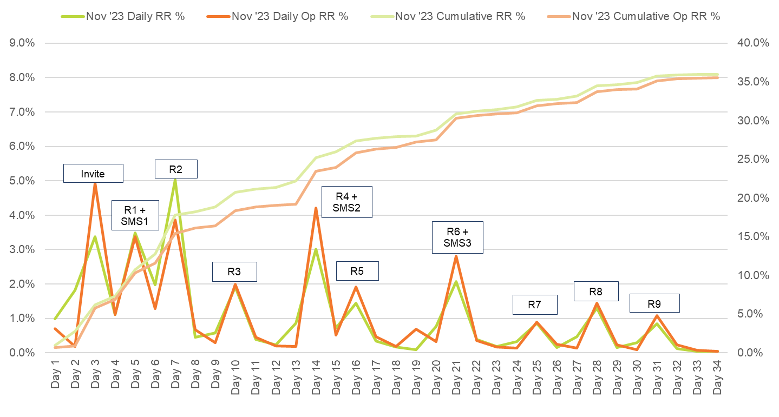

Figure 2 Response rates by date – February 2024

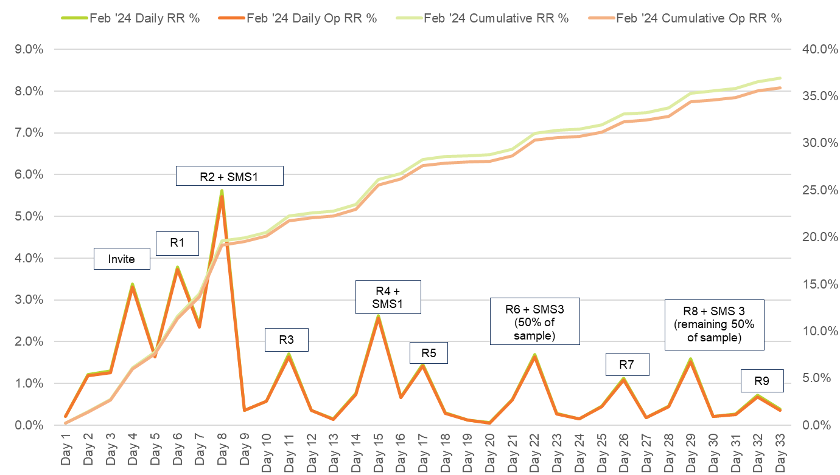  
Note: The February collection round featured experimentation with the timing of SMS3, with 50% of the total sample sent SMS3 paired with email reminder 8 to determine whether later send improved overall response.

Figure 3 Response rates by date – May 2024

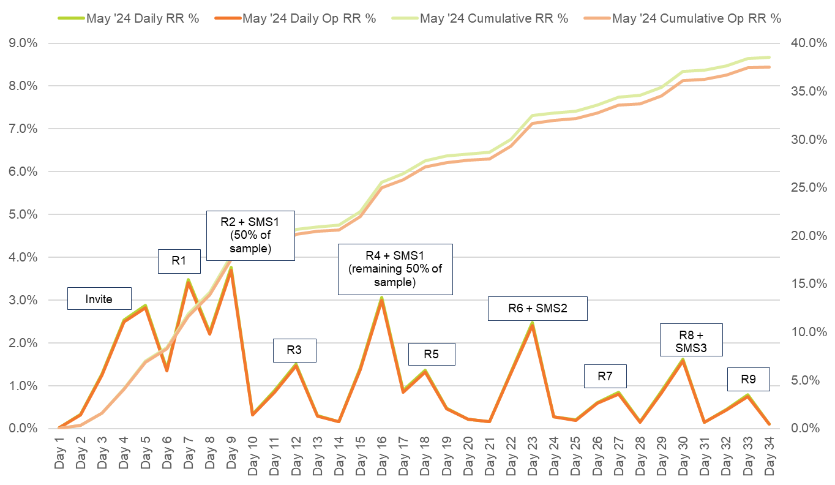

Note: The May collection round featured experimentation with the timing of SMS1, with 20% of the total sample sent SMS1 paired with email reminder 2 to determine whether earlier send improved overall response.

## Non-response analysis

This section assesses the extent and impact of non-response bias on estimates made from the 2024 GOS. Non-response bias occurs when persons who respond to the survey are systematically different from those who do not, leading to results that do not accurately reflect the population of interest. The following assessment is approached from several perspectives, by:

* supplementing response rates with measures that account for the composition of respondents compared to the population
* identifying administrative characteristics of graduates that are most different between respondents and non-respondents and that are most strongly associated with the propensity to respond to the survey
* determining if adjusting for non-response changes the key GOS indicators.

### Supplementing response rates with indicators of representativeness

Response rate is the most commonly used measure for describing how well a survey performs, since it is simple to calculate and offers a useful indicator of survey quality. It has well known limitations, however (see, for example, N Shlomo, C. Skinner, and B. Schouten[7]), since it does not account for the composition of respondents relative to the population and the subsequent impact of non-response error. Non-response error occurs when the responding population is considerably different from the in-scope population and there is a substantial degree of non-response, resulting in estimates that do not accurately represent the overall population. This is caused by the fact that, despite ideally everyone having an equal probability of responding, this is not what is observed.

To supplement the use of response rates, indicators of the representativeness of respondents (R-indicators) have been developed (B. Schouten, F. Cobben, and J. Bethlehem[8], B. Schouten, N. Shlomo, and C. Skinner[9]). These indicators use modelled probabilities of response to construct an overall measure of how well the responding population represents the in-scope population.

There are numerous R-indicators. The one used in the analysis in this section is expressed as follows:

where is the standard deviation of the predicted response propensities:

Here, is the number of in-scope graduates, is the response propensity for graduate and is the mean response propensity. The R-indicator can assume any value in the range 0-1, where a value of 1 indicates the most representative response and a value of 0 indicates the least. Values for R are only directly comparable if they are derived using the same model.

For the 2024 GOS, response propensities were predicted by using a random forest model and then calculating the R-indicator for the survey overall. As shown in Table 18, whilst the response rate has declined by 0.9 percentage points between 2022 and 2024, the R-indicator has improved by 0.2 points, that is, using these measures, representativeness could be said to be marginally improving while the response rate is slowly eroding. The relationship between response rate and R-indicator will continue to be closely monitored for future surveys.

Table 18 Comparison of representativeness over past four GOS collection cycles

|  |  |  |
| --- | --- | --- |
| Year | Response rate  (%) | R-indicator (%) |
| 2021 | 40.4 | 74.3 |
| 2022 | 39.4 | 73.8 |
| 2023 | 38.7 | 73.1 |
| 2024 | 38.5 | 74.0 |

### Characteristics associated with propensity to respond

For a number of years, the GOS has made use of predicted response rates to target sub-groups of graduates for follow-up activities. Response propensity is defined as the expected likelihood of a graduate responding to the survey, conditional on their characteristics. In contrast, response rate is the percentage of the invited population that completed the survey.

Response propensity is calculated by predicting survey completion conditional upon the characteristics available for both respondents and non-respondents. Characteristics included the following: study area, age, higher education provider, institution type (Group of 8, Other university or NUHEI), institution size, course of study type, type of attendance, citizenship, language spoken at home, country of birth, course level, gender, higher education provider type, disability, and Aboriginal or Torres Strait Islander status. A random forest model was used to predict the response propensity for all sample members. The variable importance chart shown in Figure 4 summarises the relative importance of these characteristics in predicting non-response to the GOS, where a longer bar indicates higher importance. The variables consistently most important as predictors of non-response were age, study area, and higher education provider. This information will be considered in the refinement of the contact strategy for future surveys.

Figure 4 Relative importance of graduate characteristics in predicting survey response

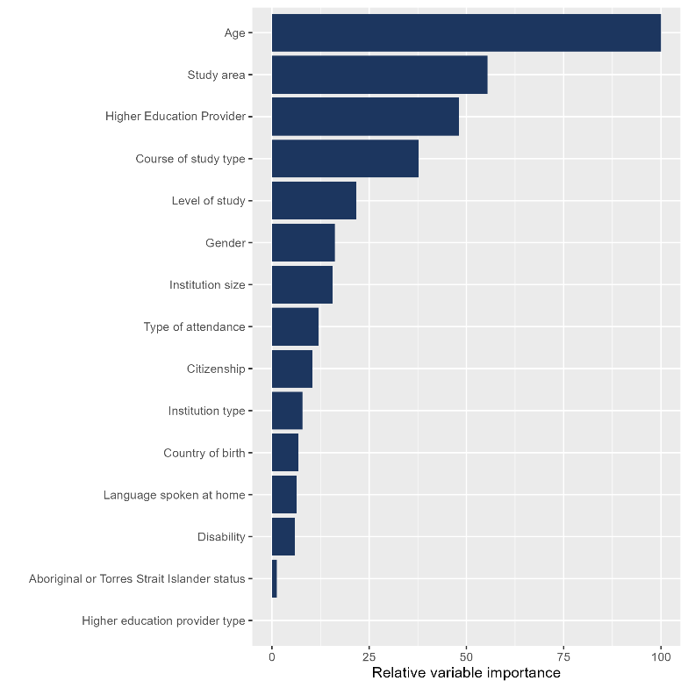

### Characteristics associated with non-response

An important assumption of the GOS in using unweighted estimates to make inferences about the population, is that non-response is essentially a random process – there is no systematic pattern of non-response, so that respondents can be treated as representative of non-respondents without risk of bias. A simple way to check this assumption is to compare the profile of respondents with that of non-respondents. The presence of extensive differences between the two groups may show that our assumption is not being met and that some adjustments may be necessary.

The characteristics most associated are described above (see Figure 4). These are presented at the overall level, whereas in this section we summarise the results of a more detailed analysis of selected characteristics.

Table 19 shows results comparing the distribution of respondents with the distribution of non-respondents for selected characteristics. A positive difference indicates that the specified category was higher among respondents than among non-respondents, and a negative difference indicates that the category was higher among non-respondents.

Alongside the difference in proportions is Cohen’s effect size (J Cohen[10]) with a classification into small, medium or large. Results without a stated effect size were ‘so small as to be trivial’.

As an example, Indigenous persons made up 1.4 per cent of respondents and 1.0 per cent of non-respondents. The difference of 0.3 percentage points (rounded) indicates that this sub-group was relatively over-represented among respondents compared to non-respondents, but the effect size (0) was negligible (<0.2). At the same time, non-Indigenous persons were under-represented among respondents (-0.3 percentage points), and this difference was also negligible. Age and level of study categorised – with higher degree by research (HDR) are characteristics which have notable differences between respondents and non-respondents at the overall level.

Table 19 Comparison between respondents and non-respondents for selected characteristics

| Characteristic | Respondents (%) | Non-respondents (%) | Difference (%) | Cohen’s effect size |
| --- | --- | --- | --- | --- |
| **Age:** 15-19 years | 1.2 | 1.5 | -0.3 | 0.0 |
| **Age:** 20-24 years | 40.7 | 53.0 | -12.3 | 0.2 Small |
| **Age:** 25-29 years | 20.1 | 22.9 | -2.8 | 0.1 |
| **Age:** 30-34 years | 11.8 | 8.7 | 3.1 | 0.1 |
| **Age:** 35-39 years | 8.6 | 5.5 | 3.1 | 0.1 |
| **Age:** 40-44 years | 6.4 | 3.6 | 2.8 | 0.1 |
| **Age:** 45-49 years | 4.5 | 2.3 | 2.3 | 0.1 |
| **Age:** 50-54 years | 3.3 | 1.4 | 1.9 | 0.1 |
| **Age:** 55+ years | 3.3 | 1.0 | 2.3 | 0.2 |
| **Study area:** Science and mathematics | 9.3 | 7.4 | 1.9 | 0.1 |
| **Study area:** Dentistry | 0.3 | 0.4 | -0.1 | 0.0 |
| **Study area:** Veterinary science | 0.4 | 0.3 | 0.1 | 0.0 |
| **Study area:** Rehabilitation | 1.2 | 1.4 | -0.2 | 0.0 |
| **Study area:** Teacher education | 9.2 | 8.7 | 0.5 | 0.0 |
| **Study area:** Business and management | 17.2 | 23.8 | -6.6 | 0.2 |
| **Study area:** Humanities, culture and social sciences | 8.2 | 6.5 | 1.7 | 0.1 |
| **Study area:** Social work | 3.4 | 2.3 | 1.2 | 0.1 |
| **Study area:** Psychology | 4.8 | 3.7 | 1.1 | 0.1 |
| **Study area:** Law and paralegal studies | 4.8 | 5.5 | -0.7 | 0.0 |
| **Study area:** Creative arts | 3.1 | 3.0 | 0.1 | 0.0 |
| **Study area:** Computing and Information Systems | 6.7 | 6.7 | -0.1 | 0.0 |
| **Study area:** Communications | 2.2 | 2.6 | -0.4 | 0.0 |
| **Study area:** Tourism, Hospitality, Personal Services, Sport and recreation | 0.2 | 0.3 | -0.1 | 0.0 |
| **Study area:** Engineering | 5.7 | 5.5 | 0.2 | 0.0 |
| **Study area:** Architecture and built environment | 2.4 | 3.0 | -0.5 | 0.0 |
| **Study area:** Agriculture and environmental studies | 1.6 | 1.0 | 0.6 | 0.1 |
| **Study area:** Health services and support | 7.4 | 6.3 | 1.1 | 0.0 |
| **Study area:** Medicine | 1.7 | 1.9 | -0.3 | 0.0 |
| **Study area:** Nursing | 9.5 | 8.9 | 0.6 | 0.0 |
| **Study area:** Pharmacy | 0.6 | 0.7 | -0.1 | 0.0 |
| **Country of birth:** Australia | 54.8 | 50.2 | 4.7 | 0.1 |
| **Country of birth:** Other | 44.8 | 49.6 | -4.7 | 0.1 |
| **Country of birth:** Unable to establish | 0.3 | 0.3 | 0.0 | 0.0 |
| **Level of study:** Undergraduate | 54.8 | 57.7 | -2.9 | 0.1 |
| **Level of study:** Postgraduate (Coursework) | 39.8 | 40.4 | -0.7 | 0.0 |
| **Level of study:** Postgraduate (Research) | 5.4 | 1.8 | 3.6 | 0.2 Small |
| **Gender:** Female | 64.0 | 57.4 | 6.5 | 0.1 |
| **Gender:** Male | 35.7 | 42.4 | -6.7 | 0.1 |
| **Gender:** Unknown | 0.3 | 0.2 | 0.1 | 0.0 |
| **Type of attendance:** Full-time | 68.0 | 72.8 | -4.7 | 0.1 |
| **Type of attendance:** Part-time | 30.4 | 25.6 | 4.7 | 0.1 |
| **Type of attendance:** No information | 1.6 | 1.6 | 0.0 | 0.0 |
| **Aboriginal or Torres Strait Islander status:** Non indigenous | 98.6 | 99.0 | -0.3 | 0.0 |
| **Aboriginal or Torres Strait Islander status:** Indigenous | 1.4 | 1.0 | 0.3 | 0.0 |
| **Language spoken at home:** English speaking background | 83.3 | 78.4 | 4.9 | 0.1 |
| **Language spoken at home:** Non-English speaking background | 16.7 | 21.6 | -4.9 | 0.1 |
| **Citizenship:** Domestic | 74.2 | 67.3 | 6.8 | 0.1 |
| **Citizenship:** Overseas | 25.8 | 32.7 | -6.8 | 0.1 |
| **Disability:** No disability | 91.4 | 93.6 | -2.3 | 0.1 |
| **Disability:** Disability | 8.6 | 6.4 | 2.3 | 0.1 |
| **Higher education provider type:** University | 93.2 | 92.8 | 0.4 | 0.0 |
| **Higher education provider type:** NUHEI | 6.8 | 7.2 | -0.4 | 0.0 |
| **Institution size:** 1-2,500 records | 8.4 | 7.7 | 0.7 | 0.0 |
| **Institution size:** 2,501-5,500 records | 20.8 | 17.6 | 3.2 | 0.1 |
| **Institution size:** 5,501-7,500 records | 22.3 | 23.8 | -1.5 | 0.0 |
| **Institution size:** 7,501-10,500 records | 14.4 | 14.2 | 0.2 | 0.0 |
| **Institution size:** 10,501+ records | 34.1 | 36.7 | -2.6 | 0.1 |
| **Institution type:** Group of 8 | 31.1 | 35.0 | -3.8 | 0.1 |
| **Institution type:** NUHEI | 6.8 | 7.2 | -0.4 | 0.0 |
| **Institution type:** Other university | 62.0 | 57.8 | 4.2 | 0.1 |

### Characteristics associated with outcomes

An important consideration is the extent to which unit characteristics are also associated with survey outcomes. For example, if a particular sub-group of the population is under-represented among respondents, any non-response error may be compounded if the sub-group also gives notably different responses that impact survey outcomes compared to other groups. In such a situation, estimates made from the survey would potentially be biased.

Using a similar approach to that above, the characteristics can be determined which have strong associations with outcome variables. First, using a random forest model, the outcome measures are predicted from respondent characteristics at the overall level. The relative importance of variables is reasonably consistent across 2024 GOS outcomes as shown in Table 20.

It should be noted that course of study type and age, which had differences between the responding and non-responding sample (refer to Table 19) are strongly associated with some or all core outcomes.

Table 20 Relative importance of graduate characteristics in predicting survey outcomes

| Variable Label | Scale of Perceived Over-qualification (SPOQ) indicator | General employment indicator | Part-time employment indicator | Full-time employment indicator |
| --- | --- | --- | --- | --- |
| Study area | 100.0 | 97.1 | 100.0 | 100.0 |
| Age | 71.2 | 86.3 | 57.7 | 65.4 |
| Higher Education Provider | 67.4 | 71.8 | 69.6 | 53.9 |
| Course of study type | 53.5 | 64.1 | 50.9 | 63.2 |
| Citizenship | 45.4 | 100.0 | 10.5 | 35.0 |
| Country of birth | 27.1 | 50.3 | 11.8 | 15.1 |
| Level of study | 25.3 | 26.1 | 18.3 | 33.8 |
| Institution size | 24.3 | 31.0 | 23.6 | 18.9 |
| Type of attendance | 17.2 | 20.1 | 16.1 | 16.2 |
| Gender | 16.0 | 18.0 | 27.7 | 15.7 |
| Language spoken at home | 13.6 | 28.8 | 5.2 | 7.4 |
| Disability | 8.3 | 12.9 | 8.2 | 8.0 |
| Institution type | 8.2 | 26.6 | 8.6 | 7.8 |
| Aboriginal or Torres Strait Islander status | 1.3 | 0.0 | 1.2 | 0.0 |
| Higher education provider type | 0.0 | 0.1 | 0.0 | 0.6 |

In summation, it is apparent that overall representativeness has remained fairly stable in recent GOS rounds. Again in 2024, when looking at particular graduate characteristics important for predicting survey response; study area, age, and higher education provider (in that order) appear as the top three areas of interest.

## Sources of response

Table 21 summarises the breakdown of online survey completion methods and includes sources of response by gender, age, and citizenship due to the variation in method of accessing the survey within these groups. As only minimal differences were observed when reviewing source of response by institution type or course level, these groups are not displayed.

Survey completion via the direct link in email communications was most popular for all sub-groups. However, males, those aged 30 or under, and international graduates were marginally less likely to respond via a link in an email communication than females, those aged over 30 years, and domestic graduates respectively. Completing via the direct link in SMS was the next most popular method of response amongst most sub-groups, except international graduates. Completion via SMS was more likely among females, those aged under 30 years, and domestic graduates.

In-field reminder calls were targeted at international graduates in the 2024 GOS in continued support of the International Engagement Strategy, which accounts for the high proportion of international graduates responding via this contact method. The Authentication source of response, which represents graduates who accessed the survey via the QILT website, accounted for less than one per cent of total response.

Table 21 Sources of response

|  | Total - % | Gender: Female - % | Gender: Male - % | Age: 30 or under - % | Age: Over 30 - % | Citizenship indicator: Domestic - % | Citizenship indicator: International - % |
| --- | --- | --- | --- | --- | --- | --- | --- |
| Final response rate | 38.5 | 41.1 | 34.5 | 33.7 | 52.0 | 40.8 | 33.2 |
| Authentication | 0.6 | 0.6 | 0.7 | 0.6 | 0.6 | 0.6 | 0.7 |
| Type in | <0.1 | <0.1 | <0.1 | 0.0 | <0.1 | <0.1 | 0.0 |
| Survey link (email) | 88.6 | 89.0 | 87.8 | 87.4 | 90.6 | 89.4 | 86.2 |
| Survey link (SMS) | 5.9 | 6.2 | 5.3 | 6.0 | 5.6 | 6.4 | 4.3 |
| In-field reminder calls | 2.0 | 1.4 | 2.9 | 2.7 | 0.6 | 0.5 | 6.2 |
| Post-field reminder calls | 1.4 | 1.2 | 1.9 | 1.6 | 1.0 | 1.4 | 1.5 |
| SMS fee-for-service | 1.6 | 1.7 | 1.4 | 1.6 | 1.5 | 1.7 | 1.1 |

It should be noted that only completed surveys directly attributable to the in-field reminder calls, post-field reminder calls and SMS are recorded as such in Table 21. It is possible that, for example, reminder call activity may prompt a graduate to click on the direct survey link in an email they had previously received. In this context, the analysis presented should only be considered indicative. It should also be noted that the opportunity to complete via each method was not necessarily equal between sub-groups.

## Sample retention for GOS-L

Graduates were generally open to being contacted for future research across all 2024 GOS collection rounds, which is the point at which the sample is built for the Graduate Outcomes Survey – Longitudinal (GOS-L).

As shown in Table 22, a total of 63,715 graduates, or more than half (53.1 per cent) of all GOS completes, agreed to be contacted for future research purposes. This level of agreement declined in 2024 compared to 2023 (57.5 per cent) and 2022 (58.0 per cent). Improved understanding of factors correlated with consent to recontact should remain an area of interest to achieve further growth of the GOS-L sample base.

Table 22 Graduate responses to further contact for GOS-L

| Sample retention phase | Collection round: 2023 November n | Collection round: 2023 November % | Collection round: 2024 February n | Collection round: 2024 February % | Collection round: 2024 May n | Collection round: 2024 May % | Collection round: Total n | Collection round: Total % |
| --- | --- | --- | --- | --- | --- | --- | --- | --- |
| Consent to contact at GOS-L: Yes | 19,270 | 52.2 | 5,286 | 54.4 | 39,159 | 53.4 | 63,715 | 53.1 |
| Consent to contact at GOS-L: No | 9,825 | 26.6 | 2,245 | 23.1 | 18,512 | 25.2 | 30,582 | 25.5 |
| Consent to contact at GOS-L: Missing | 7,839 | 21.2 | 2,180 | 22.4 | 15,659 | 21.4 | 25,678 | 21.4 |
| Consent to contact at GOS-L: Total | 36,934 | 100.0 | 9,711 | 100.0 | 73,330 | 100.0 | 119,975 | 100.0 |
| Details provided for GOS-L sample: Permanent email address as used in GOS | 15,583 | 42.2 | 4,326 | 44.5 | 33,527 | 45.7 | 53,436 | 44.5 |
| Details provided for GOS-L sample: New permanent email address provided | 3,246 | 8.8 | 640 | 6.6 | 4,234 | 5.8 | 8,120 | 6.8 |
| Details provided for GOS-L sample: Don’t have a permanent email address | 196 | 0.5 | 44 | 0.5 | 266 | 0.4 | 506 | 0.4 |
| Details provided for GOS-L sample: Do not wish to be re-contacted by email | 291 | 0.8 | 64 | 0.7 | 545 | 0.7 | 900 | 0.8 |
| Details provided for GOS-L sample: Missing | 3,576 | 9.7 | 1,012 | 10.4 | 7,069 | 9.6 | 11,657 | 9.7 |
| Details provided for GOS-L sample: Total | **36,934** | **100.0** | **9,711** | **100.0** | **73,330** | **100.0** | **119,975** | **100.0** |

Note: The responses shown here are raw and derived before data processing in accordance with the definition of the analytic unit is undertaken (refer to Section 5.1), as such total completes will not align to figures presented earlier in the report.

One in five graduates (21.4 per cent) did not provide a response to the ‘consent to future contact’ question, by either choosing not to provide a response or stopping the survey before seeing the ‘consent to future contact’ question.

Refer to the GOS-L Methodological Report series for more information about panel maintenance activity, whereby contact is made with sample members between surveys to maintain an ongoing relationship and build engagement in the lead up to the GOS-L.

# Considerations for future surveys

## Revised authentication module

The revised authentication module for the 2024 GOS reduced the amount of personal information graduates needed to provide for authentication (i.e., first name and date of birth are no longer required) and allows the option to receive an SMS instead of an email. These improvements of the authentication module overall aim to enhance support for engagement activities via social media and institution communications. Ongoing evaluation and refinement will be necessary to realise the full potential of the module.

## Social media engagement with graduates

The current GOS methodology uses social media primarily to build awareness rather than as a call to action to drive response. While some challenges will remain (such as the ability to effectively target the in-scope GOS audience), the revised authentication pathway would provide a more reliable way to accommodate survey response directly via social media. As such, the current organic and paid social media campaigns for the GOS should be reviewed for its effectiveness ahead of the 2025 GOS and beyond. Key issues for review would include the best social media platforms to promote the GOS (Facebook is unlikely to still be the best option for reaching the GOS demographic), producing more engaging posts (tone of language, type of content, animation) and the frequency of posts (to better grow the QILT social media audience).

## Targeted outreach to low responding institutions

Analysis of response by institution has identified several large sample institutions with response rates low enough to impact national response measures. While follow-up has already been conducted with these institutions (see Section 3.1), a more strategic level of support could be provided to these institutions as a priority. In some instances, these low responding institutions were high responding institutions in the years prior. Concerted engagement with senior staff at these institutions may help identify and resolve the cultural, structural or technical challenges that have led to declined response. Learnings from this targeted engagement could potentially be generalised and shared with other institutions (e.g. by webinar).

## Revised International Engagement Strategy

The non-response analysis (refer to Section 7.2) indicates that citizenship is no longer a key explanatory factor of non-response. This suggests that the International Engagement Strategy deployed in recent years may have been successful in improving international graduate response. It is recommended that current international engagement activities, such as in-field reminder call prioritisation and email customisation, continue. However, response from international graduates remains notably lower than domestic graduates at an absolute level and it may be possible to further reduce this gap with additional measures. Future customisation of email messages in other QILT surveys for international graduates will be featured in the GOS. Further review of response patterns should be conducted to identify and adapt the strongest and weakest components of the current contact protocol for international graduates (e.g., trial re-using themes proven to be effective for international graduates in multiple communications).

## GOS-L panel maintenance

The retention of the sample for the GOS-L remains a key area of importance. Panel maintenance activity gives graduates the opportunity to correct or update their best contact details ahead of their respective GOS-L collection. This activity should be regularly maintained to retain graduate engagement with QILT between completion of the GOS and commencement of GOS-L. To keep a natural feel to communications, panel maintenance activity could be timed to share the results of each QILT survey.

Appendix 1: Participating institutions

| Universities Provider Code | Universities Institution name | Total Sample (n)[11]: Nov ‘23 | Total Sample (n): Feb ‘24 | Total Sample (n): May ‘24 | Total Sample (n): Total |
| --- | --- | --- | --- | --- | --- |
| 1019 | James Cook University | 726 | 424 | 1,913 | 3,063 |
| 1034 | Murdoch University | 672 | 348 | 1,783 | 2,803 |
| 1055 | The University of Western Australia | 1,850 | 194 | 4,186 | 6,230 |
| 1058 | University of Wollongong | 1,346 | - | 3,964 | 5,310 |
| 2154 | Federation University Australia | 697 | 163 | 1,763 | 2,623 |
| 2177 | Swinburne University of Technology | 2,588 | - | 4,301 | 6,889 |
| 2200 | Central Queensland University | 1,251 | 253 | 2,378 | 3,882 |
| 2201 | University of Southern Queensland | 1,040 | - | 2,515 | 3,555 |
| 2235 | Edith Cowan University | 1,830 | 566 | 3,266 | 5,662 |
| 2236 | Curtin University | 2,505 | - | 5,715 | 8,220 |
| 2241 | University of Canberra | 1,096 | - | 2,563 | 3,659 |
| 2252 | Avondale University | 6 | 11 | 203 | 220 |
| 3001 | Charles Darwin University | 1,034 | 387 | 1,517 | 2,938 |
| 3003 | Bond University | 450 | 333 | 662 | 1,445 |
| 3004 | Western Sydney University | 3,051 | 940 | 4,777 | 8,768 |
| 3005 | Charles Sturt University | 1,732 | 370 | 3,944 | 6,046 |
| 3006 | Australian Catholic University | 1,341 | 262 | 5,391 | 6,994 |
| 3007 | Victoria University | 1,688 | 970 | 3,386 | 6,044 |
| 3010 | The University of Adelaide | 2,130 | 312 | 4,747 | 7,189 |
| 3013 | University of New South Wales | 4,326 | 4,526 | 8,464 | 17,316 |
| 3014 | University of Newcastle | 1,532 | - | 4,931 | 6,463 |
| 3016 | University of Technology Sydney | 3,654 | 414 | 6,176 | 10,244 |
| 3019 | The University of Queensland | 5,304 | 232 | 8,200 | 13,736 |
| 3020 | La Trobe University | 1,778 | 340 | 5,053 | 7,171 |
| 3025 | Macquarie University | 3,014 | 493 | 5,134 | 8,641 |
| 3027 | The University of South Australia | 1,899 | - | 4,866 | 6,765 |
| 3029 | Flinders University | 1,228 | 312 | 3,791 | 5,331 |
| 3030 | Deakin University | 4,990 | 78 | 8,757 | 13,825 |
| 3032 | Griffith University | 3,484 | - | 5,537 | 9,021 |
| 3033 | The Australian National University | 2,596 | 271 | 3,353 | 6,220 |
| 3034 | RMIT University | 4,486 | 773 | 7,864 | 13,123 |
| 3035 | Monash University | 6,430 | 1,284 | 11,873 | 19,587 |
| 3036 | The University of Melbourne | 6,922 | 1,269 | 13,414 | 21,605 |
| 3038 | Southern Cross University | 1,023 | 1,064 | 2,033 | 4,120 |
| 3039 | University of New England | 1,392 | 996 | 1,338 | 3,726 |
| 3040 | The University of Sydney | 6,809 | 1,296 | 11,018 | 19,123 |
| 3042 | Queensland University of Technology | 3,436 | 584 | 6,535 | 10,555 |
| 3043 | University of the Sunshine Coast | 792 | 431 | 1,866 | 3,089 |
| 3044 | The University of Notre Dame Australia | 747 | 134 | 1,822 | 2,703 |
| 3045 | University of Tasmania | 2,363 | 281 | 6,011 | 8,655 |
| 4331 | University of Divinity | 82 | 31 | 256 | 369 |
| 4449 | Torrens University | 1,466 | 1,301 | 1,746 | 4,513 |
| n/a | All participating universities | **96,786** | **21,643** | **189,012** | **307,441** |

| Non-University Higher Education Institutions Provider Code | Non-University Higher Education Institutions Institution name | Total Sample (n)[12]: Nov ‘23 | Total Sample (n): Feb ‘24 | Total Sample (n): May ‘24 | Total Sample (n): Total |
| --- | --- | --- | --- | --- | --- |
| 2170 | Marcus Oldham College | - | - | 102 | 102 |
| 4332 | Sydney College of Divinity | 189 | - | - | 189 |
| 4333 | Christian Heritage College | 59 | - | - | 59 |
| 4334 | Tabor College of Higher Education | 29 | 47 | 90 | 166 |
| 4335 | Australian University of Theology | 46 | 222 | 382 | 650 |
| 4336 | ACAP University College | 734 | 416 | 10 | 1,160 |
| 4337 | Eastern College Australia | - | - | 27 | 27 |
| 4338 | Moore Theological College | 6 | - | 78 | 84 |
| 4339 | Holmes Institute | 580 | - | 426 | 1,006 |
| 4343 | The Australian Institute of Music | 11 | 42 | 86 | 139 |
| 4346 | Excelsia University College | 295 | 29 | 314 | 638 |
| 4347 | Australian College of Christian Studies | - | - | 37 | 37 |
| 4352 | The Australian College of Physical Education | 30 | - | 75 | 105 |
| 4359 | The College of Law Limited | 2,253 | 1,730 | 1,233 | 5,216 |
| 4360 | Perth Bible College | <5 | 5 | <5 | 12 |
| 4361 | Endeavour College of Natural Health | - | - | 587 | 587 |
| 4362 | ICHM | 23 | <5 | np | 46 |
| 4363 | Melbourne Polytechnic | 106 | 5 | 110 | 221 |
| 4366 | Box Hill Institute | 36 | 11 | 51 | 98 |
| 4367 | Melbourne Institute of Technology | 120 | - | 160 | 280 |
| 4368 | Campion College Australia | - | - | 70 | 70 |
| 4371 | SAE University College | 315 | 206 | 360 | 881 |
| 4377 | UOW College | 50 | - | 45 | 95 |
| 4380 | UTS College | 335 | 88 | 516 | 939 |
| 4381 | International College of Management, Sydney | 120 | 176 | 193 | 489 |
| 4383 | Holmesglen Institute | np | <5 | 159 | 247 |
| 4384 | Kaplan Business School | 317 | 324 | 359 | 1,000 |
| 4386 | The Institute of Creative Arts and Technology | 9 | 22 | 103 | 134 |
| 4388 | Australian Academy of Music and Performing Arts | 21 | - | 17 | 38 |
| 4392 | Gestalt Therapy Brisbane | - | - | 28 | 28 |
| 4393 | The MIECAT Institute | np | <5 | - | 48 |
| 4394 | William Angliss Institute | 82 | - | 66 | 148 |
| 4395 | Adelaide Central School of Art | - | - | 46 | 46 |
| 4396 | LCI Melbourne | 29 | - | 20 | 49 |
| 4401 | Whitehouse Institute of Design, Australia | - | - | 110 | 110 |
| 4402 | Leo Cussen Centre for Law | 142 | 95 | 230 | 467 |
| 4405 | Australian Institute of Professional Counsellors | - | 10 | - | 10 |
| 4407 | Alphacrucis University College | 516 | - | 220 | 736 |
| 4411 | Acknowledge Education | 173 | 84 | 184 | 441 |
| 4412 | Morling College | - | - | 53 | 53 |
| 4419 | National Art School | - | - | 148 | 148 |
| 4421 | Le Cordon Bleu Australia | 11 | 8 | 21 | 40 |
| 4424 | Kaplan Higher Education Pty Ltd | 646 | 376 | 253 | 1,275 |
| 4425 | Australian Institute of Business Pty Ltd | 391 | 264 | 258 | 913 |
| 4428 | Nan Tien Institute | 14 | np | <5 | 27 |
| 4431 | Montessori World Educational Institute (Australia) | - | - | 11 | 11 |
| 4434 | Wentworth Institute of Higher Education | 34 | - | - | 34 |
| 4435 | Australian Institute of Higher Education | 185 | - | 67 | 252 |
| 4450 | TAFE Queensland | 29 | - | 67 | 96 |
| 4451 | King's Own Institute | 416 | 209 | - | 625 |
| 4453 | Australasian College of Health and Wellness | 67 | 52 | 97 | 216 |
| 4455 | SP Jain School of Management | 174 | - | - | 174 |
| 4456 | Asia Pacific International College | 89 | 63 | 51 | 203 |
| 4458 | Australian Institute of Management Education & Training | 292 | 87 | 216 | 595 |
| 4463 | Institute of Health & Management Pty Ltd | 48 | 32 | 34 | 114 |
| 4464 | Australian College of Nursing | 292 | 64 | 251 | 607 |
| 4465 | Sheridan Institute of Higher Education | 9 | - | 13 | 22 |
| 4466 | The Institute of Internal Auditors - Australia | 14 | - | 15 | 29 |
| 4467 | Polytechnic Institute Australia Pty Ltd | 33 | 48 | 61 | 142 |
| 4469 | Engineering Institute of Technology | 30 | 11 | 39 | 80 |
| 6014 | Governance Institute of Australia | 67 | - | 82 | 149 |
| 6016 | Chartered Accountants Australia and New Zealand | 326 | - | 2,180 | 2,506 |
| 6022 | Academies Australasia Polytechnic Pty Limited | 41 | 31 | - | 72 |
| 6042 | Ozford Institute of Higher Education | np | - | <5 | 8 |
| 6043 | The Cairnmillar Institute | 49 | 11 | 166 | 226 |
| 6044 | BBI - The Australian Institute of Theological Education | 47 | - | - | 47 |
| 6045 | ISN Psychology Pty Ltd | 49 | - | 80 | 129 |
| 6046 | National Institute of Organisation Dynamics Aust | - | - | <5 | <5 |
| 6048 | Southern Cross Education Institute (Higher Education) | 68 | 8 | - | 76 |
| 6052 | Leaders Institute | 8 | - | - | 8 |
| 6055 | Adelaide Institute of Higher Education | <5 | <5 | <5 | 8 |
| 6063 | Australia Advance Education Group Pty Ltd | 103 | 27 | 6 | 136 |
| 6068 | HEPCO The Tax Institute Higher Education | 14 | 15 | 16 | 45 |
| 7001 | Collarts (Australian College of the Arts) | 87 | 69 | 136 | 292 |
| 7014 | Jazz Music Institute | - | - | 11 | 11 |
| 7025 | CIC Higher Education | 34 | 5 | 12 | 51 |
| 7035 | Photography Studies College (Melbourne) | - | - | <5 | <5 |
| 7073 | Chisholm Institute | 49 | 12 | 47 | 108 |
| 7075 | TAFE NSW | 203 | - | 291 | 494 |
| 7124 | Academy of Interactive Technology | 191 | 89 | <5 | 283 |
| 7197 | Ikon Institute of Australia | 28 | - | - | 28 |
| 7221 | VIT (Victorian Institute of Technology) | 75 | - | 61 | 136 |
| 7334 | Performing Arts Education | 5 | - | 8 | 13 |
| 7338 | TAFE South Australia | np | <5 | 33 | 55 |
| 7454 | Stanley College | - | 17 | 17 | 34 |
| 7660 | Health Education & Training Institute | <5 | np | 61 | 74 |
| 7749 | Crown Institute of Higher Education Pty Ltd | - | - | 260 | 260 |
| 8119 | Lyons College | - | <5 | - | <5 |
| n/a | All participating NUHEIs | **11,008** | **5,050** | **11,654** | **27,712** |

Appendix 2: Contact protocol

Example GOS survey invitation email – desktop

~~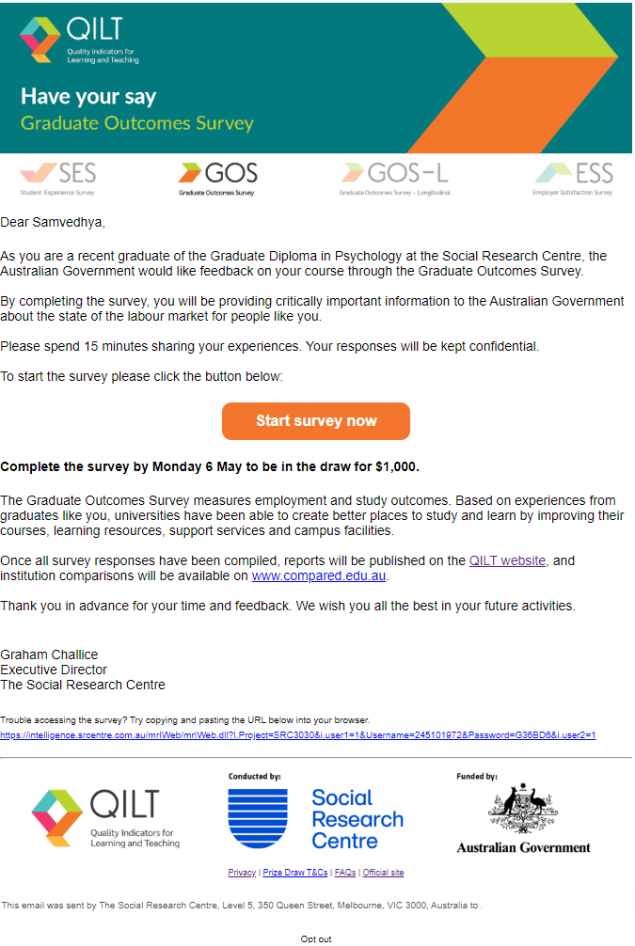~~

Example GOS survey invitation email (international) – desktop

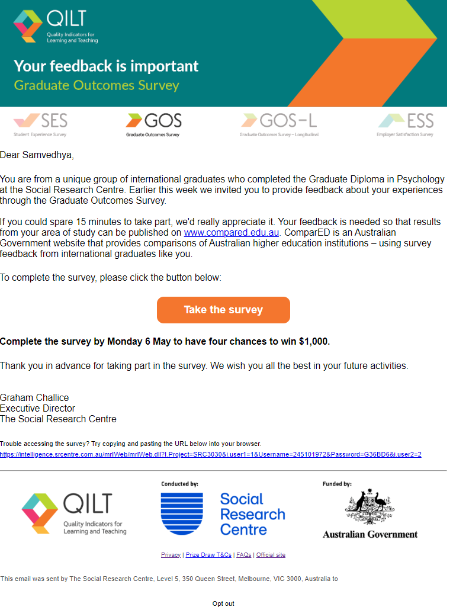

Example GOS survey invitation email – mobile

~~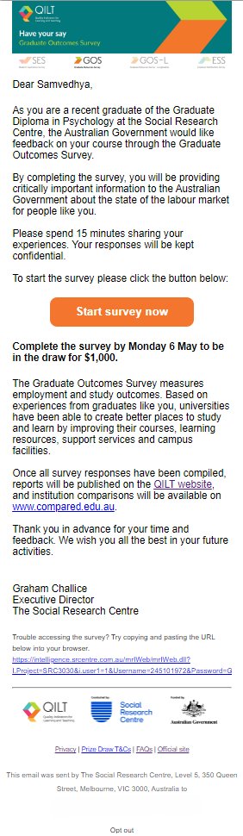~~

Example SMS content

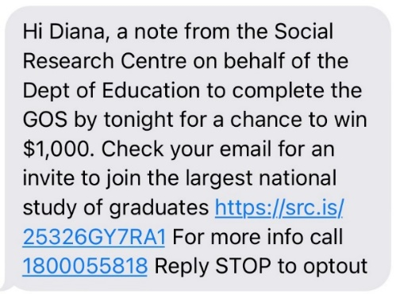

Example social media advertisement – Facebook news feed



Example landing page with authentication



Appendix 3: Core questionnaire

Please contact the Social Research Centre if you would like to read Appendix 3.

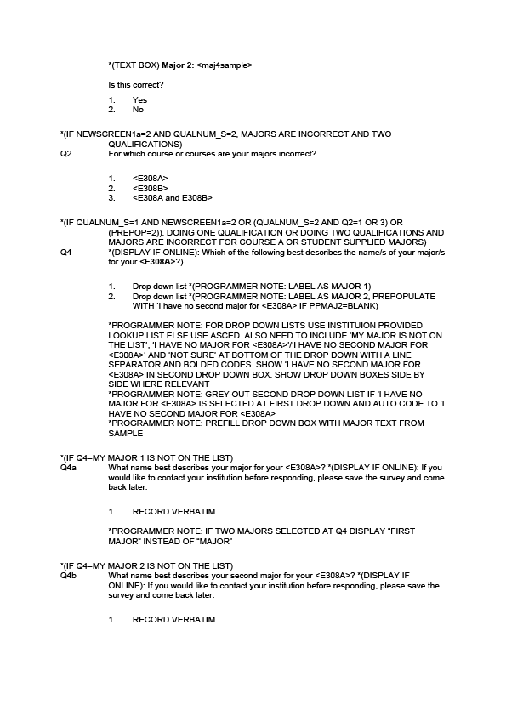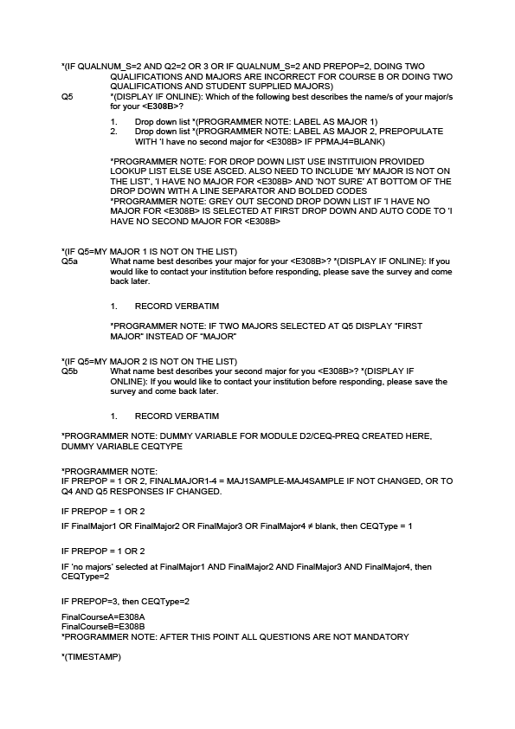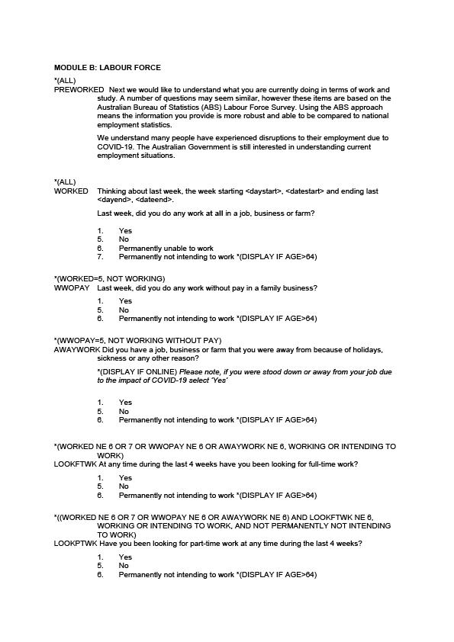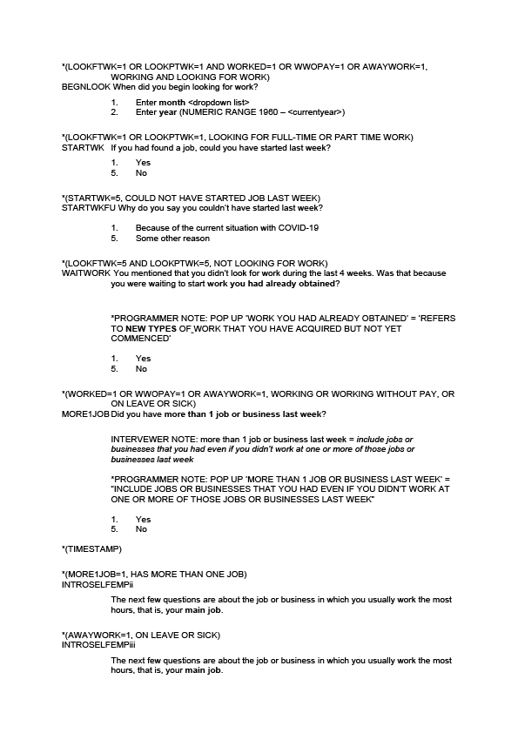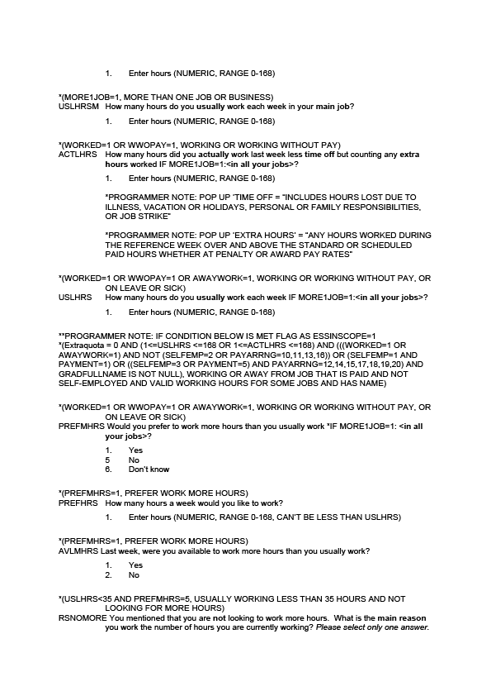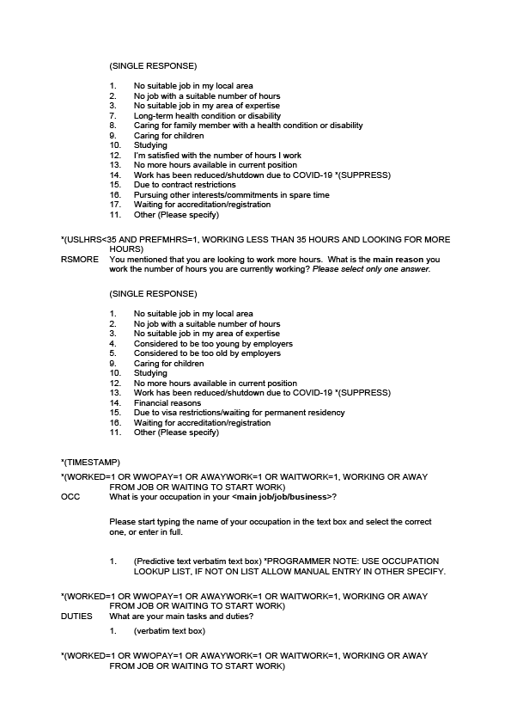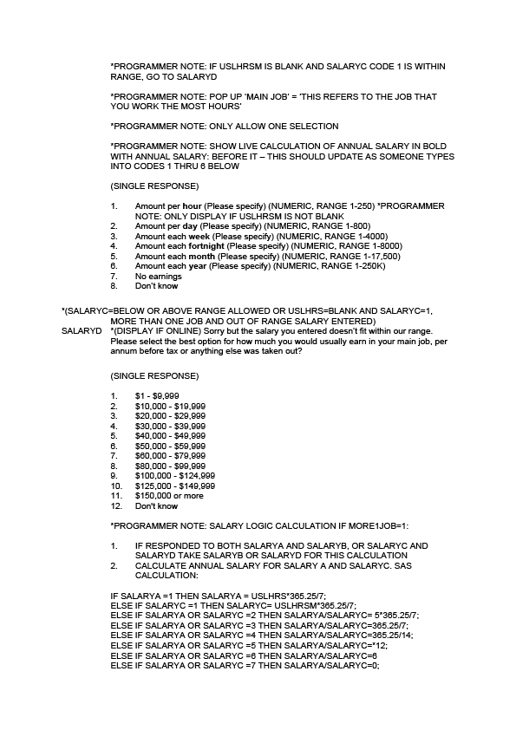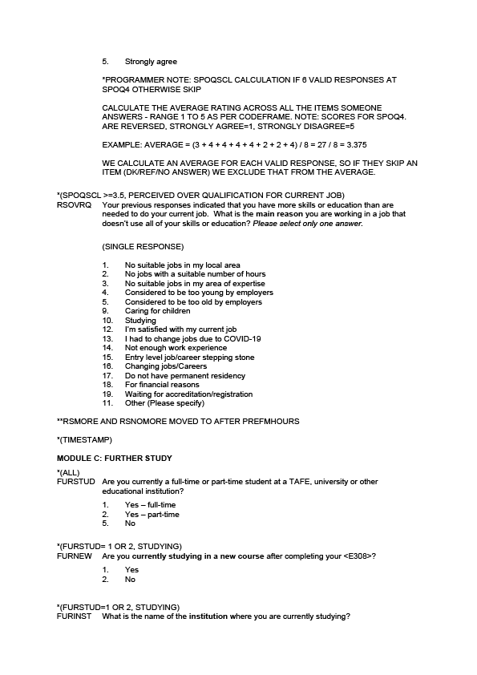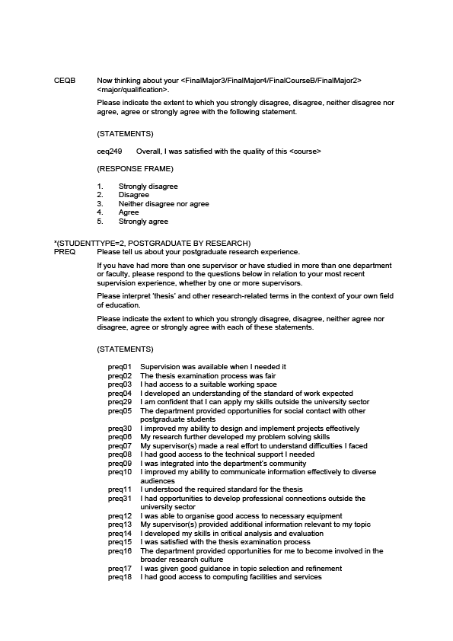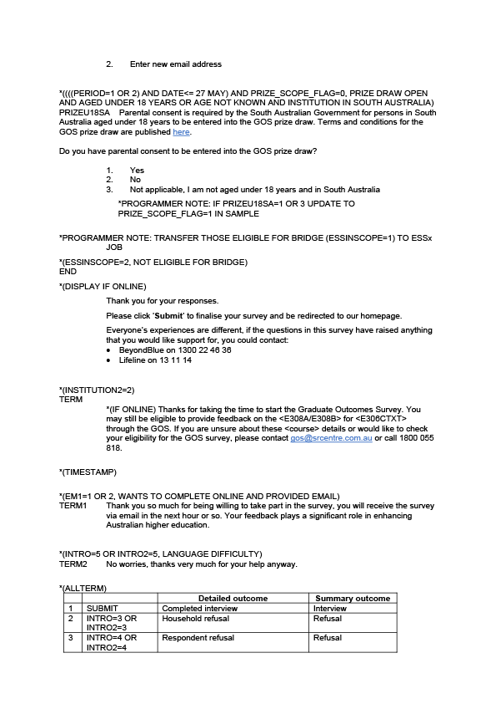

Appendix 4: Response rate by institution

The tables below show the final response rate by institution for each period of the 2024 GOS collection cycle. There was a minor variation in response rate by provider type, with an overall response rate of 38.7 per cent for universities and 36.5 per cent for NUHEIs.

At an individual institution level within provider type, the total collection response rate ranged from 53.6 per cent to 29.0 per cent for universities, and 87.5 per cent to 21.3 per cent for NUHEIs.

2024 GOS university response rates (%)

|  | **2023  November** | **2024  February** | **2024  May** | **2024 Total collection** |
| --- | --- | --- | --- | --- |
| Australian Catholic University | 41.6 | 38.9 | 35.7 | 36.9 |
| Avondale University | n/a | n/a | 44.8 | 45.0 |
| Bond University | 32.7 | 30.8 | 35.0 | 33.3 |
| Central Queensland University | 45.1 | 44.8 | 47.9 | 46.8 |
| Charles Darwin University | 43.8 | 48.7 | 53.4 | 49.4 |
| Charles Sturt University | 41.0 | 19.2 | 50.8 | 46.3 |
| Curtin University | 34.2 |  | 30.7 | 31.8 |
| Deakin University | 42.9 | 66.7 | 42.7 | 42.9 |
| Edith Cowan University | 43.2 | 42.4 | 42.6 | 42.8 |
| Federation University Australia | 37.2 | 42.1 | 41.9 | 40.7 |
| Flinders University | 48.5 | 45.8 | 44.8 | 45.7 |
| Griffith University | 36.4 |  | 38.5 | 37.7 |
| James Cook University | 48.6 | 49.1 | 43.2 | 45.2 |
| La Trobe University | 34.8 | 37.1 | 38.5 | 37.5 |
| Macquarie University | 32.2 | 39.6 | 39.9 | 37.2 |
| Monash University | 37.2 | 46.9 | 39.3 | 39.1 |
| Murdoch University | 37.4 | 38.1 | 44.8 | 42.2 |
| Queensland University of Technology | 41.0 | 45.8 | 43.2 | 42.6 |
| RMIT University | 37.9 | 50.3 | 39.5 | 39.6 |
| Southern Cross University | 35.2 | 37.8 | 40.5 | 38.5 |
| Swinburne University of Technology | 37.2 |  | 39.4 | 38.6 |
| The Australian National University | 32.3 | 35.7 | 35.6 | 34.2 |
| The University of Adelaide | 39.8 | 51.1 | 42.5 | 42.1 |
| The University of Melbourne | 43.0 | 46.8 | 41.3 | 42.1 |
| The University of Notre Dame Australia | 36.7 | 35.2 | 38.7 | 38.0 |
| The University of Queensland | 29.4 | 61.7 | 35.0 | 33.3 |
| The University of South Australia | 35.6 |  | 40.2 | 38.9 |
| The University of Sydney | 27.4 | 31.1 | 34.5 | 31.7 |
| The University of Western Australia | 33.4 | 50.6 | 34.9 | 34.9 |
| Torrens University | 48.5 | 44.9 | 53.4 | 49.4 |
| University of Canberra | 36.1 |  | 42.9 | 40.8 |
| University of Divinity | 61.0 | 70.4 | 49.4 | 53.6 |
| University of New England | 49.6 | 55.2 | 56.3 | 53.6 |
| University of New South Wales | 31.3 | 24.9 | 30.2 | 29.0 |
| University of Newcastle | 33.4 |  | 32.4 | 32.6 |
| University of Southern Queensland | 51.3 |  | 48.7 | 49.4 |
| University of Tasmania | 46.1 | 51.4 | 45.1 | 45.5 |
| University of Technology Sydney | 30.4 | 38.5 | 31.9 | 31.6 |
| University of the Sunshine Coast | 49.2 | 44.4 | 41.6 | 44.0 |
| University of Wollongong | 36.6 |  | 35.5 | 35.8 |
| Victoria University | 42.1 | 51.0 | 38.8 | 41.7 |
| Western Sydney University | 31.8 | 31.6 | 38.1 | 35.2 |
| All Universities | 37.2 | 39.5 | 39.3 | 38.7 |

Note: A blank cell indicates institution did not participate in that collection period and n/a indicates a suppressed value (n<25).

2024 GOS NUHEI response rates (%)

|  | **2023 November** | **2024 February** | **2024  May** | **2024 Total collection** |
| --- | --- | --- | --- | --- |
| **Academies Australasia Polytechnic Pty Limited** | 60.5 | 41.9 |  | 52.2 |
| **Academy of Interactive Technology** | 43.2 | 34.2 | n/a | 40.2 |
| **Adelaide Central School of Art** |  |  | 58.1 | 58.1 |
| **Adelaide Institute of Higher Education** | n/a | 0.0 | n/a | n/a |
| **Alphacrucis University College** | 33.5 |  | 42.0 | 36.2 |
| **Asia Pacific International College** | 34.9 | 18.0 | 48.0 | 33.0 |
| **Australasian College of Health and Wellness** | 40.0 | 34.9 | 41.6 | 39.6 |
| **Australia Advance Education Group Pty Ltd** | 37.1 | 48.0 | n/a | 38.3 |
| **Australian Academy of Music and Performing Arts** | 30.0 |  | 37.5 | 33.3 |
| **ACAP University College** | 44.1 | 44.2 | 60.0 | 44.3 |
| **Acknowledge Education** | 50.6 | 29.5 | 31.0 | 38.4 |
| **Australian College of Christian Studies** |  |  | 39.4 | 39.4 |
| **Australian College of Nursing** | 39.1 | 40.7 | 49.8 | 43.8 |
| **Australian University of Theology\*** | 39.0 | 47.9 | 51.3 | 49.3 |
| **Australian Institute of Business Pty Ltd** | 41.9 | 48.3 | 48.3 | 45.7 |
| **Australian Institute of Higher Education** | 28.5 |  | 33.3 | 29.8 |
| **Australian Institute of Management Education & Training** | 56.9 | 53.2 | 47.5 | 53.0 |
| **Australian Institute of Professional Counsellors** |  | n/a |  | n/a |
| **BBI - The Australian Institute of Theological Education** | 25.0 |  |  | 25.0 |
| **Box Hill Institute** | 30.0 | 45.5 | 47.7 | 41.2 |
| **CIC Higher Education** | 31.3 | n/a | 83.3 | 46.9 |
| **Campion College Australia** |  |  | 30.3 | 30.3 |
| **Chartered Accountants Australia and New Zealand** | 23.9 |  | 25.1 | 24.9 |
| **Chisholm Institute** | 42.2 | n/a | 48.9 | 44.6 |
| **Christian Heritage College** | 51.9 |  |  | 51.9 |
| **Collarts (Australian College of the Arts)** | 27.3 | 51.7 | 36.2 | 37.1 |
| **Crown Institute of Higher Education Pty Ltd** |  |  | 36.1 | 36.1 |
| **Eastern College Australia** |  |  | 69.2 | 69.2 |
| **Endeavour College of Natural Health** |  |  | 38.9 | 38.9 |
| **Engineering Institute of Technology** | 40.0 | 50.0 | 71.8 | 58.1 |
| **Excelsia University College** | 37.2 | 24.0 | 46.1 | 41.1 |
| **Gestalt Therapy Brisbane** |  |  | 60.0 | 60.0 |
| **Governance Institute of Australia** | 51.8 |  | 45.2 | 48.1 |
| **HEPCO The Tax Institute Higher Education** | n/a | 41.7 | 62.5 | 46.3 |
| **Health Education & Training Institute** | n/a | 0.0 | 55.4 | 47.8 |
| **Holmes Institute** | 37.5 |  | 42.5 | 39.6 |
| **Holmesglen Institute** | 25.0 | 0.0 | 35.6 | 31.7 |
| **ICHM** | 50.0 | n/a | 47.4 | 47.6 |
| **ISN Psychology Pty Ltd** | 40.9 |  | 38.7 | 39.6 |
| **Ikon Institute of Australia** | 56.5 |  |  | 56.5 |
| **Institute of Health & Management Pty Ltd** | 58.7 | 60.7 | 44.1 | 54.6 |
| **International College of Management, Sydney** | 35.7 | 31.6 | 37.2 | 34.9 |
| **Jazz Music Institute** |  |  | 60.0 | 60.0 |
| **Kaplan Business School** | 34.0 | 41.7 | 40.5 | 38.8 |
| **Kaplan Higher Education Pty Ltd** | 27.1 | 27.5 | 27.4 | 27.3 |
| **King's Own Institute** | 42.9 | 49.2 |  | 45.0 |
| **LCI Melbourne** | 33.3 |  | 47.4 | 39.1 |
| **Le Cordon Bleu Australia** | n/a | n/a | 38.1 | 37.5 |
| **Leaders Institute** | 87.5 |  |  | 87.5 |
| **Leo Cussen Centre for Law** | 26.0 | 27.8 | 38.5 | 32.6 |
| **Lyons College** |  | n/a |  | n/a |
| **Marcus Oldham College** |  |  | 50.0 | 50.0 |
| **Melbourne Institute of Technology** | 35.7 |  | 35.4 | 35.5 |
| **Melbourne Polytechnic** | 27.0 | n/a | 42.5 | 34.6 |
| **Montessori World Educational Institute (Australia)** |  |  | 50.0 | 50.0 |
| **Moore Theological College** | n/a |  | 44.6 | 44.3 |
| **Morling College** |  |  | 61.7 | 61.7 |
| **Nan Tien Institute** | 66.7 | n/a | n/a | 58.3 |
| **National Art School** |  |  | 50.4 | 50.4 |
| **National Institute of Organisation Dynamics Aust** |  |  | n/a | n/a |
| **Ozford Institute of Higher Education** | n/a |  | n/a | 71.4 |
| **Performing Arts Education** | n/a |  | 100.0 | 69.2 |
| **Perth Bible College** | n/a | n/a | n/a | 58.3 |
| **Polytechnic Institute Australia Pty Ltd** | 19.4 | 31.1 | 28.1 | 27.1 |
| **SAE University College** | 26.9 | 36.4 | 36.7 | 33.2 |
| **SP Jain School of Management** | 35.7 |  |  | 35.7 |
| **Sheridan Institute of Higher Education** | n/a |  | 84.6 | 75.0 |
| **Southern Cross Education Institute (Higher Education)** | 33.9 | n/a |  | 32.9 |
| **Stanley College** |  | 43.8 | 60.0 | 51.6 |
| **Sydney College of Divinity** | 37.6 |  |  | 37.6 |
| **TAFE NSW** | 36.8 |  | 42.4 | 40.1 |
| **TAFE Queensland** | 36.0 |  | 44.4 | 42.0 |
| **TAFE South Australia** | 46.7 | n/a | 40.0 | 44.9 |
| **Tabor College of Higher Education** | 55.6 | 65.9 | 59.3 | 60.5 |
| **The Australian College of Physical Education** | 25.9 |  | 42.0 | 37.5 |
| **The Australian Institute of Music** | n/a | 46.2 | 48.8 | 46.2 |
| **The Cairnmillar Institute** | 35.6 | 54.5 | 51.6 | 48.3 |
| **The College of Law Limited** | 27.3 | 24.3 | 31.5 | 27.3 |
| **The Institute of Creative Arts and Technology** | n/a | 30.0 | 40.0 | 37.9 |
| **The Institute of Internal Auditors - Australia** | 83.3 |  | 73.3 | 77.8 |
| **The MIECAT Institute** | 43.2 | n/a |  | 44.4 |
| **UOW College** | n/a |  | 36.4 | 21.3 |
| **UTS College** | 36.8 | 28.0 | 34.5 | 34.7 |
| **VIT (Victorian Institute of Technology)** | 57.5 |  | 78.3 | 66.9 |
| **Wentworth Institute of Higher Education** | 36.4 |  |  | 36.4 |
| **Whitehouse Institute of Design, Australia** |  |  | 37.5 | 37.5 |
| **William Angliss Institute** | 20.6 |  | 38.3 | 28.9 |
| **All NUHEIs** | 35.4 | 34.9 | 38.3 | 36.5 |

Note: A blank cell indicates institution did not participate in that collection period and n/a indicates a suppressed value (n<25).

*The Australian University of Theology was awarded university status in December 2024. Prior to this, the institution was known as the Australian College of Theology and was classified as a non-university higher education institution (NUHEI). Data for the 2024 GOS was collected when the institution was a NUHEI.

The Social Research Centre Pty Ltd  
Level 5, 350 Queen Street, Melbourne Vic 3000

PO Box 13328, Law Courts Vic 8010

03 9236 8500 | [info@srcentre.com.au](mailto:info@srcentre.com.au)

**srcentre.com.au**

The version of this publication is aimed to assist those with various  
vision impairments; however, The Social Research Centre and its  
employees do not guarantee that the publication meets all broad  
 accessibility standards and therefore disclaim all liability for any  
inconvenience or other consequence that may arise from readers  
relying on this publication. Please contact The Social Research   
Centre if you require further assistance.

 

1. Of the NUHEIs that agreed to participate in the 2024 GOS, 16 were non-Higher Education Support Act (HESA) institutions. In 2021, department funding of QILT participation was extended to HESA institutions for the first time and non-HESA institutions continued to be able to participate free of charge, beginning from the 2022 GOS collection cycle.
2. The TCSI system replaced the Higher Education Information Management System (HEIMS) as the authoritative source of information regarding higher education in Australia in mid-2021.
3. A soft bounce occurs when an email could not be delivered because of a temporary issue, such as the recipient’s mailbox being full or inactive.
4. A hard bounce occurs when an email could not be delivered for permanent reasons, for example when the recipient’s email address does not exist or the recipient’s email server has blocked delivery.
5. The percentage is calculated by dividing the total sample initiated for dialing (63,292) by the total sample (335,153).
6. The percentage is calculated by dividing the total sample initiated for dialing (27,722) by the total sample (335,153).
7. “Estimation of an Indicator of the Representativeness of Survey Response. Journal of Statistical Planning and Inference,” *Journal of Statistical Planning and Inference*, 2012, 201–11.
8. “Indicators for the Representativeness of Survey Response,” *Dalton Transactions*, 2009.
9. “Indicators for Monitoring and Improving Representativeness of Response,” *Journal of Official Statistics*, no. 2 (2011): 1–24.
10. “Statistical Power Analysis,” *Current Directions in Psychological Science* 1, no. 3 (1992): 98–101, <https://doi.org/10.1111/1467-8721.ep10768783>.
11. Note: Hyphens (-) represent no completed surveys for that collection round, <5 indicates a suppressed value (n < 5), and np indicates a value that is not published to prevent disclosure of a suppressed value
12. Note: Hyphens (-) represent no completed surveys for that collection round, <5 indicates a suppressed value (n < 5), and np indicates a value that is not published to prevent disclosure of a suppressed value