2024 Student Experience Survey
International Report – Accessible
OCTOBER 2025

Acknowledgements
The Quality Indicators for Learning and Teaching (QILT) survey program, including the Student Experience Survey (SES), is funded by the Australian Government Department of Education.
The Australian Government Department of Education and the Social Research Centre acknowledge the Traditional Owners and Custodians of the lands, waters and community on which this research was conducted. We pay our respects to them, their cultures and Elders past, present and emerging.
The Social Research Centre would like to thank the higher education institutions that contributed to the SES in 2024. Without the enthusiastic and committed assistance of the survey managers and institutional planners, the 2024 SES would not have been such a success.
We are also very grateful to the students who took the time to provide valuable feedback about their student experience. The SES data will be used by institutions for benchmarking and continuous improvement and will assist prospective students to make informed decisions about future study.
The 2024 SES was led by Graham Challice and the project team consisted of Lisa Bolton, Lauren Spencer, Cynthia Kim, Diana Nguyen, Vicky Tong, Hamish Scott-Stevenson, Gabriel Ong, Hannah Madison, Emmanuel Mnatzaganian, Rahul Bet, Rawan Habibeh, Joe Feng, Anthony Begovic, Columbia Winterton and Serena Kim.
For more information on the conduct and results of the 2024 SES including institutional response rates and data representativeness, see the 2024 SES Methodological Report and related tables on the QILT website: www.qilt.edu.au. The QILT team can be contacted by email at qilt@srcentre.com.au.

Executive summary
About the Student Experience Survey (SES)
The Student Experience Survey (SES) is one of four surveys in the Quality Indicators for Learning and Teaching (QILT) program. The SES provides a national framework for collecting data on the key aspects of the higher education student experience. These key aspects are referred to in the SES as focus areas and they are:
- Skills Development: Evaluates how students have developed their skills and knowledge in eight areas, including foundational, collaborative, and adaptive skills.
- Peer Engagement: Assesses the frequency of student interactions with peers inside or outside formal study.
- Teaching Quality and Engagement: Rates the relevance and focus of courses, overall teaching quality, and academic staff actions such as engaging students and providing feedback.
- Student Support and Services: Measures the helpfulness of various supports and services provided by institutions, including administrative, career development, health, and financial services.
- Learning Resources: Evaluates the quality of learning resources in seven areas, including teaching spaces, equipment, and learning materials.
The SES also measures the Overall Educational Experience which is a stand-alone item in the survey. Overall Educational Experience is closely related to students’ ratings of Teaching Quality and Engagement and Skills Development, and to areas outside the focus areas, such as students’ Sense of Belonging. The Student Experience Survey also includes an international student module which seeks information on students’ satisfaction with aspects of living in Australia and the reasons that they have chosen Australia and their specific institution for their study. (See Appendix 1 for a list of the individual items in each focus area and all survey items on the QILT website: Student Experience Questionnaire (SEQ)).
The SES results relate to commencing and later year undergraduate and postgraduate coursework students enrolled in Australian higher education institutions.
The SES International Report complements the SES National Report by providing a focused analysis of international students' experiences. In 2024, 149 higher education institutions participated in the SES, including 42 universities and 107 Non-University Higher Education Institutions (NUHEIs). Of these, all 42 universities and 97 NUHEIs had responses from international students, representing 90,378 responses at the course level (89,668 responses at the student level) and a response rate of 37.5 per cent.
Profile of the international respondents
In 2024, international students made up a substantial portion of survey respondents in the SES, comprising around one in 5 undergraduates and more than half of postgraduate coursework students. The undergraduate response rate closely aligned with their share of the overall student population, while postgraduate coursework international students were slightly overrepresented, making up 58.0 per cent of respondents compared to 54.8 per cent of the population.
Most respondents came from a small number of countries, with students from Nepal, China (excluding SARs and Taiwan), India, and a few others making up the majority. Notably, students from China were under-represented due to lower response rates relative to their population share, while students from countries like Nepal and Bhutan tended to be over-represented because of their higher response rates.
International students were primarily enrolled in a limited number of study areas—particularly Business, Computing, and Nursing at the undergraduate level, and Business, Computing, Engineering, and Teacher education at the postgraduate level. A relatively small group of institutions accounted for a large share of responses, with both universities and NUHEIs playing a prominent role.
The proportion of international student respondents has increased notably in recent years, particularly at the postgraduate coursework level. In 2024, international postgraduate coursework students accounted for 58.0 per cent of all postgraduate coursework respondents—an increase of 5.3 percentage points from the previous peak of 52.7 per cent in 2020, and the highest level recorded since 2017. This growth reflects a continued rebound following the downturn during the COVID years.
At the undergraduate level, international representation rose to 20.1 per cent in 2024. While this also marked the highest level since 2017, it was only slightly above the previous peak of 19.6 per cent in 2020, indicating a more modest recovery in this cohort.
2024 Key findings
International student education experience
International students’ rating of their Overall Educational Experience in Australia remained high from 2017 to 2019, before declining sharply in 2020 due to the COVID-19 pandemic. Since then, postgraduate coursework students have reported a strong recovery, with ratings stabilising at higher levels from 2022 to 2024, even as enrolments increased. Undergraduate ratings have improved more gradually and have yet to return to pre-pandemic levels. Notably, Skills Development ratings reached their highest levels since 2017 in 2024, and Peer Engagement ratings have shown significant year-on-year improvement during the post-pandemic recovery for both international undergraduate and postgraduate coursework students.
Comparison with domestic students
While international students have historically rated their Overall Educational Experience lower than domestic students, the gap has narrowed since 2021. By 2024, international postgraduate coursework student ratings had returned to pre-pandemic levels, while domestic ratings continued to remain slightly lower. Notably, international students rated Skills Development more positively than domestic students in 2024—by 3.3 percentage points at the undergraduate level and 6.8 percentage points at the postgraduate level. Peer Engagement also stood out, with international students reporting significantly higher ratings than domestic students, particularly in the postgraduate coursework level. In recent years, international students have also rated Teaching Quality and Engagement (formerly Teaching Quality), Student Support, and Learning Resources more positively than their domestic peers, reflecting a shift in the relative experience of these two groups.
Source country comparison
In 2024, international students from a small number of countries made up the majority of survey respondents, with 5 countries accounting for over half of both undergraduate and postgraduate coursework cohorts. While ratings of the overall experience remained stable, notable differences emerged across source countries. Undergraduate students from India and Nepal reported the highest ratings for Overall Educational Experience in 2024, while those from China (excluding SARs and Taiwan) consistently rated most focus areas lower—particularly Peer Engagement. This pattern was also evident at the postgraduate coursework level, where respondents from the Philippines and Bhutan reported higher ratings, and respondents from China (excluding SARs and Taiwan) again reported lower ratings across most focus areas, except for Learning Resources. These findings highlight the importance of understanding the diverse expectations and experiences of international students from different cultural and educational backgrounds.
Study area comparison
The 2024 results revealed a diverse international student experience across different study areas. Undergraduate students in areas such as Tourism, hospitality, personal services, sport and recreation, Health services and support and Nursing reported higher ratings in their Overall Educational Experience. In contrast, students in Computing and information systems, Rehabilitation and Architecture and built environment gave lower ratings. At the postgraduate coursework level, students from Humanities, culture and social sciences and Health services and support provided more positive feedback, while those in Dentistry, Rehabilitation and Medicine were less positive. These differences point to opportunities for targeted improvements, particularly in high-enrolment disciplines where student feedback suggests a need for improvement in various aspects of the educational experience.
Institutional comparison
International students’ ratings of their Overall Educational Experience in 2024 varied considerably across institutions. Among universities, ratings remained broadly consistent with 2023, though a 24.3 percentage point gap between the highest and lowest scoring institutions highlights ongoing variation. A small number of universities accounted for the majority of international student responses, with medium sized to smaller universities such as Bond University, Charles Sturt University, Australian Catholic University and Edith Cowan University receiving some of the highest ratings among international undergraduate students. In contrast, some Group of Eight universities reported lower ratings. At the postgraduate level, a similar spread was observed, with Bond University and James Cook University among the top performers. Students at NUHEIs generally reported higher ratings than those at universities, particularly in Peer Engagement. However, Learning Resources was an exception, where university students gave higher ratings. These patterns underscore the importance of context—such as institutional size, course offerings, and student demographics—when interpreting results.
Sense of belonging to the institution
Students’ sense of belonging—which may be linked to wellbeing, academic success, and retention—was significantly impacted by the COVID-19 pandemic, with ratings from international students dropping sharply in 2020. While international undergraduate student ratings have gradually improved since then, they have yet to return to pre-pandemic levels, suggesting ongoing challenges in rebuilding connection and inclusion. In contrast, international postgraduate coursework students have reported steady gains since 2021, with ratings reaching 62.1 per cent in 2024 and surpassing pre-pandemic levels. Notably, a gap has emerged between the two cohorts, indicating differing experiences of institutional connection in the post-pandemic learning environment.
Considered leaving current institution
In 2024, the proportion of international students who reported seriously considering leaving their institution reached its lowest level since 2017. Among international undergraduates, this figure declined to 13.1 per cent, down from a peak of 19.5 per cent in 2021. A similar trend was observed among international postgraduate coursework students, with rates stabilising at just below 13 per cent in 2023 and 2024. Among those who had considered leaving, international students cited a distinct set of challenges compared to their domestic peers. Financial difficulties was the most commonly reported reason given by international students across both undergraduate and postgraduate coursework levels. Other frequently mentioned reasons included stress, mental health, and unmet course expectations. International students were also more likely to cite concerns about career prospects, course difficulty, and English language skills—highlighting the unique academic and personal pressures they face. In contrast, domestic students more often cited competing priorities, such as paid work, family care, and study-life balance, as their main reasons.
International student living experience
In 2024, international students continued to report high levels of satisfaction with their overall living experience in Australia, with over 92 per cent of both undergraduate and postgraduate coursework students rating it positively. Personal safety—both on and off campus—and opportunities to improve English skills were the highest-rated aspects. However, employment-related experiences, such as gaining work experience and employment while studying, received lower ratings, particularly among postgraduate students. Ratings also varied by source country. Students from Nepal (for undergraduates) and the Philippines (for postgraduate coursework) reported the most positive experiences overall, while those from China (excluding SARs and Taiwan) and Bhutan tended to rate some aspects of their living experience less favourably.
Factors influencing study decisions
In 2024, international students identified personal safety and security as the most important factor in choosing to study in Australia, followed closely by the cost of living, the reputation of Australia’s education system, and the opportunity to study in an English-speaking country. While these priorities were broadly consistent across countries, notable differences emerged. Students from Nepal and Bhutan placed greater importance on having family or friends in Australia and the ability to work part-time, compared to students from China (excluding SARs and Taiwan), who consistently rated these factors lower. In 2024, when selecting an institution, international students prioritised course availability, reputation of the qualification, reputation of the institution, and employment prospects after graduation as their main consideration. While most factors were rated as important across all source countries, students from Nepal and India tended to assign higher importance overall, particularly to institutional partnerships and post-study opportunities.

Table of Contents
Executive summary iii
List of Tables vii
List of Figures viii
1. Introduction 1
1.1. About the SES 1
1.2. Participation in the 2024 SES 1
1.3. About this report 3
1.4. Changes to the international student experience since 2019 4
2. The international student experience 5
2.1. Focus areas and Overall Educational Experience 5
2.2. Comparison between international and domestic student ratings 8
2.3. Source country comparisons 12
2.4. Study area comparisons 16
2.4.1 International undergraduate students 17
2.4.2 International postgraduate coursework students 19
2.5. Institutional comparisons 24
2.5.1 Higher education institution type 24
2.5.2 Universities 25
2.5.3 Non-university higher education institutions (NUHEIs) 28
3. Other aspects of the higher education experience 31
3.1. Sense of belonging 31
3.2. Likelihood to consider leaving current institution 32
4. The living experience of international students in Australia 37
4.1. Accommodation experience 41
4.2. Use of agents 45
5. Factors in deciding where to study 46
5.1. Reasons for choosing to study in Australia 46
5.2. Reasons for choosing to study at current institution 48
Appendix 1 SES focus area items 50
A1.1 Skills Development 50
A1.2 Peer Engagement (formerly Learner Engagement) 50
A1.3 Teaching Quality and Engagement (formerly Teaching Quality) 50
A1.4 Student Support and Services (formerly Student Support) 51
A1.5 Learning Resources 51
A1.6 Overall Educational Experience 51
Appendix 2 Detailed tables 52

List of Tables
Table 1 International undergraduate student living experience by source country, 2024 (% positive rating) 39
Table 2 International postgraduate coursework student living experience by source country, 2024 (% positive rating) 40
Table 3 International student living arrangements and positive ratings, 2024 (%) 42
Table 4 International undergraduate student education experience by source country, 2022-2024 (% positive rating) 52
Table 5 International postgraduate coursework student education experience by source country, 2022-2024 (% positive rating) 53
Table 6 International undergraduate student rating by focus area and study area, 2022-2024 (% positive rating) 54
Table 7 International postgraduate coursework student rating by focus area and study area, 2022-2024 (% positive rating) 56

List of Figures
Figure 1 Proportion of responses to the SES from international students by course level, 2017-2024 4
Figure 2 The international undergraduate student experience, 2017-2024 (% positive rating) 6
Figure 3 The international postgraduate coursework student experience, 2017-2024 (% positive rating) 7
Figure 4 Undergraduate student experience by citizenship status, 2017-2024 (% positive rating) 10
Figure 5 Postgraduate coursework student experience by citizenship status, 2017-2024 (% positive rating) 11
Figure 6 Top 5 source countries for international students by course level, based on responses to the 2024 SES 12
Figure 7 Undergraduate educational experience and focus areas by source country, 2024 (% positive rating) 14
Figure 8 Postgraduate coursework educational experience and focus areas by source country, 2024 (% positive rating) 14
Figure 9 International undergraduate Overall Educational Experience by study area, 2024 (% positive rating) 22
Figure 10 International postgraduate coursework Overall Educational Experience by study area, 2024 (% positive rating) 23
Figure 11 International experience by institution type and course level, 2024 (% positive response) 25
Figure 12 Overall Educational Experience for international undergraduate university students, 2024 (% positive rating) 26
Figure 13 Overall Educational Experience for international postgraduate coursework university students, 2024 (% positive rating) 27
Figure 14 Overall Educational Experience for international undergraduate non-university higher education institution (NUHEI) students, pooled 2023-2024 (% positive rating) 29
Figure 15 Overall Educational Experience for international postgraduate coursework non-university higher education institution (NUHEI) students, pooled 2023-2024 (% positive rating) 30
Figure 16 International student sense of belonging by institution type, 2017-2024 (% positive rating) 31
Figure 17 International student sense of belonging by source country, 2024 (% positive rating) 32
Figure 18 Proportion of undergraduate students who considered early departure from institution by citizenship status, 2017-2024 32
Figure 19 Proportion of postgraduate coursework students who considered early departure from institution by citizenship status, 2017-2024 33
Figure 20 Reasons for considering early departure among undergraduate students by citizenship status, 2024 (% of those who had considered leaving) 34
Figure 21 Reasons for considering early departure among postgraduate students by citizenship status, 2024 (% of those who had considered leaving) 36
Figure 22 International student overall living experience by course level, 2020-2024 (% positive rating) 37
Figure 23 International student living experience by course level, 2024 (% positive rating) 38
Figure 24 International student accommodation experience, 2020-2024 (% positive rating) 41
Figure 25 International undergraduate student accommodation arrangements by source country, 2024 (%) 43
Figure 26 International postgraduate coursework student accommodation arrangements by source country, 2024 (%) 44
Figure 27 Use of and satisfaction with an agent to help with visa application or enrolment by course level and source country, 2024 (% positive rating) 45
Figure 28 International student reasons for choosing to study in Australia by course level, 2024 (% importance rating) 46
Figure 29 International student reasons for choosing to study in Australia by source country, 2024 (% importance rating) 47
Figure 30 International student reasons for choosing current institution by course level, 2024 (% importance rating) 48
Figure 31 International student reasons for choosing to study at current institution by source country, 2024 (% importance rating) 49

Introduction

About the SES
The Student Experience Survey (SES) provides a national framework for collecting data on key aspects of the international and domestic higher education student experience. It focuses on measurable aspects linked to learning outcomes and influenced by institutions. The SES measures 5 aspects (or focus areas) of the student experience:
- Skills Development: Evaluates how students have developed their skills and knowledge in eight areas, including foundational, collaborative, and adaptive skills.
- Peer Engagement: Assesses the frequency of student interactions with peers inside or outside formal study.
- Teaching Quality and Engagement: Rates the relevance and focus of courses, overall teaching quality, and academic staff actions such as engaging students and providing feedback.
- Student Support and Services: Measures the helpfulness of various supports and services provided by institutions, including administrative, career development, health, and financial services.
- Learning Resources: Evaluates the quality of learning resources in seven areas, including teaching spaces, equipment, and learning materials.
The SES also measures the Overall Educational Experience which is a stand-alone item in the survey. Overall Educational Experience is closely related to students’ ratings of Teaching Quality and Engagement, and Skills Development, and to areas outside the focus areas, such as students’ Sense of Belonging. The Student Experience Survey also includes an international student module which seeks information on students’ satisfaction with aspects of living in Australia and the reasons that they have chosen Australia and their specific institution for their study (see Appendix 1Error! Reference source not found. for a list of the individual items in each focus area and all survey items on the QILT website: Student Experience Questionnaire (SEQ)).
Each focus area consists of related survey items that collect student feedback. Ratings are classified as positive or negative based on responses to the underlying items, with scores representing the proportion of students who responded positively.
Originally developed as the University Experience Survey (UES) in 2011, the SES was renamed in 2015 to include non-university higher education institutions (NUHEIs). Initially focused on undergraduates, the survey expanded to include postgraduate coursework students in 2017.
From 2014 to 2019, the survey remained largely unchanged, with minor wording adjustments. In 2020, the international student module was added to measure broader aspects of their experience. In 2021, items on freedom of expression were included.
A 2022 review led to several changes in the 2023 SES, including renaming focus areas: Learner Engagement to Peer Engagement, and Student Support to Student Support and Services. The Teaching Quality focus area was renamed to Teaching Quality and Engagement, and the Sense of Belonging item became a stand-alone measure.

Participation in the 2024 SES
In 2024, of the 149 higher education institutions participated in the SES, 139 had international respondents—including 42 universities and 97 NUHEIs—up from 134 in 2023 and 129 in 2022. The survey included commencing and later-year, onshore, undergraduate, and postgraduate coursework students. All 42 universities and 97 NUHEIs had responses from international students, representing 90,378 responses at the course level (89,668 responses at the student level) and a response rate of 37.5 per cent.

2024 Participation
139 participating institutions
254,590 invitations sent
89,668 completed surveys
37.5% response rate
The scope of the Student Experience Survey (SES) has traditionally been limited to include domestic and international students studying onshore in Australia. However, between 2020 and 2023, this scope was broadened due to COVID-19 travel restrictions. During this period, some international students holding Temporary Entry Visas—while still classified as onshore—were physically located offshore at the time of the survey. These international students were included in the survey population.
In 2024, with the end of pandemic-related travel restrictions, the SES returned to its original scope, focusing once again on students living in Australia. The proportion of international student respondents located overseas at the time of the survey rose from 9.1 per cent in 2020 to 29.8 per cent in 2021, before declining to 8.9 per cent in 2022, 3.3 per cent in 2023, and 3.1 per cent in 2024. Notably, international students who were living overseas at the time of the survey, consistently rated aspects of their educational experience lower than their counterparts who were living in Australia. The impact of offshore respondents on the ratings was minimal in 2024 due to the small proportion of students living overseas compared to 2021 for example.
The main online fieldwork ran from 30 July to 1 September 2024, with a secondary collection from 10 September to 13 October 2024.
In 2024, international undergraduate students made up approximately 20 per cent of all undergraduate respondents, closely aligning with their proportion in the overall undergraduate student population (20.8 per cent). The majority of these respondents were from 5 countries—Nepal, China (excluding SARs and Taiwan), India, Vietnam, and Malaysia—which together accounted for around 53 per cent of the cohort. Notably, while students from China (excluding SARs and Taiwan) represented a larger share of the overall international undergraduate student population (22.7 per cent), they tended to respond to the survey at lower rates (15.1 per cent). In contrast, students from Nepal made up 13.0 per cent of the international undergraduate population but accounted for 15.6 per cent of the survey respondents, indicating a relatively high response rate.
In terms of study areas, international respondents were concentrated in a small number of study areas, with Business and management, Computing and information systems, and Nursing comprising about 53 per cent of responding enrolments.
In 2024, ten universities accounted for roughly 37 per cent of all international undergraduate survey respondents. Monash University and the University of New South Wales contributed the highest numbers, with 1,735 and 1,453 respondents respectively. The University of New South Wales had a response share of 4.6 per cent, closely aligned with its population proportion of 5.0 per cent, indicating good representativeness. In contrast, Monash University was slightly less representative, with a response share of 5.4 per cent compared to a population proportion of 7.2 per cent.
RMIT University showed a more pronounced gap, comprising 5.0 per cent of the international undergraduate population but contributing only 2.9 per cent of respondents. These differences highlight that response rates vary across institutions, and this variability should be considered when interpreting comparative results or drawing conclusions about student experience at the institutional level.
Additionally, around 31 per cent of international undergraduate respondents were studying at NUHEIs, with Acknowledge Education being the most prominent among them.
In contrast to the undergraduate cohort, postgraduate coursework international students comprised around 58 per cent of all SES respondents in 2024, slightly above their share of the overall student population (54.8 per cent). The majority of respondents came from 5 countries—China (excluding SARs and Taiwan), India, Nepal, Bhutan, and the Philippines—which together represented 63.4 per cent of respondents.
Similar to the international undergraduate cohort, response rates amongst postgraduate coursework students varied across source countries. Students from China (excluding SARs and Taiwan) were again underrepresented, making up 32.0 per cent of the postgraduate coursework international student population but only 23.4 per cent of respondents. In contrast, students from Bhutan accounted for just 4.3 per cent of the population but contributed 7.4 per cent of responses, indicating a relatively high response rate. These differences in response patterns should be considered when interpreting country-level insights.
International postgraduate coursework students were primarily enrolled in Business and management, Computing and information systems, Engineering, and Teacher education—about 71 per cent of the respondents were enrolled in these study areas. This concentration may influence the overall findings, as experiences can vary significantly across disciplines.
Ten institutions accounted for approximately 45 per cent of international postgraduate coursework respondents, with the University of Melbourne and the University of New South Wales having the largest shares. The University of Melbourne was slightly overrepresented, contributing 7.5 per cent of respondents compared to its population share of 6.8 per cent. Conversely, the University of New South Wales was slightly underrepresented, with 5.9 per cent of respondents against a population share of 6.6 per cent. Notably, the University of Sydney had the highest share of the in-scope population at 7.1 per cent, yet only 4.7 per cent of respondents. Additionally, around 19 per cent of these students were studying at NUHEIs, with Kaplan Business School being the most prominent provider.

About this report
The SES International Report complements the SES National Report by providing a focused analysis of international students' experiences.
Similar to the SES National report, this report places particular emphasis on the Overall Educational Experience, a stand-alone single item in the survey that is strongly associated with student ratings of Teaching Quality and Engagement, and Skills Development. It is also closely related to elements outside the focus areas, such as students' Sense of Belonging.
Section 2 provides an overview of SES results since 2017, including comparison between international and domestic students, as well as high-level 2024 results across source countries, study areas, and institutions. Detailed results are available in the accompanying tables and Power BI reports on the QILT website.
Section 3 explores additional dimensions of the international student experience, including sense of belonging and likelihood of considering leaving the institution.
Section 4 examines the living experience of international students in Australia, with a focus on accommodation experience and the use of education agents to assist with visa applications and enrolment processes.
Section 5 outlines the key factors influencing international students’ decisions to study in Australia and choose their institution. It highlights motivations such as education quality, career prospects, lifestyle, and institutional reputation.
Methodological information previously included in Appendix 1 of earlier reports is now available in the 2024 SES Methodological Report. Additional technical details—such as the SEQ items, the construction of focus area scores and confidence intervals, and the study area concordance—can be found on the QILT website, rather than in the appendices as in past reports.

Changes to the international student experience since 2019
The COVID-19 pandemic brought major disruptions to higher education in Australia, particularly for international students. Institutions rapidly shifted to online learning and adapted their teaching, resources, and student support in response to evolving restrictions. International students faced additional challenges, including travel bans, financial hardship, and the isolation of studying online—whether in Australia or overseas. Although the primary focus is on the 2024 results, this report also presents trends in international students’ ratings from 2017 to 2024, capturing both the impact of the COVID-19 period and the subsequent recovery in the years that followed.
It is important to note that the proportion of international to domestic student respondents has shifted over time (Figure 1), reflecting changes in the underlying student population. The proportion of postgraduate coursework international respondents rose significantly from a six-year low of 35.7 per cent in 2022 to 58.0 per cent in 2024—the highest level recorded since 2017 and slightly above their share of the overall postgraduate coursework student population in 2024 (54.8 per cent). While the proportion of international undergraduate respondents also trended upward during this period, the increase was more modest, rising from 16.1 per cent in 2021 to 20.1 per cent in 2024, closely aligning with their proportion in the overall undergraduate student population in 2024 (20.8 per cent).
Figure 1 Proportion of responses to the SES from international students by course level, 2017-2024
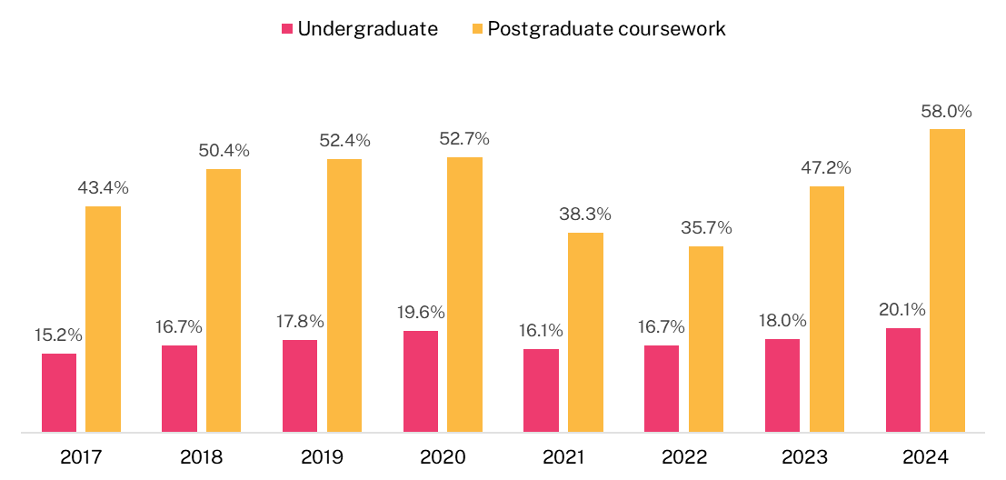

The international student experience

Focus areas and Overall Educational Experience

Overall Educational Experience
Between 2017 and 2019, international students consistently rated their Overall Education Experience in Australia positively, as student numbers continued to grow. However, in 2020, these ratings dropped sharply (Figure 2 and Figure 3). This decline coincided with the rapid changes higher education institutions had to make to teaching, learning, and student support due to the COVID-19 pandemic.
Since 2021, ratings from international undergraduate students have gradually improved, though they have not yet returned to pre-pandemic levels and have remained steady from 2022 to 2024. In contrast, international postgraduate coursework students have reported higher ratings since 2022 compared to earlier years. These ratings have remained stable from 2022 to 2024, despite a considerable year-on-year increase in enrolments.

Skills Development
International students’ ratings of their Skills Development—at both undergraduate and postgraduate coursework levels—have improved substantially since the low points of 2020 and 2021. While these ratings have remained stable from 2023 to 2024, they are still the highest recorded since 2017.

Peer Engagement
The Peer Engagement focus area was reviewed and updated in 2023, with changes made to the underlying survey items. Since the marked decline in 2020 and 2021—when many international students were studying primarily online and, in 2021, often still located overseas at the time of the survey—this focus area has shown year-on-year improvement for both international undergraduate and postgraduate coursework students.

Teaching Quality and Engagement
For both international undergraduate and postgraduate coursework students, ratings of Teaching Quality and Engagement held steady between 2023 and 2024. Despite this stability, the ratings remain higher than in any year from 2017 to 2022.

Student Support and Services
The Student Support and Services focus area was also reviewed in 2023, with new survey items introduced as part of that process. For both international undergraduate and postgraduate coursework students, ratings in this area remained steady across 2023 and 2024. Both years recorded higher results than any year from 2017 to 2022, continuing the upward trend that had already been evident prior to the 2023 review and associated changes.

Learning Resources
Undergraduate international student ratings of Learning Resources rose sharply between 2021 and 2022, then remained relatively steady from 2022 to 2023—reaching the highest level recorded since 2017. However, there was a decline of 1.5 percentage points between 2023 and 2024. For postgraduate coursework international students, ratings of Learning Resources remained stable between 2023 and 2024. Despite this stability, both years recorded higher results than any year from 2017 to 2022.
Detailed tables of results at the individual item level related to each of the focus areas are available from the QILT website in the additional tables associated with this report.

Figure 2 The international undergraduate student experience, 2017-2024 (% positive rating)
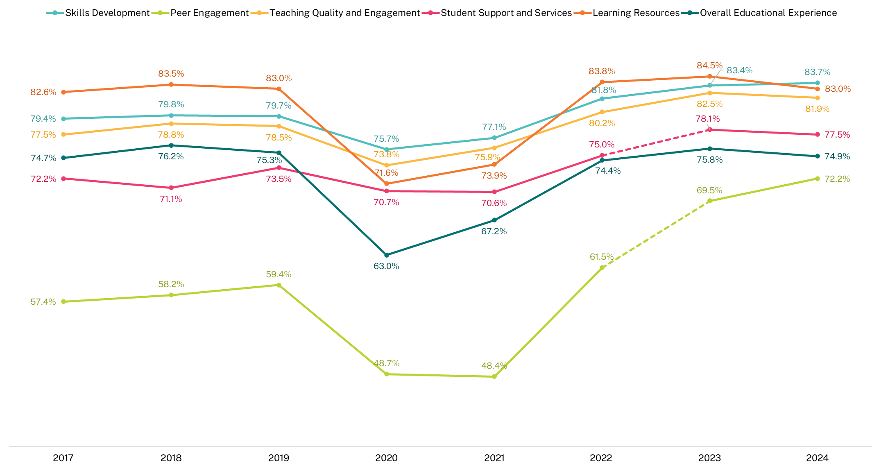
Note that the dotted lines between 2022 and 2023 indicate the change in underlying items of the Peer Engagement and Student Support and Services focus areas. When comparing year-on-year changes, it is recommended that modifications to underlying questionnaire items be taken into consideration. For more information about these changes, refer to the 2023 SES National Report.

Figure 3 The international postgraduate coursework student experience, 2017-2024 (% positive rating)
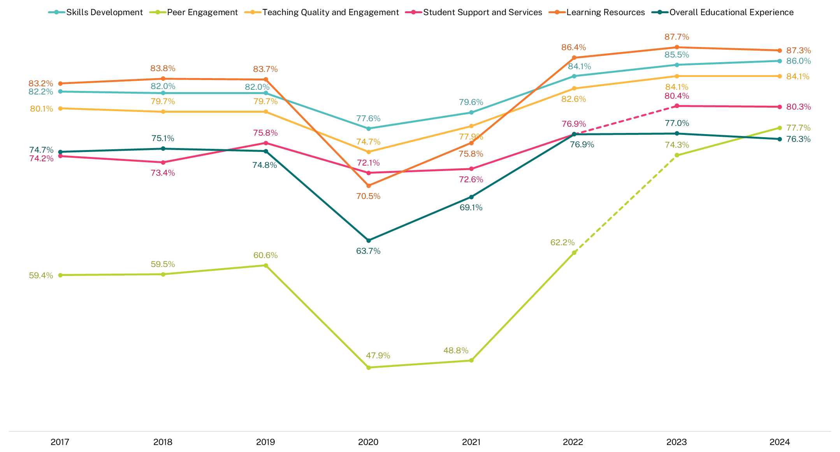
Note that the dotted lines between 2022 and 2023 indicate the change in underlying items of the Peer Engagement and Student Support and Services focus areas. When comparing year-on-year changes, it is recommended that modifications to underlying questionnaire items be taken into consideration. For more information about these changes, refer to the 2023 SES National Report.

Comparison between international and domestic student ratings

Overall Educational Experience
As seen in Figure 4 and Figure 5, international undergraduate students have consistently reported lower ratings of their Overall Educational Experience compared to domestic students since 2017. However, the gap between the two groups has narrowed since 2021. Ratings for both domestic and international undergraduate students remained relatively steady between 2023 and 2024, reflecting a period of stability following the post-pandemic recovery. While domestic student ratings in 2024 remain below pre-pandemic levels, international student ratings have returned to levels similar to those seen before the pandemic.
A similar pattern was observed among postgraduate coursework students, with international students generally reporting lower ratings of their Overall Educational Experience compared to domestic students. While domestic student ratings have shown a modest upward trend since 2020, reaching 77.2 per cent in 2024, international student ratings have remained relatively stable since 2022, following a recovery from earlier declines.

Skills Development
International student ratings of Skills Development have increased markedly for both undergraduate and postgraduate coursework students since 2020. From 2022 onward, these ratings have surpassed those of domestic students and continued to rise year on year through to 2024. In 2024, international undergraduate students rated their Skills Development 3.3 percentage points higher than domestic undergraduates, while international postgraduate coursework students rated it 6.8 percentage points higher than their domestic counterparts.

Peer Engagement
In 2024, international undergraduate students reported Peer Engagement ratings that were 14.8 percentage points higher than those of domestic undergraduates, and 37.2 percentage points higher than domestic students in postgraduate coursework programs. While this difference may be influenced by a greater proportion of domestic students studying fully or mostly online—particularly in postgraduate coursework—the gap remains similar when comparing only to domestic undergraduates studying on campus (internal mode). This difference may be associated with international students’ greater reliance on their institution for social, academic and study needs, whereas domestic students may potentially maintain stronger external peer networks and access to support.

Teaching Quality and Engagement
As shown in Figure 4, between 2017 and 2019, international undergraduate students consistently rated Teaching Quality and Engagement between 3.1 and 3.3 percentage points lower than their domestic counterparts. This gap widened in 2020, reaching 5.1 percentage points, and remained notable in 2021 at 4.1 percentage points. However, by 2022, international students’ ratings had aligned closely with those of domestic students. In 2023 and 2024, international undergraduates rated these aspects more positively—by 2.1 and 2.0 percentage points, respectively.
This pattern is similar at the postgraduate coursework level (Figure 5). International and domestic students reported similar ratings for Teaching Quality and Engagement in 2017, but from 2018 onward, domestic ratings improved while international ratings remained steady. A sharp decline in international student ratings occurred in 2020, creating a significant gap compared to domestic students. Although there was some recovery in 2021, international ratings still trailed behind. From 2022, however, international postgraduate ratings rose markedly, surpassing domestic ratings and maintaining that lead through 2024.
Teaching Quality and Engagement items with largest differences between domestic and international student ratings, 2024 (% positive rating)
In 2024, international students rated Teaching Quality and Engagement more highly than their domestic counterparts, particularly in the following aspects.
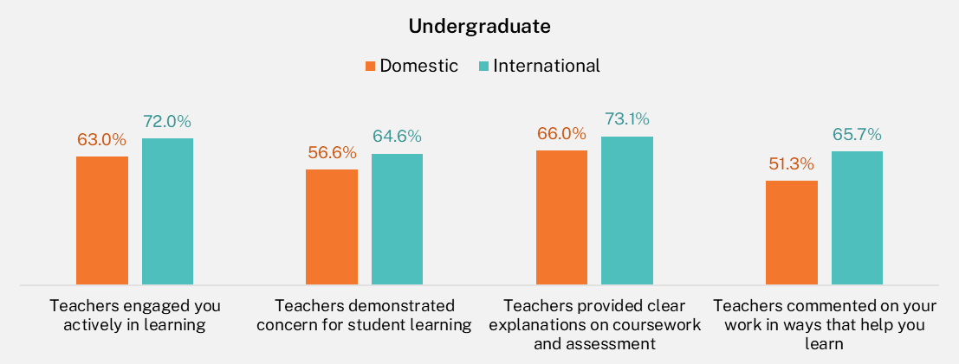
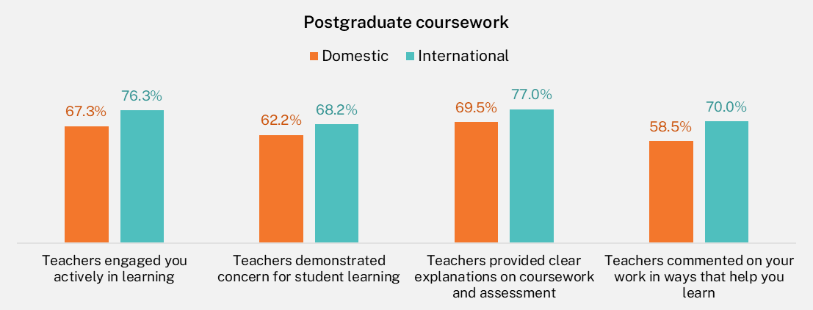

Student Support and Services
In 2024, international undergraduates rated Student Support and Services 8.3 percentage points higher than domestic students and international postgraduate coursework students rated it 12.8 percentage points higher. Before 2022, international undergraduates typically rated these services less positively than their domestic peers. However, this trend reversed from 2022 onward, with international students at both undergraduate and postgraduate coursework levels consistently giving higher ratings than domestic students. This difference remains, even when comparing with domestic students studying on campus (internal mode), who might be expected to engage more with institutional support services.

Learning Resources
International undergraduate Learning Resources ratings in 2024 were broadly similar to those of domestic undergraduates. However, international postgraduate coursework students rated Learning Resources 7.9 percentage points higher than domestic students in the same course level.

Figure 4 Undergraduate student experience by citizenship status, 2017-2024 (% positive rating)
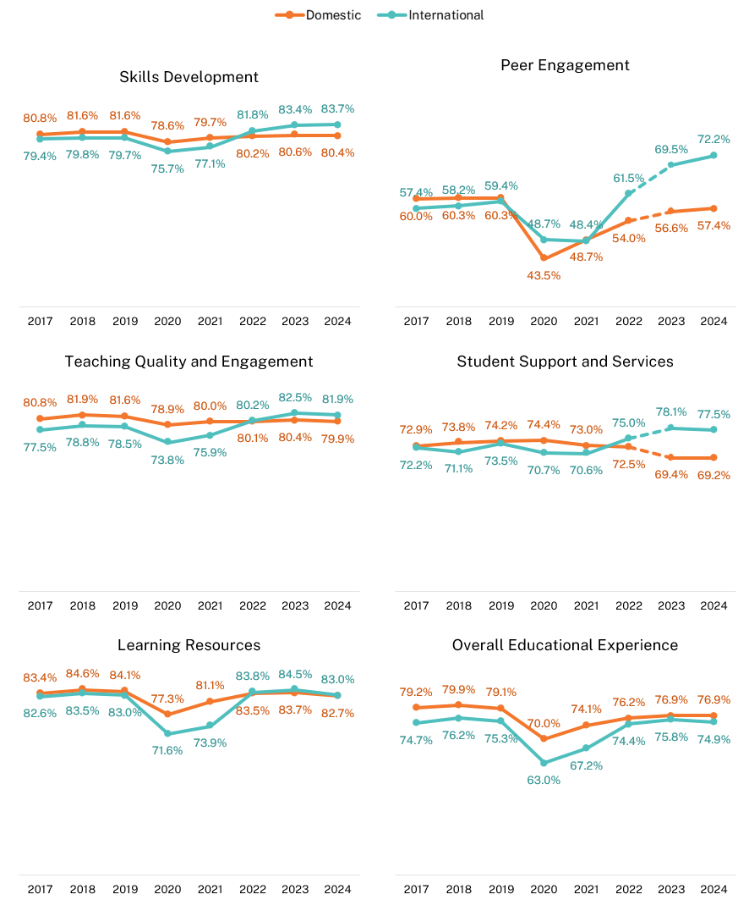
Note that the dotted lines between 2022 and 2023 indicate the change in underlying items of the Peer Engagement focus area. When comparing year-on-year changes, it is recommended that modifications to underlying questionnaire items be taken into consideration. For more information about these changes, refer to the 2023 SES National Report.

Figure 5 Postgraduate coursework student experience by citizenship status, 2017-2024 (% positive rating)
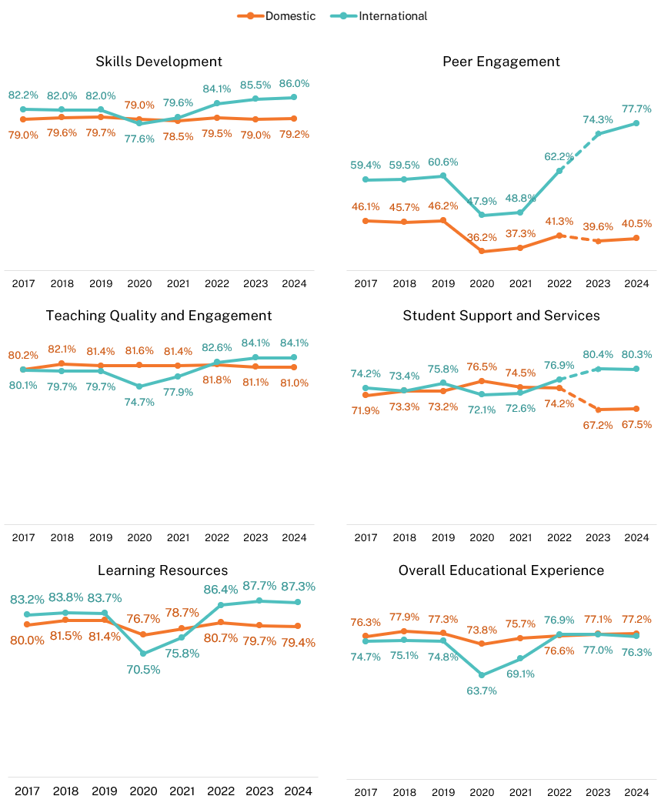
Note that the dotted lines between 2022 and 2023 indicate the change in underlying items of the Peer Engagement focus area. When comparing year-on-year changes, it is recommended that modifications to underlying questionnaire items be taken into consideration. For more information about these changes, refer to the 2023 SES National Report.

Source country comparisons
This section presents international student experience results broken down by students’ source country and course level. Countries are listed in order of the number of survey respondents at each course level.
Please note that from 2024 onward, ‘source country’ is based on the Residential Address Country Code (E658) from the Tertiary Collection of Student Information (TCSI) system. In earlier years, source country was based on the Birth Country Code (E346). This change has some minor impact on year-on-year comparisons.
In 2024, the largest source countries for international respondents are shown in Figure 6.
The top 5 source countries for each cohort accounted for 53.1 per cent of all international undergraduate survey respondents and 63.4 per cent of postgraduate coursework survey respondents, respectively.

Figure 6 Top 5 source countries for international students by course level, based on responses to the 2024 SES
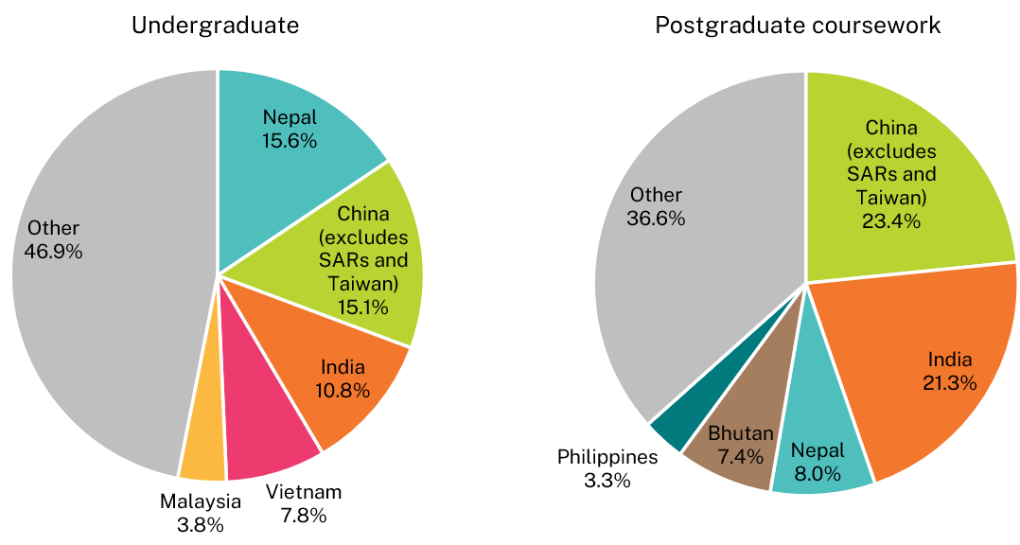
Note: Source country in 2024 was based on TCSI variable E658 (Residential address country code).

Key study areas by top 5 source countries based on responses to the 2024 SES
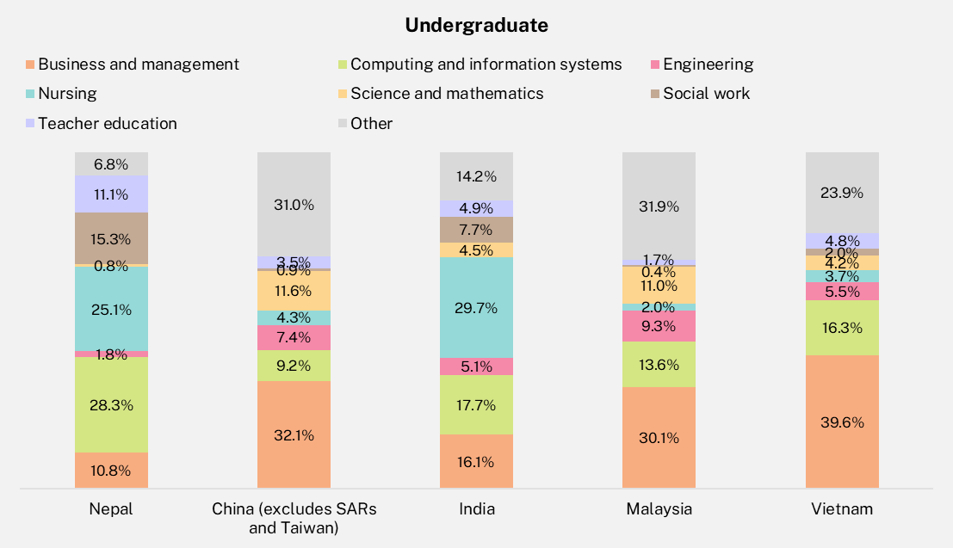
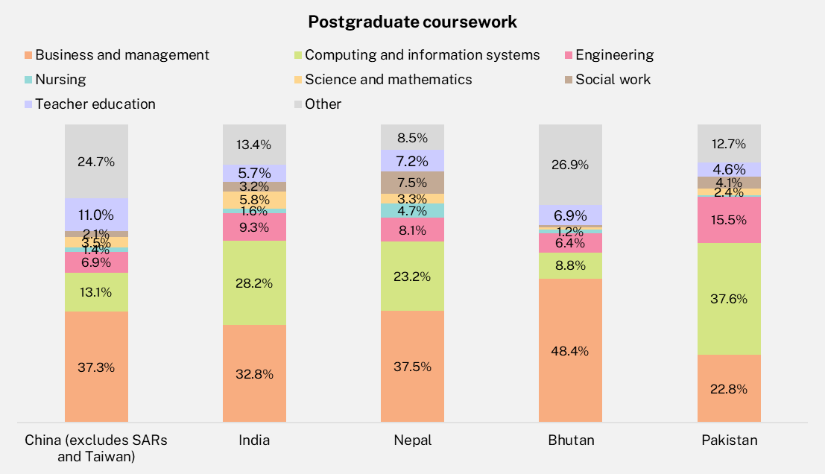
Note: Source country in 2024 was based on TCSI variable E658 (Residential address country code).

Although Section 2.1 noted that international undergraduates’ Overall Educational Experience remained relatively stable between 2023 and 2024, ratings for the Overall Educational Experience and specific focus areas varied across the top 5 source countries, as shown in Figure 7 and Figure 8.
Figure 7 Undergraduate educational experience and focus areas by source country, 2024 (% positive rating)
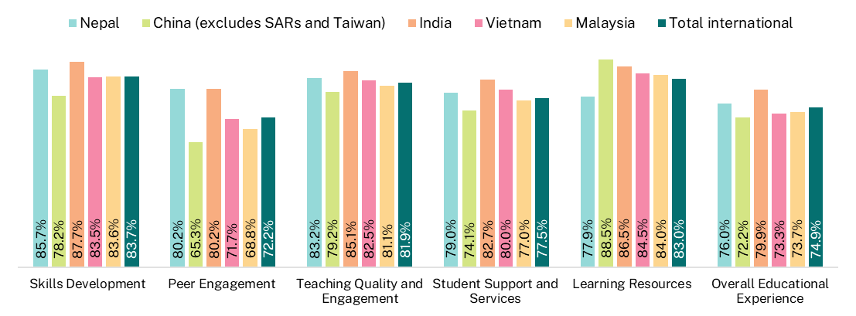
Note: Source country in 2024 was based on E658 Residential address country code. Source countries shown in this figure represent the top 5 by number of survey respondents, ordered from left to right from largest to smallest.
For example, in 2024, among undergraduate international students who responded to the survey, those from India rated their Overall Educational Experience higher than respondents from any of the other top 5 source countries, as shown in Figure 7. Respondents from Nepal also gave ratings 3.8 percentage points higher than those from China (excluding SARs and Taiwan). In fact, international undergraduate respondents from China (excluding SARs and Taiwan) reported lower scores across all focus areas—except for Learning Resources, where they gave the highest ratings among the top 5 source countries.
Peer Engagement ratings in 2024 also varied significantly among respondents from the top 5 source countries. Undergraduate respondents from China (excluding SARs and Taiwan) rated their Peer Engagement much lower than those from India and Nepal, both with a gap of 14.9 percentage points. This trend is not new—international students from China (excluding SARs and Taiwan) have consistently reported lower Peer Engagement scores than their Indian and Nepali peers since 2017, at both undergraduate and postgraduate coursework levels. Respondents from Malaysia also rated Peer Engagement lower than those from India and Nepal.
Figure 8 Postgraduate coursework educational experience and focus areas by source country, 2024 (% positive rating)
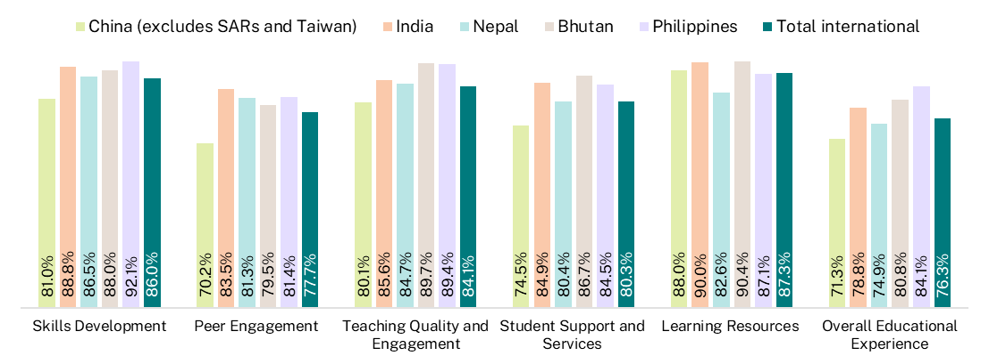
Note: Source country in 2024 was based on E658 Residential address country code. Source countries shown in this figure represent the top 5 by number of survey respondents, ordered from left to right from largest to smallest.
Figure 8 presents focus area ratings from postgraduate coursework international respondents by source country. Similar to the undergraduate results, respondents from China (excluding SARs and Taiwan) rated their Overall Educational Experience and most focus areas lower than their peers from other major source countries, with particularly low ratings for Peer Engagement. The only exception was Learning Resources, where their ratings were comparatively higher than their ratings on other focus areas. In contrast, respondents from Nepal gave the lowest ratings for Learning Resources among the top source countries.
Postgraduate coursework respondents from the Philippines rated their Overall Educational Experience higher than respondents from any of the other four major source countries.
Given that most international students undertake their studies primarily in internal mode, these findings suggest that students from different source countries may have varying expectations and experiences of higher education in Australia. This highlights the importance for institutions to understand the diverse motivations and expectations of their international student cohorts, particularly within specific study areas. Further analysis of source country differences related to the student living experience, as well as reasons for choosing Australia and their specific institution, is provided in Section 4 of this report.

Study area comparisons
This section explores the international student ratings broken down by study areas. The study areas with the largest number of international undergraduate respondents were Business and management, Computing and information systems, and Nursing. Together, these three study areas accounted for over half of all international undergraduate respondents.
At the postgraduate coursework level, international respondents were even more concentrated. More than half of all respondents came from just two study areas: Business and management, and Computing and information systems.
Overall, the 2024 results revealed a diverse international student experience across different study areas. Undergraduate students in areas such as Tourism, hospitality, personal services, sport and recreation, Health services and support and Nursing reported higher ratings in their Overall Educational Experience. In contrast, students in Computing and information systems, Rehabilitation and Architecture and built environment gave lower ratings. At the postgraduate coursework level, students from Humanities, culture and social sciences and Health services and support provided more positive feedback, while those in Dentistry, Rehabilitation and Medicine were less positive. These differences point to opportunities for targeted improvements, particularly in high-enrolment disciplines where student feedback suggests a need for improvement in various aspects of the educational experience. Addressing these disparities—particularly in high-enrolment and low-performing study areas—will be essential to ensuring a more equitable, engaging, and supportive experience for all international students.
Undergraduate study area profile (proportions based on responses to the 2024 SES)
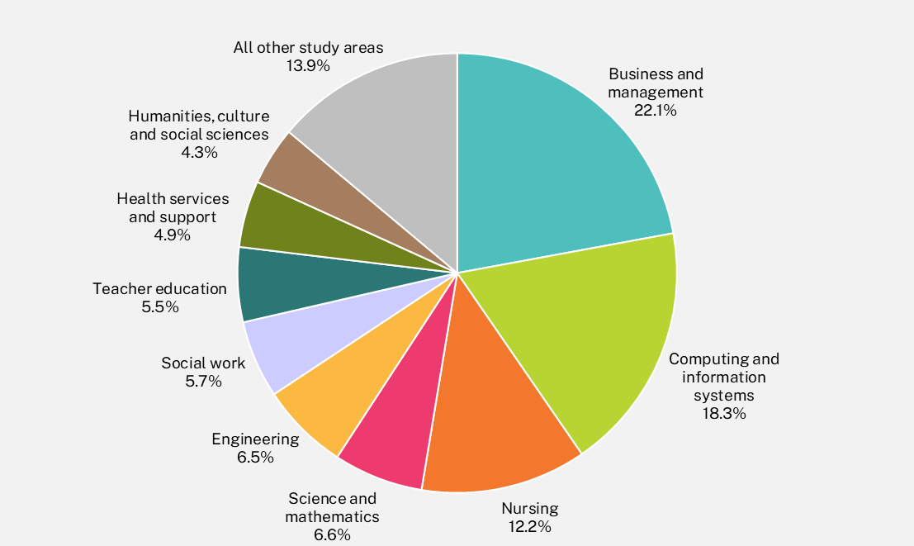

Postgraduate coursework study area profile (proportions based on responses to the 2024 SES)
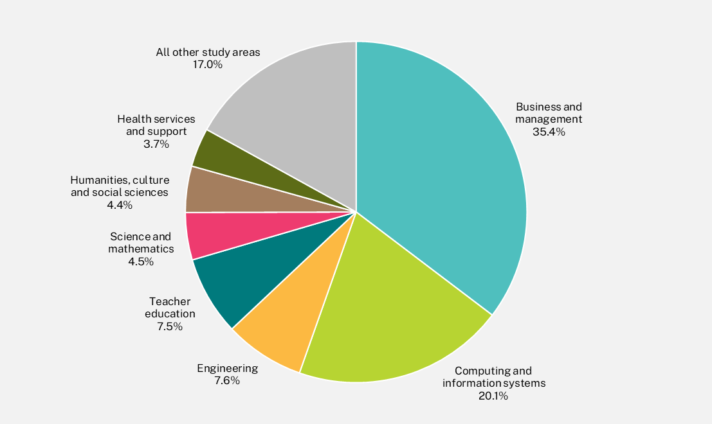

International undergraduate students
The educational experience of international undergraduate students disaggregated by study area is shown in Table 6 in Appendix 2.

Overall Educational Experience
In 2024, international undergraduate students gave the highest ratings for Overall Educational Experience in the following study areas:
- Tourism, hospitality, personal services, sport and recreation (82.1 per cent)
- Nursing (the third largest undergraduate study area) (80.6 per cent)
- Health services and support (80.6 per cent)
- Teacher education (80.0 per cent).
On the other hand, the lowest ratings came from:
- Computing and information systems (the second largest undergraduate study area) (68.3 per cent)
- Rehabilitation (69.4 per cent)
- Architecture and built environment (70.4 per cent).
This 13.8 percentage point gap between the highest and the lowest scoring study areas highlights the need to focus on improving the student experience in lower-performing areas, particularly those with high enrolments, where changes could benefit a large number of students.

Teaching Quality and Engagement
The highest ratings for Teaching Quality and Engagement came from:
- Tourism, hospitality, personal services, sport and recreation (91.6 per cent)
- Health services and support (86.2 per cent)
- Teacher education (85.3 per cent)
- Humanities, culture and social sciences (85.0 per cent)
- Psychology (85.0 per cent).
The lowest ratings were recorded in:
- Rehabilitation (74.3 per cent)
- Law and paralegal studies (75.9 per cent)
- Computing and information systems (76.3 per cent).
Given the strong association between this focus area and Overall Educational Experience, enhancing Teaching Quality and Engagement in high-enrolment study areas could significantly boost students’ overall experience and learning outcomes in institutions.

Skills Development
Study areas with the highest ratings for Skills Development included:
- Nursing (89.9 per cent)
- Teacher education (89.5 per cent)
- Social work (88.5 per cent).
Lower ratings were seen in:
- Computing and information systems (77.5 per cent)
- Veterinary science (78.0 per cent).
Given the consistently lower ratings across several focus areas and the high number of international undergraduate enrolments, the Computing and information systems study area may benefit from closer scrutiny and targeted improvement efforts.

Peer Engagement
The highest ratings for Peer Engagement came from:
- Tourism, hospitality, personal services, sport and recreation (86.7 per cent)
- Social work (84.7 per cent).
The lowest ratings were in:
- Law and paralegal studies (55.5 per cent)
- Psychology (58.2 per cent)
- Veterinary science (58.8 per cent).
There was a 31.2 percentage point difference between the highest and the lowest rated study areas. While students studying online often report lower levels of Peer Engagement, most international students study on campus or in mixed modes. This suggests that their lower ratings were less likely to be related to study mode. Further analysis may be needed to explore the underlying causes.

Student Support and Services
In 2024, international students’ ratings of Student Support and Services varied by 20.0 percentage points between the highest and the lowest:
- Highest: Nursing (84.1 per cent)
- Lowest: Veterinary science (64.1 per cent).
Other lower-scoring areas included:
- Medicine (65.2 per cent)
- Rehabilitation (70.7 per cent).
This focus area is becoming more important under the Support for Students Policy, which aims to help students succeed by improving both academic and non-academic support. Addressing the disparities in support services is essential to ensuring that all international students—regardless of their field of study—have equitable opportunities to succeed and feel supported throughout their academic journey.

Learning Resources
There was a 19.0 percentage point gap between the highest and the lowest ratings for Learning Resources.
The highest ratings were in:
- Humanities, culture and social sciences (88.4 per cent)
- Science and mathematics (88.2 per cent)
- Nursing (87.3 per cent)
- Psychology (87.3 per cent)
- Engineering (87.1 per cent).
The lowest ratings were in:
- Social work (69.4 per cent)
- Medicine (72.8 per cent)
- Rehabilitation (74.9 per cent).
These differences highlight the need to ensure consistent access to high-quality learning resources across all study areas, so that all international students can benefit from an equitable and well-supported academic environment.

International postgraduate coursework students
A similar pattern can be observed for international postgraduate coursework students, where there is variation between study areas across the focus areas and Overall Educational Experience (

Table 7).

Overall Educational Experience
In 2024, the study areas with the highest Overall Educational Experience ratings were:
- Humanities, culture and social sciences (82.3 per cent),
- Health services and support (80.1 per cent)
- Business and management (78.7 per cent), the largest study area for postgraduate coursework international students
- Nursing (77.6 per cent)
- Science and mathematics (77.6 per cent).
The study areas with the lowest ratings for Overall Educational Experience were:
- Dentistry (56.9 per cent)
- Rehabilitation (64.3 per cent)
- Medicine (64.7 per cent)
- Veterinary science (66.2 per cent).
There was a 25.4 percentage points difference between the highest and the lowest rated study areas. This wide variation highlights the importance of addressing lower-performing areas to ensure a more consistent and equitable experience across disciplines.

Teaching Quality and Engagement
Study area trends in Teaching Quality and Engagement closely aligned with those observed in Overall Educational Experience. The highest ratings came from:
- Humanities, culture and social sciences (90.7 per cent)
- Health services and support (88.4 per cent).
The lowest ratings were recorded in:
- Dentistry (60.3 per cent)
- Medicine (67.1 per cent)
- Rehabilitation (71.9 per cent)
- Veterinary science (79.7 per cent)
- Computing and information systems (79.8 per cent), which is one of the largest study areas and may warrant intervention at a sector-wide level.
The gap between the highest and lowest rated study area was 30.4 percentage points.

Skills Development
The Skills Development focus area had the lowest difference between study areas, with a 12.6 percentage point gap between the highest and lowest rated study areas. Most study areas performed well at the postgraduate coursework level, including:
- Veterinary science (91.9 per cent)
- Health services and support (90.2 per cent)
The lowest performing area was:
- Rehabilitation (79.3 per cent)
The relatively small gap in this focus area suggests that postgraduate coursework programs are generally effective in building skills, though continued attention is still needed in lower-scoring study areas.

Peer Engagement
The highest ratings came from:
- Tourism, hospitality, personal services, sport and recreation (83.8 per cent)
- Pharmacy (81.7 per cent)
- Business and management (81.2 per cent), the largest study area.
The lowest ratings were recorded in:
- Law and paralegal studies (66.2 per cent).
There was a 17.6 percentage point difference between the highest and lowest performing study areas.

Student Support and Services
The highest ratings came from:
- Tourism, hospitality, personal services, sport and recreation (85.7 per cent)
- Humanities, culture and social sciences (84.0 per cent).
The lowest ratings came from:
- Dentistry (40.9 per cent)
- Medicine (54.4 per cent)
- Veterinary science (56.0 per cent)
- Rehabilitation (57.7 per cent).
As discussed earlier, there is growing emphasis on Student Services and Support through the Universities Accord and the implementation of the Support for Students Policy, which aims to strengthen both academic and non-academic assistance to help students progress and complete their studies. The substantial 44.8 percentage point gap between the highest and lowest support ratings suggests that some study areas may benefit from more tailored or visible services to better meet the needs of international students.

Learning Resources
Dentistry was the lowest scoring study area (54.4 per cent), with a 40.6 percentage point gap compared to the highest, Tourism, hospitality, personal services, sport and recreation (95.0 per cent).

Figure 9 International undergraduate Overall Educational Experience by study area, 2024 (% positive rating)
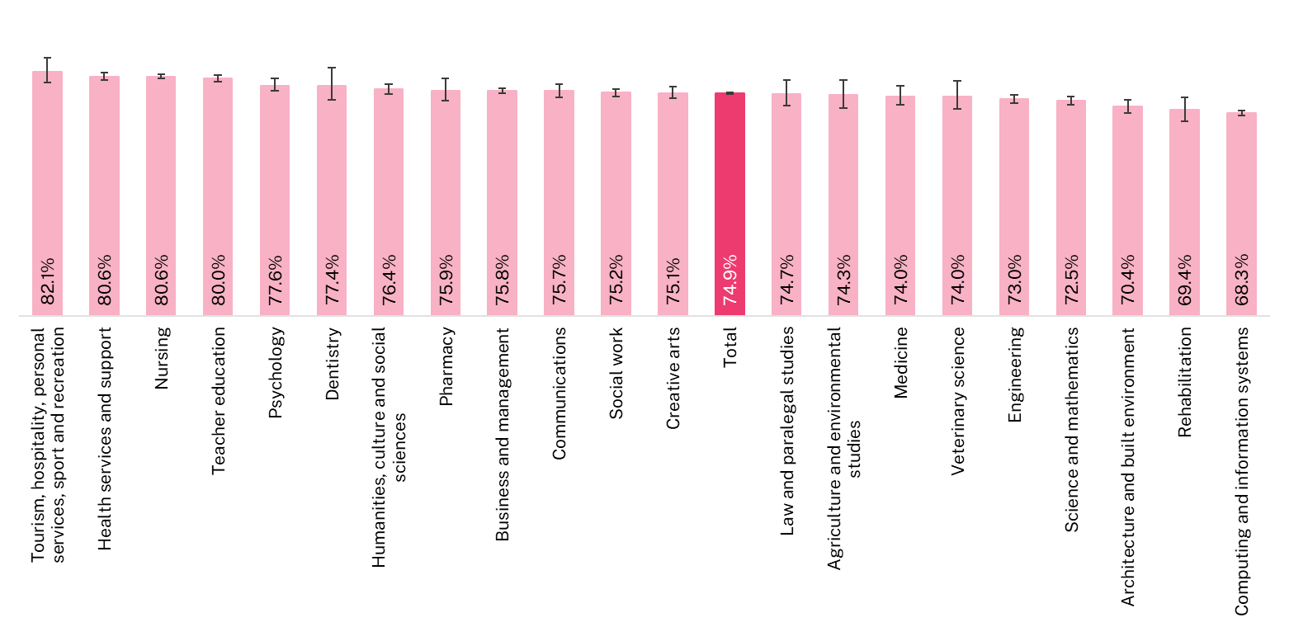
Note: The error bars in this figure represent the 90 per cent confidence intervals around the point estimates. These intervals have been calculated as 1.645 times the standard error, which has been adjusted using a finite population correction. Further details on the calculation of these confidence intervals are available on the QILT website.

Figure 10 International postgraduate coursework Overall Educational Experience by study area, 2024 (% positive rating)
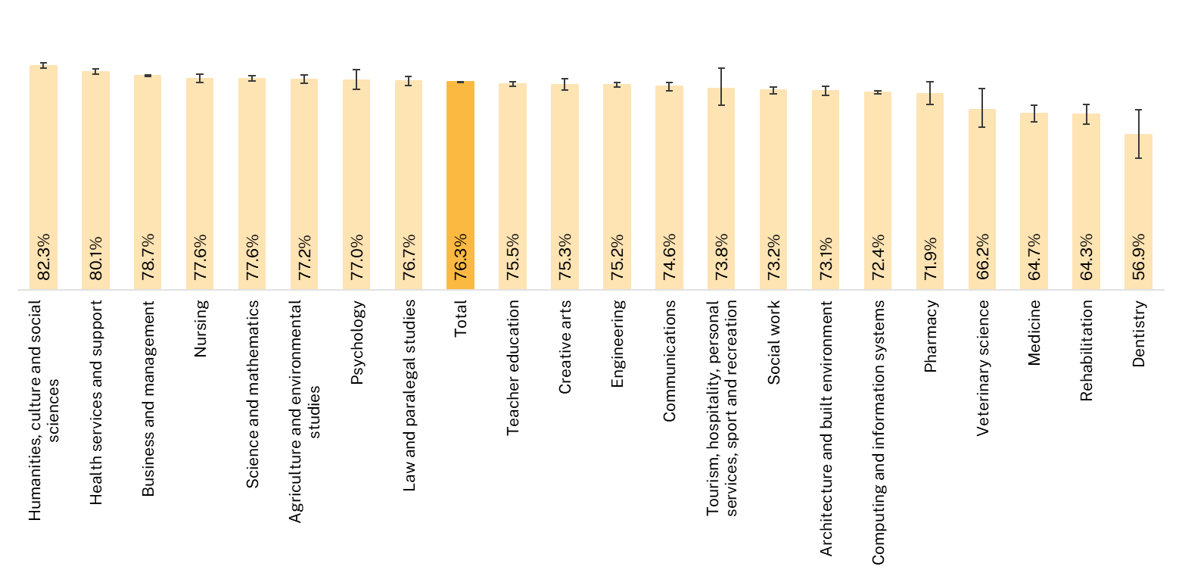
Note: The error bars in this figure represent the 90 per cent confidence intervals around the point estimates. These intervals have been calculated as 1.645 times the standard error, which has been adjusted using a finite population correction. Further details on the calculation of these confidence intervals are available on the QILT website.

Institutional comparisons
International students’ ratings of the Overall Educational Experience vary across institutions. University results are presented in Figure 12 and Figure 13, and NUHEIs results in Figure 14 and Figure 15. However, it is important to note that results for universities and NUHEIs are not directly comparable, as NUHEI data is pooled over two years to ensure sufficient sample sizes for smaller institutions.
Annual comparison data is available through the QILT website’s Power BI dashboards, while aggregate comparisons can be accessed via the ComparED website.
When interpreting these results, it is important to consider that factors beyond educational quality—such as course offerings and student demographics—may influence student ratings. Additionally, where confidence intervals overlap between institutions, no statistically significant difference can be inferred.
As with source country and study area, international undergraduate responses are concentrated among a relatively small number of institutions. For example, 10 out of 42 universities account for approximately 51 per cent of all international undergraduate responses in 2024. These universities, in order of survey response volume, were Monash University, University of New South Wales, University of Sydney, Macquarie University, University of Queensland, Swinburne University of Technology, Deakin University, RMIT University, University of Melbourne, and University of South Australia.
A similar pattern was seen at the postgraduate coursework level, where the top 10 universities account for around 54 per cent of responses. These included University of Melbourne, University of New South Wales, Monash University, University of Sydney, Murdoch University, Edith Cowan University, University of Queensland, Macquarie University, RMIT University, and Curtin University.
Among NUHEIs, international undergraduate students represented about 31 per cent of total responses, spread across 82 institutions. The largest contributor in 2024 was Acknowledge Education, accounting for approximately 14 per cent of NUHEI undergraduate responses.
For international postgraduate coursework students, NUHEIs made up around 19 per cent of total responses in 2024. Of the 52 NUHEIs with reportable data, the largest contributors were Kaplan Business School (22 per cent), Holmes Institute (13 per cent), and the Victorian Institute of Technology (also 13 per cent).

Higher education institution type
In 2024, international students at Non-University Higher Education Institutions (NUHEIs) generally rated their Overall Educational Experience and other focus areas more positively than those at universities, for both undergraduate and postgraduate coursework levels, with the exception of Learning Resources.
Among undergraduate students, ratings for Overall Educational Experience were similar between NUHEIs and universities (see Figure 11). However, postgraduate coursework students at NUHEIs rated their experience 10.5 percentage points higher than their university counterparts.
The most notable difference in undergraduate ratings was in Peer Engagement, where NUHEIs outperformed universities by 12.0 percentage points. Ratings for Student Support and Services were similar across both institution types at the undergraduate level. In contrast, postgraduate coursework students at NUHEIs rated this area 6.7 percentage points higher than those at universities.
Learning Resources was the only area where universities received higher ratings. In 2024, international undergraduate students at universities rated Learning Resources 10.7 percentage points higher than those at NUHEIs, and postgraduate coursework students rated it 5.6 percentage points higher.
It is important to note that differences in course offerings, study area profiles, and the composition of the international student population—including source countries—can influence these results.

Figure 11 International experience by institution type and course level, 2024 (% positive response)
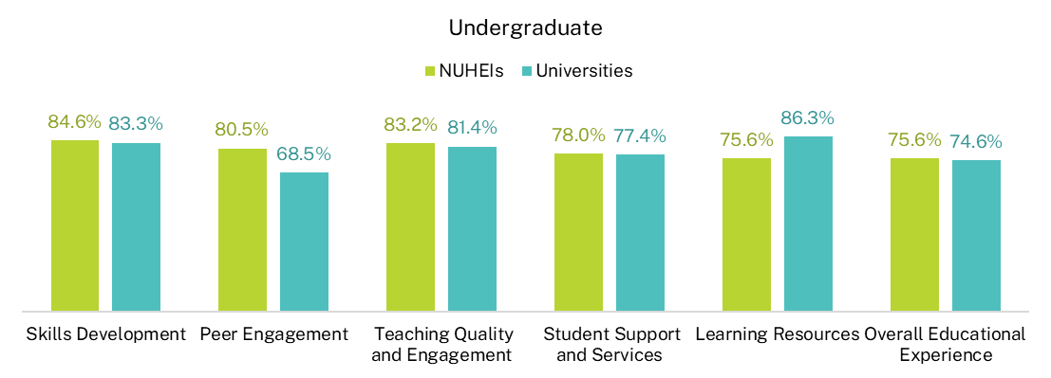
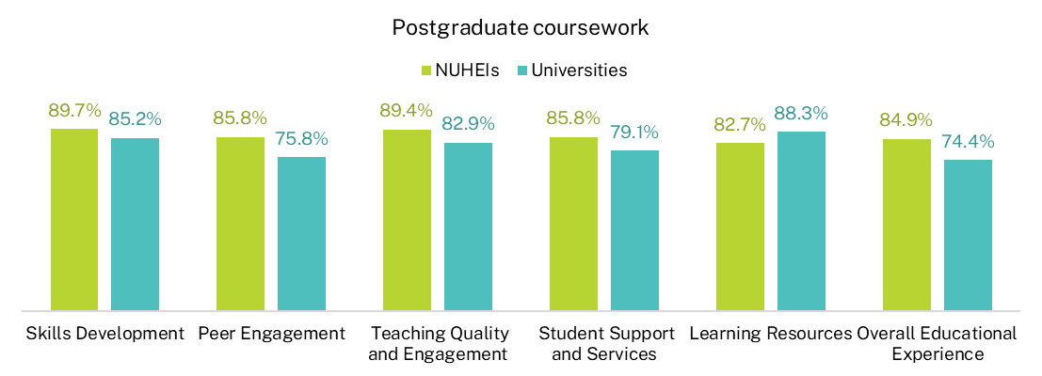
Note: Universities account for the majority of international student respondents, with NUHEIs representing 31.4 per cent of undergraduate and 18.7 per cent of postgraduate coursework students.

Universities
The Overall Educational Experience ratings for international undergraduate students at the institutional level have continued to recover from the impacts of COVID-19. In 2024, university ratings for this measure remained broadly consistent with those reported in 2023.
There was a 24.3 percentage point gap between the highest and lowest scoring universities in 2024. As shown in Figure 12, the universities with the highest positive ratings included Charles Sturt University, Australian Catholic University, Bond University, Edith Cowan University, Deakin University, and Central Queensland University. (Note: Charles Sturt University and Bond University had fewer than 90 international responses.)
At the lower end, institutions with ratings below 70 per cent included the University of Melbourne, the University of Sydney, the University of New England, the Australian National University, and University of Southern Queensland.
For international postgraduate coursework students, Overall Educational Experience ratings have remained relatively stable between 2022 to 2024. However, in 2024, there was still notable variation between institutions, with a 22.7 percentage point difference between the highest and lowest scores (see Figure 13). Universities with the highest ratings included Bond University, James Cook University, the University of the Sunshine Coast, Edith Cowan University, and Central Queensland University. Institutions with lower ratings included the University of Adelaide and Southern Cross University.
Figure 12 Overall Educational Experience for international undergraduate university students, 2024 (% positive rating)
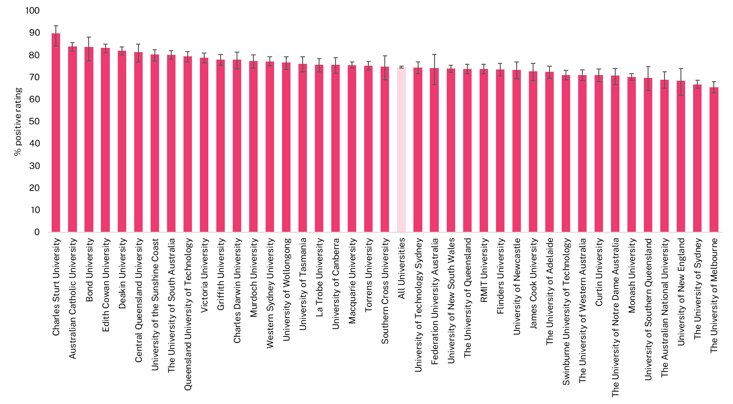
Note: The error bars in this figure represent the 90 per cent confidence intervals around the point estimates. These intervals have been calculated as 1.645 times the standard error, which has been adjusted using a finite population correction. Further details on the calculation of these confidence intervals are available on the QILT website.

Figure 13 Overall Educational Experience for international postgraduate coursework university students, 2024 (% positive rating)
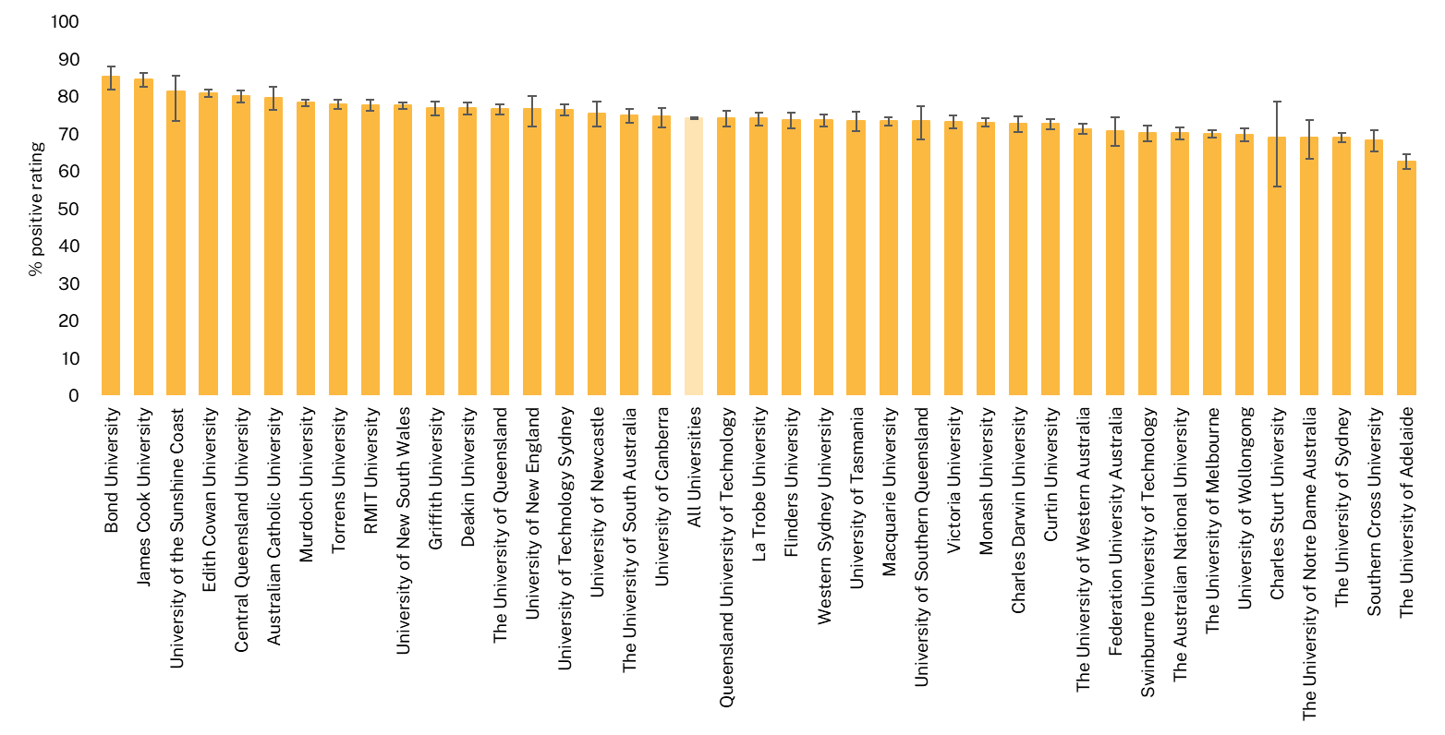
Note: The error bars in this figure represent the 90 per cent confidence intervals around the point estimates. These intervals have been calculated as 1.645 times the standard error, which has been adjusted using a finite population correction. Further details on the calculation of these confidence intervals are available on the QILT website.

Non-university higher education institutions (NUHEIs)
Since international student enrolments at individual NUHEIs tend to be much smaller than at universities, the survey data shown in Figure 14 and Figure 15 is based on pooled results from the 2023 and 2024 surveys. This approach, also used on the ComparED website, ensures that more institutions have sufficient data for reporting. To maintain data quality, results based on fewer than 25 responses have not been published.
Due to this data pooling, NUHEI results are not directly comparable with university results shown in Figure 12 and Figure 13. Additionally, pooled estimates may dilute year-on-year changes in student ratings.
Among NUHEIs with sufficient international undergraduate responses across 2023 and 2024, the institutions with the highest positive ratings for Overall Educational Experience were: Sydney College of Divinity, Leaders Institute, Sheridan Institute of Higher Education, Box Hill Institute, Equals International, Lyons College, and Collarts (Australian College of the Arts). Institutions with the lowest ratings included: SP Jain School of Management, Kent Institute Australia, SAE University College, TAFE South Australia, Crown Institute of Higher Education, Le Cordon Bleu Australia, Academy of Interactive Technology, and Southern Cross Education Institute (Higher Education).
For international postgraduate coursework students, NUHEIs with the highest ratings in Overall Educational Experience included: Australian University of Theology, Leaders Institute, Polytechnic Institute Australia, Australia Advance Education Group, CIC Higher Education, and Universal Business School Sydney. Those with the lowest ratings were: Southern Cross Education Institute (Higher Education), JMC Academy, The College of Law, Chartered Accountants Australia and New Zealand, and SP Jain School of Management.

Figure 14 Overall Educational Experience for international undergraduate non-university higher education institution (NUHEI) students, pooled 2023-2024 (% positive rating)
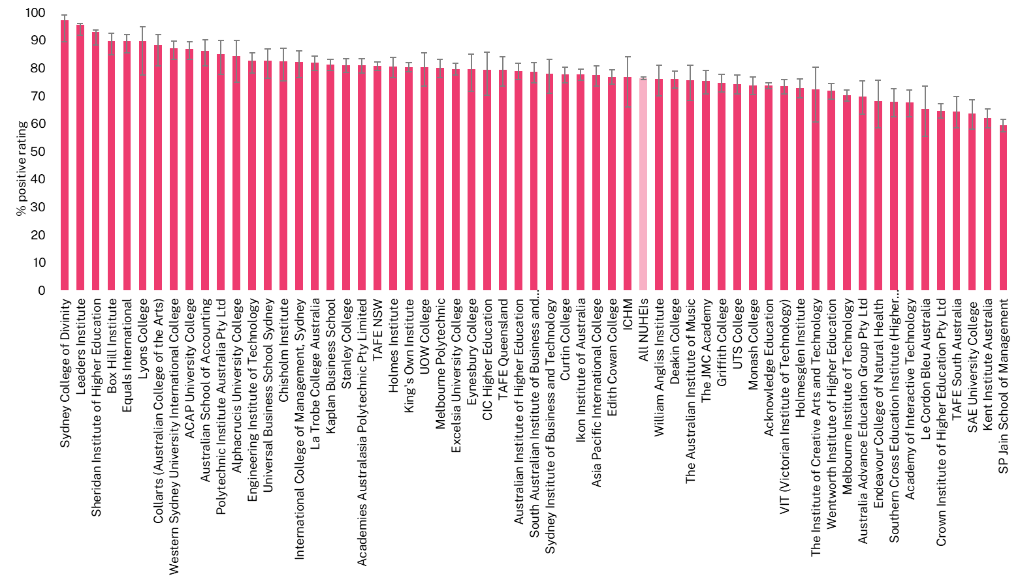

Note: The error bars in this figure represent the 90 per cent confidence intervals around the point estimates. These intervals have been calculated as 1.645 times the standard error, which has been adjusted using a finite population correction. Further details on the calculation of these confidence intervals are available on the QILT website.
Figure 15 Overall Educational Experience for international postgraduate coursework non-university higher education institution (NUHEI) students, pooled 2023-2024 (% positive rating)
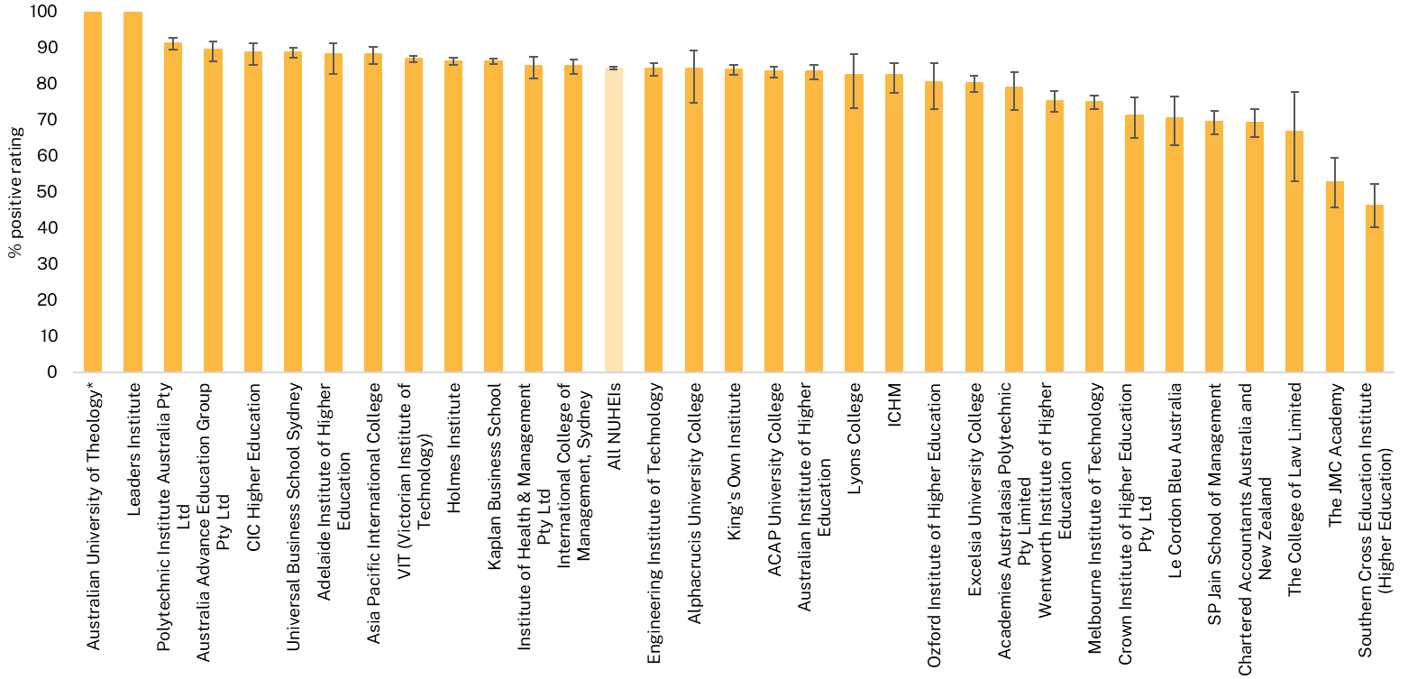

* The Australian University of Theology was awarded university status in December 2024. Prior to this, the institution was known as the Australian College of Theology and was classified as a non-university higher education institution (NUHEI). Data for the 2024 SES was collected when the institution was a NUHEI.
Note: The error bars in this figure represent the 90 per cent confidence intervals around the point estimates. These intervals have been calculated as 1.645 times the standard error, which has been adjusted using a finite population correction. Further details on the calculation of these confidence intervals are available on the QILT website. Estimates and confidence intervals become unreliable for very small sample sizes and for proportions close to 0 per cent and 100 per cent. Such occurrences are flagged, and confidence intervals are not shown. Caution should be exercised when reporting and comparing proportions for these cases.

Other aspects of the higher education experience

Sense of belonging
Sense of belonging relates to feelings of connectedness, inclusion and being accepted and valued by others. Research has shown that a student’s sense of belonging among peers and at the institution is linked with academic achievement, personal wellbeing, student satisfaction and attrition.
Positive ratings of international students’ sense of belonging to their institution dropped significantly in 2020 due to the COVID-19 pandemic. Among undergraduates, these ratings have since improved but not yet returned to pre-2020 levels. The consistent results from 2022 to 2024 suggest ongoing challenges in fostering a sense of belonging in the post-pandemic environment, particularly as many institutions continue to use online learning or have reduced in-person attendance requirements.
For international postgraduate coursework students, ratings also declined in 2020 and 2021—likely due to many students studying remotely from overseas. However, since 2021, ratings have steadily improved, reaching 62.1 per cent in 2024 and surpassing pre-pandemic levels.
Historically, undergraduate and postgraduate coursework students have reported similar levels of belonging. However, in 2024, the gap between the two groups widened to 4.8 percentage points, indicating a potential divergence in how these cohorts are experiencing connection to their institutions. There were also differences with students enrolled in NUHEIs rating their sense of belonging to their institution more highly than those in universities (Figure 16).
Figure 16 International student sense of belonging by institution type, 2017-2024 (% positive rating)
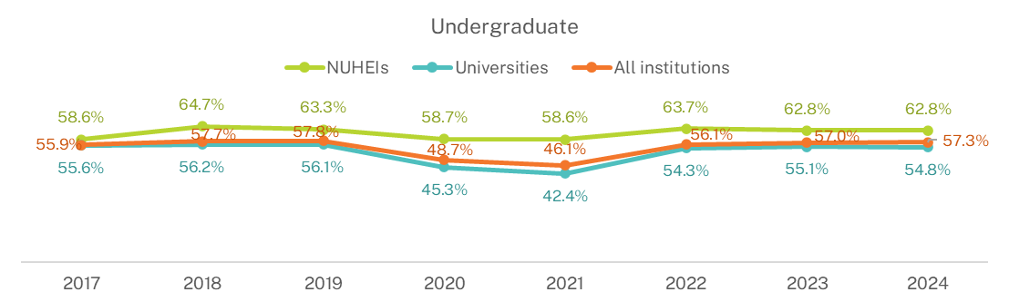
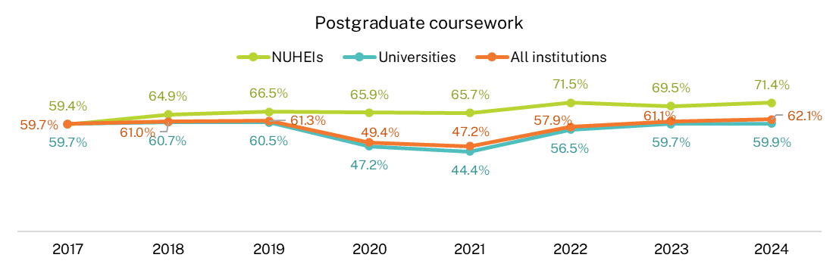

Additionally, there were differences in ratings of sense of belonging by source country with students from China at both the undergraduate and postgraduate coursework levels rating their sense of belonging to their institution lower than most other countries, other than undergraduates from Malaysia (Figure 17).
Figure 17 International student sense of belonging by source country, 2024 (% positive rating)
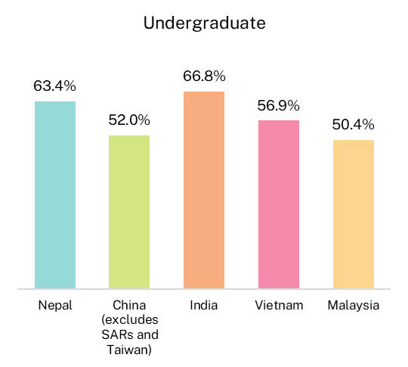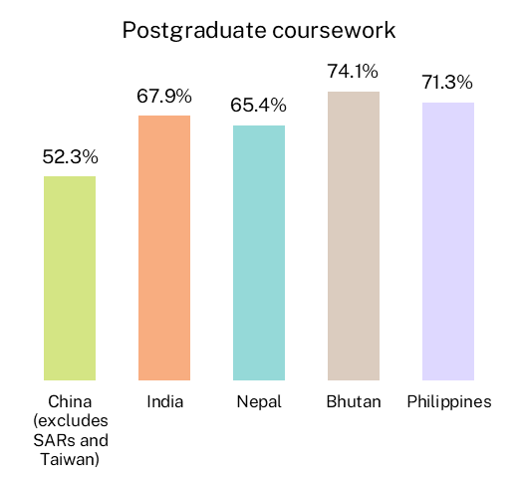
Note: Source country in 2024 was based on E658 Residential address country code.
*Source countries shown in this figure represent the top 5 by number of survey respondents, ordered from left to right from largest to smallest.

Likelihood to consider leaving current institution
In addition to questions about their educational experience, students were asked whether they had seriously considered leaving their current institution in 2024. Among domestic undergraduate students, this proportion has remained relatively stable since 2017. For international undergraduate students, the proportion has generally been lower than that of domestic students, as shown in Figure 18. However, it peaked at 19.5 per cent in 2021—likely due to the high number of international students studying remotely from overseas during the pandemic. This figure dropped 5.0 percentage points in 2022, and declined further to 13.1 per cent in 2024—the lowest level recorded since 2017.
Figure 18 Proportion of undergraduate students who considered early departure from institution by citizenship status, 2017-2024
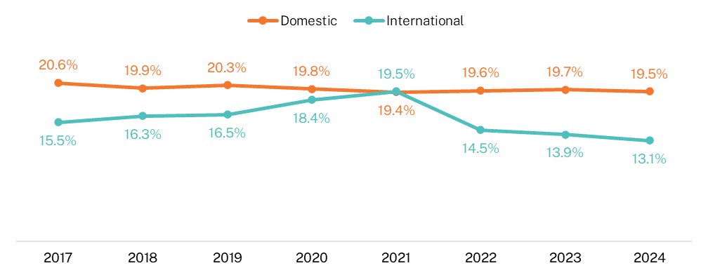

A similar pattern is observed at the postgraduate coursework level. Domestic respondents were consistently more likely than international respondents to report having considered leaving their institution during the survey year. However, in 2020 and 2021, the proportion of international postgraduate coursework students who considered leaving increased significantly, as shown in Figure 19. This likely reflects the challenges of studying remotely during the pandemic. This proportion dropped sharply in 2022 and remained relatively stable in 2023 and 2024, at 12.2 per cent and 12.8 per cent respectively. These are among the lowest levels recorded since 2017 and remain below the rate reported by domestic undergraduates.
It is important to note that the SES is conducted in August and September each year. By this time, some commencing undergraduate students experiencing transition difficulties may have already withdrawn or disengaged from their studies. Additionally, students who feel less connected to their institution may be less inclined to participate in voluntary surveys. When comparing international and domestic students, cultural factors may also influence responses. International students may be less likely to disclose sensitive issues such as considering withdrawal, possibly due to cultural norms, the financial investment involved, or concerns about potential visa or enrolment implications.
Figure 19 Proportion of postgraduate coursework students who considered early departure from institution by citizenship status, 2017-2024
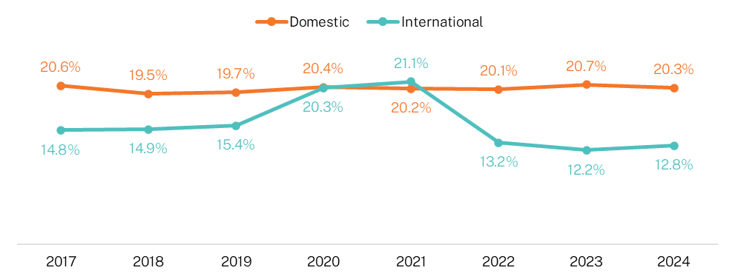

Students who reported considering leaving their institution were asked to select from a list of 28 possible reasons. They could choose multiple responses, so percentages do not total 100. It is worth noting that the list of reasons was revised in the 2023 SES as part of a broader review of the survey instrument.
Comparing the reasons cited by domestic and international students provides valuable insight into the distinct challenges faced by each group.
For international undergraduate students, the top three reasons cited for considering leaving in 2024 were financial difficulties, stress levels, and mental health. Stress and mental health were also the top two reasons cited by domestic undergraduates, though at higher rates than their international peers, as shown in Figure 20.
Domestic undergraduate students were more likely to report factors such as ‘paid work responsibilities,’ ‘difficulty with study workload,’ ‘study/life balance,’ and ‘family caring responsibilities.’ In contrast, international undergraduates more frequently cited ‘lack of career prospects,’ ‘my English language skills,’ ‘my course is too difficult,’ and ‘concerns about my institution’s reputation.’

Figure 20 Reasons for considering early departure among undergraduate students by citizenship status, 2024 (% of those who had considered leaving)
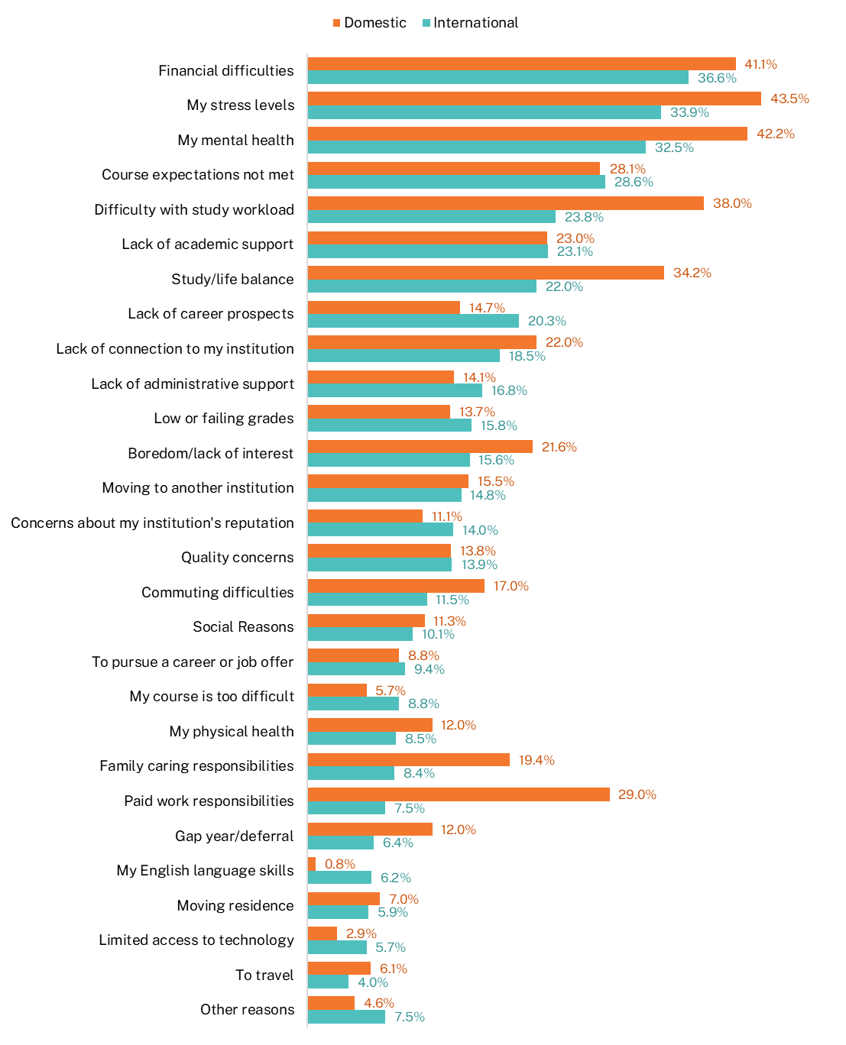

‘Financial difficulties’ were the most commonly cited reason for considering early departure among international postgraduate coursework students. The other frequently mentioned reasons included unmet course expectations, stress levels, and mental health (see Figure 21).
A notable difference between international and domestic students at the postgraduate level was the frequency of citing ‘lack of career prospects’ as a reason for considering leaving. In 2024, 24.5 per cent of international postgraduate coursework students selected this reason, compared to just 9.6 per cent of domestic students. This mirrors the undergraduate pattern, where 20.3 per cent of international students cited this reason, compared to 14.7 per cent of domestic students.
One possible explanation is that many domestic postgraduate students may be older and more likely to already have established connections to the labour market. As a result, they might be more inclined to study part-time or externally while maintaining existing jobs or professional networks. This could mean that this group feels more secure about their career paths and less reliant on their qualification to access relevant employment. In contrast, international students are often newer to the Australian job market and may face additional challenges, such as limited local experience, fewer professional connections, language or cultural barriers and visa-related employment restrictions. These factors might contribute to greater career uncertainty and more difficulty in accessing short-term employment outcomes.
In 2024, international postgraduate coursework students who had considered leaving were also less likely than domestic students to cite reasons such as ‘paid work responsibilities,’ ‘family caring responsibilities,’ ‘difficulty with study workload,’ ‘study/life balance,’ and ‘stress levels.’ These differences may again reflect the distinct life circumstances and responsibilities of international versus domestic students at the postgraduate level.

Figure 21 Reasons for considering early departure among postgraduate students by citizenship status, 2024 (% of those who had considered leaving)
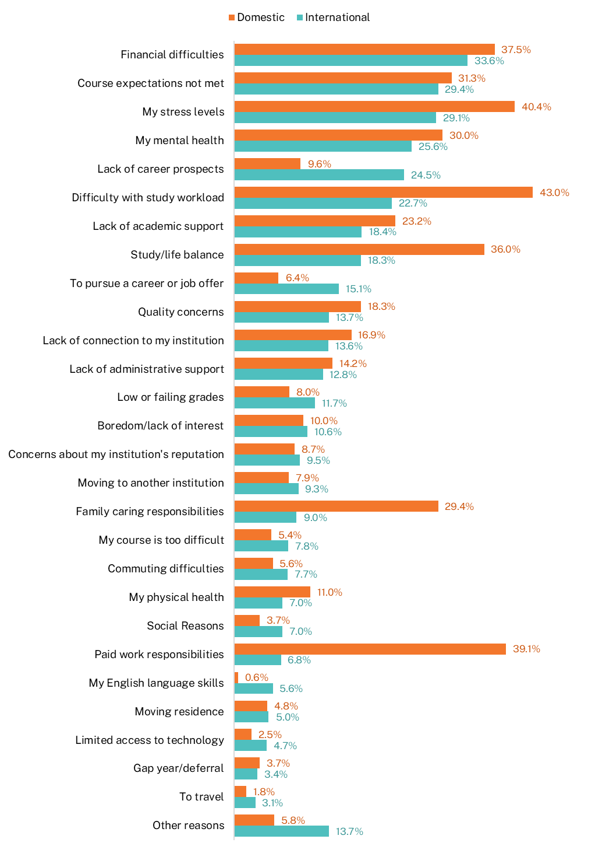

The living experience of international students in Australia
This section explores the living experience of international students in Australia and therefore excludes responses from those who were located overseas at the time of the survey. As outlined in Section 1.2, many international students were offshore between 2020 and 2022 due to COVID-19 travel restrictions. While their responses are not included in the analysis presented in this section, they are incorporated in other sections of the report.
International students generally rate their overall living experience in Australia very positively. As shown in Figure 22, 92.5 per cent of international undergraduates and 92.0 per cent of international postgraduate coursework students gave a positive rating for their living experience in 2024.
Figure 22 International student overall living experience by course level, 2020-2024 (% positive rating)
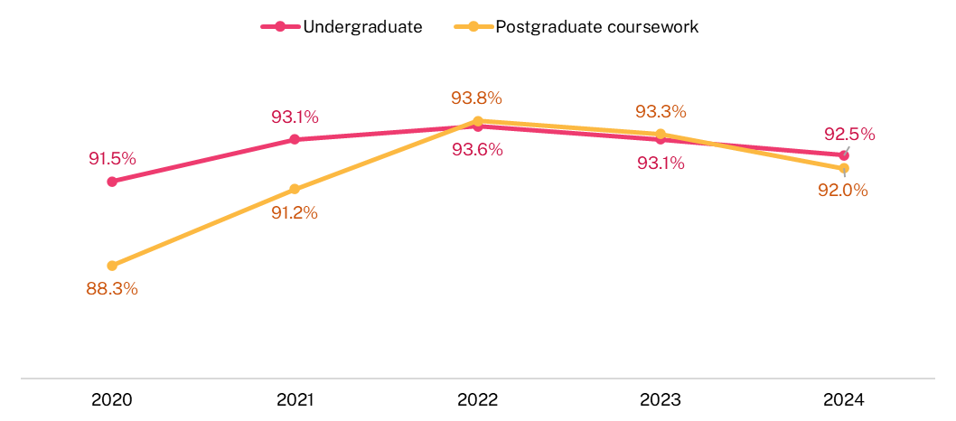

Figure 23 highlights how international students rated different aspects of their living experience in Australia. The highest-rated aspects at both undergraduate and postgraduate coursework levels were personal safety on campus, improving English skills, and personal safety off campus. In contrast, work experience received the lowest ratings from students in both groups, with postgraduate coursework students rating it 9.8 percentage points lower than undergraduates. Similarly, international postgraduate coursework students were less likely to rate employment while studying positively. Both of these lower-rated areas relate to employment and may reflect higher expectations and/or greater challenges faced by postgraduate students in finding meaningful work opportunities while studying.

Figure 23 International student living experience by course level, 2024 (% positive rating)
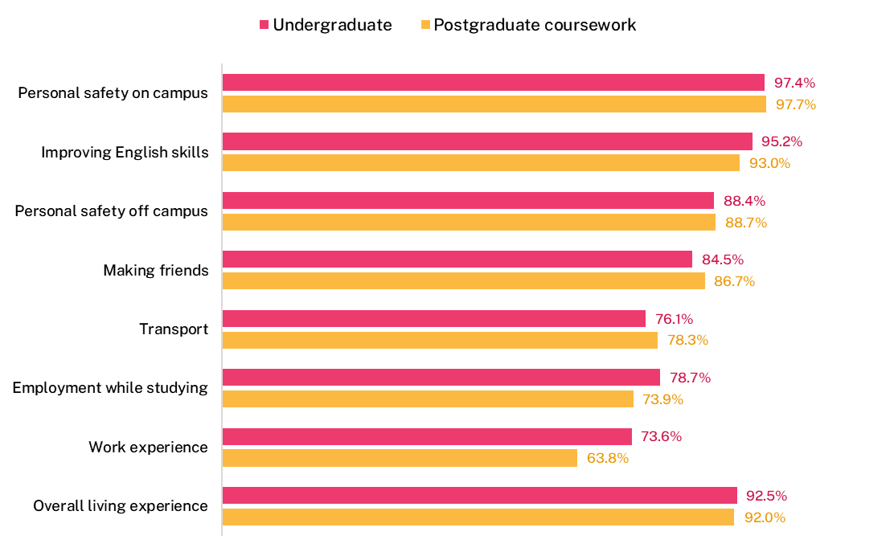

Table 1 presents satisfaction ratings from international undergraduate students from the top 5 source countries, focusing on various aspects of living in Australia. As noted earlier, these results are based solely on students who were residing in Australia at the time of the survey and exclude those who were offshore during the survey period.
Although overall satisfaction with living in Australia was high across all groups, there were some noticeable differences between countries. Students from China (excluding SARs and Taiwan) tended to rate most aspects of their living experience lower than students from the other major source countries, with the exception of Malaysia. In particular, students from China (excluding SARs and Taiwan) reported lower satisfaction with public transport and opportunities to improve their English skills.
In contrast, undergraduate students from Nepal gave consistently higher ratings across nearly all aspects of their living experience. They were especially positive about employment while studying, gaining work experience in their field, and making friends—suggesting perhaps a more positive integration into both academic and social life in Australia.
Table 1 International undergraduate student living experience by source country, 2024 (% positive rating)
 | Employment while studying | Improving English skills | Work experience in field of study | Transport | Personal safety on campus | Personal safety off campus | Making friends | Accommodation | Overall living experience
Nepal | 87.3 | 97.7 | 80.4 | 82.6 | 98.4 | 92.5 | 92.0 | 92.7 | 94.1
China (excludes SARs and Taiwan) | 74.6 | 90.5 | 73.0 | 66.1 | 95.4 | 81.3 | 82.3 | 89.8 | 90.4
India | 77.7 | 96.9 | 73.9 | 80.4 | 97.9 | 91.6 | 83.2 | 90.5 | 93.3
Vietnam | 80.1 | 96.3 | 76.5 | 75.7 | 97.6 | 89.2 | 87.8 | 92.4 | 92.9
Malaysia | 73.4 | 95.3 | 69.4 | 77.4 | 97.3 | 81.8 | 82.0 | 89.3 | 93.3
Total international | 78.7 | 95.2 | 73.6 | 76.1 | 97.4 | 88.4 | 84.5 | 90.1 | 92.5
Note: Source country in 2024 was based on E658 Residential address country code. Source countries shown in this figure represent the top 5 by number of survey respondents, ordered from top to bottom from largest to smallest.

Table 2 presents how international postgraduate coursework students from the top 5 source countries—ranked by number of survey responses—rated their living experience in Australia. As with the undergraduate results, postgraduate coursework students from China (excluding SARs and Taiwan) generally gave lower ratings across most aspects of their living experience compared to students from the other major source countries. One exception was work experience in their field of study, where students from Bhutan reported the lowest satisfaction, with only 55.2 per cent rating it positively.
Students from Bhutan also gave the lowest ratings for accommodation and overall living experience among the largest 5 respondent groups. In contrast, students from the Philippines reported the highest satisfaction across most aspects of living in Australia.
Table 2 International postgraduate coursework student living experience by source country, 2024 (% positive rating)
 | Employment while studying | Improving English skills | Work experience in field of study | Transport | Personal safety on campus | Personal safety off campus | Making friends | Accommodation | Overall living experience
China (excludes SARs and Taiwan) | 68.8 | 87.1 | 67.1 | 64.4 | 95.6 | 80.6 | 84.9 | 90.0 | 90.8
India | 75.2 | 96.5 | 62.6 | 82.2 | 98.6 | 91.9 | 86.7 | 91.2 | 92.9
Nepal | 80.6 | 96.2 | 65.7 | 83.1 | 98.9 | 90.8 | 92.4 | 91.7 | 92.7
Bhutan | 74.9 | 94.7 | 55.2 | 94.4 | 99.2 | 89.3 | 92.4 | 86.6 | 88.3
Philippines | 84.2 | 98.3 | 72.6 | 89.9 | 98.8 | 93.2 | 92.8 | 94.7 | 96.4
Total international | 73.9 | 93.0 | 63.8 | 78.3 | 97.7 | 88.7 | 86.7 | 90.0 | 92.0
Note: Source country in 2024 was based on E658 Residential address country code. Source countries shown in this figure represent the top 5 by number of survey respondents, ordered from top to bottom from largest to smallest.

Accommodation experience
International students continued to report high levels of satisfaction with their accommodation in Australia, with 90.1 per cent of undergraduates and 90.0 per cent of postgraduate coursework students rating this aspect positively in 2024, as shown in Figure 24.
Figure 24 International student accommodation experience, 2020-2024 (% positive rating)
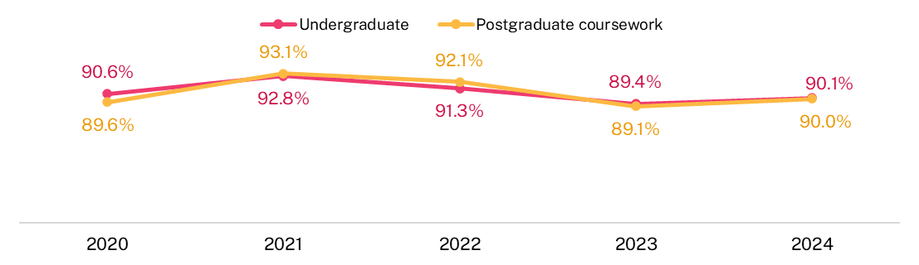
As shown in Table 3, in 2024, 17.2 per cent of international undergraduate students lived in purpose-built student accommodation (such as student residence managed by the universities, and private halls or student hostel). Just over half (53.9 per cent) of international undergraduate students lived in privately rented accommodation (such as a house, flat, room, or apartment). An additional 20.2 per cent were living with friends or relatives in their accommodation. Across all accommodation types, international undergraduates reported high levels of satisfaction with their living arrangements. The highest positive ratings came from students living with parents (94.8 per cent) and those living with friends or relatives in their accommodation (93.3 per cent). Students in private halls of residence reported the lowest satisfaction, though it remained relatively high at 84.7 per cent.
A similar pattern was observed among international postgraduate coursework students. The majority (65.8 per cent) lived in privately rented accommodation, followed by 16.3 per cent who lived with friends or relatives in their accommodation, and 12.6 per cent in purpose-built student accommodation. Satisfaction with private rentals was also high in this group, with 89.6 per cent reporting a positive experience. Students in private halls of residence reported the lowest satisfaction at 85.8 per cent, reflecting a similar pattern to that observed among international undergraduate students.

Table 3 International student living arrangements and positive ratings, 2024 (%)
 | Undergraduate % of students living in accommodation type | Undergraduate % positive rating of current living arrangements | Postgraduate coursework % of students living in accommodation type | Postgraduate coursework % positive rating of current living arrangements
Private rented house/flat/room | 53.9 | 89.4 | 65.8 | 89.6
With friends or relatives in their accommodation | 20.2 | 93.3 | 16.3 | 93.4
University or college halls of residence | 7.2 | 89.9 | 4.2 | 90.9
Private halls or student hostel | 5.4 | 84.7 | 4.9 | 85.8
Student house or flat controlled by university | 4.6 | 86.2 | 3.5 | 88.0
Homestay with a family not related to you | 4.5 | 89.0 | 3.9 | 88.0
Living with parents | 3.6 | 94.8 | 1.0 | 95.3
Other | 0.6 | 91.9 | 0.4 | 89.8
Privately rented houses, flats, or rooms were the most common type of accommodation among international undergraduate respondents across all major source countries in 2024 (Figure 25). Respondents from Nepal and India were notably more likely to live with friends or relatives in their accommodation—30.5 per cent and 27.5 per cent, respectively—compared to just 7.9 per cent of respondents from China (excluding SARs and Taiwan). In contrast, respondents from Malaysia and China (excluding SARs and Taiwan) were more likely to reside in purpose-built student accommodation, with 33.5 per cent and 25.7 per cent, respectively. This is higher than the proportions observed among respondents from India, Vietnam, Nepal, and the average across all source countries.
Among postgraduate coursework respondents, accommodation patterns also varied by country of origin (Figure 26). Respondents from Bhutan were the most likely to live in private rental housing (75.1 per cent), while those from China (excluding SARs and Taiwan) were the least likely to live with friends or relatives in their accommodation (5.9 per cent), compared to 33.4 per cent of respondents from the Philippines. However, postgraduate coursework respondents from China (excluding SARs and Taiwan) were more likely than others to live in private halls or student hostels, and more likely to reside in institution-managed student accommodation.

Figure 25 International undergraduate student accommodation arrangements by source country, 2024 (%)
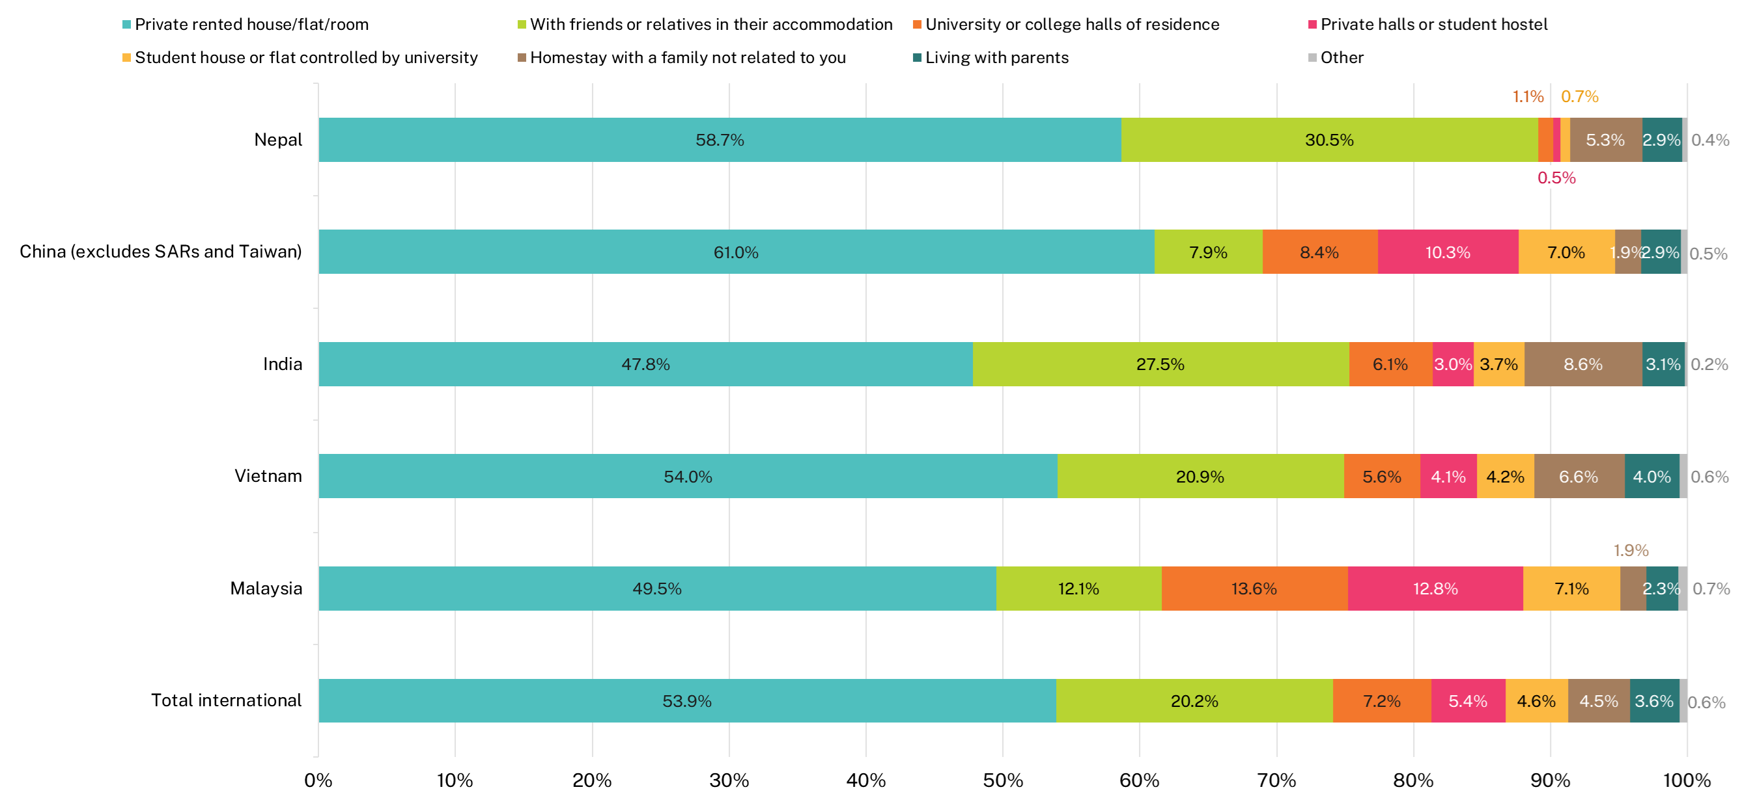
Note: Source country in 2024 was based on E658 Residential address country code. Source countries shown in this figure represent the top 5 by number of survey respondents, ordered from top to bottom from largest to smallest.

Figure 26 International postgraduate coursework student accommodation arrangements by source country, 2024 (%)
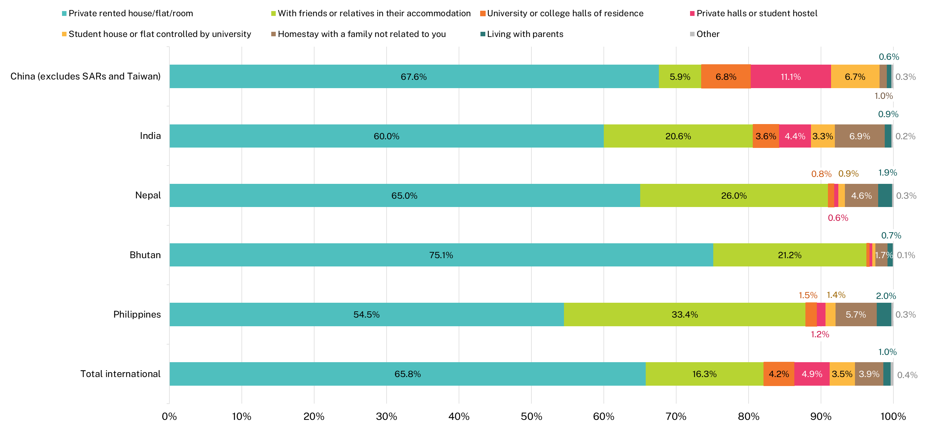
Note: Source country in 2024 was based on E658 Residential address country code. Source countries shown in this figure represent the top 5 by number of survey respondents, ordered from top to bottom from largest to smallest.

Use of agents
As shown in Figure 27, in 2024, the overwhelming majority of international undergraduate students—87.8 per cent—used an agent to assist with their visa application or enrolment at an institution when they came to Australia. Among those who used an agent, 93.6 per cent rated the service they received positively. The percent positive rating for the service provided by an agent represents the proportion of respondents who selected ‘Good’ or ‘Very good’ when asked ‘How would you rate the overall service provided by the agent?’.
Figure 27 Use of and satisfaction with an agent to help with visa application or enrolment by course level and source country, 2024 (% positive rating)
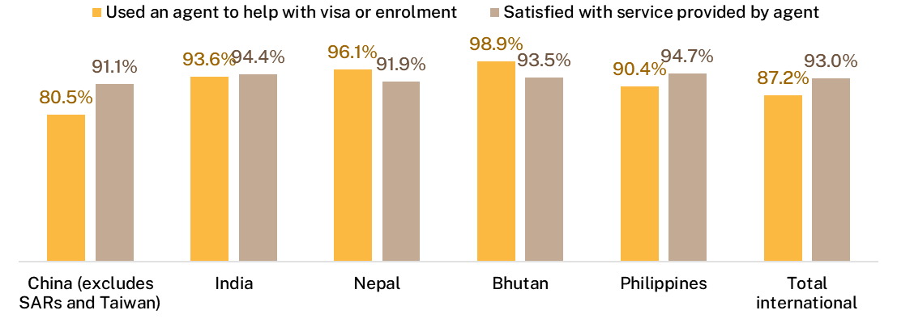
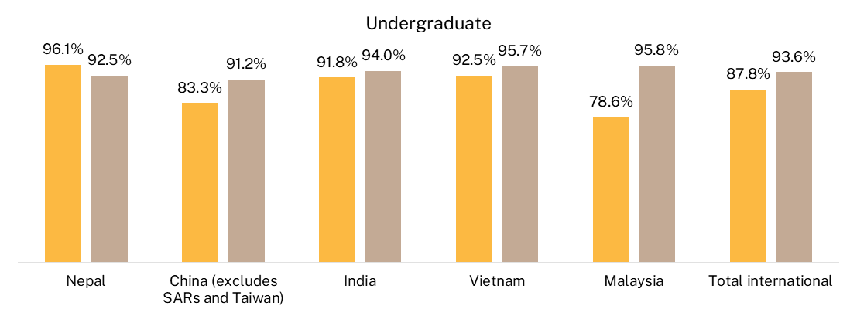
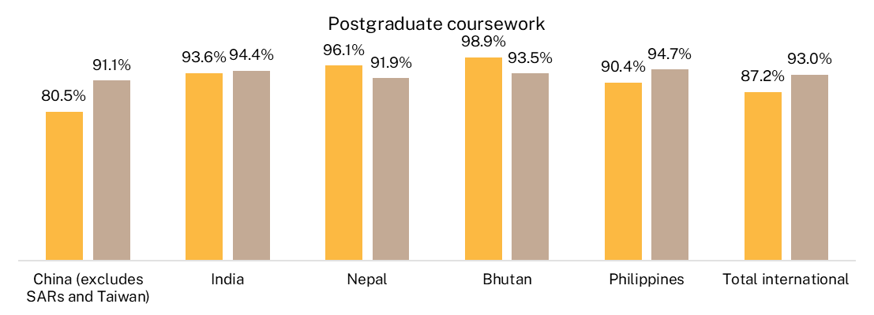
Note: Source country in 2024 was based on E658 Residential address country code. Source countries shown in this figure represent the top 5 by number of survey respondents, ordered from left to right from largest to smallest.

Factors in deciding where to study

Reasons for choosing to study in Australia
International students were asked to rate the importance of various factors in their decision to study in Australia, with key findings presented in Figure 28.
Personal safety and security emerged as the most important reason, cited as ‘extremely important’ or ‘important’ by 97.1 per cent of undergraduate and 97.7 per cent of postgraduate coursework students (Figure 28). Other highly rated factors included the cost of living, the reputation of Australia’s education system, the opportunity to study in an English-speaking country, and the chance to experience a new culture and lifestyle.
Figure 28 International student reasons for choosing to study in Australia by course level, 2024 (% importance rating)
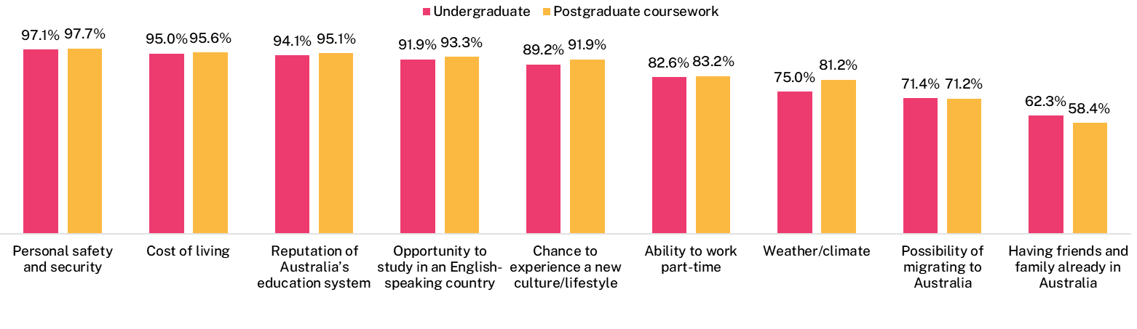
Personal safety and security was identified as the most important factor influencing the decision to study in Australia by undergraduate respondents from all 5 of the top source countries, as shown in Figure 29. While the importance of other factors varied across countries, the reputation of Australia’s education system and the cost of living were consistently rated as important.
There were notable differences between countries in the importance placed on having family and friends in Australia. This factor was rated lowest by respondents from Malaysia (49.3 per cent) and China (excluding SARs and Taiwan) (50.5 per cent), compared to a much higher rating from students from Nepal (84.3 per cent). Similarly, views on the ability to work part-time varied significantly: only 65.0 per cent of undergraduate respondents from China (excluding SARs and Taiwan) considered it highly important, compared to 96.1 per cent from Nepal and 89.3 per cent from India.
A similar pattern was observed among postgraduate coursework students. The greatest variation between countries was again in the importance of having friends and family in Australia, with a 43.3 percentage point gap between respondents from China (excluding SARs and Taiwan) (42.2 per cent) and those from Bhutan (85.5 per cent). The possibility of migrating to Australia was rated as important by 91.3 per cent of students from the Philippines, compared to just 53.8 per cent of students from China (excluding SARs and Taiwan). The ability to work part-time also showed wide variation, with 96.8 per cent of students from Nepal and 96.1 per cent from Bhutan rating it as important, compared to only 61.8 per cent of students from China (excluding SARs and Taiwan).
Figure 29 International student reasons for choosing to study in Australia by source country, 2024 (% importance rating)
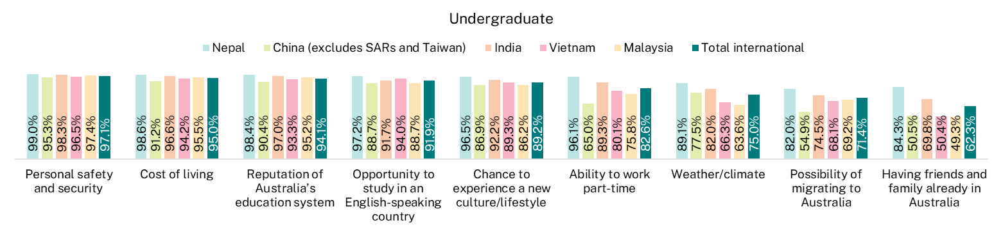
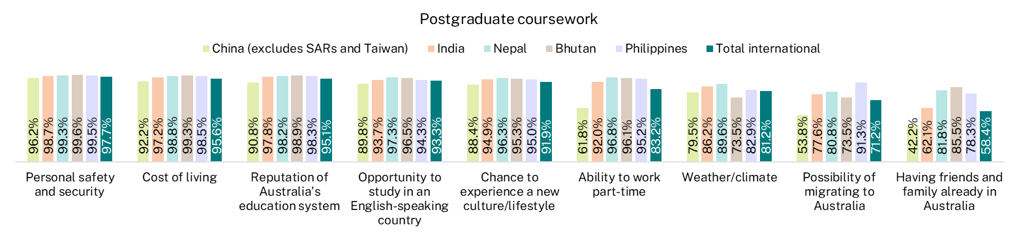
Note: Source country in 2024 was based on E658 Residential address country code. Source countries shown in this figure represent the top 5 by number of survey respondents, ordered from left to right from largest to smallest.

Reasons for choosing to study at current institution
International students studying in Australia were asked to rate the importance of various factors in their decision to apply to their current institution. As shown in Figure 30, the most important reasons cited included the institution offering the desired course, the reputation of the qualification, employment opportunities after graduation, and the reputation of the education provider. Each of these factors was rated as either extremely important or important by at least 95 per cent of students at both undergraduate and postgraduate coursework levels. The least important factor was whether the institution had a partnership with the student’s local institution, with only 66.9 per cent of international undergraduates and 63.8 per cent of postgraduate coursework students rating it as important.
Figure 30 International student reasons for choosing current institution by course level, 2024 (% importance rating)
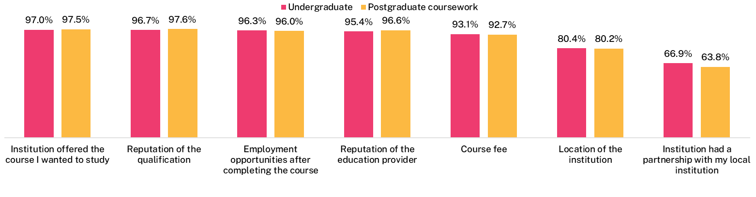
Ratings of important factors when choosing an institution were generally consistent across the top 5 source countries in terms of the order of importance as shown in Figure 31.
Similar to the reasons for choosing to study in Australia, students from India and Nepal tended to place greater importance on most factors compared to students from other countries. This was especially true for Nepalese students, who rated having a partnership with a local institution significantly higher—at 82.2 per cent—than students from the other major source countries. While respondents from China (excluding SARs and Taiwan) undergraduates tended to assign slightly lower importance to many factors, their ratings were still relatively high. For instance, although they were less likely to rate employment opportunities after course completion as a key reason for choosing their institution, 92.0 per cent still considered it important.
Among postgraduate coursework students, the pattern was similar, with most factors rated as important across all source countries. However, some differences emerged. Respondents from Nepal and Bhutan placed much higher importance on having a partnership with a local institution compared to students from other major source countries. Another notable difference was in the importance placed on course fees: respondents from China (excluding SARs and Taiwan) were less likely to rate this factor as important, with 88.4 per cent doing so, compared to over 96 per cent among respondents from the other top source countries.
Figure 31 International student reasons for choosing to study at current institution by source country, 2024 (% importance rating)
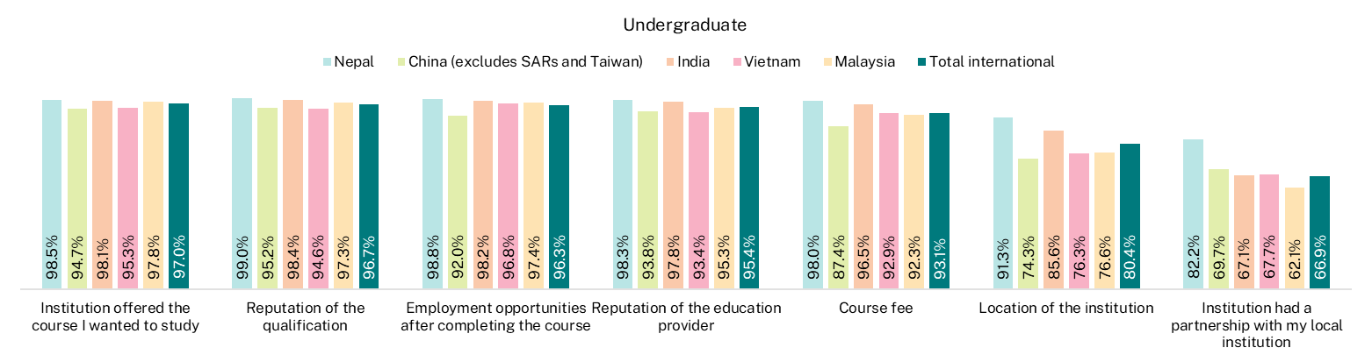
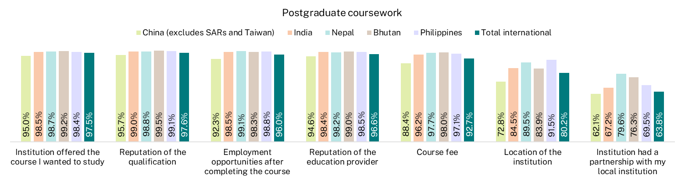
Note: Source country in 2024 was based on E658 Residential address country code. Source countries shown in this figure represent the top 5 by number of survey respondents, ordered from left to right from largest to smallest.

- SES focus area items
- Skills Development
This focus area asks students to reflect on the extent to which their course developed their skills and knowledge in eight areas, using a scale from 'not at all' to 'very much'.
To what extent has your (course) developed your:
- Critical thinking skills
- Ability to solve complex problems
- Ability to work with others
- Confidence to learn independently
- Written communication skills
- Spoken communication skills
- Knowledge of field(s) studying
- Development of work-related knowledge and skills.

- Peer Engagement (formerly Learner Engagement)
This focus area asks students to indicate how frequently they engage with other students inside and outside formal study, using a scale from ‘never’ to ‘always’.
The underlying items for this focus area are how frequently they have:
- Contributed to class discussion (e.g. in-person discussions, online chat forums, discussion boards)
- Worked with other students as part of your <course> (e.g. group assignments, in-class collaboration)
- Interacted socially with other students outside of your study
- Interacted with a diverse range of students.

- Teaching Quality and Engagement (formerly Teaching Quality)
This focus area asks students to rate the quality of their entire educational experience (i.e. Overall Educational Experience) and the quality of teaching, ranging from fair to excellent. It also asks students to evaluate the relevance and focus of their course to their education, as well as the extent to which academic staff undertake certain actions, from ‘not at all’ to ‘very much’.
The items are:
- Course well-structured and focused
- Course relevant to education as a whole
- Teachers engaged you actively in learning
- Teachers demonstrated concern for student learning
- Teachers provided clear explanations on coursework and assessment
- Teachers stimulated you intellectually
- Teachers commented on your work in ways that help you learn
- Teachers seemed helpful and approachable
- Teachers set assessment tasks that challenge you to learn
- Overall quality of teaching
- Overall quality of entire educational experience.
- Student Support and Services (formerly Student Support)
This focus area asks students to rate the helpfulness of various supports and services provided by their institution, ranging from ‘not at all helpful’ to ‘very helpful’, with an option for 'Not Used' for those who did not utilise the support services.
How helpful have you found the following supports and services provided by your institution during <survey year>:
- Enrolment process and support
- Induction/orientation activities
- Online learning platform
- Career development services
- Study or learning support services
- Counsellors and/or health services
- Financial and/or legal advisors.

- Learning Resources
The Learning Resources focus area asks students to rate the quality of various learning resources provided by the institution, ranging from ‘poor’ to ‘excellent’.
The items relate to the quality of:
- Teaching spaces
- Student spaces and common areas
- Online learning materials
- Computing/it resources
- Assigned books, notes and resources
- Laboratory or studio equipment
- Library resources and facilities.

- Overall Educational Experience
The Overall Educational Experience is a stand-alone item which asks students to think about their course this year and to rate the quality of their entire educational experience on a four-point scale from ‘poor’ to ‘excellent’.

- Detailed tables
Table 4 International undergraduate student education experience by source country, 2022-2024 (% positive rating)
 | Skills Development 2022 | Skills Development 2023 | Skills Development 2024 | Peer Engagement* 2022 | Peer Engagement* 2023 | Peer Engagement* 2024 | Teaching Quality and Engagement 2022 | Teaching Quality and Engagement 2023 | Teaching Quality and Engagement 2024 | Student Support and Services* 2022 | Student Support and Services* 2023 | Student Support and Services* 2024 | Learning Resources 2022 | Learning Resources 2023 | Learning Resources 2024 | Overall Educational Experience 2022 | Overall Educational Experience 2023 | Overall Educational Experience 2024
Nepal | 84.3 | 84.9 | 85.7 | 65.9 | 77.6 | 80.2 | 81.7 | 83.9 | 83.2 | 79.5 | 79.7 | 79.0 | 80.0 | 78.3 | 77.9 | 76.1 | 78.1 | 76.0
China (excludes SARs and Taiwan) | 78.4 | 78.7 | 78.2 | 58.6 | 64.6 | 65.3 | 79.0 | 79.5 | 79.2 | 71.6 | 74.5 | 74.1 | 87.7 | 87.7 | 88.5 | 74.1 | 72.9 | 72.2
India | 87.6 | 88.4 | 87.7 | 71.6 | 77.6 | 80.2 | 83.8 | 85.6 | 85.1 | 83.2 | 83.9 | 82.7 | 87.7 | 88.3 | 86.5 | 77.8 | 80.5 | 79.9
Vietnam | 79.7 | 81.6 | 83.5 | 60.4 | 67.2 | 71.7 | 77.9 | 81.4 | 82.5 | 73.5 | 78.5 | 80.0 | 80.1 | 83.7 | 84.5 | 70.0 | 72.1 | 73.3
Malaysia | 81.5 | 86.5 | 83.6 | 57.2 | 66.5 | 68.8 | 79.2 | 84.0 | 81.1 | 72.5 | 80.1 | 77.0 | 81.1 | 84.9 | 84.0 | 70.0 | 74.9 | 73.7
Total international | 81.8 | 83.4 | 83.7 | 61.5 | 69.5 | 72.2 | 80.2 | 82.5 | 81.9 | 75.0 | 78.1 | 77.5 | 83.8 | 84.5 | 83.0 | 74.4 | 75.8 | 74.9
Note: Source country was derived from E346 Country of birth prior to 2024. From 2024, source country was based on E658 Residential address country code. Source countries shown in this table represent the top 5 by number of survey respondents, ordered from largest to smallest.
* Prior to 2023, the Peer Engagement focus area was named Learner Engagement and Student Support and Services, was previously the Student Support focus area. This table should be used to compare the cohort responses but year on year comparisons between 2022 and 2023 should be treated with caution.

Table 5 International postgraduate coursework student education experience by source country, 2022-2024 (% positive rating)
 | Skills Development 2022 | Skills Development 2023 | Skills Development 2024 | Peer Engagement* 2022 | Peer Engagement* 2023 | Peer Engagement* 2024 | Teaching Quality and Engagement 2022 | Teaching Quality and Engagement 2023 | Teaching Quality and Engagement 2024 | Student Support and Services* 2022 | Student Support and Services* 2023 | Student Support and Services* 2024 | Learning Resources 2022 | Learning Resources 2023 | Learning Resources 2024 | Overall Educational Experience 2022 | Overall Educational Experience 2023 | Overall Educational Experience 2024
China (excludes SARs and Taiwan) | 81.5 | 80.7 | 81.0 | 58.7 | 67.6 | 70.2 | 81.9 | 79.8 | 80.1 | 74.7 | 75.0 | 74.5 | 88.6 | 88.1 | 88.0 | 77.7 | 72.6 | 71.3
India | 88.0 | 88.6 | 88.8 | 70.6 | 81.0 | 83.5 | 84.8 | 86.3 | 85.6 | 83.4 | 85.9 | 84.9 | 88.8 | 90.1 | 90.0 | 79.5 | 79.3 | 78.8
Nepal | 84.2 | 85.5 | 86.5 | 63.8 | 80.3 | 81.3 | 83.6 | 85.2 | 84.7 | 78.5 | 80.3 | 80.4 | 80.2 | 80.4 | 82.6 | 74.7 | 77.1 | 74.9
Bhutan | 90.7 | 89.1 | 88.0 | 67.8 | 77.9 | 79.5 | 90.7 | 91.1 | 89.7 | 85.6 | 89.2 | 86.7 | 88.0 | 92.9 | 90.4 | 86.1 | 84.4 | 80.8
Philippines | 93.4 | 93.6 | 92.1 | 69.0 | 76.5 | 81.4 | 91.5 | 90.9 | 89.4 | 88.4 | 86.9 | 84.5 | 90.5 | 90.3 | 87.1 | 85.0 | 85.5 | 84.1
Total international | 84.1 | 85.5 | 86.0 | 62.2 | 74.3 | 77.7 | 82.6 | 84.1 | 84.1 | 76.9 | 80.4 | 80.3 | 86.4 | 87.7 | 87.3 | 76.9 | 77.0 | 76.3
Note: Source country was derived from E346 Country of birth prior to 2024. From 2024, source country was based on E658 Residential address country code. Source countries shown in this table represent the top 5 by number of survey respondents, ordered from largest to smallest.
* Prior to 2023, the Peer Engagement focus area was named Learner Engagement and Student Support and Services, was previously the Student Support focus area. This table should be used to compare the cohort responses but year on year comparisons between 2022 and 2023 should be treated with caution.

Table 6 International undergraduate student rating by focus area and study area, 2022-2024 (% positive rating)
 | Skills Development 2022 | Skills Development 2023 | Skills Development 2024 | Peer Engagement 2022 | Peer Engagement 2023 | Peer Engagement 2024 | Teaching Quality and Engagement 2022 | Teaching Quality and Engagement 2023 | Teaching Quality and Engagement 2024 | Student Support and Services 2022 | Student Support and Services 2023 | Student Support and Services 2024 | Learning Resources 2022 | Learning Resources 2023 | Learning Resources 2024 | Overall Educational Experience 2022 | Overall Educational Experience 2023 | Overall Educational Experience 2024
Agriculture and environmental studies | 80.5 | 82.5 | 82.6 | 55.7 | 66.1 | 62.3 | 86.9 | 88.0 | 82.6 | 75.4 | 85.0 | 79.4 | 89.7 | 91.5 | 86.3 | 77.9 | 81.4 | 74.3
Architecture and built environment | 79.5 | 80.5 | 81.8 | 62.9 | 68.3 | 68.2 | 77.8 | 80.1 | 82.0 | 70.1 | 71.2 | 68.5 | 82.2 | 81.2 | 81.8 | 70.2 | 71.1 | 70.4
Business and management | 82.1 | 83.4 | 83.6 | 62.6 | 71.5 | 74.0 | 81.7 | 83.8 | 83.2 | 77.3 | 81.0 | 79.9 | 85.3 | 86.1 | 84.8 | 77.3 | 77.4 | 75.8
Communications | 83.4 | 85.1 | 82.3 | 64.7 | 69.5 | 73.3 | 85.6 | 83.7 | 83.2 | 73.6 | 76.2 | 75.3 | 87.6 | 86.5 | 86.1 | 78.7 | 76.8 | 75.7
Computing and information systems | 78.3 | 77.5 | 77.5 | 60.4 | 68.5 | 72.3 | 77.2 | 78.6 | 76.3 | 75.3 | 76.4 | 74.9 | 81.5 | 82.8 | 79.2 | 72.8 | 71.0 | 68.3
Creative arts | 80.1 | 82.5 | 84.1 | 57.1 | 65.9 | 65.3 | 83.1 | 83.9 | 83.5 | 72.6 | 73.4 | 75.0 | 83.9 | 85.0 | 83.5 | 74.9 | 75.6 | 75.1
Dentistry | 82.5 | 86.3 | 86.4 | 61.3 | 63.2 | 63.2 | 70.2 | 73.5 | 84.9 | 68.1 | 58.7 | 72.1 | 74.3 | 72.8 | 83.2 | 71.7 | 65.8 | 77.4
Engineering | 80.6 | 81.2 | 82.2 | 62.2 | 68.7 | 71.2 | 76.9 | 78.1 | 79.4 | 73.1 | 75.0 | 76.5 | 84.5 | 85.6 | 87.1 | 70.6 | 71.8 | 73.0
Health services and support | 82.8 | 86.1 | 86.3 | 59.0 | 68.4 | 71.1 | 83.8 | 85.9 | 86.2 | 76.6 | 81.5 | 80.9 | 84.9 | 88.0 | 84.9 | 76.7 | 79.1 | 80.6
Humanities, culture and social sciences | 79.1 | 81.9 | 84.0 | 58.6 | 65.3 | 65.0 | 81.6 | 82.8 | 85.0 | 70.8 | 73.8 | 73.4 | 86.0 | 88.3 | 88.4 | 72.7 | 74.2 | 76.4
Law and paralegal studies | 80.4 | 83.3 | 83.5 | 56.9 | 59.7 | 55.5 | 79.9 | 80.6 | 75.9 | 70.1 | 75.3 | 73.0 | 76.5 | 81.7 | 83.7 | 73.1 | 72.4 | 74.7
Medicine | 82.4 | 85.0 | 86.2 | 64.3 | 76.3 | 76.0 | 75.0 | 79.3 | 78.0 | 71.9 | 70.4 | 65.2 | 73.9 | 73.6 | 72.8 | 72.1 | 73.7 | 74.0
Nursing | 85.9 | 89.3 | 89.9 | 63.3 | 70.5 | 72.6 | 79.2 | 84.6 | 84.8 | 77.4 | 83.4 | 84.1 | 84.8 | 87.8 | 87.3 | 73.4 | 80.9 | 80.6
Pharmacy | 85.8 | 87.3 | 87.4 | 67.1 | 66.8 | 70.3 | 82.5 | 80.8 | 82.6 | 75.4 | 72.4 | 74.6 | 82.1 | 79.0 | 80.0 | 75.7 | 74.6 | 75.9
Psychology | 81.8 | 81.7 | 84.3 | 54.2 | 56.3 | 58.2 | 81.1 | 82.1 | 85.0 | 73.5 | 76.7 | 80.1 | 83.4 | 84.3 | 87.3 | 74.4 | 73.7 | 77.6
Rehabilitation | 83.3 | 84.5 | 79.4 | 56.9 | 68.4 | 69.4 | 79.1 | 77.7 | 74.3 | 68.6 | 67.7 | 70.7 | 78.7 | 79.6 | 74.9 | 72.3 | 74.0 | 69.4
Science and mathematics | 80.7 | 80.2 | 80.6 | 57.3 | 63.5 | 63.2 | 80.5 | 82.1 | 81.2 | 72.4 | 75.8 | 74.9 | 87.8 | 89.5 | 88.2 | 73.6 | 74.2 | 72.5
Social work | 90.0 | 90.8 | 88.5 | 70.4 | 80.0 | 84.7 | 85.3 | 87.0 | 82.7 | 78.9 | 78.7 | 73.2 | 76.3 | 72.6 | 69.4 | 77.3 | 78.6 | 75.2
Teacher education | 83.6 | 88.2 | 89.5 | 63.6 | 76.6 | 81.6 | 78.7 | 84.0 | 85.3 | 71.6 | 77.2 | 79.5 | 73.9 | 74.4 | 76.6 | 70.8 | 78.4 | 80.0
Tourism, hospitality, personal services, sport and recreation | 74.2 | 85.1 | 88.4 | 59.2 | 75.0 | 86.7 | 77.1 | 91.8 | 91.6 | 79.6 | 84.7 | 83.6 | 85.9 | 85.8 | 82.4 | 76.5 | 85.7 | 82.1
Veterinary science | 84.5 | 86.3 | 78.0 | 63.2 | 59.4 | 58.8 | 82.1 | 84.8 | 79.7 | 71.0 | 70.5 | 64.1 | 91.1 | 78.1 | 80.8 | 78.6 | 84.0 | 74.0
Total | 81.8 | 83.4 | 83.7 | 61.5 | 69.5 | 72.2 | 80.2 | 82.5 | 81.9 | 75.0 | 78.1 | 77.5 | 83.8 | 84.5 | 83.0 | 74.4 | 75.8 | 74.9

Table 7 International postgraduate coursework student rating by focus area and study area, 2022-2024 (% positive rating)
 | Skills Development 2022 | Skills Development 2023 | Skills Development 2024 | Peer Engagement 2022 | Peer Engagement 2023 | Peer Engagement 2024 | Teaching Quality and Engagement 2022 | Teaching Quality and Engagement 2023 | Teaching Quality and Engagement 2024 | Student Support and Services 2022 | Student Support and Services 2023 | Student Support and Services 2024 | Learning Resources 2022 | Learning Resources 2023 | Learning Resources 2024 | Overall Educational Experience 2022 | Overall Educational Experience 2023 | Overall Educational Experience 2024
Agriculture and environmental studies | 87.0 | 89.7 | 87.4 | 63.0 | 74.9 | 73.1 | 87.5 | 88.1 | 87.1 | 80.7 | 84.6 | 83.9 | 90.5 | 92.4 | 92.5 | 80.9 | 80.9 | 77.2
Architecture and built environment | 85.8 | 86.1 | 84.8 | 66.2 | 77.8 | 76.3 | 83.6 | 83.4 | 81.0 | 72.4 | 76.5 | 75.3 | 84.9 | 84.9 | 86.3 | 77.3 | 75.8 | 73.1
Business and management | 85.4 | 86.2 | 87.3 | 64.6 | 77.2 | 81.2 | 85.2 | 86.1 | 86.2 | 80.8 | 83.2 | 82.7 | 87.4 | 87.7 | 87.2 | 80.9 | 79.8 | 78.7
Communications | 88.9 | 85.0 | 86.4 | 63.5 | 74.8 | 77.9 | 87.0 | 88.3 | 86.2 | 80.6 | 79.8 | 77.6 | 91.7 | 92.5 | 91.4 | 82.9 | 79.2 | 74.6
Computing and information systems | 80.7 | 81.6 | 82.5 | 60.5 | 72.9 | 77.3 | 77.6 | 79.4 | 79.8 | 75.3 | 79.0 | 79.4 | 85.1 | 86.5 | 85.5 | 72.2 | 71.9 | 72.4
Creative arts | 82.2 | 84.0 | 86.6 | 56.7 | 70.9 | 76.1 | 85.9 | 83.7 | 86.4 | 75.4 | 72.6 | 72.2 | 87.9 | 87.3 | 87.2 | 81.8 | 75.8 | 75.3
Dentistry | 70.8 | 75.0 | 80.7 | 50.6 | 60.5 | 70.7 | 46.1 | 56.3 | 60.3 | 41.7 | 38.9 | 40.9 | 48.8 | 52.8 | 54.4 | 40.4 | 50.6 | 56.9
Engineering | 84.3 | 86.2 | 86.0 | 63.8 | 76.1 | 77.9 | 82.6 | 84.5 | 84.2 | 76.4 | 81.8 | 81.8 | 89.4 | 91.4 | 91.2 | 78.2 | 76.6 | 75.2
Health services and support | 84.9 | 88.4 | 90.2 | 59.0 | 71.2 | 74.6 | 83.3 | 86.3 | 88.4 | 77.5 | 81.8 | 83.6 | 86.3 | 89.1 | 88.0 | 75.6 | 77.0 | 80.1
Humanities, culture and social sciences | 87.6 | 89.6 | 89.3 | 62.2 | 75.9 | 77.7 | 89.5 | 90.2 | 90.7 | 77.3 | 83.6 | 84.0 | 90.5 | 91.5 | 92.9 | 80.9 | 83.8 | 82.3
Law and paralegal studies | 81.1 | 81.9 | 85.7 | 50.7 | 57.8 | 66.2 | 79.2 | 83.0 | 86.1 | 68.0 | 72.0 | 74.2 | 84.9 | 86.6 | 87.8 | 70.0 | 75.6 | 76.7
Medicine | 82.1 | 81.1 | 80.6 | 67.5 | 70.0 | 74.7 | 65.0 | 68.7 | 67.1 | 59.3 | 61.3 | 54.4 | 68.3 | 66.0 | 66.4 | 61.6 | 68.8 | 64.7
Nursing | 84.5 | 87.5 | 88.1 | 61.6 | 68.4 | 70.3 | 78.1 | 81.6 | 83.4 | 75.8 | 81.7 | 82.9 | 83.7 | 85.9 | 88.8 | 72.6 | 75.9 | 77.6
Pharmacy | 85.1 | 87.4 | 89.2 | 77.6 | 79.1 | 81.7 | 81.6 | 80.6 | 83.7 | 84.4 | 76.4 | 83.6 | 93.5 | 87.9 | 88.0 | 73.5 | 68.5 | 71.9
Psychology | 90.7 | 88.8 | 88.6 | 62.2 | 66.8 | 69.9 | 86.4 | 87.3 | 87.3 | 71.1 | 70.9 | 73.1 | 85.1 | 83.6 | 85.7 | 80.0 | 81.7 | 77.0
Rehabilitation | 81.7 | 83.6 | 79.3 | 71.1 | 71.0 | 72.4 | 78.0 | 72.0 | 71.9 | 70.4 | 63.9 | 57.7 | 77.5 | 78.5 | 80.1 | 70.0 | 65.3 | 64.3
Science and mathematics | 86.6 | 85.2 | 85.8 | 62.2 | 68.8 | 72.9 | 86.4 | 85.0 | 85.4 | 79.6 | 79.5 | 80.5 | 91.4 | 91.0 | 90.8 | 80.7 | 77.3 | 77.6
Social work | 82.3 | 87.3 | 87.4 | 60.2 | 76.5 | 80.0 | 78.6 | 83.9 | 81.7 | 69.4 | 77.5 | 76.7 | 78.7 | 86.1 | 82.5 | 67.2 | 76.0 | 73.2
Teacher education | 82.7 | 86.6 | 84.6 | 56.0 | 71.0 | 72.5 | 81.4 | 82.0 | 81.9 | 73.7 | 77.4 | 76.0 | 86.2 | 84.9 | 85.1 | 73.2 | 74.6 | 75.5
Tourism, hospitality, personal services, sport and recreation | 76.6 | 85.9 | 87.3 | 67.2 | 80.3 | 83.8 | 81.3 | 85.9 | 87.5 | 70.5 | 86.4 | 85.7 | 86.0 | 88.6 | 95.0 | 78.1 | 83.1 | 73.8
Veterinary science | 88.2 | 82.7 | 91.9 | 64.5 | 63.3 | 77.0 | 80.3 | 68.4 | 79.7 | 50.0 | 44.4 | 56.0 | 79.5 | 79.4 | 77.5 | 60.5 | 55.1 | 66.2
Total | 84.1 | 85.5 | 86.0 | 62.2 | 74.3 | 77.7 | 82.6 | 84.1 | 84.1 | 76.9 | 80.4 | 80.3 | 86.4 | 87.7 | 87.3 | 76.9 | 77.0 | 76.3

The Social Research Centre Pty Ltd
Level 5, 350 Queen Street, Melbourne VIC 3000
PO Box 13328, Law Courts VIC 8010
03 9236 8500 | info@srcentre.com.au
srcentre.com.au
The version of this publication is aimed to assist those with various
vision impairments; however, The Social Research Centre and its
employees do not guarantee that the publication meets all broad
accessibility standards and therefore disclaim all liability for any
inconvenience or other consequence that may arise from readers
relying on this publication. Please contact The Social Research
Centre if you require further assistance.


Based on survey item
This report discusses the characteristics of international students who responded to the survey. Demographic and course characteristics of the responding international population closely matched the total international population of students eligible to take part in the 2024 SES. However, international students from China had a lower propensity to respond to the survey at both the undergraduate and postgraduate coursework level than students from other source countries. Detailed analysis of students’ propensity to respond to the 2024 SES are discussed in the SES Methodological Report available from the QILT website.
International students are identified by the Tertiary Collection of Student Information (TCSI) derived data element Citizenship indicator (E942), with a value of 1 – ‘Overseas’.
The proportions of students from different source countries in this section are based on responses to the 2024 SES, not the total international student population. For example, students from China (excluding SARs and Taiwan) represent a larger share of the overall undergraduate international student population but tend to respond to the survey at lower rates. See the 2024 SES Methodological Report, available on the QILT website for further information.
The Support for Students Policy is an Australian Government requirement for higher education providers to ensure students have access to academic and non-academic support services. It aims to help students progress in and complete their studies. Providers must publish and annually review their support policies, and report on their implementation. For more information, see the Australian Government Department of Education’s Support for Students Policy: https://www.education.gov.au/support-students-policy
The Australian University of Theology was awarded university status in December 2024. Prior to this, the institution was known as the Australian College of Theology and was classified as a non-university higher education institution (NUHEI). Data for the 2024 SES was collected when the institution was a NUHEI.
Allen, K. A., Kern, M. L., Rozek, C. S., McInerney, D. M., & Slavich, G. M. (2021). Belonging: a review of conceptual issues, an integrative framework, and directions for future research. Australian Journal of Psychology, 73(1), 87–102. https://doi.org/10.1080/00049530.2021.1883409
Crawford, J., Allen, K. A., Sanders, T., Baumeister, R., Parker, P., Saunders, C., & Tice, D. (2024). Sense of belonging in higher education students: an Australian longitudinal study from 2013 to 2019. Studies in Higher Education, 49(3), 395–409. https://doi.org/10.1080/03075079.2023.2238006

