2024 Student Experience Survey
National Report – Accessible
SEPTEMBER 2025

Acknowledgements
The Quality Indicators for Learning and Teaching (QILT) survey program, including the Student Experience Survey (SES), is funded by the Australian Government Department of Education (the Department).
The Department and The Social Research Centre acknowledge the Traditional Owners and Custodians of the lands and waters on which this research was conducted. We pay our respects to them, their cultures and Elders past, present and emerging.
The Social Research Centre would like to thank the higher education institutions that contributed to the SES in 2024. Without the enthusiastic and committed assistance of the survey managers and institutional planners, the 2024 SES would not have been such a success.
We are also very grateful to the students who took the time to provide valuable feedback about their student experience. The SES data will be used by institutions for benchmarking and continuous improvement and will assist prospective students to make informed decisions about future study.
The 2024 SES was led by Graham Challice and the project team consisted of Lisa Bolton, Lauren Spencer, Cynthia Kim, Diana Nguyen, Vicky Tong, Gabriel Ong, Hannah Madison, Emmanuel Mnatzaganian, Rahul Bet, Rawan Habibeh, Joe Feng, Anthony Begovic, Columbia Winterton and Serena Kim.
For more information on the conduct and results of the 2024 SES including institutional response rates and data representativeness, see the 2024 SES Methodological Report and related tables on the QILT website. The QILT team can be contacted by email at qilt@srcentre.com.au.

Terminology
‘First Nations’
In recognition of the national scope of this research, this report uses the term ‘First Nations’ to encompass both Aboriginal and Torres Strait Islander peoples.
We deeply respect the rich diversity of communities, identities and clans among First Nations peoples and acknowledge there may be preferences to be known by a specific group name or Country, or as Traditional Owners and Custodians.
The terminology used in this report reflects a considered and deliberate approach to be inclusive by using ‘non-Indigenous students’ when referring to students who do not identify as an Aboriginal and/or Torres Strait Islander person in Australia. This does not infer any disrespect to those who identify as an Indigenous person from another country.

Executive summary
The Student Experience Survey (SES) is one of four surveys in the Quality Indicators for Learning and Teaching (QILT) program. The SES provides a national framework for collecting data on the key aspects of the higher education student experience. These key aspects are referred to in the SES as focus areas and they are:
- Skills Development: Evaluates how students have developed their skills and knowledge in eight areas, including foundational, collaborative, and adaptive skills.
- Peer Engagement: Assesses the frequency of student interactions with peers inside or outside formal study.
- Teaching Quality and Engagement: Rates the relevance and focus of courses, overall teaching quality, and academic staff actions such as engaging students and providing feedback.
- Student Support and Services: Measures the helpfulness of various supports and services provided by institutions, including administrative, career development, health, and financial services.
- Learning Resources: Evaluates the quality of learning resources in seven areas, including teaching spaces, equipment, and learning materials.
The SES also measures the Overall Educational Experience which is a stand-alone item in the survey. Overall Educational Experience is closely related to students’ ratings of Teaching Quality and Engagement and Skills Development, and to areas outside the focus areas, such as students’ Sense of Belonging. (See Appendix 1 for a list of the individual items in each Focus Area).
The SES results relate to commencing and later year undergraduate and postgraduate coursework students enrolled in Australian higher education institutions.
After a significant decrease in SES ratings during COVID restrictions, undergraduate ratings have improved. However, in 2024, they were still below, or similar to, pre-2020 ratings. Conversely, postgraduate coursework results have not only recovered but have exceeded pre-2020 ratings in all five focus areas.
The undergraduate rating for Overall Educational Experience in 2024 (76.5 per cent) remained broadly the same as 2023 (76.7 per cent). This continued the positive change in ratings from 2021 to 2022. However, it was not yet a full recovery to the 78 per cent to 80 per cent range observed prior to 2020.
Likewise, undergraduate ratings across most focus areas in 2024 were broadly the same as 2023 with changes between 0 and 1 percentage point. However, ratings were still lower than pre-pandemic levels.
Student Support and Services and Peer Engagement were the two exceptions with:
- Peer Engagement undergraduate ratings equal in 2024 to the highest rating in 2019 at 60.2 per cent.
- Student Support and Services undergraduate ratings, which have continued to decrease year on year since 2022, equal to 2023 at 71.2 per cent; the lowest rating since 2017.
Conversely, postgraduate coursework ratings continued to increase in 2024 across all the focus areas with ratings higher than pre-pandemic levels. These increases were modest, ranging from 0.3 to 1 percentage point, except for Peer Engagement where the postgraduate coursework rating in 2024 was the highest rating since 2017 at 62.1 per cent, up 6.1 percentage point on the 2023 rating of 56.0 per cent.
While the Overall Educational Experience postgraduate coursework rating, at 76.7 per cent, decreased compared to 2023, this was a modest change of only 0.4 percentage points.
This observed difference in undergraduate and postgraduate coursework ratings may be influenced by the relative proportions of domestic and international students at the different course levels in 2024 (as was the case in 2023):
- International student ratings were higher than domestic student ratings for all focus areas except for Learning Resources which was broadly similar for undergraduates, but higher for postgraduate coursework international students. However, domestic student ratings of the Overall Educational Experience were higher at both the undergraduate and postgraduate coursework levels.
- Domestic student ratings were either below or close to (but not exceeding) ratings seen prior to the pandemic, whereas international student ratings were higher in 2023 than they were prior to the pandemic
- The proportion of international postgraduate coursework respondents increased in 2024 to 58.0 per cent, up 10.8 percentage points from 47.2 per cent in 2023. In contrast, the proportion of international undergraduate respondents increased by only 2.1 percentage points (20.1 per cent in 2024, up from 18.0 per cent in 2023). This explains the greater improvement in aggregated postgraduate coursework results compared to undergraduate results.
The student experience by course level, 2017–24 (% positive rating)
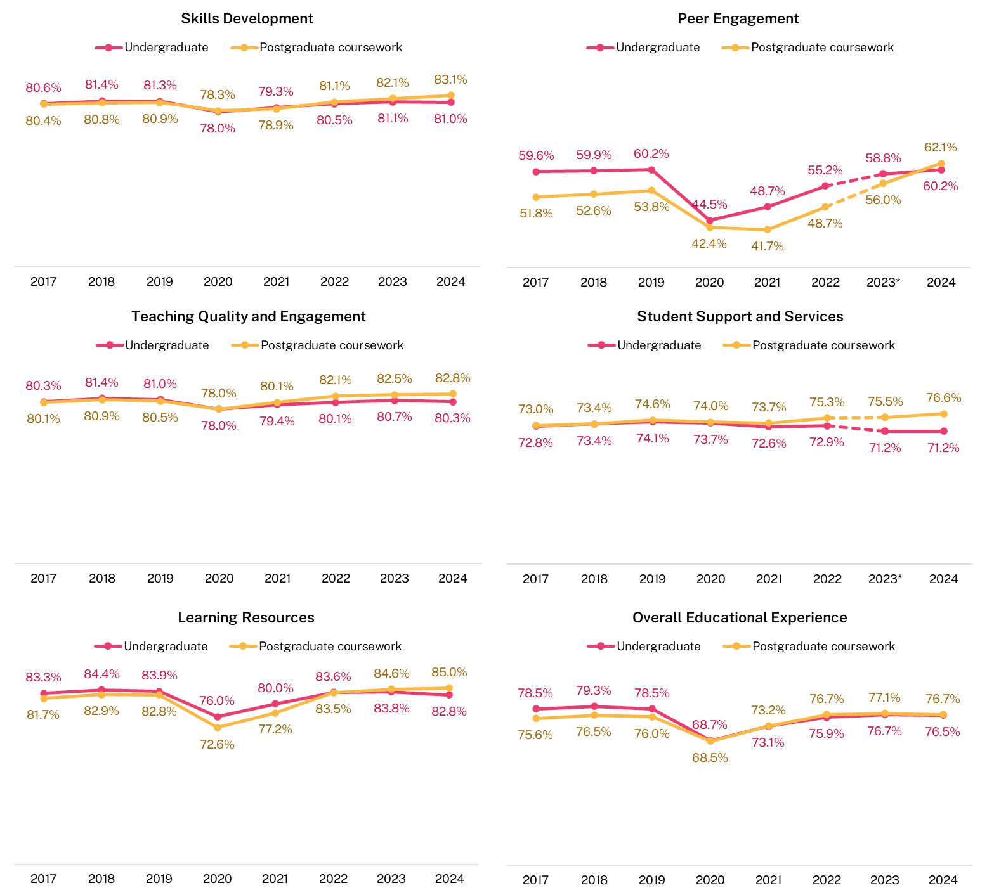
* Note that in 2023 a review was conducted on the SES instrument and revisions were made to the Student Support and Services (formerly Student Support) and Peer Engagement (formerly Learner Engagement) focus areas. For more information about these changes, refer to the 2023 SES National Report.
Demographic and equity groups
Student ratings of their educational experience differ among various demographic sub-groups. Some groups, like international students, students aged under 25, and those studying in internal or multi-modes, were more affected by changes in teaching methods and course delivery during and after the COVID-19 pandemic. However, the overall trends in student ratings have stayed broadly consistent over the years.
Age: In 2024, students aged 30 years and over rated their Overall Educational Experience more highly than those aged 29 years and under at both undergraduate and postgraduate coursework levels.
Disability: Ratings have been consistently lower for students with a reported disability since 2017 - a trend that persisted in 2024. This highlights an area where institutions could focus improvement efforts.
First Nations students: Ratings of Overall Educational Experience were similar to domestic non-Indigenous students, but undergraduate Peer Engagement ratings have been consistently lower, which may be associated with a higher proportion of First Nations students undertaking their studies in an external mode.
Stage of study: Commencing undergraduate students rated Overall Educational Experience more positively than later-year students, while later-year students rated Skills Development higher.
Study mode impact: External students (studying off-campus or online) rated the Overall Educational Experience more positively than those who studied on-campus or a combination of on-campus and online study (internal/multi-mode) students, who rated Peer Engagement, Learning Resources and Skills Development higher.
International students: Ratings were generally higher than domestic students for most focus areas, except for Learning Resources, which was similar. The Overall Educational Experience was also broadly similar.
Study areas
In 2024, the largest variations in ratings between study areas were observed in Peer Engagement and Overall Educational Experience. The differences in some of the focus area ratings between study areas are influenced by study mode. For example, study areas with more internal/multi-mode students tend to have higher observed ratings in Peer Engagement than external mode, as this focus area measures interactions with other students in classes or socially.
While some smaller study areas (i.e., areas with fewer responses) receive higher student ratings than larger ones, this is not consistent across all small study areas. Moreover, smaller study areas tend to have more volatility in their year-on-year comparison data compared to those with higher response numbers, like any small dataset.
It should also be noted that broad disciplinary aggregations often obscure details relevant to schools, faculties, and academic departments. More detailed SES results, disaggregated by 45 study areas, are available from the QILT website in the additional tables accompanying this report.
Institutions
In general, undergraduate student ratings at non-university higher education institutions (NUHEIs) tend to be higher than those at universities, except for Learning Resources, which has consistently been rated lower by students attending NUHEIs since 2017.
Postgraduate coursework students at NUHEIs tend to rate Student Support and Services, Teaching Quality and Engagement, and Overall Educational Experience higher than their counterparts at universities. This trend continued in 2024. Additionally, NUHEI postgraduate coursework student ratings surpassed university ratings in Skills Development and Peer Engagement in 2024. However, like undergraduates, postgraduate coursework students at NUHEIs continued to rate Learning Resources less positively than those at universities.
Other aspects of the student experience
Sense of belonging
Students’ sense of belonging, which encompasses feelings of connectedness, inclusion, and acceptance, is crucial for academic achievement, personal wellbeing, student satisfaction, and retention. These ratings dropped markedly in 2020 due to the pandemic. Undergraduate ratings have improved since easing of restrictions, however, have still not returned to pre-2020 levels. In comparison, postgraduate coursework ratings, which also declined in 2020 and 2021, surpassed pre-COVID levels in 2024. This increase may be partly due to the increase in international postgraduate coursework students, who have consistently reported a stronger sense of belonging compared to domestic students.
In 2024, the greatest variation in undergraduate ratings of sense of belonging to their institution was between students from NUHEIs and those from universities, with university students rating their sense of belonging lower. International students rated sense of belonging higher than domestic students, while commencing students rated it higher than later-year students. Students with a reported disability have consistently rated this lower than those without. These differences highlight areas for institutions to improve student engagement and support.
Sense of belonging to institution by course level, 2017–24 (% positive response)
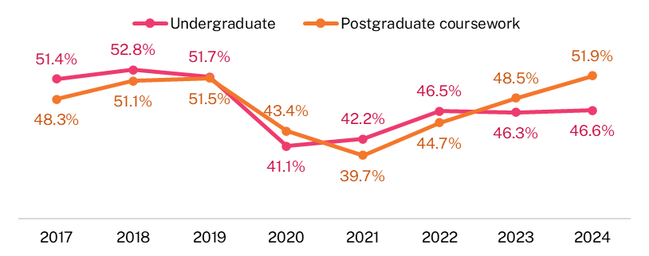
Considered leaving
In 2024, 18.3 per cent of undergraduates and 16.0 per cent of postgraduate coursework students had seriously considered leaving their institution in the survey year but had not yet left at the time of the survey.
For undergraduate students, the most cited reasons for considering leaving included stress levels, mental health, financial difficulties, study workload, and study/life balance.
Postgraduate coursework students chose financial difficulties, stress levels, study workload, unmet course expectations, study/life balance, and mental health as one of their primary reasons for considering leaving.
These reasons were only asked of students who had indicated they had considered leaving. However, other students may face similar challenges.
Likelihood to consider leaving their institution by course level, 2017–24
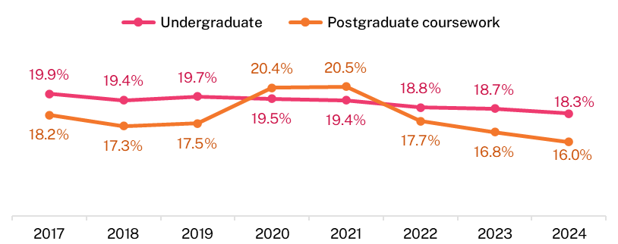

Table of Contents
Acknowledgements ii
Executive summary iii
List of Tables ix
List of Figures x
1. Background 1
1.1 About the SES 1
1.2 Participation in the 2024 SES 1
1.3 About this report 2
1.4 Context of changes in student experience since 2019 2
2. Focus areas and Overall Educational Experience 3
2.1 Results by course level 3
2.2 Results by demographic and equity groups 7
2.3 Study area 20
2.4 Institution 25
2.4.1 Higher education provider type 25
2.4.2 Universities 28
2.4.3 NUHEIs 31
3. Other aspects of the student experience 34
3.1 Sense of belonging 34
3.2 Likelihood to consider leaving current institution 38
3.3 Freedom of expression 39
Appendix 1 SES Focus area items 41
A1.1 Skills Development 41
A1.2 Peer Engagement (formerly Learner Engagement) 41
A1.3 Teaching Quality and Engagement (formerly Teaching Quality) 41
A1.4 Student Support and Services (formerly Student Support) 42
A1.5 Learning Resources 42
Appendix 2 Detailed tables 43
A2.1 Focus areas and the Overall Educational Experience 43
A2.1.1 Course level by demographic sub-groups 43
A2.2 Other aspects of the student experience 51
A2.2.1 Sense of belonging 51
A2.2.2 Considered leaving the institution 54
A2.2.3 Freedom of Expression 56

List of Tables

Table 1 The undergraduate student experience by study area, 2024 (% positive rating) 23
Table 2 The postgraduate coursework student experience by study area, 2024 (% positive rating) 24
Table 3 Freedom of expression by course level and stage of study, 2024 (% positive rating*) 40
Table 4 Undergraduate student experience by demographic sub-group, 2022–24 (% positive rating)†† 44
Table 5 Postgraduate coursework student experience by demographic group, 2022–24 (% positive rating)†† 48
Table 6 Undergraduate sense of belonging to institution, 2017–24 (% positive rating) 52
Table 7 Postgraduate coursework sense of belonging to institution, 2017–24 (% positive rating) 54
Table 8 Reasons for considering early departure from institution in 2024 by course level (%) 56
Table 9 Freedom of expression by demographic sub-group, undergraduate, 2024 (% positive rating) 57
Table 10 Freedom of expression by demographic sub-group, postgraduate coursework, 2024 (% positive rating) 60

List of Figures
Figure 1 The undergraduate student experience, 2017–24 (% positive rating) 4
Figure 2 The postgraduate coursework student experience, 2017–24 (% positive rating) 5
Figure 3 The student experience by course level, 2024 (% positive rating) 6
Figure 4 Proportion of responses to the SES from international students by course level, 2017–24 SES 7
Figure 5 Overall Educational Experience by course level and age, 2017–24 (% positive rating) 8
Figure 6 Overall Educational Experience by course level and mode of study, 2017–24 (% positive rating) 9
Figure 7 Skills Development by course level and study mode, 2017–24 (% positive rating) 10
Figure 8 Peer Engagement by course level and mode of study, 2017–24 (% positive rating) 11
Figure 9 The student experience by course level and stage of study, 2024 (% positive rating) 12
Figure 10 Overall Educational Experience by course level and citizenship, 2017–24 (% positive rating) 13
Figure 11 Peer Engagement by course level and citizenship, 2017–24 (% positive rating) 14
Figure 12 Overall Educational Experience by course level and disability status, 2017–24 (% positive rating)* 15
Figure 13 Overall Educational Experience by course level and home language, 2017–24 (% positive rating)* 16
Figure 14 Peer Engagement by course level and First Nations status, 2017–24 (% positive rating)* 17
Figure 15 Overall Educational Experience, undergraduate, 2024 (% positive rating) 20
Figure 16 Overall Educational Experience, postgraduate coursework, 2024 (% positive rating) 21
Figure 17 Undergraduate student experience by institution type, 2019–24 (% positive rating) 26
Figure 18 Postgraduate coursework student experience by institution type, 2019–24 (% positive rating) 27
Figure 19 Overall Educational Experience for undergraduate university students, 2024 (% positive rating) 29
Figure 20 Overall Educational Experience for postgraduate coursework university students, 2024 (% positive rating) 30
Figure 21 Overall Educational Experience for undergraduate non-university higher education institution (NUHEI) students, pooled 2023–24 (% positive rating) 32
Figure 22 Overall Educational Experience for postgraduate coursework non-university higher education institution (NUHEI) students, pooled 2023–24 (% positive rating) 33
Figure 23 Sense of belonging to institution by course level, 2017–24 (% positive rating*) 35
Figure 24 Sense of belonging to institution by sub-group, undergraduate, 2017–24 (% positive rating) 36
Figure 25 Sense of belonging to institution by sub-group, postgraduate coursework, 2017–24 (% positive rating) 37
Figure 26 Proportion of students who considered early departure from institution by course level, 2017–24 38
Figure 27 Top reasons for considering early departure from institution in 2024 (% of those who considered leaving) 39

Background

About the SES
The Student Experience Survey (SES) provides a national framework for collecting data on key aspects of the higher education student experience. It focuses on measurable aspects linked to learning outcomes and influenced by institutions. The SES measures five aspects (or focus areas) of the student experience:
- Skills Development: Evaluates how students have developed their skills and knowledge in eight areas, including foundational, collaborative, and adaptive skills.
- Peer Engagement: Assesses the frequency of student interactions with peers inside or outside formal study.
- Teaching Quality and Engagement: Rates the relevance and focus of courses, overall teaching quality, and academic staff actions such as engaging students and providing feedback.
- Student Support and Services: Measures the helpfulness of various supports and services provided by institutions, including administrative, career development, health, and financial services.
- Learning Resources: Evaluates the quality of learning resources in seven areas, including teaching spaces, equipment, and learning materials.
The SES also measures the Overall Educational Experience which is a stand-alone item in the survey. Overall Educational Experience is closely related to students’ ratings of Teaching Quality and Engagement and Skills Development, and to areas outside the focus areas, such as students’ Sense of Belonging. (See Appendix 1 for a list of the individual items in each Focus Area).
Each focus area consists of related survey items that collect student feedback. Ratings are classified as positive or negative based on responses to the underlying items, with scores representing the proportion of students who responded positively.
Originally developed as the University Experience Survey (UES) in 2011, the SES was renamed in 2015 to include non-university higher education institutions (NUHEIs). Initially focused on undergraduates, the survey expanded to include postgraduate coursework students in 2017.
From 2014 to 2019, the survey remained largely unchanged, with minor wording adjustments. In 2020, an international student module was added to measure broader aspects of their experience. In 2021, items on freedom of expression were included.
A 2022 review led to several changes in the 2023 SES, including renaming focus areas: Learner Engagement to Peer Engagement, and Student Support to Student Support and Services. The Teaching Quality focus area was renamed to Teaching Quality and Engagement, and the Sense of Belonging item became a stand-alone measure.

Participation in the 2024 SES
In 2024, 149 higher education institutions participated in the SES, including all 42 universities and 107 NUHEIs, up from 142 in 2023 and 141 in 2022. The survey included commencing and later-year, onshore, undergraduate, and postgraduate coursework students.
The main online fieldwork ran from 30 July to 1 September 2024, with a secondary collection from 10 September to 13 October 2024. From a sample of 692,631 students, 257,865 responses were received at the student level, resulting in 270,292 valid surveys at the course level. This represents a response rate of 37.2 per cent, comparable to 37.5 per cent in 2023 and 37.0 per cent in 2022. Despite a decline from 44.1 per cent in 2020, the 2024 response rate is still considered good, ensuring the results are representative of the student population.
For more information about the SES methodology, please refer to the 2024 SES Methodological Report available on the QILT website.

About this report
This report emphasises the Overall Educational Experience because it is a stand-alone single item strongly associated with student ratings of Teaching Quality and Engagement, as well as Skills Development. It is also closely related to elements outside the focus areas, such as students' Sense of Belonging.
Section 2 provides an overview of SES results since 2017, including high-level results for 2024 across various demographic and equity groups, study areas, and institutions. Detailed results are available in the accompanying tables and Power BI reports on the QILT website.
Section 3 explores other aspects of the student experience, including sense of belonging, likelihood of considering leaving the institution, and freedom of expression.
Methodological information previously included in Appendix 1 of earlier reports is now available in the 2024 SES Methodological Report. Additional technical details—such as the SEQ items, the construction of focus area scores and confidence intervals, and the study area concordance—can be found on the QILT website, rather than in the appendices as in past reports.

Context of changes in student experience since 2019
The higher education sector faced significant challenges due to the COVID-19 pandemic, leading to a rapid shift to online learning. In the post-pandemic period, many institutions have retained hybrid delivery modes, combining online and on-campus classes. Additionally, changes in the relative proportion of international students over time, particularly as a proportion of the postgraduate coursework population, who are predominantly studying in an internal/multi-mode of study has affected overall sector results. The primary focus of this report is the 2024 data, but it will briefly cover changes since 2019 where relevant.

Focus areas and Overall Educational Experience

Results by course level
After a significant decrease in ratings during COVID restrictions, undergraduate results have since improved. However, in 2024, undergraduate ratings across most focus areas remained broadly the same as in 2023, with changes ranging between 0 and 1 percentage point. These ratings were still below or similar to pre-2020 levels, as shown in Figure 1.
There were two exceptions: Student Support and Services, and Peer Engagement. Peer Engagement undergraduate ratings in 2024 matched the highest rating in 2019 at 60.2 percent. Conversely, Student Support and Services undergraduate ratings have trended down since 2022, remaining at 71.2 percent in 2023 and 2024 — the lowest rating since 2017.
Additionally, the undergraduate rating for Overall Educational Experience in 2024 (76.5 percent) remained broadly the same as in 2023 (76.7 percent). This continues the positive trend in ratings from 2021 to 2022. However, it has not yet fully recovered to the 78 to 80 percent range observed prior to 2020.
Conversely postgraduate coursework results in 2024 have not only recovered but also exceeded pre-2020 ratings in all five focus areas, as shown in Figure 2. The postgraduate coursework rating for Overall Educational Experience also exceeded pre-2020 ratings; however, decreased slightly in 2024 (0.4 percentage points) from its highest rating in 2023 of 82.1 per cent.

Figure 1 The undergraduate student experience, 2017–24 (% positive rating)
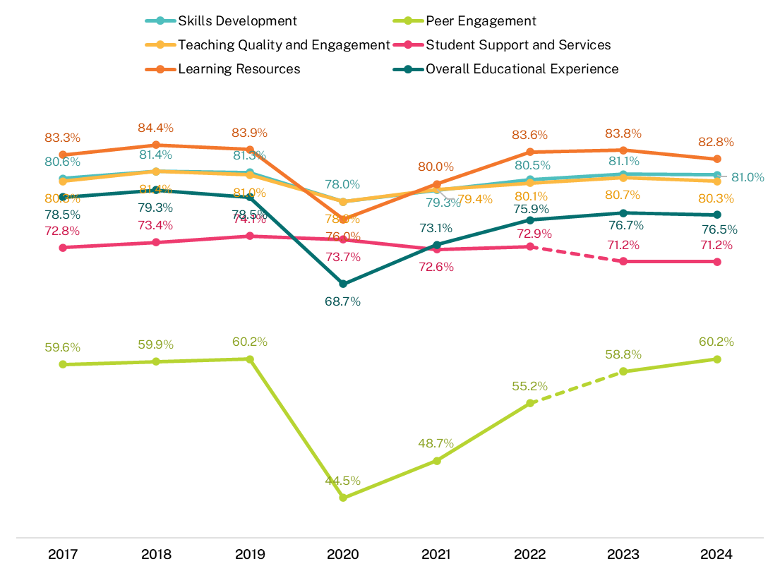

Note that the dotted lines between 2022 and 2023 indicate the change in underlying items of the Peer Engagement and Student Support and Services focus areas. When comparing year-on-year changes, it is recommended that modifications to underlying questionnaire items be taken into consideration when interpreting results. For more information about these changes, refer to the 2023 SES National Report.

Figure 2 The postgraduate coursework student experience, 2017–24 (% positive rating)
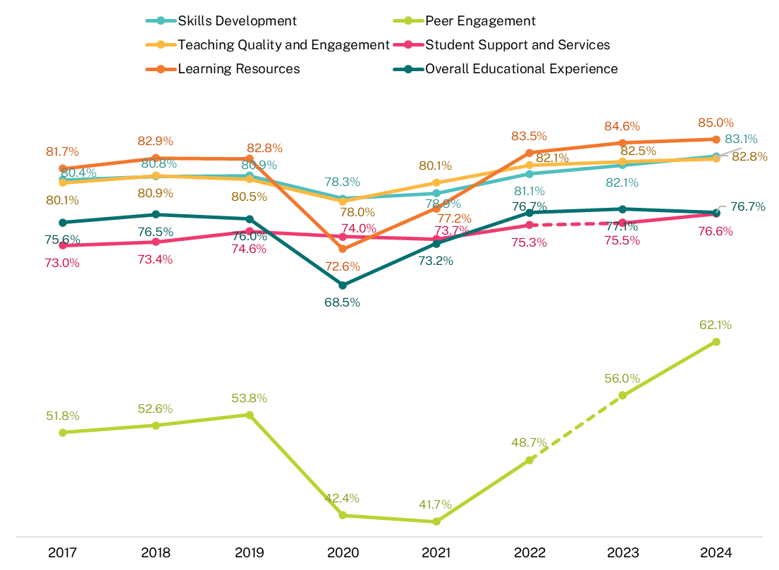

Note that the dotted lines between 2022 and 2023 indicate the change in underlying items of the Peer Engagement and Student Support and Services focus areas. When comparing year-on-year changes, it is recommended that modifications to underlying questionnaire items be taken into consideration when interpreting results. For more information about these changes, refer to the 2023 SES National Report.

Increases in 2024 in postgraduate coursework ratings were generally modest, ranging from 0.3 to 1 percentage point. The rating for Overall Educational Experience decreased by 0.4 percentage points to 76.7 per cent compared to 2023. The only exception was Peer Engagement, which reached its highest rating since 2017 at 62.1 per cent, up 6.1 percentage points from the 2023 rating of 56.0 per cent.
When comparing the ratings between study levels, in 2024 postgraduate coursework students rated all five focus areas higher than undergraduate students. The differences range from 1.9 percentage points for Peer Engagement to 5.4 percentage points for Student Support and Services. Ratings of Overall Educational Experience were similar across both course levels, differing by around 0.2 percentage points (Figure 3).
In 2024, similar to 2023, the main differentiation between the study levels was in Student Support and Services. Postgraduate coursework students rated this aspect at 76.6 per cent, compared to 71.2 per cent for undergraduates. This reflects the influence of the higher proportion of international students in the postgraduate cohort, who have rated their Student Support and Services much more positively than domestic students. International student ratings were significantly higher at both undergraduate (77.5 per cent) and postgraduate (80.3 per cent) levels, while domestic students rated this aspect at 69.2 per cent (undergraduate) and 67.5 per cent (postgraduate).
Both undergraduate and postgraduate coursework students provided higher ratings for Peer Engagement in 2024 compared to 2023. Undergraduate ratings increased by 1.4 percentage points,. For the first time in the eight years that they have been included in the SES, postgraduate coursework students rated their Peer Engagement higher than undergraduates, with a notable increase of 6.1 percentage points in 2024 compared to 2023. This increase coincided with a rise in the number of international students at the postgraduate coursework level, who have higher enrolment in an internal/multi-mode of study than their domestic counterparts. As external students are much less likely to engage in activities outlined in this focus area, this difference contributes to the variations in Peer Engagement. The relationship between Peer Engagement rating and study mode is further explained below under Study mode.
Figure 3 The student experience by course level, 2024 (% positive rating)
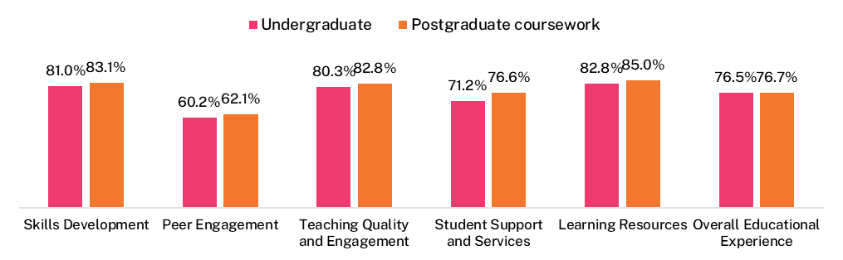

The difference in ratings between undergraduate and postgraduate coursework students, compared to pre-2020 (Figure 1 and Figure 2), are influenced by the relative proportions of domestic and international students at each level (Figure 4). This was observed in 2023 and the trend continued in 2024.
In 2024, international student ratings across focus areas were generally higher than before 2020. Conversely, domestic student ratings were either below or close to pre-2020 levels. The larger proportion of international students in the postgraduate coursework population explains the greater improvement in aggregated postgraduate results compared to undergraduate results.
It should be noted that the proportion of international to domestic student responses has changed over time (Figure 4) in line with changes to the relative population. Postgraduate coursework international responses increased markedly from a six-year low of 35.7 per cent in 2022 to 58.0 per cent in 2024, representing the highest proportion since 2017 and comprising 57,823 students. The proportion of undergraduate international student responses is much lower and has remained relatively stable, ranging from a low of 15.2 per cent in 2017 to a high of 20.1 per cent in 2024, which represents 31,845 international undergraduates.
The forthcoming 2024 SES International Report will explore the results of international students further.

Figure 4 Proportion of responses to the SES from international students by course level, 2017–24 SES
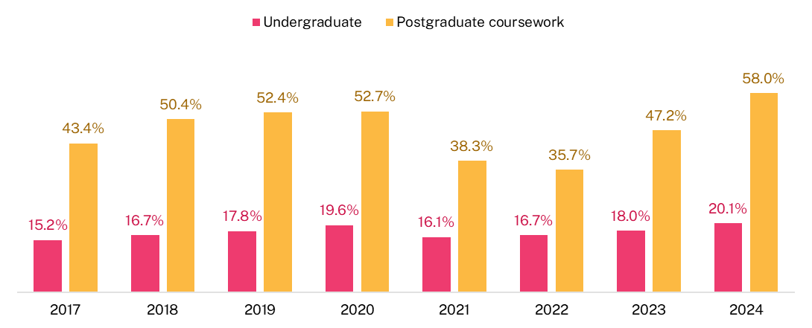

Results by demographic and equity groups
Student ratings of their educational experience vary across different demographic sub-groups. This section examines the high-level results for each group.
Note that First Nations, socio-economic, and locality data reflect comparison values for domestic students only, excluding international students. The remaining demographic and equity groups include all students, both domestic and international.

Age
In 2024, regardless of study mode, students aged 30 years and over continued to rate their Overall Educational Experience more highly than those aged 29 years and under at both undergraduate and postgraduate coursework levels (Figure 5). This trend has been consistent for undergraduates since 2020 and for postgraduate coursework students since 2017.
Changes in teaching and learning arrangements impact some student groups more than others. For instance, the ratings for Overall Educational Experience fell more notably for students aged 29 years and under compared to their older peers in 2020 (Figure 5).

Figure 5 Overall Educational Experience by course level and age, 2017–24 (% positive rating)
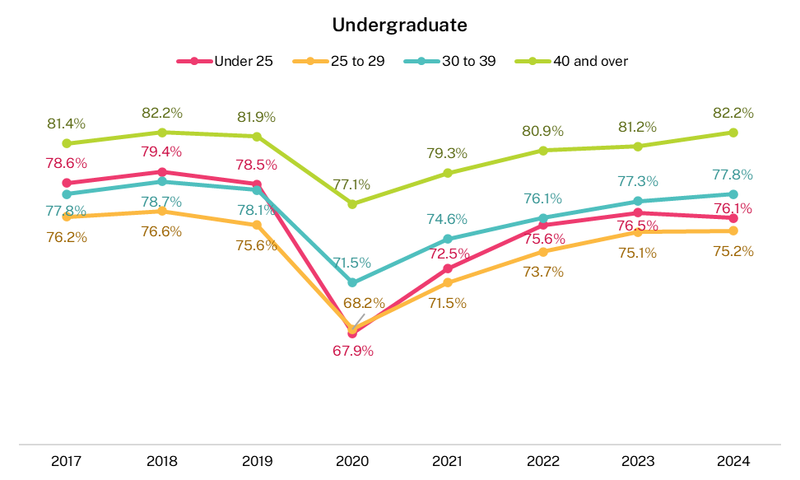
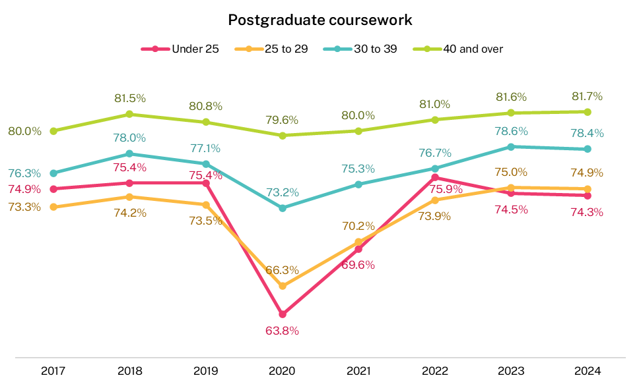

Study mode
A student’s mode of study impacts their ratings for the different focus areas. At both undergraduate and postgraduate coursework levels external students (those studying fully off-campus including online) have tended to rate their Overall Educational Experience more positively than internal /multi-mode students (those studying fully on-campus or a mix of internal and external modes) (Figure 6).
In 2024, undergraduate external students rated their Overall Educational Experience 3.7 percentage points higher than internal/multi-mode students (79.8 per cent and 76.1 per cent respectively). Similarly, postgraduate coursework students rated it 2.4 percentage points higher (78.5 per cent and 76.1 per cent respectively) (Figure 6). This suggests that externally delivered programs are more likely to meet student expectations regarding their overall educational experience compared to internal/multi-modes programs, which can range from fully on-campus to mostly online.
Figure 6 Overall Educational Experience by course level and mode of study, 2017–24 (% positive rating)
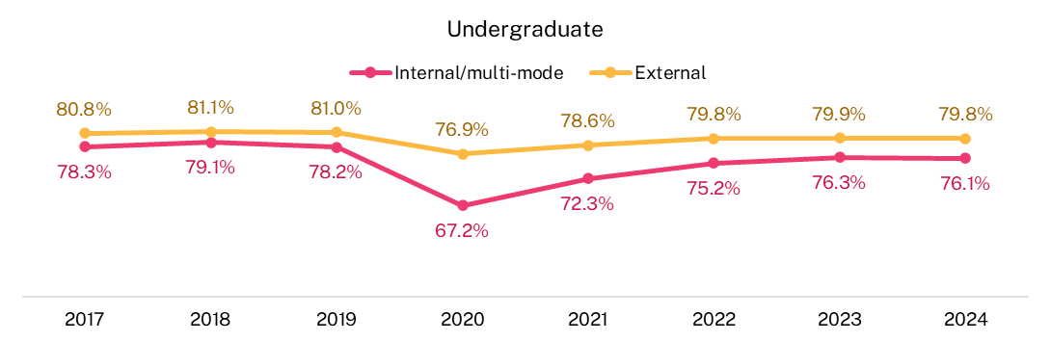
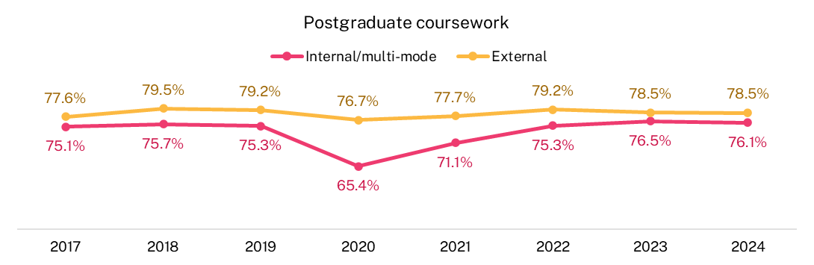

In contrast, external mode students report lower levels of Skills Development than their internal/multi-mode counterparts at both the undergraduate and postgraduate coursework levels. The gaps between the two groups are larger for postgraduate coursework students (Figure 7). This is particularly evident in their skills in working with others and the development of their spoken communication skills. These differences may be related to the opportunities students have to engage with their peers and academic staff as part of their higher education experience.

Figure 7 Skills Development by course level and study mode, 2017–24 (% positive rating)
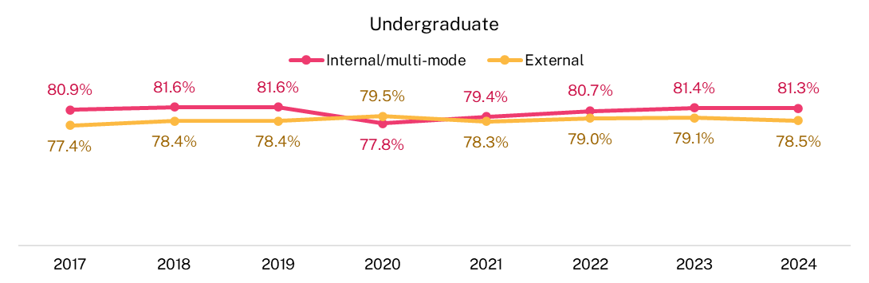
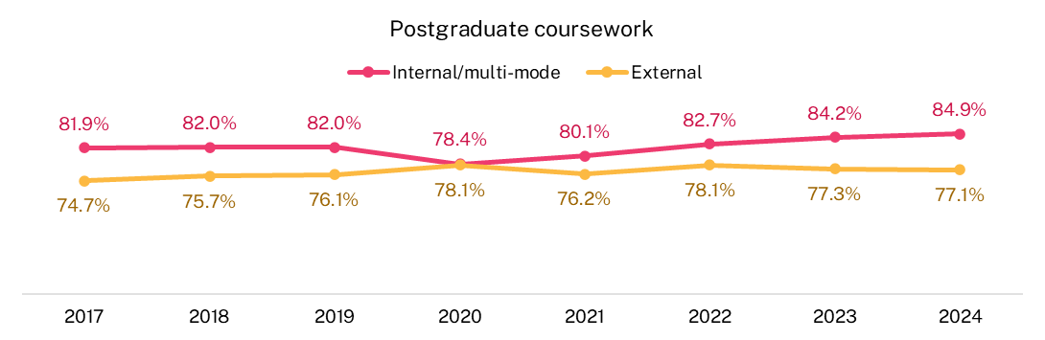

Peer Engagement in the SES measures students’ interactions with other students academically or socially. Students who study predominantly on-campus (e.g. internal/multi-mode students) tend to engage in these activities more often than external students, leading to discrepancies in their ratings. See Appendix 1 for the items under Peer Engagement.
In 2020, ratings for internal/multi-mode students dropped sharply (Figure 8) because many had to switch to online studies due to COVID-19 restrictions. Since then, their Peer Engagement ratings have improved annually, while external students' ratings have remained much lower.
In 2024, Peer Engagement ratings for internal/multi-mode students increased by 1.4 percentage points for undergraduate students and 4.5 percentage points for postgraduate coursework students compared to 2023. In contrast, ratings for external students at both study levels further decreased in 2024, widening the gap between internal/multi-mode and external students.
Figure 8 Peer Engagement by course level and mode of study, 2017–24 (% positive rating)
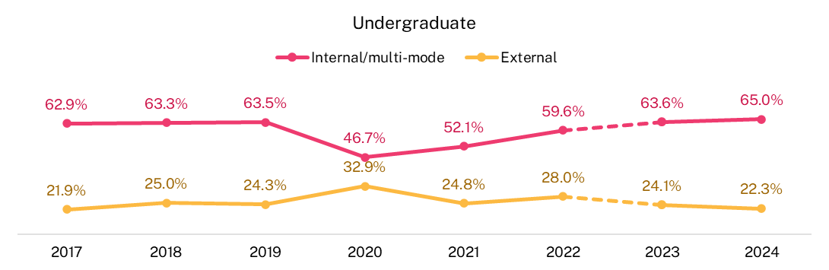
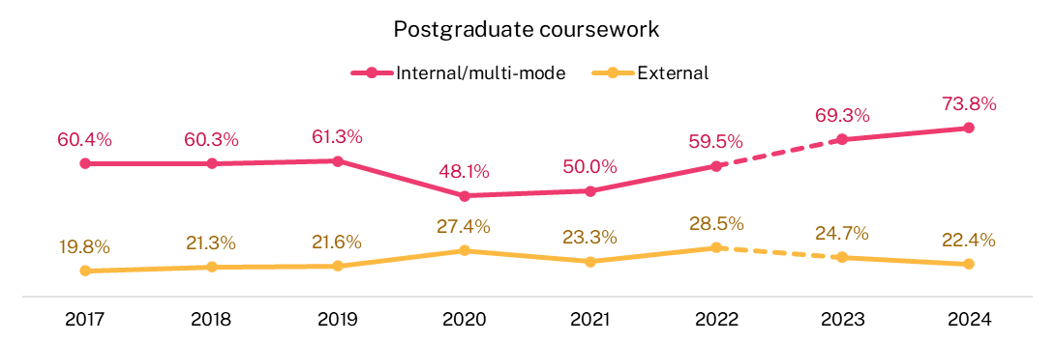
Note that the dotted lines between 2022 and 2023 indicate the change in underlying items of the Peer Engagement focus area. When comparing year-on-year changes, it is recommended that modifications to underlying questionnaire items be taken into consideration when interpreting results. For more information about these changes, refer to the 2023 SES National Report.

Stage of study
Historically, commencing students have rated their Overall Educational Experience more positively than later-year students at both undergraduate and postgraduate coursework levels. In contrast, later-year students have rated Skills Development more positively than commencing students at both levels.
In 2024, undergraduate commencing students continued to rate their experience across the focus areas more positively than later-year students, except in Skills Development (Figure 9). The largest differences between undergraduate commencing and later-year student ratings in 2024 were in Learning Resources, Student Support and Services and Overall Educational Experience which were respectively 8.1, 7.0 and 6.6 percentage points higher for commencing students than later-year students.
For postgraduate coursework students in 2024, differences in ratings between commencing and later-year students were less pronounced, likely due to their previous higher education experience. However, later-year students rated their Skills Development and Peer Engagement more highly than commencing students.

Figure 9 The student experience by course level and stage of study, 2024 (% positive rating)
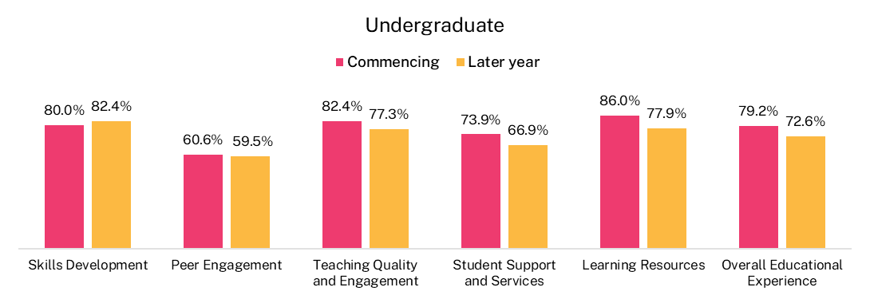
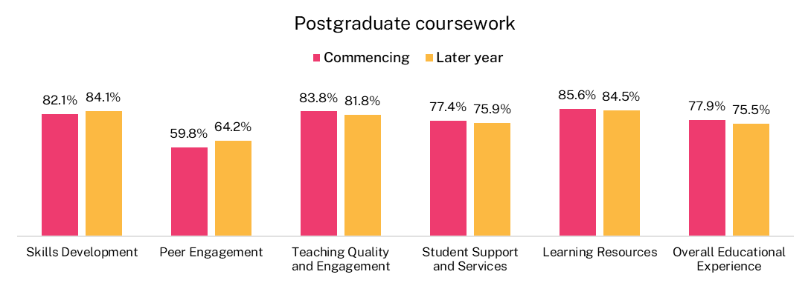

Citizenship
In 2020, international students reported a sharper fall in focus area ratings compared to domestic students, and these ratings remained relatively low in 2021. This was particularly evident in Peer Engagement, likely due to the high proportion of international students who were overseas in 2021.
From 2021 to 2023, ratings from international undergraduate and postgraduate coursework students improved significantly across all focus areas compared to pre-2020 levels. Similar to the pattern observed in 2023, all ratings from international students were higher in 2024 than before 2020, except for the Learning Resources rating among undergraduate international students, which was 83.5 per cent in 2018 and 83.0 per cent in 2024. However, for the first time since 2020, the Overall Educational Experience rating by international students decreased slightly between 2023 and 2024 for both undergraduate (from 75.8 per cent to 74.9 per cent) and postgraduate coursework students (from 77.0 per cent to 76.3 per cent) (Figure 10).

Figure 10 Overall Educational Experience by course level and citizenship, 2017–24 (% positive rating)
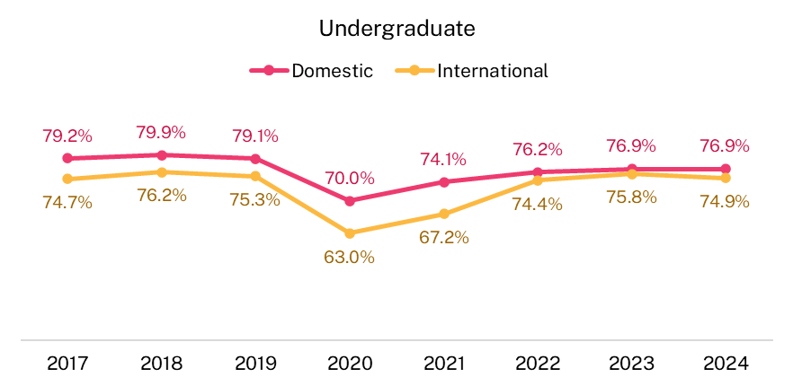
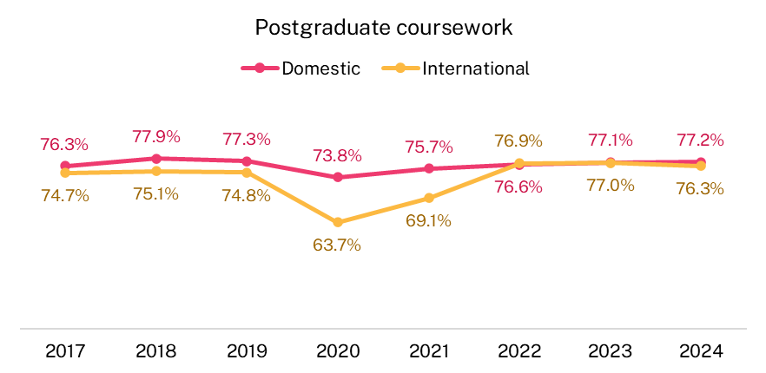

Generally, in 2024 international student ratings were higher than domestic student ratings for most focus areas, except for Learning Resources, where ratings were broadly similar between international and domestic students. In 2024, the most pronounced difference was in Peer Engagement. International undergraduate students rated Peer Engagement 14.8 percentage points higher than domestic students, and postgraduate coursework students rated it 37.2 percentage points higher (Figure 11). This higher rating by international students might be partly explained by the fact that they are more likely than domestic students to undertake their studies internally or in multi-mode. As mentioned previously, the Peer Engagement focus area measures students’ interactions with their peers in and outside of class and international students are more likely to be studying on-campus than their domestic counterparts.
Further information about the international student experience will be presented in the forthcoming 2024 SES International Report.

Figure 11 Peer Engagement by course level and citizenship, 2017–24 (% positive rating)
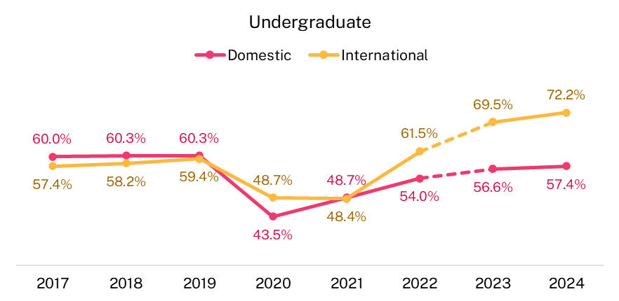
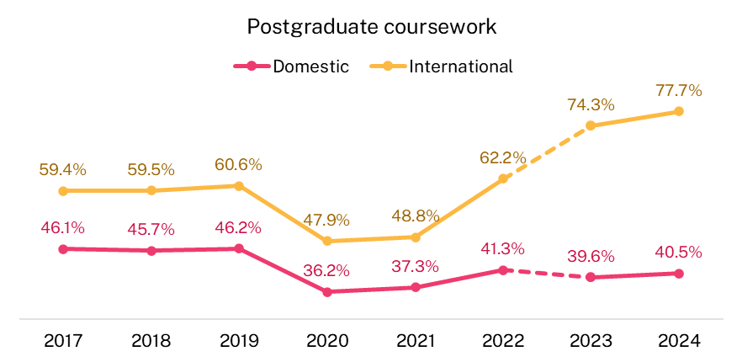
Note that the dotted lines between 2022 and 2023 indicate the change in underlying items of the Peer Engagement focus area. When comparing year-on-year changes, it is recommended that modifications to underlying questionnaire items be taken into consideration when interpreting results. For more information about these changes, refer to the 2023 SES National Report.

Disability
Students with a reported disability have consistently rated their Overall Educational Experience lower than those without a disability at both undergraduate and postgraduate coursework levels. This trend persisted in 2024, with 74.1 per cent of undergraduate students and 75.4 per cent of postgraduate coursework students with a reported disability rating Overall Educational Experience positively (Figure 12). In comparison, 76.9 per cent of undergraduate students and 76.8 per cent of postgraduate coursework students without a reported disability rated their Overall Educational Experience positively.
Additionally, in 2024, students with a reported disability rated all focus areas lower than their peers without a reported disability, continuing the trend observed since 2021.

Figure 12 Overall Educational Experience by course level and disability status, 2017–24 (% positive rating)*
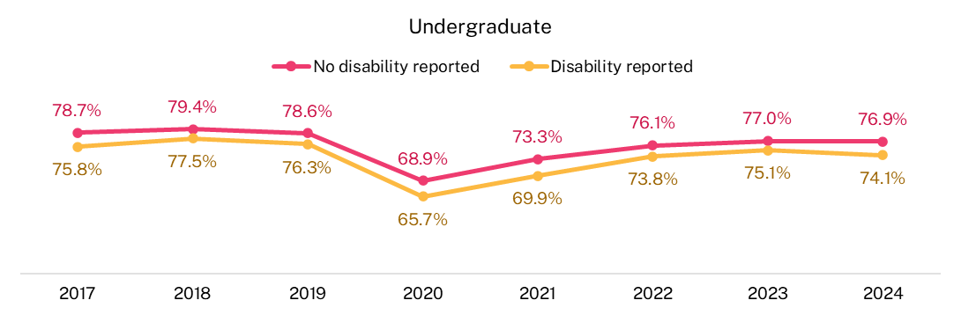
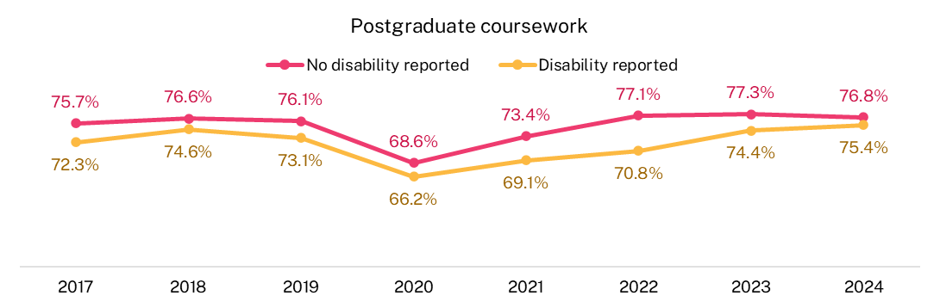
* Disability status comparisons include both domestic and international student responses

Home language
Student ratings of their educational experience vary depending on whether their home language is English or not. In this instance, this includes both international and domestic students.
Undergraduate students whose home language is not English have tended to rate Overall Educational Experience less positively than those whose home language is English. In 2024, the gap between the two groups was 2.6 percentage points (Figure 13).
Among postgraduate coursework students, there was a 1.5 percentage point difference in 2024 Overall Educational Experience ratings between those whose home language was English (77.4 per cent) and those whose home language was not English (75.9 per cent).

Figure 13 Overall Educational Experience by course level and home language, 2017–24 (% positive rating)*
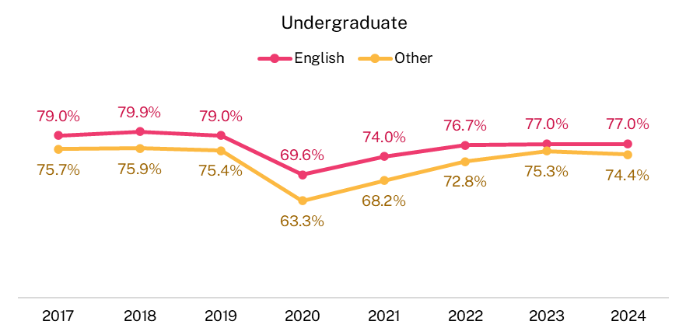
* Home language comparisons include both domestic and international student responses

First Nations
First Nations students rate their Overall Educational Experience similarly to domestic non-Indigenous students at both undergraduate and postgraduate coursework levels. In 2024, First Nations undergraduates rated Student Support and Services 3.3 per cent higher than domestic non-Indigenous students but the ratings for postgraduate coursework students was broadly similar.
However, since 2017, First Nations undergraduate students have consistently rated Peer Engagement lower than domestic non-Indigenous students. This trend continued in 2024, with First Nations undergraduate students rating Peer Engagement 6.9 percentage points lower which coincided with a larger proportion of First Nations undergraduates studying in an external mode. However, for postgraduate coursework students, First Nations students rated their Peer Engagement 1.2 percentage points higher than their domestic non-Indigenous peers. This disparity between undergraduate and postgraduate coursework comparisons may be associated with a much larger proportion of both First Nations and domestic non-Indigenous students at the postgraduate coursework level undertaking their studies in an external study mode, reducing opportunities for both groups to interact with other students academically or socially when compared to undergraduates, where a higher proportion are studying in an internal/multi-mode. (Figure 14)
It should also be noted that First Nations students make up a small proportion of the higher education population, so changes and differences in results should be interpreted with caution.
Figure 14 Peer Engagement by course level and First Nations status, 2017–24 (% positive rating)*
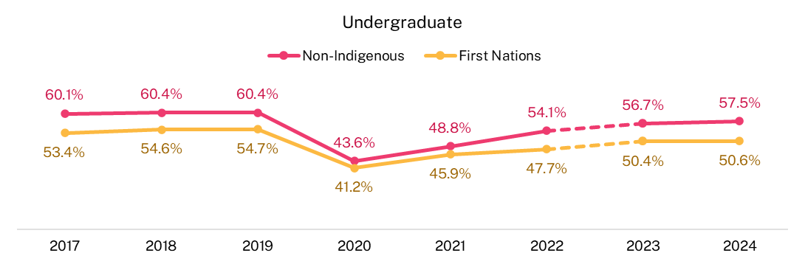
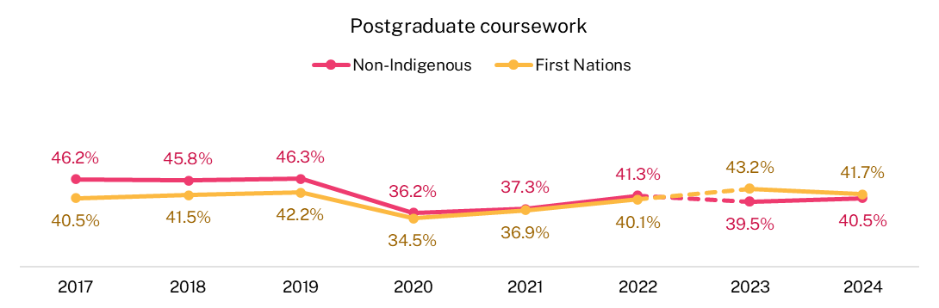
* First Nations, socio-economic, and locality figures reflect values for domestic students only, excluding international students. The remaining equity groups include all students, both domestic and international.
Note that the dotted lines between 2022 and 2023 indicate the change in underlying items of the Peer Engagement focus area. When comparing year-on-year changes, it is recommended that modifications to underlying questionnaire items be taken into consideration when interpreting results. For more information about these changes, refer to the 2023 SES National Report.
Undergraduate study area profile (proportions based on responses to the 2024 SES)
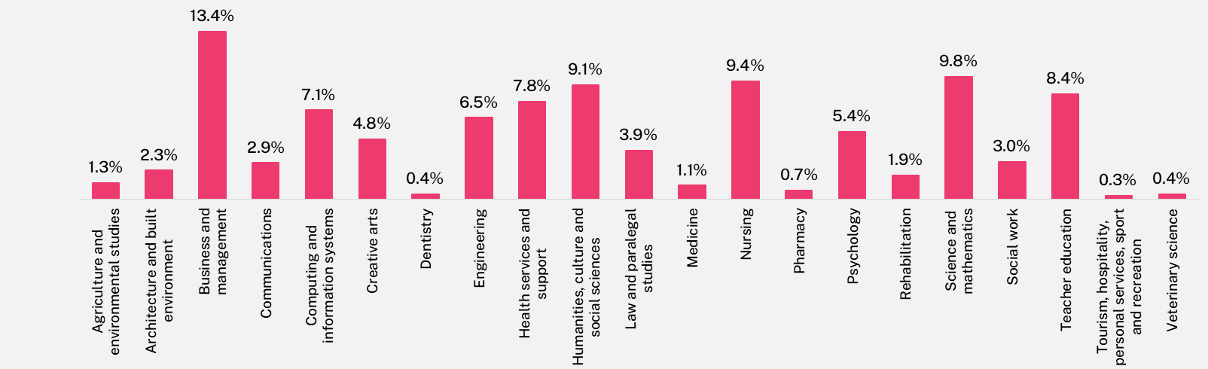

The largest study areas which have the highest influence on sector wide results are Business and management, Science and mathematics, Nursing, Humanities, culture and social sciences and Teacher education. Smaller study areas such as Tourism, hospitality, personal services, sport and recreation, Veterinary science, Dentistry and Pharmacy have a smaller effect on sector results, but are still important study areas for targeted improvement activities by institutions where appropriate.

Postgraduate coursework study area profile (proportions based on responses to the 2024 SES)
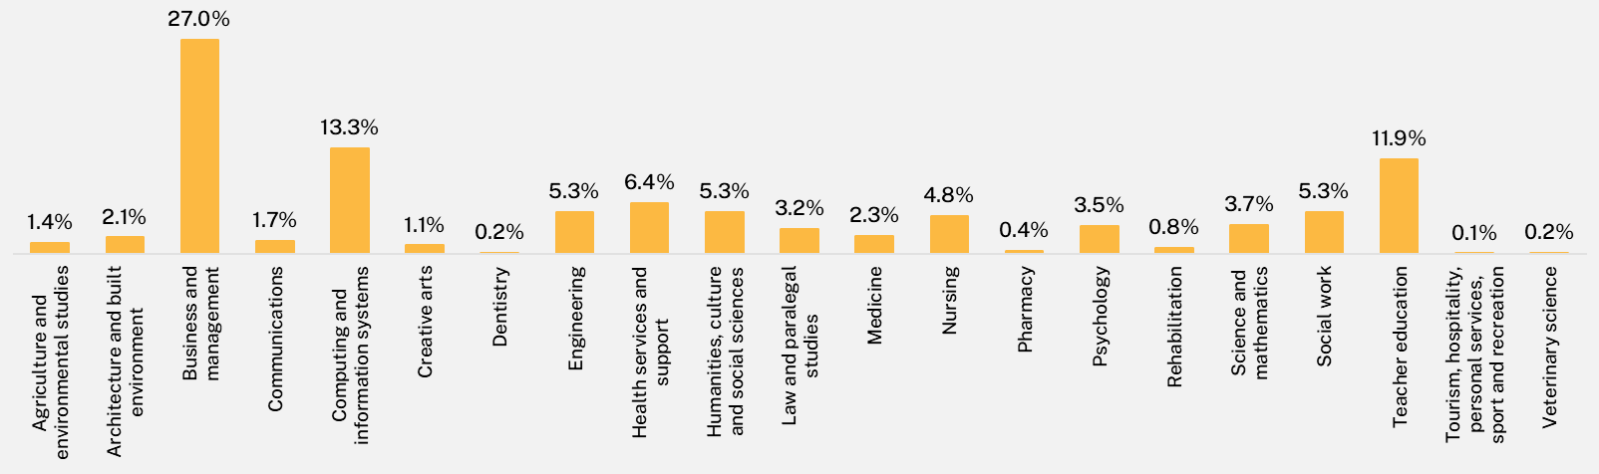

The largest study areas which have the highest influence on sector wide results are Business and management, Computing and information systems and Teacher education. Smaller study areas such as Tourism, hospitality, personal services, sport and recreation, Veterinary science, Dentistry and Pharmacy have a smaller effect on sector results, but are still important study areas for targeted improvement activities by institutions where appropriate.

Study area
Positive ratings of Overall Educational Experience differed by study area in 2024 (Figure 15 and Figure 16). This variation across study areas also held true for the 5 focus areas.
Please note that when looking at study area results, where confidence intervals overlap, there is insufficient evidence to conclude that there is a statistically significant difference between study areas. However, where intervals do not overlap, there is 90 per cent confidence that there is a difference between them.

Figure 15 Overall Educational Experience, undergraduate, 2024 (% positive rating)
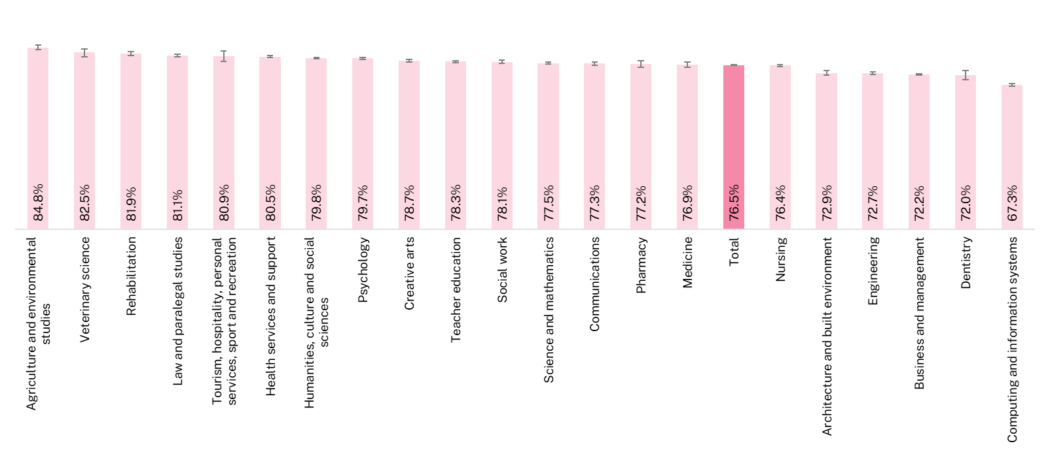

Figure 16 Overall Educational Experience, postgraduate coursework, 2024 (% positive rating)
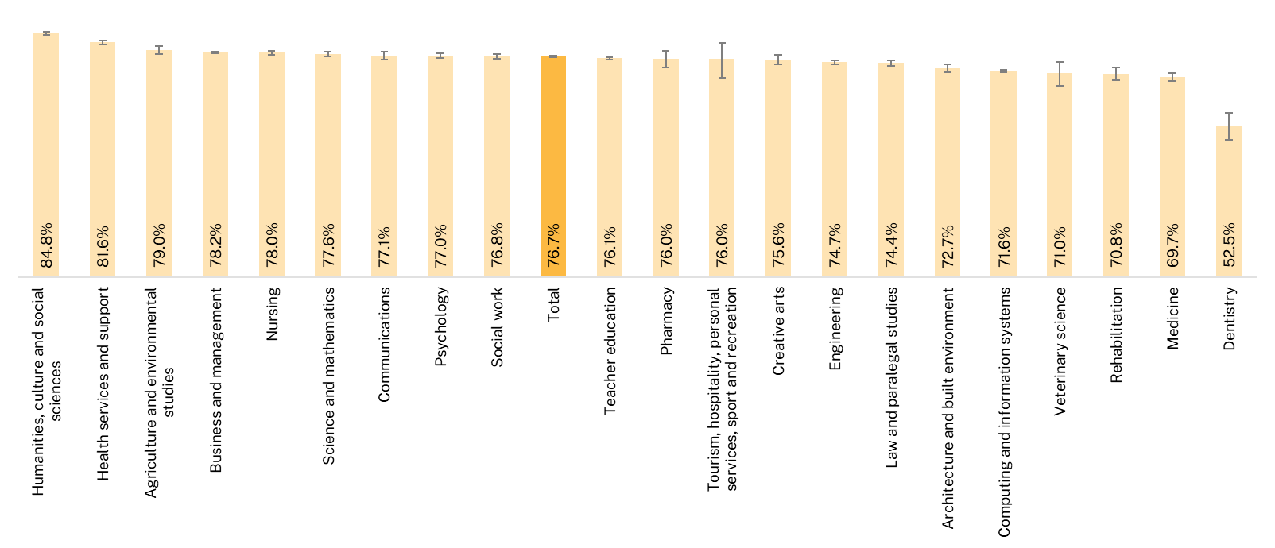

Undergraduate study area results
In 2024, the largest variation in ratings between study areas was observed in Peer Engagement and Overall Educational Experience (Table 1). In contrast, Skills Development and Teaching Quality and Engagement showed less variation in ratings across study areas.
Peer Engagement ratings showed a 27.2 percentage point difference between the highest (Medicine) and lowest (Psychology). This may be related to different study mode patterns since nearly all undergraduate students in Medicine were studying in internal/multi-mode, whereas around 18 per cent of Psychology students were studying externally. As mentioned previously, students who study in an internal/multi-mode are more likely to rate their Peer Engagement positively than those studying in an external mode.
Overall Educational Experience had a 17.5 percentage point variation in ratings between the highest, Agriculture and environmental studies, and the lowest, Computing and information systems.
Ratings for Skills Development show that Computing and information systems, Engineering, Business and management, and Science and mathematics all had lower ratings ranging from 74.0 to 78.8 per cent. The higher scores for Skills Development were seen in Social work (86.9 per cent), Rehabilitation (86.8 per cent), and Medicine (86.1 per cent). The pattern was similar for Teaching Quality and Engagement, with Computing and information systems having the lowest rating (73.4 per cent), and Tourism, hospitality, personal services, sport and recreation having the highest rating (86.4 per cent).
It should be noted that study areas with fewer responses may have more volatile year on year ratings compared to study areas with higher numbers of responses, similar to any other smaller dataset. For example, for undergraduate Veterinary science, a study area with fewer responses, the Overall Educational Experience appeared to fluctuate between 2017 and 2018 from 78.0 per cent to 85.6 per cent and then 80.4 per cent in 2019. However, given the low number of responses, caution should be exercised when generalising the findings to the broader population.
Table 1 The undergraduate student experience by study area, 2024 (% positive rating)
Study area | Skills Development | Peer Engagement | Teaching Quality and Engagement | Student Support and Services | Learning Resources | Overall Educational Experience
Agriculture and environmental studies | 81.7 | 54.5 | 86.2 | 72.4 | 88.2 | 84.8
Architecture and built environment | 79.5 | 65.3 | 79.3 | 66.5 | 78.8 | 72.9
Business and management | 78.8 | 63.4 | 76.8 | 74.1 | 82.0 | 72.2
Communications | 81.1 | 65.6 | 82.2 | 68.1 | 84.8 | 77.3
Computing and information systems | 74.0 | 61.0 | 73.4 | 71.2 | 79.1 | 67.3
Creative arts | 81.2 | 67.6 | 84.5 | 66.9 | 80.1 | 78.7
Dentistry | 84.7 | 69.0 | 76.2 | 66.5 | 77.5 | 72.0
Engineering | 78.4 | 64.5 | 76.1 | 69.2 | 83.9 | 72.7
Health services and support | 82.9 | 56.9 | 83.1 | 73.1 | 83.8 | 80.5
Humanities, culture and social sciences | 81.6 | 55.3 | 84.7 | 67.7 | 84.1 | 79.8
Law and paralegal studies | 85.1 | 54.3 | 83.3 | 69.9 | 83.4 | 81.1
Medicine | 86.1 | 74.2 | 78.2 | 65.4 | 74.7 | 76.9
Nursing | 84.9 | 61.3 | 77.7 | 75.3 | 83.8 | 76.4
Pharmacy | 85.6 | 69.9 | 80.0 | 70.8 | 82.5 | 77.2
Psychology | 81.4 | 47.0 | 83.0 | 72.6 | 84.0 | 79.7
Rehabilitation | 86.8 | 73.2 | 84.4 | 71.9 | 83.8 | 81.9
Science and mathematics | 78.9 | 59.6 | 82.1 | 68.0 | 87.2 | 77.5
Social work | 86.9 | 63.9 | 83.1 | 71.5 | 75.6 | 78.1
Teacher education | 81.2 | 55.0 | 80.2 | 72.3 | 80.8 | 78.3
Tourism, hospitality, personal services, sport and recreation | 85.9 | 72.7 | 86.4 | 79.6 | 84.0 | 80.9
Veterinary science | 82.3 | 70.4 | 82.1 | 69.6 | 85.6 | 82.5
Total | 81.0 | 60.2 | 80.3 | 71.2 | 82.8 | 76.5

Postgraduate coursework study area results
Postgraduate coursework student ratings for focus areas also varied substantially between study areas. For example, in 2024, there was a 40.7 percentage point difference in Peer Engagement ratings between the highest-rated study area, Tourism, hospitality, personal services, sport, and recreation, and the lowest-rated study area, Nursing (Table 2). This variation may be related to differences in study mode, with over 50 per cent of postgraduate coursework Nursing students studying externally, compared to around 21 per cent in Tourism, Hospitality, Personal Services, Sport, and Recreation. Study area size may also play a part in explaining the difference (Nursing is one of the larger study areas). It should also be noted that broad disciplinary aggregations often hide much of the detail that is relevant to schools, faculties, and academic departments. More detailed SES results disaggregated by 45 study areas are available from the QILT website in the additional tables associated with this report.
Table 2 The postgraduate coursework student experience by study area, 2024 (% positive rating)
Study area | Skills Development | Peer Engagement | Teaching Quality and Engagement | Student Support and Services | Learning Resources | Overall Educational Experience
Agriculture and environmental studies | 86.0 | 64.7 | 87.1 | 81.0 | 90.9 | 79.0
Architecture and built environment | 81.2 | 71.9 | 79.6 | 70.8 | 80.5 | 72.7
Business and management | 84.8 | 69.7 | 84.2 | 80.7 | 86.6 | 78.2
Communications | 85.6 | 72.0 | 87.4 | 75.1 | 90.5 | 77.1
Computing and information systems | 80.5 | 71.5 | 78.6 | 78.4 | 84.8 | 71.6
Creative arts | 84.3 | 72.7 | 85.5 | 67.2 | 85.0 | 75.6
Dentistry | 78.7 | 69.2 | 55.6 | 33.9 | 51.3 | 52.5
Engineering | 84.3 | 72.8 | 83.0 | 79.3 | 89.9 | 74.7
Health services and support | 86.3 | 51.1 | 87.6 | 76.8 | 85.7 | 81.6
Humanities, culture and social sciences | 86.3 | 56.3 | 90.5 | 80.4 | 91.9 | 84.8
Law and paralegal studies | 80.7 | 47.8 | 82.4 | 68.5 | 80.4 | 74.4
Medicine | 81.4 | 65.1 | 72.1 | 56.1 | 65.8 | 69.7
Nursing | 82.0 | 36.4 | 81.0 | 76.7 | 84.8 | 78.0
Pharmacy | 88.5 | 74.0 | 85.5 | 84.1 | 88.1 | 76.0
Psychology | 82.0 | 50.4 | 82.0 | 69.1 | 77.0 | 77.0
Rehabilitation | 84.8 | 75.8 | 77.8 | 61.6 | 80.6 | 70.8
Science and mathematics | 83.5 | 62.5 | 84.3 | 77.3 | 88.7 | 77.6
Social work | 84.5 | 62.8 | 82.2 | 73.0 | 81.8 | 76.8
Teacher education | 78.7 | 48.0 | 81.2 | 72.0 | 82.7 | 76.1
Tourism, hospitality, personal services, sport and recreation | 85.1 | 77.1 | 87.5 | 84.4 | 95.3 | 76.0
Veterinary science | 85.9 | 76.5 | 79.0 | 47.8 | 78.0 | 71.0
Total | 83.1 | 62.1 | 82.8 | 76.6 | 85.0 | 76.7

Institution
The results presented in this section are at the whole of institution level which may hide differences between institutions in particular demographic and equity groups, study areas, study modes and locations.
Further detail is available on the ComparED website where comparisons of the main focus area indicators can be compared by institution and study area. Additional comparisons of annual institutional results with breakdowns of citizenship status, study modes and course levels are available from the SES page on the QILT website.
It is strongly recommended that institutions engage with their individual QILT results and benchmarks to identify areas for improvement and monitor the efficacy of strategies undertaken to address identified issues.

Higher education provider type
Student ratings at NUHEIs are generally higher than at universities for both undergraduate and postgraduate coursework students, except for Learning Resources, which are consistently rated lower.

Undergraduate results by institution type
The largest gap in undergraduate student ratings between NUHEIs and universities was in Peer Engagement, with NUHEI ratings being 11.8 percentage points higher (Figure 17). Student Support and Services was rated higher at NUHEIs by 6.4 percentage points.
NUHEI undergraduate students rated Skills Development, Teaching Quality and Engagement and Overall Educational Experience higher than university students, with smaller differences ranging from 1.2 to 3.8 percentage points.
In contrast, undergraduate university students rated Learning Resources higher than NUHEI students by 6.9 percentage points.

Figure 17 Undergraduate student experience by institution type, 2019–24 (% positive rating)
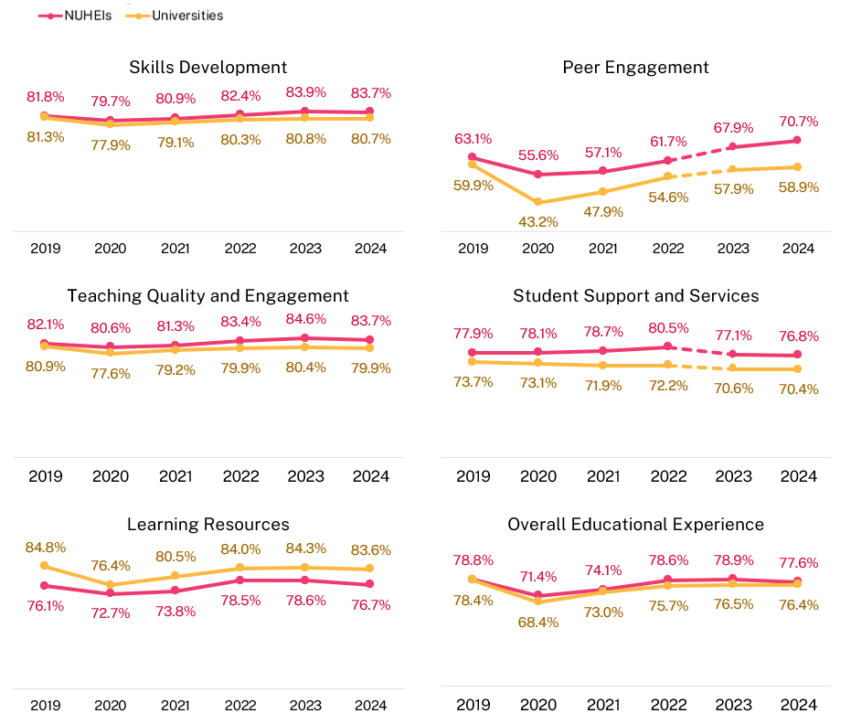
Note that the dotted lines between 2022 and 2023 indicate the change in underlying items of the Peer Engagement and Student Support and Services focus areas. When comparing year-on-year changes, it is recommended that modifications to underlying questionnaire items be taken into consideration when interpreting results. For more information about these changes, refer to the 2023 SES National Report.
Postgraduate coursework results by institution type
Similar to results for undergraduates, NUHEI postgraduate coursework students rated Skills Development, Peer Engagement, Student Support and Services, Teaching Quality and Engagement, and Overall Educational Experience higher than their counterparts at universities (Figure 18) with differences ranging from 2.4 to 6.3 percentage points.
University students have consistently rated Learning Resources higher than NUHEI students since 2022. In 2024, university students rated Learning Resources 4.0 percentage points higher than their NUHEI counterparts.
Note that course offerings, study area profiles, and student population composition can impact institution results.

Figure 18 Postgraduate coursework student experience by institution type, 2019–24 (% positive rating)
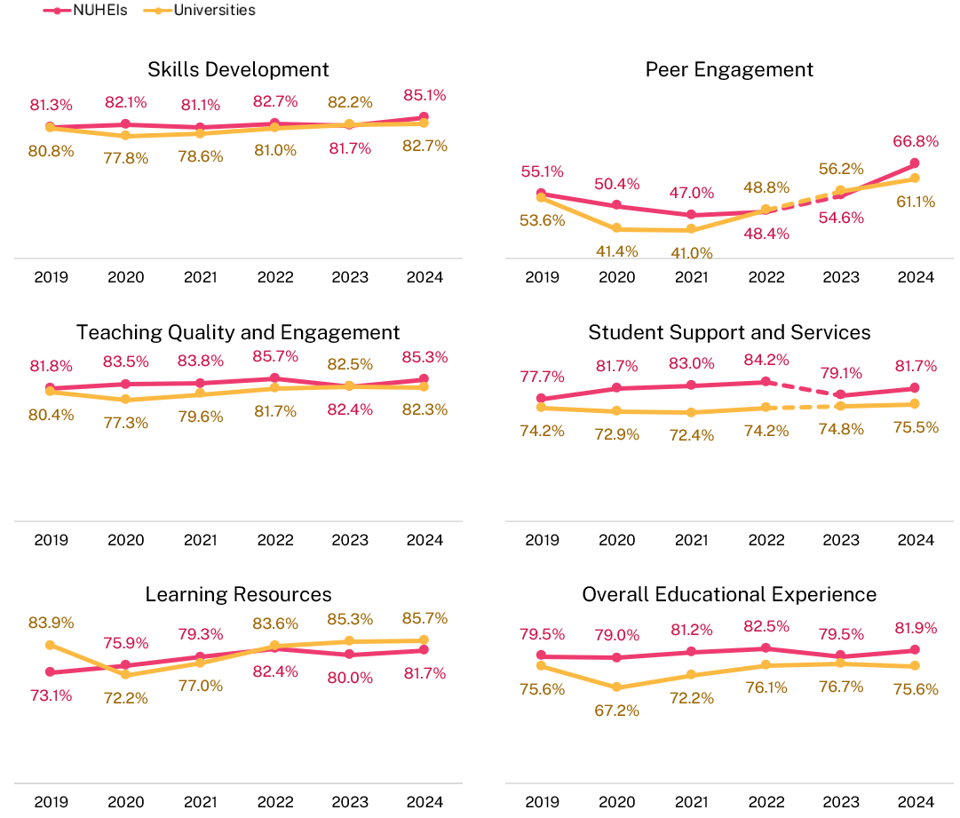

Note that the dotted lines between 2022 and 2023 indicate the change in underlying items of the Peer Engagement and Student Support and Services focus areas. When comparing year-on-year changes, it is recommended that modifications to underlying questionnaire items be taken into consideration when interpreting results. For more information about these changes, refer to the 2023 SES National Report.
There are differences in ratings of the Overall Educational Experience between various universities and NUHEIs which are presented in the next section. However, please note that when looking at institution results, where confidence intervals overlap, it cannot be inferred that an institution is or is not different to another to a statistical certainty. However, where intervals do not overlap, there is 90 per cent confidence that there is a difference between them.

Universities
Overall, there was some variation in undergraduate student ratings of Overall Educational Experience at universities in 2024. The University of Divinity, Avondale University, and Bond University (all relatively small institutions) performed substantially better than other universities, as shown in Figure 19.
Conversely, the University of New South Wales, the University of Southern Queensland, The University of Sydney, and The University of Melbourne had the lowest ratings for Overall Educational Experience by undergraduate students.
For postgraduate coursework student ratings, as seen in Figure 20, Avondale University had the highest rating for Overall Educational Experience in 2024, while The University of Notre Dame Australia recorded the lowest positive response. Confidence intervals for postgraduate coursework results are larger than for undergraduates due to a smaller number of responses.

Figure 19 Overall Educational Experience for undergraduate university students, 2024 (% positive rating)
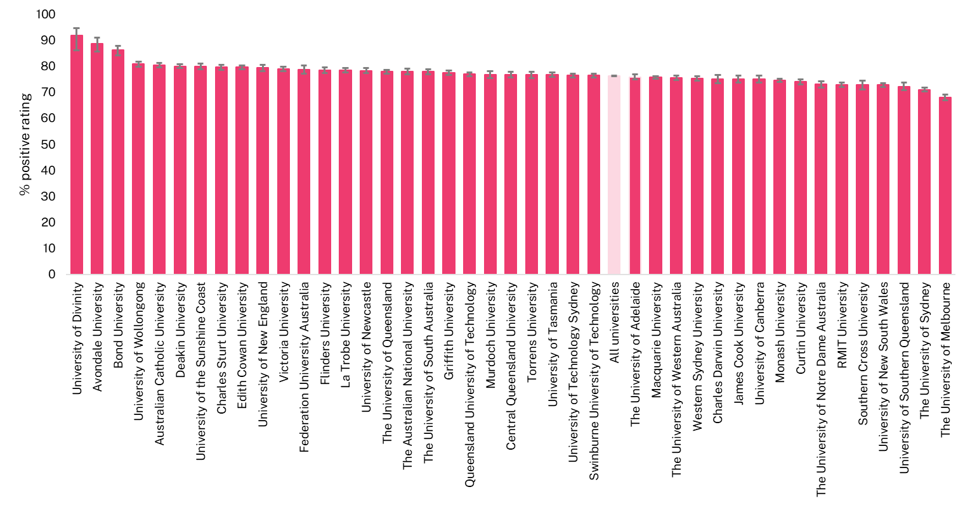

Figure 20 Overall Educational Experience for postgraduate coursework university students, 2024 (% positive rating)
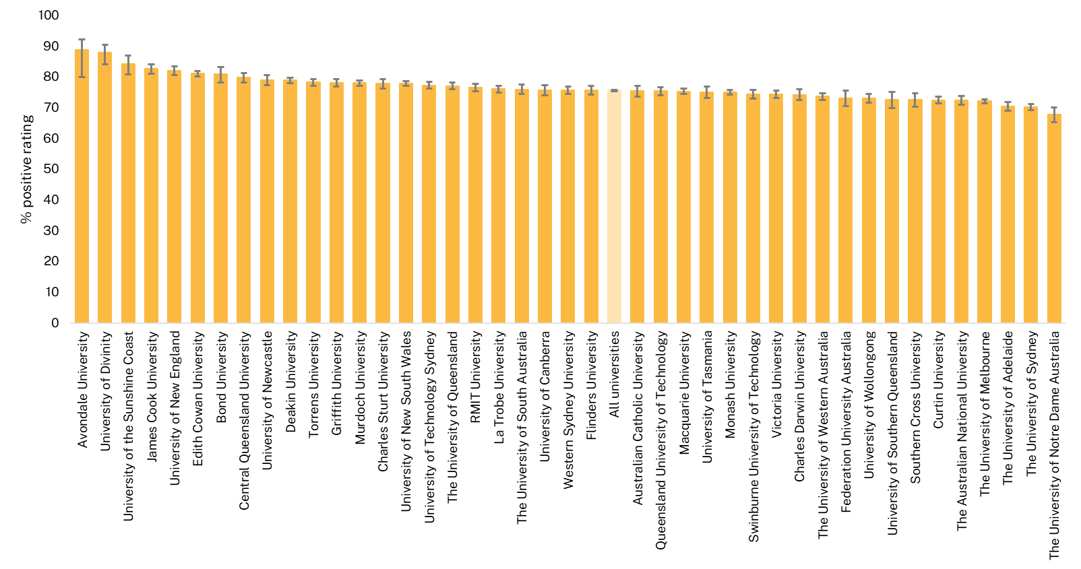

NUHEIs
Since the number of students enrolled in individual NUHEIs is much smaller than at universities, the NUHEI results in Figure 21 and Figure 22 use data pooled across two survey years. Consequently, results for NUHEIs are not directly comparable to those for universities. Additionally, results based on fewer than 25 survey responses have not been published.
Despite pooling data across two survey years, the confidence intervals for some NUHEIs remain wide. Nonetheless, there are NUHEIs where students rated their Overall Educational Experience significantly higher than in other institutions.
In 2023–24, 16 NUHEIs had over 90 per cent of undergraduate students rating their Overall Educational Experience positively; with the Cairnmiller Institute achieving 100% and several others over 95%. Conversely, 17 institutions had scores below 70%, including SP Jain School of Management, Kent Institute Australia, Think Education Group, and Crown Institute of Higher Education, which all had ratings below 65%. Figure 21 shows clear differences between higher and lower scoring institutions, indicating wide variation in student ratings.
Postgraduate coursework student ratings of their Overall Educational Experience tend to have larger confidence intervals due to the small number of responses (Figure 22). The Leaders Institute, Nan Tien Institute, The MIECAT Institute, and the Australian University of Theology had the highest positive ratings aggregated over 2023–24. Conversely, Southern Cross Education Institute (Higher Education), ISN Psychology, Chartered Accountants Australia and New Zealand, and The JMC Academy recorded relatively low scores.

Figure 21 Overall Educational Experience for undergraduate non-university higher education institution (NUHEI) students, pooled 2023–24 (% positive rating)
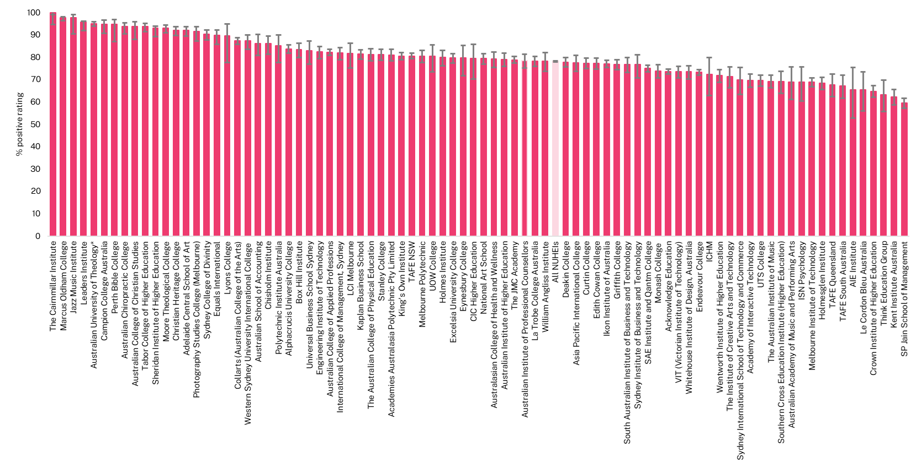
* The Australian University of Theology was awarded university status in December 2024. Prior to this, the institution was known as the Australian College of Theology and was classified as a non-university higher education institution (NUHEI). Data for the 2024 SES was collected when the institution was a NUHEI.
Figure 22 Overall Educational Experience for postgraduate coursework non-university higher education institution (NUHEI) students, pooled 2023–24 (% positive rating)
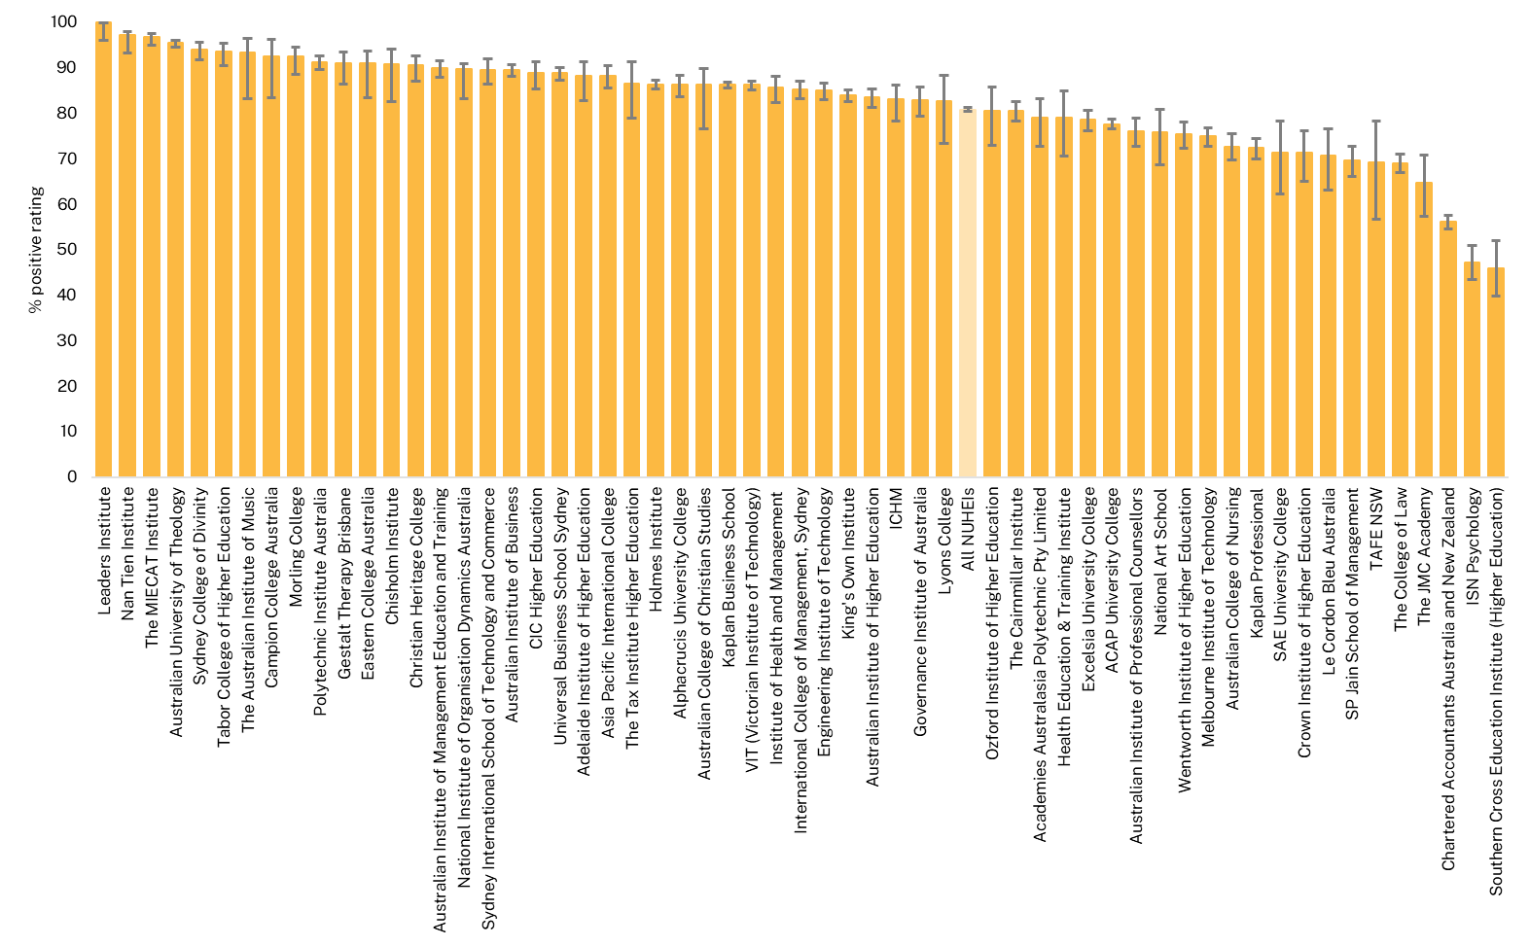

Other aspects of the student experience
This section explores aspects of the educational experience beyond the five focus areas including students' sense of belonging to their institution, whether they considered leaving their institution within the survey year, and the main reasons for such consideration.
Additionally, this section addresses student ratings of 'Freedom of Expression,' which includes perceptions of whether students and academics are free to express their views and whether students feel free from discrimination, harm, or hatred.

Sense of belonging
Sense of belonging relates to feelings of connectedness, inclusion and being accepted and valued by others. Research has shown that a student’s sense of belonging among peers and at the institution is linked with academic achievement, personal wellbeing, student satisfaction and attrition. This item was included in the Peer Engagement focus area prior to 2023 but has been a stand-alone question in the SES in 2023 and 2024.
This sense of belonging is highly associated with students’ overall educational experience and items from the Student Support and Services, such as orientation and induction activities and Teaching Quality and Engagement focus areas in particular.
Overall, students’ ratings of their sense of belonging to their institution has remained relatively low compared to other measures of the student experience. Positive ratings of students’ sense of belonging to their institution dropped significantly in 2020 during the COVID-19 pandemic (Figure 23). Undergraduate ratings have not returned to the pre-2020 average of 52.0 per cent. Consistent ratings from 2022 to 2024 suggest challenges in fostering belonging post-pandemic, as many pandemic-era practices remain.
For postgraduate coursework students, ratings declined in 2020 and 2021, likely due to a larger proportion of international students being overseas. Since 2021, postgraduate ratings have improved, reaching 51.9 per cent in 2024 and surpassing the pre-2020 average of 50.3 per cent.
Historically, undergraduate and postgraduate coursework students have rated their sense of belonging to their institution similarly. However, the gap between the two groups widened to 5.3 percentage points in 2024. This increase may be partly explained by the increase in international postgraduate coursework students, who tend to study in an internal/multi-mode.

Figure 23 Sense of belonging to institution by course level, 2017–24 (% positive rating*)
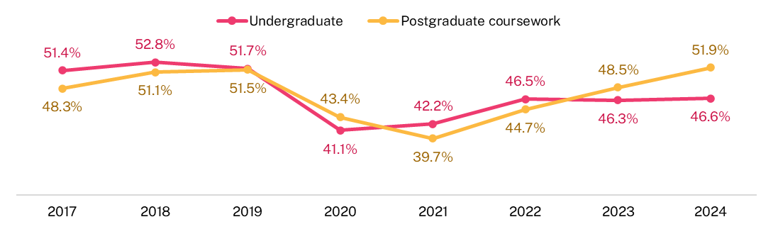
* The percent positive rating for sense of belonging represents the proportion of respondents who selected ‘Quite a bit’ or ‘Very much’ when asked ‘At your institution during <survey year>, to what extent have you had a sense of belonging to <institution name>?’
In 2024, the greatest variation in undergraduate ratings between sub-groups was between students from NUHEIs compared to those from universities, with university students reporting a lower sense of belonging by 15.2 percentage points (Figure 24). This difference is also evident for postgraduate students, where NUHEIs students rated their sense of belonging 11.6 percentage points higher than university students (Figure 25). This pattern persists when comparing international and domestic students from both universities and NUEHIs.
There was a gap in sense of belonging ratings between undergraduates whose home language was English and those whose home language was not, with a difference of 12.2 percentage points. This difference was also evident at the postgraduate coursework level, with a gap of 17.2 percentage points. These gaps persisted when comparing domestic students from non-English speaking backgrounds to those who spoke English at home.
A large difference was observed between internal/multi-mode and external study mode. External undergraduates rated their sense of belonging 9.0 percentage points lower than internal/multi-mode students, and external postgraduate coursework students rated it 21.3 percentage points lower. Despite the lower ratings, the stability of external student ratings from 2017 to 2024 suggests their sense of belonging was less impacted by the shift to online learning during the pandemic.
International students have consistently rated their sense of belonging more positively than domestic students. Since 2021, international undergraduate student ratings have returned to pre-2020 levels, remaining around 57 per cent in 2023 and 2024. In contrast, only 44.1 per cent of domestic undergraduates rated sense of belonging positively in 2024, about 7 percentage points lower than pre-2020 levels. This difference may be associated with international students’ greater reliance on their institution for social, academic and study needs, whereas domestic students may potentially maintain stronger external peer network and access to support. Additionally, domestic students are more likely to study externally, which may limit opportunities to form connections with their institution and peers, as reflected in lower Peer Engagement ratings.
Commencing undergraduates generally rate their sense of belonging higher than later-year students. In 2024, positive ratings for undergraduates remained below pre-2020 levels, with commencing student ratings approximately 5 percentage points lower and later-year student ratings about 6 percentage points behind pre-pandemic levels. These differences are less pronounced for postgraduate coursework students. Many postgraduates have recent experience from their undergraduate studies and often study online. Additionally, the increase in international students, who tend to rate their sense of belonging more highly, contributes to this trend.
Undergraduates with a reported disability rate their sense of belonging lower than those who do not have a reported disability. This trend persisted in 2024, with a gap of 5.3 percentage points between the groups, following a slight narrowing in 2023.This trend is also observed for postgraduate coursework students with students with a reported disability rating their sense of belonging less positively than their counterparts by 5.6 per cent. Given the persistence of this trend, this may be an area for focussed institutional improvement efforts such as in induction and orientation activities and other opportunities for students with disabilities to mix and work with their peers and feel more included.

Figure 24 Sense of belonging to institution by sub-group, undergraduate, 2017–24 (% positive rating)
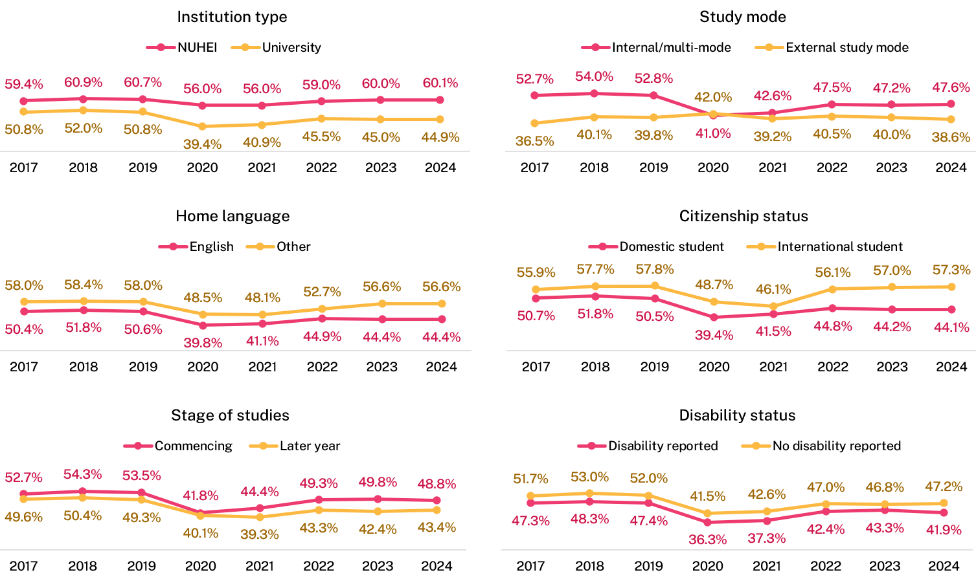

Figure 25 Sense of belonging to institution by sub-group, postgraduate coursework, 2017–24 (% positive rating)
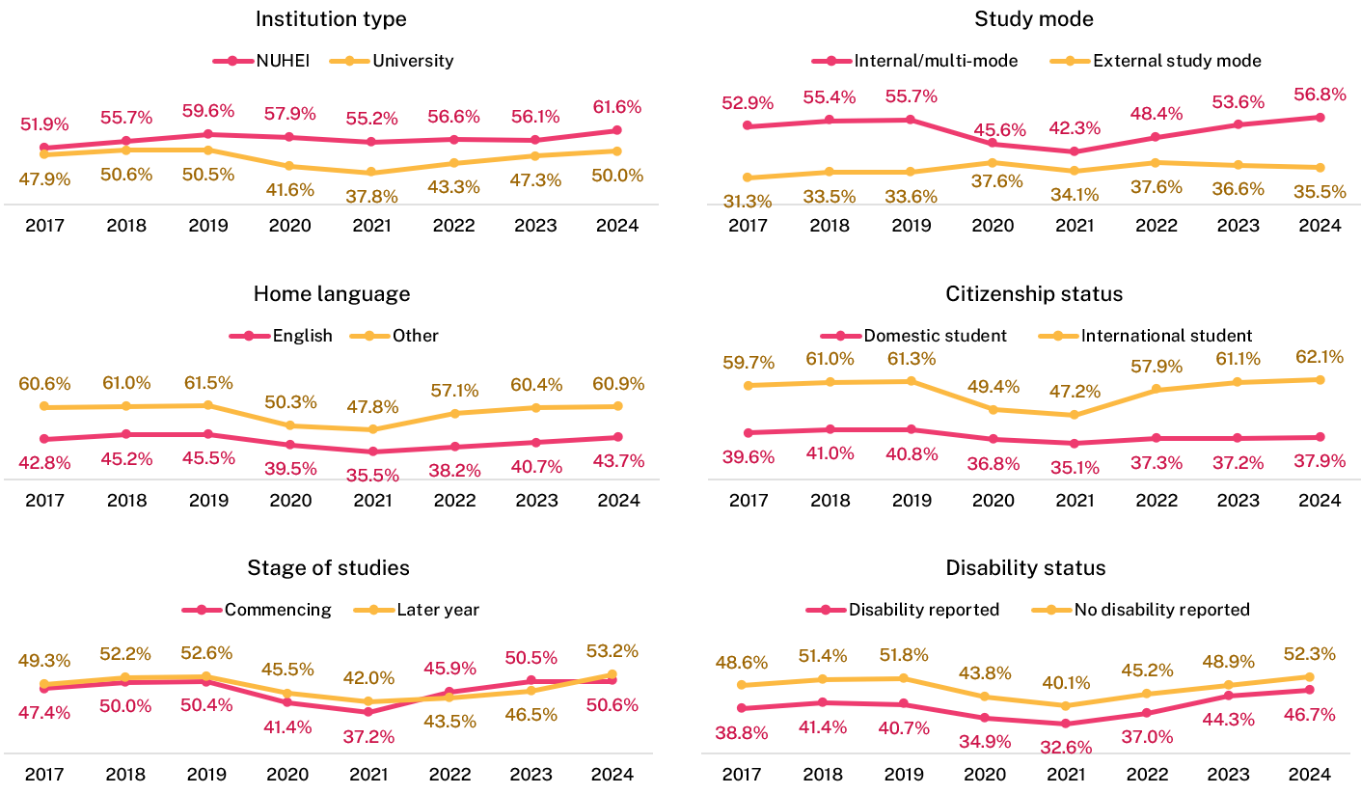

Likelihood to consider leaving current institution
In addition to questions about their higher education experience, students were also asked whether they had seriously considered leaving their current institution in the survey year. Overall, 18.3 per cent of undergraduate students indicated that they had considered leaving in 2024, the lowest since 2017. At the postgraduate coursework level, 16.0 per cent reported considered leaving in 2024, also the lowest rate since 2017 (Figure 26). While the SES asks about consideration of leaving rather than actual leaving behaviour, it may be a useful indicator of some challenges students faced during that year.
Figure 26 Proportion of students who considered early departure from institution by course level, 2017–24
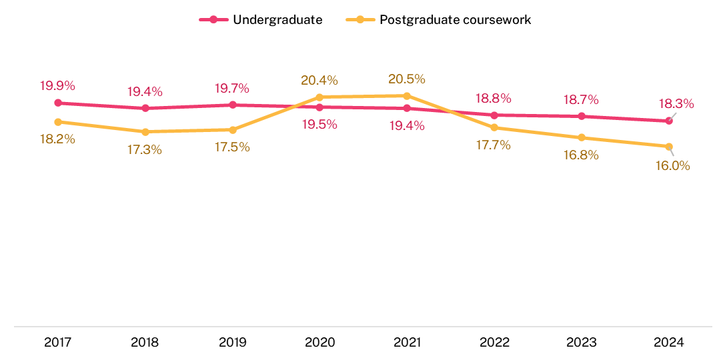
Students who considered leaving their institution were asked to indicate, from a list of 28 possible reasons, why they had considered doing so. Students could select as many reasons as applicable, so the percentages do not sum to 100. Figure 27 shows the key findings in 2024.
While students who had considered leaving represent a relatively small proportion of SES respondents, their responses suggest that institutions should examine student wellbeing, including stress levels, mental health, work/life balance, and financial difficulties. Additionally, the high proportion of students indicating unmet course expectations as a main reason for considering leaving, highlights the need to explore these expectations further and address them effectively.

Figure 27 Top reasons for considering early departure from institution in 2024 (% of those who considered leaving)
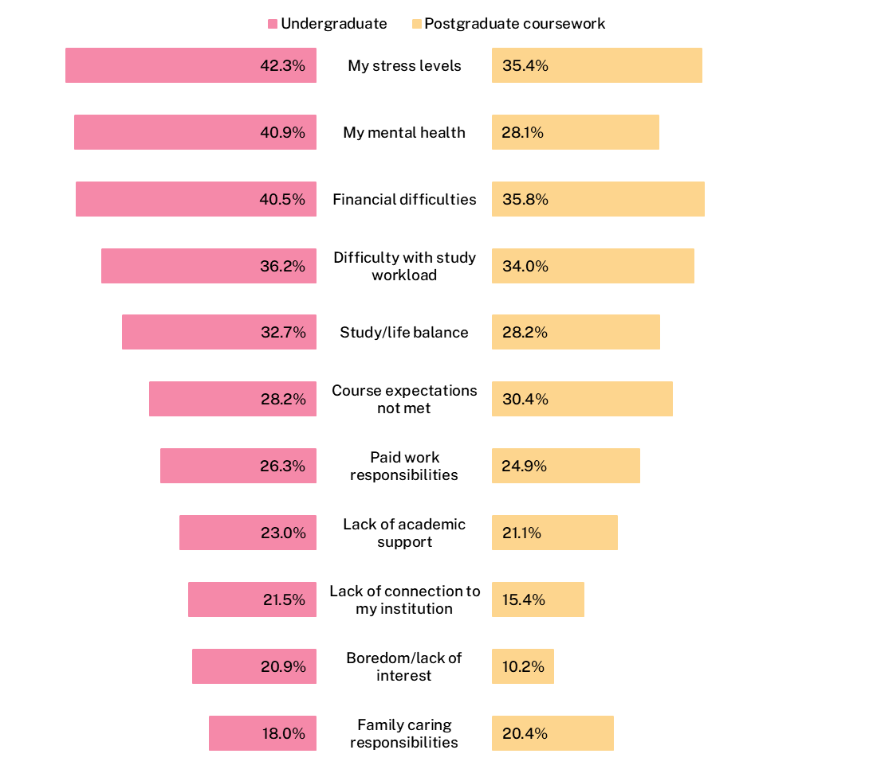

Freedom of expression
The SES includes a series of questions related to students’ perceptions of freedom of expression at their institution. Respondents were asked to indicate their level of agreement with the following statements:
- ‘I am free to express my views at [institution name]’;
- ‘Academics are free to express their views at [institution name]’; and
- ‘I am free from discrimination, harm, or hatred at [institution name]’.
In 2024, a majority of higher education students rated their overall freedom of expression positively, with 84.6 per cent of undergraduates and 85.8 per cent of postgraduate coursework students agreeing.
The proportions of positive ratings presented in Table 3 represent the respondents who agreed or strongly agreed with the statements. However, the inverse does not represent the proportion who disagreed. On average, approximately 5 per cent of respondents disagreed or strongly disagreed, while the remainder were neutral.
Table 3 Freedom of expression by course level and stage of study, 2024 (% positive rating*)
 | I am free to express my views | Academics are free to express their views | I am free from discrimination, harm or hatred | Overall freedom of expression
Undergraduate | 73.5 | 73.7 | 80.0 | 84.6
Postgraduate coursework | 77.0 | 76.1 | 81.2 | 85.8
* Item scores represent the proportion of respondents who agreed or strongly agreed with the item. Overall focus area scores are not a simple average of the underlying items.

Undergraduate results by sub-group
- Younger students generally rated aspects of freedom of expression more positively than older students. For example, 74.7 per cent of undergraduates aged under 25 agreed they were free to express their views on campus, compared to 65.9 per cent of those aged 40 and over. The lowest rating for freedom of expression among undergraduates aged 40 and over was for the item ‘Academics are free to express their views’ (62.3 per cent), compared to 75.5 per cent of undergraduates under 25.
- Female students consistently rated all items higher than male students.
- First Nations students rated their freedom from discrimination, harm and hatred lower than domestic non-Indigenous students whereas ratings were broadly similar for the other items. This is consistent with results for postgraduate coursework domestic students.
- Students with a reported disability rated all freedom of expression items lower than those without a disability.
- International undergraduate students rated their freedom to express views more positively than domestic students by 7.9 percentage points, and their rating of whether academics were free to express views by 8.7 percentage points. However, their response to freedom from discrimination, harm, or hatred was similar to domestic students.
- Students in internal/multi study modes reported higher freedom of expression ratings than those studying externally.
- Commencing undergraduate students also responded more positively across all items than later-year students.
Similar patterns were observed at the postgraduate coursework level.
These differences by demographic sub-groups, especially in relation to freedom from discrimination, harm, or hatred, may warrant further analysis to ensure support and mitigation strategies are in place.
- SES Focus area items
  - Skills Development
This focus area asks students to reflect on the extent to which their course developed their skills and knowledge in eight areas, using a scale from 'not at all' to 'very much'.
To what extent has your (course) developed your:
- Critical thinking skills
- Ability to solve complex problems
- Ability to work with others
- Confidence to learn independently
- Written communication skills
- Spoken communication skills
- Knowledge of field(s) studying
- Development of work-related knowledge and skills

  - Peer Engagement (formerly Learner Engagement)
This focus area asks students to indicate how frequently they engage with other students inside and outside formal study, using a scale from ‘never’ to ‘always’.
The underlying items for this focus area are how frequently they have:
- Contributed to class discussion (e.g. in-person discussions, online chat forums, discussion boards)
- Worked with other students as part of your <course> (e.g. group assignments, in-class collaboration)
- Interacted socially with other students outside of your study
- Interacted with a diverse range of students

  - Teaching Quality and Engagement (formerly Teaching Quality)
This focus area asks students to rate the quality of their overall educational experience and teaching quality, ranging from fair to excellent. It also asks students to evaluate the relevance and focus of their course to their education, as well as the extent to which academic staff undertake certain actions, from not at all to very much.
The items are:
- Course well-structured and focused
- Course relevant to education as a whole
- Teachers engaged you actively in learning
- Teachers demonstrated concern for student learning
- Teachers provided clear explanations on coursework and assessment
- Teachers stimulated you intellectually
- Teachers commented on your work in ways that help you learn
- Teachers seemed helpful and approachable
- Teachers set assessment tasks that challenge you to learn
- Overall quality of teaching
- Overall quality of entire educational experience

  - Student Support and Services (formerly Student Support)
This focus area asks students to rate the helpfulness of various supports and services provided by their institution, ranging from not at all helpful to very helpful, with an option for 'Not Used' for those who did not utilise the support services.
How helpful have you found the following supports and services provided by your institution during <survey year>:
- enrolment process and support
- induction/orientation activities
- online learning platform
- career development services
- study or learning support services
- counsellors and or health services
- financial and or legal advisors

  - Learning Resources
The Learning Resources focus area asks students to rate the quality of various learning resources provided by the institution, ranging from poor to excellent.
The items relate to the quality of:
- teaching spaces
- student spaces and common areas
- online learning materials
- computing/IT resources
- assigned books, notes and resources
- laboratory or studio equipment
- library resources and facilities

- Detailed tables
  - Focus areas and the Overall Educational Experience
    - Course level by demographic sub-groups

Table 4 Undergraduate student experience by demographic sub-group, 2022–24 (% positive rating)††
 |  | Skills Development 2022 | Skills Development 2023 | Skills Development 2024 | Peer Engagement 2022 | Peer Engagement 2023 | Peer Engagement 2024 | Teaching Quality and Engagement 2022 | Teaching Quality and Engagement 2023 | Teaching Quality and Engagement 2024 | Student Support and Services 2022 | Student Support and Services 2023 | Student Support and Services 2024 | Learning Resources 2022 | Learning Resources 2023 | Learning Resources 2024 | Overall Educational Experience 2022 | Overall Educational Experience 2023 | Overall Educational Experience 2024
Stage of studies | Commencing | 79.6 | 80.2 | 80.0 | 55.8 | 59.6 | 60.6 | 83.0 | 83.7 | 82.4 | 76.0 | 74.9 | 73.9 | 86.8 | 87.1 | 86.0 | 79.1 | 80.1 | 79.2
Stage of studies | Later-year | 81.5 | 82.1 | 82.4 | 54.4 | 57.9 | 59.5 | 76.9 | 77.3 | 77.3 | 69.3 | 66.7 | 66.9 | 79.6 | 79.8 | 77.9 | 72.2 | 72.9 | 72.6
Study mode* | Internal/multi-mode | 80.7 | 81.4 | 81.3 | 59.6 | 63.6 | 65.0 | 79.8 | 80.6 | 80.2 | 72.1 | 70.9 | 70.9 | 83.6 | 84.0 | 82.9 | 75.2 | 76.3 | 76.1
Study mode* | External | 79.0 | 79.1 | 78.5 | 28.0 | 24.1 | 22.3 | 82.0 | 81.5 | 81.4 | 77.9 | 74.4 | 73.5 | 83.4 | 81.0 | 80.5 | 79.8 | 79.9 | 79.8
Gender | Male | 77.3 | 77.9 | 77.9 | 56.4 | 59.2 | 60.8 | 78.2 | 79.1 | 78.6 | 72.0 | 69.5 | 69.2 | 82.5 | 82.9 | 82.0 | 73.5 | 74.0 | 73.4
Gender | Female | 82.1 | 82.8 | 82.7 | 54.5 | 58.6 | 59.8 | 81.1 | 81.6 | 81.2 | 73.3 | 72.2 | 72.2 | 84.2 | 84.3 | 83.3 | 77.1 | 78.1 | 78.2
Age | Under 25 | 80.7 | 81.3 | 81.1 | 59.5 | 63.6 | 64.6 | 80.1 | 80.7 | 80.1 | 72.1 | 71.0 | 70.8 | 84.0 | 84.3 | 83.3 | 75.6 | 76.5 | 76.1
Age | 25 to 29 | 80.0 | 80.6 | 80.8 | 48.0 | 50.1 | 51.7 | 78.4 | 78.5 | 79.0 | 72.9 | 70.4 | 71.5 | 80.5 | 79.9 | 78.7 | 73.7 | 75.1 | 75.2
Age | 30 to 39 | 78.9 | 80.3 | 80.5 | 40.6 | 42.1 | 44.8 | 79.6 | 80.5 | 80.4 | 75.2 | 72.7 | 72.7 | 81.7 | 82.1 | 81.3 | 76.1 | 77.3 | 77.8
Age | 40 and over | 80.6 | 80.5 | 80.7 | 35.6 | 35.7 | 35.0 | 83.7 | 83.7 | 84.2 | 78.4 | 74.1 | 74.4 | 83.7 | 84.0 | 82.8 | 80.9 | 81.2 | 82.2
First Nations** | First Nations | 79.7 | 81.3 | 80.6 | 47.7 | 50.4 | 50.6 | 78.6 | 79.6 | 80.3 | 74.6 | 71.7 | 72.5 | 82.2 | 82.9 | 84.6 | 76.1 | 77.8 | 77.7
First Nations** | Non-Indigenous | 80.2 | 80.6 | 80.4 | 54.1 | 56.7 | 57.5 | 80.1 | 80.4 | 79.9 | 72.4 | 69.4 | 69.2 | 83.6 | 83.7 | 82.7 | 76.2 | 76.9 | 76.9
Home language*** | English | 80.5 | 80.9 | 80.6 | 54.1 | 57.3 | 58.0 | 80.6 | 80.6 | 80.2 | 72.9 | 69.7 | 69.5 | 83.7 | 83.6 | 82.7 | 76.7 | 77.0 | 77.0
Home language*** | Other | 80.2 | 82.4 | 83.1 | 59.0 | 66.8 | 70.1 | 78.4 | 81.7 | 80.9 | 72.9 | 77.6 | 77.1 | 83.2 | 85.0 | 83.2 | 72.8 | 75.3 | 74.4
Disability | Disability reported | 77.3 | 78.9 | 77.6 | 50.9 | 55.5 | 56.3 | 78.1 | 79.3 | 78.0 | 71.3 | 68.7 | 67.0 | 80.5 | 81.2 | 78.6 | 73.8 | 75.1 | 74.1
Disability | No disability reported | 80.8 | 81.4 | 81.4 | 55.6 | 59.3 | 60.7 | 80.4 | 80.9 | 80.6 | 73.1 | 71.6 | 71.7 | 83.9 | 84.2 | 83.3 | 76.1 | 77.0 | 76.9
Citizenship status | Domestic | 80.2 | 80.6 | 80.4 | 54.0 | 56.6 | 57.4 | 80.1 | 80.4 | 79.9 | 72.5 | 69.4 | 69.2 | 83.5 | 83.7 | 82.7 | 76.2 | 76.9 | 76.9
Citizenship status | International | 81.8 | 83.4 | 83.7 | 61.5 | 69.5 | 72.2 | 80.2 | 82.5 | 81.9 | 75.0 | 78.1 | 77.5 | 83.8 | 84.5 | 83.0 | 74.4 | 75.8 | 74.9
First in family status**** | First in family | 80.7 | 81.1 | 80.9 | 53.9 | 55.4 | 56.6 | 83.7 | 83.9 | 83.0 | 77.9 | 76.2 | 76.2 | 87.5 | 88.0 | 86.4 | 79.9 | 81.0 | 80.5
First in family status**** | Not first in family | 79.2 | 79.8 | 79.5 | 59.0 | 62.4 | 63.0 | 83.0 | 83.9 | 82.2 | 74.6 | 73.3 | 72.0 | 87.2 | 87.4 | 86.3 | 79.2 | 80.2 | 79.2
Previous higher education experience | At current institution | 79.6 | 80.3 | 80.3 | 53.1 | 54.7 | 56.1 | 82.7 | 83.0 | 81.4 | 74.1 | 72.7 | 71.3 | 85.6 | 86.0 | 84.2 | 78.7 | 79.4 | 78.2
Previous higher education experience | At another institution | 79.4 | 80.4 | 80.0 | 49.6 | 53.0 | 53.6 | 84.6 | 85.0 | 83.7 | 78.4 | 77.1 | 76.3 | 86.1 | 85.8 | 84.3 | 80.9 | 81.5 | 80.3
Previous higher education experience | New to higher education | 79.6 | 80.1 | 80.0 | 58.6 | 62.8 | 63.7 | 82.4 | 83.5 | 82.1 | 75.5 | 74.6 | 73.6 | 87.3 | 87.7 | 86.8 | 78.5 | 79.8 | 79.1
Socio-economic status** † | High | 79.6 | 79.6 | 79.3 | 56.7 | 60.0 | 60.9 | 80.2 | 80.1 | 79.8 | 70.0 | 66.2 | 66.3 | 83.2 | 83.4 | 82.0 | 76.3 | 76.6 | 76.8
Socio-economic status** † | Medium | 80.5 | 81.2 | 80.8 | 53.8 | 56.6 | 56.8 | 80.2 | 80.7 | 79.9 | 72.9 | 70.6 | 70.0 | 83.7 | 84.1 | 83.2 | 76.1 | 77.1 | 77.0
Socio-economic status** † | Low | 80.3 | 81.0 | 81.1 | 49.2 | 51.1 | 51.5 | 79.6 | 80.1 | 80.2 | 74.7 | 71.7 | 72.5 | 83.8 | 83.3 | 83.2 | 75.9 | 77.0 | 77.1
Location ** † | Metro | 80.1 | 80.6 | 80.2 | 55.3 | 58.0 | 59.0 | 79.9 | 80.2 | 79.8 | 71.9 | 69.3 | 69.1 | 83.6 | 83.8 | 82.7 | 75.9 | 76.6 | 76.7
Location ** † | Regional / remote | 80.5 | 80.8 | 80.7 | 48.9 | 51.1 | 50.8 | 80.6 | 80.7 | 80.5 | 73.8 | 69.7 | 69.8 | 83.5 | 83.2 | 83.0 | 76.8 | 77.9 | 78.0
 | Total | 80.5 | 81.1 | 81.0 | 55.2 | 58.8 | 60.2 | 80.1 | 80.7 | 80.3 | 72.9 | 71.2 | 71.2 | 83.6 | 83.8 | 82.8 | 75.9 | 76.7 | 76.5
* Internal mode of attendance is where (i) the study is undertaken through attendance at the higher education provider on a regular basis, or (ii) for higher degree unit enrolments, where regular attendance is not required but the student attends the higher education provider on an agreed schedule for the purposes of supervision and/or instruction. External mode of attendance is where lesson materials, assignments, etc. are delivered to the student, and any associated attendance at the institution is of an incidental, irregular, special or voluntary nature. Multi-mode of attendance is where study is undertaken partially on an internal mode of attendance and partially on an external mode of attendance.
** First Nations, socio-economic, and locality data reflect values for domestic students only, excluding international students. The remaining demographic and equity groups include all students, both domestic and international.
*** Home language other than English refers to graduates who arrived in Australia less than 10 years prior to the year in which the data was collected, and comes from a home where a language other than English is spoken. This information is reported by institutions through the TCSI system. Data presented here includes both domestic and international student responses.
**** First in family refers to students commencing a bachelor degree level qualification when their parent(s) or guardian(s) have not. Based on the highest level of educational attainment of a student’s parent(s) or guardian(s) as identified by the student. This information is reported by institutions through the Tertiary Collection of Student Information (TCSI) system.
** † Socio-economic status and Location are derived from students’ permanent home residence against the 2011 SEIFA Index of Education and Occupation by postal area.
†† Some sub-groups may not add to 100 per cent due to rounding.

Table 5 Postgraduate coursework student experience by demographic group, 2022–24 (% positive rating)††
 |  | Skills Development 2022 | Skills Development 2023 | Skills Development 2024 | Peer Engagement 2022 | Peer Engagement 2023 | Peer Engagement 2024 | Teaching Quality and Engagement 2022 | Teaching Quality and Engagement 2023 | Teaching Quality and Engagement 2024 | Student Support and Services 2022 | Student Support and Services 2023 | Student Support and Services 2024 | Learning Resources 2022 | Learning Resources 2023 | Learning Resources 2024 | Overall Educational Experience 2022 | Overall Educational Experience 2023 | Overall Educational Experience 2024
Stage of studies | Commencing | 80.7 | 81.9 | 82.1 | 49.2 | 57.1 | 59.8 | 83.7 | 84.2 | 83.8 | 76.6 | 77.7 | 77.4 | 85.3 | 86.2 | 85.6 | 77.9 | 78.2 | 77.9
Stage of studies | Later year | 81.6 | 82.3 | 84.1 | 48.3 | 54.9 | 64.2 | 80.5 | 80.8 | 81.8 | 74.0 | 73.0 | 75.9 | 81.8 | 83.0 | 84.5 | 75.7 | 75.9 | 75.5
Study mode* | Internal/multi-mode | 82.7 | 84.2 | 84.9 | 59.5 | 69.3 | 73.8 | 81.6 | 83.1 | 83.4 | 73.8 | 76.4 | 77.6 | 83.6 | 85.3 | 85.6 | 75.3 | 76.5 | 76.1
Study mode* | External | 78.1 | 77.3 | 77.1 | 28.5 | 24.7 | 22.4 | 82.9 | 81.2 | 80.7 | 78.3 | 72.1 | 71.3 | 83.0 | 80.3 | 79.2 | 79.2 | 78.5 | 78.5
Gender | Male | 79.1 | 80.6 | 81.3 | 51.7 | 59.6 | 65.3 | 80.2 | 81.0 | 81.1 | 74.9 | 75.0 | 75.9 | 83.3 | 84.6 | 85.1 | 75.4 | 75.7 | 74.9
Gender | Female | 82.3 | 83.0 | 84.3 | 47.1 | 53.8 | 60.1 | 83.2 | 83.4 | 83.9 | 75.5 | 75.8 | 77.2 | 83.7 | 84.7 | 85.1 | 77.5 | 77.9 | 77.8
Age | Under 25 | 84.4 | 83.8 | 84.7 | 62.6 | 70.2 | 73.0 | 81.6 | 81.4 | 82.1 | 73.6 | 75.7 | 76.2 | 84.5 | 85.0 | 85.8 | 75.9 | 74.5 | 74.3
Age | 25 to 29 | 80.8 | 83.2 | 84.0 | 52.3 | 63.4 | 69.4 | 80.0 | 81.6 | 82.1 | 74.3 | 76.1 | 77.8 | 82.1 | 83.9 | 84.7 | 73.9 | 75.0 | 74.9
Age | 30 to 39 | 79.7 | 81.1 | 82.5 | 42.4 | 49.6 | 56.6 | 82.0 | 82.9 | 83.4 | 75.5 | 75.9 | 77.2 | 83.1 | 85.0 | 84.6 | 76.7 | 78.6 | 78.4
Age | 40 and over | 79.3 | 79.5 | 79.5 | 35.0 | 33.6 | 36.6 | 85.1 | 84.8 | 84.5 | 78.2 | 72.7 | 73.3 | 84.7 | 84.9 | 84.4 | 81.0 | 81.6 | 81.7
First Nations** | First Nations | 79.0 | 79.3 | 80.3 | 40.1 | 43.2 | 41.7 | 80.8 | 78.5 | 81.6 | 69.7 | 70.5 | 70.1 | 80.1 | 79.0 | 81.2 | 78.3 | 77.3 | 79.0
First Nations** | Non-Indigenous | 79.5 | 79.0 | 79.2 | 41.3 | 39.5 | 40.5 | 81.8 | 81.2 | 80.9 | 74.3 | 67.2 | 67.4 | 80.7 | 79.7 | 79.3 | 76.6 | 77.1 | 77.1
Home language*** | English | 79.7 | 80.3 | 81.0 | 42.9 | 45.8 | 50.0 | 81.9 | 81.8 | 82.1 | 74.3 | 70.6 | 72.2 | 81.2 | 81.7 | 82.0 | 76.7 | 77.4 | 77.4
Home language*** | Other | 83.8 | 84.9 | 85.4 | 60.0 | 71.5 | 75.2 | 82.4 | 83.6 | 83.6 | 76.9 | 80.0 | 79.8 | 86.3 | 87.4 | 87.2 | 76.8 | 76.5 | 75.9
Disability | Disability reported | 75.9 | 78.3 | 79.7 | 44.0 | 54.2 | 59.7 | 77.5 | 79.4 | 80.9 | 70.6 | 69.0 | 72.4 | 76.2 | 78.4 | 79.3 | 70.8 | 74.4 | 75.4
Disability | No disability reported | 81.5 | 82.4 | 83.4 | 49.1 | 56.1 | 62.3 | 82.4 | 82.8 | 82.9 | 75.6 | 76.0 | 76.9 | 84.0 | 85.2 | 85.5 | 77.1 | 77.3 | 76.8
Residence status | Domestic | 79.5 | 79.0 | 79.2 | 41.3 | 39.6 | 40.5 | 81.8 | 81.1 | 81.0 | 74.2 | 67.2 | 67.5 | 80.7 | 79.7 | 79.4 | 76.6 | 77.1 | 77.2
Residence status | International | 84.1 | 85.5 | 86.0 | 62.2 | 74.3 | 77.7 | 82.6 | 84.1 | 84.1 | 76.9 | 80.4 | 80.3 | 86.4 | 87.7 | 87.3 | 76.9 | 77.0 | 76.3
First in family status**** | First in family | 80.2 | 81.7 | 81.2 | 44.8 | 49.7 | 50.7 | 84.1 | 84.8 | 84.1 | 77.2 | 77.7 | 76.6 | 85.4 | 86.9 | 86.1 | 78.9 | 79.8 | 78.9
First in family status**** | Not first in family | 81.0 | 80.9 | 81.5 | 51.9 | 57.4 | 58.9 | 83.9 | 83.4 | 83.3 | 76.4 | 76.0 | 75.5 | 85.8 | 86.1 | 85.3 | 78.0 | 77.0 | 76.8
Previous higher education experience | At current institution | 80.7 | 81.1 | 81.0 | 52.5 | 55.3 | 56.8 | 82.3 | 82.9 | 82.8 | 72.5 | 72.6 | 71.5 | 83.6 | 84.5 | 83.4 | 75.6 | 77.3 | 76.5
Previous higher education experience | At another institution | 80.2 | 81.2 | 81.7 | 47.1 | 54.5 | 58.3 | 84.1 | 84.1 | 83.6 | 77.1 | 76.8 | 77.0 | 85.4 | 85.8 | 85.1 | 78.3 | 77.8 | 77.9
Previous higher education experience | New to higher education | 83.1 | 85.4 | 85.1 | 55.8 | 69.6 | 70.3 | 84.6 | 86.1 | 85.8 | 80.9 | 84.7 | 83.7 | 87.6 | 88.9 | 89.4 | 80.1 | 81.0 | 79.4
Socio-economic status** † | High | 78.6 | 78.3 | 78.1 | 44.1 | 43.4 | 45.2 | 80.9 | 80.1 | 80.5 | 71.8 | 64.0 | 64.0 | 79.7 | 78.0 | 78.3 | 75.2 | 75.6 | 76.1
Socio-economic status** † | Medium | 80.0 | 80.1 | 80.1 | 40.2 | 38.9 | 38.8 | 82.0 | 81.7 | 81.6 | 75.1 | 69.3 | 69.7 | 81.3 | 80.5 | 80.4 | 77.1 | 78.0 | 78.2
Socio-economic status** † | Low | 80.3 | 79.2 | 80.0 | 37.2 | 34.6 | 35.3 | 82.7 | 81.3 | 81.9 | 75.9 | 68.7 | 70.4 | 81.0 | 79.3 | 80.0 | 77.7 | 77.9 | 78.1
Location** † | Metro | 78.6 | 78.3 | 79.5 | 43.1 | 42.3 | 42.8 | 81.2 | 81.5 | 81.0 | 73.3 | 67.3 | 67.4 | 80.4 | 79.9 | 79.4 | 75.8 | 77.1 | 76.9
Location** † | Regional / remote | 80.0 | 80.1 | 78.6 | 33.6 | 31.4 | 32.2 | 83.0 | 81.9 | 81.9 | 75.6 | 67.4 | 68.9 | 80.9 | 78.8 | 79.7 | 78.3 | 78.8 | 79.3
 | Total | 81.1 | 82.1 | 83.1 | 48.7 | 56.0 | 62.1 | 82.1 | 82.5 | 82.8 | 75.3 | 75.5 | 76.6 | 83.5 | 84.6 | 85.0 | 76.7 | 77.1 | 76.7
* Internal mode of attendance is where (i) the study is undertaken through attendance at the higher education provider on a regular basis, or (ii) for higher degree unit enrolments, where regular attendance is not required but the student attends the higher education provider on an agreed schedule for the purposes of supervision and/or instruction. External mode of attendance is where lesson materials, assignments, etc. are delivered to the student, and any associated attendance at the institution is of an incidental, irregular, special or voluntary nature. Multi-mode of attendance is where study is undertaken partially on an internal mode of attendance and partially on an external mode of attendance.
** First Nations, socio-economic, and locality data reflect values for domestic students only, excluding international students. The remaining demographic and equity groups include all students, both domestic and international.
*** Home language other than English refers to graduates who arrived in Australia less than 10 years prior to the year in which the data was collected, and comes from a home where a language other than English is spoken. This information is reported by institutions through the TCSI system. Data presented here includes both domestic and international student responses.
**** First in family refers to students commencing a bachelor degree level qualification when their parent(s) or guardian(s) have not. Based on the highest level of educational attainment of a student’s parent(s) or guardian(s) as identified by the student. This information is reported by institutions through the Tertiary Collection of Student Information (TCSI) system.
**† Socio-economic status and Location are derived from students’ permanent home residence against the 2011 SEIFA Index of Education and Occupation by postal area.
†† Some sub-groups may not add to 100 per cent due to rounding.

  - Other aspects of the student experience
    - Sense of belonging

Table 6 Undergraduate sense of belonging to institution, 2017–24 (% positive rating)
 |  | 2017 | 2018 | 2019 | 2020 | 2021 | 2022 | 2023 | 2024
Stage of studies | Commencing | 52.7 | 54.3 | 53.5 | 41.8 | 44.4 | 49.3 | 49.8 | 48.8
Stage of studies | Later years | 49.6 | 50.4 | 49.3 | 40.1 | 39.3 | 43.3 | 42.4 | 43.4
Study mode* | Internal/multi-mode | 52.7 | 54.0 | 52.8 | 41.0 | 42.6 | 47.5 | 47.2 | 47.6
Study mode* | External | 36.5 | 40.1 | 39.8 | 42.0 | 39.2 | 40.5 | 40.0 | 38.6
Institution type | NUHEIs | 59.4 | 60.9 | 60.7 | 56.0 | 56.0 | 59.0 | 60.0 | 60.1
Institution type | Universities | 50.8 | 52.0 | 50.8 | 39.4 | 40.9 | 45.5 | 45.0 | 44.9
Gender | Male | 50.7 | 51.7 | 50.8 | 39.8 | 40.7 | 45.9 | 45.3 | 45.8
Gender | Female | 51.8 | 53.3 | 52.3 | 41.8 | 43.0 | 46.9 | 46.8 | 47.1
Age | Under 25 | 52.8 | 53.9 | 52.7 | 40.5 | 42.1 | 47.3 | 46.7 | 46.8
Age | 25 to 29 | 46.0 | 48.6 | 47.5 | 41.5 | 40.4 | 42.8 | 42.6 | 44.0
Age | 30 to 39 | 45.4 | 47.6 | 47.2 | 42.2 | 42.0 | 43.1 | 44.4 | 45.6
Age | 40 and over | 49.0 | 49.6 | 51.1 | 46.7 | 45.9 | 46.7 | 48.9 | 48.2
First Nations** | First Nations | 49.3 | 52.2 | 52.4 | 43.5 | 43.7 | 47.9 | 47.1 | 46.6
First Nations** | Non-Indigenous | 50.7 | 51.8 | 50.5 | 39.3 | 41.4 | 44.7 | 44.1 | 44.0
Home language*** | English | 50.4 | 51.8 | 50.6 | 39.8 | 41.1 | 44.9 | 44.4 | 44.4
Home language*** | Other | 58.0 | 58.4 | 58.0 | 48.5 | 48.1 | 52.7 | 56.6 | 56.6
Disability | Disability reported | 47.3 | 48.3 | 47.4 | 36.3 | 37.3 | 42.4 | 43.3 | 41.9
Disability | No disability reported | 51.7 | 53.0 | 52.0 | 41.5 | 42.6 | 47.0 | 46.8 | 47.2
Citizenship status | Domestic | 50.7 | 51.8 | 50.5 | 39.4 | 41.5 | 44.8 | 44.2 | 44.1
Citizenship status | International | 55.9 | 57.7 | 57.8 | 48.7 | 46.1 | 56.1 | 57.0 | 57.3
First in family status**** | First in family | 53.0 | 55.2 | 54.2 | 43.8 | 45.8 | 50.3 | 50.0 | 48.7
First in family status**** | Not first in family | 53.0 | 54.0 | 53.2 | 39.2 | 42.6 | 48.3 | 48.5 | 47.5
Previous higher education experience | At current institution | 51.6 | 53.2 | 52.0 | 41.7 | 43.7 | 47.5 | 47.0 | 46.7
Previous higher education experience | At another institution | 49.2 | 50.8 | 51.0 | 42.7 | 43.3 | 48.0 | 50.0 | 48.7
Previous higher education experience | New to higher education | 54.3 | 55.9 | 54.7 | 41.5 | 45.0 | 50.1 | 50.3 | 49.2
Socio-economic status**† | High | 49.1 | 49.6 | 48.7 | 35.6 | 38.7 | 43.3 | 41.9 | 42.3
Socio-economic status**† | Medium | 51.5 | 52.9 | 51.4 | 40.6 | 42.3 | 45.2 | 44.9 | 44.7
Socio-economic status**† | Low | 51.2 | 52.9 | 51.6 | 42.8 | 43.4 | 45.5 | 45.0 | 45.1
Location**† | Metro | 50.7 | 51.6 | 50.4 | 39.0 | 41.4 | 44.7 | 43.8 | 44.0
Location**† | Regional/remote | 50.6 | 52.8 | 51.5 | 40.6 | 42.7 | 44.2 | 44.4 | 44.0
 | Total | 51.4 | 52.8 | 51.7 | 41.1 | 42.2 | 46.5 | 46.3 | 46.6
* Internal mode of attendance is where (i) the study is undertaken through attendance at the higher education provider on a regular basis, or (ii) for higher degree unit enrolments, where regular attendance is not required but the student attends the higher education provider on an agreed schedule for the purposes of supervision and/or instruction. External mode of attendance is where lesson materials, assignments, etc. are delivered to the student, and any associated attendance at the institution is of an incidental, irregular, special or voluntary nature. Multi-mode of attendance is where study is undertaken partially on an internal mode of attendance and partially on an external mode of attendance.
** First Nations, socio-economic, and locality data reflect values for domestic students only, excluding international students. The remaining demographic and equity groups include all students, both domestic and international.
*** Home language other than English refers to graduates who arrived in Australia less than 10 years prior to the year in which the data was collected, and comes from a home where a language other than English is spoken. This information is reported by institutions through the TCSI system. Data presented here includes both domestic and international student responses.
**** First in family refers to students commencing a bachelor degree level qualification when their parent(s) or guardian(s) have not. Based on the highest level of educational attainment of a student’s parent(s) or guardian(s) as identified by the student. This information is reported by institutions through the Tertiary Collection of Student Information (TCSI) system.
**† Socio-economic status and Location are derived from students’ permanent home residence against the 2011 SEIFA Index of Education and Occupation by postal area.
†† Some sub-groups may not add to 100 per cent due to rounding.

Table 7 Postgraduate coursework sense of belonging to institution, 2017–24 (% positive rating)
 |  | 2017 | 2018 | 2019 | 2020 | 2021 | 2022 | 2023 | 2024
Stage of studies | Commencing | 47.4 | 50.0 | 50.4 | 41.4 | 37.2 | 45.9 | 50.5 | 50.6
Stage of studies | Later years | 49.3 | 52.2 | 52.6 | 45.5 | 42.0 | 43.5 | 46.5 | 53.2
Study mode* | Internal/multi-mode | 52.9 | 55.4 | 55.7 | 45.6 | 42.3 | 48.4 | 53.6 | 56.8
Study mode* | External | 31.3 | 33.5 | 33.6 | 37.6 | 34.1 | 37.6 | 36.6 | 35.5
Institution type | NUHEIs | 51.9 | 55.7 | 59.6 | 57.9 | 55.2 | 56.6 | 56.1 | 61.6
Institution type | Universities | 47.9 | 50.6 | 50.5 | 41.6 | 37.8 | 43.3 | 47.3 | 50.0
Gender | Male | 50.9 | 54.4 | 54.5 | 45.0 | 41.6 | 47.4 | 51.5 | 54.6
Gender | Female | 46.5 | 48.7 | 49.4 | 42.3 | 38.7 | 43.2 | 46.8 | 50.4
Age | Under 25 | 54.6 | 56.7 | 56.9 | 44.2 | 40.3 | 50.5 | 51.7 | 53.9
Age | 25 to 29 | 48.6 | 51.7 | 52.2 | 44.3 | 39.9 | 44.5 | 50.6 | 54.3
Age | 30 to 39 | 42.2 | 44.6 | 46.0 | 42.7 | 39.3 | 41.7 | 46.9 | 51.7
Age | 40 and over | 41.2 | 42.9 | 43.0 | 43.7 | 39.3 | 41.2 | 43.1 | 44.5
First Nations** | First Nations | 39.2 | 41.9 | 42.5 | 41.7 | 36.6 | 39.6 | 42.9 | 44.2
First Nations** | Non-Indigenous | 39.6 | 41.0 | 40.8 | 36.7 | 35.1 | 37.3 | 37.1 | 37.8
Home language*** | English | 42.8 | 45.2 | 45.5 | 39.5 | 35.5 | 38.2 | 40.7 | 43.7
Home language*** | Other | 60.6 | 61.0 | 61.5 | 50.3 | 47.8 | 57.1 | 60.4 | 60.9
Disability | Disability reported | 38.8 | 41.4 | 40.7 | 34.9 | 32.6 | 37.0 | 44.3 | 46.7
Disability | No disability reported | 48.6 | 51.4 | 51.8 | 43.8 | 40.1 | 45.2 | 48.9 | 52.3
Citizenship status | Domestic | 39.6 | 41.0 | 40.8 | 36.8 | 35.1 | 37.3 | 37.2 | 37.9
Citizenship status | International | 59.7 | 61.0 | 61.3 | 49.4 | 47.2 | 57.9 | 61.1 | 62.1
First in family status**** | First in family | 45.5 | 48.5 | 48.2 | 41.6 | 37.5 | 43.9 | 48.6 | 47.7
First in family status**** | Not first in family | 47.1 | 49.5 | 50.8 | 38.9 | 35.6 | 45.3 | 47.4 | 47.4
Previous higher education experience | At current institution | 50.1 | 51.5 | 51.8 | 41.5 | 41.6 | 46.8 | 47.8 | 47.6
Previous higher education experience | At another institution | 44.3 | 46.9 | 47.2 | 39.5 | 34.8 | 43.3 | 47.9 | 48.6
Previous higher education experience | New to higher education | 58.9 | 61.3 | 61.4 | 48.9 | 42.3 | 59.5 | 63.8 | 63.1
Socio-economic status**† | High | 38.4 | 38.8 | 38.7 | 34.2 | 32.1 | 34.5 | 33.6 | 35.4
Socio-economic status**† | Medium | 40.4 | 41.9 | 41.9 | 38.1 | 36.6 | 38.4 | 38.7 | 39.5
Socio-economic status**† | Low | 40.3 | 44.8 | 43.2 | 39.8 | 37.9 | 39.5 | 38.8 | 39.7
Location**† | Metro | 40.2 | 41.3 | 41.2 | 36.6 | 35.4 | 37.1 | 37.0 | 38.2
Location**† | Regional/remote | 37.0 | 39.0 | 38.5 | 36.8 | 34.2 | 35.3 | 36.1 | 36.6
 | Total | 48.3 | 51.1 | 51.5 | 43.4 | 39.7 | 44.7 | 48.5 | 51.9
* Internal mode of attendance is where (i) the study is undertaken through attendance at the higher education provider on a regular basis, or (ii) for higher degree unit enrolments, where regular attendance is not required but the student attends the higher education provider on an agreed schedule for the purposes of supervision and/or instruction. External mode of attendance is where lesson materials, assignments, etc. are delivered to the student, and any associated attendance at the institution is of an incidental, irregular, special or voluntary nature. Multi-mode of attendance is where study is undertaken partially on an internal mode of attendance and partially on an external mode of attendance.
** First Nations, socio-economic, and locality data reflect values for domestic students only, excluding international students. The remaining demographic and equity groups include all students, both domestic and international.
*** Home language other than English refers to graduates who arrived in Australia less than 10 years prior to the year in which the data was collected, and comes from a home where a language other than English is spoken. This information is reported by institutions through the TCSI system. Data presented here includes both domestic and international student responses.
**** First in family refers to students commencing a bachelor degree level qualification when their parent(s) or guardian(s) have not. Based on the highest level of educational attainment of a student’s parent(s) or guardian(s) as identified by the student. This information is reported by institutions through the Tertiary Collection of Student Information (TCSI) system.
**† Socio-economic status and Location are derived from students’ permanent home residence against the 2011 SEIFA Index of Education and Occupation by postal area.
†† Some sub-groups may not add to 100 per cent due to rounding.
    - Considered leaving the institution
Table 8 Reasons for considering early departure from institution in 2024 by course level (%)
Reasons considered leaving institution | Undergraduate | Postgraduate coursework
Boredom/lack of interest | 20.9 | 10.2
Commuting difficulties | 16.3 | 6.5
Concerns about my institution's reputation | 11.5 | 9.1
Course expectations not met | 28.2 | 30.4
Difficulty with study workload | 36.2 | 34.0
Family caring responsibilities | 18.0 | 20.4
Financial difficulties | 40.5 | 35.8
Gap year/deferral | 11.3 | 3.5
Lack of academic support | 23.0 | 21.1
Lack of administrative support | 14.5 | 13.6
Lack of career prospects | 15.4 | 16.1
Lack of connection to my institution | 21.5 | 15.4
Limited access to technology | 3.3 | 3.4
Low or failing grades | 14.0 | 9.6
Moving residence | 6.8 | 4.9
Moving to another institution | 15.5 | 8.5
My course is too difficult | 6.1 | 6.5
My English language skills | 1.5 | 2.8
My mental health | 40.9 | 28.1
My physical health | 11.6 | 9.3
My stress levels | 42.3 | 35.4
Paid work responsibilities | 26.3 | 24.9
Quality concerns | 13.8 | 16.3
Social Reasons | 11.1 | 5.2
Study/life balance | 32.7 | 28.2
To pursue a career or job offer | 8.9 | 10.2
To travel | 5.8 | 2.3
Other reasons | 5.0 | 9.3
    - Freedom of Expression
Table 9 Freedom of expression by demographic sub-group, undergraduate, 2024 (% positive rating)
 |  | I am free to express views | Academics are free to express their views |  | I am free from discrimination, harm or hatred | Overall freedom of expression
Stage of Studies | Commencing | 75.6 | 76.7 |  | 81.5 | 86.6
Stage of Studies | Later Year | 70.5 | 69.4 |  | 78.0 | 81.9
Study mode* | Internal/multi-mode | 74.3 |  | 74.5 | 80.1 | 85.1
Study mode* | External | 67.3 |  | 66.8 | 79.1 | 81.1
Provider Type | NUHEIs | 79.3 |  | 79.6 | 84.7 | 88.5
Provider Type | Universities | 72.8 |  | 73.0 | 79.5 | 84.2
Gender | Male | 70.5 |  | 71.7 | 79.5 | 82.5
Gender | Female | 75.1 |  | 74.8 | 80.5 | 85.9
Age | Under 25 | 74.7 |  | 75.5 | 80.7 | 85.7
Age | 25 to 29 | 71.4 |  | 70.7 | 78.4 | 82.1
Age | 30 to 39 | 70.1 |  | 68.9 | 78.4 | 81.5
Age | 40 and over | 65.9 |  | 62.3 | 76.6 | 79.1
First Nations** | First Nations | 71.9 |  | 73.0 | 75.1 | 82.4
First Nations** | Non-Indigenous | 72.0 |  | 72.0 | 80.1 | 83.9
Home language*** | English | 72.2 |  | 72.3 | 80.0 | 84.0
Home language*** | Other | 79.4 |  | 80.2 | 80.4 | 87.5
Disability | Disability reported | 70.0 |  | 69.1 | 74.1 | 80.1
Disability | No disability reported | 74.0 |  | 74.3 | 80.8 | 85.2
Citizenship status | Domestic | 72.0 |  | 72.1 | 80.0 | 83.9
Citizenship status | International | 79.9 |  | 80.8 | 80.2 | 88.0
First in family status**** | First in family | 75.4 |  | 76.6 | 81.9 | 86.7
First in family status**** | Not first in family | 75.5 |  | 76.5 | 81.5 | 86.6
Previous higher education experience | At current institution | 72.8 |  | 71.8 | 78.4 | 83.4
Previous higher education experience | At another institution | 74.1 |  | 74.4 | 80.6 | 85.1
Previous higher education experience | New to higher education | 76.6 |  | 78.3 | 82.3 | 87.6
Socio-economic status**† | High | 72.3 |  | 71.9 | 79.8 | 83.6
Socio-economic status**† | Medium | 72.1 |  | 72.2 | 80.5 | 84.2
Socio-economic status**† | Low | 71.2 |  | 71.8 | 79.2 | 83.5
Location**† | Metro | 72.1 |  | 72.2 | 79.8 | 83.8
Location**† | Regional/remote | 71.6 |  | 71.2 | 80.9 | 84.1
 | Total | 73.5 |  | 73.7 | 80.0 | 84.6
* Internal mode of attendance is where (i) the study is undertaken through attendance at the higher education provider on a regular basis, or (ii) for higher degree unit enrolments, where regular attendance is not required but the student attends the higher education provider on an agreed schedule for the purposes of supervision and/or instruction. External mode of attendance is where lesson materials, assignments, etc. are delivered to the student, and any associated attendance at the institution is of an incidental, irregular, special or voluntary nature. Multi-mode of attendance is where study is undertaken partially on an internal mode of attendance and partially on an external mode of attendance.
** First Nations, socio-economic, and locality data reflect values for domestic students only, excluding international students. The remaining demographic and equity groups include all students, both domestic and international.
*** Home language other than English refers to graduates who arrived in Australia less than 10 years prior to the year in which the data was collected, and comes from a home where a language other than English is spoken. This information is reported by institutions through the TCSI system. Data presented here includes both domestic and international student responses.
**** First in family refers to students commencing a bachelor degree level qualification when their parent(s) or guardian(s) have not. Based on the highest level of educational attainment of a student’s parent(s) or guardian(s) as identified by the student. This information is reported by institutions through the Tertiary Collection of Student Information (TCSI) system.
**† Socio-economic status and Location are derived from students’ permanent home residence against the 2011 SEIFA Index of Education and Occupation by postal area.
†† Some sub-groups may not add to 100 per cent due to rounding.

Table 10 Freedom of expression by demographic sub-group, postgraduate coursework, 2024 (% positive rating)
 |  | I am free to express views | Academics are free to express their views | I am free from discrimination, harm or hatred | Overall freedom of expression
Stage of Studies | Commencing | 77.2 | 76.1 | 81.7 | 86.3
Stage of Studies | Later Year | 76.9 | 76.0 | 80.7 | 85.4
Study mode* | Internal/multi-mode | 79.9 | 79.4 | 82.1 | 87.5
Study mode* | External | 67.6 | 64.8 | 78.3 | 80.5
Provider Type | NUHEIs | 81.2 | 81.1 | 86.4 | 89.0
Provider Type | Universities | 76.2 | 75.1 | 80.2 | 85.2
Gender | Male | 77.3 | 76.8 | 81.7 | 85.7
Gender | Female | 77.0 | 75.7 | 81.0 | 86.0
Age | Under 25 | 80.2 | 80.4 | 81.8 | 87.8
Age | 25 to 29 | 79.3 | 78.9 | 82.1 | 87.0
Age | 30 to 39 | 76.4 | 75.3 | 82.0 | 85.8
Age | 40 and over | 68.6 | 64.4 | 77.3 | 80.3
First Nations** | First Nations | 68.1 | 64.8 | 70.0 | 77.7
First Nations** | Non-Indigenous | 68.0 | 65.1 | 77.8 | 80.0
Home language*** | English | 71.0 | 68.9 | 79.0 | 82.1
Home language*** | Other | 83.7 | 84.0 | 83.6 | 90.0
Disability | Disability reported | 71.8 | 69.7 | 75.2 | 80.4
Disability | No disability reported | 77.5 | 76.5 | 81.7 | 86.3
Citizenship status | Domestic | 68.0 | 65.1 | 77.7 | 80.0
Citizenship status | International | 83.8 | 84.2 | 83.8 | 90.2
First in family status**** | First in family | 75.0 | 73.0 | 81.0 | 84.9
First in family status**** | Not first in family | 75.9 | 74.8 | 81.1 | 85.8
Previous higher education experience | At current institution | 71.8 | 69.5 | 78.8 | 82.5
Previous higher education experience | At another institution | 77.2 | 76.1 | 81.7 | 86.3
Previous higher education experience | New to higher education | 84.0 | 84.1 | 85.5 | 90.6
Socio-economic status**† | High | 67.6 | 63.9 | 77.0 | 79.2
Socio-economic status**† | Medium | 68.5 | 65.9 | 78.3 | 80.6
Socio-economic status**† | Low | 67.4 | 65.9 | 77.6 | 79.9
Location**† | Metro | 68.3 | 65.5 | 77.7 | 80.0
Location**† | Regional/remote | 66.6 | 63.6 | 77.6 | 79.7
 | Total | 77.0 | 76.1 | 81.2 | 85.8
* Internal mode of attendance is where (i) the study is undertaken through attendance at the higher education provider on a regular basis, or (ii) for higher degree unit enrolments, where regular attendance is not required but the student attends the higher education provider on an agreed schedule for the purposes of supervision and/or instruction. External mode of attendance is where lesson materials, assignments, etc. are delivered to the student, and any associated attendance at the institution is of an incidental, irregular, special or voluntary nature. Multi-mode of attendance is where study is undertaken partially on an internal mode of attendance and partially on an external mode of attendance.
** First Nations, socio-economic, and locality data reflect values for domestic students only, excluding international students. The remaining demographic and equity groups include all students, both domestic and international.
*** Home language other than English refers to graduates who arrived in Australia less than 10 years prior to the year in which the data was collected, and comes from a home where a language other than English is spoken. This information is reported by institutions through the TCSI system. Data presented here includes both domestic and international student responses.
**** First in family refers to students commencing a bachelor degree level qualification when their parent(s) or guardian(s) have not. Based on the highest level of educational attainment of a student’s parent(s) or guardian(s) as identified by the student. This information is reported by institutions through the Tertiary Collection of Student Information (TCSI) system.
**† Socio-economic status and Location are derived from students’ permanent home residence against the 2011 SEIFA Index of Education and Occupation by postal area.
†† Some sub-groups may not add to 100 per cent due to rounding.

The Social Research Centre Pty Ltd
Level 5, 350 Queen Street, Melbourne VIC 3000
PO Box 13328, Law Courts VIC 8010
03 9236 8500 | info@srcentre.com.au
srcentre.com.au
The version of this publication is aimed to assist those with various
vision impairments; however, The Social Research Centre and its
employees do not guarantee that the publication meets all broad
accessibility standards and therefore disclaim all liability for any
inconvenience or other consequence that may arise from readers
relying on this publication. Please contact The Social Research
Centre if you require further assistance.


Study Mode is derived from TCSI element E329 Mode of Attendance Code
Internal mode of attendance is where (i) the study is undertaken through attendance at the higher education provider on a regular basis, or (ii) for higher degree unit enrolments, where regular attendance is not required but the student attends the higher education provider on an agreed schedule for the purposes of supervision and/or instruction. External mode of attendance is where lesson materials, assignments, etc. are delivered to the student, and any associated attendance at the institution is of an incidental, irregular, special or voluntary nature. Multi-mode of attendance is where study is undertaken partially on an internal mode of attendance and partially on an external mode of attendance.
Later-year students include students in the final year of study from universities and all middle year and final year students from non-university higher education institutions (NUHEIs). A student’s stage of studies is an approximation only based on the ratio of a student’s accumulated equivalent full-time study load (EFTSL) to the total EFTSL of the course they are currently enrolled in.
Refer to the FOCUS_UG_ALL_17-YY_SG and FOCUS_PGC_ALL_17-YY_SG worksheets in the 2024 SES National Report Tables available on the QILT website.
Home language other than English refers to students who arrived in Australia less than 10 years prior to the year in which the data was collected, and comes from a home where a language other than English is spoken. This information is reported by institutions through the TCSI system. In this instance these data include both domestic and international students.
Refer to the FOCUS_UG_ALL_17-YY_SG and FOCUS_PGC_ALL_17-YY_SG worksheets in the 2024 SES National Report Tables available on the QILT website.
Refer to the PowerBI report, as well as the FOCUS_UG_ALL_1Y_AREA and FOCUS_PGC_ALL_1Y_AREA worksheets in the 2024 SES National Report Tables available on the QILT website.
Refer to FOCUS_UG_ALL_1Y_AREA45 and FOCUS_PGC_ALL_1Y_AREA45 worksheets in the 2024 SES National Report Tables available on the QILT website.
Allen, K. A., Kern, M. L., Rozek, C. S., McInerney, D. M., & Slavich, G. M. (2021). Belonging: a review of conceptual issues, an integrative framework, and directions for future research. Australian Journal of Psychology, 73(1), 87–102. https://doi.org/10.1080/00049530.2021.1883409
Crawford, J., Allen, K. A., Sanders, T., Baumeister, R., Parker, P., Saunders, C., & Tice, D. (2024). Sense of belonging in higher education students: an Australian longitudinal study from 2013 to 2019. Studies in Higher Education, 49(3), 395–409. https://doi.org/10.1080/03075079.2023.2238006
Detailed breakdowns of equity and demographic group results are available in Table A6 and Table A7 in section A2.2.3
* First Nations, socio-economic, and locality data reflect values for domestic students only, excluding international students. The remaining demographic and equity groups include all students, both domestic and international.

