 | 

2025 Graduate Outcomes Survey – Longitudinal (GOS-L)

National Report
May 2026



Acknowledgements
The Quality Indicators for Learning and Teaching (QILT) survey program, including the 2025 Graduate Outcomes Survey – Longitudinal (GOS-L), is funded by the Australian Government Department of Education (Department of Education).
The Department and the Social Research Centre acknowledge the Traditional Custodians of the lands and waters on which this research was conducted. We pay our respects to Elders past, present and emerging.
The Social Research Centre would especially like to thank the higher education institutions that contributed to the Graduate Outcomes Survey (GOS) in 2022 and the GOS-L in 2025. Without the enthusiastic and committed assistance of the survey managers and institutional planners, the 2025 GOS-L would not have been such a success.
We are also very grateful to the graduates who took the time to provide valuable feedback about their employment and further study outcomes. Institutions use GOS-L data for continuous improvement, including exploring ways to monitor and improve the labour force outcomes of graduates.
The 2025 GOS-L was led by Graham Challice and the project team consisted of Lauren Spencer, Vicky Tong, Michael Allan, Cynthia Kim, Dr Gabriel Ong, Willem McKenzie, Joe Feng, Erika Sitnai, Rawan Habibeh, Josh Bach and Serena Kim.
For more information about the 2025 GOS-L, including how it was conducted, visit the QILT website.
Email the QILT team at qilt@srcentre.com.au

Terminology
‘First Nations’
In recognition of the national scope of this research, this report uses the term ‘First Nations’ to encompass both Aboriginal and Torres Strait Islander peoples.
We deeply respect the rich diversity of communities, identities and clans among First Nations peoples and acknowledge there may be preferences to be known by a specific group name or Country, or as Traditional Owners and Custodians.
The terminology used in this report reflects a considered and deliberate approach to be inclusive by using ‘non-Indigenous graduates’ when referring to graduates who do not identify as an Aboriginal and/or Torres Strait Islander person in Australia. This does not infer any disrespect to those who identify as an indigenous person from another country.
‘Undergraduate’
This report uses the shorthand ‘undergraduate’ to refer to a respondent to the GOS-L who had completed an undergraduate qualification approximately 3 years earlier. This differs from the usual sense of ‘undergraduate’: a student who has not yet completed their first degree.

Executive summary
The Graduate Outcomes Survey – Longitudinal (GOS-L) is a key component of the Quality Indicators for Learning and Teaching (QILT) survey suite, capturing medium-term labour market and further study outcomes for higher education graduates. Graduates who took part in the Graduate Outcomes Survey (GOS) 4 to 6 months after course completion are invited to take part in the GOS-L 3 years later, allowing for short- and medium-term comparisons in employment and further study activities. The 2025 GOS-L National Report presents findings for graduates who completed the GOS in 2022 and the GOS-L in 2025.
In 2025, more than 48,000 graduates from 127 higher education institutions – including all 43 Australian universities – participated in the GOS-L.
Domestic graduate results
Labour force participation
The labour force participation rate has remained relatively stable across study levels since the GOS and GOS-L commenced. However, in the 2025 GOS-L, there was a notable decrease in the medium-term labour force participation rate across all study levels. This decrease can be attributed to a change to the way this metric is calculated (see Appendix 1 for further information).
Department of Education analysis indicates this change resulted in downward pressure on labour force participation rates of less than 1 percentage point for domestic undergraduates and postgraduate coursework graduates, and downward pressure of around 1.5-2.5 percentage points for domestic postgraduate research graduates. The relatively higher impact on domestic postgraduate research graduates reflects their higher propensity to report looking for work passively in the GOS-L in 2025. The change in methodology also affected the full time and overall employment rates presented in this report, and has implications on the comparability of 2025 medium-term data with historical data. Caution should be exercised when interpreting differences between 2025 medium-term results, and the short-term results and other medium-term results, as they partly reflect the change in methodology.
Accounting for changes to the labour force definition in 2025, patterns of labour force participation among domestic graduates in 2025 continued to be consistent with previous years (Figure i):
- Labour force participation rates remained above 90 per cent in the short- and medium-term across all study levels.
- Medium-term labour force participation rates for postgraduate coursework and postgraduate research graduates were lower than the short-term rates.
Figure i - Labour force participation rate by study level
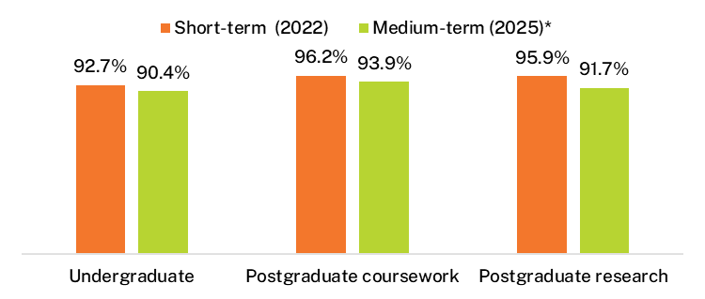
* Medium-term labour force participation rates from 2025 onwards are not directly comparable with earlier years due to a change to how the labour force is defined. Caution should be exercised when interpreting shifts in labour force participation rates from the short- to medium-term for the 2022-2025 cohort, as they partly reflect the change in methodology. See Appendix 1 for further information.
Full-time employment
Short-term undergraduate full-time employment rates rose sharply from 2021 to 2022 (Figure ii) when labour market tightness peaked following the removal of pandemic-related restrictions. This sharp rise is consistent with results from the ABS Labour Force Survey. Medium-term full-time employment rates have been less volatile as more graduates moved into managerial and professional occupations, and established themselves in the labour market.
Department of Education analysis indicates the change to how the labour force is defined in 2025 resulted in upward pressure on medium-term full-time employment rates of less than 1.5 percentage points for domestic undergraduates, upward pressure of less than 1 percentage point for domestic postgraduate coursework graduates, and upward pressure of around 1.5-2.5 percentage points for domestic postgraduate research graduates.
Figure ii - Undergraduate full-time employment rate for 2016 to 2022 domestic graduates
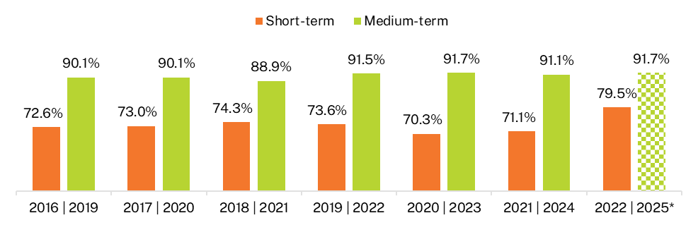
* Medium-term full-time employment rates from 2025 onwards are not directly comparable with earlier years due to a change to how the labour force is defined. Caution should be exercised when interpreting differences in full-time employment rates between 2025 medium-term results, and the short-term results and other medium-term results, as they partly reflect the change in methodology. See Appendix 1 for further information.
The undergraduate full-time employment rate was notably lower than both the postgraduate coursework and postgraduate research rates in the short-term, but the gap narrowed over the 3-year period (Figure iii). This indicates that it takes longer for undergraduates to obtain full-time employment, likely due to their lack of prior experience in the labour market.
Figure iii - Full-time employment rate by study level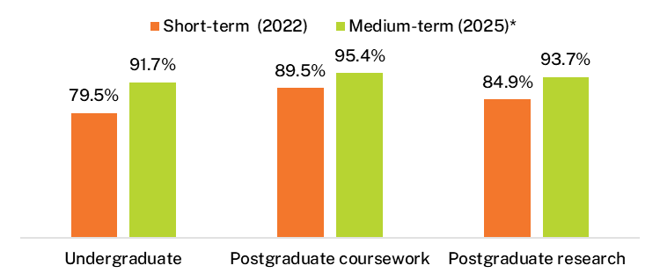
* Medium-term full-time employment rates from 2025 onwards are not directly comparable with earlier years due to a change to how the labour force is defined. Caution should be exercised when interpreting shifts in full-time employment rates from the short- to medium-term for the 2022-2025 cohort, as they partly reflect the change in methodology. See Appendix 1 for further information.
Median annual full-time salary
The 3-year (from short to medium-term) growth in median salaries reported by graduates across all study levels increased markedly in 2020 and has remained high since. This strong salary growth is consistent with national wage growth reported in the ABS Wage Price Index and ABS Average Weekly Ordinary Time Earnings for full-time adult employees.
Of the 3 study levels, undergraduate median salaries were lowest in the short- and medium-term but they had the biggest growth over the 3-year period (Figure iv). While postgraduate research graduate median salaries continue to be highest in the short-term and medium-term, growth over the 3-year period was lowest.
Despite increased salary growth across all study levels since 2020, the relative differences between study levels remained – indicating that salary growth is being driven by strong demand in the labour market, as opposed to the qualifications themselves.
Figure iv - Median annual full-time salaries by study level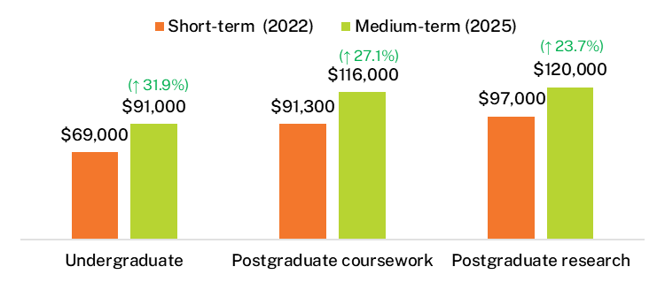
Underemployment
Rates of underemployment fell to all-time lows (since the survey commencement in 2016) across all study levels in 2022, which corresponded to the high full-time employment rates reported at this time as favourable employment conditions peaked.
Medium-term underemployment rates were slightly higher in 2025 than they were for the prior year’s cohort, however, they remained within ranges seen prior to the pandemic (Table i).
Table i - Underemployment rates by study level
 | Short-term (2022) | Medium-term (2025) | Short-term average (2016–21) | Medium-term average (2019–24)
Undergraduate | 13.7 | 7.2 | 19.3 | 7.1
Postgraduate coursework | 7.2 | 4.5 | 9.5 | 4.6
Postgraduate research | 10.8 | 5.7 | 13.2 | 5.7
The top reason graduates across all study levels in the short- and medium-term reported being underemployed was because there were ‘no more hours available in current position’. For undergraduates, ‘studying’ was the second highest reason. Graduates at the postgraduate-level were more likely to report ‘caring for children’ compared to undergraduates, which reflects the generally older age of these cohorts.
Notably, ‘no jobs in my area of expertise’ was a top reason for postgraduate research graduates who were underemployed, and this was an issue unique to this cohort in both the short- and medium-term. This may indicate postgraduate research graduates face intense competition for fewer specialised roles when trying to obtain employment that aligns with their specialised skills and education.
Study area
Consistent with previous cohorts, graduates from vocationally-oriented study areas tended to have higher full-time employment outcomes immediately following course completion compared to graduates from more generalist study areas. Full-time employment rates from vocational study areas remained high in the medium-term, while study areas with lower full-time employment rates in the short-term had much bigger gains over the 3-year period. This suggests that it can take time for graduates from some study areas to secure full-time employment but they typically catch-up over the medium-term.
Skills utilisation
Consistent with prior years, undergraduates employed full-time were less likely to be working in managerial or professional occupations than graduates with postgraduate qualifications (Figure v). Graduates with postgraduate qualifications were more likely to be employed full-time in managerial or professional occupations 4 to 6 months after course completion, and this continued to rise over the 3-year period.
The higher rates of postgraduate graduates employed in managerial or professional occupations shortly after course completion reflects the older profile of these graduates and their establishment in the labour market. These differences in occupation type across study levels also correspond with differences in median salaries.
Undergraduate occupation type varied greatly by study area. More than 90 per cent of undergraduates from vocationally-oriented study areas such as Rehabilitation, Pharmacy and Teacher education, were employed full-time in managerial occupations 4 to 6 months after course completion.
Undergraduates from generalist study areas and study areas where related occupations may require further study or accreditation had lower rates in the short-term but bigger gains over the 3-year period. Only 54.0 per cent of full-time employed undergraduates from Law and paralegal studies were working in managerial or professional occupations in the short-term, but this increased to 78.9 per cent in the medium-term.
Figure v - Domestic graduates employed in managerial and professional occupations by study level (% of those employed full-time)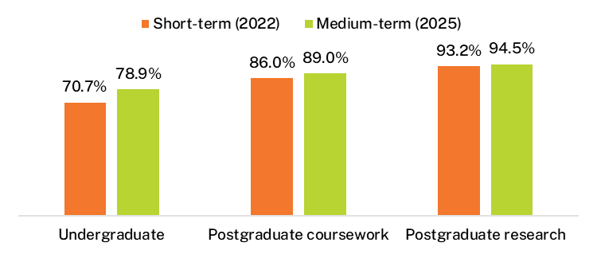
Rates of ‘perceived overqualification’, that is, graduates who reported not fully utilising their skills and education in their current jobs, was consistent across study levels, and this measure of skills underutilisation remained relatively high in the medium-term (Figure vi).

Figure vi - Perceived overqualification by study level (% of those employed full-time)
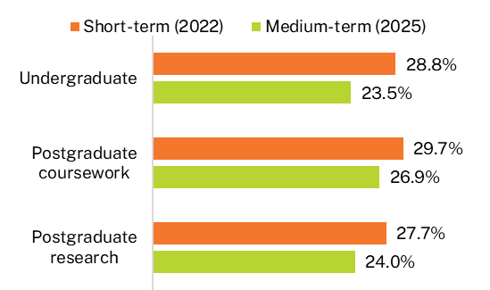
In the short-term, undergraduates employed full-time were more likely to be working in jobs that did not fully utilise their skills and education due to labour market factors, particularly because they were starting out in an ‘entry level job/career stepping stone’. Three years later, there was a more even split of labour market and personal reasons influencing the perceived underutilisation of undergraduates’ skills and education. One quarter of full-time employed undergraduates who considered themselves overqualified in their job 3 years after course completion reported being satisfied with their current job.
Postgraduate coursework graduates were more likely to report personal factors, such as satisfaction with their current jobs or that they were changing jobs/careers, than undergraduates and these differences persisted into the medium-term. Postgraduate coursework graduates were also more likely to report that they were caring for children or a family member. These findings reflect demographic, career, and life-stage differences between domestic undergraduate and postgraduate coursework graduates.
Like reasons for underemployment, postgraduate research graduates who felt overqualified in their current jobs were most likely to report ‘no suitable jobs in my area of expertise’ as the reason. This highlights a potential mismatch between labour market demand and the highly specialised skills acquired in these courses. It may also highlight a potential opportunity for institutions to provide further support and guidance for postgraduate research graduates to obtain relevant employment in their areas of expertise.
International graduate results
Short-term employment outcomes for international graduates were lower than for domestic graduates across all study levels, consistent with historical trends (Table ii).
Department of Education analysis indicates the change to how the labour force is defined in 2025 resulted in upward pressure on medium-term full-time employment rates of around 1-2 percentage points for international undergraduates and postgraduate coursework graduates, and upward pressure of less than 1 percentage point for international postgraduate research graduates.
Full-time employment rates were lower for international undergraduates in the short-term compared to their domestic counterparts, but this gap narrowed over the 3-year period. However, differences in median salaries did not diminish over time. The higher further full-time study rate for international undergraduates may partially explain the lower full-time employment rate.

Table ii - Undergraduate labour market indicators by citizenship status
 | Short-term (2022)  Domestic | Short-term (2022) International | Medium-term (2025)  Domestic | Medium-term (2025) International
Full-time employment rate (%) | 79.5 | 60.5 | 91.7 | 84.7
Median annual full-time salary ($) | 69,000 | 62,000 | 91,000 | 80,500
In further full-time study (%) | 17.5 | 25.4 | 13.4 | 17.8
Note: Medium-term full-time employment rates from 2025 onwards are not directly comparable with earlier years due to a change to how the labour force is defined. Caution should be exercised when interpreting shifts from the short- to medium-term for the 2022-2025 cohort, as they partly reflect the change in methodology. See Appendix 1 for further information.
Differences in employment and salary outcomes between domestic and international graduates were most pronounced at the postgraduate coursework level (Table iii). Notably, outcomes for international postgraduate coursework graduates were similar to international undergraduate outcomes. This differs to domestic graduates where the higher-level qualification correlated with stronger employment and salary outcomes.
This is related to domestic postgraduate coursework graduates typically being older and often attached to the labour market, which is why their employment and salary outcomes are high immediately following course completion. International graduates are younger, many of whom went straight from undergraduate to postgraduate studies and, therefore, have less prior work experience by the time they do graduate from the higher qualification.
Table iii - Postgraduate coursework labour market indicators by citizenship status
 | Short-term (2022)  Domestic | Short-term (2022) International | Medium-term (2025)  Domestic | Medium-term (2025) International
Full-time employment rate (%) | 89.5 | 61.4 | 95.4 | 88.1
Median annual full-time salary ($) | 91,300 | 62,600 | 116,000 | 85,000
In further full-time study (%) | 6.8 | 10.7 | 5.0 | 11.7
Note: Medium-term full-time employment rates from 2025 onwards are not directly comparable with earlier years due to a change to how the labour force is defined. Caution should be exercised when interpreting shifts from the short- to medium-term for the 2022-2025 cohort, as they partly reflect the change in methodology. See Appendix 1 for further information.
There was less variation in employment outcomes at the postgraduate research level (Table vi). However, international graduates earned less than domestic graduates in the short-term and this gap persisted into the medium-term. Both cohorts were employed in managerial or professional occupations, suggesting that other factors may be influencing the differences in median salaries.
Table vi - Postgraduate research labour market indicators by citizenship status
 | Short-term (2022)  Domestic | Short-term (2022) International | Medium-term (2025)  Domestic | Medium-term (2025) International
Full-time employment rate (%) | 84.9 | 75.9 | 93.7 | 90.7
Median annual full-time salary ($) | 97,000 | 89,000 | 120,000 | 110,000
In further full-time study (%) | 5.7 | 10.4 | 5.1 | 7.0
Note: Medium-term full-time employment rates from 2025 onwards are not directly comparable with earlier years due to a change to how the labour force is defined. Caution should be exercised when interpreting shifts from the short- to medium-term for the 2022-2025 cohort, as they partly reflect the change in methodology. See Appendix 1 for further information.
Like domestic graduates, international graduates from vocationally-oriented study areas tended to have higher employment outcomes in the short-term. Full-time employment rates increased at higher rates relative to domestic graduates across most study areas, leading to a much closer average full-time employment rate in the medium-term.
Considerable variation in outcomes was observed across source countries (Table v). Undergraduates from China (excludes SARs and Taiwan) had the lowest employment rates but the highest rate of further full-time study. The labour force participation rate for undergraduates from China (excludes SARs and Taiwan) was also relatively low, indicating less financial pressure to work while studying, or perhaps a preference to focus solely on their studies.
Undergraduates from Nepal and India reported much lower rates of further full-time study and higher labour force participation rates. Despite this, undergraduates from Nepal had one of the lowest full-time employment rates and a relatively low further full-time study rate. However, this cohort did have high overall employment rates in the short- and medium-term, and above average further part-time study rates.
Table v - International undergraduate labour market indicators by source country
Source country | Full-time  employment rate (%Short-term (2022) | Full-time  employment rate (%Medium-term  (2025) | Labour force participation rate (%)Short-term (2022) | Labour force participation rate (%)Medium-term  (2025) | Median annual full-time salary ($) Short-term (2022) | Median annual full-time salary ($) Medium-term  (2025) | In further full-time study (%) Short-term (2022) | In further full-time study (%) Medium-term  (2025)
China (excludes SARs and Taiwan) | 56.1 | 75.4 | 69.3 | 82.3 | 65,400 | 76,900 | 51.8 | 29.2
Nepal | 54.9 | 85.4 | 97.3 | 91.7 | 58,700 | 79,300 | 11.1 | 14.0
India | 62.1 | 87.8 | 96.0 | 86.0 | 60,500 | 84,500 | 15.7 | 12.1
Total international | 60.5 | 84.7 | 87.4 | 87.1 | 62,000 | 80,500 | 25.4 | 17.8
Note: Medium-term labour force participation rates, and full-time employment rates from 2025 onwards are not directly comparable with earlier years due to a change to how the labour force is defined. Caution should be exercised when interpreting shifts from the short- to medium-term for the 2022-2025 cohort, as they partly reflect the change in methodology. See Appendix 1 for further information.
Contents
Acknowledgements i
Executive summary ii
1. About the GOS-L 1
1.1. Participation 1
1.2. Further detail 1
2. Domestic graduate results 2
2.1. Labour force participation 2
2.2. Full-time employment 3
2.3. Overall employment 5
2.4. Median annual full-time salary 6
2.5. Underemployment 9
2.5.1 Reasons for not working more hours 10
2.6. Domestic graduate skills utilisation 12
2.6.1 Occupation type 12
2.6.2 Underutilisation of skills and education 15
2.7. Domestic graduates in further full-time study 17
2.8. Demographic and equity groups 21
2.9. Study area 27
2.10. Gender pay gap 31
2.11. Institution 33
2.11.1 Institution type 33
2.11.2 Comparative university outcomes 35
3. International graduate results 38
3.1. International graduate profile (based on responses to the 2025 GOS-L) 38
3.2. Comparative outcomes: international and domestic graduates 39
3.2.1 Undergraduate comparisons 40
3.2.2 Postgraduate coursework comparisons 41
3.2.3 Postgraduate research comparisons 42
3.2.4 Study area 44
3.3. Source country 48
Appendix 1 Changes to labour force classification 51
A1.1 Changes made to the survey instrument 51
A1.2 Impact on the 2025 GOS and 2025 GOS-L data 54
A1.2.1 Changes to key labour market indicator definitions 54
A1.3 Analysis of time series break 55
A1.4 Conclusion 57
Appendix 2 Labour market and graduate satisfaction definitions 58
A2.1 Examples of graduate labour market outcomes 58
Appendix 3 Detailed tables 60
A3.1 Study area 60
A3.2 Gender pay gap 63
A3.3 Institution tables 64

List of tables

Table 1 Main reason not working more hours, of graduates employed part-time who would prefer to work more hours (% of those employed) 11
Table 2 Domestic graduates employed in managerial and professional occupations by employment type and study level (% of those employed) 12
Table 3 Main reason for working in a job that does not fully utilise skills and education, domestic graduates employed full-time, all occupations (%) 16
Table 4 Domestic undergraduate employment outcomes by demographic sub-group 24
Table 5 Domestic undergraduate labour market and further study outcomes by study area 29
Table 6 Short- and medium-term domestic graduate employment and study outcomes by level of study and institution type 34
Table 7 Estimated impact of methodology change in the 2025 GOS-L 40
Table 8 Undergraduate short- and medium-term outcomes comparison: international and domestic graduates 41
Table 9 Postgraduate coursework short- and medium-term outcomes comparison: international and domestic graduates 42
Table 10 Postgraduate research short- and medium-term outcomes comparison: international and domestic graduates 42
Table 11 International undergraduate short- and medium-term outcomes by source country 49
Table 12 International postgraduate coursework short- and medium-term outcomes by source country 50
Table 13 Away from work questions 51
Table 14 Attachment to labour force questions 52
Table 15 Reasons for working less than usual hours and future availability questions 53
Table 16 Reasons for unemployment or not available for employment 53
Table 17 Estimated impact of methodology change 56
Table 18 Indicator definitions 58
Table 19 Domestic postgraduate coursework labour market outcomes by study area 60
Table 20 Domestic postgraduate research labour market and further study outcomes by study area 62
Table 21 Undergraduate median annual full-time salary by gender and study area 63
Table 22 Postgraduate coursework median annual full-time salary by gender and study area 63
Table 23 Domestic undergraduate full-time employment rate (%) and median salary ($) by university, short- and medium-term (with 90% confidence intervals) 64
Table 24 Domestic postgraduate coursework full-time employment rate (%) and median salary ($) by university, short- and medium-term (with 90% confidence intervals) 66

List of figures
Figure 1 Short- and medium-term labour force participation rate for 2016 to 2022 domestic graduates 2
Figure 2 Short- and medium-term full-time employment rate for 2016 to 2022 domestic graduates 4
Figure 3 Short- and medium-term overall employment rate for 2016 to 2022 domestic graduates 6
Figure 4 Short- and medium-term median salary for 2016 to 2022 domestic graduates 8
Figure 5 Short- and medium-term underemployment rate (% of those employed) 10
Figure 6 Proportion of domestic undergraduates employed full-time as managers or professionals by study area 14
Figure 7 Perceived overqualification by employment type and study level, all occupations (% of those employed) 15
Figure 8 Proportion of domestic graduates engaged in further full-time study by study level 17
Figure 9 Domestic undergraduates undertaking further full-time study by original broad field of education (%) 18
Figure 10 Broad field of education destinations of domestic undergraduates undertaking further full-time study (%) 19
Figure 11 Undergraduates in further study by socio-economic status 22
Figure 12 Domestic undergraduate full-time employment rate in the short- and medium-term, by study area 28
Figure 13 Undergraduate labour market outcomes by gender 31
Figure 14 Undergraduate gender pay gap, medium-term, and 3-year salary growth by gender 32
Figure 15 Postgraduate coursework median annual full-time salary by gender 33
Figure 16 Postgraduate research median annual full-time salary by gender 33
Figure 17 Domestic undergraduate short- and medium-term full-time employment rate by university (% with 90% confidence intervals) 36
Figure 18 Domestic postgraduate coursework short- and medium-term full-time employment rate by university, 2025 (% with 90% confidence intervals) 37
Figure 19 International graduate profile by study area and level (% based on responses to the 2025 GOS-L) 44
Figure 20 Undergraduate full-time employment rate by citizenship status and study area (%) 46

About the GOS-L
Graduates are invited to take the Graduate Outcomes Survey (GOS) 4 to 6 months after completing their studies. Graduates who responded to the GOS are invited to take the Graduate Outcomes Survey - Longitudinal (GOS-L) approximately 3 years later.
The two surveys complement and supplement one another, as the 2025 GOS-L report analyses the short- and medium-term outcomes of graduates who responded to the 2022 GOS (i.e. completed their course between March 2021 and February 2022) and the corresponding follow-up survey 3 years later.
The GOS-L is an ongoing part of the Quality Indicators for Learning and Teaching (QILT) survey suite. GOS-L reports, including this report, provide robust, rich information to improve higher education. As well as examining general labour market outcomes (rates of full-time employment, overall employment, labour force participation and median annual full-time salaries), the reports focus on areas such as the gender pay gap, reasons for underemployment and how well qualifications prepared graduates for their current jobs.
Results for domestic graduates and international graduates, whether living in Australia or overseas, are presented separately in this report. This corresponds with presentation of short-term graduate outcomes published annually in the GOS National Report and GOS International Report (see Graduate Outcomes Survey).

Participation
The 2025 GOS-L was administered for all higher education institutions whose graduates participated in the 2022 GOS and were eligible to participate in the GOS-L.
In total, 127 institutions were included, with 43 universities and 84 non-university higher education institutions (NUHEIs) across all study levels. The GOS-L achieved an overall 53.6 per cent response rate in 2025 (48,314 completed surveys), up from 48.0 per cent in 2024 and 45.0 per cent in 2023.

2025 participation
127 institutions
100,340 invitations sent
48,314 completed surveys
53.6% response rate

Further detail
This report is a selection of high-level results, but other information, such as data related to how well courses prepared graduates for work and further study, and more detailed labour force breakdowns, is available from Graduate Outcomes Survey - Longitudinal (qilt.edu.au).
This report is supported by a PowerBI workbook that allows readers to further explore data. Static Excel tables also provide supplementary data and detail.

Domestic graduate results

Labour force participation
The labour force participation rate has remained relatively stable across study levels since the GOS and GOS-L commenced (Figure 1). However, in the 2025 GOS-L, there was a notable decrease in the labour force participation rate across all study levels. This decrease can be attributed to a change to the way this metric is calculated.
Department of Education analysis (outlined in Appendix 1) indicates this change resulted in downward pressure on labour force participation rates of less than 1 percentage point for domestic undergraduates and postgraduate coursework graduates, and downward pressure of around 1.5-2.5 percentage points for domestic postgraduate research graduates. The relatively higher impact on domestic postgraduate research graduates reflects their higher propensity to report looking for work passively in the GOS-L in 2025. The change in methodology also affected the 2025 medium-term full time and overall employment rates presented in this report, and has implications on the comparability of 2025 medium-term data with historical data. Caution should be exercised when interpreting differences between 2025 medium-term results, and the short-term results and other medium-term results, as they partly reflect the change in methodology.
Accounting for changes to how labour force participation is defined in 2025, patterns of labour force participation among domestic graduates in 2025 continued to be consistent with previous years. For instance, labour force participation rates continued to be lower in the medium-term than the short-term at the postgraduate level. Additionally, labour force participation remained above 90 per cent in the short- and medium-term across all study levels.
The main reason graduates reported being no longer available to work and therefore not in the labour market was because they were ‘studying or returning to studies’. Caring responsibilities affected postgraduate level graduates more than undergraduates which aligns with the typically older age of these cohorts.
Figure 1 Short- and medium-term labour force participation rate for 2016 to 2022 domestic graduates
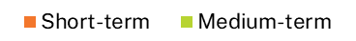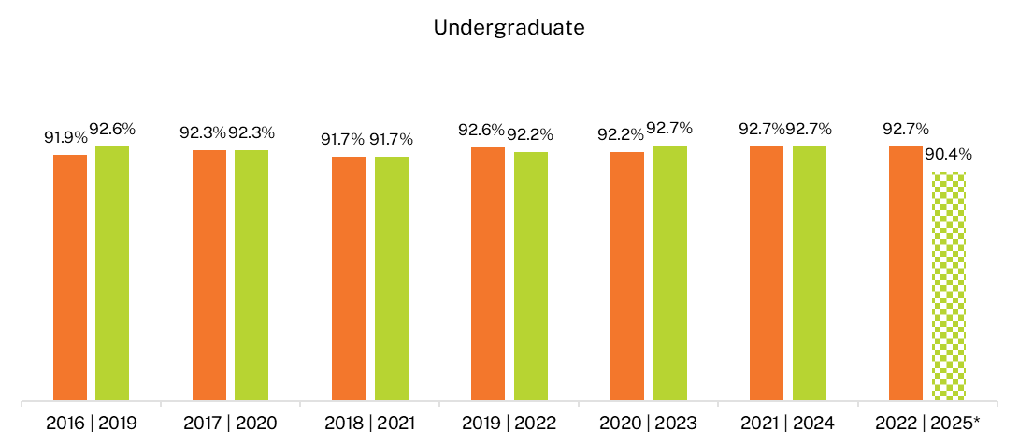
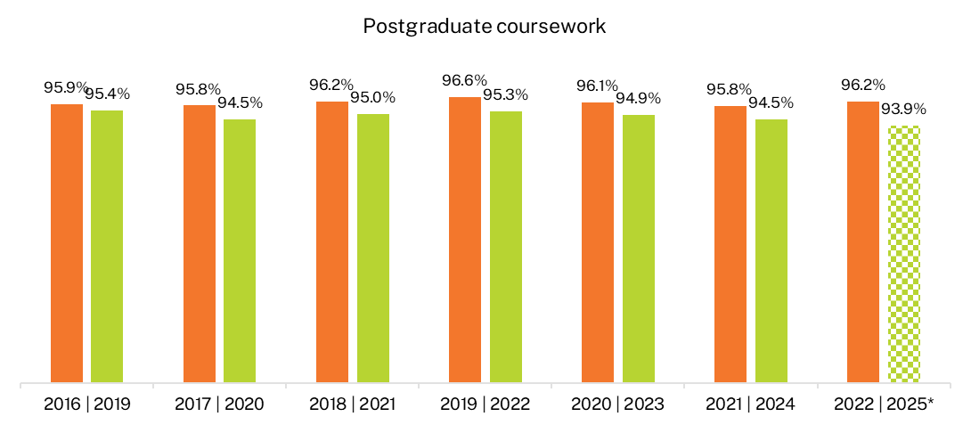
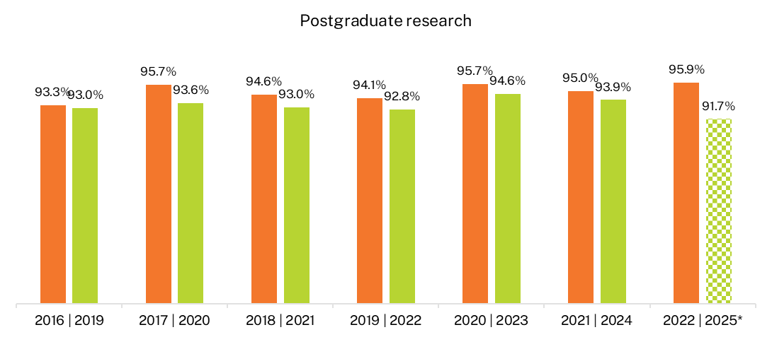
* Medium-term labour force participation rates from 2025 onwards are not directly comparable with earlier years due to a change to how the labour force is defined. Caution should be exercised when interpreting differences in labour force participation rates between 2025 medium term results, and the short-term results and other medium-term results, as they partly reflect the change in methodology. See Appendix 1 for further information.

Full-time employment
Graduates who completed the 2025 GOS-L completed the 2022 GOS when labour market tightness peaked following the removal of pandemic-related restrictions. This is reflected in the sharp rise in the short-term full-time employment rate from 2021 to 2022 (Figure 2) which is consistent with results from the Australian Bureau of Statistics (ABS) Labour Force Survey.
Despite the short-term undergraduate full-time employment rate increasing markedly in 2022, it continued to be lower than the full-time employment rate for postgraduate-level graduates. Over time, however, this gap narrows substantially, which suggests it takes time for undergraduates to obtain full-time employment – likely due to their lack of prior experience in the labour market.
In general, medium-term labour market outcomes for graduates have been less volatile than short-term outcomes. This is likely due to graduates being more established in their jobs 3 years after completing their studies, as well as the increased proportions of graduates employed in managerial and professional occupations. See Domestic graduate skills utilisation.
In 2025, medium-term full-time employment rates appeared to increase year-on-year across all study levels. However, part of this change can be attributed to the change to how the labour force is defined. Department of Education analysis indicates this change resulted in upward pressure on medium-term full-time employment rates of less than 1.5 percentage points for domestic undergraduates, upward pressure of less than 1 percentage point for domestic postgraduate coursework graduates, and upward pressure of around 1.5-2.5 percentage points for domestic postgraduate research graduates. The relatively higher impact on domestic postgraduate research graduates reflects their higher propensity to report looking for work passively in the GOS-L in 2025. Caution should be exercised when interpreting differences between 2025 medium-term results, and the short-term results and other medium-term results, as they partly reflect the change in methodology. See Appendix 1 for more information about this change.
Figure 2 Short- and medium-term full-time employment rate for 2016 to 2022 domestic graduates
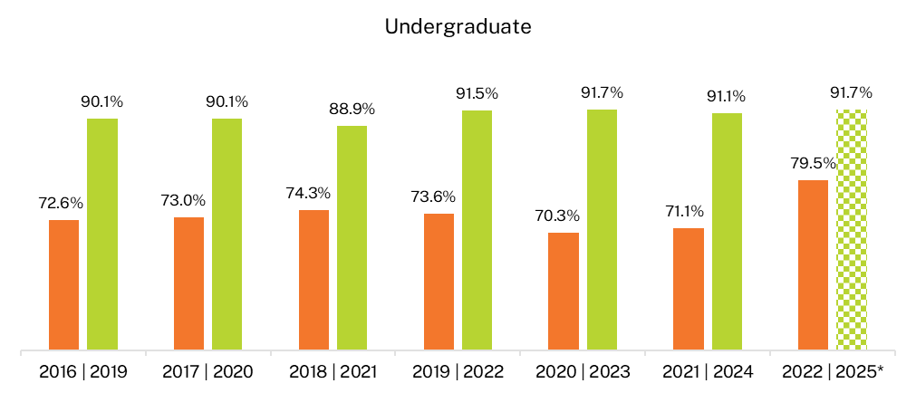
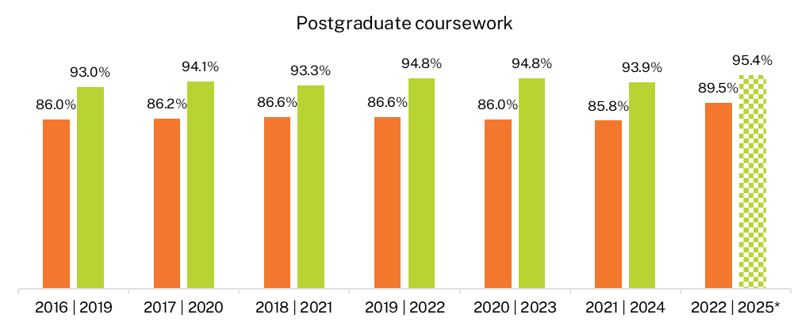
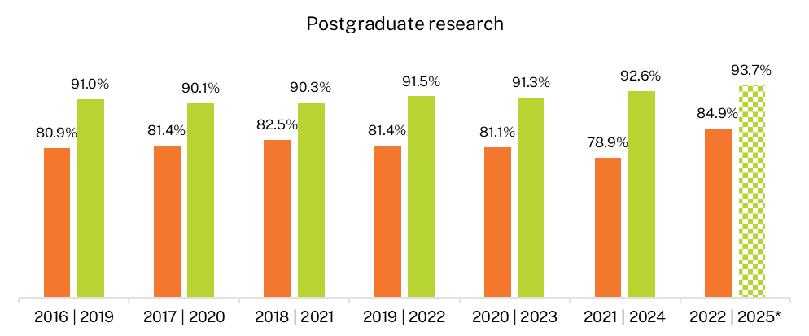
* Medium-term full-time employment rates from 2025 onwards are not directly comparable with earlier years due to a change to how the labour force is defined. Caution should be exercised when interpreting differences in full-time employment rates between 2025 medium-term results, and the short-term results and other medium-term results, as they partly reflect the change in methodology. See Appendix 1 for further information.

Overall employment
In general, there is a gap between the full-time employment rate and the overall employment rate (including part-time and full-time) of recent graduates, 4 to 6 months after course completion. Three years later, this gap narrows which may indicate that while most graduates are available to work soon after completing their studies, accessing full-time hours can take time. This pattern is most notable at the undergraduate level but can also be seen at the postgraduate research and, to a lesser extent, postgraduate coursework levels.
For example, the full-time employment rate of recent undergraduates in 2022 was 79.5 per cent (Figure 2) and the overall employment rate was 89.2 per cent (Figure 3), a difference of 9.7 percentage points. Three years later in 2025, the full-time employment rate had risen to 91.7 per cent and the overall employment rate was 94.6 per cent, a difference of only 2.9 percentage points. Note that the short-term difference in 2022 was smaller than in previous years due to the sharp rise in full-time employment discussed previously (see Full-time employment).
Please note that medium-term overall employment rates in 2025 did appear to increase year-on-year, however, this increase partly reflects the change in methodology. Department of Education analysis indicates the change to how the labour force is defined in 2025 resulted in upward pressure on medium term overall employment rates of less than 1 percentage point for both domestic undergraduates and postgraduate coursework graduates, and upward pressure of around 1.5-2.5 percentage points for domestic postgraduate research graduates. The relatively higher impact on domestic postgraduate research graduates reflects their higher propensity to report looking for work passively in the GOS-L in 2025. Caution should be exercised when interpreting differences between 2025 medium-term results, and the short-term results and other medium-term results. See Appendix 1 for more information about this change.
Figure 3 Short- and medium-term overall employment rate for 2016 to 2022 domestic graduates
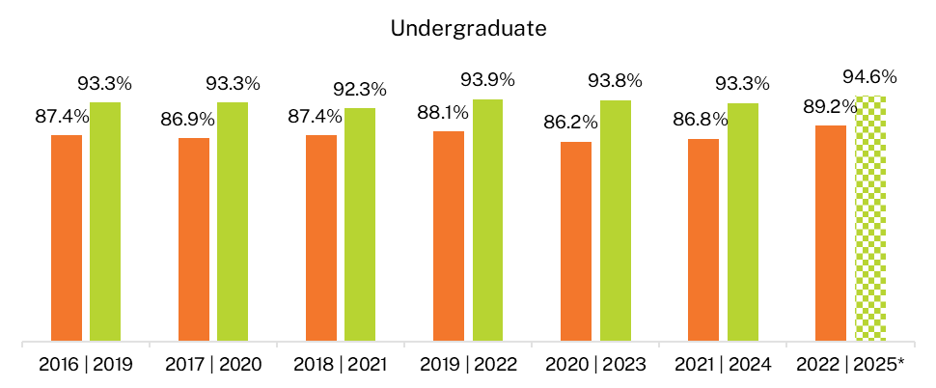

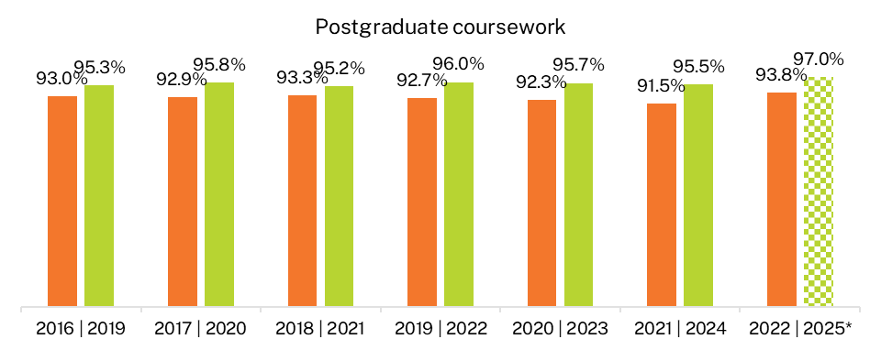

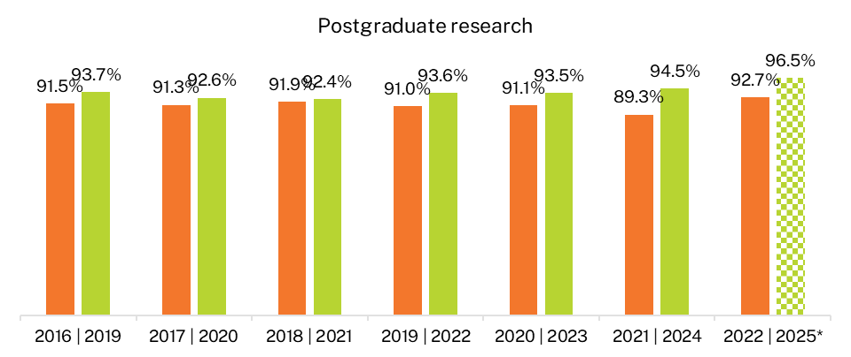
* Medium-term overall employment rates from 2025 onwards are not directly comparable with earlier years due to a change to how the labour force is defined. Caution should be exercised when interpreting differences in overall employment rates between 2025 medium-term results, and the short-term results and other medium-term results, as they partly reflect the change in methodology. See Appendix 1 for further information.

Median annual full-time salary
Domestic graduates with postgraduate qualifications have higher median salaries than those with undergraduate qualifications in the short- and medium-term (Figure 4). This difference in median salaries by study levels may be attributed to more advanced or specialised skills and knowledge acquired in a postgraduate level course, but it is also likely driven by graduates’ prior labour market experience or establishment in the labour force before or during their studies.
While undergraduate median salaries are lower in the short- and medium-term, they do increase at a higher rate than both postgraduate coursework and postgraduate research median salaries. Despite increasing at a higher rate over the 3-year period, in dollar terms, the gap in median salaries remained: the postgraduate coursework median salary was $22,300 higher than the undergraduate median salary in the short-term and this increased to $25,000 in the medium-term.
Postgraduate research graduates continued to report the highest median salary of the 3 study levels: $28,000 more than undergraduates and $5,700 more than postgraduate coursework graduates in the short-term. However, from a high starting point, their median salary grew at a slower rate, reaching $120,000 by 2025 (up 23.7 per cent), compared to increases of 31.9 per cent and 27.1 per cent for undergraduates and postgraduate coursework graduates respectively.
Notably, there has been a marked increase in 3-year salary growth (from short to medium-term) across all study levels, starting with the 2020-2023 cohort of graduates. This salary growth is consistent with the ABS' Wage Price Index and Average Weekly Ordinary Time Earnings for full-time adult employees, both of which show a steady rise in growth during this period.,

Figure 4 Short- and medium-term median salary for 2016 to 2022 domestic graduates
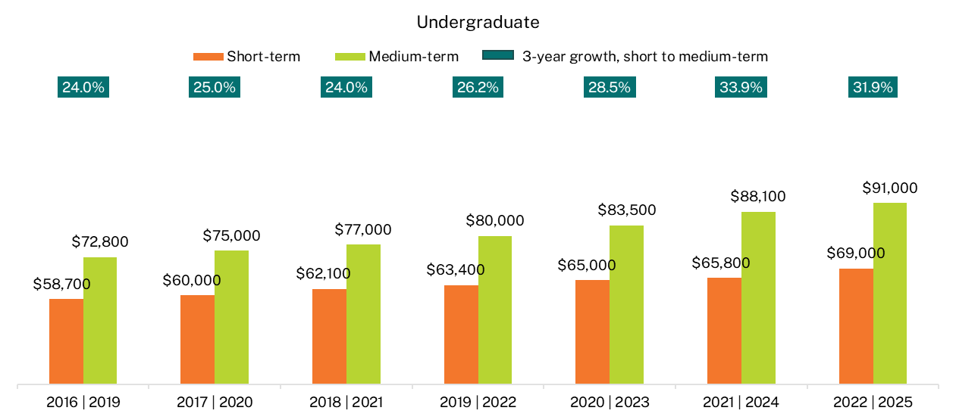
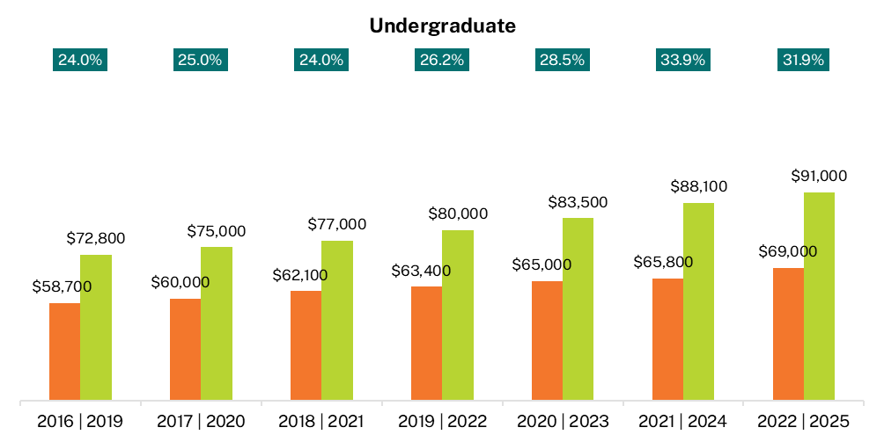
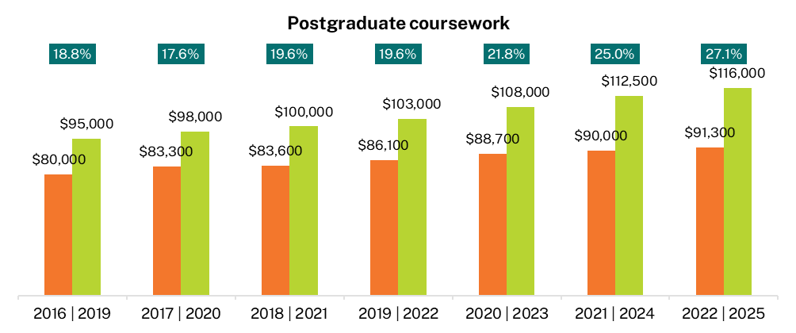
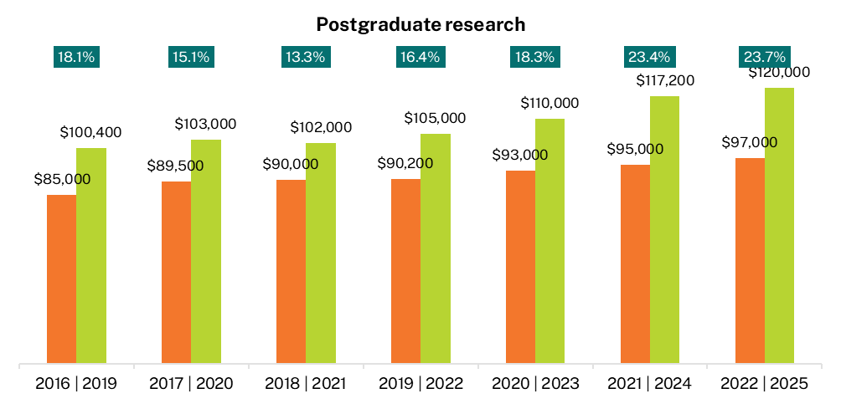

Undergraduate 3-year salary growth peaked for the 2021-2024 cohort (33.9 per cent) but remained high for the 2022-2025 cohort (31.9 per cent). The slightly lower growth rate for the 2022-2025 cohort can be attributed to the high short-term median salary recorded in 2022 as demand in the labour market peaked.
Postgraduate coursework and postgraduate research 3-year salary growth was the highest on record for this 2022-2025 cohort at 27.1 per cent and 23.7 per cent respectively. This high 3-year salary growth across all study levels reflects strong demand in the labour market, as opposed to the qualifications themselves, with the relative differences in the dollar value between study levels remaining largely intact.

Underemployment
An ‘underemployed’ person is someone employed part-time (less than 35 hours per week) who would prefer to work more hours – regardless of if they are available to work those additional hours. Rates of underemployment are typically higher in the short-term, 4 to 6 months after course completion, but narrow over time, as seen in Figure 5.
There was a substantial decline in short-term underemployment rates across all study levels in 2022. This corresponds to the sharp rise in employment outcomes and strong demand in the labour market at this time. See Full-time employment.
There was a slight increase in the underemployment rate across study levels in 2025 but these rates have returned to ranges observed prior to 2022.

Figure 5 Short- and medium-term underemployment rate (% of those employed)
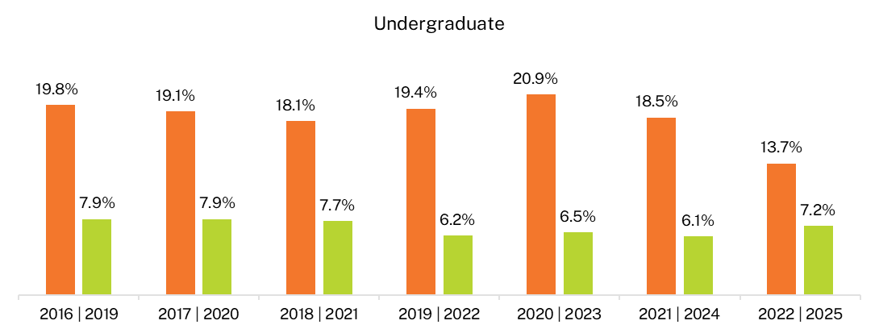
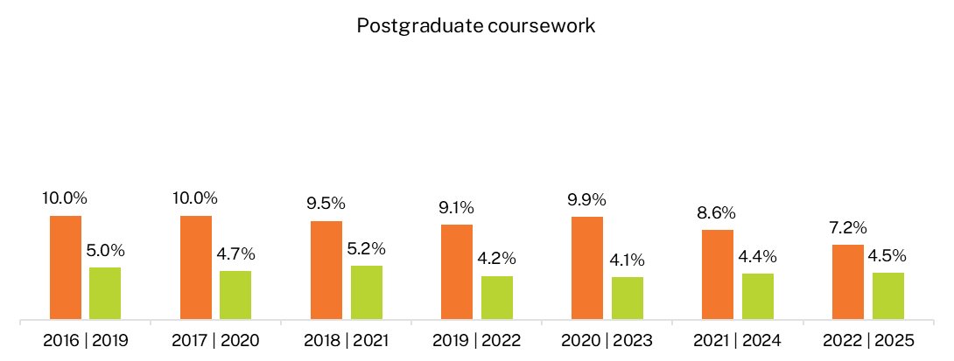
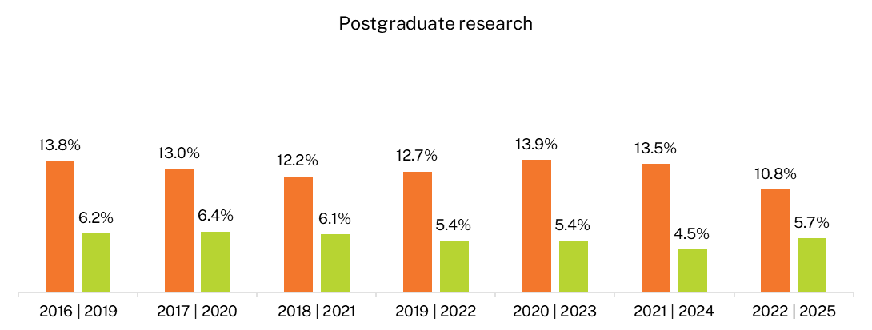

Reasons for not working more hours
Examining why graduates employed part-time are working the number of hours they do, despite their preference to work more, provides some insight into differences between underemployed graduates across study levels and how these reasons may shift from the short- to the medium-term (Table 1).
Across all study levels, ‘no more hours available in current position’ was the main reason graduates reported working the number of hours they do, despite their preference to work more. This was the top reason in the short-term and was an even bigger reason 3 years later in the medium-term. Note that the higher proportion reporting this reason in the medium-term may also be due to other reasons diminishing over time as graduates establish themselves in the labour market. For example, when recent graduates completed the GOS in 2022, COVID-19 restrictions were still impacting the labour market and this is seen in the short-term reasons across all study levels. While these restrictions were no longer relevant in 2025, some localised scarring from the pandemic is still visible. A small number of undergraduates continue to report being affected by reduced demand and employment opportunities stemming from business closures during the pandemic.
‘Studying’ was the second highest reason for undergraduates in both the short- and medium-term, but this was less of an issue at the postgraduate level. These differences are consistent with the rates of further full-time study reported by graduates across study levels. See Domestic graduates in further full-time study.
‘No jobs in my area of expertise’ was a top reason reported by postgraduate research graduates. Notably, undergraduates and postgraduate coursework graduates were much less likely to report this issue in both the short- and medium-term compared to postgraduate research graduates. This may indicate postgraduate research graduates face intense competition for fewer specialised roles when trying to obtain employment that aligns with their specialised skills and education.
Graduates who completed postgraduate qualifications were more likely to report ‘caring for children’ than undergraduates. This aligns with differences in age and life stage, particularly between undergraduates and postgraduate coursework graduates.
Table 1 Main reason not working more hours, of graduates employed part-time who would prefer to work more hours (% of those employed)
Reason type: Detailed reasons | Undergraduate:  Short-term (2022) | Undergraduate: Medium-term (2025) | Postgraduate coursework: Short-term (2022) | Postgraduate coursework: Medium-term (2025) | Postgraduate research: Short-term (2022) | Postgraduate research: Medium-term (2025)
Personal factors: Studying | 15.9 | 17.4 | 6.0 | 9.0 | 1.0 | 5.1
Personal factors: Caring for children | 4.3 | 5.5 | 10.9 | 12.7 | 7.3 | 11.2
Personal factors: Long-term health condition or disability | 0.5 | 3.5 | 0.5 | 3.4 | 0.5 | 3.1
Personal factors: Due to other commitments outside of main job | 0.8 | 4.2 | 0.3 | 3.6 | 0.0 | 1.0
Personal factors: Other personal factors | 0.8 | 3.1 | 1.6 | 3.9 | 0.0 | 0.0
Personal factors: Personal factors sub-total | 22.3 | 33.7 | 19.3 | 32.5 | 8.9 | 20.4
Labour market factors: No suitable job in my local area | 4.2 | 2.7 | 6.3 | 4.2 | 5.8 | 3.1
Labour market factors: No job with a suitable number of hours | 3.6 | 2.1 | 5.4 | 3.0 | 3.7 | 4.1
Labour market factors: No suitable job in my area of expertise | 9.1 | 4.9 | 8.4 | 4.9 | 26.7 | 13.3
Labour market factors: No more hours available in current position | 44.4 | 50.4 | 40.1 | 45.7 | 37.7 | 53.1
Labour market factors: Work has been reduced/shutdown due to COVID-19 | 5.4 | 0.1 | 6.7 | 0.0 | 4.7 | 0.0
Labour market factors: Other labour market factors | 1.7 | 0.8 | 2.5 | 1.5 | 2.1 | 2.0
Labour market factors: Labour market factors sub-total | 68.4 | 61.0 | 69.4 | 59.4 | 80.6 | 75.5
Other factors | 9.3 | 5.2 | 11.2 | 8.1 | 10.5 | 4.1
Total | 100.0 | 100.0 | 100.0 | 100.0 | 100.0 | 100.0
Employed part-time, would prefer more hours (% of those employed) | 13.7 | 7.2 | 7.2 | 4.5 | 10.8 | 5.7

Domestic graduate skills utilisation
The GOS and GOS-L include a rich array of information about the nature of graduate employment.
This section focuses on some common measures of ‘skills utilisation’ (or the ‘quality’ of graduate jobs). These include the proportion of graduates employed in managerial or professional occupations, and whether graduates believe they are utilising their skills and education in their current role.
These measures provide useful information about how well graduates' skills are matched with employment, and how these change from the short- to medium-term. However, it is important to note that there are a range of factors, beyond the quality of educational experience, that may influence occupational outcomes. This includes the proportion of graduates undertaking further full-time study, registration or professional accreditation timelines and graduate choice.

Occupation type
The proportion of graduates working in managerial and professional occupations can be used as a proxy measure of skills utilisation. This is because the classification of occupations used by the ABS suggests that most managerial and professional occupations have a skill level commensurate with qualifications at the bachelor level or higher.
The 2025 GOS-L reaffirms previous findings that undergraduates may take longer to find work in managerial or professional occupations, while domestic graduates with postgraduate qualifications are more likely to be employed in managerial or professional occupations 4 to 6 months after course completion, and this continues to rise over the 3-year period (Table 2).
The higher rates of postgraduate graduates employed in managerial or professional occupations shortly after course completion reflects the older profile of these graduates and their establishment in the labour market. These differences in occupation type across study levels also correspond with differences in median salaries. See Median annual full-time salary.
Table 2 Domestic graduates employed in managerial and professional occupations by employment type and study level (% of those employed)
 | Undergraduate: Short-term  (2022) | Undergraduate: Medium-term  (2025) | Postgraduate coursework: Short-term  (2022) | Postgraduate coursework: Medium-term  (2025) | Postgraduate research: Short-term  (2022) | Postgraduate research: Medium-term  (2025)
Full-time employed | 70.8 | 78.9 | 86.0 | 89.0 | 93.2 | 94.5
Overall employed | 60.7 | 74.6 | 84.0 | 88.3 | 91.6 | 93.4
While 78.9 per cent of undergraduates employed full-time were working in managerial or professional occupations 3 years after course completion, this varied greatly across study areas – some study areas had much higher rates in the short and medium-term that were consistent with rates reported at the postgraduate level.
Study areas considered to be more vocational – with clear career paths directly related to the qualification – tended to have high rates of undergraduates working in in managerial or professional occupations shortly after course completion and 3 years later. In comparison, more generalist study areas and study areas with requirements for additional postgraduate study and/or accreditation requirements, tended to have lower rates in the short-term but bigger gains 3 years later.
For example, more than 90 per cent of domestic undergraduates employed full-time from the areas of Rehabilitation, Pharmacy and Teacher education were working in managerial or professional occupations shortly after course completion and this remained high over time (Figure 6).
In contrast, only 54.0 per cent of Law and paralegal undergraduates were employed in managerial or professional occupations in the short-term but they had the biggest increase over the 3-year period by 24.9 percentage points – Law and paralegal undergraduates wishing to pursue careers as lawyers in Australia are typically required to undertake additional training before they can be accredited to practice which explains the slow start in the short-term but large gains over time. This is further evidenced by the relatively high further full-time study rates in the short-term and increases in full-time employment rates and median salaries presented in Table 5 for Law and paralegal domestic undergraduates.

Figure 6 Proportion of domestic undergraduates employed full-time as managers or professionals by study area
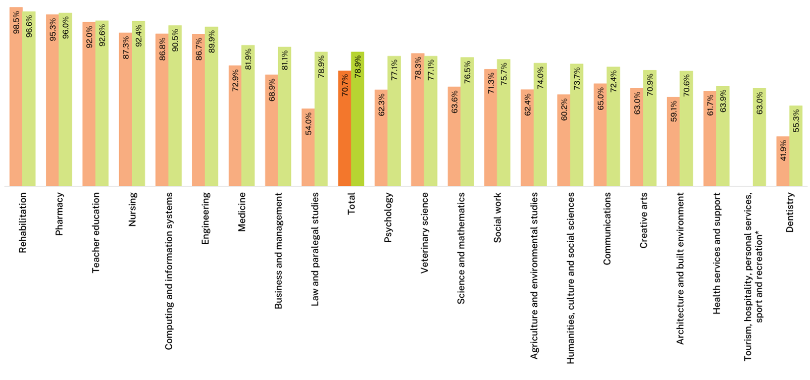
Note: This chart is sorted in descending order based on medium-term outcomes. The proportion of undergraduates employed full-time in managerial or professional occupations by broad field of education is also available in the following worksheets of the 2025 GOS-L National Tables: OCCF_UG_ALL_1Y_BFOE (full-time) and OCCO_UG_ALL_1Y_BFOE (overall employed).
‘ppts’ refers to percentage points, indicating the absolute change between two percentage values.
* Insufficient data (n<25) were present in the short-term result for Tourism, hospitality, personal services, sport and recreation.

Underutilisation of skills and education
Around 30 per cent of higher education graduates reported working in jobs that did not fully utilise their skills and education in the short-term and this remained high 3 years later.
As seen in Figure 7, shortly after course completion, 28.8 per cent of domestic undergraduates employed full-time across all occupations considered themselves overqualified for their current job. This remained high at 23.5 per cent 3 years later.
Of those who were employed overall, 38.9 per cent reported feeling overqualified shortly after graduation, remaining high at 27.8 per cent 3 years after graduation.
Notably, unlike other indicators in this report, there is little difference in the levels of perceived overqualification between domestic undergraduates and postgraduate-level graduates working full-time. (This is despite the higher proportion of postgraduate-level graduates being employed in managerial or professional occupations, as seen in Table 2.)
Figure 7 Perceived overqualification by employment type and study level, all occupations (% of those employed)
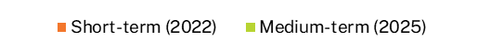
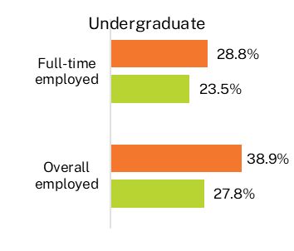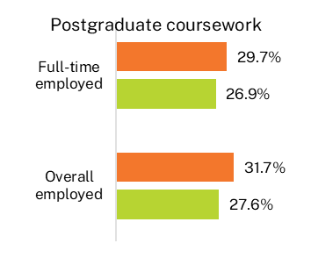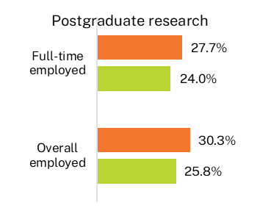
Graduates were asked to provide their main reason for working in a job that did not fully utilise their skills and education; these reasons are presented in Table 3. Across all levels of study, graduates were more likely to cite labour market factors in the short-term but 3 years later, this evened out to a mix of personal and labour market factors at the undergraduate and postgraduate research levels; personal factors were more frequently reported by postgraduate coursework graduates in the medium-term.
For recent graduates at the undergraduate level, the top reason reported was ‘entry level job/career stepping stone’, which is consistent with the early stages many of these graduates would be in their careers only 4 to 6 months after course completion. Three years later, the main reason reported by undergraduates was ‘I’m satisfied with my current job’, indicative of a personal choice.
Satisfaction with their jobs was the top reason in the medium-term for undergraduates and postgraduate coursework graduates, and the second highest for postgraduate research graduates, suggesting that not fully utilising the skills and knowledge acquired in a course does not necessarily equate to an unsuccessful outcome. This also provides insight into why so many graduates, particularly at the postgraduate level, continue to report high rates of skills underutilisation (Table 3), despite working in managerial or professional occupations (Table 2).
Interestingly, ‘not enough work experience’ remained relatively high in the medium-term for undergraduates and, to a lesser extent, postgraduate coursework graduates. This highlights an opportunity for institutions to provide more opportunities for students to gain relevant work experience as part of their coursework.
‘No suitable jobs in my area of expertise’ was one of the main reasons postgraduate research graduates reported working in a job that did not fully utilise their skills and education in both the short- and medium-term, and this seemed to affect this level of study much more than it did for undergraduates or postgraduate coursework graduates. This was also a common reason for postgraduate research graduates who were underemployed (see Reasons for not working more hours). These findings may highlight a need for institutions to provide greater careers support to these graduates, as well as a potential mismatch between labour market demand of these highly specialised skills and the number of graduates completing these courses.
Table 3 Main reason for working in a job that does not fully utilise skills and education, domestic graduates employed full-time, all occupations (%)
Reason type: Detailed reasons | Undergraduate: Short-term (2022) | Undergraduate: Medium-term (2025) | Postgraduate coursework: Short-term (2022) | Postgraduate coursework: Medium-term (2025) | Postgraduate research: Short-term (2022) | Postgraduate research: Medium-term (2025)
Personal factors: I'm satisfied with my current job | 13.0 | 25.6 | 19.4 | 29.5 | 22.2 | 25.0
Personal factors: For financial reasons | 6.6 | 9.1 | 5.6 | 10.0 | 6.4 | 11.6
Personal factors: Changing jobs/careers | 7.2 | 2.4 | 12.7 | 1.6 | 6.7 | 2.5
Personal factors: Studying | 5.8 | 5.5 | 3.3 | 3.0 | 1.7 | 1.6
Personal factors: Caring for children or family member | 1.4 | 2.3 | 3.0 | 6.0 | 1.1 | 4.7
Personal factors: Other personal factors | 0.8 | 1.8 | 0.2 | 1.8 | 0.3 | 1.6
Personal factors: Personal factors sub-total | 34.7 | 46.8 | 44.2 | 52.0 | 38.3 | 46.9
Labour market factors: No suitable jobs in my area of expertise | 8.3 | 12.4 | 9.1 | 12.1 | 21.4 | 26.6
Labour market factors: Entry level job/career stepping stone | 29.3 | 1.2 | 15.4 | 1.1 | 12.8 | 0.6
Labour market factors: Not enough work experience | 10.7 | 15.9 | 8.3 | 8.8 | 6.7 | 5.0
Labour market factors: No suitable jobs in my local area | 6.4 | 10.3 | 8.7 | 9.0 | 12.2 | 8.8
Labour market factors: Other labour market factors | 4.9 | 7.9 | 8.4 | 9.7 | 4.5 | 7.2
Labour market factors: Labour market factors sub-total | 59.6 | 47.5 | 50.0 | 40.9 | 57.5 | 48.1
Other factors | 5.7 | 5.7 | 5.8 | 7.0 | 4.2 | 5.0
Total | 100.0 | 100.0 | 100.0 | 100.0 | 100.0 | 100.0
Perceived overqualification (% of those employed full-time) | 28.8 | 23.5 | 29.7 | 26.9 | 27.7 | 24.0

Domestic graduates in further full-time study
Figure 8 represents the proportion of graduates who were enrolled in a full-time course at the time of the GOS in 2022 and the proportion enrolled at the time of the GOS-L in 2025. It should be noted that graduates may have completed additional qualifications during the 3-year period between the GOS and the GOS-L.
As expected, graduates who completed an undergraduate qualification had the greatest propensity to continue straight to further full-time study following completion of their course – almost 3 times more likely than graduates who completed postgraduate level qualifications. Three years later, 13.4 per cent of undergraduates who had responded to the 2022 GOS were undertaking further full-time study. The proportions of postgraduate-level graduates remained comparatively low in the medium-term.
Figure 8 Proportion of domestic graduates engaged in further full-time study by study level
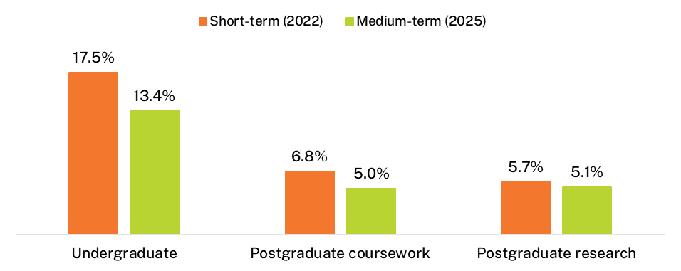
Rates of further full-time study differed by field of education. Undergraduates from the Natural and physical sciences field reported the highest further full-time study rates in the short-term, with 1 in 3 continuing straight to full-time study after completing their initial qualification – double the average rate. Three years later, rates of further full-time study remained high for these Natural and physical sciences undergraduates (Figure 9). The further full-time study rate for undergraduates from the Society and culture field of education was also relatively high in the short-term (22.6 per cent) but this dropped considerably in the medium-term (13.8 per cent). Other fields with notably lower further full-time study rates in the medium-term compared to the short-term included Creative arts, Architecture and building, and Engineering and related technologies.
Figure 9 Domestic undergraduates undertaking further full-time study by original broad field of education (%)
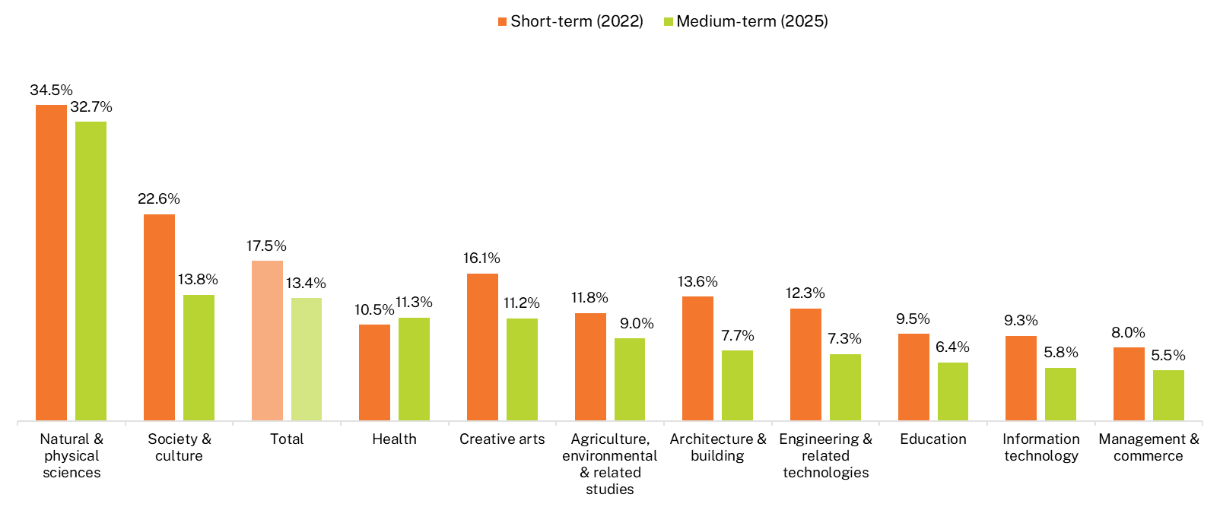

Those with undergraduate qualifications tended to move into 3 broad fields of education: Health, Society and culture, and Natural and physical sciences. These were the most popular further study destinations immediately following graduation, accounting for 71.1 per cent of undergraduates who reported engaging in further full-time study (Figure 10). By 2025, these same 3 broad fields of education accounted for an even larger proportion of undergraduates (73.3 per cent) who were engaged in further full-time study. Within these 3 broad fields of education, the proportion studying in the area of Health increased in the medium-term, while the proportion in Society and culture declined; Natural and physical sciences remained steady.
In the short-term, the majority (53.1 per cent) of Natural and physical science undergraduates who were engaged in further full-time study continued their studies in the same field, with a further 32.5 per cent moving into the field of Health. More than 80 per cent of these undergraduates were pursuing a master degree by coursework (35.1 per cent), bachelor (honours) degree (29.1 per cent) or a doctorate by research (17.2 per cent). Similar patterns were observed 3 years later, with 42.8 per cent undertaking further full-time study in the field of Natural and physical sciences, and 40.6 per cent in Health; 87.4 per cent were engaged in a master degree by coursework or doctorate by research. These findings suggest that, in general, Natural and physical science undergraduates pursue further studies in the same or related fields, advancing their skills and knowledge in postgraduate level courses.
Figure 10 Broad field of education destinations of domestic undergraduates undertaking further full-time study (%)
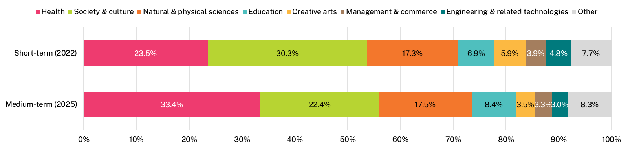

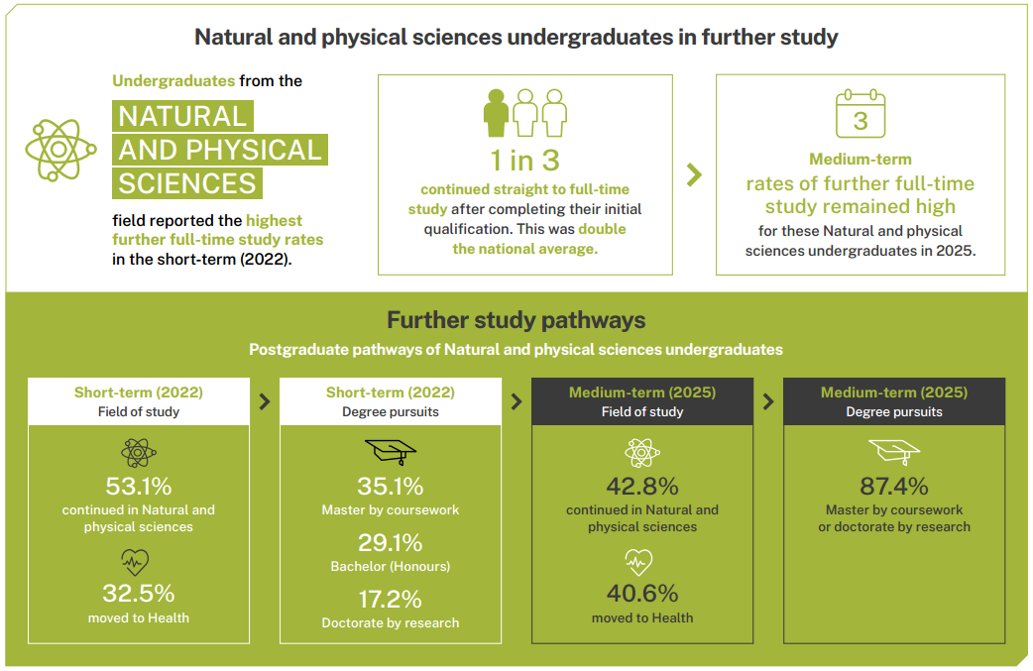

Demographic and equity groups
Outcomes varied among different sub-groups of graduates at all levels of study. This section describes results for undergraduates. Sub-group outcomes for postgraduate coursework and postgraduate research graduates follow similar patterns to undergraduates and are available in supplementary tables on the QILT website.

Disability
As seen in Table 4, domestic undergraduates with disability were less likely to be employed 4 to 6 months after completing their course than their counterparts without disability, and even less likely to be in full-time employment. Three years later, these rates improved somewhat with the difference in full-time employment narrowing from 11.1 percentage points to 5.4 percentage points, suggesting that it takes longer for these graduates to secure full-time employment.
Despite ‘catching up’ in terms of employment rates, the median salary for graduates with disability fell further behind after 3 years. The median salary for those with disability was on average $1,200 less than for graduates without disability in the short-term, but this gap increased to be on average $3,100 less than graduates without disability in the medium-term. This widening gap in median salaries may be due to the slower start for graduates with disability to secure full-time employment, and thus having less experience in the labour market 3 years later, or perhaps due to graduates with disability more likely to be in further full-time study and less likely to be employed in managerial or professional occupations, as seen in Table 5.

Graduates from regional and remote areas
Domestic undergraduates originally from regional and remote areas had higher rates of full-time employment in the short-term (by 3.5 percentage points). Three years later, these rates were broadly similar to those from metropolitan areas. Median salaries were on par for domestic undergraduates from regional/remote and metropolitan areas in both the short- and medium-term.

Age and study mode
Differences in labour market outcomes by age and study mode are likely to be related to differences in life stage and prior labour market experience. For example, those studying externally are often older and/or more likely already established in the labour market than those who have studied on-campus or in person (or through a mix of on-campus and online study).
Prior work experience or establishment in their field may also explain why those aged over 30 had better short-term outcomes for full-time employment, and why the median salary was higher for those aged over 30 in the short- and medium-term.

First Nations graduates
Employment outcomes between First Nations undergraduates and non-Indigenous undergraduates were broadly similar in the short- and medium-term. However, there was a notable difference in short-term median salaries with First Nations graduates earning on average $3,100 more than non-Indigenous graduates. This difference in median salaries persisted into the medium-term, but it is unclear if these differences in medium-term median salaries are generalisable to a broader population.
Interestingly, almost half of First Nations undergraduates were aged over 30, compared to only a third of non-Indigenous undergraduates. First Nations undergraduates were also more likely to have studied externally, 31.5 per cent compared to 20.5 per cent of non-Indigenous undergraduates. As discussed above, graduates aged over 30 and those who studied externally were both associated with higher median salaries, which may partly explain differences observed between First Nations and non-Indigenous undergraduates.

<Infographic> First Nations undergraduate profile (based on responses to the 2025 GOS-L)
First Nations undergraduates were more likely to have studied externally and be aged over 30 compared to non-Indigenous undergraduates.

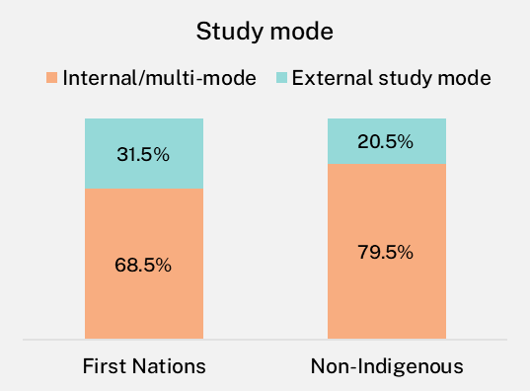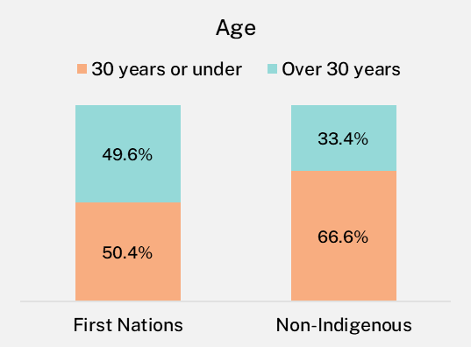
Socio-economic status
High-SES undergraduates were more likely to be in further full-time study and low-SES graduates were more likely to be in further part-time study.
Employment and median salary outcomes were broadly similar for graduates from high, medium and low socio-economic status (SES) areas.
Notably, rates of further study between undergraduates from low and high SES areas were comparable in both the short- and medium-term (Figure 11). However, high-SES graduates were more likely to be in further full-time study and low-SES graduates were more likely to be in further part-time study in both the short- and medium-term. These differences may reflect an increased capacity high SES graduates have to pursue further study on a full-time basis compared to low-SES graduates who may have to prioritise work over study due to greater financial pressures.
Figure 11 Undergraduates in further study by socio-economic status
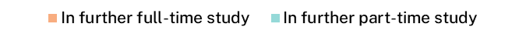
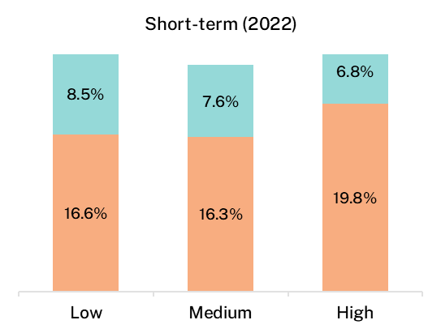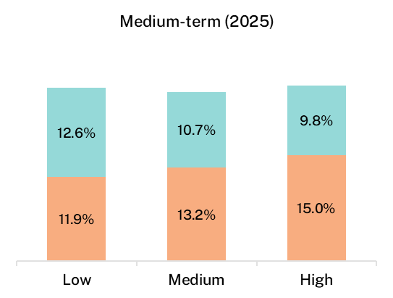

Language background
Domestic undergraduates from non-English speaking backgrounds had some of the lowest labour force outcomes of all the sub-groups, especially in the short-term. For example, their full-time employment rate was only 67.2 per cent shortly after completing their course, compared to a rate of 79.7 per cent for those from English-speaking backgrounds.
While the gap in full-time employment rates narrowed substantially over the 3 years, undergraduates from a non-English speaking background continued to be employed full-time at a rate lower than graduates whose home language was English. In addition, undergraduates from non-English speaking backgrounds reported the lowest median salaries of all sub-groups examined, in both the short- and medium-term.
Notably, these graduates were more likely to be in further full-time study in the short- and medium-term, which may limit the number of hours they can work and the types of jobs they can do. This may partially explain the lower full-time employment rates and median salaries of undergraduates from non-English speaking backgrounds.

Gender
Female undergraduates typically report higher rates of full-time employment than males but lower median salaries, and this trend continued for this 2022-2025 cohort (Table 4). Notably, female undergraduates employed full-time were less likely to be working in managerial or professional occupations than their male peers, which may partially explain the lower median salary in both the short- and medium-term. See Gender pay gap for further analysis on the gender pay gap over time and how this differs across study areas.

Table 4 Domestic undergraduate employment outcomes by demographic sub-group
 | Full-time  employment rate (%)‡ Short-term (2022) | Full-time  employment rate (%)‡ Medium-term  (2025) | Overall  employment rate (%)‡ Short-term (2022) | Overall  employment rate (%)‡ Medium-term  (2025) | Labour force participation rate (%)‡ Short-term (2022) | Labour force participation rate (%)‡ Medium-term  (2025) | Median annual full-time salary ($) Short-term (2022) | Median annual full-time salary ($) Medium-term  (2025) | In further full-time study (%) Short-term (2022) | In further full-time study (%) Medium-term  (2025) | Employed in managerial or professional occupation (% employed full-time) Short-term (2022) | Employed in managerial or professional occupation (% employed full-time) Medium-term  (2025)
Age: 30 years or under | 79.0 | 92.0 | 89.2 | 94.6 | 93.7 | 91.1 | 65,700 | 89,200 | 20.0 | 15.8 | 71.4 | 79.7
Age: Over 30 years | 80.5 | 91.1 | 89.3 | 94.5 | 90.7 | 89.0 | 74,900 | 97,000 | 12.7 | 8.9 | 69.4 | 77.2
Study mode*: Internal/multi-mode | 78.2 | 91.6 | 88.7 | 94.6 | 93.0 | 90.6 | 67,400 | 90,000 | 19.0 | 15.1 | 72.8 | 80.1
Study mode*: External study mode | 84.2 | 92.6 | 91.0 | 94.9 | 91.2 | 89.5 | 75,000 | 98,500 | 11.8 | 7.6 | 64.0 | 74.5
Gender: Male | 77.6 | 91.3 | 86.6 | 93.4 | 93.1 | 91.1 | 70,000 | 95,000 | 17.4 | 13.6 | 72.3 | 80.1
Gender: Female | 80.6 | 92.0 | 90.4 | 95.1 | 92.5 | 90.1 | 68,100 | 89,800 | 17.6 | 13.3 | 69.9 | 78.4
First Nations: First Nations | 81.1 | 90.9 | 88.2 | 94.6 | 91.8 | 88.1 | 72,000 | 95,000 | 17.1 | 17.0 | 66.0 | 78.9
First Nations: Non-Indigenous | 79.4 | 91.7 | 89.2 | 94.6 | 92.7 | 90.4 | 68,900 | 91,000 | 17.5 | 13.4 | 70.8 | 78.9
Home language**: English | 79.7 | 91.8 | 89.5 | 94.7 | 92.7 | 90.4 | 69,000 | 91,100 | 17.4 | 13.3 | 70.7 | 78.9
Home language**: Other | 67.2 | 85.0 | 72.2 | 89.5 | 89.9 | 88.6 | 65,000 | 84,100 | 25.5 | 21.7 | 72.2 | 79.8
Disability***: Disability | 69.5 | 86.9 | 83.4 | 91.5 | 88.6 | 86.5 | 67,800 | 88,200 | 21.4 | 15.8 | 68.7 | 76.5
Disability***: No disability | 80.6 | 92.3 | 89.9 | 95.0 | 93.2 | 90.9 | 69,000 | 91,300 | 17.0 | 13.1 | 70.9 | 79.2
First in family status****: First in family | 79.7 | 91.8 | 89.1 | 94.7 | 93.1 | 91.1 | 70,000 | 91,000 | 16.0 | 11.6 | 69.5 | 76.6
First in family status****: Not first in family | 80.7 | 92.5 | 90.1 | 95.0 | 93.1 | 90.7 | 68,000 | 91,000 | 19.7 | 16.0 | 73.1 | 81.5
Socio-economic status*****: High | 80.5 | 91.8 | 89.9 | 94.2 | 92.3 | 89.9 | 68,900 | 92,000 | 19.8 | 15.0 | 72.5 | 81.4
Socio-economic status*****: Medium | 79.3 | 92.1 | 89.3 | 94.9 | 93.4 | 91.2 | 68,900 | 90,000 | 16.3 | 13.2 | 71.2 | 78.5
Socio-economic status*****: Low | 79.5 | 90.6 | 88.8 | 94.2 | 91.5 | 89.4 | 70,000 | 90,100 | 16.6 | 11.9 | 69.3 | 77.3
Location***** †: Metro | 78.9 | 91.6 | 89.0 | 94.4 | 92.8 | 90.6 | 68,700 | 90,000 | 17.9 | 13.8 | 71.1 | 79.5
Location***** †: Regional/Remote | 82.4 | 92.3 | 90.7 | 95.1 | 92.3 | 90.1 | 70,000 | 91,100 | 16.3 | 12.7 | 71.7 | 78.4
Total | 79.5 | 91.7 | 89.2 | 94.6 | 92.7 | 90.4 | 69,000 | 91,000 | 17.5 | 13.4 | 70.7 | 78.9
* ‘Internal mode’ of attendance is where (i) the study is undertaken through attendance at the higher education provider on a regular basis, or (ii) for higher-degree unit enrolments, where regular attendance is not required but the student attends the higher education provider on an agreed schedule for the purposes of supervision and/or instruction. External mode of attendance is where lesson materials, assignments etc. are delivered to the student, and any associated attendance at the institution is of an incidental, irregular, special or voluntary nature. Mixed mode of attendance is where study is undertaken partially on an internal mode of attendance and partially on an external mode of attendance.
** ‘Home language other than English’ refers to graduates who arrived in Australia less than 10 years prior to the year in which the data was collected and who come from a home where a language other than English is spoken. This information is reported by institutions through the Tertiary Collection of Student Information (TCSI) system.
*** Disability information is reported by institutions through the Tertiary Collection of Student Information (TCSI) system, reflecting a disability, impairment or long-term condition which may affect a graduate’s studies.
**** ‘First in family’ refers to a graduate attaining a bachelor’s degree level qualification when their parent(s) or guardian(s) have not. This is based on the highest level of educational attainment of a student’s parent(s) or guardian(s), as identified by the student. This information is reported by institutions through the Tertiary Collection of Student Information (TCSI) system.
***** The socio-economic status and location measures are area-based, associated with students’ first permanent home address submitted when they commenced with their provider, as collected through the TCSI system. Socio-economic status is based on the ABS’ Socio-Economic Indexes for Areas (SEIFA) - The Index of Education and Occupation (IEO).
† Location measures are calculated according to the proportion of metro and regional/remote categories.
‡ Medium-term labour force participation rates, and full-time and overall employment rates from 2025 onwards are not directly comparable with earlier years due to a change to how the labour force is defined. Caution should be exercised when interpreting shifts from the short- to medium-term for the 2022-2025 cohort, as they partly reflect the change in methodology. See Appendix 1 for further information.

Study area
Comparisons of full-time employment rates by study area show that while undergraduates from some study areas, particularly those with generalist degrees, have weaker employment outcomes soon after completing their course, the difference in employment outcomes across study areas tends to narrow over time (Figure 12).
In 2022, full-time employment rates for recent undergraduates ranged from 97.8 per cent for Pharmacy and 96.9 per cent for Rehabilitation to 60.8 per cent for Creative arts and 63.0 per cent for Tourism, hospitality, personal services, sport and recreation – a difference of 37.0 percentage points between the highest and lowest study areas (Table 5).
By 2025, in the medium-term, the spread in employment rates across study areas for undergraduates had contracted to 14.7 percentage points. Full-time employment rates in many study areas that had high full-time employment rates shortly after course completion remained steady or increased further, while study areas with low full-time employment rates in the short-term had much larger increases 3 years later. For example, the two bottom study areas in 2022, Creative arts, and Tourism, hospitality, personal services, sport and recreation, had the largest increases in full-time employment rates 3 years later, by 22.8 and 27.3 percentage points respectively. In comparison, Medicine, which had the highest full-time employment rate in the medium-term, only increased by 6.4 percentage points between 2022 and 2025.
Other factors beyond labour market demand can also influence employment outcomes across study areas. For instance, the undergraduate full-time employment rate for Science and mathematics graduates was relatively low in the short- and medium-term, however, the further full-time study rate was the highest for this study area – 34.5 in the short-term and 32.7 per cent in the medium-term. Additionally, Science and mathematics undergraduates reported the lowest labour force participation rate, likely due to their propensity to continue straight into further full-time study.
Median salaries also differed across study areas and had greatly different increases over the 3-year period. In 2022, Pharmacy undergraduates reported the lowest median salary of $52,200; 3 years later, this had almost doubled to $97,700 (an increase of 87.2 per cent), well above the national average of $91,000.
The median salary for Nursing undergraduates was on par with the national average in 2022 but had the lowest 3-year salary growth of all study areas - by 2025, Nursing undergraduates reported a median salary of $85,000, falling below the national average of $91,000. Dentistry undergraduates reported the highest short-term median salary of $89,700 and this remained the highest 3 years later at $128,900.
In general terms, trends in employment outcomes for postgraduate coursework and postgraduate research graduates were broadly similar to those observed for undergraduates. That is, graduates from more vocationally oriented programs such as Pharmacy and Medicine tended to have higher rates of full-time employment in the short-term than those from more generalist study areas, such as Science and mathematics, and Communications. However, the difference diminished over time. Like undergraduate median salaries, these too varied by study area at the postgraduate level in the short- and medium-term.
Figure 12 Domestic undergraduate full-time employment rate in the short- and medium-term, by study area
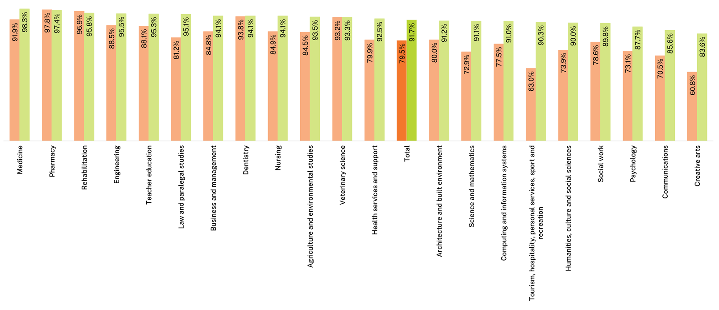
* Medium-term labour force participation rates, and full-time and overall employment rates from 2025 onwards are not directly comparable with earlier years due to a change to how the labour force is defined. Caution should be exercised when interpreting shifts from the short- to medium-term for the 2022-2025 cohort, as they partly reflect the change in methodology. See Appendix 1 for further information.
Note: ‘ppts’ refers to percentage points, indicating the absolute change between two percentage values.
Table 5 Domestic undergraduate labour market and further study outcomes by study area
Study area | Full-time  Employment rate (%)‡: Short-term (2022) | Full-time  Employment rate (%)‡: Medium-term (2025) | Overall  Employment rate (%)‡: Short-term (2022) | Overall  Employment rate (%)‡: Medium-term (2025) | Labour force participation rate (%)‡: Short-term (2022) | Labour force participation rate (%)‡: Medium-term (2025) | Median annual full-time salary ($): Short-term (2022) | Median annual full-time salary ($): Medium-term (2025) | In further full-time study (%): Short-term (2022) | In further full-time study (%): Medium-term (2025)
Agriculture and environmental studies | 84.5 | 93.5 | 92.1 | 94.8 | 88.4 | 87.4 | 70,000 | 91,200 | 11.8 | 9.0
Architecture and built environment | 80.0 | 91.2 | 90.0 | 93.4 | 94.6 | 95.5 | 65,000 | 84,000 | 13.6 | 7.7
Business and management | 84.8 | 94.1 | 90.8 | 95.4 | 96.7 | 94.9 | 65,000 | 95,000 | 8.5 | 5.7
Communications | 70.5 | 85.6 | 86.8 | 91.3 | 91.7 | 86.1 | 60,500 | 80,000 | 12.0 | 9.6
Computing and information systems | 77.5 | 91.0 | 84.2 | 92.0 | 95.0 | 95.0 | 69,100 | 100,000 | 9.3 | 5.8
Creative arts | 60.8 | 83.6 | 84.2 | 91.3 | 90.4 | 86.5 | 57,200 | 75,000 | 19.6 | 12.9
Dentistry | 93.8 | 94.1 | 92.5 | 96.9 | 95.7 | 92.9 | 89,700 | 128,900 | 11.9 | 10.7
Engineering | 88.5 | 95.5 | 91.9 | 96.3 | 96.4 | 95.5 | 71,000 | 103,000 | 12.3 | 7.3
Health services and support | 79.9 | 92.5 | 91.6 | 95.6 | 93.2 | 90.7 | 70,000 | 93,000 | 18.3 | 13.4
Humanities, culture and social sciences | 73.9 | 90.0 | 87.3 | 93.8 | 92.1 | 89.9 | 67,000 | 90,000 | 23.0 | 14.9
Law and paralegal studies | 81.2 | 95.1 | 88.2 | 96.0 | 94.1 | 92.8 | 70,000 | 100,000 | 19.1 | 6.5
Medicine | 91.9 | 98.3 | 91.2 | 98.6 | 93.5 | 90.4 | 80,000 | 115,000 | 14.1 | 21.1
Nursing | 84.9 | 94.1 | 92.6 | 97.7 | 95.5 | 92.6 | 68,900 | 85,000 | 3.5 | 8.9
Pharmacy | 97.8 | 97.4 | 99.0 | 95.9 | 95.2 | 92.4 | 52,200 | 97,700 | 15.2 | 14.3
Psychology | 73.1 | 87.7 | 87.7 | 93.4 | 90.7 | 89.3 | 69,800 | 91,300 | 30.8 | 19.3
Rehabilitation | 96.9 | 95.8 | 97.5 | 97.6 | 97.5 | 94.5 | 70,000 | 89,700 | 0.8 | 5.2
Science and mathematics | 72.9 | 91.1 | 86.2 | 92.8 | 86.8 | 84.4 | 66,500 | 85,600 | 34.5 | 32.7
Social work | 78.6 | 89.8 | 87.8 | 94.9 | 93.8 | 90.9 | 75,000 | 95,200 | 8.5 | 3.9
Teacher education | 88.1 | 95.3 | 94.6 | 97.4 | 94.8 | 91.7 | 72,300 | 92,600 | 9.5 | 6.4
Tourism, hospitality, personal services, sport and recreation | 63.0 | 90.3 | 95.0 | 92.3 | 93.0 | 90.7 | n/a | n/a | 16.2 | 15.2
Veterinary science | 93.2 | 93.3 | 95.9 | 96.9 | 97.0 | 95.0 | 64,200 | 90,000 | 13.8 | 12.4
Total | 79.5 | 91.7 | 89.2 | 94.6 | 92.7 | 90.4 | 69,000 | 91,000 | 17.5 | 13.4
Standard deviation | 10.4 | 3.7 | 4.1 | 2.2 | 2.8 | 3.3 | 8,500 | 12,700
Note: A blank cell indicates there is no data for that cell and n/a indicates a suppressed value (n<25).
‡ Medium-term labour force participation rates, and full-time and overall employment rates from 2025 onwards are not directly comparable with earlier years due to a change to how the labour force is defined. Caution should be exercised when interpreting shifts from the short- to medium-term for the 2022-2025 cohort, as they partly reflect the change in methodology. See Appendix 1 for further information.

Gender pay gap
Figure 13 shows that undergraduate employment outcomes were higher for females than males, and labour force participation rates were broadly similar. However, on average, female undergraduates earned less than their male peers in the short-term and this difference in median salaries increased 3 years later. In 2022, the difference in median salaries for undergraduates was $1,900 (or a gender pay gap of 2.7 per cent). By 2025, the difference had grown to $5,200 (or a gender pay gap of 5.5 per cent). This reflects a pattern consistent with previous cohorts of undergraduates.
Figure 13 Undergraduate labour market outcomes by gender
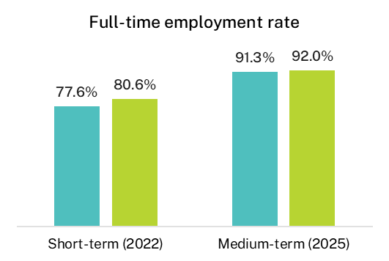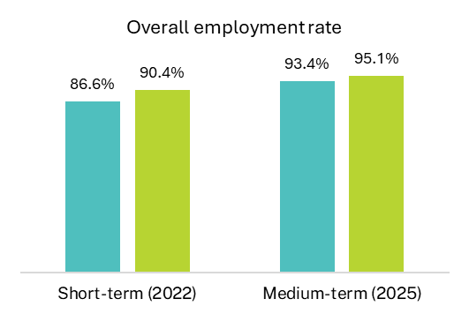
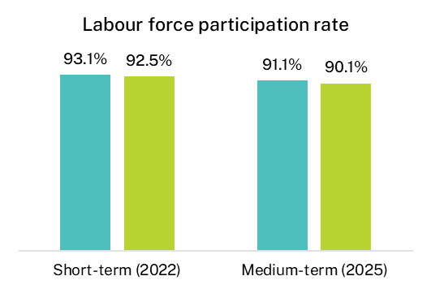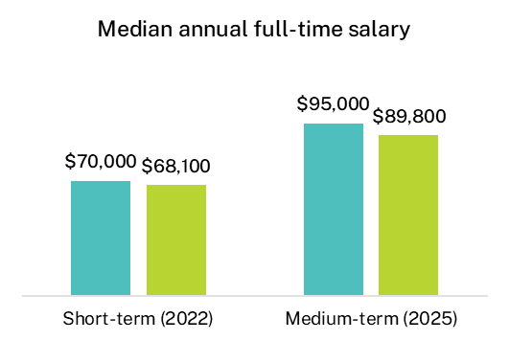
Note: Medium-term labour force participation rates, and full-time and overall employment rates from 2025 onwards are not directly comparable with earlier years due to a change to how the labour force is defined. Caution should be exercised when interpreting shifts from the short- to medium-term for the 2022-2025 cohort, as they partly reflect the change in methodology. See Appendix 1 for further information.
However, the medium-term gender pay gap of 5.5 per cent in 2025 was comparatively lower than the 7.4 per cent average gender pay gap observed between 2019 and 2024 (Figure 14). The strong labour market demand in 2021 and 2022, which led to elevated 3-year salary growth for the 2021-2024 and 2022-2025 graduate cohorts (see Median annual full-time salary), appears to have influenced the tighter gender pay gap in 2025. Females, like other sub-groups with lower median salaries, had proportionally larger 3-year salary growth as they benefited from strong demand in the labour market, resulting in a narrower gender pay gap in 2025.
Figure 14 Undergraduate gender pay gap, medium-term, and 3-year salary growth by gender
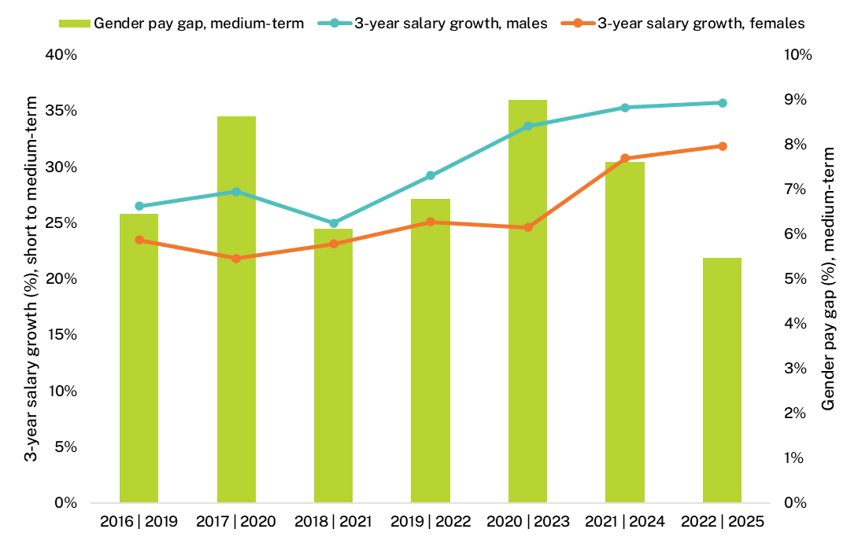
Female graduates often earn less than male graduates even within the same field of education. For example, female undergraduates from the Law and paralegal study areas reported a median salary $7,100 less than males in 2022, 4 to 6 months after course completion. While this gap did narrow over the 3 years to $3,300, females continued to earn less than males on average. See Appendix 3, Table 21 for a complete breakdown of median salaries by study area and gender in the short- and medium-term.
For other study areas, such as Science and mathematics and Computing and information systems, there was a relatively small gender pay gap between recent male and female undergraduates but this widened markedly over the 3 years – by 2025, male Computing and information systems undergraduates were on a median salary $9,000 more than females, equating to a gender pay gap of 8.7 per cent..
There were several study areas where females reported broadly similar median salaries to males in the short- and medium-term, including Psychology, Social work and Communications.
The gender pay gap is most pronounced for postgraduate coursework graduates. Shortly after completing their studies, the median salary for male graduates in this cohort was $10,800 higher than for their female counterparts (or a gender pay gap of 10.8 per cent) (Figure 15). This difference was larger 3 years later at $18,000 (or a gender pay gap of 14.0 per cent).
Figure 15 Postgraduate coursework median annual full-time salary by gender
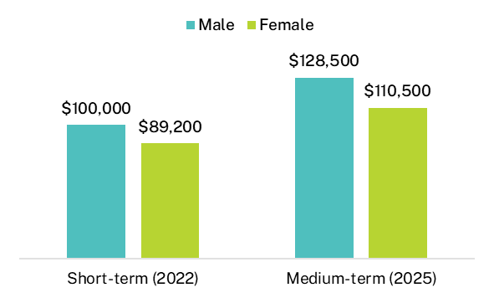
The gender pay gap across study areas at the postgraduate coursework level was biggest for Engineering – male Engineering undergraduates earned $25,200 more than females in the short-term and $24,800 more in the median-term (gender pay gaps of 25.0 per cent and 18.8 per cent respectively). There was a wide disparity in male and female median salaries in the Science and mathematics and Business management study areas in the short- and medium-term, while a large difference in median salaries for Agricultural and environmental studies did not emerge immediately but by 2025, males from this study area had a median salary that was $20,900 more than females (a gender pay gap of 17.6 per cent). See Appendix 3, Table 22 for a complete breakdown of median salaries by study area and gender in the short- and medium-term.
The difference in median salaries for postgraduate research graduates was $2,000 (or a gender pay gap of 2.0 per cent) shortly after graduation ($97,900 for males and $95,900 for females) (Figure 16). This had increased 3 years later to a difference of $3,000 ($120,000 for males and $117,000 for females), or a gender pay gap of 2.5 per cent.
Figure 16 Postgraduate research median annual full-time salary by gender
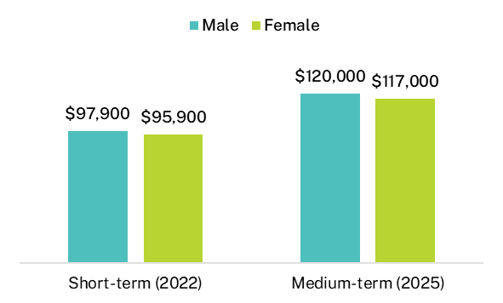
There may be many factors influencing these results, such as differences in the breadth of graduates’ skillsets, differences in career progression and job switching, life-stage impacts (including caring responsibilities), and personal preferences.

Institution

Institution type
In 2025, 94.2 per cent of total domestic respondents to the GOS-L completed a qualification at a university, while 5.8 per cent were from a non-university higher education institution (NUHEI).
In general, NUHEIs have greater proportions of postgraduates, international graduates and older graduates than universities. Graduates from NUHEIs also tend to cluster in fewer study areas.
Labour market outcomes, particularly rates of full-time employment and median salaries, remained stronger for undergraduates from universities than those from NUHEIs for the 2022-2025 cohort, in both the short- and medium-term (Table 6). Rates of labour force participation between institution types were comparable in the short- and medium-term, while the overall employment rate was the only key labour market indicator to narrow over time to similar rates.
Table 6 Short- and medium-term domestic graduate employment and study outcomes by level of study and institution type
 | Short-term (2022) Universities | Short-term (2022) NUHEIs | Medium-term (2025) Universities | Medium-term (2025) NUHEIs
Full-time employment rate (%)*: Undergraduate | 79.8 | 68.8 | 91.9 | 86.1
Full-time employment rate (%)*: Postgraduate coursework | 89.3 | 91.3 | 95.3 | 96.0
Overall employment rate (%)*: Undergraduate | 89.4 | 84.6 | 94.6 | 93.0
Overall employment rate (%)*: Postgraduate coursework | 93.8 | 93.6 | 97.0 | 96.8
Labour force participation rate (%)*: Undergraduate | 92.7 | 91.5 | 90.4 | 89.4
Labour force participation rate (%)*: Postgraduate coursework | 96.3 | 95.2 | 93.9 | 94.3
Median annual full-time salary ($): Undergraduate | 69,000 | 62,600 | 91,200 | 85,000
Median annual full-time salary ($): Postgraduate coursework | 91,800 | 90,000 | 115,000 | 122,000
In further full-time study (%): Undergraduate | 17.7 | 12.4 | 13.6 | 6.8
In further full-time study (%): Postgraduate coursework | 6.8 | 7.1 | 5.1 | 3.3
* Medium-term labour force participation rates, and full-time and overall employment rates from 2025 onwards are not directly comparable with earlier years due to a change to how the labour force is defined. Caution should be exercised when interpreting shifts from the short- to medium-term for the 2022-2025 cohort, as they partly reflect the change in methodology. See Appendix 1 for further information.
A key point of difference between undergraduates studying at universities compared to NUHEIs was age – 62.1 per cent of undergraduates from NUHEIs were aged over 30 compared to only 32.6 per cent of university undergraduates. This points to a preference older graduates – who are likely to be at a different life stage with other interests and responsibilities beyond their careers – may have for studying at a NUHEI. This difference in the age profile of undergraduates from NUHEIs may also explain the lower full-time employment rates but closer overall employment rates to undergraduates from universities.
Another key factor likely impacting outcomes at the undergraduate level is the study area profile of graduates from universities compared to NUHEIs. For instance, approximately 60 per cent of NUEHI undergraduates completed courses in the areas of Creative arts, Health services and support, Social work, and Humanities, culture and social sciences – study areas with relatively low to average full-time employment rates at the undergraduate level (Table 5).
In contrast, undergraduates from universities completed qualifications from a more diverse range of study areas. These differences in study area profiles are also likely to explain differences in further full-time study rates between institution types at the undergraduate level. In the short-term, undergraduates from the Science and mathematics and Psychology study areas reported the highest further full-time study rates – 34.5 per cent and 30.8 per cent respectively – and in the medium-term, the highest rates reported were from Science and mathematics and Medicine – 32.7 per cent and 21.1 per cent respectively. Only 5.2 per cent of NUHEI undergraduates completed courses in these 3 study areas, compared to 20.2 per cent of university undergraduates.
There was very little difference in outcomes at the postgraduate level between institution types (Table 6). Postgraduate coursework graduates from NUHEIs reported slightly higher full-time employment rates in the short-term compared to university graduates, 91.3 per cent and 89.3 per cent respectively. Notably, the median salaries of postgraduate coursework graduates were broadly similar in the short-term, but were markedly higher for NUHEI graduates 3 years later - $122,000 compared to $115,000 for university graduates.
Postgraduate coursework graduates from NUHEIs were even more concentrated in a small number of study areas than undergraduates, and this profile differed greatly to the equivalent university cohort, which may explain the higher medium-term median salary. More than half of NUHEI postgraduate coursework graduates completed qualifications in the areas of Business and management and Law and paralegal studies – study areas with some of the highest median salaries reported in the medium-term at the postgraduate coursework level (Appendix 3, Table 19).
Like undergraduates from universities, postgraduate coursework graduates were from a more diverse range of study areas than their equivalent NUHEI counterparts. The largest study area, Teacher education, accounted for 18.6 per cent of university graduates at the postgraduate coursework level and Teacher education graduates reported below average median salaries in the short- and medium-term nationally (Appendix 3, Table 19).

Comparative university outcomes
Notwithstanding differences in course offerings, student populations and local labour markets, some universities achieve higher rates of full-time employment than others over the medium-term.
Employment and salary outcomes vary across institutions. Note that factors beyond the quality of teaching, careers advice and other internal influences can affect results for institutions. These include study area and study mode offerings, the composition of the student population, and variations in state/territory and regional labour markets.
To assist interpretation of results, 90 per cent confidence intervals are included in the figures and tables that follow, which indicate the confidence intervals for the survey estimates. Note that where confidence intervals for institution estimates overlap, as seen in Figure 17 and Figure 18, it cannot be inferred that there is or is not a significant difference in full-time employment outcomes in a statistical sense.
Notwithstanding differences in course offerings, student populations and local labour markets, it appears there is differentiation among universities, with some achieving higher rates of full-time employment and median salaries than others.
There were greater variations in outcomes for domestic undergraduates in the short-term compared to the medium-term (Appendix 3, Table 23). Full-time employment rates for recent undergraduates ranged from a low of 68.0 per cent at Bond University to a high of 89.9 per cent at Charles Sturt University, a difference of 21.9 percentage points. Three years after graduation, full-time employment rates ranged from 80.7 per cent at Bond University to 96.4 per cent at the Australian National University, a difference of 15.8 percentage points.
Despite the varying rates of full-time employment between universities in the short-term, full-time employment rates were broadly consistent for most universities in the medium-term, as shown by Figure 17.
A similar pattern was observed for median salaries across universities, however, unlike differences in full-time employment rates which narrowed over the 3 years, differences in short-term median salaries persisted into the medium-term.
Similar variations in full-time employment rates across universities existed at the postgraduate coursework level, albeit less pronounced – there was a 16.1 percentage point difference in short-term full-time employment rates and this gap narrowed to 9.1 percentage points 3 years later. In 2025, the full-time employment rates of postgraduate coursework graduates across all universities, except for Torrens University, were above 90 per cent 3 years post-course completion (Appendix 3, Table 24).
Comparative institutional results are not available at postgraduate research graduate level, as there are too few survey responses. Also, due to the smaller sample sizes of NUHEIs, there is insufficient data at the NUHEI institution level to do the same level of analysis.
Figure 17 Domestic undergraduate short- and medium-term full-time employment rate by university (% with 90% confidence intervals)
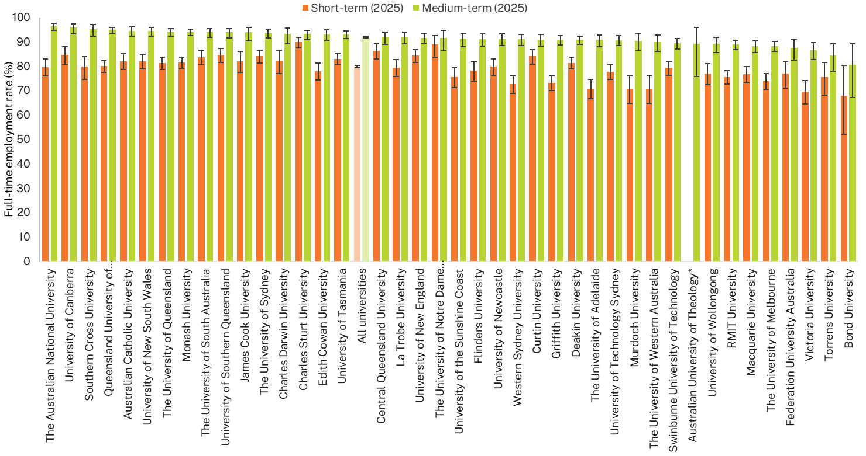
Note: Medium-term full-time employment rates from 2025 onwards are not directly comparable with earlier years due to a change to how the labour force is defined. Caution should be exercised when interpreting shifts from the short- to medium-term for the 2022-2025 cohort, as they partly reflect the change in methodology. See Appendix 1 for further information.
* In December 2024, the Tertiary Education Quality Standards Agency (TEQSA) changed the provider category in which the Australian University of Theology was registered to Australian University. Prior to this, the institution was known as the Australian College of Theology and was classified as a NUHEI. The medium-term outcome presented in this figure relates to graduates who completed their studies when the institution was classified as a NUHEI. The short-term outcome has been suppressed due to an insufficient number of responses (n<25).

Figure 18 Domestic postgraduate coursework short- and medium-term full-time employment rate by university, 2025 (% with 90% confidence intervals)
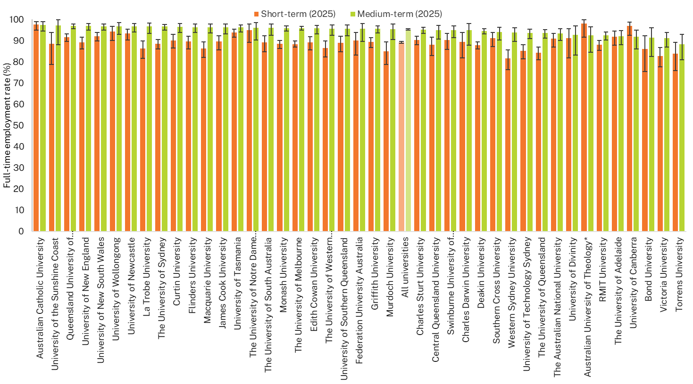
Note: Medium-term full-time employment rates from 2025 onwards are not directly comparable with earlier years due to a change to how the labour force is defined. Caution should be exercised when interpreting shifts from the short- to medium-term for the 2022-2025 cohort, as they partly reflect the change in methodology. See Appendix 1 for further information.
* In December 2024, TEQSA changed the provider category in which the Australian University of Theology was registered to Australian University. Prior to this, the institution was known as the Australian College of Theology and was classified as a NUHEI. The outcomes presented in this figure relate to graduates who completed their studies when the institution was classified as a NUHEI.

International graduate results
Detailed short-term employment outcomes for international graduates of Australian higher education providers are published annually in the Graduate Outcomes Survey International Report (See Graduate Outcomes Survey).
The GOS-L collects sufficient survey responses to enable high-level reporting of medium-term employment outcomes for international graduates, providing further context regarding the employment pathways of this graduate cohort.
It should be noted that differences in employment and further study outcomes between international and domestic graduates are affected by a range of factors, such as demographic and study area differences.
Note, too, that international graduate median salaries are reported for international graduates working in Australia only. Meanwhile, all other rates related to employment and further study outcomes, as well as skills utilisation, are for all international graduates, regardless of their location at the time of the survey.

International graduate profile (based on responses to the 2025 GOS-L)
The profile of international graduates across study levels differed to the domestic graduate profile.
The international graduate population had higher proportions of graduates across postgraduate levels compared to the domestic graduate population which had a larger proportion of undergraduates. 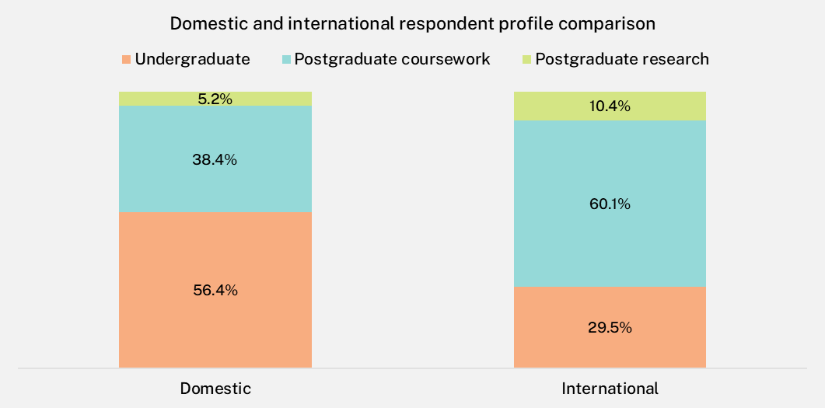
The proportions of international respondents aged 30 and under were higher than domestic respondents at the undergraduate and postgraduate coursework level. This difference was most notable at the postgraduate coursework level where the size of the international population aged 30 and under was more than double that of the domestic population (51.8 per cent compared to 21.1 per cent). This age differential between international and domestic graduates is a key factor in understanding differences in labour market outcomes, occupation types and further study outcomes presented in this chapter.
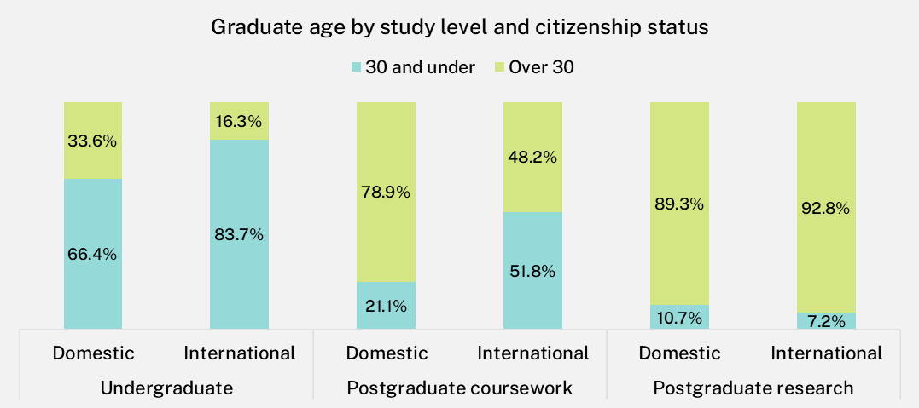
Overall, the top source countries for international students, in terms of the relative size of these populations, were China (excludes SARs and Taiwan), India and Nepal. However, the mix of source countries varied across study levels.
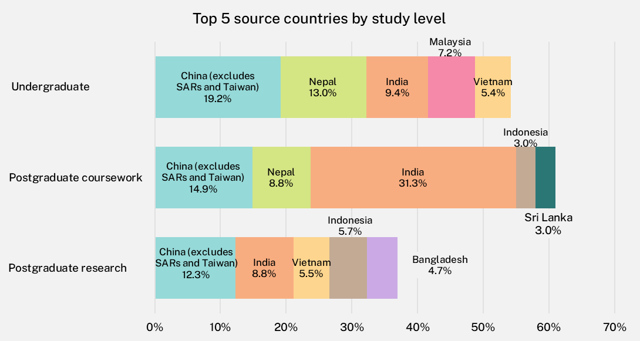

Comparative outcomes: international and domestic graduates
In general, short-term employment outcomes for international graduates are much lower than for domestic graduates and these trends continued for the 2022-2025 cohort. International graduates are more likely to be undertaking further full-time study than domestic graduates, which may partly explain the lower labour force participation rate. While employment rates for international graduates increase considerably 3 years later, narrowing the difference with domestic graduates, the gap in median salaries remains.
Differences in employment rates and median salaries are most pronounced at the postgraduate coursework level. Examining demographic, study area and undergraduate further study rates provides important context in understanding this gap. These themes are discussed in the following sections.
Changes to how the labour force is defined in 2025 affected the labour force participation rates, and full time and overall employment rates presented in this report. Differences between 2025 medium-term results, and the short-term results and other medium-term results should be interpreted with caution as they partly reflect the change in methodology. Department of Education analysis indicates this change resulted in downward pressure on labour force participation rates, and upward pressure on both full-time and overall employment rates. Table 7 provides the estimated impacts on each indicator for international graduates, by study level. See Appendix 1 for more information about this change.
Table 7 Estimated impact of methodology change in the 2025 GOS-L
Study level: Indicator | Direction of change | Domestic | International
Undergraduate: Labour force participation rate | Down | <1 ppt | 1.5-2.5 ppts
Undergraduate: Full-time employment rate | Up | <1.5 ppts | 1-2 ppts
Undergraduate: Overall employment rate | Up | <1 ppt | 1.5-2.5 ppts
Postgraduate coursework: Labour force participation rate | Down | <1 ppt | <1.5 ppts
Postgraduate coursework: Full-time employment rate | Up | <1 ppt | 1-2 ppts
Postgraduate coursework: Overall employment rate | Up | <1 ppt | <1.5 ppts
Postgraduate research: Labour force participation rate | Down | 1.5-2.5 ppts | <1.5 ppts
Postgraduate research: Full-time employment rate | Up | 1.5-2.5 ppts | <1 ppt
Postgraduate research: Overall employment rate | Up | 1.5-2.5 ppts | <1.5 ppts
Note: An overview of the analysis used to estimate these impacts is available in Appendix 1. ‘ppts’ refers to percentage points, indicating the absolute change between two percentage values.

Undergraduate comparisons
International undergraduates reported lower employment rates than domestic undergraduates in the short- and medium-term, but the gap did narrow over the 3-year period as international graduate rates increased at a higher rate than for domestic undergraduates (Table 8).
As seen in prior cohorts, the 2022-2025 international undergraduate cohort continued to report lower median salaries than their domestic counterparts in the short-term. This pay differential did not diminish over the 3-year period, despite the proportions of international undergraduates working in managerial or professional occupations being comparable to domestic undergraduates in the medium-term. Salary growth was higher for domestic undergraduates than it was for international undergraduates over the 3-year period, at 31.9 per cent and 29.8 per cent respectively.
Approximately 1 in 4 international undergraduates were underemployed in 2022, much higher than that of domestic undergraduates (13.7 per cent). The high underemployment rate corresponds to the low full-time employment rate in the short-term. Three years later, the international undergraduate full-time employment rate increased by 24.2 percentage points compared to an increase of 12.2 percentage points for domestic graduates. At the same time, the underemployment rate for international graduates fell by 15.4 percentage points compared to 6.5 percentage points for domestic graduates. These findings indicate that it takes longer for international graduates to obtain full-time hours, despite their preference to do so.
Lastly, further full-time study rates are higher for international undergraduates in the short- and medium-term. This, in part, explains the lower labour force participation rate, as some students at least, will be focusing solely on their studies. The higher further full-time study rates of international undergraduates is also important context in understanding differences in postgraduate coursework level outcomes discussed in the following section.
Table 8 Undergraduate short- and medium-term outcomes comparison: international and domestic graduates
 | Short-term (2022)  Domestic | Short-term (2022) International | Medium-term (2025)  Domestic | Medium-term (2025) International
Full-time employment rate (%)‡ | 79.5 | 60.5 | 91.7 | 84.7
Overall employment rate (%)‡ | 89.2 | 74.8 | 94.6 | 89.5
Labour force participation rate (%)‡ | 92.7 | 87.4 | 90.4 | 87.1
Median annual full-time salary ($) | 69,000 | 62,000 | 91,000 | 80,500
Underemployment rate (%) | 13.7 | 24.7 | 7.2 | 9.3
In further full-time study (%) | 17.5 | 25.4 | 13.4 | 17.8
Employed in managerial or professional occupation (% of those employed full-time) | 70.7 | 62.7 | 78.9 | 77.6
Note: International graduates’ median salary figures only include data for international graduates working in Australia.
‡ Medium-term labour force participation rates, and full-time and overall employment rates from 2025 onwards are not directly comparable with earlier years due to a change to how the labour force is defined. Caution should be exercised when interpreting shifts from the short- to medium-term for the 2022-2025 cohort, as they partly reflect the change in methodology. See Appendix 1 for further information.

Postgraduate coursework comparisons
Differences in employment and salary outcomes are most pronounced at the postgraduate coursework level. However, it should be noted that at the postgraduate coursework level in particular, the domestic cohort of graduates is more likely to be older and have established themselves in the workforce before or during their studies. This is evidenced by the high employment and median salary outcomes of domestic graduates 4 to 6 months after course completion (Table 9).
In contrast, international postgraduate coursework graduates reported much lower rates of employment in the short-term, despite having similar levels of participation in the labour force, indicating that they are available for employment. Further to this, international postgraduate coursework graduates were 3 times more likely to be underemployed – that is, employed part-time but would prefer to work more hours – suggesting that the lower full-time employment rate is not always by choice.
The underemployment rate for international graduates dropped markedly over the 3-year period, as the full-time employment rate rose sharply, bringing it much closer to the domestic rate. These findings indicate that it takes longer for international postgraduate coursework graduates to obtain full-time hours.
In dollar terms, differences in median salaries were widest at the postgraduate coursework level, with domestic graduates earning on average $28,700 more than international graduates in the short-term and $31,000 more in the medium-term. However, in terms of 3-year salary growth, the median salary for international postgraduate coursework graduates did increase at a higher rate than for domestic graduates, at 35.8 per cent and 27.1 per cent respectively.
An important distinction between international and domestic graduate outcomes at the postgraduate coursework level is how they compare relative to equivalent undergraduate outcomes. Typically, domestic graduates with postgraduate coursework qualifications have higher employment and salary outcomes, lower underemployment rates and are more likely to be employed in managerial or professional occupations than domestic undergraduates.
In contrast, international graduates with postgraduate coursework qualifications have comparable outcomes to international undergraduates. For instance, the full-time employment rate for international undergraduates in 2022 was 60.5 per cent, compared to 61.4 per cent for international postgraduate coursework graduates (see Table 8 and Table 9). Similarly, the median salary for international undergraduates in 2022 was $62,000 compared to $62,600 for international postgraduate coursework graduates. International postgraduate coursework graduates were less likely to be working in managerial or professional occupations in both the short- and medium-term.
Table 9 Postgraduate coursework short- and medium-term outcomes comparison: international and domestic graduates
 | Short-term (2022)  Domestic | Short-term (2022) International | Medium-term (2025)  Domestic | Medium-term (2025) International
Full-time employment rate (%)‡ | 89.5 | 61.4 | 95.4 | 88.1
Overall employment rate (%)‡ | 93.8 | 79.1 | 97.0 | 91.2
Labour force participation rate (%)‡ | 96.2 | 94.7 | 93.9 | 90.7
Median annual full-time salary ($) | 91,300 | 62,600 | 116,000 | 85,000
Underemployment rate (%) | 7.2 | 24.5 | 4.5 | 7.1
In further full-time study (%) | 6.8 | 10.7 | 5.0 | 11.7
Employed in managerial or professional occupation (% of those employed full-time) | 86.0 | 60.1 | 89.0 | 73.0
Note: International graduates’ median salary figures only include data for international graduates working in Australia.
‡ Medium-term labour force participation rates, and full-time and overall employment rates from 2025 onwards are not directly comparable with earlier years due to a change to how the labour force is defined. Caution should be exercised when interpreting shifts from the short- to medium-term for the 2022-2025 cohort, as they partly reflect the change in methodology. See Appendix 1 for further information.

Postgraduate research comparisons
There was less variation in employment outcomes at the postgraduate research level. In the short-term, domestic postgraduate research graduates did report higher rates of employment but this narrowed over the 3-year period (Table 10).
In the short-term, international graduates were more likely to report being underemployed but this dropped at a higher rate over the 3-year period to align with the medium-term domestic underemployment rate.
Notably, international postgraduate research graduates who were employed full-time earned less on average than their domestic counterparts in the short-term and this gap persisted into the medium-term.
As shown in Table 10, both cohorts were working in managerial or professional occupations at similar rates, suggesting other factors may be influencing the differences in median salaries. For instance, around half of international postgraduate research graduates completed studies in the areas of Engineering and Science and mathematics (Figure 19), and both of these study areas had below average median salaries in the short and medium-term (based on reported domestic salaries, see Appendix 3, Table 19).
International postgraduate research graduates were more than twice as likely to continue further full-time study immediately following course completion but this gap narrowed substantially over the 3-year period.
Table 10 Postgraduate research short- and medium-term outcomes comparison: international and domestic graduates
 | Short-term (2022)  Domestic | Short-term (2022) International | Medium-term (2025)  Domestic | Medium-term (2025) International
Full-time employment rate (%)‡ | 84.9 | 75.9 | 93.7 | 90.7
Overall employment rate (%)‡ | 92.7 | 86.3 | 96.5 | 94.8
Labour force participation rate (%)‡ | 95.9 | 96.3 | 91.7 | 96.5
Median annual full-time salary ($) | 97,000 | 89,000 | 120,000 | 110,000
Underemployment rate (%) | 10.8 | 15.0 | 5.7 | 5.8
In further full-time study (%) | 5.7 | 10.4 | 5.1 | 7.0
Employed in managerial or professional occupation (% of those employed full-time) | 93.2 | 92.2 | 94.5 | 94.8
Note: International graduates’ median salary figures only include data for international graduates working in Australia.
‡ Medium-term labour force participation rates, and full-time and overall employment rates from 2025 onwards are not directly comparable with earlier years due to a change to how the labour force is defined. Caution should be exercised when interpreting shifts from the short- to medium-term for the 2022-2025 cohort, as they partly reflect the change in methodology. See Appendix 1 for further information.

Study area
International graduates tend to cluster in a small number of study areas: Business and management, Computing and information systems, Engineering, Science and mathematics, and Nursing. The proportions vary by study level, as seen in Figure 19. The top two study areas, in terms of size, at the undergraduate and postgraduate coursework levels were Business and management and Computing and information systems. At the postgraduate research level, the largest populations of international graduates were from the Engineering and Sciences and mathematics study areas.
Figure 19 International graduate profile by study area and level (% based on responses to the 2025 GOS-L)
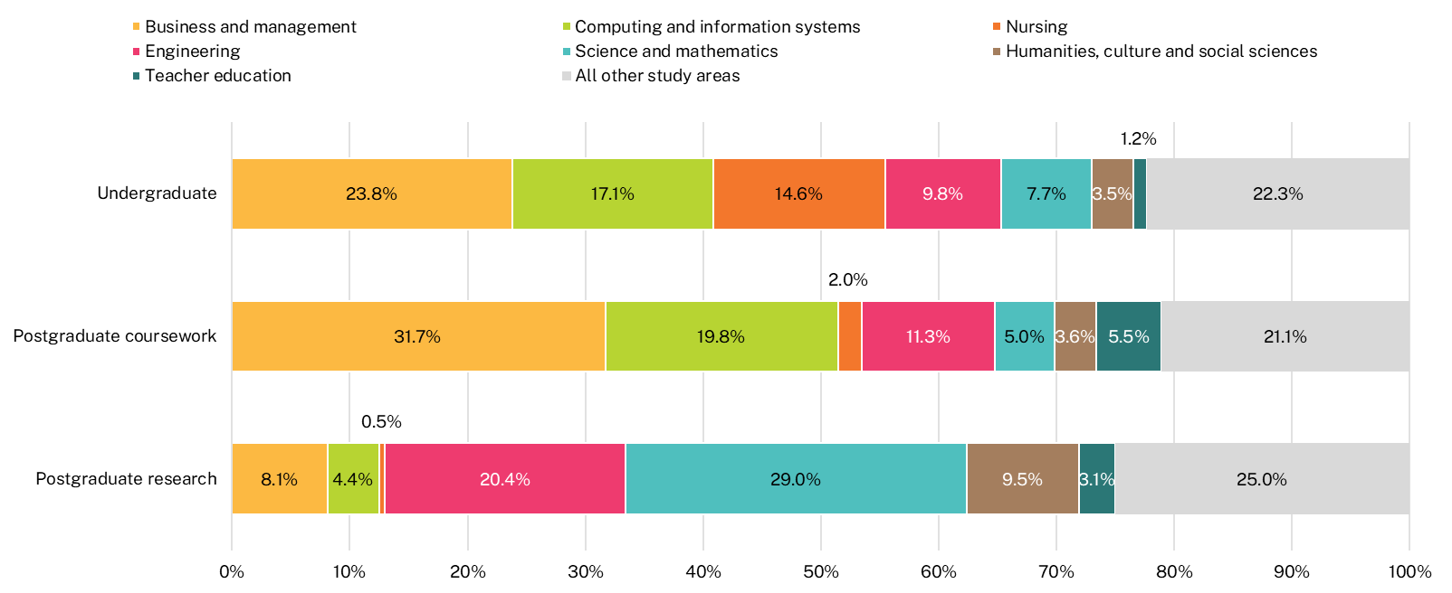
* Only selected study areas presented in this figure. For all study areas, refer to the CHAR_UG_ALL_1Y_AREA_INT, CHAR_PGC_ALL_1Y_AREA_INT and CHAR_PGR_ALL_1Y_AREA_INT worksheets in the 2025 GOS-L National Tables available on the QILT website.

Figure 20 presents full-time employment rates for domestic and international undergraduates in the short- and medium-term across study areas. Some of the largest differences in full-time employment rates between domestic and international undergraduates in the short-term were from the most populous study areas for international graduates. For example, 23.8 per cent of international undergraduates completed studies in the Business and management study area, yet the full-time employment rate was only 59.3 per cent in the short-term, compared to 84.8 per cent for domestic undergraduates. Similar differences were observed for the Computing and information systems study area. These findings indicate that study area preferences of international undergraduates do not explain the lower employment outcomes of international undergraduates overall, as the largest study areas for international graduates have some of the widest gaps between international and domestic outcomes.
Short-term full-time employment rates were high for both domestic and international undergraduates from the area of Medicine, at 91.9 per cent and 88.9 per cent respectively. These rates are high relative to the average short-term full-time employment rate for each of the cohorts, 79.5 per cent for domestic graduates and 60.5 per cent for international graduates. This suggests there is strong labour market demand for graduates from this study area.
The effect previously noted for domestic graduates regarding vocationally-oriented study areas is more pronounced for international graduates. The Social work and Health services and support study areas reported short-term full-time employment rates of 72.1 per cent and 71.2 per cent respectively, notably higher than the cohort average (60.5 per cent). In contrast, more generalist study areas like Humanities, culture and social sciences, and Science and mathematics, reported short-term full-time employment rates below the cohort average, at 53.4 per cent and 52.5 per cent respectively.
Across most study areas, full-time employment rates increased at a higher rate for international undergraduates over the 3-year period than they did for domestic undergraduates, leading to a much closer average full-time employment rate in the medium-term.
In some of the biggest study areas for international undergraduates, full-time employment rates increased at more than twice the rate for domestic undergraduates. For example, full-time employment rates for international undergraduates from Business and management rose by 25.1 percentage points over the 3-year period, compared to a 9.3 percentage point increase for their domestic counterparts. Large increases in Computing and information systems, Engineering, Science and mathematics, and Nursing were also observed for international undergraduates, narrowing the gap with domestic undergraduates markedly. These findings by study area reaffirm earlier findings that it can take time for international undergraduates to obtain full-time hours.

Figure 20 Undergraduate full-time employment rate by citizenship status and study area (%)
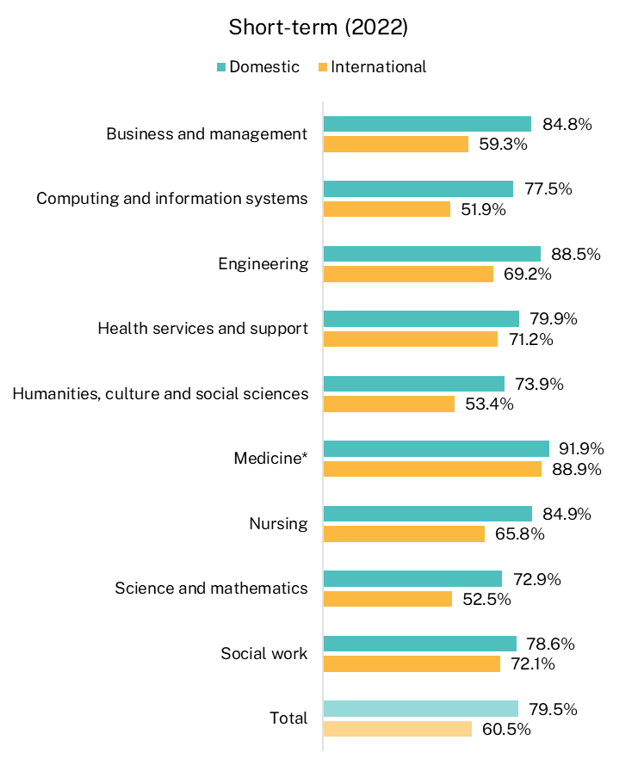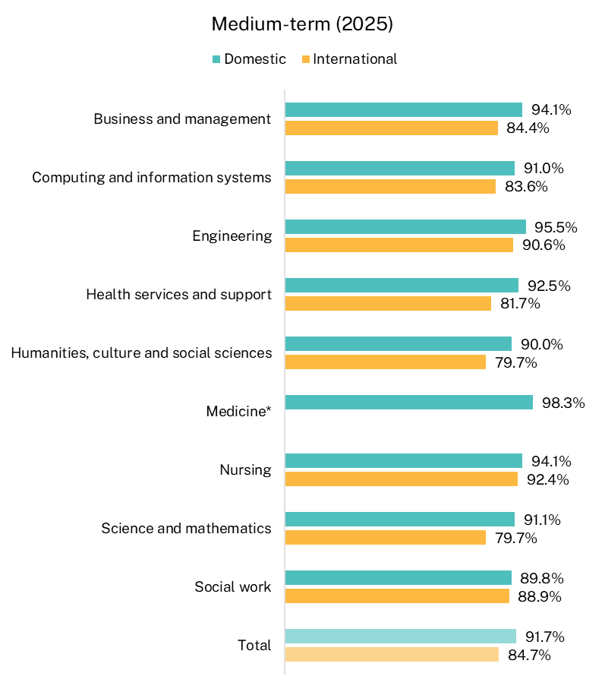
Note: Only selected study areas are presented in this figure. For all study areas, refer to the FTE_ALL_ALL_1Y_AREA and FTE_ALL_ALL_1Y_AREA_INT worksheets in the 2025 GOS-L National Tables available on the QILT website. Medium-term full-time employment rates from 2025 onwards are not directly comparable with earlier years due to a change to how the labour force is defined. Caution should be exercised when interpreting shifts from the short- to medium-term for the 2022-2025 cohort, as they partly reflect the change in methodology. See Appendix 1 for further information.
* International medium-term full-time employment rate for Medicine suppressed due to insufficient data (n<25).

Source country
This section presents employment and further full-time study outcomes for international graduates, regardless of their location at the time of the survey, disaggregated by the graduate’s source country and study level. The countries in Table 11 are Table 12 are ordered based on the total number of survey responses at that study level.
Considerable variation in outcomes by source country continued for the 2022-2025 international graduate cohort across all study levels. Differences in demographic and study area profile are likely to contribute to differences in employment outcomes and further full-time study rates.
At the undergraduate level, graduates from China (excludes SARs and Taiwan), which accounted for 28.7 per cent of the international undergraduate responding population, had some of the lowest employment outcomes but highest rates of further full-time study – more than half of undergraduates from China (excludes SARs and Taiwan) continued straight on to further full-time study after completing their initial qualification, double the average rate of international undergraduates. This high further full-time study rate corresponds with the low labour force participation rate and indicates that graduates from China (excludes SARs and Taiwan) may not have the same financial pressures to work, or perhaps a greater preference to focus on their studies. In contrast, undergraduates from Nepal and India reported much lower rates of further full-time study and higher labour force participation rates.
Notably, 97.3 per cent of undergraduates from Nepal reported being available for employment – that is, in the labour force – but these graduates had one of the lowest rates of full-time employment (54.9 per cent). Although undergraduates from Nepal had a relatively low further full-time study rate in the short- and medium-term, they had an above average further part-time study rate relative to international undergraduates overall. They also had above average overall employment rates relative to international undergraduates overall. Almost 80 per cent of undergraduates from Nepal completed studies in Computing and information systems or Nursing – two study areas with large differences in full-time employment rates between international and domestic undergraduates in the short-term (Figure 20). This demonstrates that factors beyond source country alone can influence graduate outcomes.
There was some variation in median salaries by source country for international graduates employed full-time in Australia, however, it is unclear whether these differences are generalisable to the broader population of international undergraduates due to the smaller number of survey responses. Comparing differences in median salaries of graduates who responded to the 2022 GOS and 2025 GOS-L, graduates from China (excludes SARs and Taiwan) reported a median salary above the average for international undergraduates in the short-term but this was below the average in the medium-term. A similar pattern was observed for graduates from Vietnam. Conversely, respondents from India reported below average median salaries in the short-term but above the international graduate average in the medium-term. Differences in dominant study areas graduates from source countries tend to cluster in are likely to influence these findings.
Table 11 International undergraduate short- and medium-term outcomes by source country
Source country | Full-time  employment rate (%)‡ Short-term (2022) | Full-time  employment rate (%)‡ Medium-term  (2025) | Overall  employment rate (%)‡ Short-term (2022) | Overall  employment rate (%)‡ Medium-term  (2025) | Labour force participation rate (%)‡ Short-term (2022) | Labour force participation rate (%)‡ Medium-term  (2025) | Median annual full-time salary ($) Short-term (2022) | Median annual full-time salary ($) Medium-term  (2025) | In further full-time study (%)Short-term (2022) | In further full-time study (%) Medium-term  (2025)
China (excludes SARs and Taiwan) | 56.1 | 75.4 | 59.8 | 82.0 | 69.3 | 82.3 | 65,400 | 76,900 | 51.8 | 29.2
Nepal | 54.9 | 85.4 | 82.5 | 90.1 | 97.3 | 91.7 | 58,700 | 79,300 | 11.1 | 14.0
India | 62.1 | 87.8 | 78.5 | 91.0 | 96.0 | 86.0 | 60,500 | 84,500 | 15.7 | 12.1
Malaysia | 67.6 | 90.5 | 73.6 | 94.1 | 88.3 | 89.8 | 61,400 | 80,000 | 21.5 | 15.8
Vietnam | 54.0 | 89.4 | 80.0 | 91.5 | 86.5 | 83.3 | 63,400 | 76,000 | 23.4 | 18.2
Total international | 60.5 | 84.7 | 74.8 | 89.5 | 87.4 | 87.1 | 62,000 | 80,500 | 25.4 | 17.8
Note: International graduates’ median salary figures only include data for international graduates working in Australia.
‡ Medium-term labour force participation rates, and full-time and overall employment rates from 2025 onwards are not directly comparable with earlier years due to a change to how the labour force is defined. Caution should be exercised when interpreting shifts from the short- to medium-term for the 2022-2025 cohort, as they partly reflect the change in methodology. See Appendix 1 for further information.

Similar variation in outcomes also existed at the postgraduate coursework level, although the mix of source countries making up the top 5 did vary. Notably, graduates from China (excludes SARs and Taiwan) also had the highest further full-time study rates in the short- and medium-term and the lowest labour force participation rate, particularly in the short-term. Graduates from Nepal and, in some cases, India, had weaker employment and median salary outcomes at the postgraduate level than their peers at the undergraduate level, and this did not change over time. For example, postgraduate coursework graduates from Nepal had lower full-time employment rates and median salaries in the short- and medium-term than undergraduates from Nepal.
Graduates from Indonesia had the highest full-time employment rate in the short-term and one of the highest in the medium-term (along with Sri Lanka).
Like undergraduate median salaries, there was some variation at the postgraduate coursework level with similar patterns observed by source country. Graduates from Nepal reported the lowest median salaries in both the short- and medium-term. Graduates from Indonesia had some of the highest median salaries in both the short- and medium-term, above the average for international postgraduate coursework graduates.
Table 12 International postgraduate coursework short- and medium-term outcomes by source country
Source country | Full-time  employment rate (%)‡ Short-term (2022) | Full-time  employment rate (%)‡ Medium-term  (2025) | Overall  employment rate (%)‡ Short-term (2022) | Overall  employment rate (%)‡ Medium-term  (2025) | Labour force participation rate (%)‡ Short-term (2022) | Labour force participation rate (%)‡ Medium-term  (2025) | Median annual full-time salary ($) Short-term (2022) | Median annual full-time salary ($) Medium-term  (2025) | In further full-time study (%) Short-term (2022) | In further full-time study (%) Medium-term  (2025)
India | 55.7 | 85.0 | 79.4 | 88.3 | 95.6 | 89.1 | 60,000 | 83,500 | 9.7 | 10.4
China (excludes SARs and Taiwan) | 58.2 | 88.0 | 70.0 | 91.9 | 89.2 | 89.0 | 60,000 | 80,000 | 14.5 | 17.6
Nepal | 53.5 | 83.1 | 79.6 | 87.5 | 95.9 | 90.3 | 56,400 | 75,000 | 12.9 | 13.1
Sri Lanka | 60.3 | 90.9 | 78.0 | 92.3 | 96.6 | 93.9 | 63,400 | 80,300 | 10.8 | 15.9
Indonesia | 67.3 | 91.4 | 79.0 | 92.6 | 96.0 | 93.7 | 68,500 | 90,000 | 6.1 | 10.7
Total international | 61.4 | 88.1 | 79.1 | 91.2 | 94.7 | 90.7 | 62,600 | 85,000 | 10.7 | 11.7
Note: International graduates’ median salary figures only include data for international graduates working in Australia.
‡ Medium-term labour force participation rates, and full-time and overall employment rates from 2025 onwards are not directly comparable with earlier years due to a change to how the labour force is defined. Caution should be exercised when interpreting shifts from the short- to medium-term for the 2022-2025 cohort, as they partly reflect the change in methodology. See Appendix 1 for further information.
- Changes to labour force classification
The Graduate Outcomes Survey (GOS) and Graduate Outcomes Survey – Longitudinal (GOS-L) collect information about higher education graduates’ employment and further study outcomes, as well as other information related to skills utilisation and course experience.
Key labour force indicators used in GOS and GOS-L reporting are informed by the Australian Bureau of Statistics (ABS) Labour Statistics: Concepts, Sources and Methods. Some variation in key indicator definitions has existed due to survey design differences. To enable greater alignment with the ABS labour force framework, a number of enhancements were made to the 2025 GOS and 2025 GOS-L instruments.
Improved alignment with ABS definitions of key labour force indicators used in GOS and GOS-L reporting allows for greater comparability with nationally reported figures and further enriches the data collected in the GOS and GOS-L, the only national sources of higher education graduate outcomes in Australia. However, while improvements made to key indicators in 2025 have strengthened these measures and allowed for greater comparability with national figures reported by the ABS, these changes do have implications on the comparability with historical data.
This appendix details the changes made to the questionnaire and key indicator definitions, and the impact this has on time series data.
  - Changes made to the survey instrument
The following changes were made to the labour force module in the 2025 GOS and GOS-L to improve the comparability of key labour force indicators with ABS statistics, and to provide further insight into why graduates may be unemployed or not available for employment.
- Modification to an existing question and the addition of new questions to identify graduates who are currently away from work but are considered to have a formal job attachment.
- Modification to existing questions and addition of new questions to align the GOS/GOS-L definition of unemployment with the ABS Labour Force Survey and allow for identification of graduates marginally attached to the labour force.
- New questions for full-time workers, whose actual hours were fewer than their usual hours, to identify the reason for the reduced hours and availability to work additional hours.
- For part-time workers preferring more hours, expand the ‘availability to work’ question to cover the four weeks following the survey, not just the reference week.
- The addition of a set of questions related to reasons graduates are unemployed or not in the labour force (i.e. not available for employment).

Away from work
The following questions relate to graduates who were away from work in the reference week. The expanded detail collected in this set of questions enables the identification of graduates who were away from work at the time of the survey but are considered to have a formal job attachment.
Table 13 Away from work questions
Item | Question stem | Response options
AWAYWORK  (modified in 2025) | Did you have a job, business or farm that you were away from because of holidays, sickness or any other reason? | 1. Yes – away from work as a standard work or shift arrangement  2. Yes – away from a business that I own  3. Yes – on strike, locked out or in an industrial dispute  4. Yes, holidays, sickness, or other reason  5. No  6. Permanently not intending to work
AWAYLONG (new in 2025) | Up until the end of last week, how long had you been away from work? | 1. Less than 4 weeks  2. 1 to 3 months  3. More than 3 months
AWAYPAID (new in 2025) | Were you paid, or will you be paid, for any part of the last 4 weeks?. | 1. Yes, I received workers’ compensation and expect to return to employer  2. Yes, I received workers’ compensation and do not expect to return to employer  3. Yes, I received other form of payment from employer  4. No

Unemployment/marginal attachment to the labour force
This set of questions allow for identification of graduates who were unemployed but in the labour force versus those not in the labour force but marginally attached.
Changes to existing questions (LOOKFTWK and LOOKPTWK) enable identification of graduates who either actively or passively looked for work. Passive job seekers not employed at the time of the survey can now be excluded from the labour force, aligning with the ABS definition.
Table 14 Attachment to labour force questions
Item | Question stem | Response options
LOOKFTWK (modified in 2025) | At any time during the last 4 weeks have you been looking for full-time work?  Please note:  • ‘Actively looking for work' includes written, telephoned or applied to an employer; had an interview with an employer for work; answered an advertisement for a job; checked or registered with an employment agency; taken steps to purchase or start your own business; advertised or tendered for work; and contacted friends or relatives to find work.  • ‘Passively looking for work’ includes only looking in newspapers, the internet, or notice boards, and not taking any specific action to obtain work from these sources. | 1. Yes, I have been actively looking for full-time work  2. Yes, I have been passively looking for full-time work  3. No  4. Permanently not intending to work
LOOKPTWK  (modified in 2025) | Have you been looking for part-time work at any time during the last 4 weeks?  Please note:  • ‘Actively looked for work' includes written, telephoned or applied to an employer; had an interview with an employer for work; answered an advertisement for a job; checked or registered with an employment agency; taken steps to purchase or start your own business; advertised or tendered for work; and contacted friends or relatives to find work.  • ‘Passively looked for work’ includes only looking in newspapers, the internet, or notice boards, and not taking any specific action to obtain work from these sources. | 1. Yes, I have been actively looking for part-time work  2. Yes, I have been passively looking for part-time work  3. No  4. Permanently not intending to work
WAITWORKFU  (new in 2025) | You mentioned that you didn’t look for work during the last 4 weeks. Was that because you were waiting to start work you had already obtained?  Please note ‘work you had already obtained’ refers to new types of work that you have acquired but not yet commenced. This includes waiting for a graduate role to commence. | 1. Yes  2. No
WANTJOB  (new in 2025) | Even though you are not currently working, would you like a paid job of any kind at the moment? | 1. Yes, I could start within 4 weeks if work was available  2. Yes, but I could not start within 4 weeks if work was available  3. No
STARTWKOB  (new in 2025) | Will you be starting that work in the next 4 weeks? | 1. Yes  2. No
STARTNOWK  (new in 2025) | Could you have started last week if that work had been available? | 1. Yes  2. No

Reasons for working less than usual hours and future availability
New questions to understand the reasons graduates worked less than their usual hours in the reference week, and to understand whether those who would prefer to work more hours would be available in the next 4 weeks.
Table 15 Reasons for working less than usual hours and future availability questions
Item | Question stem | Response options
RSACTLHRS  (modified in 2025) | What was the main reason you worked less than your usual hours last week?  Please select only one answer. | 1. Annual leave/holidays/flextime/long service leave  2. Own illness or injury/sick leave  3. Standard work arrangements/shift work  4. Personal reasons/study/caring for sick/injured family  5. Maternity leave or paternity leave  6. Parental leave  7. No work/not enough work available  8. Stood down  9. Bad weather/plant breakdown  10. On strike/locked out/industrial dispute  11. Seasonal work/end of season  12. Began/left/lost job during the week  13. Other (Please specify)
AVFMHRS  (new in 2025) | In the next 4 weeks, would you be available to work more hours than you usually work? | 1. Yes  2. No

Reasons for unemployment or non-participation in the labour force
The following questions provide insight into why graduates are unemployed or not available for employment. Reasons include both temporary and permanent reasons, as well as labour market specific reasons.
Table 16 Reasons for unemployment or not available for employment
Item | Question stem | Response options
RSNILF1  (new in 2025) | You mentioned that you are not currently working. What is the main reason you are not currently working?  Please select only one answer. | 1. No jobs or vacancies in local area  2. No jobs in my line of work  3. No jobs with suitable conditions/arrangements/hours in my local area  4. Not enough work experience/skills/training  5. Employers unwilling to hire me due to ill health or disability  6. Considered to be too old by employers  7. Retired  8. Difficulties with language or ethnic background  9. Waiting for accreditation/registration  10. Long-term health condition or disability  11. Short-term illness or injury  12. Caring for a person with a health condition or disability  13. Caring for children  14. Pregnancy  15. Performing home duties  16. Studying or returning to studies  17. On a temporary holiday or leisure activity  18. Lifestyle choice  19. Visa restrictions  20. Waiting for permanent residency  21. Other (Please specify)
RSNILF2  (new in 2025) | You mentioned that you are not intending to work permanently. What is the main reason you are not intending to work?  Please select only one answer. | 1. No jobs or vacancies in local area  2. No jobs in my line of work  3. No jobs with suitable conditions/arrangements/hours in my local area  4. Employers unwilling to hire me due to ill health or disability  5. Retired  6. Difficulties with language or ethnic background  7. Considered to be too old by employers  8. Long-term health condition or disability  9. Caring for a person with a health condition or disability  10. Caring for children  11. Pregnancy  12. Performing home duties  13. Lifestyle choice  14. Visa restrictions  15. Other (Please specify)
RSNOTWRK  (new in 2025) | You mentioned that you are not currently working and you have been away from your job for 1 month or more. What is the main reason you are not currently working?  Please select only one answer. | 1. Time off work  2. Own illness or injury  3. Personal reasons  4. Study  5. Caring for sick/injured family  6. Maternity leave or paternity leave  7. Parental leave  8. No work/not enough work available  9. Stood down  10. Bad weather/plant breakdown  11. Seasonal work/end of season  12. Other (Please specify)
  - Impact on the 2025 GOS and 2025 GOS-L data
Changes to existing questions LOOKFTWK (looked for full-time work) and LOOKPTWK (looked for part-time work) (Table 16), which are used in establishing whether unemployed graduates are considered available for employment and therefore in the labour force, led to a change in response patterns relative to prior years.
Previously, respondents could answer ‘yes’ or ‘no’ when asked if they had looked for full-time/part-time work. In 2025, respondents could answer ‘yes, actively’, ‘yes, passively’, or ‘no’. The total proportion responding ‘yes’ (either actively or passively) was markedly higher compared to previous years and the proportion answering ‘no’ decreased substantially. These findings indicated that respondents who may have previously been searching for work passively were previously answering either ‘yes’ or ‘no’.
Focussing on active job seekers shows a marked decrease in the proportion of respondents looking for work. As a result, the improved alignment with ABS definitions have led to changes to the labour force participation rate, and the full-time and overall employment rates presented in the GOS and GOS-L.
    - Changes to key labour market indicator definitions

Labour force participation rate
The labour force participation rate is defined as the proportion of graduates who were available for employment out of the total number of respondents. ‘Available for employment’ (and ‘available for full-time employment’) is defined as graduates who were (full-time) employed, looking for (full-time) employment or waiting to start a job in the week prior to the survey.
As discussed earlier, respondents who answered that they were passively looking for (full-time/part-time) work were classed as ‘not in the labour force’ in 2025, if the other criteria for ‘available for employment’ were not met. This has reduced the number of respondents considered available for employment which has resulted in a decreased labour force participation rate in 2025.
‘Available for full-time employment’ and ‘available for employment’ in general are key variables used in the calculation of the full-time and overall employment rates, respectively, and thus have implications on these measures.

Full-time employment rate
Graduates are considered full-time employed if they were usually or actually in paid employment for at least 35 hours per week in the week before the survey.
The full-time employment rate is defined as graduates employed full-time, as a proportion of those available for full-time employment. Given the proportion available for full-time employment was reduced in 2025, expected declines in the full-time employment rate in 2025 (consistent with ABS data) were not observed. This has had a greater impact on the undergraduate rate due to the greater likelihood of undergraduates not being available for employment due to their higher propensity for pursuing further studies.

Overall employment rate
Graduates are considered employed if they were usually or actually in paid employment for one or more hours in the week before the survey.
The overall employment rate is defined as employed graduates, as a proportion of those available for employment. Changes to those considered ‘available for employment’ have had a similar impact on the overall employment rate as the effect on the full-time employment rate.
  - Analysis of time series break
The Department of Education undertook analysis of the propensities of graduates to search for work, and their characteristics, at the aggregate study level for each of the domestic and international graduate cohorts, in the GOS and GOS-L separately. This analysis focussed on an econometric approach that leveraged data available through the ABS Labour Force, Australia to estimate the propensities of graduates to search for work had the previous methodology continued in 2025. This approach enabled the impact of the methodology change to be estimated in a way that reflected the underlying labour market conditions in 2025, noting these conditions may affect the propensity for graduates to pursue employment or further study.
- There is a strong counter-cyclical relationship between higher education enrolments and labour market conditions.
- When there is a rise in unemployment, individuals often choose to return to study or postpone entry into the workforce. For example, during the initial period of the pandemic (2020 and 2021), higher unemployment and the business restrictions in place at the time contributed to an increase in higher education enrolments.
- Conversely, when employment conditions are favourable (especially for young individuals) higher education enrolments tend to decline. This is demonstrated by the recent strong labour markets (2022-2024) contributing to a decline in higher education commencements as more potential enrolments chose to pursue immediate employment opportunities.
Only the propensities for those reporting that they were not in employment and looking for work, or not in full-time employment but available for full-time employment, needed to be assessed. Due to the way the labour force framework filters individuals into the three mutually exclusive groups of employed, unemployed, and not in the labour force, these were the only groups that were affected by the methodology change, as those considered employed were taken as reported.
- The specific groups that required analysis were:
  - Unemployed looking for full-time work (LFCLASS=5),
  - Unemployed looking for part-time work (LFCLASS=6), and
  - Available for full-time work (AVAILFT=1), via the subsets of:
    - Employed part-time, but available for full-time work,
    - Not employed, but available for full-time work (under the GOS and GOS-L this is the same group as LFCLASS=5), and
    - Employed full-time, and available for full-time work (these were unaffected by the change in methodology and were taken as reported).
- Those considered unemployed and waiting to start work (LFCLASS=7), were unaffected by the change in methodology and were taken as reported.
- Those considered not in the labour force (LFCLASS=8) were calculated as a balancing item based on estimated changes to LFCLASS=5 and LFCLASS=6.
Initial analysis was performed to support the identification of appropriate data from the ABS Labour Force, Australia. This included the assessment of graduate age profiles for each of the analysed labour force classifications to identify the key age groups, by study level for each of the domestic and international graduate cohorts, in the GOS and GOS-L separately. For international graduates in each study level, additional analysis was conducted that verified the majority of graduates in these labour force classifications remained in Australia, in both the GOS and GOS-L.
The estimates of propensities to search for work involved using predictors selected from the ABS Labour Force, Australia data that were consistent with each of the labour force classifications analysed, by study level, for each of the domestic and international graduate cohorts, in the GOS and GOS-L separately. These data were accessed through TableBuilder as well as select tables available through the Labour Force, Australia publication, including data on the flows into and out of employment (GM1) and data on labour force status by the level of highest educational attainment (LQ1). Data were selected to align to survey fieldwork periods for the GOS and GOS-L separately. Dummy variables were incorporated to reflect border closures and business restrictions in place during the pandemic.
Quality controls were used to ensure the estimates generated for each of the assessed labour force classifications were credible. This included validating each of the estimates against the expected range of results, specifically, a slightly higher count of respondents than the reported active job seekers, but notably less than the total count of those responding they were either actively or passively searching for work. The estimated proportional breakdown of respondents by labour force classification were also compared to historical proportions.
The analysis generated estimated impacts of the methodology change by study level, for each of the domestic and international graduate cohorts, in the GOS and GOS-L separately (Table 17).
Table 17 Estimated impact of methodology change
Study level: Indicator | Direction of change | GOS |  | GOS-L
Study level: Indicator | Direction of change | Domestic | International | Domestic | International
Undergraduate: Labour force participation rate | Down | 2.5-3.5 ppts | 2.5-3.5 ppts | <1 ppt | 1.5-2.5 ppts
Undergraduate: Full-time employment rate | Up | 3.5-4.5 ppts | 2.5-3.5 ppts | <1.5 ppts | 1-2 ppts
Undergraduate: Overall employment rate | Up | 2.5-3.5 ppts | 2.5-3.5 ppts | <1 ppt | 1.5-2.5 ppts
Postgraduate coursework: Labour force participation rate | Down | <1.5 ppts | <1 ppt | <1 ppt | <1.5 ppts
Postgraduate coursework: Full-time employment rate | Up | <1.5 ppts | <1.5 ppts | <1 ppt | 1-2 ppts
Postgraduate coursework: Overall employment rate | Up | <1.5 ppts | <1 ppt | <1 ppt | <1.5 ppts
Postgraduate research: Labour force participation rate | Down | <1.5 ppts | <1 ppt | 1.5-2.5 ppts | <1.5 ppts
Postgraduate research: Full-time employment rate | Up | 1.5-2.5 ppts | <1 ppt | 1.5-2.5 ppts | <1 ppts
Postgraduate research: Overall employment rate | Up | <1.5 ppts | <1 ppt | 1.5-2.5 ppts | <1.5 ppts
Note: ppts’ refers to percentage points, indicating the absolute change between two percentage values.
A direction of change is shown for each impact. These directions indicate that labour force participation rates are relatively lower under the new methodology, while full-time and overall employment rates are relatively higher.

  - Conclusion
The changes to the 2025 GOS and 2025 GOS-L instruments represent a step toward improved alignment with ABS labour force definitions. These changes did, however, impact comparability of key labour market indicators with prior years and are considered to be a break in the time series.
Analysis of differences in labour force participation rates, full-time employment rates, and overall employment rates between 2019–2024 and 2025 data should be approached with caution, as they partly reflect the change in methodology. Estimates of the impact of the change in methodology for each study level for domestic and international graduates have been provided to assist users with their interpretation.

- Labour market and graduate satisfaction definitions
The 2025 GOS-L uses labour force indicator definitions informed by the Standards for Labour Force Statistics used by the ABS. Definitions for indicators used throughout this report are presented in Table 18.
Table 18 Indicator definitions
Indicator/element | Definition
Available for employment† | Graduates who were employed, actively looking for employment or waiting to start a job in the week prior to the survey.
Available for full-time employment† | Graduates who were employed full-time or actively looking for full-time employment in the week prior to the survey. This includes those in part-time employment and looking for full-time work in the week prior to the survey.
Employed | Graduates who were usually or actually in paid employment for one or more hours in the week before the survey.
Employed full-time | Graduates who were usually or actually in paid employment for at least 35 hours per week in the week before the survey.
Employed part-time | Graduates who were usually or actually in paid employment for at least one hour but less than 35 hours in the week before the survey.
Full-time employment rate | Graduates employed full-time, as a proportion of those available for full-time work. Note that some graduates available for full-time work may be in part-time employment and looking for full-time work.
Further full-time study rate | Graduates who reported being in further full-time study, as a proportion of all graduates.
Labour force participation rate | Graduates available for employment, as a proportion of all graduates.
Median salary | The median annual salary of graduates employed full-time.
Overall course satisfaction indicator (Undergraduate and postgraduate coursework) | The proportion of graduates who ‘agreed’ or ‘strongly agreed’ that they were satisfied with the overall quality of their course.
Overall employment rate | Graduates employed for one or more hours, as a proportion of those available for employment.
Postgraduate research graduate satisfaction:  - Overall satisfaction  - Intellectual climate  - Infrastructure  - Goals and expectations  - Supervision  - Skills development  - Thesis examination and industry, and  - External engagement. | Calculated from multiple survey items, representing the proportion of graduates who gave a positive response to items associated with each aspect of their higher degree by research (HDR) experience.
Underemployed | Graduates who were usually or actually in paid employment for fewer than 35 hours per week, in the week before the survey, and who would prefer to work additional hours regardless of if they were available to work those additional hours.
† From 2025 onwards, respondents who were not currently working and only passively looking for work are no longer considered to be available for employment. Prior to 2025, both active and passive job search types were included.

  - Examples of graduate labour market outcomes
The names and examples used in this report are fictitious and are provided for illustrative purposes only.
Amy works 37 hours a week. Amy is both ‘available for employment’ and ‘available for full-time employment’, as well as both ‘employed’ and ‘employed full-time’. Amy is counted towards the labour force participation rate. Amy’s usual salary is counted towards the median salary figure.
Bryan works 20 hours a week while also studying full-time. He does not want to work additional hours. Bryan is ‘available for employment’, ‘employed’ and ‘employed part-time’ but is not ‘available for full-time work’ or ‘employed full-time’. Bryan is counted towards the full-time study rate, overall employment rate and the labour force participation rate. Bryan’s salary is not counted towards the median salary figure. Bryan is not considered ‘underemployed’.
Krishna works 6 hours a week but would prefer to work 40 hours per week. Krishna is both ‘available for employment’ and ‘available for full-time employment’. Krishna is ‘employed’ and ‘employed part-time’ but not ‘employed full-time’. Krishna is also considered ‘underemployed’. Krishna is counted towards the labour force participation rate. Krishna’s salary is not counted towards the median salary figure.
Dilek is studying full-time and is neither working nor looking for work. Dilek is ‘not available for employment’ and therefore is not counted towards the labour force participation rate. However, Dilek is counted towards the full-time study rate.
Emily is not working but she has been actively looking for full-time work. Emily is both ‘available for employment’ and ‘available for full-time employment’. Emily is counted towards the labour force participation rate. However, Emily is neither ‘employed’ nor ‘employed full-time’ and can also be referred to as ‘unemployed’.
Xavier is studying full-time and not currently working. He occasionally looks at job ads online but he has not actively looked for a job, such as registered with an employment agency, submitted an application, or asked friends and relatives for assistance in finding a job. Xavier is counted towards the full-time study rate but he is not considered ‘available for employment’ or ‘available for full-time employment’, and he is not counted towards the labour force participation rate.

- Detailed tables
  - Study area
Table 19 Domestic postgraduate coursework labour market outcomes by study area
 | Full-time  Employment rate (%) | Full-time  Employment rate (%) | Overall  Employment rate (%) | Overall  Employment rate (%) | Labour force participation rate (%) | Labour force participation rate (%) | Median annual full-time salary ($) | Median annual full-time salary ($)
Study area | Short-term (2022) | Medium-term (2025) | Short-term (2022) | Medium-term (2025) | Short-term (2022) | Medium-term (2025) | Short-term (2022) | Medium-term (2025)
Agriculture and environmental studies | 80.4 | 93.5 | 89.0 | 97.1 | 96.3 | 92.6 | 81,000 | 100,800
Architecture and built environment | 89.2 | 94.8 | 94.3 | 97.0 | 96.2 | 96.6 | 73,000 | 93,200
Business and management | 92.1 | 96.2 | 95.1 | 96.9 | 97.9 | 95.4 | 115,000 | 141,000
Communications | 74.9 | 91.1 | 88.9 | 96.1 | 94.1 | 92.3 | 78,300 | 92,500
Computing and information systems | 87.3 | 94.1 | 89.7 | 95.3 | 97.5 | 94.9 | 101,000 | 127,000
Creative arts | 78.9 | 85.8 | 88.5 | 94.6 | 96.3 | 91.4 | 67,000 | 99,000
Dentistry | 96.6 | 100.0 | 97.6 | 100.0 | 100.0 | 95.2 | n/a | n/a
Engineering | 93.7 | 97.5 | 94.0 | 98.3 | 97.1 | 94.5 | 96,800 | 130,000
Health services and support | 87.6 | 95.2 | 94.6 | 96.8 | 97.0 | 93.7 | 92,400 | 112,100
Humanities, culture and social sciences | 80.8 | 92.6 | 91.2 | 94.8 | 92.9 | 89.1 | 86,000 | 102,100
Law and paralegal studies | 90.5 | 95.7 | 91.2 | 96.4 | 96.9 | 94.8 | 84,000 | 120,000
Medicine | 97.3 | 98.4 | 97.3 | 99.2 | 97.6 | 96.1 | 83,500 | 130,000
Nursing | 94.3 | 96.5 | 96.7 | 98.4 | 96.5 | 94.6 | 91,800 | 114,000
Pharmacy | 95.2 | 94.5 | 96.1 | 97.3 | 97.5 | 94.9 | 87,700 | 120,000
Psychology | 86.8 | 95.8 | 93.0 | 97.8 | 91.6 | 93.8 | 88,000 | 110,000
Rehabilitation | 96.8 | 98.2 | 98.0 | 98.6 | 99.3 | 97.3 | 70,000 | 93,200
Science and mathematics | 82.0 | 94.3 | 88.8 | 95.7 | 93.9 | 93.0 | 89,900 | 107,000
Social work | 88.2 | 93.7 | 92.4 | 96.7 | 94.8 | 91.0 | 82,000 | 102,000
Teacher education | 90.9 | 96.1 | 95.1 | 97.5 | 96.7 | 94.3 | 89,800 | 110,000
Tourism, hospitality, personal services, sport and recreation | n/a | n/a | n/a | n/a | n/a | n/a | n/a | n/a
Veterinary science | 100.0 | 100.0 | 95.9 | 97.8 | 100.0 | 91.8 | 69,700 | 118,800
Total | 89.5 | 95.4 | 93.8 | 97.0 | 96.2 | 93.9 | 91,300 | 116,000
Standard deviation | 7.2 | 4.0 | 3.4 | 1.5 | 2.3 | 2.4 | 13,500 | 20,800
Note: A blank cell indicates there is no data for that cell and n/a indicates a suppressed value (n<25).

Table 20 Domestic postgraduate research labour market and further study outcomes by study area
 | Full-time  Employment rate (%) | Full-time  Employment rate (%) | Overall  Employment rate (%) | Overall  Employment rate (%) | Labour force participation rate (%) | Labour force participation rate (%) | Median annual full-time salary ($) | Median annual full-time salary ($)
Study area | Short-term (2022) | Medium-term (2025) | Short-term (2022) | Medium-term (2025) | Short-term (2022) | Medium-term (2025) | Short-term (2022) | Medium-term (2025)
Agriculture and environmental studies | 76.4 | 87.0 | 91.9 | 93.3 | 98.4 | 95.2 | 92,500 | 122,100
Architecture and built environment | n/a | n/a | 89.7 | 96.2 | 96.7 | 86.7 | n/a | n/a
Business and management | 86.1 | 92.9 | 90.3 | 95.2 | 97.9 | 88.4 | 103,700 | 137,500
Communications | n/a | n/a | n/a | n/a | n/a | n/a | n/a | n/a
Computing and information systems | 85.7 | 95.0 | 89.1 | 97.7 | 93.9 | 89.8 | 91,400 | 131,000
Creative arts | 73.4 | 93.0 | 87.6 | 96.5 | 96.7 | 93.5 | 100,100 | 125,000
Dentistry | n/a | n/a | n/a | n/a | n/a | n/a | n/a
Engineering | 86.1 | 94.6 | 93.3 | 96.8 | 97.6 | 92.9 | 94,800 | 120,000
Health services and support | 89.1 | 93.6 | 94.1 | 97.3 | 95.6 | 92.5 | 103,000 | 125,000
Humanities, culture and social sciences | 76.5 | 91.3 | 91.7 | 93.4 | 93.2 | 89.1 | 100,000 | 113,000
Law and paralegal studies | 84.6 | 84.0 | 93.3 | 96.4 | 96.8 | 90.3 | n/a | n/a
Medicine | 90.0 | 96.3 | 96.3 | 98.4 | 96.4 | 90.7 | 103,700 | 125,000
Nursing | 100.0 | 100.0 | 97.3 | 100.0 | 97.4 | 86.8 | 118,500 | n/a
Pharmacy | n/a | n/a | n/a | n/a | n/a | n/a | n/a | n/a
Psychology | 89.9 | 96.1 | 92.3 | 99.0 | 95.4 | 95.4 | 93,900 | 115,100
Rehabilitation | n/a | n/a | n/a | n/a | n/a | n/a | n/a | n/a
Science and mathematics | 87.9 | 93.9 | 93.1 | 96.2 | 96.3 | 93.4 | 92,500 | 115,000
Social work | n/a | n/a | n/a | n/a | n/a | n/a | n/a | n/a
Teacher education | 86.1 | 98.0 | 93.4 | 100.0 | 96.5 | 90.1 | 107,500 | 125,000
Tourism, hospitality, personal services, sport and recreation |  |  | n/a | n/a | n/a | n/a
Veterinary science | n/a | n/a | n/a | n/a | n/a | n/a | n/a | n/a
Total | 84.9 | 93.7 | 92.7 | 96.5 | 95.9 | 91.7 | 97,000 | 120,000
Standard deviation | 10.8 | 5.0 | 3.5 | 10.6 | 2.9 | 5.5 | 9,300 | 10,200
Note: A blank cell indicates there is no data for that cell and n/a indicates a suppressed value (n<25).

  - Gender pay gap
Table 21 Undergraduate median annual full-time salary by gender and study area
 | Short-term (2022) | Short-term (2022) | Short-term (2022) | Medium-term (2025) | Medium-term (2025) | Medium-term (2025)
Study area | Male median salary ($) | Female median salary ($) | Gender pay gap (%) | Male median salary ($) | Female median salary ($) | Gender pay gap (%)
Agriculture and environmental studies | 70,000 | 70,000 | 0.0 | 95,600 | 90,000 | 5.9
Architecture and built environment | 68,000 | 61,000 | 10.3 | 90,500 | 82,100 | 9.3
Business and management | 66,700 | 65,000 | 2.5 | 98,000 | 92,000 | 6.1
Communications | 60,000 | 60,500 | -0.8 | 81,000 | 80,000 | 1.2
Computing and information systems | 69,800 | 68,000 | 2.6 | 103,000 | 94,000 | 8.7
Creative arts | 60,000 | 56,000 | 6.7 | 75,500 | 74,700 | 1.1
Dentistry | n/a | 89,500 | n/a | n/a | 122,100 | n/a
Engineering | 72,100 | 70,000 | 2.9 | 104,400 | 100,500 | 3.7
Health services and support | 71,800 | 69,800 | 2.8 | 100,000 | 92,000 | 8.0
Humanities, culture and social sciences | 68,000 | 66,500 | 2.2 | 92,000 | 90,000 | 2.2
Law and paralegal studies | 76,000 | 68,900 | 9.3 | 103,300 | 100,000 | 3.2
Medicine | 81,200 | 79,300 | 2.3 | 120,000 | 110,900 | 7.6
Nursing | 71,000 | 68,900 | 3.0 | 90,200 | 85,000 | 5.8
Pharmacy | n/a | 52,200 | n/a | n/a | 96,900 | n/a
Psychology | 67,900 | 70,000 | -3.1 | 91,300 | 91,300 | 0.0
Rehabilitation | 70,200 | 69,400 | 1.1 | 95,000 | 89,000 | 6.3
Science and mathematics | 66,900 | 66,000 | 1.3 | 91,300 | 84,000 | 8.0
Social work | 74,000 | 75,300 | -1.8 | 95,200 | 95,000 | 0.2
Teacher education | 73,600 | 72,100 | 2.0 | 95,000 | 91,300 | 3.9
Tourism, hospitality, personal services, sport and recreation | n/a | n/a | n/a | n/a | n/a | n/a
Veterinary science | n/a | 63,700 | n/a | n/a | 91,500 | n/a
Total | 70,000 | 68,100 | 2.7 | 95,000 | 89,800 | 5.5
Standard deviation | 11,000 | 8,800 |  | 15,500 | 11,800

Table 22 Postgraduate coursework median annual full-time salary by gender and study area
 | Short-term (2022) | Short-term (2022) | Short-term (2022) | Medium-term (2025) | Medium-term (2025) | Medium-term (2025)
Study area | Male median salary ($) | Female median salary ($) | Gender pay gap (%) | Male median salary ($) | Female median salary ($) | Gender pay gap (%)
Agriculture and environmental studies | 82,500 | 80,000 | 3.0 | 118,500 | 97,600 | 17.6
Architecture and built environment | 75,000 | 70,000 | 6.7 | 100,000 | 90,000 | 10.0
Business and management | 122,500 | 108,000 | 11.8 | 150,000 | 132,000 | 12.0
Communications | n/a | 75,700 | n/a | 97,000 | 92,000 | 5.2
Computing and information systems | 104,400 | 97,900 | 6.2 | 130,000 | 119,600 | 8.0
Creative arts | n/a | 70,000 | n/a | 96,000 | 100,000 | -4.2
Dentistry | n/a | n/a | n/a | n/a | n/a | n/a
Engineering | 101,000 | 75,800 | 25.0 | 132,000 | 107,200 | 18.8
Health services and support | 100,200 | 90,800 | 9.4 | 128,000 | 110,000 | 14.1
Humanities, culture and social sciences | 86,000 | 85,300 | 0.8 | 103,000 | 102,000 | 1.0
Law and paralegal studies | 90,000 | 80,000 | 11.1 | 120,000 | 119,500 | 0.4
Medicine | 83,500 | 83,500 | 0.0 | 139,000 | 124,200 | 10.6
Nursing | 98,100 | 91,200 | 7.0 | 121,000 | 112,700 | 6.9
Pharmacy | n/a | 87,700 | n/a | n/a | 118,300 | n/a
Psychology | 90,000 | 87,700 | 2.6 | 119,400 | 110,000 | 7.9
Rehabilitation | 70,000 | 70,400 | -0.6 | 99,200 | 92,000 | 7.3
Science and mathematics | 97,800 | 79,700 | 18.5 | 120,000 | 100,000 | 16.7
Social work | 82,100 | 82,000 | 0.1 | 101,900 | 102,300 | -0.4
Teacher education | 90,000 | 89,000 | 1.1 | 115,000 | 108,700 | 5.5
Tourism, hospitality, personal services, sport and recreation | n/a |  | n/a | n/a |  | n/a
Veterinary science | n/a | 70,000 | n/a | n/a | n/a | n/a
Total | 100,000 | 89,200 | 10.8 | 128,500 | 110,500 | 14.0
Standard deviation | 15,500 | 13,200 |  | 24,200 | 14,000
Note: Cells marked with n/a had too few responses for meaningful analysis.
  - Institution tables
Table 23 Domestic undergraduate full-time employment rate (%) and median salary ($) by university, short- and medium-term (with 90% confidence intervals)
 | Full-time employment rate (%) | Full-time employment rate (%) | Median annual full-time salary ($) | Median annual full-time salary ($)
University | Short-term  (2022) | Medium-term  (2025) | Short-term  (2022) | Medium-term  (2025)
Australian Catholic University | 82.1 (78.6, 85.1) | 94.5 (92.2, 96.1) | 70,000 (68,500, 71,500) | 85,800 (83,600, 87,900)
Australian University of Theology* | n/a | 89.3 (75.8, 95.9) | n/a | n/a
Avondale University | n/a | n/a | n/a | n/a
Bond University | 68.0 (52.2, 80.3) | 80.6 (67.2, 89.2) | n/a | n/a
Central Queensland University | 86.3 (82.9, 89.1) | 91.8 (89.0, 93.9) | 73,000 (71,300, 74,800) | 99,600 (97,900, 101,300)
Charles Darwin University | 82.3 (76.9, 86.6) | 93.2 (89.1, 95.7) | 73,100 (68,800, 77,300) | 95,000 (89,200, 100,800)
Charles Sturt University | 89.9 (87.5, 91.9) | 93.2 (91.0, 94.8) | 73,100 (71,100, 75,000) | 100,000 (97,000, 103,000)
Curtin University | 84.1 (80.9, 86.8) | 90.9 (88.3, 93.0) | 72,000 (70,100, 73,900) | 96,700 (92,900, 100,500)
Deakin University | 81.4 (78.9, 83.6) | 90.8 (89.0, 92.4) | 67,000 (64,800, 69,200) | 88,000 (85,200, 90,800)
Edith Cowan University | 78.0 (74.3, 81.3) | 93.1 (90.7, 94.9) | 70,000 (68,700, 71,300) | 95,000 (91,500, 98,500)
Federation University Australia | 77.0 (71.0, 82.0) | 87.6 (82.6, 91.2) | 67,300 (63,600, 70,900) | 83,800 (80,600, 87,100)
Flinders University | 78.3 (73.9, 82.1) | 91.2 (88.2, 93.5) | 67,000 (64,100, 69,900) | 86,100 (83,800, 88,400)
Griffith University | 73.1 (70.0, 76.0) | 90.8 (88.7, 92.6) | 65,000 (62,900, 67,100) | 89,500 (87,400, 91,600)
James Cook University | 82.1 (77.4, 86.0) | 93.9 (90.5, 96.0) | 70,000 (67,100, 72,900) | 93,900 (89,600, 98,200)
La Trobe University | 79.4 (75.7, 82.7) | 91.8 (89.1, 93.9) | 68,700 (66,800, 70,700) | 87,000 (84,100, 89,900)
Macquarie University | 76.7 (73.2, 79.9) | 88.3 (85.6, 90.5) | 65,600 (63,200, 68,100) | 91,200 (89,100, 93,300)
Monash University | 81.6 (79.2, 83.8) | 94.0 (92.5, 95.2) | 67,900 (66,100, 69,700) | 90,100 (88,400, 91,800)
Murdoch University | 70.7 (64.8, 76.0) | 90.4 (86.3, 93.4) | 72,100 (70,000, 74,300) | 92,000 (87,600, 96,400)
Queensland University of Technology | 80.0 (77.6, 82.2) | 94.9 (93.5, 96.0) | 65,500 (64,100, 66,900) | 92,000 (89,600, 94,400)
RMIT University | 75.6 (72.8, 78.3) | 88.9 (86.8, 90.6) | 65,000 (64,100, 65,900) | 84,400 (82,200, 86,500)
Southern Cross University | 79.8 (74.7, 84.0) | 95.3 (92.3, 97.1) | 73,000 (71,000, 75,000) | 92,000 (89,300, 94,800)
Swinburne University of Technology | 79.4 (76.3, 82.1) | 89.4 (87.0, 91.4) | 70,000 (68,700, 71,300) | 93,000 (89,800, 96,200)
The Australian National University | 79.7 (76.0, 82.9) | 96.4 (94.6, 97.6) | 68,000 (66,800, 69,200) | 97,400 (95,200, 99,700)
The University of Adelaide | 70.8 (66.7, 74.7) | 90.8 (88.1, 92.8) | 63,400 (61,200, 65,700) | 85,000 (81,200, 88,800)
The University of Melbourne | 73.9 (70.5, 77.1) | 88.2 (86.0, 90.1) | 64,700 (62,700, 66,700) | 85,000 (83,000, 87,000)
The University of Notre Dame Australia | 88.9 (83.6, 92.6) | 91.5 (86.4, 94.8) | 70,000 (68,000, 72,000) | 89,800 (85,800, 93,700)
The University of Queensland | 81.3 (78.7, 83.7) | 94.1 (92.4, 95.4) | 68,000 (66,600, 69,400) | 94,000 (92,000, 96,000)
The University of South Australia | 83.8 (80.7, 86.5) | 94.0 (91.9, 95.5) | 66,500 (64,800, 68,200) | 87,700 (85,500, 89,800)
The University of Sydney | 84.1 (81.3, 86.6) | 93.6 (91.6, 95.2) | 70,000 (68,900, 71,100) | 96,000 (93,100, 98,900)
The University of Western Australia | 70.8 (64.7, 76.2) | 90.0 (86.2, 92.8) | 65,000 (62,900, 67,100) | 90,000 (86,200, 93,800)
Torrens University | 75.5 (68.2, 81.5) | 84.4 (78.0, 89.2) | 58,600 (54,500, 62,600) | 77,000 (69,900, 84,100)
University of Canberra | 84.6 (80.6, 87.9) | 95.8 (93.3, 97.4) | 71,200 (69,000, 73,400) | 95,000 (90,900, 99,100)
University of Divinity | n/a | n/a | n/a | n/a
University of New England | 84.5 (81.6, 86.8) | 91.6 (89.4, 93.4) | 75,000 (72,500, 77,500) | 98,000 (95,700, 100,300)
University of New South Wales | 82.1 (78.9, 84.8) | 94.4 (92.3, 95.9) | 70,000 (69,300, 70,700) | 99,200 (96,800, 101,600)
University of Newcastle | 79.9 (76.2, 83.1) | 91.2 (88.5, 93.3) | 68,900 (67,700, 70,100) | 91,000 (88,400, 93,600)
University of Southern Queensland | 84.6 (81.5, 87.2) | 93.9 (91.7, 95.5) | 75,300 (74,300, 76,400) | 98,000 (95,100, 100,900)
University of Tasmania | 83.1 (80.5, 85.3) | 93.1 (91.3, 94.5) | 75,100 (71,800, 78,500) | 97,000 (94,100, 99,900)
University of Technology Sydney | 77.8 (74.7, 80.7) | 90.7 (88.4, 92.5) | 65,000 (64,500, 65,500) | 90,000 (87,300, 92,700)
University of the Sunshine Coast | 75.6 (71.2, 79.4) | 91.3 (88.1, 93.6) | 67,000 (64,700, 69,300) | 90,200 (87,300, 93,000)
University of Wollongong | 77.1 (72.5, 81.1) | 89.2 (85.6, 91.9) | 70,000 (68,400, 71,600) | 91,100 (86,800, 95,400)
Victoria University | 69.5 (64.5, 74.1) | 86.6 (82.7, 89.7) | 65,800 (62,400, 69,200) | 85,000 (81,600, 88,400)
Western Sydney University | 72.6 (68.9, 76.1) | 91.1 (88.4, 93.0) | 66,000 (64,000, 68,000) | 86,100 (83,600, 88,600)
All universities | 79.8 (79.3, 80.3) | 91.9 (91.6, 92.2) | 69,000 (68,700, 69,300) | 91,200 (90,800, 91,700)
Standard deviation | 6.7 | 3.6 | 5,500 | 7,500
Note: Cells marked with n/a had too few responses for meaningful analysis.
* In December 2024, the Tertiary Education Quality Standards Agency (TEQSA) changed the provider category in which the Australian University of Theology was registered to Australian University. Prior to this, the institution was known as the Australian College of Theology and was classified as a NUHEI. The outcomes presented in this table relate to graduates who completed their studies when the institution was classified as a NUHEI.

Table 24 Domestic postgraduate coursework full-time employment rate (%) and median salary ($) by university, short- and medium-term (with 90% confidence intervals)
 | Full-time employment rate (%) | Full-time employment rate (%) | Median annual full-time salary ($) | Median annual full-time salary ($)
University | Short-term  (2022) | Medium-term  (2025) | Short-term  (2022) | Medium-term  (2025)
Australian Catholic University | 97.7 (94.9, 99.0) | 97.5 (94.5, 98.9) | 91,300 (86,700, 95,900) | 118,000 (111,800, 124,200)
Australian University of Theology | 98.1 (91.7, 99.9) | 92.6 (84.6, 96.5) | 71,000 (64,800, 77,200) | 80,000 (69,400, 90,600)
Avondale University | n/a | n/a | n/a | n/a
Bond University | 86.0 (75.5, 92.3) | 91.5 (82.5, 96.0) | n/a | 111,000 (91,600, 130,400)
Central Queensland University | 88.1 (83.0, 91.6) | 95.0 (90.8, 97.2) | 94,000 (87,100, 100,900) | 119,000 (112,500, 125,500)
Charles Darwin University | 89.4 (81.8, 93.9) | 94.9 (87.9, 98.0) | 90,000 (82,100, 97,900) | 119,900 (111,400, 128,300)
Charles Sturt University | 90.4 (88.1, 92.2) | 95.2 (93.4, 96.4) | 100,000 (95,900, 104,100) | 119,100 (115,000, 123,200)
Curtin University | 90.2 (86.5, 92.9) | 96.6 (93.8, 98.0) | 80,000 (75,100, 84,900) | 104,000 (100,000, 108,000)
Deakin University | 87.9 (86.1, 89.4) | 94.5 (93.2, 95.6) | 93,100 (89,100, 97,000) | 113,000 (109,400, 116,600)
Edith Cowan University | 89.2 (85.6, 91.8) | 95.8 (93.3, 97.3) | 98,200 (92,300, 104,100) | 117,300 (111,600, 123,100)
Federation University Australia | 90.0 (83.2, 93.9) | 95.6 (89.7, 98.0) | 92,900 (84,900, 100,800) | 109,000 (100,800, 117,200)
Flinders University | 89.6 (86.1, 92.2) | 96.4 (93.9, 97.9) | 90,000 (86,800, 93,200) | 108,000 (104,300, 111,700)
Griffith University | 89.4 (86.7, 91.5) | 95.6 (93.6, 96.9) | 88,400 (84,100, 92,600) | 115,500 (110,000, 121,000)
James Cook University | 89.6 (85.6, 92.4) | 96.2 (93.2, 97.8) | 104,700 (97,100, 112,200) | 129,300 (123,100, 135,400)
La Trobe University | 86.3 (81.6, 89.9) | 96.7 (93.4, 98.4) | 83,000 (75,000, 91,000) | 105,000 (99,700, 110,300)
Macquarie University | 86.3 (82.2, 89.4) | 96.4 (93.6, 97.9) | 96,000 (88,900, 103,100) | 121,300 (113,000, 129,500)
Monash University | 88.5 (86.4, 90.2) | 95.9 (94.5, 97.0) | 90,000 (86,400, 93,600) | 113,100 (109,200, 117,000)
Murdoch University | 85.0 (78.7, 89.5) | 95.5 (90.5, 97.9) | 80,400 (75,800, 85,100) | 105,000 (97,100, 112,900)
Queensland University of Technology | 91.6 (89.6, 93.2) | 97.0 (95.6, 97.9) | 99,100 (94,700, 103,600) | 120,000 (115,200, 124,800)
RMIT University | 88.0 (85.4, 90.1) | 92.5 (90.3, 94.2) | 90,300 (86,700, 93,900) | 115,000 (109,800, 120,200)
Southern Cross University | 91.2 (87.3, 93.8) | 94.1 (90.3, 96.3) | 99,100 (91,300, 107,000) | 133,700 (125,600, 141,900)
Swinburne University of Technology | 90.4 (85.9, 93.5) | 95.0 (91.5, 97.0) | 89,600 (82,700, 96,500) | 106,500 (96,500, 116,500)
The Australian National University | 90.9 (87.1, 93.5) | 93.4 (90.0, 95.6) | 95,000 (89,000, 100,900) | 122,400 (113,800, 131,000)
The University of Adelaide | 91.9 (87.8, 94.6) | 92.2 (88.2, 94.7) | 84,400 (75,600, 93,200) | 106,000 (100,500, 111,500)
The University of Melbourne | 88.4 (86.9, 89.8) | 95.9 (94.9, 96.7) | 90,000 (87,600, 92,400) | 109,000 (105,700, 112,300)
The University of Notre Dame Australia | 95.0 (89.3, 97.8) | 96.0 (90.3, 98.5) | 99,100 (86,400, 111,900) | 128,000 (119,200, 136,800)
The University of Queensland | 84.3 (80.9, 87.0) | 93.6 (91.1, 95.3) | 87,300 (82,900, 91,600) | 116,400 (111,000, 121,800)
The University of South Australia | 89.2 (84.7, 92.3) | 96.0 (92.5, 97.8) | 90,000 (82,900, 97,100) | 110,000 (101,700, 118,300)
The University of Sydney | 88.6 (86.0, 90.6) | 96.7 (95.0, 97.7) | 90,000 (84,000, 96,000) | 120,000 (115,900, 124,100)
The University of Western Australia | 86.5 (82.3, 89.8) | 95.7 (92.6, 97.5) | 79,600 (76,300, 82,800) | 119,000 (114,800, 123,200)
Torrens University | 83.8 (76.0, 89.1) | 88.4 (80.9, 93.0) | 95,000 (80,500, 109,500) | 110,000 (98,100, 121,900)
University of Canberra | 96.9 (92.6, 98.7) | 91.8 (86.2, 95.0) | 78,600 (72,900, 84,300) | 102,600 (96,500, 108,800)
University of Divinity | 91.1 (81.9, 95.6) | 92.7 (83.2, 96.9) | 72,000 (62,400, 81,600) | 90,000 (78,000, 102,000)
University of New England | 89.3 (86.1, 91.6) | 97.0 (95.0, 98.1) | 90,000 (83,700, 96,300) | 113,000 (106,900, 119,100)
University of New South Wales | 92.1 (89.9, 93.9) | 96.8 (95.0, 97.8) | 114,600 (109,600, 119,600) | 135,000 (129,800, 140,200)
University of Newcastle | 93.4 (90.3, 95.4) | 96.7 (94.2, 98.1) | 103,600 (98,400, 108,800) | 125,000 (120,100, 129,900)
University of Southern Queensland | 89.0 (84.8, 92.0) | 95.6 (92.3, 97.4) | 95,800 (91,200, 100,300) | 124,400 (117,800, 131,000)
University of Tasmania | 93.8 (91.6, 95.4) | 96.2 (94.2, 97.5) | 91,200 (88,400, 94,000) | 114,600 (110,100, 119,000)
University of Technology Sydney | 85.2 (81.5, 88.1) | 93.6 (91.0, 95.5) | 91,000 (85,900, 96,100) | 119,300 (113,700, 124,800)
University of the Sunshine Coast | 88.6 (78.8, 93.9) | 97.2 (88.0, 99.8) | 80,000 (71,300, 88,700) | 103,500 (88,500, 118,500)
University of Wollongong | 94.4 (90.0, 96.8) | 96.7 (93.0, 98.5) | 99,100 (93,200, 105,100) | 119,000 (109,100, 128,900)
Victoria University | 82.7 (77.6, 86.7) | 91.1 (86.9, 93.9) | 91,600 (86,100, 97,100) | 112,300 (105,300, 119,200)
Western Sydney University | 81.6 (76.4, 85.6) | 93.8 (89.7, 96.0) | 83,500 (75,500, 91,400) | 102,000 (96,700, 107,300)
All universities | 89.3 (88.8, 89.7) | 95.3 (95.0, 95.6) | 91,800 (91,000, 92,700) | 115,000 (114,200, 115,800)
Standard deviation | 4.0 | 2.3 | 8,700 | 10,400
Note: Cells marked with n/a had too few responses for meaningful analysis.
* In December 2024, the Tertiary Education Quality Standards Agency (TEQSA) changed the provider category in which the Australian University of Theology was registered to Australian University. Prior to this, the institution was known as the Australian College of Theology and was classified as a NUHEI. The outcomes presented in this table are for graduates who completed their studies when the institution was classified as a NUHEI.

Level 5, 350 Queen Street
Melbourne VIC 3000
PO Box 13328
Law Courts VIC 8010
Phone (61 3) 9114 1003
qilt@srcentre.com.au
www.qilt.com.au

The version of this publication is aimed to assist those with various
vision impairments; however, The Social Research Centre and its
employees do not guarantee that the publication meets all broad
accessibility standards and therefore disclaim all liability for any
inconvenience or other consequence that may arise from readers
relying on this publication. Please contact The Social Research
Centre if you require further assistance.

In December 2024, the Tertiary Education Quality Standards Agency (TEQSA) changed the provider category in which the Australian University of Theology was registered to Australian University. Prior to this, the institution was known as the Australian College of Theology and was classified as a non-university higher education institution (NUHEI). As data collection for the 2025 GOS-L took place after the change to provider category, the Australian University of Theology is reported as a university in this report, however, the institution was a NUHEI when data was collected in the 2022 GOS.
The labour force participation rate is defined as the proportion of graduates who were available for employment.
Prior to 2025, graduates were considered ‘available for employment’ if they were currently employed, waiting to start work or looking for work in the reference period. Changes made to the survey instrument in 2025 allow for identification of graduates actively and passively looking for work. ‘Passively looking’ includes searching newspapers, the internet, or notice boards, but not taking any specific action to obtain work from these sources. As a result, those not employed but only looking for work passively are no longer considered to be in the labour force, consistent with the Australian Bureau of Statistics (ABS) Labour Statistics: Concepts, Sources and Methods. See Appendix 1 for further information.
Wage Price Index, Australia, March 2025 | Australian Bureau of Statistics.
Average Weekly Earnings, Australia, May 2025 | Australian Bureau of Statistics. Average Weekly Ordinary Time Earnings (AWOTE) is a broader measure of labour earnings than the Wage Price Index (WPI), as it reflects the impact of workers moving to jobs with different levels of pay.
Based on the Australian and New Zealand Standard Classification of Occupations (ANZSCO). The ANZSCO was jointly developed by the ABS, Stats NZ and the then Australian Government Department of Education, Employment and Workplace Relations.
Overqualification is measured using the Scale of Perceived Overqualification (SPOQ), which assesses the extent to which graduates perceive their skills and education are not fully utilised in their current job. See the GOS-L questionnaire on the QILT website for the 8 items included in the SPOQ.
This section uses the Broad Field of Education (BFOE) categories from the ABS Australian Standard Classification of Education (ASCED) to examine graduates’ original and destination courses. For a concordance of study areas to BFOE see Study areas on the QILT website.
Refer to the STMT_PGC_ALL_1Y_SG and STMT_PGR_ALL_1Y_SG worksheets in the 2025 GOS-L National Tables available on the QILT website.
Refers to graduates who arrived in Australia less than 10 years prior to the year in which the data was collected and who come from a home where a language other than English is spoken. This information is reported by institutions through the Tertiary Collection of Student Information (TCSI) system.
Short- and medium-term postgraduate full-time employment outcomes are presented in the STMT_PGC_ALL_1Y_AREA and STMT_PGR_ALL_1Y_AREA worksheets in the 2025 GOS-L National Tables available on the QILT website.
The gender pay gap is calculated as 100 x (Male median salary – Female median salary)/Male median salary, consistent with the methodology used by the Workplace Gender Equality Agency (WGEA).
The GOS-L has included non-university higher education institutions (NUHEIs) since its inception in 2019. The number of NUHEIs included in the GOS-L has been increasing and in 2025, NUHEIs accounted for 84 of the 127 institutions represented in the GOS-L. These institutions include TAFE institutions and several specialist international, creative arts and theological colleges.
The calculation of confidence intervals is detailed in Construction of confidence intervals in QILT surveys. Confidence intervals may be wider where the number of survey responses for a given institution is relatively small. Where confidence intervals for institution estimates do not overlap, this broadly implies the difference in labour market outcomes is statistically significant. Where confidence intervals overlap it cannot be inferred that the difference either is, or is not, statistically significant.
This report discusses the characteristics of graduates who responded to both the 2022 GOS and 2025 GOS-L. Demographic and course characteristics of the responding population closely matched the total population of graduates eligible to take part in the 2025 GOS-L. Detailed analysis of graduates’ propensity to respond to the 2025 GOS-L are discussed in the 2025 GOS-L Methodological Report available to download from the QILT website: Graduate Outcomes Survey - Longitudinal
Note: ‘source country’ is derived from TCSI E346 Country of Birth Code and represents the respondent’s country of birth. Country of birth was used in reporting Graduate Outcomes Survey (GOS) results until 2023. Since 2023, the GOS has used E658 Country of Permanent Residence for deriving source country.
Concepts and sources | Australian Bureau of Statistics
For example, the predictor used for the estimation of domestic undergraduates that were employed part-time, but available for full-time work in the GOS was ABS Labour Force data on individuals employed part-time, but preferred to work full-time, that were aged 20-29 years and had a bachelor degree as the highest level of educational attainment.

