 | 

2025 Student Experience Survey

National Report
September 2026



Acknowledgments
The Quality Indicators for Learning and Teaching (QILT) survey program, including the Student Experience Survey (SES), is funded by the Australian Government Department of Education (Department of Education).
The Department of Education and the Social Research Centre acknowledge the Traditional Custodians of the lands and waters on which this research was conducted. We pay our respects to Elders, past, present and emerging.
The Social Research Centre would like to thank the higher education institutions that contributed to the SES in 2025. Without the enthusiastic and committed assistance of the survey managers and institutional planners, the 2025 SES would not have been such a success.
We are also very grateful to the students who took the time to provide valuable feedback about their student experience. Institutions use SES data for benchmarking and continuous improvement initiatives. In addition, prospective students use SES data to assist in making informed decisions about future study.
The 2025 SES was led by Graham Challice and the project team consisted of Dr Angela Baker, Lauren Spencer, Vicky Tong, Michael Allan, Cynthia Kim, Dr Gabriel Ong, Emmanuel Mnatzaganian, Benjamin Desta, Hannah Madison, Jake Edelman, Rahul Bet, Rawan Habibeh, Joe Feng, Erika Sitnai, Josh Bachand Serena Kim.
For more information about the 2025 SES, including how it was conducted, visit the QILT website: www.qilt.edu.au
Email the QILT team at qilt@srcentre.com.au.
Terminology
‘First Nations’
In recognition of the national scope of this research, this report uses the term ‘First Nations’ to encompass both Aboriginal and Torres Strait Islander peoples.
We deeply respect the rich diversity of communities, identities and clans among First Nations peoples and acknowledge there may be preferences to be known by a specific group name or Country, or as Traditional Owners and Custodians.
The terminology used in this report reflects a considered and deliberate approach to be inclusive by using ‘non-Indigenous students’ when referring to students who do not identify as an Aboriginal and/or Torres Strait Islander person in Australia. This does not infer any disrespect to those who identify as an Indigenous person from another country

Executive summary
The Student Experience Survey (SES) is one of 4 surveys included in the Quality Indicators for Learning and Teaching (QILT) suite. The SES provides a national framework for collecting data on key aspects of the higher education student experience. These key aspects are referred to in SES as the 5 focus areas and comprised of: Teaching Quality and Engagement, Skills Development, Learning Resources, Student Support and Services, and Peer Engagement. Additionally, the SES includes a single stand-alone item measuring Overall Educational Experience. All students enrolled in non-university higher education institutions (NUHEIs) and students enrolled in a university in their commencing and later year of study in an undergraduate or postgraduate coursework higher education degree studying onshore are invited to take part in the SES. The 2025 SES National Report presents findings for all students who responded to the SES between August and September 2025.
In 2025, more than 324,000 students from 153 higher education institutions – including 43 universities – participated in the SES.
Overall student experience increased at the postgraduate coursework level, while undergraduate ratings remained stable
In 2025, undergraduate student ratings of Overall Educational Experience remained stable for the third consecutive year and have not returned to the levels seen prior to the pandemic (Figure i). In contrast, postgraduate coursework ratings rose slightly, continuing to exceed pre-pandemic levels and ratings at the undergraduate level. This trend was relatively consistent across the 5 focus areas in SES. Undergraduate student ratings for the focus areas were broadly stable with small increases to Learning Resources and Peer Engagement, while postgraduate coursework student ratings increased for all focus areas except Peer Engagement.
Figure I Overall Educational Experience by course level, 2017–25 (% positive rating)
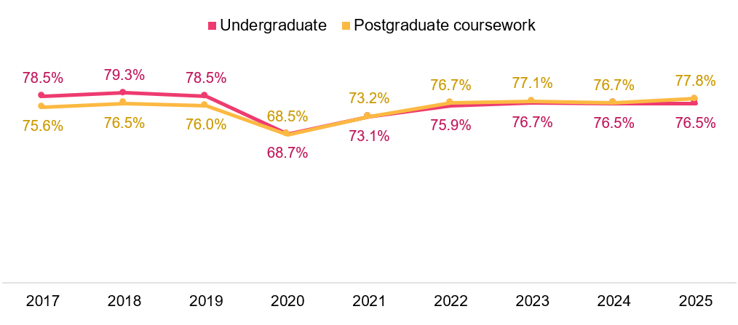
On-campus participation plays a key role in the student experience for internal students
In the post-pandemic period, many institutions have retained hybrid delivery modes, combining online and on-campus classes and giving students greater flexibility in how they participate in their higher education. For students enrolled in an internal course – that is, a course where they were expected to undertake at least some of their studies on-campus, around half of undergraduate students indicated that they participated in their studies all-on campus. Across the 5 focus areas, these students were more likely to provide a positive rating compared to those who participated in a hybrid or online capacity.
Figure ii – Undergraduate Teaching Quality and Engagement by class participation, 2025 (% positive rating)
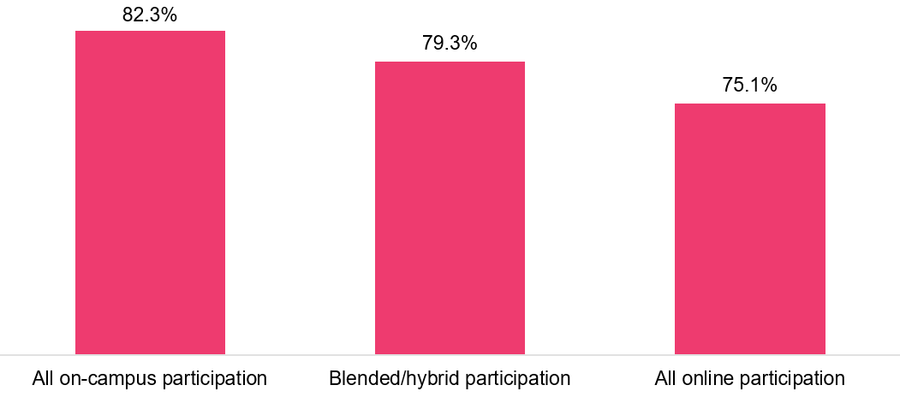
Positive results from the Tourism and Health services study areas
As with previous years, ratings of student experience tend to vary by study area. In 2025, students from study areas such as Tourism, hospitality, personal services, sport and recreation, and Health services and support were more likely to provide positive ratings for their Overall Educational Experience across both undergraduate and postgraduate coursework levels. On the other hand, students from study areas such as Computing and information systems and Dentistry were less likely to provide positive ratings for their Overall Educational Experience across both coursework levels.
Students less likely to consider leaving
The proportion of students who considered leaving their institution continued to fall in 2025 and is at an all-time low for both undergraduate and postgraduate coursework levels (Figure iii). At both coursework levels, stress levels were the most cited reason students considered leaving their institution.
Figure iii – Likelihood to consider leaving by course level, 2017–25 (%)
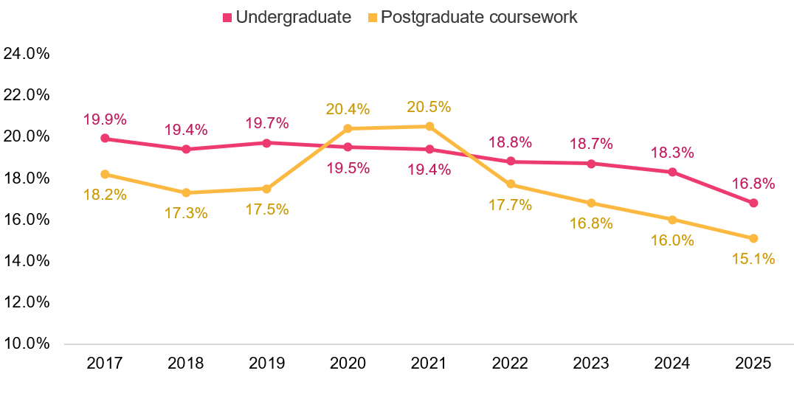
Financial circumstances negatively affect studies for a quarter of students
The proportion of students who cited financial circumstances as negatively affected their studies decreased slightly compared to previous years, however around one quarter of undergraduate and postgraduate coursework students still reported that financial circumstances negatively impacted their studies, and one third of undergraduate and postgraduate coursework students reported that paid work negatively impacted their studies in 2025 (Figure iv).
Figure iv – Negative effects on study by course level, 2025 (% negatively affected)
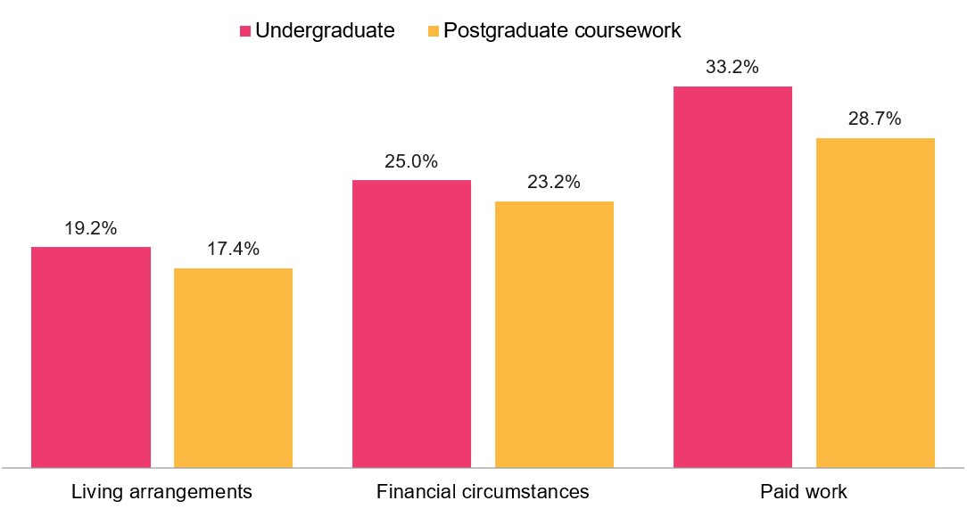
Sense of belonging for undergraduate students remains below pre pandemic levels
Across both coursework levels, there were slight increases to sense of belonging in 2025. Ratings of sense of belonging for postgraduate coursework students now exceed pre-pandemic levels, but undergraduate student ratings remain below pre-pandemic levels. As with Overall Educational Experience and the focus area ratings, those who participated in their classes on campus were more likely to provide positive ratings for sense of belonging.
Demographic and Equity groups
- Age: Students aged 30 and over were more likely to rate their Overall Educational Experience positively than those aged under 30.
- Stage of study: Compared to commencing students, later year students are more likely to rate their Skills Development positively.
- Disability: The gap in positive ratings of Overall Educational Experience between students with and without a disability is at its lowest recorded since 2017.
- First Nations: Although First Nations students rated their Overall Educational Experience similarly to non-Indigenous students, they were more likely to consider leaving their institution.
- Home language: The gap in positive ratings of Overall Educational Experience between undergraduate students whose home language is English and whose home language is not English has narrowed to its lowest recorded since 2017.

Contents
Acknowledgments…. ii
Executive summary.. iii
List of tables………… vii
List of figures………. viii
1. About the SES 1
1.1 Participation 1
1.2 Series history 1
1.3 Further detail 1
1.4 About this report 2
2. The educational experience 3
2.1 Context of changes in student experience since 2019 3
2.1.1 Citizenship status and mode of study 6
2.2 Overall Educational Experience 7
2.3 Teaching Quality and Engagement 11
2.4 Skills Development 14
2.5 Learning Resources 17
2.6 Student Support and Services 20
2.7 Peer Engagement 23
3. Other aspects of the student experience 25
1.1. Sense of belonging 25
1.2. Likelihood to consider leaving current institution 28
3.1 Negative effects on study 30
1.3. Freedom of expression 31
4. Demographic and equity groups 34
5. Study area….. 44
6. Institution……. 49
6.1 Institution type 49
6.2 Comparative institution outcomes 52
6.2.1 Universities 52
6.2.2 NUHEIs 55
Appendix 1: Understanding study mode and class participation: post-pandemic dynamics 58
A1.1 Study mode (institution-reported) 58
A1.1.1 Domestic study mode trends over time 60
A1.2 Class participation (self-reported) 61
A1.2.1 Class participation and citizenship status 62
A1.3 Relative proportions of international students over time 64

List of tables
Table 1 Other aspects of the student experience by course level and disability status, 2025 39
Table 2 Other aspects of the student experience by course level and First Nations status, 2025 43
Table 3 Undergraduate student experience by study area, 2025 (% positive rating) 46
Table 4 Postgraduate coursework student experience by study area, 2025 (% positive rating) 48

List of figures
Figure 1 Undergraduate educational experience, 2017–25 (% positive rating) 4
Figure 2 Postgraduate coursework educational experience, 2017–25 (% positive rating) 5
Figure 3 Overall Educational Experience by course level, 2017–25 (% positive rating) 7
Figure 4 Overall Educational Experience by study mode, 2017–25 (% positive rating) 8
Figure 5 Undergraduate Overall Educational Experience by class participation, enrolled internal/multi-mode, 2025 (% positive rating) 9
Figure 6 Postgraduate coursework Overall Educational Experience by class participation, enrolled internal/multi-mode, 2025 (% positive rating) 10
Figure 7 Teaching Quality and Engagement by course level, 2017–25 (% positive rating) 11
Figure 8 Undergraduate Teaching Quality and Engagement by class participation, enrolled internal/multi-mode, 2025 (% positive rating) 12
Figure 9 Postgraduate coursework Teaching Quality and Engagement by class participation, enrolled internal/multi-mode, 2025 (% positive rating) 13
Figure 10 Skills Development by course level, 2017–25 (% positive rating) 14
Figure 11 Undergraduate Skills Development by class participation, enrolled internal/multi-mode, 2025 (% positive rating) 15
Figure 12 Postgraduate coursework Skills Development by class participation, enrolled internal/multi-mode, 2025 (% positive rating) 16
Figure 13 Learning Resources by course level, 2017–25 (% positive rating) 17
Figure 14 Undergraduate Learning Resources by class participation, enrolled internal/multi-mode, 2025 (% positive rating) 18
Figure 15 Postgraduate coursework Learning Resources by class participation, enrolled internal/multi-mode, 2025 (% positive rating) 19
Figure 16 Student Support and Services by course level, 2017–25 (% positive rating) 20
Figure 17 Undergraduate Student Support and Services by class participation, enrolled internal/multi-mode, 2025 (% positive rating) 21
Figure 18 Postgraduate coursework Student Support and Services by class participation, enrolled internal/multi-mode, 2025 (% positive rating) 22
Figure 19 Peer Engagement by course level, 2017–25 (% positive rating) 23
Figure 20 Undergraduate Peer Engagement items by class participation, enrolled internal/multi-mode, 2025 (% positive rating) 24
Figure 21 Sense of belonging to institution by course level, 2017–25 (% positive rating*) 26
Figure 22 Undergraduate sense of belonging by class participation, enrolled internal/multi-mode, 2025 (% positive rating) 27
Figure 23 Proportion of students who considered early departure from institution by course level, 2017–25 28
Figure 24 Top reasons for considering early departure from institution by course level, 2025 (% of those who considered leaving) 29
Figure 25 Negative effects on study by course level, 2017–25 (% negatively affected) 31
Figure 26 Freedom of expression items by course level, 2025 32
Figure 27 Overall Freedom of Expression by course level, 2021–25 (% positive rating) 33
Figure 28 Overall Educational Experience by course level and age, 2017–25 (% positive rating) 35
Figure 29 Student experience by course level and stage of study, 2025 (% positive rating) 36
Figure 30 Overall Educational Experience by course level and disability status, 2017–25 (% positive rating) 37
Figure 31 Focus areas by course level and disability status, 2025 (% positive rating) 38
Figure 32 Overall Educational Experience by course level and home language, 2017–25 (% positive rating) 40
Figure 33 Focus areas by course level and home language, 2025 (% positive rating) 41
Figure 34 Focus areas by course level and First Nations status, 2025 (% positive rating) 42
Figure 35 Overall Educational Experience by study area, undergraduate, 2025 (% positive rating) 44
Figure 36 Overall Educational Experience by study area, postgraduate coursework, 2025 (% positive rating) 47
Figure 37 Student experience by institution type and course level, 2025 (% positive rating) 50
Figure 38 Demographic differences between universities and NUHEIs, 2025 (% based on responses to the 2025 SES) 51
Figure 39 Overall Educational Experience for undergraduate university students, 2025 (% positive rating, with 90 per cent confidence intervals) 53
Figure 40 Overall Educational Experience for postgraduate coursework university students, 2025 (% positive rating, with 90 per cent confidence intervals) 54
Figure 41 Overall Educational Experience for undergraduate non-university higher education institution (NUHEI) students, pooled 2024–25 (% positive rating, with 90 per cent confidence intervals) 56
Figure 42 Overall Educational Experience for postgraduate coursework non-university higher education institution (NUHEI) students, pooled 2024–25 (% positive rating, with 90 per cent confidence intervals) 57
Figure 43 Study mode profile by course level, 2017–25 (based on responses to the SES) 59
Figure 44 Domestic study mode profile by course level, 2017–25 (based on responses to the SES) 60
Figure 45 Class participation by enrolled study mode and course level, 2025 61
Figure 46 Undergraduate study mode and age profile by citizenship status, 2025 62
Figure 47 Undergraduate class participation for internal/multi-mode students by citizenship status, 2025 63
Figure 48 Postgraduate coursework study mode and age profile by citizenship status, 2025 64
Figure 49 Proportion of responses to the SES by citizenship status and course level, 2017–25 SES 65

About the SES
The Student Experience Survey (SES) provides a national framework for collecting data on key aspects of the higher education student experience. It focuses on measurable aspects linked to learning outcomes which can be influenced by institutions.

Participation
The 2025 SES was conducted as a national online survey among 153 higher education institutions, including 43 universities and 110 non-university higher education institutions (NUHEIs). A total of 324,547 valid survey responses were collected, representing a response rate of 43.2 per cent, which was an increase from the 37.2 per cent achieved in 2024.
2025 participation
- 153 institutions
- 824,073 invitations sent
- 324,547 completed surveys
- 43.2% response rate

Series history
Originally developed as the University Experience Survey (UES) in 2011, the SES was renamed in 2015 to include NUHEIs. Initially focused on undergraduates, the survey expanded to include postgraduate coursework students in 2017.
From 2014 to 2019, the survey remained largely unchanged, with minor wording adjustments. In 2020, an international student module was added to measure broader aspects of their experience. In 2021, items on freedom of expression were included.
A 2022 review led to several changes in the 2023 SES, including the renaming of three focus areas (Learner Engagement to Peer Engagement, Student Support to Student Support and Services, and Teaching Quality to Teaching Quality and Engagement), the establishment of the sense of belonging item as a stand-alone measure, and the addition of a set of items related to student participation in classes. Additionally, there were changes to the underlying items which comprise the Peer Engagement and Student Support and Services focus areas, meaning that caution should be exercised when comparing ratings for these focus areas between 2023 and prior years. Further information about these changes is detailed in Appendix 2 of the 2023 SES National Report available on the QILT website

Further detail
This report is supported by a Power BI workbook, which allows readers to further explore the data. Static Excel tables also provide additional data and detail that may be of interest.
Methodological information previously included in the appendices of earlier SES National reports is now available in the 2025 SES Methodological Report. Additional technical details, such as the survey instrument, the construction of focus area ratings and confidence intervals, and the study area concordance, can be found on the QILT website.
Results from the SES for international students are also published in an international report on the QILT website.
Visit the qilt.edu.au/surveys/student-experience-survey-(ses) to access these resources.

About this report
The SES National Report provides an analysis of the various aspects of the student experience measured in the SES, disaggregated by groups of interest.
Section 2 presents an overview of results from 2017 up to 2025 for the 5 key focus areas of the SES and Overall Educational Experience across undergraduate and postgraduate coursework students.
Section 3 explores additional aspects of the student experience, including sense of belonging, likelihood of considering leaving an institution, the extent to which circumstances negatively affect study and student freedom of expression.
Sections 4, 5 and 6 provide results for students across the 5 key focus areas and Overall Educational Experience disaggregated by demographic and equity groups, study areas and institutions.

The educational experience
The SES measures 5 key focus areas of the student experience, each comprising related survey items that capture students’ perceptions of their study environment:
- Teaching Quality and Engagement: Evaluates the quality, relevance and organisation of teaching, as well as how effectively academic staff engage students and provide constructive feedback.
- Skills Development: Assesses the extent to which students have developed a broad set of capabilities, including foundational, collaborative and adaptive skills.
- Learning Resources: Evaluates learning resources such as teaching spaces, equipment, library services and learning materials.
- Student Support and Services: Measures the helpfulness of institutional supports and services, including academic, administrative, wellbeing, financial and career development services.
- Peer Engagement: Examines how frequently students interact and collaborate with their peers, both within and outside formal study settings.
The SES also includes a stand-alone measure of Overall Educational Experience, which provides a view of students’ perceptions of the overall quality of their studies. Although reported separately, Overall Educational Experience is closely linked to students’ perceptions of Teaching Quality and Engagement, Skills Development and broader elements of their learning environment, such as sense of belonging.
Responses to items within each focus area are classified as positive or negative, and ratings represent the proportion of students who responded positively to the items within that focus area. Further information on the construction of the focus area ratings is available on the QILT website.

Context of changes in student experience since 2019
The higher education sector faced significant challenges due to the COVID-19 pandemic, leading to a rapid shift to online learning. In the post-pandemic period, many institutions have retained hybrid delivery modes, combining online and on-campus classes. At the same time, the expansion of flexible learning options has increased the complexity of how students engage with their courses, making it more difficult to capture individual participation patterns through a single administrative indicator.
Figure 1 and Figure 2 show that while undergraduate student ratings remain below or on par with student ratings seen prior to the pandemic (2017–19), postgraduate coursework ratings have not only recovered but have been higher across all aspects since 2023 than they were pre-2020. These findings are influenced by the relative proportions of international and domestic students at each course level, and differences in how these cohorts engage in their studies.

Figure 1 Undergraduate educational experience, 2017–25 (% positive rating)
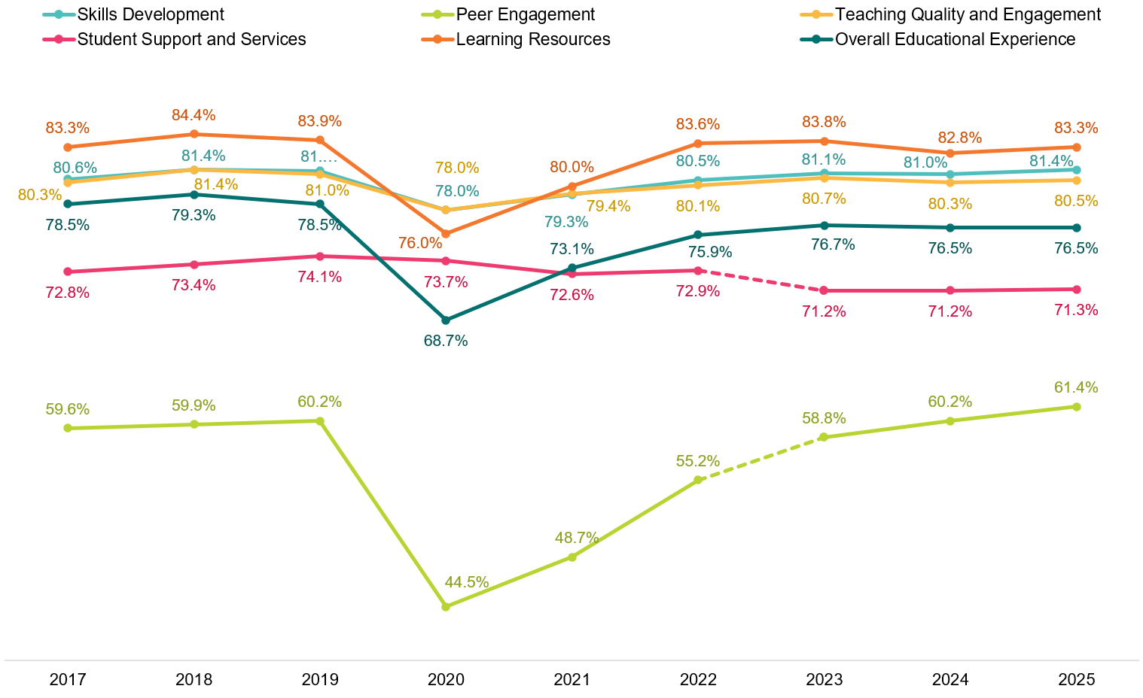
Note that the dotted lines between 2022 and 2023 indicate the change in underlying items of the Peer Engagement and Student Support and Services focus areas. When comparing year-on-year changes, it is recommended that modifications to underlying questionnaire items be taken into consideration when interpreting results. For more information about these changes, refer to the 2023 SES National Report.
Figure 2 Postgraduate coursework educational experience, 2017–25 (% positive rating)
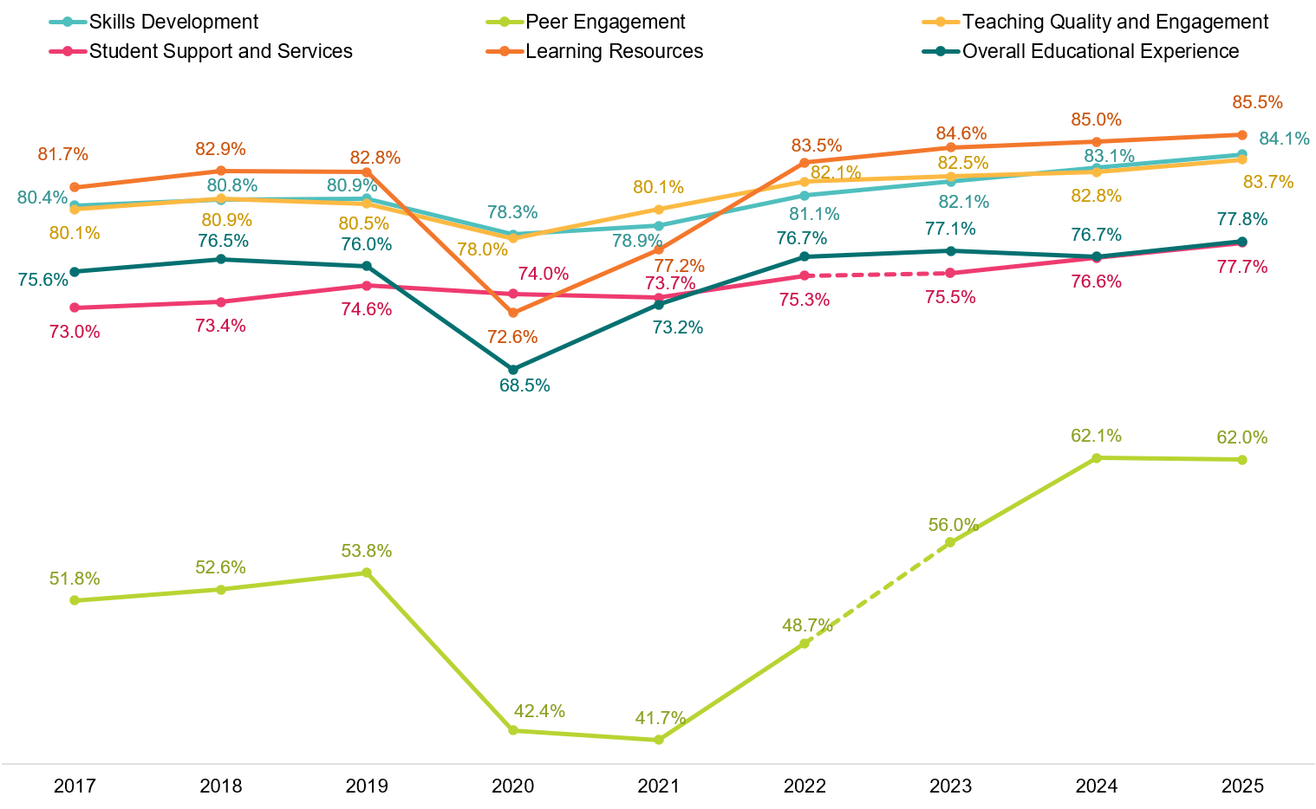
Note that the dotted lines between 2022 and 2023 indicate the change in underlying items of the Peer Engagement and Student Support and Services focus areas. When comparing year-on-year changes, it is recommended that modifications to underlying questionnaire items be taken into consideration when interpreting results. For more information about these changes, refer to the 2023 SES National Report.

Citizenship status and mode of study
International student ratings at both the undergraduate and postgraduate coursework levels have been higher since 2023 than they were prior to the pandemic. Conversely, domestic student ratings had been either below or close to (but not exceeded) ratings seen prior to the pandemic. Note in 2025, domestic postgraduate coursework Skills Development, Teaching Quality and Engagement, and Overall Educational Experience ratings did fully recover or surpass pre-2020 levels. Refer to the 2025 SES International Report to view these results.
International students represent a much larger proportion of the postgraduate coursework population than they do of the undergraduate population, which explains the greater improvement in aggregated postgraduate coursework results compared to undergraduate results seen in Figure 1 and Figure 2.
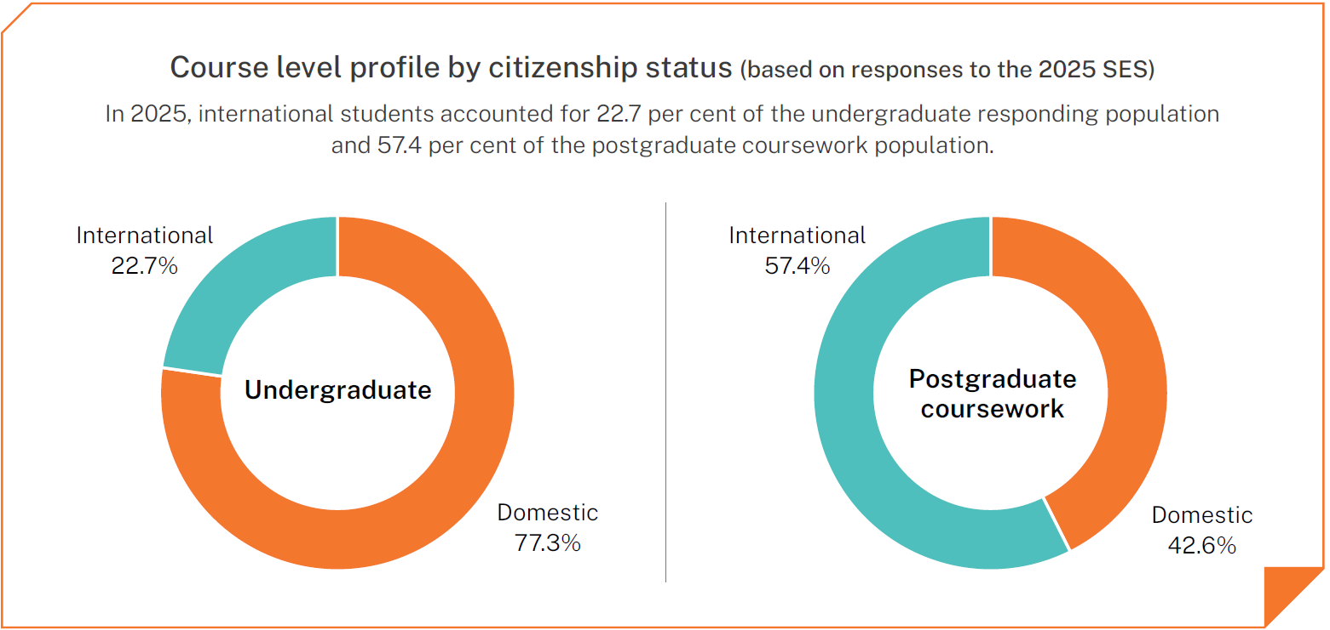
There are clear study mode and age differences between domestic and international postgraduate coursework students (Figure 48). These differences coupled with the higher proportion of international students at the postgraduate coursework level can help explain recent trends in student experience ratings for this cohort.
Study mode and age differences at the undergraduate level are less pronounced, suggesting other factors are influencing the divergence in domestic and international student ratings observed in the post-pandemic period (Figure 46). However, examining class participation as reported by students, highlights some further differences in how domestic and international students engage in their studies.
In general, international students enrolled as internal/multi-mode are more likely to report participating in their classes ‘all online’ or only ‘some’ online. In contrast, domestic students enrolled as internal/multi-mode are more likely to report participating in ‘about half’ online, or ‘mostly’ online. See Appendix 1 for more information on domestic and international students’ modes of study and self-reported class participation.
Internal/multi-mode students, regardless of citizenship status, report higher positive ratings of their student experience the more they participate in classes on-campus, whether that be ‘all on-campus’, or only ‘some’ online. This finding provides further explanation as to why international student ratings have recovered much quicker than domestic ratings since the pandemic.
The 2025 SES National Report examines differences in student experience outcomes by self-reported class participation (regardless of citizenship status), in addition to the traditional mode of study categories (internal/multi-mode and external) which have historically been used in QILT reporting.

Overall Educational Experience
Overall Educational Experience provides a broad, high-level rating of the quality of students’ educational experience during the year. It reflects students’ holistic impressions of their studies and may draw on a range of academic and non-academic aspects of their course.
Undergraduate Overall Educational Experience ratings have not returned to the levels seen prior to the pandemic, suggesting a sustained shift in how students evaluate the quality of their educational experience.
Undergraduate student ratings of Overall Educational Experience remained stable for the third consecutive year, with 76.5 per cent of students rating it positively in 2025 (Figure 3). Undergraduate Overall Educational Experience ratings declined sharply in 2020, reflecting the disruption associated with the COVID-19 pandemic. However, despite student ratings stabilising since 2023, results have not returned to the same levels observed prior to the pandemic (2017–19). This pattern suggests a sustained shift in how undergraduates evaluate their Overall Educational Experience.
In contrast, postgraduate coursework ratings of Overall Educational Experience rose to 77.8 per cent in 2025 and remained above the levels observed prior to the pandemic for the fourth consecutive year. In addition, postgraduate coursework students rated Overall Educational Experience 1.3 percentage points higher than undergraduates in 2025 – the largest difference observed since the ratings gap narrowed in 2020.
Figure 3 Overall Educational Experience by course level, 2017–25 (% positive rating)
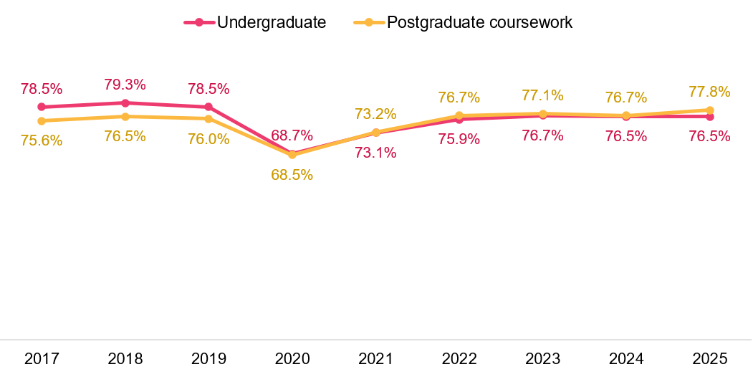
This shifting pattern may be related to the post-pandemic study mode dynamics, as students have increasingly shifted to online modes of study (see Appendix 1).
At both undergraduate and postgraduate coursework levels, external students (those studying fully off-campus including online) have tended to rate their Overall Educational Experience more positively than internal/multi-mode students (those studying fully on-campus or a mix of internal and external modes) (Figure 4).
In 2025, undergraduate external students rated their Overall Educational Experience 3.6 percentage points higher than internal/multi-mode students (79.8 per cent and 76.2 per cent respectively). Similarly, postgraduate coursework students rated it 3.4 percentage points higher (80.4 per cent and 77.0 per cent respectively).
Figure 4 Overall Educational Experience by study mode, 2017–25 (% positive rating)
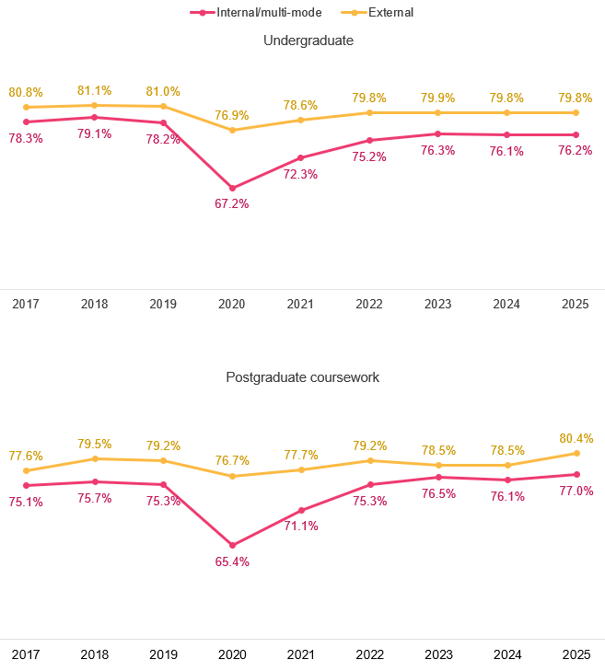
Undergraduates enrolled in internal/multi-mode studies rated their Overall Educational Experience highest when they participated in their classes ‘all on-campus’ or only did ‘some’ online.
Notably, undergraduates who were enrolled in internal/multi-mode studies, and therefore would have expected to undertake at least some of their studies on-campus, rated their Overall Educational Experience more positively if they did participate in all of their classes on-campus, compared to those who took a ‘blended/hybrid’ approach or all classes online (Figure 5). Furthermore, internal/multi-mode students who participated in all classes on-campus rated their Overall Educational Experience closer to the ratings seen prior to 2020.
In addition, undergraduates enrolled in internal/multi-mode studies who reported taking a ‘blended/hybrid’ approach to participation, had the highest positive Overall Educational Experience ratings if they did ‘some’ of their classes online (as opposed to ‘about half’ or ‘most’ online). These findings suggest there may be an inverse relationship between online studies and Overall Educational Experience for students who enrolled in an internal/multi-mode course.
It is important to note that students enrolled in external courses, and therefore intended to study remotely or online, continued to rate their experience highly. This suggests that students’ expectations regarding their mode of attendance and what they actually did do influence results.
Figure 5 Undergraduate Overall Educational Experience by class participation, enrolled internal/multi-mode, 2025 (% positive rating)
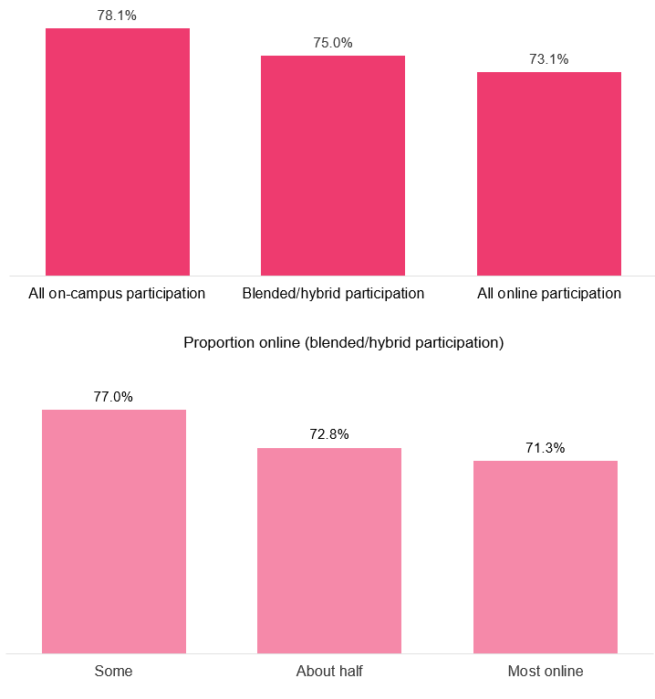

Results varied at the postgraduate coursework level, with Overall Educational Experience ratings consistent between internal/multi-mode students who did ‘all on-campus’ and ‘all online‘ (Figure 6). However, consistent with undergraduate results, those who took a ‘blended/hybrid’ approach to participation reported the highest ratings when they did only ‘some’ of their classes online.
Figure 6 Postgraduate coursework Overall Educational Experience by class participation, enrolled internal/multi-mode, 2025 (% positive rating)
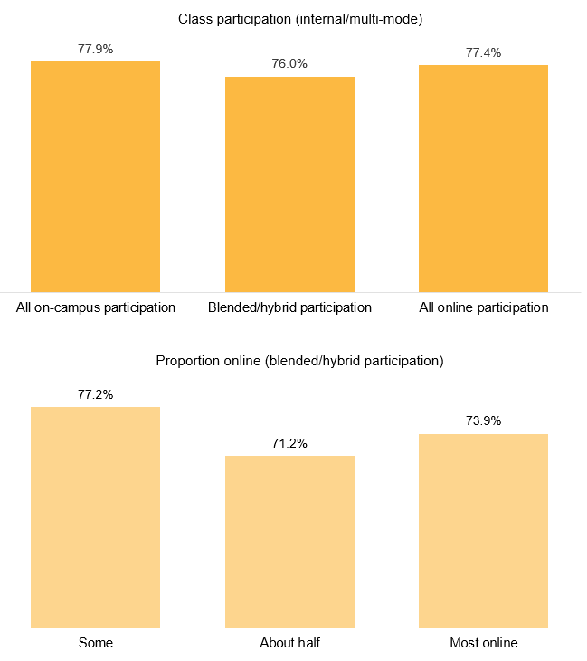

Teaching Quality and Engagement
The Teaching Quality and Engagement focus area captures students’ perceptions of the quality of the teaching they experienced during the year. It reflects students’ overarching evaluations of teaching in their course as well as their impressions of specific teaching practices and course organisation. Together, these measures provide a broad view of teaching quality, drawing on both students’ overall judgements and their reported exposure to key teaching and learning practices.
- Course well-structured and focused
- Course relevant to education as a whole
- Teachers engaged you actively in learning
- Teachers demonstrated concern for student learning
- Teachers provided clear explanations on coursework and assessment
- Teachers stimulated you intellectually
- Teachers commented on your work in ways that help you learn
- Teachers seemed helpful and approachable
- Teachers set assessment tasks that challenge you to learn
- Overall quality of teaching
- Overall quality of entire educational experience.
The Teaching Quality and Engagement focus area is highly correlated with Overall Educational Experience – that is, student ratings of Overall Educational Experience are related to student experiences with the different aspects of this focus area.
Like Overall Educational Experience, undergraduate ratings of Teaching Quality and Engagement declined in 2020 and only partially recovered to the levels seen prior to the pandemic (Figure 7). In 2025, 80.5 per cent of undergraduate students rated Teaching Quality and Engagement positively, and while this is still a relatively high number, it is below the 81.4 and 81.0 per cent recorded in 2018 and 2019 respectively.
As with other aspects of student experience for postgraduate coursework level students, ratings continued to increase in 2025, remaining above the levels seen prior to the pandemic. In 2025, 83.7 per cent of postgraduate coursework students rated Teaching Quality and Engagement positively, further widening the gap between undergraduate and postgraduate coursework ratings to 3.2 percentage points.
Figure 7 Teaching Quality and Engagement by course level, 2017–25 (% positive rating)
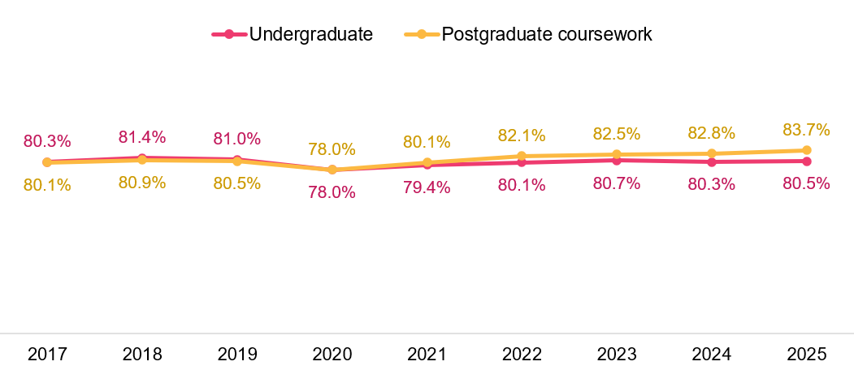
Figure 8 shows clear differences in Teaching Quality and Engagement ratings by class participation type for internal/multi-mode students: 82.3 per cent positive for those who participated ‘all on-campus’, down to 75.1 per cent who participated ‘all online’. Additionally, students who took a ‘blended/hybrid’ approach to class participation rated Teaching Quality and Engagement highest if they did only some of their classes online.
As presented in Appendix 1, 89.0 per cent of undergraduate respondents were enrolled in internal/multi-mode studies in 2025 and domestic students accounted for 77.3 per cent of undergraduate responses (see Citizenship status and mode of study). Internal/multi-mode domestic students’ greater tendency to participate in all online, or a mix of online and on-campus may explain why undergraduate ratings have not returned to the same levels seen prior to 2020.
Figure 8 Undergraduate Teaching Quality and Engagement by class participation, enrolled internal/multi-mode, 2025 (% positive rating)
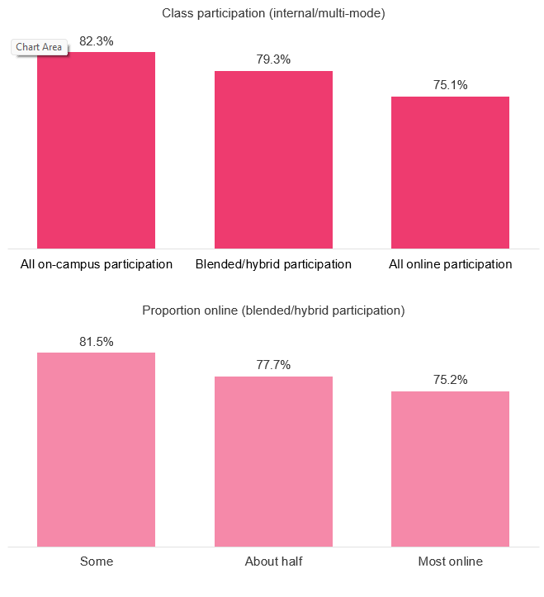
Similar patterns in internal/multi-mode student ratings at the postgraduate coursework level were observed, with those who participated ‘all on-campus' or did only ‘some’ online rating Teaching Quality and Engagement highest (Figure 9).
Figure 9 Postgraduate coursework Teaching Quality and Engagement by class participation, enrolled internal/multi-mode, 2025 (% positive rating)
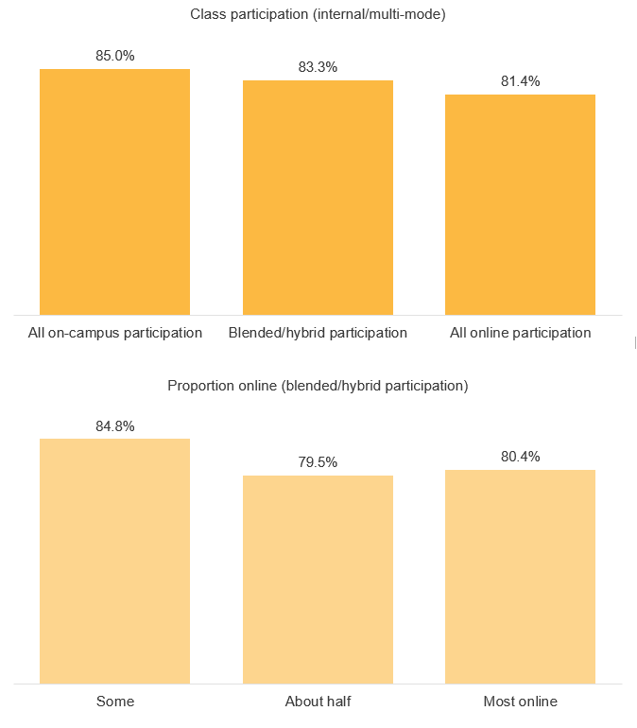

Skills Development
The Skills Development focus area captures students’ perceptions of the extent to which their course helped them develop key academic, professional and transferable skills during the year. It reflects students’ views on how their studies contributed to building capabilities that support disciplinary knowledge, communication, independent learning, problem solving and preparation for future work. Together, these measures provide an indication of the skills students felt they gained through their course.
- Critical thinking skills
- Ability to solve complex problems
- Ability to work with others
- Confidence to learn independently
- Written communication skills
- Spoken communication skills
- Knowledge of field(s) studying
- Development of work-related knowledge and skills.
Undergraduate ratings of Skills Development rose slightly in 2025 to 81.4 per cent positive (Figure 10). Postgraduate coursework ratings have increased consistently since the pandemic, surpassing pre-pandemic levels are now higher than undergraduate ratings – 84.1 per cent positive in 2025.
Figure 10 Skills Development by course level, 2017–25 (% positive rating)
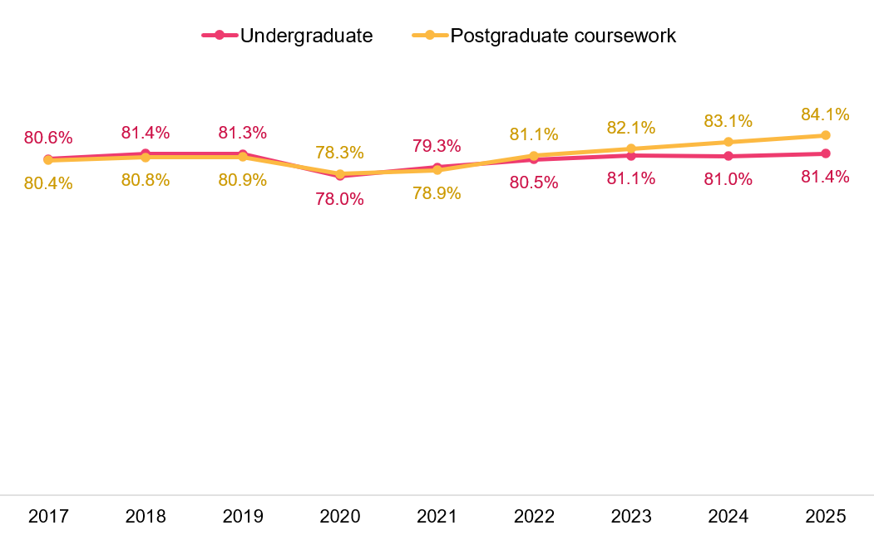

At the undergraduate level, students enrolled in internal/multi-mode studies who participated in classes all on-campus, or who only did ‘some’ online, reported higher Skills Development ratings than those who took a ‘blended/hybrid’ approach or did ‘all’ or ‘most’ online (Figure 11).
Figure 11 Undergraduate Skills Development by class participation, enrolled internal/multi-mode, 2025 (% positive rating)
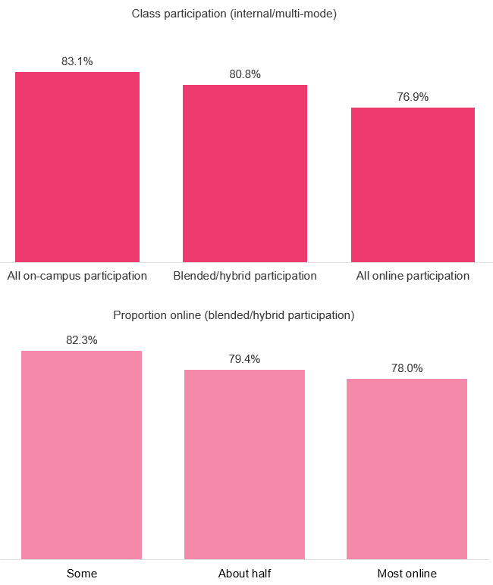

A similar pattern was observed at the postgraduate coursework level, however, there was no difference in Skills Development ratings between those who participated ‘about half’ or ‘most’ online (Figure 12).
Figure 12 Postgraduate coursework Skills Development by class participation, enrolled internal/multi-mode, 2025 (% positive rating)
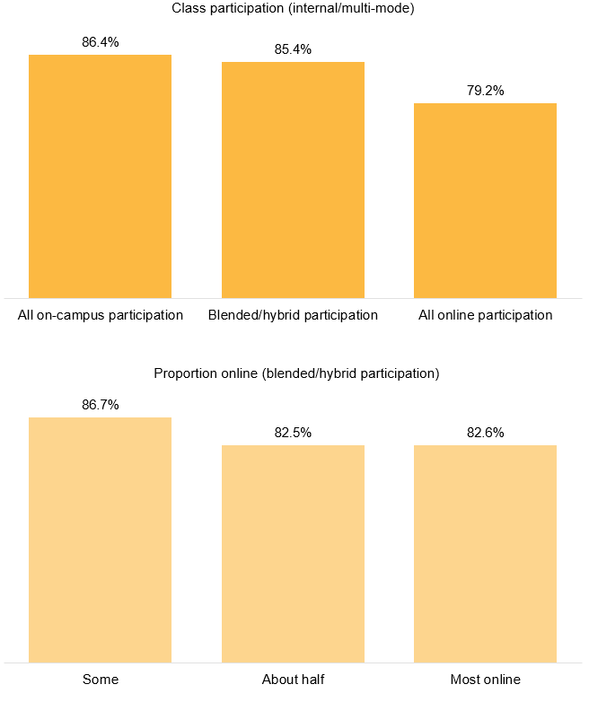

Learning Resources
The Learning Resources focus area captures students’ perceptions of the learning resources provided in their course during the year. It reflects students’ ratings of the physical, digital and academic resources that support their study, including:
- teaching spaces
- student spaces and common areas
- online learning materials
- computing/IT resources
- assigned books, notes and resources
- laboratory or studio equipment
- library resources and facilities.
Like most aspects of the student experience, ratings of Learning Resources were affected by changing study conditions in 2020, but unlike some other focus areas, ratings had mostly returned to pre-2020 levels by 2022.
Undergraduate ratings of Learning Resources rose slightly in 2025 to 83.3 per cent positive (Figure 13). Postgraduate coursework ratings have increased consistently since the pandemic, surpassing pre-pandemic levels, and are now higher than undergraduate ratings – 85.5 per cent positive in 2025.
Figure 13 Learning Resources by course level, 2017–25 (% positive rating)
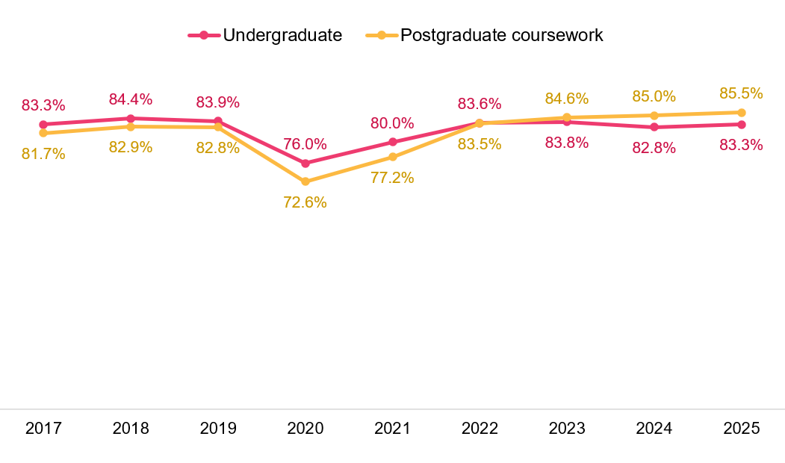
Ratings of Learning Resources are also influenced by students’ participation in classes; however, it appears that there is less variation between those who did ‘all on-campus’ or ‘blended/hybrid’, and even those who did ‘some’ versus those who did about ‘half’ online.
Figure 14 shows ratings of Learning Resources were lower for those who did ‘all’ online or ‘most’ online. These findings suggest that having at least some on-campus participation in classes for internal/multi-mode students has a positive effect on Learning Resources ratings. This may also explain why Learning Resources ratings were quick to recover in 2022, as restrictions eased.
Figure 14 Undergraduate Learning Resources by class participation, enrolled internal/multi-mode, 2025 (% positive rating)
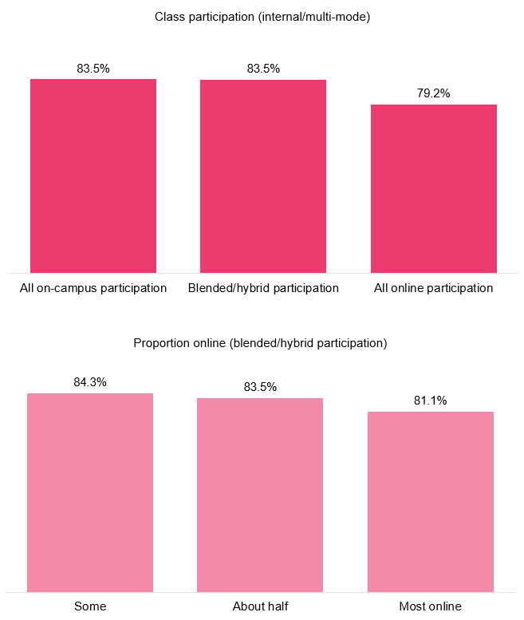
Differences in Learning Resources ratings at the postgraduate coursework level did appear to be more pronounced than for undergraduates and more consistent with differences observed for other focus areas. Internal/multi-mode postgraduate coursework students who participated in their classes ‘all on-campus’ reported higher positive ratings than those who did ‘all online’ (Figure 15). For those who took a ‘blended/hybrid’ approach, those who did ‘some online’ rated Learning Resources higher than those did ‘about half’ and most ‘online’.
Figure 15 Postgraduate coursework Learning Resources by class participation, enrolled internal/multi-mode, 2025 (% positive rating)
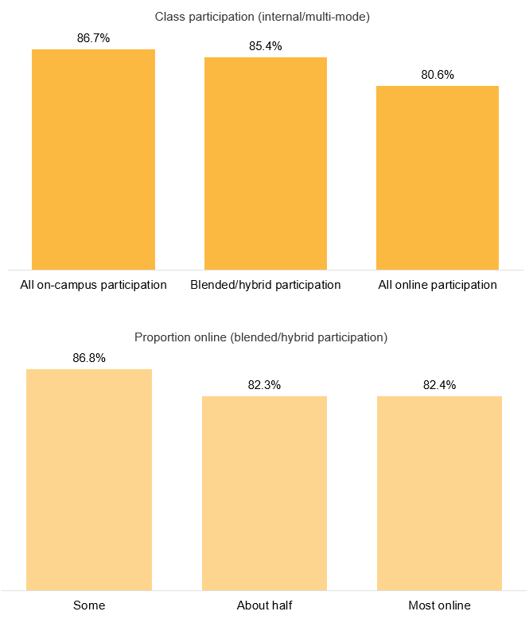

Student Support and Services
The Student Support and Services focus area captures students’ perceptions of how helpful they found key institutional supports during the year. The items cover a range of academic, administrative and wellbeing services, including:
- enrolment processes and support
- induction and orientation activities
- the online learning platform
- career development services
- study or learning support services
- counsellors and/or health services
- financial and/or legal advisors.
At the undergraduate level, ratings of Student Support and Services have remained stable for 3 consecutive years, with 71.3 per cent of undergraduates rating Student Support and Services positively in 2025 (Figure 16). In contrast, 77.7 per cent of postgraduate coursework students rated Student Support and Services positively in 2025, continuing a year-on-year increase since 2023. This divergence in results suggests that there is opportunity for institutions to review whether undergraduate student support services are meeting student needs as effectively as those provided to postgraduate coursework students.
Figure 16 Student Support and Services by course level, 2017–25 (% positive rating)
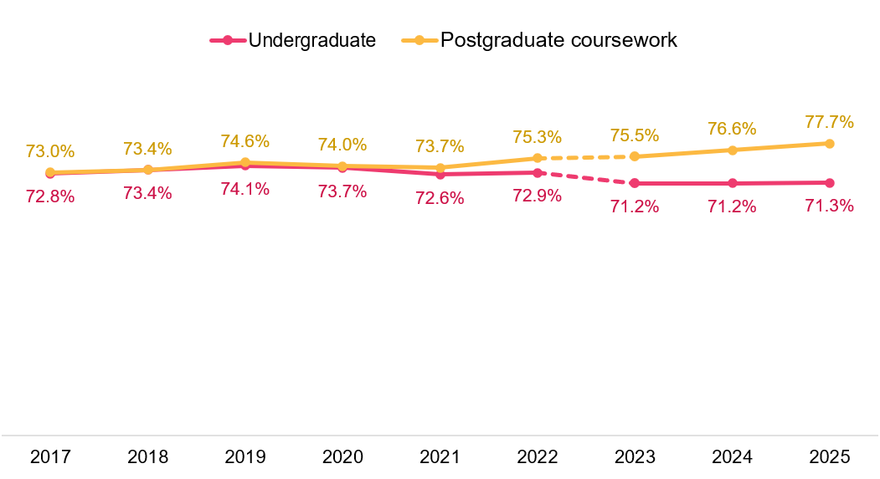
Mode of study and class participation do not appear to have the same consistent impact on Student Support and Services, like they do on some other aspects of the student experience. Figure 17 shows that there was little difference in undergraduate internal/multi-mode ratings between those who participated in classes ‘all on-campus’ versus ‘all online’, and students who studied ‘all online’ rated this focus area higher (71.5 per cent) than those who did a mix of online and on-campus (69.8 per cent). These findings indicate that perhaps other factors beyond class engagement may influence student ratings of Student Support and Services.
Figure 17 Undergraduate Student Support and Services by class participation, enrolled internal/multi-mode, 2025 (% positive rating)
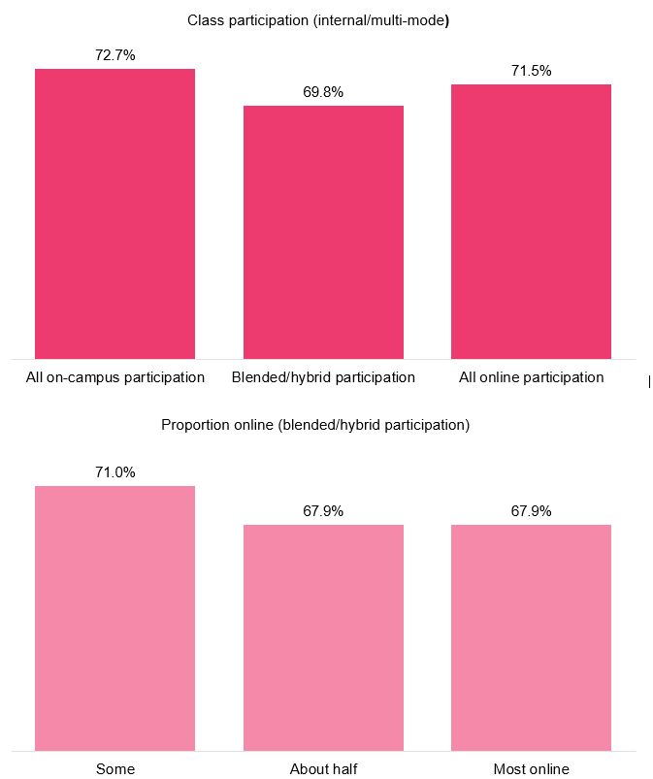

Class participation for internal/multi-mode postgraduate coursework students did, however, have some impact on student ratings. Students who participated in classes ‘all on-campus’ or ‘some’ online did rate Student Support and Services more positively (79.3 per cent and 78.7 per cent respectively) (Figure 18).
Figure 18 Postgraduate coursework Student Support and Services by class participation, enrolled internal/multi-mode, 2025 (% positive rating)
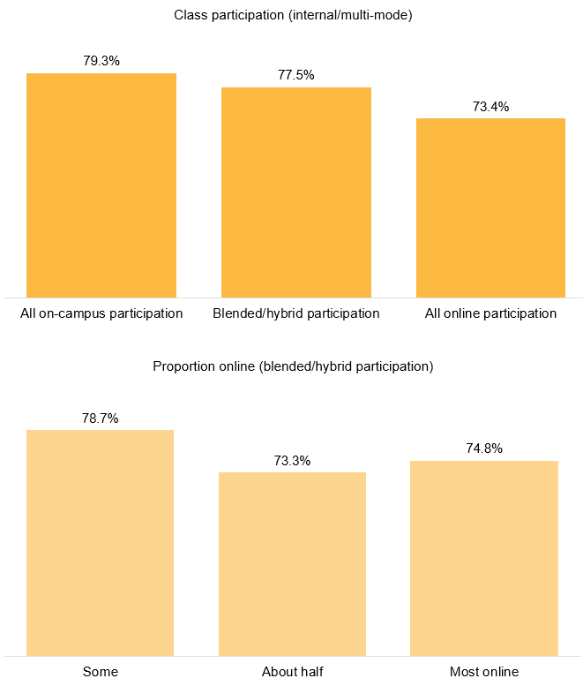

Peer Engagement
The Peer Engagement focus area reflects how frequently students interacted with other students during the year in ways that supported learning, collaboration and connection. While the items measure frequency rather than students’ evaluations of these interactions, the results provide insight into patterns of peer interaction across academic and social contexts. Specifically, this focus area measures how frequently students:
- contributed to class discussion
- worked with other students as part of the course
- interacted with other students to give or receive help with study
- interacted socially with other students outside of study
- interacted with a diverse range of students.
Ratings of the Peer Engagement focus area, which measures the frequency of peer interactions, is closely tied to study mode. Peer Engagement ratings dropped substantially in 2020 and 2021 as students studied predominately online during the pandemic (Figure 19). Undergraduate ratings had largely recovered to pre-2020 levels in 2023 and 2024. In 2025, undergraduate ratings increased to 61.4 per cent – the highest since 2017.
Postgraduate ratings of Peer Engagement have surpassed ratings seen prior to 2020. This is likely influenced by the large proportion of international students in the postgraduate coursework population, who are enrolled in internal/multi-mode studies, and more likely to participate in classes on-campus.
Figure 19 Peer Engagement by course level, 2017–25 (% positive rating)
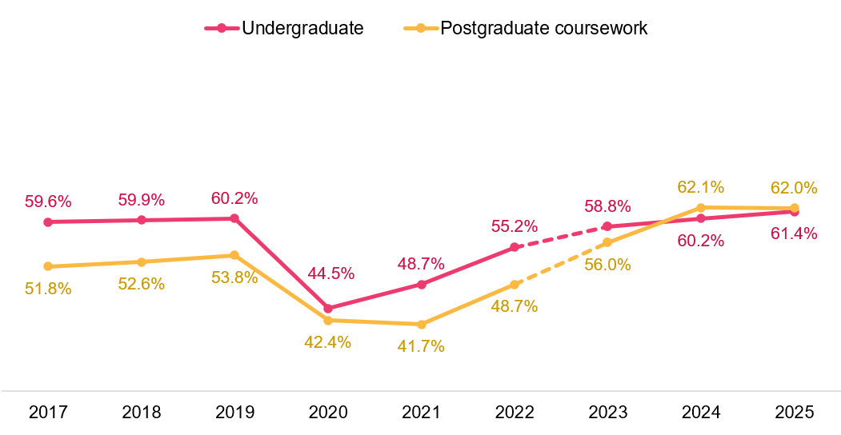
Although overall ratings of Peer Engagement have returned to historical levels, it is important to note the varying frequency of interactions between internal/multi-mode students who participated in their classes either ‘all on-campus’ or a ‘blended/hybrid’ approach, compared to those who participated ‘all online’.
Internal/multi-mode students who participated ‘all on-campus’ or took a ‘blended/hybrid’ approach were more than twice as likely to report frequent social interactions with students outside of class compared to those who did ‘all online’ (Figure 20). There were also large differences by class participation when it came to working with other students as part of the course: 71.8 per cent of those who participated in class ‘all on-campus’ reported frequently working with other students as part of the course, compared to only 35.2 per cent of those who participated in their course ‘all online’.

Figure 20 Undergraduate Peer Engagement items by class participation, enrolled internal/multi-mode, 2025 (% positive rating)
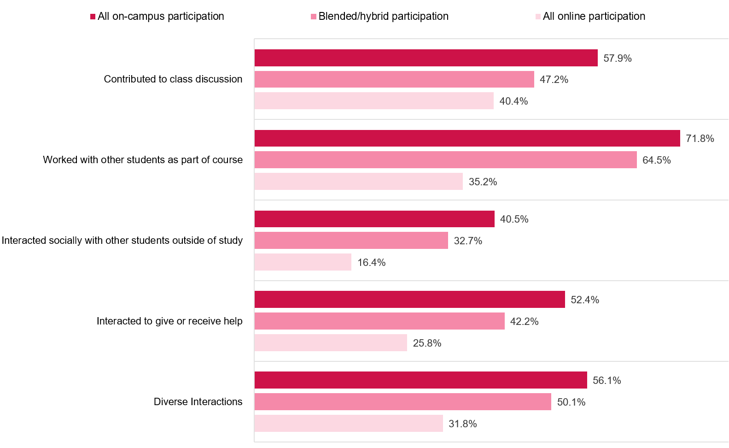

Other aspects of the student experience
This section explores aspects of the educational experience beyond the 5 focus areas, including students' sense of belonging to their institution, whether they considered leaving their institution within the survey year, and whether paid work commitments, living arrangements and financial circumstances negatively affected students’ studies.
Additionally, this section addresses student ratings of 'freedom of expression’, which includes perceptions of whether students and academics are free to express their views and whether students feel free from discrimination, harm, or hatred.

Sense of belonging
Sense of belonging relates to feelings of connectedness, inclusion and being accepted and valued by others. Research has shown that a student’s sense of belonging among peers and at the institution is linked with academic achievement, personal wellbeing, student satisfaction and attrition.
In the context of the SES, sense of belonging correlates with student ratings of Overall Educational Experience, as well as aspects of the Student Support and Services and Teaching Quality and Engagement focus areas.
Historically, student ratings of their sense of belonging to their institution have been relatively low compared to other aspects of the student experience measured in the SES. Positive ratings of students’ sense of belonging dropped significantly in 2020 during the COVID-19 pandemic (Figure 21). Despite an increase in ratings in 2025 to 48.0 per cent positive, undergraduate ratings have not returned to the pre-2020 average of 52.0 per cent. Consistent ratings from 2022 to 2024 with only modest improvement in 2025 suggest challenges in fostering belonging post-pandemic, as many pandemic-era practices remain.
For postgraduate coursework students, ratings declined in 2020 and 2021, likely due to a larger proportion of international students being overseas. Since 2021, postgraduate ratings have improved, reaching 52.6 per cent in 2025 and surpassing the pre-2020 average of 50.3 per cent positive.

Figure 21 Sense of belonging to institution by course level, 2017–25 (% positive rating*)
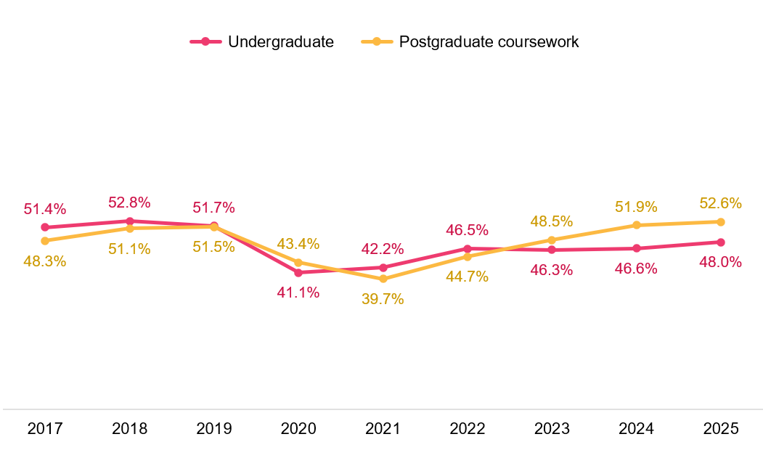
* The percent positive rating for sense of belonging represents the proportion of respondents who selected ‘Quite a bit’ or ‘Very much’ when asked ‘At your institution during <survey year>, to what extent have you had a sense of belonging to <institution name>?’
Given the importance sense of belonging has on student perceptions of their Overall Educational Experience, as well as other focus areas, understanding what drives higher ratings of this measure can help improve student outcomes more broadly.
The higher postgraduate coursework ratings since 2023 have been attributed to the increase in international postgraduate coursework students who study in an internal/multi-mode. However, this does not explain why undergraduate ratings have not recovered to the levels seen prior to the pandemic, despite 86.0 per cent of domestic students studying in an internal/multi-mode (see Appendix 1).
Figure 22 shows the impact that online participation in classes can have on internal/multi-mode students’ perceptions of their sense of belonging to the institution. For undergraduates enrolled in an internal/multi-mode study mode in 2025, sense of belonging was rated more positively for those who reported participating in all of their class on-campus – 54.4 per cent positive compared to 45.5 per cent who took a ‘blended/hybrid’ approach and 40.5 per cent for those who did all classes online despite being enrolled in internal/multi-mode studies.
For students who did report participating in a mix of online and on-campus classes (i.e. ’blended/hybrid’), there was a clear difference between those who did some online versus those who did ‘about half’ or ‘most’ online. This suggests that for students enrolled in internal/multi-mode studies, on-campus class participation helps foster a greater sense of belonging.
These findings may also explain, in part, why undergraduates ratings have not returned to pre-2020 levels: domestic students accounted for the majority of undergraduate responses and even when enrolled in internal/multi-mode studies, they are reporting high levels of participating in online classes.

Figure 22 Undergraduate sense of belonging by class participation, enrolled internal/multi-mode, 2025 (% positive rating)
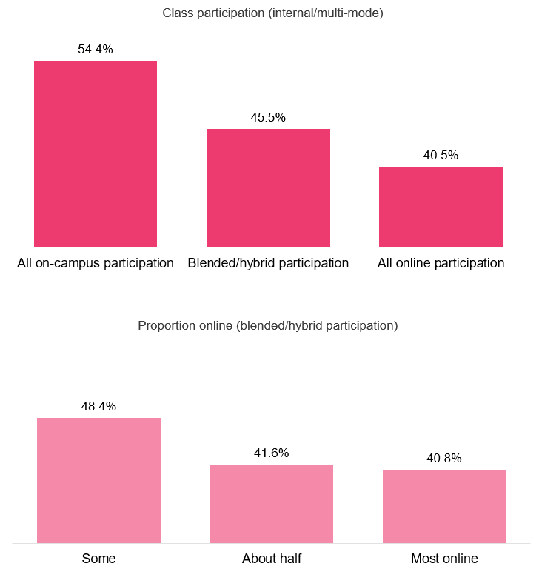

Likelihood to consider leaving current institution
The proportions of students who indicated they had seriously considered leaving their current institution in the survey year continued to fall in 2025 (Figure 23). Overall, 16.8 per cent of undergraduates and 15.1 per cent of postgraduate coursework students said they had considered leaving in 2025 –the lowest rates observed since 2017.
While the SES asks about ‘consideration’ of leaving rather than ‘actual’ leaving behaviour, responses to this item are linked to subsequent attrition. When examined together with the reasons provided, this measure offers valuable insight into the challenges and concerns of students who had considered leaving in the survey year.
Figure 23 Proportion of students who considered early departure from institution by course level,
2017–25
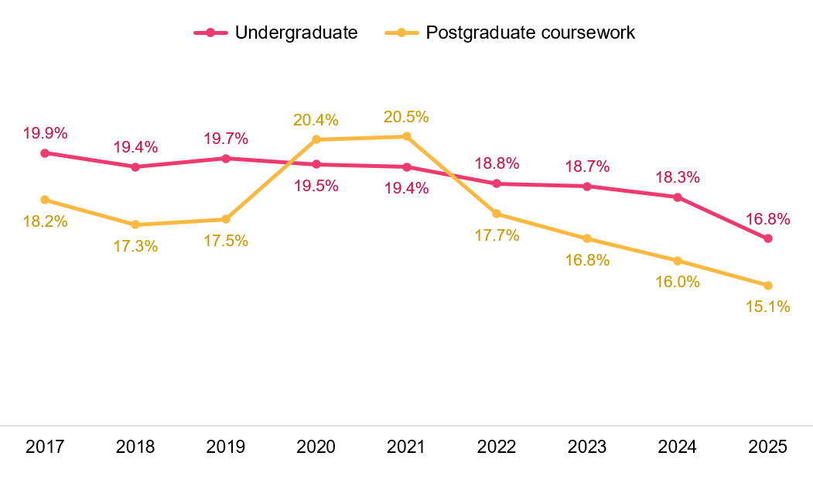

‘My stress levels’ continued to be the top reason cited by students for considering leaving their institution, mentioned by 40.0 per cent of undergraduates and 33.3 per cent of postgraduate coursework students who had considered leaving in 2025 (Figure 24).
While students who had considered leaving represent a relatively small proportion of SES respondents, their responses suggest that institutions should examine student wellbeing, including stress levels, mental health, work/life balance, and financial difficulties. Additionally, the high proportion of students indicating unmet course expectations as a main reason for considering leaving, highlights the need to explore these expectations further and address them effectively.
Figure 24 Top reasons for considering early departure from institution by course level, 2025 (% of those who considered leaving)
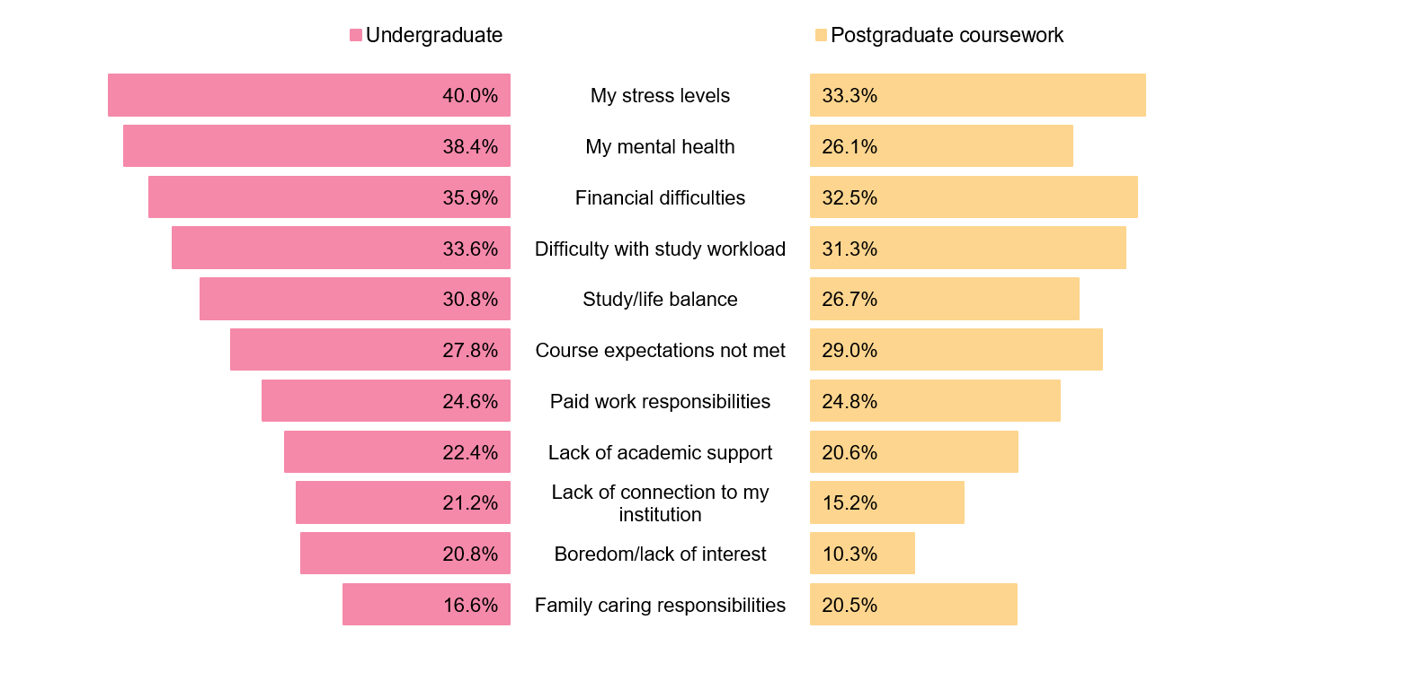
Note: Students who considered leaving their institution were asked to indicate, from a list of 28 possible reasons, why they had considered doing so. Students could select as many reasons as applicable, so the percentages do not sum to 100.

Negative effects on study
One third of undergraduates reported that paid work negatively impacted their studies in 2025.
Students are asked the extent to which their financial circumstances, living arrangements and paid work commitments negatively affected their study.
Across both levels of study, the proportions of students reporting that their living arrangements, financial circumstances and paid work commitments negatively affected their studies declined in 2025 (Figure 25).
Among undergraduates, 1 in 3 reported that paid work negatively affected their studies, 1 in 4 reported that their financial circumstances negatively affected their studies, and 1 in 5 reported that their living arrangements negatively affected their studies in 2025.
Postgraduate coursework rates followed a similar pattern to undergraduate rates in 2025 but were less pronounced.
While these challenges remain relevant for a substantial minority of students, these measures have declined in 2025 despite ongoing cost-of-living pressures in Australia. Sector-wide policy measures aimed at reducing financial barriers to study may help support continued improvement in future years.

Figure 25 Negative effects on study by course level, 2017–25 (% negatively affected)
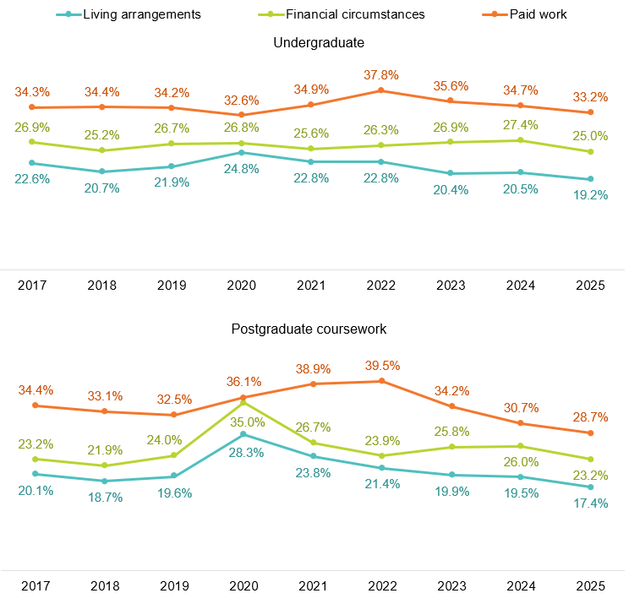
Note: The percentage negatively affected includes those who responded ‘Quite a bit’ and ‘Very much’ for each of these items.

Freedom of expression
The SES includes a series of questions related to students’ perceptions of freedom of expression at their institution. Respondents are asked to indicate their level of agreement with the following statements:
- ‘I am free to express my views at [institution name]’;
- ‘Academics are free to express their views at [institution name]’; and
- ‘I am free from discrimination, harm, or hatred at [institution name]’.
Figure 26 shows the distribution of responses to each of the freedom of expression items by course level. On average, 76.7 per cent of undergraduates and 78.8 per cent of postgraduate coursework students agreed or strongly agreed with each of the statements in 2025. In addition, approximately 5 per cent of respondents disagreed or strongly disagreed, while the remainder were neutral.
At both levels of study, students reported the highest levels of agreement (either agree or strongly agree) regarding the statement ‘I am free from discrimination, harm or hatred’.
Figure 26 Freedom of expression items by course level, 2025
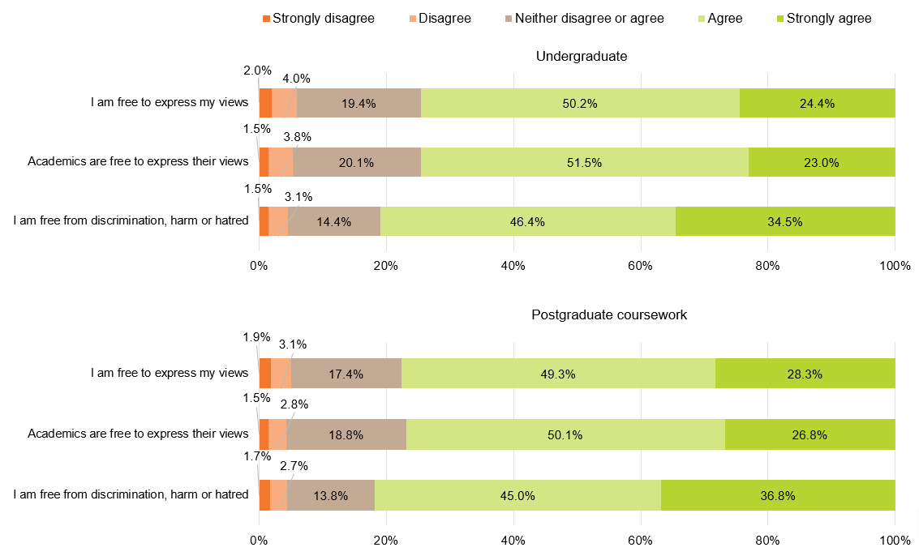
An Overall Freedom of Expression measure is calculated from responses to the 3 underlying items above. Overall Freedom of Expression has remained relatively stable since it was first introduced to the SES in 2021 (Figure 27). In 2025, 85.1 per cent of undergraduates and 86.2 per cent of postgraduate coursework students rated Overall Freedom of Expression positively
Figure 27 Overall Freedom of Expression by course level, 2021–25 (% positive rating)
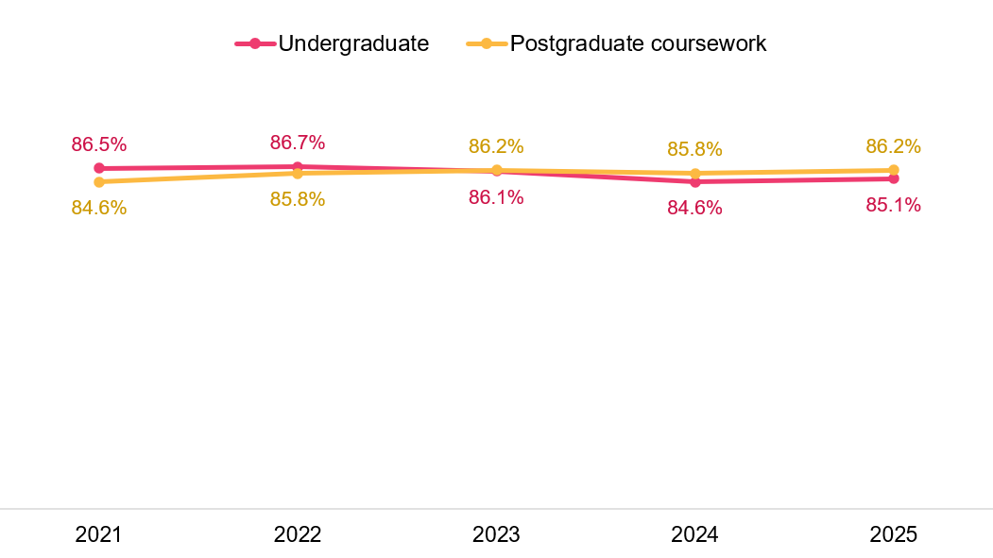

Demographic and equity groups
Student ratings of their educational experience vary across different demographic sub-groups at both levels of study. This section provides an overview of results for undergraduate and postgraduate coursework students across select demographic and equity groups. More detailed breakdowns of student experience ratings by demographic sub-groups are available in the supplementary tables on the QILT website.
Note that comparisons for First Nations results are subset to domestic students only. Other demographic and equity groups for comparison include all domestic and international students.
Age
Student experience ratings differ by age. In general, older students (aged 30 to 39, 40 and over) tend to rate their Overall Educational Experience more positively than younger students (under 25, aged 25 to 29). However, these differences by age are likely associated with differences in study mode – older students are more likely to study externally, and external students rate their Overall Educational Experience more positively than internal/multi-mode students (Figure 4), who also tend to be younger.
In 2025, undergraduate Overall Educational Experience ratings for older students increased year-on-year (82.5 per cent positive for 40 and over, 79.3 per cent positive for 30 to 39) (Figure 28). Younger student ratings partially recovered between 2021 and 2023 after the impact of the pandemic on student experience in 2020; however, they have not fully recovered and have remained relatively steady since 2023.
At the postgraduate coursework level, older student ratings did not decline as substantially in 2020 as they did for younger students. This is due to high proportion of domestic students who study externally at the postgraduate coursework level (Figure 44) – students who expected to study externally during the pandemic did not experience as much disruption to their studies as they could continue studying online.

Figure 28 Overall Educational Experience by course level and age, 2017–25 (% positive rating)
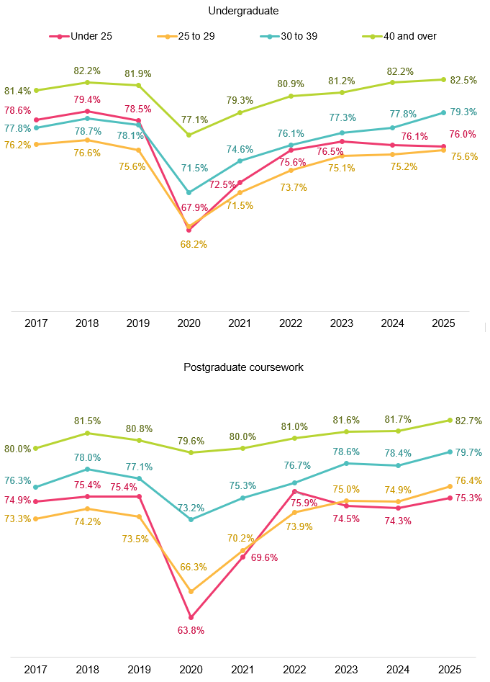

Stage of study
Historically, commencing students have rated their Overall Educational Experience more positively than later-year students at both undergraduate and postgraduate coursework levels. In contrast, later-year students have rated Skills Development more positively than commencing students at both levels.
In 2025, undergraduate commencing students continued to rate their experience across the focus areas more positively than later-year students, except in Skills Development, and Peer Engagement which was broadly similar between levels (Figure 29).
For postgraduate coursework students in 2025, differences in ratings between commencing and later-year students were less pronounced, likely due to their previous higher education experience. However, later-year students rated their Skills Development and Peer Engagement more highly than commencing students.
Figure 29 Student experience by course level and stage of study, 2025 (% positive rating)
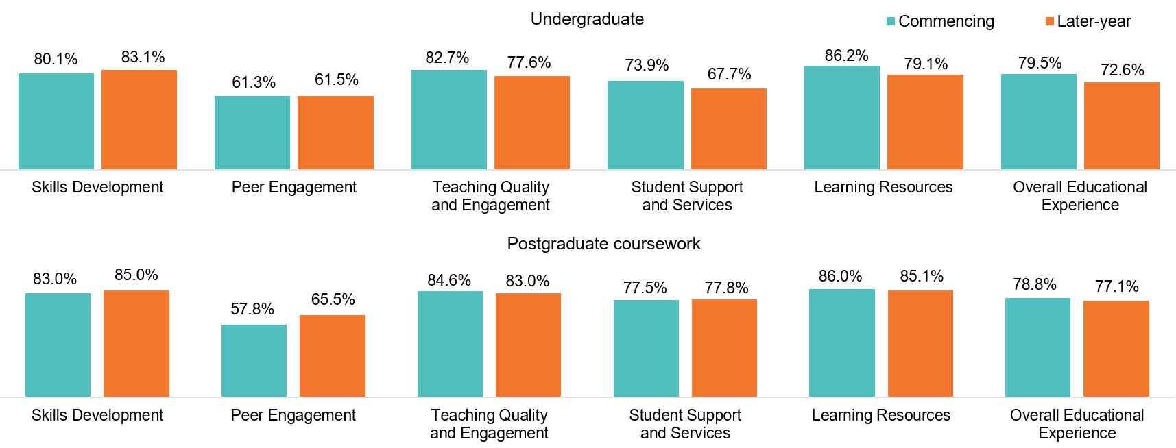
Disability
Students with disability have consistently rated their Overall Educational Experience lower than those without disability at both undergraduate and postgraduate coursework levels (Figure 30). However, in 2025, the gap in ratings narrowed to the lowest recorded since 2017 – undergraduate students with disability rated their Overall Educational Experience 1.7 percentage points lower than undergraduates without disability. At the postgraduate coursework level, students with and without a disability reported similar levels of Overall Educational Experience.
Figure 30 Overall Educational Experience by course level and disability status, 2017–25 (% positive rating)
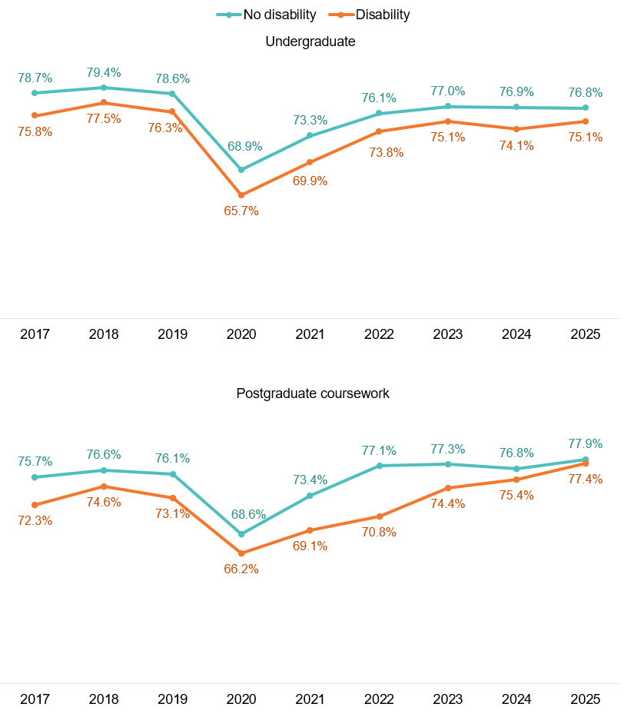Note: Disability status comparisons include both domestic and international student responses.
Consistent with prior years, students with disability ratings across the 5 focus areas were generally lower than for students without disability (Figure 31).
Figure 31 Focus areas by course level and disability status, 2025 (% positive rating)
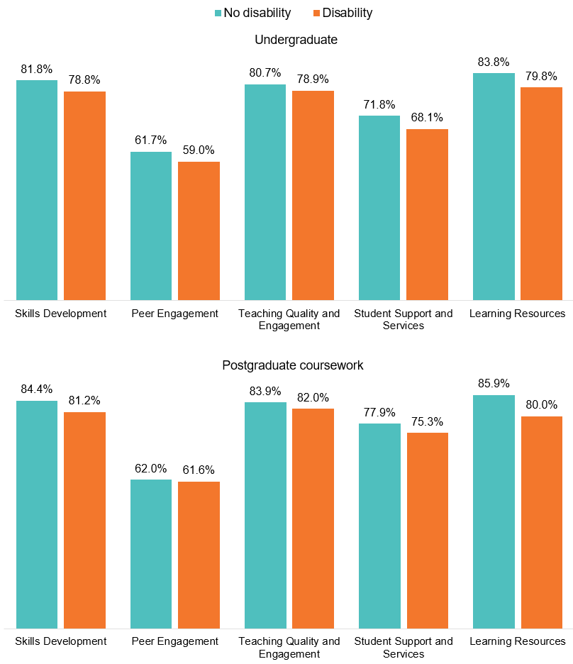
Additionally, students with disability were more likely to report they had considered leaving their institution in 2025 and that their living arrangements, financial circumstances and paid work commitments had negatively impacted their studies (Table 1). Students with disability were less likely than those without disability to have a positive sense of belonging to the institution, or agree with the aspects of freedom of expression measured in the SES (see Freedom of expression).
Table 1 Other aspects of the student experience by course level and disability status, 2025
 | No disability -Undergraduate (%) | Disability - Undergraduate (%) | No disability -Postgraduate coursework (%) | Disability -Postgraduate coursework (%)
Sense of belonging to institution (positive rating) | 48.5 | 44.5 | 52.9 | 49.4
Considered leaving institution | 16.0 | 21.9 | 14.4 | 22.4
Freedom of expression -  I am free to express my views (positive rating) | 74.9 | 72.3 | 78.0 | 73.5
Freedom of expression - Academics are free to express their views (positive rating) | 75.0 | 71.0 | 77.4 | 71.7
Freedom of expression -  I am free from discrimination, harm or hatred (positive rating) | 81.5 | 76.9 | 82.2 | 77.5
Overall Freedom of expression (positive rating) | 85.6 | 82.0 | 86.6 | 81.6
Negative effect of living arrangements on study | 18.4 | 24.6 | 17.1 | 20.7
Negative effect of financial circumstances on study | 24.0 | 31.9 | 22.7 | 29.1
Negative effect of paid work on study | 32.6 | 37.8 | 28.2 | 35.2
Home language
Student ratings of their educational experience vary depending on whether their home language is English or not. Note that classification by home language includes both international and domestic students.
Students whose home language is not English have tended to rate Overall Educational Experience less positively than those whose home language is English but this gap has narrowed in the post-pandemic era (Figure 32).
In 2025, undergraduate Overall Educational Experience ratings rose by 1.9 percentage points for those whose home language was not English. In contrast, undergraduate ratings for those whose home language was English declined, bringing ratings to their closest levels since 2017: 76.6 per cent positive for home language - English and 76.3 per cent positive for home language - other.
Among postgraduate coursework students, there was a 1.2 percentage point difference in Overall Educational Experience ratings in 2025 between those whose home language was English (78.4 per cent) and those whose home language was not English (77.2 per cent).
Figure 32 Overall Educational Experience by course level and home language, 2017–25 (% positive rating)
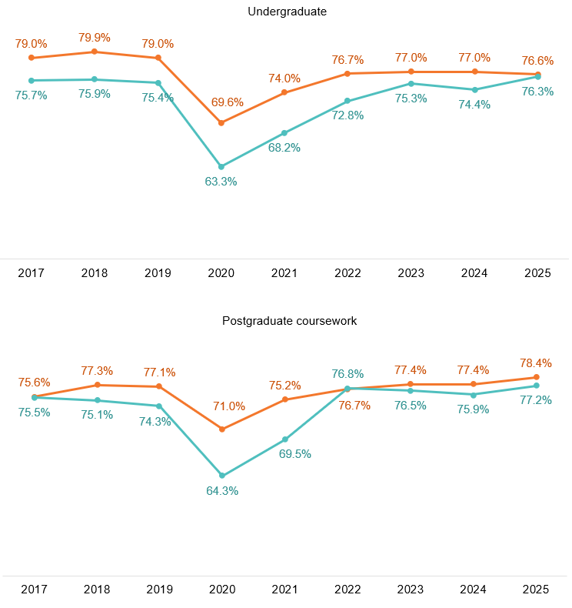
Students whose home language is not English were more likely to provide positive ratings for the 5 focus areas compared to students whose home language is English. The difference was largest for Peer Engagement, which may in part reflect higher levels of on-campus participation among international students (see Appendix 1).
Figure 33 Focus areas by course level and home language, 2025 (% positive rating)
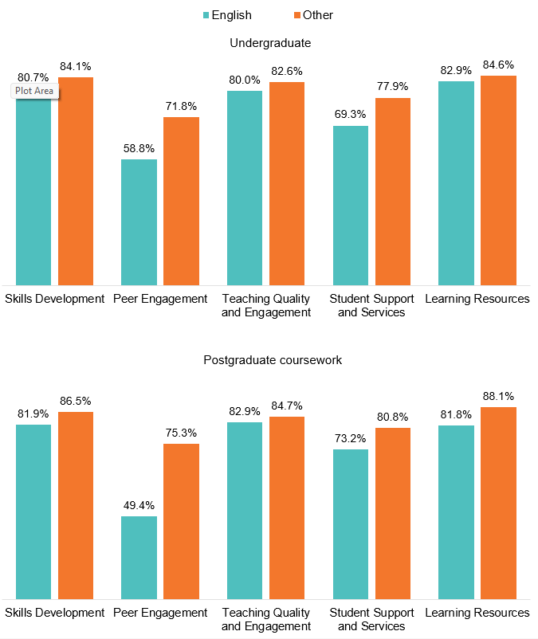
First Nations
At the undergraduate level, First Nations students tend to rate their Overall Educational Experience more positively than non-Indigenous students. At the postgraduate coursework level, First Nations and non-Indigenous students rate their Overall Educational Experience similarly (Figure 34).
First Nations students consistently rate Peer Engagement lower than non-Indigenous students and this trend continued in 2025. First Nations students are more likely to study externally which would explain the lower Peer Engagement ratings since positive ratings represent the frequency of interactions with peers and are typically lower for external students.
Figure 34 Focus areas by course level and First Nations status, 2025 (% positive rating)
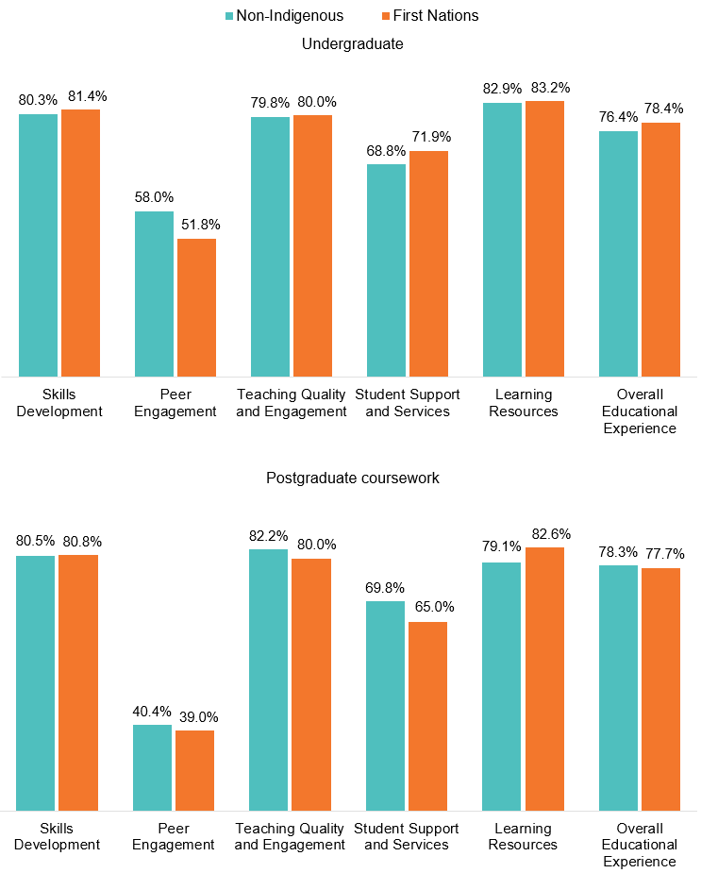
Although First Nations students rate their Overall Educational Experience either more positively, or similar to non-Indigenous students, there are broader structural inequity issues which may be impacting their higher education participation. First Nations undergraduates were more likely to have considered leaving their institution than non-Indigenous students, they were also less likely to agree that they were free from discrimination, harm and hatred, and more likely to report that their living arrangements, financial circumstances and paid work commitments negatively affected their studies (Table 2). These results suggest that sector level initiatives aimed at removing barriers to First Nation participation in higher education should focus on addressing financial pressures and fostering safe and inclusive learning environments for First Nations students.
Table 2 Other aspects of the student experience by course level and First Nations status, 2025
 | Non-Indigenous - Undergraduate (%) | First Nations -Undergraduate (%) | Non-Indigenous -Undergraduate (%) | First Nations -Postgraduate coursework (%)
Sense of belonging to institution (positive rating) | 44.9 | 48.0 | 39.5 | 40.2
Considered leaving institution | 17.9 | 26.0 | 18.6 | 29.8
Freedom of expression - I am free to express my views (positive rating) | 72.8 | 72.5 | 68.4 | 63.4
Freedom of expression - Academics are free to express their views (positive rating) | 72.5 | 71.7 | 66.0 | 61.9
Freedom of expression – I am free from discrimination, harm or hatred (positive rating) | 81.0 | 77.4 | 78.7 | 68.6
Overall Freedom of expression (positive rating) | 84.3 | 83.5 | 80.6 | 73.7
Negative effect of living arrangements on study | 19.3 | 25.8 | 17.4 | 23.1
Negative effect of financial circumstances on study | 24.9 | 38.6 | 23.5 | 30.8
Negative effect of paid work on study | 36.8 | 45.5 | 43.4 | 47.4

Study area
Across study areas, higher or lower Overall Educational Experience ratings generally align with higher or lower Teaching Quality and Engagement or Skills Development ratings, underscoring their importance in shaping students’ overall evaluations of their educational experience.
Student ratings vary across study areas. In 2025, undergraduate Overall Educational Experience ratings ranged from 86.6 per cent positive for Agriculture and environmental studies to 66.7 per cent for Computing and information systems (Figure 35).
Figure 35 Overall Educational Experience by study area, undergraduate, 2025 (% positive rating)
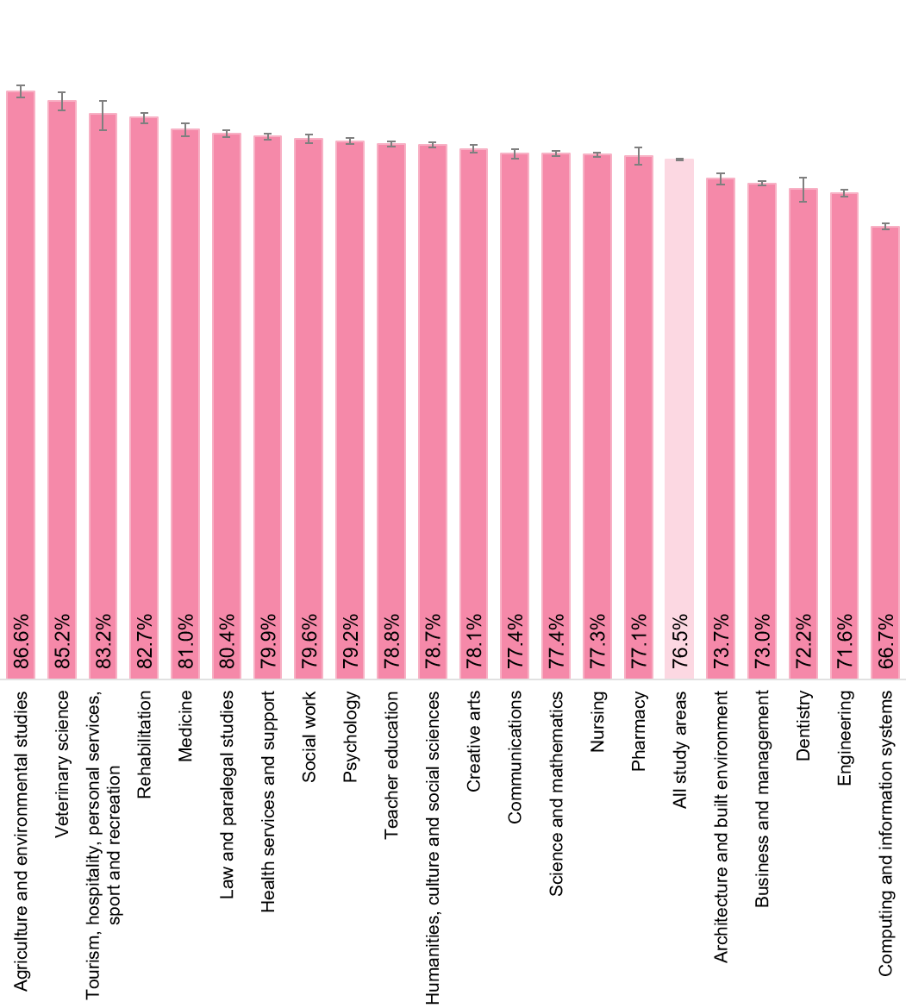
In 2025, the greatest variation in focus area ratings across study areas was observed in the Peer Engagement focus area (Table 3). This likely reflects differences in teaching and learning approaches across disciplines, including how courses are structured and delivered, which would impact the frequency of interactions students have with their peers.
There was no consistent relationship between ratings across individual focus areas and ratings of Overall Educational Experience. However, Table 3 shows that in general, high or low Overall Educational Experience ratings do correspond to high or low ratings (relative to the average) of Teaching Quality and Engagement or Skills Development. This underscores the importance of these two focus areas in students’ overall assessments of the quality of their educational experience.
It should also be noted that broad disciplinary aggregations often hide much of the detail that is relevant to schools, faculties, and academic departments. More detailed SES results disaggregated by 45 study areas are available from the QILT website in the additional tables associated with this report.

Table 3 Undergraduate student experience by study area, 2025 (% positive rating)
Study area | Skills Development | Peer Engagement | Teaching Quality and Engagement | Student Support and Services | Learning Resources | Overall Educational Experience
Agriculture and environmental studies | 84.2 | 58.8 | 88.7 | 74.0 | 89.7 | 86.6
Architecture and built environment | 78.8 | 65.1 | 78.9 | 67.4 | 79.3 | 73.7
Business and management | 78.4 | 63.8 | 76.7 | 73.5 | 82.6 | 73.0
Communications | 82.9 | 68.7 | 83.4 | 69.1 | 85.3 | 77.4
Computing and information systems | 75.8 | 62.6 | 74.6 | 72.7 | 80.8 | 66.7
Creative arts | 82.4 | 69.6 | 84.9 | 67.6 | 81.0 | 78.1
Dentistry | 84.9 | 73.9 | 74.4 | 66.1 | 75.0 | 72.2
Engineering | 78.5 | 64.9 | 75.0 | 68.9 | 84.1 | 71.6
Health services and support | 82.7 | 58.1 | 83.3 | 72.8 | 84.0 | 79.9
Humanities, culture and social sciences | 80.6 | 55.6 | 84.1 | 67.2 | 84.2 | 78.7
Law and paralegal studies | 84.8 | 54.8 | 83.2 | 69.0 | 83.4 | 80.4
Medicine | 89.8 | 83.1 | 81.2 | 70.0 | 78.6 | 81.0
Nursing | 85.0 | 62.8 | 78.7 | 74.5 | 84.2 | 77.3
Pharmacy | 85.4 | 68.3 | 80.6 | 72.0 | 82.9 | 77.1
Psychology | 81.8 | 48.6 | 83.4 | 72.6 | 84.4 | 79.2
Rehabilitation | 88.1 | 73.8 | 84.6 | 71.7 | 84.5 | 82.7
Science and mathematics | 79.6 | 60.3 | 82.5 | 68.9 | 87.3 | 77.4
Social work | 87.9 | 62.4 | 84.6 | 73.2 | 78.0 | 79.6
Teacher education | 82.2 | 57.4 | 80.9 | 72.1 | 80.5 | 78.8
Tourism, hospitality, personal services, sport and recreation | 86.5 | 70.5 | 84.5 | 80.3 | 85.3 | 83.2
Veterinary science | 84.9 | 73.3 | 85.8 | 67.0 | 85.5 | 85.2
Total | 81.4 | 61.4 | 80.5 | 71.3 | 83.3 | 76.5
Note: Cells are shaded to indicate relative position within each focus area, with green shading indicating results above the national average and orange shading indicating results below the national average.
Similar patterns of variation between study areas were observed at the postgraduate coursework level but the order of Overall Educational Experience ratings varied greatly to undergraduate ratings (Figure 36). For instance, 81.0 per cent of undergraduates from Medicine rated Overall Educational Experience, making it the fifth highest study area in 2025. In contrast, it was the second lowest rated at the postgraduate coursework level with only 69.8 per cent of students rating it positively.
Notably, the Computing and information systems and Dentistry study areas reported relatively low Overall Educational Experience ratings at both levels of study. The consistency of these results across levels suggests that factors shared across courses within these study areas may be influencing students’ overall evaluations.
Figure 36 Overall Educational Experience by study area, postgraduate coursework, 2025 (% positive rating)
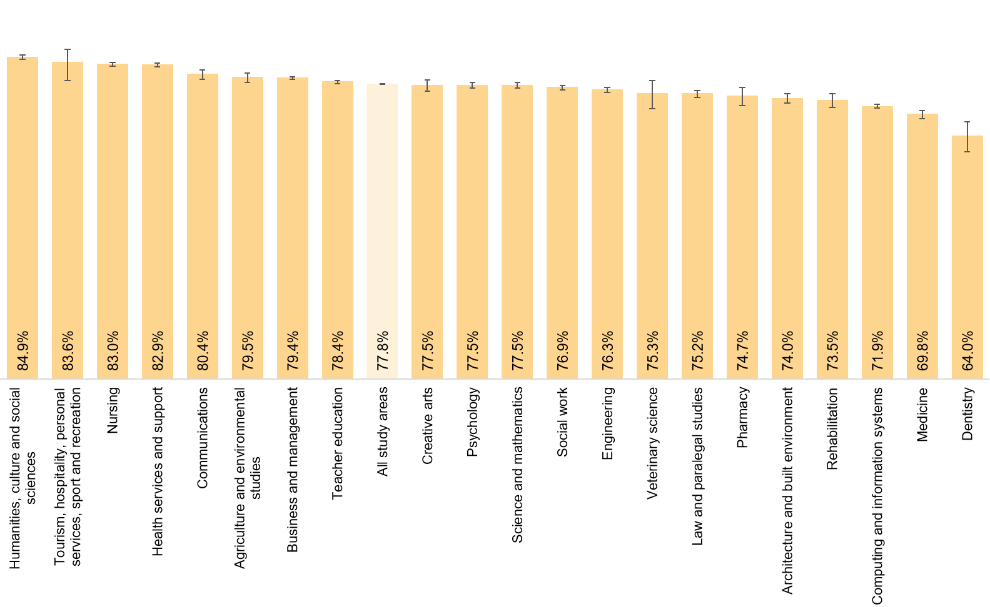

Postgraduate coursework student ratings of Overall Educational Experience were highest from the Humanities, culture and social sciences study area (84.9 per cent positive). Notably, the Humanities, culture and social sciences focus area also recorded the highest Teaching Quality and Engagement rating (90.6 per cent positive), reinforcing the close association between Teaching Quality and Engagement and students’ overall evaluations of their educational experience (Table 4).
Table 4 Postgraduate coursework student experience by study area, 2025 (% positive rating)
Study area | Skills Development | Peer Engagement | Teaching Quality and Engagement | Student Support and Services | Learning Resources | Overall Educational Experience
Agriculture and environmental studies | 86.3 | 67.7 | 87.4 | 78.3 | 91.1 | 79.5
Architecture and built environment | 84.3 | 74.3 | 82.4 | 70.7 | 81.1 | 74.0
Business and management | 85.3 | 69.9 | 85.0 | 82.0 | 87.9 | 79.4
Communications | 86.2 | 74.7 | 87.7 | 77.0 | 91.3 | 80.4
Computing and information systems | 81.5 | 71.5 | 79.7 | 79.2 | 85.8 | 71.9
Creative arts | 84.6 | 74.3 | 86.9 | 71.6 | 86.4 | 77.5
Dentistry | 82.3 | 65.6 | 70.6 | 45.1 | 64.9 | 64.0
Engineering | 85.3 | 72.7 | 84.3 | 80.8 | 91.2 | 76.3
Health services and support | 85.7 | 50.3 | 87.5 | 78.2 | 86.7 | 82.9
Humanities, culture and social sciences | 87.4 | 59.0 | 90.6 | 79.9 | 91.4 | 84.9
Law and paralegal studies | 80.4 | 47.6 | 81.2 | 70.5 | 81.2 | 75.2
Medicine | 82.7 | 67.7 | 71.3 | 56.9 | 62.5 | 69.8
Nursing | 84.9 | 34.7 | 85.5 | 80.4 | 86.8 | 83.0
Pharmacy | 87.0 | 68.1 | 82.0 | 75.7 | 84.4 | 74.7
Psychology | 84.0 | 53.5 | 83.4 | 70.0 | 75.5 | 77.5
Rehabilitation | 88.7 | 75.8 | 81.7 | 68.0 | 81.4 | 73.5
Science and mathematics | 83.8 | 63.5 | 84.6 | 79.0 | 89.8 | 77.5
Social work | 85.2 | 65.3 | 82.3 | 73.9 | 80.8 | 76.9
Teacher education | 81.9 | 50.7 | 83.5 | 74.6 | 82.6 | 78.4
Tourism, hospitality, personal services, sport and recreation | 85.8 | 73.8 | 87.5 | 74.4 | 88.9 | 83.6
Veterinary science | 92.1 | 82.8 | 81.8 | 50.0 | 81.4 | 75.3
Total | 84.1 | 62.0 | 83.7 | 77.7 | 85.5 | 77.8
Note: Cells are shaded to indicate relative position within each focus area, with green shading indicating results above the national average and orange shading indicating results below the national average.

Institution

Institution type
In 2025, 88.5 per cent of undergraduate respondents and 83.9 per cent of postgraduate coursework respondents to the SES were enrolled in courses at universities, while 11.5 per cent of undergraduates and 16.1 per cent of postgraduate coursework respondents were studying at a non-university higher education institution (NUHEI).
Student ratings at NUHEIs are generally higher than at universities for both undergraduate and postgraduate coursework students, except for Learning Resources, which is consistently rated lower. This trend continued in 2025 (Figure 37).
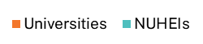
Figure 37 Student experience by institution type and course level, 2025 (% positive rating)

In general, NUHEIs are typically smaller, more specialised providers that focus on a narrower range of disciplines and qualifications than universities. They often deliver professionally oriented courses in areas such as business, creative arts, health and theology, and are more likely to enrol either international students or domestic students who are older, studying part-time and studying externally or online. These institutional and student profile differences are important context when interpreting comparisons between NUHEIs and universities.
Key differences likely influencing student ratings between NUHEIs and universities across both levels of study include the greater proportions of international students, as well as students aged 25 years and over. These differences in student profile between institution types are presented in Figure 38 for 2025. Both sub-groups were more likely to rate their student experience higher than their counterparts (see Demographic and equity groups and the 2025 SES International Report available on the QILT website).
Figure 38 Demographic differences between universities and NUHEIs, 2025 (% based on responses to the 2025 SES)
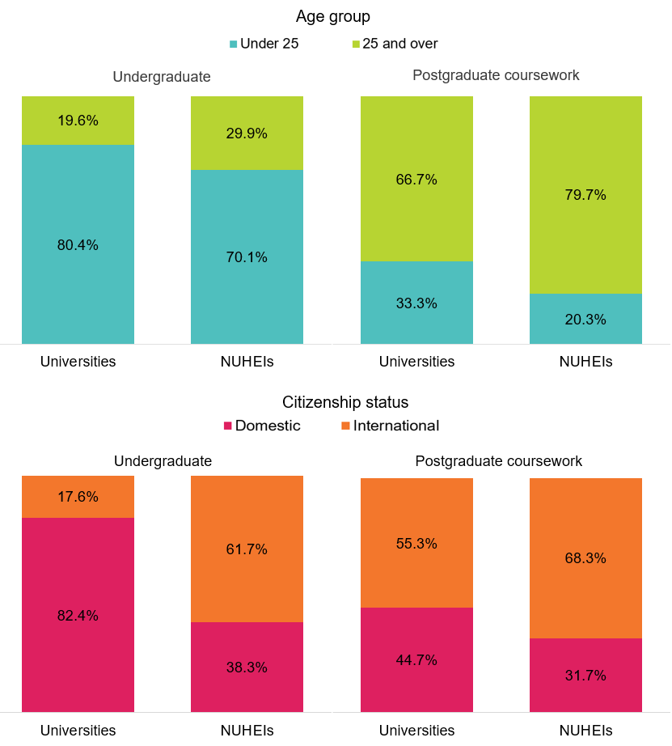

Comparative institution outcomes
Student ratings vary across institutions. Note that factors beyond the quality of teaching, resources/facilities and services provided by the institution can affect results for institutions. These include study area offerings, study mode and the composition of the student population.
To assist interpretation of results, 90 per cent confidence intervals are included in the figures that follow, which indicate the confidence intervals for the survey estimates. Note that where confidence intervals for institution estimates overlap, it cannot be inferred that there is or is not a significant difference in outcomes in a statistical sense.
Notwithstanding differences in course offerings, modes of study and student populations, it appears there is some differentiation among institutions, with some achieving higher ratings of Overall Educational Experience than others.
The following sections present institution-level ratings of Overall Educational Experience by course level. Focus area results by institution are available in supplementary tables on the QILT website.

Universities
There was some variation in undergraduate student ratings of Overall Educational Experience at universities in 2025. The Australian University of Theology, University of Divinity, Avondale University and Bond University performed substantially better than other universities (Figure 39).
Conversely, The University of Sydney, University of Southern Queensland, The Australian National University and The University of Notre Dame Australia had the lowest ratings of Overall Educational Experience by undergraduate students.
At the postgraduate coursework level, The Australian University of Theology had the highest rating of Overall Educational Experience in 2025, while The University of Notre Dame Australia recorded the lowest positive response (Figure 40).
Confidence intervals for postgraduate coursework results are larger than for undergraduates due to a smaller number of responses.

Figure 39 Overall Educational Experience for undergraduate university students, 2025 (% positive rating, with 90 per cent confidence intervals)
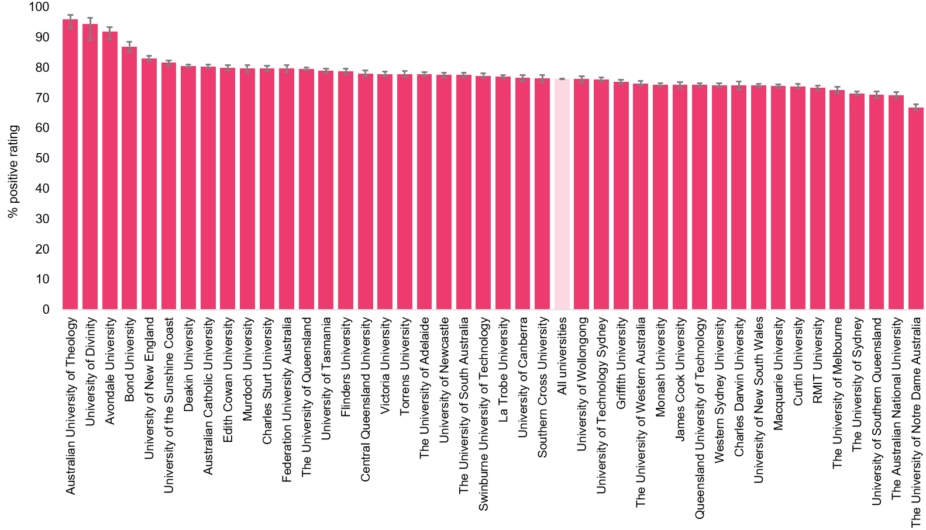
Note: Only institutions with sufficient data (i.e. n≥25) are presented in this figure. For the complete table, refer to worksheet QOE_UG_UNI_1Y_INST_FIG in the 2025 SES National Tables on the QILT website. As of January 2026, the University of Adelaide and the University of South Australia have merged to form Adelaide University. Data for the 2025 SES were collected when the institutions operated separately as the University of Adelaide and the University of South Australia.
Figure 40 Overall Educational Experience for postgraduate coursework university students, 2025 (% positive rating, with 90 per cent confidence intervals)
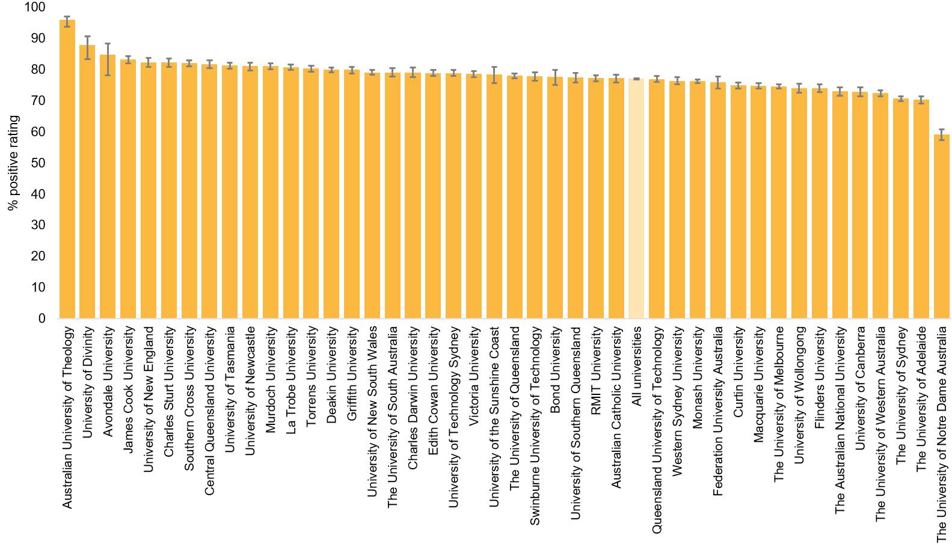
Note: Only institutions with sufficient data (i.e. n≥25) are presented in this figure. For the complete table, refer to worksheet QOE_PGC_UNI_1Y_INST_FIG in the 2025 SES National Tables on the QILT website. As of January 2026, the University of Adelaide and the University of South Australia have merged to form Adelaide University. Data for the 2025 SES were collected when the institutions operated separately as the University of Adelaide and the University of South Australia.

NUHEIs
Since the number of students enrolled in individual NUHEIs is much smaller than at universities, the NUHEI results in Figure 41 and Figure 42 use data pooled across 2 survey years. Consequently, results for NUHEIs are not directly comparable to those for universities. Additionally, results based on fewer than 25 survey responses have not been published.
Despite pooling data across two survey years, the confidence intervals for some NUHEIs remain wide. Nonetheless, there are NUHEIs where students rated their Overall Educational Experience significantly higher than in other institutions.
The same caveats about interpreting results at the institution level apply. This is even more important among NUHEIs because of the greater specialisation in course offerings by level of education and study area than among universities.
In 2024–25, 14 NUHEIs had over 90 per cent of undergraduate students rate their Overall Educational Experience positively and 11 NUHEIs had 90 per cent or higher positive ratings at the postgraduate coursework level.

Figure 41 Overall Educational Experience for undergraduate non-university higher education institution (NUHEI) students, pooled 2024–25 (% positive rating, with 90 per cent confidence intervals)
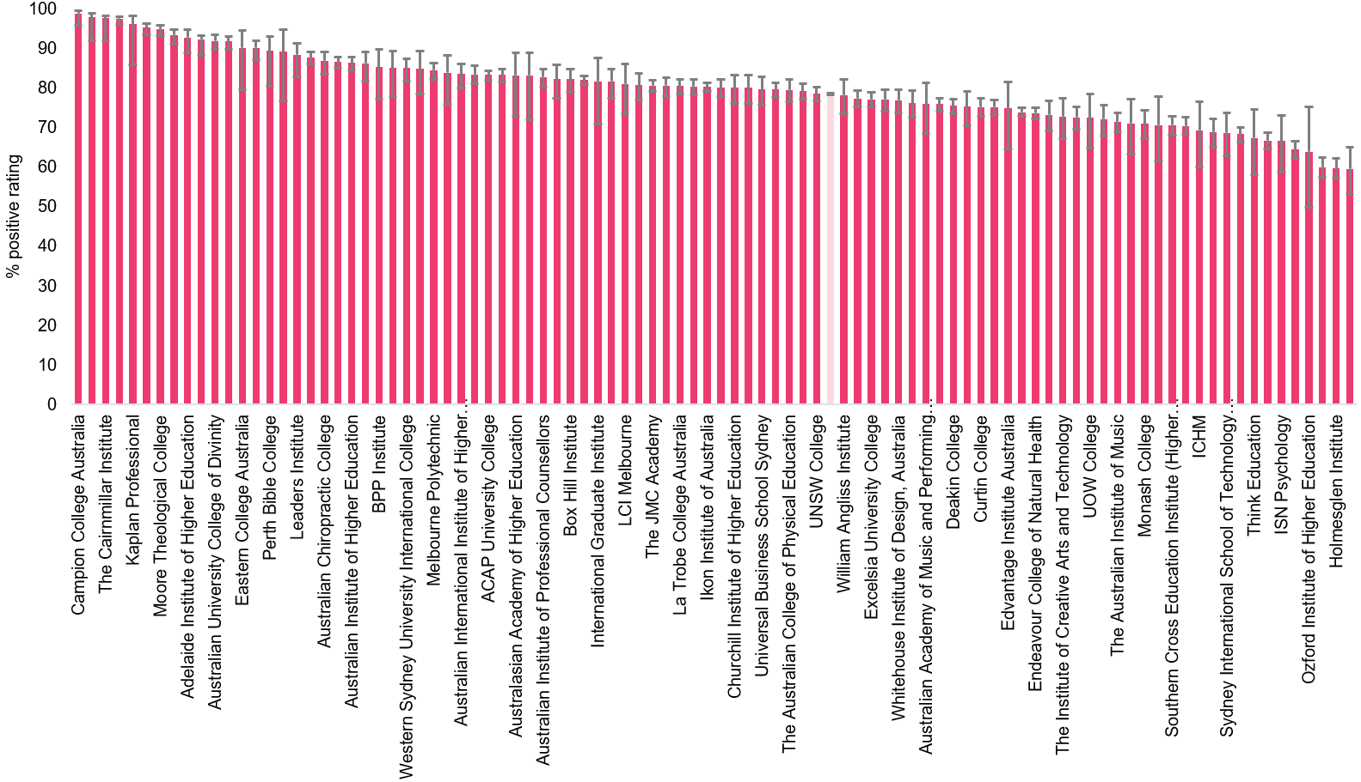
Note: Only institutions with sufficient data (i.e. n≥25) are presented in this figure. For the complete table, refer to worksheet QOE_UG_NUHEI_2YP_INST_FIG in the 2025 SES National Tables on the QILT website.
Figure 42 Overall Educational Experience for postgraduate coursework non-university higher education institution (NUHEI) students, pooled 2024–25 (% positive rating, with 90 per cent confidence intervals)
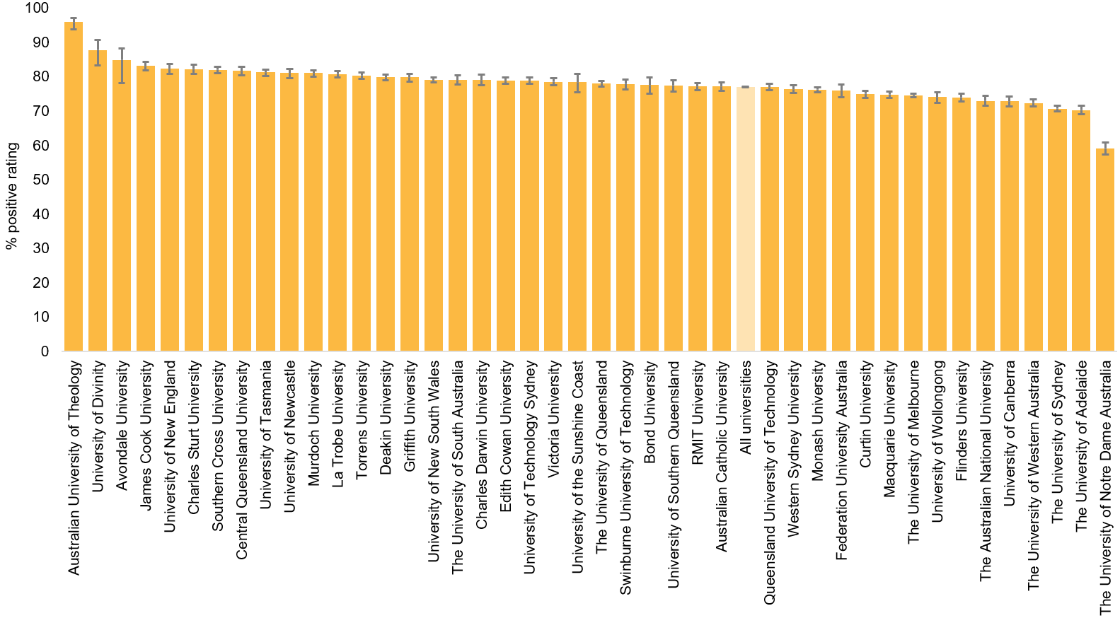
Note: Only institutions with sufficient data (i.e. n≥25) are presented in this figure. For the complete table, refer to worksheet QOE_PGC_NUHEI_2YP_INST_FIG in the 2025 SES National Tables on the QILT website.

Appendix 1 Understanding study mode and class participation: post-pandemic dynamics

Study mode (institution-reported)
Institutions record a student’s mode of study, along with other enrolment information, in the Tertiary Collection of Student Information (TCSI) system. A student’s mode of study can be categorised as ‘internal’, ‘external’ or ‘multi-modal’. Due to differences in how institutions define internal and multi-modes of attendance, these two groups are reported as a single category in SES reporting.
Figure 43 shows that among undergraduates, 89.0 per cent of respondents to the 2025 SES were enrolled in either an internal or multi-mode course and 11.0 per cent of respondents were enrolled in an external course. The proportion of students studying internally or by multi-modes dropped to its lowest level of 83.8 per cent in 2020 and while it has not returned to the rates seen prior to the pandemic, it has been increasing year-on-year since 2020.
More postgraduate coursework students study externally, due to domestic students who often return to study later in life while balancing work or family responsibilities. The split of internal/multi-mode to external ratio over time has followed a similar trend to the undergraduate level with some differences – the proportion studying externally did not peak until 2021. Since 2022, the proportions by study mode have fluctuated and in 2025, 75.5 per cent were studying internally/multi-mode – lower than the levels seen prior to the pandemic.
Figure 43 Study mode profile by course level, 2017–25 (based on responses to the SES)
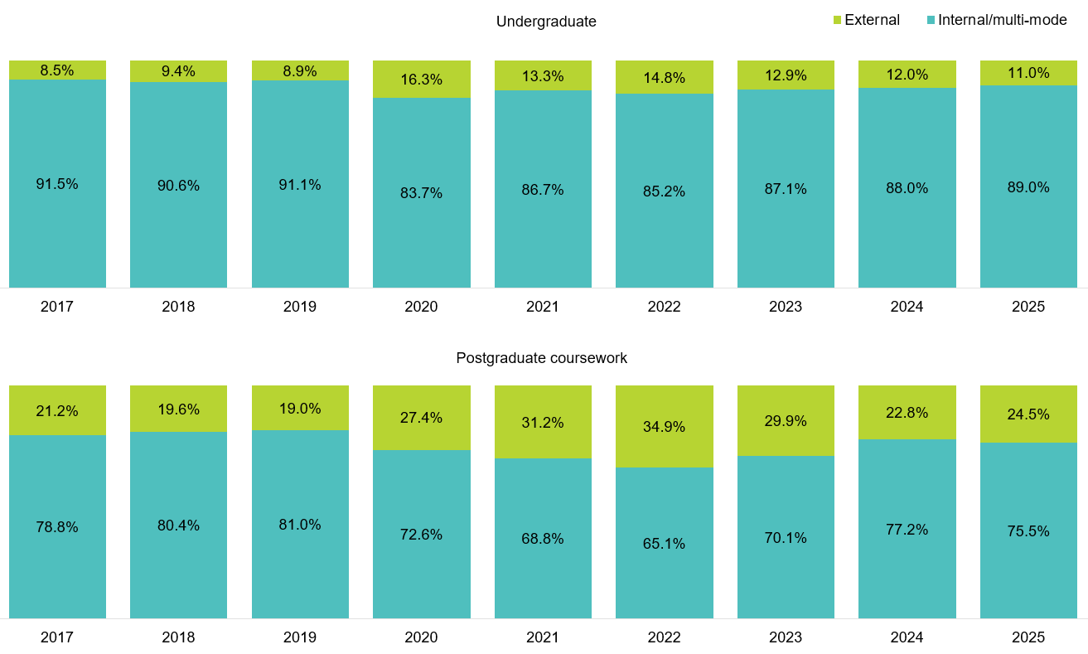
    - Domestic study mode trends over time
While international students are required to attend at least some of their classes in-person, precluding them from studying externally, there is a lot more flexibility for domestic students. Figure 44 shows that the domestic undergraduate study mode profile is comparable to undergraduates overall, which is to be expected due to the relatively high proportion of domestic students at the undergraduate level (Figure 49). However, there is a clear difference in study modes at the postgraduate level when comparing the total to domestic only – more domestic students are undertaking postgraduate coursework studies externally and this has been growing year-on-year since 2021.
Figure 44 Domestic study mode profile by course level, 2017–25 (based on responses to the SES)
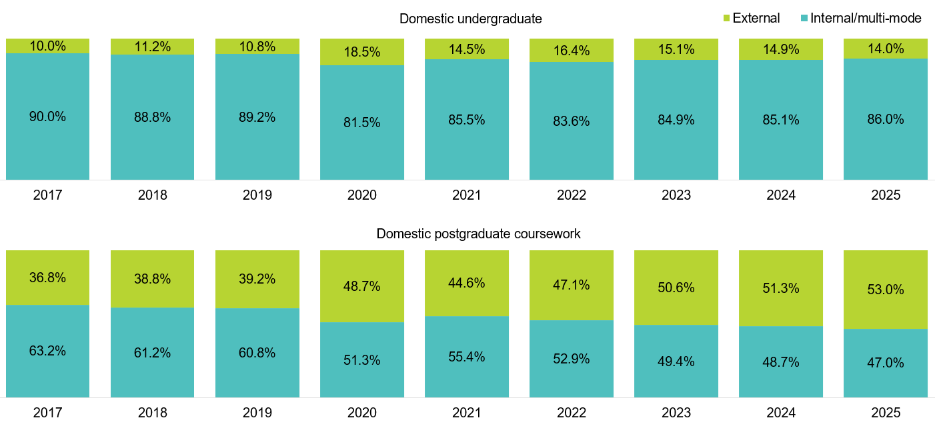

Class participation (self-reported)
To gain a deeper understanding of how students participated in their classes, the SES includes a self-reported measure of class participation, capturing whether students engaged mostly in-person, mostly online, or through a mix of study modes (i.e. ‘blended/hybrid’).
The majority of students enrolled externally also reported participating in their classes all online in 2025 – 85.0 per cent of undergraduates and 90.7 per cent of postgraduate coursework students (Figure 45). Likewise, the majority of students enrolled in internal/multi-mode studies reported participating in their classes all on-campus or through a mix of study modes – 97.0 per cent of undergraduates and 94.1 per cent of postgraduate coursework students. These findings suggest good alignment between how institutions record a student’s mode of study, and how students describe their class participation. This alignment supports the use of self-reported class participation as a nuanced measure of how students engaged with their course.
Figure 45 Class participation by enrolled study mode and course level, 2025
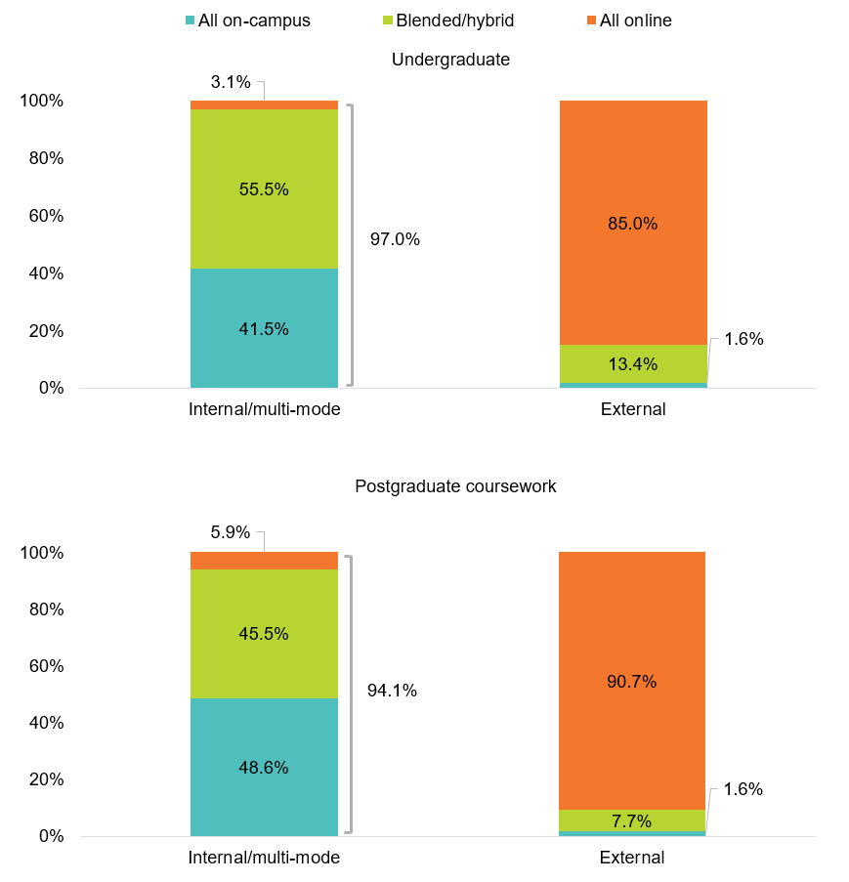
    - Class participation and citizenship status
At the undergraduate level, domestic and international students differed in their age and study mode (Figure 46). In addition, examining class participation as reported by students, highlights some further differences in how domestic and international students engage in their studies.
Figure 46 Undergraduate study mode and age profile by citizenship status, 2025
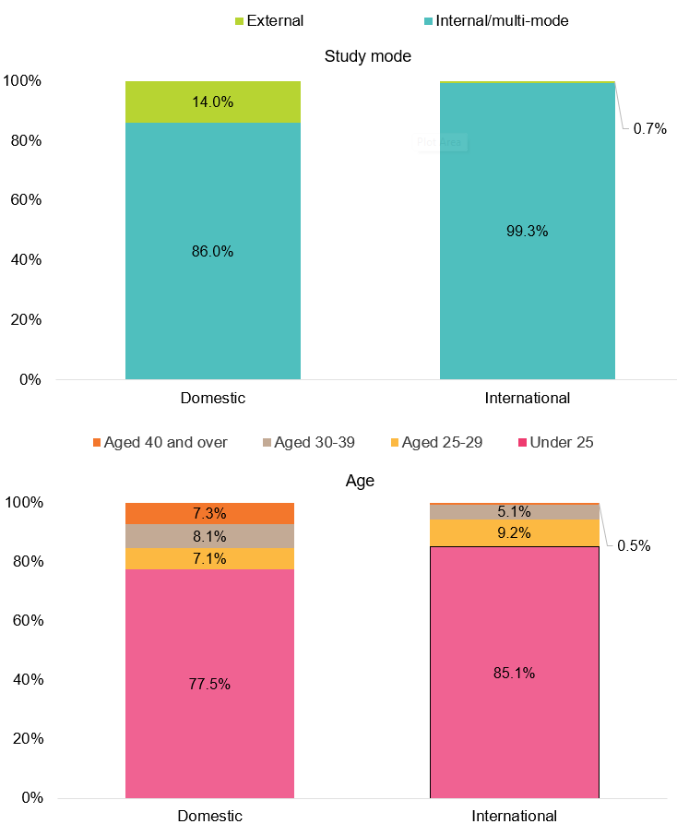
Note: Proportions based on responses to the 2025 SES.
Figure 47 shows that among undergraduates enrolled in internal/multi-mode studies, international students were more likely to have participated in all of their classes on-campus compared to domestic students (53.7 per cent and 37.3 per cent respectively). Among those who reported taking a ‘blended/hybrid’ approach to class participation (45.0 per cent of international students and 59.1 per cent of domestic students), international students were more likely to report doing some online than domestic students (62.3 per cent and 49.3 per cent respectively). In contrast, domestic students were more likely to have done ‘about half’ or ‘most’ of their classes online in 2025.
Figure 47 Undergraduate class participation for internal/multi-mode students by citizenship status, 2025
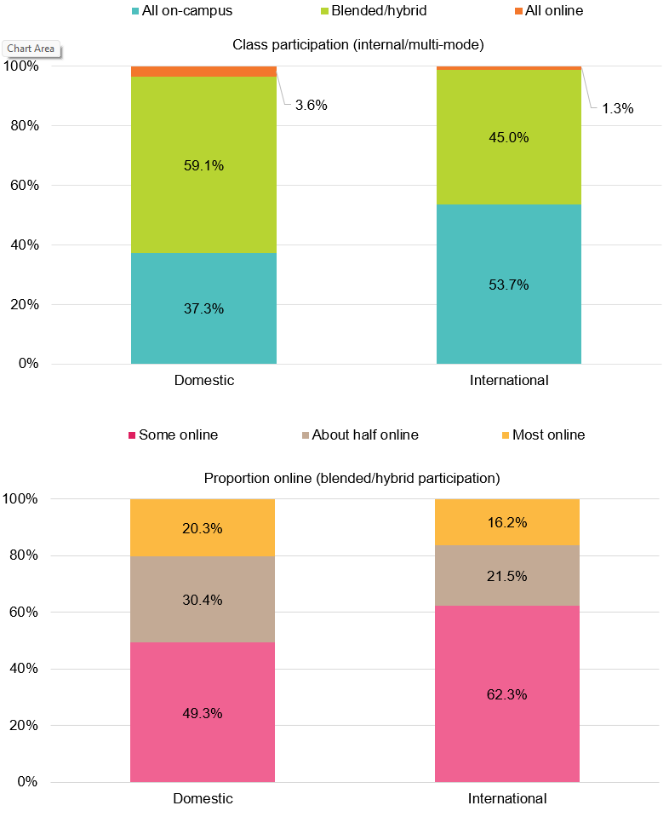

A key point of difference between domestic and international postgraduate coursework students is study mode (Figure 48). International students, as a condition of their student visa, must undertake at least some of their studies on-campus. In addition, domestic postgraduate coursework students are typically older, at a different life stage, and therefore more likely to study externally.
Figure 48 Postgraduate coursework study mode and age profile by citizenship status, 2025
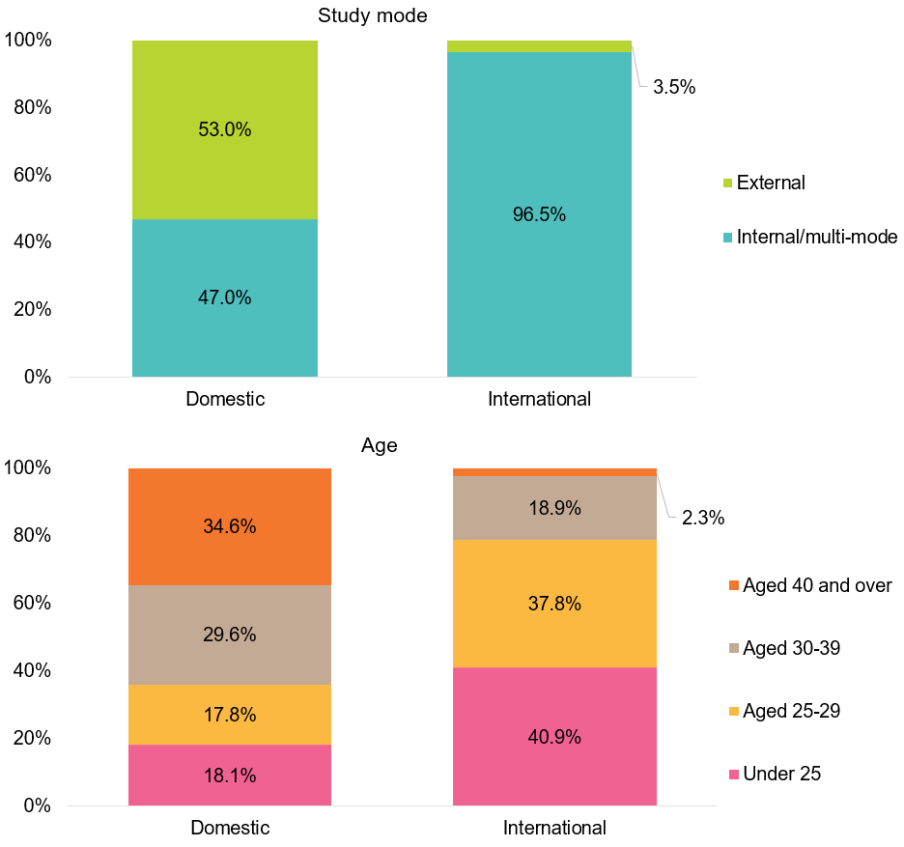
Note: Proportions based on responses to the 2025 SES.
  - Relative proportions of international students over time
In addition to study mode and class participation differences between domestic and international students, the relative proportion of international students, particularly at the postgraduate coursework level, has shifted over time, reflecting changes in the underlying student population (Figure 49).
The proportion of postgraduate coursework international respondents rose significantly from a 6-year low of 35.7 per cent in 2022 to 58.0 per cent in 2024 – the highest level recorded since 2017 – and remained high in 2025 (57.4 per cent). The proportion of international students at the undergraduate level has historically been much smaller but has also been increasing year-on-year since 2021. In 2025, international students accounted for 22.7 per cent of the undergraduate responding population; 2.6 percentage points higher than in 2024 and the highest since 2017.
Figure 49 Proportion of responses to the SES by citizenship status and course level, 2017–25 SES
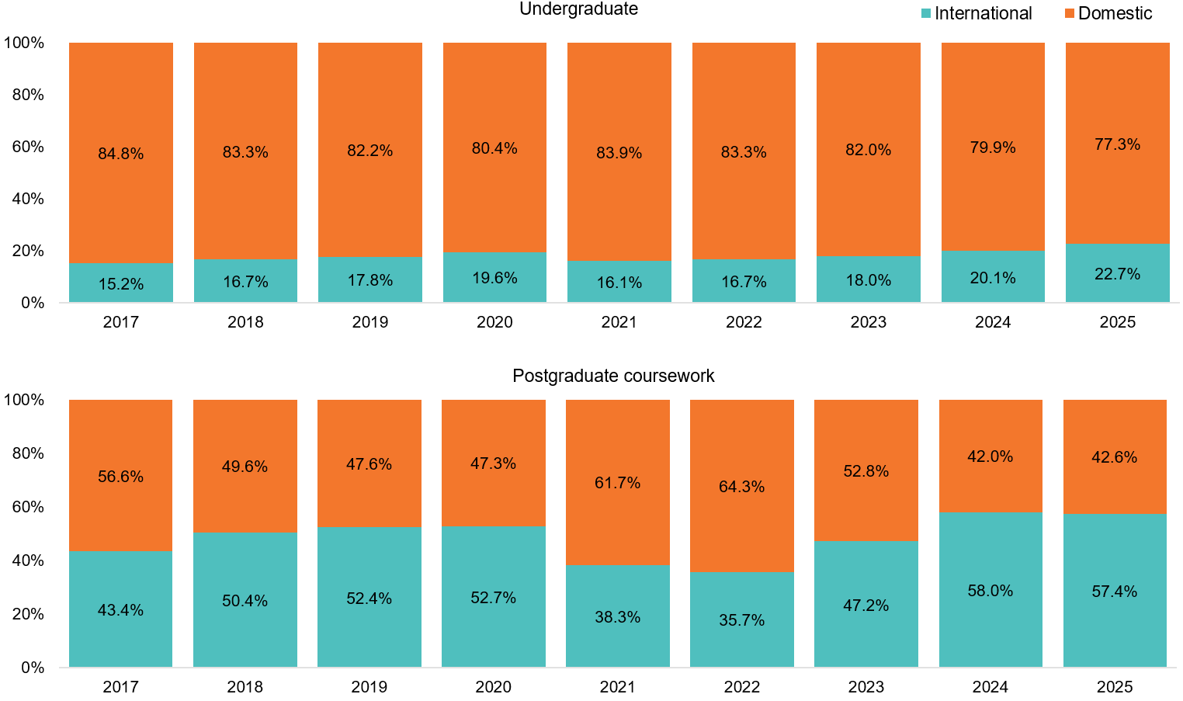



Allen, K. A., Kern, M. L., Rozek, C. S., McInerney, D. M., & Slavich, G. M. (2021). Belonging: a review of conceptual issues, an integrative framework, and directions for future research. Australian Journal of Psychology, 73(1), 87–102. https://doi.org/10.1080/00049530.2021.1883409
Crawford, J., Allen, K. A., Sanders, T., Baumeister, R., Parker, P., Saunders, C., & Tice, D. (2024). Sense of belonging in higher education students: an Australian longitudinal study from 2013 to 2019. Studies in Higher Education, 49(3), 395–409. https://doi.org/10.1080/03075079.2023.2238006
Later-year students include students in the final year of study from universities and all middle year and final year students from non-university higher education institutions (NUHEIs). A student’s stage of studies is an approximation only based on the ratio of a student’s accumulated equivalent full-time study load (EFTSL) to the total EFTSL of the course they are currently enrolled in.
Home language other than English refers to students who arrived in Australia less than 10 years prior to the year in which the data was collected and come from a home where a language other than English is spoken. This information is reported by institutions through the TCSI system. Home language data reported in the SES National Report include both domestic and international students.
Refer to FOCUS_UG_ALL_1Y_AREA45 and FOCUS_PGC_ALL_1Y_AREA45 worksheets in the 2025 SES National Report Tables available on the QILT website.
The SES has included non-university higher education institutions (NUHEIs) since 2015. The number of NUHEIs participating in the SES has been increasing and in 2025, NUHEIs accounted for 110 of the 153 registered institutions that participated.
The calculation of confidence intervals is detailed in Construction of confidence intervals in QILT surveys. Confidence intervals may be wider where the number of survey responses for a given institution is relatively small. Where confidence intervals for institution estimates do not overlap, this broadly implies the difference in labour market outcomes is statistically significant. Where confidence intervals overlap it cannot be inferred that the difference either is, or is not, statistically significant.
Refer to FOCUS_UG_UNI_1Y_INST_CI FOCUS_PGC_UNI_1Y_INST_CI for universities and FOCUS_UG_NUHEI_2Y_2YP_INST_CI and FOCUS_PGC_NUHEI_2Y_2YP_INST_CI in the 2025 SES National Report Tables available on the QILT website.
Internal mode of attendance is where (i) the study is undertaken through attendance at the higher education provider on a regular basis, or (ii) for higher degree unit enrolments, where regular attendance is not required but the student attends the higher education provider on an agreed schedule for the purposes of supervision and/or instruction. External mode of attendance is where lesson materials, assignments, etc. are delivered to the student, and any associated attendance at the institution is of an incidental, irregular, special or voluntary nature. Multi-mode of attendance is where study is undertaken partially on an internal mode of attendance and partially on an external mode of attendance. See Mode of attendance code | TCSI Support for more information.
Education Services for Overseas Students Act 2000 (Cth), National Code of Practice for Providers of Education and Training to Overseas Students 2018, Standard 8.

