 | 

2026 Graduate Outcomes Survey - Longitudinal (GOS-L)

National Report
October 2026



Acknowledgements
The Quality Indicators for Learning and Teaching (QILT) survey program, including the 2026 Graduate Outcomes Survey - Longitudinal (GOS-L), is funded by the Australian Government Department of Education (Department of Education).
The Department of Education and the Social Research Centre acknowledge the Traditional Custodians of the lands and waters on which this research was conducted. We pay our respects to Elders past, present and emerging.
The Social Research Centre would especially like to thank the higher education institutions that contributed to the Graduate Outcomes Survey (GOS) in 2023 and the GOS-L in 2026. Without the enthusiastic and committed assistance of the survey managers and institutional planners, the 2026 GOS-L would not have been such a success.
We are also very grateful to the graduates who took the time to provide valuable feedback about their employment and further study outcomes. Institutions use GOS-L data for continuous improvement, including exploring ways to monitor and improve the labour force outcomes of graduates.
The 2026 GOS-L was led by Graham Challice and the project team consisted of Michael Allan, Dr Gabriel Ong, Vicky Tong, Willem McKenzie, Cynthia Kim, Joe Feng, Erika Sitnai, Rawan Habibeh, Josh Bach and Serena Kim.
For more information about the 2026 GOS-L, including how it was conducted, visit the QILT website: Graduate Outcomes Survey - Longitudinal.
Email the QILT team at qilt@srcentre.com.au
Terminology
‘First Nations’
In recognition of the national scope of this research, this report uses the term ‘First Nations’ to encompass both Aboriginal and Torres Strait Islander peoples.
We deeply respect the rich diversity of communities, identities and clans among First Nations peoples and acknowledge there may be preferences to be known by a specific group name or Country, or as Traditional Owners and Custodians.
The terminology used in this report reflects a considered and deliberate approach to be inclusive by using ‘non-Indigenous graduates’ when referring to graduates who do not identify as an Aboriginal and/or Torres Strait Islander person in Australia. This does not infer any disrespect to those who identify as an indigenous person from another country.
‘Undergraduate’
This report uses the shorthand ‘undergraduate’ to refer to a respondent to the GOS-L who had completed an undergraduate qualification approximately 3 years earlier. This differs from the usual sense of ‘undergraduate’: a student who has not yet completed their first degree.

Executive summary
The Graduate Outcomes Survey – Longitudinal (GOS-L) is a key component of the Quality Indicators for Learning and Teaching (QILT) survey suite. The GOS-L captures medium-term labour market and further study outcomes for higher education graduates 3 years after finishing their degree. These same graduates also took part in the Graduate Outcomes Survey (GOS) 4 to 6 months after course completion, allowing investigation of graduate outcomes over time. This 2026 GOS-L National Report presents findings for graduates who completed the GOS in 2023 (‘short-term’) and the GOS-L in 2026 (‘medium-term’).
In 2026, more than 43,000 graduates from 125 higher education institutions – including 43 Australian universities – participated in the GOS-L.
Full-time employment rate is above 90 per cent for all graduates 3 years after finishing their course
Undergraduates report much lower full-time employment rates than postgraduate coursework and postgraduate research graduates 4 to 6 months after completing their course. Three years later, the difference between study levels narrowed and the full-time employment rate across all study levels was at least 91.8 per cent, broadly consistent with results from 2025 (Figure i). Postgraduate coursework graduates and postgraduate research graduates continue to report slightly higher employment rates than undergraduates, possibly due to their older age profile and longer attachment to the workforce.
Figure i Short- and medium-term full-time employment rate for 2023 domestic graduates
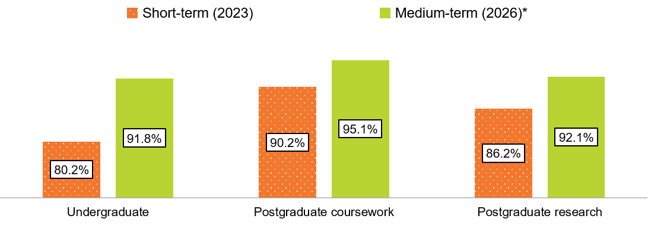
* Caution should be exercised when interpreting differences in full-time employment rates between 2026 medium-term results and the short-term results, as they partly reflect a change in methodology. Refer to the 2025 GOS-L report for further information.
Graduate’s median annual full-time salary increases significantly in the first 3 years following completion of their degree
The 3-year (from short-term to medium-term) annual full-time salary growth for the 2023–2026 cohort continued to be relatively high compared to cohorts from the pre-pandemic years (prior to 2020). Undergraduate and postgraduate coursework 3-year median salary growth (31.0 per cent and 22.4 per cent respectively) decreased compared to the 2022–2025 cohort (31.9 per cent and 27.1 per cent respectively), and postgraduate research graduates reported an all-time high of 25.0 per cent, an increase from 23.7 per cent reported by the 2022–2025 cohort. While undergraduate median salaries are lower in the short- and medium-term, they increased at a higher rate than both postgraduate coursework and postgraduate research median salaries (see Figure ii). Despite the higher growth reported by undergraduates, differences in median salary levels remained between undergraduate and postgraduate coursework graduates, possibly reflecting the skills and knowledge acquired through the different study levels as well as prior labour market experience.
Figure ii Short- and medium-term median salary for 2023 domestic graduates
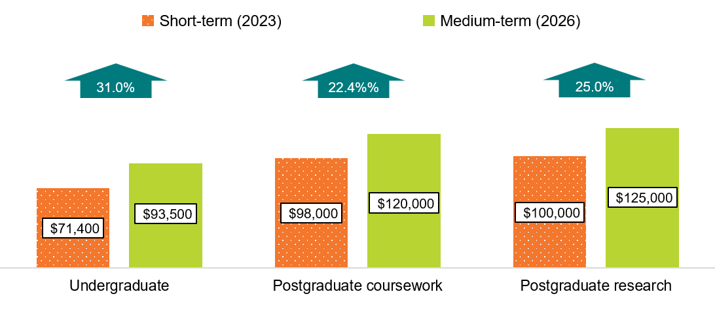Graduates transition into their preferred employment arrangements over time
Although 14.4 per cent of undergraduates indicated that they were working part-time and would prefer more hours in the short-term, 73.5 per cent of these undergraduates who were available for work in the medium-term were either employed full-time or satisfied with their working hours, with similar proportions for postgraduate coursework and postgraduate research graduates (Figure iii). These findings indicate that although graduates may not initially secure their desired employment arrangements 4 to 6 months after course completion, a substantial proportion do so over time.
Figure iii Select medium-term (2026) labour force classification for domestic graduates who were underemployed in 2023
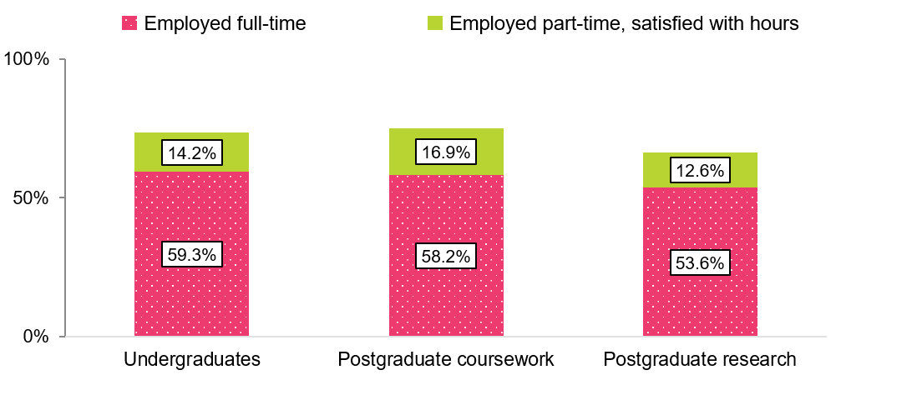
Perceived overqualification persists in the medium term, but this does not indicate poor graduate outcomes
Across all study levels, around 28 per cent of graduates who completed the GOS in 2023 were working in jobs that they felt were not fully utilising their skills and education 3 years after course completion. The main reason cited in the medium term across all study levels was 'I'm satisfied with my current job', at 26.8 per cent for undergraduates, and 29.3 per cent and 31.9 per cent for postgraduate coursework and postgraduate research graduates respectively. This suggests that not fully utilising skills and knowledge acquired in a course does not necessarily indicate an unsuccessful outcome for graduates. Among postgraduate research graduates that felt they were underutilised, 25.1 per cent reported that this was primarily due to a lack of suitable jobs in their area of expertise. This highlights that aligning employment with the highly specialised skills and education of this cohort presents challenges, even in the medium-term.
Differences between international and domestic graduate employment outcomes were smallest at the postgraduate research level
International graduates reported much lower full-time employment rates than their domestic counterparts in the short-term, but these differences narrowed in the medium-term. When compared to their domestic counterparts, full-time employment rates in the medium-term were 7.7 percentage points lower for international undergraduates, and 7.6 percentage points lower for postgraduate coursework graduates. The difference in the medium-term full-time employment rate for postgraduate research graduates was only 1.5 percentage points, suggesting that international graduates from this level of study have similar experiences in employment outcomes when compared to their domestic counterparts.
International graduates consistently report lower median salaries than their domestic peers, especially at the postgraduate coursework level
Differences in median salary between international and domestic graduates widen from the short-term to the medium-term. Compared to their domestic counterparts, reported medium-term salaries were $8,500 less for international undergraduates, $34,000 less for international postgraduate coursework graduates and $13,000 less for international postgraduate research graduates (Figure iv). Notably, international postgraduate coursework graduate median salaries are comparable to international undergraduate median salaries in the short- and medium-term. This suggests that, unlike domestic graduates, international graduates at this level continue to experience difficulty in translating their higher qualification into higher earnings 3 years after course completion.

Demographic and equity groups
- Disability: Domestic undergraduates with a disability in 2023 reported lower full-time and overall employment rates than domestic undergraduates without a disability, although the gap narrows in the medium-term.
- Regional/remoteness: Domestic undergraduates originally from regional and remote areas had much higher rates of full-time employment in the short-term and medium-term.
- Socio-economic status (SES): In the short- and medium-term, domestic undergraduates from high and low-SES areas had broadly similar rates of full-time employment and median salary.
- Language background: Domestic undergraduates from non-English speaking backgrounds reported the lowest full-time employment rate of all demographic sub-groups in the short- and medium-term. While median salary and rates of employment in managerial or professional roles for domestic undergraduates from non-English and English-speaking backgrounds were relatively comparable in the short-term, differences in these outcomes emerge in the medium-term.
Figure iv Medium-term median salary by study level and citizenship status for 2023 graduates
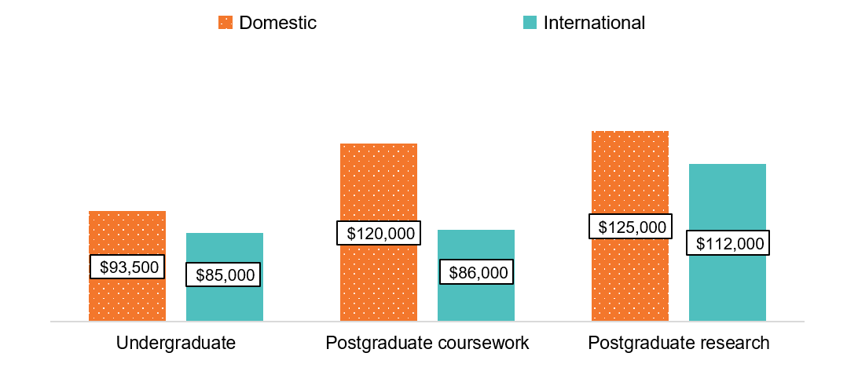
Contents
Executive summary ii
1. About the GOS-L 1
1.1 Participation 1
1.2 Further detail 1
1.3 Labour force participation changes 1
2. Domestic graduate results 2
2.1 Labour force participation 2
2.2 Full-time employment 5
2.3 Overall employment 8
2.4 Median annual full-time salary 9
2.5 Underemployment 11
2.5.1 Reasons for not working more hours 14
2.6 Domestic graduate skills utilisation 16
2.6.1 Occupation type 16
2.6.2 Underutilisation of skills and education 17
2.7 Domestic graduates in further full-time study 21
2.8 Demographic and equity groups 25
Disability 25
Graduates from regional and remote areas 25
Age…… 25
First Nations graduates 25
Socio-economic status 26
Language background 26
Gender. 26
2.9 Study area 30
2.10 Gender pay gap 35
2.11 Institution 36
2.11.1 Institution type 36
2.11.2 Comparative university outcomes 38
3. International graduate results 41
3.1 International graduate profile (based on responses to the 2026 GOS-L) 41
3.2 Comparative outcomes: international and domestic graduates 44
3.2.1 Undergraduate comparisons 44
3.2.2 Postgraduate coursework comparisons 45
3.2.3 Postgraduate research comparisons 46
3.2.4 Study area 47
3.3 Source country 50
Appendix 1 Labour market and graduate satisfaction definitions 53
A1.1 Examples of graduate labour market outcomes 54
Appendix 2 Detailed tables 55
A2.1 Gender pay gap 55
A2.2 Study area 57

List of tables
Table 1 Main reason not working more hours, of graduates employed part-time who would prefer to work more hours (% of those employed) 15
Table 2 Domestic graduates employed in managerial and professional occupations by employment type and study level (% of those employed) 16
Table 3 Main reason for working in a job that does not fully utilise skills and education, domestic graduates employed full-time, all occupations (%) 19
Table 4 Domestic undergraduate employment outcomes by demographic sub-group 27
Table 5 Domestic undergraduate labour market and further study outcomes by study area 32
Table 6 Short- and medium-term domestic graduate employment and study outcomes by study level and institution type 37
Table 7 Undergraduate short- and medium-term outcomes comparison: international and domestic graduates 44
Table 8 Postgraduate coursework short- and medium-term outcomes comparison: international and domestic graduates 45
Table 9 Postgraduate research short- and medium-term outcomes comparison: international and domestic graduates 46
Table 10 International undergraduate short- and medium-term outcomes by source country 51
Table 11 International postgraduate coursework short- and medium-term outcomes by source country 52
Table 12 Indicator definitions 53
Table 13 Undergraduate median annual full-time salary by gender and study area 55
Table 14 Domestic postgraduate coursework labour market outcomes by study area 57

List of figures
Figure 1 Short- and medium-term labour force participation rate for 2017 to 2023 domestic graduates 3
Figure 2 Reasons graduates are not in the labour force by study level, medium-term 2026 4
Figure 3 Short- and medium-term full-time employment rate for 2017 to 2023 domestic graduates 6
Figure 4 Full-time job experience by course level in the short- to medium-term, 2023 graduates 7
Figure 5 Short- and medium-term overall employment rate for 2017 to 2023 domestic graduates 8
Figure 6 Share of graduates employed part-time by study level, 2023 graduates (% of those employed) 9
Figure 7 Short- and medium-term median salary for 2017 to 2023 domestic graduates 10
Figure 8 Short- and medium-term median salary for 2023 graduates in their first full-time job by study level 11
Figure 9 Short- and medium-term underemployment rate (% of those employed) 12
Figure 10 Medium-term labour force classification for those underemployed in the short-term 13
Figure 11 Proportion of graduates who transitioned into a managerial and professional role in the medium-term by study level (% of those employed in other occupations in the short-term) 17
Figure 12 Perceived overqualification by employment type and study level, all occupations (% of those employed) 17
Figure 13 Proportion of domestic graduates engaged in further full-time study by study level 22
Figure 14 Domestic undergraduates undertaking further full-time study by original broad field of education (%) 23
Figure 15 Broad field of education destinations of domestic undergraduates undertaking further full-time study (%) 24
Figure 16 Domestic undergraduate full-time employment rate in the short- and medium-term, by study area 31
Figure 17 Median annual full-time salary by gender and study level 35
Figure 18 Undergraduate gender pay gap, medium-term, and 3-year salary growth by gender 36
Figure 19 Domestic undergraduate short- and medium-term full-time employment rate by university (% with 90% confidence intervals) 39
Figure 20 Domestic postgraduate coursework short- and medium-term full-time employment rate by university (% with 90% confidence intervals) 40
Figure 21 International graduate profile by study area and level (% based on responses to the 2026 GOS-L) 47
Figure 22 Undergraduate full-time employment rate by citizenship status and study area (%) 49
List of infographics
Infographic 1: Reasons associated with skill underutilisation in the short- to medium-term 21
Infographic 2: Domestic and international respondent profile comparison 41
Infographic 3: Graduate age by study level and citizenship status 42
Infographic 4: Top 5 source countries by study level 43

About the GOS-L
Graduates are invited to take the Graduate Outcomes Survey (GOS) 4 to 6 months after completing their studies. Graduates who responded to the GOS are invited to take the Graduate Outcomes Survey - Longitudinal (GOS-L) approximately 3 years later.
The two surveys complement and supplement one another, as the 2026 GOS-L report analyses the short- and medium-term outcomes of graduates who responded to the 2023 GOS (i.e. completed their course between March 2022 and February 2023) and the corresponding follow-up survey 3 years later.
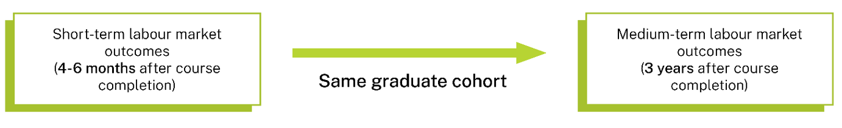
The GOS-L is an ongoing part of the Quality Indicators for Learning and Teaching (QILT) survey suite. GOS-L reports, including this report, provide robust, rich information to improve higher education. As well as examining general labour market outcomes (rates of full-time employment, overall employment, labour force participation and median annual full-time salaries), the reports focus on areas such as the gender pay gap, reasons for underemployment and how well qualifications prepared graduates for their current jobs.
Results for domestic graduates and international graduates, whether living in Australia or overseas, are presented separately in this report. This corresponds with presentation of short-term graduate outcomes published annually in the GOS National Report and GOS International Report (see Graduate Outcomes Survey).

Participation
The 2026 GOS-L was administered for all higher education institutions whose graduates participated in the 2023 GOS and were eligible to participate in the GOS-L.
In total, 125 institutions were included, with 43 universities and 82 non-university higher education institutions (NUHEIs) across all study levels. The GOS-L achieved an overall 53.6 per cent response rate in 2026 (43,665 completed surveys).

2026 participation
- 125 institutions
- 90,064 invitations sent
- 43,665 completed surveys
- 53.6% response rate

Further detail
This report is a selection of high-level results, but other information, such as data related to how well courses prepared graduates for work and further study, and more detailed labour force breakdowns, is available from Graduate Outcomes Survey - Longitudinal (qilt.edu.au).
This report is supported by a PowerBI workbook that allows readers to further explore data. Static Excel tables also provide supplementary data and detail.

Labour force participation changes
In 2025, changes were made to the labour force module in the GOS-L to enable greater alignment with the ABS labour force framework. These changes have implications for the comparability of medium-term labour force participation, full-time employment and overall employment with historical data prior to 2025. As a result, caution should be exercised when interpreting differences between medium-term and short-term outcomes for these measures. See Appendix 1 in the 2025 GOS-L National Report for further information.

Domestic graduate results

Labour force participation
Medium-term labour force participation for undergraduates and postgraduate coursework graduates decreased slightly from 2025 to 2026 while remaining relatively stable for postgraduate research graduates (Figure 1). Additionally, differences in levels of labour force participation across study levels in 2026 remain consistent with previous years. For example, the labour force participation rate of postgraduates remains higher than undergraduates, in both the short-term and medium-term.
Note that while there appears to be a decrease in the labour force participation rate across all study levels starting in 2025 and persisting in 2026, this decrease can be attributed to a change to the way the metric is calculated starting in 2025. Caution should be exercised when interpreting differences between medium-term results from 2025 onwards with historical medium- and short-term results.
Figure 1 Short- and medium-term labour force participation rate for 2017 to 2023 domestic graduates
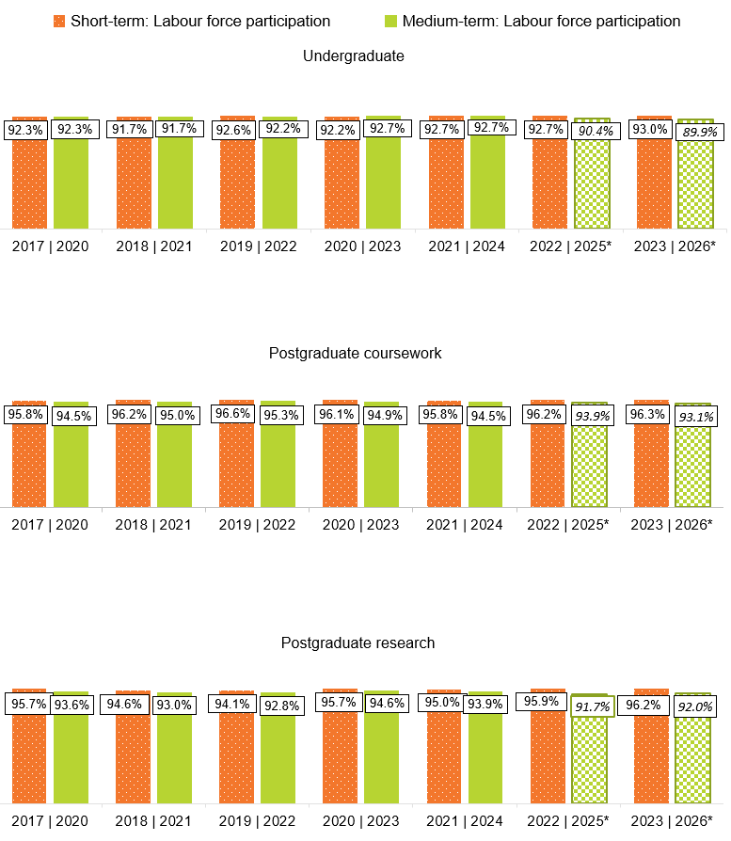
* Medium-term labour force participation rates from 2025 onwards are not directly comparable with earlier years due to a change to how the labour force is defined. Caution should be exercised when interpreting differences in labour force participation rates between 2025 and 2026 medium-term results, and the short-term results and other medium-term results, as they partly reflect the change in methodology. See Appendix 1 in the 2025 GOS-L National Report for further information.

A possible reason for the difference between medium-term undergraduate and postgraduate participation rates include a larger proportion of undergraduates deciding to return to (or actively engaged in) further study, even in the medium-term (Figure 2). In 2026, 42.2 per cent of undergraduates cited further studies as a reason they were not intending to work, compared to 18.6 per cent and 21.9 per cent among postgraduate coursework and postgraduate research graduates respectively. This aligns with the profiles of graduates from the three study levels— undergraduates are more likely to be at the beginning of their higher education journey compared to postgraduates.
Figure 2 Reasons graduates are not in the labour force by study level, medium-term 2026
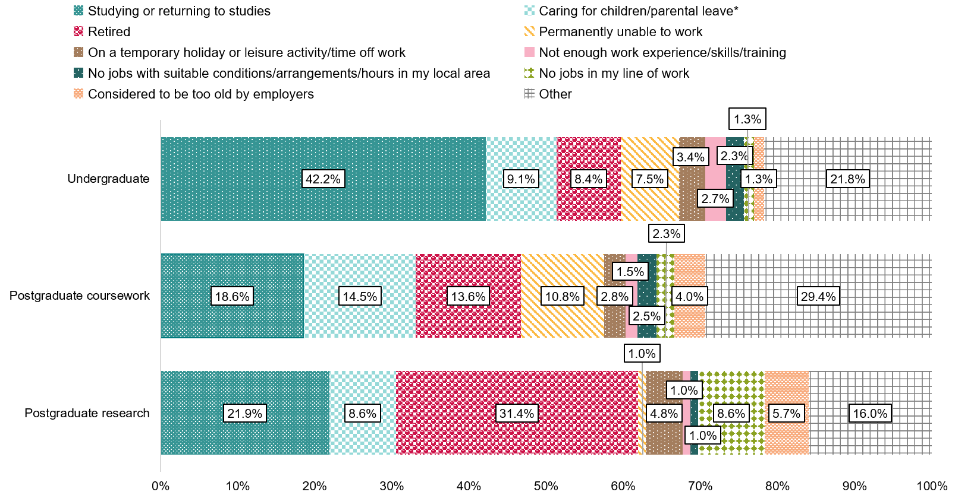
*’Caring for children/parental leave’ also includes the reason ‘maternity leave or paternity leave’.

Full-time employment
Graduates who completed the 2026 GOS-L completed the 2023 GOS during a period of favourable employment conditions due to reduced competition for job vacancies. This is reflected in the sharp rise in the short-term full-time employment rate across all study levels in 2022, with a further increase in 2023 (Figure 3). These results are consistent with results from the Australian Bureau of Statistics (ABS) Labour Force Survey.
In line with previous years, the 2023 short-term undergraduate full-time employment rate (80.2 per cent) continued to be lower than the full-time employment rate for postgraduate coursework (90.2 per cent) and postgraduate research graduates (86.2 per cent). Over the medium-term, this difference narrowed to 3.3 percentage points between undergraduate and postgraduate coursework graduates, and 0.3 percentage points between undergraduate and postgraduate research graduates. This narrowing over the medium-term suggests that it takes more time for undergraduates to transition to full-time employment after their studies – reflecting both their relatively lower levels of prior work experience and their propensity to pursue further study (see Domestic graduates in further full-time study).
The 2026 medium-term full-time employment rates remained consistent with 2025 for undergraduates and postgraduates coursework graduates, and slightly decreased for postgraduate research graduates. In general, medium-term labour market outcomes for graduates are less volatile than short-term outcomes. This is likely due to graduates being more established in their jobs 3 years after completing their studies, as well as the increased proportions of graduates employed in managerial and professional occupations (see Domestic graduate skills utilisation).
Note that in 2025, medium-term full-time employment rates appeared to increase year-on-year across all study levels. Part of this change can be attributed to the change in how the labour force is defined. Caution should be exercised when interpreting differences between medium-term results prior to 2025 as a result of this change. See Appendix 1 in the 2025 GOS-L National Report for further information.
Figure 3 Short- and medium-term full-time employment rate for 2017 to 2023 domestic graduates
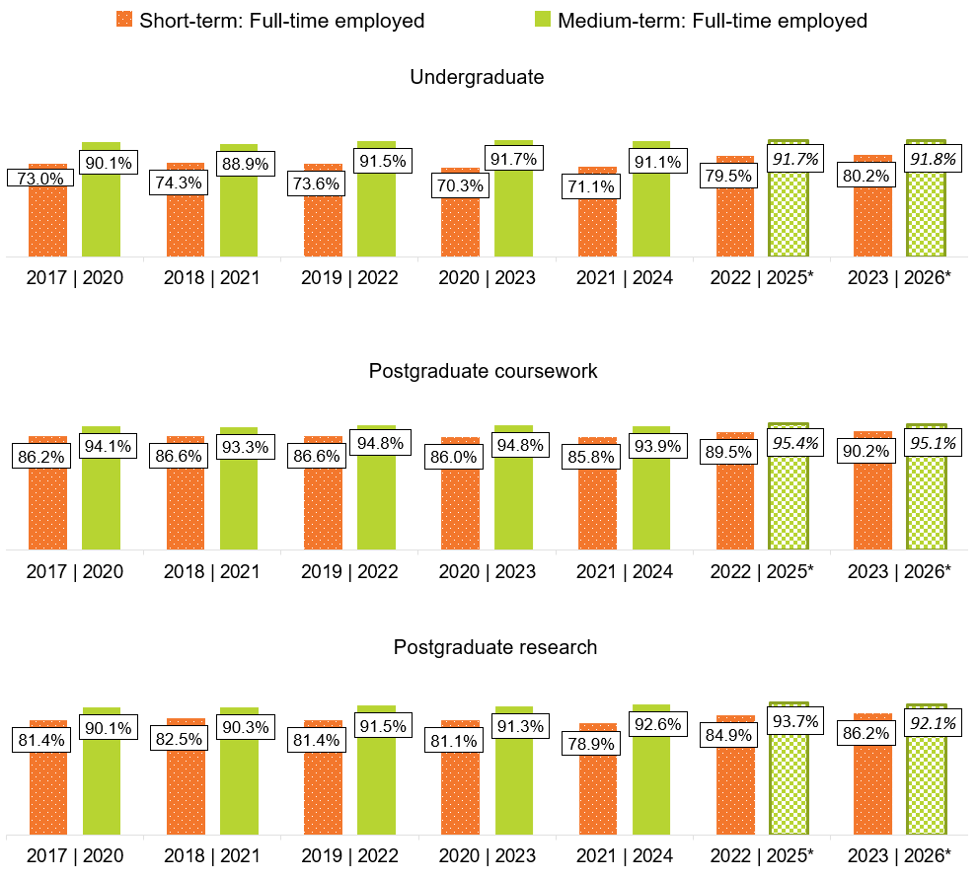
* Medium-term full-time employment rates from 2025 onwards are not directly comparable with earlier years due to a change to how the labour force is defined. Caution should be exercised when interpreting differences in full-time employment rates between 2025 and 2026 medium-term results, and the short-term results and other medium-term results, as they partly reflect the change in methodology. See Appendix 1 in the 2025 GOS-L National Report for further information.
Undergraduates’ lower full-time employment rate in the short-term can be partially attributed to their lower age and consequently lower levels of work experience. In the short-term, of those who were full-time employed and working for an employer, 38.1 per cent of undergraduates were working in their first full time job (Figure 4)., In contrast, only 11.2 per cent of postgraduate coursework graduates and 20.7 per cent of postgraduate research graduates were working in their first full-time job in the short-term. Compared to undergraduates, a much larger share of postgraduate coursework and postgraduate research graduates had been working with their employer for longer than 12 months. In the medium-term, the proportion of undergraduates working in their first full-time job drops dramatically to 3.3 per cent, reflecting the increase in full-time work experience for this cohort over the short- to medium-term.
Figure 4 Full-time job experience by course level in the short- to medium-term, 2023 graduates
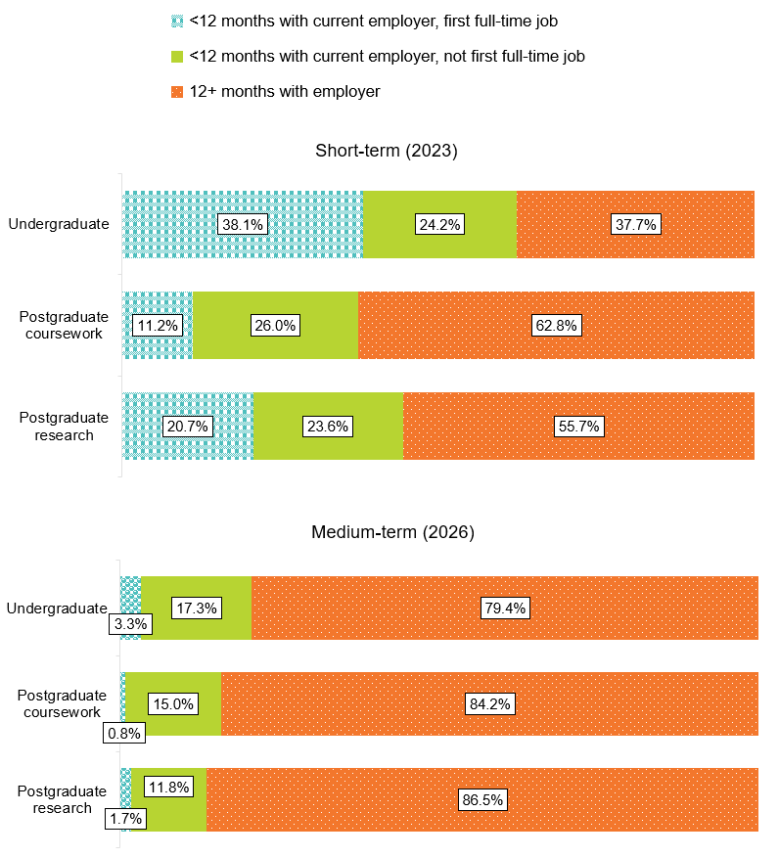
*First full-time job is only asked of those who have been with their current employer for less than 12 months. This metric is a proxy indicator for recent entrants to the full-time labour market.

Overall employment
The difference in overall employment rates between the short-term and medium-term for 2023 graduates narrowed in 2026, reflecting the transition of those unemployed into part-time and full-time employment in the medium term. Compared to 2025, medium-term overall employment rates have remained stable at the undergraduate level and slightly decreased at the postgraduate coursework and postgraduate research level.
Figure 5 Short- and medium-term overall employment rate for 2017 to 2023 domestic graduates
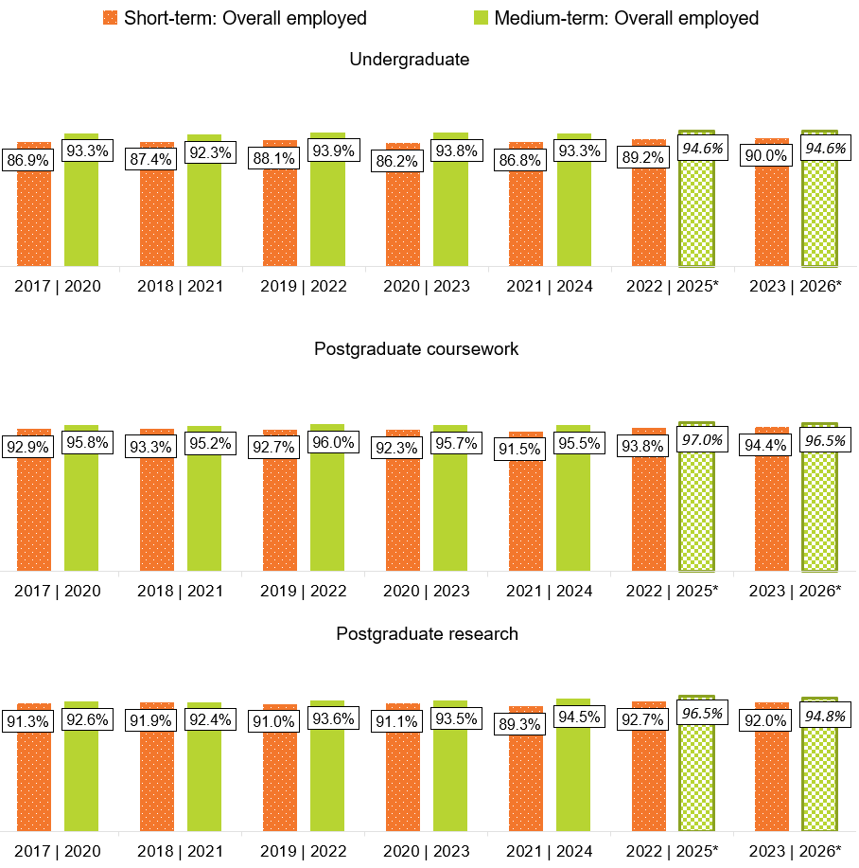
* Medium-term overall employment rates from 2025 onwards are not directly comparable with earlier years due to a change to how the labour force is defined. Caution should be exercised when interpreting differences in overall employment rates between 2025 and 2026 medium-term results, and the short-term results and other medium-term results, as they partly reflect the change in methodology. See Appendix 1 in the 2025 GOS-L National Report for further information.
In general, the full-time employment rate is lower than the overall employment rate (including part-time and full-time hours) of recent graduates, 4 to 6 months after course completion. Three years later, this difference narrows which may indicate that while most graduates are available to work full-time soon after completing their studies, accessing full-time hours can take time. This pattern is most notable at the undergraduate level but can also be seen at the postgraduate research and, to a lesser extent, postgraduate coursework levels.
For example, the full-time employment rate of recent undergraduates in 2023 was 80.2 per cent (Figure 3) and the overall employment rate was 90.0 per cent (Figure 5), a difference of 9.8 percentage points. Three years later in 2026, the full-time employment rate had risen to 91.8 per cent and the overall employment rate was 94.6 per cent, a difference of only 2.8 percentage points.
These patterns coincide with a large decrease in the proportion of employed undergraduates who were working part-time hours from the short-term to medium-term (Figure 6). This decrease is reflective of undergraduates taking time to transition to full-time employment. For postgraduate coursework and postgraduate research graduates, the share of part-time hours only slightly decreased from the short-term to medium-term.
Figure 6 Share of graduates employed part-time by study level, 2023 graduates (% of those employed)
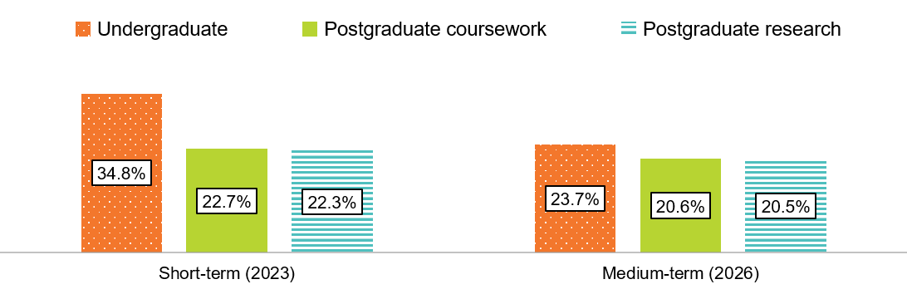

Median annual full-time salary
Domestic graduates with postgraduate qualifications have higher median salaries than those with undergraduate qualifications in the short- and medium-term (Figure 7). This difference in median salaries by study levels may be attributed to more advanced or specialised skills and knowledge acquired in a postgraduate level course, but it is also likely driven by graduates’ prior labour market experience or establishment in the labour force before or during their studies.
While undergraduate median salaries were lower in the short- and medium-term, they increased at a higher rate than both postgraduate coursework and postgraduate research median salaries. Despite increasing at a higher rate over the 3-year period, in dollar terms, the difference in median salaries remained: the postgraduate coursework median salary was $26,500 higher than the undergraduate salary in the medium-term. Compared to the 2022–2025 cohort, this difference has widened by $1,500.
Postgraduate research graduates continued to report the highest median salary of the 3 study levels: $28,600 more than undergraduates and $2,000 more than postgraduate coursework graduates in the short-term. From a high starting point, postgraduate research graduate median salary grew at a slower rate in comparison to undergraduates (25.0 per cent compared to 31.0 per cent), and faster compared to postgraduate coursework graduates (22.4 per cent).
Figure 7 Short- and medium-term median salary for 2017 to 2023 domestic graduates
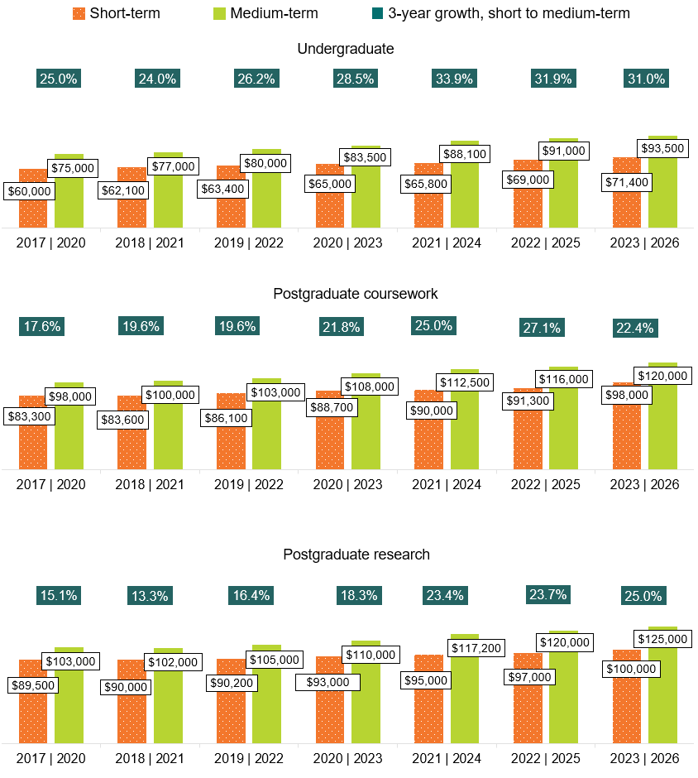
Note: Salary growth in the 2023–2026 period continued to be relatively high compared to the pre-pandemic years among all levels of study. This is consistent with the relatively high levels of salary growth across the public and private sectors per the ABS Wage Price Index as well as the Average Weekly Ordinary Time Earnings for full-time adult employees during the same period.,
Strong salary growth occurred for undergraduates during 2022 and 2023, a period of favourable employment conditions due to reduced competition for job vacancies. As both of these years were fully experienced by the 2021–2024 cohort, this cohort recorded the peak undergraduate 3-year salary growth in the GOS-L series (33.9 per cent). The 3-year growth rate has diminished slightly for both the 2022–2025 (31.9 per cent) and 2023–2026 (31.0 per cent) cohorts, as the 3-year growth periods move beyond 2022 and 2023.
The salary growth rate for postgraduate coursework dropped substantially for the 2023–2026 cohort (to 22.4 per cent, from 27.1 per cent for the 2022–2025 cohort). It should be noted that this may in part be due to the particularly high short-term salary for this cohort in 2023, coupled with a medium-term salary that is in line with historical data.
The salary growth rate for postgraduate research has continued to climb from 23.7 per cent for the 2022–2025 cohort to a new high of 25.0 per cent for the 2023–2026 cohort.
The relatively higher salary growth rate for undergraduates compared to postgraduate coursework and postgraduate research graduates can be partially explained by the differences in prior labour force experience, as entrants to the labour force typically see higher growth in salary during their first few years. As outlined in Full-time employment, undergraduates were more likely to be working in their first full-time job compared to postgraduate coursework and postgraduate research graduates in the short-term.
The 3-year salary growth for undergraduate and postgraduate coursework graduates who indicated they were in their first full-time job in the short-term (Figure 8), was notably higher than the growth reported by the broader undergraduate and postgraduate coursework cohorts respectively (Figure 7). Postgraduate coursework graduates in their first full-time job reported a short-term median salary that was lower than the broader postgraduate coursework cohort by $22,700 (and only slightly higher than the short-term median salary of undergraduates). This lower short-term median salary led to a 3-year growth rate that was 13.0 percentage points higher than the broader postgraduate coursework cohort. Notably, reported salary for postgraduate research graduates in their first full-time job was higher than graduates in their first full-time job at other study levels in the short-term, and their salary growth was lower from the short-term to medium-term.
Figure 8 Short- and medium-term median salary for 2023 graduates in their first full-time job by study level
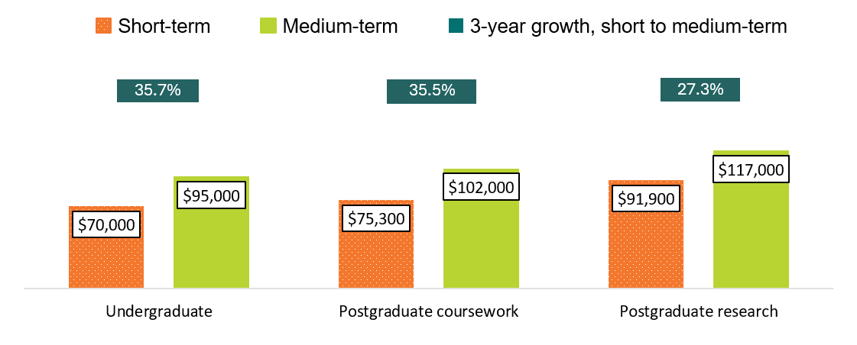

Underemployment
An ‘underemployed’ person is someone employed part-time (less than 35 hours per week) who would prefer to work more hours – regardless of if they are available to work those additional hours. Rates of underemployment are typically higher in the short-term, 4 to 6 months after course completion, but narrow over time, as seen in Figure 9.
In 2023, short-term underemployment rates followed a pattern of continued recovery from the tail end of the pandemic. Following a sharp drop in underemployment in 2022, underemployment increased slightly for undergraduates and postgraduate coursework graduates and slightly decreased for postgraduate research graduates. Across all study levels, short-term underemployment remained well below the ranges observed prior to 2022.
In the medium-term, underemployment levels in 2026 remained broadly similar to 2025, ranging from 4.7 per cent for postgraduate coursework graduates, to 7.5 per cent for undergraduates.
Figure 9 Short- and medium-term underemployment rate (% of those employed)
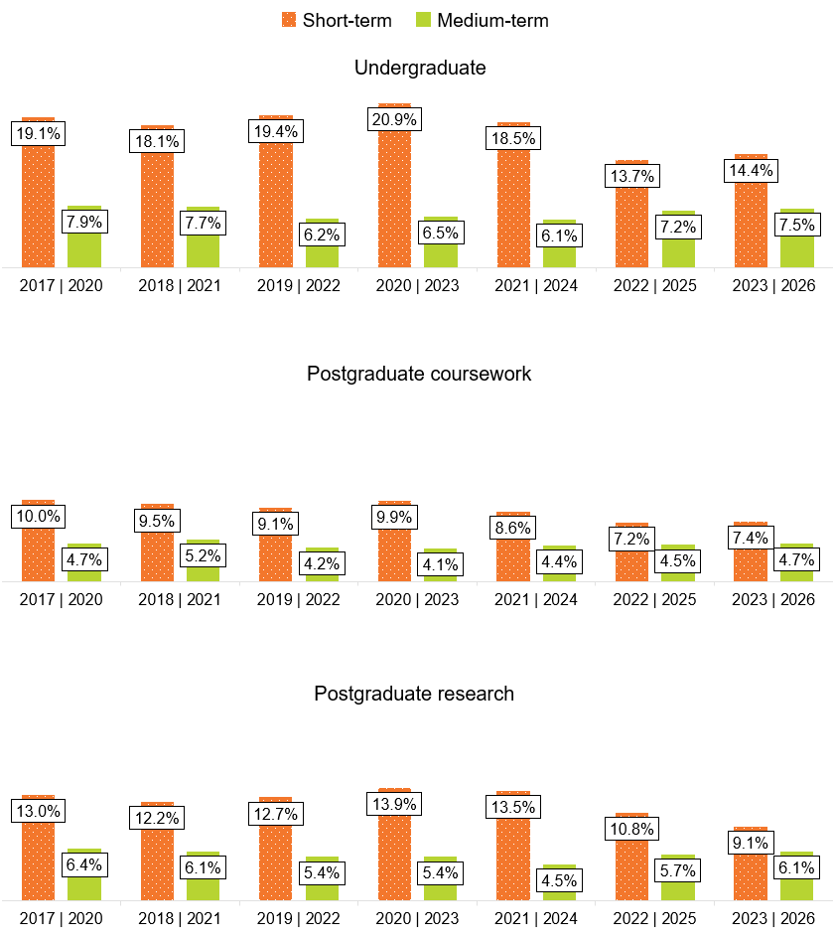
Three years after course completion, 59.3 per cent of short-term underemployed undergraduates who were available for work in the medium-term had transitioned to full-time employment (Figure 10). The results are similar at the postgraduate coursework and postgraduate research level. These results suggest that even though graduates may not initially be in a position to acquire employment which aligns with their skills and qualifications in the short-term, a considerable proportion of these graduates go on to acquire employment which suit their preferences in the medium-term.
Figure 10 Medium-term labour force classification for those underemployed in the short-term
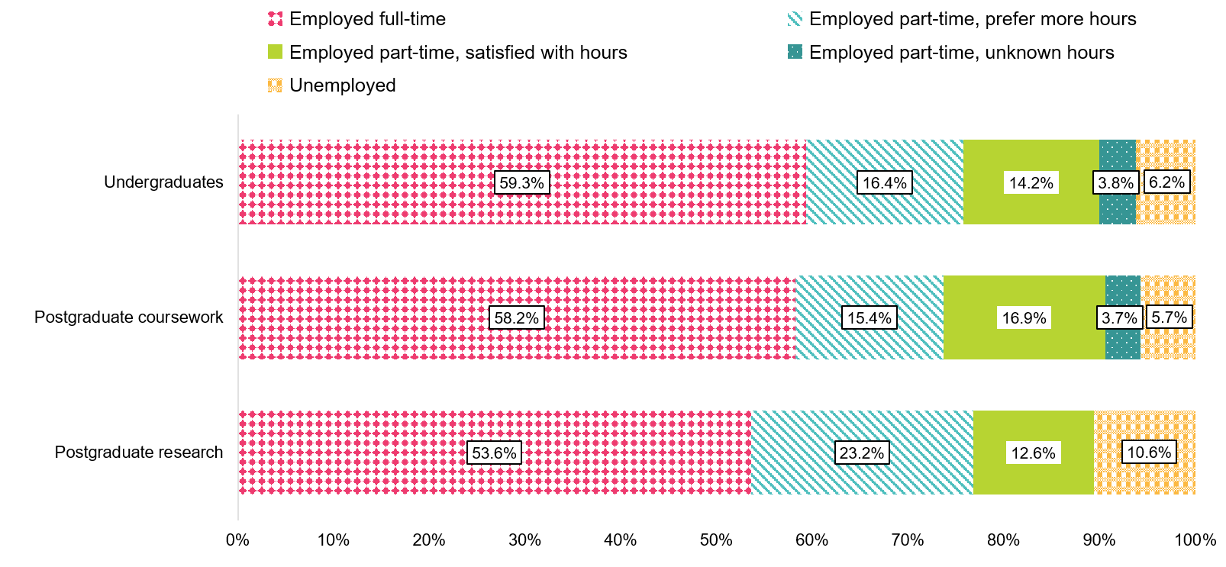

Reasons for not working more hours
Examining why graduates employed part-time are working the number of hours they do, despite their preference to work more, provides some insight into differences between underemployed graduates across study levels and how these reasons may shift from the short-term to the medium-term (Table 1).
Across all study levels, ‘no more hours available in current position’ was the main reason graduates reported working the number of hours they do, despite their preference to work more in both the short-term and medium-term. While employees may prefer part-time working arrangements with greater flexibility than standard full-time employment, employers may adjust their workforce by changing hours of employees (rather than changing number of employees) when accounting for changes in business demand. Notably, this proportion increases in the medium-term due to other labour market factors diminishing over time as graduates establish themselves in the labour market.
For undergraduates, ‘studying’ was the second most cited reason in both the short-term and medium-term. Notably, the proportion of underemployed undergraduates citing ‘studying’ as a main reason for not working more hours slightly increases 3 years after course completion, reflecting the strong propensity for undergraduates to pursue further study (see Domestic graduates in further full-time study).
For postgraduate coursework graduates, ‘caring for children’ was the second most cited reason in the short-term and medium-term and they were more than twice as likely to cite this reason compared to undergraduates and postgraduate research graduates. This aligns with postgraduate coursework graduates’ older age profile, particularly compared to undergraduates.
For postgraduate research graduates, ‘no jobs in my area of expertise’ was the second most cited reason, and they were more than twice as likely to report this reason compared to undergraduates and postgraduate coursework graduates. This may indicate difficulties for these graduates in securing employment that aligns with their specialised skills and education in the short-term. The proportion of underemployed postgraduate research graduates citing this as a main reason for not working more hours, diminishes over time, suggesting that graduates are increasingly able to transition into roles better aligned with their skills in the medium-term.
Table 1 Main reason not working more hours, of graduates employed part-time who would prefer to work more hours (% of those employed)
Reason type | Undergraduate:  Short-term (2023) | Undergraduate:  Medium-term (2026) | Postgraduate coursework:  Short-term (2023) | Postgraduate coursework:  Medium-term (2026) | Postgraduate research:  Short-term (2023) | Postgraduate research:  Medium-term (2026)
Personal factors: Studying | 16.6 | 17.8 | 7.3 | 7.6 | 1.9 | 7.5
Personal factors: Caring for children | 4.6 | 5.4 | 14.0 | 11.8 | 3.7 | 6.6
Personal factors: Long-term health condition or disability | 0.5 | 3.8 | 0.6 | 4.1 | 0.6 | 3.8
Personal factors: Due to other commitments outside of main job | 0.7 | 3.7 | 1.1 | 4.4 | 3.1 | 3.8
Personal factors: Other personal factors | 0.3 | 2.7 | 0.8 | 4.6 | 0.0 | 0.9
Sub-total:  Personal factors | 22.8 | 33.3 | 23.9 | 32.5 | 9.3 | 22.6
Labour market factors: No suitable job in my local area | 4.1 | 3.0 | 5.5 | 4.4 | 7.4 | 5.7
Labour market factors: No job with a suitable number of hours | 4.9 | 2.6 | 5.4 | 3.2 | 7.4 | 6.6
Labour market factors: No suitable job in my area of expertise | 10.3 | 5.1 | 9.3 | 6.9 | 23.5 | 14.2
Labour market factors: No more hours available in current position | 45.3 | 51.9 | 38.6 | 45.7 | 41.4 | 48.1
Labour market factors: Other labour market factors | 2.7 | 0.3 | 3.2 | 0.0 | 3.7 | 0.0
Sub-total:  Labour market factors | 67.3 | 62.9 | 62.1 | 60.2 | 83.3 | 74.5
Other factors | 9.9 | 3.8 | 14.0 | 7.3 | 7.4 | 2.8
Total | 100.0 | 100.0 | 100.0 | 100.0 | 100.0 | 100.0
Employed part-time, would prefer more hours (% of those employed) | 14.4 | 7.5 | 7.4 | 4.7 | 9.1 | 6.1

Domestic graduate skills utilisation
This section focuses on measures of ‘skills utilisation’, which to an extent reflects the ‘quality’ of graduate jobs. These include the proportion of graduates employed in managerial or professional occupations, and whether graduates believe they are utilising their skills and education in their current role.
These measures provide useful information about how well graduates' skills are matched with employment, and how these change from the short-term to medium-term. It is important to note that there are a range of factors, beyond the quality of educational experience, that may influence occupational outcomes. This includes the proportion of graduates undertaking further full-time study, and registration or professional accreditation timelines.

Occupation type
The proportion of graduates working in managerial and professional occupations can be used as a proxy measure of skills utilisation. This is because the classification of occupations used by the ABS suggests that most managerial and professional occupations have a skill level commensurate with qualifications at the bachelor level or higher.
The 2026 GOS-L reaffirms previous findings that undergraduates may take longer to find work in managerial or professional occupations, while domestic graduates with postgraduate qualifications are more likely to be employed in managerial or professional occupations 4 to 6 months after course completion, and this continues to rise over the 3-year period (Table 2).
The higher rates of postgraduate coursework graduates employed in managerial or professional occupations shortly after course completion reflect the older profile of these graduates and their establishment in the labour market. These differences in occupation type across study levels also correspond with differences in median salaries (see Median annual full-time salary).
Table 2 Domestic graduates employed in managerial and professional occupations by employment type and study level (% of those employed)
Employment type | Undergraduate:  Short-term (2023) | Undergraduate:  Medium-term (2026) | Postgraduate coursework:  Short-term (2023) | Postgraduate coursework:  Medium-term (2026) | Postgraduate research:  Short-term (2023) | Postgraduate research:  Medium-term (2026)
Full-time employed | 70.6 | 78.7 | 85.7 | 89.1 | 90.5 | 93.6
Overall employed | 61.3 | 74.6 | 84.0 | 88.3 | 89.7 | 92.8
Four to six months after course completion, 29.4 per cent of undergraduates in full-time employment were not working in managerial or professional roles. Of those still working full-time 3 years later, 54.5 per cent reported working in managerial and professional occupations (Figure 11). The proportions transitioning into managerial and professional roles were even higher for graduates from the postgraduate coursework and postgraduate research levels. As with improvements in outcomes for graduates who were underemployed in the short-term, this result suggests that although graduates may not initially find employment that matches their skills and education in the short-term, a large proportion are able to find more suitable employment in the medium-term.
Figure 11 Proportion of graduates who transitioned into a managerial and professional role in the medium-term by study level (% of those employed in other occupations in the short-term)
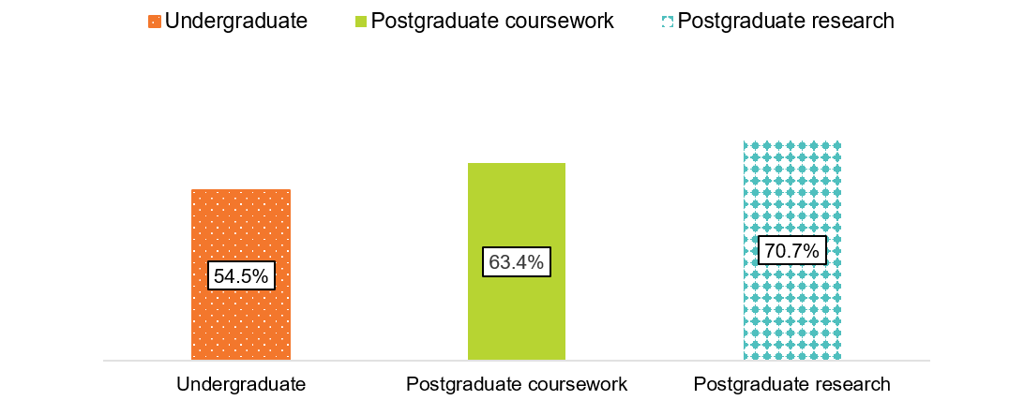

Underutilisation of skills and education
Shortly after course completion, 28.0 per cent of domestic undergraduates employed full-time considered themselves overqualified (see Figure 12). This decreased to 23.6 per cent 3 years later, though the rate remains high, suggesting that even 3 years on, graduates were not fully utilising their skills and education. Results were similar for postgraduate coursework and postgraduate research graduates despite the higher proportion of these graduates being employed in managerial or professional occupations (Table 2).
Of those who were employed overall, 38.0 per cent of undergraduates reported feeling overqualified in the short-term, which decreased to 28.0 per cent 3 years later. This may reflect that a sizeable proportion of undergraduates employed overall in the short-term were pursuing full-time study and thus would be more likely to be working in jobs that allow them to balance work with their study commitments.
Figure 12 Perceived overqualification by employment type and study level, all occupations (% of those employed)
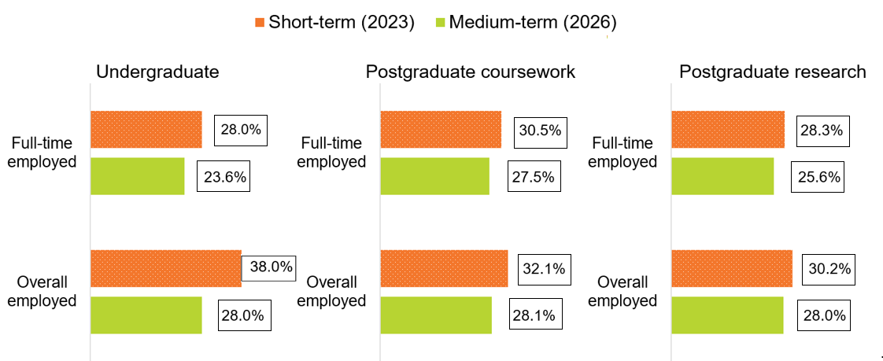

Although perceived overqualification persists in the medium-term, satisfaction with their current job was the most commonly cited reason for working in a job that did not fully utilise graduates’ skills and education across all study levels. This suggests that not fully utilising skills and knowledge does not necessarily indicate an unsuccessful outcome for graduates.
Graduates were asked to provide their main reason for working in a job that did not fully utilise their skills and education; these reasons are presented in Table 3. 38.0%
After recently graduating, undergraduates cited that the main reason for working in a job that did not fully utilise their skills and education was 'entry level job/career stepping stone' (29.1 per cent). Three years later, this reason notably decreased to 0.8 per cent, reflecting graduates getting a foothold into the job market.
For postgraduate coursework graduates, 'I'm satisfied with my current job' was the main reason cited, with 20.2 per cent citing this reason in the short-term, and increased to 29.3 per cent in the medium-term. The growth in graduates citing this reason for perceived overqualification is consistent across all study levels in the medium-term, suggesting that not fully utilising skills and knowledge acquired in a course does not necessarily equate to an unsuccessful outcome.
Postgraduate research graduates were much more likely to cite 'No suitable jobs in my area of expertise' as their main reason in the short-term (19.3 per cent) compared to undergraduates (7.1 per cent) and postgraduate coursework graduates (9.0 per cent), increasing to 25.1 per cent in the medium-term. This is consistent with the reasons cited by this cohort who were underemployed (see Reasons for not working more hours), highlighting that these graduates may benefit from additional career support to help them align their highly specialised skills with available roles.
When looking at the main reason for working in a job that does not fully utilise skills and education, there is a notable growth in personal as opposed to labour market factors in the short- to medium-term for undergraduates and postgraduate research graduates. This suggests that over time, as these cohorts establish themselves in the labour market, skill underutilisation becomes less driven by labour market mismatch and more by personal preferences.

Table 3 Main reason for working in a job that does not fully utilise skills and education, domestic graduates employed full-time, all occupations (%)
Reason type | Undergraduate:  Short-term (2023) | Undergraduate:  Medium-term (2026) | Postgraduate coursework:  Short-term (2023) | Postgraduate coursework:  Medium-term (2026) | Postgraduate research:  Short-term (2023) | Postgraduate research:  Medium-term (2026)
Personal factors:  I'm satisfied with my current job | 13.9 | 26.8 | 20.2 | 29.3 | 22.0 | 31.9
Personal factors:  For financial reasons | 8.1 | 6.9 | 6.4 | 5.8 | 6.5 | 4.7
Personal factors:  Changing jobs/careers | 8.2 | 1.5 | 14.4 | 2.0 | 8.2 | 2.0
Personal factors:  Studying | 6.1 | 5.6 | 3.4 | 2.4 | 2.2 | 1.2
Personal factors:  Caring for children or family member | 1.3 | 2.1 | 4.0 | 6.6 | 2.4 | 5.3
Personal factors:  Other personal factors | 1.4 | 1.6 | 0.4 | 1.6 | 0.3 | 2.3
Sub-total:  Personal factors | 39.0 | 44.5 | 48.8 | 47.7 | 41.6 | 47.4
Labour market factors:  No suitable jobs in my area of expertise | 7.1 | 12.9 | 9.0 | 14.6 | 19.3 | 25.1
Labour market factors:  Entry level job/career stepping stone | 29.1 | 0.8 | 13.5 | 1.0 | 14.7 | 0.9
Labour market factors:  Not enough work experience | 9.6 | 16.6 | 7.3 | 8.1 | 5.7 | 3.2
Labour market factors:  No suitable jobs in my local area | 6.5 | 10.1 | 9.0 | 12.0 | 7.1 | 11.1
Labour market factors:  Other | 3.5 | 7.4 | 7.1 | 8.4 | 6.7 | 4.4
Sub-total:  Labour market factors | 55.8 | 47.8 | 45.9 | 44.1 | 53.5 | 44.7
Other factors | 5.2 | 7.6 | 5.2 | 8.2 | 4.9 | 7.9
Total | 100.0 | 100.0 | 100.0 | 100.0 | 100.0 | 100.0
Perceived overqualification (% of those employed full-time) | 28.0 | 23.6 | 30.5 | 27.5 | 28.3 | 25.6

Infographic 1: Reasons associated with skill underutilisation in the short- to medium-term
For undergraduates and postgraduate research graduates, reasons for working in jobs that do not fully utilise their skills and education shift from labour market factors to personal factors over the short- to medium-term.
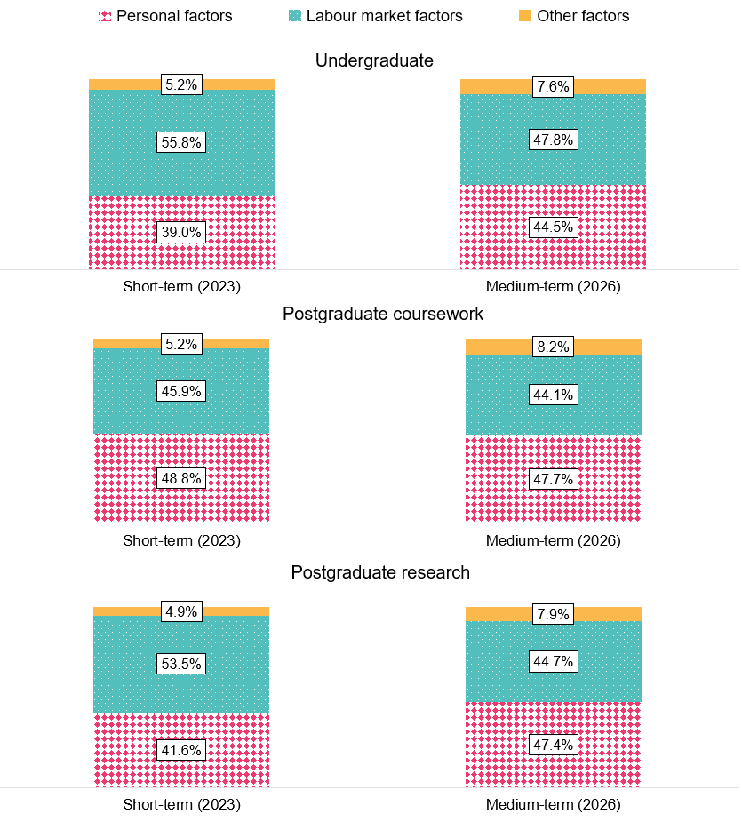

Domestic graduates in further full-time study
Figure 13 shows the proportion of graduates who were enrolled in a full-time course at the time of the GOS in 2023 and the proportion enrolled at the time of the GOS-L in 2026. It should be noted that graduates may have completed additional qualifications during the 3-year period between the GOS and the GOS-L.
Graduates who completed an undergraduate qualification had the greatest propensity to continue straight to further full-time study following completion of their course – almost 3 times more likely than graduates who completed postgraduate level qualifications. In the medium-term, undergraduates were still much more likely to be undertaking full-time study compared to graduates from postgraduate level qualifications. This sustained pattern suggests that the educational journey for undergraduates commonly extends beyond the medium-term.
Figure 13 Proportion of domestic graduates engaged in further full-time study by study level
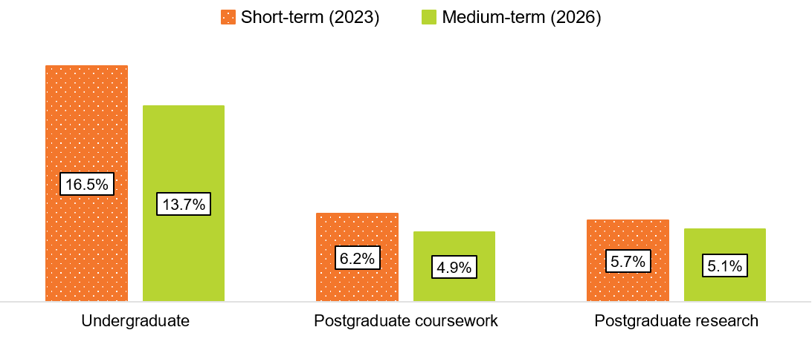
Rates of further full-time study differed by field of education., As with previous years, undergraduates from Natural and physical sciences reported the highest further full-time study rates in the short-term, which is up to 3 times higher than other study areas. Notably, this remains high in the medium-term (Figure 14) reflecting the long academic trajectory for students in this field of education. The further full-time study rate for undergraduates from Society and culture was also relatively high in the short-term (22.7 per cent) but this dropped considerably in the medium-term (15.1 per cent). Rates of further full-time study for other broad fields of education remained stable or decreased slightly from the short- to medium-term.

Figure 14 Domestic undergraduates undertaking further full-time study by original broad field of education (%)
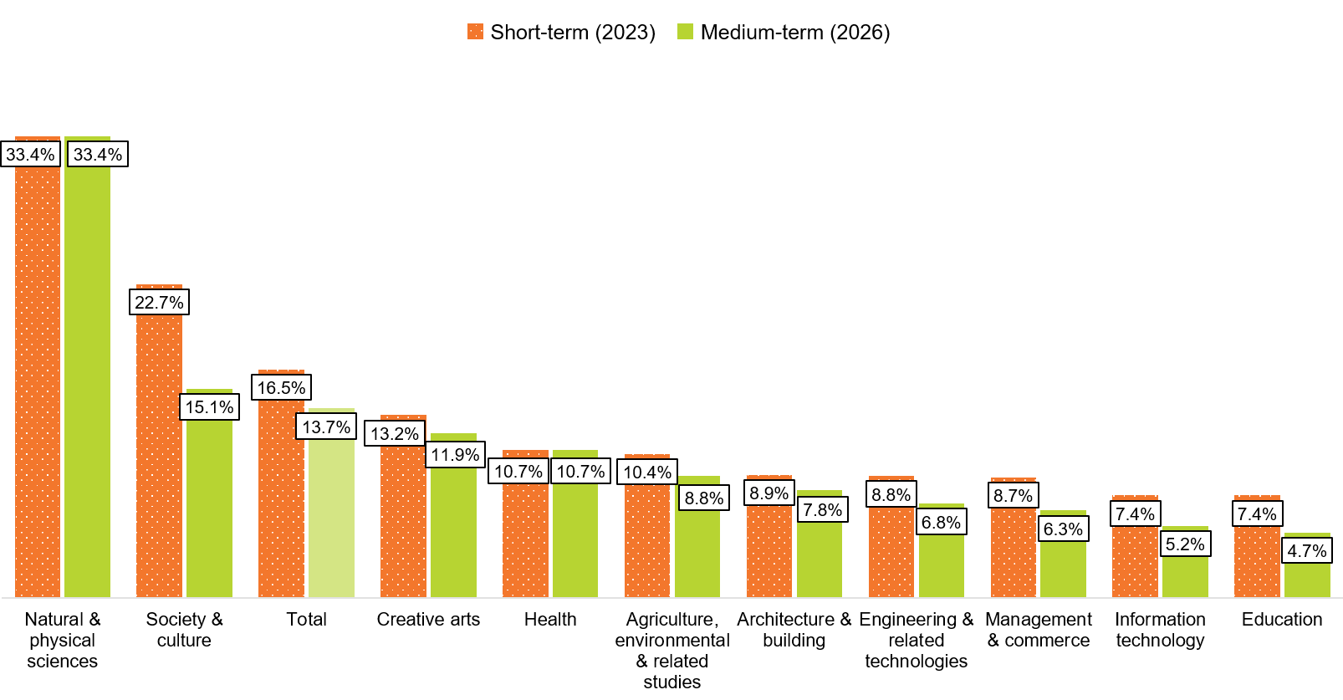For both the short-term and medium-term, over 70 per cent of undergraduates in further full-time study moved into one of 3 broad fields of education: Health, society and culture, and Natural and physical sciences (Figure 15). Within these 3 broad fields of education, the proportion studying Health increased in the short- to medium-term from 24.0 per cent to 33.5 per cent, while the proportion of those studying Society and culture declined from 31.9 per cent to 24.1 per cent. The proportion of undergraduates in further full-time study in Natural and physical sciences remained steady.
Figure 15 Broad field of education destinations of domestic undergraduates undertaking further full-time study (%)
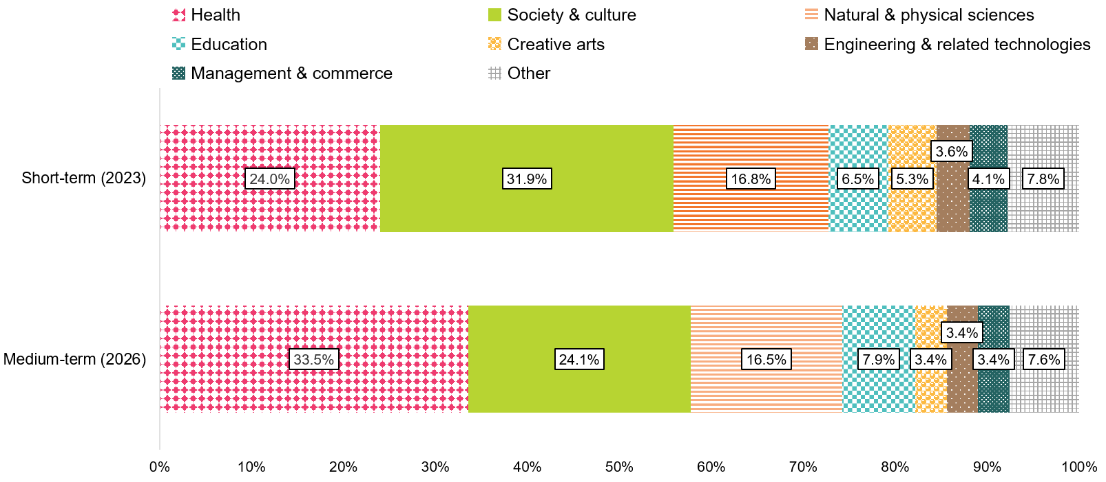
Note: 'Other' includes Agriculture, environmental & related studies and Architecture & Building, Information Technology. For a full-breakdown, please refer to the 2026 GOS-L National Report Tables on the QILT website.

Demographic and equity groups
Outcomes varied among different sub-groups of graduates at all levels of study. This section describes results for undergraduates. Sub-group outcomes for postgraduate coursework and postgraduate research graduates follow similar patterns to undergraduates and are available in supplementary tables on the QILT website.

Disability
As seen in Table 4, domestic undergraduates with disability in 2023 were less likely to be employed 4 to 6 months after completing their course than their counterparts without disability, and even less likely to be in full-time employment. Three years later, the difference in full-time employment rates narrowed from 10.6 percentage points to 5.6 percentage points, suggesting that it takes longer for these graduates to secure full-time employment. It is worth noting that despite the rates narrowing, the difference remained substantial even after 3 years.
For those who were able to secure full-time employment, skills utilisation, as measured by those working in professional and managerial occupations, was broadly comparable across undergraduates with and without disability over the short- and medium-term.
Notably, the median salary for domestic undergraduates with disability in the short-term was comparable to graduates without disability, with a difference of only $400, but this gap increased to $2,700 over the medium-term. This widening gap in median salaries may be due to the slower start for graduates with disability. As graduates with a disability take longer to secure full-time employment, they would on average have less experience in the labour market in the medium-term.

Graduates from regional and remote areas
Domestic undergraduates originally from regional and remote areas had much higher rates of full-time employment in the short-term (by 6.0 percentage points). Their rates also remained higher 3 years later, albeit with the gap narrowing to 3.0 percentage points.
Notably, domestic undergraduates originally from regional and remote areas reported slightly higher median salaries, and slightly higher rates of working in managerial or professional positions, with these differences remaining broadly consistent over the medium-term.

Age
Undergraduates aged over 30 reported moderately higher rates of full-time employment in the short-term compared to those aged 30 years and under (a difference of 3.9 percentage points), but this gap narrows in the medium-term (a difference of 0.6 percentage points). This is likely because older graduates are more likely to be already established in the labour market at the time of the GOS, while younger graduates require time to build up their experience.
Notably, labour market experience also manifests through salary differences: although younger graduate full-time employment rates catch-up over the medium-term, undergraduate median salaries remain much lower over the short-term (a difference of $7,300) and medium-term (a difference of $8,700) for those aged 30 years and under.

First Nations graduates
In the short-term, First Nations undergraduates reported higher full-time employment rates compared to non-Indigenous undergraduates (a difference of 4.7 percentage points). In the medium-term, full-time employment rates were broadly similar, although First Nations undergraduates continued to report a slightly higher full-time employment rate (a difference of 2.5 percentage points). First Nations undergraduates also reported higher median salaries (a difference of $2,400) in the short-term compared to non-Indigenous undergraduates, and this difference grew slightly (a difference of $4,600) in the medium-term.
While the short-term outcomes may be partially explained by the higher rate of First Nations undergraduates working in managerial or professional occupations, First Nations and non-Indigenous undergraduates reported similar rates of employment in managerial or professional occupations in the medium-term (78.4 per cent for First Nations undergraduates, and 78.7 per cent for non-Indigenous undergraduates).

Socio-economic status
Employment and median salary outcomes were broadly similar for graduates from high, medium and low socio-economic status (SES) areas.
In the short- and medium-term, high-SES undergraduates and low-SES undergraduates had broadly similar rates of full-time employment (ranging from 79.9 to 81.0 per cent in the short-term to 91.4 to 92.3 per cent in the medium-term) and median salary (ranging from $71,000 to $71,400 in the short-term to $91,800 to $94,000 in the medium-term).
Socio-economic status appears to be associated with quality of employment, as high-SES undergraduates were more likely to be working in managerial or professional roles when compared to low- and medium-SES undergraduates, a difference of over 3 percentage points in both the short- and medium-term.

Language background
Domestic undergraduates from non-English speaking backgrounds reported the lowest labour force outcomes of all the sub-groups. In the short-term, their full-time employment rate was only 65.6 per cent, compared to 80.5 per cent for undergraduates from English speaking backgrounds. This gap narrows substantially in the medium-term, although undergraduates from a non-English speaking background continued to report a lower full-time employment rate (84.4 per cent) than graduates from English-speaking backgrounds (91.9 per cent).
While median salary and rates of employment in managerial or professional occupations from undergraduates from non-English speaking backgrounds and English-speaking backgrounds were relatively comparable in the short-term, a gap becomes apparent in the medium-term. Undergraduates from non-English speaking backgrounds reported a lower median salary (a difference of $3,600) and lower rates of working in managerial or professional occupations (a difference of 4.5 percentage points) in the medium-term.

Gender
Female undergraduates reported broadly similar rates of full-time employment compared to males in the short- and medium-term, and female undergraduates employed full-time were also slightly less likely to be working in managerial or professional occupations. In the short- and medium-term, female undergraduates historically reported lower median salaries, which continued in 2026. See Gender pay gap for further analysis on the gender pay gap over time and how this differs across study areas.

Table 4 Domestic undergraduate employment outcomes by demographic sub-group
Category | Full-time  employment rate (%)‡:  Short-term (2023) | Full-time  employment rate (%)‡:  Medium-term (2026) | Overall  employment rate (%)‡:  Short-term (2023) | Overall  employment rate (%)‡:  Medium-term  (2026) | Labour force participation rate (%)‡:  Short-term (2023) | Labour force participation rate (%)‡:  Medium-term (2026) | Median annual full-time salary ($):  Short-term (2023) | Median annual full-time salary ($):  Medium-term  (2026) | Employed in managerial or professional occupation (% employed full-time):  Short-term (2023) | Employed in managerial or professional occupation (% employed full-time):  Medium-term (2026)
Age:  30 years or under | 78.9 | 91.6 | 89.9 | 94.4 | 93.8 | 91.0 | 70,000 | 91,300 | 71.1 | 79.4
Age:  Over 30 years | 82.8 | 92.2 | 90.2 | 95.1 | 91.5 | 87.6 | 77,300 | 100,000 | 69.4 | 77.1
Study mode: Internal/  multi-mode | 78.7 | 91.4 | 89.9 | 94.4 | 93.4 | 90.4 | 70,000 | 91,800 | 73.1 | 80.2
Study mode: External study mode | 85.3 | 93.1 | 90.9 | 95.2 | 92.0 | 88.4 | 77,600 | 100,000 | 63.2 | 73.9
Gender:  Male | 79.4 | 91.7 | 87.7 | 93.7 | 92.8 | 90.1 | 74,000 | 99,000 | 72.8 | 79.3
Gender: Female | 80.7 | 91.9 | 91.1 | 95.0 | 93.1 | 89.8 | 70,100 | 91,000 | 69.4 | 78.5
First Nations: First Nations | 84.8 | 94.2 | 88.2 | 94.8 | 93.9 | 86.8 | 73,800 | 97,800 | 72.6 | 78.4
First Nations: Non-Indigenous | 80.1 | 91.7 | 90.1 | 94.6 | 93.0 | 89.9 | 71,400 | 93,200 | 70.5 | 78.7
Home language**: English | 80.5 | 91.9 | 90.2 | 94.7 | 93.0 | 90.0 | 71,400 | 93,600 | 70.6 | 78.8
Home language**: Other | 65.6 | 84.4 | 80.6 | 89.2 | 93.6 | 86.5 | 72,100 | 90,000 | 70.1 | 74.3
Disability***: Disability | 70.8 | 86.8 | 85.0 | 91.6 | 89.2 | 85.7 | 71,000 | 91,200 | 69.6 | 77.0
Disability***: No disability | 81.4 | 92.4 | 90.8 | 95.0 | 93.6 | 90.5 | 71,400 | 93,900 | 70.7 | 79.0
First in family status****: First in family | 81.3 | 92.2 | 90.5 | 94.9 | 93.2 | 90.8 | 72,000 | 93,000 | 68.8 | 77.9
First in family status****: Not first in family | 80.0 | 91.8 | 90.4 | 94.6 | 93.4 | 90.3 | 71,000 | 93,600 | 73.9 | 80.7
Socio-economic status*****: High | 80.1 | 91.4 | 90.8 | 93.9 | 92.9 | 90.1 | 71,000 | 94,000 | 73.7 | 81.7
Socio-economic status*****: Medium | 79.9 | 92.1 | 90.0 | 94.9 | 93.4 | 90.6 | 71,400 | 91,800 | 70.2 | 78.5
Socio-economic status*****: Low | 81.0 | 92.3 | 90.1 | 95.0 | 92.8 | 89.3 | 71,000 | 93,900 | 70.5 | 77.2
Location***** †: Metro | 78.8 | 91.2 | 89.7 | 94.2 | 93.3 | 90.3 | 71,000 | 92,300 | 71.0 | 78.9
Location***** †: Regional/  Remote | 84.8 | 94.2 | 92.0 | 95.9 | 92.6 | 90.1 | 72,000 | 93,900 | 72.6 | 80.7
Total | 80.2 | 91.8 | 90.0 | 94.6 | 93.0 | 89.9 | 71,400 | 93,500 | 70.6 | 78.7
* ‘Internal mode’ of attendance is where (i) the study is undertaken through attendance at the higher education provider on a regular basis, or (ii) for higher-degree unit enrolments, where regular attendance is not required but the student attends the higher education provider on an agreed schedule for the purposes of supervision and/or instruction. External mode of attendance is where lesson materials, assignments etc. are delivered to the student, and any associated attendance at the institution is of an incidental, irregular, special or voluntary nature. Mixed mode of attendance is where study is undertaken partially on an internal mode of attendance and partially on an external mode of attendance.
** ‘Home language other than English’ refers to graduates who arrived in Australia less than 10 years prior to the year in which the data was collected and who come from a home where a language other than English is spoken. This information is reported by institutions through the Tertiary Collection of Student Information (TCSI) system.
*** Disability information is reported by institutions through the Tertiary Collection of Student Information (TCSI) system, reflecting a disability, impairment or long-term condition which may affect a graduate’s studies.
**** ‘First in family’ refers to a graduate attaining a bachelor’s degree level qualification when their parent(s) or guardian(s) have not. This is based on the highest level of educational attainment of a student’s parent(s) or guardian(s), as identified by the student. This information is reported by institutions through the Tertiary Collection of Student Information (TCSI) system.
***** The socio-economic status and location measures are area-based, associated with students’ first permanent home address submitted when they commenced with their provider, as collected through the TCSI system. Socio-economic status is based on the ABS’ Socio-Economic Indexes for Areas (SEIFA) - The Index of Education and Occupation (IEO).
† Location measures are calculated according to the proportion of metro and regional/remote categories.
‡ Medium-term labour force participation rates, and full-time and overall employment rates from 2025 onwards are not directly comparable with earlier years due to a change to how the labour force is defined. Caution should be exercised when interpreting shifts from the short- to medium-term for the 2023–2026 cohort, as they partly reflect the change in methodology.
See Appendix 1 in the 2025 GOS-L National Report for further information.

Study area
Comparisons of full-time employment rates by study area show that while undergraduates from some study areas, particularly those with generalist degrees, have weaker employment outcomes soon after completing their course, the difference in employment outcomes across study areas tends to narrow over time (Figure 16).
In 2023, full-time employment rates for recent undergraduates ranged from 96.6 per cent for Rehabilitation and 100.0 per cent for Pharmacy to 56.7 per cent for Creative arts and 66.9 per cent for Communications– a difference of 43.3 percentage points between the highest and lowest study areas.
In the medium-term, the difference between the highest and lowest full-time employment rates across study areas for undergraduates had contracted to 18.5 percentage points. This is partially driven by improvement in outcomes for study areas with low short-term full-time employment rates; these study areas reported the highest increases in full-time employment in the medium-term (Table 5). For example, the two lowest study areas for full-time employment in 2023, Creative arts and Communications, had some of the largest increases in full-time employment in the medium-term, by 22.0 and 21.3 percentage points respectively.
While full-time employment rates decreased in variation across the short- to medium-term, the variation in median salaries across study areas increased over the medium-term. For example, the median salary for undergraduates in the short-term (2023) varied from $56,900 for Pharmacy to $83,800 for Medicine. In the medium-term (2026), the undergraduate median salary ranged from $76,400 for Creative arts to $124,900 for Medicine.
Median salary growth also varied between study areas in the short- to medium-term. In 2023, Pharmacy undergraduates reported the lowest median salary of $56,900. 3 years later, reported salaries almost doubled to $99,100, a growth rate of 74.2 per cent. In contrast, Nursing undergraduates reported a median salary of $70,000 in the short-term and $89,700 in the medium-term, a growth rate of only 28.1 per cent. Although the high full-time employment rates for graduates from both study areas indicate strong demand, the differences in salary growth suggest that industry specific factors shape pay in the short- to medium-term.
Trends in employment outcomes for postgraduate coursework graduates were broadly similar to those observed for undergraduates. Graduates from vocationally oriented programs such as Nursing and Medicine had higher rates of full-time employment in the short-term compared to those from generalist study areas, such as Science and mathematics, and Communications, though this difference diminished over the medium-term.

Figure 16 Domestic undergraduate full-time employment rate in the short- and medium-term, by study area
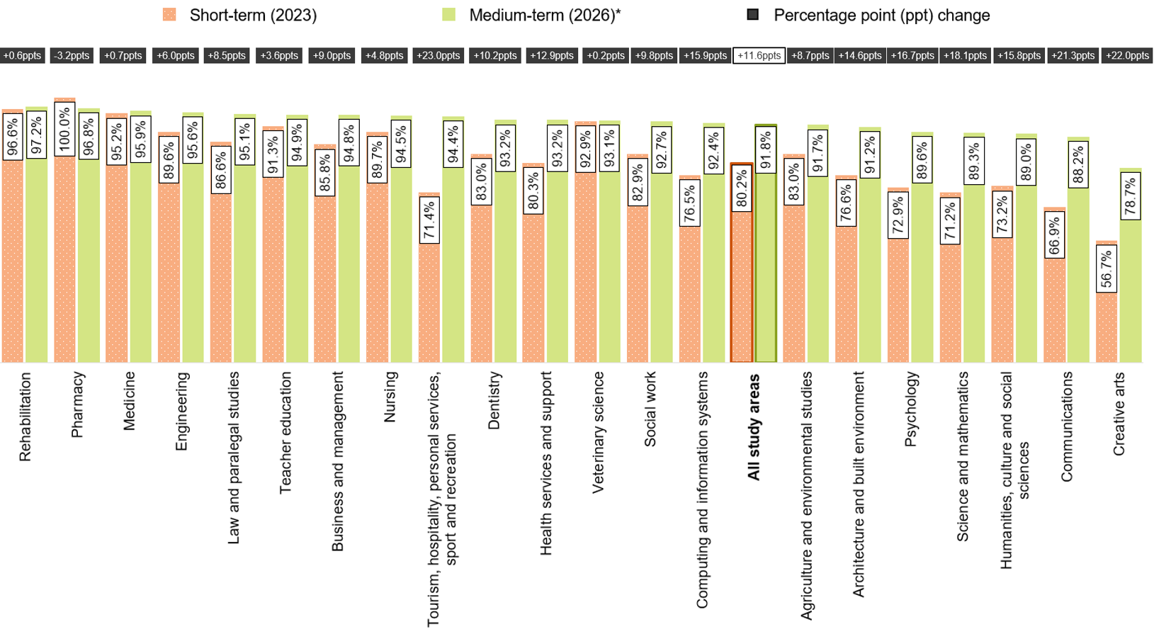
Note: ‘ppts’ refers to percentage points, indicating the absolute change between two percentage values.
* Medium-term labour force participation rates, and full-time and overall employment rates from 2025 onwards are not directly comparable with earlier years due to a change to how the labour force is defined. Caution should be exercised when interpreting shifts from the short- to medium-term for the 2023–2026 cohort, as they partly reflect the change in methodology. See Appendix 1 in the 2025 GOS-L National Report for further information.

Table 5 Domestic undergraduate labour market and further study outcomes by study area
Study area | Full-time  Employment rate (%)‡ :  Short-term (2023) | Full-time  Employment rate (%)‡ :  Medium-term (2026) | Overall  Employment rate (%)‡:  Short-term (2023) | Overall  Employment rate (%)‡:  Medium-term (2026) | Labour force participation rate (%)‡:  Short-term (2023) | Labour force participation rate (%)‡:  Medium-term (2026) | Median annual full-time salary ($):  Short-term (2023) | Median annual full-time salary ($):  Medium-term (2026) | In further full-time study (%):  Short-term (2023) | In further full-time study (%):  Medium-term (2026)
Agriculture and environmental studies | 83.0 | 91.7 | 89.7 | 93.5 | 92.5 | 88.7 | 71,500 | 95,100 | 10.4 | 8.8
Architecture and built environment | 76.6 | 91.2 | 87.3 | 93.9 | 96.4 | 89.9 | 70,000 | 89,900 | 8.9 | 7.8
Business and management | 85.8 | 94.8 | 91.8 | 96.1 | 96.2 | 94.6 | 70,000 | 95,000 | 9.2 | 6.2
Communications | 66.9 | 88.2 | 86.0 | 92.8 | 90.6 | 86.1 | 66,000 | 82,000 | 10.3 | 11.2
Computing and information systems | 76.5 | 92.4 | 83.4 | 93.8 | 96.4 | 93.1 | 75,000 | 102,000 | 7.5 | 5.2
Creative arts | 56.7 | 78.7 | 83.4 | 89.3 | 91.6 | 86.8 | 59,500 | 76,400 | 15.7 | 12.4
Dentistry | 83.0 | 93.2 | 89.9 | 92.4 | 98.6 | 94.3 | n/a | 112,700 | 7.1 | 6.5
Engineering | 89.6 | 95.6 | 91.7 | 96.4 | 96.4 | 95.7 | 75,000 | 107,000 | 8.7 | 6.8
Health services and support | 80.3 | 93.2 | 92.9 | 95.9 | 93.6 | 90.3 | 71,400 | 93,900 | 17.3 | 12.7
Humanities, culture and social sciences | 73.2 | 89.0 | 88.0 | 92.5 | 91.0 | 88.3 | 69,000 | 90,600 | 22.9 | 16.0
Law and paralegal studies | 86.6 | 95.1 | 91.0 | 96.7 | 95.7 | 94.6 | 73,100 | 103,000 | 19.8 | 6.9
Medicine | 95.2 | 95.9 | 96.4 | 97.5 | 93.0 | 87.9 | 83,800 | 124,900 | 14.7 | 18.5
Nursing | 89.7 | 94.5 | 93.7 | 97.6 | 95.9 | 92.9 | 70,000 | 89,700 | 5.0 | 8.4
Pharmacy | 100.0 | 96.8 | 99.2 | 98.3 | 93.1 | 90.1 | 56,900 | 99,100 | 13.9 | 11.9
Psychology | 72.9 | 89.6 | 88.5 | 92.5 | 90.3 | 88.3 | 70,000 | 92,500 | 28.7 | 23.0
Rehabilitation | 96.6 | 97.2 | 97.7 | 97.2 | 97.3 | 95.4 | 70,700 | 95,000 | 2.2 | 5.4
Science and mathematics | 71.2 | 89.3 | 87.8 | 92.7 | 88.0 | 83.8 | 70,000 | 88,000 | 33.4 | 33.4
Social work | 82.9 | 92.7 | 91.1 | 96.7 | 94.5 | 88.5 | 77,600 | 97,000 | 11.6 | 6.4
Teacher education | 91.3 | 94.9 | 95.3 | 96.9 | 95.0 | 92.8 | 75,000 | 95,000 | 7.4 | 4.7
Tourism, hospitality, personal services, sport and recreation | 71.4 | 94.4 | 87.2 | 97.6 | 97.9 | 87.5 | n/a | 86,000 | 15.0 | 5.6
Veterinary science | 92.9 | 93.1 | 92.4 | 96.0 | 93.8 | 90.2 | 69,800 | 92,000 | 15.7 | 13.6
All study areas | 80.2 | 91.8 | 90.0 | 94.6 | 93.0 | 89.9 | 71,400 | 93,500 | 16.5 | 13.7
Note: A blank cell indicates there is no data for that cell and n/a indicates a suppressed value (n<25).
‡ Medium-term labour force participation rates, and full-time and overall employment rates from 2025 onwards are not directly comparable with earlier years due to a change to how the labour force is defined. Caution should be exercised when interpreting shifts from the short- to medium-term for the 2023–2026 cohort, as they partly reflect the change in methodology. See Appendix 1 in the 2025 GOS-L National Report for further information.

Gender pay gap
As outlined in Demographic and equity groups, female undergraduates reported employment outcomes that were broadly similar to males in the short- and medium-term. However, female undergraduates reported lower median salaries compared to their male peers in the short-term (a difference of $3,900, or gender pay gap of 5.3 per cent), and this difference increased in the medium-term ($8,000, or a gender pay gap of 8.1 per cent). The gender pay gap is more pronounced for postgraduate coursework graduates, who experienced a gap of 10.6 per cent in 2023 and 10.8 per cent in 2026 between female and male graduates. Furthermore, in contrast to undergraduates, this gap has remained relatively stable over the long-term. Postgraduate research graduates reported the lowest gender pay gaps—a pay gap of 1.9 per cent in the short-term to 1.4 per cent in the medium-term.
Figure 17 Median annual full-time salary by gender and study level
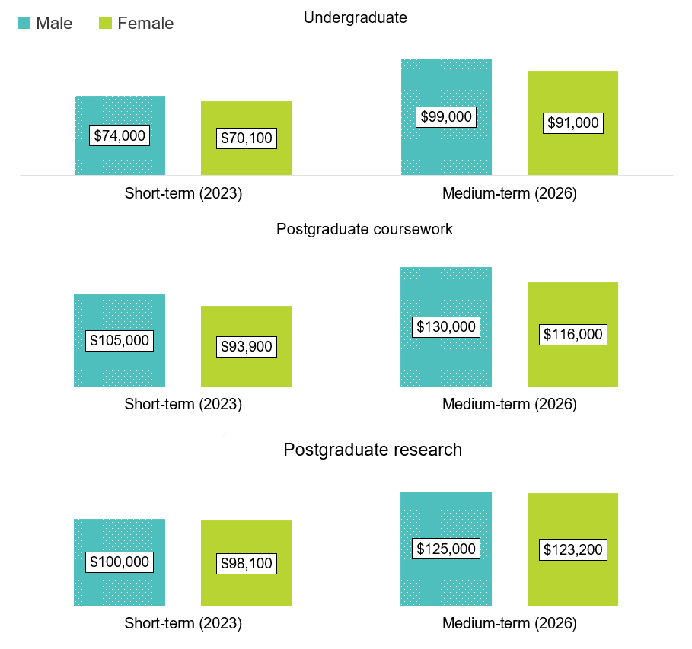
The medium-term gender pay gap of 8.1 per cent in 2026 is a notable increase from 5.5 per cent in 2025, but is lower than the two previous highs reported in 2020 and 2023. Strong wages growth occurred for undergraduates during 2022 and 2023, a period of favourable employment conditions due to reduced competition for job vacancies. As the 3-year growth periods move beyond 2022 and 2023, the average growth has since declined.
Figure 18 Undergraduate gender pay gap, medium-term, and 3-year salary growth by gender
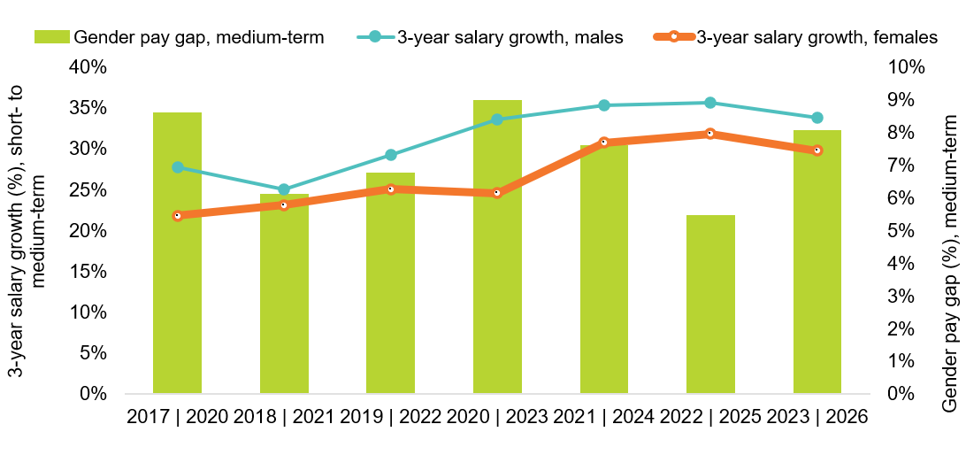
Note: The gender pay gap is calculated as 100 x (Male median salary – Female median salary)/Male median salary, consistent with the methodology used by the Workplace Gender Equality Agency (WGEA).
Female graduates often earn less than male graduates, even within the same field of education. For example, female undergraduates from the Business and management study area reported a median salary $2,000 less than males in 2023, 4 to 6 months after course completion, and this gap increased to $8,000 in 2026. Notably however, there were several study areas where females reported broadly similar median salaries to males in the short- and medium-term including Nursing, Communications and Creative arts. See Appendix 2 for a complete breakdown of median salaries by study area and gender in the short- and medium-term.
There may be many factors influencing these results, such as differences in the breadth of graduates’ skillsets, differences in career progression and job switching, life-stage impacts (including caring responsibilities), and personal preferences.

Institution

Institution type
In 2026, 94.4 per cent of total domestic respondents for the GOS-L completed a qualification at a university, while 5.6 per cent were from a non-university higher education institution (NUHEI).
In general, NUHEIs have greater proportions of postgraduates, international graduates and older graduates than universities. Graduates from NUHEIs also tend to cluster in a few study areas with graduates from Creative Arts (22.0 per cent) and Health services and support (17.7 per cent) making up just under half of the NUHEI undergraduate cohort. At the postgraduate coursework level, over half of NUHEI graduates were from Business and management (36.7 per cent) and Law and paralegal studies (31.3 per cent).
Undergraduates from universities report higher full-time employment, overall employment and labour force participation than undergraduates from NUHEIs in both the short- and medium-term (Table 6). Notably, although undergraduates from universities reported only slightly higher median salaries than undergraduates from NUHEIs in the short-term, this difference widened in the medium-term. The differences in employment outcomes for graduates from universities and NUHEIs may partly explained by differences in study areas: the largest share of undergraduates from NUHEIs came from Creative arts (22.0 per cent), a study area with comparatively low employment outcomes in the short- to medium-term. In contrast, only 4.3 per cent of university undergraduates were from Creative arts.
Table 6 Short- and medium-term domestic graduate employment and study outcomes by study level and institution type
Category | Universities: Short-term (2023) | NUHEIs: Short-term (2023) | Universities: Medium-term (2026) | NUHEIs: Medium-term (2026)
Full-time employment rate (%)*:  Undergraduate | 80.6 | 65.3 | 92.0 | 83.3
Full-time employment rate (%)*:  Postgraduate coursework | 90.1 | 92.1 | 95.0 | 95.9
Overall employment rate (%)*:  Undergraduate | 90.2 | 83.8 | 94.7 | 91.0
Overall employment rate (%)*:  Postgraduate coursework | 94.3 | 95.0 | 96.5 | 96.5
Labour force participation rate (%)*:  Undergraduate | 93.1 | 89.7 | 90.1 | 84.8
Labour force participation rate (%)*:  Postgraduate coursework | 96.3 | 96.0 | 93.0 | 93.6
Median annual full-time salary ($):  Undergraduate | 71,400 | 70,000 | 93,900 | 80,000
Median annual full-time salary ($):  Postgraduate coursework | 98,000 | 97,700 | 120,000 | 129,400
In further full-time study (%):  Undergraduate | 16.6 | 14.3 | 13.8 | 10.2
In further full-time study (%):  Postgraduate coursework | 6.2 | 5.5 | 5.1 | 3.0
* Medium-term labour force participation rates, and full-time and overall employment rates from 2025 onwards are not directly comparable with earlier years due to a change to how the labour force is defined. Caution should be exercised when interpreting shifts from the short- to medium-term for the 2023–2026 cohort, as they partly reflect the change in methodology. See Appendix 1 in the 2025 GOS-L National Report for further information.
At the postgraduate coursework level, graduates from NUHEIs reported slightly higher full-time employment rates in the short-term compared to university graduates, 92.1 percent and 90.1 per cent respectively, but this difference decreased in the medium-term, to 95.9 for graduates from NUHEIs and 95.0 for graduates from universities. Notably, in contrast to results at the undergraduate level, median salaries for postgraduate coursework graduates were similar in the short-term, but in the medium-term postgraduate coursework graduates from NUHEIs reported higher median salaries – $129,400 compared to $120,000 for university graduates. As with the undergraduate results, these differences may be partly explained by study area differences. The majority of NUHEI postgraduate coursework graduates were from Business and management (36.7 per cent) and Law and paralegal studies (31.3 per cent)—graduates from these study areas reported high employment and median salary outcomes in the medium-term (see Appendix 2).

Comparative university outcomes

Notwithstanding differences in course offerings, student populations and local labour markets, some universities achieve higher rates of full-time employment than others over the medium-term.
Employment and salary outcomes vary across institutions. Note that factors beyond the quality of teaching, careers advice and other internal influences can affect results for institutions. These include study area and study mode offerings, the composition of the student population, and variations in state/territory and regional labour markets.
To assist interpretation of results, 90 per cent confidence intervals are included in the figures and tables that follow, which indicate the confidence intervals for the survey estimates. Note that where confidence intervals for institution estimates overlap, as seen in Figure 19 and Figure 20, it cannot be inferred that there is or is not a significant difference in full-time employment outcomes in a statistical sense.
Notwithstanding differences in course offerings, student populations and local labour markets, it appears there is differentiation among universities, with some achieving higher rates of full-time employment and median salaries than others. There were greater variations in outcomes for domestic undergraduates in the short-term compared to the medium-term. Full-time employment rates for recent undergraduates ranged from a low of 66.5 per cent at Victoria University to a high of 92.8 per cent at Charles Sturt University, a difference of 26.3 per cent. Three years after course completion, full-time employment rates ranged from 85.9 per cent at the University of Melbourne to 97.0 per cent at Charles Darwin University, a difference of 11.1 percentage points.
Despite the varying rates of full-time employment between universities in the short-term, full-time employment rates were broadly consistent for most universities in the medium-term, as shown in Figure 19.
A similar pattern was observed for median salaries across universities, however, unlike differences in full-time employment rates which narrowed over the 3 years, differences in short-term median salaries persisted into the medium-term.
Similar variations in full-time employment rates across universities existed at the postgraduate coursework level, albeit less pronounced – there was a 19.5 percentage point difference in short-term full-time employment rates, which narrowed to 11.7 percentage points 3 years later.
Comparative institutional results are not available at postgraduate research graduate level, as there are too few survey responses. Also, due to the smaller sample sizes of NUHEIs, there is insufficient data at the NUHEI institution level to do the same level of analysis.

Figure 19 Domestic undergraduate short- and medium-term full-time employment rate by university (% with 90% confidence intervals)
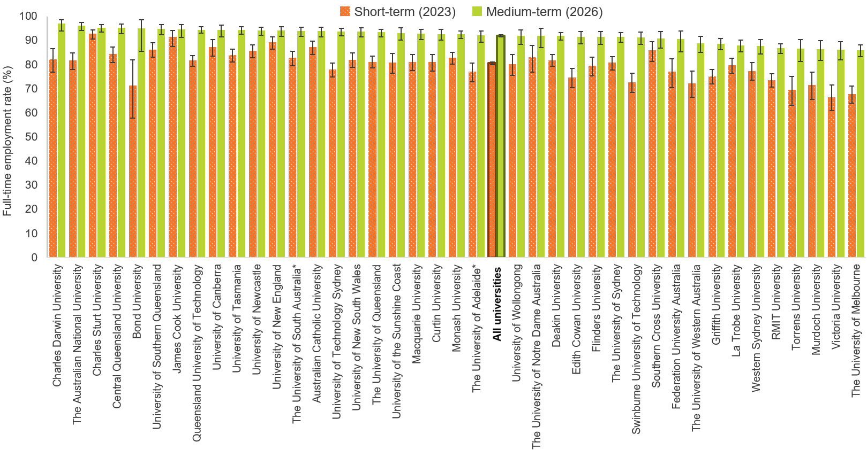
Note: 1. Institutional results are influenced by factors such as student characteristics, course offerings and variations in regional labour market conditions. Results should therefore not be interpreted as a measure of institutional performance in isolation.
2. Medium-term full-time employment rates from 2025 onwards are not directly comparable with earlier years due to a change to how the labour force is defined. Caution should be exercised when interpreting shifts from the short- to medium-term for the 2023–2026 cohort, as they partly reflect the change in methodology. See Appendix 1 in the 2025 GOS-L National Report for further information.
* As of January 2026, the University of Adelaide and the University of South Australia have merged to form Adelaide University. Data for the 2026 GOS-L were collected and reported separately for the University of Adelaide and the University of South Australia.
Figure 20 Domestic postgraduate coursework short- and medium-term full-time employment rate by university (% with 90% confidence intervals)
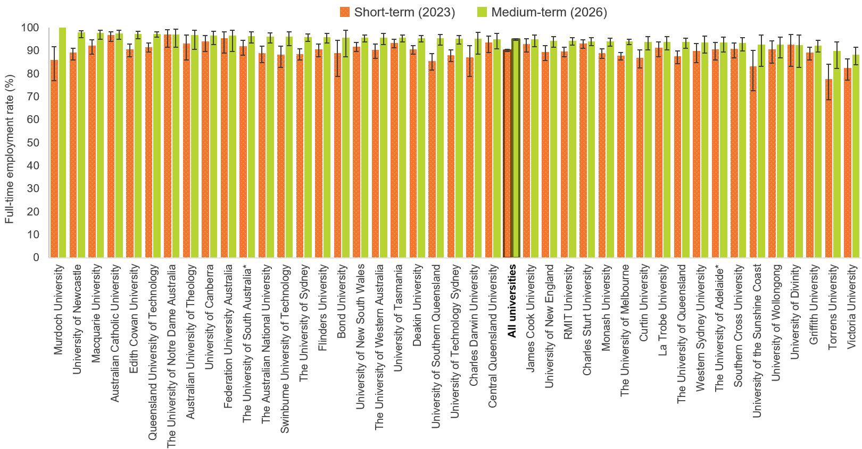
Note: 1. Institutional results are influenced by factors such as student characteristics, course offerings and variations in regional labour market conditions. Results should therefore not be interpreted as a measure of institutional performance in isolation. CIs are not displayed when estimates are 0% or 100%.
2. Medium-term full-time employment rates from 2025 onwards are not directly comparable with earlier years due to a change to how the labour force is defined. Caution should be exercised when interpreting shifts from the short- to medium-term for the 2023–2026 cohort, as they partly reflect the change in methodology. See Appendix 1 in the 2025 GOS-L National Report for further information.
* As of January 2026, the University of Adelaide and the University of South Australia have merged to form Adelaide University. Data for the 2026 GOS-L were collected and reported separately for the University of Adelaide and the University of South Australia.

International graduate results
The GOS-L collects sufficient survey responses to enable high-level reporting of medium-term employment outcomes for international graduates, providing further context regarding the employment pathways of this graduate cohort.
It should be noted that differences in employment and further study outcomes between international and domestic graduates are affected by a range of factors, such as demographic and study area differences.
Note, too, that international graduate median salaries are reported for international graduates working in Australia only. Meanwhile, all other rates related to employment and further study outcomes, as well as skills utilisation, are for all international graduates, regardless of their location at the time of the survey.

International graduate profile (based on responses to the 2026 GOS-L)
The profile of international graduates across study levels differed to the domestic graduate profile.
Domestic graduates were predominantly undergraduates, while international graduates were predominantly postgraduate coursework graduates. Postgraduate research graduates account for a higher proportion of the international graduate cohort (16.3 per cent) compared to the domestic graduate cohort (5.5 per cent).
Infographic 2: Domestic and international respondent profile comparison
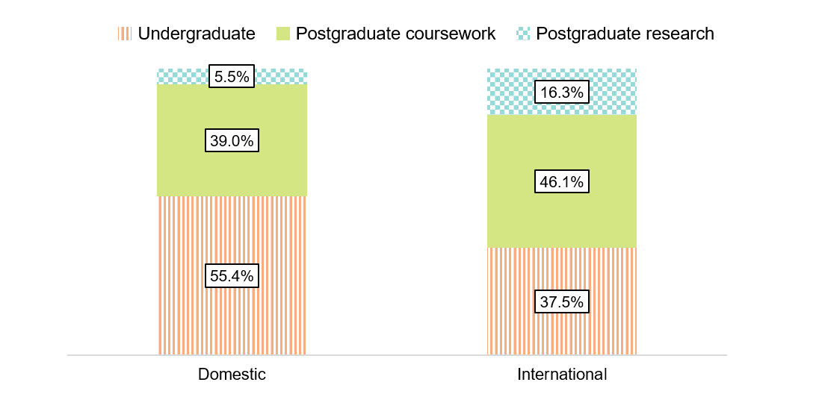
At the undergraduate and postgraduate coursework levels, international graduates tended to be younger compared to domestic graduates. This difference was most notable at the postgraduate coursework level, where graduates aged 30 and under made up just under half of the international postgraduate coursework respondents, but only around 1 in 5 domestic postgraduate coursework graduates were aged 30 and under. This age differential between international and domestic graduates is a key factor in understanding differences in labour market outcomes, occupation types and further study outcomes presented in this section.
Infographic 3: Graduate age by study level and citizenship status
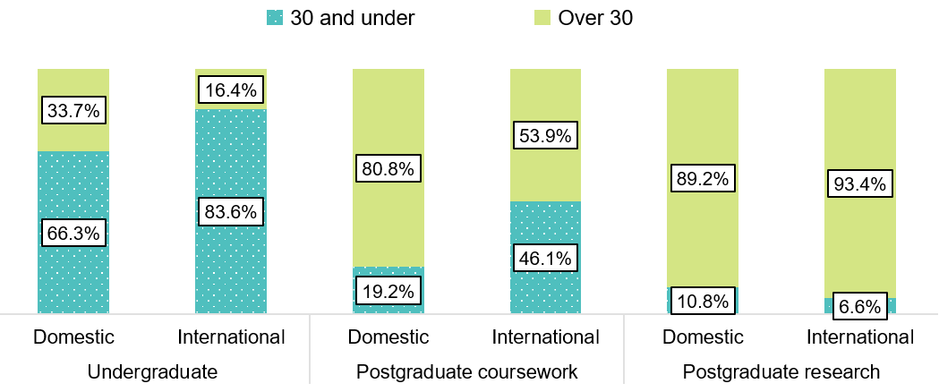

International graduates predominantly come from a small number of countries. At the undergraduate and postgraduate coursework levels, graduates from China (excludes SARs and Taiwan), India and Nepal accounted for a substantial proportion of all international graduates. At the postgraduate research level, there was more variation in source countries with graduates from the top 5 source countries only accounting for a total of 39.8 per cent of the international graduate cohort.
Infographic 4: Top 5 source countries by study level
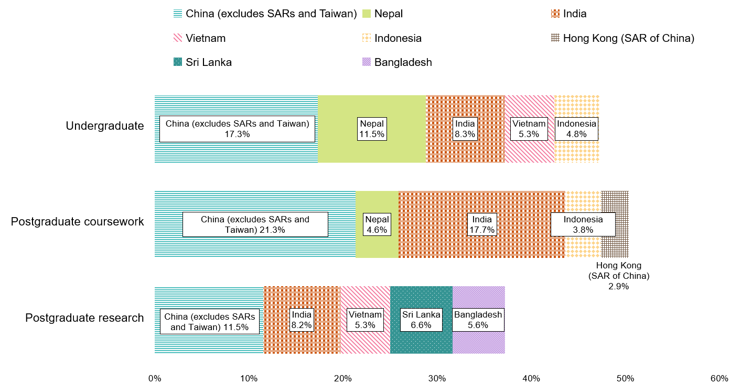

Comparative outcomes: international and domestic graduates
Short-term employment outcomes for international graduates are typically lower than for domestic graduates, and these trends continued for the 2023–2026 cohort. While employment rates for international graduates increased 3 years later, differences in full-time employment and median salary with their domestic counterparts remained.

Undergraduate comparisons
International undergraduates reported lower overall employment (a difference of 14.1 percentage points) and full-time employment rates (a difference of 17.7 percentage points) in the short-term compared to their domestic counterparts. These differences narrow in the medium-term (a difference of 5.5 percentage points for overall employment and 7.7 percentage points for full-time employment) as international graduate employment rates increased at a higher rate than for domestic undergraduates (Table 7).
As opposed to employment rates, which see differences decrease between domestic and international graduates in the short- to medium-term, differences in reported median salaries between domestic and international graduates increased in the medium-term. In the short-term international undergraduates reported median salaries which were $5,400 below reported median salaries for domestic undergraduates. In the medium-term, this difference increased to $8,500.
Approximately one in four international undergraduates were underemployed in 2023, much higher than the proportion of domestic undergraduates who were underemployed (14.4 per cent) in the short-term. In the medium-term, the proportion of international undergraduates who were underemployed dropped to 10.2 per cent, compared to 7.5 per cent for domestic undergraduates. These findings indicate that international undergraduates take longer to obtain full-time hours, despite their preference to do so.
Table 7 Undergraduate short- and medium-term outcomes comparison: international and domestic graduates
Category | Short-term (2023):  Domestic | Short-term (2023):  International | Medium-term (2026):  Domestic | Medium-term (2026):  International
Full-time employment rate (%)‡ | 80.2 | 62.5 | 91.8 | 84.1
Overall employment rate (%)‡ | 90.0 | 75.9 | 94.6 | 89.1
Labour force participation rate (%)‡ | 93.0 | 89.3 | 89.9 | 88.4
Median annual full-time salary ($) | 71,400 | 66,000 | 93,500 | 85,000
Underemployment rate (%) | 14.4 | 23.6 | 7.5 | 10.2
In further full-time study (%) | 16.5 | 24.7 | 13.7 | 15.8
Employed in managerial or professional occupation (% of those employed full-time) | 70.6 | 64.3 | 78.7 | 77.2
Note: International graduates’ median salary figures only include data for international graduates working in Australia.
‡ Medium-term labour force participation rates, and full-time and overall employment rates from 2025 onwards are not directly comparable with earlier years due to a change to how the labour force is defined. Caution should be exercised when interpreting shifts from the short- to medium-term for the 2023–2026 cohort, as they partly reflect the change in methodology. See Appendix 1 in the 2025 GOS-L National Report for further information.

Postgraduate coursework comparisons
Differences in postgraduate coursework employment outcomes were similar to the undergraduate level, but were more pronounced. International postgraduate coursework graduates reported lower rates of full-time employment in the short-term compared to domestic graduates (a difference of 23.1 percentage points). In the medium-term, this difference decreased to 7.6 percentage points.
Consistent with previous years, there were large differences in reported median salary for domestic and international cohorts at the postgraduate coursework level, and these salary differences remained over time, with international postgraduate coursework graduates reporting median salaries $31,000 less than their domestic counterparts in the short-term and $34,000 less in the medium-term.
The larger differences in employment and salary outcomes between domestic and international postgraduate coursework cohorts may partly be attributed to differences in profile between domestic and international graduates at this level (see International graduate profile). The domestic cohort of postgraduate coursework graduates is older and more likely to have established themselves in the workforce before or during their studies.
Notably, international postgraduate coursework graduates were around two and a half times as likely to be underemployed in the short-term (18.9 per cent) compared to domestic postgraduate coursework graduates (7.4 per cent). This improves to 7.2 per cent in the medium-term, which is broadly comparable to medium-term outcomes for domestic undergraduates (7.5 per cent). This finding indicates that although they are highly qualified, international postgraduate coursework graduates may find it difficult to obtain a role aligned with their skills in the short-term, but they are able to transition to such roles over time.
International postgraduate coursework graduate median salaries are comparable to international undergraduate median salaries in the short- (a difference of $1,000) and medium-term (a difference of $1,000). This indicates that even 3 years after completing their course, international postgraduate coursework graduates are still not able to experience the improvement in outcomes that domestic graduates experience from the higher-level qualification.
Table 8 Postgraduate coursework short- and medium-term outcomes comparison: international and domestic graduates
Category | Short-term (2023): Domestic | Short-term (2023): International | Medium-term (2026): Domestic | Medium-term (2026): International
Full-time employment rate (%)‡ | 90.2 | 67.1 | 95.1 | 87.5
Overall employment rate (%)‡ | 94.4 | 78.6 | 96.5 | 90.8
Labour force participation rate (%)‡ | 96.3 | 93.6 | 93.1 | 89.5
Median annual full-time salary ($) | 98,000 | 67,000 | 120,000 | 86,000
Underemployment rate (%) | 7.4 | 18.9 | 4.7 | 7.2
In further full-time study (%) | 6.2 | 15.3 | 4.9 | 11.5
Employed in managerial or professional occupation (% of those employed full-time) | 85.7 | 64.3 | 89.1 | 76.2
Note: International graduates’ median salary figures only include data for international graduates working in Australia.
‡ Medium-term labour force participation rates, and full-time and overall employment rates from 2025 onwards are not directly comparable with earlier years due to a change to how the labour force is defined. Caution should be exercised when interpreting shifts from the short- to medium-term for the 2023–2026 cohort, as they partly reflect the change in methodology. See Appendix 1 in the 2025 GOS-L National Report for further information.

Postgraduate research comparisons
The differences between domestic and international employment outcomes were smallest at the postgraduate research level. In the short-term, international postgraduate research graduates reported a full-time employment rate 8.1 percentage points lower than their domestic counterparts, which is comparable to the gap in the medium-term for the undergraduate and postgraduate coursework cohorts. This difference decreases to 1.5 percentage points in the medium-term, with 90.6 per cent of international postgraduate research graduates attaining full-time employment 3 years after graduating.
Despite the smaller difference in full-time employment rates, international postgraduate research graduates who worked full-time hours still reported lower median salaries than their domestic counterparts in the short-term (a difference of $7,100) which increases in the medium-term (a difference of $13,000). This suggests that although international postgraduate research graduates are more likely to find employment compared to international graduates at other study levels, international graduates at this level are less likely to receive similar compensation to their domestic counterparts.
Table 9 Postgraduate research short- and medium-term outcomes comparison: international and domestic graduates
Category | Short-term (2023):  Domestic | Short-term (2023):  International | Medium-term (2026):  Domestic | Medium-term (2026):  International
Full-time employment rate (%)‡ | 86.2 | 78.1 | 92.1 | 90.6
Overall employment rate (%)‡ | 92.0 | 87.9 | 94.8 | 94.7
Labour force participation rate (%)‡ | 96.2 | 97.0 | 92.0 | 95.8
Median annual full-time salary ($) | 100,000 | 92,900 | 125,000 | 112,000
Underemployment rate (%) | 9.1 | 14.5 | 6.1 | 7.0
In further full-time study (%) | 5.7 | 9.6 | 5.1 | 5.9
Employed in managerial or professional occupation (% of those employed full-time) | 90.5 | 90.9 | 93.6 | 94.0
Note: International graduates’ median salary figures only include data for international graduates working in Australia.
‡ Medium-term labour force participation rates, and full-time and overall employment rates from 2025 onwards are not directly comparable with earlier years due to a change to how the labour force is defined. Caution should be exercised when interpreting shifts from the short- to medium-term for the 2023–2026 cohort, as they partly reflect the change in methodology. See Appendix 1 in the 2025 GOS-L National Report for further information.

Study area
International graduates at the undergraduate and postgraduate coursework levels tend to cluster in a small number of study areas. Business and management, Computing and information systems, Engineering, and Nursing account for half of all international graduates for these cohorts, although the proportions vary by study level, as shown in Figure 21. At the postgraduate research level, half of international graduates came from just two study areas: Engineering and Science and mathematics.
Figure 21 International graduate profile by study area and level (% based on responses to the 2026 GOS-L)
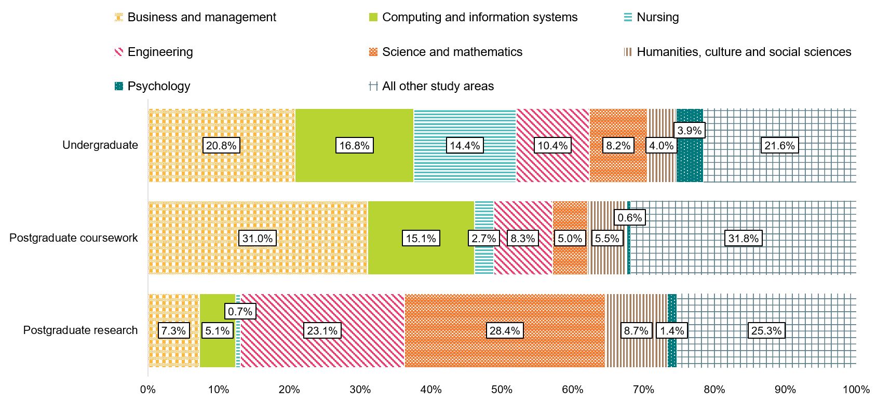
* Only selected study areas presented in this figure. For all study areas, refer to the CHAR_UG_ALL_1Y_AREA_INT, CHAR_PGC_ALL_1Y_AREA_INT and CHAR_PGR_ALL_1Y_AREA_INT worksheets in the 2026 GOS-L National Tables available on the QILT website.

Figure 22 presents full-time employment rates for domestic and international undergraduates in the short- and medium-term across study areas. Short-term full-time employment rates were high for both domestic and international undergraduates for vocationally-oriented study areas, particularly for in-demand study areas such as Medicine (92.3 per cent for international undergraduates and 95.2 per cent for domestic undergraduates). In the medium-term, the full-time employment rates remained high for both cohorts (96.4 per cent for international undergraduates and 95.9 per cent for domestic undergraduates).
In contrast, international undergraduates from study areas such as Business and management, Computing and information systems and Engineering reported much lower full-time employment rates in the short-term (61.6, 52.2, and 59.7 per cent respectively) compared to domestic undergraduates (85.8, 76.5, and 89.6 per cent respectively). While the full-time employment rates for international undergraduates from these study areas improved substantially over the medium-term, they remained lower than their domestic counterparts.
Notably, international undergraduates from Health services and support reported continued differences in full-time employment. Just over half of undergraduates from this cohort were working full-time hours in the short-term, and only 77.8 per cent were employed full-time in the medium-term, the lowest out of all reported study areas for international undergraduates in the medium-term. In contrast, over 93.2 per cent of domestic undergraduates from Health services and support were employed full-time in the medium-term. This indicates that undergraduates from this study area find it particularly difficult to find full-time employment in the short-term, and these difficulties persist in the medium-term.
Figure 22 Undergraduate full-time employment rate by citizenship status and study area (%)
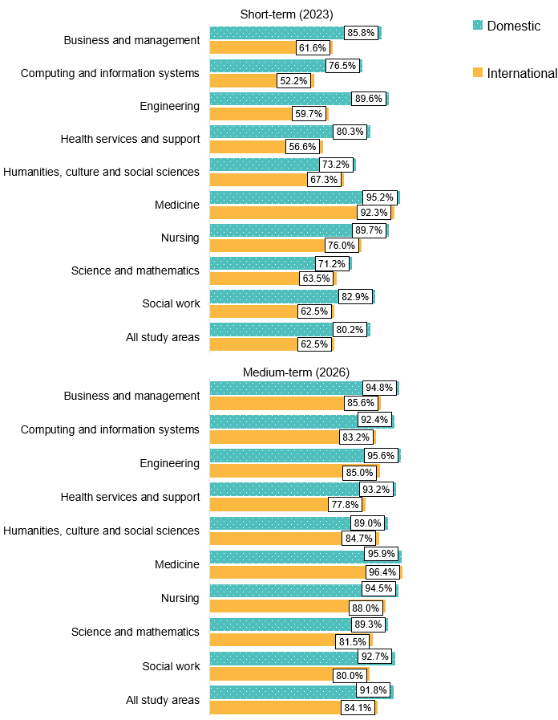
Note: 1. Only selected study areas are presented in this figure. For all study areas, refer to the FTE_ALL_ALL_1Y_AREA and FTE_ALL_ALL_1Y_AREA_INT worksheets in the 2026 GOS-L National Tables available on the QILT website.
2. Medium-term full-time employment rates from 2025 onwards are not directly comparable with earlier years due to a change to how the labour force is defined. Caution should be exercised when interpreting shifts from the short- to medium-term for the 2023–2026 cohort, as they partly reflect the change in methodology. See Appendix 1 in the 2025 GOS-L National Report for further information.

Source country
This section presents employment and further full-time study outcomes for international graduates, disaggregated by the graduate’s source country and study level. The countries in Table 10 and Table 11 are ordered based on the total number of survey responses at that study level.
At the undergraduate level, graduates from China (excludes SARs and Taiwan) reported lower labour-force participation (71.5 per cent) in the short-term compared to the international average (89.3), and they were also almost twice as likely to be pursuing further full-time study in the short-term compared to the international average. This high further full-time study rate and relatively low labour force participation rate and indicates that graduates from China (excludes SARs and Taiwan) may not have the same financial pressures to work, or perhaps a greater preference to focus on their studies. In contrast, undergraduates from the other top source countries reported labour force participation rates at or above 91.3 per cent in the short-term, with undergraduates from Nepal and India reporting much higher rates of labour force participation (97.4 per cent and 96.8 per cent) in the short-term compared to the international average.
In the medium-term, employment and median salary outcomes for undergraduates from China (excludes SARs and Taiwan) lagged behind other source countries. Although the full-time employment rate for undergraduates from China (excludes SARs and Taiwan) was slightly under the international average reported full-time employment rate (a difference of 1.5 percentage points) in the short-term, it was well below the international average (a difference of 9.7 percentage points) in the medium-term. Undergraduates from China (excludes SARs and Taiwan) also saw the smallest growth in salary (from $67,100 to $79,300) out of the top 5 source countries. Undergraduates from Indonesia reported the lowest full-time employment rate of the top 5 source countries in the short-term (50.0 per cent), but reported the highest improvement in full-time employment rate in the medium-term (87.5 per cent). Median salary for undergraduates from Indonesia was, however, lower than the international average in the short-term and this persisted in the medium-term. This suggests that undergraduates from Indonesia take a bit longer to break into the workforce when compared to undergraduates from other countries.
Note that it is unclear whether differences between source countries are generalisable to a broader population due to the small number of survey responses.

Table 10 International undergraduate short- and medium-term outcomes by source country
Source country | Full-time  employment rate (%)‡:  Short-term (2023) | Full-time  employment rate (%)‡:  Medium-term (2026) | Overall  employment rate (%)‡:  Short-term (2023) | Overall employment rate (%)‡:  Medium-term (2026) | Labour force participation rate (%)‡:  Short-term (2023) | Labour force participation rate (%)‡:  Medium-term (2026) | Median annual full-time salary ($):  Short-term (2023) | Median annual full-time salary ($):  Medium-term  (2026) | In further full-time study (%):  Short-term (2023) | In further full-time study (%):  Medium-term  (2026)
China (excludes SARs and Taiwan) | 61.0 | 74.4 | 65.7 | 84.5 | 71.5 | 79.7 | 67,100 | 79,300 | 45.2 | 26.1
Nepal | 66.0 | 86.1 | 88.5 | 90.7 | 97.4 | 89.1 | 66,800 | 85,600 | 13.2 | 14.1
India | 57.8 | 83.1 | 78.2 | 90.0 | 96.8 | 91.7 | 67,800 | 88,800 | 12.7 | 10.1
Vietnam | 69.9 | 90.6 | 77.9 | 92.7 | 94.2 | 89.2 | 65,200 | 82,000 | 27.8 | 15.2
Indonesia | 50.0 | 87.5 | 71.6 | 91.9 | 91.3 | 87.4 | 60,000 | 75,800 | 27.1 | 14.6
All internationals | 62.5 | 84.1 | 75.9 | 89.1 | 89.3 | 88.4 | 66,000 | 85,000 | 24.7 | 15.8
Note: International graduates’ median salary figures only include data for international graduates working in Australia.
‡ Medium-term labour force participation rates, and full-time and overall employment rates from 2025 onwards are not directly comparable with earlier years due to a change to how the labour force is defined. Caution should be exercised when interpreting shifts from the short- to medium-term for the 2023–2026 cohort, as they partly reflect the change in methodology. See Appendix 1 in the 2025 GOS-L National Report for further information.
There were slightly fewer differences in salary growth between source countries at the postgraduate coursework level, with postgraduate coursework graduates from 4 of the top 5 source countries reporting increases of $17,100 to $21,400 over the short- to medium-term. Notably, postgraduate coursework graduates from China (excludes SARs and Taiwan) and Nepal were more likely to pursue further full-time study in the short-term compared to the international average, and this continued in the medium-term with 21.1 per cent of graduates from China (excludes SARs and Taiwan) and 14.2 per cent of graduates from Nepal still pursuing further full-time study 3 years after graduating with a postgraduate coursework qualification.
Table 11 International postgraduate coursework short- and medium-term outcomes by source country
Source country | Full-time employment rate (%)‡:  Short-term (2023) | Full-time employment rate (%)‡:  Medium-term (2026) | Overall employment rate (%)‡:  Short-term (2023) | Overall employment rate (%)‡:  Medium-term (2026) | Labour force participation rate (%)‡:  Short-term (2023) | Labour force participation rate (%)‡:  Medium-term (2026) | Median annual full-time salary ($):  Short-term (2023) | Median annual full-time salary ($):  Medium-term (2026) | In further full-time study (%):  Short-term (2023) | In further full-time study (%):  Medium-term (2026)
China  (excludes SARs and Taiwan) | 60.3 | 84.1 | 71.0 | 87.4 | 88.9 | 86.4 | 60,000 | 80,000 | 19.6 | 21.1
India | 58.8 | 81.6 | 78.3 | 86.7 | 94.9 | 88.6 | 62,600 | 84,000 | 10.2 | 9.0
Nepal | 67.0 | 86.9 | 80.4 | 90.3 | 96.0 | 83.2 | 63,000 | 80,100 | 19.8 | 14.2
Indonesia | 80.6 | 97.0 | 84.3 | 96.4 | 93.5 | 91.1 | n/a | 79,200 | 24.8 | 9.3
Hong Kong (SAR of China) | 56.2 | 91.7 | 62.1 | 91.8 | 94.6 | 92.4 | 70,000 | 89,000 | 6.2 | 4.7
All internationals | 67.1 | 87.5 | 78.6 | 90.8 | 93.6 | 89.5 | 67,000 | 86,000 | 15.3 | 11.5
Note: 1. International graduates’ median salary figures only include data for international graduates working in Australia.
2. A blank cell indicates there is no data for that cell and n/a indicates a suppressed value (n<25).
‡ Medium-term labour force participation rates, and full-time and overall employment rates from 2025 onwards are not directly comparable with earlier years due to a change to how the labour force is defined. Caution should be exercised when interpreting shifts from the short- to medium-term for the 2023–2026 cohort, as they partly reflect the change in methodology. See Appendix 1 in the 2025 GOS-L National Report for further information.

- Labour market and graduate satisfaction definitions
The 2026 GOS-L uses labour force indicator definitions informed by the Standards for Labour Force Statistics used by the ABS. Definitions for indicators used throughout this report are presented in Table 12.
Table 12 Indicator definitions
Indicator/element | Definition
Available for employment† | Graduates who were employed, actively looking for employment or waiting to start a job in the week prior to the survey.
Available for full-time employment† | Graduates who were employed full-time or actively looking for full-time employment in the week prior to the survey. This includes those in part-time employment and looking for full-time work in the week prior to the survey.
Employed | Graduates who were usually or actually in paid employment for one or more hours in the week before the survey.
Employed full-time | Graduates who were usually or actually in paid employment for at least 35 hours per week in the week before the survey.
Employed part-time | Graduates who were usually or actually in paid employment for at least one hour but less than 35 hours in the week before the survey.
Full-time employment rate | Graduates employed full-time, as a proportion of those available for full-time work. Note that some graduates available for full-time work may be in part-time employment and looking for full-time work.
Further full-time study rate | Graduates who reported being in further full-time study, as a proportion of all graduates.
Labour force participation rate | Graduates available for employment, as a proportion of all graduates.
Median salary | The median annual salary of graduates employed full-time.
Overall course satisfaction indicator (Undergraduate and postgraduate coursework) | The proportion of graduates who ‘agreed’ or ‘strongly agreed’ that they were satisfied with the overall quality of their course.
Overall employment rate | Graduates employed for one or more hours, as a proportion of those available for employment.
Postgraduate research graduate satisfaction:  - Overall satisfaction  - Intellectual climate  - Infrastructure  - Goals and expectations  - Supervision  - Skills development  - Thesis examination and industry, and  - External engagement. | Calculated from multiple survey items, representing the proportion of graduates who gave a positive response to items associated with each aspect of their higher degree by research (HDR) experience.
Underemployed | Graduates who were usually or actually in paid employment for fewer than 35 hours per week, in the week before the survey, and who would prefer to work additional hours regardless of if they were available to work those additional hours.
† From 2025 onwards, respondents who were not currently working and only passively looking for work are no longer considered to be available for employment. Prior to 2025, both active and passive job search types were included.
  - Examples of graduate labour market outcomes
The names and examples used in this report are fictitious and are provided for illustrative purposes only.
Amy works 37 hours a week. Amy is both ‘available for employment’ and ‘available for full-time employment’, as well as both ‘employed’ and ‘employed full-time’. Amy is counted towards the labour force participation rate. Amy’s usual salary is counted towards the median salary figure.
Bryan works 20 hours a week while also studying full-time. He does not want to work additional hours. Bryan is ‘available for employment’, ‘employed’ and ‘employed part-time’ but is not ‘available for full-time work’ or ‘employed full-time’. Bryan is counted towards the full-time study rate, overall employment rate and the labour force participation rate. Bryan’s salary is not counted towards the median salary figure. Bryan is not considered ‘underemployed’.
Krishna works 6 hours a week but would prefer to work 40 hours per week. Krishna is both ‘available for employment’ and ‘available for full-time employment’. Krishna is ‘employed’ and ‘employed part-time’ but not ‘employed full-time’. Krishna is also considered ‘underemployed’. Krishna is counted towards the labour force participation rate. Krishna’s salary is not counted towards the median salary figure.
Dilek is studying full-time and is neither working nor looking for work. Dilek is ‘not available for employment’ and therefore is not counted towards the labour force participation rate. Although he is not ‘employed’, he is not considered ‘unemployed’. However, Dilek is counted towards the full-time study rate.
Emily is not working but she has been actively looking for full-time work. Emily is both ‘available for employment’ and ‘available for full-time employment’. Emily is counted towards the labour force participation rate. However, Emily is neither ‘employed’ nor ‘employed full-time’ and can also be referred to as ‘unemployed’.
Xavier is studying full-time and not currently working. He occasionally looks at job ads online but he has not actively looked for a job, such as registered with an employment agency, submitted an application, or asked friends and relatives for assistance in finding a job. Xavier is counted towards the full-time study rate but he is not considered ‘available for employment’ or ‘available for full-time employment’, and he is not counted towards the labour force participation rate.
Steve completed his qualification on shore in Australia but moved overseas after graduation. He now works 37 hours a week for an Italian employer. Steve is both ‘available for employment’ and ‘available for full-time employment’, as well as both ‘employed’ and ‘employed full-time’. Steve is counted towards the labour force participation rate. Steve’s salary is not counted towards the median salary figure.
- Detailed tables
  - Gender pay gap
Table 13 Undergraduate median annual full-time salary by gender and study area
Study area | Short-term (2023):  Male median salary ($) | Short-term (2023):  Female median salary ($) | Short-term (2023):  Gender pay gap (%) | Medium-term (2026):  Male median salary ($) | Medium-term (2026):  Female median salary ($) | Medium-term (2026):  Gender pay gap (%)
Agriculture and environmental studies | 75,200 | 70,000 | 6.9 | 100,000 | 92,000 | 8.0
Architecture and built environment | 73,200 | 65,200 | 10.9 | 95,200 | 82,000 | 13.9
Business and management | 70,500 | 68,500 | 2.8 | 100,000 | 92,000 | 8.0
Communications | 68,500 | 65,200 | 4.8 | 81,300 | 82,200 | -1.1
Computing and information systems | 75,000 | 73,100 | 2.5 | 102,000 | 101,700 | 0.3
Creative arts | 62,600 | 57,400 | 8.3 | 75,000 | 77,000 | -2.7
Dentistry | n/a | n/a | n/a | n/a | 109,300 | n/a
Engineering | 75,000 | 75,000 | 0.0 | 108,000 | 104,400 | 3.3
Health services and support | 75,300 | 71,000 | 5.7 | 98,100 | 92,000 | 6.2
Humanities, culture and social sciences | 70,000 | 68,000 | 2.9 | 95,000 | 90,000 | 5.3
Law and paralegal studies | 78,000 | 72,000 | 7.7 | 109,300 | 100,700 | 7.9
Medicine | : 89,200 | 83,000 | 7.0 | 130,200 | 120,300 | 7.6
Nursing | 69,700 | 70,000 | -0.4 | 89,900 | 89,700 | 0.2
Pharmacy | n/a | 56,100 | n/a | n/a | 99,100 | n/a
Psychology | 72,400 | 70,000 | 3.3 | 95,600 | 92,000 | 3.8
Rehabilitation | 70,100 | 71,000 | -1.3 | 90,000 | 95,100 | -5.7
Science and mathematics | 71,300 | 67,400 | 5.5 | 93,700 | 85,000 | 9.3
Social work | 77,300 | 77,700 | -0.5 | 99,000 | 97,000 | 2.0
Teacher education | 76,000 | 75,000 | 1.3 | 96,700 | 93,400 | 3.4
Tourism, hospitality, personal services, sport and recreation | n/a | n/a | n/a | n/a | n/a | n/a
Veterinary science | n/a | 68,400 | n/a | n/a | 93,600 | n/a
All study areas | 74,000 | 70,100 | 5.3 | 99,000 | 91,000 | 8.1
Note: 1. A blank cell indicates there is no data for that cell and n/a indicates a suppressed value (n<25).
2. The gender pay gap is calculated as 100 x (Male median salary – Female median salary)/Male median salary, consistent with the methodology used by the Workplace Gender Equality Agency (WGEA).
  - Study area
Table 14 Domestic postgraduate coursework labour market outcomes by study area
Study area | Full-time - employment rate (%):  Short-term (2023) | Full-time - employment rate (%):  Medium-term (2025) | Overall - employment rate (%):  Short-term (2023) | Overall - employment rate (%):  Medium-term (2025) | Labour force participation rate (%):  Short-term (2023) | Labour force participation rate (%):  Medium-term (2025) | Median annual full-time salary ($):  Short-term (2023) | Median annual full-time salary ($):  Medium-term (2025)
Agriculture and environmental studies | 83.1 | 93.5 | 90.9 | 96.2 | 95.4 | 95.4 | 83,200 | 102,000
Architecture and built environment | 89.5 | 92.9 | 93.2 | 93.8 | 98.2 | 93.3 | 75,100 | 98,000
Business and management | 92.6 | 95.2 | 94.7 | 96.0 | 97.8 | 94.8 | 121,000 | 148,700
Communications | 79.3 | 87.5 | 93.6 | 94.7 | 90.8 | 91.7 | 73,000 | 100,000
Computing and information systems | 87.9 | 93.5 | 92.7 | 95.1 | 97.3 | 94.2 | 107,200 | 130,000
Creative arts | 75.9 | 86.9 | 87.2 | 90.5 | 91.4 | 90.6 | 78,000 | 90,000
Dentistry | n/a | n/a | 96.0 | 100.0 | 89.3 | 96.4 | n/a | n/a
Engineering | 91.6 | 96.2 | 92.9 | 97.0 | 96.9 | 95.3 | 107,000 | 137,900
Health services and support | 89.8 | 95.1 | 94.1 | 97.0 | 97.8 | 93.4 | 99,200 | 118,300
Humanities, culture and social sciences | 86.9 | 93.4 | 92.7 | 96.3 | 93.7 | 89.2 | 86,000 | 105,000
Law and paralegal studies | 92.6 | 95.7 | 93.0 | 97.1 | 96.9 | 93.1 | 86,000 | 121,400
Medicine | 97.6 | 98.1 | 99.2 | 97.6 | 95.9 | 95.9 | 87,700 | 130,000
Nursing | 92.3 | 96.2 | 96.3 | 97.7 | 96.9 | 93.7 | 98,100 | 119,000
Pharmacy | 100.0 | 100.0 | 100.0 | 100.0 | 98.0 | 96.1 | 79,300 | 105,700
Psychology | 90.0 | 92.9 | 93.9 | 94.9 | 91.5 | 90.5 | 95,000 | 118,300
Rehabilitation | 98.2 | 100.0 | 97.0 | 100.0 | 97.8 | 94.8 | 74,300 | 95,800
Science and mathematics | 82.7 | 92.4 | 91.8 | 93.9 | 94.1 | 89.1 | 96,500 | 116,000
Social work | 83.0 | 93.2 | 93.3 | 96.9 | 96.1 | 90.8 | 86,700 | 104,800
Teacher education | 90.9 | 96.9 | 95.5 | 97.5 | 96.8 | 93.6 | 95,000 | 111,000
Tourism, hospitality, personal services, sport and recreation | n/a | n/a | n/a | n/a | n/a | n/a | n/a | n/a
Veterinary science | 97.3 | 93.5 | 100.0 | 95.2 | 93.2 | 95.5 | 79,300 | 100,000
All study areas | 90.2 | 95.1 | 94.4 | 96.5 | 96.3 | 93.1 | 98,000 | 120,000
Note: A blank cell indicates there is no data for that cell and n/a indicates a suppressed value (n<25).

Median salaries are reported for international graduates working in Australia only.
The labour force participation rate is defined as the proportion of graduates who were available for employment.
Prior to 2025, graduates were considered ‘available for employment’ if they were currently employed, waiting to start work or looking for work in the reference period. Changes made to the survey instrument in 2025 allow for identification of graduates actively and passively looking for work. ‘Passively looking’ includes searching newspapers, the internet, or notice boards, but not taking any specific action to obtain work from these sources. As a result, those not employed but only looking for work passively are no longer considered to be in the labour force, consistent with the Australian Bureau of Statistics (ABS) Labour Statistics: Concepts, Sources and Methods. See Appendix 1 in the 2025 GOS-L National Report for further information.
Labour Force, Australia, March 2026 | Australian Bureau of Statistics.
Graduate indicated that they were not self-employed.
First full-time job is only asked of those who have been with their current employer for less than 12 months.
Graduates are employed part-time if they are usually or actually in paid employment for at least one hour but less than 35 hours in the week before the survey.
Wage Price Index, Australia, March 2026 | Australian Bureau of Statistics.
Average Weekly Earnings, Australia, November 2025 | Australian Bureau of Statistics. Average Weekly Ordinary Time Earnings (AWOTE) is a broader measure of labour earnings than the Wage Price Index (WPI), as it reflects the impact of workers moving to jobs with different levels of pay.
Based on the Australian and New Zealand Standard Classification of Occupations (ANZSCO). The ANZSCO was jointly developed by the ABS, Stats NZ and the then Australian Government Department of Education, Employment and Workplace Relations.
Overqualification is measured using the Scale of Perceived Overqualification (SPOQ), which assesses the extent to which graduates perceive their skills and education are not fully utilised in their current job. See the GOS-L questionnaire on the QILT website for the 8 items included in the SPOQ.
This section uses the Broad Field of Education (BFOE) categories from the ABS Australian Standard Classification of Education (ASCED) to examine graduates’ original and destination courses. See ABS Broad and Narrow Fields.
For a concordance of study areas to BFOE see Study areas on the QILT website.
Refer to the STMT_PGC_ALL_1Y_SG and STMT_PGR_ALL_1Y_SG worksheets in the 2026 GOS-L National Tables available on the QILT website.
Refers to graduates who arrived in Australia less than 10 years prior to the year in which the data was collected and who come from a home where a language other than English is spoken. This information is reported by institutions through the Tertiary Collection of Student Information (TCSI) system.
Short- and medium-term postgraduate full-time employment outcomes are presented in the STMT_PGC_ALL_1Y_AREA and STMT_PGR_ALL_1Y_AREA worksheets in the 2026 GOS-L National Tables available on the QILT website.
The gender pay gap is calculated as 100 x (Male median salary – Female median salary)/Male median salary, consistent with the methodology used by the Workplace Gender Equality Agency (WGEA).
The GOS-L has included non-university higher education institutions (NUHEIs) since its inception in 2019. The number of NUHEIs included in the GOS-L has been increasing and in 2026, NUHEIs accounted for 82 of the 125 institutions represented in the GOS-L. These institutions include TAFE institutions and several specialist international, creative arts and theological colleges.
The calculation of confidence intervals is detailed in Construction of confidence intervals in QILT surveys. Confidence intervals may be wider where the number of survey responses for a given institution is relatively small. Where confidence intervals for institution estimates do not overlap, this broadly implies the difference in labour market outcomes is statistically significant. Where confidence intervals overlap it cannot be inferred that the difference either is, or is not, statistically significant.
Detailed short-term employment outcomes for international graduates of Australian higher education providers are published annually in the Graduate Outcomes Survey International Report (See Graduate Outcomes Survey).
Restricting salary data to graduates working in Australia provides a consistent basis for comparing domestic and international graduate salaries. This approach avoids the influence of exchange rates and differences in purchasing power across countries.
This report discusses the characteristics of graduates who responded to both the 2023 GOS and 2026 GOS-L. Demographic and course characteristics of the responding population closely matched the total population of graduates eligible to take part in the 2026 GOS-L. Detailed analysis of graduates’ propensity to respond to the 2026 GOS-L are discussed in the 2026 GOS-L Methodological Report available to download from the QILT website: Graduate Outcomes Survey - Longitudinal.
‘Source country’ is derived from TCSI E658 Residential Address Country Code and represents the respondent’s residential country at enrolment. Country of birth was used in reporting Graduate Outcomes Survey (GOS) results until 2023.
Short-term salary data were unavailable for graduates from Indonesia due to insufficient survey responses (n<25).

