

**Graduate incomes: Insights from administrative data**

October 2021

Phil Aungles, Gabrielle Hodgson and Simon Parbery

The authors would like to acknowledge the helpful comments received by departmental colleagues and an anonymous referee on the paper. Any errors or omissions remain the responsibility of the authors. The views expressed in this paper are those of the authors and do not necessarily reflect those of the Department of Education, Skills and Employment or the Australian Government.

ISBN: xxxxxxxx

Creative Commons

With the exception of the Commonwealth Coat of Arms, the Department’s logo, any material protected by a trade mark and where otherwise noted all material presented in this document is provided under a [Creative Commons Attribution 4.0 International](http://dnet.hosts.network/education/Resources/Documents/Creative%20Commons%20Attribution%204.0%20International) (http://creativecommons.org/licenses/by/3.0/au/) licence.

The details of the relevant licence conditions are available on the Creative Commons website (accessible using the links provided) as is the full legal code for the [CC BY 4.0 International](http://dnet.hosts.network/education/Resources/Documents/CC%20BY%204.0%20International) (http://creativecommons.org/licenses/by/4.0/legalcode).

The document must be attributed as ‘Graduate incomes: Insights from administrative data’.

Contents

Key findings 1

Graduate incomes by student and course characteristics 1

Tracking cohorts of graduates over time – impact of the GFC and lessons for COVID‑19 1

Multivariate analysis 2

Graduate incomes – insights from administrative data 3

Background 4

Australian Taxation Office (ATO) administrative data on graduate incomes 10

Privacy 10

Scope and data quality 10

Comparison of ATO administrative data and GOS survey data 11

Total income and assessable income measures 12

2018 incomes of 2016 graduates 13

2018 incomes of 2016 combined degree graduates 22

Trends in incomes of initial graduates by gender 23

2007 cohort of graduates – growth in incomes 25

Tracking the growth in incomes of different graduate cohorts 38

Multivariate analysis of graduate incomes 41

Factors influencing initial graduate incomes 41

Factors influencing graduate incomes ten years after graduation 48

Conclusion 54

Attachment A: Comparability of graduate income measures derived from ATO administrative records and the Graduate Outcomes Survey (GOS) 55

Graduate income measures by student characteristics 55

Graduate income measures by university by study area 57

Attachment B: ATO administrative data – income measures 59

Total Income or Loss 59

Assessable Income 59

References 61

# Key findings

## Graduate incomes by student and course characteristics

* Data on graduate incomes derived from administrative sources from the Australian Taxation Office (ATO) and the Australian Government Actuary (AGA) provide more detail and greater insight on the return on investment among higher education graduates.
* Currently there are around 100,000 records available for analysis of the incomes of each cohort of domestic bachelor graduates every year.
* Graduates who report lower initial incomes generally also experience greater variation or uncertainty in their incomes. This includes, for example, younger graduates, those from a non-English speaking background, those with a reported disability or who attended a non-university higher education institution.
* Study areas and universities reporting lower initial incomes also experience greater variation or uncertainty in their incomes. In part, this is associated with their graduates being more likely to proceed to further full-time study delaying entry to the labour market.
* Combined degree holders earn 19 per cent more than single degree holders on average. Graduates combining a generalist degree e.g. Science and mathematics, with another degree generally experience a larger increase in their incomes than graduates combining a vocationally oriented degree e.g. Business and management, with another degree.

## Tracking cohorts of graduates over time – impact of the GFC and lessons for COVID‑19

* Since the GFC, graduate cohorts have experienced lower real incomes immediately following graduation. This is consistent with previous evidence that, since the GFC, graduate employment is lower immediately following graduation.
* However, a key finding is that graduate incomes do recover around six to eight years after graduation.
* Similarly, post-GFC graduate cohorts have experienced greater variation or uncertainty in their incomes immediately following graduation but this effect diminishes around five to seven years after graduation.
* Female graduates immediately following graduation have experienced faster growth in incomes since the GFC leading to a closing of the gender gap in incomes. In part, this is due to faster growth in employment among female graduates since the GFC.
* However, in the ten years following graduation, female graduates experience slower growth in incomes and greater variation in their incomes and this finding is consistent across all study areas.
* Study areas and universities with lower initial incomes tend to catch up over time. The impact of delayed entry to the labour market as a result of further study also appears to diminish over time.
* In summary, graduates are taking longer to settle into the labour market since the GFC and this process can take around six to eight years.
* The post-GFC period coincided with a marked increase in the supply of graduates. That most graduates do make a successful transition to the labour market over time, notwithstanding the initial demand shock following the GFC, suggests on the supply side employers are facing greater difficulty in absorbing the increased supply of graduates post-GFC.
* Maintaining and developing connections with the labour market and employers, for example, through work integrated learning and internships, will assist the transition of graduates into the labour market in a post COVID-19 environment.

## Multivariate analysis

* Factors that have a larger influence on graduate incomes immediately following graduation include study area, further study and institution. Choice of course rather than institution appears to play a more important role in informing student preferences to go to university.
* Prior ability, in as much as this can be measured by ATAR and basis of admission, is found to have much less influence than other measurable factors explaining only a small part of the variation in graduate incomes.
* It is important to acknowledge that measurable factors identified above such as student, course and institution characteristics explain only a small part of the overall variation in graduate incomes. Other factors not measured in the data such as occupation and industry and personal characteristics such as motivation and resilience are also likely to influence graduate incomes.
* Gender plays a much larger role in graduate incomes over the longer term, though much less so immediately following graduation. The different choices made by male and female graduates as they move between various labour market states highlights the role played by supply factors in influencing graduate incomes over the longer term.

# Graduate incomes – insights from administrative data

The return on investment in higher education is a key issue in the context of the greater difficulty graduates have experienced in finding employment since the Global Financial Crisis (GFC). In addition, there has been substantial growth in higher education completions over the last decade associated with the former demand driven system. The experience of graduates post-GFC becomes even more relevant in the context of the COVID-19 induced downturn in the economy and labour market. That is, what are the lessons for graduate incomes arising from a significant downturn in economic activity?

Combining administrative data on graduate incomes from the Australian Taxation Office (ATO) with administrative data from higher education enrolment and completions records from the Higher Education Information Management System (HEIMS) enables greater insight on the return on investment in higher education using disaggregated data. In particular, the ATO administrative data on graduate incomes enables greater insight on the return on investment in higher education among different groups of students. A key interest is the extent to which graduate incomes vary by institution and field of education. This paper investigates the extent to which administrative data are capable of substituting or replacing survey data on graduate incomes for the purposes of informing student choice on the ComparED website.

It should be noted at the outset this paper is restricted to analysis of graduate incomes. However, graduate incomes have a key bearing on the operation of the Higher Education Loan Program (HELP). For example, identifying which groups of graduates earn higher incomes is likely to impact on their ability to repay their loans. Note, the operation of HELP is beyond the scope of the present paper. Similarly, analysis of the incomes of students that fail to complete their courses is beyond the scope of the present paper. A more thorough understanding of the operation of HELP would require analysis of the incomes of both completing and non-completing students.

The first section of this paper provides background and context to the investigation of recent trends in graduate incomes. The second section provides a literature review of other studies that have examined graduate incomes using administrative data from the Australian Treasury and also in New Zealand, the United Kingdom and Canada. The third section describes the derivation of data on ATO graduate incomes. The fourth section examines differences in graduate incomes among different groups of graduates using data on the 2018 incomes of the cohort of graduates who completed their studies in 2016. The fifth section examines changes in graduate incomes over time. It does this by tracking the 2007 cohort of graduates describing growth in their incomes at least 1 year and up to 11 years following completion of their studies. The sixth section examines different cohorts of graduates comparing their incomes both before and after the Global Financial Crisis (GFC). The seventh section of the paper undertakes a multivariate or regression analysis describing the influence of various student and course characteristics on graduate incomes. The conclusion summarises possible lessons from the GFC on likely outcomes for graduates post COVID-19.

## Background

Since 2019 the demand (employment) for persons with bachelor level or higher attainment has exceeded that of persons whose highest level of educational attainment was a vocational education and training qualification, as shown by Figure 1. The most striking feature of Figure 1 is that all of the gains in employment over the last forty years have been made by tertiary educated persons. While it is also the case that employment among persons whose highest educational attainment level was completion of Year 12 increased by 20 per cent, this almost offset the reduction in employment, 25 per cent, among persons with the lowest level of educational attainment, those that did not complete Year 12.

**Figure 1: Employment by educational attainment (000's)**

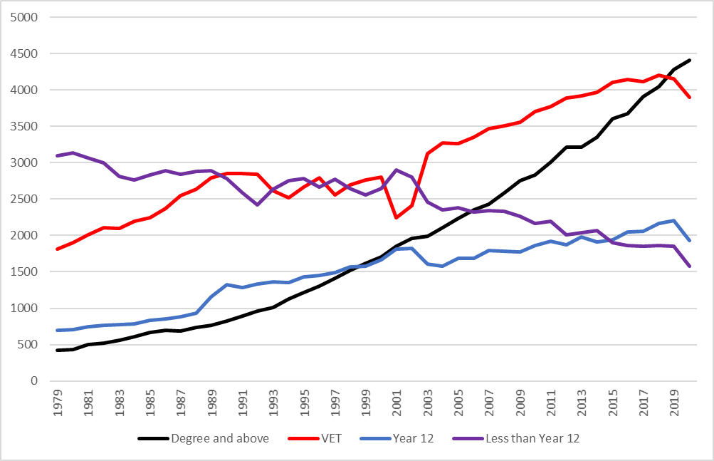

*Source: ABS, Education and Work, 6227.0*

Turning to the supply side, the number of domestic undergraduate completions has increased by around half, 47 per cent, since 2001. It is notable that most of this increase occurred over the last decade, with the number of completions increasing by 31 per cent between 2009 and 2019.

**Figure 2: Domestic undergraduate completions**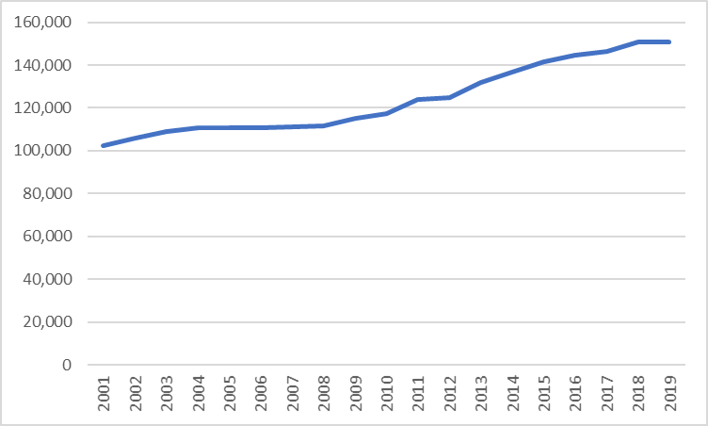

*Source: Department of Education, Skills and Employment, Higher Education Statistics, uCube*

What has been the net result of the growth in demand and supply of persons with higher education qualifications? In terms of quantities (as measured by the unemployment rate), Figure 3 shows higher education graduates always have lower unemployment, though their advantage in the labour market appears to have diminished a little in recent years. The other point worth noting is that in previous economic downturns, unemployment has tended to increase faster among non-graduates than graduates i.e. graduates fare better in a downturn. Perhaps due to COVID-19 restrictions and the supply side nature of the current downturn, graduate unemployment appears to have increased more sharply in 2020.

**Figure 3: Unemployment rate of persons with a bachelor level or higher qualification, a vocational education and training qualification and total, %**

*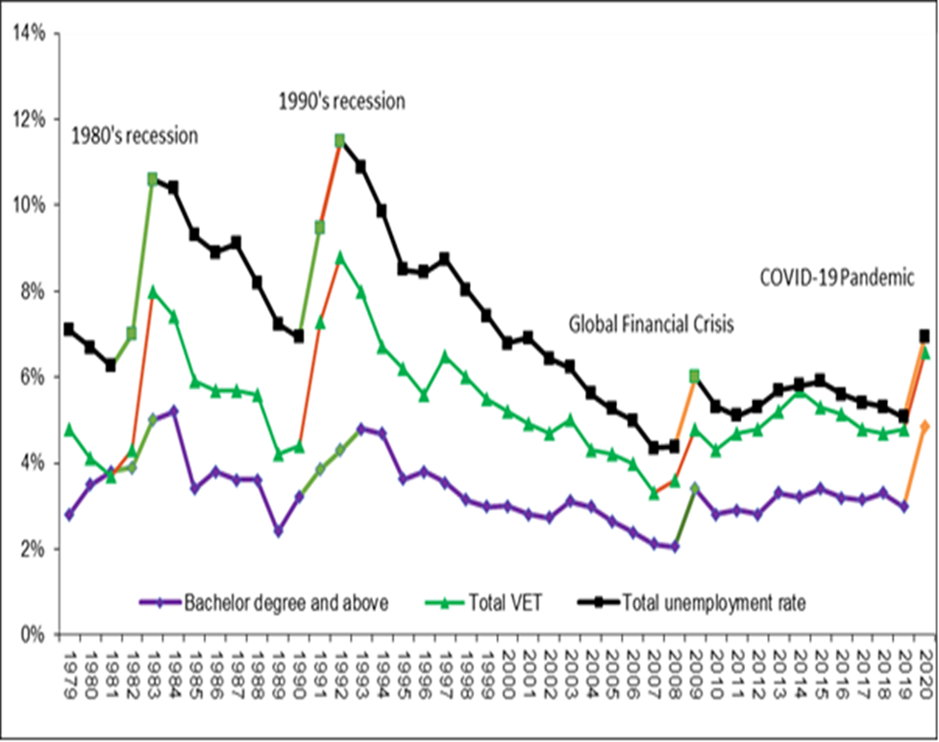Source: ABS, Education and Work, 6227.0*

Analysis of prices (incomes) reveals a similar story, as shown by Figure 4. The median weekly income of higher education graduates in 2020 was $1,400 in comparison with $1,120 for vocational education and training graduates with a Certificate III/IV qualification, a premium of 23 per cent. The income premium of higher education graduates over persons without post-school qualifications was substantially higher at 65 per cent, with median incomes for the latter group being $820. The income premium of higher education graduates has diminished a little over time, as shown by Figure 4, suggesting the supply of higher education graduates may have run ahead of demand in relative terms.

**Figure 4: Median weekly income by educational attainment, $**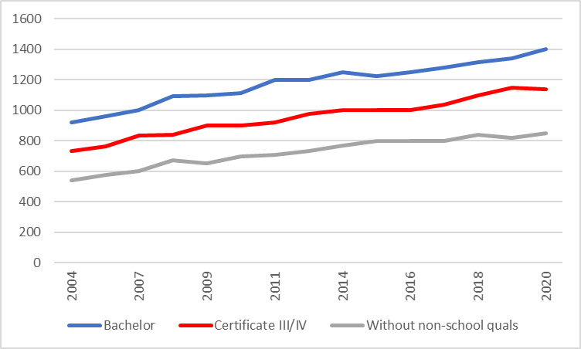

*Source: ABS, Characteristics of Workers, 6333.0*

Full-time employment among recent graduates four months after completion of their degree, as shown by results from the Australian Graduate Survey/Graduate Outcomes Survey in Figure 5, declined substantially following the 1990s recession and the Global Financial Crisis (GFC), never fully recovering after each downturn and reaching a low point of 68.1 per cent in 2014. Thereafter, graduate employment strengthened, though not to the same level as experienced before the GFC. In 2020, as result of COVID-19 restrictions and the supply side induced downturn in the economy and labour market, the full-time employment rate among undergraduates fell to its second lowest level ever, 68.7 per cent. Results from the Beyond Graduation Survey/Graduate Outcomes Survey – Longitudinal surveys show there was a slight downturn in full-time employment three years after graduation following the GFC. However, the fall in full-time employment was not as severe as it was for those immediately following graduation. This suggests since the GFC it now takes graduates longer to settle into the labour market.

**Figure 5: Full-time employment of undergraduates four months and three years after completion of their degree, %**

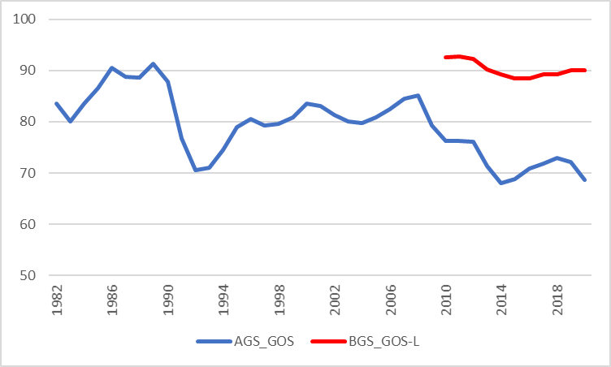

*Source: Australian Graduate Survey, Graduate Outcomes Survey, Beyond Graduation Survey and Graduate Outcomes Survey-Longitudinal,* [www.qilt.edu.au](http://www.qilt.edu.au)

Figure 6 shows trends in real graduate starting salaries for undergraduates in full-time employment. Real median full-time salaries among recent graduates were relatively static during the Accord period in the 1980s and declined during the 1990s recession. Thereafter, there has been a steady rise in real median full-time salaries among recent graduates from the mid-1990s onwards.

**Figure 6: Real median salaries of undergraduates employed full-time four months after completion of their degree, 1977=100**

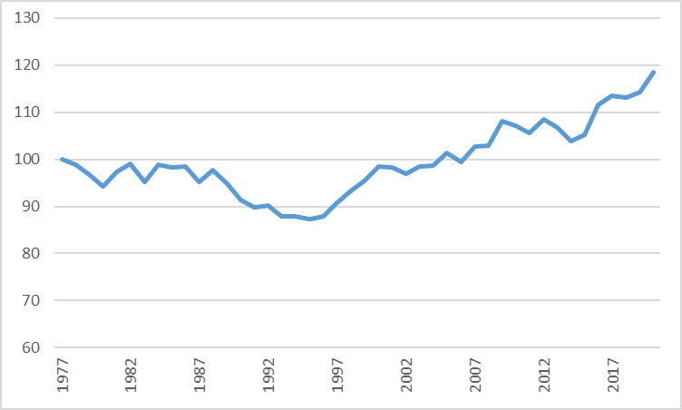

*Source: Australian Graduate Survey, Graduate Outcomes Survey,* [*www.qilt.edu.au*](http://www.qilt.edu.au) *and ABS, Consumer Price Index, 6401.0*

*Note: break in the series from 2015 to 2016 with change from AGS to GOS*

**Literature review**

Recent studies both in Australia and overseas have undertaken analysis of graduate incomes using administrative data. The Australian Government Treasury (2020) combined personal income tax data from the Australian Taxation Office (ATO) with HELP graduate loans data and business data for 1990/91 to 2017-18 to examine the impact of labour market conditions on graduates in the ten years after they completed their degrees. The study found a 5 percentage point increase in the youth unemployment rate at the time of graduation resulted in an 8 per cent reduction in graduate earnings in the first year after graduation, a 3 ½ per cent loss after five years with the effect gradually fading to zero around ten years after graduation. This scarring effect on graduate earnings was found to be lower among postgraduates, graduates from Group of Eight (Go8) universities and older graduates. The scarring effect on graduate earnings was attributed to graduates staying with lower productivity, lower wage firms in a weaker labour market. Therefore, removing barriers to labour mobility was proposed as a solution to reducing the consequences of graduating in a weak labour market.

The New Zealand Ministry of Education (2020) used data from the Integrated Data Infrastructure (IDI) linking tax data with administrative data on education and social welfare to undertake analysis of the relationship between education and earnings. The study found for the 2009 cohort of school leavers that nine years later, persons completing a degree were earning 45 per cent more than persons who had completed Level 2 school qualifications only. However, since degree holders experienced foregone earnings while they were studying, it took 10 years for them to catch up in terms of cumulative earnings in comparison with those completing Level 2 school qualifications. The study noted the supply of degree educated persons had increased substantially with the proportion of 25-34 year-olds with a degree increasing from 1 in 10 in 1991 to 4 in 10 by 2018. The study found the hourly earnings premium of degree holders over those without school qualifications had fallen from 50 per cent in 1998 to 38 per cent in 2018, suggesting the relative supply of educated labour may have run ahead of the demand for those without school qualifications. On the other hand, earnings differences between degree holders and those with school qualifications had largely remained the same over the last 20 years, suggesting balance had been achieved in relative supply and demand. The study also examined the influence of field of study on the annual earnings of young bachelor graduates five years after completion of their studies. Information technology graduates earned 18 per cent more in annual earnings than did the average bachelor graduate and other fields of study with higher earnings included Health, 16 per cent and Engineering, 13 per cent above the national average. On the other hand, graduates from fields of study with lower than average earnings were Creative arts, 16 per cent lower, Architecture and building and Education, both 7 per cent lower. The study also tracked the incomes of graduates both before and after the Global Financial Crisis (GFC). The study found that for the 2009 and 2010 post-GFC cohorts their real earnings in the first year after study had fallen by as much as 5 per cent but for the 2017 cohort first year earnings had recovered to the same level as pre-GFC cohorts. Comparison of earnings trajectories in the 10 years after study showed broadly comparable growth in earnings, except for those cohorts entering the workforce after the GFC, their starting point was lower as noted above.

The Institute for Fiscal Studies (2020) in the United Kingdom used the Longitudinal Education Outcomes (LEO) dataset linking administrative data from schools, higher education, taxation (tax records from 2005/06 to 2016/17) and pensions to estimate lifetime earnings benefits of an undergraduate degree. They estimated the net present value of an undergraduate degree was 130,000 pounds for men and 100,000 for women. There were substantial differences in the net present value of a degree by subject studied, for example for men, ranging from over 500,000 pounds for Medicine and Economics to negative returns for Creative arts and Social care. The study found the variation in individual returns was larger for subjects that have higher average returns. The study also found university type had an influence on the estimated lifetime earnings benefit of a degree for males but much less so among females. For example, the net present value of an undergraduate degree for males attending the Russell Group of universities was around 250,000 pounds but less than 150,000 pounds at all other types of universities. Also, the variation in earnings was higher for males attending the Russell Group of universities.

A study published by Statistics Canada (2020) combined post-secondary education administrative data and taxation data examining the median earnings of bachelor graduates five years out for those who graduated between 2010 and 2012. The focus of the study was on outcomes by detailed field of education. A regression analysis was conducted to adjust median earnings by field of education for age, institution and year of graduation. The study found six out of the top ten fields of education by median earnings for men and seven out of the top ten for women were Engineering fields of education and these were associated with natural resource extraction. Other higher earning fields of education included Pharmacy, Information Technology and Nursing. Most of the fields of education with low median earnings were in the Arts or Humanities fields of education.

## Australian Taxation Office (ATO) administrative data on graduate incomes

The department, in collaboration with the Australian Taxation Office (ATO) and the Australian Government Actuary (AGA), has combined administrative data on graduate incomes from the Australian Taxation Office (ATO) with administrative data from higher education enrolment and completions records sourced from the Higher Education Information Management System (HEIMS).

### Privacy

Data on graduate incomes derived from ATO administrative data are collected under the legislative authority of the *Higher Education Support Act 2003* (HESA) for the purposes of improvement of the operation of the Higher Education Loan Program (HELP). Access to graduate incomes data is restricted to a small group of departmental officers who are designated as Higher Education Loan Program (HELP) officers. Access and handling of graduate incomes data complies with relevant legislation and the Information Privacy Principles (IPPs). Data on graduate incomes are published only where this refers to the incomes of five (5) or more graduates to maintain the confidentiality of individual graduates.

### Scope and data quality

The ATO graduate incomes data in this paper refers to the 2017-18 financial year, the latest available data. Data for later years are incomplete because of delays in the submission of taxation returns. As a result, ATO data on graduate incomes are only available with a considerable time lag. For the 2017-18 financial year, this paper focuses initially on graduates who completed their studies in calendar 2016. That is, it examines the incomes of graduates who completed their degree at least one year and up to two years previously.

The creation of the data file for the analysis of graduate incomes sourced from ATO administrative records is shown in Figure 7. HEIMS records show there were 333,342 completions in 2016. First, the scope of ATO data on graduate incomes is restricted to graduates who have incurred a study debt through HECS-HELP, FEE-HELP, SA-HELP or OS-HELP programs. International students are not eligible to receive student loans and are therefore out of scope. So only the incomes of domestic graduates are reported in this paper. In 2016 there were 222,959 domestic completions. Second, the focus of this paper is on the incomes of bachelor level graduates with the incomes of sub-bachelor graduates and postgraduate coursework graduates reported separately. In 2016 there were 136,025 domestic bachelor completions (bachelor pass, bachelor honours and bachelor graduate entry). Next, graduates who paid fees up front or who were in receipt of a scholarship and did not incur a student loan debt are out of scope resulting in 123,985 records. Graduates who are deceased, who may have left Australia or who have failed to fill in a tax return are out of scope resulting in 113,338 records. To avoid duplication of records, graduates recorded as completing another bachelor degree in the following year are excluded from analysis resulting in 110,421 records. Finally, the paper, rather than counting completions, drops to one record per graduate resulting in 109,023 records, enabling examination of the incomes of unique graduates.



### Comparison of ATO administrative data and GOS survey data

One of the main purposes of collecting data on graduate incomes derived from ATO administrative records is that it can provide data at a more disaggregated level than is currently available through provision of survey data on graduate salaries. In turn, this may enable publication of graduate incomes data at more disaggregated level to better inform student choice on the ComparED website. A key question is the comparability of graduate incomes data derived from administrative and survey sources and this issue is examined in Attachment A.

### Total income and assessable income measures

The ATO collects a range of income measures as part of the annual tax return lodgement process – see Attachment B for more details. The preferred measure of graduate income used in this paper is total income or loss. However, the total income or loss measure is not available prior to 2014. Instead, for historical analysis of graduate incomes prior to 2014 this paper uses a measure of assessable income which is calculated by AGA for the purpose of determining the value of income contingent loan repayments.

From the ATO administrative data, the total income or loss (hereafter referred to as total income) in the 2017-18 financial year for each bachelor graduates who completed their studies is compared with their assessable income. The two measures show a high correlation of 0.98 suggesting they are broadly comparable measures of graduate incomes. A longer time series of total income will become available for analysis over time.

## 2018 incomes of 2016 graduates

This section uses ATO administrative data from the 2017-2018 financial year, hereafter referred to as 2018 for ease of exposition, to examine the incomes of different groups of graduates immediately following graduation. The focus is on the 2018 incomes of 2016 graduates, that is, the incomes of graduates in 2018 who would have completed their degree at least one year and up to two years previously in 2016.

Figure 8 shows the median income of the 2016 cohort of domestic bachelor graduates who had completed their degree at least one year and up to two years previously was $51,200 in 2018. Administrative data on graduate incomes enables a more thorough ongoing examination of variation in graduate incomes, particularly among different groups of graduates. The variation in graduate incomes measures, in a material sense, the uncertainty associated with undertaking higher education, as shown by Figure 8. In 2018, those at the 25th percentile of graduate incomes earned $31,800 while those at the 75th percentile earned $66,900, more than twice or 2.11 times their counterparts on lower incomes (the interquartile ratio is used as a simple summary statistic to report the variation in graduate incomes throughout the remainder of this paper).

**Figure 8: 2018 income quartiles of 2016 graduates, $***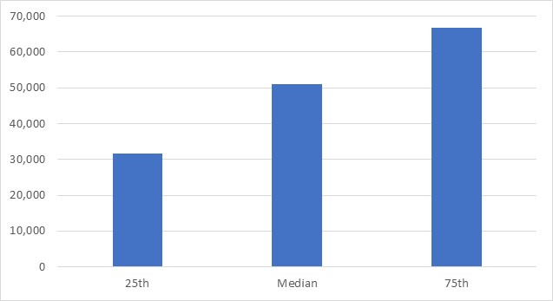**Source: Australian Taxation Office (ATO) administrative data*

Figure 9 shows the median income of male graduates, as measured by administrative data, was $51,400 which was marginally higher, 0.7 per cent, than the median income of female graduates of $51,000. There was greater variation in graduate incomes among males than females at least one year and up to two years following graduation. Male graduate incomes at the 75th percentile were 2.22 times higher than at the 25th percentile whereas female graduate incomes were 2.04 times higher.

**Figure 9: 2018 incomes of 2016 graduates by gender, $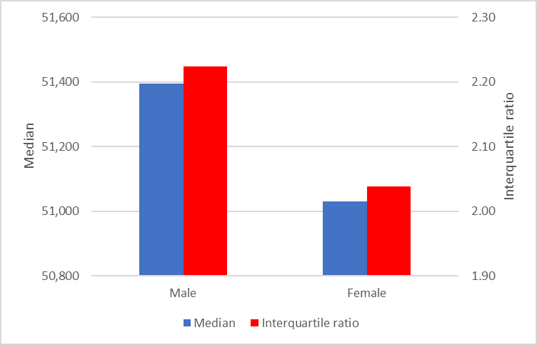***Source: ATO administrative data*

Patterns in median incomes among different groups of graduates are as follows: graduates who were older (30 years and over), from an English speaking background, from an Indigenous background, with no reported disability or who attended university (in comparison with graduates who attended a non-university higher education institution) had higher median incomes by a margin of 13 per cent, 1 per cent, 14 per cent, 14 per cent and 38 per cent than their respective counterparts, as shown by Figures 10-15. Administrative data show graduates from low socioeconomic status backgrounds earned 4 per cent more than their counterparts from a high socioeconomic status background – see Figure 14. Also, Figure 16 shows the median income of graduates who attended a Regional Network University (RUN) was 22 per cent higher than the median income of graduates from a Group of Eight (Go8) university. This issue is explored in more detail at provider level later in the paper.

An interesting feature shown by Figures 10-16 is that graduates with lower initial incomes, generally from disadvantaged backgrounds, though not always the case, also reported greater variation in incomes. That is the interquartile ratio between incomes was larger. Graduates who were younger (under 30 years old), from a non-Indigenous background, with a reported disability, from a high socioeconomic status background, who attended a non-university higher education institution (NUHEIs) or who attended a Go8 university, not only had lower median incomes but were also likely to report more variable incomes than their counterparts.

**Figure 10: 2018 incomes of 2016 graduates by age group, $**

*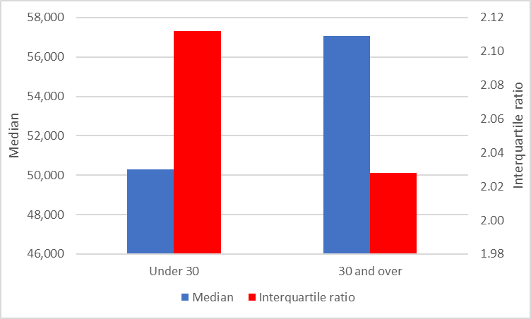**Source: ATO administrative data*

**Figure 11: 2018 incomes of 2016 graduates by language background, $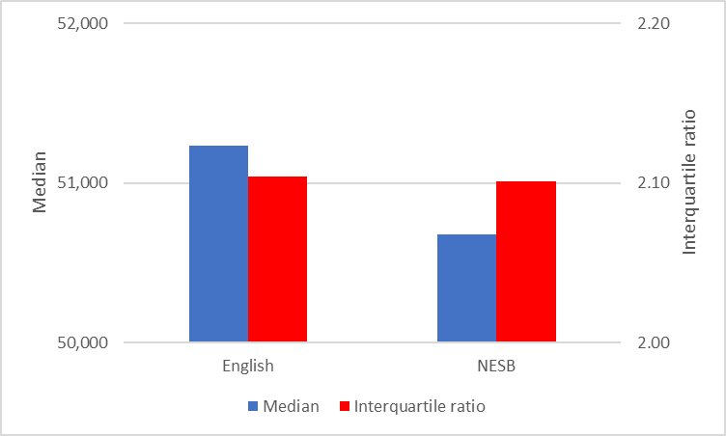***Source: ATO administrative data*

**Figure 12: 2018 incomes of 2016 graduates by Indigenous status, $**  
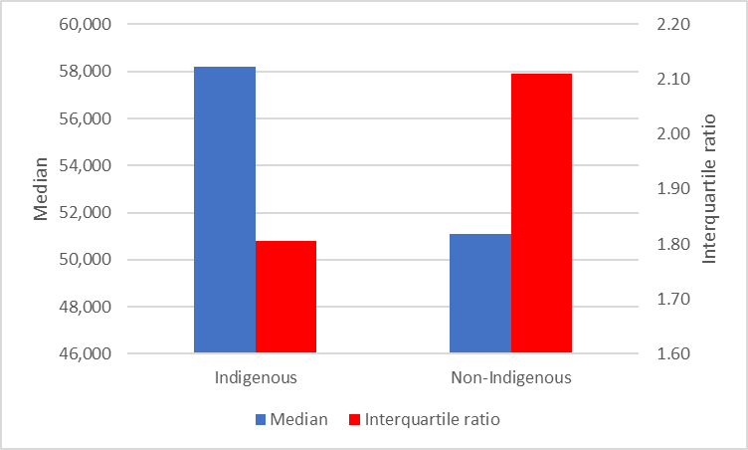

*Source: ATO administrative data*

**Figure 13: 2018 incomes of 2016 graduates by disability status, $**

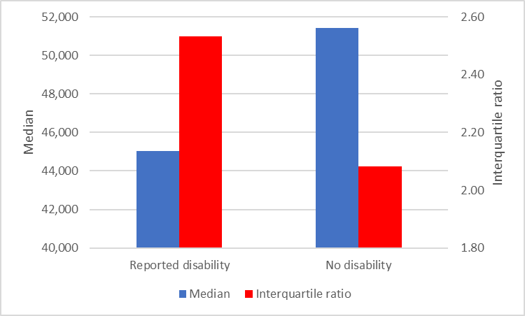  
*Source: ATO administrative data*

**Figure 14: 2018 incomes of 2016 graduates by socioeconomic status, $  
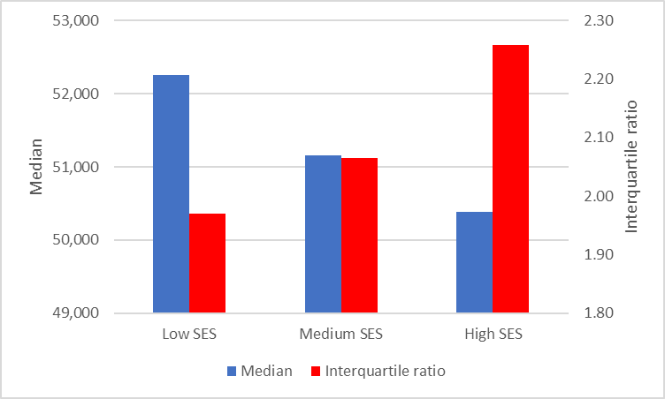**

*Source: ATO administrative data*

**Figure 15: 2018 incomes of 2016 graduates by type of provider, $**

**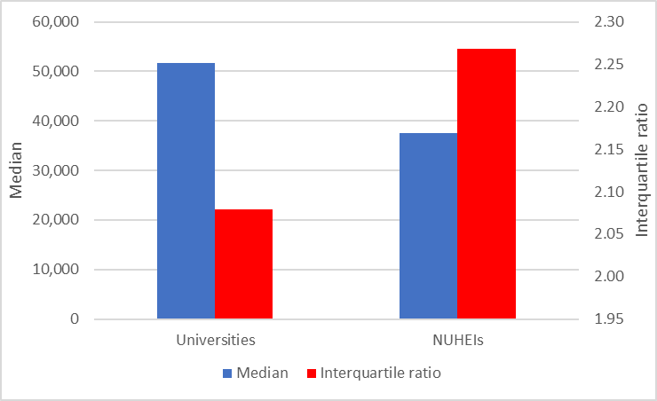***Source: ATO administrative data*

**Figure 16: 2018 incomes of 2016 graduates by type of university, $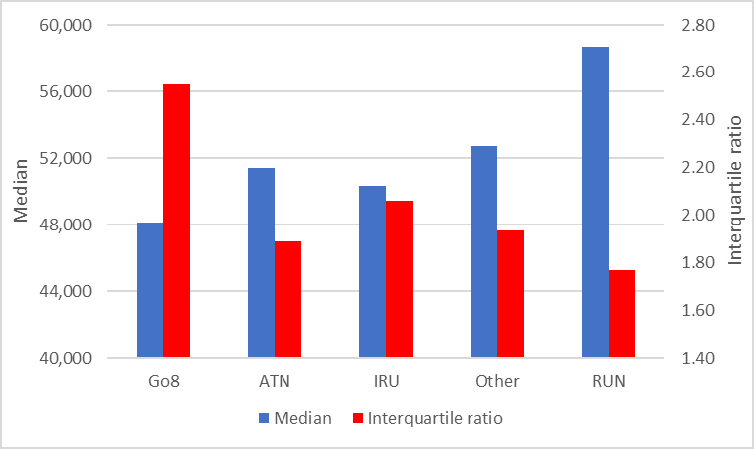***Source: ATO administrative data*

The administrative data on graduate incomes confirm findings from the 2017 Graduate Outcomes Survey showing graduates with vocationally focused degrees report higher median incomes immediately following graduation. At least one year and up to two years following graduation, those with highest median incomes studied Medicine ($84,000), Dentistry ($78,300), Teacher education ($65,200), Engineering ($63,600) and Nursing ($62,200), as shown by Figure 17. Graduates with lowest median incomes following graduation were those completing Science and mathematics degrees who earned $32,600. In part, this is due to Science and mathematics graduates being more likely to undertake further study, as shown by results from the 2017 Graduate Outcomes Survey. It is generally the case that study areas where graduates were more likely to undertake further full-time study also had lower initial incomes (correlation =-0.69). Other graduates with lower median incomes following completion of their degree included those who completed Creative arts ($33,600) and Humanities, culture and social sciences ($36,900) degrees. That is, graduates with generalist degrees and those more likely to undertake further study following graduation had lower incomes.

While graduates with generalist degrees experience lower incomes on average following graduation, they also experience greater variation in incomes. That is, there is more uncertainty attached to completing those degrees in a material sense. Figure 17 clearly shows the negative relationship between median income and the interquartile ratio in income by study area (correlation = -0.77). For Medicine graduates, the variation in graduate incomes was relatively low with graduates at the 75th percentile earning 23 per cent more than their counterparts at the 25th percentile. This compares with the experience of Science and mathematics graduates where those at the 75th percentile earned almost three times as much, 2.97, as their counterparts at the 25th percentile.

Universities with highest median incomes among bachelor degree holders at least one year and up to two years following graduation include James Cook University ($65,200), CQUniversity ($63,400), University of Southern Queensland ($62,400), Charles Darwin University ($62,200), University of Notre Dame Australia ($62,000), Charles Sturt University ($60,700) and the University of New England ($58,900), as shown by Figure 18. Most, but not all, of these universities are distance providers with large numbers of external students. These students typically have an ongoing relationship with an employer while studying which confers a ‘head start’ in the labour market upon graduation resulting in higher incomes immediately following graduation.

On the other hand, universities with lowest median incomes among bachelor degree holders include the University of Divinity ($24,900), the University of Melbourne ($29,300) and the University of Western Australia ($35,300). Analysis of graduate incomes at the latter two universities is complicated by course structures at these universities where students undertake a generalist three year degree before proceeding to a professional two year postgraduate degree. This has the effect of delaying entry to the labour market among these graduates. The combination of generalist courses and delayed entry to the labour market results in lower reported median incomes among graduates from these universities, at least in the short-term. The 2016 cohort of graduates from universities with low initial incomes were more likely to have gone on to further full-time study as shown by results from the 2017 Graduate Outcomes Survey (correlation = -0.68). Further study has the effect of delaying entry to the labour market which contributes to lower graduate incomes, at least in the short-term.

Once again, results by university show the negative relationship between median income and variation in incomes (correlation = -0.84). For example, James Cook University graduates at the 75th percentile earn 55 per cent more than their counterparts at the 25th percentile whereas graduates from the University of Western Australia at the 75th percentile earn more than three times, 3.01, than those at the 25th percentile.

Figure 19 shows results by non-university higher education institution (NUHEIs). Those with highest median incomes among bachelor degree holders at least one year and up to two years following graduation include Avondale College of Higher Education ($64,400) and Christian Heritage College ($51,300). The negative relationship between median income and variation in incomes still holds among NUHEIs though the relationship is not as strong (correlation = -0.39). One reason for this may be that there is more ‘noise’ in the data for NUHEIs owing to the smaller number of graduates at these institutions.

**Figure 17: 2018 incomes of 2016 graduates by study area (21), $**

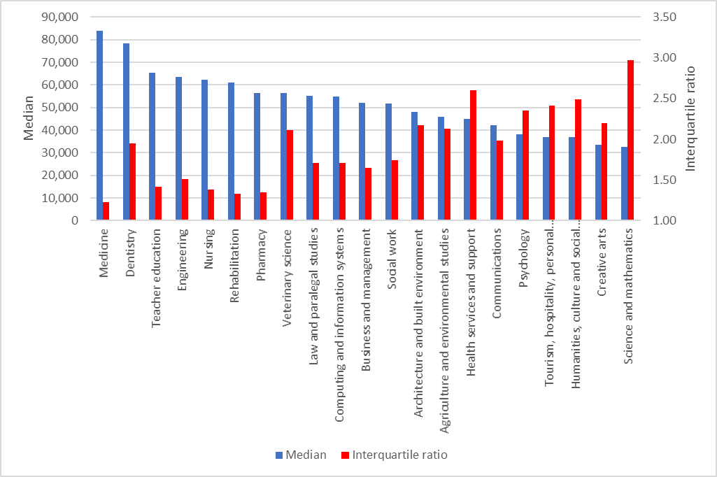  
Source: ATO administrative data

**Figure 18: 2018 incomes of 2016 graduates by university, $**

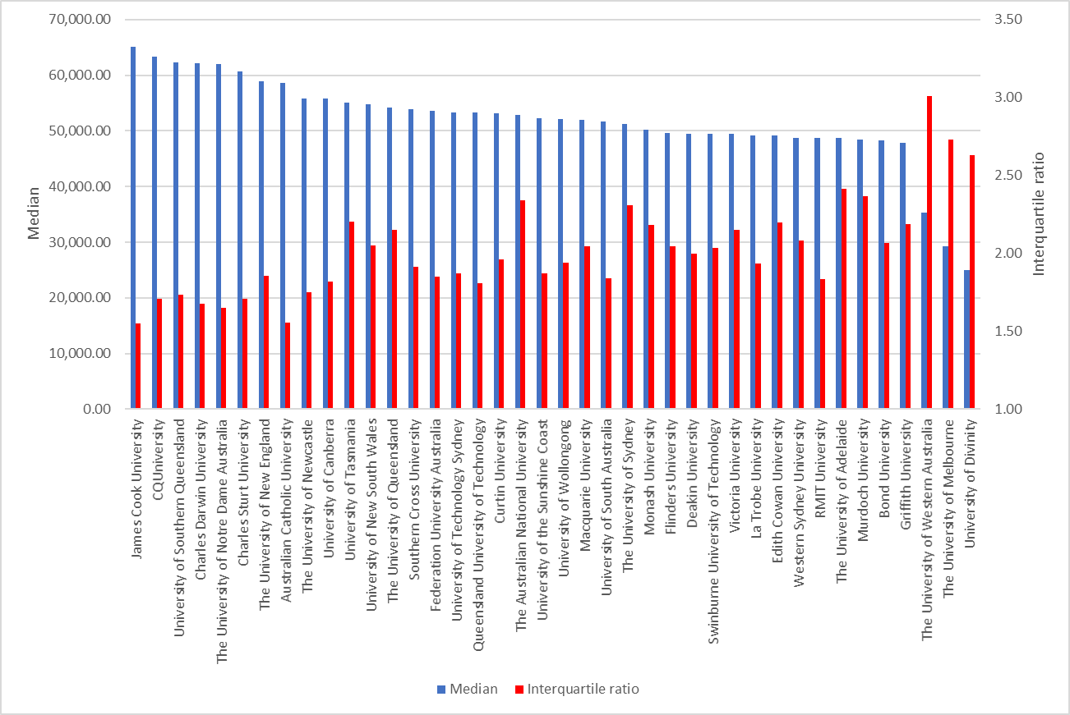

*Source: ATO administrative data*

**Figure 19: 2018 incomes of 2016 graduates by non-university higher education institution (NUHEI), $**

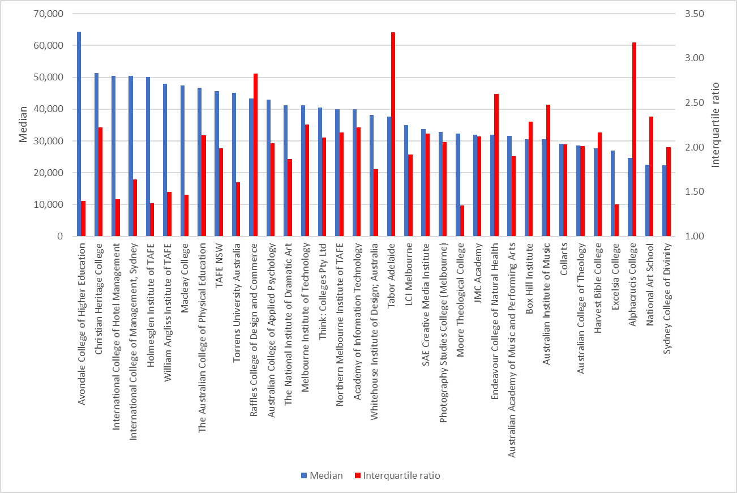  
*Source: ATO administrative data*

### 2018 incomes of 2016 combined degree graduates

There were 12,242 domestic bachelor graduates who completed combined degrees in 2016 comprising around 11 per cent of all domestic bachelor graduates. Males were marginally more likely to have completed combined degrees, 12 per cent, in comparison with females, 11 per cent. Study areas where graduates were most likely to undertake a combined degree were Law and paralegal studies, 25 per cent, Medicine, 25 per cent, and, Veterinary science, 20 per cent.[1]

The median income in 2018 of graduates who completed a combined degree in 2016 was $59,200 in comparison with $50,000 for single degree holders, a premium of 19 per cent. Male combined degree holders’ median income was $59,800 in comparison with $50,000 for single degree holders, a premium of 20 per cent. By way of contrast, female combined degree holders’ median income was $58,800 in comparison with $49,900 for single degree holders, a lower premium of 18 per cent.

The impact of undertaking a combined degree on incomes is pronounced, as shown by Figure 20. For example, where graduates combined a generalist degree with another degree, the gain in income (in comparison with single degree holders) was appreciable. Science and mathematics graduates with combined degrees increased their incomes by almost three-quarters by 74 per cent while Humanities, culture and social sciences graduates with combined degrees increased their incomes by over half by 61 per cent. On the other hand, the gain in income from undertaking a combined degree was less marked for those with a vocationally oriented degree. For example, graduates combining a Business and management degree with another degree increased their incomes by 9 per cent and Law and paralegal graduates with combined degrees increased their incomes by 7 per cent. In some study areas, graduates with combined degrees earned less than graduates undertaking a single degree. For example, Teacher education graduates with combined degrees earned 2 per cent less and Rehabilitation graduates with combined degrees earned 6 per cent less.

**Figure 20: 2018 incomes of 2016 combined and single degree graduates by 21 study areas, $**

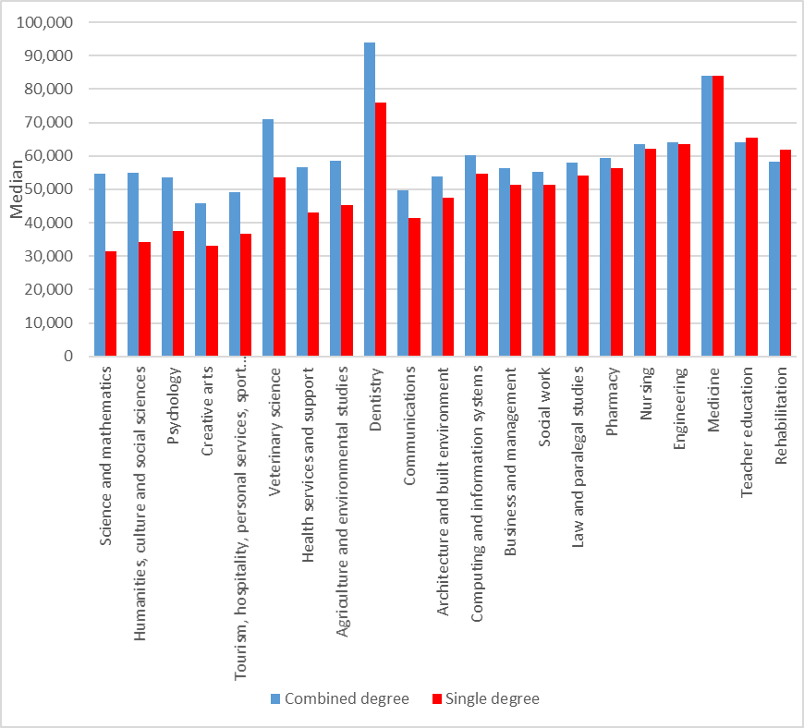

*Source: ATO administrative data*

### Trends in incomes of initial graduates by gender

Survey data from the Graduate Outcomes Survey and its predecessor show a slight fall in the gender gap in median salaries among undergraduates immediately following graduation from 6.0 per cent in 2009 to 2.5 per cent in 2020.[2] However, salaries information published from survey data refers to graduates in full-time employment only. The ATO administrative data provide an alternative indicator of the monetary gain from undertaking higher education showing the incomes of all graduates, including those who were employed full-time, employed part-time, unemployed and not in the labour force. There is no ready way of identifying the labour force status of graduates from the ATO data. The ATO data show the gender gap in incomes of initial graduates was broadly similar to the survey data in 2009 at 4.4 per cent, as shown by Figure 21. Since 2014, female graduates immediately following graduation have had higher incomes than male graduates with a gap of 1.9 per cent in 2018. Note the time series from the ATO data, as described above, are only available using the assessable income measure. Earlier data from Figure 9 showed a gender gap in incomes of initial graduates in favour of males of 0.7 per cent using the total income measure. The point here is not to focus on the absolute value of incomes but rather the trend in incomes among initial graduates. This shows over the last decade the incomes of female graduates immediately following graduation have increased faster by 21 per cent in comparison with 13 per cent among male graduates.

**Figure 21: Median income of initial graduates by gender, 2009 -2018, $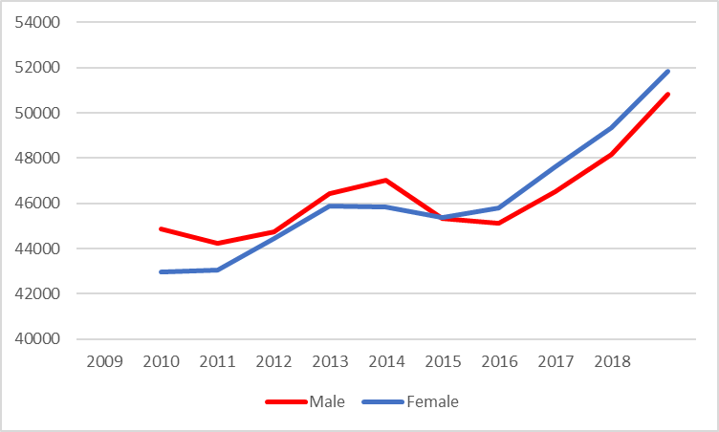***Source: ATO administrative data*

Female graduates are more likely than males to be employed immediately following graduation, as shown by Figure 22. The more important point here is the trend in graduate employment. The gap between female and male employment among initial graduates has grown over time increasing by around two percentage points between 2008 and 2015 (corresponding to the 2007 and 2014 completion cohorts). Note, data in Figure 22 are not compiled after 2015 due to the break in series with the introduction of the Graduate Outcomes Survey. While initial female graduates were still more likely than males to be employed in 2016 and 2017, there was a slight reduction in the gap between female and male employment in 2017. Since graduates in employment are likely to earn more than graduates not in employment, the growing gap in employment between females and males (notwithstanding the slight reversal in 2017) is likely contributing, in part, to faster growth in median incomes among female graduates immediately following graduation.

**Figure 22: Employment of initial graduates, 2008 – 2015, %**  
**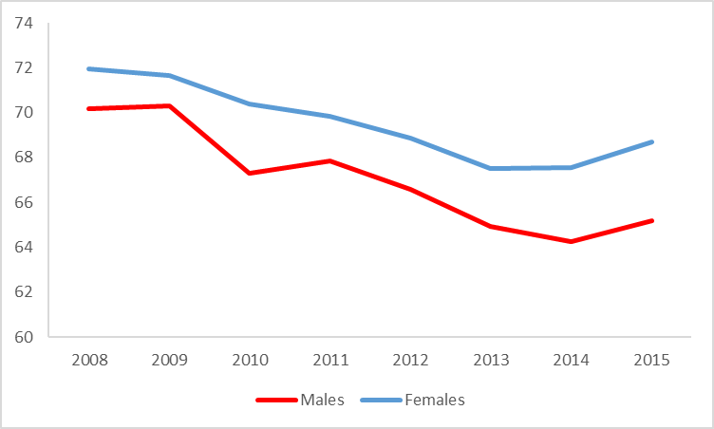***Source: Graduate Destination Survey, 2008-2015. NB % employment refers to the percentage of initial bachelor graduates in full-time employment, in part-time or casual employment and seeking full-time employment or, in part-time or casual employment but not seeking full-time employment, as a proportion of all initial bachelor graduates, in effect, the employment to population ratio.*

## 2007 cohort of graduates – growth in incomes

The previous section showed some groups of graduates had lower incomes immediately following completion of their studies. In some cases, this was associated with bachelor graduates proceeding to further full-time study with the effect of delaying their entry to the labour market resulting in lower employment and incomes. This section uses ATO administrative data to track graduate incomes over time enabling examination of whether graduates with lower initial incomes recover or if graduates with higher initial incomes maintain their advantage in terms of achieving higher incomes over the medium and longer term. This section examines the progress of the 2007 cohort of graduates, as measured by growth in incomes, at least one year but less than two years after graduation in 2009 through to at least ten years but less than eleven years after graduation in 2018.

The average bachelor graduate experienced steady growth in their income in the decade following graduation increasing by 88 per cent, as shown by Figure 23. Graduates at the 75th percentile experienced faster growth in income increasing by 100 per cent. Graduates on lower incomes at the 25th percentile also experienced growth in income, though at a slower rate, increasing by 79 per cent. Consequently, the variation in graduate incomes increases the longer the time period after graduation, as measured by the change in the interquartile ratio, increasing from 1.92 to 2.16 between 1 year and 10 years after graduation. That is, graduates at the 75th percentile earned slightly less than twice as much as graduates at the 25th percentile immediately following graduation and this increased to more than two-fold in the ten years following graduation.

**Figure 23: Median and quartile income of 2007 cohort of bachelor graduates between one and ten years after graduation, $** 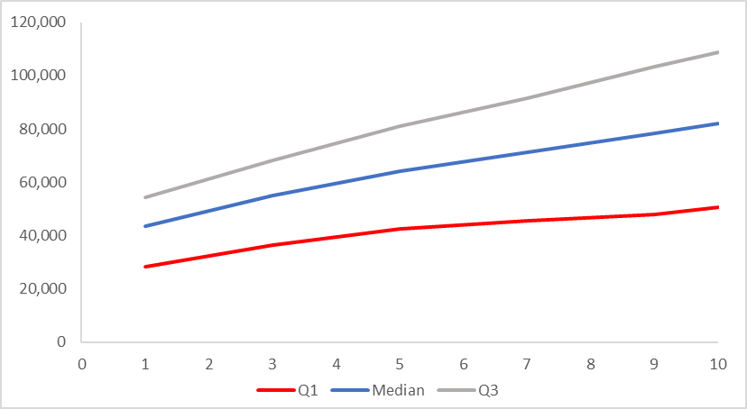

*Source: ATO administrative data*

There are very different trends in the incomes of male and female graduates following completion of their studies as shown by Figure 24. As noted above, immediately following graduation in 2009, the median income of male graduates exceeded that of their female counterparts by around 4 per cent. Thereafter, the median income of male graduates increased more rapidly, from $44,900 to $96,200 in 2018. That is, the median income of male graduates more than doubled between 2009 and 2018. By way of comparison, the median income of female graduates increased more slowly from $43,000 to $72,700, an increase of 69 per cent.

**Figure 24: Median income of 2007 cohort of bachelor graduates between one and ten years after graduation by gender, $**

*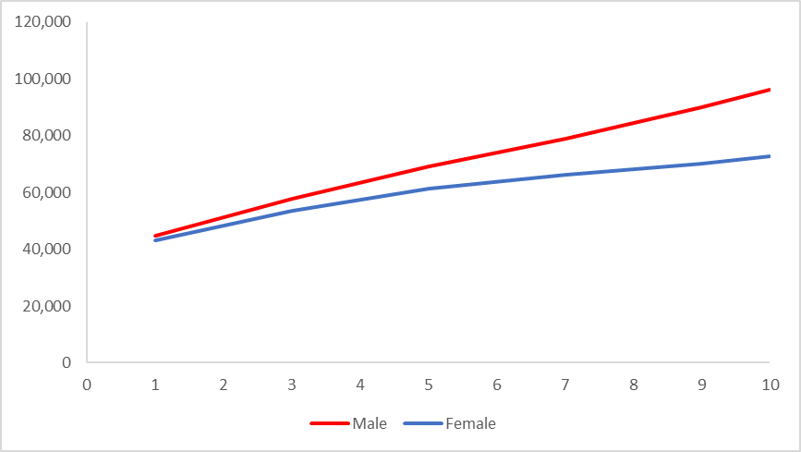  
Source: ATO administrative data*

As noted before, immediately following graduation there is a larger spread in the incomes of male than female graduates. However, an interesting feature of Figure 25 is that over time the pattern of incomes as measured by the variation in incomes changes for males and females. Among male graduates, the interquartile ratio actually falls over time from 1.98 to 1.86. On the other hand, the longer the time period after graduation, the greater the variation in incomes of female graduates becomes, increasing from 1.90 to 2.26. That is, there is greater uncertainty associated with the attainment of a bachelor degree among female than male graduates. Data from the 2018 Graduate Outcomes Survey – Longitudinal tracking undergraduates in the three years following graduation shows that females are much more likely than males to move between various labour market states e.g. between full-time employment, part-time employment, unemployment and not in the labour force.[3] Thus, the greater variability in the incomes of female graduates in the medium term is, in part, likely associated with their movement between different labour market states over time.

**Figure 25: Interquartile ratio of incomes of 2007 cohort of bachelor graduates between one and ten years after graduation by gender**

*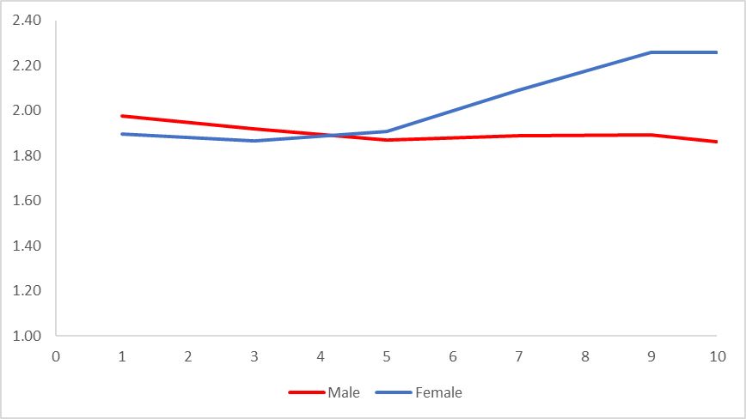  
Source: ATO administrative data*

Further insight into the slower growth of the incomes of female graduates is provided in Figure 26 showing income growth over time by gender for those with and without dependants. Unfortunately, income data by dependant status is only available in recent years, but nevertheless it does show trends in income for the 2013 cohort of graduates at least four years after graduation. There are a couple of features to note from Figure 26. First, female graduates, regardless of whether they have dependants or not, have slower growth in incomes than their male counterparts in the four years following graduation. Second, graduates with dependants, both male and female graduates have slower growth in incomes. Female graduates with dependants have the slowest growth in incomes, increasing by 14 per cent in the four years after graduation and this contrasts with the experience of male graduates without dependants whose incomes increased by 45 per cent over the same period. Over the longer term, it would appear a mix of demand and supply forces are contributing to trends in the incomes of male and female graduates over time. From above, even for those without dependants, male graduate incomes increased faster than female graduate incomes. Females are also more likely to have graduated in courses with slower growth in incomes over time such as Teacher Education and Nursing – see below. Evidence presented above in Figure 26 suggests supply side forces such as choices about family formation are also likely contributing to trends in the incomes of male and female graduates over time.

**Figure 26: 2013 cohort of bachelor graduates, income growth 2015-2018 by gender and dependant status, %**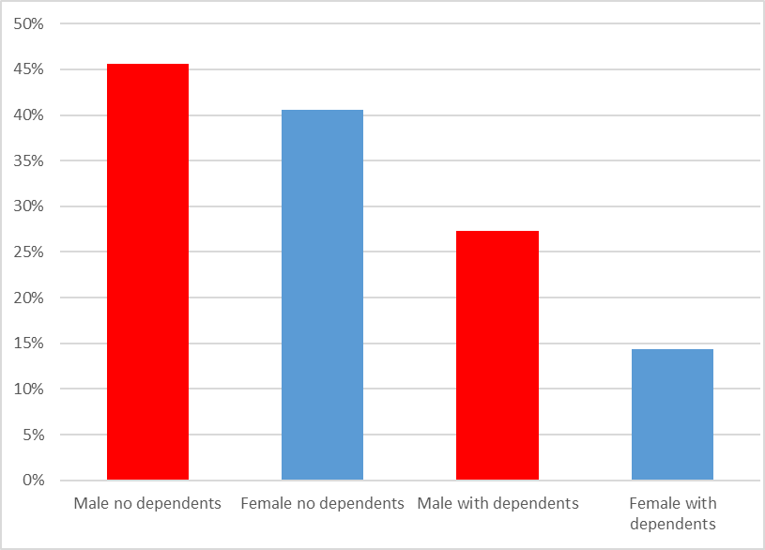

*Source: ATO administrative data*

Graduates from study areas with stronger initial incomes also experience higher incomes ten years following graduation (correlation = 0.80). For example, graduates with highest incomes ten years after graduation include Medicine, $169,000, Engineering, $112,900 and Dentistry, $104,800, as shown by Figure 27. However, it is also the case that graduates with lower initial incomes experience relatively faster growth in their incomes in the ten years following graduation, that is, their incomes catch up in some senses. For example, graduates in Creative arts, Humanities, culture and social sciences, Psychology and, Science and mathematics, experience relatively faster growth in incomes in the decade following graduation, by 102 per cent, 133 per cent, 128 per cent and 146 per cent respectively. There is a negative correlation between initial incomes and growth in incomes in the ten years following graduation by study area (-0.51). As noted earlier, graduates from study areas with lower initial incomes were more likely to be undertaking further study. It appears further study is of advantage to graduates enabling their incomes to grow more rapidly over time. There is a strong relationship between further study and income growth between 2009-2018   
(correlation = 0.66).

**Figure 27: 2007 cohort of bachelor graduates, 2009 income (LHS, $) and 2018 income (RHS, $)   
by study area** 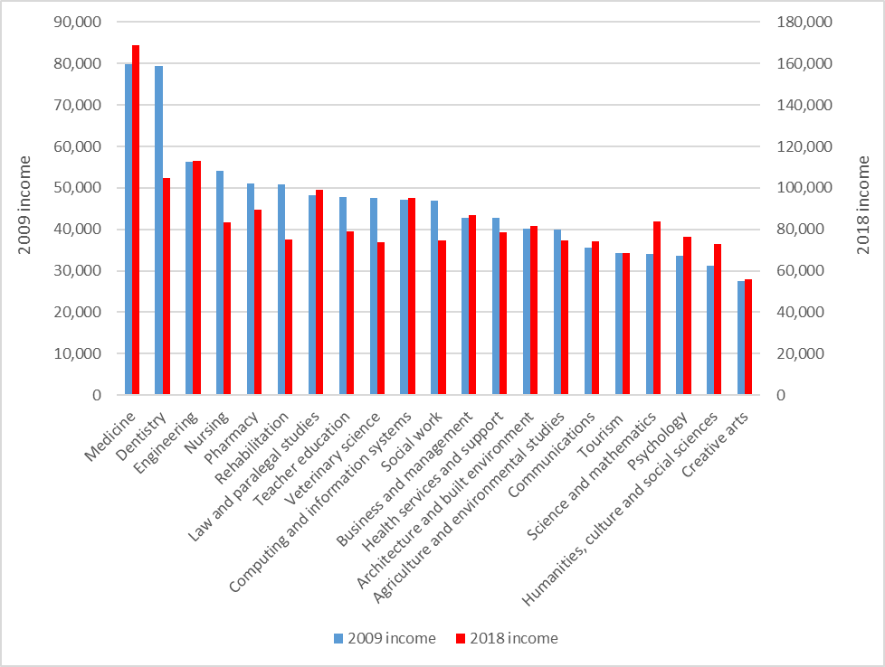*Source: ATO administrative data*

Figure 28 shows the median income of graduates ten years out by study area and the percentage of female graduates by study area. It shows there are proportionately fewer females in study areas with higher incomes over the longer term, though the relationship is relatively weak. The correlation between income ten years out and the percentage of female graduates = -0.37. Nevertheless, that relationship has strengthened over time as the correlation between income one year out and the percentage of female graduates was lower (correlation = -0.09). Also, there tends to be proportionately more female graduates in study areas that experienced slower growth in incomes, such as Teacher Education and Nursing, though the relationship was relatively weak and negative (correlation = -0.38). Evidence shows male salaries have increased much faster than female salaries over time within each study area. This suggests factors beyond subject choice such as such as occupation, age, experience, personal factors and possible inequalities within workplaces contribute to the gender gap in salaries over time.

**Figure 28: 2007 cohort of bachelor graduates, 2018 income (LHS, $) and % female (RHS) by study area**

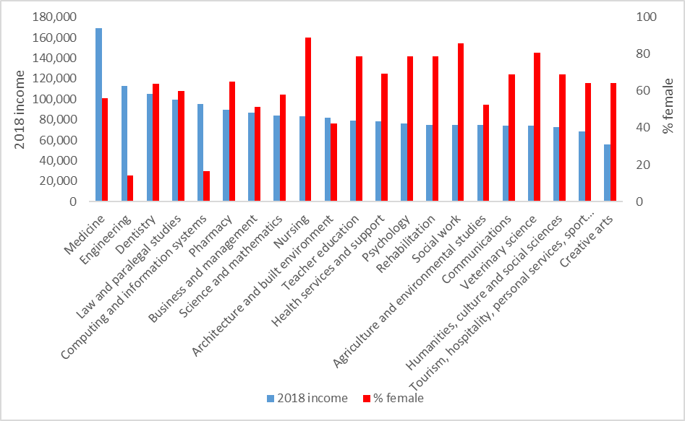  
Source: ATO administrative data

Older graduates immediately following graduation, as noted above, are more likely to have an ongoing relationship with an employer and the labour market and this is reflected in higher earnings, as shown by Figure 29. However, in the decade following graduation, graduates aged under 30 experience faster growth in income increasing by 91 per cent in comparison with 73 per cent for graduates aged 30 and over. Ten years after graduation the median income of younger graduates, $82,100 has almost recovered to be just below that of older graduates, $82,400. Immediately following graduation older graduates have greater dispersion in their incomes[4] However, ten years after graduation, this has been reversed as younger graduates have greater variation in incomes than older graduates, as shown by Figure 30.

**Figure 29:** **Median income of 2007 cohort of bachelor graduates between one and ten years after graduation by age,** $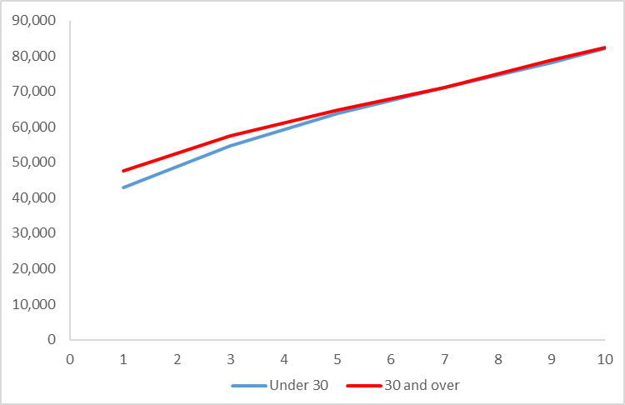

*Source: ATO administrative data*

**Figure 30: Interquartile ratio of incomes of 2007 cohort of bachelor graduates between one and ten years after graduation by age**

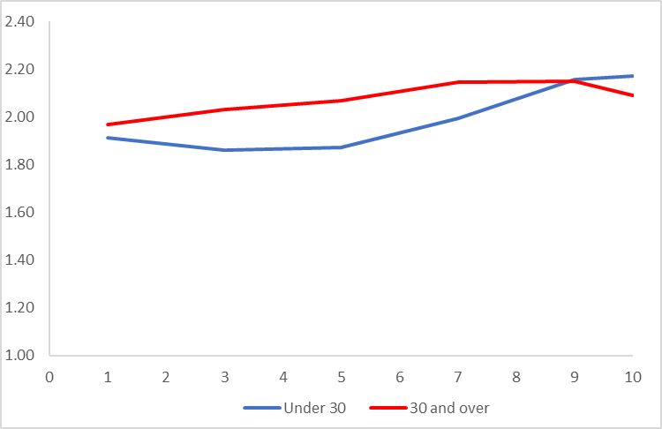  
*Source: ATO administrative data*

Graduates from a non-English speaking background have slightly lower incomes for up to three years following graduation but thereafter they have higher incomes, as shown by Figure 31. In the ten years following graduation, the median income of non-English speaking graduates increased faster by 95 per cent to $84,100. English speaking graduates experienced slower growth in median income increasing by 87 per cent so that ten years after graduation they had a median income of $81,900. While non-English speaking graduates have lower variation in their incomes for up to three years following graduation, thereafter they experience greater variation in their incomes, as shown by Figure 32.

**Figure 31: Median income of 2007 cohort of bachelor graduates between one and ten years after graduation by language background,** $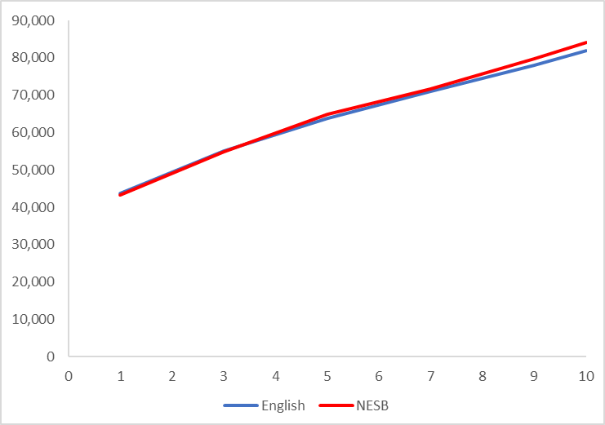*Source: ATO administrative data*

**Figure 32: Interquartile ratio of incomes of 2007 cohort of bachelor graduates between one and ten years after graduation by language background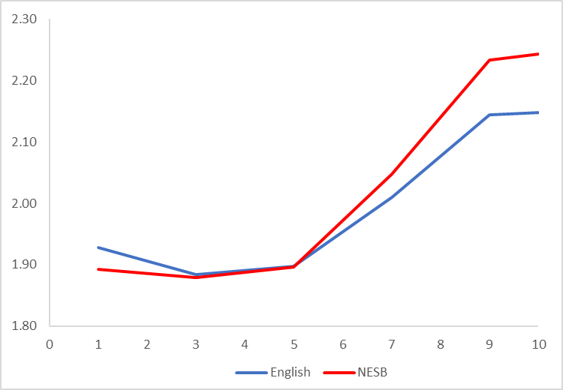***Source: ATO administrative data*

Immediately following graduation Indigenous graduates have a higher median income than non-Indigenous graduates but that advantage disappears over time, as shown by Figure 33. In the ten years following graduation, the median income of Indigenous graduates increased by 76 per cent to $82,500. Non-Indigenous graduates experienced faster growth in median income increasing by 88 per cent so that ten years after graduation they had a median income of $82,200. Non-Indigenous graduates generally experience greater variation in their incomes in the ten year period following graduation, as shown by Figure 34.

**Figure 33: Median income of 2007 cohort of bachelor graduates between one and ten years after graduation by Indigenous status, 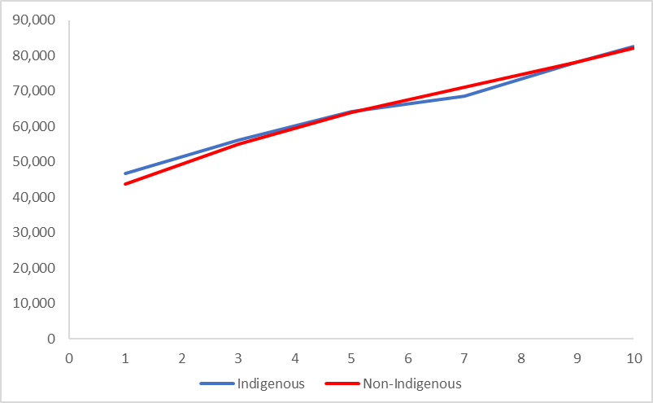**$  
*Source: ATO administrative data*

**Figure 34: Interquartile ratio of incomes of 2007 cohort of bachelor graduates between one and ten years after graduation by Indigenous status**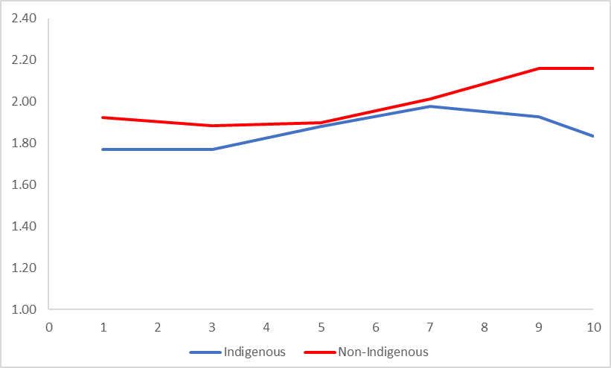   
*Source: ATO administrative data*

Graduates with a reported disability experience lower incomes immediately following graduation than those with no reported disability, as shown by Figure 35. In the ten years following graduation, the median income of those with a reported disability increased by 83 per cent, more slowly than growth of 101 per cent in the median income of graduates with no reported disability. Not only do graduates with a reported disability experience lower incomes, they also experience greater variation in their incomes, as shown by Figure 36.

**Figure 35: Median income of 2007 cohort of bachelor graduates between one and ten years after graduation by disability status,** $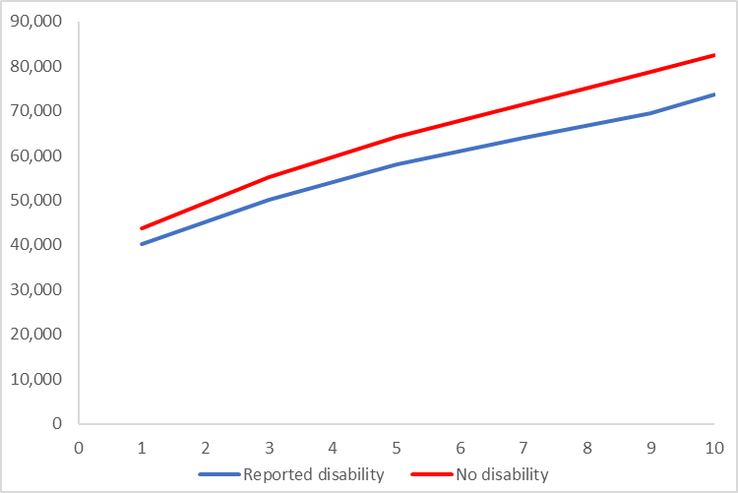  
*Source: ATO administrative data*

**Figure 36: Interquartile ratio of incomes of 2007 cohort of bachelor graduates between one and ten years after graduation by disability status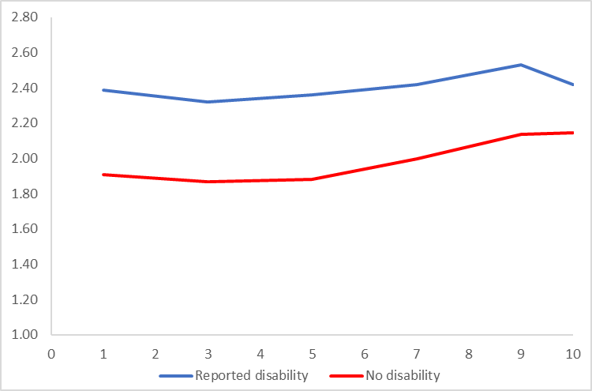***Source: ATO administrative data*

Graduates from low socioeconomic status backgrounds have higher incomes immediately following graduation, as shown by Figure 37. In part, this is associated with low socioeconomic status graduates being more likely to acquire vocationally oriented degrees which tend to have higher employment and salary outcomes immediately following graduation. However, in the ten years following graduation, graduates from a high socioeconomic status background experience faster growth in incomes, 96 per cent in comparison with 86 per cent for graduates from a medium SES background and 80 per cent for those from a low SES background. As a result, ten years after graduation the median income of high SES graduates of $84,500 surpasses that of medium SES graduates, $81,300 and low SES graduates, $80,400.

**Figure 36: Median income of 2007 cohort of bachelor graduates between one and ten years after graduation by socioeconomic status,** $

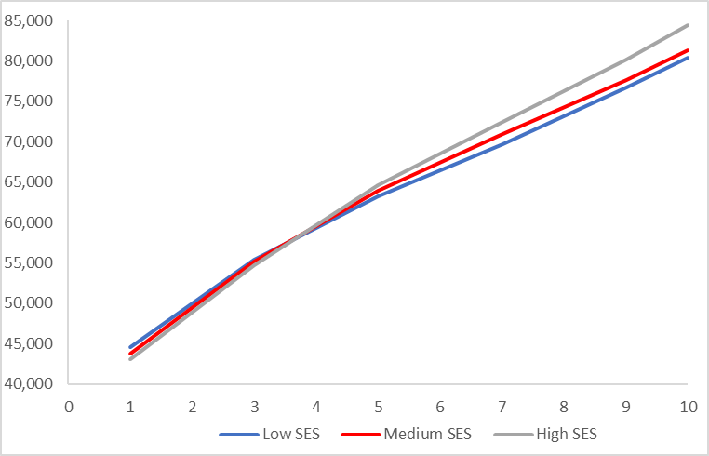  
*Source: ATO administrative data*

Variation in incomes increases over time among graduates from all socioeconomic backgrounds, as shown by Figure 38. It remains the case that graduates from a high socioeconomic status background experience greater variation in their incomes both immediately following graduation and ten years after graduation.

**Figure 38: Interquartile ratio of incomes of 2007 cohort of bachelor graduates between one and ten years after graduation by socioeconomic status**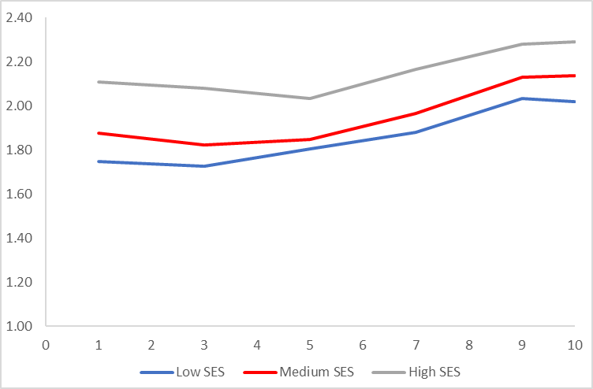   
*Source: ATO administrative data*

Patterns in in changes in income by university are broadly similar to those by study area, though mostly a little weaker. For example, graduates from universities with higher initial incomes in 2009 also had higher incomes ten years after graduation in 2018 (correlation = 0.61). Universities with highest incomes ten years after graduation include the University of New South Wales, $96,500, the University of Western Australia, $94,100 and the University of Technology, Sydney, $92,800, as shown by Figure 39. Nevertheless, graduates from some universities with weaker initial incomes such as Bond University, the University of Sydney, the University of Adelaide, University of the Sunshine Coast, and the University of Melbourne experience a recovery in their incomes in the decade following graduation, increasing relatively faster by 125 per cent, 114 per cent, 110 per cent, 107 per cent and 106 per cent respectively. However, there is only a moderate negative relationship between initial incomes and growth in incomes in the ten years following graduation (correlation = - 0.42). As noted above, further study contributes to delayed entry to the labour market and lower initial incomes for graduates at some universities. Thereafter, however, there is some evidence that universities where graduates are more likely to undertake further study achieve faster growth in incomes in the ten years following graduation (correlation = 0.60).

Graduates at non-university higher education institutions (NUHEIs) generally experienced slower growth in incomes in the ten years following graduation, increasing by 80 per cent, in comparison with university graduates whose incomes increased by 88 per cent. Graduates from NUHEIs that had highest incomes ten years after graduation included the Australian College of Physical Education, $82,800 and the Navitas College of Public Safety Pty Ltd, $74,200, as shown by Figure 40. Once again, graduates from some NUHEIs with weaker initial incomes experienced faster growth in incomes in the decade following graduation, but the relationship was very weak   
(correlation = -0.15).

**Figure 39: 2007 cohort of bachelor graduates, 2009 income (LHS, $) and 2018 income (RHS, $)  
 by university**

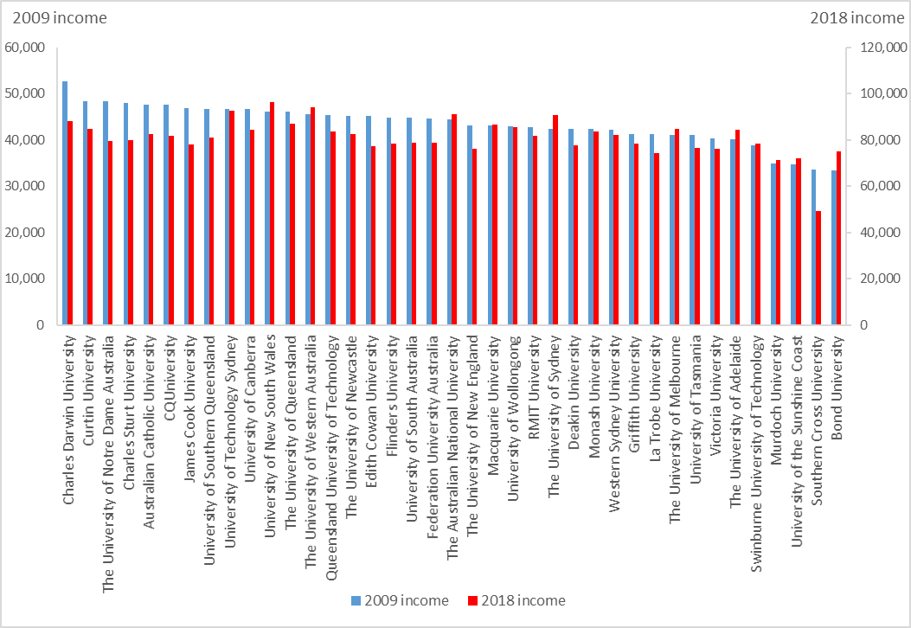  
*Source: ATO administrative data*

**Figure 40: 2007 cohort of bachelor graduates, 2009 income (LHS, $) and 2018 income (RHS, $) by non-university higher education institution (NUHEI)**

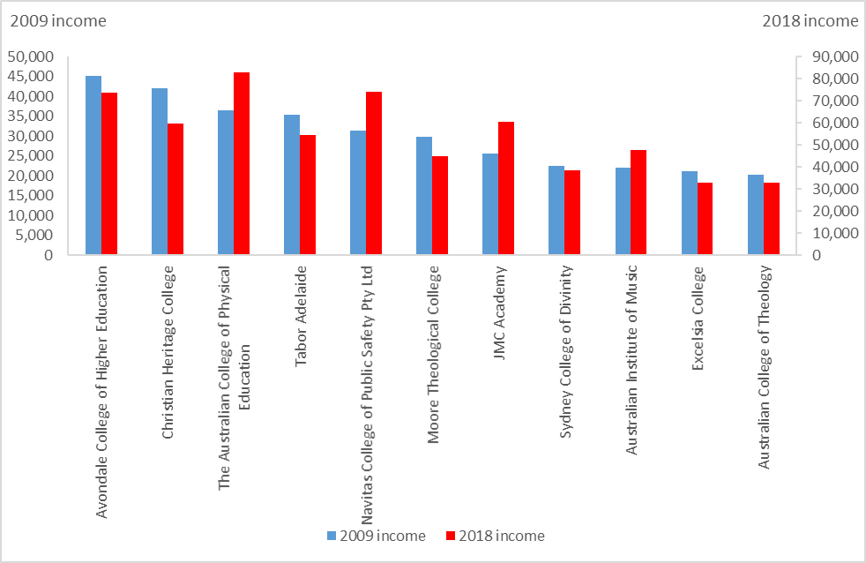

*Source: ATO administrative data*

## Tracking the growth in incomes of different graduate cohorts

What might be the experiences of graduates following the COVID-19 pandemic? As a possible guide to this question, it is salutary to examine the experience of graduates in the last economic downturn following the Global Financial Crisis (GFC).

The previous section examined the growth in incomes of the 2007 cohort of graduates. Essentially, this cohort of graduates mostly entered the labour market in 2008 prior to the onset of the Global Financial Crisis in late 2008. As such, the 2007 cohort of graduates serves as a baseline to measure the impact of the GFC on the progress of graduate incomes. As noted above, evidence from the Graduate Outcome Survey and the Graduate Outcomes Survey – Longitudinal and their predecessor surveys shows that since the GFC it has taken graduates longer to establish themselves in the labour market.

This section uses ATO administrative data to examine whether the GFC had a material impact on graduate incomes. First, the paper examines the experience of different cohorts of initial graduates, for example, the 2007 cohort at least one year and less than two years out in 2009, the 2009 cohort in 2011 through to the 2016 cohort emerging in 2018. Figure 41 shows that following the GFC, the real median income of initial graduates declined from $43,700 in 2009 to $39,400 in 2015, a decline of 10 per cent, before recovering, though not completely to 2009 levels, to $42,400 in 2018. The decline in real incomes of initial graduates following the GFC is, in part, due to lower employment and higher unemployment among initial graduates as shown earlier in Figure 5. For graduates who were in full-time employment, the Graduate Outcomes Survey shows there was little growth in real starting salaries between 2009 and 2015, though increasing thereafter. Also, Figure 2 above shows there was a steady expansion in the supply of graduates following the GFC and this is also likely to have contributed to downward pressure on the real incomes of graduates. So it appears lower demand and increasing supply have acted to lower initial graduate incomes in the decade following the GFC.

**Figure 41: Real median income of initial graduates, 2009 – 2018 (2009 prices), $**

*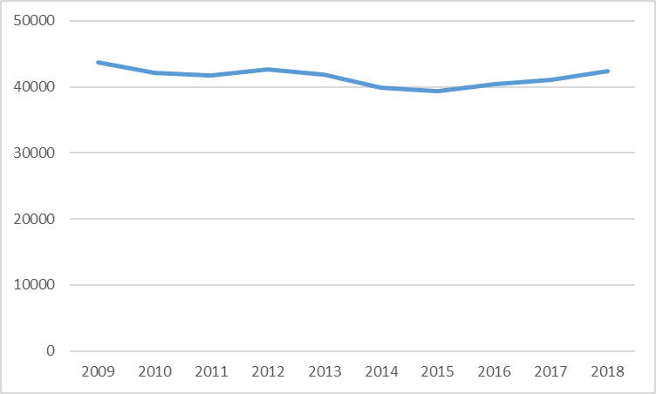**Source: ATO administrative data, ABS, Consumer Price Index, 6401.0*

Moving beyond the experience of graduates as they initially enter the labour market, the paper now tracks the progress of different cohorts of graduates in the labour market up to ten years following completion of their studies. The 2007 cohort of graduates, who would mostly have entered the labour market before the GFC, experienced growth in real incomes of 55 per cent in the ten years following graduation to 2018. The progress of subsequent cohorts of graduates who completed their studies in 2009, 2011, 2013, 2015 and 2016 is shown in Figure 42. Perhaps surprisingly, succeeding cohorts have generally fared better than the pre-GFC 2007 cohort in terms of growth in real incomes, notwithstanding their lower initial incomes. For example, eight years after graduation, the 2009 cohort had experienced growth in real incomes of 55 per cent in comparison with 48 per cent for the 2007 cohort. As a result, the real median income of the 2009 cohort eight years after graduation, $64,800, just exceeded that of the 2007 cohort eight years after graduation of $64,700. Figure 42 also shows the 2011 cohort and 2013 cohort experienced faster growth in real incomes than the 2007 cohort of graduates. Six years after graduation, the real median income of the 2011 cohort, $60,500, exceeded that of the 2007 cohort six years after graduation of $59,600. Notwithstanding their slower initial start in the labour market, the GFC does not appear to have adversely impacted the growth in incomes of post GFC graduate cohorts. Over time, it appears their real incomes catch up around six to eight years after graduation to the those of the 2007 pre-GFC graduate cohort. Patterns are broadly similar for male and female graduates, with the gap slightly larger for post-GFC cohorts of male graduates in comparison with their male pre-GFC counterparts.

**Figure 42: Growth in real median incomes of different bachelor graduate cohorts up to ten years after graduation (2009 income of 2007 cohort = 100)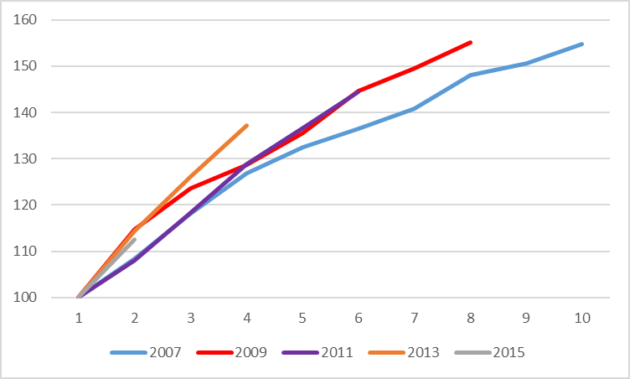***Source: ATO administrative data*

As well as lower initial incomes, post-GFC cohorts appear to have experienced greater variation or uncertainty in their incomes immediately following completion of their bachelor degree. Figure 43 shows whether the variation or uncertainty associated with attainment of a degree has changed following the GFC using the interquartile ratio in incomes of the 2007 cohort of graduates as numeraire. That is, where the measure of relative variation is greater than 100, it can be said there is greater uncertainty in graduate incomes among post-GFC graduate cohorts in comparison with the pre-GFC 2007 graduate cohort. For example, the red line, shows that for the 2009 cohort of graduates immediately following graduation, variation in their incomes was 10 per cent higher than for the pre-GFC 2007 cohort of graduates. In the years following the GFC, the 2009 cohort generally experienced greater uncertainty in their incomes than the 2007 cohort, but the gap had disappeared seven years after graduation. That is, seven years after graduation, the 2009 cohort experienced similar variation in their incomes as the 2007 cohort. The same pattern is evident for the 2011, 2013, 2015 and 2016 graduate cohorts. That is, following the GFC and immediately after graduation, these cohorts experienced more uncertainty in their incomes than did the pre-GFC 2007 cohort. Thereafter, in the four years and six years following graduation, the experience of the 2011 and 2013 post-GFC graduate cohorts more closely resembles the experience of pre-GFC graduates. This confirms, once again, that following the GFC some graduates appear to have faced greater difficulty entering the labour market though most appear to make a successful transition to the labour market at a later point in time. These patterns are broadly similar for male and female graduates. Tracking the progress of different cohorts immediately following graduation, there are no marked trends by study area. That is, it does not appear that increasing uncertainty in graduate incomes is associated with any particular study area(s).

**Figure 43: Relative variation in income of different bachelor graduate cohorts between one and seven years after graduation (2007 graduate cohort as numeraire=100)**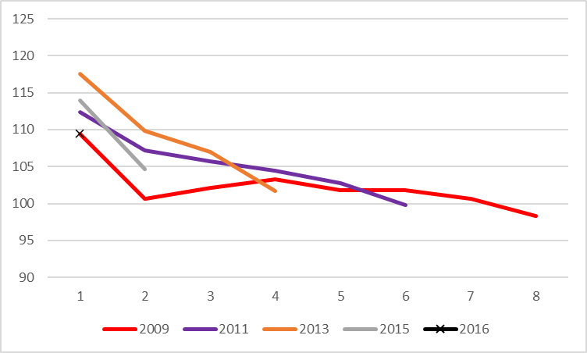 *Source: ATO administrative data*

## Multivariate analysis of graduate incomes

This section shows the results of multivariate analyses of graduate incomes. The purpose here is to show the independent influence of a range of student and course characteristics on graduate incomes. For example, it is well known that mode of study and age influence graduate incomes.[5] However, mode of study and age are correlated as external graduates are more likely to be older. As a result, it is difficult to separate the influence of mode of study and age. Multivariate analysis enables better understanding of the influence of a range of student and course characteristics. This includes gender, age, language background, Indigenous status, disability status, socioeconomic status, location, mode and type of study, study area, combined degrees, further full-time study, type of provider and institution. Also, the influence of prior ability on graduate incomes is measured, in as much as this can be measured through a combination of ATAR and basis of admission variables.

### Factors influencing initial graduate incomes

Table 1 shows the influence of student and course characteristics and institution on graduate incomes using a series of bivariate linear regressions in order to demonstrate the strength of the relationship between each of the explanatory variables and graduate incomes. That is, it measures in an approximate sense how important each of the explanatory or independent variables are in explaining variation in initial graduate incomes. Next, Table 2 presents the results of the multivariate regression analysis showing the independent influence of student and course characteristics and institution on graduate incomes. That is, it shows how much an individual graduate might earn in comparison with other graduates, independent of all other influences. For example, how much a male graduate might earn in comparison with a female graduate, independent of the influence of all other factors that impact on male and female graduate incomes. Table 3 compares median incomes by study area with ‘modified’ estimates, that is, comparing estimates by study area independent of the influence of all other characteristics. For example, this assumes graduates in each study area share the same set of characteristics i.e. they resemble the national average graduate in all respects with the exception of the study area of the graduate. This enables identification of the independent influence of study area on graduate salaries, in effect placing study areas on a ‘level playing field’ and giving a better reflection of differences in graduate incomes by study area. A similar approach is taken for estimates of university level incomes shown in Table 4.

The full model including all the student characteristics listed in Table 1 explains 13.78 per cent of the variation in graduate incomes (adjusted R2). The relatively low proportion of variance explained by the full model is not uncommon in cross-sectional models such as the graduate income analysis presented here. This result suggests there are likely to be many other factors not captured by the model that might influence graduate incomes. For example, occupation and industry are likely to influence graduate incomes, but they have not been included in the model since administrative data in this area are not sufficiently reliable. Student traits such as motivation and resilience, not measured by the model, are likely to have a large influence on graduate incomes.

Table 1 shows study area has the largest influence on graduate incomes among measurable variables, explaining around 10 per cent of the variation in graduate incomes. The second largest factor is further full-time study, explaining 6 per cent of the variation in graduate incomes. The third most important factor is institution (university), explaining 2 per cent of the variation in graduate incomes. It is important to note Table 1 shows only bivariate relationships and therefore may be overstating the strength of the relationship between particular factors and graduate incomes. For example, the three factors having most influence on graduate incomes, study area, further full-time study and institution are likely related. Students attending Group of Eight institutions are more likely to be studying generalist courses such as Science and mathematics and Humanities, culture and social sciences courses, rather than vocationally oriented courses, and are more likely to engage in further study. Conversely, students attending regional universities are more likely to be studying vocationally oriented courses and are less likely to go on to further study. Thus, the results shown in Table 1 are likely to represent the ‘upper bound’ of the influence of each factor on graduate incomes. This is also the reason that the sum of the adjusted R2 from the bivariate linear regressions shown in Table 1 is greater than the adjusted R2 of the full model (13.78 per cent). The other point to note about the bivariate relationships is that, because of the issue of collinearity (variables being related) described above, they demonstrate the strength of association rather than causation. Fortunately, previous research can provide some insight into the likely direction of causation between study area, further full-time study and institution. A survey of Year 12 students found that choice of course rather than institution appears to play a more important role in forming the preferences of students intending to go to university.[6] This is consistent with the evidence presented in Table 1 where study area appears to have a larger influence than further full-time study and institution on graduate incomes.

**Table 1:** **Ordinary Least Squares linear regression analysis (bivariate model) by student and course characteristics for 2018 incomes of the 2016 cohort of domestic bachelor graduates**

|  |  |
| --- | --- |
| **Student and course characteristic** | **Adjusted R2  (% variation explained)** |
| Study area | 10.34 |
| Further full-time study | 6.37 |
| Institution (university) | 2.33 |
| Type of institution | 1.34 |
| Mode of study (internal/external/multi-modal) | 1.04 |
| Age group (<30, 30 and over) | 1.03 |
| Combined degree | 0.61 |
| Type of study (full-time, part-time) | 0.25 |
| Basis of admission-ATAR group | 0.21 |
| Disability status | 0.12 |
| Location (First address metro/regional/remote) | 0.12 |
| Gender | 0.10 |
| Language background | 0.04 |
| Socioeconomic status (First address) | 0.02 |
| Indigenous status | 0.02 |
| **Full model including above variables (including institution, not type of institution)** | **13.78** |

‘Modified’ estimates presented in Table 3 show the influence of study area, independent of all other factors, on graduate incomes. For example, ‘modified’ estimates show Dentistry graduates have highest incomes immediately following graduation, $85,100 followed by Medicine graduates, $80,600. On the other hand, ‘modified’ estimates show the study area with lowest graduate incomes immediately after graduation, after controlling for the influence of all other measurable factors, were Creative arts graduates, $39,500. While Science and mathematics graduates had lowest incomes (21st) measured in original data, Table 3 shows in terms of ‘modified’ estimates they ranked 15th. Science and mathematics graduates are more likely to go on to further study which delays entry to the labour market and lowers incomes. Once further study and all other measurable factors are controlled for, the incomes of Science and mathematics graduates appear more favourable, though still lower than the national average. Notwithstanding the observation above about Science and mathematics graduates, there is a relatively close correspondence between original and ‘modified’ estimates of graduate incomes by study area at least one year after graduation with a rank correlation coefficient = 0.87. Results from Table 3 demonstrate that even after controlling for other measurable factors, study area has a major influence on graduate incomes immediately following graduation, of the order of $10,000’s.

Further full-time study is entered as a continuous variable in the model and Table 2 shows that for each percentage point increase in the proportion of graduates undertaking further full-time study[7] the income of an individual graduate is likely to fall by $383.

Measuring the influence of institution (university) on initial graduate incomes is complicated by a range of countervailing influences. Repeating observations made earlier, estimates of university incomes using original data shown in Table 4 demonstrate that universities with highest incomes are often distance providers while those with lowest incomes have higher proportions undertaking generalist degrees and undertaking further study. ‘Modified’ estimates presented in Table 4 show the influence of university, independent of all other factors, on graduate incomes. For example, the University of Melbourne ranks 39th based on original data but 14th according to ‘modified’ estimates. The University of Melbourne has a higher proportion of graduates undertaking generalist degrees who are more likely to go on to further study and these factors are both associated with lower incomes immediately following graduation. Once these and all other measurable factors are controlled for, the incomes of University of Melbourne graduates appear more favourable. Since study area and further full-time study have larger influence on graduate incomes as shown in Table 1, this is reflected in considerable differences between original and ‘modified’ estimates of graduate incomes at university level as shown in Table 4. This is also reflected in a relatively low value of the rank correlation coefficient = 0.39 between original and ‘modified’ estimates of incomes at university level immediately following graduation. Table 1 shows institution/university has much less influence on graduate incomes than study area or further study. This is reflected in ‘modified’ estimates of graduate incomes in Table 4 where after controlling for other measurable factors, differences in graduate incomes immediately following graduation between most universities are of a lesser order of magnitude, for example, within a few $1,000’s of the national university average of $51,700.

Type of institution has a slightly lesser impact than institution/university on graduate incomes explaining 1.34 per cent of overall variation, as shown by Table 1. For example, graduates from Regional Universities Network (RUN) earn $1,000 more and graduates from Innovative Research Universities (IRU) earn $900 less than graduates from non-aligned universities immediately following graduation, once allowance is made for all other measurable factors on graduate incomes, as shown by Table 2. Incomes of graduates from Group of Eight (Go8), ATN and Table B universities are not significantly different from incomes of graduates from non-aligned universities, as shown by Table 2.

Mode of study explains 1.04 per cent of the variation in graduate incomes, as shown by Table 1, with graduates undertaking external study likely to earn $5,400 more and those undertaking study by mixed mode earning $1,400 more than graduates studying internally, as shown by Table 2.

Age of the graduate explains around 1.03 per cent of the variation in graduate incomes, as shown by Table 1, with graduates aged 30 years and over likely to earn $6,200 more than graduates aged less than 30 years old, as shown by Table 2.

Prior ability, as measured by a student’s basis of admission including their ATAR score, explains only a relatively small proportion, 0.21 per cent, of the variation in initial graduate incomes. Basis of admission and ATAR is much less important than study area, further study, institution, age, mode of study, type of institution and type of study in explaining differences in graduate incomes, as shown by Table 1. The influence of ATAR on graduate incomes has the expected effect with graduates in the highest ATAR decile estimated to earn $4,500 more than graduates admitted on the basis of no ATAR. Similarly, graduates in the second highest ATAR decile are estimated to earn $2,100 more and graduates in the third highest decile $700 more than graduates admitted on the basis of no ATAR.

Gender has very little influence on graduate incomes, 0.10 per cent, at least immediately after graduation. Male graduates are estimated to earn $2,100 more than female graduates. Socioeconomic status also has limited influence, 0.02 per cent, on graduate incomes. Graduates from a high socioeconomic status background are estimated to earn $2,500 more than graduates from a low socioeconomic status background, with no significant difference in earnings between those with a medium and low socioeconomic status background. Note once again these findings differ from the earlier findings based on original or crude data showing high socioeconomic status graduates had lower incomes, as shown by Figure 14 above. Since high socioeconomic status graduates are more likely to complete generalist degrees and undertake further study, both factors which are associated with lower incomes, then once these factors are controlled for, the incomes of high socioeconomic status graduates appear more favourable.

**Table 2: Ordinary Least Squares linear regression analysis (full model) by student and course characteristics for 2018 incomes of the 2016 cohort of domestic bachelor graduates**

|  |  |  |
| --- | --- | --- |
| **Student and course characteristic *- (reference category)*** | **Coefficient** | **Pr > (t)** |
| Intercept | $50,513* | <.0001 |
| *Gender (Female)* |  |  |
| Male | $2,108* | <.0001 |
| *Age (Under 30)* |  |  |
| 30 years and over | $6,196* | <.0001 |
| *Language background (English speaking background)* |  |  |
| Non-English speaking background | -$3,938* | <.0001 |
| *Indigenous status (Non-Indigenous)* |  |  |
| Indigenous | $2,411* | 0.0069 |
| *Disability status (No disability*) |  |  |
| Reported disability | -$3,606* | <.0001 |
| *Socioeconomic status (Low SES)* |  |  |
| High SES | $2,511* | <.0001 |
| Medium SES | $344 | 0.2011 |
| *Location status (Metro)* |  |  |
| Remote | $5,294* | <.0001 |
| Regional | $175 | 0.5403 |
| *Basis of admission/ATAR (No ATAR)* |  |  |
| ATAR 90.05-100 | $4,463* | <.0001 |
| ATAR 80.05-90 | $2,106* | <.0001 |
| ATAR 70.05 – 80 | $734* | 0.0367 |
| ATAR 60.05 - 70 | $289 | 0.5037 |
| ATAR 30 - 60 | -$850 | 0.1491 |
| *Mode of study (Internal)* |  |  |
| External | $5,436 * | <.0001 |
| Mixed mode | $1,422* | <.0001 |
| *Type of study (Full-time)* |  |  |
| Part-time | $3,244* | <.0001 |
| *Combined indicator (Single degree)* |  |  |
| Combined degree | $5,694* | <.0001 |
| *Further full-time study* | -$383* | <.0001 |
| *Study area (Business and management)* |  |  |
| Dentistry | $33,297 * | <.0001 |
| Medicine | $28,779 * | <.0001 |
| Engineering | $7,869 * | <.0001 |
| Nursing | $5,845 * | <.0001 |
| Veterinary Science | $4,882 * | 0.0022 |
| Law and Paralegal Studies | $4,673 * | <.0001 |
| Rehabilitation | $4,226 * | <.0001 |
| Pharmacy | $2,895 * | 0.009 |
| Teacher education | $2,669 * | <.0001 |
| Health services and support | $1,340 * | 0.0055 |
| Architecture and built environment | $1,160 | 0.0818 |
| Computing and information systems | $3 | 0.9964 |
| Psychology | -$1,765 * | 0.0100 |
| Science and mathematics | -$2,611 * | <.0001 |
| Social work | -$3,875 * | <.0001 |
| Agriculture and environmental studies | -$4,467 * | <.0001 |
| Humanities, culture and social sciences | -$6,679 * | <.0001 |
| Communications | -$8,372 * | <.0001 |
| Tourism, hospitality, personal services, sport and recreation | -$10,864 * | <.0001 |
| Creative arts | -$12,332 * | <.0001 |
| *Type of university (Non-aligned university)\*\** |  |  |
| RUN | $1,004* | 0.0092 |
| Table B | $77 | 0.9134 |
| Go8 | -$25 | 0.9314 |
| ATN | -$308 | 0.3245 |
| IRU | -$886 * | 0.0027 |

|  |  |  |
| --- | --- | --- |
| **Student and course characteristic *- (reference category)*** | **Coefficient** | **Pr > (t)** |
| *University (Monash University)* |  |  |
| The Australian National University | $ 6,084 * | <.0001 |
| University of Tasmania | $ 5,851 * | <.0001 |
| University of Canberra | $ 5,644 * | <.0001 |
| James Cook University | $ 5,533 * | <.0001 |
| CQUniversity | $ 5,488 * | <.0001 |
| University of Technology Sydney | $ 5,350 * | <.0001 |
| Western Sydney University | $ 5,289 * | <.0001 |
| Charles Sturt University | $ 4,764 * | <.0001 |
| The University of Sydney | $ 4,346 * | <.0001 |
| Bond University | $ 4,303 * | 0.0046 |
| University of Wollongong | $ 4,141 * | <.0001 |
| University of New South Wales | $ 4,006 * | <.0001 |
| Federation University Australia | $ 3,908 * | 0.0003 |
| The University of Melbourne | $ 3,762 * | <.0001 |
| The University of Adelaide | $ 3,709 * | <.0001 |
| Queensland University of Technology | $ 3,386 * | <.0001 |
| The University of Newcastle | $ 2,799 * | <.0001 |
| Charles Darwin University | $ 2,419 | 0.0814 |
| Australian Catholic University | $ 2,347 * | 0.001 |
| University of Southern Queensland | $ 2,346 * | 0.0137 |
| The University of Western Australia | $ 2,202 * | 0.0041 |
| The University of New England | $ 2,080 * | 0.0369 |
| Victoria University | $ 1,980 * | 0.0127 |
| The University of Notre Dame Australia | $ 1,968 * | 0.0255 |
| Macquarie University | $ 1,965 * | 0.0038 |
| Curtin University | $ 1,917 * | 0.0039 |
| University of the Sunshine Coast | $ 749 | 0.4455 |
| The University of Queensland | $ 676 | 0.3016 |
| University of South Australia | $ 375 | 0.5973 |
| Swinburne University of Technology | $ 355 | 0.6417 |
| RMIT University | $ 349 | 0.5834 |
| Griffith University | $ 168 | 0.794 |
| Edith Cowan University | -$ 172 | 0.8301 |
| Flinders University | -$ 216 | 0.7866 |
| Murdoch University | -$ 815 | 0.3963 |
| Southern Cross University | -$ 1,361 | 0.1987 |
| Deakin University | -$ 1,391 * | 0.0277 |
| La Trobe University | -$ 2,423 * | 0.0004 |

* significant at 5 per cent level

Adjusted R2 = 13.78%

N=97,702

** Note institution is included in the full model, but not type of university. Results shown here for type of university have been derived by excluding institution and including type of university in the regression model.

**Table 3:** **2018 incomes and 2018 OLS ‘modified’ incomes of 2016 graduates by study area, $**

|  |  |  |  |
| --- | --- | --- | --- |
| **Median income** | | **OLS ‘modified’ median income\*** | |
|  |  |  |  |
| Medicine | $ 84,000 | Dentistry | $ 85,100 |
| Dentistry | $ 78,300 | Medicine | $ 80,600 |
| Teacher education | $ 65,300 | Engineering | $ 59,700 |
| Engineering | $ 63,600 | Nursing | $ 57,600 |
| Nursing | $ 62,200 | Veterinary science | $ 56,700 |
| Rehabilitation | $ 61,000 | Law and paralegal studies | $ 56,500 |
| Pharmacy | $ 56,500 | Rehabilitation | $ 56,000 |
| Veterinary science | $ 56,400 | Pharmacy | $ 54,700 |
| Computing and information systems | $ 55,400 | Teacher education | $ 54,500 |
| Law and paralegal studies | $ 55,400 | Health services and support | $ 53,100 |
| Social work | $ 53,100 | Architecture and built environment | $ 53,000 |
| Business and management | $ 52,300 | Computing and information systems | $ 51,800 |
| Architecture and built environment | $ 48,800 | Business and management | $ 51,800 |
| Agriculture and environmental studies | $ 45,600 | Psychology | $ 50,000 |
| Health services and support | $ 45,600 | Science and mathematics | $ 49,200 |
| Communications | $ 42,800 | Social work | $ 47,900 |
| Psychology | $ 38,200 | Agriculture and environmental studies | $ 47,300 |
| Humanities, culture and social sciences | $ 37,200 | Humanities, culture and social sciences | $ 45,100 |
| Tourism, hospitality, personal services, sport and recreation | $ 36,900 | Communications | $ 43,400 |
| Creative arts | $ 34,000 | Tourism, hospitality, personal services, sport and recreation | $ 40,900 |
| Science and mathematics | $ 32,600 | Creative arts | $ 39,500 |
| **Total** | **$ 51,700** | **Total** | **$ 51,700** |

* OLS ‘modified’ estimates are calculated to show the influence of study area independent of the influence of all other characteristics by assuming graduates in each study area share the same set of characteristics i.e. they resemble the national average graduate in all respects other than study area.

**Table 4: 2018 incomes and 2018 OLS ‘modified’ incomes of 2016 graduates by university, $**

|  |  |  |  |
| --- | --- | --- | --- |
| **Median income** | | **OLS ‘modified’ median income\*** | |
| James Cook University | $ 65,200 | The Australian National University | $ 56,200 |
| CQUniversity | $ 63,400 | University of Tasmania | $ 56,000 |
| University of Southern Queensland | $ 62,400 | University of Canberra | $ 55,700 |
| Charles Darwin University | $ 62,200 | James Cook University | $ 55,600 |
| The University of Notre Dame Australia | $ 62,000 | CQUniversity | $ 55,600 |
| Charles Sturt University | $ 60,700 | University of Technology Sydney | $ 55,500 |
| The University of New England | $ 58,900 | Western Sydney University | $ 55,400 |
| Australian Catholic University | $ 58,600 | Charles Sturt University | $ 54,900 |
| The University of Newcastle | $ 55,800 | The University of Sydney | $ 54,500 |
| University of Canberra | $ 55,800 | Bond University | $ 54,400 |
| University of Tasmania | $ 55,000 | University of Wollongong | $ 54,200 |
| University of New South Wales | $ 54,800 | University of New South Wales | $ 54,100 |
| The University of Queensland | $ 54,200 | Federation University Australia | $ 54,000 |
| Southern Cross University | $ 53,800 | The University of Melbourne | $ 53,900 |
| Federation University Australia | $ 53,600 | The University of Adelaide | $ 53,800 |
| University of Technology Sydney | $ 53,400 | Queensland University of Technology | $ 53,500 |
| Queensland University of Technology | $ 53,300 | The University of Newcastle | $ 52,900 |
| Curtin University | $ 53,200 | Charles Darwin University | $ 52,500 |
| The Australian National University | $ 52,900 | Australian Catholic University | $ 52,500 |
| University of the Sunshine Coast | $ 52,300 | University of Southern Queensland | $ 52,500 |
| University of Wollongong | $ 52,200 | The University of Western Australia | $ 52,300 |
| Macquarie University | $ 51,900 | The University of New England | $ 52,200 |
| University of South Australia | $ 51,600 | Victoria University | $ 52,100 |
| The University of Sydney | $ 51,300 | The University of Notre Dame Australia | $ 52,100 |
| Monash University | $ 50,200 | Macquarie University | $ 52,100 |
| Flinders University | $ 49,600 | Curtin University | $ 52,000 |
| Deakin University | $ 49,500 | University of the Sunshine Coast | $ 50,800 |
| Swinburne University of Technology | $ 49,500 | The University of Queensland | $ 50,800 |
| Victoria University | $ 49,400 | University of South Australia | $ 50,500 |
| La Trobe University | $ 49,300 | Swinburne University of Technology | $ 50,500 |
| Edith Cowan University | $ 49,200 | RMIT University | $ 50,500 |
| Western Sydney University | $ 48,800 | Griffith University | $ 50,300 |
| RMIT University | $ 48,700 | Monash University | $ 50,100 |
| The University of Adelaide | $ 48,700 | Edith Cowan University | $ 49,900 |
| Murdoch University | $ 48,400 | Flinders University | $ 49,900 |
| Bond University | $ 48,400 | Murdoch University | $ 49,300 |
| Griffith University | $ 47,800 | Southern Cross University | $ 48,700 |
| The University of Western Australia | $ 35,300 | Deakin University | $ 48,700 |
| The University of Melbourne | $ 29,300 | La Trobe University | $ 47,700 |
| **Total** | **$ 51,700** | **Total** | **$ 51,700** |

* OLS ‘modified’ estimates are calculated to show the influence of university independent of the influence of all other characteristics by assuming graduates in each university share the same set of characteristics i.e. they resemble the national average graduate in all respects other than university.

### Factors influencing graduate incomes ten years after graduation

Above it was shown study area, further full-time study and institution have the largest influence, among measurable factors, on graduate incomes immediately following graduation at least one year and up to two years after graduates have completed their degree. Tables 5-8 repeat the analysis above but show the influence of measurable factors on graduate incomes at least ten years after graduation. That is, results presented in Tables 5-8 show the influence of a range of student and course characteristics and institution on the 2018 incomes of the 2007 cohort of domestic bachelor graduates.

The first point to note from Table 5 is that the overall variation explained by the full model of graduate incomes ten years after graduation, 13.95 per cent is broadly similar to the overall variation explained by the full model of graduate incomes one year after graduation, 13.78 per cent, shown in Table 1. Table 5 shows study area has the largest influence on graduate incomes ten years after graduation, explaining around 9 per cent of overall variation. ‘Modified’ estimates presented in Table 7 show the influence of study area, independent of all other factors or all other things being equal, on graduate incomes over the longer term. For example, ‘modified’ estimates show Medicine graduates have highest incomes ten years after graduation, $191,800 followed by Dentistry graduates, $119,800, Law and paralegal studies graduates, $94,100 and Engineering graduates, $100,800. On the other hand, ‘modified’ estimates show the study area with lowest graduate incomes over the longer term, after controlling for the influence of all other measurable factors, remained Creative arts graduates, $60,200. Study areas with high initial incomes also tend to have higher incomes over the longer term. This is shown by the relatively close correspondence between ‘modified’ estimates of graduate incomes by study area immediately following graduation and ten years after graduation (rank correlation coefficient = 0.66).

A key difference in graduate incomes ten years after graduation is the role of gender. Earlier in the paper it was shown there is relatively little difference in the incomes of male and female graduates immediately after graduation, though female incomes have shown a tendency to increase in relative terms immediately after graduation over time. Ten years after graduation, gender has the second largest influence among measurable factors, explaining 5 per cent of the variation in graduate incomes. Table 6 shows, after controlling for all other measurable factors, ten years after graduation male graduates earn $26,700 more than female graduates. Repeating evidence cited earlier in the paper, female graduates are much more likely than male graduates to move between various labour market states after graduation and over time e.g. between full-time employment, part-time employment, unemployment and not in the labour force. This contributes to greater variation in the incomes of female graduates over the longer term.

Ten years after graduation, institution still appears to influence graduate incomes explaining 2 per cent of overall variation, although having slightly less influence than immediately after graduation, as shown by Table 5. ‘Modified’ estimates presented in Table 8 show the influence of institution, independent of all other factors, on graduate incomes over the longer term. For example, ‘modified’ estimates show graduates from the University of New South Wales have highest incomes ten years after graduation, $96,900 followed by graduates from the University of Sydney, $94,800 and Bond University graduates, $93,900 and graduates from. Table 6 shows graduates from Go8 universities, controlling for all other measurable factors, were likely to earn $4,300 more than graduates from non-aligned universities over the longer term. On the other hand, ten years out, graduates from IRU and NUHEIs earned $2,900 and $14,900 less than graduates from non-aligned universities. Graduate incomes from Table B, ATN and RUN universities were not significantly different from those of non-aligned universities ten years after graduation. There is some evidence that institutions with high initial incomes also tend to have higher incomes over the longer term, though this appears a moderate rather than a strong relationship. This is shown by the correspondence between ‘modified’ estimates of graduate incomes by institution immediately following graduation and ten years after graduation (rank correlation coefficient = 0.58).

While further full-time study influences graduate incomes one year out it was found to have much less influence on graduate incomes ten years out explaining only 0.20 per cent of overall variation, as shown by Table 5. Similarly, the age of the graduate plays a much lesser role in influencing graduate incomes ten years out explaining only 0.09 per cent of overall variation. On the other hand, socioeconomic status has more influence on graduate incomes ten years out, though still explaining a relatively small proportion of overall variation, 0.36 per cent. Graduates from a high SES background earn $2,700 more than their low SES counterparts ten years after graduation, broadly similar to the difference in their incomes immediately following graduation. The incomes of medium SES graduates were not significantly different from those of low SES graduates over the longer term. Note also that basis of admission and ATAR score was found to have no influence on graduate incomes ten years out. The incomes of graduates with higher or lower ATAR scores were not significantly different from those of graduates without an ATAR score ten years after graduation. This contrasts with the earlier finding where basis of admission and ATAR scores have a moderate influence on incomes immediately following graduation. That is, the influence of basis of admission and ATAR scores on graduate incomes diminishes over time as other factors play a greater role over the longer term.

**Table 5: Ordinary Least Squares linear regression analysis (bivariate model) by student and course characteristics for 2018 total taxable income or loss of the 2007 cohort of domestic bachelor graduates**

|  |  |
| --- | --- |
| **Student and course characteristic** | **Adjusted R2  (% variation explained)** |
| Study area (21) | 9.23 |
| Gender | 5.16 |
| Institution (universities only) | 1.53 |
| Type of institution | 1.10 |
| Socioeconomic status (First address) | 0.36 |
| Combined degree | 0.30 |
| Further full-time study | 0.20 |
| Location (First address metro/regional/remote) | 0.17 |
| Mode of study (internal, external, multi-modal) | 0.14 |
| Disability status | 0.12 |
| Age group (<30, 30+) | 0.09 |
| Language background | 0.03 |
| Type of study (Full-time, part-time) | 0.00 |
| Basis of admission - ATAR group | 0.00 |
| Indigenous status | 0.00 |
| **Full model including above variables (including institution, not type of institution)** | **13.95** |

**Table 6: Ordinary Least Squares linear regression analysis (full model) by student and course characteristics for 2018 incomes of the 2007 cohort of domestic bachelor graduates**

|  |  |  |
| --- | --- | --- |
| **Student and course characteristic *- (reference category)*** | **Coefficient** | **Pr > (t)** |
| Intercept | $79,625 * | <.0001 |
| *Gender (Female)* |  |  |
| Male | $26,728 * | <.0001 |
| *Age (Under 30)* |  |  |
| 30 years and over | $287 | 0.696 |
| *Language background (English speaking background)* |  |  |
| Non-English speaking background | -$6,761 * | <.0001 |
| *Indigenous status (Non-Indigenous)* |  |  |
| Indigenous | $908 | 0.7407 |
| *Disability status (No disability*) |  |  |
| Reported disability | -$9,666 * | <.0001 |
| *Socioeconomic status (Low SES)* |  |  |
| High SES | $2,678 * | 0.0012 |
| Medium SES | $213 | 0.7666 |
| *Location status (Metro)* |  |  |
| Remote | $1,240 | 0.6644 |
| Regional | -$573 | 0.4587 |
| *Basis of admission/ATAR (No ATAR)* |  |  |
| ATAR 90.05-100 | $2,268 | 0.8082 |
| ATAR 80.05-90 | -$4,993 | 0.5473 |
| ATAR 70.05 – 80 | -$12,497 | 0.1707 |
| ATAR 60.05 - 70 | -$5,156 | 0.6727 |
| ATAR 30 - 60 | -$4,956 | 0.6505 |
| *Mode of study (Internal)* |  |  |
| External | $4,572 * | 0.0001 |
| Mixed mode | -$838 | 0.3369 |
| *Type of study (Full-time)* |  |  |
| Part-time | -$1,996 * | 0.0011 |
| *Combined indicator (Single degree)* |  |  |
| Combined degree | $10,666 * | <.0001 |
| *Further full-time study* | -$98 * | 0.0059 |
| *Study area (Business and management)* |  |  |
| Medicine | $102,003 * | <.0001 |
| Dentistry | $30,010 * | <.0001 |
| Engineering | $10,956 * | <.0001 |
| Law and paralegal studies | $10,784 * | <.0001 |
| Pharmacy | $8,330 * | 0.0027 |
| Computing and information systems | -$4,968 * | 0.0008 |
| Science and mathematics | -$6,983 * | <.0001 |
| Architecture and built environment | -$8,560 * | <.0001 |
| Psychology | -$9,885 * | <.0001 |
| Nursing | -$10,282 * | <.0001 |
| Health services and support | -$11,488 * | <.0001 |
| Teacher education | -$12,933 * | <.0001 |
| Communications | -$13,988 * | <.0001 |
| Agriculture and environmental studies | -$15,982 * | <.0001 |
| Rehabilitation | -$16,263 * | <.0001 |
| Humanities, culture and social sciences | -$16,367 * | <.0001 |
| Veterinary science | -$17,065 | 0.0529 |
| Tourism | -$17,149 * | <.0001 |
| Social work | -$18,488 * | <.0001 |
| Creative arts | -$29,616 * | <.0001 |
| *Type of university (Non-aligned university)\*\** |  |  |
| Go8 | $4,276 * | <.0001 |
| Table B | $875 | 0.7524 |
| ATN | $694 | 0.3317 |
| RUN | -$2,167 | 0.0562 |
| IRU | -$2,859 * | 0.0001 |
| NUHEIs | -$14,901 * | <.0001 |

|  |  |  |
| --- | --- | --- |
| **Student and course characteristic *- (reference category)*** | **Coefficient** | **Pr > (t)** |
| *University (Monash University)* |  |  |
| University of New South Wales | $15,453 * | <.0001 |
| The University of Sydney | $13,383 * | <.0001 |
| Bond University | $12,454 * | 0.0183 |
| University of Technology Sydney | $12,012 * | <.0001 |
| University of Tasmania | $10,973 | 0.2892 |
| University of Wollongong | $8,721 * | <.0001 |
| Macquarie University | $7,731 * | <.0001 |
| The University of Western Australia | $4,843 * | 0.0328 |
| Charles Darwin University | $4,488 | 0.2366 |
| Western Sydney University | $4,312 * | 0.0039 |
| The Australian National University | $4,306 | 0.0543 |
| University of Canberra | $3,619 | 0.1600 |
| The University of Melbourne | $2,502 | 0.1409 |
| The University of Adelaide | $1,613 | 0.4100 |
| RMIT University | $492 | 0.7698 |
| Australian Catholic University | $119 | 0.9526 |
| The University of Newcastle | -$71 | 0.9663 |
| Queensland University of Technology | -$252 | 0.8661 |
| The University of Queensland | -$338 | 0.8388 |
| Flinders University | -$747 | 0.6935 |
| CQUniversity | -$1,467 | 0.5575 |
| University of Southern Queensland | -$1,561 | 0.5123 |
| Federation University Australia | -$1,857 | 0.4791 |
| Edith Cowan University | -$2,067 | 0.2347 |
| Curtin University | -$2,352 | 0.1784 |
| Deakin University | -$3,099 | 0.0562 |
| University of South Australia | -$3,219 * | 0.0487 |
| Charles Sturt University | -$3,788 * | 0.0458 |
| The University of Notre Dame Australia | -$3,947 | 0.2574 |
| Griffith University | -$4,211 * | 0.0059 |
| The University of New England | -$4,554 * | 0.0423 |
| James Cook University | -$4,657 * | 0.0322 |
| Swinburne University of Technology | -$4,929 * | 0.0204 |
| La Trobe University | -$5,875 * | 0.0003 |
| Victoria University | -$6,983 * | 0.0003 |
| University of the Sunshine Coast | -$9,475 * | 0.0039 |
| Murdoch University | -$10,061 * | 0.0151 |

* significant at 5 per cent level

Adjusted R2 = 13.95%

N=58,937

** Note institution is included in the full model, but not type of university. Results shown here for type of university have been derived by excluding institution and including type of university in the regression model.

**Table 7:** **2018 incomes and 2018 OLS ‘modified’ incomes of 2007 graduates by study area, $**

|  |  |  |  |
| --- | --- | --- | --- |
| **Median income** | | **OLS ‘modified’ median income\*** | |
|  |  |  |  |
| Medicine | $169,000 | Medicine | $ 191,800 |
| Engineering | $112,900 | Dentistry | $ 119,800 |
| Dentistry | $104,800 | Engineering | $ 100,800 |
| Law and paralegal studies | $99,200 | Law and paralegal studies | $ 100,600 |
| Computing and information systems | $95,300 | Pharmacy | $ 98,200 |
| Pharmacy | $89,700 | Business and management | $ 89,800 |
| Business and management | $86,800 | Computing and information systems | $ 84,900 |
| Science and mathematics | $83,800 | Science and mathematics | $ 82,800 |
| Nursing | $83,400 | Architecture and built environment | $ 81,300 |
| Architecture and built environment | $81,500 | Psychology | $ 79,900 |
| Teacher education | $78,800 | Nursing | $ 79,500 |
| Health services and support | $78,500 | Health services and support | $ 78,300 |
| Psychology | $76,300 | Teacher education | $ 76,900 |
| Rehabilitation | $75,100 | Communications | $ 75,800 |
| Social work | $74,700 | Agriculture and environmental studies | $ 73,800 |
| Agriculture and environmental studies | $74,500 | Rehabilitation | $ 73,600 |
| Communications | $74,300 | Humanities, culture and social sciences | $ 73,500 |
| Veterinary science | $73,800 | Veterinary science | $ 72,800 |
| Humanities, culture and social sciences | $72,700 | Tourism | $ 72,700 |
| Tourism | $68,700 | Social work | $ 71,300 |
| Creative arts | $55,700 | Creative arts | $ 60,200 |
| **Total** | **$82,200** | **Total** | **$82,200** |

* OLS ‘modified’ estimates are calculated to show the influence of study area independent of the influence of all other characteristics by assuming graduates in each study area share the same set of characteristics i.e. they resemble the national average graduate in all respects other than study area.

**Table 8: 2018 incomes and 2018 OLS ‘modified’ incomes of 2007 graduates by university, $**

|  |  |  |  |
| --- | --- | --- | --- |
| **Median income** | | **OLS ‘modified’ median income\*** | |
| University of New South Wales | $96,500 | University of New South Wales | $96,900 |
| The University of Western Australia | $94,100 | The University of Sydney | $94,800 |
| University of Technology Sydney | $92,800 | Bond University | $93,900 |
| The Australian National University | $91,200 | University of Technology Sydney | $93,400 |
| The University of Sydney | $90,600 | University of Tasmania | $92,400 |
| Charles Darwin University | $88,300 | University of Wollongong | $90,100 |
| The University of Queensland | $87,200 | Macquarie University | $89,200 |
| Macquarie University | $86,700 | The University of Western Australia | $86,300 |
| University of Wollongong | $85,500 | Charles Darwin University | $85,900 |
| Curtin University | $84,800 | Western Sydney University | $85,700 |
| The University of Melbourne | $84,600 | The Australian National University | $85,700 |
| The University of Adelaide | $84,600 | University of Canberra | $85,000 |
| University of Canberra | $84,500 | The University of Melbourne | $83,900 |
| Queensland University of Technology | $83,600 | The University of Adelaide | $83,000 |
| Monash University | $83,600 | RMIT University | $81,900 |
| Australian Catholic University | $82,700 | Australian Catholic University | $81,500 |
| The University of Newcastle | $82,500 | Monash University | $81,400 |
| Western Sydney University | $82,100 | The University of Newcastle | $81,400 |
| CQUniversity | $82,000 | Queensland University of Technology | $81,200 |
| RMIT University | $81,700 | The University of Queensland | $81,100 |
| University of Southern Queensland | $81,100 | Flinders University | $80,700 |
| Charles Sturt University | $80,000 | CQUniversity | $80,000 |
| The University of Notre Dame Australia | $79,600 | University of Southern Queensland | $79,900 |
| Federation University Australia | $78,800 | Federation University Australia | $79,600 |
| University of South Australia | $78,700 | Edith Cowan University | $79,400 |
| Swinburne University of Technology | $78,600 | Curtin University | $79,100 |
| Flinders University | $78,500 | Deakin University | $78,300 |
| Griffith University | $78,500 | University of South Australia | $78,200 |
| James Cook University | $78,000 | Charles Sturt University | $77,600 |
| Deakin University | $77,900 | The University of Notre Dame Australia | $77,500 |
| Edith Cowan University | $77,400 | Griffith University | $77,200 |
| University of Tasmania | $76,400 | The University of New England | $76,900 |
| The University of New England | $76,200 | James Cook University | $76,800 |
| Victoria University | $76,200 | Swinburne University of Technology | $76,500 |
| Bond University | $75,100 | La Trobe University | $75,500 |
| La Trobe University | $74,200 | Victoria University | $74,400 |
| University of the Sunshine Coast | $72,000 | University of the Sunshine Coast | $72,000 |
| Murdoch University | $71,300 | Murdoch University | $71,000 |
| **Total** | **$82,400** | **Total** | **$82,400** |

* OLS ‘modified’ estimates are calculated to show the influence of university independent of the influence of all other characteristics by assuming graduates in each university share the same set of characteristics i.e. they resemble the national average graduate in all respects other than university

## Conclusion

What are the prospects of higher education graduates in a COVID-19 environment? The experience of previous economic downturns may be salutary. First, higher education graduates always do better in the labour market achieving higher employment and incomes. Second, a higher education degree is good insurance in a downturn. In previous downturns, unemployment always increased much faster among the least skilled.

Since the GFC, there is evidence that graduates have taken longer to settle into the labour market with lower employment and incomes immediately following graduation. However, graduate incomes appear to recover around six to eight years following graduation with the variation in graduate incomes returning to pre-GFC levels. The post-GFC period coincided with a marked increase in the supply of graduates. That graduates do make a successful transition into the labour market after several years suggests, notwithstanding the initial demand shock following the GFC, on the supply side employers have had increasing difficulty absorbing or sorting the available graduates since the GFC.

Study area appears to be a key factor in how graduates fare in the labour market. Immediately following graduation, graduates with vocational degrees experience higher employment and incomes than generalist graduates. As a result, it appears graduates with generalist degrees take longer to settle into the labour market. Study areas and universities with lower initial incomes are more likely to have graduates undertaking further study delaying their entry to the labour market which lowers their initial incomes. Thereafter, graduates from these study areas and universities achieve faster growth and reduced uncertainty in their incomes.

In response to the COVID-19 pandemic and the ensuing economic downturn, JobSeeker and JobKeeper payments were configured based on the need for businesses and employees to maintain their connection with the labour market to achieve better labour market outcomes. The importance of labour market connections with employers is already well known in the higher education sector. For example, external and older graduates are more likely to combine study and employment and this ongoing connection with the labour market results in higher employment and incomes following graduation. The labour market experience of graduate cohorts following the GFC demonstrates the difficulty new graduates have encountered as a result of their delayed entry to the labour market. Maintaining and developing connections with the labour market, for example, through work integrated learning and internships, will assist the transition of graduates into the labour market. Delayed entry to the labour market is likely to be more acutely felt by some groups of graduates than others. If the experience of different cohorts of graduates following the GFC is any guide, the effect of delayed entry to the labour market, while unwanted and unwelcome, may be transitory as graduates do appear to settle into the labour market given additional time.

The experience of graduate cohorts following the GFC demonstrates demand side factors play an influential role in shaping graduate incomes. That said, the different choices made by male and female graduates as they move between various labour market states highlights the role supply side factors play in influencing graduate incomes over the longer term. Tracking graduates over time suggests graduate incomes over the longer term are the result of the rich interplay of demand and supply forces.

## Attachment A: Comparability of graduate income measures derived from ATO administrative records and the Graduate Outcomes Survey (GOS)

### Graduate income measures by student characteristics

This attachment provides information on the comparability of measures of graduate incomes derived from ATO administrative records and from survey data. This will help inform whether administrative data are capable of substituting or replacing survey data on graduate incomes for the purposes of informing student choice on the ComparED website.

Table A1 shows the median income of the 2016 cohort of domestic bachelor graduates who had completed their degree at least one year and up to two years previously was $51,200 in 2018. By way of comparison, the median salary reported in the 2017 GOS was higher at $60,000. One reason for this result may be the survey data refer to the salaries of graduates working in full-time employment whereas the administrative data refer to all graduates, including those who were employed part-time, unemployed or not in the labour force who typically have lower incomes. A countervailing factor is that the administrative data for 2018 refer to graduates who have been in the workforce for a longer time period and this is likely to lead to higher reported graduate salaries, all other things being equal. Another countervailing factor is that the administrative data refer to bachelor degree holders only whereas the survey data refer to all undergraduates including sub-bachelor degree holders who typically report lower incomes.

Table A1 shows the median income of male graduates, as measured by administrative data, was $51,400 which was marginally higher, 0.7 per cent, than the median income of female graduates of $51,000. This compares with results from the 2017 Graduate Outcomes Survey where median salaries of male graduates were 2 per cent above those of female graduates. Male graduates are more likely to undertake further study than female graduates. A higher rate of further study among male graduates would be expected to lead, all other things being equal, to a lower level of income. Since the ATO administrative data includes all graduates, including those undertaking further study this might account, in part, for the lower gender gap in graduate incomes reported by the ATO administrative data.

Patterns in median incomes among different groups of graduates, as reported by the ATO administrative data and survey data, were broadly similar though sometimes of different orders of magnitude, as shown by Table A1. For example, graduates who were older (30 years and over), from an English speaking background, from an Indigenous background, who attended a university (in comparison with graduates who attended a non-university higher education institution) and who attended a university from the Regional Universities Network (RUN) reported higher median incomes using either the ATO or GOS measure of graduate income. Graduates with no reported disability and from a low socioeconomic status background reported higher median incomes in the ATO administrative data but not in the GOS survey data.

**Table A1: Comparison of graduate income measures derived from ATO administrative records and the Graduate Outcomes Survey**

|  |  |  |
| --- | --- | --- |
|  | **2018 ATO data** | **2017 GOS data** |
|  |  |  |
| Median income | $51,200 | $60,000 |
|  |  |  |
| Male | $51,400 | $60,100 |
| Female | $51,000 | $59,000 |
| Difference % | 0.7% | 2% |
|  |  |  |
| Under 30 | $50,300 | $58,200 |
| 30 and over | $57,100 | $66,800 |
| Difference | 13% | 15% |
|  |  |  |
| English speaking background | $51,200 | $60,000 |
| Non-English speaking background | $50,700 | $56,400 |
| Difference | 1% | 6% |
|  |  |  |
| Indigenous status | $58,200 | $62,600 |
| Non-Indigenous status | $51,100 | $60,000 |
| Difference | 14% | 4% |
|  |  |  |
| Reported disability | $45,000 | $60,000 |
| No reported disability | $51,400 | $60,000 |
| Difference | 14% | 0% |
|  |  |  |
| Low socioeconomic status | $52,300 | $60,000 |
| Medium socioeconomic status | $51,200 | $59,600 |
| High socioeconomic status | $50,400 | $60,000 |
| Difference (Low SES – High SES) | 4% | 0% |
|  |  |  |
|  |  |  |
| Universities | $51,700 | $60,000 |
| NUHEIs | $37,600 | $52,200 |
| Difference | 38% | 15% |
|  |  |  |
| Go8 | $48,100 | $59,000 |
| IRU | $50,300 | $59,100 |
| ATN | $51,400 | $58,000 |
| RUN | $58,700 | $63,500 |
| Other | $52,700 | $60,000 |
| Difference (RUN – Go8) | 22% | 8% |

### Graduate income measures by university by study area

One of the main advantages of collecting data on graduate incomes from ATO administrative records is that it can provide data at more disaggregated level. Providing more disaggregated information on graduate incomes by institution and field of education may be valuable for informing student choice. Currently, the ComparED website shows the median salary of domestic undergraduates by university by study area for persons employed full-time with data derived from the Graduate Outcomes Survey. Median salaries are only calculated where individuals have an annual salary greater than $20,000, as this value is assumed as the lower bound for the salary of undergraduates working full-time. Graduate incomes data derived from administrative sources (ATO) are compiled on a different basis due to the nature of the data. As noted earlier, the preferred measure of graduate income from ATO administrative data used in this paper is the median total income of domestic bachelor degree graduates.

Comparison of the 2016 GOS measure of median salaries by university by study area with the 2017 ATO measure of graduate incomes by university by study area shows a relatively high correlation of 0.65. While clearly there are some differences between the two measures, and the source of these differences is investigated below, this provides some level of reassurance about publication of either measure of graduate incomes on the ComparED website.

The first point of difference between the GOS and ATO measures of graduate incomes is the level of study where GOS data refer to domestic undergraduates whereas the ATO data refer to domestic bachelor graduates. To show the impact of level of study, from the GOS survey data the median incomes of domestic undergraduates employed full-time are compared with the same figure from the GOS survey data for domestic bachelor level graduates by university by study area. This makes minimal difference as the correlation between the two data series is very high at 0.99.

Next, the impact of the labour force status of graduates is examined. The ATO data include all graduates as it is not possible to identify the labour force status of graduates from this data source. That is, graduates employed full-time, employed part-time, unemployed or not in the labour force. By way of comparison, the GOS survey data only collects salary information for persons who are employed full-time or employed part-time. To show the impact of labour force status, in a partial sense, from the GOS survey data the median salary of domestic bachelor graduates for persons employed full-time with annual incomes greater than $20,000 are compared with the same figure from the GOS survey data for all employed persons with annual incomes greater than $0 by university by study area. While the correlation between the two measures is relatively high, at 0.78, this shows whether persons are employed full-time or employed part-time does materially impact the pattern of graduate incomes by university by study area.

Next, the impact of different data sources is isolated, at least in part. The GOS survey data showing the median incomes of employed bachelor graduates with annual incomes greater than $0 are compared with ATO administrative data showing the median total incomes of all graduates by university by study area. These two measures are broadly similar as the correlation is relatively high at 0.90.

In summary, the major source of the difference between the ATO and GOS measures of graduate income appears to lie in the impact of the labour force status of graduates where the former refers to all graduates while the latter refers to graduates in full-time employment only.

*Reporting of graduate incomes from ATO administrative records on the ComparED website*

Figure 7 above showed the derivation of measures of graduate incomes from ATO administrative records. When reporting graduate incomes by institution by field of education derived from ATO administrative records, the ComparED website will show three indicators to demonstrate the quality of data:

1. the number of domestic bachelor completions reported through HEIMS;
2. the number of domestic bachelor completions reported through ATO data showing total tax records, that is, after removing graduates without a student loan or who did not fill in a tax return; and
3. the number of unique tax records reported through ATO data, removing duplicate records to report the number of unique domestic bachelor graduates with a tax record.

## Attachment B: ATO administrative data – income measures

### Total Income or Loss

There are a range of income components and measures that can be used for analysis of graduate incomes. Total income or loss is the preferred measure of income used in this paper as it captures all income streams from a range of sources and shows the maximum earnings of graduates. Therefore, it is assessed as providing the most comprehensive measure of graduate incomes.

Some of the other income components and totals that could also be considered are

* Employment income
* Personal services income
* Net business income
* Other income
* Taxable income or loss
* Assessable income – see below for definition.

Most of these other measures are narrower measures of income. For example, employment income includes all income received from employers in salary or wages. However, this measure is too narrow as it excludes income from self-employment. Taxable income or loss is the other major alternative to the total income or loss measure. However, it includes deductions which have less to do with individual choices about education and labour market participation and more to do with individual’s behavioural responses to administrative arrangements in the taxation system.

### Assessable Income

The ATO has provided the following definition of assessable income:

A person’s repayment (relates to HECS repayment) income (assessable Income) for an income year is an amount equal to the sum of:   
(a) the person’s taxable income for the income year; and   
(b) the person’s total net investment loss (within the meaning of the Income Tax Assessment Act 1997) for the income year; and   
(c) if the person:   
(i) is an employee (within the meaning of the Fringe Benefits Tax Assessment Act 1986); and   
(ii) has a reportable fringe benefits total (within the meaning of that Act) for the income year;   
the reportable fringe benefits total for the income year; and   
(d) the person’s *exempt foreign income for the income year; and   
(e) the person’s reportable superannuation contributions (within the meaning of the Income Tax Assessment Act 1997) for the income year.  
Note: This does not include a debtor’s foreign-sourced income which overseas debtors will need to include in the calculation for their HELP repayments from 1st July 2017.

A comparison of the total income and loss and assessable income measures reveals some inconsistencies. A large number of income values reported as null by the ATO for the total income measure are reported as zero by AGA for the assessable income measure. This appears to be due to AGA reporting an income value of zero where the ATO indicated that no tax return was lodged. This discrepancy applies to a significant number of graduates in each year. For example, in the 2018 tax year for 2016 bachelor graduates there were 10,089 null entries in ATO’s total income measure compared with 6,035 in AGA’s assessable income measure. The outstanding 4,054 (ATO) null entries are reported as zeros in assessable income which accounts for a discrepancy of 3.4 per cent in the 119,105 unique income values. One method of overcoming this discrepancy is to remove zero income values for assessable income from the analysis. This will have the effect of raising the reported value of median income and percentiles of income.

It is worth noting that the assessable income measure is limited to positive values and has a lower upper bound compared to the total income measure resulting in a narrower range of income values. Also, negative values in the total income measure are reported as zero values in the assessable income measure.

## References

Australian Government Treasury (2020), ‘The Career Effects of Labour Market Conditions at Entry’, Treasury Working Paper, Dan Andrews, Nathan Deutscher, Jonathan Hambur and David Hansell, Treasury Working Paper, June 2020, <https://treasury.gov.au/publication/p2020-85098>

Institute for Fiscal Studies (2020), ‘The impact of undergraduate degrees on lifetime earnings’, [Jack Britton](https://www.ifs.org.uk/people/profile/668), [Lorraine Dearden](https://www.ifs.org.uk/people/profile/7), [Laura van der Erve](https://www.ifs.org.uk/people/profile/3766) and [Ben Waltmann](https://www.ifs.org.uk/people/profile/4690), Institute for Fiscal Studies, 29 Feb 2020 , <https://www.ifs.org.uk/publications/14729>

NZ Ministry of Education (2020), ‘Education and Earnings: A New Zealand Update, June 2020, <https://www.educationcounts.govt.nz/publications/80898/education-and-earnings>

Statistics Canada (2020), [Which Bachelor's Degree Programs Were Associated with the Highest Pay Prior to the COVID-19 Pandemic? A Focus on Very Detailed Fields of Study (statcan.gc.ca)](https://www150.statcan.gc.ca/n1/pub/11-626-x/11-626-x2020018-eng.pdf), Mark Frenette and Tomasz Handler, 24 August 2020.

1. Percentage refers to proportion of graduates within a study area who undertake a combined degree. Note, graduates undertaking a combined degree are counted in both study areas. For example, the income of a graduate with a combined Bachelor Science/Bachelor Laws degree will be reported as the same value within both the Science and mathematics and Law and paralegal studies study areas.
2. 2020 Graduate Outcomes Survey, p.4, [www.qilt.edu.au](http://www.qilt.edu.au)
3. See 2018 Graduate Outcomes Survey – Longitudinal, pp 22 and 23 and Table 11, www.qilt.edu.au
4. Note the finding that older graduates have greater dispersion in their incomes immediately following graduation is based on the measure of assessable income and contrasts with the finding earlier in the paper using the total income measure that younger graduates have greater dispersion in incomes immediately following graduation.
5. See 2018 Graduate Outcomes Survey, p.60, Table 34, [www.qilt.edu.au](http://www.qilt.edu.au)
6. ‘Year 12 Student Choices: A survey on factors influencing Year 12 decision making in post-school destination choice of university and preferred subject’, Department of Education, Employment and Workplace Relations and Roy Morgan Research, June 2009, p.iii. Also, [Jobs, interests and student course choices – Andrew Norton](https://andrewnorton.net.au/2020/06/21/jobs-interests-and-student-course-choices/) cites evidence showing interest in the field of study as a key determinant of student choice.
7. Within an institution and study area.