

**Sub-bachelor graduate incomes: Insights from administrative data**

October 2021

Phil Aungles, Gabrielle Hodgson and Simon Parbery

The authors would like to acknowledge the helpful comments received by departmental colleagues and an anonymous referee on the paper. Any errors or omissions remain the responsibility of the authors. The views expressed in this paper are those of the authors and do not necessarily reflect those of the Department of Education, Skills and Employment or the Australian Government.

ISBN: xxxxxxxx

Creative Commons

With the exception of the Commonwealth Coat of Arms, the Department’s logo, any material protected by a trade mark and where otherwise noted all material presented in this document is provided under a [Creative Commons Attribution 4.0 International](http://dnet.hosts.network/education/Resources/Documents/Creative%20Commons%20Attribution%204.0%20International) (http://creativecommons.org/licenses/by/3.0/au/) licence.

The details of the relevant licence conditions are available on the Creative Commons website (accessible using the links provided) as is the full legal code for the [CC BY 4.0 International](http://dnet.hosts.network/education/Resources/Documents/CC%20BY%204.0%20International) (http://creativecommons.org/licenses/by/4.0/legalcode).

The document must be attributed as ‘Sub-bachelor graduate incomes: Insights from administrative data’.

**Contents**

Key findings 1

Sub-bachelor graduate incomes – insights from administrative data 2

Australian Taxation Office (ATO) administrative data on sub-bachelor graduate incomes 2

2018 incomes of 2016 sub-bachelor graduates 4

2007 cohort of sub-bachelor graduates – growth in incomes 13

Tracking the growth in incomes of different sub-bachelor cohorts 23

Conclusion 26

Attachment: Detailed income comparisons of sub-bachelor and bachelor graduates 27

# Key findings

* Sub-bachelor graduates earn around a third or 34 per cent less than bachelor graduates immediately following graduation.
* Sub-bachelor graduates also experience more variation or uncertainty in their incomes than bachelor graduates.
* This is likely due to sub-bachelor graduates being less qualified and having less experience.
* Sub-bachelor graduates in study areas and universities with high initial incomes also have higher incomes ten years after graduation.
* Nevertheless, there is some evidence study areas and universities with lower initial incomes catch up after ten years.
* Sub-bachelor graduates experienced lower incomes and greater uncertainty in their incomes following the GFC. This effect was more marked in comparison with bachelor graduates and more marked again in comparison with postgraduate coursework graduates.
* The experience of the GFC suggests an economic downturn is likely to have a bigger impact on graduates with lower level qualifications and less experience.

# Sub-bachelor graduate incomes – insights from administrative data

This paper examines the incomes of sub-bachelor graduates as revealed by Australian Taxation Office (ATO) administrative data where sub-bachelor graduates include those with associate degree advanced diploma, diploma and other undergraduate qualifications. Sub-bachelor qualifications enable persons to acquire employment requiring tertiary level qualifications and can also be a pathway to higher level qualifications. These two factors combined influence the incomes of sub-bachelor graduates. This paper closely follows the structure and content of an accompanying paper examining the incomes of bachelor graduates from ATO administrative data. This paper focuses on results and analysis of sub-bachelor graduate incomes data. Readers are referred to the accompanying paper on bachelor graduate incomes for a more fulsome explanation of data sources and methods.

The first section of this paper describes the derivation of data on ATO graduate incomes. The second section examines differences in sub-bachelor graduate incomes among different groups of graduates using data on the 2018 incomes of the cohort of graduates who completed their studies in 2016. The third section examines changes in sub-bachelor graduate incomes over time. It does this by tracking the 2007 cohort of sub-bachelor graduates describing growth in their incomes at least 1 year and up to 11 years following completion of their studies. The fourth section examines different cohorts of sub-bachelor graduates comparing their incomes both before and after the Global Financial Crisis (GFC). The conclusion summarises findings with respect to the incomes of sub-bachelor graduates.

For ease of exposition, this paper refers to sub-bachelor graduates as graduates except where comparisons are made with bachelor level graduates.

## Australian Taxation Office (ATO) administrative data on sub-bachelor graduate incomes

The creation of the data file for the analysis of sub-bachelor graduate incomes sourced from ATO administrative records is shown in Figure 1. HEIMS records show there were 333,342 completions in 2016. First, the scope of ATO data on graduate incomes is restricted to graduates who have incurred a study debt through HECS-HELP, FEE-HELP, SA-HELP or OS-HELP programs. International students are not eligible to receive student loans and are therefore out of scope. So only the incomes of domestic graduates are reported in this paper. In 2016 there were 223,016 domestic completions. Second, the focus of this paper is on the incomes of sub-bachelor level graduates with the incomes of bachelor and postgraduate coursework graduates reported separately. In 2016 there were 8,652 domestic sub-bachelor completions. Next, graduates who paid fees up front or who were in receipt of a scholarship and did not incur a student loan debt are out of scope resulting in 7,361 records. Graduates who are deceased, who may have left Australia or who have failed to fill in a tax return are out of scope resulting in 5,953 records. To avoid duplication of records, graduates recorded as completing another postgraduate coursework degree in the following year are excluded from analysis resulting in 5,918 records. Finally, the paper, rather than counting completions, drops to one record per graduate resulting in 5,901 records, enabling examination of the incomes of unique graduates.

**Figure 1: Creation of ATO data file for 2016 sub-bachelor completions**

333,342 completions in 2016 in HEIMS

Restrict to domestic completions

223,016 domestic completions in HEIMS

Restrict to sub-bachelor completions

8,652 domestic sub-bachelor completions in HEIMS

Restrict to completions who had a HELP debt

7,361 domestic sub-bachelor completions with a student debt

Restrict to completions with a valid 2017/18 tax return

5,953 domestic sub-bachelor completions with a student debt who lodged a 2017/18 tax return

Remove records with a 2017 PGC completion

5,918 domestic sub-bachelor completions with a student debt who lodged a 2017/18 tax return and did not complete a sub-bachelor degree in 2017

Filter to one record per graduate

5,901 domestic sub-bachelor graduates with a student debt who lodged a 2017/18 tax return and did not complete a sub-bachelor degree in 2017

## 2018 incomes of 2016 sub-bachelor graduates

This section uses ATO administrative data from the 2017-2018 financial year, hereafter referred to as 2018 for ease of exposition, to examine the incomes of different groups of sub-bachelor graduates immediately following graduation. The focus is on the 2018 incomes of 2016 graduates, that is, the incomes of sub-bachelor graduates in 2018 who would have completed their degree at least one year and up to two years previously in 2016.

Figure 2 shows the median income of the 2016 cohort of domestic sub-bachelor graduates who had completed their degree at least one year and up to two years previously was $33,800 in 2018. This was around a third or 34 per cent lower than the comparable figure for domestic bachelor degree holders of $51,200.

Administrative data on graduate incomes enables a more thorough examination of variation in graduate incomes, particularly among different groups of graduates. The variation in graduate incomes measures, in a material sense, the uncertainty associated with undertaking higher education, as shown by Figure 2. In 2018, those at the 25th percentile of incomes earned $20,600 while those at the 75th percentile earned $54,800, which was well over twice as much or 2.66 times their counterparts on lower incomes (the interquartile ratio is used as a simple summary statistic to report the variation in graduate incomes throughout the remainder of this paper). The spread of bachelor degree incomes was smaller at 2.11 immediately following graduation. Sub-bachelor degree holders, being less qualified and perhaps with less experience, may face greater difficulty transitioning to the labour market and this contributes to greater uncertainty in their incomes.

The remainder of this section focuses on comparison of sub-bachelor graduate incomes among different groups of graduates. Comparison of bachelor and sub-bachelor incomes by student and course characteristics and institution is provided in the Attachment.

**Figure 2: 2018 incomes of 2016 graduates by level of course $****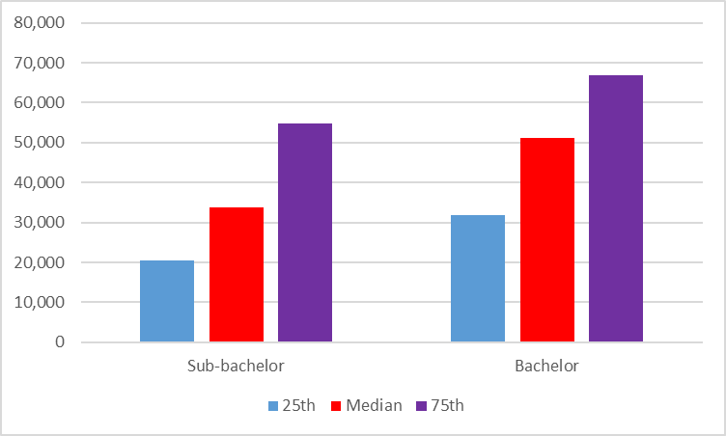***Source: ATO administrative data*

Figure 3 shows the median income of male graduates, as measured by administrative data, was $35,300 which was higher, 9 per cent, than the median income of female graduates of $32,300. There was greater variation in graduate incomes among males than females at least one year and up to two years following graduation. Male incomes at the 75th percentile were 3.04 times higher than at the 25th percentile whereas female graduate incomes were 2.42 times higher.

**Figure 3: 2018 incomes of 2016 sub-bachelor graduates by gender, $**

*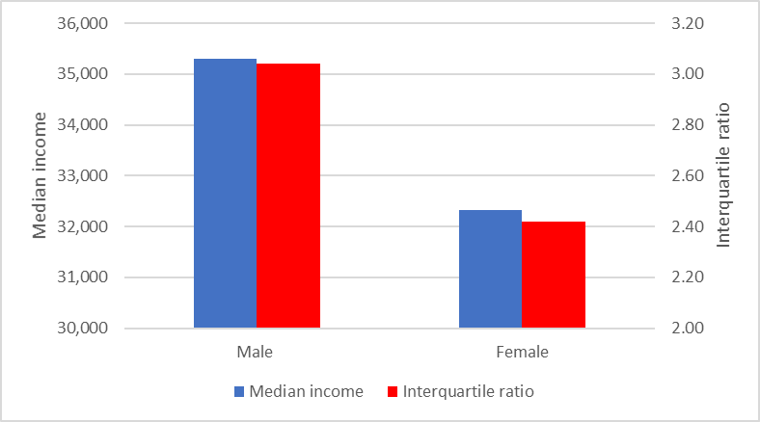**Source: ATO administrative data*

Patterns in median incomes among different groups of sub-bachelor graduates were similar to those among bachelor graduates. That is, graduates who were older (30 years and over), from an English speaking background, from an Indigenous background, with no reported disability, or who attended university (in comparison with graduates who attended a non-university higher education institution) had higher median incomes by a margin of 83 per cent, 19 per cent, 20 per cent, 37 per cent and 40 per cent than their respective counterparts, as shown by Figures 4-10. Graduates from a low socioeconomic status background had higher median incomes, by 9 per cent, than graduates from a high socioeconomic status background, as shown by Figure 8. Also, Figure 10 shows the median income of graduates who attended a Regional Network University (RUN) were much higher than for graduates attending other university groups, for example, being more than double, 130 per cent higher than the median income of graduates from an Australian Technology Network (ATN) university (see the analysis of institution results below for further insight on this result). Further details on comparison of sub-bachelor and bachelor incomes by student and course characteristics and institution is provided in the Attachment.

In the accompanying paper, it was generally the case that bachelor graduates with lower initial incomes, usually from disadvantaged backgrounds, also reported greater variation in incomes. This was not found to be the case with sub-bachelor graduates, as shown by Figures 4-10, where graduates with higher initial incomes also reported greater variation in incomes. That is, the interquartile ratio between incomes was larger among graduates who were older, from an English speaking background, from an Indigenous background, for those with a reported disability, from a low socioeconomic status background and for those who attended a university. The only exceptions were graduates with a reported disability and graduates from ‘Other’ universities who had lower average incomes but greater variation in their incomes.

**Figure 4: 2018 incomes of 2016 sub-bachelor graduates by age, $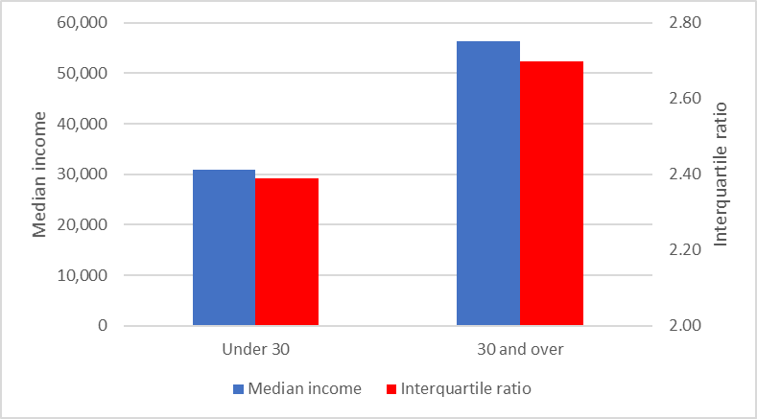***Source: ATO administrative data*

**Figure 5: 2018 incomes of 2016 sub-bachelor graduates by language background,$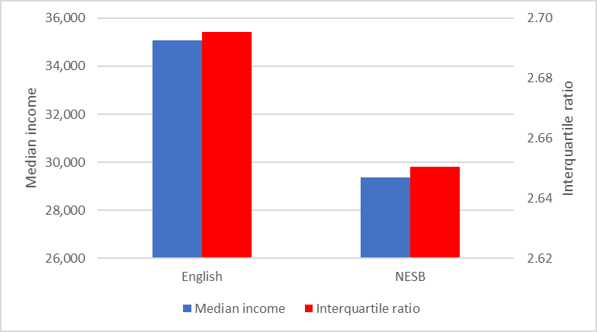***Source: ATO administrative data*

**Figure 6: 2018 incomes of 2016 sub-bachelor graduates by Indigenous status, $****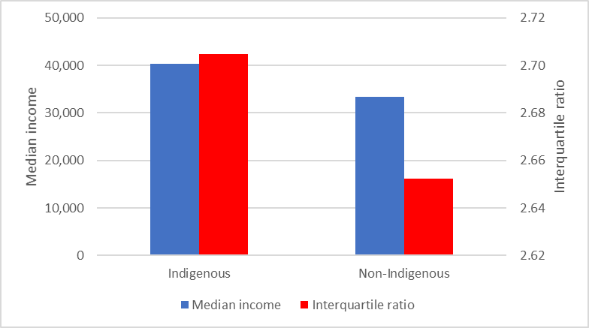***Source: ATO administrative data*

**Figure 7: 2018 incomes of 2016 sub-bachelor graduates by disability status, $**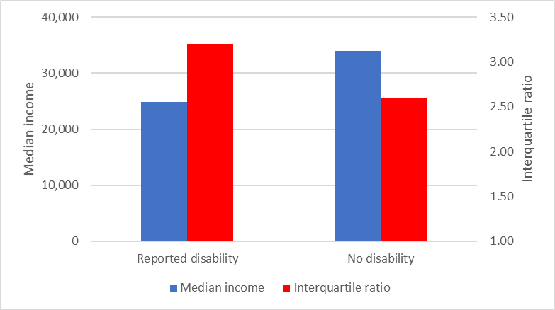

*Source: ATO administrative data*

**Figure 8: 2018 incomes of 2016 sub-bachelor graduates by socioeconomic status, $****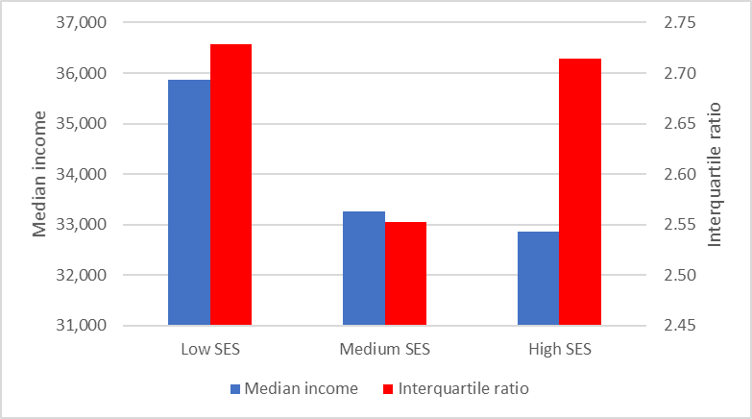***Source: ATO administrative data*

**Figure 9: 2018 incomes of 2016 sub-bachelor graduates by type of provider, $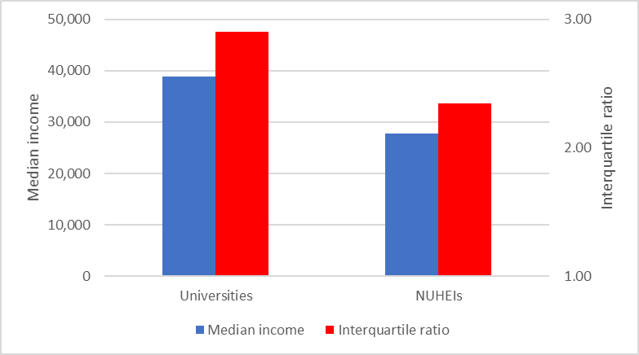***Source: ATO administrative data*

**Figure 10: 2018 incomes of 2016 sub-bachelor graduates by type of university, $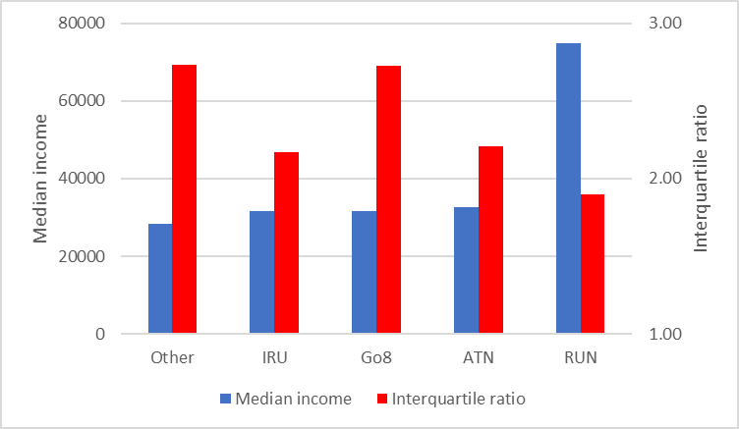***Source: ATO administrative data*

The administrative data on graduate incomes show sub-bachelor graduates with highest median incomes immediately following graduation studied Law and paralegal studies ($79,500), Psychology ($54,300), Architecture and built environment ($45,100), Veterinary science ($43,800) and Social work ($42,100), as shown by Figure 11. Sub-bachelor graduates with lowest incomes following graduation were those completing Teacher education degrees who earned $26,000 on average. Other graduates with lower median incomes following completion of their degree included those who completed Health services and support ($27,400) and Science and mathematics ($27,900) degrees. Graduates from study areas with lowest incomes were more likely to experience greater variation in their incomes, though this relationship was relatively weak (correlation = -0.40). For example, the variation in graduate incomes was lower for Law and paralegal graduates at 1.44 in comparison with 2.33 for Teacher education graduates.

Universities with highest median incomes among sub-bachelor degree holders at least one year and up to two years following graduation include Charles Sturt University ($80,200), the University of Technology, Sydney ($65,400), the University of Southern Queensland ($62,200) and CQUniversity ($59,200), as shown by Figure 12. There were a large number of graduates from Charles Sturt University with Law and paralegal studies sub-bachelor degrees and this accounts, in part, for the higher median incomes of RUN sub-bachelor degree graduates. On the other hand, universities with lowest median incomes among sub-bachelor degree holders include the University of Canberra ($23,900), the Australian National University ($24,800) and Macquarie University ($24,800). Results by university show a negative relationship between median income and variation in incomes, though this relationship was weak (correlation = -0.28).

Figure 13 shows results by non-university higher education institution (NUHEIs). Those with highest median incomes among sub-bachelor degree holders at least one year and up to two years following graduation include Marcus Oldham College ($46,300), the Australian College of Applied Psychology ($43,400), Raffles College of Design and Commerce ($43,100), the Australian Institute of Music ($42,600) and Northern Melbourne Institute of TAFE ($40,500). The negative relationship between median income and variation in incomes still holds among NUHEIs though once again this relationship is not strong (correlation = -0.46).

**Figure 11: 2018 incomes of 2016 sub-bachelor graduates by study area (21), $****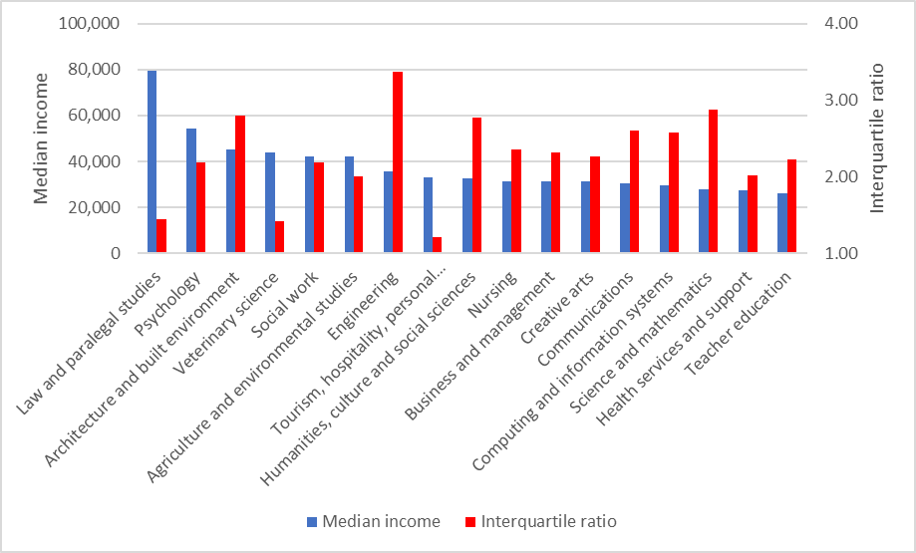***Source: ATO administrative data*

**Figure 12: 2018 incomes of 2016 sub-bachelor graduates by university, $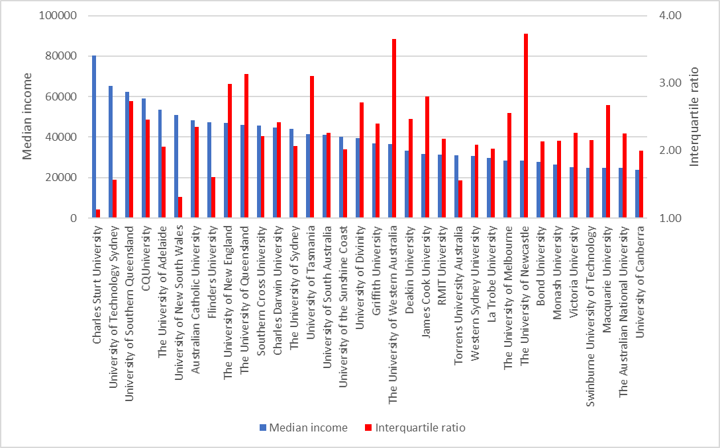***Source: ATO administrative data*

**Figure 13: 2018 incomes of 2016 sub-bachelor graduates by non-university higher education institution (NUHEI), $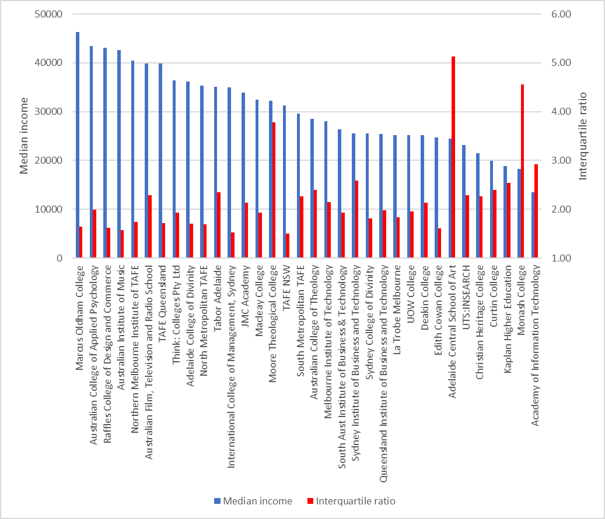***Source: ATO administrative data*

## 2007 cohort of sub-bachelor graduates – growth in incomes

This section uses ATO administrative data to track graduate incomes over time enabling examination of whether graduates with lower initial incomes recover or if those with higher initial incomes maintain their advantage in terms of achieving higher incomes over the medium and longer term. This section examines the progress of the 2007 cohort of sub-bachelor graduates, as measured by growth in incomes, at least one year but less than two years after graduation in 2009 through to at least ten years but less than eleven years after graduation in 2018. Note, growth in graduate incomes is assessed using the measure of assessable income as the measure of total income, used previously in this paper, is unavailable before 2014. The accompanying paper on bachelor graduate incomes showed the total income and assessable income measures were closely related.

The median income of sub-bachelor graduates increased from $48,100 in 2009 at least one year after graduation to $85,200 in 2018 at least ten years after graduation, an increase of 50 per cent, as shown by Figure 13. This is slower than growth in the median income of bachelor level graduates in the ten years after graduation, which increased by 88 per cent. Like bachelor graduates, the incomes of sub-bachelor graduates at the 75th percentile rose faster, by 54 per cent. Unlike bachelor graduates, the incomes of sub-bachelor graduates at the 25th percentile increased faster, by 58 per cent. As a result, the interquartile ratio in the incomes of sub-bachelor graduates decreased from 2.65 one year after graduation to 2.03 ten years after graduation.

**Figure 13: Median income of 2007 cohort of sub-bachelor graduates between one and ten years after graduation by interquartile range, $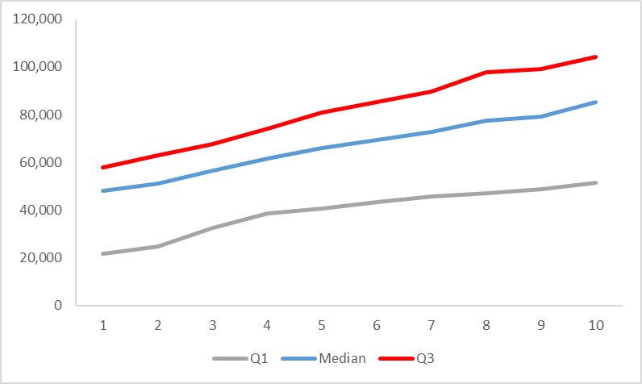***Source: ATO administrative data*

As occurred among bachelor graduates, the median income of male sub-bachelor graduates increased more rapidly than for women by 52 per cent, from $54,400 in 2009, one year after graduation to $95,900 in 2018, ten years after graduation. By way of comparison, the median income of female graduates increased more slowly by 44 per cent, from $34,900 one year after graduation to $66,900 ten years after graduation, as shown by Figure 14.

**Figure 14: Median income of 2007 cohort of sub-bachelor graduates between one and ten years after graduation by gender, $**

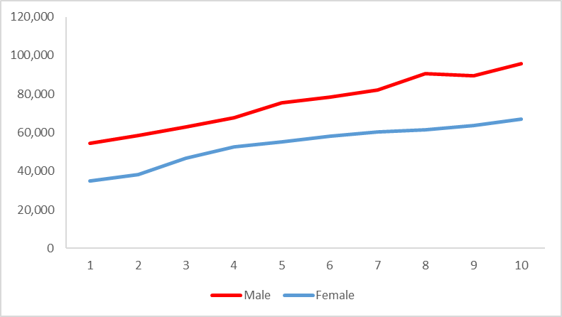  
*Source: ATO administrative data*

There is much greater variation in the incomes of female sub-bachelor graduates than among their male counterparts in the first ten years after graduation, as shown in Figure 15. Note, this is different to the situation straight after graduation using the total income measure where female sub-bachelor graduates had lower variation in incomes straight after graduation, as shown above in Figure 3. Over time, the interquartile ratio of female sub-bachelor incomes declines slightly from 3.01 one year after graduation to 2.16 seven years after graduation. Thereafter, the interquartile ratio increases to 2.50 ten years after graduation. Among male sub-bachelor graduates, the variation in incomes tends to decline over time with the interquartile ratio falling from 2.11 one year after graduation to 1.60 ten years after graduation. In general, there appears greater uncertainty associated with the attainment of a sub-bachelor degree among female than male graduates. In the previous paper concerning bachelor graduates, it was shown that females are much more likely than males to move between various labour market states e.g. between full-time employment, part-time employment, unemployment and not in the labour force. This trend is evident among the wider female labour force as shown by ABS Labour Force Survey data. Most likely, the movement of female sub-bachelor graduates between labour market states is contributing, in part, to greater variation in their incomes over time.

**Figure 15: Interquartile ratio of incomes of 2007 cohort of sub-bachelor graduates between one and ten years after graduation by gender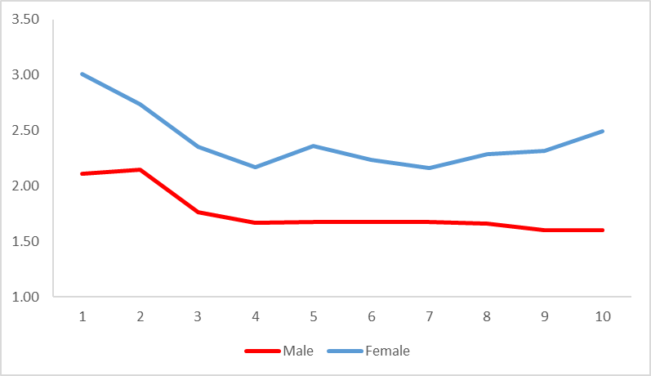***Source: ATO administrative data*

Older graduates are more likely to have an ongoing relationship with an employer and the labour market, which is reflected in higher earnings immediately following graduation, as shown by Figure 18. However, in the decade following graduation, the incomes of graduates aged under 30 recovered somewhat, increasing by 104 per cent in comparison with 64 per cent for graduates aged 30 and over. Nevertheless, ten years after graduation the median income of younger graduates, $84,000, is still below that of older graduates, $89,700. Unlike the earlier data on taxable income, the data on assessable income suggests younger graduates have greater dispersion in their incomes immediately following graduation. However, over time the variation in incomes declines so that ten years after graduation the interquartile ratio for younger graduates was 1.99 which was lower than that for older graduates of 2.16, as shown by Figure 19.

**Figure 18: Median income of 2007 cohort of sub-bachelor graduates between one and ten years after graduation by age, $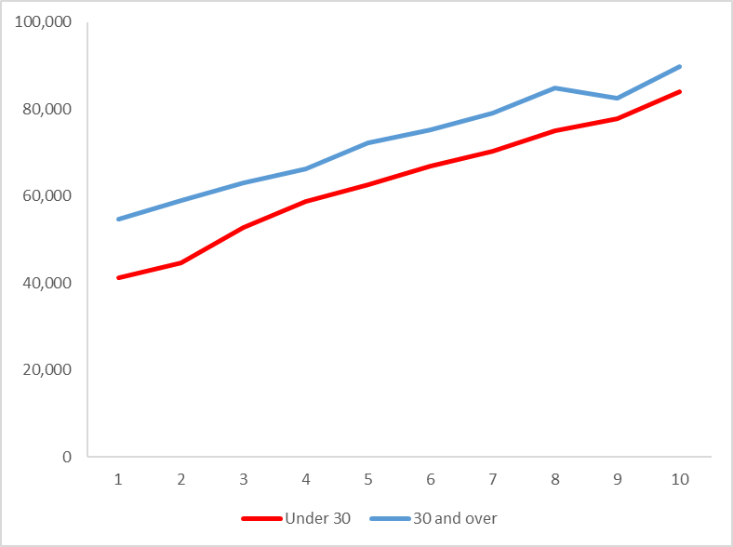***Source: ATO administrative data*

**Figure 19: Interquartile ratio of incomes of 2007 cohort of sub-bachelor graduates between one and ten years after graduation by age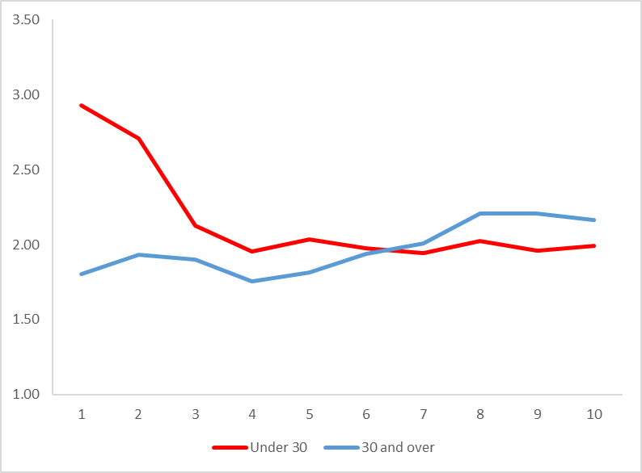***Source: ATO administrative data*

Immediately following graduation, graduates from a non-English speaking background have lower incomes, as shown by Figure 20. However, in the decade following graduation, the incomes of non-English speaking graduates recovered somewhat, increasing faster by 177 per cent in comparison with 71 per cent for English speaking graduates. Nevertheless, ten years after graduation the median income of non-English speaking graduates, $76,300, is still below that of English speaking graduates, $86,400. Unlike the earlier data on taxable income, the data on assessable income suggests non-English speaking graduates have greater dispersion in their incomes immediately following graduation. In the ten years following graduation, graduates from a non-English speaking background continue to experience greater variation in their incomes, as shown by Figure 21.

**Figure 20: Median income of 2007 cohort of sub-bachelor graduates between one and ten years after graduation by language background, $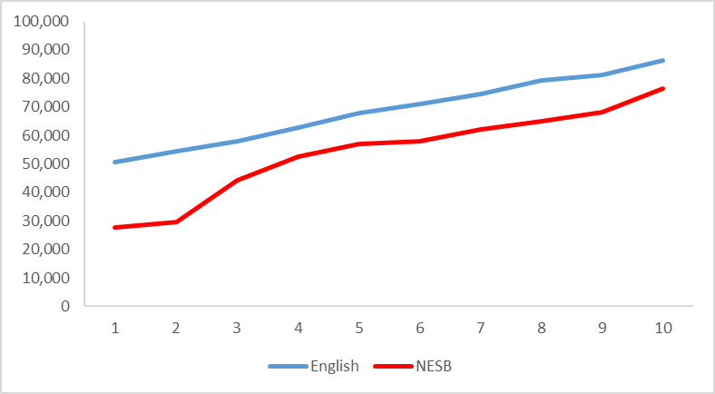***Source: ATO administrative data*

**Figure 21: Interquartile ratio of incomes of 2007 cohort of sub-bachelor graduates between one and ten years after graduation by language background**

**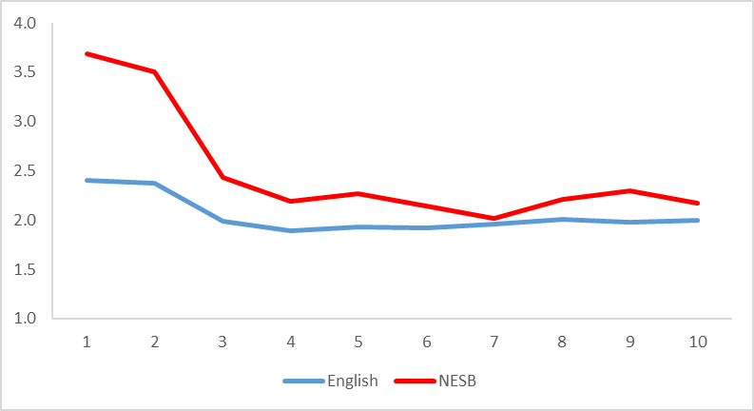***Source: ATO administrative data*

Unlike the data on taxable income, the data on assessable income suggests Indigenous graduates have a lower median income immediately following graduation, as shown by Figure 22. In the ten years following graduation, the median income of Indigenous graduates increased by 61 per cent to $73,100. Non-Indigenous graduates experienced faster growth in median income increasing by 77 per cent so that ten years after graduation they had a higher median income of $85,500. The data on assessable incomes suggests, unlike the data on taxable incomes, that Indigenous graduates experience less variation in their incomes immediately after graduation. Figure 23 shows Indigenous graduates generally experience less variation in their incomes in the ten years following graduation.

**Figure 22: Median income of 2007 cohort of sub-bachelor graduates between one and ten years after graduation by Indigenous status, $ 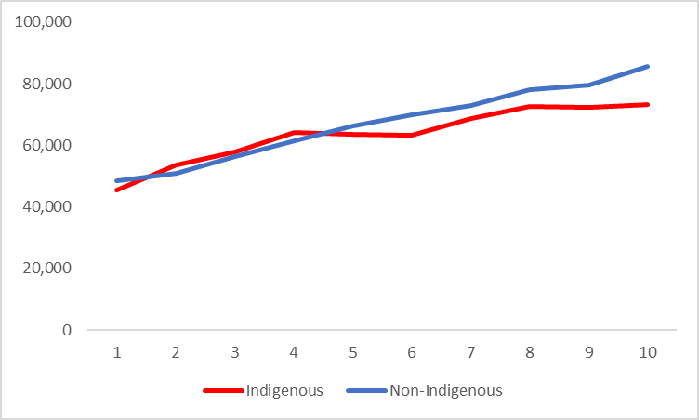***Source: ATO administrative data*

**Figure 23: Interquartile ratio of incomes of 2007 cohort of sub-bachelor graduates between one and ten years after graduation by Indigenous status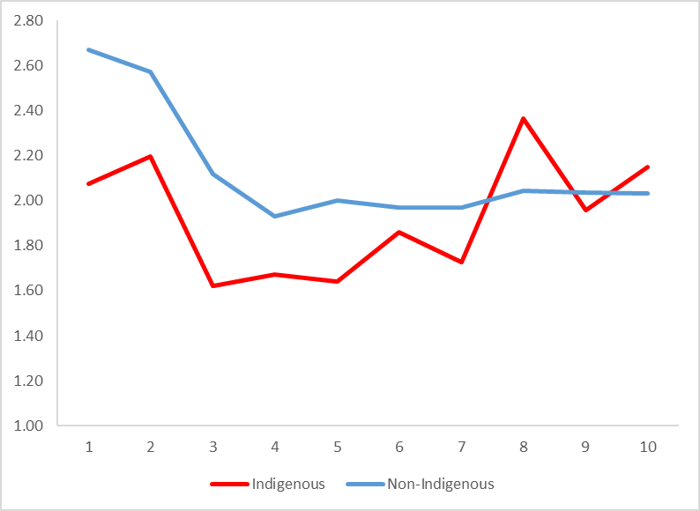***Source: ATO administrative data*

Graduates with a reported disability experience lower incomes immediately following graduation than those with no reported disability, as shown by Figure 24. In the ten years following graduation, the median income of those with a reported disability increased by 33 per cent, much more slowly than growth of 75 per cent in the median income of graduates with no reported disability. Not only do graduates with a reported disability experience lower incomes, they also experience greater variation in their incomes in the ten years following graduation, as shown by Figure 25.

**Figure 24: Median income of 2007 cohort of sub-bachelor graduates between one and ten years after graduation by disability status, $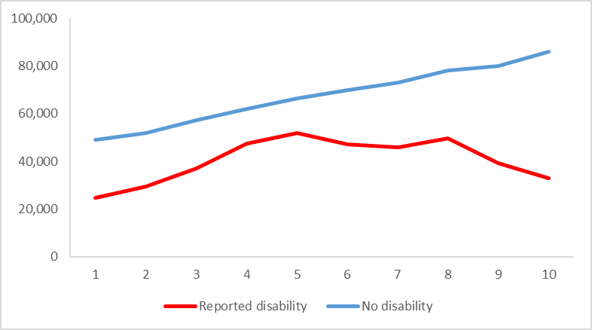***Source: ATO administrative data*

**Figure 25: Interquartile ratio of incomes of 2007 cohort of sub-bachelor graduates between one and ten years after graduation by disability status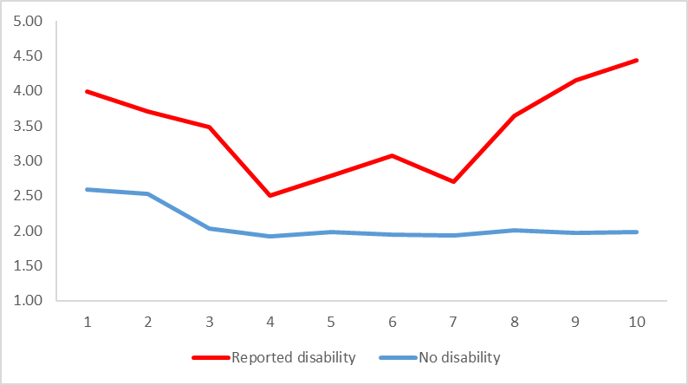***Source: ATO administrative data*

The experience of sub-bachelor graduates from a low socioeconomic status background in the ten years following graduation is similar to that of their bachelor counterparts in that they experience slower growth in incomes. In the ten years following graduation, the median income of sub-bachelor graduates increased by 63 per cent in comparison with 71 per cent for graduates from a medium socioeconomic status background and 137 per cent for those from a high socioeconomic status background, as shown by Figure 26. Unlike the data on taxable income, the data on assessable income suggests low socioeconomic status graduates have lower variation in incomes immediately after graduation. Ten years after graduation, high socioeconomic status graduates continue to have the greatest dispersion in their incomes with the interquartile ratio being 2.16 in comparison with 2.04 for low socioeconomic status graduates and 1.95 for medium socioeconomic status graduates, as shown by Figure 27.

**Figure 26: Median income of 2007 cohort of sub-bachelor graduates between one and ten years after graduation by socioeconomic status, $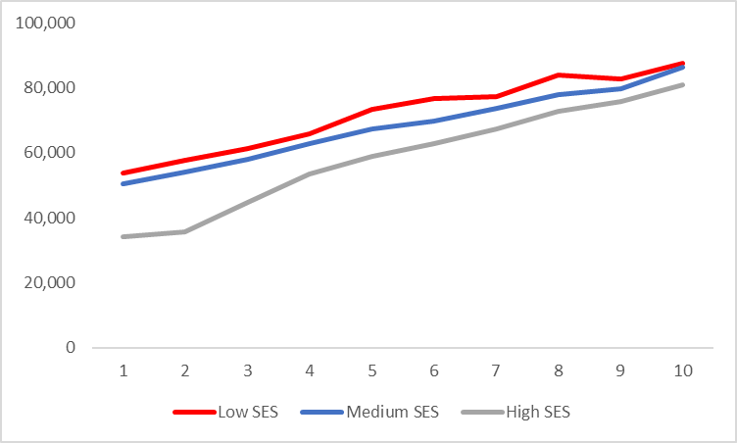***Source: ATO administrative data*

**Figure 27: Interquartile ratio of incomes of 2007 cohort of sub-bachelor graduates between one and ten years after graduation by socioeconomic status****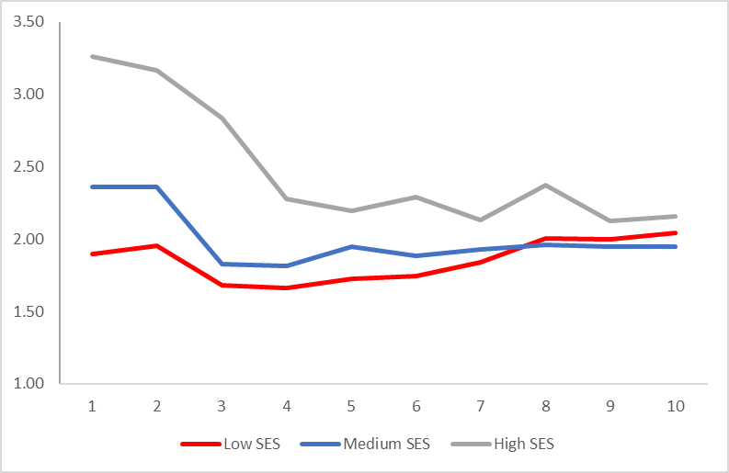***Source: ATO administrative data*

Graduates from study areas with stronger initial incomes also experience higher incomes ten years following graduation (correlation = 0.78). For example, graduates with highest incomes ten years after graduation include Engineering, $110,700 and Law and paralegal studies, $99,200, as shown by Figure 28. However, there is some evidence that graduates with lower initial incomes experience stronger growth in their incomes in the ten years following graduation (correlation = -0.82). For example, graduates in Business and management and, Computing and information systems, experience faster growth in incomes in the decade following graduation, by 225 per cent and 212 per cent respectively.

**Figure 28: 2007 cohort of sub-bachelor graduates, 2009 income (LHS, $) and 2017 income (RHS, $) by study area**

*Source: ATO administrative data*

Patterns in changes in income by university are broadly similar to those by study area. For example, graduates from universities with higher initial incomes in 2009 also had higher incomes ten years later in 2018 (correlation = 0.67). Universities with highest incomes ten years after graduation include Charles Sturt University, $99,000, CQUniversity, $90,400 and the University of New South Wales, $88,400, as shown by Figure 29. There is evidence that universities with lower initial incomes experience a recovery in their incomes with faster growth in their incomes in the ten years following graduation (correlation = -0.65). Graduates experiencing faster growth in their incomes in the ten years following graduation include Monash University increasing by 298 per cent, the University of Adelaide, 125 per cent, Macquarie University, 108 per cent and the University of South Australia, 102 per cent.

Graduates from non-university higher education institutions (NUHEIs) with lower incomes immediately following graduation caught up as they experienced faster growth in their incomes in the ten years after graduation (correlation = 0.62). Graduates from NUHEIs that had highest incomes ten years after graduation included UTS Insearch, $76,700 and Monash College, $74,900, as shown by Figure 30.

**Figure 29: 2007 cohort of sub-bachelor graduates, 2009 income (LHS, $) and 2018 income (RHS, $ ) by university****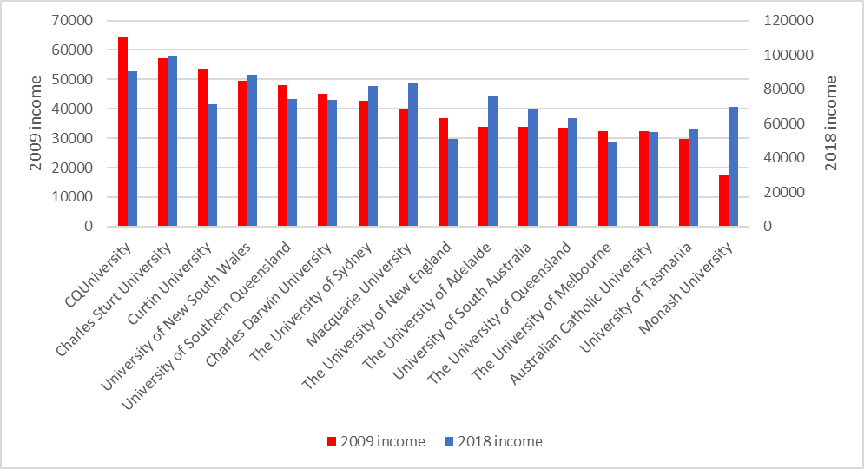**  
Source: ATO administrative data

**Figure 30: 2007 cohort of sub-bachelor graduates, 2009 income (LHS, $) and 2018 income (RHS, S) by non-university higher education institution (NUHEI)**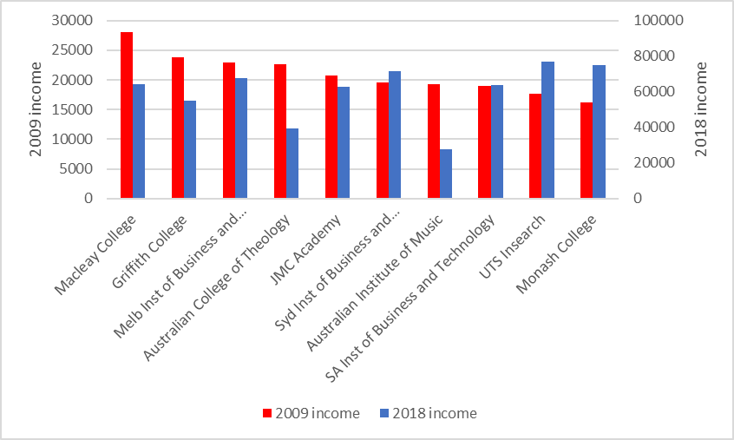   
Source: ATO administrative data

## Tracking the growth in incomes of different sub-bachelor cohorts

The earlier paper examining the incomes of bachelor graduates found that immediately following graduation, successive cohorts had experienced declining real incomes following the GFC, but their incomes did recover around six to eight years later.

By way of comparison with bachelor graduates, the real incomes of sub-bachelor graduates immediately following graduation have shown a much sharper fall since the GFC. Figure 31 shows that following the GFC, the real median income of graduates at least one year and up to two years after graduation declined from $48,100 in 2009 to $26,100 in 2017, a fall of 54 per cent. There was a slight rise of 5 per cent to $27,500 in 2018. There is an important caveat to add that the number of sub-bachelor graduates is much smaller. As a result, the creation or elimination of one or two sub-bachelor courses at an institution(s) might impact the results described above. That said, there has been a consistent and steady decline in the real median incomes of sub-bachelor graduates since the GFC.

**Figure 31: Real median income of initial sub-bachelor graduates, 2009 – 2018 (2009 prices), $**

*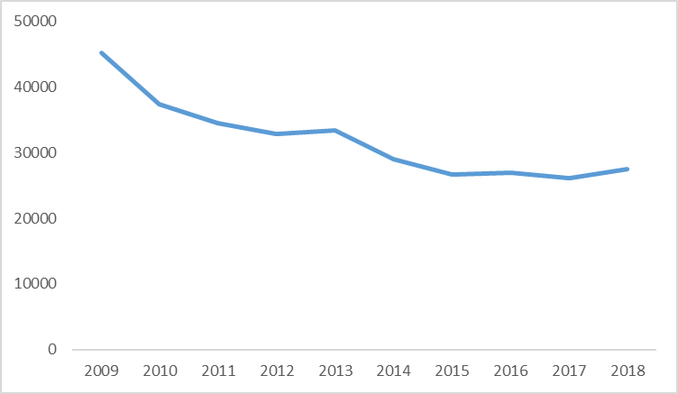**Source: ATO administrative data*

Tracking the progress of different cohorts of graduates over time, there appear to be contrasting experiences between bachelor and sub-bachelor graduates. From the earlier paper, initial bachelor graduates experienced a decline in their real incomes following the GFC, but thereafter their incomes appeared to recover in the six to eight years after graduation. By way of comparison, sub-bachelor graduates experienced a much sharper decline in their real incomes following the GFC, as shown above. Figure 32 shows the real incomes of different cohorts of sub-bachelor graduates have followed a very different path following graduation. The real incomes of the pre-GFC 2007 cohort increased by 46 per cent in the ten years following graduation. Subsequent post-GFC cohorts experienced much lower initial incomes, as shown above, but their incomes have grown much faster in subsequent years, though their real incomes have not fully recovered. For example, from the first to the eighth year after graduation, the real incomes of the 2009 cohort of graduates had increased by 70 per cent which was faster than growth in real incomes of the 2007 cohort of 38 per cent. However, the real median income of the 2009 cohort eight years after graduation was $58,700 which remained well below the real median income of the 2007 cohort eight years after graduation of $66,400. Similarly, from the first to the sixth year after graduation, the real incomes of the 2011 cohort of graduates had increased by 60 per cent, much faster than the real incomes of the 2007 cohort of 27 per cent. However, the real median income of the 2011 cohort six years after graduation was $53,400 which remained well below the real median income of the 2007 cohort six years after graduation of $61,000. Similar trends are observed for the 2013 and 2015 cohorts.

Trends observed for sub-bachelor graduate cohorts contrast with the experiences of bachelor and postgraduate coursework graduates following the GFC. As noted above, bachelor graduates experienced lower real incomes post-GFC but their real incomes appeared to have recovered between six to eight years after graduation. There appears to have been little discernible impact of the GFC on trajectory of the real incomes of postgraduate coursework graduates, as shown in an earlier paper. On the other hand, the real incomes of sub-bachelor graduates appear much lower following the GFC and, unlike bachelor graduates, they appear not to have recovered in the ensuing years.

**Figure 32: Growth in real median incomes of different sub-bachelor graduate cohorts up to ten years after graduation (2009 income of 2007 cohort = 100)**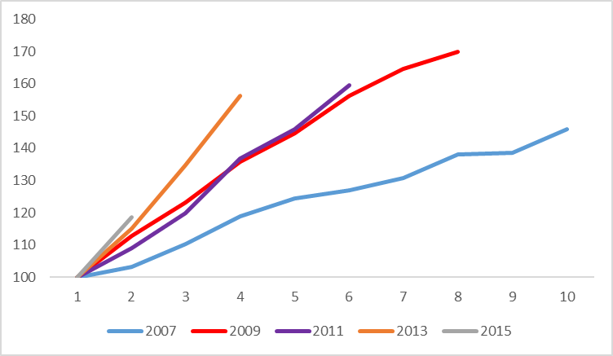 *Source: ATO administrative data*

Like bachelor and postgraduate coursework graduates, evidence suggests that since the GFC, the variation or uncertainty associated with attainment of a sub-bachelor degree has increased. Figure 33 shows whether the uncertainty associated with attainment of a degree has changed following the GFC using the interquartile ratio in incomes of the 2007 cohort of graduates as numeraire. That is, where the measure of relative variation is greater than 100, it can be said there is greater uncertainty in graduate incomes among post-GFC graduate cohorts in comparison with the pre-GFC 2007 graduate cohort. For example, for each of the 2009, 2011 and 2013 cohorts immediately following graduation, variation in their incomes was around 20 to 25 per cent higher than for the pre-GFC 2007 cohort of graduates and increased further in subsequent years. For the 2009 cohort, the variation in incomes was on a par with that of the 2007 cohort eight years after graduation. This is a little longer than for bachelor graduates where the variation in incomes among post-GFC cohorts was on a par with that for the pre-GFC cohort around five to seven years after graduation. On the other hand, variation in incomes for the more recent 2015 and 2016 cohorts appears to have been more similar to that of the pre-GFC 2007 cohort.

**Figure 33: Relative variation in income of different sub-bachelor graduate cohorts between one and eight years after graduation (2007 graduate cohort as numeraire=100)** 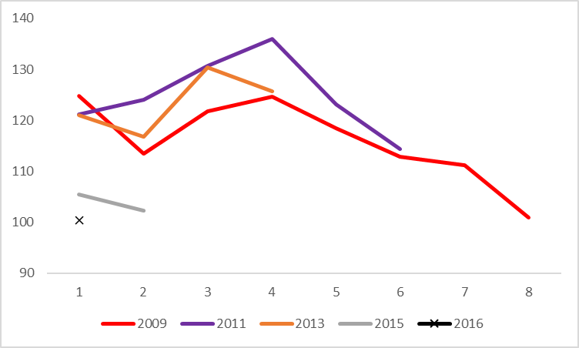

*Source: ATO administrative data*

In summary, the GFC appears to have impacted the incomes of sub-bachelor degree graduates to a greater degree than bachelor or postgraduate coursework graduates. Sub-bachelor degree graduates experienced a sharper fall in their real incomes following the GFC and the real incomes of post-GFC cohorts appear not to have recovered, unlike their counterparts with a bachelor degree. In addition, post-GFC cohorts with a sub-bachelor degree appear to have experienced greater variation in their incomes following the GFC for up to eight years following graduation. These results appear plausible in that graduates with lower level sub-bachelor degree qualifications have experienced a larger decline and greater variation in their incomes following the GFC whereas the impact of the GFC on those with higher level bachelor or postgraduate coursework degrees appears much less or more muted.

## Conclusion

Sub-bachelor graduates earn around a third, 34 per cent, less than bachelor graduates immediately following graduation. They also experience more variation or uncertainty in their incomes. Having lower incomes and greater uncertainty in their incomes is most likely a reflection of their lower level qualifications and less experience.

Sub-bachelor graduates’ incomes grow more slowly than that of their bachelor counterparts in the ten years after graduation, 50 per cent in comparison with 88 per cent. Study areas and institutions with higher initial incomes are likely to have higher incomes ten years after graduation. There is evidence, however, that study areas and universities with lower incomes immediately after graduation experience faster growth in their incomes in the ten years following graduation and catch up, though not fully.

The GFC appears to have had a more severe impact on the incomes of sub-bachelor graduates. They experienced a steady decline in their real incomes following the GFC. This contrasts with the experience of bachelor graduates, who while they experienced a decline in incomes following the GFC, found their incomes generally recovered about six to eight years after graduation. As well as experiencing lower incomes, sub-bachelor graduates also experienced much more variation or uncertainty in their incomes following the GFC than did bachelor graduates. This is consistent with evidence from the ABS Labour Force Survey that persons with lower qualifications, skills and experience generally fare worse during an economic downturn.

## Attachment: Detailed income comparisons of sub-bachelor and bachelor graduates

**Table A1: 2018 incomes of 2016 graduates by level of course by student and course characteristics**

|  |  |  |  |  |
| --- | --- | --- | --- | --- |
|  | Sub-bachelor | | Bachelor | |
|  | Median income | Interquartile ratio | Median income | Interquartile ratio |
|  |  |  |  |  |
| Total | $33,800 | 2.66 | $51,200 | 2.11 |
|  |  |  |  |  |
| Male | $35,300 | 3.04 | $51,400 | 2.22 |
| Female | $32,300 | 2.42 | $51,100 | 2.04 |
|  |  |  |  |  |
| Under 30 | $30,900 | 2.39 | $50,300 | 2.11 |
| 30 and over | $56,300 | 2.70 | $57,100 | 2.03 |
|  |  |  |  |  |
| Indigenous | $40,300 | 2.70 | $58,200 | 1.81 |
| Non-Indigenous | $33,400 | 2.65 | $51,100 | 2.11 |
|  |  |  |  |  |
| English speaking background | $35,100 | 2.70 | $51,200 | 2.10 |
| Non-English speaking background | $29,400 | 2.65 | $50,700 | 2.10 |
|  |  |  |  |  |
| Reported disability | $24,800 | 3.20 | $45,000 | 2.53 |
| No reported disability | $34,000 | 2.61 | $51,400 | 2.08 |
|  |  |  |  |  |
| Low socioeconomic status | $35,900 | 2.73 | $52,300 | 1.97 |
| Medium socioeconomic status | $33,300 | 2.55 | $51,200 | 2.07 |
| High socioeconomic status | $32,900 | 2.71 | $50,400 | 2.26 |
|  |  |  |  |  |
| Go8 | $31,700 | 2.73 | $48,100 | 2.55 |
| ATN | $32,600 | 2.21 | $51,400 | 1.89 |
| IRU | $31,600 | 2.17 | $50,300 | 2.06 |
| RUN | $74,900 | 1.90 | $58,700 | 1.77 |
| Other | $28,300 | 2.73 | $52,700 | 1.93 |
|  |  |  |  |  |
| University | $38,900 | 2.90 | $51,700 | 2.08 |
| NUHEI | $27,800 | 2.34 | $37,600 | 2.27 |
|  |  |  |  |  |

**Table A2: 2018 incomes of 2016 graduates by level of course by study area**

|  |  |  |  |  |
| --- | --- | --- | --- | --- |
|  | Sub-bachelor | | Bachelor | |
|  | Median income | Interquartile ratio | Median income | Interquartile ratio |
|  |  |  |  |  |
| Science and mathematics | $27,900 | 2.87 | $32,600 | 2.97 |
| Computing and information systems | $29,500 | 2.58 | $54,900 | 1.71 |
| Engineering | $35,700 | 3.37 | $63,600 | 1.51 |
| Architecture and building | $45,100 | 2.80 | $48,000 | 2.17 |
| Agriculture and environmental studies | $42,100 | 2.01 | $45,800 | 2.13 |
| Health services and support | $27,400 | 2.02 | $45,000 | 2.60 |
| Medicine | $80,400 | 1.23 | $84,000 | 1.23 |
| Nursing | $31,500 | 2.35 | $62,200 | 1.38 |
| Pharmacy | $54,400 | 1.42 | $56,500 | 1.35 |
| Dentistry | $74,100 | 1.92 | $78,300 | 1.95 |
| Veterinary science | na | na | $56,400 | 2.11 |
| Rehabilitation | $59,300 | 1.34 | $61,000 | 1.33 |
| Teacher education | $26,000 | 2.23 | $65,200 | 1.41 |
| Business and management | $31,200 | 2.32 | $52,100 | 1.65 |
| Humanities, culture and social sciences | $32,600 | 2.77 | $36,900 | 2.49 |
| Social work | $42,100 | 2.18 | $51,700 | 1.74 |
| Psychology | na | na | $38,200 | 2.35 |
| Law and paralegal studies | $79,500 | 1.44 | $55,200 | 1.71 |
| Creative arts | $31,200 | 2.26 | $33,600 | 2.20 |
| Communications | $30,500 | 2.61 | $42,200 | 1.98 |
| Tourism, hospitality, personal services, sport and recreation | na | na | $37,000 | 2.41 |
| Total | $33,800 | 2.66 | $51,200 | 2.10 |

**Table A3: 2018 incomes of 2016 graduates by level of course by university**

|  |  |  |  |  |
| --- | --- | --- | --- | --- |
|  | Sub-bachelor | | Bachelor | |
|  | Median income | Interquartile ratio | Median income | Interquartile ratio |
| Australian Catholic University | na | na | $58,600 | 1.56 |
| Bond University | $27,700 | 2.13 | $48,400 | 2.06 |
| Charles Darwin University | $44,700 | 2.42 | $62,200 | 1.68 |
| Charles Sturt University | $80,200 | 1.12 | $60,700 | 1.71 |
| CQUniversity | $59,200 | 2.46 | $63,400 | 1.71 |
| Curtin University | na | na | $53,200 | 1.96 |
| Deakin University | $33,200 | 2.47 | $49,500 | 2.00 |
| Edith Cowan University | na | na | $49,200 | 2.20 |
| Federation University Australia | na | na | $53,600 | 1.85 |
| Flinders University | na | na | $49,600 | 2.05 |
| Griffith University | $36,900 | 2.40 | $47,800 | 2.19 |
| James Cook University | $31,500 | 2.81 | $65,200 | 1.55 |
| La Trobe University | $29,800 | 2.02 | $49,300 | 1.94 |
| Macquarie University | $24,800 | 2.67 | $51,900 | 2.04 |
| Monash University | $26,400 | 2.14 | $50,200 | 2.18 |
| Murdoch University | $47,300 | 2.29 | $48,400 | 2.37 |
| Queensland University of Technology | na | na | $53,300 | 1.81 |
| RMIT University | $31,500 | 2.17 | $48,700 | 1.84 |
| Southern Cross University | $45,800 | 2.21 | $53,800 | 1.91 |
| Swinburne University of Technology | $24,900 | 2.15 | $49,500 | 2.04 |
| The Australian National University | $24,800 | 2.26 | $52,900 | 2.34 |
| The University of Adelaide | $53,400 | 2.06 | $48,700 | 2.42 |
| The University of Melbourne | $28,400 | 2.55 | $29,300 | 2.73 |
| The University of New England | $46,900 | 2.99 | $58,900 | 1.86 |
| The University of Newcastle | na | na | $55,800 | 1.75 |
| The University of Notre Dame Australia | na | na | $62,000 | 1.65 |
| The University of Queensland | $46,100 | 3.13 | $54,200 | 2.15 |
| The University of Sydney | na | na | $51,300 | 2.31 |
| The University of Western Australia | $36,700 | 3.65 | $35,300 | 3.01 |
| University of Canberra | $23,900 | 2.00 | $55,800 | 1.82 |
| University of Divinity | $39,500 | 2.71 | $24,900 | 2.63 |
| University of New South Wales | na | na | $54,800 | 2.05 |
| University of South Australia | $41,100 | 2.26 | $51,600 | 1.84 |
| University of Southern Queensland | $62,200 | 2.74 | $62,400 | 1.73 |
| University of Tasmania | $41,300 | 3.10 | $55,000 | 2.20 |
| University of Technology Sydney | na | na | $53,400 | 1.87 |
| University of the Sunshine Coast | $40,200 | 2.02 | $52,300 | 1.87 |
| University of Wollongong | na | na | $52,200 | 1.94 |
| Victoria University | $25,000 | 2.26 | $49,400 | 2.15 |
| Western Sydney University | $30,800 | 2.09 | $48,800 | 2.08 |
| Total universities | $38,900 | 2.90 | $51,700 | 2.08 |

**Table A4: 2018 incomes of 2016 graduates by level of course by non-university higher education institution (NUHEI)**

|  |  |  |  |  |
| --- | --- | --- | --- | --- |
|  | Sub-bachelor | | Bachelor | |
|  | Median income | Interquartile range | Median income | Interquartile range |
|  |  |  |  |  |
| Australian College of Theology | $28,600 | 2.40 | $28,500 | 2.01 |
| Australian Film, Television and Radio School | $39,900 | 2.28 | na | na |
| Australian Institute of Music | $42,600 | 1.58 | $30,500 | 2.48 |
| Christian Heritage College | $21,500 | 2.27 | $51,300 | 2.22 |
| Curtin College | $19,900 | 2.40 | na | na |
| Deakin College | $25,200 | 2.14 | na | na |
| JMC Academy | $33,900 | 2.14 | $32,000 | 2.12 |
| La Trobe Melbourne | $25,200 | 1.83 | na | na |
| Macleay College | $32,500 | 1.93 | $47,400 | 1.47 |
| Marcus Oldham College | $46,300 | 1.64 | na | na |
| Melbourne Institute of Technology | $28,000 | 2.15 | $41,200 | 2.25 |
| Northern Melbourne Institute of TAFE | $40,500 | 1.74 | $40,000 | 2.17 |
| Queensland Institute of Business and Technology | $25,400 | 1.98 | na | na |
| South Aust Institute of Business & Technology | $26,300 | 1.93 | na | na |
| Sydney College of Divinity | $25,500 | 1.82 | $22,300 | 2.00 |
| Sydney Institute of Business and Technology | $25,600 | 2.59 | na | na |
| TAFE Queensland | $39,800 | 1.72 | na | na |
| Think: Colleges Pty Ltd | $36,400 | 1.93 | $40,600 | 2.11 |
| UTS Insearch | $23,200 | 2.29 | na | na |
| Total NUHEIs | $27,800 | 2.34 | $37,600 | 2.27 |